**Papa John’s Rota**

**Minutes**

Attendees: Adam, Pete, Toby

Apologies: None

Date: 26/08/19

Subject: Rota Project

Today we have finalised our decision on software to use to develop this product, and whiteboard prototyped the workflow for the rota application from the managers perspective.

After our tasks from the last meeting we had, we have decided that the piece of software that best suits our requirements for this product is Bubble.is, and so when we begin development this is what we will use.

The client has asked for the following functionality to be included in the product: the ability to add and remove staff onto the system as well as edit their details, the ability to access the rota and add or remove shifts, the ability to receive and then accept or deny requests for holiday from members of staff, and the ability to send alert messages to specific or all members of staff in order to contact them regarding extra shifts. 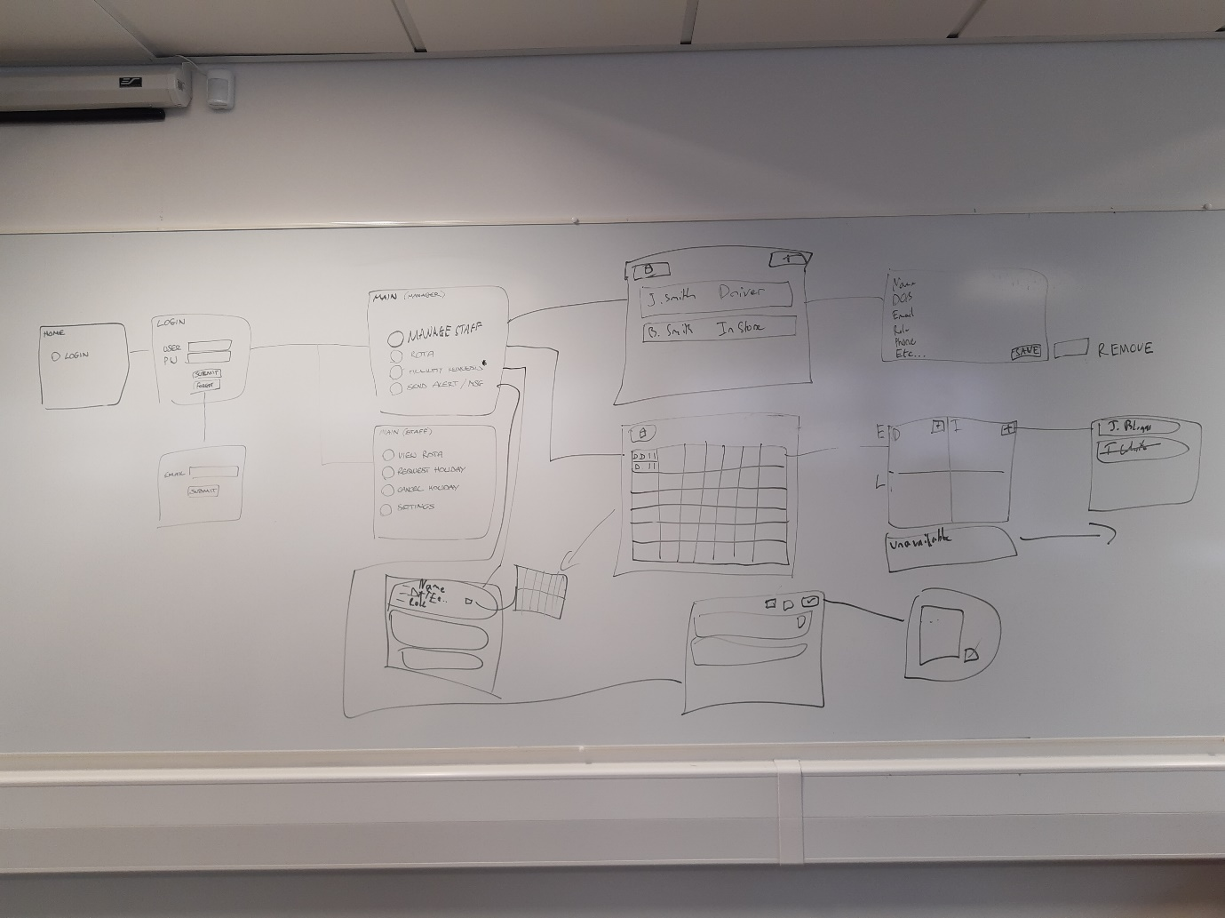

As you can see in the above image we have worked out what we believe to be the best workflow for the web page to achieve this.