**Papa John’s Rota**

**Minutes**

Attendees: Adam, Pete, Toby

Apologies: None

Date: 02/09/2019

Subject: Rota Project

Today we have whiteboard prototyped the workflow for the rota application from the employees (drivers and in store staff) perspective.

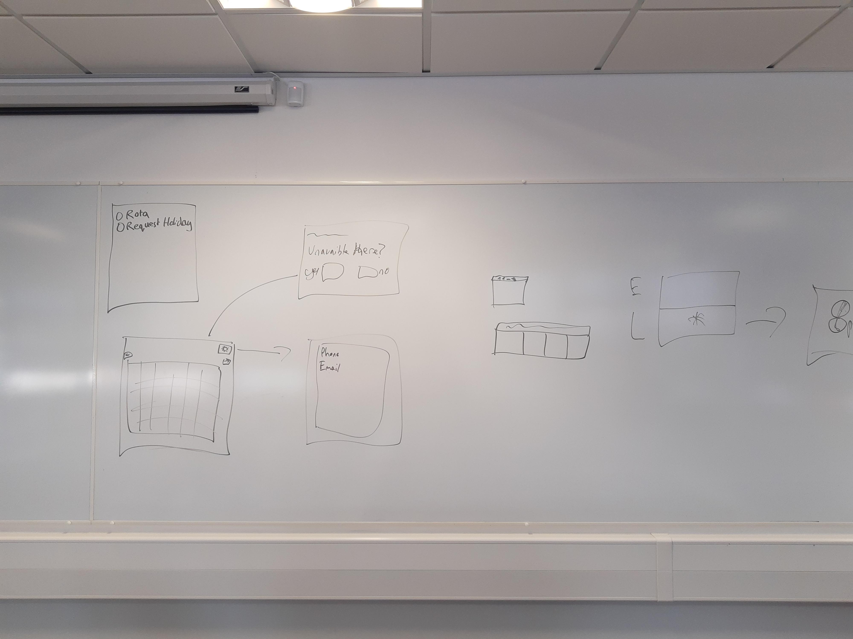

The employees must be able to view their shifts on the rota as well as request holiday so on the first page (after login) they will be given a page with these two options.

We have also arranged a meeting with the client to discuss our current progress on the project and to showcase our initial design of the workflow of the website. The meeting has been arranged for 6/9/19.