
aes220
Windows Installation Manual

High-Speed USB FPGA Mini-Module
Aessent Technology Ltd

aes220 High-Speed USB FPGA Mini-Module

Windows Installation Manual V1.3
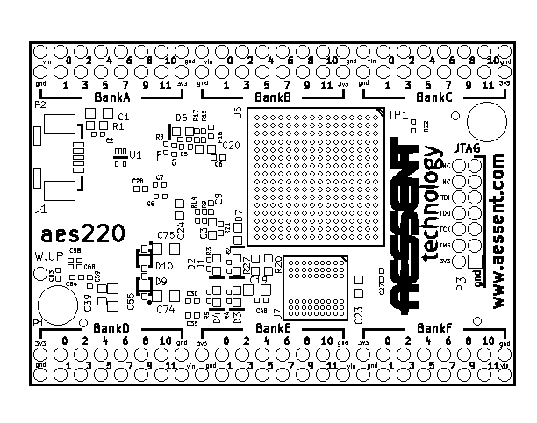
Doc Nb: UM220-02-A  www.aessent.com | Mini-Module Series  Windows Installation Manual

Table of Contents
1 Driver installation 3
2 Installing the aes220 API 10
3 Installing aes220Programmer 11

- Driver installation

This manual will guide the user through installing the necessary files to use the aes220 High-Speed USB FPGA mini-module on a Microsoft Windows systems.

It applies to Windows XP, Windows Vista and Windows 7 platforms with the exception of Windows XP 64bits.

Download and uncompress the aes220WindowsInstall.zip folder in a location of your choice

Plug the aes220 module into a USB port.
Windows should not recognise the device and start the Found New Hardware Wizard:
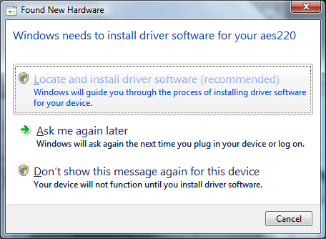
Select "Locate and Install driver software (recommended)" option

When asked to "Insert the disc that came with your aes220" Click on "I don't have the disc. Show me other options."
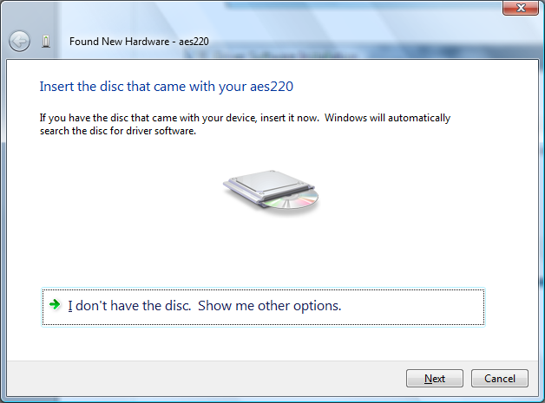

On the next screen choose "Browse my computer for driver software (advanced)"
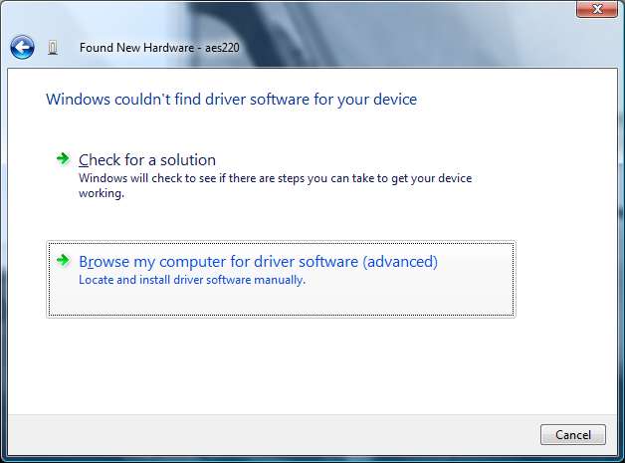

Browse to where the top folder for the drivers is located (the folder containing the .inf file and x86/amd64 folders) and click next

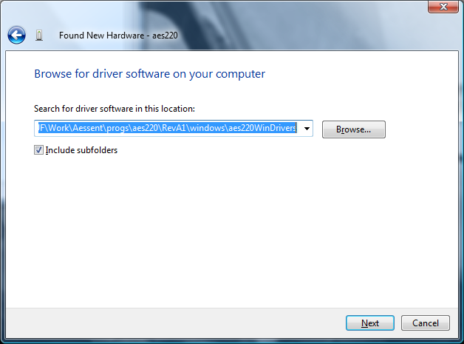
Windows Security might warn you about not being able to verify the publisher of the driver.
Select the "Install this driver software anyway" option:
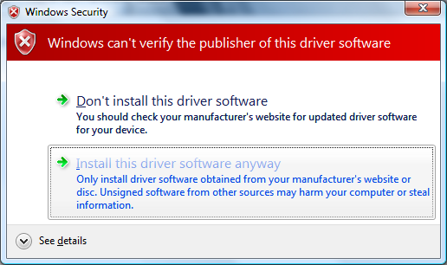
Eventually the successful driver installation window should appear:
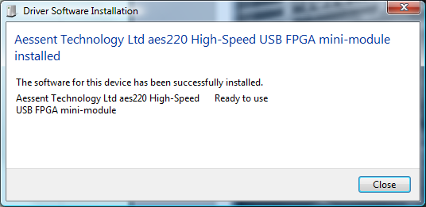

Note to Windows Vista users

On Windows Vista it can happen that the installation fails the first time round:
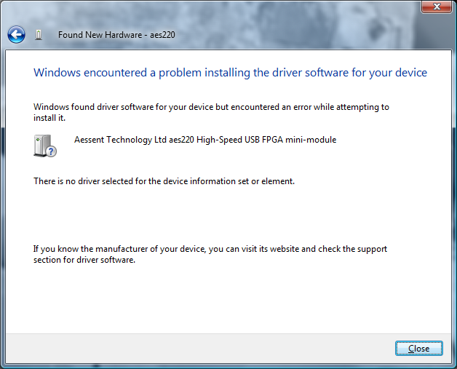

If this is the case open the Device Manager:
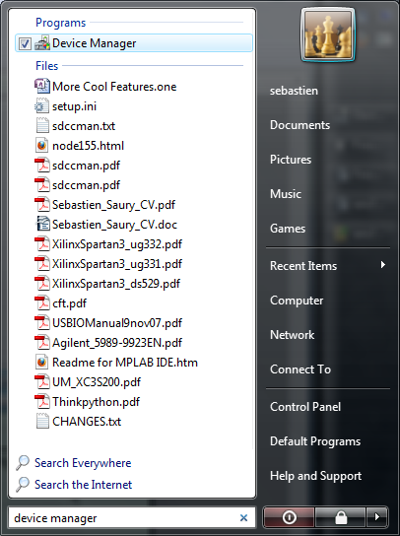

Right click on the aes220 device which should be preceded by a warning sign:
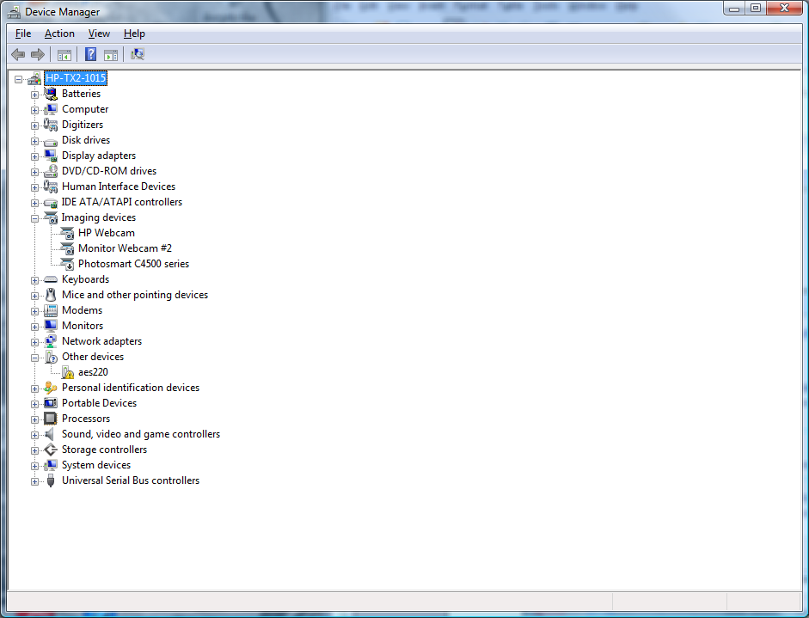
Select the uninstall option
and click OK when asked about uninstalling the device from the system:
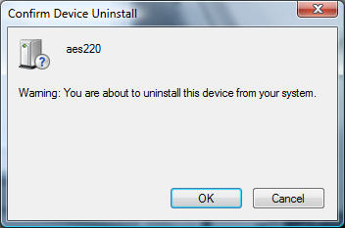
The device should now have disappear from the Device Manager list.

Unplug the module and re-connect it.

Windows will look for the driver again and a message will appear with a successful installation this time.

If looking into the Device Manager the whole device description will now appear under the libusb devices listing:
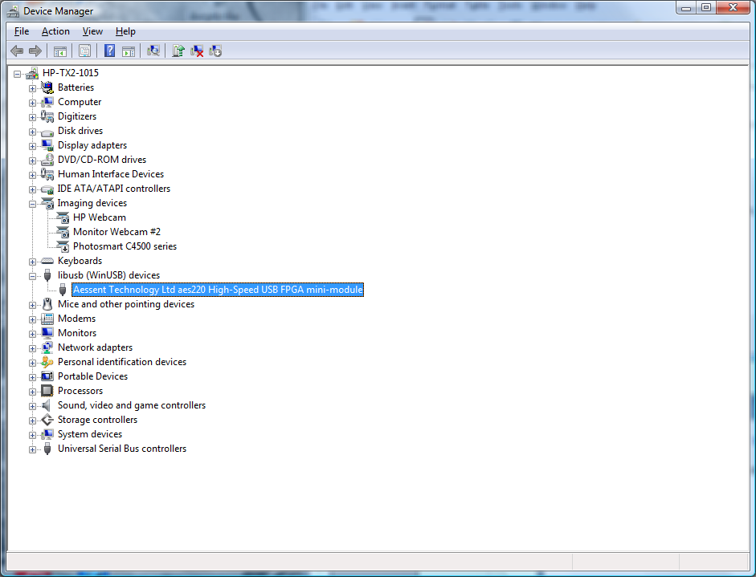

- Installing the aes220 API

The aes220 API facilitates the communication with the FPGA via the USB interface. It consists of a collection of C routines interfacing with the firmware inside the aes220 micro-controller. These routines are described in the software support documentation at: http://www.aessent.com/products/aes220-minimodule.html

In order to use the API you need to copy the following files into a location of your choice and then set your linker to include the location path:
libaes220-x.x.x.dll
libaes220-x.x.x.dll.a
libaes220-x.x.x.dll.def

Note: replace the x.x.
x in the files names with the current library version.

- Installing aes220Programmer

In order to run aes220Programmer on a Windows platform all is needed is to copy a few dll files into the platform system32 folder.

Unless you have libusb and MinGW already installed on your computer copy the dll files from \aes220_win_files\DLL\ (contained in aes220WindowsInstall.zip) to C:\windows\system32\ (or wherever is located the system32 folder on your system)

No other setup is required.

- If nothing happens when plugging aes220 module

It can happen that although no driver is found the driver wizard does not come up on the screen.
If that is the case open the “Device Manager” via the “Control Panel” or the Windows Key.

In “Other Devices” there should be the aes220 device with a warning yellow icon.
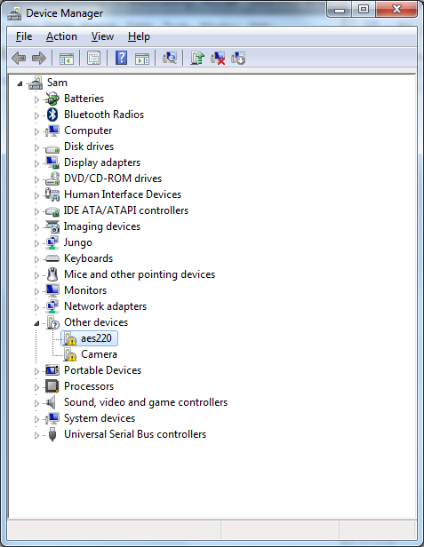
Right click on the device and select “Update Driver Software...”

