# Aromal Kunnel

# 22BAI10288

# Aromalkunnel2022@vitbhopal.ac.in

Ques 1)

Asha has a huge collection of country currencies. She decided to count the total number of distinct country currencies in her collection. She asked for your help. You pick the currency one by one from a stack of country currencies.

Find the total number of distinct country currencies.

Input Format: The first line contains an integer N , the total number of country currencies.

The next N lines contains the name of the country where the currency is from

Sample Input and Output

Enter Number of Currencies

3

Enter the name of the country India

1

Enter the name of the country USA

2

Enter the name of the country Japan

3

Ans)

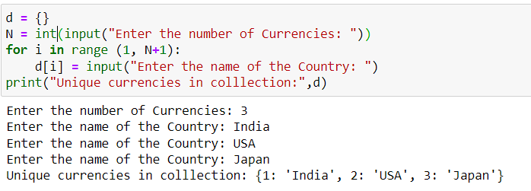

Ques 2)

A startup company named 'MY_Chat' having four employees names as Sunny, Ravi, Vijay and Messi having the respected salaries are 25000,23000, 26000, and 30000.

After six months, Sunny resigned from his job.

Update data based on employee name.

Input format: Sunny

Output format: all employee data after update

Ans)

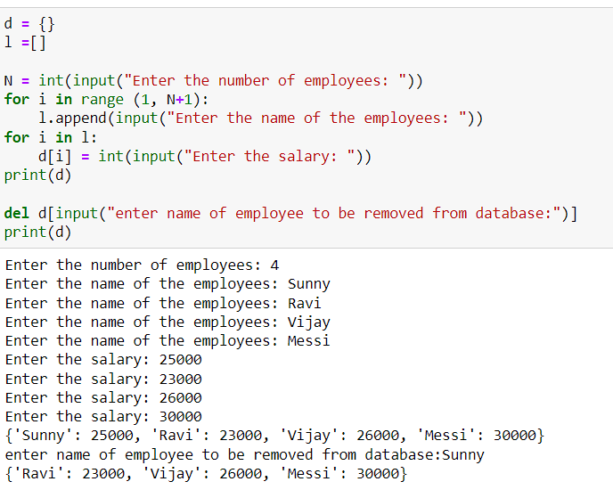

Ques 3)

Write a Python Program to Check if a Given Key Exists in a Dictionary or Not

Ans)

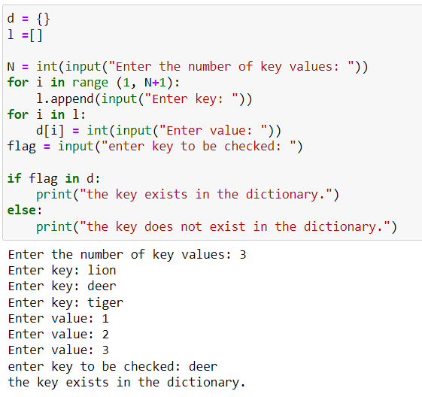

Ques 4)

A quiz was conducted in a programming tutorial class for 10 marks. Calculate Mean and Standard Deviation of the marks scored by minimum seven students in the class. Use the appropriate functions provided by Python.

Input format: Enter 7 integers with spaces

format: Mean is:

Standard Deviation is:

Ans)

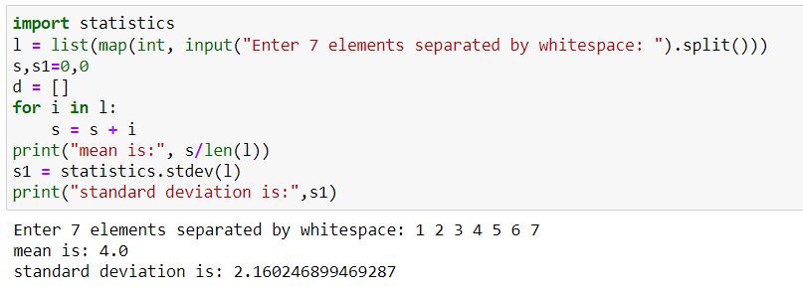

Ques 5)

School attendance register needs to be prepared with several columns. Amongst ‘Name’ column size need to be decided based on the longest word in the list of students’ names.

The program takes a list of words and returns the word with the longest length. If there are two or more words of the same length then the first one is considered.

Input format : One integer (Number of Words) followed by list words separated by newline or enter

Output format : The word with the longest length is:

Ans)

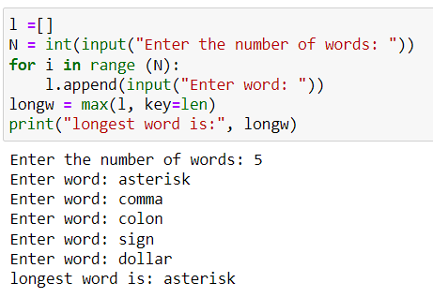

Ques 6)

Python Program to remove the given key from a dictionary

Ans)

