# **Assignment 05**

**Aromal S K**

**22BAI10288**

**Q1 – WAP to implement constructor in Java**

**P1**

**Code :**

abstract class DomainExpansion {

    abstract void deploy();

}

class Gojo extends DomainExpansion {

    void deploy(){

        System.out.println("Gojo - Ryuki Tenkai : MuRyo Ku Sho");

    }

}

class Sukuna extends DomainExpansion {

    void deploy() {

        System.out.println("Sukuna - Ryuki Tenkai : Fuku Ma Mi Zu Shi");

    }

}

class testAbstract {

    public static void main(String[] args) {

        DomainExpansion s = new Sukuna();

        s.deploy();

        DomainExpansion g = new Gojo();

        g.deploy();

    }

}

**Output :**

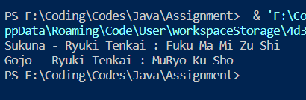

**P2**

**Code :**

class Cars {

    void cars() {

        System.out.println("There are many Category of Cars....");

    }

}

class SuperCar extends Cars {

    void supercars() {

        System.out.println("One of those categories is Supercars....");

    }

}

class NissanGTR extends SuperCar {

    void gtr() {

        System.out.println("NISSAN GTR is a Super Car");

    }

}

class TestInheritance {

    public static void main(String[] args) {

        NissanGTR d = new NissanGTR();

        d.cars();

        d.supercars();

        d.gtr();

    }

}

**Output :**

