**Year 12**

**Design Photography ATAR**

**In Class Assessment**

**Total time for the task: 50 minutes**

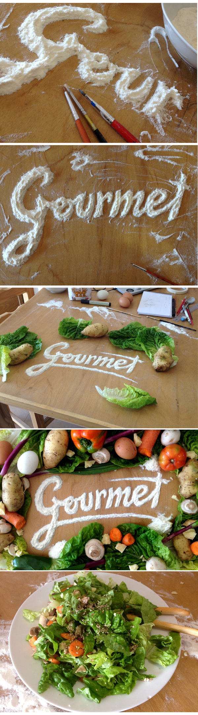

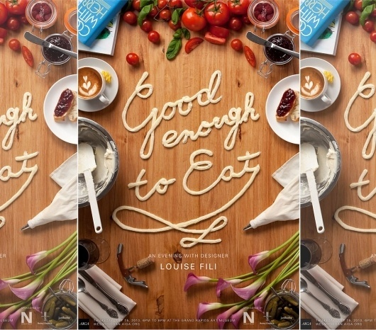

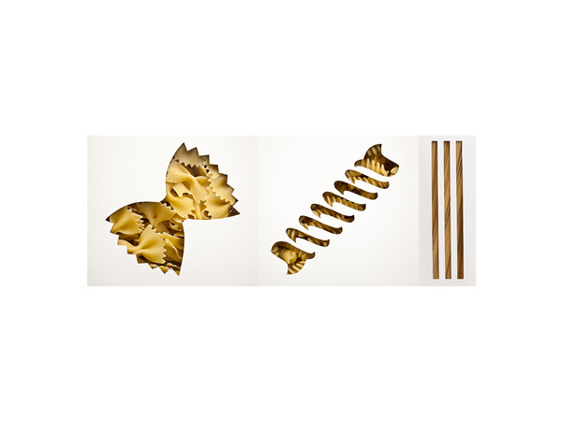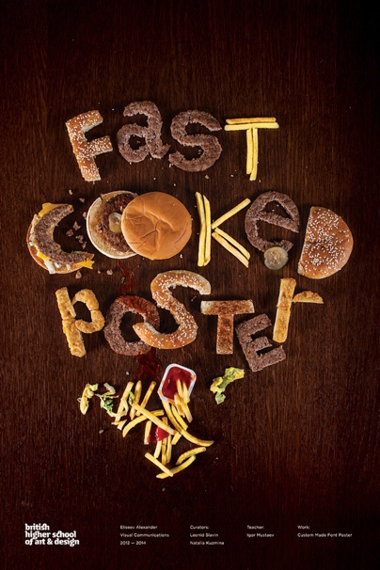

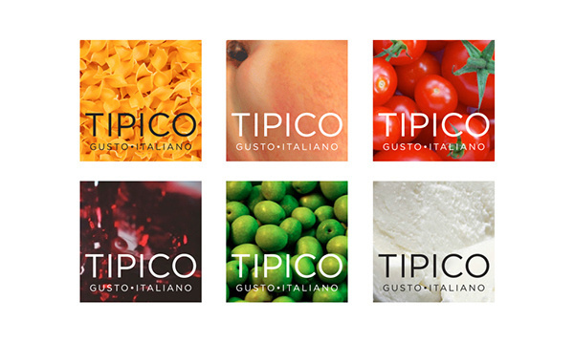

**Figure 1:** Inspirational mood board provided by your client; *The Sydney International   
Food Festival.*

**Question 1 (16 marks)**

**Design Brief:** The Sydney International Food Festival (SIFF) has hired you to create a photographic advertising campaign for their 2022 event. They have provided you with a mood board of inspiration (see Figure 1).

Refer to Figure 1 shown on the previous page to answer all parts of this question.

1. Use idea generation techniques (SCAMPER) and synectics to develop ideas relevant to the design brief. You may use colour and annotations to support your ideas. Use the space allocated below. (6 marks)

# Question 1 (continued)

1. Using the space below, draw **two** options for the SIFF 2022 Photographic Advertising campaign. You may use colour and annotations to help support your ideas. (6 marks)

# Question 1 (continued)

# c) Using your most effective design from part (b) explain how you have used colour theory to address the needs of the brief from SIFF and appeal to their target audience. (4 marks)

|  |
| --- |
|  |
|  |
|  |
|  |
|  |
|  |
|  |
|  |
|  |
|  |

**Question 2 (6 marks)**

(a) Draw a communication model below and label the parts. (3 marks)

Communication model name:

(b) With reference to part (a), identify examples of noise that may interfere with communication. (3 marks)

|  |
| --- |
|  |
|  |
|  |
|  |
|  |
|  |
|  |
|  |
|  |

**Question 3 (4 marks)**

**Figure 2:**  Print Advertisement for *Heinz Seriously Good Creamy Sauce*

**Question 3 (continued) (4 marks)**

Refer to Figure 2 to answer all parts of this question.

1. Identify **one** element of design used in Figure 1. (1 mark)
2. Identify **one** design principle used in Figure 1. (1 mark)
3. Describe how the element of design and the design principle you identified in parts (a) and (b) have been applied in the design. (2 marks)

Element of design:

Design principle:

**End of questions**