Computer Architecture PROJECT REPORT
Made using CPUSim

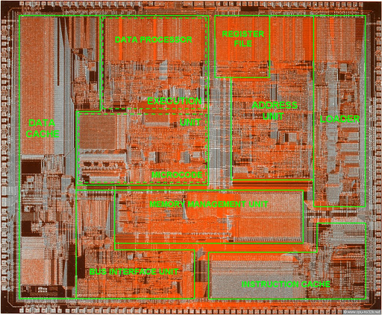

Rohan Daniel - 2018A7PS0584H
Abhinav Sukumar Rao - 2018A7PS0172H
Pranav Rajagopalan - 2018A7PS0177H
Bhavyesh Desai - 2018A7PS0164H
Akul Singhal - 2018A7PS0193H

INTRODUCTION
Using Dale Skrien’s CPUSim software running on JavaFX™, we attempt to build 2 Machines:
Machine 177013 (Part A) features a single register that is accessible by the programmer, namely an accumulator and 16 instructions.
Machine 6402 (Part B) features a register array of which each register can be accessed by the user. Additionally, 2 registers, namely D1 and D2 have been introduced.

ASSUMPTION
- An assumption for the m2m instruction is that both of its operands are indirect memory locations, one of them being treated as a register, namely memory address 0x02.
- Another particularly interesting assumption is that we have a multiplexer from the IR to the register array, since there needs to be a way to select a register array based on the index provided in the instruction.
- Another assumption is that we don’t require the values of certain registers to be preserved during instruction executions, i.e. a few registers are “clobbered” over the course of the instruction: In part A, the accumulator, and in Part B, accumulator, D1 and D2. As a result, it is a requirement
- The reason for the above is because of the lack of either a temporary register to store the intermediate values, or the lack of a datapath between the registers.

Contributions
- Rohan Daniel: Machine instructions for Machine 177013, Microinstructions for Machine 6402.
- Abhinav Sukumar Rao: Microinstructions for Machine 177013, Machine instructions for Machine 177013 and B, Code for Part-A-D
- Pranav Rajagopalan: Microinstruction fine-tuning for the Machine 6402, part B modifications
- Bhavyesh Desai: Part B-D Code, Report, Documentation, Stress Test
- Akul Singhal: Part B-D Code, Report, Documentation

Opcodes and description
Instruction | Format | Description | Machine 177013 | Machine 6402
hlt | hlt | Halt machine execution. | ✓ | ✓
ipa | ipa | Read input to accumulator | ✓ | ✓
opa | opa | Output accumulator contents | ✓ | ✓
jmp | jmp address | Unconditional jump | ✓ | ✓
bz | bz address | Branch if contents of accumulator is zero | ✓ | ✓
bnz | bnz address | Branch if contents of accumulator is not zero | ✓ | ✓
bpos | bpos address | Branch if contents of accumulator is positive | ✓ | ✓
bneg | bneg address | Branch if contents of accumulator is negative | ✓ | ✓
add | add address | Add value at address to accumulator | ✓ | ✓
sub | sub address | Subtract value at address to acumulator | ✓ | ✓
li | li value | Load immediate to accumulator | ✓ | ✓
lda | lda address | Load value at given address to accumulator | ✓ | ✓
sta | sta address | Store value at given address to accumulator | ✓ | ✓
m2a | m2a address | Move value at address contained at the given address to accumulator. | ✓ | ✓
m2m | m2m address | Move value at address contained in 0x2 to address contained at given address. | ✓ | ✓
labuf | labuf D1 / D2 | Load accumulator to specified buffer | ✗ | ✓
lbufa | lbufa D1 / D2 | Load specified buffer to accumulator | ✗ | ✓
lara | lara registerIndex | Load accumulator to given index of register array | ✗ | ✓
lraa | lraa registerIndex | Load given index of register array to accumulator | ✗ | ✓
addra | addra registerIndex1 registerIndex2 | Add the contents of the two specified indices of the register array in the accumulator and store it back into position registerIndex1 of the register array. | ✗ | ✓
subra | subra registerIndex1 registerIndex2 | Subtract the contents of the second specified index of the register array from the first in the accumulator and store it back into position registerIndex1 of the register array. | ✗ | ✓
ina | ina | Increment Accumulator | ✗ | ✓
dea | dea | Decrement Accumulator | ✗ | ✓

SCREENSHOTS
PART A - Machine 177013
- Hardware: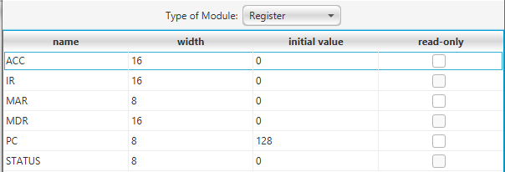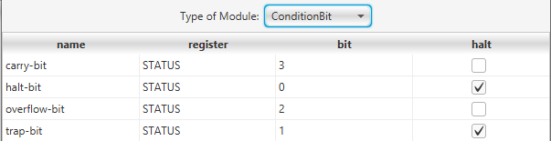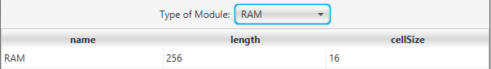
- Fetch Cycle:
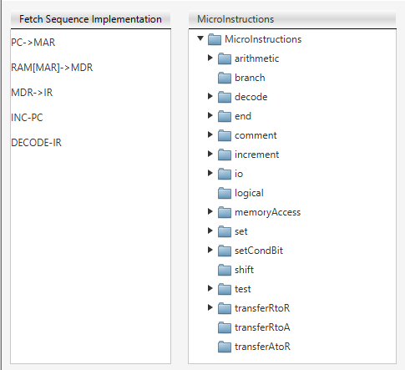
- Important Microinstructions:
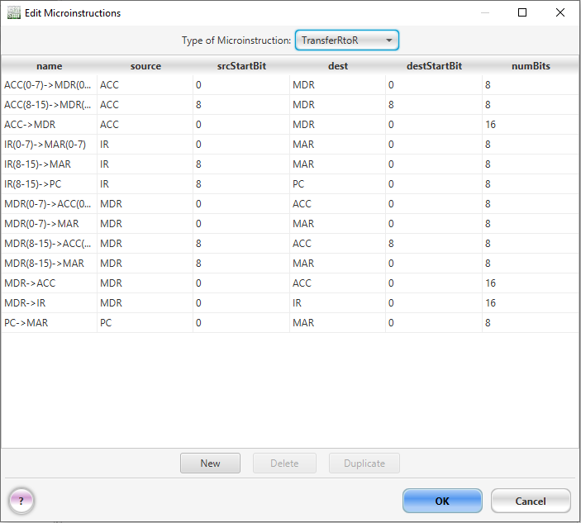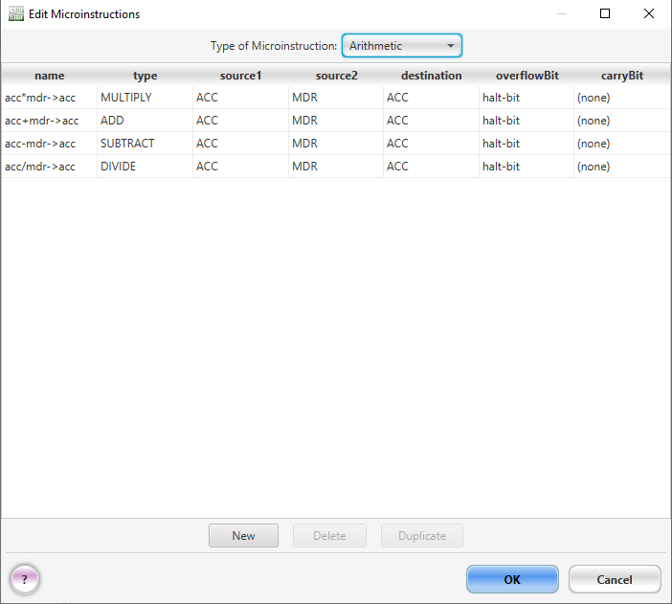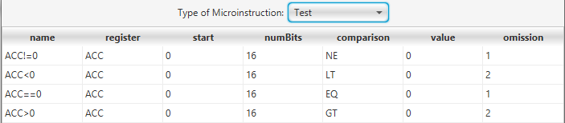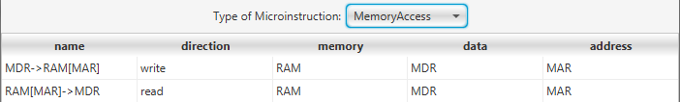
PART B - Machine 6402
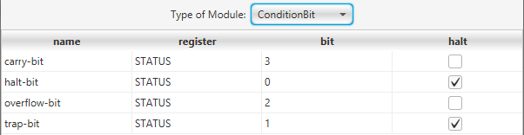
- Hardware: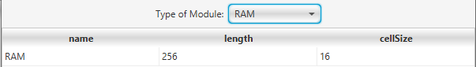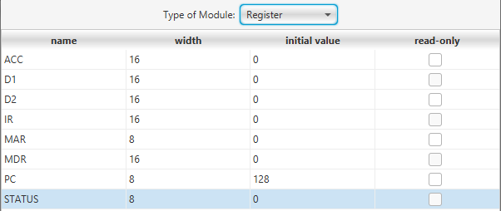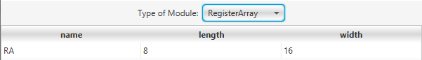
- Fetch Sequence: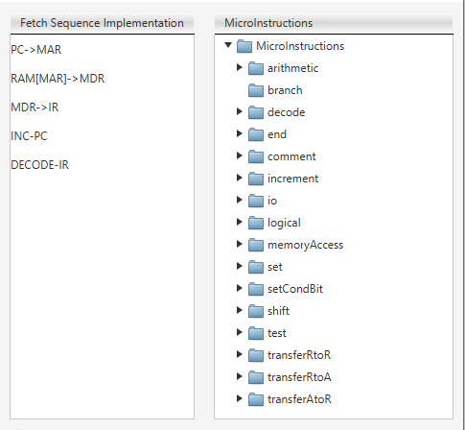
- Important Microinstructions:
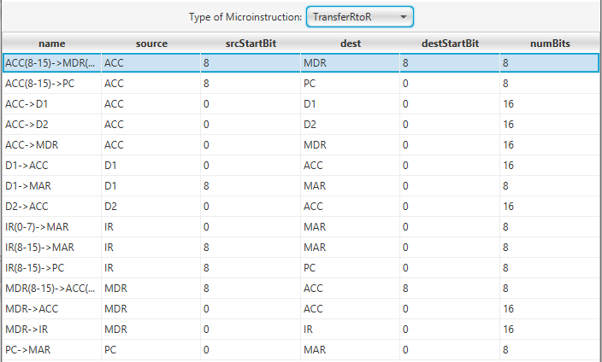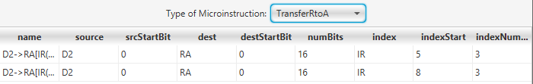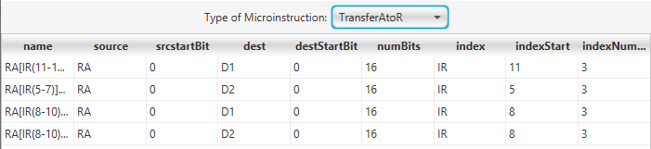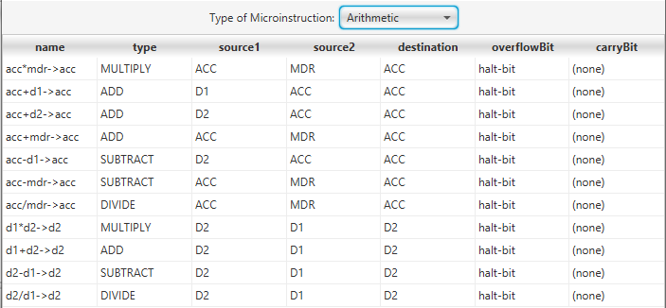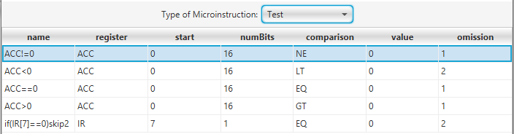

CONCLUSIONS AND RESULTS
- We managed to finish the assignment with working code and understood the need for multiple registers and datapaths, without which it may cause difficulties with implementations for instructions.
- We understood how to work with register arrays and their benefits over individual registers.

