Module 3 – Machine Learning Development Life Cycle

Introduction
The Machine Learning Lifecycle is a systematic process that describes how a machine learning model is developed, implemented, and maintained in real-world applications. It provides a clear framework for building ML systems in an organized and effective manner. The lifecycle begins with identifying the problem and collecting relevant data. After that, the data is prepared and explored, useful features are created or selected, and suitable models are trained and evaluated.
Once the model performs well, it is deployed so that it can be used in practical applications. However, deployment is not the final step. The model must be monitored continuously to ensure that it remains accurate and reliable over time. If the data changes or the model’s performance decreases, it may need to be updated or retrained. Therefore, the machine learning lifecycle is important because it helps in creating models that are not only accurate, but also reliable, scalable, and suitable for real-world use.
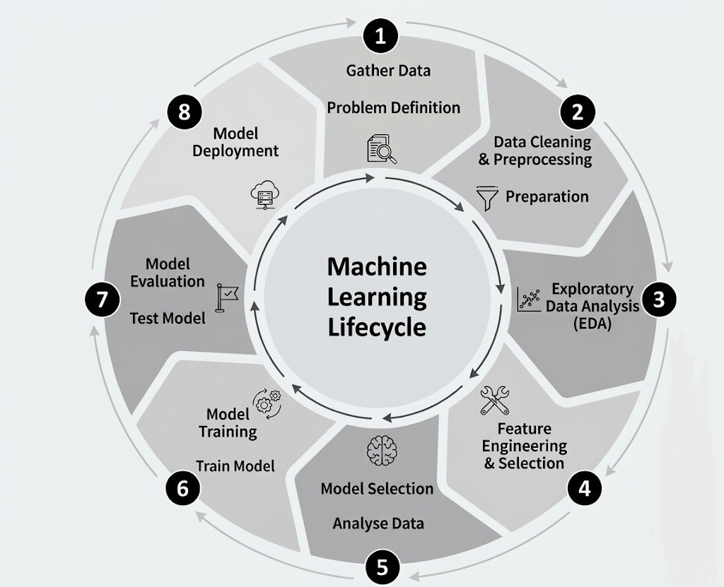
Fig. 3.1: Machine Learning Lifecycle

Goal
The goal of this module is to understand each step involved in developing a machine learning project, from identifying the problem to deploying the final model. By learning this life cycle, we can see how every stage plays an important role in building a machine learning system that is accurate, useful, and reliable in real-world situations.

1. Problem Framing

Introduction
Every machine learning project begins with a problem. But before we start collecting data or training a model, we first need to understand the problem clearly. If we do not know exactly what we want to solve, the model may not be useful, even if it works well technically.
This first step is called problem framing. It means taking a general problem and turning it into a clear machine learning task. In simple words, it helps us answer questions like: What is the actual problem? Can machine learning solve it? What kind of output do we want?

Goal
The goal of problem framing is to clearly define the problem, understand whether it can be solved using machine learning, decide what type of ML problem it is, and choose how success will be measured.

Business Problem to ML Problem
In real life, problems usually start as business or practical problems, not machine learning problems.
For example, a company may say:
- “Our customers are leaving.”
- “Sales are dropping.”
- “Too many fake transactions are happening.”
- “Students are scoring poorly.”
These statements describe the problem, but they are still too broad for a machine learning model.
So we convert them into specific machine learning questions, such as:
- Can we predict which customers are likely to leave?
- Can we forecast future sales?
- Can we detect whether a transaction is fraud or not?
- Can we predict which students may need extra support?
This is an important step because a machine learning model needs a clear input and a clear output.
Simple real-life example:
A school notices that some students fail the final exam.
This is the general problem.
Now we frame it as an ML problem: Can we predict which students are at risk of failing based on attendance, test marks, and assignment submission?
Now the problem is much more clear and ready for machine learning.

Types of ML Problems
Once the problem is clear, the next step is to identify what kind of machine learning problem it is.
Some common types are:
1. Classification
This is used when the output is a category.
Examples: Spam or not spam, fraud or not fraud, pass or fail, disease or no disease
Real-life example:
A hospital wants to predict whether a patient has diabetes or not.
Since the answer is one of two categories, this is a classification problem.
2. Regression
This is used when the output is a number.
Examples: House price, temperature, salary, sales amount
Real-life example: A real estate company wants to predict the price of a house based on size, location, and number of rooms. Since the result is a number, this is a regression problem.
3. Clustering
This is used when we want to group similar data together.
Examples: Customer segmentation, grouping similar products, grouping students based on performance
Real-life example: A shopping app wants to group customers into categories like frequent buyers, occasional buyers, and premium customers. This is a clustering problem.

Current Solution
Before using machine learning, it is important to understand how the problem is being solved right now.
Questions to ask:
- Is the task being done manually?
- Is there already a software system for it?
- Are people using fixed rules?
- What problems exist in the current method?
This step helps us understand whether machine learning is really needed and what improvement we expect.
Real-life example:
Suppose a bank is checking fraud transactions using fixed rules like:
- If transaction amount is very high, flag it
- If location changes suddenly, flag it
This is the current solution.
But these fixed rules may miss many fraud cases.
So the bank may decide to use machine learning to find hidden patterns that rules cannot catch easily.

Metrics to Measure Success
Once the problem is framed, we need a way to judge whether the model is doing well or not. This is done using metrics.
The metric depends on the type of problem.
Examples:
- Accuracy for general classification
- Precision and Recall for fraud detection or medical diagnosis
- Mean Squared Error for regression
- F1 Score when both precision and recall matter
But success should not be judged only by technical metrics. It should also connect to the real goal.
Real-life example:
If a company builds a customer churn model, success is not just “good accuracy.”
The real success may be fewer customers leaving, more customers staying after offers or higher company revenue.
So, metrics should match both the ML task and the real business need.

Check Assumptions
Before starting the project, we should check whether our basic assumptions are correct. This helps save time and avoid problems later.
Some simple questions are:
- Do we have enough data?
- Is the data available in the right format?
- Is the target output clearly defined?
- Can patterns in the data actually solve the problem?
- Is machine learning really needed, or will simple rules work?
Real-life example: A company wants to predict employee resignation. But after checking the data, they find that they have only 20 employee records and many fields are missing.

Real World Example:
Let us take one complete example.
Suppose an online shopping company notices that many users visit the website, add items to the cart, but leave without buying.
This is the business problem.
Now the company frames it as an ML problem:
Can we predict which users are likely to leave without completing the purchase?
Then they identify the type of problem, since the answer is “buy” or “not buy,” it is a classification problem
Current solution: The company sends the same reminder email to every user
But this may not be effective for everyone.
The metrics to measure success include prediction accuracy, conversion rate, and increase in total purchases
Check assumptions:
- Is user activity data available?
- Do we have enough past records?
- Are important fields like time spent, cart items, and clicks available?
Now the company has a clearly framed problem, and the project can move forward in the right way.
Problem framing is the first and one of the most important steps in the machine learning life cycle. It helps convert a general real-life problem into a clear machine learning task.
By understanding the business problem, choosing the correct type of ML problem, studying the current solution, deciding success metrics, and checking assumptions, we make sure the project starts on the right path.
A well-framed problem makes the rest of the machine learning process much easier and more meaningful.

2. Data Collection

Introduction
Once the problem is clear, the next step is to collect the data needed for the project. Machine learning models learn from data, so the kind of data we collect has a big effect on the final result.
If the data is useful and relevant, the model can learn better. If the data is missing, incomplete, or unrelated to the problem, the model may not perform well. That is why data collection is one of the most important steps in the machine learning life cycle.

Goal
The goal of data collection is to gather the right data from suitable sources so that the machine learning model can learn meaningful patterns and solve the problem properly.

Data Sources
Data can come from many different places. The source depends on the type of problem we are trying to solve.
Some common data sources are company databases, websites, mobile apps, sensors and devices, surveys and forms, public datasets and social media platforms.
Real-life example:
Suppose a food delivery app wants to predict whether an order will be delivered late.
Possible data sources could be order history, delivery partner location, traffic data, weather data and customer address details.
All these sources can help the model understand what affects delivery time.
So, data collection is not just about collecting any data. It is about collecting the right data.

Structured vs Unstructured Data
Collected data can be mainly of two types: structured and unstructured.
1. Structured Data
This is data that is already organized in rows and columns, like a table.
Examples:
- Excel sheet
- SQL database table
- CSV file
Real-life example: A student marks table with columns like roll number, name, marks, and attendance. This is structured data because it is neatly arranged.
2. Unstructured Data
This is data that is not stored in a fixed table format.
Examples:
- images
- videos
- audio files
- emails
- social media posts
- text documents
Real-life example: If a company wants to analyze customer reviews, the review text is unstructured data.
It is not neatly arranged like rows and columns.
So, in simple words:
- structured data = organized table-like data
- unstructured data = free-form data like text, images, and audio
Both types are useful in machine learning depending on the problem.

Using APIs
Sometimes the required data is not stored directly in our own system. In such cases, we may collect data using APIs.
API stands for Application Programming Interface.
An API helps one software system request data from another software system.
Simple real-life example:
Suppose we are building a weather prediction app.
Instead of collecting weather data ourselves, we can use a weather API to get:
- temperature
- humidity
- rainfall
- wind speed
Another example is a map app using an API to get location data or traffic updates.
So APIs make data collection easier and faster because they allow us to fetch data directly from other platforms or services.

Data Formats (JSON, SQL)
After collecting data, it also matters how the data is stored. Different systems store data in different formats.
Two common formats are JSON and SQL.
1. JSON
- JSON stands for JavaScript Object Notation.
- It is a simple text-based format used to store and share data.
- It is very common in APIs and web applications.
Example of JSON:
{
"name": "Riya",
"age": 21,
"city": "Bhopal"
}
This format is easy for systems to read and exchange.
Real-life example:
When a weather app gets data from an online weather service, the response often comes in JSON format.
2. SQL
- SQL stands for Structured Query Language.
- It is used to store and manage data in relational databases.
- Data in SQL is usually stored in tables with rows and columns.
Real-life example:
A college may store student data in an SQL database like this:
Student_Id | Name | Marks
101 | Aditi | 76
102 | Rahul | 82
This is useful when the data is organized and needs to be searched, updated, or filtered easily.

Real World Example
Let us take one full example.
Suppose a hospital wants to build a machine learning model to predict whether a patient may need emergency care.
For this, the hospital may collect data from different sources such as:
- patient records from hospital database
- lab reports
- heart rate data from monitoring devices
- symptom details from forms
- past admission history
Some of this data is structured, like patient age and blood pressure records. Some of it may be unstructured, like doctor notes or medical reports in text form. The hospital may also use APIs to get outside data, such as nearby ambulance availability or weather conditions if needed. The data may be stored in formats like SQL tables for patient records or JSON format for API responses. This shows how data collection brings together many pieces of information for one ML project.

Data collection is a very important step in the machine learning life cycle because the model can only learn from the data it is given. Good data collection means choosing the right sources, understanding whether the data is structured or unstructured, using APIs when needed, and storing the data in proper formats like JSON or SQL. If the right data is collected in the right way, the next steps in machine learning become much easier and more effective.

3. Exploratory Data Analysis

Introduction
After collecting data, we should not start model building immediately. First, we need to understand the data properly. We need to see what kind of information is present, whether the data is clean, and if there are any patterns or problems inside it.
This step is called Exploratory Data Analysis, or EDA.
In simple words, EDA means looking at the data carefully before using it. It helps us understand the dataset, notice important patterns, and find issues that may affect the model later.

Goal
The goal of exploratory data analysis is to study the dataset in detail, understand the values inside it, find patterns and relationships, and identify any problems before moving to the next step of machine learning.

Understanding Dataset
The first step in EDA is understanding the dataset. Before doing any deeper analysis, we should know what the data contains.
Some simple questions we should ask are:
- How many rows and columns are there?
- What does each column mean?
- Which columns contain numbers?
- Which columns contain text or categories?
- Are there missing values?
- Are some rows repeated?
- Does anything look unusual?
This gives us a basic idea of the dataset and helps us know where to focus.
Real-life example:
Suppose we have a dataset of students with columns like name, age, attendance, study hours, marks and result.
When we first look at the data, we may notice some students have missing marks, attendance is written differently in some rows and a few entries may be repeated So before doing anything else, we first try to understand the data as it is.

Univariate Analysis
Univariate analysis means studying one variable at a time.
The purpose is to understand how one feature behaves on its own.
For example, we may want to know:
- what is the average age of students
- how marks are distributed
- how many students passed or failed
- which product category is most common
This helps us understand each column separately.
Real-life example:
Suppose an online shopping company has a customer dataset.
If they study only the Age column, they may find:
- most customers are between 20 and 35 years old
- very few customers are above 60
If they study only the Product Category column, they may find:
- electronics is bought the most
- books are bought less often
This is univariate analysis because only one variable is being studied at a time.

Bivariate Analysis
Bivariate analysis means studying two variables together to understand whether there is any relationship between them.
This helps us answer questions like:
- Does study time affect marks?
- Does salary affect house price?
- Does age affect spending?
- Does attendance affect exam results?
This is important because machine learning models often depend on the relationship between variables.
Real-life example:
- Suppose we compare study hours and marks in a student dataset. We may observe that students who study more hours usually score higher marks.
- In a house price dataset, if we compare house size and price, we may see that bigger houses often cost more.
So bivariate analysis helps us understand how one variable changes with another.

Data Visualization
Data visualization means showing data in the form of charts, graphs, and plots so that it becomes easier to understand.
Sometimes numbers in a table are hard to read, but when we show the same data in a graph, the pattern becomes much clearer.
Data visualization is very useful in EDA because it helps us:
- see patterns quickly
- compare values easily
- spot unusual points
- understand distributions better
Some common visualization methods are:
- Bar Chart – used for comparing categories
- Histogram – used to see the distribution of numbers
- Pie Chart – used to show proportions
- Box Plot – used to spot spread and outliers
- Scatter Plot – used to study relationship between two variables
Real-life example:
Suppose a school wants to understand student marks.
Instead of reading a long table of marks, they can use:
- a bar chart to compare marks of students
- a histogram to see how marks are distributed
- a scatter plot to compare study hours and marks
This makes the data much easier to understand.
Another example:
A company analyzing product sales can use:
- a bar chart to compare sales in different cities
- a pie chart to show category-wise sales
- a line chart to show sales over time
So visualization helps turn raw data into something more meaningful and easy to read.

Real World Example
Let us take one complete example. Suppose a company wants to predict whether a customer will buy a product. Before building the model, they first perform EDA.
Step 1: Understanding the dataset
They check:
- how many customer records are present
- what columns are available
- whether there are missing values
- whether data types are correct
The dataset may contain age, gender, city, salary, time spent on website, purchased or not purchased.
Step 2: Univariate analysis
They study one variable at a time:
- age distribution
- salary distribution
- most common city
- number of customers who purchased
Step 3: Bivariate analysis
They compare two variables:
- age vs purchase behavior
- salary vs purchase behavior
- time spent on website vs purchase behavior
Step 4: Data visualization
They use graphs to make analysis easier:
- histogram for age
- bar chart for city-wise customers
- scatter plot for salary vs purchase
- pie chart for purchase percentage
After doing all this, the company understands the data much better and can now move to model building with more confidence.

Exploratory Data Analysis is a very important step in machine learning because it helps us understand the dataset before using it. By understanding the dataset, doing univariate analysis, studying relationships through bivariate analysis, and using data visualization, we get a clear picture of the data. This helps us find problems early, understand useful patterns, and make better decisions in the next steps of the machine learning process

4. Data Preparation

Introduction
After collecting the data and studying it through exploratory analysis, the next step is to prepare it properly. This step is very important because real-world data is usually not perfect. It may have mistakes, missing values, repeated entries, unnecessary columns, or information written in different formats.
A machine learning model learns from the data we give it. So if the data is messy, incomplete, or unclear, the model may also learn the wrong patterns. That is why data preparation is needed before model building.
In simple words, data preparation means cleaning and improving the dataset so that it becomes ready for machine learning.
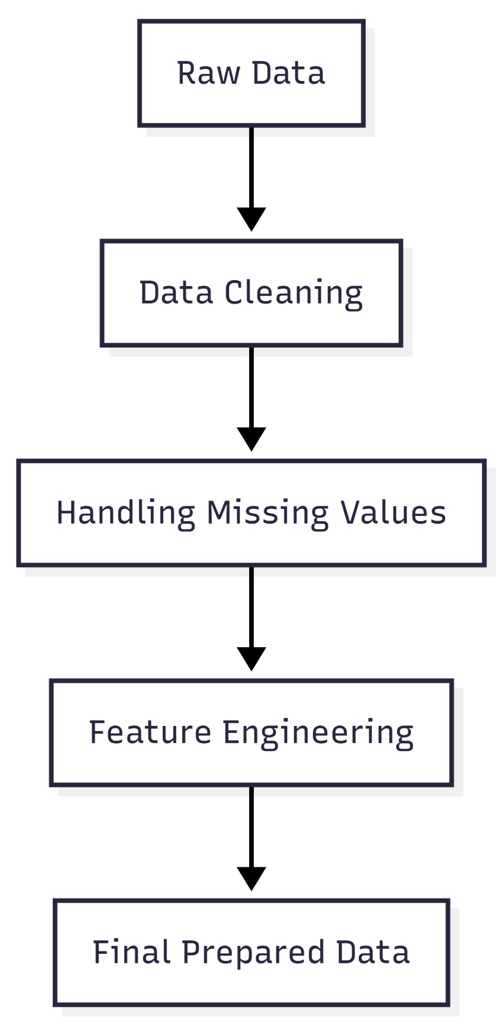
Fig 4.1: Flowchart of Data Preparation in Machine Learning

Goal
The goal of data preparation is to make the data clean, complete, and useful for the model. This includes removing errors, dealing with missing values, and creating better features so that the model can learn more effectively and give better results.

Data Cleaning
Data cleaning is the process of fixing problems in the dataset. Real-world data is often collected from many sources, and because of that, it may contain many issues.
Some common problems in raw data are duplicate records, spelling mistakes, wrong values, mixed formats, extra spaces, invalid entries, unwanted columns and noisy data
If these issues are not fixed, the model may get confused and produce poor results.
Let us understand this with simple examples.
Example 1: Duplicate records
Suppose a college dataset contains the same student record twice. If both records are kept, the model may give extra importance to that student’s data. So duplicate rows should be removed.
Example 2: Inconsistent values
Imagine a “City” column contains:
- Bhopal
- bhopal
- BHOPAL
- Bpl
All these values mean the same city, but the machine may treat them as different categories. So they should be made consistent.
Example 3: Wrong values
In a student dataset, if one row shows age as 150, that is clearly incorrect. Such values need to be corrected or removed.
Example 4: Unnecessary columns
Sometimes a dataset contains columns like serial number, customer ID or random code. These may not help in prediction and can be removed if they are not useful.
Data cleaning is about making the dataset more correct, organized, and reliable.

Handling Missing Values
Missing values are one of the most common problems in machine learning datasets. A value may be missing because it was not entered, it was lost, or it was unavailable at the time of collection.
For example:
- a customer may not enter age
- a patient’s blood pressure reading may be missing
- a student’s attendance value may be blank
Since many machine learning models cannot work properly with missing values, we need to handle them carefully.
There are different ways to do this.

1. Removing Missing Data
If only a few rows have missing values, we may simply remove those rows.
Example:
If a dataset has 10,000 rows and only 5 rows have missing salary values, deleting those rows may be fine.
We can also remove a column if most of its values are missing and it is not very useful.
Example:
If a column called “Middle Name” is empty for 90% of records and does not help in prediction, we may remove it.
But this method should be used carefully, because deleting too much data may reduce useful information.

2. Filling Missing Values
Instead of removing data, we can also fill missing values using different methods.
Mean
For numerical data, missing values can be replaced with the average.
Example:
If some salary values are missing, we may fill them using the average salary.
Median
This is useful when the data has outliers.
Example:
If house prices vary a lot, median may be better than mean.
Mode
For categorical data, we can fill missing values using the most common category.
Example:
If the “City” column is missing for some customers, we may fill it with the most common city.
Fixed Value
Sometimes we use a fixed label such as:
- 0
- Unknown
- Not Available
Example:
In a survey, if occupation is missing, we may fill it with “Unknown”.

3. Choosing the Right Method
There is no single rule for handling missing values. The best method depends on:
- how much data is missing
- what type of column it is
- how important that column is
- whether removing data will cause information loss
Real-life example:
Suppose a hospital has a patient dataset with:
- age
- blood pressure
- sugar level
- diagnosis
If a few rows are missing sugar level, they may fill it using the median.
But if an important column like diagnosis is missing, those rows may need to be removed because the target output is not available.
So the aim is not just to fill blanks somehow, but to choose a method that keeps the data meaningful.

Feature Engineering
Feature engineering means improving the dataset by creating new features or changing existing ones in a better way.
A feature is simply a column or variable used as input for the model.
Sometimes the original dataset does not directly contain the most useful information. In such cases, we create new features from the available data so that the model can learn better.
This is called feature engineering.

Why Feature Engineering Matters
Even if the data is clean, the model may not perform well if the features are weak.
Better features can:
- make patterns more clear
- improve model accuracy
- reduce confusion
- help the model learn faster
So feature engineering is about presenting the data in a smarter and more useful way.

Common Types of Feature Engineering

1. Creating New Features
Sometimes we can create a new feature from existing ones.
Example:
If a dataset has:
- date of birth
We can create:
- age
Age is often more useful than raw date of birth for prediction.

2. Combining Features
Two or more columns can be combined to form a new feature.
Example:
In an employee dataset:
- basic salary
- bonus
can be combined into:
- total income
This new feature may be more meaningful for the model.

3. Extracting Useful Information
Sometimes one column contains a lot of information, and we can extract the useful part.
Example:
From a full date like 15-08-2024, we can extract:
- day
- month
- year
- weekday
This is useful in sales or attendance prediction.

4. Converting Categories into Better Form
If the data contains text categories, we may need to make them more usable.
Example:
A “Department” column may contain:
- HR
- Sales
- IT
The model cannot directly work with text in many cases, so these may later be converted into machine-readable form.

5. Removing Weak Features
Feature engineering is not only about adding features. It also includes removing features that do not help.
Example:
In a house price prediction model, a column like “Owner’s Favorite Color” is not useful. Keeping such features may only add noise.

Real-Life Examples of Feature Engineering
Example 1: Student Performance Prediction
Original columns:
- attendance
- assignment marks
- exam marks
- date of birth
Possible engineered features:
- total marks
- average marks
- age
These new features may help the model better predict the final result.
Example 2: E-commerce Website
Original columns:
- total visits
- total purchases
- total cart additions
Possible engineered features:
- purchase rate = purchases / visits
- cart conversion = purchases / cart additions
These new features can show customer behavior more clearly.
Handling Imbalanced Data(SMOTE)
In machine learning, sometimes the dataset is imbalanced, which means one class has many more examples than the other class. This is called imbalanced data. In such cases, the machine learning model mostly learns from the larger class and may ignore the smaller class.
SMOTE is a technique used to solve this problem. SMOTE stands for Synthetic Minority Oversampling Technique. Its job is to increase the number of examples in the minority class. But instead of simply copying the old data again and again, it creates new artificial examples that are similar to the existing minority class data.
This helps the model learn both classes better and improves prediction, especially for the minority class.

Example
Suppose a dataset has:
- 950 normal emails
- 50 spam emails
Here, spam emails are much fewer than normal emails. So the model may learn to predict mostly “normal” and may miss many spam emails.
If we use SMOTE, it will create new artificial spam email examples based on the existing spam data. After that, the dataset becomes more balanced, and the model can learn spam patterns better.

Real-Life Example
A common real-life example is fraud detection in banking. In a bank, most transactions are normal, and only a very small number are fraudulent. If the model is trained on this kind of imbalanced data, it may predict almost every transaction as normal and fail to detect fraud cases.
By using SMOTE, more synthetic fraud-like examples are created in the training data. This helps the model understand fraud patterns better and improves its ability to detect suspicious transactions.

Conclusion
Data preparation is a very important step in machine learning because raw data is rarely ready to use directly. It often contains mistakes, missing values, and features that may not be useful in their current form.
By doing data cleaning, handling missing values properly, and using feature engineering, we make the dataset more meaningful and suitable for machine learning.
A model can learn well only when the input data is clear and useful. That is why good data preparation often makes a big difference in the final performance of a machine learning system.

Model Building

Introduction
Model building is an important stage in the machine learning process. After the data has been cleaned, prepared, and useful features have been selected, the next step is to build a model. In simple words, model building means creating a machine learning system that can learn patterns from data and use those patterns to make predictions or decisions.
The main aim of model building is to develop a model that can understand the relationship between input data and output results.
Example:
- Predict house prices
- Classify emails as spam or not spam
- Detect whether a transaction is fraudulent
A good model should not only perform well on the training data, but should also give accurate results on new, unseen data.

Goal
The goal of model building is to create a machine learning model that can learn from available data and make useful predictions. It also aims to choose a suitable algorithm, train it properly, check its performance, and improve it so that it works effectively in real-world situations.

1. Model Training
Model training is the process in which the machine learning algorithm learns from the training data. During this step, the model studies the examples given to it and tries to identify patterns, relationships, and rules from the data.
In simple terms, training is like teaching the model using past examples. The model takes input data, compares its predictions with the actual output, and then adjusts itself to reduce errors. This process continues until the model learns enough to make better predictions.
Before training begins, the dataset is usually divided into different parts such as training data, validation data, and testing data. The training set is used to teach the model, the validation set helps in improving it, and the test set is used later to check final performance. In some cases, cross-validation is also used, especially when the dataset is small.
The choice of algorithm depends on the problem type. If the task is to predict a continuous value, regression algorithms may be used. If the task is to classify data into categories, classification algorithms are used. Thus, training helps the model learn according to the problem it is trying to solve.
Example: Suppose we want to predict student marks. We give the model past data such as study hours, attendance, and assignment scores along with the final marks. The model learns from this data and tries to understand how these factors affect student performance.

2. Model Evaluation
Once the model has been trained, the next step is model evaluation. Model evaluation means checking how well the trained model performs. It helps us understand whether the model is making correct predictions and whether it can work well on unseen data.
This step is very important because a model may perform well during training but may fail in real-life situations. Therefore, evaluation is needed to measure its actual quality. Different evaluation metrics are used depending on the type of machine learning problem.
For regression problems:
Common evaluation metrics include
- Mean Absolute Error (MAE)
- Mean Squared Error (MSE)
- Root Mean Squared Error (RMSE)
These metrics show how far the predicted values are from the actual values.
For classification problems:
- Accuracy
- Precision
- Recall
- F1-score
- ROC-AUC
These metrics help in understanding how well the model is classifying different classes.
Model evaluation also helps compare different models. If several algorithms are trained on the same data, evaluation allows us to identify which one gives the best performance. In this way, it supports better model selection.

Example
If a spam detection model is trained, evaluation will help check how many emails are correctly classified as spam or not spam. It also helps identify whether the model is missing important spam emails or wrongly labeling normal emails as spam.

3. Model Optimization
After evaluation, the next step is model optimization. Model optimization means improving the model so that it performs better. In many machine learning algorithms, there are certain parameters called hyperparameters that control how the model learns. Adjusting these parameters properly can improve the performance of the model.
For example
In a decision tree, hyperparameters may include:
- Maximum depth of the tree
- Minimum number of samples required for a split
In logistic regression, a hyperparameter may include:
- Regularization strength
Finding the best combination of these hyperparameters is called hyperparameter tuning or model optimization.
Optimization is necessary because the first trained model may not always be the best one. By tuning the model carefully, we can reduce errors, improve accuracy, and make the model more generalizable. Common methods used for optimization include Grid Search, Random Search, and more advanced approaches such as Bayesian Optimization.
Model optimization should always be done carefully, because too much tuning may also lead to overfitting. Therefore, the model must be optimized in a balanced way so that it performs well not only on training data, but also on new data.
Example:
Suppose a decision tree model is used to predict customer churn, but its performance is average. By changing hyperparameters like tree depth or split size, the model may give better predictions. This process is called model optimization.

6. Deployment and Monitoring

Introduction
Building a model is not the final step in a machine learning project. A model becomes truly useful only when it is put into a real system and starts helping people or businesses in actual situations.
This step is called deployment. But even after deployment, the work is not over. The model must be tested properly and monitored regularly to make sure it continues to work well.
In simple words, deployment and monitoring mean putting the trained model into real use and checking over time whether it is still performing properly.

Goal
The goal of deployment and monitoring is to make the trained model available for real-world use, test whether it works correctly in that environment, and keep checking its performance over time so that it remains reliable and useful.

Model Deployment
Model deployment means placing the trained machine learning model into a real application or system so that it can be used for making predictions.
A model may be deployed in many ways, such as:
- inside a website
- inside a mobile app
- in a company’s backend system
- as an API service
- in cloud platforms
Once deployed, the model can receive new input data and give predictions in real time or in batches.
Real-life example: Suppose a food delivery app has built a model to predict delivery time. If the model stays only in a notebook, it is not useful to customers. But once it is deployed into the app, it can predict estimated delivery time for every new order.
That is deployment.
Another example:
A bank may deploy a fraud detection model into its transaction system so that every new transaction can be checked automatically.
So deployment is about making the model part of a working system.

Why Deployment is Important
A model may perform well during training, but that alone is not enough. It should also work properly when real users start using it.
Deployment makes the model practical. It turns a trained model into something that can create actual value.
Without deployment:
- the model stays only as an experiment
- users cannot benefit from it
- businesses cannot use it for decision-making
So deployment is the step that connects machine learning with the real world.

Model Testing
After deployment, the next step is model testing.
Testing means checking whether the model is working correctly in the real environment. Even if the model performed well during training, issues can still happen after deployment.
Some things we may test are:
- Is the model receiving correct input data?
- Is it giving output in the expected format?
- Is prediction speed acceptable?
- Is the model working correctly with the app or software system?
- Are there any errors in real usage?
Real-life example:
Suppose a shopping website deploys a recommendation model.
After deployment, the team checks:
- whether product suggestions are being shown correctly
- whether the system is responding quickly
- whether the correct user data is reaching the model
If any part fails, the model may not work properly even if it was trained well.
So testing helps make sure the deployed model is actually usable.

Model Monitoring
Model monitoring means regularly checking the model after deployment to make sure it is still performing well over time.
This is important because
- real-world data can change
- User behavior can change
- Market conditions can change
- Customer preferences can change
Because of these changes, a model that worked well earlier may become less accurate later.
This problem is often called model drift or data drift.
Monitoring helps us notice such problems early.
Things that are commonly monitored include prediction accuracy, response time, input data changes, unusual prediction patterns, system errors, or drop in business performance
Real-life example:
Suppose an online movie app uses a recommendation model.
At first, the model works well. But after a few months, user interests change because of new movie trends. If the model is not monitored, it may keep giving old-style recommendations that users no longer like.
By monitoring the model, the company can detect that performance is dropping and retrain the model with fresh data.
So monitoring keeps the model useful even after deployment.

Why Monitoring Matters in Real Life
A machine learning model is not a “build once and forget forever” system.
Unlike simple software rules, machine learning models depend on patterns in data. If the data changes, the model’s behavior may also need to change.
Without monitoring:
- wrong predictions may continue for a long time
- user trust may reduce
- business losses may happen
- important errors may go unnoticed
So monitoring is necessary to keep the system stable, accurate, and dependable.

Real World Example
Let us take one complete example.
Suppose a hospital builds a machine learning model to predict whether a patient may need emergency treatment.

Step 1: Model Deployment
The trained model is deployed into the hospital’s software system. Now when a new patient’s details are entered, the model can predict risk level automatically.

Step 2: Model Testing
The hospital checks:
- whether patient data is reaching the model correctly
- whether the output appears properly in the system
- whether predictions are generated fast enough for doctors to use
- whether the system works without errors

Step 3: Model Monitoring
Over time, the hospital monitors:
- whether prediction quality remains good
- whether patient patterns are changing
- whether the model needs retraining using newer medical data
This helps the hospital make sure the model remains helpful and reliable in real patient care.
The Machine Learning Development Life Cycle helps us understand how a machine learning project moves from the problem stage to real-world use. Each step, such as problem framing, data collection, data preparation, model building, deployment, and monitoring, has its own importance. If every stage is done properly, the final model becomes more accurate, reliable, and useful. Therefore, the ML life cycle is essential for building machine learning systems that can work effectively in practical situations.

