Module 2 – Challenges in Machine Learning

Introduction
Machine learning has become a powerful tool for solving real-world problems, from predicting diseases to recommending products. However, one thing that is often overlooked is that machine learning is completely dependent on data. If the data is not good, the model cannot perform well.
In real-world scenarios, many machine learning failures occur not because of incorrect algorithms, but due to issues present in the data itself. Problems such as insufficient data, biased or non-representative datasets, noisy inputs, and irrelevant features can significantly affect the performance of a model.These issues often result in inaccurate predictions and unreliable outcomes. Hence, it is important to properly understand and address data-related challenges to build effective and dependable machine learning systems.

In this article, we will explore the major data-related challenges in detail.

Goal
The aim of this section is to understand how different issues related to data, such as lack of data, poor quality, bias, and irrelevant features, can affect machine learning models. Since ML models learn directly from data, any problem in the data can directly influence the model’s performance, fairness, and reliability.
1. Insufficient Data
One of the major challenges in machine learning is insufficient data. Machine learning models learn patterns from the examples given to them, so the amount and quality of data are very important. When the dataset is too small, the model does not get enough information to understand the problem properly. As a result, it may fail to learn useful patterns and give inaccurate predictions.
This problem is common in real-life situations where collecting data is difficult or expensive. For example, in healthcare, a hospital may want to build a model to detect a rare disease, but only a small number of patient records may be available. Similarly, a new e-commerce startup may want to recommend products to users, but it may not have enough customer purchase history or browsing data in the beginning.
Examples of Insufficient Data in Machine Learning
1. Healthcare Example: A hospital trying to detect a rare disease may not have enough patient reports or medical images. Because of this, the model may not learn properly and may give unreliable results.
2. Startup Business Example: A new online shopping company may want to recommend products, but it may not have enough customer data at the start. As a result, the recommendation system may not work accurately.
When data is insufficient, the model may either fail to learn properly or memorize the limited training data. This leads to poor performance on new, unseen data.
To solve this problem, techniques like data augmentation, transfer learning, and synthetic data generation can be used. Overall, sufficient and diverse data is essential for building accurate and reliable machine learning models.
2. Non-Representative Data
Another important challenge in machine learning is non-representative data. Even if a large amount of data is available, the model may still perform poorly if that data does not properly reflect real-world situations. Non-representative data means the dataset is biased or does not include all types of cases equally.
This problem usually happens when data is collected from limited sources or when some groups are underrepresented. For example, if a model is trained only on data from one city or one age group, it may not work properly for people from other regions or different backgrounds.
Examples of Non-Representative Data in Machine Learning
1. Hiring Example: Suppose a company trains a hiring model using old employee data. If the past data mostly includes candidates from a particular background, the model may unfairly prefer similar candidates and ignore others.
2. Face Recognition Example: If a face recognition system is trained mostly on images of a specific skin tone or age group, it may not identify people from other groups accurately.
The biggest issue with non-representative data is bias and unfairness. A model trained on biased data can produce biased results, which is dangerous in areas like hiring, banking, and law enforcement. Another problem is poor generalization. The model may perform well during training but fail in real-world situations because it has not seen diverse examples.
To reduce this problem, it is important to use balanced and diverse datasets. Methods like stratified sampling and cross-validation can also help improve model performance on unseen data.
In simple words, if the training data does not match the real world, the machine learning model will not work properly in real-life applications.
3. Poor Quality Data
Data quality is one of the most important factors in machine learning because it directly affects how well a model performs. Poor quality data may contain missing values, wrong entries, noise, or inconsistencies. If such data is used without proper cleaning, the model may learn incorrect patterns and give inaccurate results.
In real-world situations, messy or incomplete data is very common. This may happen because of human mistakes, faulty data collection systems, or outdated records. For example, if some values are missing in a dataset, the model may make wrong assumptions during training. In the same way, outliers or extreme values can disturb the model’s understanding of normal data patterns.
Examples of Poor Quality Data in Machine Learning
1. Student Data Example:
Suppose a school wants to predict student performance, but some records have missing marks or incorrect attendance details. If this data is used directly, the model may give unreliable predictions.
2. Customer Data Example: Imagine an online shopping company using customer data for prediction, but some entries contain wrong phone numbers, repeated records, or incomplete addresses. This poor quality data can reduce the accuracy of the model.
To solve this problem, data preprocessing is very important. Techniques like data cleaning, handling missing values, outlier detection, and normalization help improve the quality of data before training the model.
In simple words, if the input data is poor, the model output will also be poor. Therefore, good quality data is essential for building accurate and reliable machine learning models.
4. Irrelevant Features
Another important data challenge in machine learning is the presence of irrelevant features. Features are the input variables given to a model, but not every feature is useful for prediction. Some features may be unnecessary and do not help the model learn meaningful patterns.
When irrelevant features are included, they can confuse the model. Instead of focusing on important information, the model may try to learn from useless data. This increases the complexity of the model, slows down training, and can even reduce accuracy.
Examples of Irrelevant Features in Machine Learning
1. House Price Prediction Example: If we want to predict house prices, features like location, size, and number of rooms are useful. But a feature like customer ID or house listing number is irrelevant because it does not affect the actual price.
2. Student Performance Example: To predict student performance, features like study hours, attendance, and previous marks are important. But details like roll number or registration ID do not help in prediction and may only add unnecessary information.
Irrelevant features also make the model harder to understand. When too many unnecessary inputs are added, it becomes difficult to know which features are actually influencing the result.
To solve this problem, techniques like feature selection and dimensionality reduction are used. Domain knowledge is also very helpful in deciding which features are important and which should be removed.
In simple terms, irrelevant features act like distractions, as they do not contribute to the model’s learning and may even reduce its overall performance.
Conclusion
Data challenges play a fundamental role in determining the success of machine learning models. No matter how advanced the algorithm is, the performance of a model largely depends on the quality and suitability of the data it is trained on. Issues such as insufficient data, non-representative datasets, poor data quality, and irrelevant features can significantly affect the model’s ability to learn, generalize, and produce accurate predictions.
These challenges not only impact model performance but also raise important concerns related to fairness, reliability, and interpretability. A model trained on poor or biased data can lead to misleading results and may fail when applied to real-world situations.
Therefore, it is essential to carefully collect, preprocess, and manage data before building machine learning models. By addressing these data-related challenges, we can develop more accurate, reliable, and trustworthy machine learning systems that perform effectively in real-world applications.

2. Model Challenges
In machine learning, building an effective model is just as important as working with good data. However, designing and training the right model is not always easy. Sometimes, a model may fail to learn important patterns, while in other cases, it may learn too much from the data, including noise. Both situations can negatively affect the model’s performance and its ability to make accurate predictions.
These challenges are commonly known as underfitting and overfitting, and they are closely related to the concept of the bias–variance trade-off. Understanding these issues is essential for developing models that perform well not only on training data but also on new, unseen data.
Goal
The goal is to understand the main challenges faced while building and training machine learning models, especially how models learn and handle complexity.

1. Underfitting
Underfitting occurs when a machine learning model is too simple to capture the underlying patterns in the data. In such cases, the model fails to learn the important relationships between input and output variables.
As a result, the model performs poorly on both training and testing data, indicating that it has not learned sufficiently from the data.
Underfitting can occur for several reasons, such as using an overly simple model, having insufficient or weak features, applying excessive regularization, or not training the model for an adequate amount of time. In these situations, the model makes strong assumptions about the data, which limits its ability to capture complex patterns.
This problem is associated with high bias, which means that the model oversimplifies the problem and ignores important variations in the data. At the same time, it exhibits low variance, as its predictions remain relatively consistent even when the input data changes.
In simple terms, underfitting occurs when the model is not capable of learning the underlying patterns in the data.
To address underfitting, several approaches can be used:
- Increasing the complexity of the model
- Adding more relevant features
- Reducing regularization
- Training the model for a longer duration
- Applying proper feature scaling
Examples of Underfitting in Machine Learning
1. Student Marks Example: A model is used to predict student marks, but it considers only study hours and ignores attendance, assignments, and class performance. Because of this, the model becomes too simple and gives poor results.
2. House Price Prediction Example: A model tries to predict house prices using only the number of rooms. It ignores important factors like location, size, and nearby facilities, so it cannot predict prices accurately.
3. Sales Prediction Example: A company wants to predict product sales, but the model uses only product price and ignores season, customer demand, and advertisement effects. This makes the model too simple and causes poor predictions.

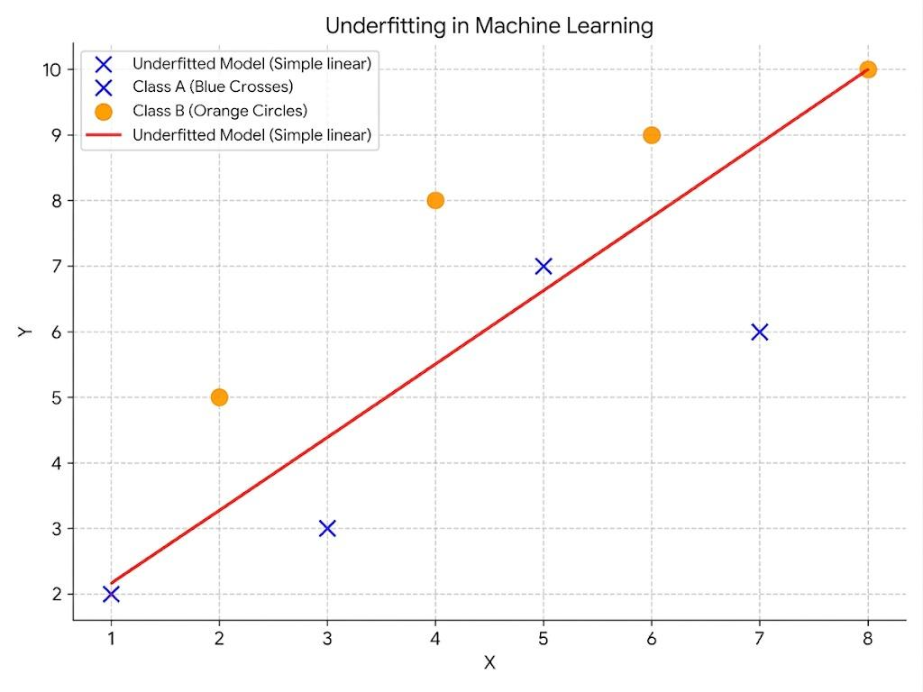
Figure 2.1: Underfitting in Machine Learning

2. Overfitting
Overfitting occurs when a model learns too much from the training data, including noise and irrelevant details. Instead of capturing the general pattern, the model starts memorizing the training data.
As a result, the model performs extremely well on training data but fails to generalize when applied to new, unseen data. This makes the model unreliable in real-world scenarios.
Overfitting usually happens when the model is too complex, contains too many features, or is trained on a very small dataset. The absence of proper regularization can also contribute to this issue.
This problem is associated with high variance, which means that the model is highly sensitive to changes in the training data. Even small variations in the input can lead to significantly different predictions. At the same time, the model has low bias because it fits the training data very closely.
In simple terms, overfitting occurs when the model memorizes the data instead of learning the underlying patterns.
To reduce overfitting, several techniques can be used:
- Collecting more training data
- Reducing model complexity
- Applying regularization techniques (such as L1 and L2)
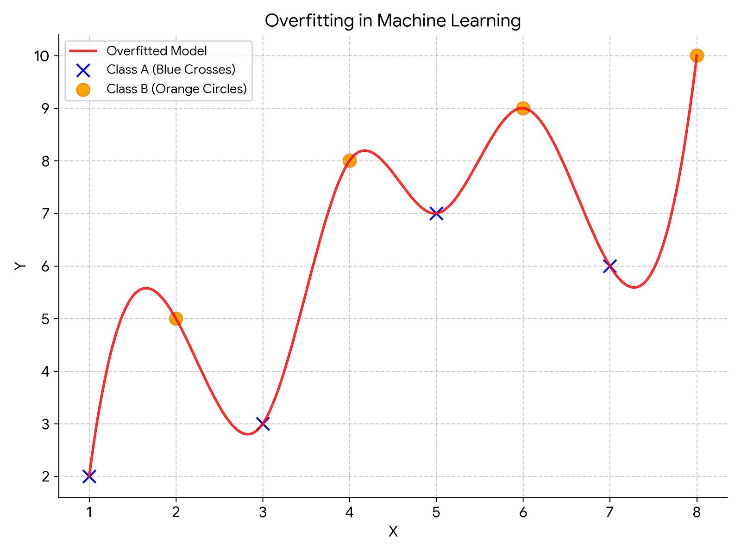
Figure 2.2: Overfitting in Machine Learning

- Using dropout in neural networks
- Implementing early stopping
- Cleaning noisy data to improve generalization
Examples of Overfitting in Machine Learning
1. Spam Email Detection: A model may learn very specific words or patterns from the training emails instead of understanding general spam characteristics. Because of this, it may fail to detect new spam emails correctly.
2. Image Classification: A model may memorize small details or background patterns in training images instead of focusing on the actual object. So, when a new image is given, the model may give wrong predictions.
3. Bias–Variance Trade-off
The concepts of underfitting and overfitting are closely related through the bias–variance trade-off. This trade-off represents the balance between a model’s ability to capture patterns in the data (bias) and its sensitivity to variations in the training data (variance).
Bias refers to the error introduced due to overly simplistic assumptions made by the model. A model with high bias tends to underfit the data, as it fails to capture important patterns. On the other hand, variance refers to the model’s sensitivity to changes or fluctuations in the training data. A model with high variance tends to overfit, as it captures noise along with the underlying patterns.
As model complexity increases, bias decreases while variance increases. Conversely, when the model is too simple, variance decreases but bias increases. Therefore, the objective is to achieve a balance where both bias and variance are minimized.
An ideal model is one that is sufficiently complex to capture the underlying patterns in the data, yet not so complex that it learns noise. Such a model performs well on both training and testing data and is able to generalize effectively to new, unseen data.

3. System and Deployment Challenges

Introduction
In machine learning, building a model is only one part of the complete process. A model may show very good accuracy during training and testing, but that does not guarantee that it will work smoothly in a real-world environment. The actual difficulty often begins after the model is ready. It has to be integrated into software, deployed properly, monitored regularly, and maintained over time.
This is why system and deployment challenges are very important in machine learning. A model is not useful just because it is accurate. It becomes truly valuable only when it can be used in a real application without creating technical, operational, or financial problems. In practical machine learning systems, many issues appear after model development, especially related to software integration, offline learning and deployment, and the cost involved in building and maintaining the entire system.

Goal
The goal of this topic is to understand the practical challenges that come after model building, especially software integration, offline learning and deployment, and the cost involved in machine learning systems. These challenges matter because real-world ML systems need more than just a trained model to be successful.

Software Integration
A machine learning model usually cannot work on its own. To be useful in real-world applications, it must become part of a larger software system such as a mobile app, website, business dashboard, or backend service. This creates software integration challenges, because the model has to work smoothly with databases, APIs, user interfaces, and existing software tools. It must be able to take input data from the system, process it correctly, and return predictions in a usable form. Even if the model is accurate, it may still fail in practice if it is slow, unstable, or difficult to connect with the rest of the software. Therefore, before deployment, teams often need to optimize the code, test the model carefully, and package it in a reliable way so that it can be used effectively by real users.

Example
Consider a movie recommendation system used in a streaming app. The machine learning model may be trained successfully to recommend movies based on user behavior. But to use it in the real app, the model must connect with the user database, the recommendation engine, and the mobile interface. If this connection is slow or faulty, users may not receive recommendations on time, which reduces the usefulness of the model.
Fig 3.1:Flowchart of Software Integration in Machine Learning

Offline Learning / Deployment
Many machine learning models are first trained in an offline environment. This means they are built using past data, tested separately, and then moved into production later.
This approach works well in many cases, but it also brings challenges. Once the model is deployed, real-world data may start changing. User behavior may change, market conditions may change, or the system may receive data that looks different from the training data. In that case, the model may become less accurate over time.
So deployment is not just about putting the model into use once. It also requires regular monitoring, testing, and sometimes retraining to keep the system useful. A model that performs well during training may still perform poorly in the real world if it is not maintained properly.

Example
Imagine a telecom company that builds a model to predict customer churn using last year’s customer records. At the time of training, the model may perform very well. However, after deployment, new customer behavior, new pricing plans, or competitor offers may change how users act. If the model is not monitored and updated, it may continue making predictions based on old patterns and become less accurate over time.
Fig 3.2:Flowchart of Offline learning in Machine Learning
Cost Involved in ML Systems
Machine learning systems can be expensive to build and maintain. The cost is not limited to model training. It also includes data collection, data cleaning, storage, computing resources, deployment tools, monitoring, and maintenance.
Example:
In a machine learning project:
- Large datasets require more storage space and higher processing power
- Complex models need powerful hardware (like GPUs) to run efficiently
- Teams often use cloud services, containers, and monitoring tools
- Skilled engineers are needed to maintain and manage the system
- A major portion of time is spent on data preparation
- Ensuring the system is reliable and works smoothly is also very important
So even if a machine learning idea looks good, it still has to be practical and affordable for real use.
Conclusion
System and deployment challenges remind us that machine learning is not only about training a model. After the model is built, it must be connected with software, deployed properly, monitored regularly, and maintained over time. Along with this, the cost of building and running the system must also be managed. So, a machine learning model is truly useful only when it works smoothly, stays reliable, and remains practical in real-world applications.

