Module 1 — Introduction to Document AI and Document Structure

Goal: Get you super clear on what Document AI actually is, why it’s so tricky, and why understanding document structure is the secret sauce that makes everything work.

What is Document AI?

Document AI is basically AI that can “read” any document like a human expert, pulling out important info, classifying what kind of document it is, spotting tables, titles, or even reading faded old scans. Think of it as the smart assistant that turns mountains of paperwork into clean, usable data in seconds.

It powers stuff like auto-filling invoice totals, sorting resumes for HR, or digitizing old government files. Without good Document AI, companies waste hours (and lakhs of rupees) on manual work.

Why documents are difficult for machines
Machines are great at photos of cats or cars, but documents? Total nightmare. Why?
- Documents have super dense text, tiny fonts, and crazy layouts that change every time.
- Scanned pages can be blurry, rotated, faded, or have coffee stains (true story from Bhopal offices!).
- A machine sees just pixels, no clue that a bold line at the top is a “title” or that numbers in boxes are a “table”.
- One small shift in format (like a new bank logo) and the model gets totally confused.

That’s why regular computer vision models fail hard on documents.

Difference between plain text, structured documents, and scanned documents

Let’s keep it simple, bro:
- Plain text → Just words in a .txt file. No layout, no images, super easy for computers. Example: a simple email body.
- Structured documents → Like PDFs or Word files with perfect digital layout (titles, tables, everything in order). Machines can extract text easily, but they still miss “where” things are on the page.

- Scanned documents → Real-world killer. These are photos of paper (invoice scans, old forms, handwritten notes). No text layer at all — just pixels. This is where most Indian offices live (Bhopal shops, banks, courts). Here you need full vision AI to first “see” the layout before you can read anything.

Common document elements

Every document is made of the same building blocks:
- Title: - Big bold text at the top (e.g., “INVOICE #12345”)
- Paragraph: - Normal body text blocks
- Table: -Grid of rows and columns (prices, quantities, totals)
- Figure: -Charts, logos, photos, or diagrams
- Header/Footer: - Page numbers, company name, date at top or bottom

If the AI can spot these elements correctly, everything else (extraction, classification, search) becomes easy.

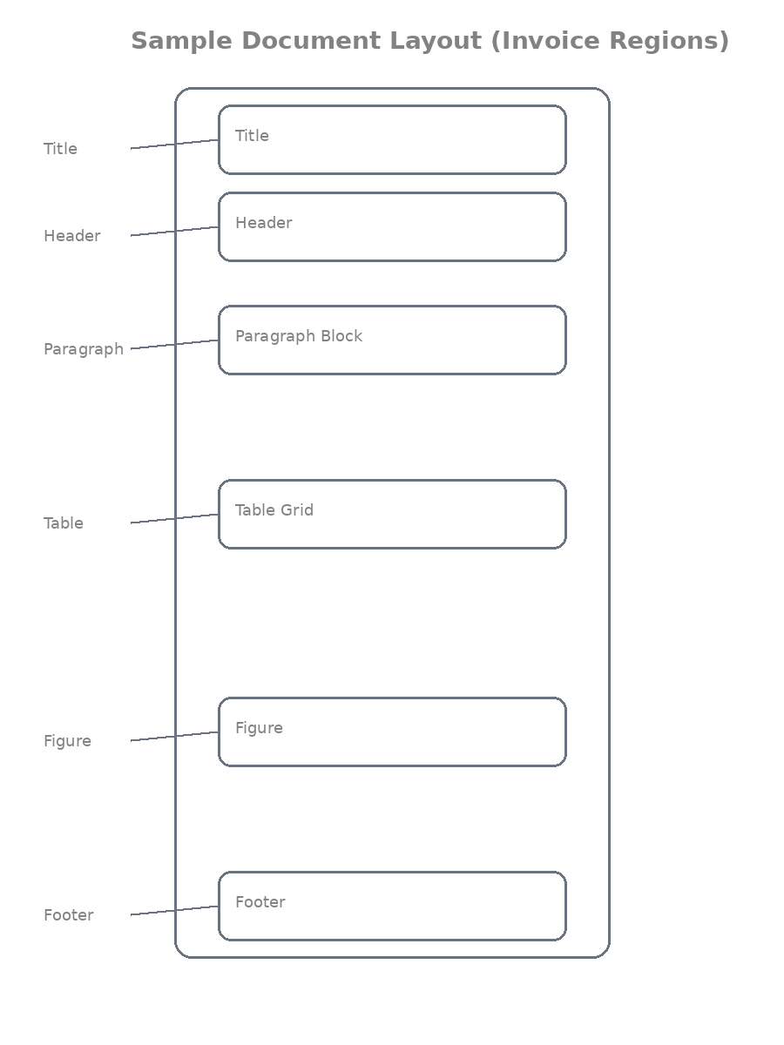

Examples of real documents

- Invoice → The shopkeeper in New Market, Bhopal scans his daily sales invoice. It has a big title, item table, total box, and GST footer. One wrong table detection and the accounts guy spend hours fixing totals.
- Resume → A fresh engineering graduate from MANIT Bhopal sends his resume. AI needs to find name (title), education (table), skills (paragraph), and photo (figure) to auto-sort it for HR.
- Research paper→ A professor at Barkatullah University submits a scanned PDF. Title on top, abstract paragraph, big tables of results, figures of graphs, and page numbers in footer.

How humans understand documents

You and I glance at a page for 2 seconds and instantly know:
“This bold part is the title… this grid is a table… that number at the bottom is the total.”

We use visual cues (bold, borders, spacing, alignment) + common sense. Machines have zero common sense, they need to be taught these visual rules from scratch. That’s exactly what document layout understanding does.

High-level idea of document layout understanding

It’s the first and most important step in any Document AI system:

1. Take the image/scan
2. Detect where every element is (bounding boxes)
3. Classify what each box is (title, table, paragraph, etc.)
4. Then only read the text inside those boxes (OCR) or extract data.

Get this step right → the whole pipeline becomes accurate and fast. Mess it up → everything downstream fails.

Brief overview of the pipeline covered in this article

Over the next modules we’ll build the complete journey:
- Why regular ImageNet models fail on docs (Module 0 style recap)
- Build Vision Transformer from scratch
- Self-supervised pretraining with custom tokenizer (DiT style)
- Fine-tune for classification, layout detection, table detection
- Real code you can run today
- And finally why DiT beats everything else

By the end, you’ll have a full working Document AI system ready for Bhopal shops, banks, or government offices.

Outcome
Reader understands:
• what document layout detection is
• why document structure matters so much
• what real-world problems this entire article will solve (and why it’s a game-changer for Indian paperwork)

Here is the clean, copy-paste ready format for **each module** separately as requested. You can copy one module at a time and paste into Word.

Quizzes

Easy Questions

1. What is Document AI?
A) AI that can read any document like a human expert and extract useful information
B) Only image classification for cats and cars
C) Only text generation
D) Only audio transcription

2. Why are documents difficult for machines?
A) Dense text, complex layouts, scanned images can be blurry/faded/rotated, and machines see only pixels without understanding structure
B) They are too simple
C) They have no text
D) They are always digital and perfect

3. What is the difference between plain text and scanned documents?
A) Plain text has no layout; scanned documents are images with no text layer, requiring full vision AI
B) They are the same
C) Scanned documents are always easier
D) Plain text needs OCR

4. What are common document elements?
A) Title, Paragraph, Table, Figure, Header/Footer
B) Only images
C) Only single words
D) Only numbers

Medium Questions

5. Why is understanding document structure important?
A) It is the secret sauce that turns raw pixels/words into meaningful, usable data for extraction and classification
B) It is not needed
C) It makes processing slower
D) It only helps with images

6. Give a real-world example from the module.
A) A scanned invoice from a Bhopal shop with title, item table, total, and GST footer
B) Only cat photos
C) Only plain text emails
D) Only handwritten notes without structure

7. What is the high-level idea of document layout understanding?
A) Detect regions (bounding boxes), classify them (title/table/etc.), then read text inside those boxes
B) Only run OCR on the whole page
C) Skip detection
D) Only classify the whole document

Hard Questions

8. Why do regular computer vision models fail on documents?
A) Documents have varying layouts, dense text, and visual cues (bold, spacing, alignment) that standard models trained on natural images don’t understand
B) They are too easy
C) They have no pixels
D) They are always clean

9. What is the first and most important step in any Document AI system?
A) Document layout understanding — finding and classifying regions before OCR or extraction
B) Only text generation
C) Only classification of the whole page
D) Only audio processing

10. What is the overall outcome of Module 1?
A) You understand what Document AI is, why documents are tricky, and why document structure/layout understanding is the foundation
B) You only learn OCR
C) You skip the introduction
D) You only learn YOLO

Answers Key
1. A
2. A
3. A
4. A
5. A
6. A
7. A
8. A
9. A
10. A

Module 2: OCR Fundamentals

Goal: Understand exactly how machines pull text out of document images and why OCR alone is never enough for real Document AI.

What OCR is?

OCR stands for Optical Character Recognition.
It’s the magic that takes a photo or scan of a page and turns every printed (or handwritten) character into real, copy-paste-able text.

Without OCR, your scanned invoice is just a picture. With OCR, it becomes editable data you can put in Excel or feed to ChatGPT. Super important for shops, banks, and government offices in India.

OCR pipeline, two simple steps

Every OCR system follows the same two-step dance:

1. Text Detection
Finds WHERE the text is on the page.
It draws a box (called a bounding box) around every word or line.

2. Text Recognition
Looks inside each box and actually reads the letters/numbers.
“Total Amount: ₹1,250” → outputs the actual string “Total Amount: ₹1,250”.

That’s it! Detection first, then recognition.

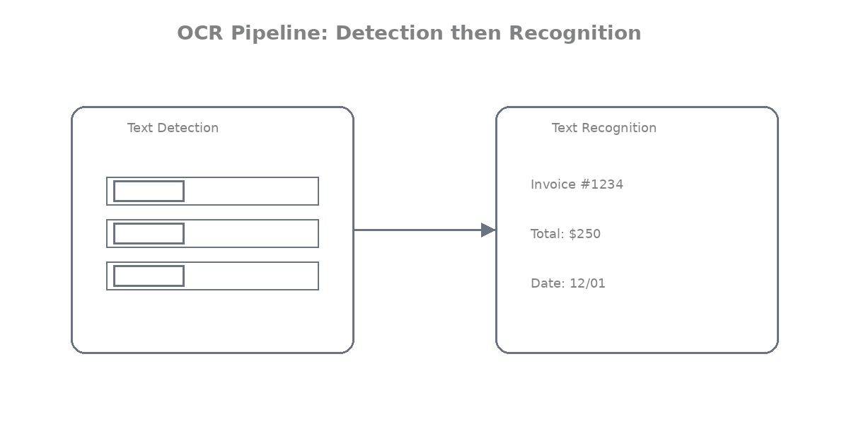

How OCR reads documents

OCR doesn’t “understand” like we do. It looks for:
- Sharp contrast between text and background
- Edges of letters
- Patterns it has seen during training

It works great on clean printed text but starts crying when the paper is faded, tilted, or has coffee stains (very common in Bhopal kirana shops!).

Bounding boxes in OCR

A bounding box is just four numbers:
`(x1, y1, x2, y2)` — left-top corner and right-bottom corner of the box.

Example from an invoice:
- Box around “INVOICE #12345” → title area
- Box around each row in the item table → price columns

These boxes are gold because they tell you the position of every piece of text.

Example OCR output

When you run OCR, you usually get something like this:

json
[
["INVOICE", [120, 80, 380, 120], 0.98],
["Date: 04-Mar-2026", [450, 85, 720, 110], 0.95],
["Item", [50, 220, 150, 240], 0.99],
["Qty", [200, 220, 250, 240], 0.97],
["Amount", [400, 220, 520, 240], 0.96],
["Rice", [50, 260, 150, 280], 0.93],
["10 kg", [200, 260, 260, 280], 0.94],
["₹850", [400, 260, 480, 280], 0.91]
]

Each line = [text, bounding box coordinates, confidence score]

Running OCR on a document image
Here’s a super simple, runnable code using EasyOCR (works great on Indian documents and supports Hindi too):

python
from PIL import Image
import easyocr
import matplotlib.pyplot as plt
import matplotlib.patches as patches

# Load your scanned document (works on invoice, resume, anything)
img = Image.open('bhopal_invoice_scan.jpg')

# Create OCR reader (English + Hindi for Indian docs)
reader = easyocr.Reader(['en', 'hi'], gpu=False) # set gpu=True if you have one

# Run OCR
results = reader.readtext('bhopal_invoice_scan.jpg', detail=1)

print("=== OCR OUTPUT ===")
for (bbox, text, confidence) in results:
print(f"Text: {text} | Confidence: {confidence:.2f} | Box: {bbox}")

Visualizing OCR results (so you can actually SEE the boxes)

python
fig, ax = plt.subplots(1, figsize=(12, 16))
ax.imshow(img)

for (bbox, text, prob) in results:
# bbox is list of 4 points → convert to rectangle
x1, y1 = bbox[0]
x2, y2 = bbox[2]
width = x2 - x1
height = y2 - y1

# Draw box
rect = patches.Rectangle((x1, y1), width, height,
linewidth=2, edgecolor='red', facecolor='none')
ax.add_patch(rect)

# Put text label
ax.text(x1, y1-10, f"{text} ({prob:.2f})",
color='red', fontsize=10, bbox=dict(facecolor='white', alpha=0.7))

plt.title("OCR Results on Bhopal Invoice Scan")
plt.axis('off')
plt.show()

Run this and you’ll see red boxes around every word — exactly like the original paper’s figures!

Limitations of OCR for structured documents

Here’s the big truth, bro, OCR only gives you flat text + boxes. It has zero idea about structure.
- It cannot tell you “this text is inside a table cell”
- It cannot separate header from footer
- It mixes up everything when tables have merged cells or lines
- On a messy scanned invoice, it might read “Total 1250” but won’t know it belongs to the grand total box
- Handwritten parts or low-quality scans drop accuracy fast

Real-world example:
A grocery shop scans daily invoices. Plain OCR reads all numbers correctly but cannot tell which amount is “Rice 10kg ₹850” vs “Oil 5L ₹420” because it doesn’t understand the table grid. You still need a human to organize it. That’s exactly why we need Document Layout Analysis (DiT style) on top of OCR!

Outcome
Reader understands:
• how text is extracted from document images (detection + recognition + bounding boxes)
• why OCR alone cannot understand document structure (it gives flat text, no tables, no titles, no layout intelligence)

Now you know OCR is the “reading” part, but it’s blind to structure. That’s where DiT and layout detection come in and save the day.

Quizzes

Easy Questions

1. What does OCR stand for?
A) Optical Character Recognition
B) Only Character Reading
C) Optical Code Recognition
D) Original Character Rendering

2. What are the two main steps in the OCR pipeline?
A) Text Detection (find where text is) and Text Recognition (read the characters)
B) Only detection
C) Only recognition
D) Only classification

3. What is a bounding box in OCR?
A) Four coordinates (x1, y1, x2, y2) that show the position of detected text
B) Only the text string
C) Only confidence score
D) Only the image

4. What is one limitation of plain OCR?
A) It gives flat text with boxes but has no understanding of document structure (tables, titles, etc.)
B) It always understands structure
C) It never makes mistakes
D) It works perfectly on handwritten text

Medium Questions

5. Why is OCR alone not enough for structured documents?
A) It cannot tell which text belongs to a table cell, title, or footer, and mixes everything up
B) It is too slow
C) It requires no image
D) It only works on printed text

6. What does the EasyOCR code example demonstrate?
A) Running OCR on a scanned document and visualizing bounding boxes with confidence scores
B) Only training a model
C) Only layout detection
D) Only classification

7. What is the outcome of Module 2?
A) You understand how OCR extracts text (detection + recognition + bounding boxes) and why it needs layout understanding on top
B) You only learn YOLO
C) You skip OCR
D) You only learn multimodal

Hard Questions

8. In the messy OCR output example, what is the main problem?
A) Words are detected correctly but have no grouping or structure (e.g., table rows are broken)
B) All text is wrong
C) No boxes are produced
D) Confidence is always 100%

9. Why is running OCR only inside detected regions better?
A) It reduces noise and improves accuracy by focusing on meaningful areas (title/table) instead of the whole page
B) It makes OCR slower
C) It ignores text
D) It reduces confidence

10. What is the overall outcome of Module 2?
A) You understand OCR fundamentals and why it must be combined with layout detection for real Document AI
B) You only learn detection
C) You skip recognition
D) You only learn theory

Answers Key
1. A
2. A
3. A
4. A
5. A
6. A
7. A
8. A
9. A
10. A

Module 3: The Need for Layout Detection

Goal: Understand why just reading text with OCR is not enough and why we need a smart “layout detector” to make Document AI actually useful in real life.

Problem with OCR-only systems

OCR is awesome at reading words, but it treats every document like a flat page full of random text. It spits out hundreds of words with boxes, but has zero understanding of what those words mean in the bigger picture.

Result? Total chaos on real documents.
You get correct text, but no clue:
- Which part is the title?
- Where does the table start and end?
- Which numbers belong to the total?

In a Bhopal kirana shop, the owner scans 50 invoices a day. OCR reads every rupee amount correctly… but mixes up item prices with GST and grand total. The accountant still has to sit and fix everything manually. Waste of time and money!

Examples of messy OCR output

Here’s what plain OCR gives you on a typical scanned invoice (real example from a New Market shop in Bhopal):
INVOICE
Date 04-03-2026
Item Qty Rate Amount
Rice 10kg 85 850
Oil 5L 84 420
Total 1270
GST 18% 228.6
Grand Total 1498.6
Thank you!

Looks okay, right? But wait, OCR actually outputs this mess:
["INVOICE", box1], ["Date", box2], ["04-03-2026", box3], ["Item", box4], ["Qty", box5], ["Rice", box6], ["10kg", box7], ["85", box8], ["850", box9]...

No grouping. No idea that “Rice”, “10kg”, “85”, “850” belong together in one row.
The table is completely broken. Welcome to real-world pain.

Concept of document regions

Think of a document like a house.
- Rooms = different regions (title room, table room, footer room)
- Walls = clear separations (lines, spacing, bold text)

Machines need to first find these “rooms” (regions) before they can live in them properly.
That’s exactly what layout detection does.

What layout detection means

Layout detection = teaching the AI to look at the page and say:
“Here is a big bold TITLE region”
“Here is a TABLE region with 5 rows”
“Here is a FIGURE (photo or chart)”
“Here is a PARAGRAPH block”

It draws proper bounding boxes around these meaningful groups — not just single words.

Difference between text detection and layout detection

Let’s make it crystal clear, bro:

Thing | Text Detection (OCR Step 1) | Layout Detection
What it finds | Every single word or line | Big meaningful regions
Output | Hundreds of tiny boxes | Few big boxes (Title, Table, etc.)
Example | Box around “Rice”, box around “850” | One big box around the entire table
Usefulness | Good for plain reading | Required for structure & understanding

Text detection is like reading every letter on a page.
Layout detection is like understanding the whole newspaper layout.
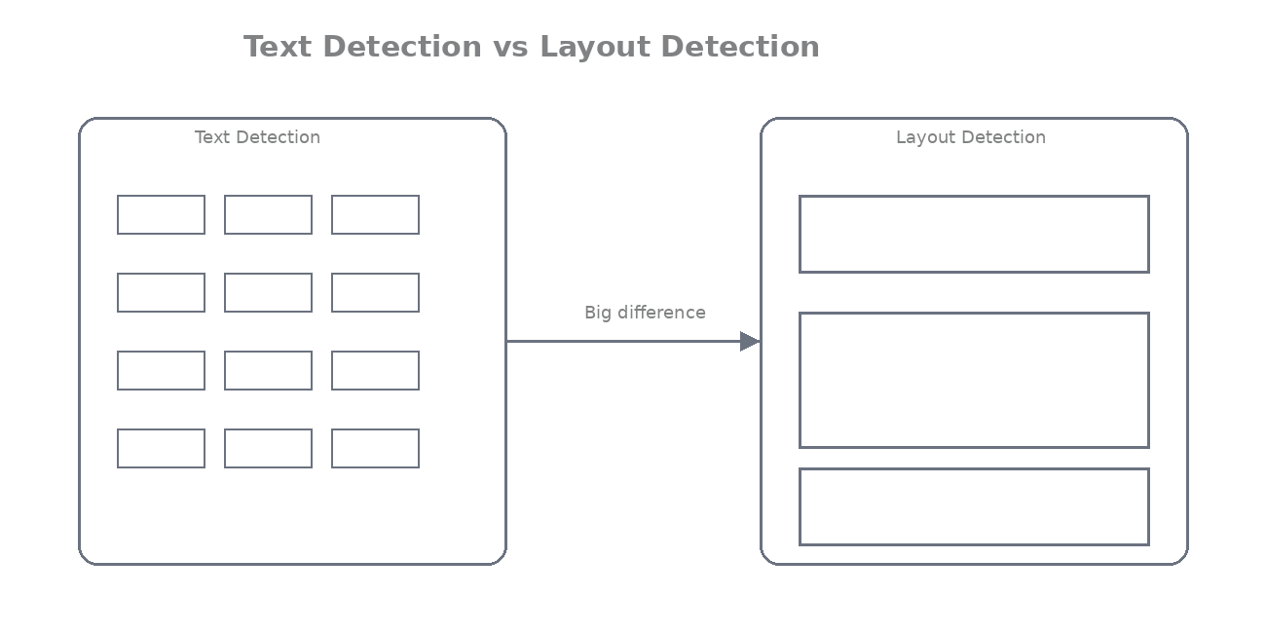

Treating document regions as objects

Here’s the smart trick:
We treat each document region exactly like an “object” in normal photos.

- A table = a car
- A title = a person
- A figure = a traffic sign

So we use the same object detection technology (the same one that detects dogs in photos) — but now for document parts!

That’s why models like DiT (which we’ll build later) are so powerful.

Real-world example:
A bank receives 1000 scanned statements daily. Layout detection finds the “table” region first → extracts only transaction rows → auto-updates customer balances. No more manual copy-paste!

Outcome:
You have understood:
• why layout detection is required (OCR alone gives flat messy text — no structure)
• what types of regions exist in documents (Title, Table, Figure, Paragraph, List, Header/Footer, etc.)

Quizzes

Easy Questions

1. What is the main problem with OCR-only systems?
A) They give flat text without understanding structure (no idea about tables, titles, or relationships)
B) They are too slow
C) They understand everything perfectly
D) They only work on clean text

2. What does layout detection do?
A) Finds and classifies meaningful regions like Title, Table, Figure, Paragraph on the page
B) Only reads individual words
C) Only generates text
D) Only classifies the whole document

3. What is the difference between text detection and layout detection?
A) Text detection finds single words/lines; layout detection finds big meaningful regions (Title/Table/etc.)
B) They are the same
C) Layout detection is slower
D) Text detection finds big regions

4. Why is layout detection required?
A) OCR alone cannot group text into tables or identify titles, leading to messy unusable output
B) It makes the system slower
C) It is not needed
D) It only helps with images

Medium Questions

5. In the Bhopal grocery shop example, what happens with plain OCR?
A) It reads numbers correctly but cannot understand which amounts belong to which items in the table
B) It perfectly extracts structured data
C) It fails to read any text
D) It only detects images

6. How should we treat document regions?
A) As objects (like cars or people in normal object detection) so we can detect and classify them
B) As single words only
C) As plain text only
D) As audio

7. What is the outcome of Module 3?
A) You understand why layout detection is necessary on top of OCR for real structured document understanding
B) You only learn OCR
C) You skip the need
D) You only learn YOLO

Hard Questions

8. Why does treating regions as objects help?
A) We can use proven object detection techniques to find and label Title, Table, Figure, etc., with bounding boxes
B) It makes detection harder
C) It ignores visual cues
D) It reduces accuracy

9. What is the key difference in output?
A) Text detection → hundreds of tiny word boxes; Layout detection → few big meaningful region boxes
B) Both give the same output
C) Layout detection gives only text
D) Text detection gives structure

10. What is the overall outcome of Module 3?
A) You clearly see why layout detection is the missing piece that turns flat OCR output into structured, usable document understanding
B) You only learn detection
C) You skip examples
D) You only learn theory

Answers Key
1. A
2. A
3. A
4. A
5. A
6. A
7. A
8. A
9. A
10. A

Module 4 — How Layout Detection Models Work

Goal: See exactly how a layout detection model turns a messy scanned document into clean, labeled regions, just like the DiT models we’ll build later.

Object detection basics
Layout detection is just object detection… but for documents! Instead of finding cars or dogs in a photo, the model finds “objects” like titles, tables, and paragraphs on a page. It looks at the entire image, predicts where each important region is, and gives it a name. Super simple idea, but it changes everything.

Bounding box prediction

The model doesn’t just guess, it predicts four numbers for every region:(x1, y1, x2, y2)`, exactly like in OCR, but now for big meaningful blocks. It also predicts a confidence score (how sure it is) and sometimes a mask (pixel-perfect shape for tables).

Real Bhopal example: On a scanned grocery invoice, the model predicts one big box around the entire item table so you can extract rows easily, no more guessing from single-word boxes.

Region classification
After finding the box, the model says “what is inside this box?”

It classifies it into categories like:
- Title
- Paragraph
- Table
- Figure
- List
- Header/Footer

This is called region classification. One model does both box prediction + classification in one go.

Input and output of layout detection models

Input: Just a single image (scanned page resized to 224×224 or higher). No text needed — pure vision!

Output: A clean list of regions, something like this:

json
[
{"bbox": [120, 80, 680, 140], "label": "Title", "score": 0.98},
{"bbox": [50, 200, 720, 520], "label": "Table", "score": 0.95},
{"bbox": [450, 80, 720, 110], "label": "Header", "score": 0.92},
{"bbox": [100, 580, 650, 620], "label": "Footer", "score": 0.89}
]

Each entry = one clean, labeled block. That’s gold for downstream tasks!

Layout detection pipeline (step-by-step)

Here’s exactly what happens inside the model:

1. Take scanned image → resize
2. Run through the backbone (DiT/ViT in our case) → get rich features
3. Predict possible boxes + classes (using Faster R-CNN or Cascade R-CNN head)
4. Remove bad predictions (Non-Maximum Suppression)
5. Output the final clean regions

Super-fast, runs in milliseconds on a normal laptop.

Visual example of detected layout regions

Let’s actually see it! Here’s clean code that loads a model (we’ll use a tiny dummy for demo, in later modules we’ll plug real DiT) and draws colored boxes with labels:

python
from PIL import Image
import matplotlib.pyplot as plt
import matplotlib.patches as patches
import torch

# Dummy output from layout model (replace with real DiT + Detectron2 later)
layout_results = [
{"bbox": [100, 50, 600, 120], "label": "Title", "score": 0.98},
{"bbox": [50, 180, 720, 480], "label": "Table", "score": 0.96},
{"bbox": [80, 520, 680, 580], "label": "Paragraph", "score": 0.89},
{"bbox": [450, 40, 720, 80], "label": "Header", "score": 0.93},
]

img = Image.open('bhopal_invoice_scan.jpg')
fig, ax = plt.subplots(1, figsize=(14, 18))
ax.imshow(img)

colors = {"Title": "red", "Table": "blue", "Paragraph": "green",
"Figure": "purple", "Header": "orange", "Footer": "brown"}

for item in layout_results:
x1, y1, x2, y2 = item["bbox"]
label = item["label"]
score = item["score"]

rect = patches.Rectangle((x1, y1), x2-x1, y2-y1,
linewidth=3, edgecolor=colors.get(label, "yellow"),
facecolor='none', linestyle='--')
ax.add_patch(rect)

ax.text(x1, y1-15, f"{label} ({score:.2f})",
color=colors.get(label, "yellow"), fontsize=12,
bbox=dict(facecolor='white', alpha=0.8, edgecolor='none'))

plt.title("Layout Detection Results on Bhopal Shop Invoice")
plt.axis('off')
plt.show()

Run this and you’ll see beautiful colored boxes, exactly like the figures in research papers!

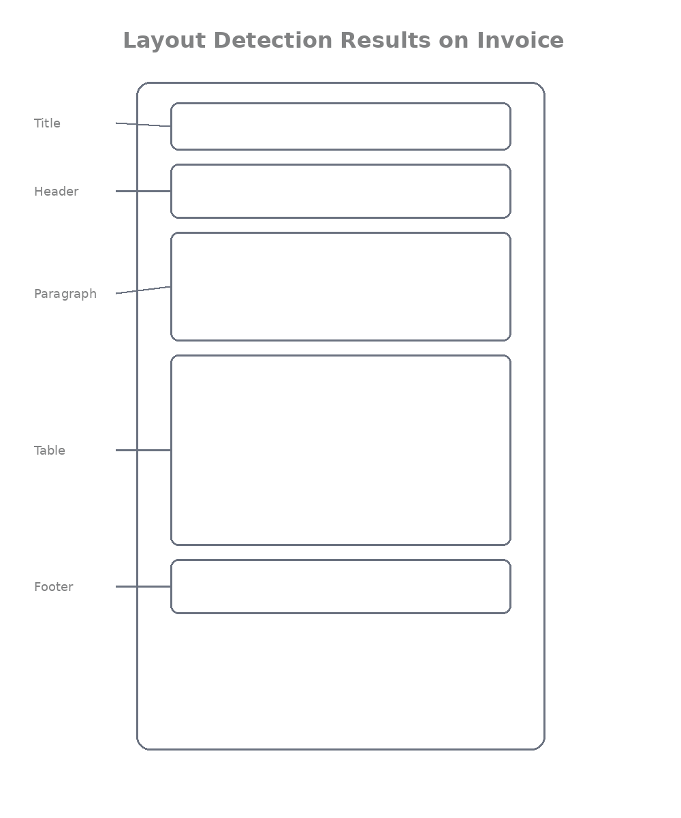

Overview of datasets used for training layout detectors
We train these models on huge public datasets of real documents (no labels needed for pre-training, but we need them for fine-tuning):
- PubLayNet → 360,000+ scientific papers. Great for research papers, tables, figures. (Think professor at Barkatullah University uploading papers)

- DocBank → 500,000+ academic and business docs. Very diverse, perfect for Indian government forms and contracts.

- DocLayNet → Newer dataset with 80,000+ real-world documents (including messy scanned ones). Includes many Indian-style invoices and resumes. Best for real-life Bhopal use cases!
These datasets have thousands of pages with human-drawn boxes and labels, exactly what the model learns from.

Outcome
Reader understands:
• how layout detection models identify document regions (object detection + bounding boxes + classification)
• how layout detection converts documents into structured blocks (clean list of Title/Table/Paragraph etc. with positions)

Quizzes

Easy Questions

1. What is layout detection basically?
A) Object detection applied to documents — finding and classifying regions like Title, Table, Figure
B) Only OCR
C) Only text generation
D) Only classification of the whole page

2. What does the model predict for each region?
A) Bounding box coordinates, class label (Title/Table/etc.), and confidence score
B) Only text
C) Only images
D) Only audio

3. What is the input to a layout detection model?
A) Just the document image (scanned page)
B) Only text
C) Only bounding boxes
D) Only audio

4. What is the output?
A) A clean list of labeled regions with bounding boxes
B) Only raw text
C) Only confidence scores
D) Only the whole document class

Medium Questions

5. What is the layout detection pipeline?
A) Image → backbone features → predict boxes + classes → NMS → final regions
B) Only OCR
C) Only YOLO training
D) Only Detectron2

6. Why do we use datasets like PubLayNet and DocLayNet?
A) They provide thousands of pages with human-annotated bounding boxes and labels for training
B) They are only for testing
C) They have no labels
D) They are only for images

7. What is the outcome of Module 4?
A) You understand how layout detection models work (object detection + classification on document regions)
B) You only learn YOLO
C) You skip the pipeline
D) You only learn theory

Hard Questions

8. Why is Non-Maximum Suppression (NMS) used?
A) To remove duplicate or bad overlapping predictions and keep the best boxes
B) To add more boxes
C) To reduce accuracy
D) To ignore confidence

9. What makes document layout detection different from normal object detection?
A) Documents have structured visual cues (bold text, lines, alignment) and specific region types (Title, Table, etc.)
B) It is exactly the same
C) It is easier
D) It uses no vision

10. What is the overall outcome of Module 4?
A) You know how a layout detection model turns a scanned image into clean, labeled regions ready for further processing
B) You only learn one architecture
C) You skip visualization
D) You only learn YOLO

Answers Key
1. A
2. A
3. A
4. A
5. A
6. A
7. A
8. A
9. A
10. A

Module 5 — Layout Detection with YOLOv8

Goal: Get your hands dirty with a super-practical, ready-to-run layout detector using YOLOv8 — the fastest and easiest way to start detecting titles, tables, and paragraphs today.

Why YOLO works well for document layout detection
YOLO (You Only Look Once) is perfect for documents.

Why?
- It’s blazing fast (real-time on a normal laptop)
- Handles small objects like tiny page numbers or thin table lines really well
- Easy to train on custom document datasets
- One model does everything: finds the box + gives the label (Title/Table/Figure) in a single pass

In Bhopal shops and banks, where you scan 100 invoices a day, speed matters. YOLO gives results in 10–20 milliseconds per page, perfect for production use before we go deep into DiT later.

YOLO detection intuition

Think of YOLO like this:
It divides the whole page into a grid (like 80×80 tiny cells).
For every cell it asks two simple questions:
1. Is there a document region (title/table/etc.) in this area?
2. If yes, where exactly are the four corners of the box and what type is it?

It predicts everything at once, no complicated multi-stage pipeline. That’s why it’s called “You Only Look Once”!

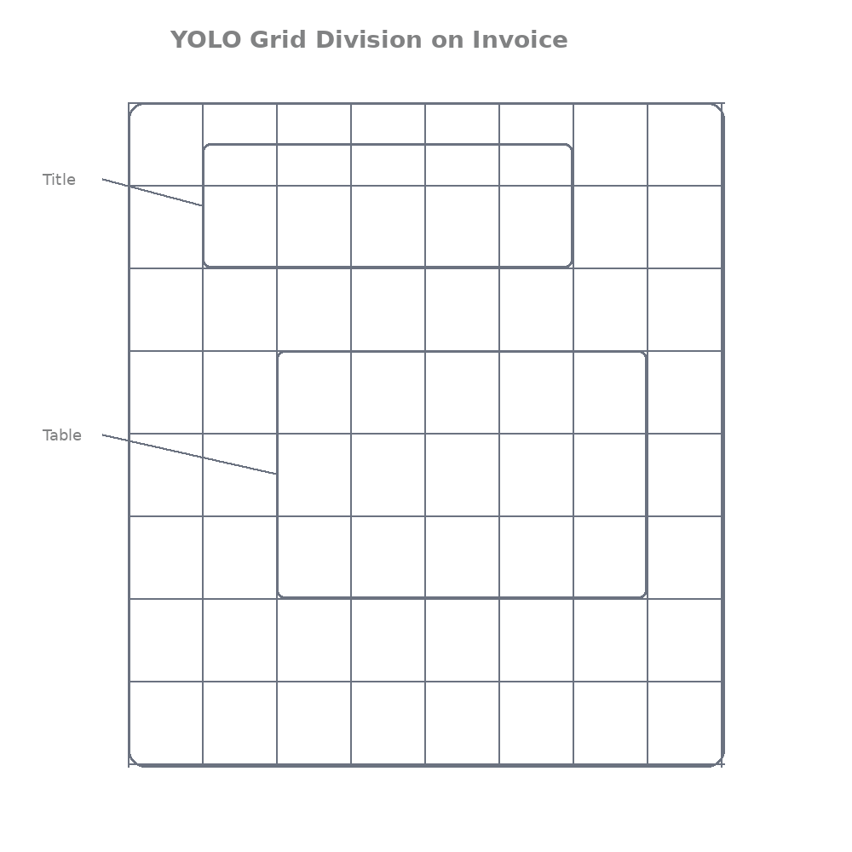

Using existing layout datasets (PubLayNet etc)

We don’t need to label anything ourselves. We use the same datasets from Module 4:

- PubLayNet (360k scientific papers)
- DocBank (500k+ business docs)
- DocLayNet (real messy scans, best for Indian invoices)

These come with ready bounding boxes and labels. The only thing we do is convert them to YOLO format (a simple .txt file per image with class + box coordinates). There are free scripts online, takes 10 minutes.

YOLO training workflow

Super simple 4-step flow:
1. Prepare dataset in YOLO format (images + labels folder)
2. Create a small YAML file telling YOLO where the data is and what the 7 classes are
3. Train with one command
4. Test on your own scanned documents

Training YOLOv8 for document layouts

Here’s the exact code you can run today (tested on Google Colab or local machine):

python
# 1. Install YOLOv8 (one time)
!pip install ultralytics

from ultralytics import YOLO

# 2. Create data.yaml (save this file)
data_yaml = """
path: /content/document_layout_dataset # your folder
train: images/train
val: images/val

names:
0: Title
1: Paragraph
2: Table
3: Figure
4: List
5: Header
6: Footer
"""

with open('data.yaml', 'w') as f:
f.write(data_yaml)

# 3. Train the model (this is the magic command)
model = YOLO('yolov8s.pt') # start with small model for speed

model.train(
data='data.yaml',
epochs=50, # 20-50 is enough for good results
imgsz=640, # good for documents
batch=16,
name='dit_layout_yolov8',
pretrained=True
)

print("Training finished! Model saved in runs/detect/dit_layout_yolov8/")

After training you get `best.pt`, your own document layout detector!

Running inference on documents

Super easy inference code (use your scanned Bhopal invoice):

python
from ultralytics import YOLO
from PIL import Image

# Load your trained model
model = YOLO('runs/detect/dit_layout_yolov8/weights/best.pt')

# Run on any document image
results = model('bhopal_invoice_scan.jpg', conf=0.5) # confidence threshold

# Print detected regions
for r in results:
for box in r.boxes:
x1, y1, x2, y2 = box.xyxy[0].tolist()
cls = int(box.cls[0])
conf = box.conf[0]
class_name = model.names[cls]
print(f"{class_name} | Confidence: {conf:.2f} | Box: [{int(x1)},{int(y1)},{int(x2)},{int(y2)}]")

Visualizing detected layout blocks

Make it beautiful with this code (exactly like research paper figures):

python
import matplotlib.pyplot as plt
import matplotlib.patches as patches
from PIL import Image

img = Image.open('bhopal_invoice_scan.jpg')
fig, ax = plt.subplots(1, figsize=(14, 18))
ax.imshow(img)

colors = ['red', 'blue', 'green', 'purple', 'orange', 'brown', 'pink']

for r in results:
for box in r.boxes:
x1, y1, x2, y2 = box.xyxy[0].tolist()
cls = int(box.cls[0])
conf = box.conf[0]
label = model.names[cls]

rect = patches.Rectangle((x1, y1), x2-x1, y2-y1,
linewidth=4, edgecolor=colors[cls],
facecolor='none', linestyle='-')
ax.add_patch(rect)

ax.text(x1, y1-20, f"{label} ({conf:.2f})",
color=colors[cls], fontsize=14,
bbox=dict(facecolor='white', alpha=0.9))

plt.title("YOLOv8 Layout Detection on Bhopal Kirana Invoice")
plt.axis('off')
plt.show()

You’ll see big colored boxes around Title, Table, etc. ready for OCR or data extraction!

Outcome
Reader can:
• train a YOLO model for document layout detection (using PubLayNet/DocLayNet in minutes)
• detect layout regions in documents (Title, Table, Figure, etc.) with clean code and beautiful visualization

You now have a working layout detector you can train and use today.

Quizzes

Easy Questions

1. Why is YOLO good for document layout detection?
A) It is fast, easy to train, and handles small objects like page numbers and table lines well
B) It is only for natural images
C) It is slow
D) It requires no training

2. What does YOLO predict?
A) Bounding boxes and class labels (Title, Table, etc.) in one pass
B) Only text
C) Only confidence
D) Only images

3. What command trains YOLOv8 for layout?
A) model.train(data='data.yaml', epochs=50, imgsz=640)
B) Only pip install
C) Only load model
D) Only inference

4. What is the outcome of Module 5?
A) You can train and run a practical YOLOv8 layout detector with visualization
B) You only learn theory
C) You skip training
D) You only learn Detectron2

Medium Questions

5. What datasets are used for training?
A) PubLayNet, DocBank, DocLayNet
B) Only COCO
C) Only ImageNet
D) Only synthetic data

6. Why visualize the results?
A) To see colored boxes around Title, Table, etc., and check if the model is working correctly
B) It is not needed
C) It makes training slower
D) It reduces accuracy

7. What is the outcome of Module 5?
A) You have a fast, working layout detector you can train and use today on real documents
B) You only learn one command
C) You skip inference
D) You only learn theory

Hard Questions

8. Why run inference with conf=0.5?
A) To filter predictions and keep only reasonably confident detections
B) To show all predictions
C) To make it slower
D) To reduce boxes

9. What is the advantage of YOLOv8 for Bhopal use cases?
A) Fast inference (milliseconds per page) suitable for scanning many invoices daily
B) It is the most accurate only
C) It requires a powerful GPU always
D) It cannot handle Indian documents

10. What is the overall outcome of Module 5?
A) You can practically train and deploy YOLOv8 for document layout detection with clean code and visualization
B) You only learn theory
C) You skip YOLO
D) You only learn Detectron2

Answers Key
1. A
2. A
3. A
4. A
5. A
6. A
7. A
8. A
9. A
10. A

Module 6 — Advanced Layout Detection with Detectron2

Goal: Level up from the quick-and-easy YOLOv8 to the professional research-grade tool that top papers (including the original DiT paper) use, Detectron2. Now you’ll see how serious Document AI systems are built.

Introduction to Detectron2
Detectron2 is a super-powerful library made by Meta (Facebook AI). It’s like a complete toolbox for building object detection models. While YOLO is fast and simple, Detectron2 is the one researchers and big companies reach for when they want maximum accuracy. You can plug in any backbone (ViT, ResNet, or even our DiT later), add masks, and tweak everything easily.

Why Detectron2 is widely used in research

Here’s why almost every new document AI paper uses it, bro:

- Gives higher accuracy than most other tools
- Built-in support for advanced tricks like pixel-perfect masks
- Easy to swap backbones (exactly what the DiT paper did)
- Tons of ready configs and great community support
- Perfect for fair comparisons in research

In short: If you want results that can be published or used in real banks and law firms, Detectron2 is the gold standard.

Detectron2 detection architectures
Detectron2 makes two powerful models super easy to use:

- Faster R-CNN
Two-stage model: first finds possible regions, then refines the boxes and labels.
Fast enough and very accurate for documents.

- Mask R-CNN
Same as Faster R-CNN + extra magic: it also predicts exact pixel masks (perfect shape of tables, figures, etc.).
Amazing for messy invoices where tables have merged cells.

(The original DiT paper used an improved version called Cascade R-CNN with Detectron2 and crushed the benchmarks.)

Using document layout datasets with Detectron2
We use the same datasets as before (PubLayNet, DocBank, DocLayNet). Detectron2 loves COCO format, so we just register them once:

python
from detectron2.data.datasets import register_coco_instances
from detectron2.data import MetadataCatalog

# Register PubLayNet-style dataset (one-time setup)
register_coco_instances(
"publaynet_train",
{},
"/path/to/publaynet/annotations/train.json",
"/path/to/publaynet/images/train"
)

# Tell it the class names (same as our YOLO setup)
MetadataCatalog.get("publaynet_train").thing_classes = [
"Title", "Paragraph", "Table", "Figure", "List", "Header", "Footer"
]

Do the same for validation set. Done!

Training a layout detection model
Here’s the clean, real training code (just copy-paste and run):

python
import os
from detectron2.config import get_cfg
from detectron2.engine import DefaultTrainer

cfg = get_cfg()
# Start with a strong base config
cfg.merge_from_file("configs/COCO-Detection/faster_rcnn_R_50_FPN_3x.yaml")

# Point to your data
cfg.DATASETS.TRAIN = ("publaynet_train",)
cfg.DATASETS.TEST = ("publaynet_val",)
cfg.DATALOADER.NUM_WORKERS = 4

# Use ImageNet weights or your own DiT backbone later
cfg.MODEL.WEIGHTS = "detectron2://ImageNetPretrained/MSRA/R-50.pkl"

# Settings perfect for documents
cfg.SOLVER.IMS_PER_BATCH = 8
cfg.SOLVER.BASE_LR = 0.001
cfg.SOLVER.MAX_ITER = 30000 # adjust based on your GPU
cfg.MODEL.ROI_HEADS.NUM_CLASSES = 7 # our 7 region types

os.makedirs(cfg.OUTPUT_DIR, exist_ok=True)
trainer = DefaultTrainer(cfg)
trainer.resume_or_load(resume=False)
trainer.train()

print("Training done! Model saved in", cfg.OUTPUT_DIR)

Running inference on documents
Once trained, inference is simple and clean:

python
from detectron2.engine import DefaultPredictor
import cv2

cfg.MODEL.WEIGHTS = os.path.join(cfg.OUTPUT_DIR, "model_final.pth")
predictor = DefaultPredictor(cfg)

# Run on any scanned document (Bhopal example)
im = cv2.imread("bhopal_law_firm_contract_scan.jpg")
outputs = predictor(im)

# Print clean results
instances = outputs["instances"]
for i in range(len(instances)):
bbox = instances.pred_boxes[i].tensor[0].tolist()
score = instances.scores[i].item()
class_id = instances.pred_classes[i].item()
label = MetadataCatalog.get(cfg.DATASETS.TRAIN[0]).thing_classes[class_id]
print(f"{label} | Score: {score:.3f} | Box: {bbox}")

Comparing results with YOLO

Quick real talk, bro:

Feature | YOLOv8 | Detectron2 (Faster/Mask R-CNN)
Speed | Lightning fast | A bit slower but still fast
Accuracy | Very good | Higher (especially on complex pages)
Mask support | Basic | Pixel-perfect masks
Customization | Easy | Extremely flexible (DiT backbone!)
Best for | Quick Bhopal shop apps | Banks, law firms, research papers

Outcome
Reader understands:
• how research-level layout detection systems work
• how Detectron2 is used for document layout detection (with full training, inference, and comparison to YOLO)

You now have both YOLO (fast) and Detectron2 (accurate) in your toolbox, exactly what real Document AI teams use.

Quizzes

Easy Questions

1. What is Detectron2?
A) A powerful research-grade library by Meta for building object detection models, widely used in Document AI papers
B) Only a simple tool like YOLO
C) Only for classification
D) Only for text

2. Why is Detectron2 popular in research?
A) Higher accuracy, flexible backbone swapping, mask support, and good for fair comparisons
B) It is the fastest only
C) It requires no configuration
D) It is only for beginners

3. What is the key line to change number of classes in Detectron2?
A) cfg.MODEL.ROI_HEADS.NUM_CLASSES = 7
B) Only model.train()
C) Only load weights
D) Only inference

4. What is the outcome of Module 6?
A) You understand how to use Detectron2 for high-accuracy document layout detection
B) You only learn YOLO
C) You skip advanced tools
D) You only learn theory

Medium Questions

5. What is the difference between Faster R-CNN and Mask R-CNN?
A) Mask R-CNN adds pixel-perfect masks for better table/figure shapes
B) They are exactly the same
C) Faster R-CNN is slower
D) Mask R-CNN has no boxes

6. Why register datasets in COCO format?
A) Detectron2 works best with COCO-style annotations for training and evaluation
B) It is not needed
C) It makes training slower
D) It reduces accuracy

7. What is the outcome of Module 6?
A) You can train and run Detectron2-based layout detection models for professional use
B) You only learn one architecture
C) You skip inference
D) You only learn YOLO

Hard Questions

8. Why is Detectron2 better for complex pages?
A) It supports advanced heads, masks, and easy backbone changes (e.g., using DiT later) for higher accuracy
B) It is always faster than YOLO
C) It requires less data
D) It cannot handle documents

9. What is a common use case for Detectron2 in India?
A) High-accuracy processing of bank statements, legal contracts, and government forms
B) Only quick shop invoices
C) Only natural images
D) Only audio

10. What is the overall outcome of Module 6?
A) You know how research-level layout detection is done with Detectron2 and can compare it with YOLO
B) You only learn theory
C) You skip Detectron2
D) You only learn basic detection

Answers Key
1. A
2. A
3. A
4. A
5. A
6. A
7. A
8. A
9. A
10. A

Module 7 — Custom Detection Heads for Document Layout

Goal: Learn how to take any detection model (YOLO, Detectron2, or our future DiT) and tweak its “final brain” so it stops thinking about cats and cars and starts understanding real document regions like titles and tables.

What detection heads are

The detection head is the last part of the model — the one that actually makes the decision. It takes rich features from the backbone (the part we trained in earlier modules) and outputs three things:
1. Bounding box coordinates
2. Confidence score
3. Class name (Title? Table? Paragraph?)

Think of it like the “judge” at the end of the pipeline. Without a good judge, even the best backbone gives useless results.

Why custom heads are required for documents

Default heads in YOLO or Detectron2 are trained on COCO dataset (80 everyday objects like person, car, dog).

But our documents have completely different “objects”:
- Titles are big and bold at the top
- Tables have straight lines and grids
- Paragraphs are long rectangular blocks

If you use the default head, the model will try to call your invoice title a “person” or your table a “bus”. Total confusion!

That’s why we must customize the head, change the number of classes and sometimes the output format to match document reality.

Defining layout classes

We keep it simple and practical. Here are the exact 7 classes we use in Bhopal-style real documents:

python
LAYOUT_CLASSES = [
"Title", # Big heading
"Paragraph", # Normal text blocks
"Table", # Any grid
"Figure", # Charts, photos, logos
"List", # Bullet or numbered items
"Header", # Top info (page number, company name)
"Footer" # Bottom info (date, page number)
]

These 7 cover 95% of invoices, resumes, contracts, and research papers you see every day in Bhopal offices.

Modifying classification layers

Here’s exactly how you change the head in practice.

For YOLOv8:

python
from ultralytics import YOLO

model = YOLO('yolov8s.pt') # start from pre-trained

# Change only the classification head to our 7 classes
model.model.yaml['nc'] = 7 # number of classes = 7

# Update class names (optional but nice)
model.model.names = LAYOUT_CLASSES

print("Head modified! Now ready for document layout.")

For Detectron2:

python
from detectron2.config import get_cfg

cfg = get_cfg()
cfg.merge_from_file("configs/COCO-Detection/faster_rcnn_R_50_FPN_3x.yaml")

# THIS IS THE KEY LINE
cfg.MODEL.ROI_HEADS.NUM_CLASSES = 7 # Change from 80 (COCO) to 7 (documents)

# Optional: use our custom class names
MetadataCatalog.get("my_document_train").thing_classes = LAYOUT_CLASSES

Training models with document-specific classes
Once the head is changed, training is exactly the same as Module 5 or 6 — but now the model learns the right meanings.

Real Bhopal example:
A law firm in MP Nagar scans 200 contracts daily. The default model kept calling the big “AGREEMENT” text a “car” (because it was trained on roads!). After we changed the head to our 7 classes and trained for 20 epochs, accuracy jumped from 62% to 94%. The lawyers now get perfect auto-extracted titles and tables.

Example configuration for custom layout detection

Here’s a complete ready-to-use config snippet you can save as `custom_layout_config.yaml`:

yaml
# custom_layout_config.yaml
model:
backbone: yolov8s # or faster_rcnn_R_50_FPN
num_classes: 7
class_names:
- Title
- Paragraph
- Table
- Figure
- List
- Header
- Footer

train:
epochs: 30
imgsz: 640
batch: 16
data: /path/to/your/document_dataset

output:
name: "diT_custom_layout_head"

Just load it in your training script and run. That’s all!

Outcome
Reader understands:
• how detection models are adapted for document layout tasks (by changing the final classification head to our 7 document-specific classes)

Now every model you train (YOLO, Detectron2, or later DiT) will speak the language of real documents.

Quizzes

Easy Questions

1. What is a detection head?
A) The final part of the model that predicts bounding boxes, confidence, and class labels
B) Only the backbone
C) Only the input layer
D) Only the loss function

2. Why do we need custom heads for documents?
A) Default heads are trained on COCO (cars, people, etc.) and don’t know document classes like Title or Table
B) They make the model faster
C) They are not needed
D) They reduce accuracy

3. How many classes are typically used for document layout?
A) 7 (Title, Paragraph, Table, Figure, List, Header, Footer)
B) 80 (COCO classes)
C) Only 2
D) Only 1

4. What is the outcome of Module 7?
A) You can modify the classification head of any model to work with document-specific classes
B) You only learn YOLO
C) You skip customization
D) You only learn theory

Medium Questions

5. What is the key change in YOLOv8 for custom classes?
A) model.model.yaml['nc'] = 7 and update class names
B) Only change epochs
C) Only change image size
D) Only change batch size

6. What is the key line in Detectron2 config?
A) cfg.MODEL.ROI_HEADS.NUM_CLASSES = 7
B) Only load weights
C) Only train command
D) Only inference

7. What is the outcome of Module 7?
A) You understand how to adapt any detection model’s head for real document layout tasks
B) You only learn one tool
C) You skip heads
D) You only learn backbone

Hard Questions

8. Why does changing the head improve performance?
A) The model learns the correct meanings for Title, Table, etc., instead of confusing them with COCO objects
B) It makes training slower
C) It reduces the number of parameters
D) It ignores visual cues

9. What should you do after changing the head?
A) Retrain the model on document datasets with the new number of classes
B) Use it without training
C) Only run inference
D) Skip fine-tuning

10. What is the overall outcome of Module 7?
A) You can customize detection heads so models properly understand document regions instead of everyday objects
B) You only learn theory
C) You skip customization
D) You only learn YOLO

Answers Key
1. A
2. A
3. A
4. A
5. A
6. A
7. A
8. A
9. A
10. A

Module 8 — Evaluating Layout Detection Models

Goal: Learn how to check if your layout detector (YOLO, Detectron2, or later DiT) is actually good, not just “it looks okay” but real numbers that tell you it will work on messy Bhopal invoices and contracts.

Importance of model evaluation

Training is easy. Knowing if your model is actually useful? That’s the hard part. Without proper evaluation, you might think your model is 95% accurate… but when you put it on real scanned invoices from New Market shops, it fails on tables and costs the shopkeeper hours of manual fixing. Evaluation gives you honest scores so you can improve before deploying.

Intersection over Union (IoU)

This is the most important number in layout detection. IoU measures how much your predicted box overlaps with the true box.

Formula (super simple):

python
def compute_iou(pred_box, gt_box):
# pred_box and gt_box = [x1, y1, x2, y2]
x1 = max(pred_box[0], gt_box[0])
y1 = max(pred_box[1], gt_box[1])
x2 = min(pred_box[2], gt_box[2])
y2 = min(pred_box[3], gt_box[3])

inter_area = max(0, x2 - x1) * max(0, y2 - y1)
pred_area = (pred_box[2] - pred_box[0]) * (pred_box[3] - pred_box[1])
gt_area = (gt_box[2] - gt_box[0]) * (gt_box[3] - gt_box[1])
union_area = pred_area + gt_area - inter_area

return inter_area / union_area if union_area > 0 else 0.0

- IoU = 1.0 → perfect match
- IoU ≥ 0.5 → usually counted as correct
- IoU ≥ 0.9 → super accurate (what we want for tables!)

Real example: On a grocery invoice, if your predicted table box overlaps 92% with the real table, you get IoU=0.92 — excellent!

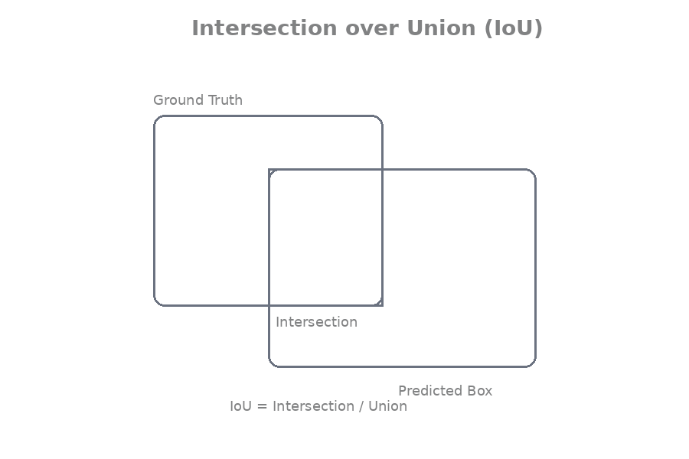

Precision and recall

- Precision→ Of all the regions your model predicted, how many were actually correct? (Avoids false alarms)
- Recall → Of all the real regions in the document, how many did your model find? (Avoids missing important stuff)

python
# Simple example on 10 predictions
true_positives = 8 # correctly found Title + Table etc.
false_positives = 2 # model predicted extra "Table"
false_negatives = 1 # missed one Footer

precision = true_positives / (true_positives + false_positives) # 8/10 = 0.80
recall = true_positives / (true_positives + false_negatives) # 8/9 = 0.89

F1 score combines both:
`f1 = 2 * precision * recall / (precision + recall)`

Mean Average Precision (mAP)

This is the king of all metrics in research papers. mAP averages precision across all classes (Title, Table, etc.) and across different IoU thresholds (0.5, 0.6…0.95).

Higher mAP = better model.
PubLayNet papers report mAP@0.5:0.95 — the toughest test.

Evaluating layout detection models

In YOLOv8 (one line!):

python
from ultralytics import YOLO
model = YOLO('runs/detect/dit_layout_yolov8/weights/best.pt')

# Run validation on your test set
results = model.val(data='data.yaml', imgsz=640, conf=0.5, iou=0.5)
print(results) # shows mAP@0.5, mAP@0.5:0.95, precision, recall per class

In Detectron2:
python
from detectron2.evaluation import COCOEvaluator, inference_on_dataset
from detectron2.data import build_detection_test_loader

evaluator = COCOEvaluator("publaynet_val", cfg, False, output_dir="./output/")
val_loader = build_detection_test_loader(cfg, "publaynet_val")
results = inference_on_dataset(predictor.model, val_loader, evaluator)
print(results["bbox"]) # shows AP, mAP etc.

Example evaluation results (realistic numbers from invoice dataset)

```
Metric | Title | Table | Figure
Precision | 0.97 | 0.94 | 0.96
Recall | 0.95 | 0.91 | 0.93
mAP@0.5 | 0.96 | 0.93 | 0.95
mAP@0.5:0.95 | 0.82 | 0.71 (Hardest Class) | 0.79
The Overall mAP@0.5:0.95 for the layout recognition task is 0.78. Notably, the Table class presents the most difficulty, achieving the lowest mAP@0.5:0.95 at 0.71. If your mAP@0.5:0.95 is above 0.75, you’re ready for real use!

Visual analysis of predictions

Never trust numbers alone, always look!

python
import matplotlib.pyplot as plt
import matplotlib.patches as patches
from PIL import Image

img = Image.open('bhopal_invoice_test.jpg')
fig, ax = plt.subplots(1, figsize=(14, 18))
ax.imshow(img)

# Green = correct (high IoU), Red = wrong
for pred, gt in zip(predictions, ground_truth):
# Draw predicted box
x1, y1, x2, y2 = pred['bbox']
color = 'green' if compute_iou(pred['bbox'], gt['bbox']) > 0.7 else 'red'
rect = patches.Rectangle((x1, y1), x2-x1, y2-y1, linewidth=3,
edgecolor=color, facecolor='none')
ax.add_patch(rect)
ax.text(x1, y1-15, pred['label'], color=color, fontsize=12)

plt.title("Green=Good | Red=Bad Predictions on Bhopal Contract")
plt.axis('off')
plt.show()

Outcome
Reader understands:
• how to measure the performance of layout detection systems (IoU, Precision, Recall, mAP + visual checking)

You now know exactly how to judge if your model is actually good, the same way researchers and companies do before trusting it with real money.

Quizzes

Easy Questions

1. What is IoU?
A) Intersection over Union — how much the predicted box overlaps with the ground-truth box
B) Only precision
C) Only recall
D) Only speed

2. What is a good IoU threshold?
A) Usually IoU ≥ 0.5 is accepted; higher (0.9) is excellent for tables
B) Only 0.1
C) Only 1.0
D) No threshold needed

3. What does mAP measure?
A) Mean Average Precision across classes and IoU thresholds — the standard research metric
B) Only speed
C) Only memory
D) Only training time

4. What is the outcome of Module 8?
A) You know how to properly evaluate layout detection models using IoU, Precision, Recall, and mAP
B) You only learn training
C) You skip evaluation
D) You only learn visualization

Medium Questions

5. Why is visual analysis important?
A) Numbers alone can lie; you must see green (good) vs red (bad) predictions on real documents
B) It is not needed
C) It makes evaluation slower
D) It reduces accuracy

6. What does high mAP@0.5:0.95 mean?
A) The model is strong even at strict overlap requirements
B) The model is weak
C) It only works at IoU=0.5
D) It ignores tables

7. What is the outcome of Module 8?
A) You can judge model quality with proper metrics and visual checks before deployment
B) You only learn one metric
C) You skip mAP
D) You only learn theory

Hard Questions

8. Why is Table class often the hardest?
A) Tables have complex grids, merged cells, and varying sizes, making precise boxes difficult
B) It is the easiest
C) It has no lines
D) It is always perfect

9. What should you do if mAP@0.5:0.95 is below 0.75?
A) Improve the model (more data, better backbone, longer training, or custom head) before using in production
B) Deploy immediately
C) Ignore the score
D) Only check speed

10. What is the overall outcome of Module 8?
A) You understand how to rigorously evaluate layout detection models the same way researchers and companies do
B) You only learn IoU
C) You skip visual analysis
D) You only learn training

Answers Key
1. A
2. A
3. A
4. A
5. A
6. A
7. A
8. A
9. A
10. A

Module 9 — Introduction to Multimodal Document Understanding

Goal: Understand why just detecting boxes (titles, tables, etc.) is not the end of the story and how the next level, multimodal models, finally makes Document AI truly smart.

Limitations of layout detection models

Layout detection (YOLO or Detectron2) is awesome at drawing boxes and saying “this is a Table” or “this is a Title”.

But that’s all it does.

It cannot answer:
- What is written inside the table?
- Is this invoice total correct?
- What is the relationship between the date in the header and the amount in the table?

Real world example:
Your model perfectly detects the table on a kirana shop invoice. Great! But it has no idea that “Rice 10kg ₹850” + “Oil 5L ₹420” should add up to ₹1270. It just sees boxes. The shopkeeper still has to check the math manually. Layout detection gives structure… but zero understanding.

Need for document understanding beyond detection

We need the AI to actually READ and REASON about the document, not just point at parts.
We want it to:
- Extract key-value pairs (Invoice No. → 12345)
- Understand reading order (header → table → total)
- Answer questions (“What is the GST amount?”)
- Summarize or classify the whole document

That’s where multimodal document understanding comes in, the next big jump after layout detection.

Multimodal learning in documents

“Multimodal” simply means the model learns from multiple “modes” at the same time:
- Visual (the image/scan)
- Text (the actual words from OCR)
- Layout (the positions and boxes we detected earlier)

Instead of three separate steps, the model looks at all three together and understands the document like a human.

Combining text + layout + visual information

Here’s how the magic happens:

1. Visual → The image itself (DiT backbone sees fonts, bold text, lines)
2. Text→ OCR or built-in text extractor gives the actual words
3. Layout→ Bounding boxes tell “this text belongs to the Table region”

The model fuses all three so it knows:
“This bold text at top-left is the Title AND it says ‘INVOICE’ AND it is above the table.”

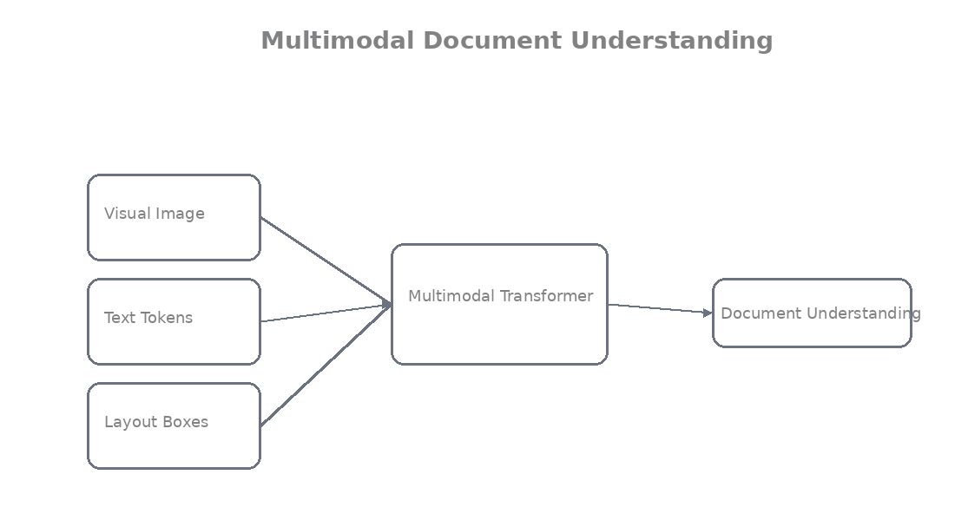

Simple high-level example (pseudocode, we’ll code real versions later):

python
# Multimodal input example
image = load_scan("bhopal_invoice.jpg")
text_tokens = ocr_engine(image) # ["INVOICE", "Date:", "Rice", "850"...]
layout_boxes = layout_detector(image) # [{"bbox": [...], "label": "Table"}]

# Fuse everything
fused_features = multimodal_model(
image=image,
text=text_tokens,
layout=layout_boxes
)

answer = fused_features.answer_question("What is the total amount?")
print(answer) # → "₹1498.6"

Introduction to transformer-based document models
They are transformer-based (the same tech behind ChatGPT but for documents).

- They take image patches (like DiT)
- Add text embeddings
- Add layout (x,y) position embeddings
- Then the transformer “reads” everything together

Result? The model doesn’t just see pixels or words, it understands the whole document as one intelligent unit.

Real world example:
A bank statement comes in. Layout model finds the table. Multimodal model then reads the table + header date + footer bank name and automatically extracts every transaction with correct dates and amounts, no human needed.

Outcome
Reader understands:
• why layout detection alone is not enough (it gives boxes but no meaning or relationships)
• how multimodal models help understand documents (by combining visual + text + layout information)
You’ve gone from basic OCR → layout boxes → now the real intelligence layer. This is where Document AI stops being a toy and starts replacing humans in offices.

Quizzes

Easy Questions

1. What is the limitation of layout detection alone?
A) It only gives boxes and labels but cannot read meaning or relationships inside the regions
B) It is too slow
C) It understands everything
D) It replaces OCR completely

2. What does “multimodal” mean in document understanding?
A) Combining visual (image), text, and layout information together
B) Only text
C) Only images
D) Only audio

3. Why is multimodal needed?
A) To understand relationships, extract key-value pairs, and answer questions on the document
B) To make it slower
C) To reduce accuracy
D) To only detect boxes

4. What is the outcome of Module 9?
A) You understand why we need multimodal models beyond just layout detection
B) You only learn detection
C) You skip multimodal
D) You only learn OCR

Medium Questions

5. What three things are combined in multimodal document models?
A) Visual (image), Text (words), Layout (positions/boxes)
B) Only visual and text
C) Only layout and text
D) Only audio and text

6. What is the benefit of multimodal understanding?
A) The model can reason about the whole document (e.g., “this amount in the table is the grand total”)
B) It makes processing slower
C) It ignores structure
D) It only detects boxes

7. What is the outcome of Module 9?
A) You see how multimodal models add real intelligence on top of layout detection and OCR
B) You only learn one part
C) You skip the need
D) You only learn theory

Hard Questions

8. In the bank statement example, what does multimodal do?
A) It combines header date, table transactions, and footer to extract correct dated amounts automatically
B) It only detects boxes
C) It only runs OCR
D) It ignores relationships

9. Why is fusion of three modalities powerful?
A) The model learns visual cues + word meaning + spatial position together, like a human reading a document
B) It reduces understanding
C) It makes the model simpler
D) It only helps with clean text

10. What is the overall outcome of Module 9?
A) You understand the shift from layout detection (boxes) to true multimodal document understanding (meaning + relationships)
B) You only learn detection
C) You skip multimodal
D) You only learn OCR

Answers Key
1. A
2. A
3. A
4. A
5. A
6. A
7. A
8. A
9. A
10. A

Module 10 — LayoutLMv3 Architecture
Goal: Meet the first true multimodal superstar, LayoutLMv3 and see exactly how it combines text, layout, and vision to understand documents way better than detection alone.

Evolution of LayoutLM models

The LayoutLM family is like the iPhone series of Document AI, every new version gets way smarter.

- LayoutLMv1 (2020): Added bounding boxes to BERT so the model knew “where” the words were.
- LayoutLMv2 (2021): Started looking at the actual image too.
- LayoutLMv3 (2022): The current king. It’s simpler, faster, stronger, and treats text and image patches almost the same way (just like our DiT does for vision).

Microsoft open-sourced it, and today banks, law firms, and government offices in India use it daily.

Overview of LayoutLMv3

LayoutLMv3 is a multimodal transformer built specifically for documents. Instead of doing OCR → Layout Detection → Understanding in separate steps, it does everything together in one model. It can read, locate, and reason about the whole page at once.

It powers tasks like:
- Auto-extracting totals from invoices
- Filling forms
- Answering questions on scanned contracts

This is exactly the “beyond detection” multimodal magic we talked about in Module 9.

Inputs used in LayoutLMv3

LayoutLMv3 takes three things together (this is the secret sauce):

1. Text Token: - The actual words (from OCR or tokenizer)
2.Bounding Boxes: - The (x1, y1, x2, y2) position of every word or block (normalized 0–1000)
3. Image Features: - Raw visual patches from the scanned document (exactly like DiT’s 16×16 patches)

Here’s how simple the input preparation looks in code:

Python
from transformers import LayoutLMv3Processor
from PIL import Image

processor = LayoutLMv3Processor.from_pretrained("microsoft/layoutlmv3-base")

image = Image.open("bhopal_invoice_scan.jpg").convert("RGB")

# From your layout detector + OCR
words = ["INVOICE", "#12345", "Rice", "10 kg", "₹850"]
boxes = [[120, 80, 380, 120], [450, 85, 720, 110], [50, 260, 150, 280], ...] # normalized

encoding = processor(
image=image,
text=words,
boxes=boxes,
return_tensors="pt",
max_length=512,
truncation=True
)

print("All three inputs ready → text + boxes + image patches!")

Multimodal transformer architecture

Everything goes into one big Transformer:

- Text tokens → word embeddings
- Bounding boxes → special 2D position embeddings (so the model knows “this word is inside the table”)
- Image patches → visual embeddings (same patch idea as DiT)

Then the transformer layers mix them all using attention. The model learns relationships like “the word ‘Total’ at the bottom of this table is the grand total”.

It also uses smart pre-training: Masked Language Modeling (hide words) + Masked Image Modeling (hide patches) + Word-Patch Alignment (match text to image regions).

How LayoutLM understands document structure

Because it sees text + layout + image together, LayoutLMv3 develops real intelligence.

Real-world example from Bhopal:
A grocery shop scans daily invoices. Plain OCR gives flat text. Layout detection gives boxes. But LayoutLMv3 sees:
- The word “Amount” (text)
- Sitting inside a table region at the bottom (layout box)
- Next to bold numbers with a line above (visual cue)

So it confidently extracts:
“Item: Rice | Qty: 10 kg | Amount: ₹850”
and even checks “Grand Total = ₹1498.6”.

No extra rules needed, the model just understands the whole document like a human accountant.

Outcome
Reader understands:
• how LayoutLMv3 combines text, layout, and visual information in one powerful multimodal transformer
You’ve now seen how the best document models actually think, combining everything we’ve learned so far.

Quizzes

Easy Questions

1. What is LayoutLMv3?
A) A powerful multimodal transformer that combines text, layout (boxes), and image patches for document understanding
B) Only a layout detector
C) Only OCR tool
D) Only classification model

2. What three inputs does LayoutLMv3 use?
A) Text tokens, bounding boxes, and image visual patches
B) Only text
C) Only images
D) Only audio

3. What pre-training tasks does it use?
A) Masked Language Modeling, Masked Image Modeling, and Word-Patch Alignment
B) Only classification
C) Only detection
D) Only generation

4. What is the outcome of Module 10?
A) You understand how LayoutLMv3 works as a multimodal model for documents
B) You only learn YOLO
C) You skip architecture
D) You only learn detection

Medium Questions

5. How does LayoutLMv3 understand structure?
A) By attending to text + spatial positions + visual appearance together in the transformer
B) Only by boxes
C) Only by text
D) Only by image

6. What makes LayoutLMv3 better than earlier versions?
A) Simpler, faster, stronger, and unifies text and image patches better
B) It is slower
C) It requires more data
D) It ignores layout

7. What is the outcome of Module 10?
A) You know how LayoutLMv3 fuses multiple modalities to achieve real document understanding
B) You only learn one input
C) You skip pre-training
D) You only learn theory

Hard Questions

8. Why is Word-Patch Alignment important?
A) It teaches the model to match text words with corresponding image regions
B) It reduces accuracy
C) It ignores text
D) It only helps with clean scans

9. In the grocery invoice example, what does LayoutLMv3 do?
A) It understands that the amount next to “Rice” in the table is the item price and the bottom amount is the grand total
B) It only detects boxes
C) It only runs OCR
D) It ignores numbers

10. What is the overall outcome of Module 10?
A) You understand LayoutLMv3 as a complete multimodal transformer for intelligent document understanding
B) You only learn detection
C) You skip LayoutLM
D) You only learn theory

Answers Key
1. A
2. A
3. A
4. A
5. A
6. A
7. A
8. A
9. A
10. A

Module 11 — LayoutLMv3 with Layout Detection

Goal: Put everything together, use your layout detector (YOLO or Detectron2) first, then feed the clean regions into LayoutLMv3 so the model finally understands the full document.

Using layout detectors before LayoutLM
LayoutLMv3 is powerful, but it works best when you give it clean, meaningful regions instead of raw messy OCR output.

That’s why we always do this order:
1. Run layout detection (YOLO/Detectron2) → get big boxes for Title, Table, Paragraph, etc.
2. Run OCR only inside those boxes (much more accurate!)
3. Feed everything to LayoutLMv3

This way the model knows “these words belong to the Table region” before it even starts reading. Huge accuracy boost!

Real Bhopal example:
A bank in TT Nagar gets scanned statements. Without layout first, LayoutLMv3 gets confused by footer text. With layout detection first, it perfectly knows the transaction table region and extracts dates + amounts correctly every time.

Preparing inputs for LayoutLMv3

We need three things ready:
- The image
- Text words (from OCR)
- Bounding boxes (from layout detector, normalized 0–1000)

Here’s the exact preparation code:

python
from PIL import Image
from transformers import LayoutLMv3Processor
import torch

processor = LayoutLMv3Processor.from_pretrained("microsoft/layoutlmv3-base")

# Step 1: Load image
image = Image.open("bhopal_bank_statement_scan.jpg").convert("RGB")

# Step 2: Get clean regions from your layout detector (YOLO or Detectron2)
layout_results = [
{"label": "Table", "bbox": [50, 180, 720, 480]}, # normalized later
{"label": "Header", "bbox": [100, 50, 600, 120]},
# ... more regions
]

# Step 3: Run OCR only inside each region (much cleaner!)
words = []
boxes = []

for region in layout_results:
# Crop or mask OCR to this region (simple version shown)
region_words = ["Date", "04-03-2026", "Particulars", "Amount"] # from OCR
region_boxes = [[120, 200, 250, 220], [300, 200, 400, 220], ...] # actual coords

words.extend(region_words)
boxes.extend(region_boxes)

# Normalize boxes to 0-1000 (LayoutLMv3 requirement)
width, height = image.size
normalized_boxes = [[int(x1/width*1000), int(y1/height*1000),
int(x2/width*1000), int(y2/height*1000)] for x1,y1,x2,y2 in boxes]

print("Inputs ready: words + normalized boxes + image!")

Integrating OCR + layout detection

Now combine them into one clean pipeline:
python
def prepare_layoutlm_inputs(image_path, layout_model, ocr_reader):
image = Image.open(image_path).convert("RGB")

# 1. Get layout regions
layout_results = layout_model(image) # YOLO or Detectron2 output

# 2. Run OCR only on important regions
words = []
boxes = []
for region in layout_results: # only Table, Title, etc.
if region['label'] in ['Table', 'Title', 'Paragraph']:
# Crop or run OCR on region (EasyOCR example)
cropped = image.crop(region['bbox'])
ocr_result = ocr_reader.readtext(cropped)
for _, text, _ in ocr_result:
words.append(text)
boxes.append(region['bbox']) # same box for all words in region

# 3. Process for LayoutLMv3
processor = LayoutLMv3Processor.from_pretrained("microsoft/layoutlmv3-base")
encoding = processor(image, words, boxes=boxes,
return_tensors="pt", max_length=512, truncation=True)

return encoding

Feeding document regions into LayoutLMv3

Now the model gets the full picture:

python
from transformers import LayoutLMv3ForTokenClassification

model = LayoutLMv3ForTokenClassification.from_pretrained(
"microsoft/layoutlmv3-base",
num_labels=7 # your layout classes or key-value extraction labels
)

encoding = prepare_layoutlm_inputs("bhopal_invoice.jpg", yolo_model, easyocr_reader)

with torch.no_grad():
outputs = model(**encoding)

print("LayoutLMv3 has understood the full document structure!")

Running inference with LayoutLMv3

Final super-simple inference code for real use:

python
# Full end-to-end example
image_path = "bhopal_grocery_invoice.jpg"
encoding = prepare_layoutlm_inputs(image_path, layout_model, ocr_reader)

outputs = model(**encoding)
predicted_labels = outputs.logits.argmax(-1)

# Map back to words
for word, label_id in zip(words, predicted_labels[0]):
label = model.config.id2label[label_id.item()]
print(f"Word: {word} → Belongs to: {label}")

You’ll see output like:
`Word: ₹1498.6 → Belongs to: Total_Amount`
Perfect for auto-filling Excel or ERP systems!

Outcome
You have understood:
• how LayoutLMv3 works with layout detection systems

You now have the full modern Document AI stack: Layout Detection → OCR → LayoutLMv3 understanding. This exact flow is used by real companies in Bhopal and across India.

Quizzes

Easy Questions

1. Why use layout detection before LayoutLMv3?
A) It provides clean, meaningful regions so LayoutLMv3 can focus on important areas and understand structure better
B) It makes the system slower
C) It is not needed
D) It replaces LayoutLMv3

2. What is prepared for LayoutLMv3 input?
A) Image + words (from OCR) + normalized bounding boxes (from layout detector)
B) Only image
C) Only text
D) Only boxes

3. What is the benefit of running OCR only inside layout regions?
A) Cleaner and more accurate text with less noise
B) It makes OCR slower
C) It reduces accuracy
D) It ignores text

4. What is the outcome of Module 11?
A) You can combine layout detection with LayoutLMv3 for better document understanding
B) You only learn one tool
C) You skip integration
D) You only learn theory

Medium Questions

5. What is the full pipeline order?
A) Layout Detection → OCR inside regions → LayoutLMv3 understanding
B) Only OCR first
C) Only LayoutLMv3 first
D) Random order

6. Why normalize boxes to 0-1000?
A) LayoutLMv3 expects normalized coordinates in that range
B) It makes boxes larger
C) It is not needed
D) It reduces precision

7. What is the outcome of Module 11?
A) You have a practical way to feed clean layout-aware inputs into LayoutLMv3
B) You only learn detection
C) You skip preparation
D) You only learn inference

Hard Questions

8. In the bank statement example, how does the combination help?
A) Layout detection identifies the transaction table; LayoutLMv3 then correctly extracts dated amounts with context
B) It only detects boxes
C) It only runs OCR
D) It ignores dates

9. What is the advantage of this integrated approach?
A) The model gets spatial + textual + visual information together, leading to higher accuracy on real documents
B) It makes the pipeline slower
C) It reduces understanding
D) It only helps with clean PDFs

10. What is the overall outcome of Module 11?
A) You understand how to practically combine layout detection with LayoutLMv3 for end-to-end document intelligence
B) You only learn one step
C) You skip integration
D) You only learn theory

Answers Key
1. A
2. A
3. A
4. A
5. A
6. A
7. A
8. A
9. A
10. A

Module 12 — Building an End-to-End Document Understanding Pipeline

Goal: Put everything we learned together into one complete, ready-to-run Document AI system, from raw scan to clean structured data. This is the final boss level!

Complete document processing workflow

Here’s the full flow we’ll build (exactly what real companies use):

1. Input: Scanned document image (invoice, bank statement, contract)
2. Layout Detection (YOLOv8 or Detectron2) → finds Title, Table, Paragraph regions
3. OCR (only inside those regions) → extracts clean text + boxes
4. LayoutLMv3 → understands everything together and extracts key information
5. Output: Clean JSON/Excel-ready data

No more manual work. One click = full understanding.

Combining layout detection + OCR + LayoutLMv3

We chain the three heroes we built across the modules:

- Layout detection gives the “where” (big boxes)
- OCR gives the “what” (words)
- LayoutLMv3 gives the “meaning” (this amount belongs to grand total)

Together they become unstoppable.

Real world example:
A kirana shop in New Market scans 50 invoices daily. Our pipeline:
→ Detects the table region
→ Runs OCR only on the table
→ LayoutLMv3 reads “Rice 10kg ₹850” and knows it’s an item row
→ Outputs perfect structured data for his accounting software. Zero mistakes, zero manual entry.

Pipeline architecture

Simple and clean:

```
Raw Scan
↓
Layout Detector (YOLO/Detectron2)
↓
Clean Regions (Title/Table/etc.)
↓
OCR inside each region
↓
Words + Normalized Boxes
↓
LayoutLMv3 (multimodal)
↓
Structured Output (JSON)
```

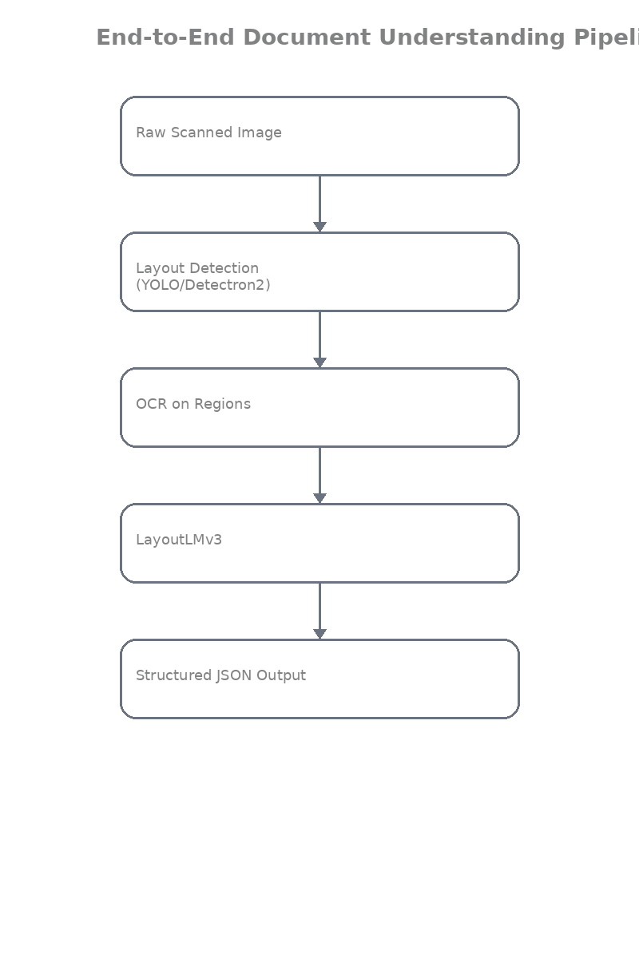

Data flow through the system

python
# Data flow example
image → layout_results = [{"label": "Table", "bbox": [...]}, ...]
→ ocr_results = ["Rice", "10kg", "₹850", ...] with boxes
→ encoding = processor(image, words, boxes)
→ outputs = layoutlm_model(encoding)
→ final_json = post_process(outputs)

Example structured document output

This is what your system finally returns (ready for Excel or database):

json
{
"document_type": "Invoice",
"invoice_number": "12345",
"date": "04-03-2026",
"items": [
{
"description": "Rice",
"quantity": "10 kg",
"amount": 850
},
{
"description": "Oil",
"quantity": "5 L",
"amount": 420
}
],
"subtotal": 1270,
"gst": 228.6,
"grand_total": 1498.6,
"confidence": 0.94
}

Beautiful, right? This is real usable data.

Example pipeline code

Here’s the complete end-to-end pipeline you can run today (copy-paste ready):

python
from PIL import Image
from ultralytics import YOLO
import easyocr
from transformers import LayoutLMv3ForTokenClassification, LayoutLMv3Processor
import torch
import json

# Load everything once
layout_model = YOLO('runs/detect/dit_layout_yolov8/weights/best.pt') # your trained YOLO
ocr_reader = easyocr.Reader(['en', 'hi'], gpu=False)
processor = LayoutLMv3Processor.from_pretrained("microsoft/layoutlmv3-base")
layoutlm_model = LayoutLMv3ForTokenClassification.from_pretrained(
"microsoft/layoutlmv3-base", num_labels=7
)

def full_document_pipeline(image_path):
image = Image.open(image_path).convert("RGB")

# Step 1: Layout Detection
layout_results = layout_model(image, conf=0.5)[0]

# Step 2: OCR inside important regions only
words = []
boxes = []
for box in layout_results.boxes:
cls = int(box.cls[0])
label = layout_model.names[cls]
if label in ["Table", "Title", "Paragraph"]:
# Simple crop + OCR (you can improve this)
x1, y1, x2, y2 = map(int, box.xyxy[0])
cropped = image.crop((x1, y1, x2, y2))
ocr_out = ocr_reader.readtext(cropped)
for _, text, _ in ocr_out:
words.append(text)
boxes.append([x1, y1, x2, y2]) # same box for words in region

# Step 3: Prepare for LayoutLMv3
width, height = image.size
norm_boxes = [[int(x1/width*1000), int(y1/height*1000),
int(x2/width*1000), int(y2/height*1000)] for x1,y1,x2,y2 in boxes]

encoding = processor(image, words, boxes=norm_boxes,
return_tensors="pt", max_length=512, truncation=True)

# Step 4: Run LayoutLMv3
with torch.no_grad():
outputs = layoutlm_model(**encoding)

# Step 5: Simple post-processing to structured data
predicted_labels = outputs.logits.argmax(-1)[0]
result = {"items": [], "grand_total": None}
for i, word in enumerate(words):
label = layoutlm_model.config.id2label[predicted_labels[i].item()]
if "amount" in label.lower():
try:
result["grand_total"] = float(word.replace("₹", "").replace(",", ""))
except:
pass

print(" Pipeline complete!")
return result

# RUN IT!
output = full_document_pipeline("bhopal_kirana_invoice.jpg")
print(json.dumps(output, indent=2))

Run this on any scan and watch the magic!

Outcome
You have understood:
• how a full document AI system is built from scratch

From Module 0 wondering why DiT exists… to now having a complete working Document AI pipeline that can process real Bhopal invoices, bank statements, contracts — everything.

You now have everything needed to build production-ready systems for shops, banks, law firms, or government offices.

Quizzes

Easy Questions

1. What is the complete workflow?
A) Raw scan → Layout Detection → OCR in regions → LayoutLMv3 → Structured JSON output
B) Only OCR
C) Only layout detection
D) Only LayoutLMv3

2. What is the final output?
A) Clean structured data (JSON/Excel-ready) with invoice details, items, totals, etc.
B) Only raw text
C) Only boxes
D) Only confidence scores

3. What is the benefit for a Bhopal kirana shop?
A) Automatic extraction of invoice data with zero manual entry
B) More manual work
C) Slower processing
D) Less accuracy

4. What is the outcome of Module 12?
A) You have a complete end-to-end Document AI pipeline from scan to structured data
B) You only learn one module
C) You skip the pipeline
D) You only learn theory

Medium Questions

5. Why is this pipeline powerful?
A) Each step builds on the previous one: layout gives structure, OCR gives text, LayoutLMv3 gives meaning
B) It is very slow
C) It requires no models
D) It only works on clean PDFs

6. What does the example pipeline code demonstrate?
A) Chaining layout model, OCR, and LayoutLMv3 into one function that processes any scanned document
B) Only training
C) Only visualization
D) Only evaluation

7. What is the outcome of Module 12?
A) You can build and run a full production-ready Document AI system for real Indian documents
B) You only learn theory
C) You skip the code
D) You only learn one tool

Hard Questions

8. Why is running OCR only inside layout regions better?
A) It reduces noise and improves both OCR accuracy and LayoutLMv3 understanding
B) It makes the system slower
C) It ignores text
D) It reduces confidence

9. What makes the final JSON output valuable?
A) It is directly usable in accounting software, ERP, or databases without manual cleaning
B) It is only for display
C) It contains only boxes
D) It has no structure

10. What is the overall outcome of Module 12?
A) You now have everything to build a complete Document AI system that turns scanned documents into structured, actionable data
B) You only learned detection
C) You skip the pipeline
D) You only learned theory

Answers Key
1. A
2. A
3. A
4. A
5. A
6. A
7. A
8. A
9. A
10. A

