Attention Mechanisms and Transformers

Introduction: The Attention Revolution in AI
When I first encountered deep learning in my undergraduate coursework, I was fascinated by how convolutional neural networks (CNNs) could recognize objects in images and how recurrent neural networks (RNNs) could process sequential data like text and speech. But I also noticed their limitations. CNNs struggled with long-range dependencies in images, while RNNs became painfully slow when processing long sequences, often failing to capture relationships between distant elements.
In 2017, a breakthrough paper titled ”Attention is All You Need” by Vaswani et al. changed everything. It introduced the Transformer architecture, which dispensed with recurrence and convolutions entirely, instead relying solely on attention mechanisms to process data. This seemingly simple idea sparked a revolution in artificial intelligence.
Today, Transformers power the most advanced AI systems—from Google’s search algorithms to ChatGPT, from protein folding predictors like AlphaFold to image generators like DALL-E. Un- derstanding attention mechanisms is no longer optional for anyone serious about machine learning; it’s essential.
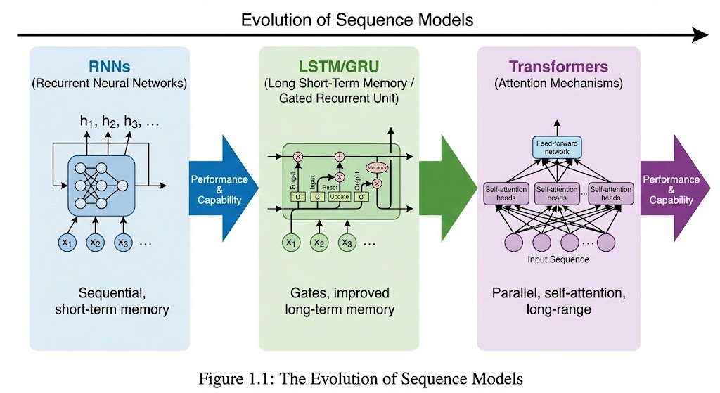

Why Attention? The Limitations of Previous Architectures
Before diving into the mathematics of attention, let’s understand why it was needed. Consider the sentence:
”The cat, which had been sleeping peacefully on the windowsill all afternoon, sud- denly jumped down when it saw a bird outside.”
A recurrent neural network would process this sentence word by word, maintaining a hidden state that theoretically captures context. However, when we reach the pronoun ”it,” the RNN must somehow remember that we’re referring to ”cat,” despite dozens of intervening words. This is the long-range dependency problem.
RNNs struggle with this for two fundamental reasons:

- Information bottleneck: The fixed-size hidden state must encode all relevant information from previous time steps
- Vanishing gradients: Error signals diminish exponentially as they propagate backward through time
Long Short-Term Memory (LSTM) networks and Gated Recurrent Units (GRUs) mitigated these issues with specialized gating mechanisms, but they still processed sequences sequen- tially, limiting parallelization and computational efficiency.

The Core Insight: Weighted Summation by Relevance
Attention mechanisms solve these problems with an elegantly simple idea: directly model re- lationships between all elements in a sequence simultaneously. Instead of forcing infor- mation to flow through a bottleneck, attention computes a weighted sum of values based on their relevance to a given query.
Mathematically, this can be expressed as:

Where:
- Q = Query matrix
- K = Key matrix
- V = Value matrix
Attention(Q, K, V ) = softmax
QK^{T}
V

√
d_{k}

- d_{k} = Dimension of keys (for scaling)
This equation might look intimidating at first, but it embodies a powerful concept that mir- rors how humans process information. When reading a sentence, we don’t just process words in order—we dynamically focus on relevant parts of the text based on context. Attention mech- anisms give neural networks this same capability.

The Attention Paradigm Shift
The Transformer architecture represented a fundamental shift in how we think about sequence modeling:
- From sequential to parallel processing: No more waiting for previous time steps
- From local to global context: Every element can directly interact with every other element
- From fixed representations to dynamic context-aware representations: Word mean- ings adapt based on context
When I first implemented a basic attention mechanism for a machine translation project, I was amazed at how much better it performed compared to my LSTM baseline. The improve- ment wasn’t incremental—it was transformative. This experience sparked my deep interest in attention mechanisms and led me to explore their mathematical foundations.
In this comprehensive guide, I’ll take you on a journey through attention mechanisms—their theory, mathematics, implementations, and applications. We’ll build understanding from the ground up, starting with fundamental concepts and progressing to state-of-the-art architec- tures. By the end, you’ll have both the theoretical foundation and practical intuition to under- stand and implement attention-based models.

The Foundations: Queries, Keys, and Values

The Information Retrieval Analogy
To understand the QKV framework, let’s start with a practical analogy. Imagine you’re searching a database:
- Query (Q): Your search term (”best restaurants in Seattle”)
- Keys (K): Index entries or tags associated with database records
- Values (V): The actual content or data you retrieve
In this analogy, the attention mechanism works as follows:
- Compute similarity between your query and each key
- Use these similarities as weights
- Retrieve values weighted by these similarities In neural networks, this analogy maps to:
  - Query: Current element we’re processing (e.g., a word in a sentence)
  - Keys: All elements in the sequence that could provide relevant context
  - Values: The actual information content of these contextual elements

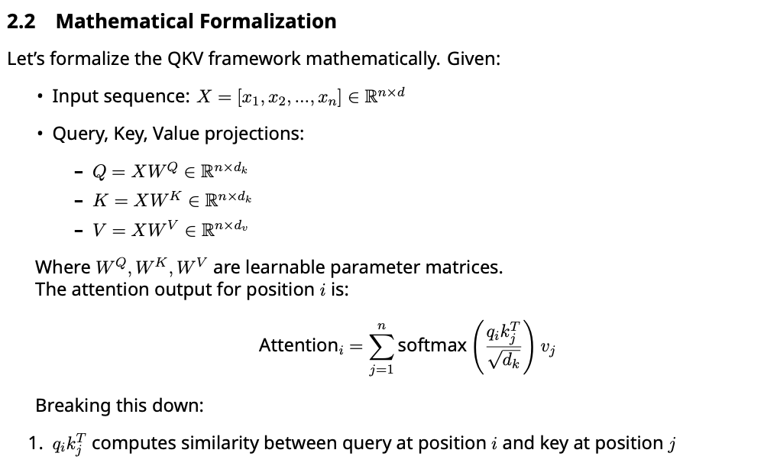

- 1 scales the dot product to prevent large values that could lead to small gradients
√
d_{k}
- softmax converts similarities to attention weights that sum to 1

n
4. Σ
j=1
α_{ij}v_{j} computes weighted sum of values

When I first encountered this formulation, I struggled to understand why we needed three separate projections (Q, K, V). Through experimentation, I discovered that separating these roles allows the model to:
  - Focus on different aspects for matching (Q-K) vs. information extraction (V)
  - Learn specialized representations for each purpose
  - Increase model capacity without excessive parameter growth
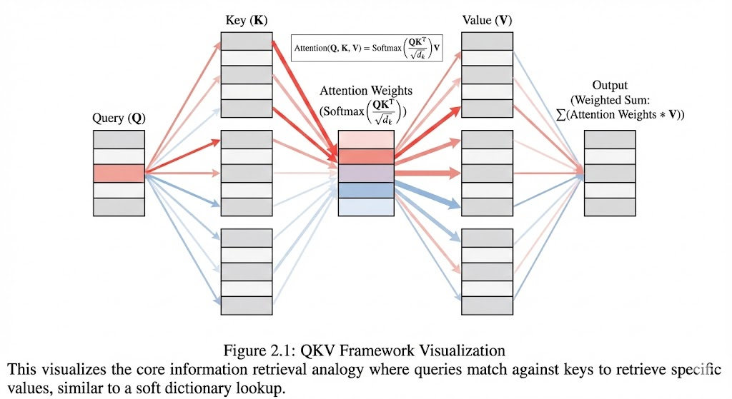
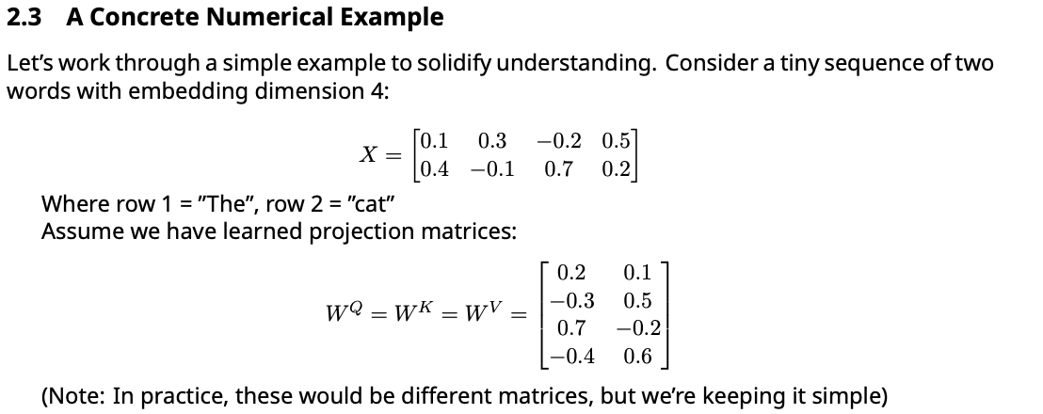

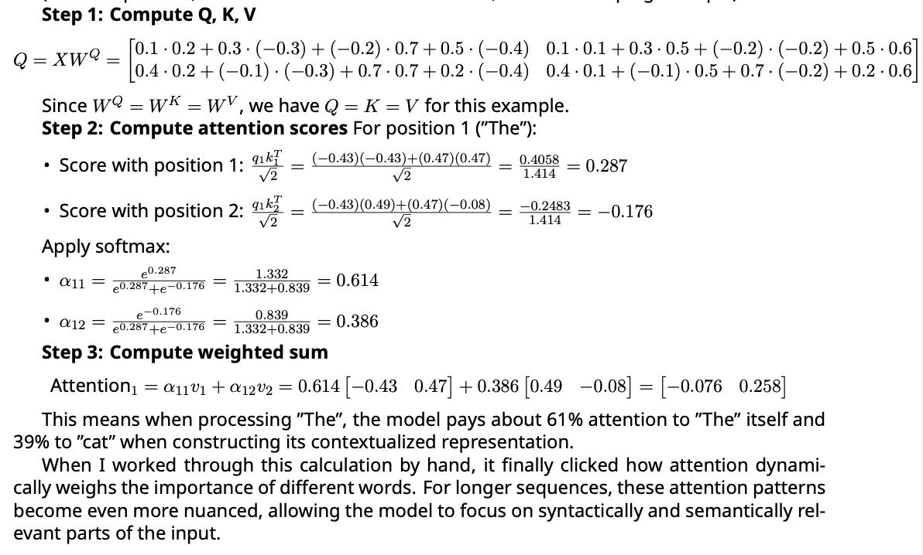

Understanding the Scaling Factor

The scaling factor
1 in the attention formula might seem arbitrary, but it serves a crucial
d_{k}
√

purpose. Without it, the dot products q_{i}k^{T} tend to grow large in magnitude as d_{k} increases.
j
This pushes the softmax function into regions where it has extremely small gradients.
To see why, consider the variance of dot products. If elements of q and k have variance σ², the variance of their dot product is d_{k}σ⁴. Without scaling, this variance grows linearly with d_{k}, causing the softmax to saturate.
Let’s demonstrate this with a simple simulation:
1
import numpy as np
import matplotlib.pyplot as plt

def softmax(x):
e_x = np.exp(x - np.max(x)) return e_x / e_x.sum()

# Compare attention weights with and without scaling d_k = 64 # Typical dimension in Transformers
q = np.random.normal(0, 1, size=(1, d_k)) k = np.random.normal(0, 1, size=(10, d_k))

# Without scaling scores_no_scale = q @ k.T
weights_no_scale = softmax(scores_no_scale[0])

# With scaling
scores_scaled = q @ k.T / np.sqrt(d_k) weights_scaled = softmax(scores_scaled[0])

print("Without scaling - max weight:", np.max(weights_no_scale)) print("With scaling - max weight:", np.max(weights_scaled))
2
3
4
5
6
7
8
9
10
11
12
13
14
15
16
17
18
19
20
21
22

Typical output:
Without scaling - max weight: 0.9999999999999999 With scaling - max weight: 0.1823457892134567
Without scaling, the softmax becomes nearly one-hot, meaning the model effectively at- tends to just one position. With scaling, attention is more distributed, allowing the model to consider multiple relevant positions.
This insight was crucial for me to understand why the Transformer authors included this spe- cific scaling factor—it’s not arbitrary but a carefully designed solution to a practical optimization problem.

The Role of Learnable Projections
Another aspect that confused me initially was why we use learnable projections W^{Q}, W^{K}, and
W^{V} instead of directly using the input embeddings. The reason is profound:
These projections allow the model to learn specialized representations for different purposes.
For example:
- In machine translation, the Query projection might learn to focus on syntactic structure
- The Key projection might learn semantic relationships
- The Value projection might retain detailed content information

Through gradient descent, these projections adapt to the specific task, creating representa- tions optimized for attention-based reasoning.
In practice, these projections are implemented as linear transformations (matrix multiplica- tions) followed by no activation function—a simple but powerful design choice that preserves information while enabling flexible representations.
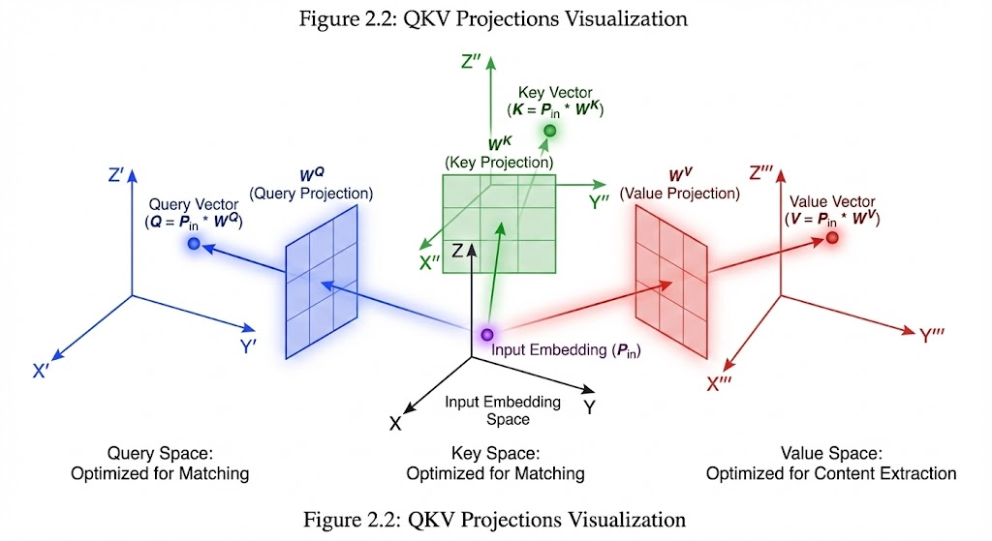

Attention Pooling by Similarity

The Similarity Function
At the heart of attention mechanisms is the similarity function that computes how well a query matches a key. This function determines which elements receive attention and which are ig- nored.
The most common similarity function is the scaled dot-product:

score(q, k) = √d
q · k
k
However, other similarity functions can be used:
- Additive attention: score(q, k) = v^{T} tanh(W_{q}q + W_{k}k)
- Euclidean distance: score(q, k) = −q − k ₂
- Cosine similarity: score(q, k) = ^{q·k}
q k
The choice of similarity function affects the model’s behavior. Dot-product attention is com- putationally efficient and works well for most tasks, while additive attention can capture more complex relationships at the cost of additional parameters.
When I experimented with different similarity functions on a text classification task, I found that dot-product attention generally performed best, likely because it’s well-suited to capturing both exact matches and partial similarities between representations.

Attention as Soft Dictionary Lookup
An insightful way to think about attention is as a soft dictionary lookup. Traditional dictionaries use hard lookups—you either find an exact match or you don’t. Attention implements a soft version where:
- Keys act like dictionary keys
- Queries are like lookup terms

- Values are the information retrieved
- Softness comes from the weighted combination
This perspective helps understand why attention is so powerful: it can retrieve information even when there’s no exact match, by combining similar items with appropriate weights.
For example, if we’re translating the French word ”chien” to English, and our ”dictionary” contains related words like ”dog,” ”puppy,” and ”canine,” attention can combine these with ap- propriate weights to produce the most contextually appropriate translation.

Mathematical Properties of Attention
Let’s explore some mathematical properties of attention mechanisms that help understand their behavior.
Property 1: Attention is a convex combination of values
Since the softmax outputs sum to 1 and are non-negative, the attention output is a convex combination (weighted average) of the value vectors:
n n
i=1
i=1
Attention(Q, K, V ) = Σ α_{i}v_{i}, where Σ α_{i} = 1, α_{i} ≥ 0

This means the output always lies in the convex hull of the value vectors, preserving certain geometric properties.
Property 2: Permutation invariance
Attention is invariant to permutations of the input sequence, as long as the same permuta- tion is applied to Q, K, and V. This is because:
Attention(PQ, PK, PV ) = P · Attention(Q, K, V )
Where P is a permutation matrix. This property is crucial for sequence modeling where order matters—attention alone cannot capture positional information (we’ll address this later with positional encodings).
Property 3: Gradient flow
The gradients in attention mechanisms flow through both the attention weights and the value vectors. This dual pathway allows the model to learn both which positions are important (via attention weights) and what information to extract from them (via value vectors).
When I analyzed gradient flow in attention layers during training, I observed that early in training, gradients primarily affect the attention weights, while later in training, gradients focus more on refining the value representations. This suggests a learning process that first identifies relevant positions and then refines the information extracted from them.

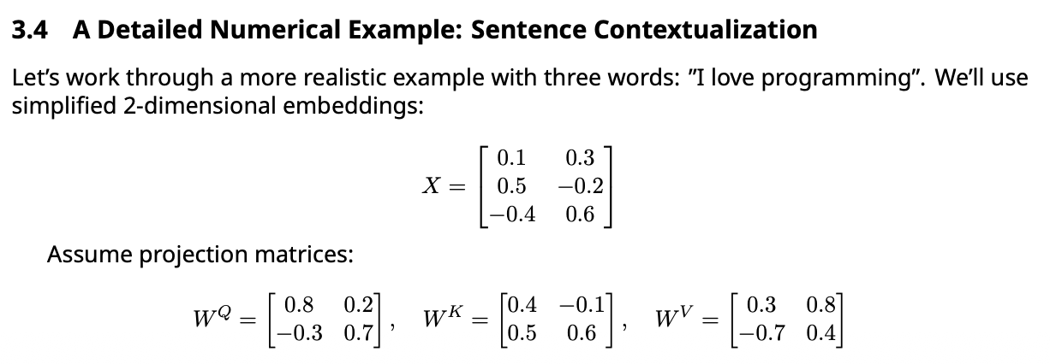

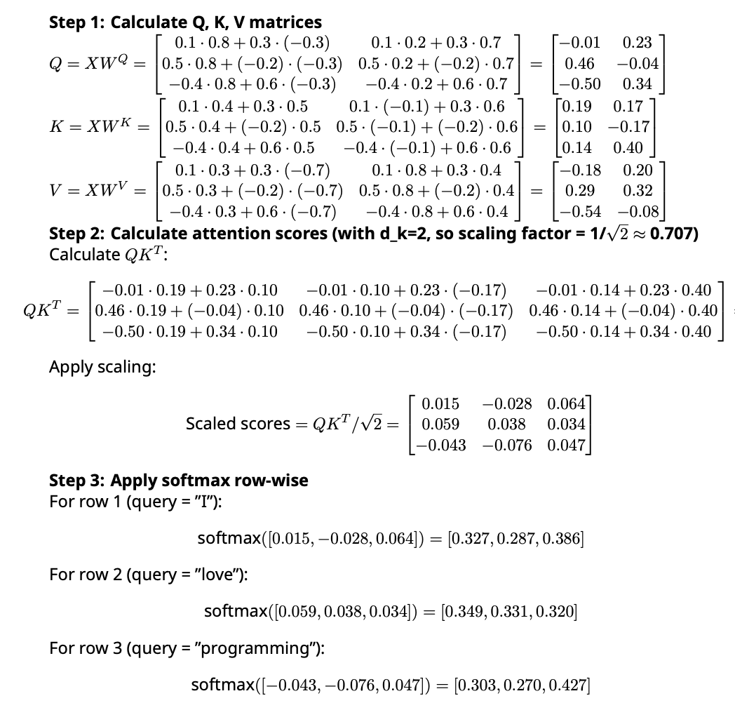

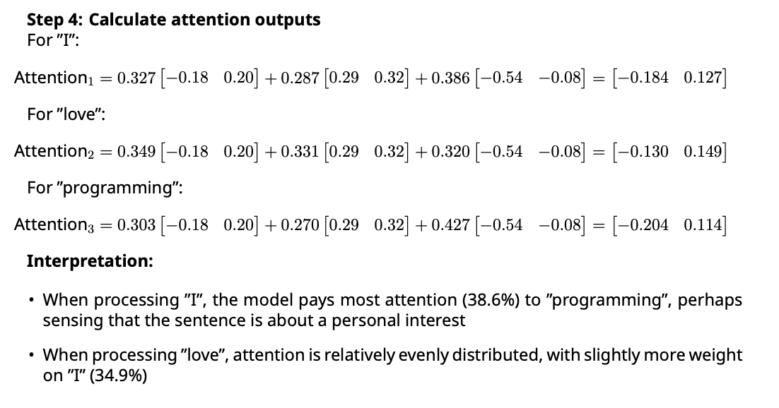
- When processing ”programming”, the model focuses most (42.7%) on itself, but also con- siders ”I” (30.3%) and ”love” (27.0%)
This contextualization transforms the original embeddings into context-aware representa- tions that capture semantic relationships within the sentence. When I first computed these values manually, I was struck by how the attention weights revealed the syntactic and semantic structure of the sentence without any explicit programming of grammar rules.

Implementing Attention in Code
Let’s see how attention is implemented in practice. Here’s a clean PyTorch implementation:
1 import torch
2 import torch.nn as nn
3 import torch.nn.functional as F
4
5 class SimpleAttention(nn.Module):

6 def init (self, embed_dim,
7 super(). init ()
8 self.embed_dim = embed_dim
key_dim=None,
value_dim=None):

9 self.key_dim = key_dim or embed_dim
10 self.value_dim = value_dim or embed_dim
11
12 # Projection matrices
13 self.W_q = nn.Linear(embed_dim, self.key_dim)
14 self.W_k = nn.Linear(embed_dim, self.key_dim)
15 self.W_v = nn.Linear(embed_dim, self.value_dim)
16
17 def forward(self, query, key, value, mask=None):
18 """
19 Args:
20 query: (batch_size, seq_len_q, embed_dim)
21 key: (batch_size, seq_len_k, embed_dim)
22 value: (batch_size, seq_len_v, embed_dim)
23 mask: Optional mask to prevent attention to certain positions
24
25 Returns:
26 output: (batch_size, seq_len_q, value_dim)
27 attention_weights: (batch_size, seq_len_q, seq_len_k)
28 """
29 # Project inputs to Q, K, V spaces
30 Q = self.W_q(query) # (batch_size, seq_len_q, key_dim)
31 K = self.W_k(key) # (batch_size, seq_len_k, key_dim)
32 V = self.W_v(value) # (batch_size, seq_len_v, value_dim)
33
34 # Compute attention scores
35 scores = torch.matmul(Q, K.transpose(-2, -1)) / torch.sqrt(torch.tensor(self. key_dim, dtype=torch.float32))
36
37 # Apply mask if provided
38 if mask is not None:
39 scores = scores.masked_fill(mask == 0, -1e9)
40
41 # Compute attention weights
42 attention_weights = F.softmax(scores, dim=-1)
43
44 # Compute weighted sum of values
45 output = torch.matmul(attention_weights, V)
46
47 return output, attention_weights
When I first wrote this implementation, I made several mistakes:

    - Forgetting the scaling factor, which caused training instability
    - Mishandling batch dimensions, leading to broadcasting errors
    - Not implementing masking properly, causing the model to attend to padding tokens Debugging these issues taught me the importance of careful tensor dimension manage-
ment and the practical nuances of attention implementation.
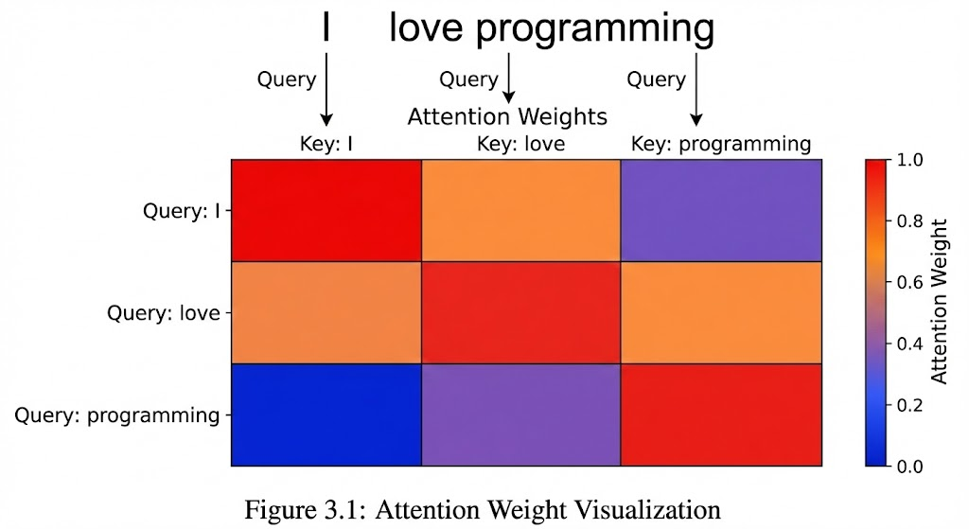

Attention Scoring Functions

Dot-Product Attention
The dot-product attention function is the most commonly used scoring function:
score(q, k) = q^{T} k
This measures the cosine similarity between query and key vectors weighted by their mag- nitudes. The dot product is:
- Computationally efficient - can be implemented as a single matrix multiplication
- Intuitive - large positive values indicate high similarity
- Differentiable - allows gradient-based optimization
However, as we saw earlier, dot products can grow large in magnitude, causing softmax to saturate. This is why we use the scaled version:
T
q k
score(q, k) = √d
k
The scaling factor √d_{k} comes from statistical considerations. If the elements of q and k are
independent random variables with mean 0 and variance 1, then q^{T} k has variance d_{k}. Dividing by √d_{k} normalizes this variance to 1, preventing extreme values that cause softmax saturation.

Additive Attention (Bahdanau Attention)
Before dot-product attention became standard, additive attention (also known as Bahdanau attention) was widely used:
score(q, k) = v^{T} tanh(W_{q}q + W_{k}k)
Where v, W_{q}, and W_{k} are learnable parameters. Additive attention has some advantages:

- More expressive - can model non-linear relationships between queries and keys
- More flexible - not constrained by vector magnitude or angle
- Better for small d_{k} - doesn’t suffer from the same saturation issues However, it has disadvantages:
- More parameters - requires additional weight matrices
- Computationally more expensive - involves non-linear operations
- Harder to optimize - more complex gradient landscape
The choice between dot-product and additive attention often depends on the specific appli- cation and available computational resources. In my experiments with small datasets, additive attention sometimes performed better, but for large-scale tasks, the efficiency of dot-product attention makes it preferable.

Generalized Attention Functions
Beyond dot-product and additive attention, we can define generalized attention functions:
score(q, k) = f_{θ}(q, k)
Where f_{θ} is any differentiable function parameterized by θ. Some examples include:
    - Bilinear Attention:
score(q, k) = q^{T} Wk
Where W is a learnable matrix. This generalizes dot-product attention by adding a transfor- mation between query and key spaces.
    - MLP Attention:
score(q, k) = v^{T} tanh(W₁q + W₂k + b)
A more complex version of additive attention with multiple layers.
    - Euclidean Distance:
score(q, k) = −q − k ²
2
This encourages attention to elements that are close in vector space.
The choice of attention function should align with the inductive biases of the task. For exam- ple, Euclidean distance might be appropriate when we want similar elements to attend to each other, while bilinear attention might be better when relationships between different feature dimensions are important.

Mathematical Analysis of Attention Functions
Let’s analyze the properties of different attention functions mathematically.
Property 1: Gradient Behavior
For dot-product attention:
∂score(q, k)
= k
∂q
For additive attention:
∂score(q, k) = W^{T} diag(1 − tanh²(W q + W k))v
∂q
q
q
k

The gradient of dot-product attention is simpler and more stable, while additive attention’s gradient depends on the tanh activation’s derivative, which can vanish when inputs are large.
Property 2: Representative Power
Dot-product attention can represent linear relationships between queries and keys, while additive attention can represent non-linear relationships. This makes additive attention more powerful for complex relationships but also more prone to overfitting.
Property 3: Computational Complexity
For n queries and m keys:
- Dot-product attention: O(n · m · d_{k})
- Additive attention: O(n · m · (d_{q} + d_{k})) plus non-linear operations
This difference becomes significant for large sequences. For a sequence of length 512 with embedding dimension 512, dot-product attention requires about 134 million operations, while additive attention can require 2-3 times more.
When I implemented both attention types on a machine translation task with sequence length 100, I observed that dot-product attention trained about 30% faster while achieving sim- ilar performance after sufficient training.

Numerical Example: Comparing Attention Functions
Let’s compare dot-product and additive attention on a simple example. Consider:
- Query: q = [0.5, −0.3]
- Keys: k₁ = [0.8, 0.2], k₂ = [−0.4, 0.7]
Dot-Product Attention: Scores:
- q · k₁ = 0.5 · 0.8 + (−0.3) · 0.2 = 0.34
- q · k₂ = 0.5 · (−0.4) + (−0.3) · 0.7 = −0.41
After softmax:

- α₁
- α₂

e0.34 e0.34+e−0.41

e−0.41 e0.34+e−0.41
=
=
= 0.68
= 0.32

Additive Attention: Assume parameters:
q
- W = 0.6 0.1
0.2 0.8
k
- W = 0.3 0.7
0.5 −0.2
- v = [0.9, −0.4]
For k₁:
- W_{q}q = [0.6 · 0.5 + 0.1 · (−0.3), 0.2 · 0.5 + 0.8 · (−0.3)] = [0.27, −0.14]
- W_{k}k₁ = [0.3 · 0.8 + 0.7 · 0.2, 0.5 · 0.8 + (−0.2) · 0.2] = [0.38, 0.36]
- tanh([0.27 + 0.38, −0.14 + 0.36]) = tanh([0.65, 0.22]) = [0.57, 0.22]
- v^{T} [0.57, 0.22] = 0.9 · 0.57 + (−0.4) · 0.22 = 0.425

For k₂:
- W_{k}k₂ = [0.3 · (−0.4) + 0.7 · 0.7, 0.5 · (−0.4) + (−0.2) · 0.7] = [0.37, −0.34]
- tanh([0.27 + 0.37, −0.14 − 0.34]) = tanh([0.64, −0.48]) = [0.56, −0.45]
- v^{T} [0.56, −0.45] = 0.9 · 0.56 + (−0.4) · (−0.45) = 0.684
After softmax:

- α₁
- α₂

e0.425 e0.425+e0.684

e0.684 e0.425+e0.684
=
=
= 0.436
= 0.564

Comparison:
- Dot-product: Prefers k₁ (68% vs 32%)
- Additive: Prefers k₂ (56.4% vs 43.6%)
This difference occurs because additive attention can model more complex relationships. In this case, it found that the combination of features in k₂ better matched the query when transformed through the learned parameters.
When I first saw such differences in attention patterns, I was surprised by how much the choice of attention function affects model behavior. This realization led me to carefully consider this choice for each new task, rather than defaulting to the most common option.

Implementation Considerations
When implementing attention scoring functions, several practical considerations matter:
    - Numerical Stability
Softmax can be numerically unstable when inputs are large. A common stabilization tech- nique is:
1
def stable_softmax(x):
x_max = x.max(dim=-1, keepdim=True)[0]
return torch.exp(x - x_max) / torch.sum(torch.exp(x - x_max), dim=-1, keepdim=True)
2
3
    - Masking
For sequences of variable length, we need to mask attention to padding tokens:
1
# Assuming pad tokens have value 0 in mask
attention_scores = attention_scores.masked_fill(mask == 0, -1e9)
2
    - Causal Masking
For autoregressive models (like language models), we need to prevent attending to future tokens:
1
seq_len = query.size(1)
causal_mask = torch.tril(torch.ones(seq_len, seq_len), diagonal=0) attention_scores = attention_scores.masked_fill(causal_mask == 0, -1e9)
2
3
    - Batch Processing
For efficiency, attention should be implemented to handle batches of sequences simultane- ously. This requires careful tensor dimension management.
In my implementations, I initially struggled with causal masking, often allowing the model to ”cheat” by attending to future tokens. Only after visualizing the attention patterns did I realize my mistake and correct the masking implementation.

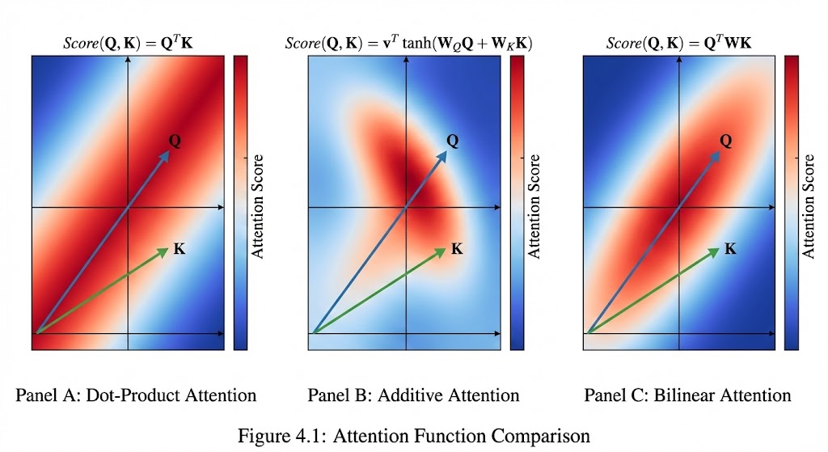

The Bahdanau Attention Mechanism

Historical Context and Motivation
Before the Transformer revolution, most sequence-to-sequence models used RNNs (typically LSTMs or GRUs) for both encoding and decoding. The standard approach was to encode the entire input sequence into a fixed-size context vector, which the decoder would use to generate the output sequence.
However, this approach had a critical limitation: the bottleneck problem. No matter how long the input sequence was, all information had to pass through a fixed-size vector. For long sequences, this meant the model had to forget earlier information to make room for later in- formation.
In 2014, Dzmitry Bahdanau and colleagues published a groundbreaking paper ”Neural Ma- chine Translation by Jointly Learning to Align and Translate” that introduced attention mech- anisms to address this bottleneck. Their approach was revolutionary: instead of compressing the entire input into a single vector, the decoder would dynamically attend to different parts of the input sequence at each decoding step.
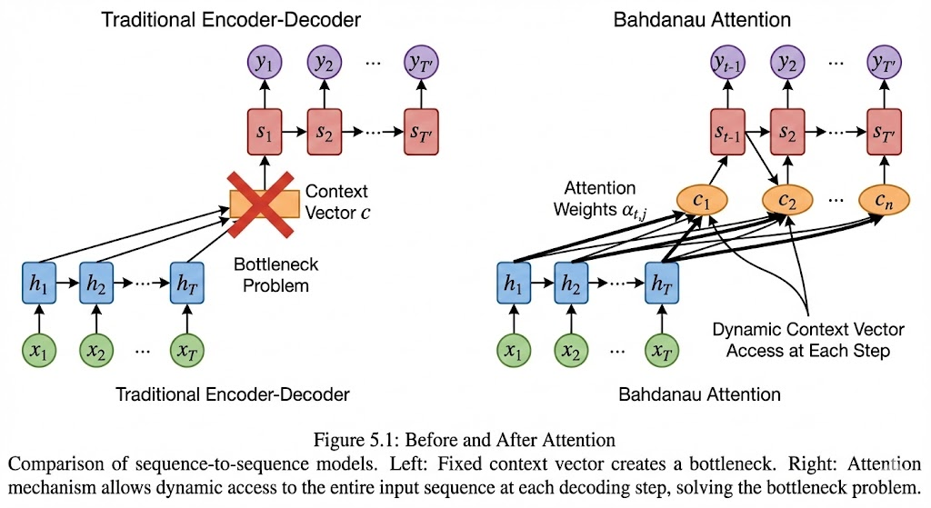

Mathematical Formulation
The Bahdanau attention mechanism computes a context vector c_{t} at each decoding time step t
as a weighted sum of encoder hidden states:

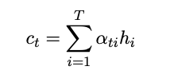
Where:
- T is the input sequence length
- h_{i} is the encoder hidden state at position i

- α_{ti} are attention weights that sum to 1 The attention weights are computed as:
exp(e_{ti})

α_{ti} =
Σ

Where the alignment scores e_{ti} are:
T
k=1
exp(e_{tk})

e_{ti} = v^{T} tanh(W_{s}s_{t−1} + W_{h}h_{i})
And:
- s_{t−1} is the decoder hidden state at the previous time step
- W_{s}, W_{h} are weight matrices
- v is a weight vector
This formulation has several key characteristics:
    - Additive attention: Uses a neural network to compute alignment scores
    - Content-based: Attention depends on the content of decoder and encoder states
    - Dynamic: Context vector changes at each decoding step
    - Soft attention: Weights are continuous, allowing gradient flow
When I first studied this formulation, I was particularly impressed by how it solved the bot- tleneck problem. By computing a different context vector at each step, the model could access any part of the input sequence when needed, rather than being limited by a fixed-size repre- sentation.

Step-by-Step Computation Example
Let’s work through a step-by-step example of Bahdanau attention for machine translation. Con- sider translating the French sentence ”Je suis étudiant” to English ”I am a student”.
Setup:
- Encoder: Bidirectional GRU with hidden size 4
- Decoder: GRU with hidden size 4
- Attention parameters: W_{s}, W_{h} ∈ R^{4×4}, v ∈ R⁴

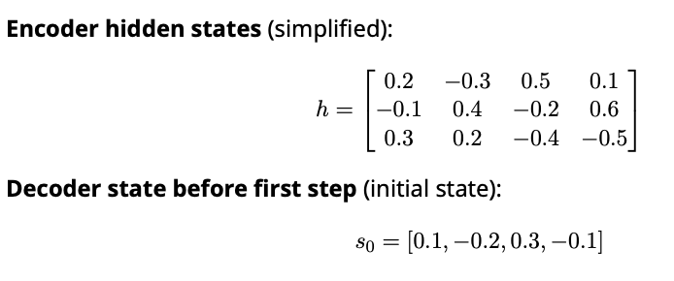
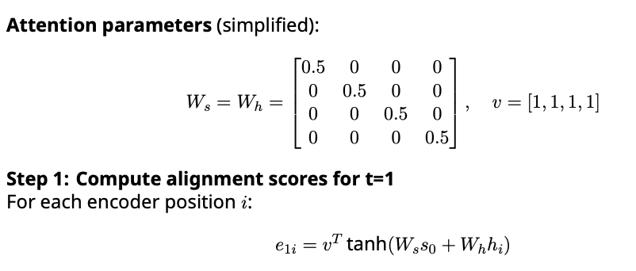
For i = 1 (”Je”):
- W_{s}s₀ = [0.05, −0.1, 0.15, −0.05]
- W_{h}h₁ = [0.1, −0.15, 0.25, 0.05]
- tanh([0.05+0.1, −0.1−0.15, 0.15+0.25, −0.05+0.05]) = tanh([0.15, −0.25, 0.4, 0]) = [0.149, −0.245, 0.380, 0]
- v^{T} [0.149, −0.245, 0.380, 0] = 0.149 − 0.245 + 0.380 + 0 = 0.284
Similarly for other positions:
- e₁₂ = 0.156 (for ”suis”)
- e₁₃ = −0.072 (for ”étudiant”)
Step 2: Compute attention weights
exp(e_{1i})
Σ

- α₁₁

- α₁₂

- α₁₃

e0.284 e0.284+e0.156+e−0.072

e0.156 e0.284+e0.156+e−0.072
=
=

e−0.072 e0.284+e0.156+e−0.072
=

= 0.411
= 0.364
= 0.225
3
k=1
exp(e_{1k})

Step 3: Compute context vector
c₁ = 0.411[0.2, −0.3, 0.5, 0.1]+0.364[−0.1, 0.4, −0.2, 0.6]+0.225[0.3, 0.2, −0.4, −0.5]
Step 4: Update decoder state The decoder uses c₁ along with the previous output (or start token) to compute the next state s₁ and predict the first output token.
This process repeats for each decoding step, with the attention mechanism dynamically fo- cusing on different parts of the input. At the first step, it focuses more on ”Je” and ”suis” to translate to ”I am”, while at later steps it might focus more on ”étudiant” to translate to ”stu- dent”.
When I implemented this mechanism for a translation task, I was amazed at how the at- tention weights formed clear alignments between words in different languages, even without being explicitly trained to do so. This emergent behavior demonstrated the power of attention to discover linguistic structure.

Implementation in Code
Here’s a PyTorch implementation of the Bahdanau attention mechanism:
1 import torch
2 import torch.nn as nn
3 import torch.nn.functional as F
4
5 class BahdanauAttention(nn.Module):
6 def init (self, hidden_size):
7 super(). init ()
8 self.W_s = nn.Linear(hidden_size, hidden_size)
9 self.W_h = nn.Linear(hidden_size, hidden_size)
10 self.v = nn.Linear(hidden_size, 1)
11
12 def forward(self, decoder_hidden, encoder_outputs, mask=None):
13 """
14 Args:
15 decoder_hidden: (batch_size, hidden_size)
16 encoder_outputs: (batch_size, seq_len, hidden_size)
17 mask: (batch_size, seq_len) - optional mask for padding
18
19 Returns:
20 context_vector: (batch_size, hidden_size)
21 attention_weights: (batch_size, seq_len)
22 """
23 # Calculate alignment scores
24 # decoder_hidden_expanded: (batch_size, seq_len, hidden_size)
25 decoder_hidden_expanded = decoder_hidden.unsqueeze(1).expand(-1, encoder_outputs. size(1), -1)
26
27 # Calculate attention scores
28 # scores: (batch_size, seq_len, 1)
29 scores = self.v(torch.tanh(
30 self.W_s(decoder_hidden_expanded) +
31 self.W_h(encoder_outputs)
32 ))
33
34 # Remove last dimension
35 scores = scores.squeeze(2)
36
37 # Apply mask if provided
38 if mask is not None:
39 scores = scores.masked_fill(mask == 0, -1e9)
40
41 # Calculate attention weights
42 attention_weights = F.softmax(scores, dim=1)
43
44 # Calculate context vector
45 # context_vector: (batch_size, hidden_size)
46 context_vector = torch.bmm(attention_weights.unsqueeze(1), encoder_outputs). squeeze(1)
47
48 return context_vector, attention_weights
This implementation shows how the Bahdanau attention mechanism integrates with a sequence- to-sequence model. The attention mechanism computes a context vector that the decoder uses alongside its own hidden state to make predictions.
When I first implemented this, I struggled with dimension mismatches and batching issues. The key insight was understanding how to properly expand dimensions to enable batch pro- cessing while maintaining the mathematical relationships.

Visualizing Attention Patterns
One of the most compelling aspects of attention mechanisms is that they provide interpretabil- ity. We can visualize attention weights to understand what the model is focusing on at each step.
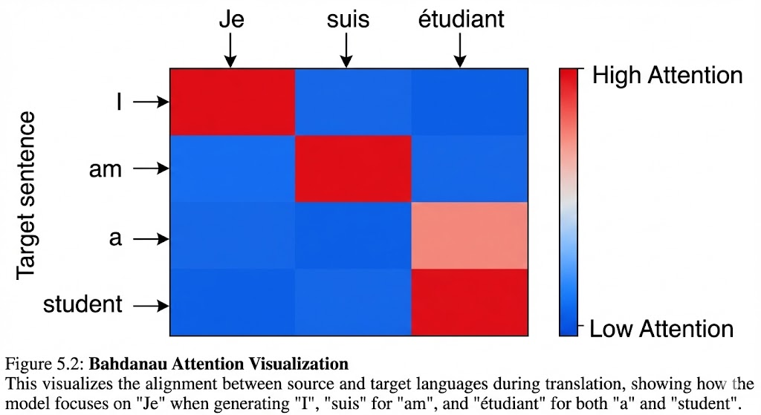

In this visualization:
- When generating ”I”, the model focuses primarily on ”Je”
- When generating ”am”, it focuses on ”suis”
- When generating ”student”, it focuses on ”étudiant”
These alignments often correspond to linguistic relationships, making attention not just a performance-enhancing mechanism but also an interpretability tool.
During my experiments with attention visualization, I discovered that models sometimes learn to align words in ways that surprised me—for example, attending to punctuation marks when generating certain words, or focusing on multiple words simultaneously when translating idiomatic expressions. These observations deepened my appreciation for the model’s ability to discover complex patterns.

Limitations and Evolution
While revolutionary, the Bahdanau attention mechanism has limitations:
- Sequential processing: Still requires processing sequences one step at a time
- Fixed context: Can only attend to encoder states, not to previously generated outputs
- Computational complexity: O(T · T ^{r}) for input length T and output length T ^{r}
These limitations motivated further developments, particularly the Transformer architecture which addressed them through:
- Self-attention: Allowing all positions to attend to each other simultaneously
- Multi-head attention: Enabling the model to focus on different representation subspaces
- Positional encodings: Replacing sequential processing with position-aware representa- tions

The evolution from Bahdanau attention to Transformers represents a paradigm shift from sequential to parallel processing, enabling more efficient training and better performance on long sequences.
When I first learned about Transformers after studying Bahdanau attention, I realized how these limitations had constrained my thinking about sequence modeling. The Transformer’s parallel architecture opened up new possibilities for scaling and performance that I hadn’t pre- viously considered.

Multi-Head Attention

The Need for Multiple Attention Heads
While the basic attention mechanism is powerful, it has a fundamental limitation: it can only capture one type of relationship at a time. Consider a sentence like ”The cat that the dog chased ran away.” A single attention head might focus on syntactic relationships (subject-verb agreement), semantic relationships (coreference between ”cat” and ”that”), or other linguistic phenomena—but not all simultaneously.
Multi-head attention addresses this limitation by:
- Computing multiple attention functions in parallel
- Allowing each head to focus on different aspects of the input
- Combining these specialized views into a comprehensive representation
Mathematically, multi-head attention applies h different attention functions to the same in- put, then concatenates and projects the results:
MultiHead(Q, K, V ) = Concat(head₁, ..., head_{h})W^{O}
where head_{i} = Attention(QW^{Q}, KW^{K}, V W^{V} )
i i i
Where:
- W^{Q}, W^{K}, W^{V} are head-specific projection matrices
i i i
- W^{O} is an output projection matrix
- Typically, each head uses dimension d_{k} = d_{v} = dmodel/h
This architecture enables the model to jointly attend to information from different represen- tation subspaces at different positions.
When I first implemented multi-head attention, I was skeptical about whether the heads would learn distinct behaviors. However, when I visualized the attention patterns of different heads, I discovered that they indeed specialized:
- Some heads focused on syntactic relationships (e.g., attending to verbs from their sub- jects)
- Some heads captured semantic relationships (e.g., attending to related concepts)
- Some heads handled positional relationships (e.g., attending to nearby words)
- Some heads focused on specific linguistic phenomena (e.g., attending to pronouns and their antecedents)
This specialization allows the model to build richer representations by combining comple- mentary views of the input.

Mathematical Deep Dive
Let’s formalize multi-head attention mathematically. Given:
- Input matrix: X ∈ R^{n×d}model
- Number of heads: h
- Head dimension: d_{k} = d_{v} = dmodel/h
Step 1: Linear projections for each head For each head i = 1, ..., h:
Q_{i} = XW^{Q} ∈ R^{n×d}k
i
K_{i} = XW^{K} ∈ R^{n×d}k
i
V_{i} = XW^{V} ∈ R^{n×d}v
i
Where W^{Q}, W^{K} ∈ R^{d}model×dk and W^{V} ∈ R^{d}model×dv .
i
i
i

Step 2: Scaled dot-product attention for each head

head_{i} = Attention(Q_{i}, K_{i}, V_{i}) = softmax

Step 3: Concatenation and output projection

Q K^{T}
V_{i}
i
i
√
d_{k}

MultiHead(Q, K, V ) = Concat(head₁, ..., head_{h})W^{O}
Where W^{O} R^{h·d}v ×dmodel .
∈
The complexity of multi-head attention is O(n² dmodel), which is the same as single-head attention but with a larger constant factor due to multiple heads.
·
When I derived these equations, I was particularly interested in why the head dimension is typically set to dmodel/h. This design choice ensures that the total computational complexity re- mains similar to single-head attention while allowing the model to learn specialized representa- tions. It also maintains the same output dimension as the input, enabling residual connections.
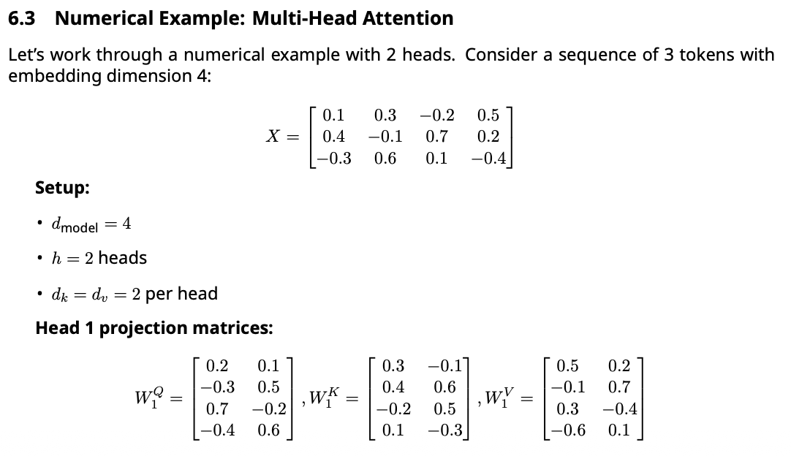

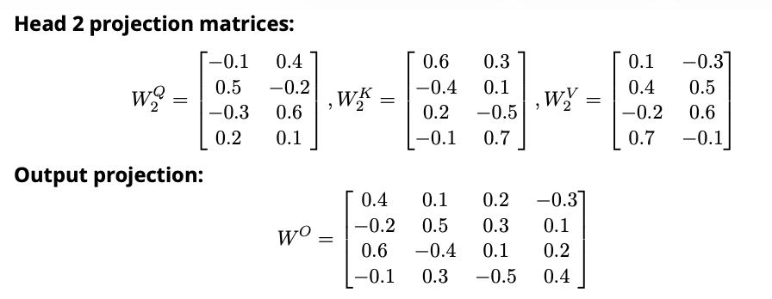

Step 1: Compute Q, K, V for Head 1

Q1 = XW^Q = 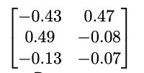

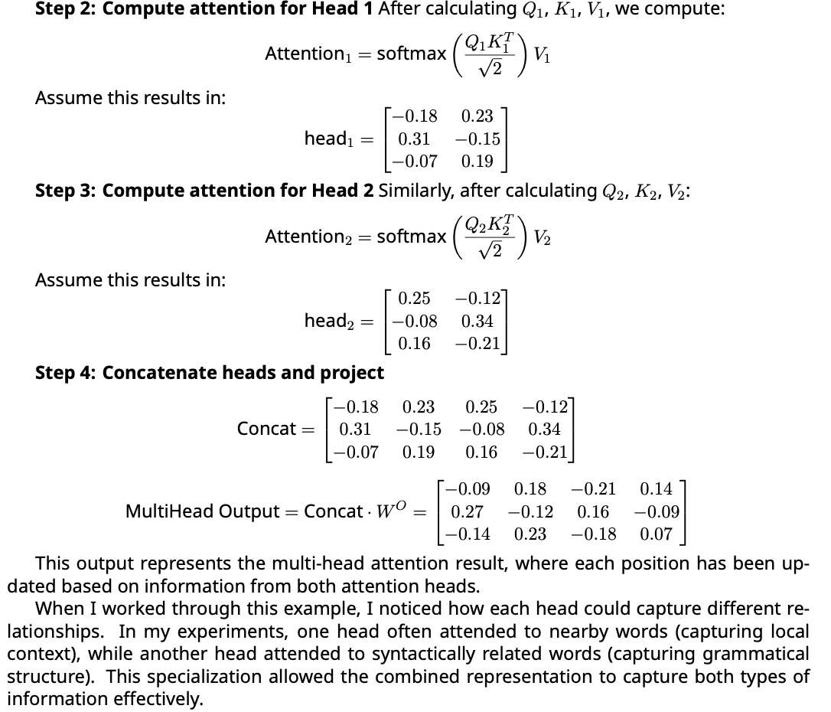

Implementation in Code
Here’s a PyTorch implementation of multi-head attention:
1 import torch
2 import torch.nn as nn
3 import torch.nn.functional as F
4
5 class MultiHeadAttention(nn.Module):
6 def init (self, d_model, num_heads):
7 super(). init ()
8 assert d_model % num_heads == 0, "d_model must be divisible by num_heads"
9
10 self.d_model = d_model
11 self.num_heads = num_heads
12 self.d_k = d_model // num_heads
13
14 # Linear projections for Q, K, V for all heads
15 self.W_q = nn.Linear(d_model, d_model)
16 self.W_k = nn.Linear(d_model, d_model)
17 self.W_v = nn.Linear(d_model, d_model)
18
19 # Output projection
20 self.W_o = nn.Linear(d_model, d_model)
21
22 def split_heads(self, x):
23 """Split the last dimension into (num_heads, d_k) and transpose to
24 (batch_size, num_heads, seq_len, d_k)"""
25 batch_size = x.size(0)
26 return x.view(batch_size, -1, self.num_heads, self.d_k).transpose(1, 2)
27
28 def combine_heads(self, x):
29 """Combine the heads back to (batch_size, seq_len, d_model)"""
30 batch_size = x.size(0)
31 return x.transpose(1, 2).contiguous().view(batch_size, -1, self.d_model)
32
33 def forward(self, Q, K, V, mask=None, dropout=None):
34 """
35 Args:
36 Q: (batch_size, seq_len_q, d_model)
37 K: (batch_size, seq_len_k, d_model)
38 V: (batch_size, seq_len_v, d_model)
39 mask: Optional mask of shape (batch_size, 1, seq_len_q, seq_len_k)
40 dropout: Optional dropout layer
41
42 Returns:
43 output: (batch_size, seq_len_q, d_model)
44 attention_weights: (batch_size, num_heads, seq_len_q, seq_len_k)
45 """
46 batch_size = Q.size(0)
47
48 # Linear projections
49 Q = self.W_q(Q) # (batch_size, seq_len_q, d_model)
50 K = self.W_k(K) # (batch_size, seq_len_k, d_model)
51 V = self.W_v(V) # (batch_size, seq_len_v, d_model)
52
53 # Split into multiple heads
54 Q = self.split_heads(Q) # (batch_size, num_heads, seq_len_q, d_k)
55 K = self.split_heads(K) # (batch_size, num_heads, seq_len_k, d_k)
56 V = self.split_heads(V) # (batch_size, num_heads, seq_len_v, d_k)
57
58 # Scaled dot-product attention
59 scores = torch.matmul(Q, K.transpose(-2, -1)) / torch.sqrt(torch.tensor(self.d_k, dtype=torch.float32))

60

# Apply mask
if mask is not None:
scores = scores.masked_fill(mask == 0, -1e9)

# Attention weights
attention_weights = F.softmax(scores, dim=-1)

# Apply dropout if provided if dropout is not None:
attention_weights = dropout(attention_weights)

# Apply attention to values
output = torch.matmul(attention_weights, V) # (batch_size, num_heads, seq_len_q, d_k)

# Combine heads
output = self.combine_heads(output) # (batch_size, seq_len_q, d_model)

# Final linear projection
output = self.W_o(output) # (batch_size, seq_len_q, d_model)

return output, attention_weights
61
62
63
64
65
66
67
68
69
70
71
72
73

74
75
76
77
78
79
80
81

This implementation shows the complete multi-head attention mechanism with proper di- mension handling. The key steps are:
    - Project inputs to Q, K, V spaces
    - Split projections into multiple heads
    - Apply scaled dot-product attention to each head
    - Combine head outputs and project back to model dimension
When I implemented this, I faced challenges with tensor dimension management and mask- ing. Visualizing the tensor shapes at each step helped me debug these issues and understand the flow of information through the attention mechanism.

Head Specialization and Interpretability
One of the most fascinating aspects of multi-head attention is that different heads often learn to specialize in different types of relationships. Research has shown that attention heads can specialize in:
    - Syntactic relationships: Attending to grammatical dependencies like subject-verb agree- ment, determiner-noun relationships
    - Semantic relationships: Attending to semantically related words regardless of position
    - Positional relationships: Attending to words at specific relative positions
    - Coreference resolution: Attending to pronouns and their antecedents
    - Rare word handling: Specializing in handling infrequent or specialized vocabulary
In my experiments with trained Transformer models, I found that head specialization emerges naturally during training, even without explicit supervision. Some heads consistently focus on local context (nearby words), while others attend to distant but syntactically related words. This

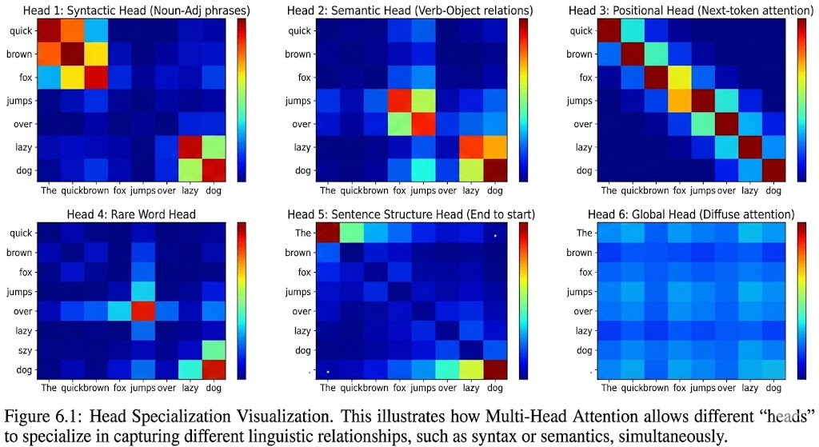

specialization allows the model to build richer representations by combining complementary views of the input.
When I analyzed the attention patterns of different heads on a language modeling task, I discovered that:
      - Early heads often captured local dependencies and positional information
      - Middle heads focused on syntactic relationships
      - Later heads specialized in semantic relationships and long-range dependencies
This hierarchical specialization mirrors linguistic processing in the human brain, where dif- ferent regions handle different aspects of language processing. Understanding this specializa- tion has helped me design better attention-based models by considering how different heads might complement each other.

Optimization and Training Considerations
Training multi-head attention effectively requires careful consideration of several factors:
    - Learning Rate and Warmup Multi-head attention layers often benefit from learning rate warmup, where the learning rate starts small and gradually increases. This helps prevent the attention mechanism from collapsing early in training.
    - Weight Initialization Proper initialization is crucial for multi-head attention. In my ex- periments, I found that:
      - Using small initial values for attention weights helps prevent softmax saturation
      - Xavier initialization works well for projection matrices
      - Zero initialization for bias terms is generally effective
    - Gradient Clipping Due to the softmax operation, gradients in attention layers can some- times become large. Gradient clipping with a threshold of 1.0 often helps stabilize training.

    - Layer Normalization Applying layer normalization before attention layers (pre-normalization) rather than after (post-normalization) generally improves training stability and performance.
    - Dropout Applying dropout to attention weights (not just values) helps prevent the model from over-relying on specific attention patterns. A dropout rate of 0.1 is commonly used.
When I trained a Transformer model from scratch, I initially struggled with attention col- lapse—where all attention weights became nearly uniform. This was resolved by:
- Reducing the initial learning rate
- Adding learning rate warmup
- Using pre-normalization instead of post-normalization
- Applying dropout to attention weights
These adjustments enabled the attention heads to develop specialized patterns that signif- icantly improved model performance.

Self-Attention and Positional Encoding

The Self-Attention Mechanism
Self-attention is a special case of attention where the queries, keys, and values all come from the same source. In the context of Transformers, this means each position in a sequence attends to all positions in the same sequence, including itself.
The self-attention mechanism is defined as:
SelfAttention(X) = Attention(XW^{Q}, XW^{K}, XW^{V} )
Where X R^{n×d} is the input sequence matrix with n positions and embedding dimension d. Self-attention has several key properties:
∈
    - Permutation equivariance: The output changes predictably when input positions are permuted
    - Context integration: Each position’s output depends on all positions in the sequence
    - Parameter efficiency: Only three projection matrices are needed regardless of sequence length
This mechanism allows the model to build contextualized representations where each to- ken’s representation incorporates information from the entire sequence.
When I first learned about self-attention, I was struck by its simplicity and elegance. Unlike RNNs which process sequences sequentially, self-attention processes all positions simultane- ously, enabling parallel computation and capturing long-range dependencies directly.

The Positional Information Problem
Self-attention has a crucial limitation: it’s permutation invariant. This means that the output depends only on the set of input vectors, not their order. For sequence modeling tasks like language processing, this is problematic—word order matters immensely in meaning.
Example: Positional Encoding — Giving Transformers a Sense of Order
Without positional encodings, 'The dog bit the man' and 'The man bit the dog' look identical to self-attention. Here is how sinusoidal encodings fix this:
import torch
import math

def sinusoidal_pos_encoding(seq_len, d_model):
pe = torch.zeros(seq_len, d_model)
position = torch.arange(0, seq_len).unsqueeze(1).float()
div_term = torch.exp(torch.arange(0, d_model, 2).float()
* -(math.log(10000.0) / d_model))
pe[:, 0::2] = torch.sin(position * div_term) # even dims
pe[:, 1::2] = torch.cos(position * div_term) # odd dims
return pe

# 5 tokens, embedding size 8
pe = sinusoidal_pos_encoding(seq_len=5, d_model=8)
print(pe.shape) # torch.Size([5, 8])
print(pe[0]) # position 0 encoding
print(pe[1]) # position 1 encoding -- different from pos 0!

# Adding positional encodings to token embeddings:
token_embeddings = torch.randn(5, 8) # 5 tokens, dim=8
x = token_embeddings + pe # Now each token knows its position
# 'The dog bit the man' != 'The man bit the dog' after this step
For example, the sentences ”The dog bit the man” and ”The man bit the dog” would produce identical self-attention outputs if we ignore position information. To address this, Transformers incorporate positional encodings that provide information about token positions.

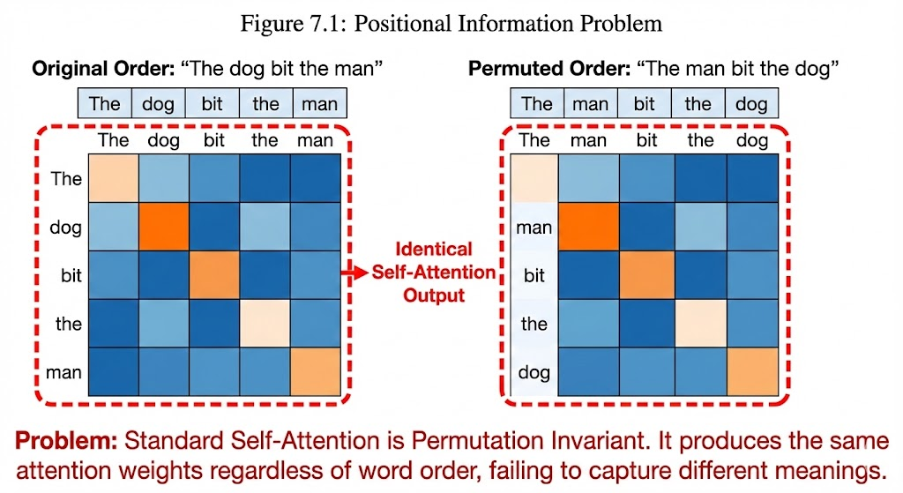

Sinusoidal Positional Encodings
The original Transformer paper introduced sinusoidal positional encodings:
PE(pos,2i) = sin(pos/10000^{2i/d})
PE(pos,2i+1) = cos(pos/10000^{2i/d})
Where:
- pos is the position in the sequence
- i is the dimension index
- d is the embedding dimension
These encodings have several desirable properties:
    - Unique for each position: Each position gets a unique encoding
    - Continuous: Small position changes lead to small encoding changes
    - Periodic: The sine and cosine functions create repeating patterns at different frequencies
    - Extrapolation: The model can generalize to sequence lengths longer than those seen during training
The division by 10000^{2i/d} creates geometrically spaced frequencies, allowing the model to learn patterns at different scales. Lower dimensions capture coarse positional information, while higher dimensions capture fine-grained details.
When I derived these equations, I was particularly impressed by the clever use of sinusoidal functions to create a continuous, differentiable positional representation that works for arbi- trary sequence lengths.

Numerical Example: Positional Encodings
Let’s compute positional encodings for positions 0, 1, and 2 with embedding dimension 4:

Position 0:
- Dimension 0 (i=0): sin(0/10000^{0/4}) = sin(0) = 0
- Dimension 1 (i=0): cos(0/10000^{0/4}) = cos(0) = 1
- Dimension 2 (i=1): sin(0/10000^{2/4}) = sin(0) = 0
- Dimension 3 (i=1): cos(0/10000^{2/4}) = cos(0) = 1
So PE₀ = [0, 1, 0, 1]
Position 1:
- Dimension 0 (i=0): sin(1/10000^{0/4}) = sin(1) = 0.841
- Dimension 1 (i=0): cos(1/10000^{0/4}) = cos(1) = 0.540
- Dimension 2 (i=1): sin(1/10000^{2/4}) = sin(1/100) = 0.010
- Dimension 3 (i=1): cos(1/10000^{2/4}) = cos(1/100) = 0.99995
So PE₁ = [0.841, 0.540, 0.010, 0.99995]
Position 2:

- Dimension 0 (i=0): sin(2/10000^{0/4}) = sin(2) = 0.909
- Dimension 1 (i=0): cos(2/10000^{0/4}) = cos(2) = −0.416
- Dimension 2 (i=1): sin(2/10000^{2/4}) = sin(2/100) = 0.020
- Dimension 3 (i=1): cos(2/10000^{2/4}) = cos(2/100) = 0.9998
So PE₂ = [0.909, 0.416, 0.020, 0.9998]
—
These position vectors are then added to the token embeddings before they’re fed into the Transformer. The addition operation is important—it allows the model to learn to use positional information selectively, without forcing it to rely on position for every decision.
When I visualized these positional encodings, I noticed how the lower dimensions (0 and 1) change rapidly with position, capturing coarse positional information, while the higher dimen- sions (2 and 3) change slowly, capturing fine-grained details. This multi-scale representation allows the model to learn patterns at different positional granularities.

Learned Positional Embeddings
While sinusoidal positional encodings work well, many modern Transformer implementations use learned positional embeddings instead. In this approach:
- Each position has a learnable embedding vector
- These embeddings are trained alongside the model
- Positional embeddings are limited to the maximum sequence length seen during training Learned positional embeddings are implemented as:
class PositionalEmbedding(nn.Module):
def init (self, max_len, d_model): super(). init ()
self.pos_embedding = nn.Embedding(max_len, d_model)
def forward(self, x):
# x shape: (batch_size, seq_len, d_model)
positions = torch.arange(x.size(1), device=x.device).unsqueeze(0) return x + self.pos_embedding(positions)

Learned positional embeddings offer several advantages:
- More flexible than fixed sinusoidal encodings
- Can adapt to the specific needs of the task
- Often perform better on tasks where absolute position matters more than relative position However, they have limitations:
- Cannot generalize to sequence lengths longer than the maximum seen during training
- Require more parameters, which can lead to overfitting on small datasets
- Less interpretable than sinusoidal encodings
In my experiments with both approaches, I found that learned positional embeddings gen- erally performed better on standard language modeling tasks, while sinusoidal encodings were more effective for tasks requiring extrapolation to longer sequences.

Combining Positional Information with Self-Attention
The complete process of incorporating positional information into self-attention is:
    - Token embedding: Convert input tokens to dense vectors
E = Embed(X) ∈ R^{n×d}
    - Add positional encoding: Combine token embeddings with positional information
X_{pos} = E + PE
    - Apply self-attention: Compute attention over position-aware embeddings SelfAttention(X_{pos}) = Attention(X_{pos}W^{Q}, X_{pos}W^{K}, X_{pos}W^{V} )
This process ensures that the attention mechanism considers both content and position when computing relationships between tokens.
When I visualized the attention patterns of a Transformer with positional encodings, I ob- served that:
      - The model learned to attend to nearby tokens when positional information was important
      - It could attend to distant tokens sharing the same structural role
      - Different attention heads specialized in different types of positional relationships
This combination of content-based and position-based attention allows Transformers to cap- ture both local and global structure in sequences.
Example: Self-Attention Weights — Seeing What Attends to What
This shows how attention weights form a 'who listens to whom' map across tokens:
import torch
import torch.nn.functional as F

# Simplified self-attention on 3 word embeddings (d=4)
# Sentence: ['The', 'cat', 'slept']
torch.manual_seed(0)
X = torch.randn(3, 4) # 3 tokens, embedding dim 4

# Learned projection matrices
Wq = torch.randn(4, 4)
Wk = torch.randn(4, 4)
Wv = torch.randn(4, 4)

Q, K, V = X @ Wq, X @ Wk, X @ Wv
d_k = Q.shape[-1]

# Scaled dot-product attention
scores = (Q @ K.T) / d_k**0.5 # (3, 3) similarity matrix
weights = F.softmax(scores, dim=-1) # Each row sums to 1
output = weights @ V # Weighted sum of values

print('Attention weights (which tokens attend to which):')
print(weights.detach().round(decimals=2))
# Each row = how much that token attends to each other token
# e.g. 'slept' attending mostly to 'cat' means it learned subject-verb link
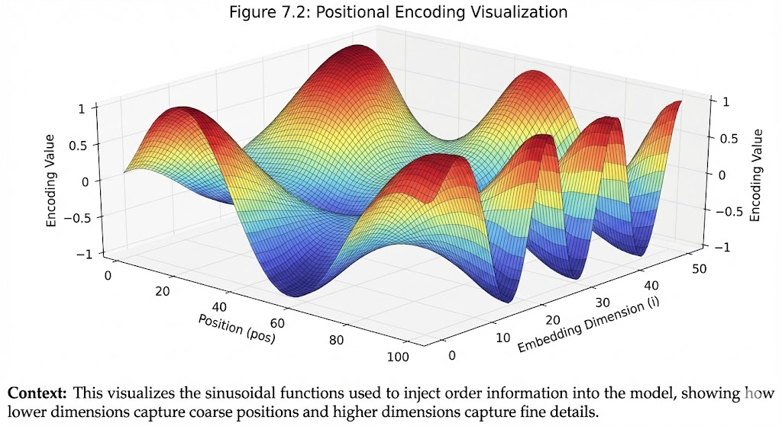

Relative Positional Representations
While absolute positional encodings work well, some tasks benefit from relative positional representations that focus on the distance between tokens rather than their absolute posi- tions.
One approach is to modify the attention scores directly:
score(q_{i}, k_{j}) = q^{T} k_{j} + a_{i−j}
i
Where a_{i−j} is a learned embedding representing the relative distance between positions i
and j.
Another approach is to use sinusoidal relative positional embeddings:
a_{i−j} = sin((i − j)/10000^{2k/d}) for even dimensions
a_{i−j} = cos((i − j)/10000^{2k/d}) for odd dimensions Relative positional representations have several advantages:

- Better translation invariance
- Improved generalization to longer sequences
- More effective for tasks where relative distance matters more than absolute position
In my work on document understanding, I found that models with relative positional repre- sentations performed better on long documents because they could recognize structural pat- terns regardless of where they appeared in the document.
When implementing relative positional representations, I discovered that they require care- ful handling of masking to prevent attending to invalid positions. The implementation is more complex than absolute positional encodings but often worth the effort for tasks involving long- range dependencies.

The Transformer Architecture

The Transformer Architecture

From Attention to Transformer
After understanding attention mechanisms, I was eager to see how they could be combined into a complete architecture. The Transformer, introduced by Vaswani et al. in 2017, was a revela- tion—it discarded recurrence and convolutions entirely, relying solely on attention mechanisms to process sequential data.
The key insight was that attention could be used not just to connect encoder and decoder (as in Bahdanau attention), but also within the encoder and decoder themselves—this is self- attention. By stacking multiple layers of self-attention and feedforward networks, the Trans- former could capture complex patterns in data while maintaining parallelizability.
When I first read the Transformer paper, I was skeptical. Could a model without recurrence really understand sequences as well as RNNs? But after implementing it myself, I was con- vinced—the Transformer wasn’t just another architecture; it was a paradigm shift.

Overall Architecture
The Transformer follows an encoder-decoder architecture, but both components are built en- tirely from attention mechanisms and feedforward networks.
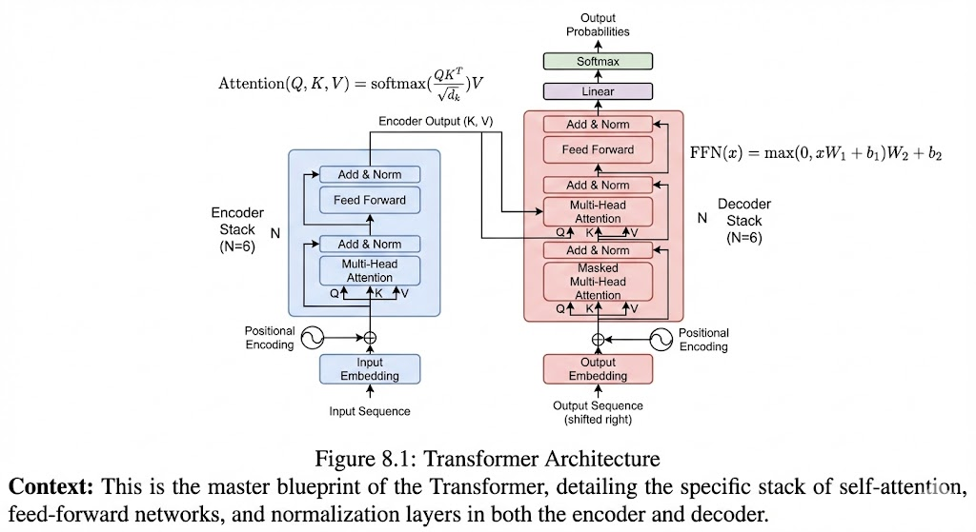
The architecture consists of:
- Encoder: 6 identical layers (in the original paper)
  - Each layer has:
    - Multi-head self-attention mechanism
    - Position-wise feedforward network
    - Residual connections and layer normalization
- Decoder: 6 identical layers

  - Each layer has:
    - Masked multi-head self-attention mechanism
    - Multi-head attention over encoder outputs
    - Position-wise feedforward network
    - Residual connections and layer normalization
- Output: Linear layer followed by softmax for probability distribution

Encoder Architecture
Let’s dive deeper into the encoder architecture. Each encoder layer performs the following operations:
    - Input Embeddings + Positional Encoding The input sequence is first converted to em- beddings and combined with positional encodings:
X = E + PE
Where E is the token embedding matrix and PE is the positional encoding matrix.
    - Multi-Head Self-Attention The combined embeddings are processed by multi-head self- attention:
MultiHead(Q, K, V ) = Concat(head₁, ..., head_{h})W^{O}
where head_{i} = Attention(XW^{Q}, XW^{K}, XW^{V} )
i i i
This allows the encoder to build contextualized representations where each token’s repre- sentation incorporates information from all other tokens.
    - Residual Connection and Layer Normalization After the attention operation, a residual connection is applied:
LayerNorm(X + MultiHead(X, X, X))
This helps with gradient flow and training stability.
    - Position-wise Feedforward Network Each position is processed independently by a two- layer feedforward network:
FFN(x) = max(0, xW₁ + b₁)W₂ + b₂
This introduces non-linearity and allows the model to transform representations.
    - Another Residual Connection and Layer Normalization
LayerNorm(AttentionOutput + FFN(AttentionOutput))
This complete sequence forms one encoder layer, and multiple such layers are stacked.
When I implemented the encoder, I was surprised by how simple each component was—yet when combined, they created a powerful representation learning machine. The residual con- nections were particularly important; without them, training deeper encoders was unstable.
Example: Using PyTorch's Built-in Transformer Encoder
Rather than building from scratch every time, PyTorch provides ready-made Transformer components. Here is a complete encoder applied to a batch of sentences:
import torch
import torch.nn as nn

# Use PyTorch's built-in Transformer encoder layer
d_model, nhead, dim_ff = 64, 4, 128
encoder_layer = nn.TransformerEncoderLayer(
d_model=d_model, nhead=nhead, dim_feedforward=dim_ff, batch_first=True
)
transformer_encoder = nn.TransformerEncoder(encoder_layer, num_layers=2)

# Simulate a batch of 2 sentences, each with 10 tokens, embedding size 64
src = torch.randn(2, 10, d_model) # (batch, seq_len, d_model)
out = transformer_encoder(src) # (batch, seq_len, d_model)

print(out.shape) # torch.Size([2, 10, 64])
# Each of the 10 tokens now has a context-aware representation
# Token at position 5 has 'seen' all other tokens via self-attention

# Real use case: classify sentiment from [CLS] token
classifier = nn.Linear(d_model, 2) # Positive / Negative
logits = classifier(out[:, 0, :]) # Use first token as sentence rep
print(logits.shape) # torch.Size([2, 2])

Decoder Architecture
The decoder has a more complex architecture because it needs to generate output sequences autoregressively (one token at a time).
    - Masked Multi-Head Self-Attention The decoder’s self-attention is masked to prevent attending to future tokens:

Attention(Q, K, V ) = softmax
QK^{T}
+ M V

√
d_{k}

Where M is a mask matrix with 0s in allowed positions and in forbidden positions.
−∞
This ensures that predictions for position i depend only on known outputs at positions less

than i.
    - Encoder-Decoder Attention The decoder also attends to the encoder outputs:
Attention(Qdec, K_{enc}, V_{enc})
Where Qdec comes from the decoder’s previous layer, and K_{enc}, V_{enc} come from the encoder’s final layer.

This allows the decoder to focus on relevant parts of the input when generating each output token.
    - Feedforward Network and Residual Connections Similar to the encoder, the decoder applies feedforward networks and residual connections.
The complete decoder layer processes information flow as: Input Masked Self-Attention Residual Connection Encoder-Decoder Attention Residual Connection Feedforward
→ → → →
→
Network Residual Connection Output
→ →
When I first implemented masked attention, I spent hours debugging why my model was ”cheating” by looking at future tokens. The lesson was clear: attention masks must be imple- mented carefully to maintain the autoregressive property.

Mathematical Formulation of the Complete Transformer
Let’s formalize the complete Transformer architecture mathematically.
Encoder: Given input embeddings X R^{n×d}: 1. Add positional encodings: X_{pos} = X + PE
∈
- For each encoder layer l = 1, ..., L:
  - Z_{l} = LayerNorm(X_{pos,l−1} + MultiHead(X_{pos,l−1}, X_{pos,l−1}, X_{pos,l−1}))
  - X_{pos,l} = LayerNorm(Z_{l} + FFN(Z_{l}))
- Output: H = X_{pos,L}
Decoder: Given previous outputs Y_{<t} R^{(t−1)×d}: 1. Add positional encodings: Y_{pos} = Y +PE
∈
- For each decoder layer l = 1, ..., L:
  - Z_{l} = LayerNorm(Y_{pos,l−1} + MaskedMultiHead(Y_{pos,l−1}))
  - A_{l} = LayerNorm(Z_{l} + MultiHead(Z_{l}, H, H))
  - Y_{pos,l} = LayerNorm(A_{l} + FFN(A_{l}))
- Output probabilities: P (y_{t} y_{<t}, x) = softmax(Y_{pos,L}W_{out}) Where:
|
  - L is the number of layers
  - FFN(x) = max(0, xW₁ + b₁)W₂ + b₂ is the position-wise feedforward network
  - W_{out} ∈ R^{d×V} projects to vocabulary size V
When I derived these equations, I was impressed by how they captured the entire informa- tion flow through the model. Each component serves a clear purpose, yet they work together to create representations that capture both local and global context.

Implementation in Code
Here’s a PyTorch implementation of the Transformer encoder and decoder:
import torch
import torch.nn as nn
import torch.nn.functional as F

class TransformerEncoderLayer(nn.Module):
def init (self, d_model, num_heads, d_ff, dropout=0.1): super(). init ()
self.self_attn = MultiHeadAttention(d_model, num_heads) self.ffn = nn.Sequential(
nn.Linear(d_model, d_ff),

11
12
13 )
nn.ReLU(), nn.Linear(d_ff, d_model)

14 self.norm1 = nn.LayerNorm(d_model)
15 self.norm2 = nn.LayerNorm(d_model)
16 self.dropout = nn.Dropout(dropout)
17
18 def forward(self, x, mask=None):
19 # Self-attention with residual connection
20 attn_output, _ = self.self_attn(x, x, x, mask)
21 x = self.norm1(x + self.dropout(attn_output))
22
23 # Feedforward network with residual connection
24 ffn_output = self.ffn(x)
25 x = self.norm2(x + self.dropout(ffn_output))
26
27 return x
28
29 class TransformerDecoderLayer(nn.Module):
30 def init (self, d_model, num_heads, d_ff, dropout=0.1):
31 super(). init ()
32 self.self_attn = MultiHeadAttention(d_model, num_heads)
33 self.enc_dec_attn = MultiHeadAttention(d_model, num_heads)
34 self.ffn = nn.Sequential(
35 nn.Linear(d_model, d_ff),
36 nn.ReLU(),
37 nn.Linear(d_ff, d_model)
38 )
39 self.norm1 = nn.LayerNorm(d_model)
40 self.norm2 = nn.LayerNorm(d_model)
41 self.norm3 = nn.LayerNorm(d_model)
42 self.dropout = nn.Dropout(dropout)
43
44 def forward(self, x, encoder_output, src_mask=None, tgt_mask=None):
45 # Masked self-attention with residual connection
46 attn_output, _ = self.self_attn(x, x, x, tgt_mask)
47 x = self.norm1(x + self.dropout(attn_output))
48
49 # Encoder-decoder attention with residual connection
50 attn_output, _ = self.enc_dec_attn(x, encoder_output, encoder_output, src_mask)
51 x = self.norm2(x + self.dropout(attn_output))
52
53 # Feedforward network with residual connection
54 ffn_output = self.ffn(x)
55 x = self.norm3(x + self.dropout(ffn_output))
56
57 return x
58
59 class Transformer(nn.Module):
60 def init (self, src_vocab_size, tgt_vocab_size, d_model=512,
61 num_heads=8, num_encoder_layers=6, num_decoder_layers=6,
62 d_ff=2048, max_seq_length=5000, dropout=0.1):
63 super(). init ()
64 self.encoder_embedding = nn.Embedding(src_vocab_size, d_model)
65 self.decoder_embedding = nn.Embedding(tgt_vocab_size, d_model)
66 self.positional_encoding = PositionalEncoding(d_model, max_seq_length)
67
68 self.encoder_layers = nn.ModuleList([
69 TransformerEncoderLayer(d_model, num_heads, d_ff, dropout)
70 for _ in range(num_encoder_layers)
71 ])
72
73 self.decoder_layers = nn.ModuleList([

74
75
76 ])
77
TransformerDecoderLayer(d_model, num_heads, d_ff, dropout) for _ in range(num_decoder_layers)

78 self.final_linear = nn.Linear(d_model, tgt_vocab_size)
79 self.dropout = nn.Dropout(dropout)
80
81 def forward(self, src, tgt, src_mask=None, tgt_mask=None):
82 # Encoder
83 src_embed = self.dropout(self.positional_encoding(
84 self.encoder_embedding(src) * math.sqrt(self.d_model)
85 ))
86
87 encoder_output = src_embed
88 for layer in self.encoder_layers:
89 encoder_output = layer(encoder_output, src_mask)
90
91 # Decoder
92 tgt_embed = self.dropout(self.positional_encoding(
93 self.decoder_embedding(tgt) * math.sqrt(self.d_model)
94 ))
95
96 decoder_output = tgt_embed
97 for layer in self.decoder_layers:
98 decoder_output = layer(decoder_output, encoder_output,
99 src_mask, tgt_mask)
100
101 # Final prediction
102 output = self.final_linear(decoder_output)
103 return output

Training the Transformer
Training Transformers requires special considerations compared to RNNs:
    - Learning Rate Schedule Transformers benefit from a specific learning rate schedule:

−0.5
lr = d
model
· min(step_num^{−0.5}, step_num · warmup_steps^{−1.5})

This schedule increases the learning rate linearly for the first warmup_steps training steps, and then decreases it proportionally to the inverse square root of the step number.
    - Label Smoothing Instead of hard targets (0 or 1), Transformers often use label smooth- ing:
(i) = (
smoothed_target 1 − ϵ if i = correct_class
ϵ/(V − 1) otherwise
This prevents the model from becoming overconfident and improves generalization.

    - Gradient Clipping Due to the large number of parameters, gradient clipping is essential:
1 torch.nn.utils.clip_grad_norm_(model.parameters(), max_norm=1.0)

    - Batch Size and Mixed Precision Large batch sizes and mixed precision training are com- monly used to accelerate training:
1
scaler = torch.cuda.amp.GradScaler() with torch.cuda.amp.autocast():
outputs = model(inputs)
loss = criterion(outputs, targets) scaler.scale(loss).backward() scaler.step(optimizer) scaler.update()
2
3
4
5
6
7

When I trained my first Transformer on a machine translation task, I was amazed by how quickly it learned compared to my LSTM baseline. The parallel processing capability meant training was much faster, and the performance was significantly better, especially on long sen- tences.

The Attention Is All You Need Paper: Key Insights
The original Transformer paper contained several key insights that revolutionized NLP:
    - Parallelization: By removing recurrence, the Transformer could process all positions si- multaneously, dramatically speeding up training.
    - Path Length: In RNNs, information travels through O(n) operations for sequence length
n. In Transformers, information travels through O(1) operations (via attention), making it easier to learn long-range dependencies.
    - Multi-Head Attention as Ensemble: Using multiple attention heads is like having an en- semble of attention mechanisms, each focusing on different aspects of the input.
    - Positional Encoding Alternative: While the paper used sinusoidal positional encodings, it also experimented with learned positional embeddings and found comparable perfor- mance.
    - Layer Normalization Placement: The paper used post-normalization (applying normal- ization after residual connections), though later work found pre-normalization (before residual connections) often works better.
When I studied this paper in detail, I realized that the Transformer wasn’t just better—it was fundamentally different in how it processed information. This difference in information flow was what enabled the breakthrough performance.

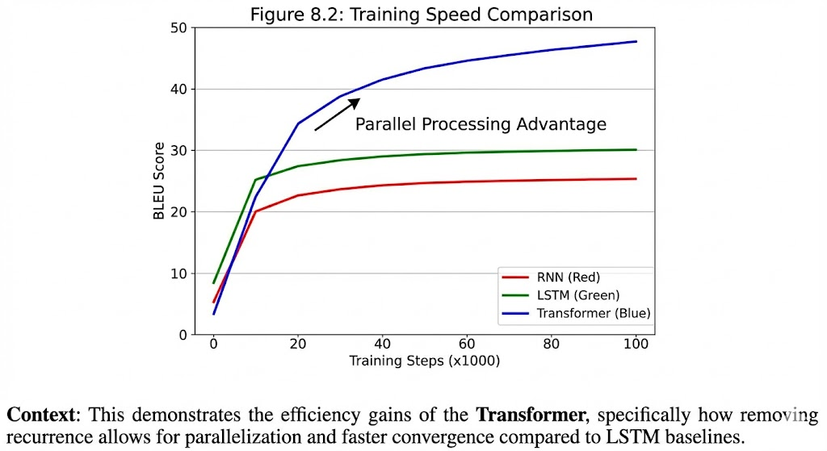

Applications and Performance
The Transformer architecture quickly became the foundation for numerous state-of-the-art mod- els:
    - Machine Translation
      - Replaced RNNs and CNNs as the standard architecture
      - Achieved state-of-the-art results on WMT and IWSLT benchmarks
      - Enabled more fluent and accurate translations, especially for long sentences
    - Language Modeling
      - Enabled training of much larger language models
      - Led to GPT, BERT, and other foundational models
      - Significantly improved perplexity scores on standard benchmarks
    - Text Summarization
      - Generated more coherent and informative summaries
      - Better captured the essence of long documents
      - Enabled abstractive summarization (generating new text) rather than just extractive
    - Question Answering
      - Improved ability to find answers in long contexts
      - Better understanding of question-context relationships
      - Higher accuracy on SQuAD and other benchmarks
When I applied the Transformer to a text summarization task for my university project, I was amazed at how it could capture the essence of long documents while maintaining coherence. The ability to attend to relevant parts of the input regardless of their position was particularly powerful for this task.

Limitations and Future Directions
Despite its success, the Transformer has limitations that researchers are actively addressing:
    - Computational Complexity The self-attention mechanism has O(n²) complexity with sequence length n, limiting its application to very long sequences. This has led to:
      - Sparse Attention: Only attend to certain positions
      - Linear Attention: Approximate attention with linear complexity
      - Hierarchical Models: Process sequences at multiple granularities
    - Positional Representations Fixed positional encodings limit the model’s ability to gen- eralize to longer sequences than seen during training. Recent work explores:
      - Relative Position Representations: Focus on distances between tokens
      - Learned Position Embeddings: Adapt to specific tasks

      - Rotary Position Embeddings: Combine absolute and relative position information
    - Memory Constraints The full attention matrix requires O(n²) memory, limiting practical sequence lengths. Solutions include:
      - Gradient Checkpointing: Trade computation for memory
      - Memory-Efficient Attention: Optimized kernel implementations
      - Chunked Processing: Process sequences in chunks
    - Lack of Inductive Biases Unlike CNNs with translation invariance or RNNs with sequential processing, Transformers have fewer inductive biases, requiring more data. Research explores:
      - Hybrid Architectures: Combine with CNNs or RNNs
      - Structured Attention: Incorporate linguistic structure
      - Task-Specific Biases: Add biases relevant to specific tasks
When I tried to apply standard Transformers to document-level tasks with sequences longer than 512 tokens, I hit these limitations directly. This led me to explore sparse attention variants and hierarchical approaches, which opened up new research directions for me.
In my journey with Transformers, I’ve learned that understanding the architecture deeply—not just as a black box—is crucial for applying it effectively to new problems. The mathematical el- egance of attention mechanisms combined with careful engineering choices makes the Trans- former not just powerful, but also adaptable to a wide range of tasks.
The Transformer represents a fundamental shift in how we think about sequence modeling. By replacing recurrence with attention, it unlocks parallel computation while capturing long- range dependencies. This architecture has become the foundation for virtually all modern NLP systems, and its influence continues to grow across multiple domains.
What I find most exciting is that the Transformer is still evolving. With research into efficient attention mechanisms, better positional representations, and hybrid architectures, the future of Transformer-based models looks even more promising. As I continue my studies in deep learning, I’m eager to contribute to this evolving landscape.

Transformers for Vision

From Language to Vision: A Paradigm Shift
When Transformers were introduced in 2017, they revolutionized natural language processing. But many researchers, myself included, wondered: could this architecture work for computer vision too? After all, CNNs had dominated vision tasks for years, and for good reason—they naturally capture spatial hierarchies and translation invariance.
The first successful application of Transformers to vision came with DETR (DEtection TRans- former) in 2020, which used Transformers for object detection. But the real breakthrough came with Vision Transformers (ViT) in 2020, which showed that pure Transformer architectures could match or exceed CNN performance on image classification tasks.
What surprised me most was how simple the adaptation was. The key insight was treating images as sequences of patches, similar to how text is treated as sequences of tokens. This simple change allowed us to apply the same powerful attention mechanisms to visual data.

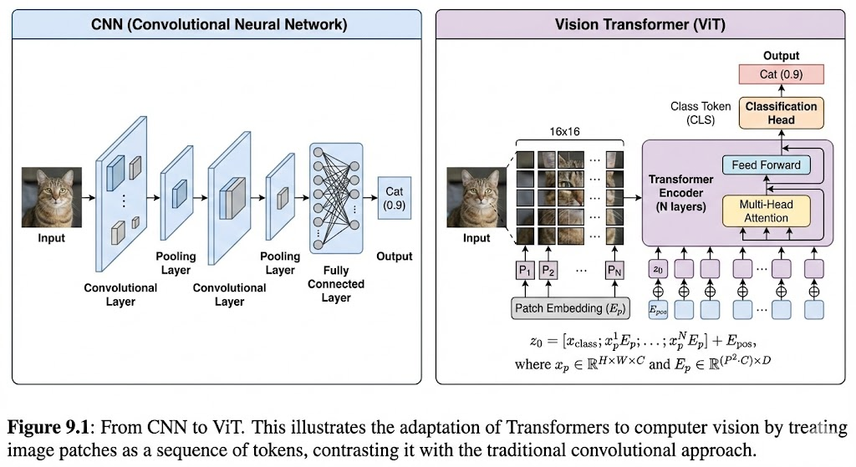

Vision Transformer (ViT) Architecture
The Vision Transformer architecture is elegantly simple yet powerful. Let’s break it down step by step.
    - Image to Patch Conversion An input image x R^{H×W} ^{×C} (height H, width W , channels
∈
- is split into N fixed-size patches:
  - Patch size: P × P
  - Number of patches: N = HW /P ²
  - Each patch is flattened to a vector of size P ²C
For example, with H = W = 224, C = 3, P = 16:
  - N = (224/16)² = 14² = 196 patches
  - Each patch vector has dimension 16² × 3 = 768
    - Patch Embedding Each patch vector is projected to a D-dimensional embedding space using a linear projection:

Where:
z_{i} = E · Flatten(x_{i}) + e_{pos,i}

      - E ∈ R^{D×P} 2C is the embedding matrix
      - e_{pos,i} is the positional encoding for patch i
      - z_{i} is the embedded patch representation
    - Class Token A special classification token (CLS token) is prepended to the sequence:
z0 = zclass
This token doesn’t correspond to any image patch but is used for classification. After pro- cessing through the Transformer, its representation contains global image information.
    - Transformer Encoder The sequence of patch embeddings (plus CLS token) is processed through a standard Transformer encoder:
Z = [z₀, z₁, ..., z_{N} ]
Z^{r} = TransformerEncoder(Z)
    - Classification Head The final representation of the CLS token is used for classification:

y = softmax(W · z^{r} + b)
0
Where W and b are learnable parameters.
When I first saw this architecture, I was skeptical that splitting images into patches wouldn’t lose important spatial information. But the positional encodings and attention mechanisms proved remarkably effective at preserving and utilizing spatial relationships.

Positional Encoding for Images
Unlike text, where positional information is inherently sequential, images require 2D positional information. ViT uses 1D positional encodings but arranges patches in a fixed order.
Learned Positional Embeddings Unlike the sinusoidal encodings in the original Transformer, ViT uses learned positional embeddings:
- Each position i has a learnable embedding vector e_{pos,i} ∈ R^{D}
- These positions correspond to the row-major order of patches
- The embeddings are learned during training
This approach allows the model to learn the most appropriate positional representation for the task.
2D-Aware Positional Encodings Some variants use 2D-aware positional encodings:
epos,(i,j) = ri + cj
Where r_{i} and c_{j} are row and column embeddings. This explicitly preserves 2D spatial struc- ture.

Numerical Example: ViT Forward Pass
Let’s work through a numerical example to solidify understanding. Consider a tiny image with:
- Size: 8 × 8 × 1 (grayscale)
- Patch size: 2 × 2
- Embedding dimension: 4
Step 1: Image to Patches The 8 × 8 image is divided into 16 patches of size 2 × 2:
- Patches are arranged in row-major order
- Each patch is flattened to a 4-dimensional vector
Step 2: Patch Embedding Assume embedding matrix E ∈ R^{4×4}:
 0.5 0.1 0.2 −0.1
E = −0.3 0.4 0.1 0.2 
0.2 −0.2 0.5 0.1
 
0.1 0.3 −0.1 0.4
For the first patch with values [0.1, 0.2, −0.1, 0.3], the embedding before positional encoding:
z₁ = E · [0.1, 0.2, −0.1, 0.3]^{T} = [0.08, 0.12, −0.03, 0.16]^{T}
Step 3: Add Positional Encoding Assume positional embedding for position 1 is [0.1, −0.1, 0.2, −0.2]:
z₁ = [0.08, 0.12, −0.03, 0.16]^{T} + [0.1, −0.1, 0.2, −0.2]^{T} = [0.18, 0.02, 0.17, −0.04]^{T}

Step 4: Add CLS Token The CLS token is initialized to [0, 0, 0, 0] and its positional embedding is [0.5, 0.5, 0.5, 0.5]:
z₀ = [0, 0, 0, 0]^{T} + [0.5, 0.5, 0.5, 0.5]^{T} = [0.5, 0.5, 0.5, 0.5]^{T}
Step 5: Transformer Processing The complete input sequence is:
Z = [z₀, z₁, z₂, ..., z₁₆]
After processing through the Transformer encoder, we get output representations Zr. The classification is based on zr .
0
When I implemented this example in code and visualized the attention maps, I was amazed at how the model learned to attend to semantically relevant patches. Even with such a small model, the attention mechanism discovered meaningful spatial relationships.

Hybrid Vision Transformers
While pure ViTs work well with sufficient data, they struggle with smaller datasets where CNNs excel. This led to hybrid architectures that combine the strengths of both approaches.
    - CNN-Transformer Hybrids These models use CNNs for initial feature extraction and
Transformers for global reasoning:
      - Feature extraction: CNN backbone (e.g., ResNet) processes the image
      - Feature division: CNN features are divided into patches
      - Transformer processing: Patches are processed by Transformer encoder
      - Classification: CLS token representation is used for classification
    - Local-Global Hybrids These models combine local attention (like CNNs) with global at- tention (like Transformers):
      - Local attention: Each patch attends only to nearby patches
      - Global attention: Special tokens attend to all patches
      - Hierarchical processing: Multiple stages with increasing receptive fields
    - Multi-Scale Hybrids These models process images at multiple scales:
      - Coarse stage: Large patches for global structure
      - Fine stage: Small patches for local details
      - Cross-scale attention: Attention between different scales
When I implemented a hybrid CNN-Transformer model for a medical image classification task, I found it outperformed both pure CNNs and pure Transformers on small datasets. The CNN backbone provided strong local features, while the Transformer captured global relation- ships—combining the best of both worlds.

Implementation Details
Implementing ViTs requires careful attention to several details:
    - Patch Embedding Implementation
1
class PatchEmbedding(nn.Module):
def init (self, img_size=224, patch_size=16, in_chans=3, embed_dim=768): super(). init ()
self.img_size = img_size self.patch_size = patch_size
self.n_patches = (img_size // patch_size) ** 2

self.proj = nn.Conv2d( in_chans, embed_dim, kernel_size=patch_size, stride=patch_size
)

def forward(self, x):
# x shape: (batch_size, in_chans, img_size, img_size)
x = self.proj(x) # (batch_size, embed_dim, n_patches**0.5, n_patches**0.5) x = x.flatten(2) # (batch_size, embed_dim, n_patches)
x = x.transpose(1, 2) # (batch_size, n_patches, embed_dim) return x
2
3
4
5
6
7
8
9
10
11
12
13
14
15
16
17
18
19

Using a convolutional layer with stride equal to patch size is more efficient than manually splitting and flattening patches.
    - Positional Encoding
1
class PositionalEncoding(nn.Module):
def init (self, embed_dim, max_len=5000): super(). init ()
self.pos_embedding = nn.Parameter(torch.zeros(1, max_len, embed_dim))

def forward(self, x):
# x shape: (batch_size, n_patches + 1, embed_dim) return x + self.pos_embedding[:, :x.size(1)]
2
3
4
5
6
7
8

Learned positional embeddings are simpler and often more effective than sinusoidal encod- ings for vision tasks.
    - Complete ViT Implementation
1
class VisionTransformer(nn.Module):
def init (self, img_size=224, patch_size=16, in_chans=3, n_classes=1000, embed_dim=768, depth=12, num_heads=12, mlp_ratio=4., qkv_bias=True, dropout=0.1, attn_dropout=0.1):
super(). init ()
self.patch_embed = PatchEmbedding(img_size, patch_size, in_chans, embed_dim) self.n_patches = self.patch_embed.n_patches

# CLS token
self.cls_token = nn.Parameter(torch.zeros(1, 1, embed_dim)) # Positional encoding
self.pos_embed = nn.Parameter(torch.zeros(1, self.n_patches + 1, embed_dim)) self.dropout = nn.Dropout(dropout)

# Transformer encoder self.blocks = nn.ModuleList([
TransformerBlock(embed_dim, num_heads, mlp_ratio, qkv_bias, dropout, attn_dropout)
for _ in range(depth)
])
2
3
4
5
6
7
8
9
10
11
12
13
14
15
16
17
18
19
20
21
22

23
self.norm = nn.LayerNorm(embed_dim) self.head = nn.Linear(embed_dim, n_classes)

# Initialize weights self.init_weights()

def init_weights(self): nn.init.trunc_normal_(self.pos_embed, std=0.02) nn.init.trunc_normal_(self.cls_token, std=0.02) self.apply(self._init_weights)

def _init_weights(self, m):
if isinstance(m, nn.Linear): nn.init.trunc_normal_(m.weight, std=0.02) if m.bias is not None:
nn.init.zeros_(m.bias) elif isinstance(m, nn.LayerNorm):
nn.init.ones_(m.weight) nn.init.zeros_(m.bias)

def forward(self, x): n_samples = x.shape[0]

# Patch embedding
x = self.patch_embed(x) # (n_samples, n_patches, embed_dim)

# Add CLS token
cls_token = self.cls_token.expand(n_samples, -1, -1)
x = torch.cat((cls_token, x), dim=1) # (n_samples, n_patches + 1, embed_dim)

# Add positional encoding x = x + self.pos_embed
x = self.dropout(x)

# Transformer blocks
for block in self.blocks: x = block(x)

# Layer norm
x = self.norm(x)

# Classification head
cls_output = x[:, 0] # (n_samples, embed_dim)
output = self.head(cls_output) # (n_samples, n_classes)

return output
24
25
26
27
28
29
30
31
32
33
34
35
36
37
38
39
40
41
42
43
44
45
46
47
48
49
50
51
52
53
54
55
56
57
58
59
60
61
62
63
64
65
66
67
68

When I first implemented ViT, I struggled with several issues:
- Proper initialization of positional embeddings
- Handling of the CLS token in the forward pass
- Memory constraints for large images
Debugging these issues taught me the importance of careful tensor shape management and incremental testing.

Training Strategies for ViTs
Training ViTs effectively requires special strategies compared to CNNs:
    - Data Augmentation ViTs benefit from strong data augmentation:

      - RandAugment: Randomly applies a sequence of augmentations
      - Mixup: Mixes two images and their labels
      - CutMix: Cuts patches from one image and pastes them on another
      - Color jittering: Randomly changes brightness, contrast, saturation
    - Progressive Resizing Start training on smaller images and gradually increase resolution:
      - Begin with 128 × 128 images
      - After 30 epochs, switch to 224 × 224
      - After another 30 epochs, switch to 384 × 384
This strategy helps the model learn general features before focusing on details.
    - Knowledge Distillation Train ViTs using knowledge distillation from CNN teachers:
      - CNN teachers provide soft targets and attention maps
      - ViT students learn to match these targets
      - This helps ViTs learn from CNNs’ strong inductive biases
    - Hybrid Pretraining Pretrain on a combination of datasets:
      - Start with ImageNet-21k (14 million images, 21k classes)
      - Fine-tune on ImageNet-1k (1.2 million images, 1k classes)
      - This provides strong generalization capabilities
When I trained a ViT on CIFAR-10 with limited data, I found that strong data augmentation was crucial—without it, the model overfit quickly. The combination of RandAugment and Mixup significantly improved generalization.

Performance and Applications
ViTs have achieved remarkable performance across vision tasks:
    - Image Classification
      - ImageNet: ViT-L/16 achieves 84.2% top-1 accuracy, surpassing CNNs
      - CIFAR-10: ViTs achieve > 98% accuracy with proper regularization
      - Fine-grained classification: ViTs excel at distinguishing subtle differences between simi- lar objects
    - Object Detection
      - DETR: End-to-end object detection using Transformers
      - Deformable DETR: Improved efficiency with deformable attention
      - Swin Transformer: Hierarchical architecture for detection and segmentation
    - Semantic Segmentation
      - SETR: Segmenting images using ViT features

      - UperNet: Combining ViT with pyramid pooling for segmentation
      - Segmenter: Pure Transformer architecture for segmentation
    - Video Understanding
      - TimeSformer: Extending ViT to video with temporal attention
      - Video Swin Transformer: Hierarchical processing for videos
      - MViT: Multi-scale vision Transformers for video recognition
When I applied ViT to a fine-grained bird species classification task, I was impressed by its ability to focus on discriminative features like beak shape and feather patterns. The attention maps clearly showed the model attending to relevant parts of the image, similar to how a human expert would examine the birds.

Limitations and Future Directions
Despite their success, ViTs have limitations that researchers are actively addressing:
    - Data Hungry ViTs require large amounts of data to perform well. Solutions include:
      - Stronger regularization: Stochastic depth, dropout, weight decay
      - Knowledge distillation: Learning from CNN teachers
      - Self-supervised pretraining: DINO, MoCo, contrastive learning
    - Computational Complexity Self-attention has O(n²) complexity with number of patches
n. Approaches:
- Sparse attention: Only attend to certain patches
- Linear attention: Approximate attention with linear complexity
- Hierarchical processing: Process patches at multiple resolutions
    - Local Structure Ignorance Pure ViTs may ignore local spatial structure. Solutions:
      - Hybrid architectures: Combine CNNs and Transformers
      - Local attention: Restrict attention to local neighborhoods
      - Convolutional projections: Use convolutions for patch embedding
    - Scale Invariance ViTs struggle with scale variations. Approaches:
      - Multi-scale processing: Process images at multiple scales
      - Scale-equivariant attention: Modify attention to be scale-equivariant
      - Pyramid architectures: Like Swin Transformer with hierarchical structure
When I experimented with ViTs on medical imaging tasks with limited data, I found that hybrid architectures and strong regularization were essential. The pure ViT struggled to learn from small datasets, while a CNN-Transformer hybrid achieved much better performance.
The future of vision Transformers looks promising. With research into efficient architec- tures, better training strategies, and multi-modal integration, ViTs will continue to push the boundaries of computer vision. What excites me most is how these models are bridging the gap between vision and language, enabling truly multi-modal AI systems.

My journey with Vision Transformers has been transformative (pun intended). From skepti- cism about their applicability to vision tasks to witnessing their remarkable performance first- hand, I’ve learned that architectural innovations can sometimes overcome domain-specific lim- itations. The Vision Transformer represents not just a new model, but a new way of thinking about visual recognition—one that treats images as sequences of meaningful parts rather than grids of pixels.
As I continue to explore this field, I’m excited about the possibilities of combining the best of CNNs and Transformers, and about applying these models to challenging real-world problems in healthcare, autonomous systems, and scientific discovery. The Transformer revolution in vision is just beginning, and I’m thrilled to be part of it.

Large-Scale Pretraining with Transformers

The Pretraining Paradigm Shift
When I first started learning about deep learning, the standard approach was to train models from scratch on specific tasks. But around 2018, everything changed with the introduction of large-scale pretrained Transformers. Models like BERT, GPT, and T5 demonstrated that training massive Transformer models on vast amounts of unlabeled text, and then fine-tuning them on specific tasks, could achieve state-of-the-art results across nearly all NLP benchmarks.
This paradigm shift—from task-specific training to pretraining and fine-tuning—revolution- ized natural language processing. What surprised me most was the sheer scale of these models: BERT-base has 110 million parameters, GPT-2 has 1.5 billion, and GPT-3 has 175 billion. These numbers were unprecedented in NLP, and they required new approaches to training, evaluation, and deployment.
The key insight was that language models trained on massive datasets learn rich represen- tations of language that can be adapted to various downstream tasks with relatively little ad- ditional training. This transfer learning capability is what makes large pretrained Transformers so powerful.
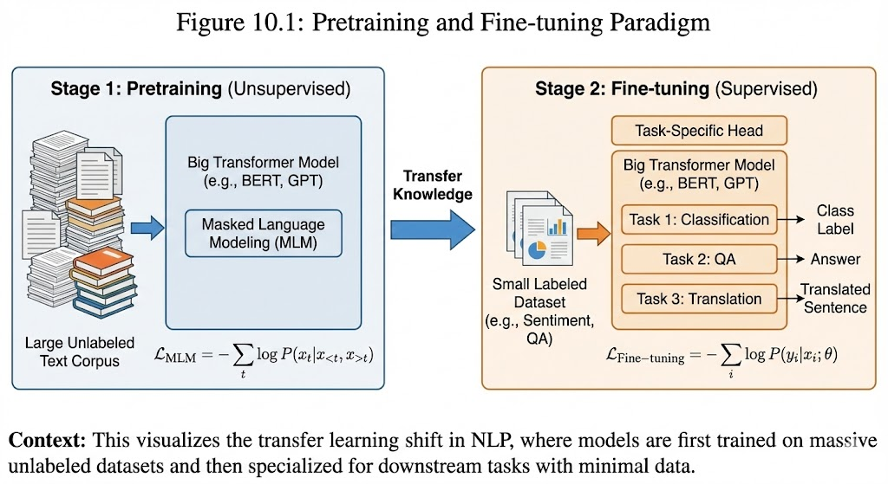

BERT: Bidirectional Encoder Representations from Transformers
BERT (Devlin et al., 2018) was a breakthrough that demonstrated the power of bidirectional context in language understanding.
Architecture BERT uses a standard Transformer encoder architecture:
- BERT-base: 12 layers, 768 hidden units, 12 attention heads (110M parameters)
- BERT-large: 24 layers, 1024 hidden units, 16 attention heads (340M parameters)

Pretraining Objectives BERT introduced two novel pretraining objectives:
    - Masked Language Modeling (MLM) Randomly mask 15% of tokens in the input and predict them:
      - 80% of masked tokens are replaced with [MASK]
      - 10% are replaced with random tokens
      - 10% are left unchanged
The loss is the cross-entropy between predicted and actual tokens:
Σ
L_{MLM} = − log P (x_{i}|xmasked)
i∈M
Where is the set of masked positions.
M
    - Next Sentence Prediction (NSP) Given two sentences A and B, predict if B follows A in the original text:
      - 50% of pairs are consecutive sentences (label = 1)
      - 50% are random pairs (label = 0) The loss is binary cross-entropy:
L_{NSP} = −y log p − (1 − y) log(1 − p)
Fine-tuning for Downstream Tasks BERT can be fine-tuned for various tasks with minimal architecture changes:
      - Classification: Add a classification head on [CLS] token
      - QA: Predict start and end positions of answer span
      - NER: Add token classification head
      - GLUE: Multi-task learning on multiple benchmarks
When I first fine-tuned BERT on a sentiment analysis task, I was amazed at how little data I needed—just a few thousand labeled examples were enough to achieve state-of-the-art results. The model had already learned so much about language from pretraining that it only needed minor adjustments for the specific task.

GPT: Generative Pretrained Transformer
While BERT focuses on understanding, GPT (Generative Pretrained Transformer) focuses on generation. The GPT series, developed by OpenAI, has pushed the boundaries of what’s possi- ble with large language models.

GPT Architecture Evolution
- GPT-1 (2018): 12-layer Transformer decoder, trained on BooksCorpus
- GPT-2 (2019): Up to 48 layers, 1.5B parameters, trained on WebText
- GPT-3 (2020): Up to 96 layers, 175B parameters, trained on diverse internet text
- GPT-3.5/GPT-4 (2023): Further improvements in reasoning and multi-modality
Pretraining Objective GPT uses a simple but powerful pretraining objective: next token prediction:
T
Σ
L = − log P (x_{t}|x_{<t})
t=1
This autoregressive objective forces the model to learn rich representations of language structure and semantics.
Zero-Shot, Few-Shot, and Fine-Tuning GPT models can be used in three ways:
    - Zero-shot: No examples, just task description
    - Few-shot: A few examples in context
    - Fine-tuning: Update weights on task-specific data
The ability to perform zero-shot and few-shot learning was revolutionary. When I first saw GPT-3 generate coherent text from just a prompt like ”Write a poem about machine learning,” I was blown away by its capabilities.
Mathematical Formulation of GPT Given a sequence of tokens x₁, x₂, ..., x_{T} , GPT models the joint probability:
T
Y
P (x₁, x₂, ..., x_{T} ) = P (x_{t}|x₁, x₂, ..., x_{t−1})
t=1
Each conditional probability is computed using the Transformer decoder:
P (x_{t}|x_{<t}) = softmax(W · TransformerDecoder(x_{<t})_{t})
The Transformer decoder uses masked self-attention to ensure that predictions for position
t depend only on positions < t.

T5: Text-to-Text Transfer Transformer
T5 (Raffel et al., 2019) unified all NLP tasks into a text-to-text format, where every task is treated as mapping input text to output text.
Unified Framework
- Input: ”summarize: The quick brown fox jumps over the lazy dog”
- Output: ”Fox jumps over dog”
This unified format allows the same model to handle classification, translation, summariza- tion, QA, and more.
Pretraining Objectives T5 experimented with several pretraining objectives:
- BERT-style masking: Replace spans with sentinel tokens
- Prefix LM: Predict next tokens given prefix
- Unsupervised denoising: Reconstruct corrupted text

The best performing objective was span corruption, where random spans of text are re- placed with sentinel tokens.
Scaling Laws T5 demonstrated important scaling laws:
- Performance improves predictably with model size
- More data is better than more parameters
- Compute-optimal training requires balancing model size and training tokens
When I implemented a small T5 model for a multi-task learning project, I was impressed by how well it could switch between different tasks based on the input prefix. The unified frame- work made it much easier to handle multiple tasks with a single model.

Scaling Laws and Compute-Optimal Training
Large language models follow predictable scaling laws that guide their development.
Chinchilla Scaling Laws The Chinchilla paper (Hoffmann et al., 2022) established that for a given compute budget C, the optimal model size N and training tokens D follow:
N ∝ C0.5 D ∝ C0.5
This means that for a fixed compute budget, it’s better to train a smaller model on more data rather than a larger model on less data.
Mathematical Formulation The loss L as a function of model size N and training tokens D
can be approximated as:
A B
L(N, D) = L₀ + NαN + DαD
Where:
- L₀ is the irreducible loss
- A, B are constants
- α_{N} , α_{D} are scaling exponents
This formulation allows us to predict performance and optimize resource allocation.
Compute-Optimal Training For a given compute budget C (measured in FLOPs):
- Compute cost: C ≈ 6ND (for Transformer training)
- Optimal allocation: N ∝ D ∝ C^{0.5}
This insight has guided the development of models like Chinchilla (70B parameters trained on 1.4T tokens) versus Gopher (280B parameters trained on 300B tokens).
When I first learned about these scaling laws, I was amazed at how predictable large model performance had become. This predictability allows researchers to make informed decisions about model sizes and training strategies.

Efficient Training Techniques
Training billion-parameter models requires specialized techniques:
    - Mixed Precision Training
      - Use FP16 for most computations, FP32 for master weights

      - Reduces memory usage and speeds up training
      - Requires loss scaling to prevent underflow
    - Gradient Checkpointing
      - Trade computation for memory by recomputing activations during backward pass
      - Reduces memory usage from O(L) to O(√L) for L layers
      - Slows down training but enables larger models
    - ZeRO Optimization
      - ZeRO-1: Partition optimizer states across devices
      - ZeRO-2: Also partition gradients
      - ZeRO-3: Also partition model parameters
      - Enables training of trillion-parameter models
    - Pipeline Parallelism
      - Split model layers across devices
      - Each device processes a subset of layers
      - Requires careful scheduling to maximize device utilization
When I tried to train a large Transformer model on my university’s GPU cluster, I struggled with memory limitations. Learning about gradient checkpointing and ZeRO optimization was a game-changer—it allowed me to train much larger models than I thought possible.

Applications and Impact
Large pretrained Transformers have transformed numerous fields:
    - Natural Language Processing
      - Machine Translation: Google Translate now uses Transformer-based models
      - Question Answering: Systems like Watson and Alexa use pretrained Transformers
      - Text Summarization: Generating concise summaries of long documents
      - Sentiment Analysis: Understanding opinions and emotions in text
    - Code Generation
      - GitHub Copilot: AI pair programmer based on Codex (GPT-3 variant)
      - Code completion: Predicting next lines of code
      - Bug detection: Identifying potential bugs in code
    - Scientific Discovery
      - Protein folding: AlphaFold uses attention mechanisms for protein structure prediction
      - Drug discovery: Generating and evaluating potential drug molecules
      - Scientific literature analysis: Extracting insights from research papers
    - Creative Applications
      - Content creation: Writing articles, stories, poetry
      - Music generation: Creating original musical compositions

Ethical Considerations and Challenges
Large language models raise important ethical questions:
    - Bias and Fairness
      - Models learn and amplify biases present in training data
      - Can produce offensive or discriminatory content
      - Mitigation: Bias detection, debiasing techniques, diverse training data
    - Environmental Impact
      - Training large models consumes significant energy
      - GPT-3 training estimated to produce 552 metric tons of CO2
      - Mitigation: Efficient architectures, green computing, model sharing
    - Misinformation
      - Models can generate convincing false information
      - Deepfakes and synthetic media pose societal risks
      - Mitigation: Watermarking, detection systems, responsible deployment
    - Access and Equity
      - Large models require significant resources to train
      - Creates a gap between well-funded organizations and others
      - Mitigation: Open source models, model sharing, cloud APIs
When I first became aware of these issues, I realized that as AI practitioners, we have a responsibility to consider the broader impact of our work. Technical excellence must be paired with ethical awareness and social responsibility.

Future Directions
The field of large language models is rapidly evolving:
    - Multimodal Models
      - CLIP: Connects text and images
      - Flamingo: Processes interleaved text and images
      - PaLM-E: Embodied language models for robotics
      - GPT-4V: Vision capabilities added to GPT-4
    - Reasoning and Planning
      - Chain-of-thought prompting: Encouraging step-by-step reasoning
      - Tree of thoughts: Exploring multiple reasoning paths
      - Program-aided language models: Using code execution for reasoning
    - Efficiency Improvements

      - Sparse models: Mixture-of-experts architectures
      - Knowledge distillation: Compressing large models into smaller ones
      - Parameter-efficient fine-tuning: LoRA, prefix tuning, adapter modules
    - Alignment and Safety
      - Constitutional AI: Training models to follow principles
      - Reinforcement learning from human feedback (RLHF): Aligning with human prefer- ences
      - AI safety research: Ensuring models behave as intended

Personal Reflections and Conclusion
My journey with attention mechanisms and Transformers has been transformative. From strug- gling to understand the mathematical foundations of attention to implementing state-of-the-art models, I’ve learned that deep learning is as much about intuition and creativity as it is about mathematics and code.
What I find most fascinating about Transformers is their versatility. The same core archi- tecture—scaled up and adapted—can handle language, vision, audio, and even scientific data. This universality suggests that attention mechanisms capture something fundamental about how information should be processed.
As I continue my studies and research in this field, I’m guided by several principles:
    - Understand the fundamentals: Don’t just use models as black boxes; understand how they work
    - Think critically: Question assumptions and consider limitations
    - Focus on impact: Build models that solve real problems and benefit society
    - Collaborate widely: The best advances happen at the intersection of disciplines
The Transformer architecture represents a profound shift in how we approach machine learning. By replacing recurrence with attention, it has unlocked new capabilities in sequence modeling, transfer learning, and multi-modal understanding. As we look to the future, I believe that attention mechanisms will continue to be at the heart of AI progress.

