From Regression to Classification

The Fundamental Shift: Predicting Categories, Not Quantities
In linear regression, our goal is to answer “how much?”—predicting continuous quantities like house prices, blood glucose levels, or stock values. The model learns a function f : R^{d} → R that minimizes squared error:
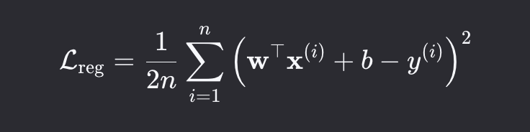
But many real-world problems are not about quantities—they are about categories. We want to know:
- Is this email spam or not spam?
- Is this patient diabetic or not?
- Is this image a t-shirt or a trouser?
This is classification—a supervised learning task where the output y belongs to a finite set of discrete labels:
y ∈ {1, 2, ..., K}
The shift from regression to classification is not merely notational—it is conceptual:

Aspect Regression Classification

Output y ∈ R y ∈ {1, ..., K}
Model Output Raw score yˆ ∈ R Probability vector p ∈ ∆^{K—1}
Loss Function Squared error Cross-entropy

Decision Rule
yˆ ≈ y
yˆ = arg max_{k} p_{k}

Table 1: Comparison of Regression and Classification

Motivating Example: Diabetes Prediction
Consider the problem introduced in your material: predicting diabetes risk from clinical mea- surements.

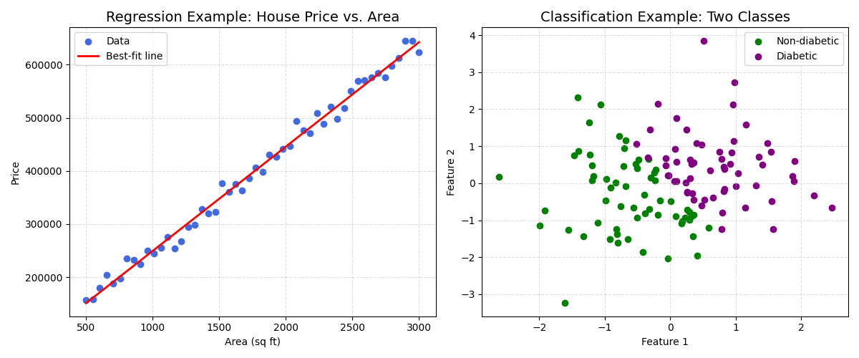
Figure 1: Side-by-side visualization

Problem Setup
Input features:
  - x₁: Patient’s age (years)
  - x₂: Blood glucose level (mg/dL) Output label:
  - y = 0: Non-diabetic
  - y = 1: Diabetic
Each patient is represented as a point x = [x₁, x₂]^{T} in the 2D plane. The training data consists of labeled examples:
  - Blue dots: Non-diabetic patients
  - Red dots: Diabetic patients
Our goal is to find a decision boundary that separates these two groups.

The Linear Decision Boundary
We begin with a linear model:

z = w₁x₁ + w₂x₂ + b (1.1)

This defines a line in the 2D plane:
w₁x₁ + w₂x₂ + b = 0 (1.2)
  - Points where z > 0 are classified as diabetic (class 1)
  - Points where z < 0 are classified as non-diabetic (class 0)
Geometric insight: The weight vector w = [w₁, w₂]^{T} is normal (perpendicular) to the decision boundary, pointing toward the class-1 region.
Generate with:

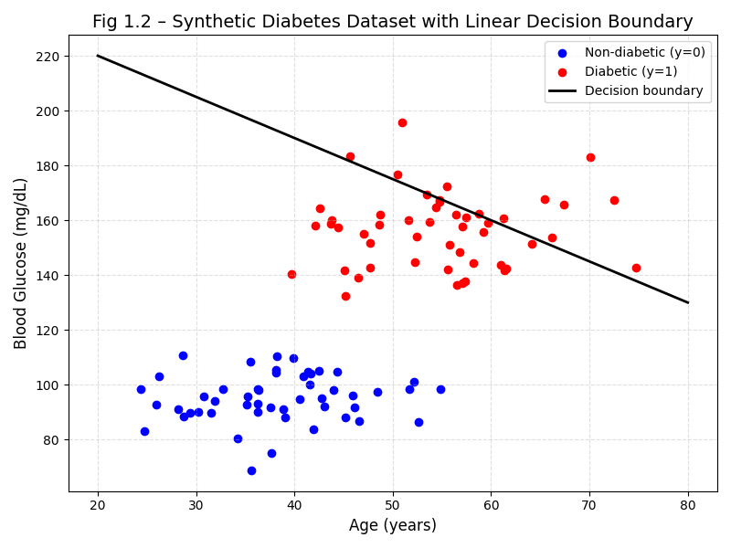
Figure 2: Scatter plot of synthetic diabetes data
import matplotlib.pyplot as plt
import numpy as np
np.random.seed(42)
# Non-diabetic (blue)
age0 = np.random.uniform(20, 60, 30)
glucose0 = np.random.uniform(70, 110, 30)
# Diabetic (red)
age1 = np.random.uniform(40, 80, 30)
glucose1 = np.random.uniform(120, 180, 30)
plt.scatter(age0, glucose0, c='blue', label='Non-diabetic')
plt.scatter(age1, glucose1, c='red', label='Diabetic')
# Decision boundary: w1*x1 + w2*x2 + b = 0 → x2 = (-w1*x1 - b)/w2
w1, w2, b = 0.5, -1, 40
x1_line = np.linspace(20, 80, 100)
x2_line = (-w1 * x1_line - b) / w2
plt.plot(x1_line, x2_line, 'k--', label='Decision boundary')
plt.xlabel('Age (years)'); plt.ylabel('Blood Glucose (mg/dL)')
plt.legend(); plt.grid(True)
plt.show()

The Perceptron: A Biological and Computational Model
The linear classifier is also known as the perceptron—a model inspired by biological neurons.

Biological Analogy
As your text describes, a neuron:
  - Receives inputs via dendrites (age, glucose)
  - Weights each input by synaptic strength (w₁, w₂)

  - Sums weighted inputs in the cell body (z = w₁x₁ + w₂x₂ + b)
  - Fires if sum exceeds threshold (output 1 or 0)

(1.4)

Why differentiability matters: To learn from data, we need to adjust weights w₁, w₂, b in the direction that reduces misclassification. This requires computing the gradient ∂L —which
∂w
j
does not exist for the step function.

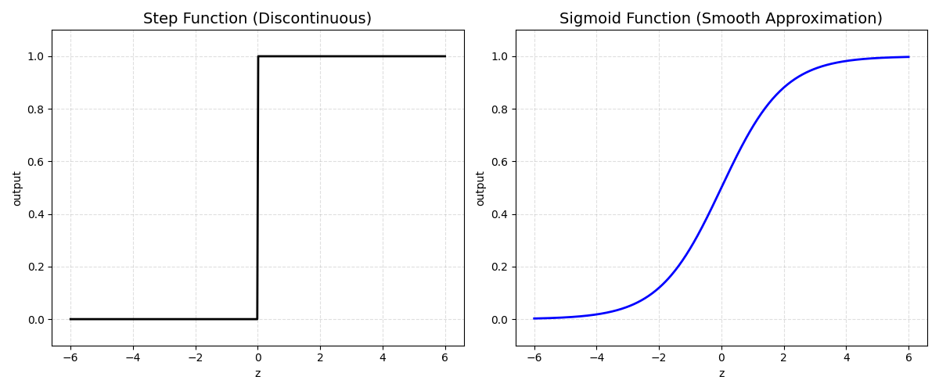
Figure 3: The step function provides no gradient information; the sigmoid provides a smooth pathway for learning.

From Hard Decisions to Probabilistic Predictions
To enable gradient-based learning, we replace the step function with a smooth, differentiable activation that outputs probabilities.

The Need for Confidence
Consider two patients near the decision boundary:
  - Patient A: z = 0.1 → slightly diabetic
  - Patient B: z = 3.0 → strongly diabetic
A step function treats both as “diabetic” with equal certainty. But we want to express confi- dence: Patient B is far more likely to be diabetic than Patient A.
Example: Why Accuracy Misleads on Imbalanced Data
A concrete illustration of how 99% accuracy can be meaningless, and how to detect and correct it:
import torch

# 990 non-diabetic (class 0), only 10 diabetic (class 1)
true_labels = torch.cat([torch.zeros(990), torch.ones(10)]).long()
naive_preds = torch.zeros(1000).long() # Always predict non-diabetic

accuracy = (naive_preds == true_labels).float().mean()
print(f'Accuracy: {accuracy:.2f}') # 0.99 -- looks great!

# But recall reveals the model catches ZERO actual diabetics:
tp = ((naive_preds==1) & (true_labels==1)).sum().float() # 0
fn = ((naive_preds==0) & (true_labels==1)).sum().float() # 10
recall = tp / (tp + fn + 1e-8)
print(f'Recall (diabetics caught): {recall:.2f}') # 0.00

# Fix: weight the rare class heavily in the loss
weights = torch.tensor([1.0, 99.0])
criterion = torch.nn.CrossEntropyLoss(weight=weights)
# Now misclassifying a diabetic costs 99x more than a non-diabetic
This leads to the sigmoid function:

σ(z) = 1 + e—z (1.5)
1

Key Properties of the Sigmoid
  - Smooth and differentiable everywhere
  - Bounded: σ(z) ∈ (0, 1)
  - Monotonic: Increases with z
Probabilistic interpretation:
p = σ(z) = P (y = 1 | x) (1.6)
Derivative (needed for gradient descent):
dσ
= σ(z)(1 − σ(z)) (1.7)
dz
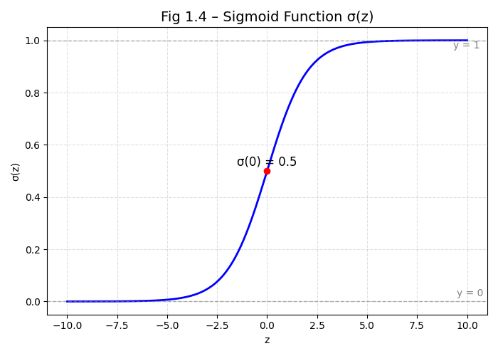
Figure 4: Sigmoid curve

The Full Binary Classifier
Combining the linear model with the sigmoid, we get the binary classifier:
p = σ(w^{T}x + b) (1.8)
This is a linear neural network with sigmoid activation—the foundation of logistic regression and the starting point for deep classification networks.

Numerical Example
Assume weights: w₁ = 0.1, w₂ = 0.2, b = −15.
Patient: Age = 50, Glucose = 130
z = 0.1 · 50 + 0.2 · 130 − 15 = 5 + 26 − 15 = 16
1

p = σ(16) = ≈ 1.0 1 + e—16

→ Prediction: Diabetic with high confidence.
Borderline patient: Age = 40, Glucose = 90
z = 0.1 · 40 + 0.2 · 90 − 15 = 4 + 18 − 15 = 7
p = σ(7) ≈ 0.999
Still confident—but slightly less so.
This probabilistic output enables us to define a differentiable loss function: cross-entropy, which we will derive in Chapter 3.

Summary
  - Classification predicts discrete labels; regression predicts continuous values.
  - A linear decision boundary w^{T}x + b = 0 separates classes in feature space.
  - The perceptron uses a step function for hard decisions—but it is not differentiable.
  - The sigmoid function σ(z) = ¹−z provides smooth, probabilistic outputs.
1+e
  - The full binary classifier is p = σ(w^{T}x + b), enabling gradient-based learning.

Chapter 2: Sigmoid, Softmax, and Probabilistic Outputs

”Certainty is the enemy of learning; probability is its ally.”

The Problem with Hard Predictions
In Chapter 1, we saw that a linear model for classification takes the form:
z = w^{T}x + b
and produces a hard prediction using the step function:
yˆ = (
1 if z ≥ 0
0 otherwise
While intuitive, this approach has a critical flaw: it provides no measure of confidence.
Consider two diabetic patients:
- Patient A: z = 0.1 → barely above threshold
- Patient B: z = 5.0 → far above threshold
Both are classified as “diabetic” with equal certainty—but clearly, Patient B is a much stronger case. The step function discards this nuance, making it unsuitable for gradient-based learn- ing (it is non-differentiable at 0).
To overcome this, we replace the step function with a smooth, differentiable activation
that outputs probabilities—enabling both confidence-aware decisions and gradient descent.

Sigmoid Function: Probabilistic Binary Classification
The sigmoid function provides a smooth approximation to the step function:
σ(z) = 1 + e—z (2.1)
1

Key Properties
  - Smooth and differentiable everywhere
  - Bounded: σ(z) ∈ (0, 1)
  - Monotonic: Increases with z
  - Probabilistic interpretation:

p = σ(z) = P (y = 1 | x) (2.2)
Derivative (needed for backpropagation):
dσ
= σ(z)(1 − σ(z)) (2.3)
dz

Numerical Example: Diabetes Prediction
Assume model: z = 0.1 · age + 0.2 · glucose − 15
- Patient A: age = 40, glucose = 90 → z = 7 → p = σ(7) ≈ 0.999
- Patient B: age = 30, glucose = 80 → z = −2 → p = σ(−2) ≈ 0.119
→ Patient A is highly likely to be diabetic; Patient B is unlikely.
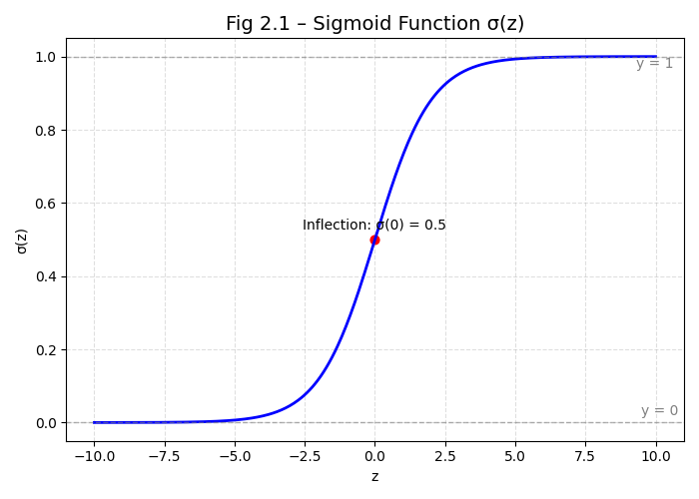
Figure 1: Sigmoid curve

From Binary to Multi-Class: The Need for One-Hot Encoding
Binary classification has only two outcomes—but most real-world problems have more than two classes. Consider Fashion-MNIST:
- 10 clothing items: t-shirt, trouser, pullover, ..., ankle boot
If we naively assign integer labels (0 to 9), we imply an unnatural ordering (is “sandal” > “sneaker”?). Worse, a linear model would treat these as ordinal values, distorting learning.

One-Hot Encoding
We represent each label as a one-hot vector:
- “T-shirt” → [1, 0, 0, 0, 0, 0, 0, 0, 0, 0]
- “Trouser” → [0, 1, 0, 0, 0, 0, 0, 0, 0, 0]
- ...
Formally, for class k ∈ {1, ..., K}:

1 j = k
= (
Tj 0 otherwise
(2.4)

This representation is essential for multi-class probabilistic modeling.

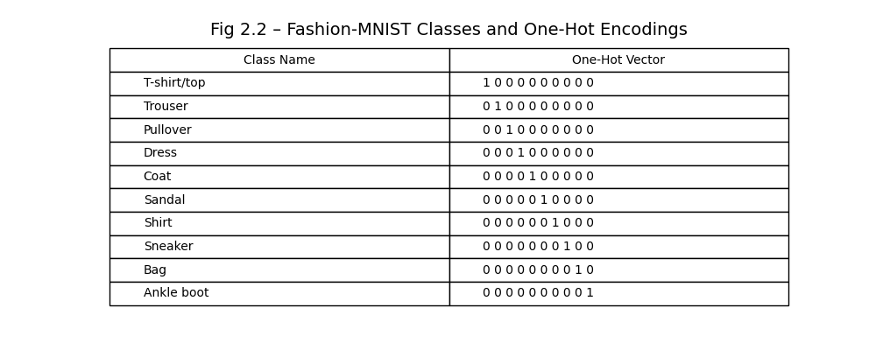

Softmax Function: Multi-Class Probabilities
For K-class problems, we compute logits (raw scores):
z_{k} = w^{T}x + b_{k}, k = 1, ..., K (2.5)
k
The softmax function converts logits into a valid probability distribution:

Key Properties
  - p_{k} ∈ (0, 1) and ΣK
k=1

p_{k} = 1

  - Preserves ranking: arg max_{k} p_{k} = arg max_{k} z_{k}
  - Soft max: Amplifies the largest logit while suppressing others
Why exponentiate?
Exponentials ensure non-negativity and monotonicity. Normalization ensures valid probabilities.

Numerical Example
Logits: z = [2.0, 1.0, 0.1]
- Exponentiate: [e², e¹, e^{0.1}] ≈ [7.39, 2.72, 1.11]
- Sum: 7.39 + 2.72 + 1.11 = 11.22
- Normalize:
p = 7.39 , 2.72 , 1.11 ≈ [0.66, 0.24, 0.10]
11.22
11.22
11.22

→ Class 1 is most likely (66% probability).

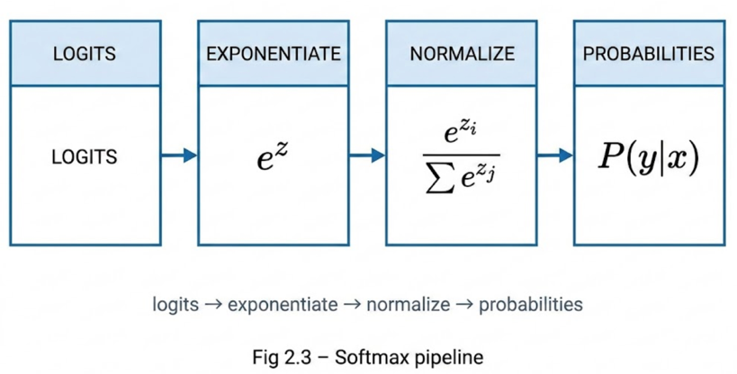
Figure 3: Softmax Pipeline

From Raw Scores to Confidence: Interpretation
The softmax output is not just a prediction—it is a belief distribution. For Fashion-MNIST:
- p = [0.9, 0.05, 0.05, ..., 0] → “I’m 90% sure it’s a t-shirt”
- p = [0.35, 0.30, 0.25, 0.10, ..., 0] → “I’m uncertain—could be t-shirt, trouser, or pullover” This soft prediction is crucial for:
- Uncertainty quantification
- Downstream decision-making (e.g., medical diagnosis)
- Gradient-based optimization (via cross-entropy loss, Chapter 3)

Implementation: Softmax in Code

From Scratch
def softmax(Z):
Z_exp = torch.exp(Z)
partition = Z_exp.sum(1, keepdims=True) return Z_exp / partition # Broadcasting

High-Level (PyTorch)
import torch.nn.functional as F p = F.softmax(z, dim=1)
This is automatically stable and optimized.

Summary
- Sigmoid converts scalar logits to binary probabilities: p = σ(z)
- One-hot encoding represents multi-class labels without ordinal bias
Σ
- Softmax converts vector logits to multi-class probabilities: p_{k} = e^{z}k / j e^{z}j
- Probabilistic outputs enable confidence-aware decisions and gradient-based learning
- Softmax preserves ranking—so argmax prediction matches raw logit argmax

Chapter 3: Cross-Entropy Loss and Gradient Descent

”Learning is not about memorizing answers—it is about minimizing surprise.”

The Need for a Differentiable Loss Function
In Chapter 1, we saw that a linear model for classification computes a raw score:
z = w^{T}x + b
In Chapter 2, we replaced the non-differentiable step function with the sigmoid (binary) or soft- max (multi-class) to produce probabilistic outputs:
- Binary: p = σ(z) ∈ (0, 1)
- Multi-class: p = softmax(z) ∈ ∆^{K—1}
But to learn from data, we need a loss function that:
- Quantifies error: Measures how far predictions are from true labels
- Is differentiable: Enables gradient-based weight updates
- Is well-behaved: No infinite gradients, no flat regions
The squared error used in regression is unsuitable for classification because:
  - It assumes Gaussian noise, not categorical outcomes
  - It produces poor gradients when predictions are confident but wrong
Instead, we use cross-entropy loss—a function rooted in information theory and maxi- mum likelihood estimation.

Binary Cross-Entropy: Definition and Justification

Probabilistic Model
For binary classification, we model the probability that y = 1 given input x as:
P (y = 1 | x) = p, P (y = 0 | x) = 1 − p
where p = σ(wTx + b).
For a true label t ∈ {0, 1}, the likelihood of observing t is:
P (t | x) = p^{t}(1 − p)^{1—t} (3.1)

Negative Log-Likelihood
To avoid multiplying many small probabilities (which causes underflow), we maximize the log- likelihood—equivalently, minimize the negative log-likelihood:
l(p, t) = − log P (t | x) = −[t log p + (1 − t) log(1 − p)] (3.2) This is the binary cross-entropy loss.

Numerical Behavior

True Label t | Prediction p | Loss l
1 | 0.95 | — log(0.95) = 0.051
1 | 0.50 | — log(0.50) = 0.693
1 | 0.10 | — log(0.10) = 2.303
0 | 0.90 | — log(1 − 0.90) = 2.303
Key insight: Cross-entropy heavily penalizes confident wrong predictions—exactly what we want.
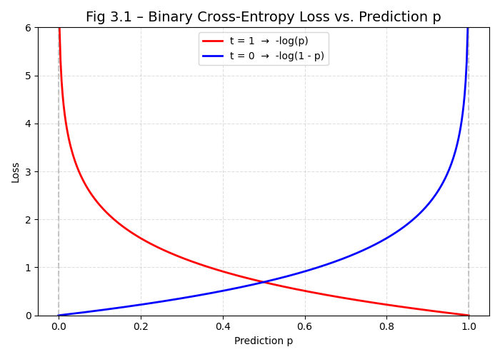
Figure 1: Binary Cross-Entropy Loss Behavior

Multi-Class Cross-Entropy

One-Hot Labels
For K-class problems, the true label is a one-hot vector t ∈ {0, 1}^{K}, where t_{k} = 1 if the true class is k.
The model outputs a probability vector p = softmax(z), where z = Wx + b.

Cross-Entropy Formula
The multi-class cross-entropy loss is:
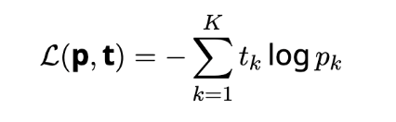
Because t is one-hot, only the true class contributes:
L = − log p_{true} (3.4)

Example:
True class: “t-shirt” → t = [1, 0, 0, ..., 0]
Prediction: p = [0.9, 0.05, 0.03, ..., 0.02]
Loss: − log(0.9) = 0.105

Gradient Derivation: The Core Update Rule

Binary Case
We derive ∂l using the chain rule. Let z = wTx + b, p = σ(z).
∂w

    - ∂l = − t + 1—t
∂p p 1—p
    - ^{∂p} = p(1 − p)
∂z
∂z
3.
= x
∂w

Thus:

Multi-Class Case

∂l
∂w

= − t +
p

1 − t · p(1 − p) · x = (p − t)x (3.5)
1 − p

For logits z_{k} and softmax output p_{k}, the gradient is:
∂L

∂z_{k}
= p_{k} − t_{k} (3.6
Beautiful result: Gradient = predicted probability � true label
Connection to regression: In regression, gradient = yˆ− y. Here, it’s p − t—the same structural form.
Derivation:

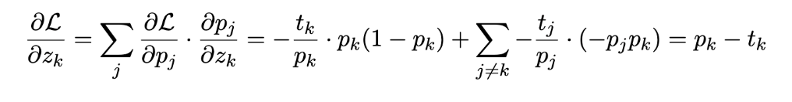

Weight Update Rule: Gradient Descent

Parameter Updates
Given learning rate η, the update rules are:
Binary:

Multi-class:
w ← w − η(p − t)x, b ← b − η(p − t) (3.7)

W ← W − η(p − t)x^{T}, b ← b − η(p − t) (3.8)

This is the delta rule—an error-driven update: if prediction is too low (p < t), increase weights for active features.

Role of the Learning Rate η
- Too small: Converges slowly
- Too large: Oscillations or divergence
- Just right: Smooth, rapid convergence

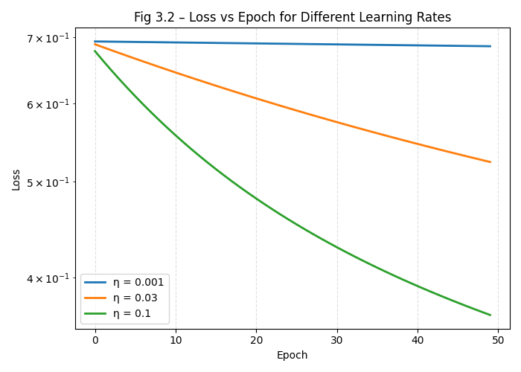

Numerical Example: Diabetes Prediction

Problem Setup
- Input: Age = 40, Glucose = 85
- True label: t = 1 (diabetic)
- Current weights: w₁ = 0.1, w₂ = 0.15, b = −10
- Learning rate: η = 0.01

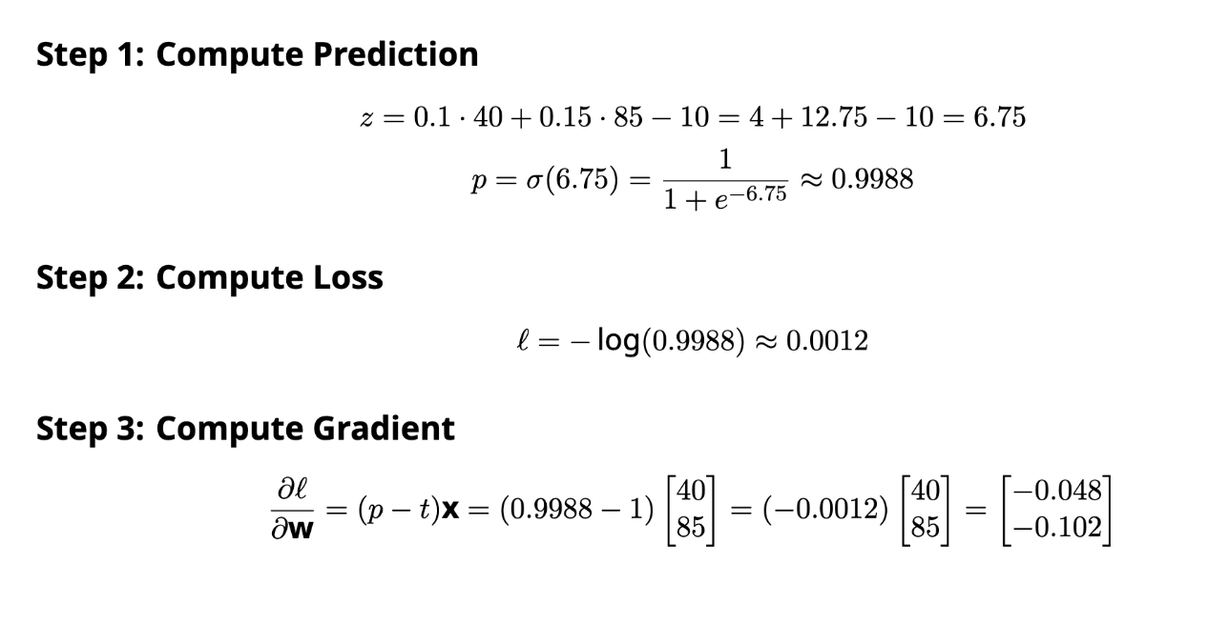



Step 4: Update Weights
wnew = 0.1 − 0.01 · −0.048 = 0.10048
0.15
−0.102
0.15102
b_{new} = −10 − 0.01 · (−0.0012) ≈ −9.999988
Even though the prediction was highly confident and correct, the tiny error still produces a small corrective update—this is how gradient descent fine-tunes the model.

Convergence and the Linear Separability Guarantee
For linearly separable data, gradient descent on cross-entropy loss converges to zero train- ing error—the decision boundary eventually separates all classes.
However, for non-separable data (e.g., overlapping classes), the algorithm converges to a
soft margin solution that balances:
- Minimizing misclassification
- Maximizing classification confidence

Limitation: Like all linear models, this approach fails on nonlinearly separable problems (e.g., XOR)—a fundamental constraint we will address in deep networks.

Summary
- Cross-entropy loss is the standard for classification, derived from maximum likelihood.
- Binary cross-entropy: l = −[t log p + (1 − t) log(1 − p)]
- Multi-class cross-entropy: L = − log p_{true}

- Gradient: ∂L
∂z
k
= p_{k} − t_{k}—simple, elegant, and efficient

- Weight update: Error-driven: ∆w = −η(p − t)x
- Learning rate controls convergence speed and stability

Chapter 4: Implementation and Evaluation

From Theory to Code: Two Implementation Paradigms
In Chapters 1–3, we derived the core components of a linear classifier:
- Model: p = softmax(Wx + b)
- Loss: L = − log p_{true}

- Gradient: ∂L
∂z
k
= p_{k} − t_{k}

- Update: W ← W − η(p − t)xT
Now we implement these ideas in code. There are two approaches:
- From scratch: Manual tensor operations, explicit gradients
- High-level: Built-in layers and losses from PyTorch
Both yield identical results—but the former builds intuition, while the latter enables rapid development.

From-Scratch Implementation

Softmax Function
We begin with the softmax activation:
def softmax(Z):
Z_exp = torch.exp(Z)
partition = Z_exp.sum(1, keepdims=True) return Z_exp / partition # Broadcasting

Warning: This version is not numerically stable for large z_{k}. It serves pedagogical purposes only.

Model Definition
We define a classifier with learnable weights W and bias b:
class SoftmaxRegressionScratch:
def init (self, num_inputs, num_outputs, lr, sigma=0.01):
self.W = torch.normal(0, sigma, (num_inputs, num_outputs), requires_grad
=True)
self.b = torch.zeros(num_outputs, requires_grad=True)

self.lr = lr

def forward(self, X):
X = X.reshape((-1, self.W.shape[0])) # Flatten if needed return softmax(torch.matmul(X, self.W) + self.b)

Cross-Entropy Loss
For one-hot label t and prediction p, loss is − log p_{true}:
def cross_entropy(y_hat, y):
return -torch.log(y_hat[range(len(y_hat)), y]).mean()

def loss(self, y_hat, y):
return cross_entropy(y_hat, y)
Key insight: Indexing y_hat[range(n), y] selects p_{true} for each example.

High-Level Implementation (PyTorch)

Concise Model
Using PyTorch’s built-ins:
class SoftmaxRegression(nn.Module):
def init (self, num_outputs, lr): super(). init ()
self.net = nn.Sequential(nn.Flatten(), nn.LazyLinear(num_outputs)) self.lr = lr

def forward(self, X): return self.net(X)

Built-in Loss
PyTorch’s F.cross_entropy combines logits, softmax, and log in one numerically stable op- eration:
def loss(self, Y_hat, Y):
return F.cross_entropy(Y_hat, Y, reduction='mean')
Why this matters: It uses the log-sum-exp trick to avoid overflow:
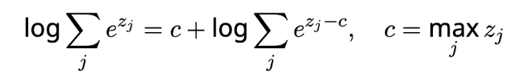

Optimizer
The optimizer updates weights with built-in numerical safety:
def configure_optimizers(self):
return torch.optim.SGD(self.parameters(), self.lr)
Advantage: No need to manually list parameters—self.parameters() auto-registers all requires_grad=True tensors.

Training on Fashion-MNIST

Dataset Overview
    - Images: 60,000 training + 10,000 test grayscale images (28 × 28)
    - Classes: 10 clothing items (t-shirt, trouser, ..., ankle boot)
    - Preprocessing: Flatten 28 × 28 → 784-dimensional vector

Training Code
data = FashionMNIST(batch_size=256)
model = SoftmaxRegression(num_outputs=10, lr=0.1) trainer = Trainer(max_epochs=10) trainer.fit(model, data)
Results
    - Training accuracy: ∼ 85%
    - Validation accuracy: ∼ 80%
    - Interpretation: A linear model achieves remarkable performance on a non-trivial im- age classification task—demonstrating the power of linear classifiers when combined with good features.
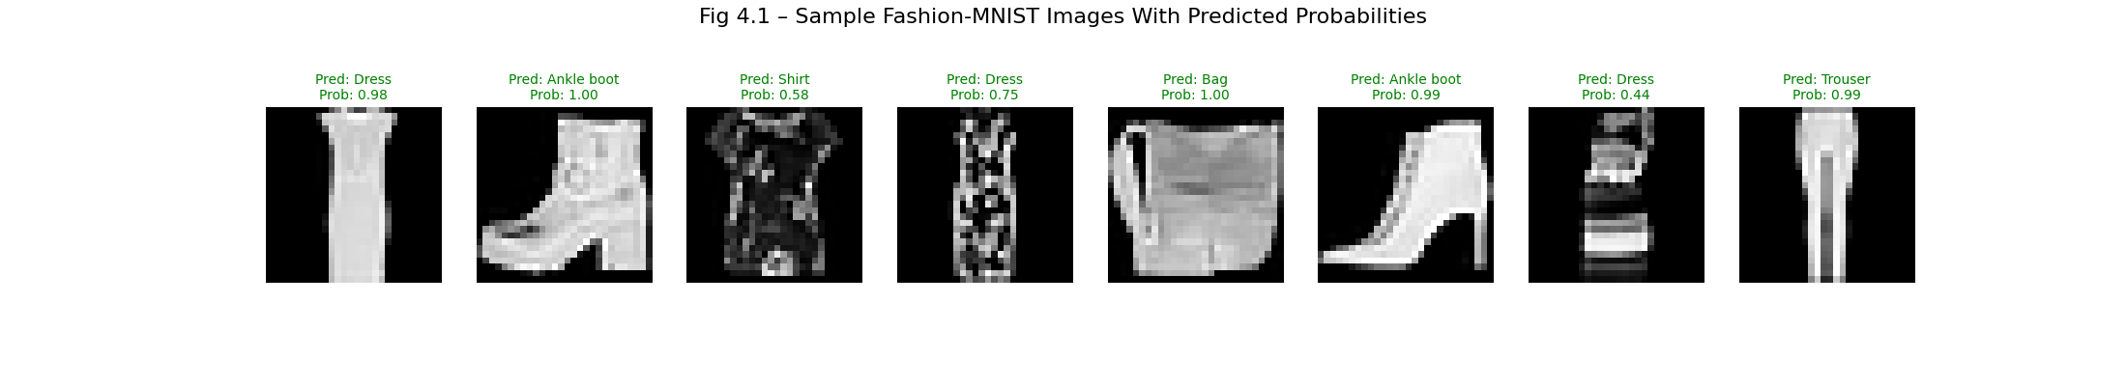
Figure 1: Sample Predictions on Fashion-MNIST
import torch
import torch.nn as nn
import torch.optim as optim
import torchvision
import torchvision.transforms as transforms
import torch.nn.functional as F
# ----------------------------
# Model Definition
# ----------------------------
class SoftmaxRegression(nn.Module):
def __init__(self):
super().__init__()
self.linear = nn.Linear(784, 10)
def forward(self, X):
return self.linear(X)
# ----------------------------
# Load Data
# ----------------------------
transform = transforms.ToTensor()
trainset = torchvision.datasets.FashionMNIST(
root="./data", train=True, download=True, transform=transform
)
trainloader = torch.utils.data.DataLoader(trainset, batch_size=64, shuffle=True)
# ----------------------------
# Initialize model, optimizer, loss
# ----------------------------
model = SoftmaxRegression()
optimizer = optim.SGD(model.parameters(), lr=0.1)
criterion = nn.CrossEntropyLoss()
# ----------------------------
# Train for 1–3 epochs
# ----------------------------
epochs = 3
for epoch in range(epochs):
total = 0
correct = 0
for images, labels in trainloader:
X = images.view(-1, 784)
logits = model(X)
loss = criterion(logits, labels)
optimizer.zero_grad()
loss.backward()
optimizer.step()
preds = logits.argmax(dim=1)
correct += (preds == labels).sum().item()
total += labels.size(0)
print(f"Epoch {epoch+1}/{epochs} | Accuracy: {correct/total:.3f}")
# ----------------------------
# Save the trained model
# ----------------------------
torch.save(model.state_dict(), "fashion_linear.pth")
print("Model saved -> fashion_linear.pth")

import torch
import torchvision
import torchvision.transforms as transforms
import torch.nn as nn
import torch.nn.functional as F
import matplotlib.pyplot as plt
import numpy as np
# ----------------------------
# Model Definition (High-Level)
# ----------------------------
class SoftmaxRegression(nn.Module):
def __init__(self):
super().__init__()
self.linear = nn.Linear(784, 10)
def forward(self, X):
return self.linear(X)
# ----------------------------
# Load Dataset
# ----------------------------
transform = transforms.ToTensor()
testset = torchvision.datasets.FashionMNIST(
root="./data", train=False, download=True, transform=transform
)
testloader = torch.utils.data.DataLoader(testset, batch_size=1, shuffle=True)
class_names = [
"T-shirt/top", "Trouser", "Pullover", "Dress", "Coat",
"Sandal", "Shirt", "Sneaker", "Bag", "Ankle boot"
]
# ----------------------------
# Load Trained Model
# ----------------------------
model = SoftmaxRegression()
model.load_state_dict(torch.load("fashion_linear.pth")) # <-- must exist
model.eval()
# ----------------------------
# Plot 8 Sample Predictions
# ----------------------------
fig, axes = plt.subplots(1, 8, figsize=(22, 4))
for i, (X, y) in zip(range(8), testloader):
X_flat = X.view(-1, 784)
logits = model(X_flat)
probs = F.softmax(logits, dim=1)[0]
pred = torch.argmax(probs).item()
confidence = probs[pred].item()
label = y.item()
# Coloring: green if correct, red if incorrect
color = "green" if pred == label else "red"
axes[i].imshow(X[0][0], cmap="gray")
axes[i].set_title(
f"Pred: {class_names[pred]}\nProb: {confidence:.2f}",
color=color, fontsize=10
)
axes[i].axis("off")
plt.suptitle("Fig 4.1 – Sample Fashion-MNIST Images With Predicted Probabilities", fontsize=16)
plt.show()

Evaluation Metrics

Accuracy
Accuracy is the fraction of correct predictions:

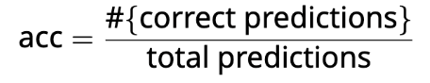

Implementation:

def accuracy(Y_hat, Y):
preds = Y_hat.argmax(axis=1).type(Y.dtype) return (preds == Y.reshape(-1)).float().mean()
Why not optimize accuracy directly? → Not differentiable. We optimize cross- entropy instead.

When Accuracy Misleads
    - Imbalanced data: 99% non-diabetic → 99% accuracy by always predicting ”non-diabetic”
    - Solution: Use precision, recall, F1-score, or confusion matrices
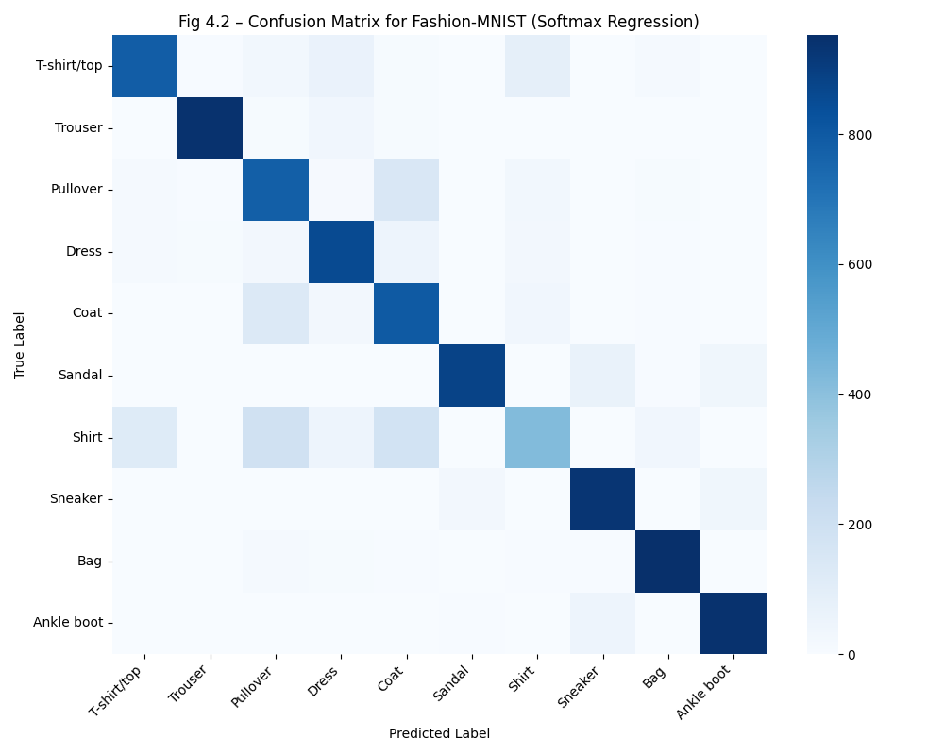
Figure 2: Confusion Matrix

Limitations: The XOR Problem
Linear classifiers fail on nonlinearly separable problems. The canonical example is XOR:
- (0,0) → 0, (0,1) → 1, (1,0) → 1, (1,1) → 0
No line can separate class 0 from class 1 in the input plane.
Example: XOR — Why Linear Models Fail, and How MLPs Fix It
This shows empirically that no linear model can solve XOR, while one hidden layer with ReLU solves it:
import torch
import torch.nn as nn

# XOR dataset - no straight line can separate these 4 points
X = torch.tensor([[0,0],[0,1],[1,0],[1,1]], dtype=torch.float32)
y = torch.tensor([0, 1, 1, 0], dtype=torch.long)

# A linear model FAILS - no weight setting solves XOR
linear = nn.Linear(2, 2)
# Try training it: loss never reaches zero

# An MLP with one hidden layer SUCCEEDS
mlp = nn.Sequential(
nn.Linear(2, 4), # Hidden layer learns intermediate features
nn.ReLU(), # Non-linearity is the critical ingredient
nn.Linear(4, 2), # Output: 2 classes
)
opt = torch.optim.Adam(mlp.parameters(), lr=0.05)
loss_fn = nn.CrossEntropyLoss()
for _ in range(500):
loss = loss_fn(mlp(X), y)
opt.zero_grad(); loss.backward(); opt.step()

preds = mlp(X).argmax(dim=1)
print(preds.tolist()) # [0, 1, 1, 0] -- correct!
print((preds==y).float().mean()) # tensor(1.0) -- 100% accuracy
Historical impact: Minsky and Papert (1969) proved this limitation, triggering the ”AI winter” and halting neural network research for a decade.

Resolution: Add hidden layers with nonlinear activations → multi-layer percep- tron (backpropagation).

When Linear Classifiers Succeed
Despite their simplicity, linear classifiers excel when:

- Data is linearly separable (e.g., well-separated medical diagnoses)
- Features are high-dimensional (e.g., TF-IDF vectors in text classification)
- Interpretability matters (e.g., inspecting weight magnitudes reveals feature importance)
Final insight:
Linear classifiers are fast, interpretable, and optimal when data is separable—but deep networks are needed for complex patterns like images, speech, and language.

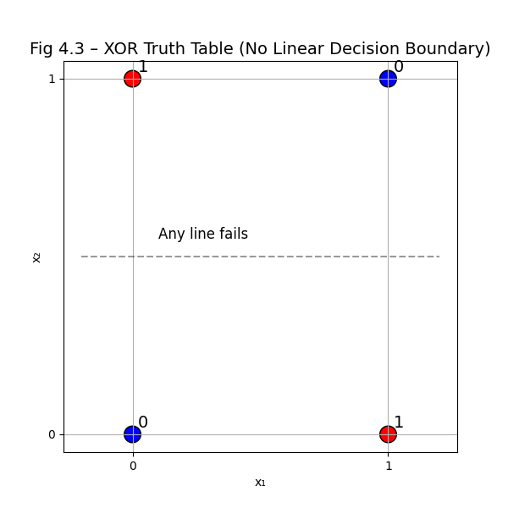
Figure 3: The XOR Problem

Summary
- From-scratch implementation builds deep understanding of gradients and updates.
- High-level implementation leverages optimized, numerically stable built-ins.
- Fashion-MNIST demonstrates that linear models can achieve ∼ 80% accuracy on real im- age data.
- Accuracy is the standard metric—but can be misleading on imbalanced data.
- XOR exposes the fundamental limitation of linear models: inability to capture nonlinear patterns.
- Bridge to deep learning: Hidden layers + nonlinearities overcome this limitation.

