Chapter 1
Computational Performance

Compilers and Interpreters

Imperative vs Symbolic Programming
When we write Python code like:

def add(a, b): return a + b

def fancy_func(a, b, c, d):
e = add(a, b)
f = add(c, d)
g = add(e, f) return g

We’re using imperative (interpreted) programming. Python executes each line sequen- tially, storing intermediate results like e and f. This is easy to understand and debug—but inefficient at scale.
Why?
- Every function call is interpreted by Python (single-threaded).
- Intermediate values stay in memory even if unused later.
- On fast hardware (e.g., GPUs), Python becomes the bottleneck.
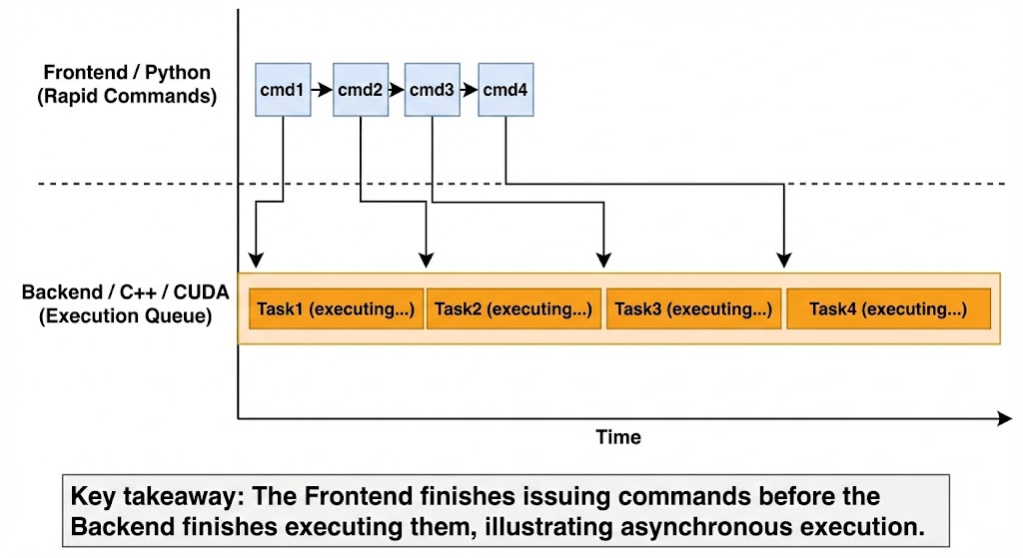
Figure 1.1: Data flow in an imperative program.
In contrast, symbolic programming (used in Theano, TensorFlow v1) works in three steps:
      - Define all operations as a computational graph.
      - Compile the graph into an optimized low-level program.
      - Execute it with inputs—bypassing Python. Benefits:
        - Faster (no Python interpreter overhead)
        - Compiler can optimize away unused ops (e.g., turn entire function into print(10))
        - Memory can be released early
        - Models can be exported to non-Python environments
Drawbacks:
        - Hard to debug (can’t inspect intermediates easily)
        - Less flexible control flow

Hybrid Programming
Modern frameworks (like PyTorch) combine both worlds:
- Develop in imperative mode (easy prototyping)
- Deploy in symbolic mode via TorchScript
Example:
1
net = nn.Sequential(...) net = torch.jit.script(net)
# Normal model
# Compile for speed
2

After scripting:
- The same model runs faster
- It can be saved independently of Python
Note: In practice, TorchScript may not speed up tiny models due to overhead—but shines in production.

Asynchronous Computation
Modern systems have many parallel units: CPU cores, GPU cores, multiple GPUs. But Python is single-threaded, so how do we keep all hardware busy?
Answer: Asynchronous execution.

How It Works
- When you call torch.mm(a, a) on GPU, PyTorch queues the operation in the backend (C++/CUDA).
- Python immediately returns control, even before GPU finishes.
- You can queue many operations fast.

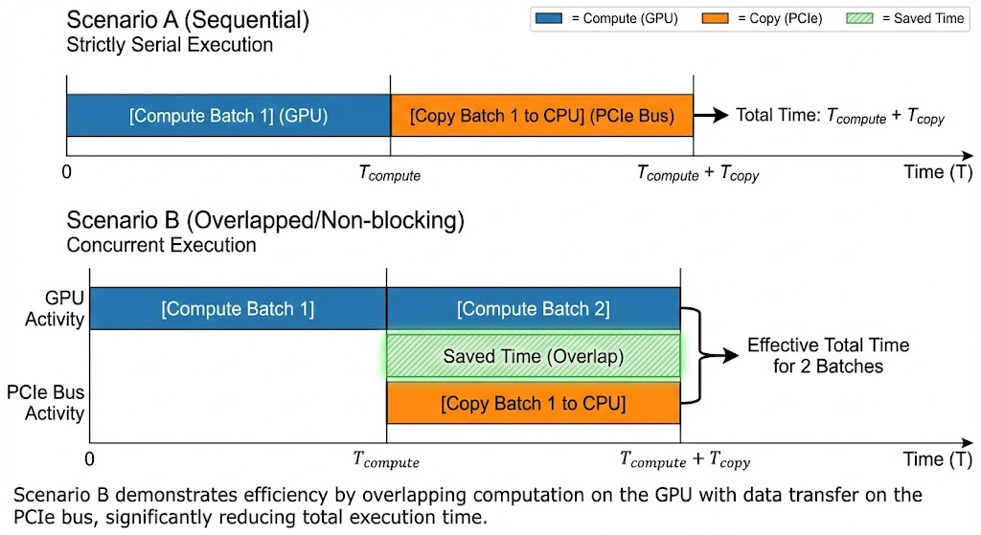
Figure 1.2: Frontend vs. Backend execution.

When Does Python Wait? (Blocking Operations)
Python must wait when it needs the actual value:
- print(tensor)
- .cpu(), .numpy()
- .item()
- torch.cuda.synchronize()
Pitfall: Frequent .cpu() in training loop kills performance.

Performance Gain Example
1
# Asynchronous
for _ in range(10000): y = x + 1 torch.cuda.synchronize()

# Synchronous
for _ in range(10000): y = x + 1 y.wait_to_read()
# Wait once -> 0.93 sec
# Wait every time -> 3.16 sec
2
3
4
5
6
7
8
→ 3.4× speedup just by avoiding unnecessary sync!

Automatic Parallelism
Deep learning frameworks automatically parallelize independent operations.

Parallel GPU Computation
If you run:
1
run(x_gpu1) # on GPU0 run(x_gpu2) # on GPU1
2
Without synchronize() between, the system executes both in parallel.
Benchmark:
- GPU0 alone: 0.466 sec
- GPU1 alone: 0.451 sec
- Both together: 0.466 sec (not 0.9+ sec!)
The framework schedules tasks automatically across devices.

Overlapping Computation & Communication
Moving data (GPU → CPU) is slow:
- Compute on GPU: 0.47 sec
- Copy to CPU: 2.31 sec
But: you can start copying while GPU still computes!
Use non_blocking=True:

1 y_cpu = y.to('cpu', non_blocking=True)
Result:
- Total time: 1.69 sec (vs 2.78 sec sequential)
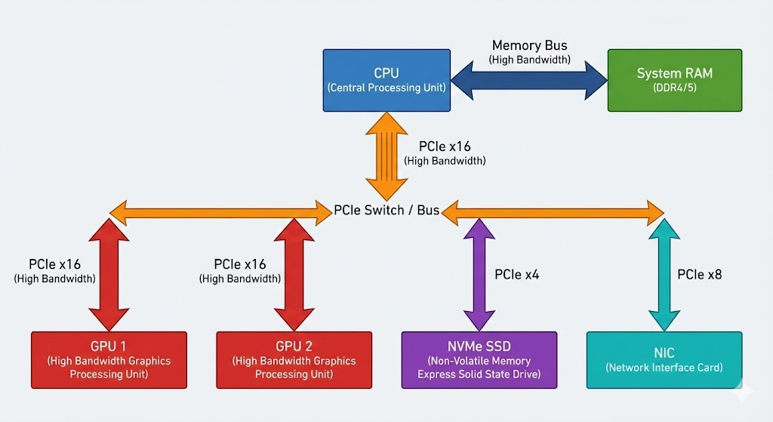
Figure 1.3: Overlapping computation and communication.
Rule: Always use non_blocking=True when copying from GPU to CPU.

➔ Example: Blocking vs. Non-Blocking GPU→CPU Transfer — Timing Code
The 1.69 s vs 2.78 s numbers above come from overlapping a GPU→CPU copy with active GPU computation. Here is a minimal reproducible example:
import torch, time

device = 'cuda'
x = torch.randn(8000, 8000, device=device) # ~256 MB tensor

# --- BLOCKING (sequential) ---
torch.cuda.synchronize()
t0 = time.perf_counter()
y = x @ x.T # GPU compute (~0.47 s)
z = y.to('cpu') # GPU->CPU copy (~2.31 s, blocks Python)
torch.cuda.synchronize()
print(f'Sequential: {time.perf_counter()-t0:.2f} s') # ~2.78 s

# --- NON-BLOCKING (overlapped) ---
torch.cuda.synchronize()
t0 = time.perf_counter()
y = x @ x.T # queue compute
z = y.to('cpu', non_blocking=True) # queue copy — Python continues
w = x @ x[:, :100] # more GPU work while copy runs
torch.cuda.synchronize() # wait for ALL queued ops
print(f'Overlapped: {time.perf_counter()-t0:.2f} s') # ~1.69 s

# Pitfall to avoid in training loops:
for batch in loader:
loss = model(batch).sum()
print(loss.item()) # BAD: .item() blocks GPU every single step!
# Fix: accumulate loss as a tensor; print once per epoch.
The key insight: Python’s GIL runs on the CPU while the GPU executes independently. As long as you avoid forcing Python to inspect GPU values (.item(), .cpu(), print), the backend can keep the GPU saturated.

Hardware
To optimize performance, understand your hardware stack.
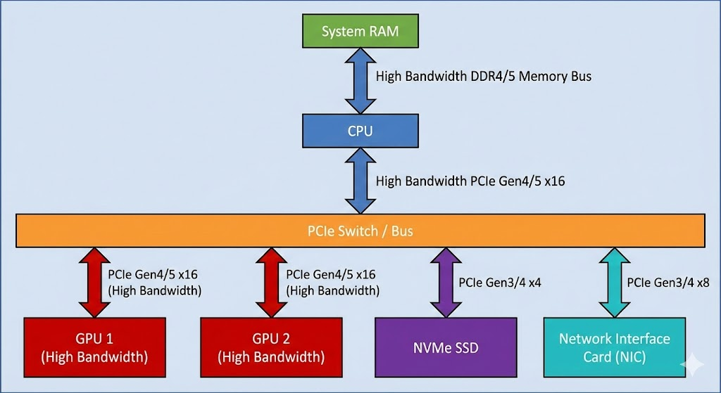
Figure 1.4: Computer architecture block diagram.

Latency & Bandwidth (2025 Estimates)

Component | Bandwidth | Latency
L1 Cache | ∼1 TB/s | ∼1.5 ns
RAM | 20–100 GB/s | ∼100 ns
NVMe SSD | 3–8 GB/s | ∼100–200 µs
PCIe 4.0 x16 | 32 GB/s | ∼5 µs
10 GbE Ethernet | ∼1 GB/s | ∼50 µs
GPU Memory (GDDR6) | 500–2000 GB/s | ∼200 ns
Table 1.1: Hardware latency and bandwidth estimates.

Key Insight: Moving data is often slower than computing it. Example: Copying 160 MB over 10 GbE = 160 ms. Same over NVLink = 1.6 ms.

CPUs
- Use SIMD (AVX2/NEON) for vector math
- But nowhere near GPUs in FLOPS (e.g., Xeon: 1 TFLOP vs RTX 4090: 80 TFLOP)

GPUs
- Thousands of cores (e.g., RTX 4090: 16,384 CUDA cores)
- Tensor Cores: Accelerate FP16 matrix ops (used in mixed precision)
- Memory bandwidth: 500–2000 GB/s

NVLink vs PCIe
- NVLink: 50–300 GB/s (GPU-to-GPU)
- PCIe: 16–32 GB/s
→ Prefer NVLink for multi-GPU training.

Training on Multiple GPUs

Three Strategies
      - Model Parallelism: Split layers across GPUs
→ High comm cost, hard to balance → Not recommended
      - Layer-wise Parallelism: Split channels per layer (AlexNet-style)
→ Still high sync cost → Avoid
      - Data Parallelism: Copy full model to all GPUs; split batch
→ Simple, scalable, standard
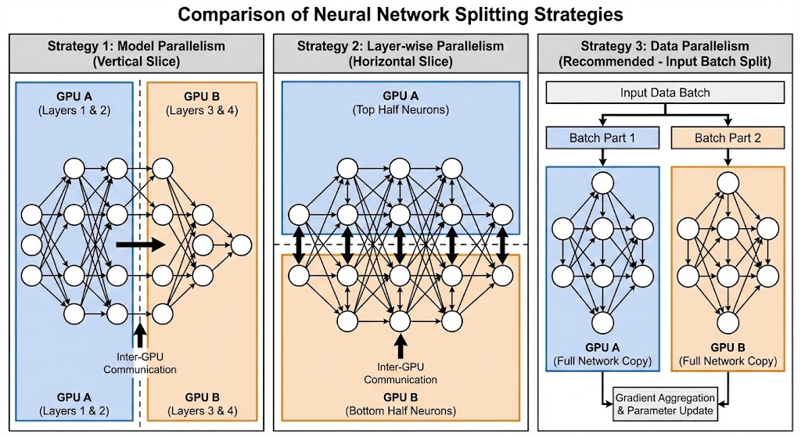
Figure 1.5: Parallelization strategies.

How Data Parallelism Works
      - Split batch: e.g., 256 → 128 per GPU
      - Each GPU computes forward + backward
      - All-reduce: Sum gradients across GPUs
      - Update weights locally (all GPUs get same params)
Bonus: Larger effective batch → can scale learning rate. BatchNorm: Use sync batch norm or increase per-GPU batch size.

➔ Example: Data Parallelism in Action — Splitting a 256-Sample Batch Across 4 GPUs
Suppose you have a batch of 256 ImageNet images and 4 GPUs. Here is the full DDP cycle step by step:
# Step 1: Batch is divided evenly by DistributedSampler
# GPU 0 receives images 0-63
# GPU 1 receives images 64-127
# GPU 2 receives images 128-191
# GPU 3 receives images 192-255

# Step 2: Each GPU runs forward + backward INDEPENDENTLY (no sync needed)
# Each GPU accumulates its own local gradient tensor

# Step 3: NCCL Ring All-Reduce — gradients averaged across GPUs
# Bandwidth = O(N) not O(N^2), so it scales well
# After all-reduce every GPU holds the SAME averaged gradient

# Step 4: Each GPU updates its local model copy with the same gradient
# => all model copies remain identical => repeat

# Effective batch size = 64 * 4 = 256
# Linear Scaling Rule (Goyal et al. 2017):
# if base_lr was tuned for batch=64, use lr = base_lr * 4 for batch=256
base_lr = 0.01
effective_lr = base_lr * 4 # = 0.04

# Minimal DDP setup (one process per GPU):
import torch.distributed as dist
from torch.nn.parallel import DistributedDataParallel as DDP

dist.init_process_group(backend='nccl')
model = MyModel().to(rank)
model = DDP(model, device_ids=[rank]) # gradients auto all-reduced
Real-world rule: prefer DDP over DataParallel for any setup with 2+ GPUs. DataParallel copies the entire model output to GPU 0 for loss computation, creating a memory and bandwidth bottleneck that worsens with model size.

Concise Implementation for Multiple GPUs
    - Option 1: DataParallel (Simple but Limited)
1 model = nn.DataParallel(model)

- Easy, but:
  - GPU 0 becomes bottleneck
  - Gradients pass through master GPU
  - Poor scaling beyond 2 GPUs

    - Option 2: DistributedDataParallel (DDP)
- One process per GPU
- Peer-to-peer gradient sync (via NCCL)
- No master GPU → near-linear scaling
- Works across machines
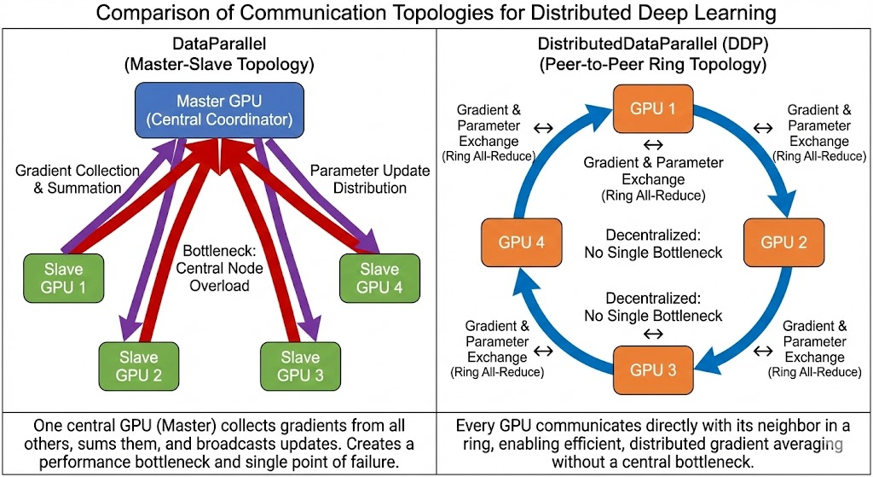
Figure 1.6: DDP vs. DataParallel.

Best practice: Use DDP for real training.

Parameter Servers

The Scaling Problem
On multiple machines, GPUs communicate via slow Ethernet (1–10 GbE), not NVLink.
If all gradients go to one machine, it becomes a bottleneck.

Solution: Parameter Servers (PS)
- Shard model parameters across multiple server nodes
- Each worker:
  - Computes gradients
  - Push gradients to servers (push(key, grad))
  - Pull updated params (pull(key))
Benefits:
- Scales to 1000s of workers
- Fault-tolerant (async updates)
- Flexible hardware

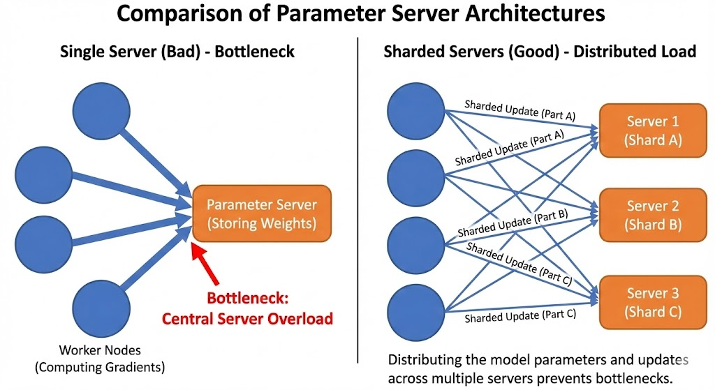
Figure 1.7: Parameter server architecture.

When to Use What?

Scenario Strategy

1–8 GPUs, one server DDP + Ring All-Reduce 10+ machines, cloud Parameter Server Model too big for 1 GPU FSDP / DeepSpeed + PS

Table 1.2: Parallel training strategies.

Example: High-Performance Training Loop (Best Practices)
import torch
import torch.nn as nn
import torch.optim as optim
import torch.distributed as dist
from torch.nn.parallel import DistributedDataParallel as DDP
from torch.cuda.amp import autocast, GradScaler
from torch.utils.data import DataLoader, DistributedSampler

def setup_ddp(rank, world_size):
dist.init_process_group(
backend="nccl",
init_method="env://",
world_size=world_size,
rank=rank
)
torch.cuda.set_device(rank)

def cleanup_ddp():
dist.destroy_process_group()

def train(rank, world_size, dataset):
setup_ddp(rank, world_size)

device = torch.device(f"cuda:{rank}")

model = nn.Sequential(
nn.Linear(1024, 2048),
nn.ReLU(),
nn.Linear(2048, 10)
).to(device)

model = DDP(model, device_ids=[rank])

optimizer = optim.Adam(model.parameters(), lr=1e-3)
criterion = nn.CrossEntropyLoss()

scaler = GradScaler() # mixed precision

sampler = DistributedSampler(dataset)
loader = DataLoader(
dataset,
batch_size=128,
sampler=sampler,
pin_memory=True
)

model.train()
for epoch in range(10):
sampler.set_epoch(epoch)

for x, y in loader:
# non-blocking GPU transfer
x = x.to(device, non_blocking=True)
y = y.to(device, non_blocking=True)

optimizer.zero_grad()

with autocast(): # FP16 compute
output = model(x)
loss = criterion(output, y)

scaler.scale(loss).backward()
scaler.step(optimizer)
scaler.update()

cleanup_ddp()

Key Takeaway
This example demonstrates how modern deep learning frameworks convert theoretical performance concepts—such as asynchronous execution, automatic parallelism, and optimized hardware utilization—into concise, practical code. By combining DistributedDataParallel, mixed precision, and non-blocking data transfers, models scale efficiently across GPUs while minimizing Python overhead and communication latency, turning computational efficiency from a bottleneck into a competitive advantage.

Final Checklist for Performance
- Use DDP, not DataParallel
- Enable mixed precision (torch.cuda.amp)
- Use non_blocking=True for GPU→CPU copies
- Avoid .cpu(), .item(), print(tensor) in loops

- Profile with PyTorch Profiler or nsys
- Match parallelism strategy to hardware
Remember: Great models are useless if they take weeks to train. Master com- putational performance—and turn “impossible” into “done by Friday.”

