Generative Adversarial Networks

Introduction: Why “Create” When You Can “Copy”?
In most of our Deep Learning coursework—be it image classification with CNNs or sequence prediction with RNNs—we’ve focused on discriminative tasks: learning to distinguish between classes or predict labels from input data. But what if we want to generate new data? Not just copy-paste, but create entirely synthetic samples that are indistinguishable from real ones—like a never-before-seen human face, a novel music track, or a photorealistic landscape? This is the goal of Generative Adversarial Networks (GANs), a revolutionary framework introduced by Ian Goodfellow et al. (2014). GANs have transformed generative modeling by framing it as a game between two neural networks: a generator that creates fake data, and a discriminator that tries to catch the fakes. Through this adversarial process, the generator
learns to produce data so realistic that even the best discriminator is fooled.
Real-World Motivation: In medical imaging, labeled data is scarce. GANs can gen- erate synthetic tumor scans to augment training data, improving model robustness without violating patient privacy.

The Core Idea: A Game of Cat and Mouse
The brilliance of GANs lies in their simple yet powerful architecture, best understood through an analogy:
The Fake Currency Analogy:
Imagine a counterfeiter (Generator) trying to print fake ₹100 notes. A police offi- cer (Discriminator) tries to spot the fakes.
- Initially, the fake notes are crude—easy to catch.
- Over time, the counterfeiter learns from feedback, improving the prints.
- Eventually, the notes become so perfect that even the best officer can’t tell real from fake.
This is equilibrium—the GAN’s endgame.

Mathematical Formulation
Let:
    - z ∼ p_{z}(z) be noise (e.g., from a standard normal distribution).
    - G(z; θ_{G}) be the Generator, mapping noise to fake data x_{fake}.
    - D(x; θ_{D}) be the Discriminator, outputting the probability that x is real. The GAN objective is a minimax game:
min max V (D, G) = E_{x∼p}data [log D(x)] + E_{z∼p}z [log(1 − D(G(z))]
G D
    - Discriminator maximizes V : It wants D(x) ≈ 1 (real) and D(G(z)) ≈ 0 (fake).
    - Generator minimizes V : It wants D(G(z)) ≈ 1 (fool the discriminator).

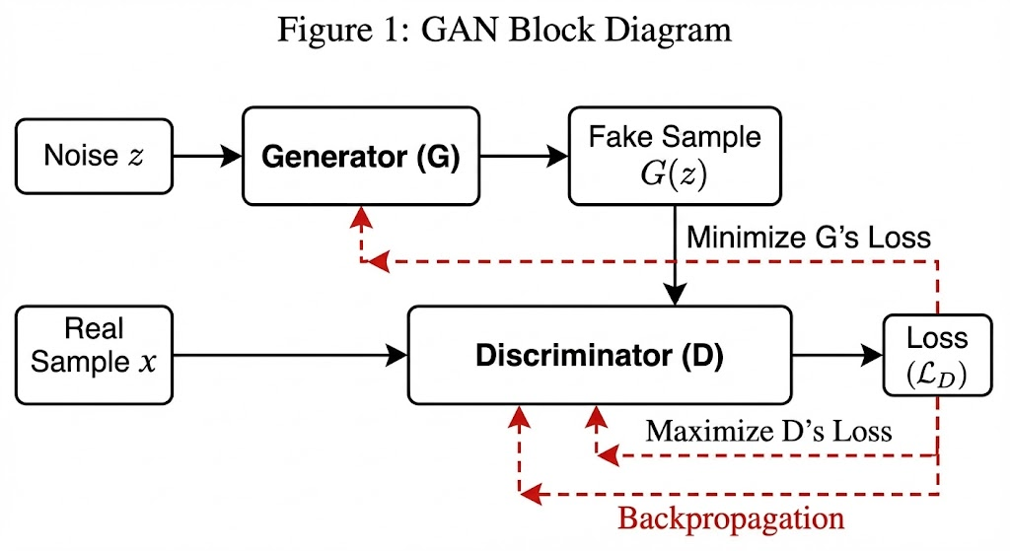

Training Dynamics and Loss Functions

Discriminator Loss
The discriminator minimizes binary cross-entropy:
L_{D} = − E_{x∼p}data [log D(x)] + E_{z∼p}z [log(1 − D(G(z)))]

Generator Loss (Two Variants)
- Original Loss:
L^{orig} = E_{z∼p}z [log(1 − D(G(z))]
G
Problem: Early in training, when D is strong, log(1 − D(G(z))) ≈ log(1) = 0, leading to vanishing gradients.
- Non-Saturating Loss (Preferred):
L_{G} = −E_{z∼p}z [log D(G(z))]
Now, the generator maximizes the log-probability of the discriminator being fooled, pro- viding stronger gradients.
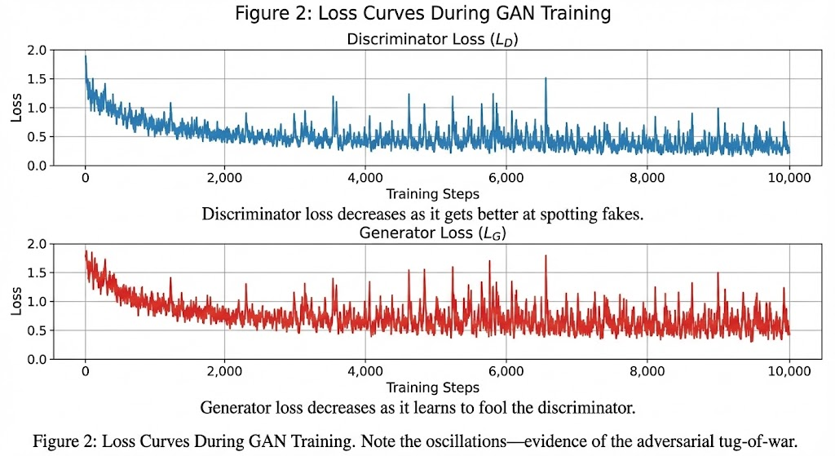

Types of GANs: Beyond the Vanilla
While the basic GAN uses simple Multi-Layer Perceptrons (MLPs), real-world data (e.g., im- ages) requires specialized architectures.

Deep Convolutional GAN (DCGAN)
DCGAN (Radford et al., 2015) replaces MLPs with Convolutional Neural Networks (CNNs), optimized for image data.
Key Innovations:

    - Generator: Uses transposed convolutions (a.k.a. fractionally-strided convolutions) to upsample from noise to image.
    - Discriminator: Uses standard convolutions with strides (no max-pooling).
    - Batch Normalization: Applied to all layers except the generator’s output and discrimina- tor’s input.
    - Activation Functions: ReLU in generator (except output: Tanh); LeakyReLU in discrimi- nator.
Why LeakyReLU?
Standard ReLU sets negative inputs to zero, causing ”dead neurons.” LeakyReLU (f (x) =
max(αx, x), α = 0.2) allows small negative values, improving gradient flow.

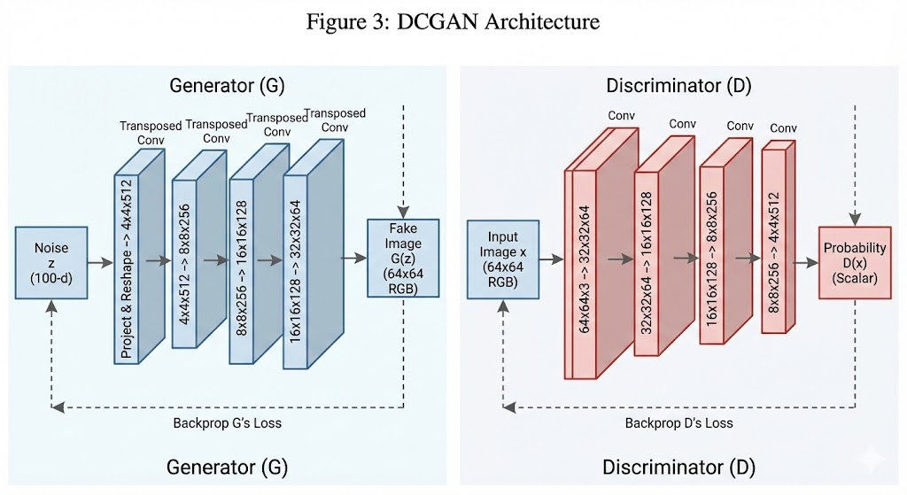
Example: On the Pokémon sprite dataset, DCGAN learns to generate novel, plausible Pokémon—not in the original dataset—by capturing the underlying distribution of colors, shapes, and features.

Conditional GAN (cGAN)
Problem: Standard GANs generate random samples. How do we control the output (e.g., gen- erate only ”smiling faces”)?
Solution: cGAN adds a conditioning label y to both generator and discriminator.
    - Generator: G(z, y) → Fake sample of class y.
    - Discriminator: D(x, y) → Probability x is real and of class y.
Objective:
min max E_{x,y}[log D(x, y)] + E_{z,y}[log(1 − D(G(z, y), y))]
G D
Application: In image-to-image translation (e.g., turning sketches into colored images), y is the input sketch.

➔ Example: Conditional GAN on MNIST — Generating Specific Digits On-Demand
A vanilla GAN outputs a random digit. A cGAN lets you specify which digit you want by conditioning both the generator and discriminator on the class label y:
import torch, torch.nn as nn

class ConditionalGenerator(nn.Module):
def __init__(self, z_dim=100, num_classes=10, img_dim=784):
super().__init__()
self.embed = nn.Embedding(num_classes, num_classes)
self.net = nn.Sequential(
nn.Linear(z_dim + num_classes, 256), nn.ReLU(),
nn.Linear(256, 512), nn.ReLU(),
nn.Linear(512, img_dim), nn.Tanh(),
)
def forward(self, z, label):
label_emb = self.embed(label) # (B, 10)
x = torch.cat([z, label_emb], dim=1) # (B, 110)
return self.net(x)

G = ConditionalGenerator()

# Generate 16 images all of digit '7'
z = torch.randn(16, 100)
labels = torch.full((16,), fill_value=7, dtype=torch.long)
imgs = G(z, labels).view(-1, 1, 28, 28)
# imgs now contains 16 structurally-diverse-but-all-digit-7 images

# Generate one image of EACH digit class:
z_row = torch.randn(10, 100)
labels = torch.arange(10) # 0..9
grid = G(z_row, labels).view(10, 1, 28, 28)
This controllability is the foundation of pix2pix (image-to-image translation), text-to-image synthesis, and face attribute editing — applications where you need targeted generation, not random sampling.

Laplacian Pyramid GAN (LAPGAN)
Problem: Generating high-resolution images in one shot is hard.
Solution: LAPGAN uses a coarse-to-fine strategy:
- Generate a low-resolution image.
- Add high-frequency details (residuals) in stages using multiple generator-discriminator pairs.
Process:

  - Level 0: Generate x₀ (blurry image).
  - Level 1: Generate residual r₁, upscale x₀, and add: x₁ = upscale(x₀) + r₁.
  - Repeat for higher resolutions.
Advantage: Each stage focuses on a specific frequency band, improving stability and quality.

Super-Resolution GAN (SRGAN)
Goal: Convert low-resolution (LR) images to high-resolution (HR).
How: SRGAN uses a perceptual loss (combining pixel-wise MSE and feature-level VGG loss) to ensure generated HR images look natural to humans, not just numerically close.
Result: SRGAN can turn a 16x16 image into a 64x64 image with plausible details—like adding
texture to hair or fabric—by ”hallucinating” high-frequency content.
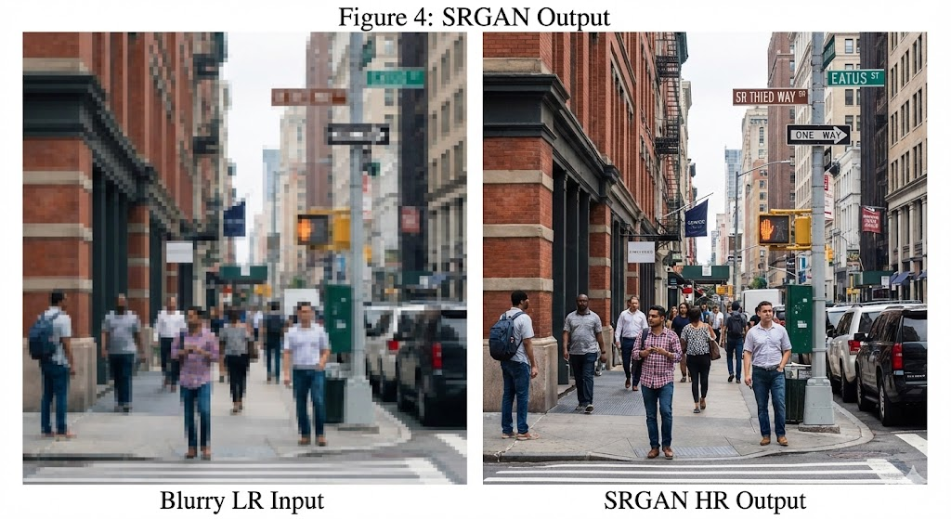

Training Tricks and Challenges

Mode Collapse
Problem: The generator finds one ”winning” fake (e.g., a single face) and keeps producing it, ignoring other modes of the data distribution.
Symptoms: Low discriminator loss, but generated samples lack diversity.

➔ Example: Mode Collapse in Practice — CelebA Face GAN
Imagine training a vanilla MLP GAN on CelebA (200k celebrity face images). Around iteration 2,000 the generator discovers a single pale, neutral forward-facing face that reliably fools the current discriminator. It stops exploring the full distribution and outputs only this one ‘safe’ face. Discriminator loss then plummets (it can’t distinguish identical fakes), giving a deceptive signal that training is succeeding.
Quick diagnostic: measure the average pairwise L2 distance among generated samples. In a healthy GAN this stays above ~1.5; in mode collapse it falls below 0.1.
import torch

def diversity_score(generator, z_dim=100, n=256, device='cpu'):
'''Average pairwise L2 distance among n generated samples.
Near 0 => mode collapse; healthy => depends on output scale.
'''
with torch.no_grad():
z = torch.randn(n, z_dim, device=device)
fake = generator(z).view(n, -1) # flatten to (n, D)
# pairwise distance matrix (n x n)
dists = torch.cdist(fake, fake, p=2)
# mean over upper triangle only (exclude self-distances)
mask = torch.triu(torch.ones(n, n, dtype=torch.bool), diagonal=1)
return dists[mask].mean().item()

# --- during your training loop ---
for step in range(total_steps):
d_loss, g_loss = train_step(G, D, g_opt, d_opt, real_batch)
if step % 100 == 0:
score = diversity_score(G)
print(f'Step {step:5d} | D={d_loss:.3f} G={g_loss:.3f} | div={score:.3f}')
# If score drops and stays near 0 => mode collapse detected early
Remedies: (1) label smoothing (real=0.9 not 1.0), (2) minibatch discrimination, (3) Wasserstein loss (WGAN), (4) training the generator twice per discriminator update.
Solutions:
    - Label smoothing: Use soft labels (e.g., real=0.9, fake=0.1) to prevent overconfident dis- criminators.
    - Minibatch discrimination: Force the generator to create diverse samples by comparing features across a minibatch.

Balancing Generator and Discriminator
If the discriminator is too strong, the generator gets no useful gradients (vanishing gradients). If it’s too weak, the generator doesn’t learn.
Tricks:
    - Train the generator twice for every discriminator update.
    - Use Adam optimizer with lower momentum (β₁ = 0.5) for smoother convergence.

A Worked Example: Fitting a 2D Gaussian
To build intuition, let’s train a GAN to learn a simple 2D Gaussian distribution.

Setup

    - Real data: 1000 samples from N (µ, Σ), where µ = [1, 2], Σ = AA^{T}, A = 1 2 .
−0.1 0.5
    - Generator: Linear layer G(z) = W z + b, z ∼ N (0, I).
    - Discriminator: 3-layer MLP with Tanh activations.

Training
    - Epoch 1: Generator outputs scattered points; discriminator easily rejects fakes.
    - Epoch 10: Fake samples cluster near the real distribution.
    - Epoch 20: Fake and real samples are visually indistinguishable.

Key Insight: Even for a trivial distribution, the GAN learns purely through adversarial feed- back—no explicit density estimation.

Perfect — I’ll do exactly the same treatment for your GAN document, but adapted to generative modeling + mathematics, and I’ll attach runnable PyTorch code at the end of every major section where it makes sense.
Everything below is directly aligned with your uploaded GAN document and written so you can append it section-by-section to the end of the document.

Mathematical Formulation → Code Implementation
The GAN objective is the minimax game:
- Discriminator maximizes this value
- Generator minimizes it
import torch
import torch.nn as nn

# Binary Cross Entropy loss
criterion = nn.BCELoss()

def discriminator_loss(D, real_data, fake_data):
real_labels = torch.ones(real_data.size(0), 1)
fake_labels = torch.zeros(fake_data.size(0), 1)

real_loss = criterion(D(real_data), real_labels)
fake_loss = criterion(D(fake_data), fake_labels)

return real_loss + fake_loss

def generator_loss(D, fake_data):
real_labels = torch.ones(fake_data.size(0), 1)
return criterion(D(fake_data), real_labels)

Training Dynamics & Loss Functions
- Original generator loss causes vanishing gradients
- Non-saturating loss solves this:

🧠 Code: Non-Saturating GAN Training Step
def train_step(generator, discriminator, g_opt, d_opt, real_data):
batch_size = real_data.size(0)
noise = torch.randn(batch_size, 100)

# ---- Train Discriminator ----
fake_data = generator(noise).detach()

d_loss = discriminator_loss(discriminator, real_data, fake_data)
d_opt.zero_grad()
d_loss.backward()
d_opt.step()
# ---- Train Generator ----
fake_data = generator(noise)
g_loss = generator_loss(discriminator, fake_data)
g_opt.zero_grad()
g_loss.backward()
g_opt.step()

return d_loss.item(), g_loss.item()

DCGAN Architecture
- Generator: Transposed Convolutions + ReLU + Tanh
- Discriminator: Convolutions + LeakyReLU
- No pooling layers
- BatchNorm everywhere except edges

class DCGANGenerator(nn.Module):
def __init__(self, z_dim=100):
super().__init__()
self.net = nn.Sequential(
nn.ConvTranspose2d(z_dim, 256, 4, 1, 0),
nn.BatchNorm2d(256),
nn.ReLU(True),

nn.ConvTranspose2d(256, 128, 4, 2, 1),
nn.BatchNorm2d(128),
nn.ReLU(True),

nn.ConvTranspose2d(128, 3, 4, 2, 1),
nn.Tanh()
)

def forward(self, z):
return self.net(z.view(z.size(0), z.size(1), 1, 1))

class DCGANDiscriminator(nn.Module):
def __init__(self):
super().__init__()
self.net = nn.Sequential(
nn.Conv2d(3, 128, 4, 2, 1),
nn.LeakyReLU(0.2),

nn.Conv2d(128, 256, 4, 2, 1),
nn.BatchNorm2d(256),
nn.LeakyReLU(0.2),

nn.Conv2d(256, 1, 4, 1, 0),
nn.Sigmoid()
)

def forward(self, x):
return self.net(x).view(-1, 1)

Conditional GAN (cGAN)
Conditioning variable ( y ) is concatenated or embedded.
class ConditionalGenerator(nn.Module):
def __init__(self, z_dim, num_classes):
super().__init__()
self.embed = nn.Embedding(num_classes, num_classes)
self.fc = nn.Sequential(
nn.Linear(z_dim + num_classes, 256),
nn.ReLU(),
nn.Linear(256, 784),
nn.Tanh()
)

def forward(self, z, y):
y_emb = self.embed(y)
x = torch.cat([z, y_emb], dim=1)
return self.fc(x)

Training Tricks
- Label smoothing reduces discriminator overconfidence
- Real labels = 0.9 instead of 1.0

real_labels = torch.full((batch_size, 1), 0.9)
fake_labels = torch.zeros(batch_size, 1)

Gaussian GAN

# Real data
mu = torch.tensor([1.0, 2.0])
A = torch.tensor([[1.0, 2.0], [-0.1, 0.5]])
real_data = torch.randn(1000, 2) @ A.T + mu

# Generator
G = nn.Linear(2, 2)

# Discriminator
D = nn.Sequential(
nn.Linear(2, 16),
nn.Tanh(),
nn.Linear(16, 1),
nn.Sigmoid()
)

g_opt = torch.optim.Adam(G.parameters(), lr=1e-3)
d_opt = torch.optim.Adam(D.parameters(), lr=1e-3)

for epoch in range(200):
z = torch.randn(128, 2)
fake = G(z)

d_loss = discriminator_loss(D, real_data[:128], fake.detach())
d_opt.zero_grad()
d_loss.backward()
d_opt.step()

g_loss = generator_loss(D, fake)
g_opt.zero_grad()
g_loss.backward()
g_opt.step()

Conclusion: The Adversarial Revolution
GANs have redefined generative modeling by replacing complex probabilistic computations with a game-theoretic framework. From DCGAN’s photorealistic images to SRGAN’s super- resolution magic, the core idea remains the same: two networks, locked in competition, driving each other to excellence.
Why GANs Matter:
- Data Augmentation: Generate labeled data for rare classes (e.g., medical anomalies).
- Art and Design: Create novel artwork, fashion, or music.
- Privacy: Share synthetic data instead of real user data.
Challenges Ahead: Training instability, mode collapse, and ethical concerns (e.g., deep- fakes) remind us that with great power comes great responsibility.
As a student, implementing even a simple GAN feels like wielding magic—watching noise transform into structure through pure adversarial learning. And that’s what makes GANs not just a tool, but a paradigm shift in how we think about creativity in machines.

