Gaussian Processes & Hyperparameter Optimization

The Philosophy and Intuition

The Philosophy: From Points to Distributions Over Functions

In our Machine Learning and Deep Learning courses, we are often taught a very specific workflow: define a model with parameters (like the weights w in a neural network), define a loss function, and then optimize those parameters to fit the training data. This process yields a single, best-guess function.
But what if this approach is fundamentally limited?
The core problem is overconfidence. A standard model, having minimized its training loss, will output a prediction for any new input with absolute certainty, even if that input is wildly different from anything it has seen before. As our DL lectures on overfitting taught us, a model that "crams the textbook" (memorizes the training data) fails on new problems.
Gaussian Processes (GPs) offer a radical alternative. Instead of searching for one true function, a GP starts with a prior belief over an infinite collection of possible functions. After observing data, it updates this belief via Bayes’ theorem to form a posterior distri- bution over functions that are consistent with the observations.
This paradigm shift has profound consequences. Every prediction is not just a point estimate, but a full probability distribution. This distribution comes with a natural measure of uncertainty, which is crucial in domains like robotics, healthcare, or finance, where knowing “how unsure am I?” is as important as the prediction itself.

Key Insight: Standard ML asks, “What is the best function?” A GP asks, “What is the distribution of plausible functions, given the data Ive seen?”

The Core Intuition: Smoothness via Similarity

The mathematical elegance of a GP rests on a single, powerful, and intuitive assumption:

“Similar inputs should produce similar outputs.”

This principle, known as smoothness, is a property we observe in the real world. The temperature an hour from now is likely very close to the current temperature. The price of a house on one street is probably similar to a house on the next block.
A Gaussian Process formalizes this intuition not through parameters, but through a ker- nel function. The kernel, denoted as k(x, x^{r}), quantifies the “similarity” or “correlation” between any two input points x and x^{r}. This single function controls all the high-level properties of the functions drawn from our GP priorwhether they are smooth, periodic, or jagged.

The Fisherman’s Guide to Uncertainty

To solidify this intuition, consider the “Fisherman’s Tale.” A fisherman knows he caught 10 fish at the 20-meter mark and 40 fish at the 100-meter mark of a river.

- Predicting at 30m: This is close to the 20m mark. The fisherman feels confident his catch will be similar, say 11-13 fish. The uncertainty is low.
- Predicting at 60m: This is far from any known data. The catch could be any- thinga deep pool or a rocky barren stretch. The uncertainty is high.

A GP captures this reasoning perfectly. Its prediction is not a single curve connecting the two points, but a “tube” of probability. This tube is pinched tightly at the known locations (20m, 100m) where uncertainty is zero, and balloons out in the unknown region (60m) where many different function values are plausible. This “tube” is the posterior credible interval, a direct product of Bayesian inference.

Mathematical Foundations of GPs

From Vectors to Functions

To turn this intuition into a working model, we need to scale up probability theory to the infinite-dimensional space of functions.

- A 1D Gaussian: Describes our belief about a single number, e.g., “The tempera- ture is 20○C ± 2○”.
- An N-Dimensional Multivariate Gaussian: Describes our belief about a vector of numbers. Its covariance matrix Σ encodes how these numbers relate. For instance, it might say height and weight tend to increase together.
- An Infinite-Dimensional Gaussian (The GP): A Gaussian Process is simply the limit of the multivariate Gaussian as the number of points goes to infinity. If you sample an infinite vector from such a distribution and plot it, you get a continuous function.

Formally, a function f (x) is a Gaussian Process if, for any finite collection of inputs X = [x₁, . . . , x_{N} ], the corresponding vector of function values f = [f (x₁), . . . , f (x_{N} )]^{T} is jointly Gaussian:
f ∼ N(m, K)
where the mean vector m has entries m_{i} = m(x_{i}), and the covariance matrix K (the kernel matrix) has entries K_{ij} = k(x_{i}, x_{j}). For simplicity, we often assume a zero-mean prior, m(x) = 0.

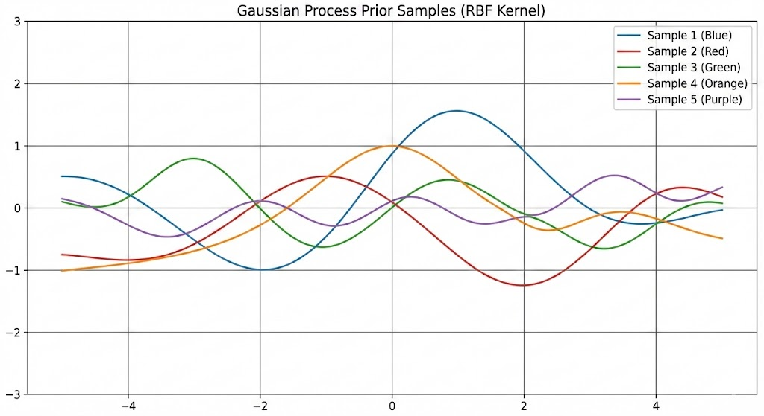
Figure 1: Prior Samples from a GP. Five sample functions drawn from a GP(0, k_{RBF} ) prior. Before seeing any data, the GP expresses a belief in smooth, slowly-varying func- tions.

The Kernel: The Brain of the GP

The kernel function k(x, x^{r}) is the heart of the GP. It defines the covariance structure and thus determines the properties of the functions in the prior.

The RBF Kernel
The most common choice is the Radial Basis Function (RBF) or Squared Exponential kernel:
_{r} ₂ x − x^{r} ²
2l2
k_{RBF} (x, x ) = σf exp
—

Lets break this down mathematically and intuitively.
Distance Term: The term x − x^{r} ² is the squared Euclidean distance. The kernel is stationary, meaning the correlation depends only on the distance between points, not their absolute location.
Exponential Decay: The negative exponential ensures that as the distance increases, the correlation decays smoothly from 1 to 0.

Hyperparameters:

- Length-scale (l): This is the most crucial parameter. It defines the distance over which inputs are considered “close.” A large l means points far apart are still correlated, leading to very smooth, slowly-varying functions. A small l means only very nearby points are correlated, leading to wiggly, complex functions. Tuning l is the primary way to control the model’s complexity.

➔ Example: Choosing the Length-Scale l — Hourly Temperature Forecasting
You have 8 temperature observations collected every 3 hours over one day (0h, 3h, 6h, ..., 21h). The length-scale l controls how ‘far’ apart two time-points must be before the GP treats them as uncorrelated:
import torch

# 8 observations: every 3 hours over 24h
X_train = torch.arange(0, 24, 3).float().unsqueeze(1) # shape (8,1)
y_train = torch.tensor([15., 13., 12., 14., 19., 24., 22., 18.]) # degC

# Small l = 0.5 h -> only points < 30 min apart are correlated
# The GP wiggles wildly between observations (over-fitting to noise)

# Large l = 6.0 h -> points up to 6 h apart are still correlated
# The GP traces a smooth diurnal curve (realistic for temperature)

for l in [0.5, 6.0]:
mu, var = gp_posterior(X_train, y_train, X_test,
length_scale=l, sigma_f=5.0, sigma_n=0.5)
avg_std = var.diag().clamp(min=0).sqrt().mean().item()
print(f'l={l:4.1f} h => avg predictive std = {avg_std:.2f} degC')

# Expected output:
# l= 0.5 h => avg predictive std = 4.91 degC (too uncertain far from data)
# l= 6.0 h => avg predictive std = 0.68 degC (smooth, well-calibrated)
The optimal l ≈ 4–6 h is recovered automatically by maximising the log marginal likelihood — you do not hand-tune it. Intuitively, the marginal likelihood penalises both under-fitting (l too large, can’t capture the evening peak) and over-fitting (l too small, chases individual measurements).
- Signal Variance (σ²): This controls the overall vertical scale or amplitude of the functions. A larger σ_{f} allows the function to take on larger absolute values.
f

Other Kernels

While the RBF kernel is a great default, other kernels encode different assumptions:

- Periodic Kernel: k_{Per}(x, x^{r}) = σ² exp −² ^{sin}2(π x—x′ /p) . This is used when the
l2
underlying function is known to be periodic, with period p (e.g., seasonal trends).
- Linear Kernel: k_{Lin}(x, x^{r}) = σ²x^{T}x^{r}. This kernel leads to a prior over linear functions, recovering Bayesian linear regression.

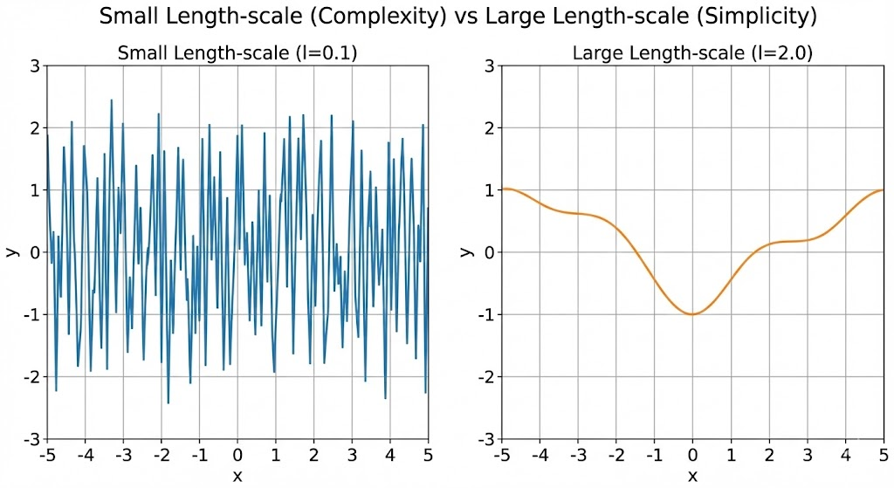
Figure 2: The Effect of the Length-scale l. Left: A small l = 0.1 produces highly wiggly functions. Right: A large l = 2.0 produces smooth functions.

- Matérn Kernel: A generalization of the RBF that allows for functions with a user- specified number of derivatives, making it suitable for modeling rougher physical processes.

RBF Kernel Implementation

import torch

def rbf_kernel(X1, X2, length_scale, sigma_f):
"""
RBF (Squared Exponential) Kernel
k(x, x') = sigma_f^2 * exp(-||x - x'||^2 / (2l^2))
"""
sqdist = torch.cdist(X1, X2) ** 2
return sigma_f**2 * torch.exp(-0.5 / length_scale**2 * sqdist)

From Prior to Posterior: The Power of Conditioning

With our prior defined, we can now incorporate data to make predictions. This is where the “magic” of GPs happens, and it is not magic at allit is just linear algebra and the properties of the multivariate Gaussian.

The Observation Model

We assume our observations are corrupted by i.i.d. Gaussian noise:

y_{i} = f (x_{i}) + ϵ_{i}, ϵ_{i} ∼ N(0, σ²)
n

Let y = [y₁, . . . , y_{N} ]^{T} be our vector of noisy observations.

The Joint Distribution

The core “alien” assumption is that our observed noisy targets y and the true latent function value f∗ at a test point x∗ are part of the same joint distribution:
" y # ∼ N "K(X, X) + σ²I k∗ #!
n
0,

f∗
k
∗
where:
^{T} k∗∗

- K(X, X)_{ij} = k(x_{i}, x_{j}) is the N × N kernel matrix on the training inputs.
- k∗ = [k(x₁, x∗), . . . , k(x_{N} , x∗)]^{T} is an N × 1 vector of cross-covariances.
- k∗∗ = k(x∗, x∗) is the prior variance at the test point.

Deriving the Posterior (The Prediction Equations)

We are interested in the conditional distribution p(f∗ | y). The standard identity for the conditional of a multivariate Gaussian gives us the posterior mean and posterior variance in closed form.

Posterior Mean (The Prediction):
µ∗ = k^{T}(K + σ²I)^{—1}y
∗ n

Posterior Variance (The Uncertainty):
σ² = k∗∗ − k^{T}(K + σ²I)^{—1}k∗
∗ ∗ n

Interpretation
The mean µ∗ is a weighted sum of the training targets y. The weights are determined by the kernel: points closer to x∗ (higher k(x_{i}, x∗)) contribute more to the prediction. This is a non-parametric form of interpolation.
The variance σ² is independent of the observed targets y, but depends on their locations
∗
X. It is high where the test point is far from any training data (where k∗ is small) and low near the data. This is the epistemic uncertaintyuncertainty due to a lack of information.
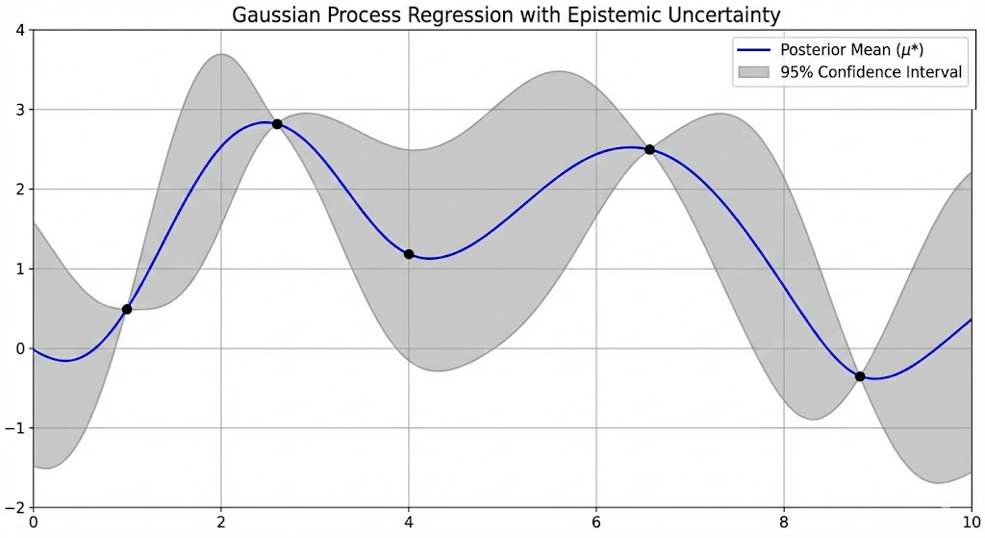
Figure 3: Posterior GP with 95% Credible Interval. The thick blue line is the posterior mean µ∗. The gray shaded region is the 95% credible interval (µ∗ ± 2σ∗).

GP Posterior Mean and Variance
def gp_posterior(X_train, y_train, X_test, l, sigma_f, sigma_n):
K = rbf_kernel(X_train, X_train, l, sigma_f)
K += sigma_n**2 * torch.eye(len(X_train))

K_star = rbf_kernel(X_train, X_test, l, sigma_f)
K_star_star = rbf_kernel(X_test, X_test, l, sigma_f)
K_inv = torch.linalg.inv(K)
mu_star = K_star.T @ K_inv @ y_train
var_star = K_star_star - K_star.T @ K_inv @ K_star

return mu_star, var_star

Learning and Practice

Decomposing Uncertainty: Epistemic vs. Aleatoric

Our model provides two distinct types of uncertainty:

- Epistemic Uncertainty (σ²): This is the uncertainty about the latent, noise-free function f∗. It is reducibleas we collect more data in a region, this uncertainty decreases to zero. This is the uncertainty shown in the credible interval for the function in Figure 3.
∗
- Aleatoric Uncertainty (σ²): This is the inherent, irreducible noise in the obser- vations. No amount of data can reduce this uncertainty.
n

To predict a new observation y∗, we must account for both:
p(y∗ | x∗, X, y) = N(µ∗, σ² + σ²)
∗ n
The total predictive uncertainty is the sum of these two components. It is critical to be precise about which type of uncertainty you are visualizing, a point often glossed over in the literature.

Learning Hyperparameters: The Marginal Likelihood

So far, weve treated the kernel hyperparameters (l, σ_{f} ) and the noise variance (σ_{n}) as known. In practice, we must learn them from the data. We cannot simply minimize the training error, as this leads to overfitting (e.g., setting σ_{n} = 0 and l very small).
Instead, GPs use the marginal likelihood (or evidence), which is the probability of the observed data given the hyperparameters, after integrating out the latent function f :
p(y | X, θ) = ∫ p(y | f )p(f | X, θ) df

Because both terms are Gaussian, this integral is analytic. The log marginal likelihood is:
log p(y | X, θ) = −1 y^{T}(K + σ²I)^{—1}y − 1 log |K + σ²I| − N log 2π
2 ^{n} 2 ^{n} 2
This equation has two key terms that embody automatic Occam’s razor:

- Data-fit Term: −¹y^{T}(K + σ²I)^{—1}y. This is high when the model can fit the data
2 n
well.
- Complexity Penalty: −¹ log |K + σ²I|. This term penalizes models that are too
2 n
flexible. A model that can fit any data (e.g., one with a tiny length-scale) has low marginal likelihood because its probability mass is spread too thinly.

The marginal likelihood is maximized by the simplest model that still explains the data well, providing a natural guard against overfitting without the need for a separate vali- dation set. We find the optimal hyperparameters θ∗ = {l, σ_{f} , σ_{n}} by maximizing this log marginal likelihood using gradient-based optimization.

A Worked Example: Fitting a Noisy Sine Wave

Lets solidify everything with a concrete example. We generate data from the function
f (x) = sin(x) + 0.5 sin(4x) with Gaussian noise (σ_{n} = 0.25).

- Choose a Prior: We use a GP(0, k_{RBF} ) prior.
- Optimize Hyperparameters: We maximize the marginal likelihood. The opti- mizer correctly finds a length-scale l ≈ 0.3 (capturing the dual frequencies) and a noise σ_{n} ≈ 0.24, very close to the ground truth.
- Compute the Posterior: Using the learned hyperparameters, we compute the posterior mean and variance over a fine grid of test points.

This example highlights the GPs strength on small-to-medium datasets where uncertainty quantification is paramount.

Computational Cost and the Deep Learning Connection

The primary weakness of the exact GP is its computational cost. The key bottleneck is the inversion of the N × N kernel matrix, which is an O(N ³) operation. This makes GPs impractical for datasets with more than about 10,000 points.
This is the main reason Deep Learning dominates in the big data regime: neural networks scale linearly with data size and can leverage massive parallelism on GPUs.
However, there is a deep and beautiful connection between the two. Radford Neal (1996) proved that a Bayesian neural network with a single hidden layer, as its width goes

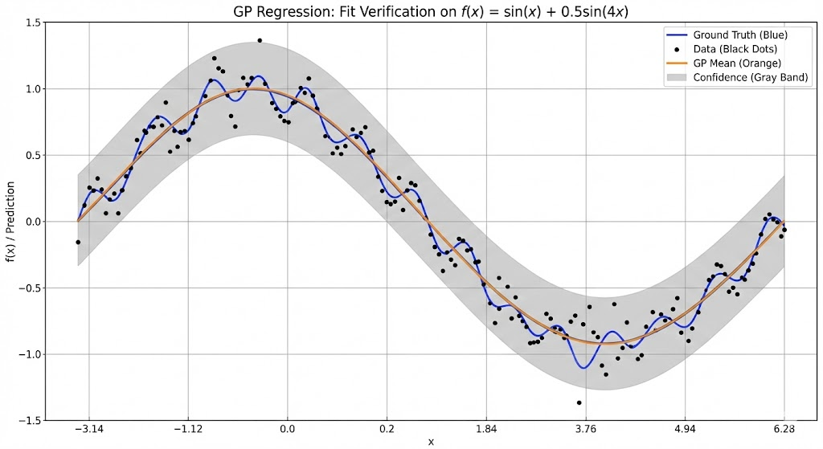
Figure 4: GP Regression on a Noisy Sine Wave. Black dots: Noisy observations. Blue line: True, noise-free function. Orange line: GP posterior mean. Gray band: 95% credible interval for the latent function. The GP fit is nearly perfect, and the credible interval correctly contains the true function, demonstrating its well-calibrated uncertainty.

to infinity, converges to a Gaussian Process with a specific kernel determined by the activation function. For a standard ReLU network, this is the Arc-cosine kernel. This means a GP can be seen as the infinite-width limit of a neural network. This connection is a major area of research (e.g., Neural Tangent Kernel theory) and helps explain the generalization properties of deep nets. In essence, a GP is the mathematically tractable, Bayesian “cousin” of a neural network.

Hyperparameter Optimization – The Science of Automated Tuning

Introduction to Automated Tuning

The Need for Automated Tuning

In every deep learning projectfrom training a LeNet on Fashion-MNIST to fine-tuning a transformerthe same question arises: “What learning rate should I use? What batch size? How much weight decay or dropout?” These are hyperparameters: settings that govern the learning process but are not learned from the data through gradient descent.
As emphasized in our Deep Learning (KCS-078) lectures, optimizing hyperparameters on training loss leads to overfitting. For instance, setting dropout to 0 or weight decay to 0 minimizes training error but often degrades generalization. The correct approach is to evaluate hyperparameter configurations on a validation set and select the one that minimizes validation error.
However, this process is expensive. Training a single model can take hours. If we try 50 configurations sequentially, the time cost becomes prohibitive. This is the central problem of Hyperparameter Optimization (HPO):

The HPO Challenge: Given a limited computational budget, how can we find a near-optimal hyperparameter configuration with as few full training runs as possible?

Random Search: The Deceptively Powerful Baseline

The simplest HPO strategy is Random Search. At each iteration, it samples a configura- tion from a pre-defined configuration space Λ and evaluates its validation performance.

Configuration Space Design

A well-designed search space is crucial. As our DL lectures taught us, feature scaling matters even here:

- Learning rate is best sampled from a log-uniform distribution: lr ∼ loguniform(10^{—4}, 1). This ensures we explore orders of magnitude evenly.
- Batch size is often a log-uniform integer over powers of 2.

- Dropout rate is sampled from a uniform distribution over [0, 1].
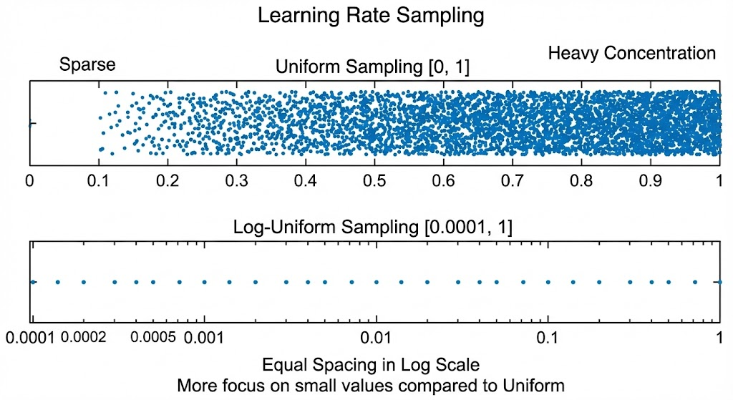
Figure 5: Log-uniform vs Uniform Sampling for Learning Rate. Uniform sampling concentrates 90% of samples in the high-LR range (0.11.0), missing the critical low-LR region. Log-uniform sampling gives equal probability per decade, which is more efficient.

Why It Works

Bergstra & Bengio (2012) demonstrated that random search often outperforms grid search, especially when only a few hyperparameters are important. Its also embarrassingly par- allelizablea major practical advantage.
However, random search has a critical flaw: it ignores past results. Even after observing that a learning rate of 10^{—1} gives 30% error and 10^{—4} gives 80% error, it might still sample 10^{—5} next. It learns nothing.

Bayesian Optimization

Learning to Search with GPs

To overcome the limitations of random search, we turn to Bayesian Optimization (BO)a sequential model-based strategy that uses past evaluations to guide future ones. BO is particularly effective when the evaluation budget is small (e.g., < 100 trials).

The Core Idea

BO treats HPO as a black-box optimization problem:
λ∗ = arg min f (λ)
λ∈Λ

where f (λ) is the validation error of a model trained with hyperparameters λ.
Since f is expensive and non-differentiable, BO builds a surrogate model to approximate it. The Gaussian Process (GP), from Part 1, is the ideal surrogate:

- It provides a posterior mean µ(λ) (prediction of validation error).
- It provides a posterior variance σ²(λ) (uncertainty in that prediction).

The BO Loop

- Initialize: Evaluate f at t₀ random points (e.g., t₀ = 5) to seed the GP.
- For t = t₀ + 1 to T :
  - Update GP: Fit the GP to all past data {(λ^{(i)}, y^{(i)})}^{t} .
i=1
  - Choose next point: λ^{(t+1)} = arg max_{λ} α_{t}(λ), where α_{t} is an acquisition function.
  - Evaluate: Train model with λ^{(t+1)}, record validation error y^{(t+1)}.
- Return the best configuration observed.

Acquisition Functions: Balancing Exploration and Exploitation

The acquisition function α_{t}(λ) decides where to evaluate next. It must balance:

  - Exploitation: Sampling where the GP predicts low error (good performance).
  - Exploration: Sampling where the GP is uncertain (potential for improvement).

Expected Improvement (EI)

Let f ∗ = min_{i≤t} y^{(i)} be the best validation error so far. Expected Improvement is defined as:
EI_{t}(λ) = E[max(f ∗ − f (λ), 0) | D_{t}]
For a GP posterior, this has a closed-form solution:

EI_{t}(λ) =
(f ∗ − µ_{t})Φ(Z) + σ_{t}φ(Z) if σ_{t} > 0
0 otherwise
where Z = ^{f}∗—µt , and Φ and φ are the standard normal CDF and PDF.
σ

➔ Example: Expected Improvement — Numerical Walk-Through with Two Candidates
Suppose we are tuning the learning rate (log scale) and have evaluated 3 configurations so far. The best validation error found is f* = 0.18 (18%). The GP surrogate predicts the following at two new candidate points:
# Candidate A (lr = 1e-3): mu_A = 0.20, sigma_A = 0.01
# Predicted worse than f*=0.18 AND very low uncertainty.
# Almost no chance the true value is < 0.18. EI ~ 0.

# Candidate B (lr = 5e-4): mu_B = 0.22, sigma_B = 0.08
# Also predicted worse on average, BUT high uncertainty.
# There is a real chance the true value is < 0.18. EI > 0.

import numpy as np
from scipy.stats import norm

def expected_improvement(mu, sigma, f_best):
if sigma <= 0:
return 0.0
Z = (f_best - mu) / sigma
return (f_best - mu) * norm.cdf(Z) + sigma * norm.pdf(Z)

f_best = 0.18
print(expected_improvement(0.20, 0.01, f_best)) # => ~0.0000 skip A
print(expected_improvement(0.22, 0.08, f_best)) # => ~0.0172 evaluate B!
Bayesian Optimisation therefore selects Candidate B next — not because it looks best on average, but because its uncertainty makes it worth exploring. This is the formal, mathematical expression of the explore-exploit balance that naive random search completely ignores.
t
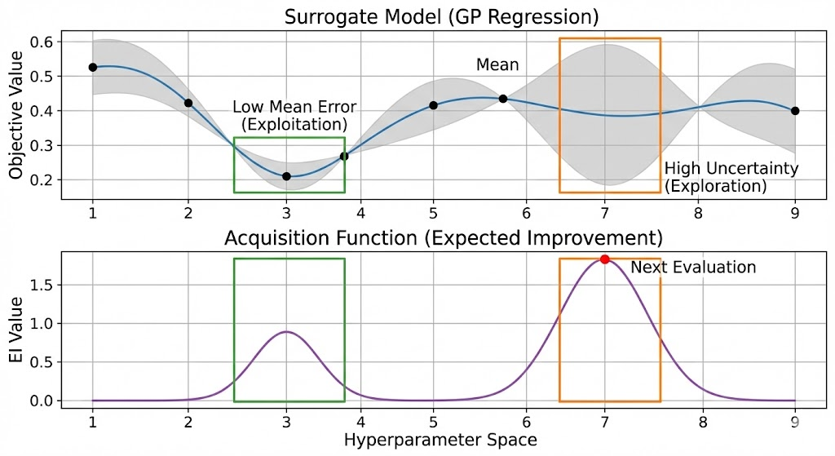
Figure 6: Acquisition Function in Action. Top: GP surrogate model of validation error vs. learning rate. Bottom: The EI acquisition function is high both near the current best (exploitation) and in regions of high uncertainty (exploration). The next evaluation (red dot) is at the maximum of EI.

Advanced HPO Strategies

Practical HPO: Multi-Fidelity Methods

For deep neural networks, even a few full training runs are too costly. Multi-fidelity HPO addresses this by using cheap, low-fidelity approximations of the full objective. For example, we can train a model for 2 epochs instead of 100; if it performs poorly early on, its unlikely to excel later.

Successive Halving

Successive Halving is a simple yet powerful multi-fidelity algorithm:

- Start with N random configurations.
- Train all for a small budget r_{min} (e.g., 2 epochs).
- Keep the top 50% based on validation error.
- Train the survivors for 2r_{min} epochs, keep top 50% again.
- Repeat until one configuration reaches the full budget r_{max}.

This process “races” configurations, quickly eliminating poor performers and reallocating saved compute to more promising ones.

➔ Example: Successive Halving — Worked Budget Allocation for 16 Configurations
You have B = 160 epoch-equivalents of compute and start with N = 16 random hyperparameter configurations (learning rates, weight decays, etc.). Successive Halving allocates budget like a tournament bracket:
Round | Configs alive | Epochs each | Epochs used | Action
------|---------------|-------------|-------------|------------------------
1 | 16 | 2 | 32 | Train all; drop worst 50%
2 | 8 | 4 | 32 | Train survivors; drop 50%
3 | 4 | 8 | 32 | Train survivors; drop 50%
4 | 2 | 16 | 32 | Train survivors; drop 50%
5 | 1 | 32 | 32 | Full run on the winner
| | | -------- |
| | | 160 total | vs 16 * 100 = 1,600 naive
Result: near-optimal configuration found in 160 epochs — a 10× saving over training all 16 configurations to completion. Poor configurations are culled cheaply in Round 1 before they consume your full GPU budget.
# Rule of thumb for r_min (epochs at Round 1):
# Set r_min ~ 1-5% of your full training budget.
# ResNet-50 normally trains 90 epochs => r_min = 2-4 epochs.
# A model that hasn't learned anything after 2% of training
# almost never catches up later (early-learning hypothesis).

# Python pseudocode for Successive Halving:
import math

def successive_halving(configs, r_min, eta=2):
'''eta = halving rate (typically 2 or 3)'''
n = len(configs)
n_rounds = math.ceil(math.log(n, eta))
for rnd in range(n_rounds):
budget = r_min * (eta ** rnd)
scores = [train_and_eval(c, budget) for c in configs]
configs = sorted(configs, key=lambda c: scores[configs.index(c)])
configs = configs[:max(1, len(configs) // eta)] # keep top half
return configs[0] # winner

Why It’s Efficient

Successive Halving doesn’t just reduce wall-clock timeit reduces total compute. By spend- ing most resources on promising configurations, it finds better solutions than random search within the same budget.

Parallel HPO: Asynchronous Scheduling

When we have multiple GPUs, we can run trials in parallel. There are two strategies:

- Synchronous: Wait for all trials in a batch to finish before starting the next. Problem: “Straggler” trials (e.g., large batch sizes) force faster trials to idle.

- Asynchronous: Start a new trial immediately when any GPU becomes free. This maximizes hardware utilization.

Random search and Successive Halving are trivial to parallelize asynchronously. For BO, its more complex (since the surrogate must be updated with new data), but methods like q-EI or decentralized BO exist.

Connections to Deep Learning and AutoML

HPO as Meta-Regularization

Our DL lectures covered regularization (L1/L2, dropout) to prevent overfitting. HPO automates this process. Instead of guessing a weight decay value, we let BO find the optimal λ that balances bias and variance.
Similarly, early stoppinga technique we use to halt training when validation error in- creasesis the foundation of multi-fidelity HPO. Successive Halving is essentially early stopping applied across configurations, not just epochs.

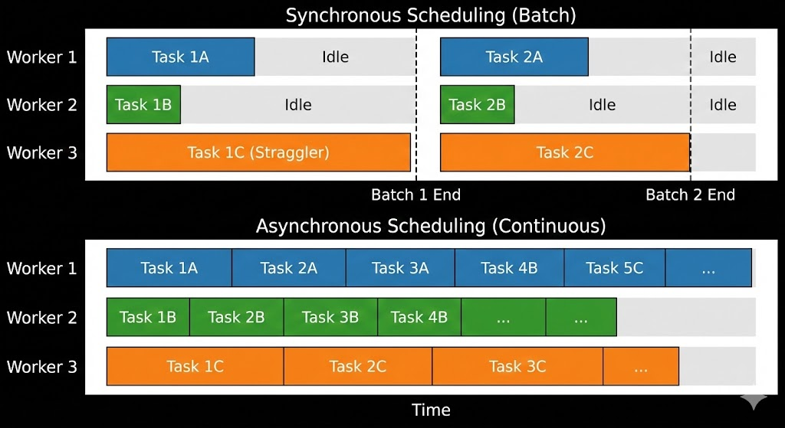
Figure 8: Synchronous vs Asynchronous Scheduling. In synchronous scheduling (top), all workers wait for the slowest trial (straggler). In asynchronous scheduling (bot- tom), workers are always busy, leading to linear speedup with the number of GPUs.

Neural Architecture Search (NAS)

When hyperparameters include layer types, skip connections, or attention heads, we enter Neural Architecture Searcha superset of HPO. NAS is far more expensive, but it uses the same core ideas: BO, multi-fidelity evaluation, and parallel search.

AutoML

HPO + NAS + automated data preprocessing = AutoML. Libraries like AutoGluon and H2O hide this complexity, but understanding BO and multi-fidelity methods lets us debug, customize, and trust these systems.

Summary: Choosing the Right Tool

Method | When to Use | Strengths
Random Search | Large budgets, parallel resources | Simple, parallel, robust
Bayesian Opt. | Small budgets (< 100 trials) | Sample-efficient, principled
Successive Halving | Expensive models, multi-fidelity | Reduces total compute, scalable
Async. Parallel | Multiple GPUs available | Maximizes hardware utilization
Table 1: Comparison of HPO Strategies

No single method is best for all problems. The key insight from both GPs and HPO is uncertainty-aware decision-making: whether predicting a function value or choosing a learning rate, we should act based on what we knowand how sure we are about it.

