Chapter 1

Natural Language Processing: Pretraining

Word Embedding (word2vec)

Introduction to Word Embeddings
When we think about natural language, words are the basic building blocks that carry meaning. But how can we represent these words in a way that computers can understand and process? This is where word embeddings come into play.
In simple terms, word embeddings are numerical representations of words in a continuous vector space. Instead of treating words as discrete symbols, we map each word to a real-valued vector that captures its semantic meaning. This technique has become fundamental in modern natural language processing.
Before diving into advanced techniques like word2vec, let’s first understand why traditional approaches fall short.

The Problem with One-Hot Vectors
In earlier approaches to natural language processing, we often used one-hot vectors to rep- resent words. If our vocabulary has V different words, each word would be represented as a vector of length V with all zeros except for a single 1 at the position corresponding to that word’s index.
For example, with a small vocabulary [“cat”, “dog”, “bird”, “fish”], the one-hot vector for “dog” would be [0, 1, 0, 0].
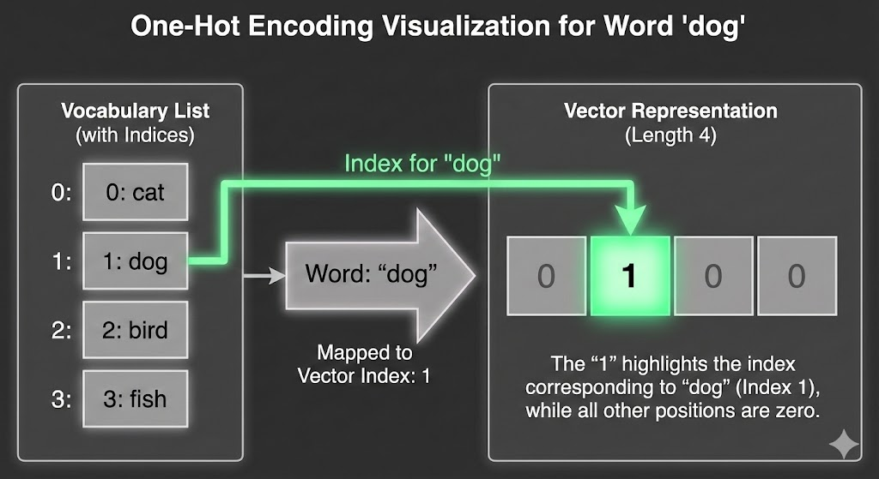
Figure 1.1: One-hot vector representation.

While one-hot vectors are simple to construct, they have significant limitations:
      - High Dimensionality: With vocabularies often containing hundreds of thousands of words, these vectors become extremely sparse and high-dimensional.
      - No Semantic Information: One-hot vectors cannot capture relationships between words. The cosine similarity between any two different one-hot vectors is always zero, meaning

they’re all equally “distant” from each other.
      - Inefficient Learning: Neural networks struggle to learn meaningful patterns from such sparse, high-dimensional representations.
The cosine similarity between two vectors u and v is defined as:
cosine_similarity(u, v) = u · v = cos θ
u v
Where θ is the angle between the vectors.
Since the dot product between any two different one-hot vectors is zero, their cosine similar- ity is also zero. This means one-hot vectors cannot encode semantic similarities between words like “king” and “queen” or “car” and “truck”.

Self-Supervised Learning with word2vec
To address these limitations, researchers developed word2vec, a powerful technique for learn- ing word embeddings. The key insight behind word2vec is that words appearing in similar con- texts tend to have similar meanings.
word2vec operates on the principle of distributional semantics: “You shall know a word by the company it keeps” ( J.R. Firth). Instead of relying on manual annotations, word2vec learns from the structure of the text itself, making it a self-supervised learning approach.
word2vec consists of two main model architectures:
      - Skip-gram model: Predicts context words given a center word
      - Continuous Bag of Words (CBOW): Predicts a center word given its context words
Both models learn word embeddings by analyzing the co-occurrence patterns of words in large text corpora.
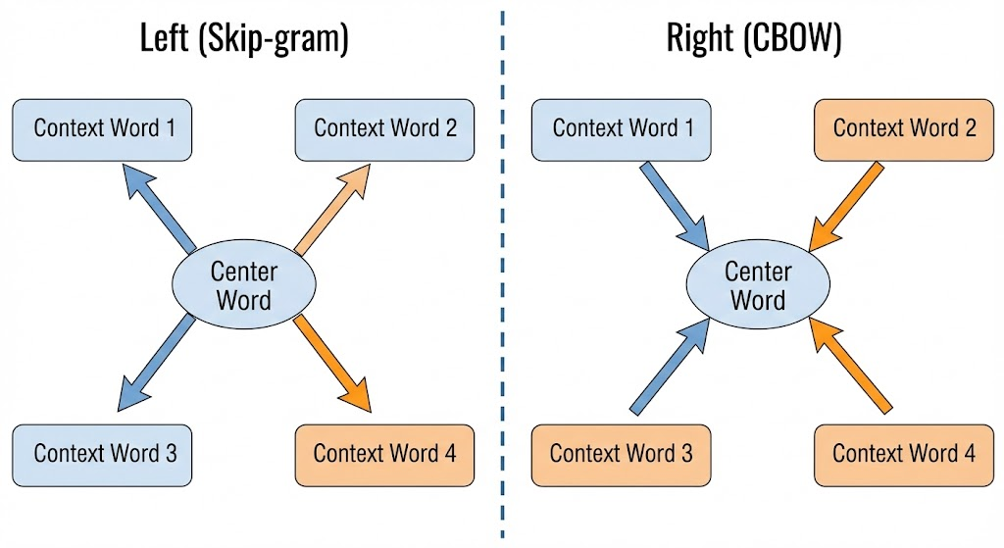
Figure 1.2: Skip-gram vs. CBOW architectures.

The Skip-Gram Model in Detail
Let’s dive deeper into the skip-gram model. The skip-gram model assumes that a center word can be used to generate the words surrounding it within a certain context window.

➔ Example: Skip-Gram Training Pairs — "The man loves his son" (window=2)
For each center word the skip-gram model generates (center, context) training pairs with every word within the window. Here is the full pair extraction from "The man loves his son":
sentence = ['The', 'man', 'loves', 'his', 'son']
window = 2

# Center word: 'The' (index 0) — only right context available
# pairs: ('The','man'), ('The','loves')

# Center word: 'man' (index 1)
# pairs: ('man','The'), ('man','loves'), ('man','his')

# Center word: 'loves' (index 2) <- the most useful center word
# pairs: ('loves','The'), ('loves','man'), ('loves','his'), ('loves','son')

# Center word: 'his' (index 3)
# pairs: ('his','man'), ('his','loves'), ('his','son')

# Center word: 'son' (index 4) — only left context
# pairs: ('son','loves'), ('son','his')

# Total positive pairs from this sentence: 14
# Each pair becomes one (correct) training example.
# The model is trained to give high P(context | center) for these pairs.

# Quick Python extraction:
pairs = []
for i, center in enumerate(sentence):
for j in range(max(0,i-window), min(len(sentence),i+window+1)):
if i != j:
pairs.append((center, sentence[j]))
print(pairs)
# [('The','man'), ('The','loves'), ('man','The'), ('man','loves'), ...]
Training on millions of such pairs forces the embedding vectors of 'man' and 'loves' to be nearby in the vector space (they co-occur often), while 'loves' and 'apple' remain distant (they rarely appear together). This is the distributional semantics principle in action.
For example, consider the sentence: “the man loves his son”
If we choose “loves” as our center word with a context window size of 2, the context words would be “the”, “man”, “his”, and “son”.
Mathematically, given a center word w_{c} with dictionary index c, the skip-gram model con- siders the conditional probability of generating each context word w_{o} (with dictionary index o) as:
o
i
c

P (w_{o}|w_{c}) = Σ
i∈U
Where:
exp(uTv_{c}) exp(uTv )

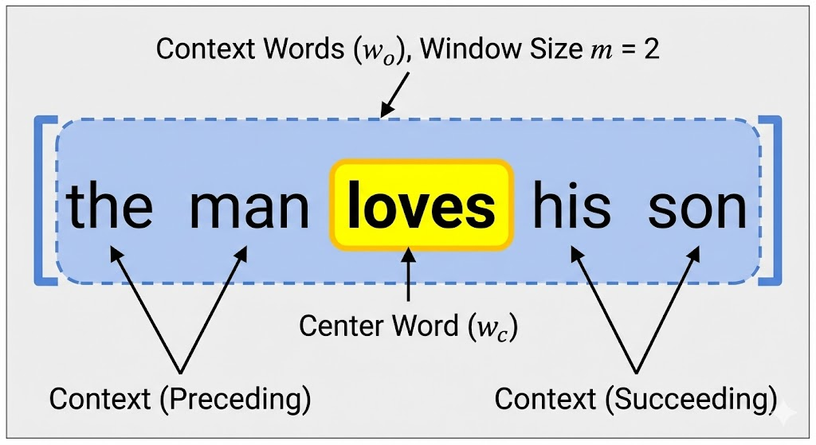
Figure 1.3: Context window extraction.

- v_{c} is the vector representation of the center word
- u_{o} is the vector representation of the context word
- V is the set of all words in the vocabulary
- The softmax function ensures that the probabilities sum to 1
The model assumes that context words are generated independently given the center word, so the joint probability of generating all context words is:

2m
Y
P ({w_{o}1 , w_{o}2 , ..., w_{o}2m}|w_{c}) = P (w_{o}i|w_{c})
i=1
Where m is the context window size.
The skip-gram model’s architecture is relatively simple but powerful. Each word has two vector representations:
- One when it appears as a center word (v)
- One when it appears as a context word (u)
These vectors are learned during training to maximize the likelihood of observing the actual context words around each center word.

The Continuous Bag of Words (CBOW) Model
In contrast to the skip-gram model, the Continuous Bag of Words (CBOW) model predicts the center word based on its surrounding context words.
Using the same example sentence “the man loves his son” with “loves” as the center word and window size 2, CBOW would try to predict “loves” given the context words “the”, “man”, “his”, and “son”.
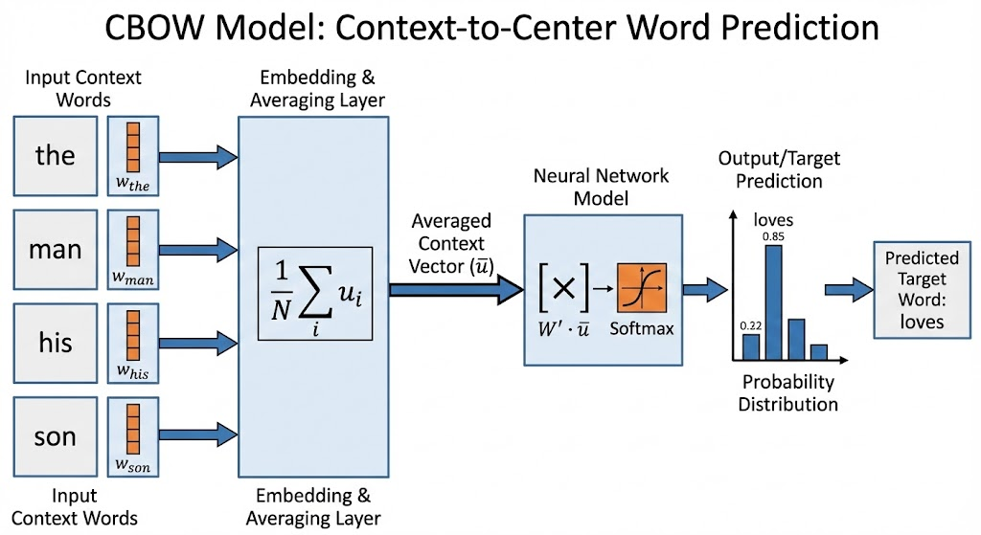
Figure 1.4: CBOW architecture.

The CBOW model computes the conditional probability of the center word w_{c} given its con- text words as:
exp(vTu¯)
c
P (w_{c}|w_{o}1 , w_{o}2 , ..., w_{o}2m ) = Σi∈U exp(vTu¯)
i
Where u¯ is the average of the context word vectors:

u¯ = 1 Σ u
2m
2m
o_{i}
i=1
The key difference from skip-gram is that CBOW averages the context word vectors before predicting the center word.

Training Word Embeddings
Training word2vec models involves optimizing the vector representations to maximize the like- lihood of the observed word-context relationships in the training corpus.
For the skip-gram model, we want to maximize:

2m
Σ
log P ({w_{o}1 , w_{o}2 , ..., w_{o}2m}|w_{c}) = log P (w_{o}i|w_{c})
i=1
For CBOW, we maximize:

log P (w_{c}|w_{o}1 , w_{o}2 , ..., w_{o}o )
2m
These optimization problems can be solved using stochastic gradient descent. However, the softmax computation in both models requires summing over all words in the vocabulary, which can be computationally expensive for large vocabularies.
During training, we typically use negative sampling or hierarchical softmax (discussed in the next section) to make the computation more efficient.
After training is complete, the center word vectors v from the skip-gram model or the context word vectors u from the CBOW model are used as the final word embeddings.

Properties of Word Embeddings
Well-trained word embeddings exhibit fascinating properties:
      - Semantic Similarity: Words with similar meanings have similar vector representations. For example, “king” and “queen” will be closer in the vector space than “king” and “apple”.
      - Vector Arithmetic: Word embeddings often support meaningful vector arithmetic. The famous example is:
king − man + woman ≈ queen

➔ Example: Vector Arithmetic — king - man + woman ≈ queen
The famous word analogy demonstrates that well-trained embeddings encode relational structure. The gender offset vector (woman - man) can be added to any male noun to produce its female counterpart:
# Using gensim's pre-trained word2vec (Google News, 300-d)
from gensim.models import KeyedVectors
wv = KeyedVectors.load_word2vec_format('GoogleNews-vectors.bin', binary=True)

# The classic analogy: king - man + woman
result = wv.most_similar(positive=['king','woman'], negative=['man'], topn=3)
print(result)
# [('queen', 0.7118), ('monarch', 0.6190), ('princess', 0.5910)]

# Country → capital analogy: France - Paris + Berlin
result2 = wv.most_similar(positive=['Berlin','France'], negative=['Paris'], topn=1)
print(result2)
# [('Germany', 0.7894)]

# Verb tense analogy: running - run + walk
result3 = wv.most_similar(positive=['walk','running'], negative=['run'], topn=1)
print(result3)
# [('walking', 0.8432)]

# Why does this work?
# The training objective forces: v(king) - v(man) ≈ v(queen) - v(woman)
# because 'king/man' and 'queen/woman' share almost identical contexts.
# The difference vector encodes the concept 'royalty + gender'.
This property emerges automatically from training — no explicit supervision about gender, royalty, or grammar was provided. It is purely a consequence of the co-occurrence statistics in the corpus.
This demonstrates that the embeddings capture gender relationships between words.
      - Dimensional Meaning: Each dimension in the embedding space can represent certain semantic or syntactic features. For example, one dimension might represent gender, an- other formality, and another tense.
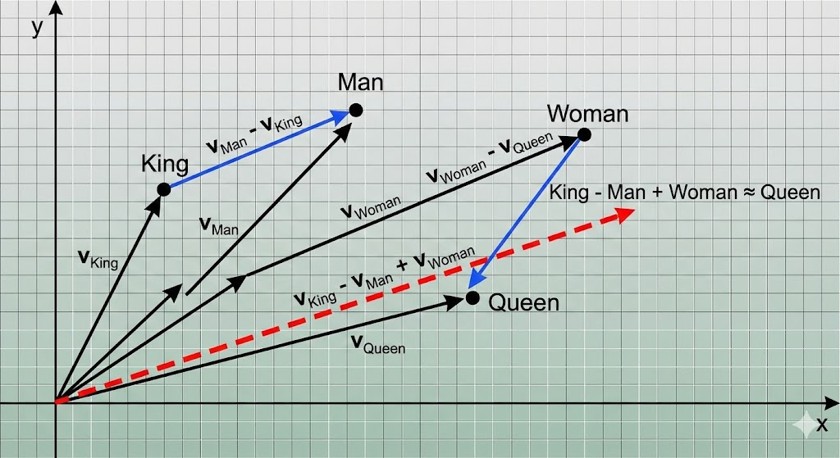
Figure 1.5: Vector relationships in embedding space.

Practical Considerations
When working with word2vec models, several practical considerations are important:
      - Context Window Size: A larger window size captures broader semantic relationships but may miss syntactic details. Smaller windows focus on syntactic relationships.
      - Embedding Dimension: Typical dimensions range from 50 to 300. Higher dimensions can capture more nuanced relationships but require more training data and computational resources.
      - Training Corpus: The quality and domain of the training corpus significantly impact the quality of embeddings. Domain-specific corpora produce better embeddings for that do- main.
      - Subsampling: High-frequency words like “the”, “a”, and “in” are often subsampled to im- prove training efficiency and quality.
Word embeddings have revolutionized natural language processing by providing dense, meaningful representations of words that capture semantic relationships. These embeddings serve as the foundation for more advanced models like BERT and have enabled significant progress in tasks like machine translation, sentiment analysis, and question answering.

Summary of Word Embeddings
Word embeddings are vector representations of words that capture semantic meaning. The word2vec framework includes two models:
      - Skip-gram: Predicts context words from a center word
      - CBOW: Predicts a center word from context words
Both models learn by analyzing word co-occurrence patterns in large text corpora. After training, the resulting embeddings exhibit remarkable properties like semantic similarity and analogical reasoning capabilities.
These embeddings form the foundation for modern NLP systems, enabling computers to understand and process human language in more meaningful ways. In the next section, we’ll explore techniques to make the training of these models more computationally efficient.

Approximate Training

The Computational Challenge
In the previous section, we learned about word2vec models and their ability to learn meaningful word embeddings. However, there’s a significant computational challenge that arises during training.
Recall the conditional probability calculation in the skip-gram model:
exp(uTv_{c})
o

P (w_{o}|w_{c}) = Σ
i∈U
i
c
exp(uTv )

The denominator requires summing over all words in the vocabulary V, which can contain hundreds of thousands or even millions of words. This computation becomes prohibitively ex- pensive during training, especially when calculating gradients.

For example, with a vocabulary of 1 million words, each forward and backward pass would need to compute 1 million dot products and exponentials. This computational burden makes training word2vec models on large corpora impractical without approximation techniques.

Negative Sampling
One effective solution to this problem is negative sampling, introduced by Mikolov et al. in 2013. Instead of computing probabilities for all words in the vocabulary, negative sampling focuses on a small subset of words for each training example.
The core idea is simple: for each positive example (a center word and its actual context word), we sample a small number of negative examples (the center word paired with random non-context words).
Let’s define:
- D as the set of positive examples (observed word-context pairs)
- D^{r} as the set of negative examples (randomly sampled word pairs) The objective function becomes:
j

Where:
T
o
log σ(u v_{c}) + Σ
w_{j} ∈D′
log σ(−u^{T}v_{c})

- σ(x) = ¹−x is the sigmoid function
1+e
- w_{o} is the actual context word
- w_{j} are the negative samples
The gradient computation now only involves 1 + K words (1 positive and K negative sam- ples) instead of the entire vocabulary. With K typically set to 5-20, this reduces computational complexity dramatically.
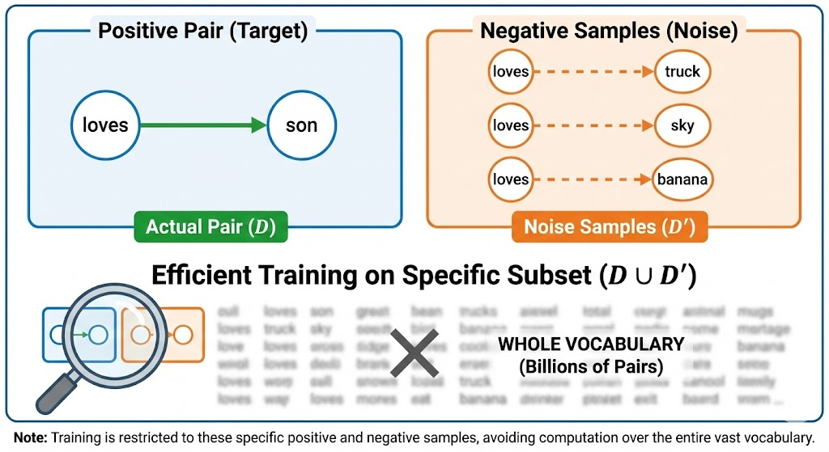
Figure 1.7: Negative sampling illustration.

The probability of selecting a word as a negative sample is proportional to its frequency raised to the power of 3/4:

f (w_{i})^{3/4}
P (w ) =
Σ

i V
j=1
f (w_{j})3/4

Where f (w_{i}) is the frequency of word w_{i} in the corpus. This distribution balances between frequent words (which provide more training signal) and rare words (which need to be repre- sented well).

Hierarchical Softmax
Another approach to approximating the softmax computation is hierarchical softmax. Instead of computing probabilities over all words directly, hierarchical softmax organizes the vocabulary into a binary tree structure.
Each word in the vocabulary becomes a leaf node in the tree, and each internal node repre- sents a binary classifier that decides whether to go left or right in the tree.
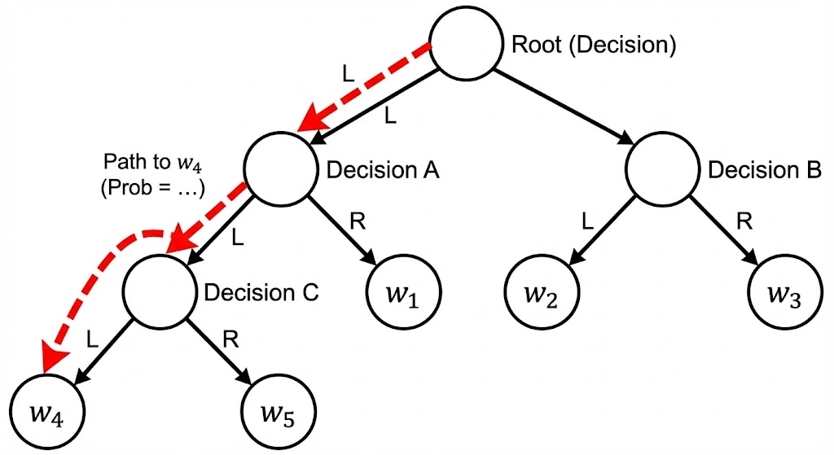
Figure 1.8: Hierarchical softmax tree structure.

The conditional probability of a word w given context c is defined as the product of proba- bilities along the path from the root to the leaf node representing w:

Where:
n(w,i)

P (w|c) =
L(w)—1

i=1
Y

σ n(w, i + 1) = ch(n(w, i)) · u^{T}
vc

- L(w) is the number of nodes on the path from root to word w
- n(w, i) is the i-th node on this path
- ch(n) is the left child of node n
- u_{n(w,i)} is the vector representation of node n(w, i)
- σ(x) is the sigmoid function
This approach reduces the computational complexity from O(V ) to O(log V ) per training example, where V is the vocabulary size. For a vocabulary of 1 million words, this reduces the computation from 1 million operations to about 20 operations.

Comparison of Approximation Methods
Both negative sampling and hierarchical softmax offer significant computational advantages over the full softmax approach. Let’s compare them:
Negative Sampling:
- Advantages: Simpler to implement, often performs better empirically, allows for paral- lelization
- Disadvantages: Requires tuning the number of negative samples, quality depends on negative sampling distribution
Hierarchical Softmax:
- Advantages: No need to tune number of negative samples, theoretically grounded

- Disadvantages: Performance depends on tree structure, cannot be easily parallelized, construction of optimal tree is non-trivial
In practice, negative sampling is more commonly used due to its simplicity and better empir- ical performance. The optimal tree structure for hierarchical softmax is difficult to determine, and poor tree structures can lead to suboptimal embeddings.

Practical Implementation Considerations
When implementing these approximation methods, several practical considerations arise:
      - Sampling Distribution: For negative sampling, the choice of sampling distribution is crucial. Using the unigram distribution raised to the power of 3/4 (as recommended by Mikolov et al.) works well in practice.
      - Number of Negative Samples: More negative samples lead to better quality embeddings but slower training. A common trade-off is 5-20 negative samples per positive example.
      - Tree Construction: For hierarchical softmax, Huffman coding is often used to build the binary tree, as it assigns shorter codes to frequent words, optimizing the training process.
      - Batch Processing: Both methods can be efficiently implemented using batch processing on GPUs, which significantly speeds up training.

Computational Complexity Analysis
Let’s analyze the computational complexity of each approach:
      - Standard Softmax:
        - Forward pass: O(V d) where V is vocabulary size and d is embedding dimension
        - Backward pass: O(V d)
        - Total: O(V d)
      - Negative Sampling (with K negative samples):
        - Forward pass: O((1 + K)d)
        - Backward pass: O((1 + K)d)
        - Total: O(Kd)
      - Hierarchical Softmax:
        - Forward pass: O(d log V )
        - Backward pass: O(d log V )
        - Total: O(d log V )
For a typical scenario with V = 10⁶, d = 100, and K = 10:
- Standard softmax: O(10⁸) operations
- Negative sampling: O(10³) operations
- Hierarchical softmax: O(2 × 10³) operations
This represents a reduction in computational complexity by a factor of 100,000, making train- ing feasible on standard hardware.

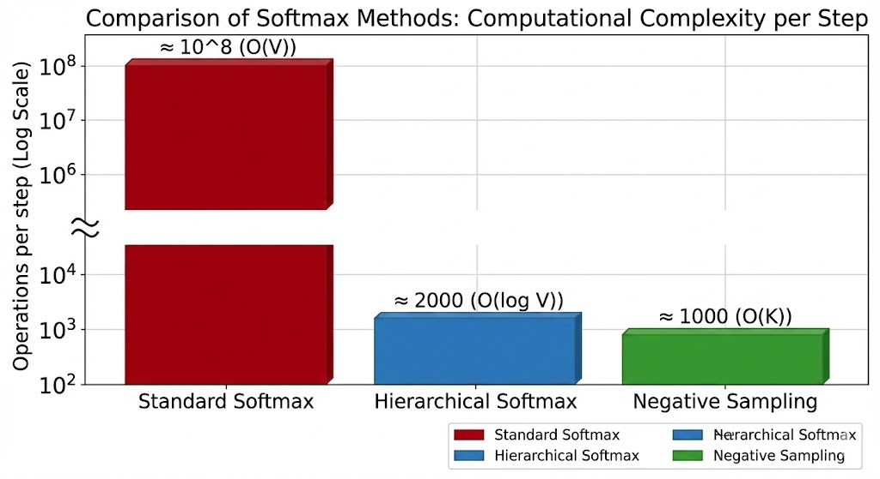
Figure 1.9: Computational complexity comparison.

Impact on Embedding Quality
While approximation methods make training feasible, they can impact the quality of the result- ing embeddings:
      - Negative Sampling: Tends to produce better embeddings for frequent words but may struggle with rare words. The quality improves with more negative samples but at the cost of computational efficiency.
      - Hierarchical Softmax: Performance depends heavily on the tree structure. Huffman cod- ing helps by giving shorter paths to frequent words, but the hierarchical organization may not always reflect semantic relationships.
      - Training Stability: Negative sampling often leads to more stable training compared to hierarchical softmax, which can be sensitive to the initial tree structure.
In practice, the choice between these methods depends on the specific application, available computational resources, and the characteristics of the training corpus.

Modern Alternatives
While negative sampling and hierarchical softmax were groundbreaking when introduced, mod- ern approaches have further improved efficiency:
      - Noise Contrastive Estimation (NCE): A more theoretically grounded approach that frames the problem as binary classification between data samples and noise samples.
      - Importance Sampling: Focuses computation on the most informative words by using a proposal distribution.
      - Adaptive Softmax: Organizes the vocabulary into clusters and uses different embedding dimensions for frequent and rare words.
      - Differentiated Softmax: Uses different dimensionalities for word representations based on their frequency.
These methods build upon the foundations laid by negative sampling and hierarchical soft- max, continuing to push the boundaries of efficient word representation learning.

Summary of Approximate Training Methods
Training word embeddings efficiently requires approximation techniques due to the compu- tational complexity of the softmax operation over large vocabularies. Negative sampling and hierarchical softmax are two key approaches:
      - Negative sampling replaces the full softmax with binary classification between positive and negative examples, reducing complexity from O(V ) to O(K) where K is the number of negative samples.

      - Hierarchical softmax organizes the vocabulary into a binary tree structure, reducing com- plexity from O(V ) to O(log V ).
Both methods enable practical training of word embeddings on large corpora. Negative sampling is generally preferred due to its simplicity and better empirical performance, while hierarchical softmax provides theoretical guarantees with careful tree construction.
These approximation techniques have been instrumental in making word embeddings ac- cessible and practical for a wide range of natural language processing applications.

The Dataset for Pretraining Word Embeddings

Introduction to Pretraining Datasets
Training high-quality word embeddings requires large, diverse text corpora that capture the richness of language usage. The choice of dataset significantly impacts the quality and gener- alizability of the resulting embeddings.
In this section, we’ll explore the Penn Treebank (PTB) dataset, a widely used benchmark for training and evaluating language models, including word embeddings. We’ll also discuss important data preprocessing techniques that are crucial for effective training.
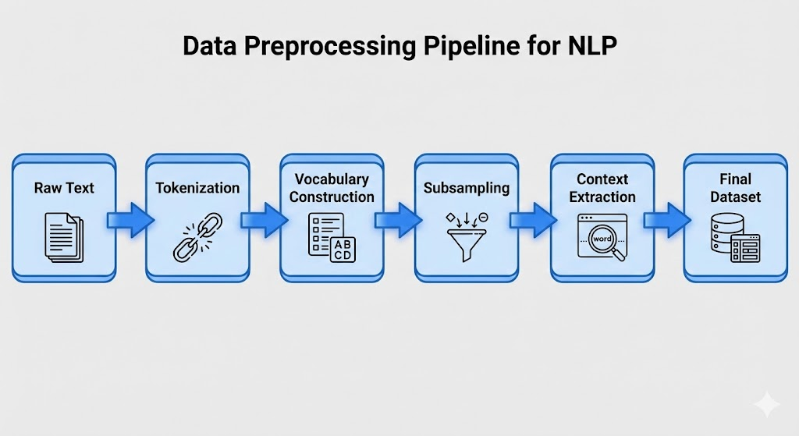
Figure 1.10: Dataset preparation pipeline.

The Penn Treebank Dataset
The Penn Treebank (PTB) is a corpus of naturally occurring text annotated with linguistic infor- mation. For our purposes, we’ll use the version that contains raw text without syntactic anno- tations.
Key characteristics of the PTB dataset:
- Source: Wall Street Journal articles
- Size: Approximately 42,069 sentences in the training set
- Vocabulary: Around 10,000 unique words after preprocessing
- Format: Each line contains a sentence with space-separated words
The PTB dataset is relatively small compared to modern web-scale corpora, but it’s well- curated, clean, and has become a standard benchmark for language modeling research.
To load the PTB dataset, we can use the following approach:

1
import os
from d2l import torch as d2l

def read_ptb():
"""Load the PTB dataset into a list of text lines.""" data_dir = d2l.download_extract('ptb')
with open(os.path.join(data_dir, 'ptb.train.txt')) as f: raw_text = f.read()
return [line.split() for line in raw_text.split('\n')]
2
3
4
5
6
7
8
9

After reading the dataset, we build a vocabulary that maps each word to a unique integer ID. Words that appear less than a specified threshold (typically 10 times) are replaced with a special “<unk>” token to handle rare words.

Data Preprocessing Techniques
Raw text data requires several preprocessing steps before it can be used for training word em- beddings:

- Subsampling High-Frequency Words
High-frequency words like “the”, “a”, and “in” appear very frequently in text but provide limited contextual information. Training on all occurrences of these words is computationally inefficient and can bias the model toward frequent but less informative patterns.
Mikolov et al. (2013) proposed a subsampling technique where each word w_{i} is discarded with probability:
P (w ) = 1 − s t

i

Where:
  - f (w_{i}) is the frequency of word w_{i}

f (w_{i})

  - t is a threshold parameter (typically 10^{—4})
  - Only words with f (w_{i}) > t are considered for subsampling This formula ensures that:
- Very frequent words are more likely to be discarded
- Extremely frequent words have a high probability of being discarded
- Rare words are almost never discarded
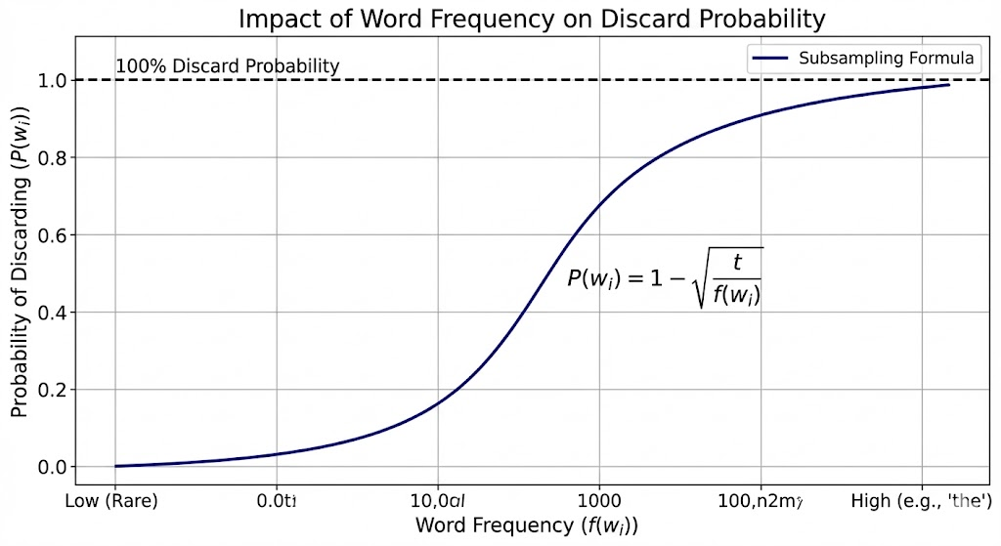
Figure 1.12: Subsampling probability curve.

For example, the word “the” might have a 97% chance of being discarded, while a rare word like “floccinaucinihilipilification” would almost never be removed.

- Tokenization and Vocabulary Construction
Tokenization is the process of splitting text into meaningful units (tokens), typically words or subwords. For English text, simple whitespace tokenization often works well, but more sophis- ticated approaches may be needed for other languages or specific domains.
Vocabulary construction involves:
- Counting word frequencies
- Setting a minimum frequency threshold (e.g., 10 occurrences)
- Creating a mapping from words to indices
- Adding special tokens like “<unk>” for unknown words
The vocabulary size is a crucial hyperparameter. Larger vocabularies capture more linguistic nuances but increase computational complexity. Smaller vocabularies are more efficient but may lose important distinctions.

- Context Window Extraction
Word embedding models like skip-gram and CBOW rely on context windows around center words. For each center word in the corpus, we extract its surrounding context words within a specified window size.
The context window size is a hyperparameter that typically ranges from 2 to 10 words. Larger windows capture broader semantic relationships, while smaller windows focus on syntactic re- lationships.
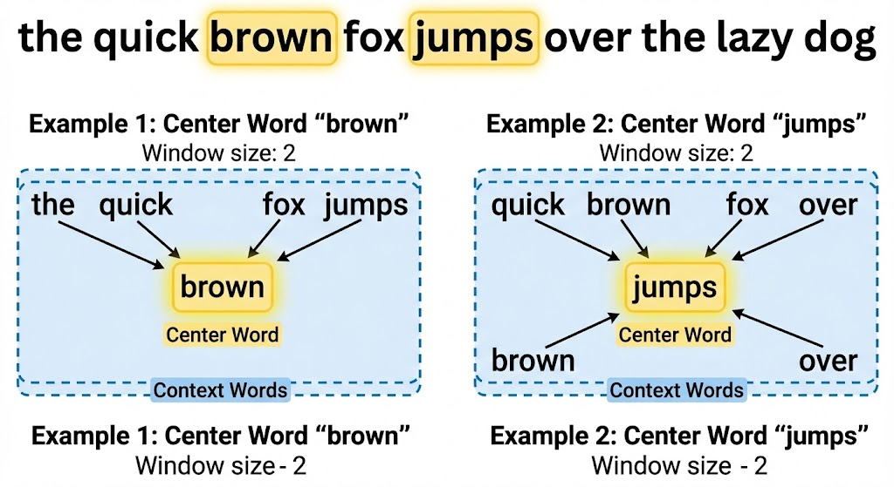
Figure 1.13: Context window example.

For example, with the sentence “the quick brown fox jumps over the lazy dog” and window size 2:
  - Center word “brown” has context words [“the”, “quick”, “fox”, “jumps”]
  - Center word “jumps” has context words [“quick”, “brown”, “fox”, “over”]

Creating Training Examples
After preprocessing, we need to convert the text corpus into training examples suitable for the word embedding model.
For the skip-gram model:
      - Each center word and its context words form multiple training examples
      - For negative sampling, we also need to generate negative examples The process involves:

- Extracting Center and Context Words
For each sentence in the corpus, we iterate through each word as a potential center word and extract its context words within the specified window size. The window size can be randomized between 1 and a maximum value to give more weight to closer words.
1
def get_centers_and_contexts(corpus, max_window_size): """Return center words and context words in skip-gram.""" centers, contexts = [], []
for line in corpus: if len(line) < 2:
continue centers += line
for i in range(len(line)):
window_size = random.randint(1, max_window_size) indices = list(range(max(0, i - window_size),
min(len(line), i + 1 + window_size))) indices.remove(i) # Exclude the center word contexts.append([line[idx] for idx in indices])
return centers, contexts
2
3
4
5
6
7
8
9
10
11
12
13
14

- Generating Negative Samples
For negative sampling, we need to generate noise words that are not in the context of the center word. These should be sampled according to a specific distribution, typically the unigram distribution raised to the power of 0.75:
1
def get_negatives(all_contexts, vocab, counter, K): """Return noise words in negative sampling.""" sampling_weights = [counter[vocab.to_tokens(i)]**0.75
for i in range(1, len(vocab))] all_negatives, generator = [], RandomGenerator(sampling_weights) for contexts in all_contexts:
negatives = []
while len(negatives) < len(contexts) * K: neg = generator.draw()
if neg not in contexts: negatives.append(neg)
all_negatives.append(negatives) return all_negatives
2
3
4
5
6
7
8
9
10
11
12
13

Batch Processing
During training, we process examples in batches to leverage parallel computation on GPUs. However, context windows have variable sizes, making batch creation challenging.
To handle this, we:
      - Pad shorter sequences to match the longest sequence in the batch
      - Use masking to ignore padded elements during loss computation
      - Track which elements are actual context words vs. negative samples The batch creation process involves:
def batchify(data):
"""Return a minibatch of examples for skip-gram with negative sampling.""" max_len = max(len(c) + len(n) for _, c, n in data)
centers, contexts_negatives, masks, labels = [], [], [], [] for center, context, negative in data:
1
2
3
4
5

6
cur_len = len(context) + len(negative) centers += [center]
contexts_negatives += [context + negative + [0] * (max_len - cur_len)] masks += [[1] * cur_len + [0] * (max_len - cur_len)]
labels += [[1] * len(context) + [0] * (max_len - len(context))] return (torch.tensor(centers).reshape((-1, 1)),
torch.tensor(contexts_negatives), torch.tensor(masks), torch.tensor(labels))
7
8
9
10
11
12
13
14

Dataset Statistics After Preprocessing
After applying these preprocessing techniques to the PTB dataset, we observe significant changes:
      - Vocabulary Size: Reduced from approximately 10,000 words to around 6,700 after apply- ing the minimum frequency threshold.
      - Sentence Length: Average sentence length decreases due to subsampling of high-frequency words.
      - Training Examples: Approximately 1.5 million center-context pairs are generated from the original 42,069 sentences.
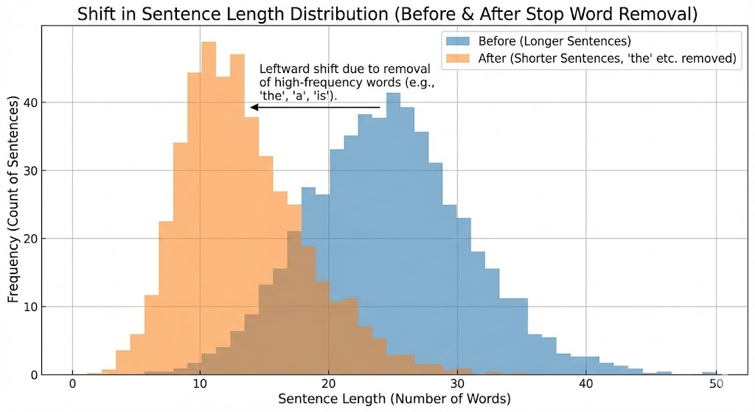
Figure 1.14: Sentence length distribution.

Impact of Preprocessing on Model Performance
The preprocessing steps we’ve discussed have significant implications for model performance:
      - Subsampling: Reduces training time by 2-4x while often improving embedding quality by focusing on more informative word occurrences.
      - Vocabulary Filtering: Smaller vocabularies train faster but may lose nuances. The opti- mal threshold balances coverage and efficiency.
      - Context Window Size: Affects the semantic vs. syntactic focus of embeddings. Larger windows (5-10) capture semantic relationships better, while smaller windows (2-5) capture syntactic patterns.
      - Negative Sampling Ratio: The number of negative samples per positive example affects training speed and embedding quality. More negative samples improve quality but slow training.

Best Practices for Dataset Preparation
Based on extensive research and practice, here are best practices for preparing datasets for word embedding training:

      - Corpus Selection: Use domain-relevant corpora when possible. For general-purpose em- beddings, use diverse, high-quality text.
      - Preprocessing Order:
        - Tokenization
        - Lowercasing (for case-insensitive models)
        - Vocabulary construction with frequency thresholding
        - Subsampling of high-frequency words
        - Context window extraction
      - Hyperparameter Tuning:
        - Subsampling threshold: t = 10^{—4} is a good starting point
        - Maximum window size: 5 for skip-gram, 10 for CBOW
        - Negative samples: 5-15 per positive example
        - Minimum word frequency: 5-10 occurrences
      - Data Shuffling: Shuffle the corpus before training to ensure diverse batches and prevent the model from learning corpus-specific patterns.

Summary of Dataset Preparation
Preparing datasets for word embedding pretraining involves several crucial steps:
      - Dataset Selection: The Penn Treebank provides a clean, well-curated corpus for bench- marking.
      - Subsampling: High-frequency words are randomly discarded to improve training effi- ciency and quality.
      - Vocabulary Construction: Words below a frequency threshold are replaced with “<unk>”, creating a manageable vocabulary size.
      - Context Extraction: For each center word, context words within a dynamic window size are extracted.
      - Negative Sampling: Noise words are sampled according to a frequency-based distribu- tion for efficient training.
      - Batch Creation: Variable-length contexts are padded and masked for efficient GPU pro- cessing.
These preprocessing steps transform raw text into a format suitable for efficient training of high-quality word embeddings. The choices made during preprocessing significantly impact both training efficiency and the quality of the resulting embeddings.

Pretraining word2vec

Introduction to Practical Implementation
Now that we understand the theoretical foundations of word embeddings and the skip-gram model, let’s dive into the practical implementation of pretraining word2vec. In this section, we’ll explore how to actually train a skip-gram model with negative sampling using real data. We’ll implement the model step-by-step, from defining the architecture to training and evaluating the learned embeddings.
The implementation we’ll discuss uses the Penn Treebank (PTB) dataset that we prepared in the previous section. This dataset provides a manageable yet meaningful corpus for training word embeddings, containing approximately 42,000 sentences after preprocessing.
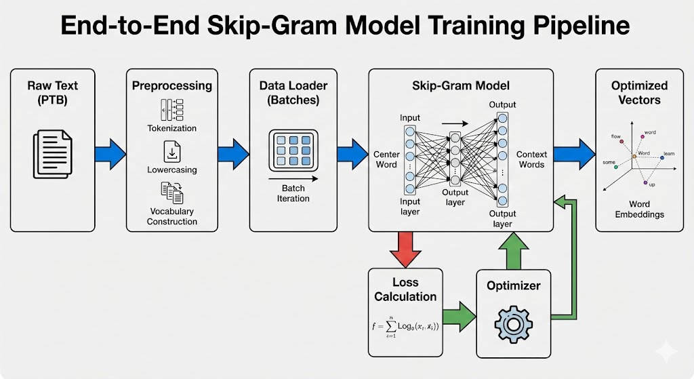
Figure 1.15: Word2vec training pipeline.

The Skip-Gram Model Architecture
The skip-gram model can be efficiently implemented using embedding layers and matrix oper- ations. Let’s break down the core components:

Embedding Layer Fundamentals
An embedding layer is a fundamental building block for word representation learning. It maps discrete token indices to continuous vector representations. Mathematically, an embedding layer can be viewed as a lookup table that stores vector representations for each word in the vocabulary.
If we have a vocabulary of size V and want to represent each word as a d-dimensional vector, the embedding layer maintains a weight matrix W of shape (V, d). For a word with index i, its vector representation is simply the i-th row of this matrix:
v_{i} = W [i, :]
In practice, modern deep learning frameworks implement this efficiently using dedicated embedding layers. For example, in PyTorch:
1 embed = nn.Embedding(num_embeddings=20, embedding_dim=4)
This creates an embedding layer that can handle 20 different tokens, each represented by a 4-dimensional vector.
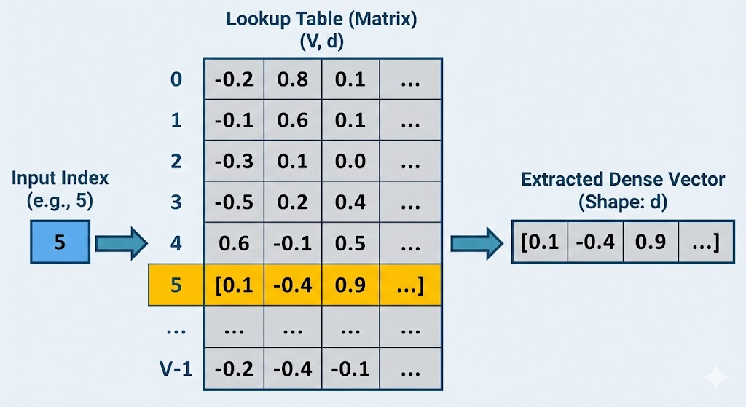
Figure 1.16: Embedding layer operation.

When we pass a tensor of token indices to the embedding layer, it returns the corresponding vectors. For a batch of token indices with shape (batch_size, seq_length), the output will have shape (batch_size, seq_length, embedding_dim).

Forward Propagation in Skip-Gram
The skip-gram model’s forward propagation involves computing the similarity between center word vectors and context word vectors. Given a center word c and context words {w₁, w₂, ..., w_{n}}, we want to compute the probability of each context word appearing around the center word.
The core operation is the dot product between the center word vector and each context word vector. For efficiency, we can use batch matrix multiplication:
1
def skip_gram(center, contexts_and_negatives, embed_v, embed_u): v = embed_v(center) # Center word vectors
u = embed_u(contexts_and_negatives) # Context and noise word vectors pred = torch.bmm(v, u.permute(0, 2, 1))
return pred
2
3
4
5

This function takes:
- center: Indices of center words (shape: batch_size × 1)
- contexts_and_negatives: Indices of context words and negative samples (shape: batch_size
× max_len)
- embed_v: Embedding layer for center words
- embed_u: Embedding layer for context words
The output pred has shape (batch_size, 1, max_len), where each element represents the dot product between a center word vector and a context/noise word vector.
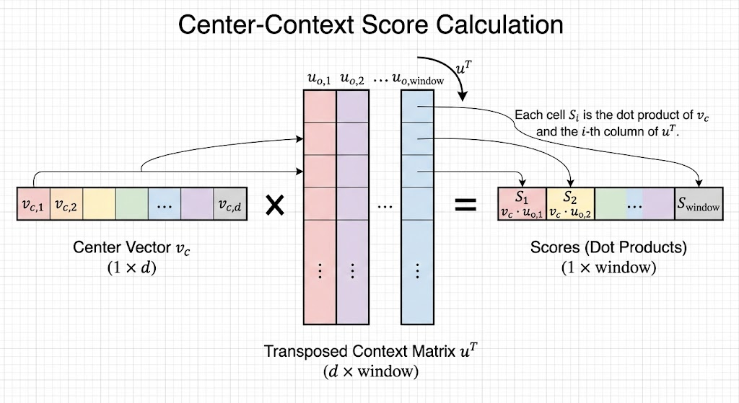
Figure 1.17: Skip-gram forward pass.

Mathematically, for a center word c and context word o, the prediction score is:
s(c, o) = v^{T}u_{o}
c
Where:
- v_{c} is the vector representation of center word c
- u_{o} is the vector representation of context word o
These scores will later be passed through a sigmoid function to obtain probabilities.

Training with Negative Sampling
To train the skip-gram model efficiently, we use negative sampling as described in Section 1.2. This requires a specialized loss function that handles both positive examples (actual context words) and negative examples (randomly sampled noise words).

Binary Cross-Entropy Loss with Masking
The binary cross-entropy loss is well-suited for negative sampling because it treats each word prediction as a binary classification task: is this word a true context word or not?
The standard binary cross-entropy loss for a single prediction is:

L(y, yˆ) = −[y log(yˆ) + (1 − y) log(1 − yˆ)]
Where:
- y is the true label (1 for positive examples, 0 for negative examples)
- yˆ is the predicted probability
However, due to variable-length context windows and padding, we need a masked version of this loss that only considers non-padded elements. We implement this as:
1
class SigmoidBCELoss(nn.Module):
def forward(self, inputs, target, mask=None):
out = nn.functional.binary_cross_entropy_with_logits( inputs, target, weight=mask, reduction="none")
return out.mean(dim=1)
2
3
4
5

This loss function:
      - Applies sigmoid internally to convert logits to probabilities
      - Uses the mask to ignore padded elements
      - Computes the mean loss across non-masked elements for each example
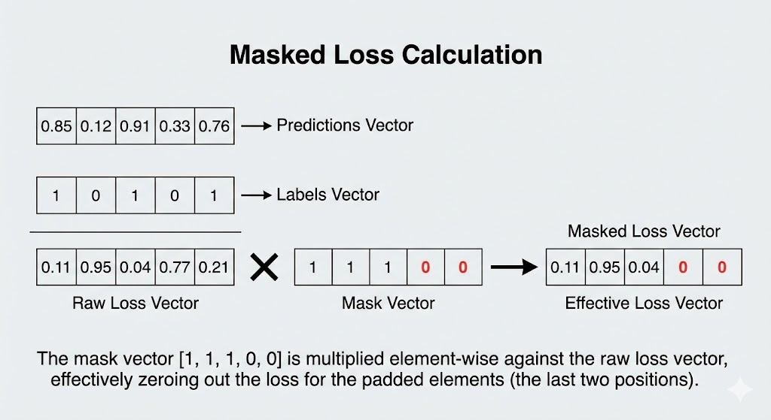
Figure 1.18: Masked binary cross-entropy loss.

Model Parameter Initialization
Proper initialization of model parameters is crucial for effective training. For the embedding layers, we use Xavier uniform initialization, which helps maintain stable gradients during train- ing:
1
def init_weights(module):
if type(module) == nn.Embedding: nn.init.xavier_uniform_(module.weight)
2
3

We create two separate embedding layers:
- One for center words (embed_v)
- One for context words (embed_u)
This separation allows the model to learn different representations depending on whether a word is used as a center word or a context word:

1
embed_size = 100
net = nn.Sequential(
nn.Embedding(num_embeddings=len(vocab), embedding_dim=embed_size), nn.Embedding(num_embeddings=len(vocab), embedding_dim=embed_size)
)
2
3
4
5

The embedding dimension (100 in this case) is a hyperparameter that controls the expres- siveness of the word representations. Larger dimensions can capture more nuanced relation- ships but require more training data and computational resources.

Training Loop Implementation
The training loop for word2vec involves iterating through minibatches of training examples, computing the loss, and updating the model parameters. Here’s the complete implementation:
1
def train(net, data_iter, lr, num_epochs, device=d2l.try_gpu()): net.apply(init_weights)
net = net.to(device)
optimizer = torch.optim.Adam(net.parameters(), lr=lr)
animator = d2l.Animator(xlabel='epoch', ylabel='loss', xlim=[1, num_epochs]) metric = d2l.Accumulator(2)

for epoch in range(num_epochs):
timer, num_batches = d2l.Timer(), len(data_iter) for i, batch in enumerate(data_iter):
optimizer.zero_grad()
center, context_negative, mask, label = [data.to(device) for data in batch] pred = skip_gram(center, context_negative, net[0], net[1])
l = (loss(pred.reshape(label.shape).float(), label.float(), mask)
/ mask.sum(axis=1) * mask.shape[1]) l.sum().backward()
optimizer.step() metric.add(l.sum(), l.numel())

animator.add(epoch + 1, (metric[0] / metric[1],)) print(f'loss {metric[0] / metric[1]:.3f}, '
f'{metric[1] / timer.stop():.1f} tokens/sec on {str(device)}')
2
3
4
5
6
7
8
9
10
11
12
13
14
15
16
17
18
19
20
21
22

This training loop:
      - Initializes the model weights
      - Sets up the optimizer (Adam) with the specified learning rate
      - Iterates through epochs and batches
      - For each batch:
        - Gets the center words, context words, mask, and labels
        - Computes predictions using the skip-gram model
        - Calculates the masked loss
        - Backpropagates gradients and updates parameters
      - Tracks and displays the average loss over time

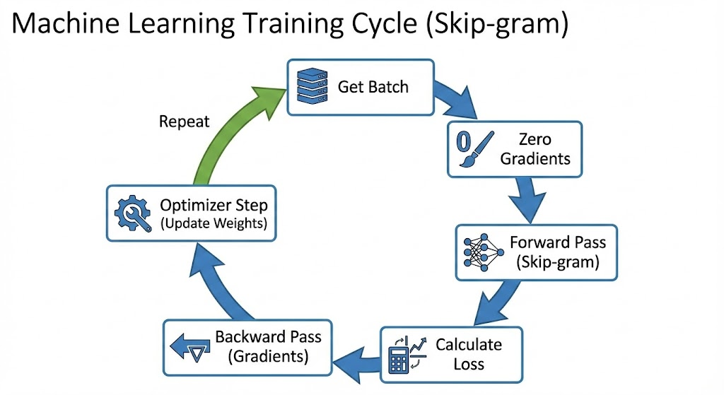
Figure 1.19: Training loop workflow.

Evaluating Word Embeddings
After training the word2vec model, we can evaluate the quality of the learned embeddings by finding semantically similar words. This is done using cosine similarity between word vectors:
cosine_similarity(u, v) = u · v
u v
We implement a function to find the k most similar words to a given query word:
1
def get_similar_tokens(query_token, k, embed):
W = embed.weight.data
x = W[vocab[query_token]]
cos = torch.mv(W, x) / torch.sqrt(torch.sum(W * W, dim=1) * torch.sum(x * x) + 1e-9) topk = torch.topk(cos, k=k+1)[1].cpu().numpy().astype('int32')
for i in topk[1:]: # Remove the input word
print(f'cosine sim={float(cos[i]):.3f}: {vocab.to_tokens(i)}')
2
3
4
5
6
7

When we apply this to the trained model, we get meaningful results. For example, searching for words similar to “chip”:
cosine sim=0.702: microprocessor cosine sim=0.649: mips
cosine sim=0.643: intel
This demonstrates that the model has learned meaningful semantic relationships between words. The high cosine similarity between “chip” and “microprocessor” reflects their close se- mantic relationship in the domain of computer hardware.
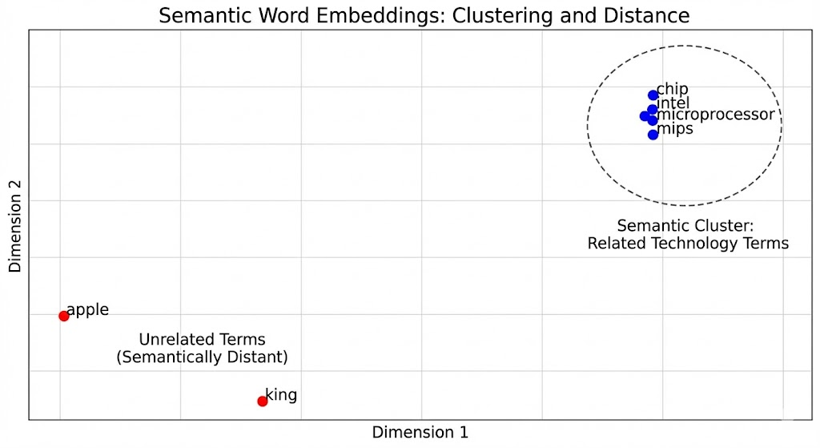
Figure 1.20: Embedding visualization.

Practical Considerations and Hyperparameters
Several hyperparameters significantly impact the quality and efficiency of word2vec training:
      - Embedding Dimension: Typical values range from 50 to 300. Higher dimensions capture more information but require more data and computation.
      - Context Window Size: Controls how many words around the center word are considered as context. Larger windows (5-10) capture broader semantic relationships, while smaller windows (2-5) focus on syntactic relationships.
      - Number of Negative Samples: The ratio of negative to positive examples. Common val- ues are 5-20. More negative samples improve quality but slow training.

      - Learning Rate: Typically set between 0.001 and 0.01. Too high can cause instability, too low slows convergence.
      - Subsampling Threshold: Controls how aggressively high-frequency words are discarded. The default value of 10^{—4} works well for most corpora.
For the PTB dataset with our implementation, we use:
        - Embedding dimension: 100
        - Context window size: 5
        - Negative samples per positive example: 5
        - Learning rate: 0.002
        - Training epochs: 5
These settings provide a good balance between training speed and embedding quality for this dataset size.

Applications of Word Embeddings
The word embeddings learned through this process have numerous applications:
      - Semantic Search: Finding words or documents with similar meanings
      - Sentiment Analysis: Understanding emotional context by examining word relationships
      - Machine Translation: Mapping words between languages based on semantic similarity
      - Named Entity Recognition: Identifying entities by their contextual patterns
      - Question Answering: Matching questions with relevant answers based on semantic con- tent
The vectors can be used directly as features in downstream tasks or fine-tuned for specific applications. Their ability to capture semantic relationships makes them invaluable for modern NLP systems.
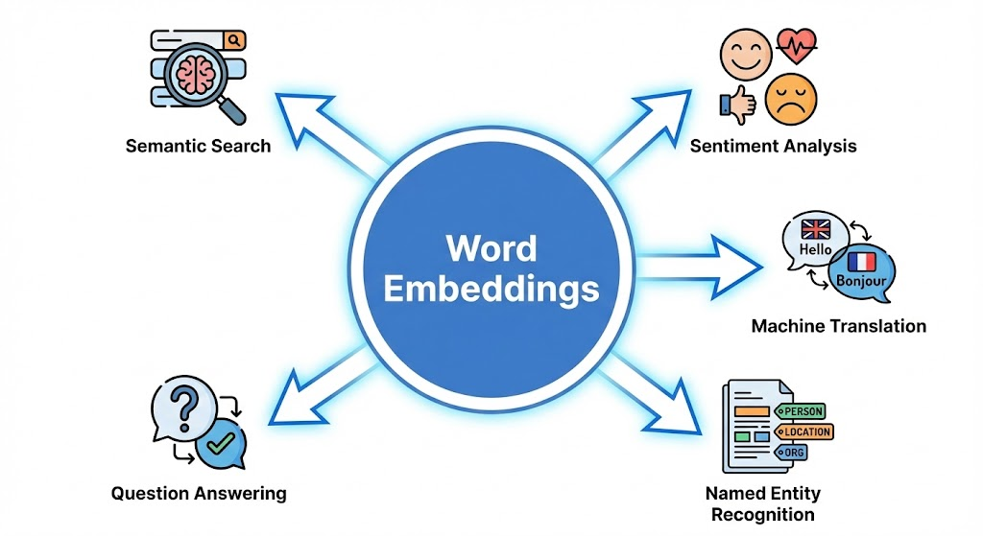
Figure 1.21: Applications of word embeddings.

Summary of Pretraining word2vec
In this section, we’ve implemented the complete pipeline for pretraining word2vec embeddings:
      - We used embedding layers to map discrete word indices to continuous vector represen- tations
      - We implemented the skip-gram model with batch matrix multiplication for efficiency

      - We applied negative sampling with binary cross-entropy loss to make training computa- tionally feasible
      - We trained the model on the PTB dataset with appropriate hyperparameters
      - We demonstrated how to find semantically similar words using cosine similarity
The resulting word embeddings capture meaningful semantic relationships between words, as demonstrated by finding words similar to “chip” such as “microprocessor,” “mips,” and “intel.” These embeddings form the foundation for more advanced NLP models and can be directly applied to various downstream tasks. The techniques we’ve learned here scale to much larger
datasets and can produce even higher-quality embeddings when trained on billions of words.
In the next section, we’ll explore an alternative approach to word embeddings called GloVe (Global Vectors), which takes a different perspective on capturing word relationships using global corpus statistics.

Word Embedding with Global Vectors (GloVe)

Introduction to Global Statistics
While word2vec models learn word embeddings by predicting context words, they primarily focus on local context windows. This approach might miss broader statistical patterns that exist across the entire corpus. GloVe (Global Vectors) addresses this limitation by directly leveraging global word co-occurrence statistics to learn word embeddings.
The key insight behind GloVe is that the ratio of word co-occurrence probabilities contains meaningful semantic information. For example, the ratio of probabilities P(“solid”|“ice”)/P(“solid”|“steam”) should be much higher than P(“gas”|“ice”)/P(“gas”|“steam”), reflecting the semantic relation-
ships between these words.

From Skip-Gram to Global Statistics
To understand GloVe, let’s revisit the skip-gram model from a global statistics perspective. In skip-gram, we model the conditional probability of context word w_{j} given center word w_{i} as:
exp(uTv_{i})
j
P (w |w ) =
j i ΣV exp(uTv )
k=1
k
i
Where:
- v_{i} is the vector representation of center word w_{i}
- u_{j} is the vector representation of context word w_{j}
- V is the vocabulary size

If we consider the entire corpus, we can count the number of times word w_{j} appears in the context of word w_{i}, denoted as X_{ij}. The total number of context words for w_{i} is X_{i} = k X_{ik}.
Σ
The empirical conditional probability can be estimated as:
Pˆ(w |w ) = Xij
j i Xi
The skip-gram loss function can then be viewed as minimizing the cross-entropy between the model’s predicted distribution and the empirical distribution from the corpus.

Limitations of Cross-Entropy Loss
While cross-entropy loss works well for probability distributions, it has limitations when applied to word co-occurrence statistics:
      - Computational Complexity: The denominator in the softmax requires summing over all vocabulary words, which is expensive for large vocabularies.
      - Rare Events: Cross-entropy loss assigns high weight to rare events, which might not be desirable when dealing with word co-occurrences.
      - Frequency Imbalance: Very frequent word pairs can dominate the training process, over- shadowing meaningful but less frequent relationships.
These limitations motivate the development of alternative loss functions that can better han- dle global co-occurrence statistics.

The GloVe Model Architecture
GloVe addresses these limitations by making three key changes to the skip-gram approach:
      - Logarithmic Transformation: Instead of modeling probabilities directly, GloVe models the logarithm of co-occurrence counts:
w^{T}w~ _{j} + b_{i} + ˜b_{j} ≈ log(X_{ij})
i
Where:
        - w_{i} and w~ _{j} are the word and context vectors
        - b_{i} and ˜b_{j} are bias terms
      - Squared Loss: GloVe uses squared error loss instead of cross-entropy:
V
J = Σ f (X_{ij})(w^{T}w~ _{j} + b_{i} + ˜b_{j} − log(X_{ij}))²
i
i,j=1
      - Weighting Function: Not all co-occurrences are equally important. GloVe introduces a weighting function f (X_{ij}) that:
        - Assigns zero weight to zero co-occurrences
        - Increases weight for small counts
        - Caps the weight for very large counts to prevent domination by frequent words
The recommended weighting function is:
((X/x_{max})^{α} if X < x_{max}
1 otherwise
f (X) =
Where x_{max} = 100 and α = 0.75 are commonly used parameters.

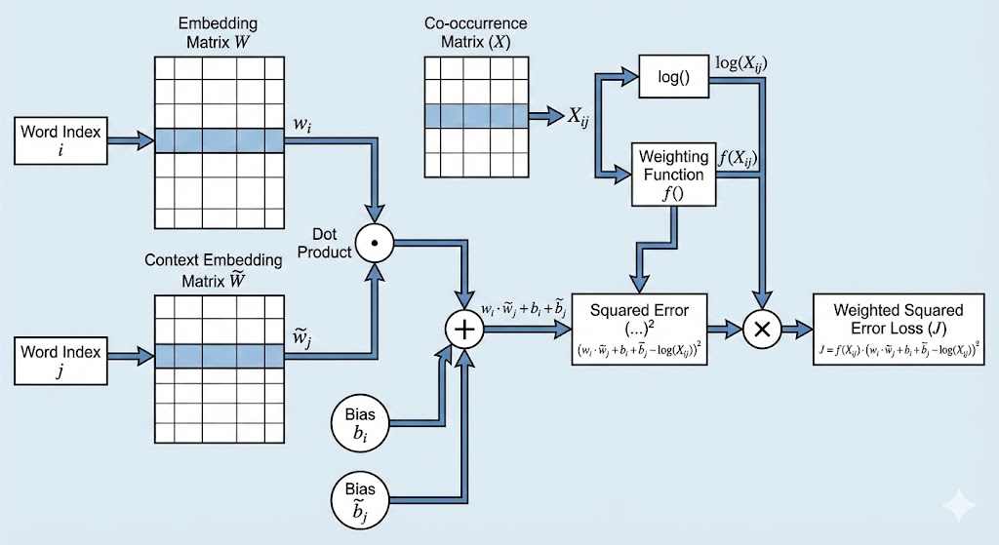
Figure 1.23: GloVe model architecture.

Mathematical Derivation of GloVe
The intuition behind GloVe can be derived from analyzing word co-occurrence ratios. Consider the ratio:
P (w_{k}|w_{i})
P (w_{k}|w_{j})
This ratio helps distinguish relevant words from irrelevant ones. For example:
- For words “ice” and “steam”, the ratio for “solid” should be high
- For words “ice” and “steam”, the ratio for “gas” should be low
- For words “ice” and “steam”, the ratio for “water” should be around 1
- For words “ice” and “steam”, the ratio for “fashion” should be around 1
This suggests that the vector difference w_{i} − w_{j} should encode semantic relationships.
Specifically, we want:
F (w , w , w~ ) = Pik

i j k
Pjk

Where F is some function that captures this relationship. A simple solution is:

F (w_{i} − w_{j}, w~ _{k}) = exp((w_{i} − w_{j})^{T}
Taking logarithms and rearranging, we get:

w~ _{k}) =
exp(wTw~ _{k})
exp(wTw~ _{k})
i
j

w^{T}w~ _{k} − w^{T}w~ _{k} = log(P_{ik}) − log(P_{jk})
i j
For this to hold for all k, we need:
w^{T}w~ _{k} = log(X_{ik}) + c
i
Where c is a constant. Adding bias terms to account for word-specific properties, we arrive at the GloVe objective:
w^{T}w~ _{j} + b_{i} + ˜b_{j} = log(X_{ij})
i

Training Procedure
Training GloVe involves the following steps:
      - Compute Co-occurrence Matrix:
        - Scan the entire corpus
        - Count co-occurrences within a context window

        - Build the matrix X where X_{ij} is the number of times word j appears in the context of word i
      - Precompute Weighted Errors:
        - For each non-zero X_{ij}, compute the error term e_{ij} = wTw~ _{j} + b_{i} + ˜b_{j} − log(X_{ij})
i
        - Apply the weighting function f (X_{ij})
      - Gradient Descent:
        - For each non-zero co-occurrence, update the word vectors and biases:
w_{i} ← w_{i} − η · f (X_{ij}) · e_{ij} · w~ _{j} w~ _{j} ← w~ _{j} − η · f (X_{ij}) · e_{ij} · w_{i} b_{i} ← b_{i} − η · f (X_{ij}) · e_{ij}
˜b_{j} ← ˜b_{j} − η · f (X_{ij}) · e_{ij}
Where η is the learning rate.
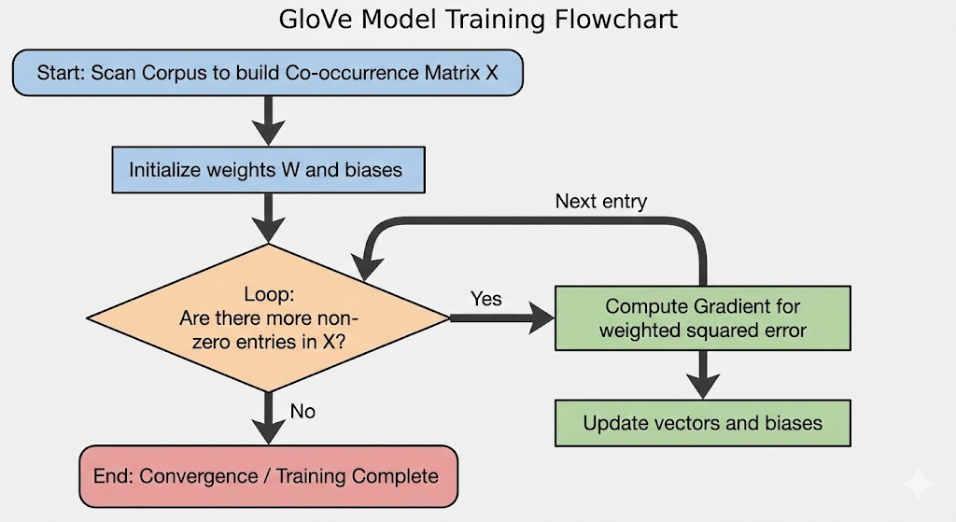
Figure 1.24: GloVe training procedure.

Symmetry in GloVe
An important property of GloVe is that the co-occurrence matrix is symmetric: X_{ij} = X_{ji}. This means that the relationship between words i and j is the same regardless of which is the center word and which is the context word.
In practice, GloVe learns two vectors for each word: w_{i} (as center word) and w~ _{i} (as context word). After training, the final word vector is typically the sum of these two vectors:
wfinal = wi + w~ i
i
This summation helps create more robust representations by combining both perspectives.

Advantages of GloVe
GloVe offers several advantages over word2vec:
      - Global Statistics: By using the entire corpus statistics, GloVe can capture relationships that might be missed by local context windows.
      - Efficient Training: Since GloVe works directly with precomputed co-occurrence counts, it can be more memory-efficient for very large corpora.
      - Parallelization: The training process can be easily parallelized since the co-occurrence matrix can be computed and stored independently.
      - Stable Performance: GloVe tends to produce more consistent embeddings across differ- ent runs and hyperparameter settings.

Comparing GloVe and word2vec
Both GloVe and word2vec have been extensively compared in the literature. While they often produce similar quality embeddings, there are some notable differences:
Performance on Word Similarity Tasks:
- GloVe often performs better on semantic similarity tasks
- word2vec may perform better on syntactic analogy tasks
Training Efficiency:
- word2vec can be faster for very large corpora since it doesn’t require storing the full co- occurrence matrix
- GloVe can be more efficient for medium-sized corpora where the co-occurrence matrix fits in memory
Parameter Sensitivity:
- GloVe is generally less sensitive to hyperparameter choices
- word2vec performance can vary significantly with window size and negative sampling set- tings
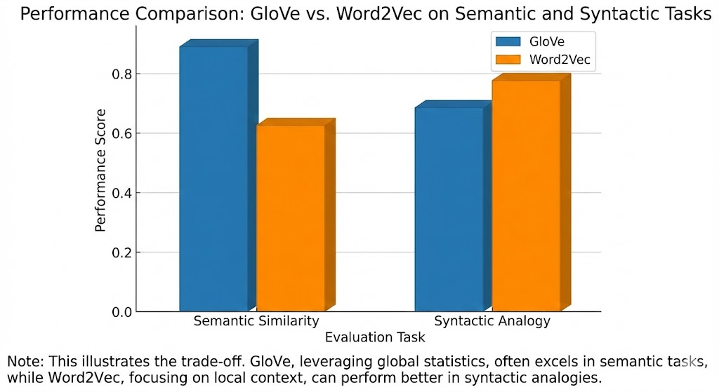
Figure 1.25: GloVe vs. word2vec performance.

Practical Implementation Considerations
When implementing GloVe, several practical considerations arise:
      - Co-occurrence Matrix Size: For a vocabulary of size V, the co-occurrence matrix has V ²
entries. For V = 100,000, this would require 40GB of memory just to store the counts.
      - Sparse Representation: In practice, most word pairs never co-occur, so the matrix is ex- tremely sparse. Efficient sparse matrix representations are essential.
      - Dynamic Context Windows: Using dynamic context windows (larger weights for closer words) can improve performance.
      - Subsampling: Similar to word2vec, high-frequency words can be subsampled to improve training efficiency.
      - Vector Initialization: Proper initialization of word vectors and biases is important for con- vergence.

Applications and Evaluation
Like word2vec embeddings, GloVe vectors can be evaluated through word similarity and anal- ogy tasks. For example, using 300-dimensional GloVe vectors trained on Wikipedia and Giga- word:
Word Similarity:
- “man” is most similar to “woman”, “boy”, “person”
- “king” is most similar to “queen”, “monarch”, “prince”
- “computer” is most similar to “software”, “hardware”, “system”
Word Analogies:
- man : woman :: king : queen
- Paris : France :: Tokyo : Japan
- quick : quickly :: happy : happily
These evaluations demonstrate that GloVe effectively captures both semantic and syntactic relationships between words.

Summary of GloVe
GloVe provides an elegant approach to word embedding by leveraging global corpus statistics rather than local context windows. Its key innovations include:
      - Modeling the logarithm of co-occurrence counts with a linear relationship
      - Using squared loss with adaptive weighting to handle frequency imbalances
      - Incorporating bias terms to account for word-specific properties
      - Exploiting the symmetry of word co-occurrences

Subword Embedding

The Morphological Challenge
Traditional word embedding approaches like word2vec and GloVe treat each word as an atomic unit, assigning a unique vector to each distinct word form. While effective for common words, these methods face significant limitations with morphologically complex languages or rare word forms. Words sharing common morphological structures have no parameter sharing, leading to inefficient use of training data.
Consider English words like “helps,” “helped,” and “helping”—all inflected forms of “help.” Each receives a separate vector despite semantic relationships. This problem intensifies in mor- phologically rich languages like Finnish or Turkish, where a single root can generate dozens of forms.
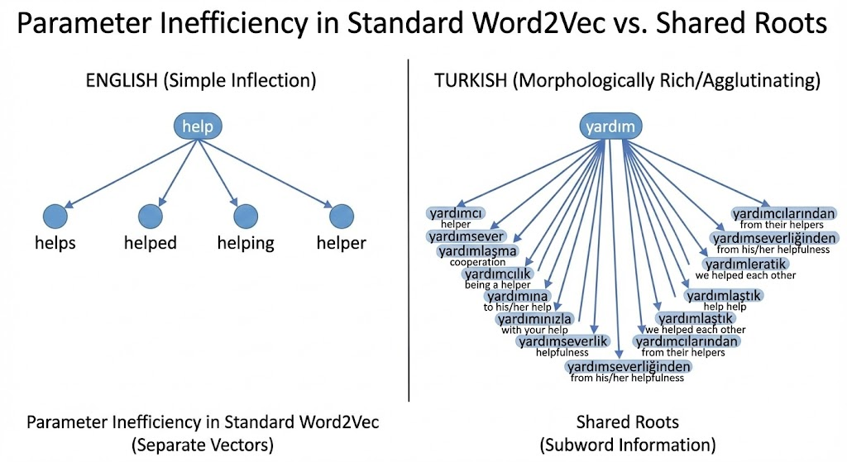
Figure 1.1: Morphological relationships and word forms.

The core challenges include:
      - Data sparsity: Rare words appear too infrequently for meaningful representation learn- ing
      - Out-of-vocabulary words: New words have no representation
      - Parameter inefficiency: Each word form requires separate parameters
      - Morphological blindness: Models cannot leverage shared substructures

The fastText Approach
The fastText model (Bojanowski et al., 2017) addresses these limitations by representing words as bags of character n-grams rather than atomic units. Instead of learning vectors for complete words, fastText learns vectors for character subsequences (subwords) and represents words as sums of their component subword vectors.

Subword Decomposition Process
For any word in fastText:
- Boundary marking: Special characters “<” and “>” are added to distinguish prefixes and suffixes
- N-gram extraction: Character n-grams of specified lengths (typically 3-6 characters) are extracted
- Special token inclusion: The complete word with boundary markers is included as a spe- cial subword
For the word “where,” after boundary marking (“<where>”), n=3 extraction yields: “<wh”, “whe”, “her”, “ere”, “re>”, plus the special subword “<where>”.
Mathematically, for word w, G_{w} represents all its subwords of length 3-6 plus the special complete word subword. The vector representation is:
v_{w} = Σ z_{g}
g∈Gw
Where z_{g} is the vector for subword g. This composition allows words with similar morpho- logical structures to share parameters. The rare word “antidisestablishmentarianism” can still receive meaningful representation through components like “anti,” “dis,” “establish,” and “ment.”

Byte Pair Encoding
While fastText uses fixed-length character n-grams, Byte Pair Encoding (BPE) learns variable- length subword units directly from training data. BPE was originally a compression technique adapted for NLP subword tokenization.

BPE Algorithm
BPE operates through iterative merging:
- Initialization: Start with base vocabulary of individual characters plus special tokens
- Frequency analysis: Compute frequency of all symbol pairs
- Iterative merging: In each iteration:
  - Identify most frequent pair of consecutive symbols
  - Merge them to create a new symbol
  - Update corpus by replacing all occurrences with the new symbol
  - Add new symbol to vocabulary
- Termination: Continue until vocabulary reaches predefined size
This process learns subword units reflecting morphological structure while adapting to train- ing corpus characteristics. For English, BPE might learn suffixes like “ing,” “ed,” and “ly” as dis- tinct units.

Text Segmentation with BPE
When segmenting new text, BPE uses a greedy longest-match-first approach. The algorithm attempts to match the longest possible subword units from the learned vocabulary, handling unknown words by breaking them into known components.
For instance, with vocabulary containing “tall,” “er,” and “_”, the word “tallest_” segments as [“tall”, “e”, “s”, “t”, “_”] since “tallest” isn’t in vocabulary but “tall” is.

Advantages of Subword Embeddings
Subword embeddings offer significant advantages over word-level approaches:

Handling Rare and Unknown Words
By decomposing words into subword units, models generate meaningful representations for rare or unseen words. The word “discombobulate” might never appear in training data, but its subwords “dis,” “com,” “bob,” “ulate” likely will, allowing the model to infer meaning from structure.

Cross-Lingual and Morphological Benefits
Subword approaches excel with morphologically rich languages. In Finnish, where nouns have up to 15 case forms, subword embeddings capture shared roots while distinguishing inflections. Similarly, agglutinative languages like Turkish benefit from identifying meaningful morphemes.

Parameter Efficiency
Subword models share parameters across related words. Instead of separate vectors for “work,” “works,” “worked,” “working,” and “worker,” a subword model learns vectors for “work” and suf- fixes like “s,” “ed,” “ing,” and “er.” This parameter sharing improves generalization, especially for low-frequency words.

Word Similarity and Analogy

Evaluating Word Embeddings
Word embeddings capture semantic and syntactic relationships as geometric properties in vec- tor space. Validating embedding quality requires systematic evaluation methods measuring how well they encode human-understood linguistic relationships. Two fundamental paradigms dominate this space: word similarity tasks and word analogy tasks.

Word Similarity Tasks
Word similarity evaluation measures how well embeddings reflect human judgments of seman- tic relatedness between word pairs. The fundamental assumption is that words with similar meanings should have similar vector representations, typically quantified using cosine similar- ity.

Cosine Similarity in Vector Space
Cosine similarity between vectors u and v is defined as:
cosine(u, v) = u · v = cos θ
u v
Where θ is the angle between vectors. This measure ranges from -1 to 1, with values closer to 1 indicating greater semantic similarity. Geometrically, words with similar meanings occupy proximate regions in embedding space, forming clusters of semantically related terms.
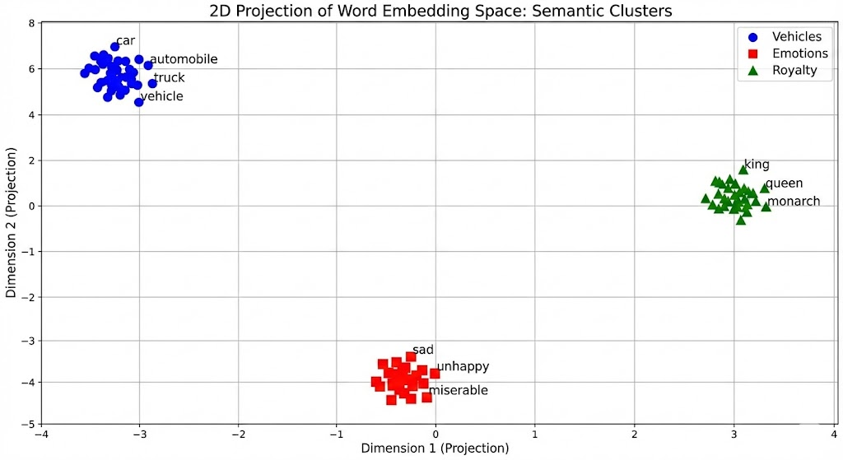
Figure 1.2: Semantic clusters in vector space.

Benchmark Datasets
Researchers developed standardized datasets with human-assigned similarity ratings:
      - WordSim-353: 353 word pairs rated 0-10 by human annotators
      - SIMLEX-999: Focuses on pure semantic similarity rather than relatedness
      - MEN Dataset: 3,000 word pairs with crowdsourced similarity ratings
      - Rare Words Dataset: Specifically evaluates handling of low-frequency words
Performance is measured using Spearman’s rank correlation between model-predicted sim- ilarities and human judgments. Higher correlations indicate better quality embeddings.

Qualitative Analysis
Finding the k most similar words to a query provides qualitative insights:
      - “king” returns: “queen” (cosine=0.83), “monarch” (0.79), “royal” (0.76)
      - “car” returns: “automobile” (0.88), “vehicle” (0.82), “truck” (0.78)
      - “sad” returns: “unhappy” (0.85), “depressed” (0.82), “miserable” (0.79)
These results demonstrate embeddings’ ability to capture synonymy, hyponymy, and emo- tional associations.

Word Analogy Tasks
Word analogies test whether embeddings can capture relational patterns beyond simple simi- larity. The classic example is “king : queen :: man : woman”—if you know three words, can you predict the fourth?

Vector Arithmetic and Semantic Relationships
Semantic relationships often correspond to consistent vector offsets:
v_{b} − v_{a} ≈ v_{d} − v_{c}
Rearranged to solve for unknown word d:
v_{d} ≈ v_{b} − v_{a} + v_{c}
This works because semantic relationships create consistent directional shifts:
- Gender: vqueen − vking ≈ vwoman − vman
- Country-capital: vParis − vFrance ≈ vBerlin − vGermany
- Verb tense: v_{went} − v_{go} ≈ v_{ran} − v_{run}
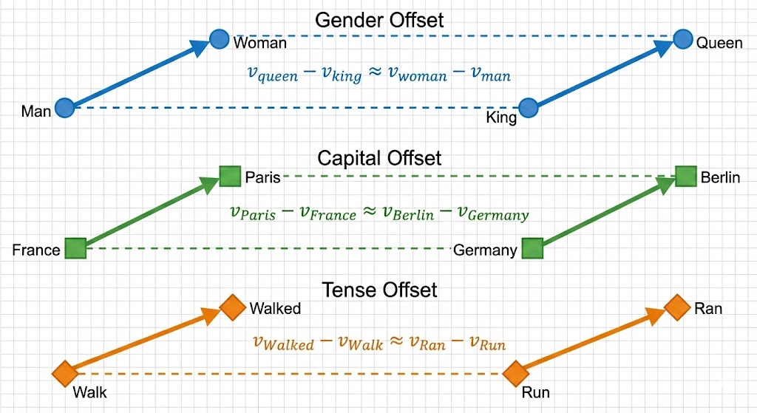
Figure 1.3: Vector arithmetic and analogies.

Types of Relationships
Word embeddings capture various relationship types:
Semantic Relationships:
- Geographic: France : Paris :: Italy : Rome
- Family relations: Brother : Sister :: Uncle : Aunt
- Antonymy: Hot : Cold :: Happy : Sad
Syntactic Relationships:
- Comparative forms: Big : Bigger :: Fast : Faster
- Superlative forms: Bad : Worst :: Good : Best
- Pluralization: Dog : Dogs :: Cat : Cats
- Verb tenses: Walk : Walked :: Run : Ran
The Google analogy dataset (19,544 questions) measures accuracy—the percentage where the correct answer appears in top k most similar words. Modern embeddings achieve:
- Basic word2vec: ∼70-75% accuracy
- GloVe: ∼75-78% accuracy
- Contextual embeddings: ∼85-90% accuracy

Contextual Representations
A fundamental limitation of traditional embeddings is context-independence—assigning single vectors regardless of context. This fails with polysemous words like “bank” (financial institution vs. river edge) or “crane” (bird vs. construction equipment).
Contextual embedding models like ELMo, GPT, and BERT generate different vectors based on surrounding context. “Bank” in “I deposited money at the bank” has a different representation than in “I sat on the bank of the river.” Contextual embeddings generally outperform static embeddings on similarity and analogy tasks, particularly for polysemous words.

Bidirectional Encoder Representations from Transformers (BERT)

Evolution to Context-Sensitive Representations
Word embedding models like word2vec and GloVe produce context-independent representa- tions—each word receives a fixed vector regardless of surrounding context. While capturing valuable semantic information, they fundamentally fail to address language’s contextual na- ture.
Consider “bank” in these sentences:
      - “I deposited money at the bank.”
      - “I sat on the bank of the river.”
Despite completely different meanings, context-independent embeddings assign identical vectors. This limitation becomes pronounced with highly polysemous words having multiple meanings.
Formally, context-independent representation is:
v_{i} = f (w_{i})
Natural language requires context-sensitive representations:
v_{i} = g(w_{i}, C)
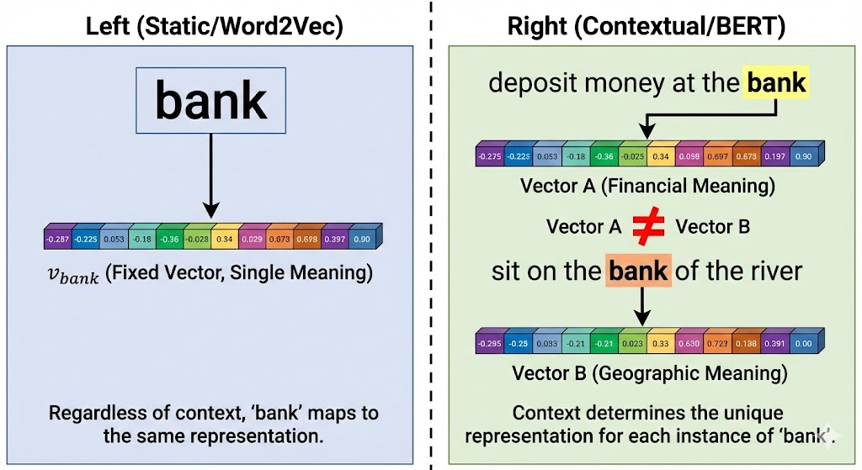
Figure 1.4: Context-independent vs. Context-sensitive representations.

Precursors to BERT
Before BERT, two significant advances paved the way: ELMo and GPT.

ELMo: Bidirectional but Task-Specific
ELMo (Peters et al., 2018) generated context-sensitive representations using pretrained bidirec- tional LSTM language models. It combined intermediate layer representations:
v_{i} = Σ s_{j}LSTM_{j}(w_{i}, C)
L
j=0
ELMo’s innovation was bidirectional context processing. However, it required crafting spe- cialized architectures for each downstream task, making it task-specific rather than task-agnostic. ELMo representations were added to existing task-specific models as additional features.

GPT: Task-Agnostic but Unidirectional
GPT (Radford et al., 2018) used a Transformer decoder architecture with autoregressive lan- guage modeling. Unlike ELMo, GPT was task-agnostic—the same architecture adapted to vari- ous tasks through fine-tuning.
However, GPT’s autoregressive nature meant it only considered left context (previous words). In “I went to the bank to deposit cash,” “bank” depends heavily on future context “to deposit cash” to determine meaning.

BERT: The Best of Both Worlds
BERT (Devlin et al., 2018) combines strengths of previous approaches:
      - Bidirectional context: Like ELMo, considers both left and right context
      - Task-agnostic architecture: Like GPT, requires minimal changes for different tasks
      - Transformer encoder: Uses full Transformer encoder architecture
BERT’s key insight is that jointly conditioning on both left and right context in all layers gen- erates deeper bidirectional representations than previous approaches. This is achieved through two novel pretraining tasks.
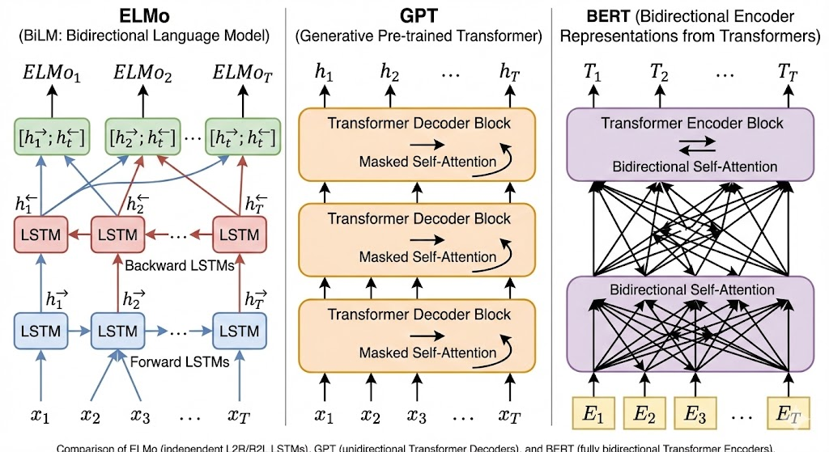
Figure 1.5: Architecture comparison: ELMo vs. GPT vs. BERT.

BERT Architecture and Input Representation
Transformer Encoder Foundation
BERT comes in two standard configurations:
      - BERT-Base: 12 layers, 768 hidden units, 12 attention heads, 110 million parameters
      - BERT-Large: 24 layers, 1024 hidden units, 16 attention heads, 340 million parameters The Transformer encoder allows each token to attend to all others through self-attention
mechanisms, capturing rich contextual relationships regardless of distance.

Input Representation Design
BERT’s input representation handles both single sentences and sentence pairs:
Tokenization: BERT uses WordPiece tokenization (BPE variant) with 30,000 vocabulary size.
Out-of-vocabulary words break into subword units:
      - “playing” → [“play”, “##ing”]
      - “unhappiness” → [“un”, “##happi”, “##ness”]
Special Tokens:
      - [CLS]: Classification token at sequence beginning
      - [SEP]: Separator token between sentences or sequence end
      - [MASK]: Used during pretraining for masked tokens
      - [UNK]: Unknown tokens
      - [PAD]: Padding tokens
Input Construction:
      - Single sentence: [CLS] token_1 token_2 ... token_n [SEP]
      - Sentence pair: [CLS] sentence1_tokens [SEP] sentence2_tokens [SEP]
Embedding Composition: Final input embedding combines three layers:
- Token embeddings: Word/subword embeddings
- Segment embeddings: Distinguish sentence A and B
- Position embeddings: Learnable positional encodings Mathematically:
E(ti) = Etoken(ti) + Esegment(s) + Eposition(i)
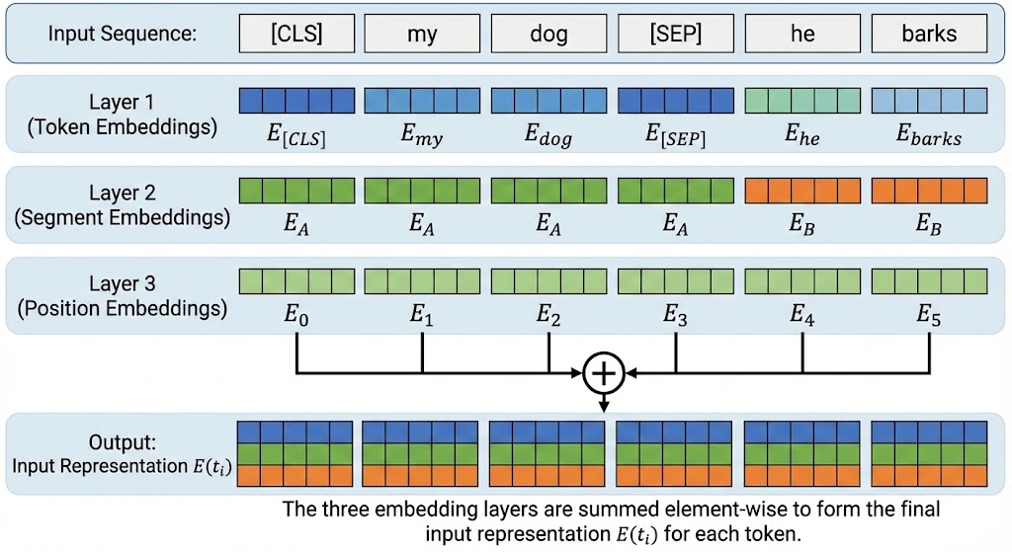
Figure 1.6: BERT input representation.

BERT Pretraining Tasks
BERT pretraining uses two tasks enabling effective bidirectional context learning.

Masked Language Modeling (MLM)
Traditional language models predict next words given previous context. BERT randomly masks 15% of tokens and predicts them using bidirectional context.
Masking strategy prevents train-test mismatch:
      - 80% of time: Replace with [MASK]
      - 10% of time: Replace with random token
      - 10% of time: Keep original token
This prevents reliance on [MASK] and encourages contextual usage. MLM uses a two-layer MLP to predict masked tokens.

Next Sentence Prediction (NSP)
MLM learns token-level representations, but NSP helps understand sentence relationships cru- cial for tasks like natural language inference.
During pretraining:
      - 50% of time: Second sentence follows first in corpus
      - 50% of time: Second sentence randomly sampled
The model predicts whether second sentence follows first using the [CLS] token represen- tation.

Combined Training Objective
Total pretraining loss combines MLM and NSP losses:
L = LMLM + LNSP
This combined objective enables BERT to learn both rich token representations and sentence- level relationships simultaneously.

Pretraining Data and Computational Requirements
BERT pretrained on massive corpora:
      - BooksCorpus (800 million words)
      - English Wikipedia (2,500 million words)
Total dataset contains about 3.3 billion words with these hyperparameters:
      - Batch size: 256 sequences
      - Training steps: 1,000,000
      - Peak learning rate: 1e-4 with warmup and decay
      - Sequence length: 128 tokens (90% of steps), 512 tokens (10%)
Computational requirements are substantial—BERT-Base pretraining takes about 4 days on 4 cloud TPUs (16 chips total).

Transfer Learning with BERT
BERT’s power comes from transfer learning—using pretrained models as starting points for downstream tasks.

Fine-tuning Process
- Task-specific heads: Add simple output layers:
  - Classification: Linear layer on [CLS] representation
  - Question answering: Predict answer span start/end positions
  - Named entity recognition: Classification layer for each token
- Fine-tuning: Train entire model on labeled task data
  - Learning rate: 2e-5 to 5e-5
  - Epochs: 2-4
  - Batch size: 16-32

Input Format for Different Tasks
BERT handles various tasks with minimal input changes:
- Sentence classification: [CLS] sentence tokens [SEP]
- Sentence pair classification: [CLS] premise tokens [SEP] hypothesis tokens [SEP]
- Question answering: [CLS] question tokens [SEP] context tokens [SEP]
- Sequence labeling: [CLS] sentence tokens [SEP]
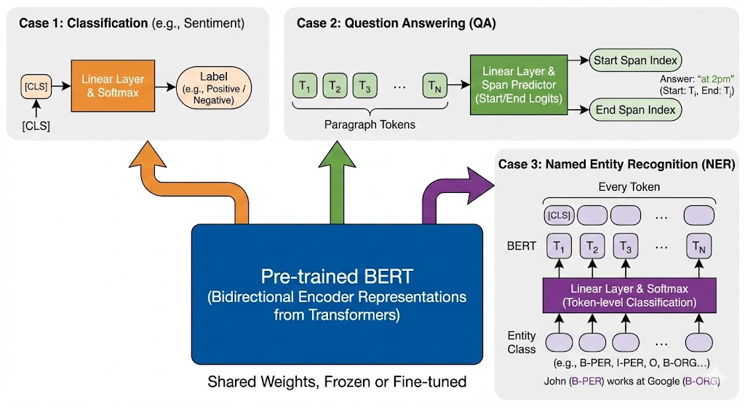
Figure 1.7: Fine-tuning BERT.

BERT’s Impact and Limitations
BERT achieved state-of-the-art results on 11 NLP tasks, including:
      - GLUE Benchmark: 4.5% improvement over previous state-of-the-art
      - SQuAD: 1.5% improvement on exact match
      - SWAG: 16.1% improvement on commonsense reasoning
      - Named Entity Recognition: 0.5-1.5% improvement This success sparked numerous variants:
      - RoBERTa: Removes NSP, trains longer on more data

      - ALBERT: Reduces parameters through sharing
      - DistilBERT: Smaller, faster with 95% of BERT’s performance
      - XLNet: Uses permutation language modeling

Limitations
Despite success, BERT has limitations:
      - Computational cost: Large memory footprint, slow inference
      - Input length: Maximum 512 tokens, cannot handle long documents
      - Static context window: Cannot incorporate knowledge beyond input
      - Pretraining-task gap: MLM may not optimally prepare for downstream tasks
BERT represents a fundamental shift in NLP—from context-independent to context-sensitive representations, from task-specific to task-agnostic architectures. Its impact transformed NLP research and practice, establishing a paradigm that continues evolving through variants and improvements.

The Dataset for Pretraining BERT

From Theory to Practice: BERT Pretraining Data
While the BERT architecture provides the foundation for powerful language understanding, its true potential emerges only when trained on massive, high-quality text corpora. The original BERT model was pretrained on the concatenation of BookCorpus (800 million words) and En- glish Wikipedia (2.5 billion words), creating representations that capture broad linguistic pat- terns. However, for educational purposes and domain-specific applications, we often need to understand how to prepare custom datasets for BERT pretraining.
In this section, we explore the WikiText-2 dataset as a practical alternative for demonstrating BERT pretraining. WikiText-2 offers several advantages over smaller corpora like Penn Treebank (PTB):
      - It retains original punctuation, crucial for next sentence prediction tasks
      - It preserves original case sensitivity and numerical values
      - At approximately 2 million words, it’s over twice the size of PTB
      - The content comes from verified Wikipedia articles, ensuring relatively high quality

Dataset Structure and Preparation
The WikiText-2 dataset is organized as a collection of paragraphs where each line represents one paragraph. Unlike PTB, which processes text into simplified formats, WikiText-2 maintains natural language characteristics including:
      - Original punctuation marks with spaces inserted before them

      - Case-sensitive tokens
      - Numerical values in their original form
      - Proper nouns and specialized terminology
To prepare this dataset for BERT pretraining, we need to implement several preprocessing steps:

- Reading and Initial Processing

1
def _read_wiki(data_dir):
file_name = os.path.join(data_dir, 'wiki.train.tokens') with open(file_name, 'r') as f:
lines = f.readlines()
# Convert to lowercase and split paragraphs into sentences paragraphs = [line.strip().lower().split(' . ')
for line in lines if len(line.split(' . ')) >= 2] random.shuffle(paragraphs)
return paragraphs
2
3
4
5
6
7
8
9

This function reads the dataset, converts text to lowercase for simplicity, and splits para- graphs into sentences using periods as delimiters. Only paragraphs with at least two sentences are retained, as they’re necessary for the next sentence prediction task.

- Vocabulary Construction
BERT requires a comprehensive vocabulary that includes:
  - Special tokens: [CLS], [SEP], [MASK], [PAD], [UNK]
  - Frequently occurring words (appearing at least 5 times in WikiText-2)
  - Subword units to handle out-of-vocabulary words

Generating Pretraining Examples
BERT pretraining involves two distinct tasks that require different data preparation strategies:

Next Sentence Prediction (NSP) Task
The NSP task trains BERT to understand relationships between consecutive sentences. For each training example, we need to create pairs of sentences where:
      - 50% of pairs are genuine consecutive sentences (positive examples)
      - 50% of pairs are randomly combined sentences from different contexts (negative exam- ples)
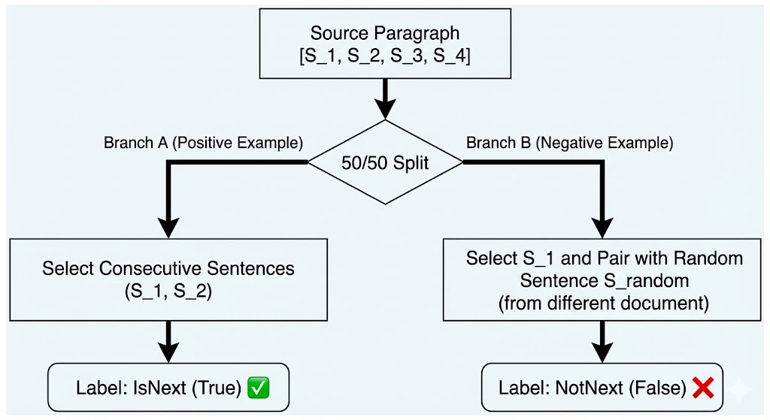
Figure 1.2: NSP data generation.

The implementation involves two key functions:

- _get_next_sentence: Creates a single sentence pair with a boolean label
- _get_nsp_data_from_paragraph: Processes an entire paragraph to generate multiple NSP examples
For a paragraph with sentences [S₁, S₂, S₃, ..., S_{n}], we can create pairs (S₁, S₂), (S₂, S₃), etc., and randomly replace the second sentence in approximately half of these pairs with a sentence from another paragraph.

Masked Language Modeling (MLM) Task
The MLM task trains BERT to predict masked tokens based on their bidirectional context. For each input sequence:
  - 15% of tokens are randomly selected for prediction
  - Of these selected tokens:
    - 80% are replaced with [MASK]
    - 10% are replaced with random tokens
    - 10% remain unchanged
This masking strategy prevents the model from learning to rely exclusively on the [MASK] token during pretraining, creating a smoother transition to fine-tuning where the [MASK] token rarely appears.
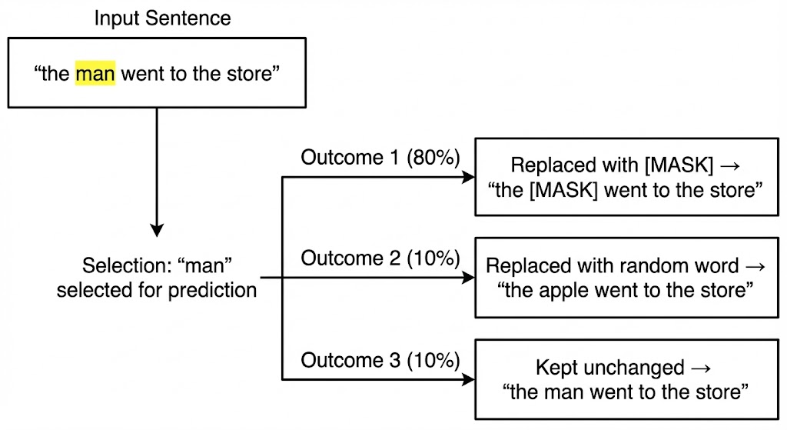
Figure 1.3: MLM token masking process.

The implementation involves:
- Identifying candidate positions (excluding special tokens)
- Selecting 15% of these positions for prediction
- Applying the masking strategy with appropriate probabilities
- Recording the original tokens as prediction targets

Practical Considerations and Challenges
When preparing datasets for BERT pretraining, several practical challenges arise:

Vocabulary Size Management
WikiText-2’s vocabulary size (approximately 20,000 tokens after filtering) is substantially smaller than the 30,000 tokens used in the original BERT. This reduction affects model capacity and may limit performance on specialized vocabulary. For production systems, vocabulary size should be carefully balanced against computational constraints.

Sequence Length Limitations
The maximum sequence length (64 tokens in our example vs 512 in original BERT) significantly impacts the model’s ability to capture long-range dependencies. Shorter sequences are com- putationally efficient but may miss important context. This trade-off is particularly important for document-level understanding tasks.

Data Quality and Domain Adaptation
Wikipedia text has distinct characteristics compared to other domains like scientific literature or social media. Models pretrained on Wikipedia may not transfer well to specialized domains without additional pretraining on domain-specific corpora.

Computational Resource Requirements
Even with the reduced WikiText-2 dataset, BERT pretraining demands substantial computational resources. The original BERT-Base required 4 days on 16 TPU chips. Our educational version can run on consumer GPUs but with significantly reduced model capacity.

Summary
Preparing datasets for BERT pretraining involves sophisticated data processing pipelines that transform raw text into structured training examples for multiple pretraining objectives. The WikiText-2 dataset provides a practical balance between size and quality for educational pur- poses, while highlighting the key challenges in data preparation for contextual language mod- els.
Key components of BERT dataset preparation include:
- Careful corpus selection balancing size, quality, and domain relevance
- Implementation of specialized functions for generating NSP and MLM training examples

- Efficient data structures for storing and retrieving preprocessed examples
- Proper handling of special tokens, padding, and sequence lengths
These preprocessing steps form the foundation for effective BERT pretraining, ensuring the model learns rich contextual representations from the data’s statistical patterns.

