Data Manipulation:

Data Manipulation with Tensors
When I first started diving into deep learning, I thought I could just stick with the NumPy arrays I knew and loved. But I quickly realized that to build effective deep learning models, we need something more powerful. We need efficient ways to store and manipulate data that can scale to millions of parameters and run on GPUs.
The foundation of this entire process involves two key steps: acquiring data and processing it once it’s inside the computer’s memory. At the core of modern deep learning frameworks like PyTorch lies the tensor. Think of a tensor as an n-dimensional array on steroids—it extends traditional NumPy arrays with two critical capabilities that changed the game for me:
- Automatic Differentiation: They track their own history, allowing us to compute gradi- ents automatically (crucial for backpropagation).
- GPU Acceleration: They can live on the GPU, speeding up matrix math by 50x-100x com- pared to CPUs.

Tensor Anatomy
Tensors represent multidimensional arrays of numerical values. Depending on how many ”axes” or dimensions they have, we give them different names. I like to think of them this way:
    - Scalar (0-D): A single point, like a temperature reading (25.0).
    - Vector (1-D): A line of points, like a row of data ([1, 2, 3]).
    - Matrix (2-D): A grid, like a black-and-white image (28 × 28 pixels).
    - Higher-order tensor (n-D): A cube or hypercube, like a batch of color images (Batch ×
Height × Width × Color).
In PyTorch, creating these is straightforward. Here’s how I usually start:
1
import torch

# Create a vector with values 0 to 11 x = torch.arange(12)
# Output: tensor([0, 1, 2, 3, 4, 5, 6, 7, 8, 9, 10, 11])

# Check the total number of elements (volume) x.numel() # Returns 12

# Check the shape (dimensions) x.shape # Returns torch.Size([12])
2
3
4
5
6
7
8
9
10
11
One concept that confused me initially was reshaping. We can change the shape of a tensor without changing its values or total size. It’s like taking a deck of cards laid out in one long row and stacking them into 4 piles of 13. The cards are the same; the organization is different.
1
# Reshape vector into 3x4 matrix
X = x.reshape(3, 4) # Output:
# tensor([[0, 1, 2, 3],
# [4, 5, 6, 7],
# [8, 9, 10, 11]])
2
3
4
5
6

When initializing neural networks, we rarely type out values manually. We usually need specific initialization patterns:

1
# Tensor of zeros (common for biases) torch.zeros((2, 3, 4))

# Tensor of ones torch.ones((2, 3, 4))

# Random values from standard normal distribution (common for weights) torch.randn(3, 4)

# Manual creation from Python lists
torch.tensor([[2, 1, 4, 3], [1, 2, 3, 4], [4, 3, 2, 1]])
2
3
4
5
6
7
8
9
10
11

Indexing and Slicing
If you know Python lists, you essentially know PyTorch indexing. It follows the same zero-based conventions, but with superpowers for multi-dimensional data.
1
# Access last row (negative indexing works!) X[-1] # Returns tensor([8, 9, 10, 11])

# Access rows 1 and 2 (index 1 up to 3) X[1:3] # Returns rows at indices 1 and 2

# Modify specific element
X[1, 2] = 17 # Sets element at row 1, column 2 to 17

# Set multiple elements at once (Bulk assignment)
X[:2, :] = 12 # Sets all elements in first two rows to 12
2
3
4
5
6
7
8
9
10
11
This bulk assignment is incredibly useful. For example, in dropout layers, we often want to zero out entire chunks of a matrix.

Operations: The Math Engine
Deep learning is essentially massive amounts of simple math operations running in parallel.
Elementwise operations are the most common. They apply a standard scalar operation to
each element independently. This is great because it can be massively parallelized on a GPU.
1
x = torch.tensor([1.0, 2, 4, 8])
y = torch.tensor([2, 2, 2, 2])

# Basic arithmetic applied to every element x + y # tensor([3., 4., 6., 10.])
x * y # tensor([2., 4., 8., 16.])
x / y # tensor([0.5, 1., 2., 4.])
2
3
4
5
6
7
Concatenation is how we stack data. For instance, if I process two different batches of images and want to combine them into one big batch, I use concatenation.
1
X = torch.arange(12).reshape(3, 4)
Y = torch.tensor([[2, 1, 4, 3], [1, 2, 3, 4], [4, 3, 2, 1]])

# Concatenate along rows (stacking vertically) torch.cat((X, Y), dim=0) # Creates 6x4 matrix

# Concatenate along columns (stacking horizontally) torch.cat((X, Y), dim=1) # Creates 3x8 matrix
2
3
4
5
6
7
8
Logical operations let us create masks, which are vital for things like causal masking in Transformers (where we hide future tokens).
1
X == Y # Returns tensor of True/False values X.sum() # Sum all elements: tensor(66)
2

Broadcasting: The Magic Trick
Broadcasting was the hardest concept for me to grasp, but it’s the most powerful. It enables operations between tensors of different shapes.

➔ Example: Broadcasting Shape Rules — Step-by-Step Worked Examples
PyTorch broadcasts by aligning shapes from the right and expanding any dimension of size 1. Here are three cases that trip up most beginners:
import torch

# ── CASE 1: Adding a bias vector to a batch of activations ──
activations = torch.randn(32, 256) # 32 samples, 256 features
bias = torch.randn(256) # one bias per feature
out = activations + bias # bias broadcast along dim-0 → (32,256)
print(out.shape) # torch.Size([32, 256])

# ── CASE 2: Row-normalisation (divide each row by its max) ──
scores = torch.randn(4, 10) # 4 samples, 10 class scores
row_max = scores.max(dim=1, keepdim=True).values # shape (4, 1)
normalised = scores / row_max # (4,10) / (4,1) → (4,10)
print(normalised.shape) # torch.Size([4, 10])

# ── CASE 3: Outer product via broadcasting ──
a = torch.tensor([1., 2., 3.]) # shape (3,)
b = torch.tensor([10., 20.]) # shape (2,)
outer = a.unsqueeze(1) * b.unsqueeze(0) # (3,1) * (1,2) → (3,2)
print(outer)
# tensor([[10., 20.],
# [20., 40.],
# [30., 60.]])

# ── COMMON ERROR: shape mismatch ──
x = torch.randn(3, 4)
y = torch.randn(3) # (3,) aligns to last dim → needs (4,) not (3,)
# x + y --> RuntimeError: shapes (3,4) and (3,) cannot be broadcast
# Fix: y.unsqueeze(1) → (3,1) broadcasts correctly with (3,4)
Memory tip: broadcasting never copies data — it is a virtual view. The only cost is the arithmetic itself, so always prefer broadcasting over explicit torch.repeat() or torch.tile() to save memory.
The mechanism works in two virtual steps:
- Expand arrays: It effectively copies elements along axes of length 1 to match the larger tensor.
- Perform operation: It does the math on these expanded arrays.

1
a = torch.arange(3).reshape(3, 1) # Shape: 3x1 (Column vector)
b = torch.arange(2).reshape(1, 2) # Shape: 1x2 (Row vector)

# After broadcasting, both become 3x2 matrices! a + b
# Output:
# tensor([[0, 1],
# [1, 2],
# [2, 3]])
2
3
4
5
6
7
8
9

Why does this work?
- a is copied along columns: [[0,0], [1,1], [2,2]]
- b is copied along rows: [[0,1], [0,1], [0,1]]
- Then it just adds them.
This saves us from writing nested loops and keeps code clean and fast.

Saving Memory: In-Place Operations
Memory is the bottleneck in deep learning. We update millions of parameters thousands of times. If every update created a new copy of the model weights, we’d run out of RAM in seconds. Standard operations like Y = Y + X allocate new memory for the result. In-place opera-
tions modify the tensor directly in memory.
1
# Standard assignment (Bad for memory in training loops) before = id(Y)
Y = Y + X
id(Y) == before # Returns False (New object created!)

# In-place operations (Good for parameter updates) Z = torch.zeros_like(Y)
before = id(Z)
Z[:] = X + Y # Slice assignment forces in-place update id(Z) == before # Returns True

# Alternative syntax using += before = id(X)
X += Y
id(X) == before # Returns True
2
3
4
5
6
7
8
9
10
11
12
13
14
15

Conversion to Other Python Objects
Finally, we don’t live in a vacuum. We often need to use libraries like Matplotlib or SciPy which expect NumPy arrays, or just print a value to the console.

1
# Tensor to NumPy array (shares memory location - fast!) A = X.numpy()

# NumPy array to tensor B = torch.from_numpy(A)

# Converting single-element tensors to Python scalars a = torch.tensor([3.5])
a.item() # Returns standard Python float 3.5 float(a) # Casting works too
int(a) # Returns 3
2
3
4
5
6
7
8
9
10
11

Summary
Tensors are more than just data containers; they are the fundamental building blocks of the deep learning world. They offer efficient storage, flexible manipulation through slicing and broadcasting, and the critical ability to run on GPUs. Understanding these operations is like learning the grammar of a language—once you master creation, indexing, and memory man- agement, you can start composing complex sentences (neural networks) that actually do amaz- ing things.

Data Preprocessing in Deep Learning

The Critical Role of Data Preprocessing
In the real world of machine learning, the adage ”garbage in, garbage out” holds profound truth. While textbooks often present clean, perfectly formatted datasets, actual data is messy, inconsistent, and full of surprises. Data preprocessing—the transformation of raw data into a format suitable for machine learning models—is not merely a preliminary step; it’s often the difference between a model that works and one that fails spectacularly.
Consider this sobering statistic: data scientists spend approximately 80% of their time on data preprocessing and only 20% on actual model building and evaluation. This imbalance exists for good reason. Raw data typically contains:
- Missing values scattered throughout the dataset
- Inconsistent formatting and encoding schemes
- Outliers and extreme values that distort statistical properties
- Features on vastly different scales that confuse optimization algorithms
- Categorical variables that numerical models cannot interpret directly
A poorly preprocessed dataset can lead to model instability, poor generalization, biased pre- dictions, and computational inefficiency. The goal of data preprocessing is to transform raw data into a representation that preserves meaningful information while removing noise and irrelevant details.

Data Loading and Initial Exploration

Beyond CSV: Understanding Common Data Formats
While CSV files are ubiquitous, real-world datasets come in various formats:
    - Parquet: Columnar storage, compression (Large datasets).
    - HDF5: Hierarchical structure (Scientific data).
    - JSON: Nested structures (Web data).
    - Pickle: Python-specific serialization.

Data Inspection Techniques
Before preprocessing, thorough data inspection is essential.
1
import pandas as pd import numpy as np

# Load the dataset
data = pd.read_csv('house_tiny.csv')

# 1. Basic information
print("=== BASIC DATASET INFORMATION ===")
print(f"Dataset shape: {data.shape}")
2
3
4
5
6
7
8
9

10
print(f"Data types:\n{data.dtypes}\n")

# 2. Missing value analysis
print("=== MISSING VALUE ANALYSIS ===")
missing_values = data.isnull().sum()
missing_percentage = (missing_values / len(data)) * 100
print(pd.DataFrame({'Missing Count': missing_values, 'Percentage': missing_percentage}))

# 3. Statistical summary
print("=== STATISTICAL SUMMARY ===")
print(data.describe(include='all'))
11
12
13
14
15
16
17
18
19
20

This comprehensive inspection reveals limitations like high missing value rates or mixed data types, guiding our preprocessing strategy.

Theoretical Framework for Handling Missing Values

Understanding Missing Data Mechanisms
Not all missing data is created equal.
- Missing Completely at Random (MCAR): Probability of missingness is uniform. Safe to remove without bias.
- Missing at Random (MAR): Missingness depends on observed data (e.g., income missing for younger people). Requires imputation.
- Missing Not at Random (MNAR): Missingness depends on the unobserved value itself (e.g., high earners hiding income). Introduces bias difficult to correct.

➔ Example: MCAR vs MAR vs MNAR — Real-World Examples from a Medical Dataset
The three missing-data mechanisms require different handling strategies. Here is a concrete medical scenario illustrating each:
# Dataset: patient records with columns:
# [age, blood_pressure, income, cholesterol, diabetes_diagnosis]

# ── MCAR: Missing Completely At Random ──────────────────────────
# A lab technician accidentally drops 5% of blood samples.
# Which patients lose results is random — unrelated to their health.
# Test: compare demographics of missing vs non-missing groups → no difference
# Action: safe to drop rows or use simple imputation (mean/median)

# ── MAR: Missing At Random ──────────────────────────────────────
# Income is missing more often for younger patients (who declined to share).
# Missingness depends on 'age' (observed) but not on 'income' itself.
# Test: logistic regression of 'income_missing ~ age' → significant
# Action: use multiple imputation (MICE) conditioned on age

# ── MNAR: Missing Not At Random ─────────────────────────────────
# Cholesterol is missing because patients with very high readings
# refused re-testing (the missing VALUE drives the missingness).
# Test: no statistical test can confirm MNAR from observed data alone
# Action: domain expertise + sensitivity analysis; imputation will be biased

# Quick Python check for potential MAR pattern:
import pandas as pd
df = pd.read_csv('patients.csv')
df['income_missing'] = df['income'].isna().astype(int)
print(df.groupby('income_missing')['age'].mean())
# income_missing
# 0 52.3 (non-missing income — older patients)
# 1 31.7 (missing income — younger patients) -> likely MAR
Why this matters for deep learning: if you blindly drop rows with missing values from a MNAR dataset, you systematically exclude the highest-risk patients — your model learns on a biased sample and will under-predict risk for exactly the patients who need it most.

Imputation Strategies
Simple Imputation
    - Mean/Median: Replace numerical missing values with the mean/median. Reduces vari- ance.
    - Mode: Replace categorical missing values with the most frequent category.

Advanced Imputation
    - K-Nearest Neighbors (KNN): Find k nearest samples and impute based on them. Pre- serves local structure.
    - MICE (Multiple Imputation by Chained Equations): Uses regression models to estimate missing values iteratively.

1
# Numerical Feature Handling (Mean Imputation) mean_rooms = data['NumRooms'].mean(skipna=True) data['NumRooms'] = data['NumRooms'].fillna(mean_rooms)

# Categorical Feature Handling (Treat Missing as Category) data['RoofType'] = data['RoofType'].fillna('Missing')
2
3
4
5
6

Feature Engineering and Transformation

Categorical Feature Encoding
    - One-Hot Encoding: Creates binary features. Good for nominal data.
    - Ordinal Encoding: Maps categories to integers based on order.
    - Target Encoding: Replaces category with mean target value. Useful for high-cardinality features but risks overfitting.

1
# One-Hot Encoding with Missing Indicator
inputs_encoded = pd.get_dummies(inputs, columns=['RoofType'], dummy_na=True)
2

Feature Scaling
Critical for optimization algorithms.
    - Standardization: X^{r} = (X − µ)/σ.
    - Min-Max Scaling: X^{r} = (X − X_{min})/(X_{max} − X_{min}).
    - Robust Scaling: Uses median and IQR, robust to outliers.

1
from sklearn.preprocessing import StandardScaler scaler = StandardScaler()
inputs_scaled = scaler.fit_transform(inputs_imputed)
2
3

Conversion to Tensor Format: Optimization

Memory Optimization
Data types matter for memory.
    - float64 -> 8 bytes
    - float32 -> 4 bytes (Standard for DL)
    - uint8 -> 1 byte (masks, images)

1
import torch

# Convert to Float32 Tensor
X_tensor = torch.tensor(X_numpy, dtype=torch.float32) y_tensor = torch.tensor(y_numpy, dtype=torch.float32)
2
3
4
5

Batch Processing with DataLoader
Efficiently feeding data to the model.
1
from torch.utils.data import TensorDataset, DataLoader

dataset = TensorDataset(X_tensor, y_tensor)
loader = DataLoader(dataset, batch_size=32, shuffle=True, num_workers=2)
2
3
4

Best Practices and Common Pitfalls

Prevent Data Leakage
A common mistake is applying preprocessing to the entire dataset before splitting. Correct Workflow: 1. Split into Train/Test. 2. Fit preprocessors (calculate mean/std) on Train data only.
3. Transform both Train and Test data using Train statistics.

Outlier Handling
Use the IQR method to detect and handle outliers (e.g., capping/Winsorization).

Summary
Data preprocessing is a multi-step pipeline involving cleaning, imputation, encoding, and scal- ing. Mastering these techniques ensures that your deep learning models are stable, efficient, and capable of generalizing to new data. By understanding the theoretical underpinnings (like missing data mechanisms) and practical implementation details (like memory optimization), you lay a solid foundation for successful machine learning projects.

Linear Algebra
- Linear Algebra

Mathematical Foundations
Linear algebra provides the mathematical framework for representing and manipulating data in deep learning. While we’ve been working with tensors operationally, understanding their mathematical properties is essential for developing sophisticated models.

Scalars
Scalars represent single numerical values and form the atomic building blocks of tensor opera- tions. Formally, we denote scalars by lowercase letters (x, y, z) and define them as elements of the real number space R. In code, scalars are implemented as zero-dimensional tensors:
1
x = torch.tensor(3.0) y = torch.tensor(2.0)
x + y, x * y, x / y, x**y
# Output: (tensor(5.), tensor(6.), tensor(1.5000), tensor(9.))
2
3
4

Vectors
Vectors are ordered arrays of scalars that represent points in n-dimensional space. We denote vectors by bold lowercase letters (x, y, z) and define them as elements of R^{n}, where n is the di- mensionality. In neural networks, vectors typically represent feature vectors where each com- ponent corresponds to a distinct attribute.
Mathematically, a vector x ∈ R^{n} can be written as:
x = [x₁, x₂, ..., x_{n}]^{T}
In code, vectors are implemented as first-order tensors:
1
x = torch.arange(3)
# Output: tensor([0, 1, 2])

x[2] # Access third element (zero-based indexing) # Output: tensor(2)

len(x), x.shape
# Output: (3, torch.Size([3]))
2
3
4
5
6
7
8
Important distinction: In mathematical notation, vector indices start at 1 (x₁, x₂, ...), while in programming they start at 0 (x[0], x[1], ...).

Matrices
Matrices extend vectors to two dimensions, representing linear transformations between vector spaces. We denote matrices by bold capital letters (A, B, C) and define them as elements of R^{m×n}, where m is the number of rows and n is the number of columns.
A matrix A ∈ R^{m×n} can be written as:
 
a11 a12 ... a1n a21 a22 ... a2n
A  
= ... ... ... ...
am1 am2 ... amn
In code, matrices are implemented as second-order tensors:

1
A = torch.arange(6).reshape(3, 2) # Output:
# tensor([[0, 1],
# [2, 3],
# [4, 5]])
2
3
4
5

Matrix transpose: The transpose of a matrix A, denoted AT, exchanges rows and columns such that (AT)_{ij} = A_{ji}:
1
A.T
# Output:
# tensor([[0, 2, 4],
# [1, 3, 5]])
2
3
4
Symmetric matrices satisfy A = AT. These matrices are important in covariance calcula- tions and optimization:
1
A = torch.tensor([[1, 2, 3], [2, 0, 4], [3, 4, 5]])
A == A.T # Returns tensor of True values
2

Tensors
Tensors generalize scalars, vectors, and matrices to arbitrary dimensions. An n-order tensor belongs to the space R^{d}1×d2×...×dn , where each d_{i} represents the dimension along axis i.
In computer vision applications:
    - Single image: 3-order tensor ∈ R^{h×w×c} (height × width × channels)
    - Batch of images: 4-order tensor ∈ R^{b×h×w×c} (batch × height × width × channels)

1
torch.arange(24).reshape(2, 3, 4) # Output:
# tensor([[[ 0, 1, 2, 3],
# [ 4, 5, 6, 7],
# [ 8, 9, 10, 11]],
# [[12, 13, 14, 15],
# [16, 17, 18, 19],
# [20, 21, 22, 23]]])
2
3
4
5
6
7
8

Basic Properties of Tensor Arithmetic
Tensor operations follow consistent mathematical properties that enable efficient computation:
Elementwise operations: Operations between tensors of identical shape produce outputs with the same shape:
1
A = torch.arange(6, dtype=torch.float32).reshape(2, 3)
B = A.clone() # Create copy A + B
# Output:
# tensor([[ 0., 2., 4.],
# [ 6., 8., 10.]])
2
3
4
5
6
Hadamard product: The elementwise product of two matrices, denoted A ⊙ B:
1
A * B
# Output:
# tensor([[ 0., 1., 4.],
# [ 9., 16., 25.]])
2
3
4
Scalar-tensor operations: Adding or multiplying a scalar with a tensor affects all elements equally while preserving shape:

1
a = 2
X = torch.arange(24).reshape(2, 3, 4) a + X # Adds 2 to every element
(a * X).shape # Returns torch.Size([2, 3, 4])
2
3
4

Reduction Operations
Reduction operations collapse tensor dimensions through aggregation functions:

Sum reduction: The sum of all elements in a vector x ∈ R^{n} is denoted Σn
i=1
1
x = torch.arange(3, dtype=torch.float32) x.sum() # Returns tensor(3.)
2

For matrices, we can specify reduction axes:
    - axis=0: Sum along rows (preserves columns)
    - axis=1: Sum along columns (preserves rows)
x_{i}:

1
A.sum(axis=0), A.sum(axis=1)
# Output shapes: torch.Size([3]), torch.Size([2])
2
Mean reduction: The mean is the sum divided by the number of elements:
1
A.mean(), A.sum() / A.numel() # Both return tensor(2.5000)
2

Non-Reduction Sum
Sometimes we need to preserve tensor dimensions during reduction for broadcasting compat- ibility:
1
sum_A = A.sum(axis=1, keepdims=True)
# Output: tensor([[ 3.], [12.]]), shape: torch.Size([2, 1])

A / sum_A # Broadcasting creates row-normalized matrix # Output:
# tensor([[0.0000, 0.3333, 0.6667],
# [0.2500, 0.3333, 0.4167]])
2
3
4
5
6
7
Cumulative sum: Computes running totals along specified axes without reduction:
1
A.cumsum(axis=0) # Output:
# tensor([[0., 1., 2.],
# [3., 5., 7.]])
2
3
4

Dot Products
The dot product (inner product) between vectors x, y ∈ R^{n} is fundamental to machine learning:

1
y = torch.ones(3, dtype=torch.float32) torch.dot(x, y) # Returns tensor(3.) torch.sum(x * y) # Equivalent computation
2
3
Applications:
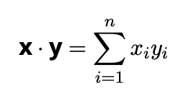

- Weighted averages: If weights w are non-negative and sum to 1, w·x represents a weighted average
- Cosine similarity: After normalization, dot products measure angular similarity between vectors

Matrix-Vector Products
Matrix-vector multiplication represents linear transformations from R^{n} to R^{m}:

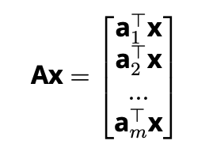
where aT represents the i-th row of A.
i
1
A.shape, x.shape # (torch.Size([2, 3]), torch.Size([3])) torch.mv(A, x), A @ x # Both return tensor([ 5., 14.])
2

Matrix-Matrix Multiplication
Matrix-matrix multiplication extends the dot product concept to transform entire sets of vectors simultaneously

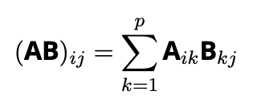

where A ∈ R^{m×p} and B ∈ R^{p×n}.
1
B = torch.ones(3, 4) torch.mm(A, B), A @ B # Both return:
# tensor([[ 3., 3., 3., 3.],
# [12., 12., 12., 12.]])
2
3
4
5

Important distinction: Matrix multiplication (AB) is fundamentally different from the Hadamard product (A ⊙ B). The former represents composition of linear transformations, while the latter performs elementwise multiplication.

Norms
Norms quantify vector magnitude and enable distance metrics essential for optimization:
l₂ norm (Euclidean norm): Measures Euclidean distance from origin:

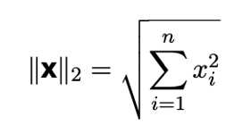

1
u = torch.tensor([3.0, -4.0]) torch.norm(u) # Returns tensor(5.)

l₁ norm (Manhattan norm): Sum of absolute values, less sensitive to outliers:
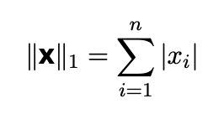

1 torch.abs(u).sum() # Returns tensor(7.)
Frobenius norm: Extension of l₂ norm to matrices:
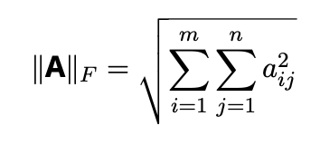

1 torch.norm(torch.ones((4, 9))) # Returns tensor(6.)
Theoretical significance: Norms provide the mathematical foundation for loss functions in optimization. Minimizing the l₂ norm between predictions and targets corresponds to least squares regression, while minimizing l₁ norm promotes sparsity in solutions.
These linear algebra concepts form the mathematical backbone of deep learning, enabling efficient representation and transformation of high-dimensional data through neural network architectures.

Calculus

Introduction: Why Calculus Matters
In deep learning, we frequently need to understand how small changes in model parameters affect the output. This is where calculus becomes essential. It provides the mechanism to opti- mize our models by telling us exactly how to adjust weights to minimize error. Without calculus, specifically derivatives, training neural networks would be a blind search.

Derivatives and Differentiation

The Rate of Change
The derivative measures the instantaneous rate of change of a function with respect to its input. Formally, for a function f : R → R, the derivative at point x is defined as:
fr(x) = lim f (x + h) − f (x)
h→0 h
This limit represents the slope of the tangent line to the function at point x. When this limit exists, we say the function is differentiable at x.
Example: Consider f (x) = 3x² − 4x. To find f^{r}(1), we can compute numerically:

h | f (1+h)—f (1)  h
0.1 | 2.3000
0.01 | 2.0300
0.001 | 2.0030
0.0001 | 2.0003
0.00001 | 2.00003
Table 1: Numerical approximation of the derivative converging to 2.
As h approaches zero, the difference quotient approaches 2, confirming that f^{r}(1) = 2. Ana- lytically: f^{r}(x) = 6x − 4, so f^{r}(1) = 6(1) − 4 = 2.

Visualizing Derivatives
For the function f (x) = 3x² −4x, the tangent line at x = 1 has slope f^{r}(1) = 2 and passes through the point (1, f (1)) = (1, −1). The equation of this tangent line is:
y = f^{r}(1)(x − 1) + f (1) = 2(x − 1) − 1 = 2x − 3
This linear approximation is accurate near x = 1 but becomes less accurate as we move away. Such local linear approximations are the basis for many optimization algorithms used in machine learning.

Partial Derivatives and Gradients
In deep learning, we typically work with functions of multiple variables (millions of weights). For a function f : R^{n} → R, we need to know how the function changes as we change just one variable while holding others constant.

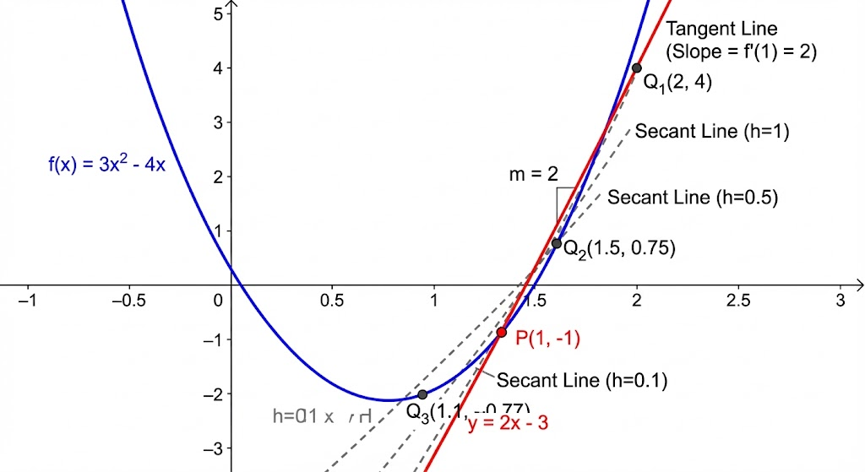
Figure 1: Visualizing the derivative as a tangent line.

Partial Derivatives
The partial derivative with respect to the i-th variable is defined as:
∂f = lim f (x₁, ..., x_{i} + h, ..., x_{n}) − f (x₁, ..., x_{i}, ..., x_{n})
∂x_{i} h→0 h

The Gradient Vector
The gradient of f , denoted ∇_{x}f (x), is the vector containing all partial derivatives:

∇_{x}f (x) =

Example: For f (x, y) = x² + 3xy + y²:
∂f
∂x₁

∂f
,
∂x₂
∂f ^{T}
, ...,

∂x_{n}

^{∂f} = 2x + 3y
•
∂x
^{∂f} = 3x + 2y
•
∂y
- ∇f = [2x + 3y, 3x + 2y]^{T}
The gradient has a crucial geometric property: it points in the direction of steepest ascent of the function. To minimize a loss function, we move in the opposite direction (−∇f ). This is the foundation of **Gradient Descent**.

The Chain Rule: Backpropagation’s Core
The chain rule is fundamental because neural networks are compositions of many functions (layers).

Single Variable Chain Rule
If y = f (u) and u = g(x), then:

dy dy du
= ·
dx du dx

Multivariate Chain Rule
For multivariate functions, if z = f (y) where y = g(x), then:
∇_{x}z = ∇_{y}z · ∇_{x}y
Example: Let z = f (y) = y² and y = g(x) = 3x + 1.
    - dz = 2y
dy
    - ^{dy} = 3
dx
    - dz = ^{dz} · ^{dy} = 2y · 3 = 6y = 6(3x + 1)
dx dy dx
In matrix form, for z = f (y) where y = Ax + b (a linear layer):
∇_{x}z = A^{T}∇_{y}z
This matrix-vector multiplication is the computational foundation of backpropagation in neural networks. The error signal (∇_{y}z) is propagated backwards through the linear transformation A.

Automatic Differentiation (Autograd)
Deep learning frameworks like PyTorch do not require us to manually derive these gradients. They use Automatic Differentiation (Autograd).

Computational Graphs
Autograd builds a **computational graph** (specifically, a Directed Acyclic Graph or DAG) as we perform operations.
    - **Nodes**: Operations (add, multiply, ReLU, etc.)
    - **Edges**: Tensors flowing between operations
When we compute the forward pass (calculating the loss), the graph is built dynamically. When we call ‘.backward()‘, the framework traverses this graph in reverse order to compute gradients using the chain rule.

Forward vs. Reverse Mode
There are two main modes of automatic differentiation:
- **Forward Mode**: Computes derivatives alongside the forward pass. Efficient when in- put dimension < output dimension.
- **Reverse Mode (Backpropagation)**: Computes the output first, then propagates deriva- tives backward. Efficient when input dimension (parameters) output dimension (scalar loss).
Deep learning almost exclusively uses **Reverse Mode** because we typically have millions of parameters but a single scalar loss value.

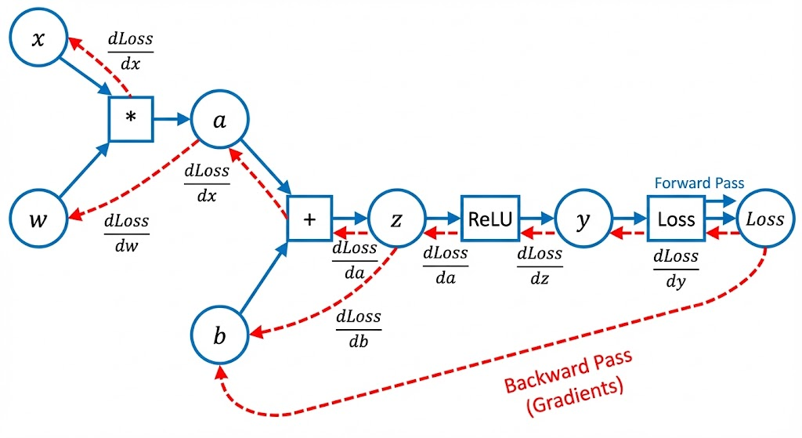
Figure 2: Computational Graph for Automatic Differentiation.

Autograd in Practice

1
import torch

x = torch.tensor(2.0, requires_grad=True) y = 3 * x**2 - 4 * x

# Compute gradients (Reverse Mode AD) y.backward()

print(f"f(2) = {y.item()}")
print(f"f'(2) = {x.grad.item()}") # Should be 6(2) - 4 = 8
2
3
4
5
6
7
8
9
10

This capability allows us to focus on designing models rather than solving differential equa- tions.

Advanced Calculus Concepts

The Jacobian Matrix
When dealing with vector-valued functions f : R^{n} → R^{m}, the derivative is the **Jacobian ma- trix** J ∈ R^{m×n}:

Jij
∂f_{i}
=
∂x_{j}

This matrix contains all partial derivatives of all outputs with respect to all inputs. In deep learning, we rarely compute the full Jacobian explicitly due to its size. Instead, we compute
**Vector-Jacobian Products (VJP)**, which corresponds to the chain rule step ∇_{x}L = J^{T} ∇_{y}L.

Hessian Matrix and Second-Order Optimization
The **Hessian matrix** H contains all second-order partial derivatives:
∂²f
Hij = ∂x ∂x
i j
The Hessian provides information about the curvature of the loss landscape.
    - **Positive Definite Hessian**: Local minimum (bowl shape).
    - **Negative Definite Hessian**: Local maximum (hill shape).
    - **Indefinite Hessian**: Saddle point.
Standard Gradient Descent uses only first-order information (gradient). **Second-order methods** (like Newton’s Method) use the Hessian to take smarter steps, but computing the Hessian for large neural networks is computationally prohibitive.

Numerical Stability
Calculus in deep learning is performed using floating-point arithmetic, which is subject to pre- cision errors.
    - Vanishing Gradients: In deep networks, multiplying many small derivatives (e.g., from sigmoid activations) can cause the gradient to shrink to zero, stopping learning.
    - Exploding Gradients: Multiplying many large derivatives can cause gradients to grow uncontrollably, causing instability.
Techniques like Gradient Clipping, Batch Normalization, and residual connections (ResNets) are designed to mitigate these calculus-based issues.

Automatic Differentiation: The Engine of Deep Learning

Computational Foundations
While manual differentiation works for simple functions, deep learning models involve com- plex composite functions with millions of parameters. Computing gradients by hand becomes impractical and error-prone. Automatic differentiation (autograd) solves this problem by algo- rithmically computing exact derivatives through computational graphs.
The core idea is straightforward: any computation can be represented as a directed graph where nodes represent operations and edges represent data flow. For example, the function f (x) = 2x² can be decomposed into:
- u = x²
- v = 2u
Automatic differentiation applies the chain rule systematically through this graph. Two pri- mary modes exist:
  - Forward mode: Computes derivatives alongside the forward pass. Efficient when input dimension < output dimension.
  - Reverse mode (backpropagation): Computes derivatives in reverse order. Efficient for functions with many inputs and single output (common in deep learning).
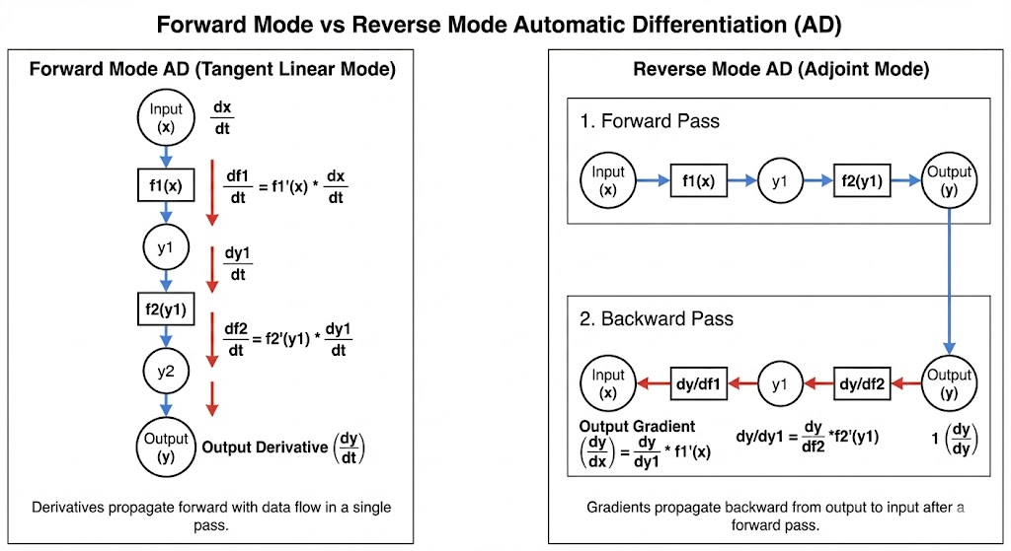
Forward vs. Reverse Mode Automatic Differentiation.

Implementation in Practice
Modern deep learning frameworks implement reverse-mode automatic differentiation. When we define a computation, the framework builds a dynamic computational graph tracking oper- ations. During the backward pass, it computes gradients by traversing this graph in reverse.
Key terminology:
- Leaf nodes: Input variables (typically model parameters).
- Root node: Final output (typically loss function).
- Gradient flow: Direction of derivative propagation from root to leaves.

A Simple Example
Consider y = 2x² where x = [0, 1, 2, 3]:
1
import torch

x = torch.arange(4.0, requires_grad=True)
y = 2 * torch.dot(x, x) # y = 2x_1^2 + 2x_2^2 + ... + 2x_n^2 y.backward()
print(x.grad) # [0., 4., 8., 12.]
2
3
4
5
6

The analytical solution gives ^{∂y}
∂x
i

= 4x_{i}, matching our computed gradients. This demon-

strates how autograd handles vector-valued inputs correctly.

Non-Scalar Variables
When the output is non-scalar (e.g., vector-valued loss functions), we need to specify how to combine gradients. The common approach is to sum individual gradients:
1
x.grad.zero_()
y = x * x # Vector output
y.sum().backward() # Equivalent to y.backward(gradient=torch.ones_like(y))
2
3
This computes ∇_{x} Σ y_{i} rather than the full Jacobian matrix, which would be computationally
i
expensive for high-dimensional outputs.

Advanced Autograd Concepts

Detaching Computation
Sometimes we need to exclude certain computations from gradient tracking. This is crucial when:
    - Implementing custom gradient formulas
    - Stopping gradient flow through specific operations
    - Creating auxiliary variables that shouldn’t affect optimization

1
x.grad.zero_() y = x * x
u = y.detach() # Break gradient flow z = u * x # dz/dx = u, not 3x^2 z.sum().backward()
2
3
4
5

Here, detach() creates a new tensor with the same values but no computational history.
The gradient ∂z = u rather than the full derivative ^{∂(x}3) = 3x².
∂x ∂x

Control Flow Operations
A powerful feature of modern autograd systems is their ability to handle arbitrary control flow:
1
def f(a):
b = a * 2
while b.norm() < 1000: b = b * 2
return b if b.sum() > 0 else 100 * b
2
3
4
5

Even with dynamic loops and conditionals, the computational graph is built at runtime based on actual execution paths. This enables:

    - Variable-length sequence processing
    - Dynamic neural architectures
    - Custom loss functions with complex logic
The gradient computation respects the actual execution path taken during the forward pass, making these systems remarkably flexible for research and production use cases.

Theoretical Significance
Automatic differentiation provides the mathematical backbone for training deep neural net- works through gradient-based optimization. By efficiently computing exact gradients of com- plex composite functions, it enables:
- Training models with millions of parameters
- Implementing sophisticated optimization algorithms
- Building custom architectures without manual derivative calculations
This automation has been instrumental in the rapid advancement of deep learning, allowing researchers and practitioners to focus on model design rather than mathematical implemen- tation details. The combination of automatic differentiation with GPU acceleration creates the foundation for modern deep learning systems.

Best Practices and Pitfalls

In-Place Operations
In-place operations (like x += y) can break the computational graph because they modify data needed for gradient computation. PyTorch will raise an error if an in-place operation invalidates required history.

Gradient Accumulation
By default, .backward() accumulates gradients in the .grad attribute. This is useful for RNNs but requires manually zeroing gradients (optimizer.zero_grad()) before each training step to avoid summing gradients from previous batches.
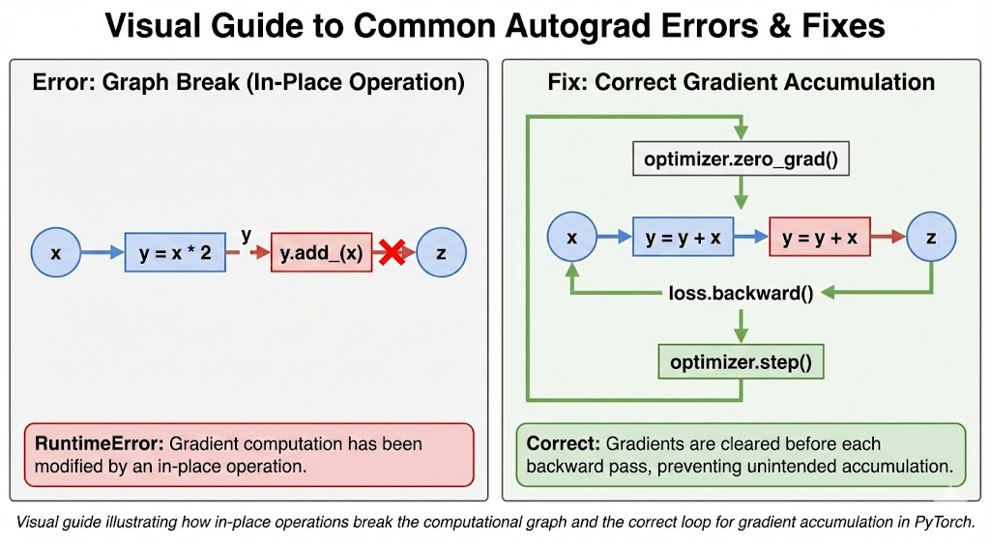
Common Autograd Pitfalls.

Comprehensive Probability and Statistics for Deep Learn- ing

The Foundation of Uncertainty in Machine Learning
Probability and statistics form the mathematical backbone of machine learning. While linear al- gebra provides the language for representing data and calculus gives us tools for optimization, probability theory enables us to reason about uncertainty—a fundamental aspect of real-world data and predictions. In deep learning, we rarely deal with deterministic relationships; instead, we work with noisy measurements, incomplete information, and stochastic processes. Under- standing probability allows us to build models that not only make predictions but also quantify their confidence.
This section develops a comprehensive understanding of probability and statistics, starting with intuitive examples and progressing to the formal mathematical framework that underpins modern machine learning algorithms. We’ll explore both theoretical foundations and practical applications, ensuring you can not only perform calculations but also interpret their meaning in real-world contexts.

Coin Toss: Our First Probabilistic Model
Let’s begin with the simplest probabilistic experiment: a coin toss. This deceptively simple ex- ample contains all the fundamental concepts we’ll need for more complex scenarios.
Consider an experiment where we toss a coin n times:
    - Heads count: h
    - Tails count: t
For a fair coin, the theoretical probability of heads is p = 0.5. However, in practice, we esti- mate probabilities from observed data using empirical frequencies:

h pˆheads = n,
t pˆtails = n

Key property: These empirical frequencies always sum to 1:
pˆheads + pˆtails = 1

This reflects the fundamental rule that probabilities of all possible outcomes must sum to 1.
1
import torch import numpy as np
import matplotlib.pyplot as plt

# Simulate coin tosses
def simulate_coin_tosses(n_tosses, seed=42): torch.manual_seed(seed)
# Generate random numbers in [0, 1) random_values = torch.rand(n_tosses) # Count heads (values < 0.5)
heads = (random_values < 0.5).sum().item() tails = n_tosses - heads
return heads, tails

# Run simulations with increasing number of tosses n_tosses_list = [10, 50, 100, 500, 1000, 5000, 10000]
results = []
2
3
4
5
6
7
8
9
10
11
12
13
14
15
16
17

18
for n in n_tosses_list:
h, t = simulate_coin_tosses(n) p_hat_heads = h / n p_hat_tails = t / n
results.append((n, h, t, p_hat_heads, p_hat_tails))
print(f"n = {n:5d}, heads = {h:5d}, tails = {t:5d}, p_hat_heads = {p_hat_heads:.4f}")
19
20
21
22
23
Mathematical Insight: The uniform random number generator used in the simulation pro- duces values in the interval [0, 1). For any subinterval [a, b) within [0, 1), the probability of landing in that interval is b a. This property ensures that when we simulate a fair coin (threshold at 0.5), exactly half the interval [0, 0.5) corresponds to heads and half [0.5, 1) to tails.
—
Law of Large Numbers: Estimates converge as n√→ ∞. Central Limit Theorem: The error
in our empirical estimate decreases at a rate of 1/ n. This means that to reduce the error
by a factor of 10, we need 100 times more samples—a crucial consideration when designing experiments or evaluating model performance.

A More Formal Treatment

Sample Spaces and Events
The coin toss example introduces us to several key concepts in probability theory, but we need a more formal framework to handle complex scenarios.
Sample Space (Ω): The set of all possible outcomes of an experiment.
    - Coin toss: Ω = {H, T }
    - Die roll: Ω = {1, 2, 3, 4, 5, 6}
    - Two coin tosses: Ω = {(H, H), (H, T ), (T, H), (T, T )}
Event: A subset of the sample space representing a specific outcome or collection of out- comes.
    - First coin heads in two tosses: A = {(H, H), (H, T )}
    - Die equals 1: B = {1}
    - Die shows odd number: C = {1, 3, 5}

Probability Axioms
The mathematical foundation of probability rests on three fundamental axioms established by Andrey Kolmogorov:
- Non-negativity: For any event A, P (A) ≥ 0.
- Normalization: The probability of the entire sample space is 1: P (Ω) = 1.
- Countable Additivity: For mutually exclusive events A_{i} (where A_{i} ∩ A_{j} = ∅ for i /= j):
Σ
P (∪_{i}A_{i}) = P (A_{i})
i

From these, we can derive many important properties:
  - Complement Rule: P (A) + P (A^{c}) = 1

  - Empty Set: P (∅) = 0
  - Disjoint Events: P (A ∩ A^{c}) = 0
1
# Define sample spaces and events coin_toss = ['H', 'T']
two_coin_toss = [('H','H'), ('H','T'), ('T','H'), ('T','T')]
die_roll = [1, 2, 3, 4, 5, 6]

# Define events
first_coin_heads = [('H','H'), ('H','T')] die_equals_1 = [1]
die_odd = [1, 3, 5]

# Calculate probabilities assuming uniform distribution P_first_coin_heads = len(first_coin_heads) / len(two_coin_toss) P_die_equals_1 = len(die_equals_1) / len(die_roll)
P_die_odd = len(die_odd) / len(die_roll)

print(f"Probability first coin is heads: {P_first_coin_heads:.4f}") print(f"Probability die equals 1: {P_die_equals_1:.4f}") print(f"Probability die is odd: {P_die_odd:.4f}")
2
3
4
5
6
7
8
9
10
11
12
13
14
15
16
17
18

Random Variables

From Events to Numbers
While events help us describe outcomes, machine learning algorithms work with numerical values. Random variables bridge this gap by assigning numbers to outcomes in a sample space. Random Variable (X): A function that maps outcomes from the sample space to real num-
bers.
    - Random variable value event: P (X = x)
    - Range event: P (a ≤ X ≤ b)

Discrete vs. Continuous Random Variables
    - Discrete Random Variables: Take values from a countable set (like integers). Example: Binomial distribution (coin tosses).
    - Continuous Random Variables: Take values from an uncountable set (like real numbers). For continuous random variables, we use probability density functions (PDFs). The prob- ability of X falling within an interval [a, b] is:

P (a ≤ X ≤ b) =
b
f (x)dx
∫
a

1
# Discrete random variable: Binomial distribution (coin tosses) def binomial_pmf(k, n, p):
"""Probability mass function for binomial distribution""" from math import comb
return comb(n, k) * (p ** k) * ((1 - p) ** (n - k))

# Continuous random variable: Normal distribution def normal_pdf(x, mu=0, sigma=1):
"""Probability density function for normal distribution"""
return (1 / (sigma * np.sqrt(2 * np.pi))) * np.exp(-0.5 * ((x - mu) / sigma) ** 2)
2
3
4
5
6
7
8
9
10

Multiple Random Variables

Joint Probability
When working with multiple random variables, we need to consider their joint behavior.
P (X = x, Y = y)

Marginalization
Often, we know the joint distribution but need the distribution of a single variable. This is achieved through marginalization:
Σ
P (X = x) = P (X = x, Y = y)
y

Conditional Probability
Conditional probability represents how the probability of one event changes when we know another event has occurred:

P (X = x|Y = y) =
P (X = x, Y = y) P (Y = y)

Bayes’ Theorem
Bayes’ theorem is perhaps the most important result in probability theory for machine learning.
P (X Y ) = P (Y |X)P (X)
|
P (Y )
Or in simplified form:
P (X|Y ) ∝ P (Y |X)P (X)

The HIV Test Example
Let’s apply Bayes’ Theorem to a classic diagnostic problem.
    - Prior probability of having HIV: P (H = 1) = 0.001
    - True positive rate (Sensitivity): P (D = 1|H = 1) = 0.99
    - False positive rate: P (D = 1|H = 0) = 0.01
We want to find P (H = 1|D = 1). First, calculate evidence P (D = 1):
P (D = 1) = P (D = 1|H = 1)P (H = 1) + P (D = 1|H = 0)P (H = 0)

P (D = 1) = 0.99 · 0.001 + 0.01 · 0.999 = 0.01098

Now, calculate posterior:

P (H = 1 D = 1) = 0.99 · 0.001 0.09
| ≈
0.01098

Even with a 99% accurate test, a positive result only implies a 9% chance of disease because the prior probability was so low.

Expectations and Variances

Expectation
Discrete:
Σ

Continuous:
E[X] = xP (X = x)
x
E[X] = ∫ xf (x)dx

Variance
Variance measures the spread of data around the mean.
Var(X) = E[(X − E[X])²] = E[X²] − (E[X])²

Covariance Matrix
For vector-valued random variables, the covariance matrix Σ captures the relationship between elements:
# Discrete random variable expectation
def expected_value_discrete(values, probabilities):
return sum(v * p for v, p in zip(values, probabilities))

# Fair six-sided die die_values = [1, 2, 3, 4, 5, 6] die_probabilities = [1/6] * 6
expected_die = expected_value_discrete(die_values, die_probabilities) print(f"Expected value of fair die: {expected_die:.4f}")
 | Σ = E[(X − E[X])(X − E[X | ])^{T}]
1
2
3
4
5
6
7
8
9
6 | Information Theory in Deep Learning

Information theory provides powerful tools for understanding neural networks.

Entropy
Entropy H(P ) measures the uncertainty of a probability distribution.
Σ
H(P ) = − P (x) log₂ P (x)
x
    - High Entropy: Uniform distribution (maximum uncertainty).
    - Low Entropy: Peaked distribution (high certainty).

KL Divergence
Kullback-Leibler Divergence measures the ”distance” between two distributions P and Q.

DKL
(P Q) = P (x) log P (x)
x Q(x)
|| Σ

