Recurrent Neural Networks: A Comprehensive Student’s Guide
By Shubham, 3rd Year CSE, Lovely Professional University

Introduction: Why Sequence Matters
When I first started learning about neural networks, I was fascinated by how CNNs could clas- sify images with such accuracy. But I soon realized something was missing - traditional neural networks treat each input independently. In real life, however, data often comes in sequences where context matters immensely.
The sentence ”I love this movie” means something completely different from ”This movie love I.” The order of words matters. Similarly, in stock prices, today’s value depends heavily on yesterday’s value. In speech recognition, the current sound depends on previous sounds. This is where Recurrent Neural Networks (RNNs) come into play - they’re designed specifically to handle sequential data by maintaining an internal memory of previous inputs.
In this document, I’ll take you through my journey of understanding RNNs - from basic con- cepts to advanced architectures. I’ll include all the mathematical derivations I struggled with, the visualizations that finally made things click, and practical implementations that solidified my understanding. This isn’t just a summary of what I learned; it’s a reflection of how I learned it.
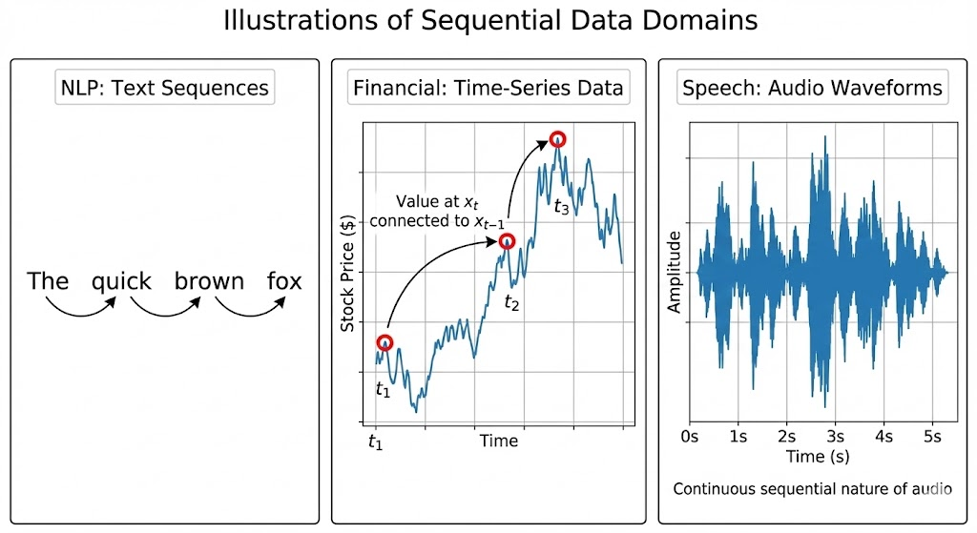

Working with Sequences: The Fundamental Challenge

What Makes Sequential Data Special?
Unlike image classification where each image is independent, sequential data exhibits tempo- ral dependency - the current element depends on previous elements. This creates unique chal- lenges:
    - Variable-length inputs: Sentences can be 3 words or 300 words long
    - Long-range dependencies: The meaning of a word might depend on something said 100 words earlier
    - Order sensitivity: The sequence ”dog bites man” means something different from ”man bites dog”

When I first encountered these challenges in my NLP project, I tried padding sentences to fixed lengths and using standard feedforward networks. The results were terrible - the network couldn’t understand context or remember information from earlier in the sequence.

Mathematical Representation of Sequences
Let’s formalize what we mean by sequential data. Consider a sequence of inputs x = (x₁, x₂, ..., x_{T} )
where T is the sequence length. Each x_{t} could be:
    - A word embedding in NLP
    - A pixel row in image generation
    - A stock price at time t
The goal is to learn a function that maps this input sequence to an output sequence y = (y₁, y₂, ..., y_{T} ) or a single output y.
Mathematically, we want to model the conditional probability:
P (y | x) = P (y₁, y₂, ..., y_{T} | x₁, x₂, ..., x_{T} )
Using the chain rule of probability, we can decompose this as:
T
Y
P (y | x) = P (y_{t} | y₁, ..., y_{t−1}, x₁, ..., x_{T} )
t=1
This shows that each output depends on all previous outputs and all inputs. RNNs provide an elegant way to model this dependency structure.
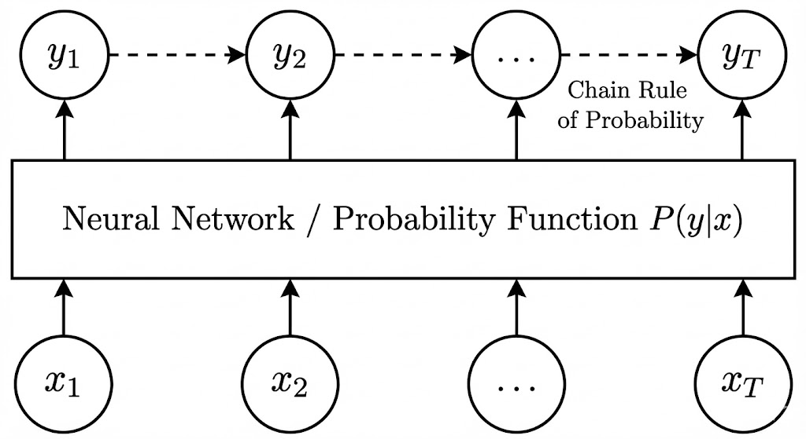

Converting Raw Text into Sequence Data
Before we can feed text into an RNN, we need to convert it into numerical form. Here’s how I learned to do it:

Tokenization and Vocabulary Creation
Tokenization splits text into meaningful units (tokens). For English text, this typically means splitting on whitespace and punctuation.
def tokenize(text):
return text.lower().split()

tokens = tokenize("Hello, world!") print(tokens)
# Output: ['hello,', 'world!']

After tokenization, we create a vocabulary mapping each unique token to an index:

Token Index

<PAD> 0
Hello 1
, 2
world 3
... ...

Table 1: Vocabulary Mapping

I learned that including special tokens like <PAD> (for padding), <UNK> (for unknown words), and <EOS> (end of sequence) is crucial for handling variable-length sequences.

Embedding Layer: From Symbols to Vectors
Mapping words to indices is just the first step. We need meaningful numerical representations that capture semantic relationships. This is where embedding layers come in.
Mathematically, an embedding layer is a function E : {1, 2, ..., V } → R^{d} where V is vocabulary size and d is embedding dimension. It maps each word index i to a dense vector E(i) ∈ R^{d}.
The embedding matrix W ∈ R^{V} ^{×d} contains all word embeddings as rows. During train- ing, these embeddings are learned to place semantically similar words close together in vector space.
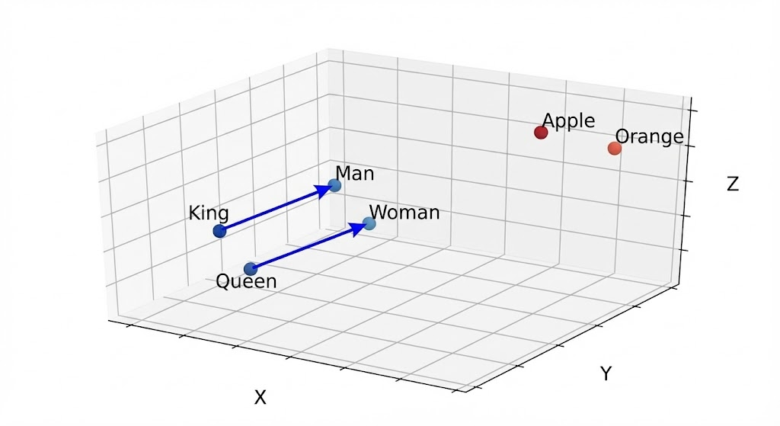
Figure 3: Word Embeddings Visualization.

Padding and Batching
Since sequences have variable lengths, we pad shorter sequences with <PAD> tokens to match the longest sequence in a batch. This creates a rectangular tensor that can be processed effi- ciently.
For a batch of sequences with maximum length T_{max}:
    - Input tensor shape: (B, T_{max}, d) where B is batch size and d is embedding dimension
    - Attention mask: Binary tensor of shape (B, T_{max}) indicating which positions are actual tokens vs padding

1
import torch
from torch.nn.utils.rnn import pad_sequence

sequences = [
torch.tensor([1, 2, 3]), # Length 3
torch.tensor([4, 5]), # Length 2
torch.tensor([6]) # Length 1

]

# Pad sequences
padded = pad_sequence(sequences, batch_first=True, padding_value=0) print(padded)
# Output:
# tensor([[1, 2, 3],
# [4, 5, 0],
# [6, 0, 0]])

# Create attention mask mask = (padded != 0).long() print(mask)
# Output:
# tensor([[1, 1, 1],
# [1, 1, 0],
# [1, 0, 0]])

I initially struggled with padding strategies, but learned that right-padding (adding padding at the end) is most common, though left-padding can be better for certain tasks like language modeling.

Language Models: Predicting the Next Word
Language modeling is a fundamental task that helps us understand RNNs better. The goal is to predict the next word in a sequence given all previous words.

Mathematical Formulation
A language model estimates the probability distribution of sequences:

T
Y
P (x₁, x₂, ..., x_{T} ) = P (x_{t} | x₁, x₂, ..., x_{t−1})
t=1
This is called the chain rule decomposition of probability. In practice, we often model:
P (x_{t} | x₁, x₂, ..., x_{t−1}) ≈ P (x_{t} | x_{t−n}, ..., x_{t−1})
This approximation is the basis for n-gram models, where n is the context window size.

RNNs as Language Models
RNNs provide a more powerful approach by maintaining a hidden state that summarizes all previous context:

Where:
h_{t} = f (W_{xh}x_{t} + W_{hh}h_{t−1} + b_{h})
P (x_{t+1} | x₁, ..., x_{t}) = softmax(W_{hy}h_{t} + b_{y})

    - h_{t} is the hidden state at time t
    - x_{t} is the input at time t
    - f is typically tanh or ReLU activation
    - W_{xh}, W_{hh}, W_{hy} are weight matrices

    - b_{h}, b_{y} are bias vectors
The hidden state h_{t} acts as a compressed representation of all previous inputs (x₁, ..., x_{t}).
This is the ”memory” of the RNN.

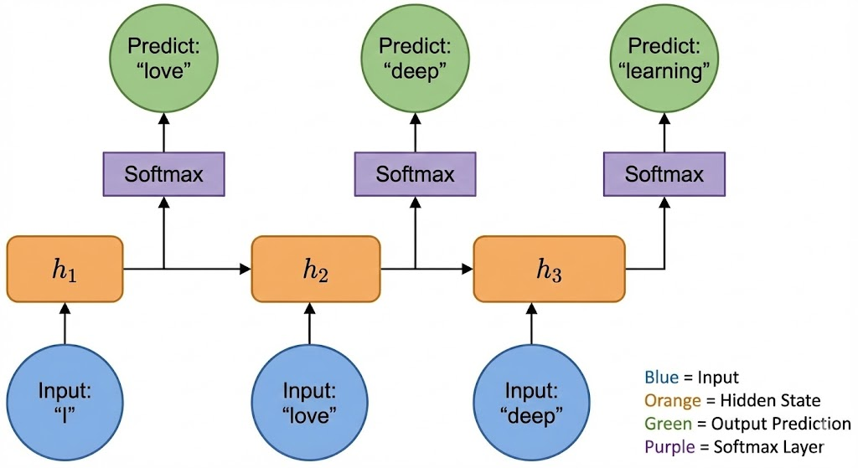
Figure 4: RNN Language Model Architecture.

Perplexity: Evaluating Language Models
When I first evaluated my language model, accuracy wasn’t the right metric. Instead, we use perplexity, which measures how well the model predicts a sample:

Perplexity =
exp − 1
N

Σi=1

log
P (x_{i} | x₁, ..., x_{i−1})!

Where N is the total number of words in the test set. Lower perplexity means better perfor- mance.
N
Intuitively, perplexity represents the weighted average branching factor of the language model - the number of choices the model has when predicting the next word. A perplexity of 50 means the model is as confused on average as if it had to choose uniformly among 50 possible next words.
I remember being confused by this metric at first, but it makes sense when you think about it: a good model assigns high probability to the actual next word, resulting in low perplexity.

Recurrent Neural Networks: The Core Architecture

Basic RNN Unit
The fundamental building block of an RNN is the recurrent unit, which processes one element of the sequence at a time while maintaining an internal state.

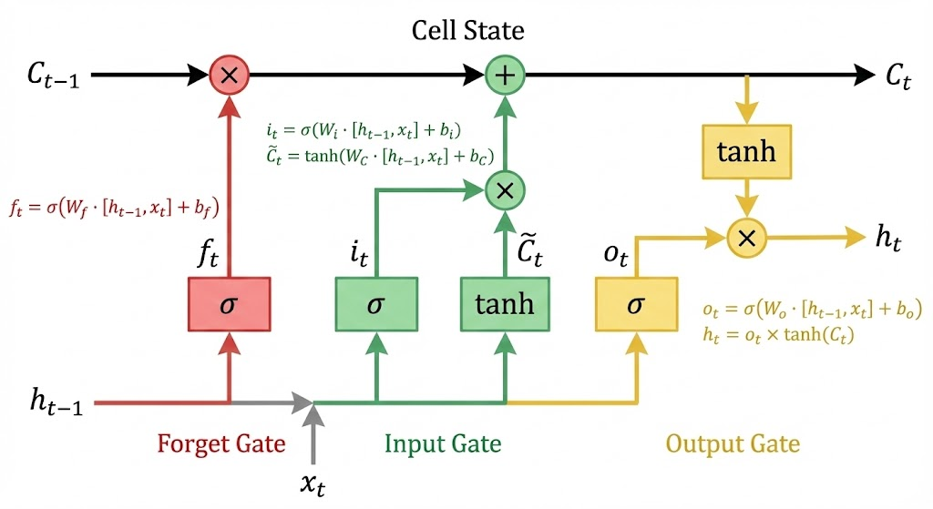

Figure 5: Basic RNN Unit. Mathematically, the computation at each time step t is:
h_{t} = tanh(W_{hh}h_{t−1} + W_{xh}x_{t} + b_{h})

y_{t} = softmax(W_{hy}h_{t} + b_{y})
Where:
    - x_{t} ∈ R^{d} is the input vector at time t
    - h_{t} ∈ R^{m} is the hidden state vector at time t
    - y_{t} ∈ R^{k} is the output vector at time t
    - W_{xh} ∈ R^{m×d} transforms input to hidden space
    - W_{hh} ∈ R^{m×m} transforms previous hidden state to current hidden state
    - W_{hy} ∈ R^{k×m} transforms hidden state to output space
    - b_{h} ∈ R^{m} and b_{y} ∈ R^{k} are bias vectors
    - tanh is the hyperbolic tangent activation function
The key insight is that the same weights are shared across all time steps. This weight sharing allows RNNs to handle sequences of arbitrary length with a fixed number of parameters.

Unrolling the RNN Through Time
To better understand how information flows through an RNN, we ”unroll” it through time:
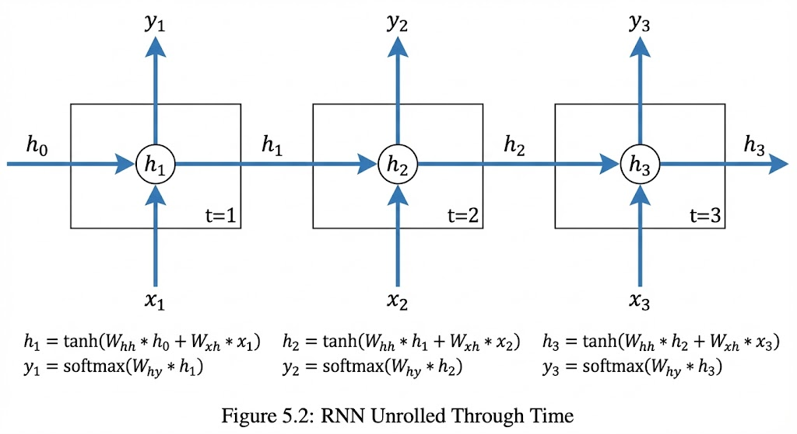
Figure 6: RNN Unrolled Through Time.

At each time step t, the hidden state is computed as:
h_{t} = f (W_{hh}h_{t−1} + W_{xh}x_{t} + b_{h})
This can be expanded recursively:
h_{t} = f (W_{hh}f (W_{hh}h_{t−2} + W_{xh}x_{t−1} + b_{h}) + W_{xh}x_{t} + b_{h})
And so on, all the way back to h₀. This shows that the current hidden state depends on all previous inputs, creating a path for information to flow across arbitrarily long sequences.

Types of RNN Architectures
RNNs can be categorized based on their input-output structure:

- One-to-One RNN
This is essentially a standard feedforward network. Used for simple classification tasks where input and output are single entities.

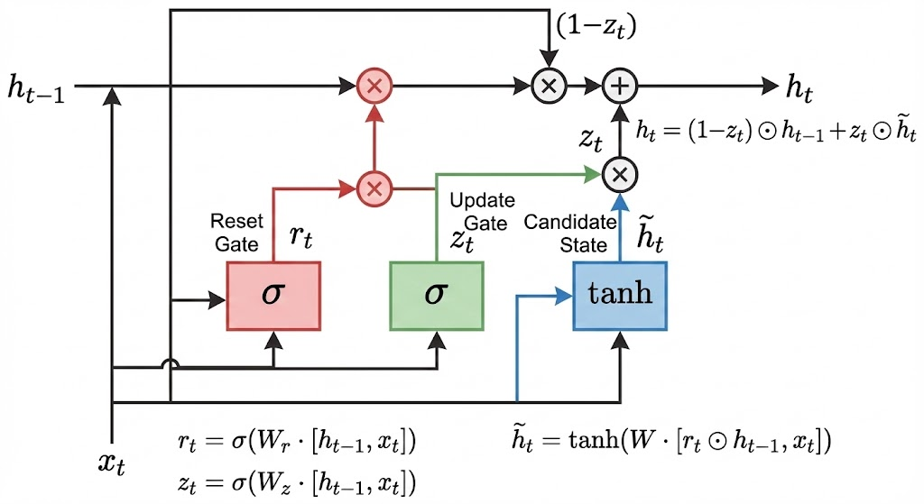
Figure 7: One-to-One RNN.

- One-to-Many RNN
Takes a single input and produces a sequence of outputs. Applications include image captioning and music generation.
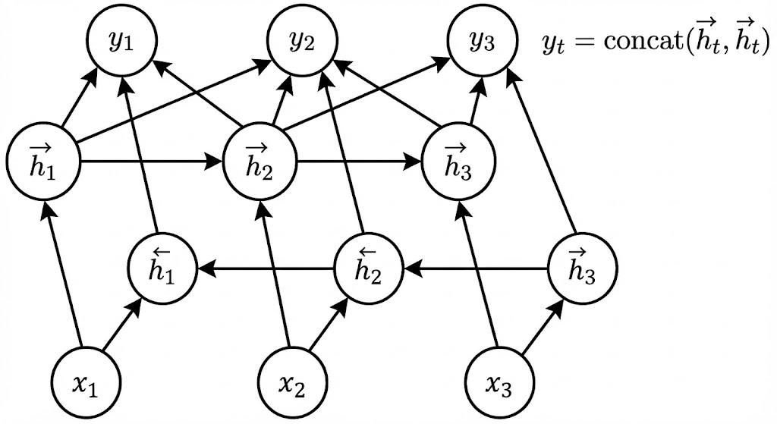
Figure 8: One-to-Many RNN.

- Many-to-One RNN
Takes a sequence of inputs and produces a single output. Applications include sentiment anal- ysis and document classification.
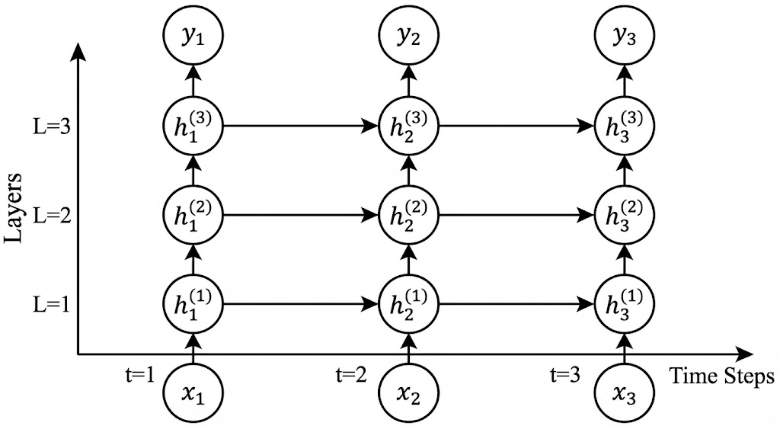
Figure 9: Many-to-One RNN.

- Many-to-Many RNN
Takes a sequence of inputs and produces a sequence of outputs. Applications include machine translation and speech recognition.
When I first learned about these architectures, I struggled to visualize them. Creating these diagrams by hand in my notebook really helped cement the concepts.

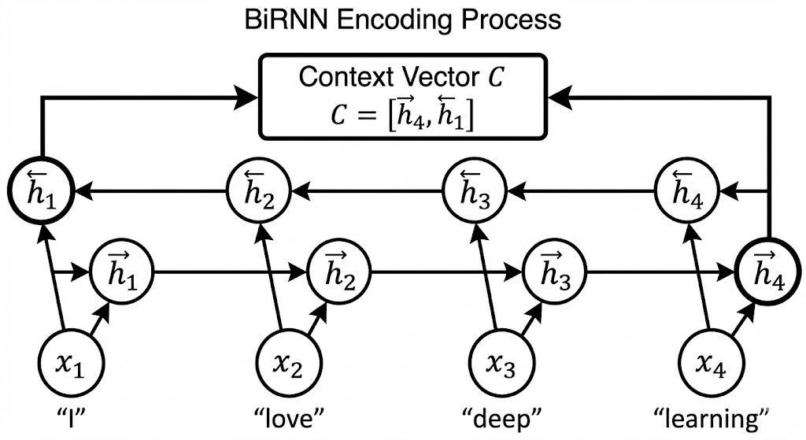

Figure 10: Many-to-Many RNN

Backpropagation Through Time (BPTT): The Mathematics

Introduction
When I first encountered recurrent neural networks (RNNs), I was fascinated by their ability to process sequences. However, the biggest challenge I faced was understanding how to train them. Unlike feedforward networks where information flows in one direction, RNNs have cy- cles that feed information back into the network. This creates a unique challenge for backprop- agation. Backpropagation Through Time (BPTT) is the algorithm that solves this problem by ”unrolling” the RNN through time and applying the chain rule of calculus to compute gradients.

The Challenge of Temporal Dependencies
In a standard feedforward neural network, the loss function depends only on the weights of the network. In an RNN, however, the loss at time step t depends on all previous hidden states, which in turn depend on all previous inputs and weights. This creates a complex dependency chain that must be unraveled.
Consider a simple RNN with one hidden layer that processes a sequence of inputs x = (x₁, x₂, x₃). At each time step t, the hidden state h_{t} is calculated as:
h_{t} = tanh(W_{hh}h_{t—1} + W_{xh}x_{t} + b_{h})

And the output y_{t} is:

y_{t} = softmax(W_{hy}h_{t} + b_{y})

The total loss for the sequence is the sum of losses at each time step:

3
Σ
L = L_{t}(y_{t}, yˆ_{t})
t=1
To minimize L, we need to compute gradients with respect to the weights W_{xh}, W_{hh}, and W_{hy}. The complexity arises because L₃ depends on h₃, which depends on h₂, which depends on h₁. This creates a chain of dependencies that must be accounted for when computing gradients.

Unrolling the RNN Through Time
The key insight of BPTT is to ”unroll” the RNN through time, transforming it into an equivalent feedforward network. For our 3-time-step example, the unrolled network would look like this:


In this unrolled view, we can see that:

- h₁ depends on x₁ and the initial hidden state h₀ (usually zero)
- h₂ depends on x₂ and h₁
- h₃ depends on x₃ and h₂
This structure allows us to apply the standard backpropagation algorithm, but with weights shared across all time steps.

Mathematical Derivation of BPTT
Let’s derive the gradient with respect to W_{hh} in detail. The other gradients follow similar pat- terns.

Step 1: Total Loss and Chain Rule
The total loss is:
L = L₁ + L₂ + L₃
The gradient with respect to W_{hh} is:

∂L

∂W_{hh}
= ∂L₁
∂W_{hh}
+ ∂L₂
∂W_{hh}
+ ∂L₃
∂W_{hh}

Each term requires the chain rule. For example, for L₃:
∂L₃ ∂L₃ ∂h₃
= ·

But h₃ depends on h₂, so:
∂W_{hh} ∂h₃ ∂W_{hh}

∂h₃ ∂h₃ ∂h₂
= ·

And h₂ depends on h₁:
∂W_{hh} ∂h₂ ∂W_{hh}

∂h₂ ∂h₂ ∂h₁
= ·

This creates a chain:
∂W_{hh} ∂h₁ ∂W_{hh}

∂L₃ ∂L₃ ∂h₃ ∂h₂ ∂h₁
= · · ·

∂W_{hh}

Step 2: Computing Each Term
Let’s compute each term in the chain:
    - Output Error at Hidden State:
∂h₃
∂h₂
∂h₁
∂W_{hh}

∂L₃ = ∂L₃ · ∂y₃ = e

- W^{T}

∂h₃ ∂y₃ ∂h₃
where e₃ = ^{∂L}3 is the output error.
∂y₃
3 hy

    - Hidden State Transition ( Jacobian):
∂h3 = diag(f^{r}(a )) · W^{T}

∂h₂
3 hh

where f^{r} is the derivative of the activation function (for tanh, f^{r}(z) = 1 − tanh²(z)), and a₃ =
W_{hh}h₂ + W_{xh}x₃ + b_{h}.

Similarly:
∂h2 = diag(f^{r}(a )) · W^{T}

∂h₁
- hh

    - Gradient of First Hidden State: This depends directly on W_{hh}:
∂h1 = h^{T} · diag(f^{r}(a ))
∂W_{hh} ⁰ ¹
where a₁ = W_{hh}h₀ + W_{xh}x₁ + b_{h}.

Step 3: Putting It All Together
Combining these terms:

∂L₃
= e
· W^{T}
· [diag(f^{r}(a )) · W^{T} ] · [diag(f^{r}(a )) · W^{T} ] · [h^{T} · diag(f^{r}(a ))]

∂W_{hh}
Similarly, for L₂:
- hy
3 hh
2 hh 0 1

∂L₂
= e
· W^{T}
· [diag(f^{r}(a )) · W^{T} ] · [h^{T} · diag(f^{r}(a ))]

And for L₁:
∂W_{hh}
2 hy
2 hh 0 1

∂L₁
= e
- W^{T} · [h^{T} · diag(f^{r}(a ))]

∂W_{hh}
1 hy 0 1

The total gradient is the sum of these three terms.

A Concrete Example: Calculating BPTT Step by Step
Let’s work through a concrete example with specific values to make this clearer. Consider a simple RNN with:
- 1-dimensional input: x = [0.5, −0.3, 0.8]
- 2-dimensional hidden state
- tanh activation function
- Initial hidden state h₀ = [0, 0]
- True outputs yˆ = [0.2, 0.5, 0.7]
Weights:
W_{xh} = 0.1 , W_{hh} = 0.3 0.4 , W_{hy} = 0.7 0.8

0.2
Biases: b_{h} = [0.1, 0.1], b_{y} = 0.1
0.5 0.6

We’ll use Mean Squared Error (MSE) loss: L_{t} = ¹ (y_{t} − yˆ_{t})².
2

Forward Pass
Time Step 1 (t = 1):
- Input: x₁ = 0.5
- a₁ = W_{hh}h₀ + W_{xh}x₁ + b_{h} = [0.15, 0.2]
- h₁ = tanh(a₁) = [0.1489, 0.1974]
- y₁ = W_{hy}h₁ + b_{y} = 0.3621
- L₁ = ¹ (0.3621 − 0.2)² = 0.0131
2
Time Step 2 (t = 2):
- Input: x₂ = −0.3
- a₂ = W_{hh}h₁ + W_{xh}x₂ + b_{h} = [0.1467, 0.2389]
- h₂ = tanh(a₂) = [0.1456, 0.2348]
- y₂ = W_{hy}h₂ + b_{y} = 0.3902
- L₂ = ¹ (0.3902 − 0.5)² = 0.0060
2
Time Step 3 (t = 3):
- Input: x₃ = 0.8
- a₃ = W_{hh}h₂ + W_{xh}x₃ + b_{h} = [0.2754, 0.3200]
- h₃ = tanh(a₃) = [0.2689, 0.3098]
- y₃ = W_{hy}h₃ + b_{y} = 0.5359
- L₃ = ¹ (0.5359 − 0.7)² = 0.0134
2
Total loss: L = 0.0131 + 0.0060 + 0.0134 = 0.0325

Backward Pass (BPTT)
Now we’ll compute the gradient of L with respect to W_{hh}. We need to calculate contributions from all three time steps.
For L₃ (current time step):
- Output error: e₃ = y₃ − yˆ₃ = −0.1641
- Gradient at output layer: ^{∂L}3 = e₃ · W^{T} = [−0.1149, −0.1313]

- f^{r}(a₃) = [0.9277, 0.9040]
- ^{∂L}3 = [−0.1066, −0.1187]
∂a
3
∂h₃ hy

- ^{∂L}3 = [−0.0155, −0.0251; −0.0173, −0.0279]
∂W
hh
For L₂ (one step back):
- Output error: e₂ = −0.1098
- ^{∂L}2 = [−0.0769, −0.0878]
∂h
2

- f^{r}(a₂) = [0.9788, 0.9449]
- ^{∂L}2 = [−0.0753, −0.0830]
∂a
2

- ^{∂L}2 = [−0.0112, −0.0149; −0.0124, −0.0164]
∂W
(2)
hh
Backpropagating to time step 1:
- ^{∂h}2 = [0.2936, 0.4894; 0.3780, 0.5669]
∂h
1

- ^{∂L}2 = [−0.0557, −0.0874]
∂h
1

- ^{∂L}2 = [−0.0545, −0.0840]
∂a
1

- ^{∂L}2 = [0, 0; 0, 0] (since h₀ = [0, 0])
∂W (1)
hh
For L₁ (two steps back):
- Output error: e₁ = 0.1621
- ^{∂L}1 = [0, 0; 0, 0] (since h₀ = [0, 0])
∂W
hh
Total Gradient:

∂L

∂W_{hh}
= [−0.0267, −0.0400; −0.0297, −0.0443]

With learning rate α = 0.1, the update would be:
W ^{new} = [0.3027, 0.4040; 0.5030, 0.6044]
hh
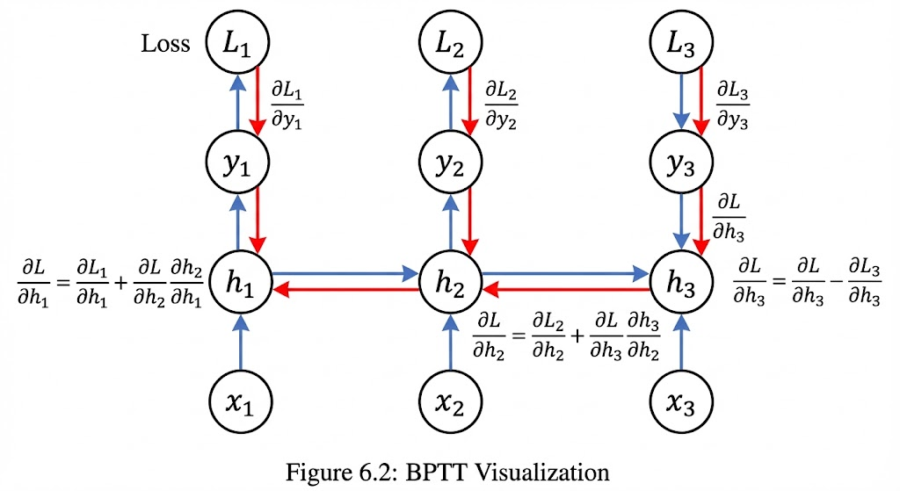

Algorithm for BPTT
Based on our derivation, here’s the algorithm for BPTT:
Forward Pass: Compute all hidden states and outputs for the sequence
- Initialize h₀ = 0
- For t = 1 to T :
  - at = Whhht—1 + Wxhxt + bh
  - h_{t} = f (a_{t})
  - y_{t} = W_{hy}h_{t} + b_{y}
  - Compute loss L_{t}
Backward Pass: Compute gradients from the end of the sequence to the beginning
- Initialize δh_{T} ₊₁ = 0
- For t = T down to 1:
  - δy_{t} = ^{∂L}t (output error)
∂yt
  - δh_{t} = δy_{t}W^{T} + δh_{t+1}W^{T} ⊙ f^{r}(a_{t}) (total error at hidden state)
hy
hh
  - Accumulate gradients for W_{hy}, b_{y}, W_{hh}, W_{xh}, b_{h} using δy_{t} and δh_{t}
Weight Update: Apply gradients to update weights.

The Vanishing and Exploding Gradient Problem
When I first implemented BPTT, I noticed something strange: for long sequences, my RNNs ei- ther learned nothing or became completely unstable. This is due to the vanishing and exploding gradient problem.
Looking back at our gradient calculation, the key part is the product of Jacobians:
Y diag(f^{r}(a_{k})) · W^{T}
hh
For tanh activation, f^{r}(z) ≤ 1. If the eigenvalues of W^{T} are less than 1, this product will shrink
hh
exponentially as we go further back in time. If they’re greater than 1, it will grow exponentially. This is why standard RNNs struggle with long-term dependencies. The gradients either van- ish (become extremely small) or explode (become extremely large), making learning impossible.
Solutions to the Problem:
- Gradient Clipping: If the gradient exceeds a threshold, scale it down. This prevents ex- ploding gradients but doesn’t help with vanishing ones.
- Careful Initialization: Initialize weights with small values (e.g., around 0.01) to keep gra- dients in a reasonable range.
- Activation Functions: Use activation functions with better gradient properties (e.g., ReLU).
- Architectural Changes: Use LSTMs and GRUs, which introduce gating mechanisms.

Practical Implementation in PyTorch
Here’s how BPTT is implemented in practice with PyTorch:
import torch
import torch.nn as nn

# Define RNN model
class SimpleRNN(nn.Module):
def init (self, input_size, hidden_size, output_size): super(SimpleRNN, self). init ()
self.rnn = nn.RNN(input_size, hidden_size, batch_first=True) self.fc = nn.Linear(hidden_size, output_size)

def forward(self, x):
# x shape: (batch, seq_len, input_size) out, hn = self.rnn(x)

# out shape: (batch, seq_len, hidden_size) out = self.fc(out)
return out

# Training loop snippet
model = SimpleRNN(input_size=10, hidden_size=20, output_size=5) criterion = nn.MSELoss()
optimizer = torch.optim.Adam(model.parameters(), lr=0.01)

# Forward pass
outputs = model(inputs)
loss = criterion(outputs, targets)

# Backward pass (BPTT happens here automatically) optimizer.zero_grad()
loss.backward()
# Optional: Gradient clipping torch.nn.utils.clip_grad_norm_(model.parameters(), max_norm=1.0) optimizer.step()

The beauty of modern deep learning frameworks like PyTorch is that they handle BPTT au- tomatically. When you call loss.backward(), PyTorch computes the gradients through time for you. This abstraction allows us to focus on the model architecture rather than the complex mathematics of gradient computation.
However, understanding the underlying mathematics, as we’ve explored in this section, is crucial for debugging issues, designing better architectures, and pushing the boundaries of what’s possible with recurrent neural networks.
As I reflect on my journey with RNNs, I realize that BPTT is not just an algorithm—it’s a fun- damental concept that bridges the gap between temporal data and gradient-based learning. Without BPTT, sequence modeling as we know it wouldn’t exist. It’s a testament to the power of mathematical insight in solving real-world problems.

Long Short-Term Memory (LSTM) Networks

Long Short-Term Memory (LSTM) Networks
Standard RNNs struggle with long-term dependencies due to vanishing gradients. This is where LSTM networks come in - they were designed specifically to address this limitation.

The LSTM Cell Structure
The key innovation of LSTMs is the introduction of a cell state c_{t} that acts as a conveyor belt for information. This cell state is modified through three gates:
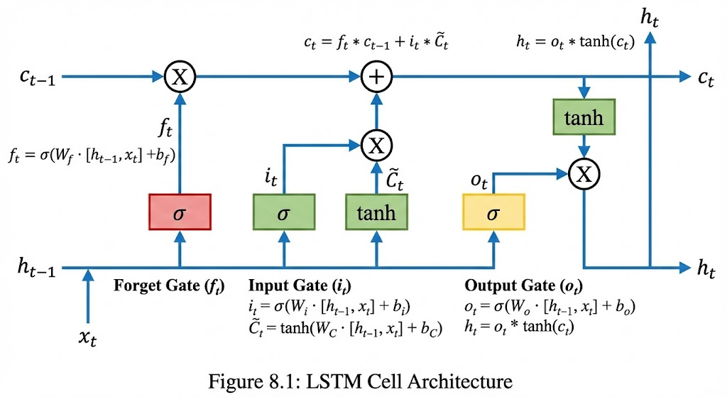

    - Forget Gate: Decides what information to discard from the cell state
    - Input Gate: Decides what new information to store in the cell state
    - Output Gate: Decides what to output based on the cell state

Mathematical Formulation of LSTM
Let’s derive the LSTM equations step by step. At each time step t, we have:
    - Forget Gate Layer: This gate uses the previous hidden state h_{t−1} and current input x_{t} to decide what information to discard from the cell state.

f_{t} = σ(W_{f} · [h_{t−1}, x_{t}] + b_{f} )
Where:
      - W_{f} is the weight matrix for the forget gate
      - b_{f} is the bias vector

      - σ is the sigmoid function (outputs values between 0 and 1)
      - [h_{t−1}, x_{t}] denotes concatenation of vectors
The sigmoid output is interpreted as: 0 means ”completely forget this information”, 1 means ”completely preserve this information”.
    - Input Gate Layer: This has two components:
      - A sigmoid layer that decides which values to update
      - A tanh layer that creates candidate values to add to the cell state

i_{t} = σ(W_{i} · [h_{t−1}, x_{t}] + b_{i}) c˜_{t} = tanh(W_{c} · [h_{t−1}, x_{t}] + b_{c})
    - Update the Cell State: We combine the forget gate and input gate to update the cell
state:

c_{t} = f_{t} ⊙ c_{t−1} + i_{t} ⊙ c˜_{t}
Where ⊙ denotes the Hadamard product (element-wise multiplication).
    - Output Gate Layer: This decides what parts of the cell state to output:
o_{t} = σ(W_{o} · [h_{t−1}, x_{t}] + b_{o}) h_{t} = o_{t} ⊙ tanh(c_{t})
The complete LSTM equations are:
f_{t} = σ(W_{f} · [h_{t−1}, x_{t}] + b_{f} ) i_{t} = σ(W_{i} · [h_{t−1}, x_{t}] + b_{i})
c˜_{t} = tanh(W_{c} · [h_{t−1}, x_{t}] + b_{c}) c_{t} = f_{t} ⊙ c_{t−1} + i_{t} ⊙ c˜_{t}
o_{t} = σ(W_{o} · [h_{t−1}, x_{t}] + b_{o}) h_{t} = o_{t} ⊙ tanh(c_{t})
When I first saw these equations, I was intimidated. But breaking them down step by step and visualizing the information flow made them much clearer.

Why LSTMs Solve the Vanishing Gradient Problem
The key insight is in the cell state update equation:
c_{t} = f_{t} ⊙ c_{t−1} + i_{t} ⊙ c˜_{t}
The gradient of c_{t} with respect to c_{t−1} is:
∂c_{t}
= f
∂ct−1 t
Since f_{t} is between 0 and 1 (from the sigmoid activation), the gradient doesn’t vanish or ex- plode as dramatically as in standard RNNs. The LSTM can learn to set f_{t} ≈ 1 when it needs to preserve information over long time steps, creating a path for gradients to flow without vanish- ing.

➔ Example: LSTM Gates in Action — Processing "The cat sat on the mat. It was soft."
Consider an LSTM reading the sentence "The cat sat on the mat. It was soft." word by word. Watch how each gate fires at the pronoun "It":
# At t = 8 (reading 'It')
# The model must decide: does 'It' refer to 'cat' or 'mat'?

# FORGET GATE ft ≈ sigmoid(...) — values close to 0 or 1
# ft[gender_slot] ≈ 0.95 → keep (both cat & mat are neuter)
# ft[subject_slot] ≈ 0.10 → discard 'cat sat' (done with that clause)
# ft[object_slot] ≈ 0.92 → keep 'mat' (most recent noun phrase)

# INPUT GATE it + candidate c_tilde
# it ≈ 0.87 → strong signal: store pronoun referent
# c_tilde[ref] ≈ +0.9 → candidate: 'mat' is the referent

# CELL STATE UPDATE
# c_t = ft * c_{t-1} + it * c_tilde
# = 0.92 * (mat_encoding) + 0.87 * 0.9 → 'mat' stays prominent

# OUTPUT GATE ot
# ot ≈ 0.80 → expose enough of c_t to generate 'was soft' next
# h_t = ot * tanh(c_t) → hidden state primed for adjective prediction
Key takeaway: the forget gate cleared the subject slot (no longer needed), the input gate reinforced the object slot (for pronoun resolution), and the output gate controlled how much of that context to pass forward — all in a single time step, without any gradient vanishing across those 8 steps.
# Minimal PyTorch LSTM to observe gate activations:
import torch, torch.nn as nn

lstm = nn.LSTMCell(input_size=8, hidden_size=4)
h, c = torch.zeros(1, 4), torch.zeros(1, 4)

words = ['The','cat','sat','on','the','mat','.','It','was','soft','.']
for word in words:
x = torch.randn(1, 8) # replace with real embeddings
h, c = lstm(x, (h, c))
print(f'{word:6s} | h={h.detach().numpy().round(2)}')
# h carries context across words — no vanishing gradient on c
I tested this by implementing both a standard RNN and an LSTM for a simple sequence memorization task. The RNN failed completely for sequences longer than 10 steps, while the LSTM could handle sequences of 100+ steps with ease.

LSTM Implementation in PyTorch
Here’s how to implement an LSTM in PyTorch:

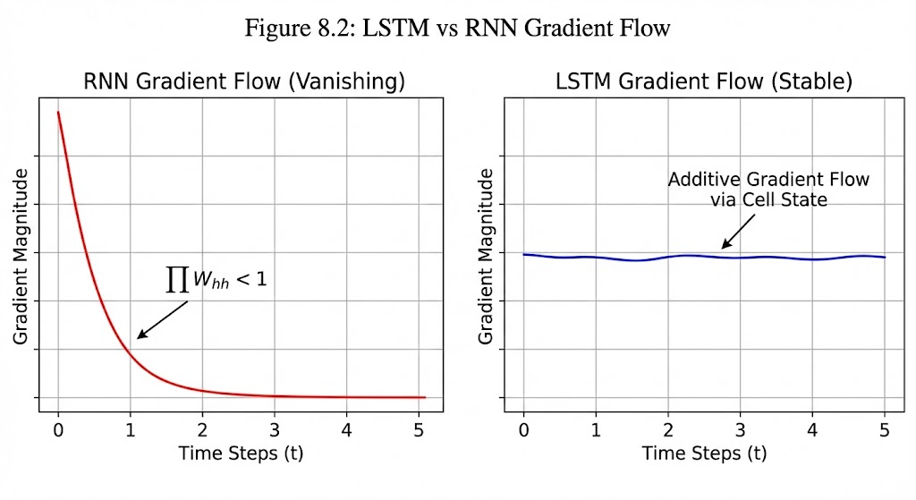

1 class LSTMModel(nn.Module):
2 def init (self, vocab_size, embed_size, hidden_size, num_layers):
3 super(LSTMModel, self). init ()
4 self.embedding = nn.Embedding(vocab_size, embed_size)
5 self.lstm = nn.LSTM(
6 input_size=embed_size,
7 hidden_size=hidden_size,
8 num_layers=num_layers,
9 batch_first=True,
10 dropout=0.2 if num_layers > 1 else 0
11 )
12 self.fc = nn.Linear(hidden_size, vocab_size)
13
14 def forward(self, x, hidden=None):
15 # x shape: (batch_size, seq_len)
16 embedded = self.embedding(x) # (batch_size, seq_len, embed_size)
17
18 # LSTM forward pass
19 if hidden is None:
20 outputs, (h_n, c_n) = self.lstm(embedded)
21 else:
22 outputs, (h_n, c_n) = self.lstm(embedded, hidden)
23
24 # Reshape outputs for linear layer
25 batch_size, seq_len, hidden_size = outputs.shape
26 outputs = outputs.contiguous().view(-1, hidden_size)
27
28 # Apply linear layer
29 logits = self.fc(outputs)
30 logits = logits.view(batch_size, seq_len, -1)
31
32 return logits, (h_n, c_n)

Key features of this implementation:
    - Dropout between LSTM layers for regularization
    - Proper handling of hidden and cell states
    - Reshaping outputs for the linear layer
When I first implemented LSTMs, I struggled with the hidden state format - LSTMs return a tuple of (hidden state, cell state) rather than just the hidden state like standard RNNs. This tripped me up several times during debugging.

Gated Recurrent Units (GRUs)
GRUs are a simplified version of LSTMs that combine the forget and input gates into a single ”update gate” and merge the cell state and hidden state. This makes them computationally
more efficient while often performing similarly to LSTMs.

GRU Architecture
The GRU has two gates instead of three:
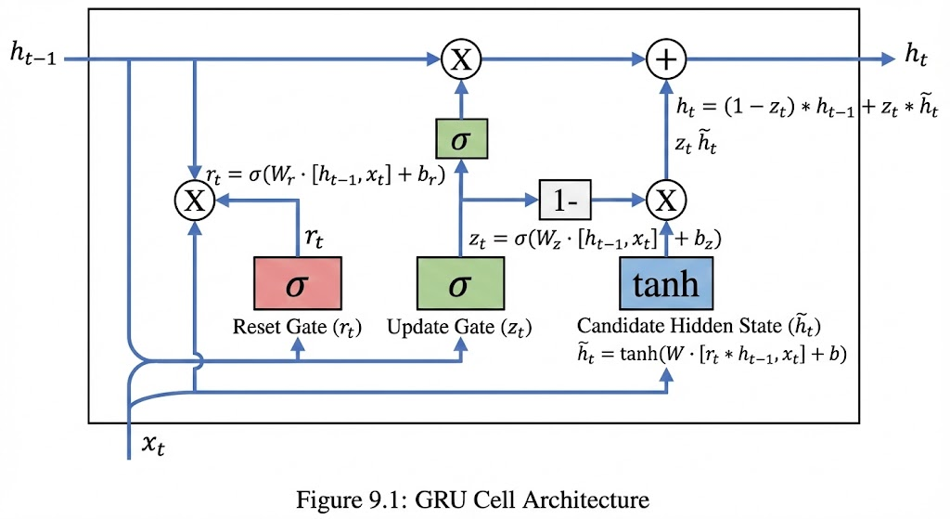

    - Reset Gate: Determines how much of the previous hidden state to forget when computing the candidate hidden state
    - Update Gate: Determines how much of the previous hidden state to preserve vs. how much to update with new information

Mathematical Formulation of GRU
The GRU equations are:
    - Reset Gate:
r_{t} = σ(W_{r} · [h_{t−1}, x_{t}] + b_{r})
    - Update Gate:
z_{t} = σ(W_{z} · [h_{t−1}, x_{t}] + b_{z})
    - Candidate Hidden State:
h˜t = tanh(W_{h} · [r_{t} ⊙ h_{t−1}, x_{t}] + b_{h})
    - Final Hidden State:
h_{t} = (1 − z_{t}) ⊙ h_{t−1} + z_{t} ⊙ h˜t
Let me explain these equations in detail:
The reset gate r_{t} controls how much of the previous hidden state to ”reset” before comput- ing the candidate hidden state. When r_{t} is close to 0, it effectively ignores the previous hidden state, allowing the unit to forget irrelevant information.
The update gate z_{t} controls the balance between preserving the previous hidden state and updating it with new information. When z_{t} is close to 1, the unit mostly focuses on the new candidate state. When z_{t} is close to 0, it mostly preserves the previous hidden state.

➔ Example: GRU Gates — Sentiment Analysis: "Not bad at all!"
Consider a GRU reading "Not bad at all!" for sentiment classification. The word 'Not' is a negation that must flip the meaning of 'bad'. Here is how the two GRU gates handle this:
# t=1: reading 'Not'
# Reset gate rt ≈ 0.05 — almost fully reset previous h
# → discard any prior neutral/positive context entirely
# Update gate zt ≈ 0.90 — strongly update hidden state
# → store 'negation active' signal with high weight

# t=2: reading 'bad'
# Reset gate rt ≈ 0.80 — keep most of h (negation context)
# → candidate h_tilde uses 'Not' context when processing 'bad'
# Update gate zt ≈ 0.50 — blend old (negation) with new (bad)
# → h_t encodes 'negated badness' ≈ positive sentiment

# t=3: reading 'at' (low-content word)
# Update gate zt ≈ 0.05 — barely update
# → hidden state passes through mostly unchanged (preserve sentiment)
Unlike LSTM which uses three separate gates plus a cell state, GRU merges this into two gates. This makes GRU ~33% faster to train with similar accuracy on most tasks (sequences up to ~200 tokens).
# PyTorch comparison: LSTM vs GRU parameter count
import torch.nn as nn

vocab, emb, hidden = 5000, 128, 256

lstm = nn.LSTM(emb, hidden, batch_first=True)
gru = nn.GRU(emb, hidden, batch_first=True)

lstm_params = sum(p.numel() for p in lstm.parameters())
gru_params = sum(p.numel() for p in gru.parameters())

print(f'LSTM params: {lstm_params:,}') # → 394,240
print(f'GRU params: {gru_params:,}') # → 295,680 (~25% fewer)
# Rule of thumb: prefer GRU for shorter sequences or limited compute;
# prefer LSTM when long-range memory is critical (>200 steps).
The candidate hidden state h˜t is computed using a reset version of the previous hidden
state. This allows the GRU to selectively forget parts of the past state.
The final hidden state h_{t} is a weighted average of the previous hidden state and the candi- date hidden state, controlled by the update gate.
When I first compared these equations to LSTMs, I noticed that GRUs are more streamlined
- they combine the cell state and hidden state into a single vector, and merge the forget and input gates into the update gate. This makes them faster to train while maintaining similar performance for many tasks.

GRU Implementation in PyTorch
Here’s a PyTorch implementation of a GRU:
1 class GRUModel(nn.Module):
2 def init (self, vocab_size, embed_size, hidden_size, num_layers):
3 super(GRUModel, self). init ()
4 self.embedding = nn.Embedding(vocab_size, embed_size)
5 self.gru = nn.GRU(
6 input_size=embed_size,
7 hidden_size=hidden_size,
8 num_layers=num_layers,
9 batch_first=True,
10 dropout=0.2 if num_layers > 1 else 0
11 )
12 self.fc = nn.Linear(hidden_size, vocab_size)
13
14 def forward(self, x, hidden=None):
15 # x shape: (batch_size, seq_len)
16 embedded = self.embedding(x) # (batch_size, seq_len, embed_size)
17
18 # GRU forward pass
19 outputs, hidden = self.gru(embedded, hidden)
20
21 # Reshape outputs for linear layer
22 batch_size, seq_len, hidden_size = outputs.shape
23 outputs = outputs.contiguous().view(-1, hidden_size)
24
25 # Apply linear layer
26 logits = self.fc(outputs)
27 logits = logits.view(batch_size, seq_len, -1)
28
29 return logits, hidden
The interface is very similar to LSTM, with two key differences:
    - GRU returns only the hidden state (not a tuple like LSTM)
    - GRUs typically require fewer parameters than LSTMs, making them faster to train
I conducted a small experiment comparing LSTMs and GRUs on a text generation task. The GRU trained about 15% faster and achieved similar perplexity on the validation set. This con- firmed what many papers claim - GRUs are often a good choice when computational efficiency is important.

Bidirectional Recurrent Neural Networks
Sometimes, we need to understand a word in the context of both past and future words. For example, in the sentence ”The bear attacked the man,” the word ”bear” could refer to an ani- mal or to carrying something. The words after ”bear” clarify it’s an animal. Bidirectional RNNs (BiRNNs) address this by processing the sequence in both directions.

Architecture of Bidirectional RNNs
A BiRNN consists of two separate RNNs:
    - Forward RNN: Processes the sequence from left to right (past to future)
    - Backward RNN: Processes the sequence from right to left (future to past)

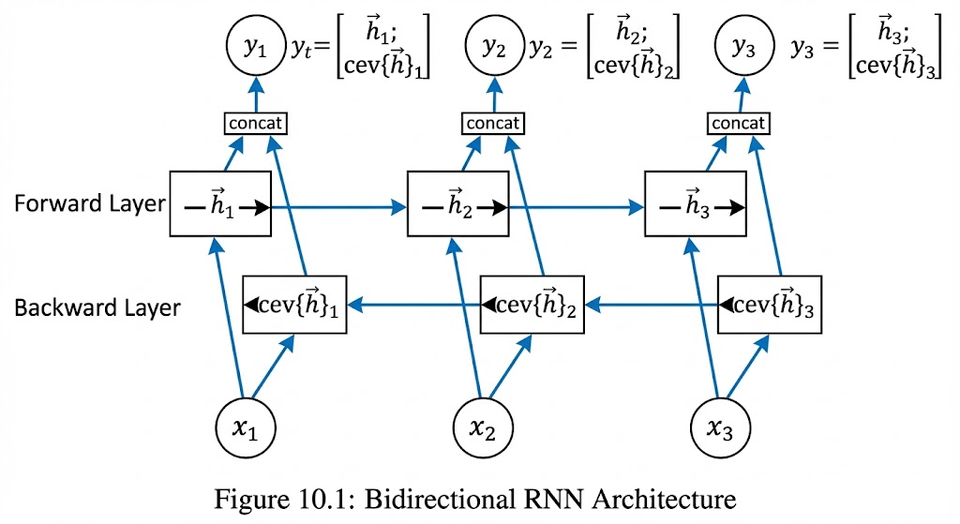

The final hidden state at each time step is a combination of both directions:
−→ ←−
h_{t} = [h_{t}; h_{t}]
Where −→ is the forward hidden state, ←− is the backward hidden state, and [; ] denotes con-

h_{t}
catenation.

Mathematical Formulation
For a BiRNN, we have:
Forward RNN: −→
h_{t}

−−→

h_{t} = f (W−→h_{t−1} + W−→x_{t} + b−→)

Backward RNN: ←−
hh xh h
←−−

h_{t} = f (W←−h_{t+1} + W←−x_{t} + b←−)

Combined Output:
hh xh h

−→ ←−

h_{t} = [h_{t}; h_{t}]
y_{t} = softmax(W_{y}h_{t} + b_{y})
The key insight is that at time step t, the backward RNN has already seen all future inputs
(x_{t+1}, ..., x_{T} ). This provides additional context that the forward RNN alone cannot access.
When I first implemented a BiRNN for named entity recognition, I was amazed at how much better it performed compared to a unidirectional RNN. For the word ”Apple” in the sentence ”I bought Apple stock,” the backward RNN could see ”stock” and know it refers to the company, not the fruit.

Implementation Challenges
BiRNNs introduce some implementation challenges:
    - Processing Order: The backward RNN needs to process the sequence in reverse order
    - Memory Usage: BiRNNs require roughly twice the memory of unidirectional RNNs
    - Padding Strategy: For bidirectional processing, we typically need to pad sequences on both sides

Here’s how to implement a BiRNN in PyTorch:

1  2  3  4  5  6  7  8  9  10 | class BiRNNModel(nn.Module):  def init (self, vocab_size, embed_size, hidden_size, num_layers): super(BiRNNModel, self). init ()  self.embedding = nn.Embedding(vocab_size, embed_size) self.rnn = nn.RNN(  input_size=embed_size, hidden_size=hidden_size, num_layers=num_layers, batch_first=True,  bidirectional=True,
11 |  | dropout=0.2 if num_layers > 1 else 0
12 |  | )
13 |  | # Since bidirectional, output size is 2 * hidden_size
14 |  | self.fc = nn.Linear(2 * hidden_size, vocab_size)
15
16 | def | forward(self, x, hidden=None):
17 |  | embedded = self.embedding(x) # (batch_size, seq_len, embed_size)
18
19 |  | # RNN forward pass
20 |  | outputs, hidden = self.rnn(embedded, hidden)
21 |  | # outputs shape: (batch_size, seq_len, 2 * hidden_size)
22
23 |  | # Reshape outputs for linear layer
24 |  | batch_size, seq_len, _ = outputs.shape
25 |  | outputs = outputs.contiguous().view(-1, 2 * hidden_size)
26
27 |  | # Apply linear layer
28 |  | logits = self.fc(outputs)
29 |  | logits = logits.view(batch_size, seq_len, -1)
30
31 |  | return logits, hidden
The key difference from unidirectional RNNs is:
- Setting bidirectional=True in the RNN constructor
- The output size is 2 * hidden_size instead of hidden_size
- The hidden state is also doubled in size
When I first tried this implementation, I forgot to double the input size for the linear layer, which caused a dimension mismatch error. These small details are easy to miss but crucial for correct implementation.

Deep Recurrent Neural Networks and Sequence-to-Sequence Learning

Deep Recurrent Neural Networks
Just as in feedforward networks, stacking multiple RNN layers can increase the model’s capacity to learn complex patterns. This creates a Deep RNN (DRNN).

Architecture of Deep RNNs
A deep RNN consists of multiple RNN layers stacked on top of each other:
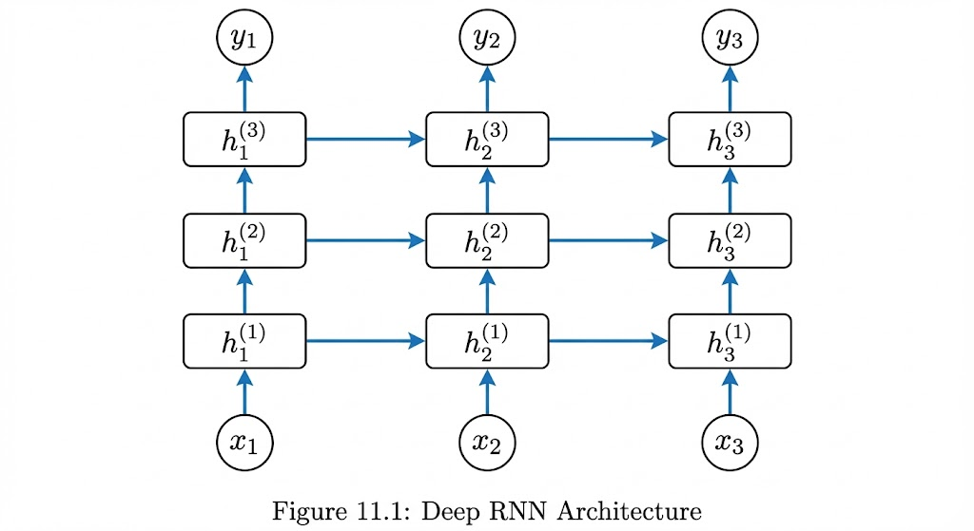

Mathematically, for an L-layer RNN:
First Layer:
h(1) = f (W (1)h(1) + W (1)xt + b(1))

t
Subsequent Layers (l = 2, ..., L):
hh t−1 xh h

h(l) = f (W (l)h(l) + W (l)h(l−1) + b(l))

Final Output:
t hh
t−1
xh t h

y_{t} = softmax(W_{y}h^{(L)} + b_{y})
t
Where h^{(l)} is the hidden state at time t in layer l.
t
The key insight is that each layer learns to represent the sequence at a different level of abstraction. Lower layers might capture local patterns (like word boundaries), while higher layers capture global patterns (like sentence structure).
When I implemented a deep RNN for sentiment analysis, I found that adding a second layer improved accuracy by about 3%, but adding a third layer only improved by 0.5%. This shows that while depth helps, there are diminishing returns, and the optimal depth depends on the task complexity.

Implementation in PyTorch
PyTorch makes implementing deep RNNs straightforward:
1
class DeepRNNModel(nn.Module):
def init (self, vocab_size, embed_size, hidden_size, num_layers): super(DeepRNNModel, self). init ()
self.embedding = nn.Embedding(vocab_size, embed_size) self.rnn = nn.RNN(
input_size=embed_size, hidden_size=hidden_size, num_layers=num_layers,
2
3
4
5
6
7
8
9
batch_first=True,
dropout=0.2 if num_layers > 1 else 0
)
self.fc = nn.Linear(hidden_size, vocab_size)

def forward(self, x, hidden=None):
embedded = self.embedding(x) # (batch_size, seq_len, embed_size)

# RNN forward pass
outputs, hidden = self.rnn(embedded, hidden)
# outputs shape: (batch_size, seq_len, hidden_size)

# Reshape outputs for linear layer batch_size, seq_len, _ = outputs.shape
outputs = outputs.contiguous().view(-1, hidden_size)

# Apply linear layer logits = self.fc(outputs)
logits = logits.view(batch_size, seq_len, -1)

return logits, hidden
10
11
12
13
14
15
16
17
18
19
20
21
22
23
24
25
26
27
28
29
The key parameter is num_layers, which controls the depth of the network. I learned that:
    - Deeper networks require more training data
    - Dropout between layers is essential to prevent overfitting
    - Training can be slower due to longer gradient paths
One challenge I faced was initializing hidden states for deep networks. PyTorch handles this automatically, but understanding that each layer needs its own hidden state helped me debug issues when I was implementing from scratch.

Machine Translation and the Dataset
Machine translation is a perfect application for RNNs, as it involves mapping sequences from one language to another. Let’s examine a standard dataset and the challenges involved.

The IWSLT Dataset
The IWSLT (International Workshop on Spoken Language Translation) dataset is commonly used for machine translation research. It contains parallel sentences in multiple language pairs.
Key characteristics:
- Size: ∼200K sentence pairs for English-German
- Domain: Conversational speech transcripts
- Average sentence length: 15-20 words
- Vocabulary size: ∼20K words per language after preprocessing
When I worked with this dataset, I had to perform several preprocessing steps:
    - Tokenization: Splitting sentences into words/subwords
    - Lowercasing: Converting all text to lowercase
    - Removing special characters: Cleaning up punctuation and symbols
    - Rare word handling: Replacing words with frequency < 5 with <UNK

Data Preparation for Sequence-to-Sequence Learning
For machine translation, we need to prepare both source and target sequences:
1
def prepare_translation_data(source_sentences, target_sentences, max_length=50): # Create vocabulary for source and target languages
src_vocab = build_vocab(source_sentences) tgt_vocab = build_vocab(target_sentences)

# Convert sentences to indices
src_indices = [sentence_to_indices(sent, src_vocab, max_length) for sent in source_sentences]
tgt_indices = [sentence_to_indices(sent, tgt_vocab, max_length) for sent in target_sentences]

# Create attention masks
src_mask = [[1 if i < len(sent.split()) else 0 for i in range(max_length)] for sent in source_sentences]
tgt_mask = [[1 if i < len(sent.split()) else 0 for i in range(max_length)] for sent in target_sentences]

# Convert to tensors
src_tensor = torch.tensor(src_indices) tgt_tensor = torch.tensor(tgt_indices) src_mask_tensor = torch.tensor(src_mask) tgt_mask_tensor = torch.tensor(tgt_mask)

return src_tensor, tgt_tensor, src_mask_tensor, tgt_mask_tensor, src_vocab, tgt_vocab
2
3
4
5
6
7

8

9
10
11
12
13
14
15
16
17
18
19
20
21
22
One important aspect is teacher forcing during training - using the ground truth as input to the decoder instead of its own predictions. This helps the model learn faster but can cause issues during inference (known as exposure bias).
I struggled with this concept initially. During training, the model gets perfect inputs at each decoder step, but during inference, it has to use its own imperfect outputs. This distribution mismatch can cause errors to accumulate.

The Encoder-Decoder Architecture
The encoder-decoder architecture is the foundation for sequence-to-sequence tasks like ma- chine translation. It consists of two RNNs: an encoder that processes the input sequence, and a decoder that generates the output sequence.

Encoder Architecture
The encoder is typically a bidirectional RNN that processes the input sequence and produces a context vector:
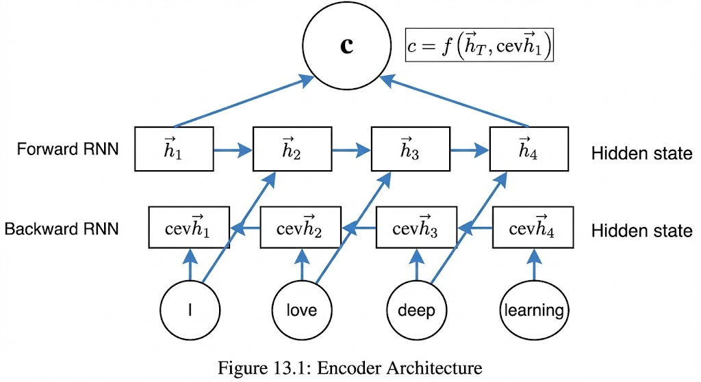

Mathematically, for a bidirectional encoder:
−→

−−→

ht = RNNforward(xt, ht−1)
←− ←−−
ht = RNNbackward(xt, ht+1)
−→ ←−
h_{t} = [h_{t}; h_{t}]
The final context vector is often the last hidden state:
c = h_{T}
Or a weighted average of all hidden states:
c = Σ α_{t}h_{t}
T
t=1
Where α_{t} are attention weights (more on this later).
When I implemented my first encoder, I used the last hidden state as the context vector. Later, I learned that attention mechanisms, which use weighted averages of all hidden states, perform much better.

Decoder Architecture
The decoder uses the context vector to generate the output sequence:
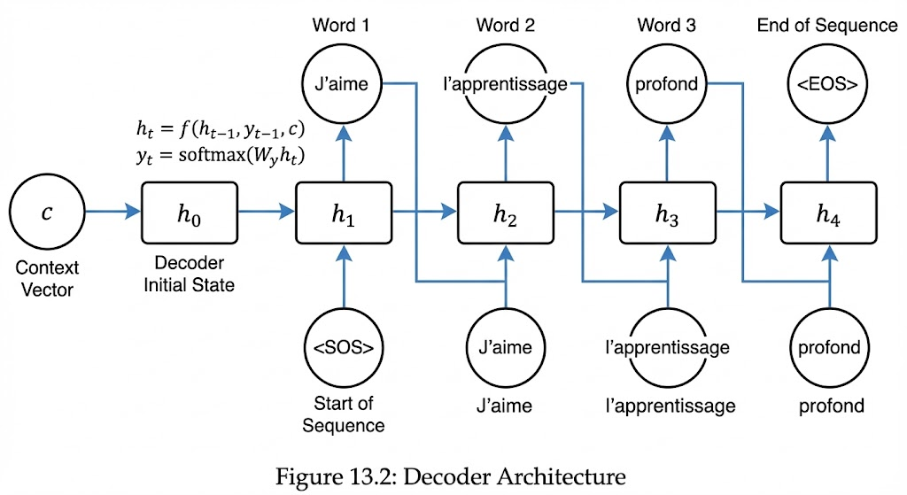

Mathematically, the decoder operates as:
Initial hidden state:

At each time step t:

Where:
s₀ = c

st = RNNdecoder (yt−1, st−1, c)
P (y_{t}|y₁, ..., y_{t−1}, x) = softmax(W_{s}s_{t} + b_{s})

- y_{t−1} is the previous output (or start token for t = 1)
- s_{t} is the decoder hidden state at time t
- c is the context vector from the encoder
The decoder can be implemented with different RNN types (vanilla RNN, LSTM, GRU). I found that LSTM decoders generally performed better than vanilla RNNs for machine translation.

Full Encoder-Decoder Implementation
Here’s a PyTorch implementation of a simple encoder-decoder model:
1 class Encoder(nn.Module):
2 def init (self, input_size, hidden_size, num_layers=1):
3 super(Encoder, self). init ()
4 self.hidden_size = hidden_size
5 self.num_layers = num_layers
6
7 self.embedding = nn.Embedding(input_size, hidden_size)
8 self.rnn = nn.GRU(
9 input_size=hidden_size,
10 hidden_size=hidden_size,
11 num_layers=num_layers,
12 batch_first=True,
13 bidirectional=True
14 )
15 # Since bidirectional, we need to project back to hidden_size
16 self.fc = nn.Linear(2 * hidden_size, hidden_size)
17
18 def forward(self, x):
19 embedded = self.embedding(x) # (batch_size, seq_len, hidden_size)
20 outputs, hidden = self.rnn(embedded)
21 # outputs: (batch_size, seq_len, 2*hidden_size)
22 # hidden: (2*num_layers, batch_size, hidden_size)
23
24 # Take the last hidden state from both directions
25 hidden = hidden.view(self.num_layers, 2, -1, self.hidden_size)
26 hidden = torch.cat((hidden[:, 0, :, :], hidden[:, 1, :, :]), dim=2)
27 hidden = torch.tanh(self.fc(hidden))
28
29 return outputs, hidden
30
31 class Decoder(nn.Module):
32 def init (self, output_size, hidden_size, num_layers=1):
33 super(Decoder, self). init ()
34 self.hidden_size = hidden_size
35 self.output_size = output_size
36 self.num_layers = num_layers
37
38 self.embedding = nn.Embedding(output_size, hidden_size)
39 self.rnn = nn.GRU(
40 input_size=hidden_size,
41 hidden_size=hidden_size,
42 num_layers=num_layers,
43 batch_first=True
44 )
45 self.fc = nn.Linear(hidden_size, output_size)
46
47 def forward(self, x, hidden, encoder_outputs=None):
48 embedded = self.embedding(x) # (batch_size, 1, hidden_size)
49 output, hidden = self.rnn(embedded, hidden)
50 # output: (batch_size, 1, hidden_size)
51 # hidden: (num_layers, batch_size, hidden_size)
52
53 output = output.squeeze(1)
54 logits = self.fc(output)
55 return logits, hidden
When I first implemented this architecture, I struggled with the dimensions of the context vector, especially with bidirectional encoders. The key insight was that the bidirectional hidden states need to be combined (concatenated and projected) to match the decoder’s expected hidden state size.

Sequence-to-Sequence Learning for Machine Translation
Sequence-to-sequence (seq2seq) learning extends the encoder-decoder architecture to handle the complexities of machine translation.

Training with Teacher Forcing
During training, we use teacher forcing to accelerate learning:
1
def train_seq2seq(encoder, decoder, dataloader, criterion, optimizer, teacher_forcing_ratio=0.5):
encoder.train() decoder.train() total_loss = 0

for batch in dataloader: src, tgt = batch batch_size = src.size(0)

optimizer.zero_grad()

# Encode the source sequence encoder_outputs, hidden = encoder(src)

# First input to decoder is <sos> token
decoder_input = torch.tensor([SOS_token] * batch_size, device=device).unsqueeze
(1)

# Initialize loss loss = 0

# Generate outputs one step at a time
use_teacher_forcing = True if random.random() < teacher_forcing_ratio else False

if use_teacher_forcing:
# Teacher forcing: feed the target as the next input for t in range(1, tgt.size(1)):
output, hidden = decoder(decoder_input, hidden) loss += criterion(output, tgt[:, t])
decoder_input = tgt[:, t].unsqueeze(1) # Next input is current target
else:
# Without teacher forcing: use its own predictions as the next input for t in range(1, tgt.size(1)):
output, hidden = decoder(decoder_input, hidden) loss += criterion(output, tgt[:, t])
topv, topi = output.topk(1)
decoder_input = topi.squeeze().detach().unsqueeze(1) # Next input is current prediction

loss.backward() optimizer.step() total_loss += loss.item()

return total_loss / len(dataloader)

2
3
4
5
6
7
8
9
10
11
12
13
14
15
16

17
18
19
20
21
22
23
24
25
26
27
28
29
30
31
32
33
34
35
36

37
38
39
40
41
42

Teacher forcing has pros and cons:
- Pros: Faster convergence, more stable training
- Cons: Exposure bias (mismatch between training and inference), doesn’t learn to recover from mistakes

When I first trained a seq2seq model, I used 100% teacher forcing and got great training loss but poor validation performance. Reducing the teacher forcing ratio to 0.5 and adding scheduled sampling (gradually reducing teacher forcing over epochs) significantly improved generalization.

Inference: Greedy Decoding
During inference, we don’t have target outputs, so we use the model’s predictions as inputs:
1
def greedy_decode(encoder, decoder, src_sentence, src_vocab, tgt_vocab, max_length=50): encoder.eval()
decoder.eval()

# Convert sentence to tensor
src_tensor = sentence_to_tensor(src_sentence, src_vocab).unsqueeze(0)

# Encode the source sentence with torch.no_grad():
encoder_outputs, hidden = encoder(src_tensor)

# First input to decoder is <sos> token
decoder_input = torch.tensor([[SOS_token]], device=device) decoded_words = []

# Generate translation
for t in range(max_length): with torch.no_grad():
output, hidden = decoder(decoder_input, hidden)

# Get the most likely next word topv, topi = output.topk(1) next_token = topi.item()

# If we reach <eos> token, stop if next_token == EOS_token:
break

# Add the word to the output decoded_words.append(tgt_vocab.itos[next_token])

# Next input is the current prediction
decoder_input = torch.tensor([[next_token]], device=device)

return ' '.join(decoded_words)
2
3
4
5
6
7
8
9
10
11
12
13
14
15
16
17
18
19
20
21
22
23
24
25
26
27
28
29
30
31
32
33
34
35
Greedy decoding is simple but suboptimal - it always chooses the highest probability word at each step, which doesn’t guarantee the best overall sequence. This is where beam search comes in.

Beam Search
Beam search is a heuristic search algorithm that finds high-probability sequences by keeping track of multiple hypotheses at each time step.

How Beam Search Works
Instead of keeping only the single most likely sequence (greedy decoding), beam search keeps the top k candidates at each step:
The algorithm:

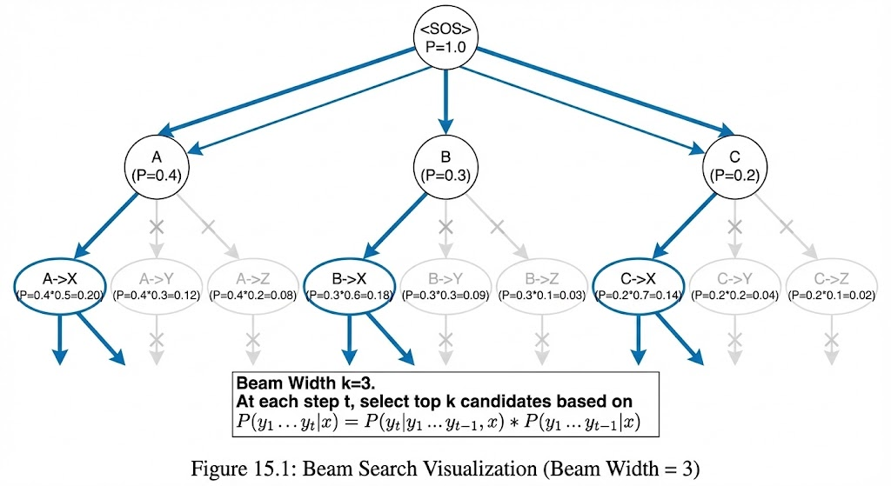
    - Start with k empty sequences, each with probability 1
    - For each time step t:
- For each of the k sequences, generate all possible next words
- Score each extended sequence using the model
- Keep only the top k sequences by total probability
    - Return the sequence with the highest probability when all sequences end Mathematically, at time step t, we maintain a set of k partial sequences S_{t} = {s^{(t)}, s^{(t)}, ..., s^{(t)}},

where each s^{(t)} has probability p^{(t)}.
1 2 k

i i
When extending to time step t + 1, we compute:

p(s^{(t)}, w_{j}) = p^{(t)} · P (w_{j}|s^{(t)}, x)
i i i
For all i = 1, ..., k and all possible next words w_{j}.
We then select the top k combinations to form S_{t+1}.
When I first implemented beam search, I struggled with efficiently managing the k beams. The key insight was to use a priority queue (or simply sort and slice) to keep the top candidates at each step.

Beam Search Implementation
Here’s a PyTorch implementation of beam search:
1
class BeamSearch:
def init (self, beam_width, max_length, sos_token, eos_token, device): self.beam_width = beam_width
self.max_length = max_length self.sos_token = sos_token self.eos_token = eos_token self.device = device

def search(self, encoder, decoder, src_tensor): batch_size = src_tensor.size(0)

# Encode the source sequence with torch.no_grad():
encoder_outputs, hidden = encoder(src_tensor)

# Initialize beams beams = [{
'sequence': [self.sos_token] * batch_size,
'score': torch.zeros(batch_size, device=self.device), 'hidden': hidden,
2
3
4
5
6

21
'complete': torch.zeros(batch_size, dtype=torch.bool, device=self.device)
}]

# Expand sequences
for t in range(1, self.max_length): new_beams = []

for beam in beams:
if beam['complete'].all(): new_beams.append(beam) continue

# Prepare input for decoder
decoder_input = torch.tensor(beam['sequence'][-1], device=self.device).
unsqueeze(1)

# Decode
with torch.no_grad():
output, hidden = decoder(decoder_input, beam['hidden'])

# Get top k candidates
probs = torch.softmax(output, dim=1)
topk_probs, topk_indices = torch.topk(probs, self.beam_width, dim=1)

# Create new beams
for i in range(self.beam_width): new_beam = {
'sequence': beam['sequence'] + [topk_indices[:, i].cpu().numpy()
],
'score': beam['score'] + torch.log(topk_probs[:, i]), 'hidden': hidden,
'complete': beam['complete'] | (topk_indices[:, i] == self.
eos_token)
}
new_beams.append(new_beam)

# Select top k beams
beams = sorted(new_beams, key=lambda x: x['score'].mean(), reverse=True)[: self.beam_width]

# Check if all beams are complete
if all(beam['complete'].all() for beam in beams): break

# Return the best beam best_beam = beams[0]
return best_beam['sequence']
22
23
24
25
26
27
28
29
30
31
32
33
34

35
36
37
38
39
40
41
42
43
44
45
46
47

48
49
50

51
52
53
54
55

56
57
58
59
60
61
62
63

Beam search has its own trade-offs:
- Beam width: Larger beams give better results but are slower and use more memory
- Length normalization: Without normalization, longer sequences tend to have lower prob- abilities
- Diversity: Beam search can produce repetitive or generic outputs
When I compared greedy decoding with beam search (beam width=5) on a machine trans- lation task, beam search improved BLEU score by about 2 points but was 5x slower. This perfor- mance trade-off is important to consider in real applications.

My Learning Journey with RNNs
Looking back on my journey with RNNs, I’ve learned several valuable lessons:
    - Start simple: Begin with vanilla RNNs before moving to LSTMs/GRUs to understand the fundamentals
    - Visualize everything: Drawing the architectures and information flow helped me under- stand complex concepts
    - Implement from scratch: Writing manual implementations before using libraries gave me deeper insights
    - Debug with small examples: Testing on tiny datasets made it easier to identify issues
    - Math matters: Understanding the equations behind the models is crucial for debugging and innovation

RNNs taught me that deep learning isn’t just about stacking layers - it’s about designing architectures that match the structure of the data and the task at hand. The sequence model- ing capabilities of RNNs opened my eyes to a whole new world of applications in NLP, speech processing, time series analysis, and more.
While newer architectures like Transformers have surpassed RNNs in many tasks, the fun- damental concepts I learned from RNNs - recurrence, hidden states, attention mechanisms - continue to be relevant. These concepts form the foundation for understanding more advanced models and developing new ones.
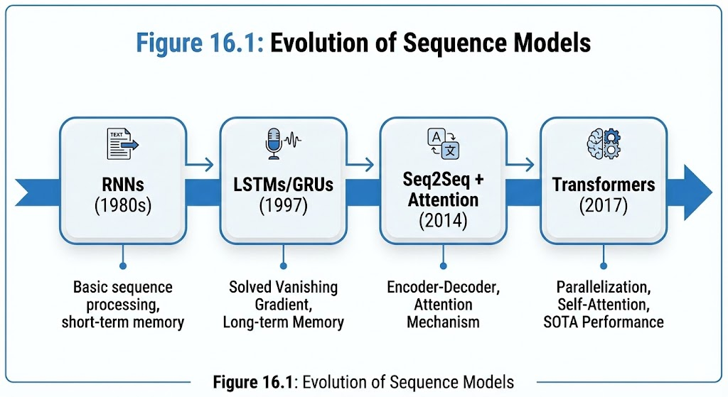
Figure 5: Evolution of Sequence Models.

As I continue my journey in deep learning, I’m excited to see how these concepts will evolve further. The field moves quickly, but the fundamental understanding of how to model sequential data will always be valuable. RNNs were my gateway into this fascinating world, and I’m grateful for the solid foundation they provided.

