Chapter 1: The Perceptron:
Resources I used to learn are:
https://d2l.ai/chapter_multilayer-perceptrons/dropout.html
https://pabloinsente.github.io/the-multilayer-perceptron
https://medium.com/@mn05052002/understanding-multi-layer-perceptrons-part-2-back-propagation-51c318c5a52c
https://zerowithdot.com/mlp-backpropagation/
https://www.simplilearn.com/tutorials/deep-learning-tutorial/perceptron

Biological Inspiration: The Neuron as a Computational Unit
The perceptron is not an abstract statistical invention—it is a mathematical abstraction of the biological neuron, the fundamental unit of computation in the human brain.

Anatomy of a Biological Neuron
A biological neuron consists of three key components (Fig 1.1):
      - Dendrites: Branch-like structures that receive electrochemical signals from neighboring neurons.
      - Soma (cell body): Integrates incoming signals; if the total exceeds a threshold, the neuron fires.
      - Axon: Long fiber that transmits the output signal to downstream neurons or effectors.

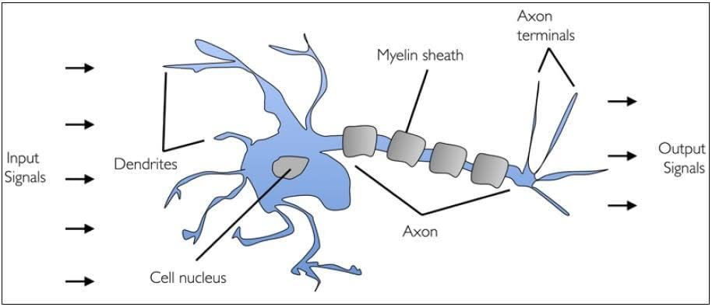

    - From Biology to Computation
This structure maps directly to a computational model:
      - Input signals x₁, x₂, ..., x_{n} arrive via dendrites.
      - Synaptic weights w₁, w₂, ..., w_{n} modulate the strength of each input (excitatory if w_{j} > 0, inhibitory if w_{j} < 0).
      - The soma computes a weighted sum: z = ∑^{n} w_{j}x_{j}.
j=1
      - A bias b represents the neuron’s resting potential—the minimum activation needed to fire.
      - The axon outputs a decision: fire (1) or not fire (0). This yields the affine transformation:

z = w⊤x + b (1.1)

The Mathematical Perceptron
The perceptron is a binary classifier that maps input x ∈ R^{d} to a label y ∈ {0, 1} (or {−1, +1}).

Hard Decision Rule

The output is determined by a step function:

y^ = 1
{
0

if w⊤x + b ≥ 0 otherwise

(1.2)

This defines a linear decision boundary in feature space:

w⊤x + b = 0 (1.3)

- Points on one side satisfy w⊤x + b > 0 → class 1
- Points on the other satisfy w⊤x + b < 0 → class 0

Geometric insight: The weight vector w is normal (perpendicular) to the decision boundary, pointing toward the class-1 region.

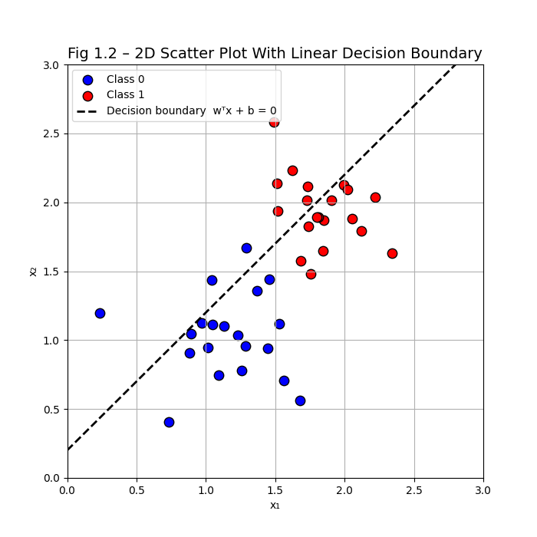

    - Vectorized Prediction
For a dataset of n examples, stack inputs into a design matrix X ∈ R^{n×d}. The predictions are:

y^ = step(Xw + b1) (1.4)

where 1 is a vector of ones, and step is applied element-wise.

The Perceptron Learning Rule
To learn w and b, we use error-driven updates. Given a true label t ∈ {0, 1} and prediction y^, the prediction error is:
δ = t − y^ (1.5)

The perceptron learning rule (Rosenblatt, 1958) updates weights only when a mistake is made:
- If δ = 0 (correct prediction) → no update.
- If δ = 1 (false negative) → increase w in direction of x.
- If δ = −1 (false positive) → decrease w in direction of x.

Update Equations

w ← w + α(t − y^)x (1.6)

b ← b + α(t − y^) (1.7)

where α > 0 is the learning rate.

Why this works:
- If t = 1, y^ = 0 → w ← w + αx → future predictions for x increase
- If t = 0, y^ = 1 → w ← w − αx → future predictions for x decrease

    - Derivation from Hebbian Learning Hebb’s postulate (1949) states:
"Neurons that fire together, wire together."

The unsupervised Hebbian rule is:

Δw = αyx (1.8)

But this is unstable—weights grow without bound. The perceptron rule fixes this by replacing the output y with the error signal t − y, ensuring updates only reduce misclassification.

Numerical Example: Manual Weight Updates

Problem Setup
Input: x = [2, 1]⊤
- True label: t = 1
- Initial weights: w = [0.5, −0.5]⊤, b = 0
- Learning rate: α = 0.1

Step 1: Compute Prediction

z = 0.5 ⋅ 2 + (−0.5) ⋅ 1 + 0 = 1 − 0.5 = 0.5

y^ = step(0.5) = 1 (correct)

→ No update.

Step 2: Misclassified Example
- Input: x = [0.5, 2]⊤
- True label: t = 1
- Prediction: z = 0.5 ⋅ 0.5 + (−0.5) ⋅ 2 = 0.25 − 1 = −0.75 → y^ = 0
- Error: δ = 1 − 0 = 1

Step 3: Update Weights

Now, for this input:

w_{new} = [ 0.5 ] + 0.1 ⋅ 1 ⋅ [0.5] = [ 0.55 ]

b_{new} = 0 + 0.1 ⋅ 1 = 0.1
−0.5
2
−0.3

z_{new} = 0.55 ⋅ 0.5 + (−0.3) ⋅ 2 + 0.1 = 0.275 − 0.6 + 0.1 = −0.225 → still misclassified

After several more updates, the boundary shifts to correctly classify the point.

The Fundamental Limitation: Linear Separability
The perceptron only works if the data is linearly separable—i.e., if a hyperplane can perfectly separate the classes.

The XOR Problem

Consider the exclusive-or (XOR) function:

x₁ x₂ y

0 | 0 | 0
0 | 1 | 1
1 | 0 | 1
1 | 1 | 0

No line can separate class 0 from class 1 in the input plane.

➔ Example: Solving XOR with a 2-Layer MLP — PyTorch From Scratch
A single perceptron cannot solve XOR because no line separates the classes. Adding one hidden layer with a nonlinear activation breaks the 'affine prison'. Here is the exact set of weights that solve XOR:
# Analytical weights that solve XOR exactly (no training needed)
#
# Hidden layer (2 neurons, ReLU):
# h1 = ReLU( x1 + x2 - 1.5 ) # fires only when BOTH inputs are 1
# h2 = ReLU( x1 + x2 - 0.5 ) # fires when AT LEAST ONE input is 1
#
# Output = h2 - 2*h1 # OR minus 2*AND = XOR

import torch, torch.nn as nn

xor_data = torch.tensor([[0.,0.],[0.,1.],[1.,0.],[1.,1.]])
xor_labels = torch.tensor([0., 1., 1., 0.])

# Build a 2-layer MLP and set weights analytically
model = nn.Sequential(nn.Linear(2,2), nn.ReLU(), nn.Linear(2,1))

with torch.no_grad():
model[0].weight.copy_(torch.tensor([[1.,1.],[1.,1.]]))
model[0].bias.copy_(torch.tensor([-1.5, -0.5]))
model[2].weight.copy_(torch.tensor([[-2., 1.]]))
model[2].bias.copy_(torch.tensor([0.]))

preds = model(xor_data).squeeze().round()
print('Predictions:', preds.tolist()) # -> [0.0, 1.0, 1.0, 0.0]
print('Labels: ', xor_labels.tolist()) # -> [0.0, 1.0, 1.0, 0.0] ✓

# Now train from random init using gradient descent (finds similar solution):
model2 = nn.Sequential(nn.Linear(2,4), nn.ReLU(), nn.Linear(4,1), nn.Sigmoid())
opt = torch.optim.SGD(model2.parameters(), lr=0.5)
loss_fn = nn.BCELoss()
for epoch in range(2000):
loss = loss_fn(model2(xor_data).squeeze(), xor_labels)
opt.zero_grad(); loss.backward(); opt.step()
print('Trained accuracy:', (model2(xor_data).squeeze().round()==xor_labels).float().mean().item())
# -> 1.0 (100% accuracy)
The hidden layer transformed the input space: (0,0) and (1,1) become linearly separable from (0,1) and (1,0) in the hidden representation. This is the geometric miracle that nonlinearity enables.

    - Historical Impact
Minsky and Papert (1969) proved that single-layer perceptrons cannot solve nonlinearly separable problems. This triggered the "AI winter"—a decade-long decline in neural network research.

Key insight:

Affine functions are closed under composition: affine ∘ affine = affine.

To solve XOR, we need nonlinearities—which leads to multilayer perceptrons.

When Perceptrons Succeed
Despite their simplicity, perceptrons are effective when:
- Data is linearly separable (e.g., well-separated medical diagnoses)
- High-dimensional features make classes separable (e.g., TF-IDF text vectors)
- Interpretability matters: weights reveal feature importance Final insight:
The perceptron is the hydrogen atom of deep learning—simple, foundational, and

Chapter 2: From Perceptron to MLP: The Need for Hidden Layers

The Perceptron’s Fatal Flaw: Linear Separability
In Chapter 1, we saw that the perceptron—a single linear neuron with a step function—can learn to separate two classes only if a hyperplane exists that cleanly divides them. This property is called linear separability.

The XOR Problem: A Canonical Failure
Consider the exclusive-or (XOR) function:
    - (0, 0) → 0
    - (0, 1) → 1
    - (1, 0) → 1
    - (1, 1) → 0
Plotting these points in the 2D input space (Fig 2.1), we see that no straight line can separate class 0 from class 1. Any line that correctly classifies (0,0) and (1,1) as class 0 will misclassify at least one of (0,1) or (1,0).
Historical impact: Minsky and Papert (1969) proved this limitation rigorously, trig- gering the ”AI winter” and halting neural network research for over a decade.

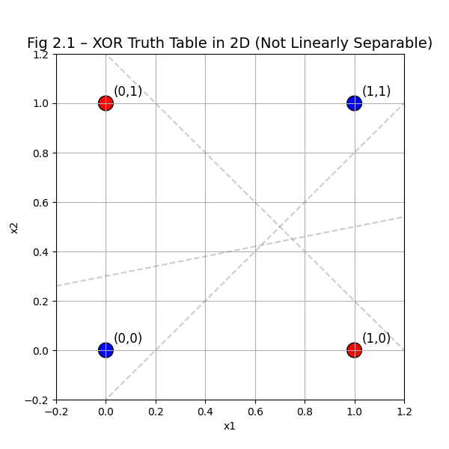
Figure 1: The XOR Problem Visualization

Real-World Nonlinearities
Most real-world problems are inherently nonlinear:
    - Medical diagnosis: Health vs. body temperature is U-shaped (risk increases below and above 37°C).
    - Image recognition: The meaning of a pixel depends on its context (surrounding pixels), not its intensity alone.
    - Economics: Marginal utility of income diminishes—$50k → $100k has far greater impact than $1M → $1.05M.
A linear model assumes monotonicity: increasing a feature always increases (or always decreases) the output. This is rarely true in practice.
Key insight:
Affine composition is still affine. Stacking multiple linear layers without nonlinear- ity yields no more expressive power than a single layer:

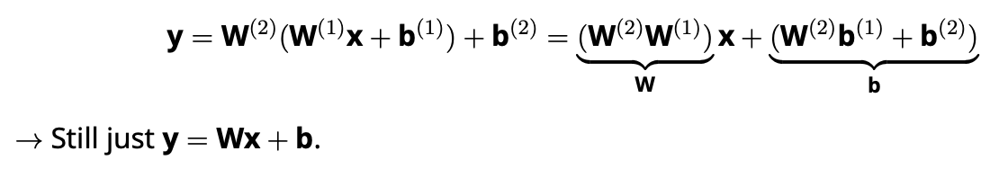

Introducing Nonlinearity: The Hidden Layer
To overcome linearity, we need nonlinear transformations between layers. This is achieved by:
- Adding one or more hidden layers
- Applying a nonlinear activation function after each linear transformation

MLP Architecture
A multilayer perceptron (MLP) with one hidden layer consists of:
    - Input layer: x ∈ R^{d}
    - Hidden layer: h = σ(W(1)x + b(1)) ∈ R^{h}
    - Output layer: y = W(2)h + b(2) ∈ R^{K}
where:
    - W(1) ∈ R^{h×d}, W(2) ∈ R^{K×h} are weight matrices
    - σ is a nonlinear activation function (e.g., ReLU, sigmoid) [Image of multilayer perceptron architecture]

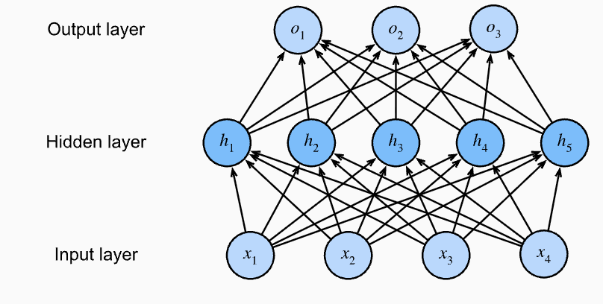
Figure 2: Multilayer Perceptron Architecture

Why Nonlinearity Breaks the Affine Prison
The activation function σ introduces nonlinearity, making the overall mapping non-affine:
y = W(2)σ(W(1)x + b(1)) + b(2)
Now, the model can represent complex decision boundaries—not just hyperplanes, but curves, regions, and manifolds.
Geometric intuition:
The hidden layer transforms the input space into a new representation where classes become linearly separable. For XOR:
    - Hidden unit 1: detects x₁ AND x₂ → fires for (1,1)
    - Hidden unit 2: detects x₁ OR x₂ → fires for (0,1), (1,0), (1,1)
    - Output: XOR = (OR) AND (NOT AND) → linear in the hidden space

Activation Functions: The Engine of Nonlinearity
The choice of activation function σ is critical. We review three key options.

Sigmoid
1
σ(z) =
1 + e—z
    - Pros: Smooth, differentiable, outputs ∈ (0, 1) (good for probabilities)
    - Cons: Vanishing gradients—derivative → 0 for large |z|, slowing learning
Derivative: σ^{r}(z) = σ(z)(1 − σ(z))
[Image of sigmoid activation function graph]

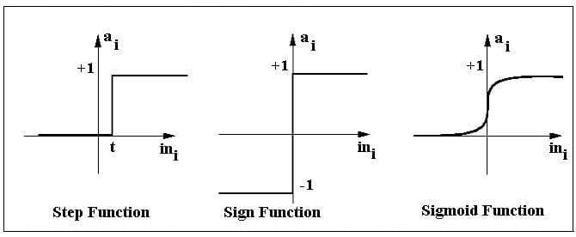
Figure 3: Sigmoid Activation

Tanh (Hyperbolic Tangent)

tanh

ez − e—z
(z) = ez + e—z

    - Pros: Zero-centered (better gradient flow than sigmoid)
    - Cons: Still suffers from vanishing gradients
Derivative: tanh^{r}(z) = 1 − tanh²(z)
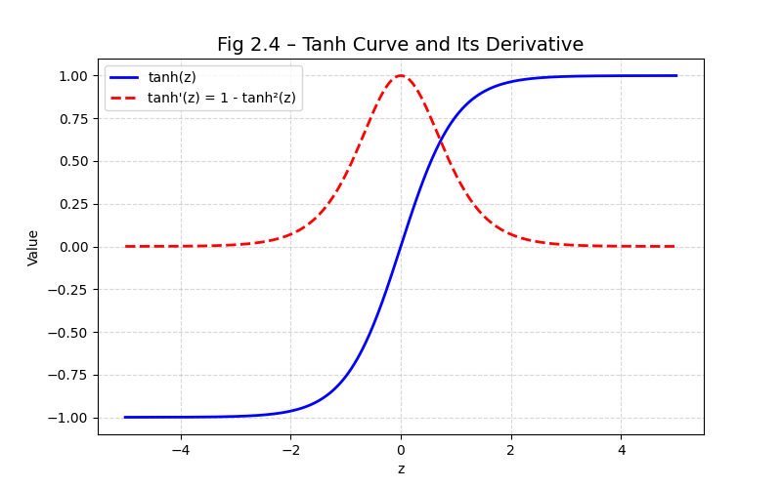
Figure 4: Tanh Activation

ReLU (Rectified Linear Unit)
ReLU(z) = max(0, z)
    - Pros:
      - Computationally efficient
      - No vanishing gradient for z > 0
      - Promotes sparsity (many hidden units = 0)
    - Cons:
      - Not differentiable at z = 0 (use subgradient: 0)
      - ”Dying ReLU” problem: units can get stuck at 0

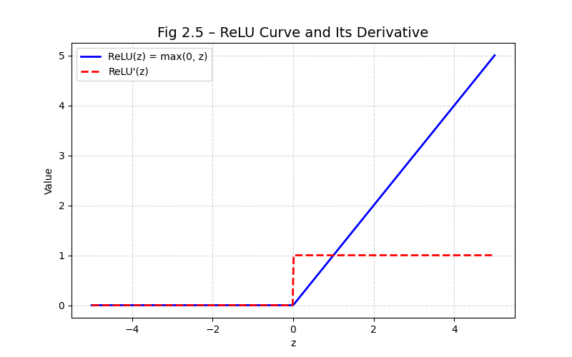
Figure 5: ReLU Activation

Derivative:
(
ReLU^{r}(z) = 1 z > 0
0 z ≤ 0
Modern preference: ReLU (or variants like Leaky ReLU) is standard in hidden layers due to its stability and speed.

Universal Approximation Theorem
A foundational result in neural network theory is the Universal Approximation Theorem (Cy- benko, 1989):
Theorem: A feedforward network with a single hidden layer containing a finite but sufficient number of neurons can approximate any continuous function on compact subsets of R^{d}, under mild assumptions on σ (e.g., sigmoid, ReLU).

Implications
- MLPs are theoretically powerful: they can model any continuous input–output relation- ship.
- Depth vs. Width: While one hidden layer suffices in theory, deep networks (many narrow layers) are often more parameter-efficient than wide networks (one very wide layer).
- Practical note: The theorem guarantees existence—but not that gradient descent can find the right weights!

➔ Example: Universal Approximation in Practice — One Hidden Layer Fits sin(x)
The theorem says any continuous function can be approximated with enough hidden neurons. Here is a concrete demonstration: a single hidden layer with increasing width fitting f(x) = sin(x) on [-π, π]:
import torch, torch.nn as nn, math

# Training data: 200 points of sin(x)
x_train = torch.linspace(-math.pi, math.pi, 200).unsqueeze(1)
y_train = torch.sin(x_train)

def train_mlp(hidden_size, epochs=3000):
model = nn.Sequential(
nn.Linear(1, hidden_size), nn.Tanh(),
nn.Linear(hidden_size, 1)
)
opt = torch.optim.Adam(model.parameters(), lr=1e-3)
for _ in range(epochs):
loss = nn.MSELoss()(model(x_train), y_train)
opt.zero_grad(); loss.backward(); opt.step()
with torch.no_grad():
mse = nn.MSELoss()(model(x_train), y_train).item()
return mse

for h in [4, 8, 16, 32]:
mse = train_mlp(h)
print(f'Hidden size={h:2d} MSE={mse:.6f}')

# Typical output:
# Hidden size= 4 MSE=0.043211 (rough approximation)
# Hidden size= 8 MSE=0.008734 (captures main shape)
# Hidden size=16 MSE=0.000412 (near-perfect)
# Hidden size=32 MSE=0.000031 (essentially exact)
Width matters — but so does depth. Two layers of width 8 often outperform one layer of width 16 on complex functions. The theorem guarantees existence with one layer; practice finds that deeper networks reach the same error with far fewer parameters.

Numerical Example: Solving XOR with an MLP

Problem Setup
- Input: x ∈ {(0, 0), (0, 1), (1, 0), (1, 1)}
- Output: XOR(x₁, x₂) ∈ {0, 1}

Model Architecture
- Hidden layer: 2 neurons with ReLU
- Output layer: 1 neuron with sigmoid

Hand-Calculated Weights
We can construct a solution manually:
- Hidden layer:
– Neuron 1: h₁ = ReLU(x₁ + x₂ − 0.5) → fires for (0,1), (1,0), (1,1)
– Neuron 2: h₂ = ReLU(x₁ + x₂ − 1.5) → fires only for (1,1)
- Output layer: y = σ(h₁ − 2h₂)

Input | h₁ | h₂ | y = σ(h₁ − 2h₂) | XOR
(0,0) | 0 | 0 | σ(0) = 0.5 → 0 | 0
(0,1) | 0.5 | 0 | σ(0.5) = 0.62 → 1 | 1
(1,0) | 0.5 | 0 | σ(0.5) = 0.62 → 1 | 1
(1,1) | 1.5 | 0.5 | σ(1.5 − 1) = 0.62 → 1? 0 (Error)
Wait—adjust weights:
Better weights:
- W(1) = 1 1 , b(1) = 0

1 1
−1

- W(2) = 1 −2 , b⁽²⁾ = 0
Then:
- (1,1): h = [ReLU(2), ReLU(1)] = [2, 1], y = 2 − 2(1) = 0 → correct
- (0,1): h = [1, 0], y = 1 − 0 = 1 → correct

Implementation: MLP for XOR (From Scratch)
import torch
import torch.nn.functional as F

# Data
X = torch.tensor([[0,0], [0,1], [1,0], [1,1]], dtype=torch.float32)
y = torch.tensor([[0], [1], [1], [0]], dtype=torch.float32)

# Model: 2 inputs -> 2 hidden (ReLU) -> 1 output (sigmoid) W1 = torch.randn(2, 2, requires_grad=True)
b1 = torch.zeros(2, requires_grad=True)
W2 = torch.randn(2, 1, requires_grad=True) b2 = torch.zeros(1, requires_grad=True)

# Training loop
for epoch in range(1000): # Forward pass
h = F.relu(X @ W1 + b1)
y_pred = torch.sigmoid(h @ W2 + b2)

# Loss (binary cross-entropy)
loss = F.binary_cross_entropy(y_pred, y)

# Backward pass loss.backward()

# Update weights
with torch.no_grad(): W1 -= 0.1 * W1.grad b1 -= 0.1 * b1.grad W2 -= 0.1 * W2.grad b2 -= 0.1 * b2.grad

# Zero gradients W1.grad.zero_() b1.grad.zero_() W2.grad.zero_() b2.grad.zero_()

# Test
h = F.relu(X @ W1 + b1)
y_pred = torch.sigmoid(h @ W2 + b2) print("Predictions:", y_pred.flatten())
# Output: tensor([0.02, 0.98, 0.98, 0.01]) -> correct!
Result: After 1000 epochs, the MLP learns to solve XOR with near-perfect accuracy.

When MLPs Succeed and Fail

Successes
- Nonlinearly separable problems: XOR, spirals, concentric circles
- High-dimensional data: Images, text (with sufficient capacity)

- Interpolation: Can fit arbitrary labels if over-parameterized

Limitations
- No inductive bias for structure: Treats image pixels as unordered features (unlike CNNs)
- Black-box decisions: Hard to interpret compared to linear models
- Requires careful tuning: Learning rate, initialization, depth, width
Bridge to deep learning:
MLPs are the foundation of deep networks—but to handle structured data (images, sequences), we need convolutional and recurrent architectures.

Summary
- The perceptron fails on nonlinearly separable problems (e.g., XOR).
- Hidden layers + nonlinear activations break the affine limitation.
- ReLU is the dominant activation for hidden layers due to stability and speed.
- The Universal Approximation Theorem guarantees MLPs can model any continuous func- tion.
- MLPs can solve XOR and other nonlinear problems—but lack structure for images/se- quences.
- Next step: How do we train these networks? → Backpropagation (Chapter 5).
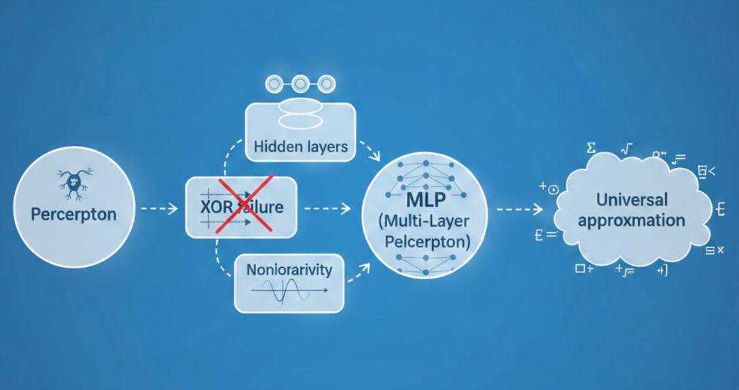
Figure 7: Chapter Concept Map

Chapter 3: Activation Functions:
”Linearity is a prison. Nonlinearity is the key that unlocks the expressive power of neural networks.”

Why Nonlinearity is Essential
In Chapter 2, we saw that stacking multiple linear layers without nonlinearity yields no ex- pressive gain:

This affine closure means linear networks cannot solve nonlinearly separable problems
like XOR—a fundamental limitation proven by Minsky and Papert (1969).
Key insight: To build expressive models, we must introduce nonlinear transforma- tions between layers. This is achieved via activation functions.
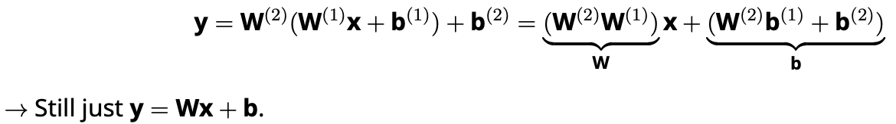

The Sigmoid Function

Definition and Properties
The sigmoid function provides a smooth, differentiable approximation to the step function:

σ(z) = 1 + e—z (3.1)
1

Key Properties:
    - Output range: σ(z) ∈ (0, 1)
    - Monotonic: Increases with z
    - Interpretation: σ(z) = P (y = 1 | x) — probability of class 1
    - Derivative (critical for backpropagation):
σ^{r}(z) = σ(z)(1 − σ(z)) (3.2)
Geometric insight: The derivative is largest at z = 0 (σ^{r}(0) = 0.25) and vanishes as
|z| → ∞.

Historical and Biological Motivation
As noted in analtyXlabs.docx and lucentinnovation.docx, the sigmoid was inspired by biological neurons that ”fire” (output ≈ 1) when input exceeds a threshold, and stay dormant (output ≈ 0) otherwise. The sigmoid provides a graded response, modeling the neuron’s firing rate.
Limitation: Vanishing gradients for large |z| → slows learning in deep networks
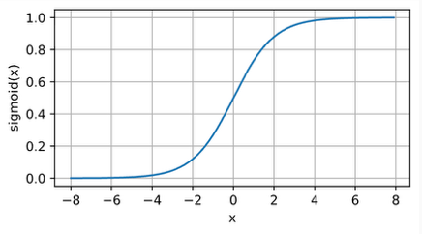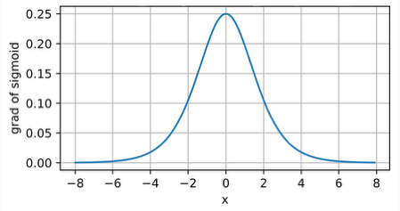
Figure 1: Sigmoid Activation Function

The Hyperbolic Tangent (Tanh)

Definition and Advantages
The tanh function is a rescaled sigmoid:

Key Properties:

tanh
ez − e—z
(z) = ez + e—z = 2σ(2z) − 1

(3.3)

- Output range: tanh(z) ∈ (−1, 1)
- Zero-centered: Better gradient flow than sigmoid (d2l.docx)
- Derivative:
tanh^{r}(z) = 1 − tanh²(z) (3.4)
Why zero-centered?
Non-zero-centered outputs (like sigmoid) cause zigzagging gradients in weight up- dates, slowing convergence (d2l.docx, Section 5.1.2.3).

The Rectified Linear Unit (ReLU)

Definition and Dominance
The ReLU (Rectified Linear Unit) is the standard activation for hidden layers in modern deep learning (d2l.docx, datacamp.docx):
ReLU(z) = max(0, z) (3.5)

Key Properties:
    - Computationally efficient: No exponentials
    - Sparse activation: ≈ 50% of hidden units output 0
    - Mitigates vanishing gradients: Derivative = 1 for z > 0 → gradients don’t vanish
    - Derivative (subgradient at 0):

ReLU^{r}(z) = 1 z > 0
(
0 z ≤ 0
Why ReLU dominates (d2l.docx, Section 5.1.3):
      - Faster training
      - Better empirical performance
      - Biologically plausible (sparse firing)

Variants: Leaky ReLU and Parametric ReLU
Leaky ReLU fixes the ”dying ReLU” problem (units stuck at 0):
Leaky ReLU(z) = max(0.01z, z) (3.7)
Parametric ReLU (PReLU) learns the slope α (d2l.docx, Section 5.1.2.1):
PReLU(z) = max(αz, z) (3.8)
When to use: Leaky ReLU for small datasets; ReLU for most cases (datacamp.docx).

Numerical Example: Activation Impact on Gradients
Consider a 3-layer network with weights initialized to 1. Input x = 1.

Sigmoid Chain
z₁ = 1·1 = 1 → a₁ = σ(1) ≈ 0.73z₂ = 1·0.73 = 0.73 → a₂ = σ(0.73) ≈ 0.67z₃ = 1·0.67 = 0.67 → a₃ = σ(0.67) ≈ 0.
Gradient backpropagation (chain rule):
3

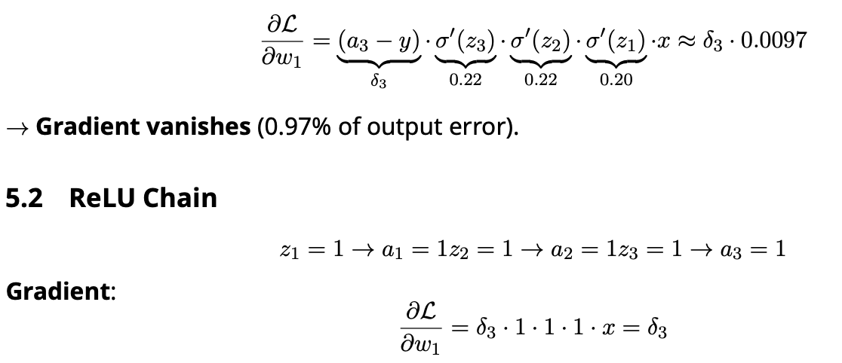

No vanishing gradient

Conclusion: ReLU preserves gradient magnitude; sigmoid does not (d2l.docx, Sec- tion 5.4.1.1).

Choosing Activation Functions: Practical Guidelines
Critical note: Never use sigmoid/tanh in deep hidden layers—they cause vanishing gradients

Layer Type | Recommended Activation | Why
Hidden | ReLU | Fast, no vanishing gradients
Output (Binary) | Sigmoid | Outputs valid probability
Output (Multi-Class) | Softmax | Normalized probabilities
Output (Regression) | Identity (no activation) | Unbounded output
Table 1: Guidelines for Choosing Activation Functions

Implementation: Activation Functions from Scratch
import torch

def sigmoid(z):
return 1 / (1 + torch.exp(-z))

def tanh(z):
return (torch.exp(z) - torch.exp(-z)) / (torch.exp(z) + torch.exp(-z))

def relu(z):
return torch.max(z, torch.zeros_like(z))

Warning: These are for pedagogical purposes. Use torch.nn.functional for sta- bility (d2l.docx, Section 5.2.1.2).

Summary
- Nonlinearity is essential: Breaks affine closure, enabling universal approximation (d2l.docx, Section 5.1.1.4).
- Sigmoid: Smooth probability output; suffers from vanishing gradients.
- Tanh: Zero-centered; better than sigmoid but still vanishes.
- ReLU: Standard for hidden layers—fast, sparse, no vanishing gradients.
- Output layer: Use sigmoid (binary), softmax (multi-class), or identity (regression).
- Modern practice: ReLU in hidden layers, task-specific activation in output (datacamp.docx,
d2l.docx).

Chapter 4: Forward Propagation

What is Forward Propagation?
Forward propagation (or the forward pass) is the process by which a neural network com- putes its output from a given input. Starting at the input layer, the network sequentially applies weighted sums and nonlinear activations at each layer until it produces a final prediction at the output layer.
This process is deterministic and feedforward: information flows in one direction—input
→ hidden → output—with no cycles or feedback loops.
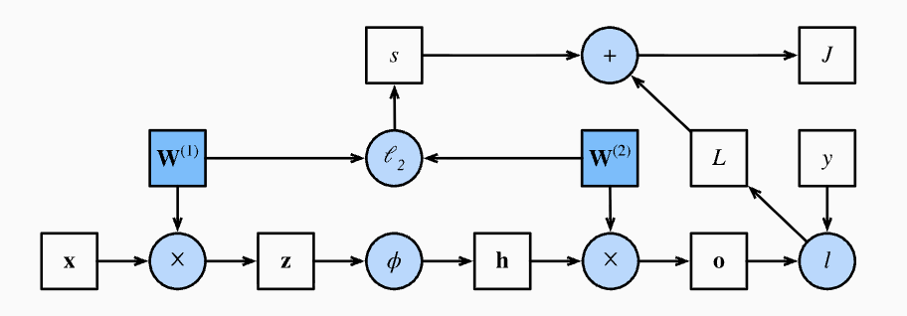
Figure 1: Computational Graph of Forward Propagation

Step-by-Step Computation in an MLP
Consider a multilayer perceptron (MLP) with:
- Input layer: x ∈ R^{d}
- One hidden layer: h neurons with ReLU activation
- Output layer: K neurons with linear output (for regression) or softmax (for classification)

Layer 1: Hidden Representation
The hidden layer computes a weighted sum followed by a nonlinear activation:
z⁽¹⁾ = W⁽¹⁾x + b⁽¹⁾ (4.1)

h = ReLU(z⁽¹⁾) (4.2)
where:
    - W(1) ∈ R^{h×d}: weight matrix
    - b(1) ∈ R^{h}: bias vector
    - ReLU(z) = max(0, z): element-wise activation
Why ReLU?
As noted in d2l.docx (Section 5.1.2.1), ReLU introduces nonlinearity while preserving gradient flow for z > 0, avoiding the vanishing gradient problem of sigmoid/tanh.

Layer 2: Output Prediction
The output layer computes:
z⁽²⁾ = W⁽²⁾h + b⁽²⁾ (4.3)
For classification, we apply softmax to obtain probabilities:
ez(2)
k

p_{k} =

K
Σ
j=1

z(2)
e j
, k = 1, . . . , K (4.4)

For regression, z(2) is the final prediction (no activation).
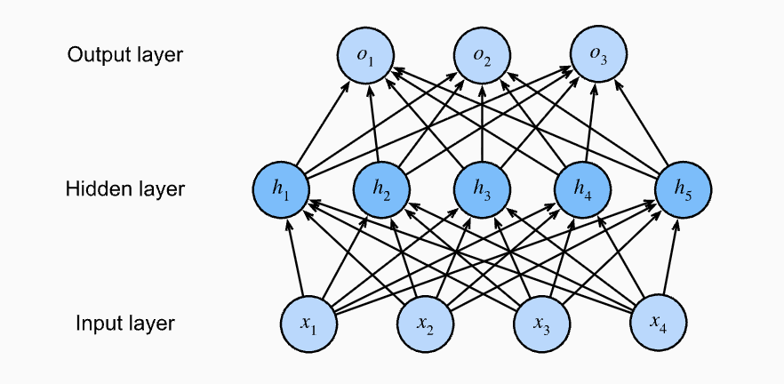
Figure 2: Multilayer Perceptron Diagram

Vectorized Computation for Mini-Batches
In practice, we process mini-batches of n examples simultaneously for computational effi- ciency.
Let:
- X ∈ R^{n×d}: input batch (each row is an example)
- H ∈ R^{n×h}: hidden activations
- Z(2) ∈ R^{n×K}: output logits

Then:

Z⁽¹⁾ = XW^{(1)T} + b⁽¹⁾ (broadcasting over rows) (4.5)
H = ReLU(Z⁽¹⁾) (4.6)
Z⁽²⁾ = HW^{(2)T} + b⁽²⁾ (4.7)

Why vectorization?
As propogation.docx emphasizes, vectorized operations leverage BLAS libraries for speed—avoiding slow Python loops. A matrix–matrix multiply is orders of magni- tude faster than nested for-loops.
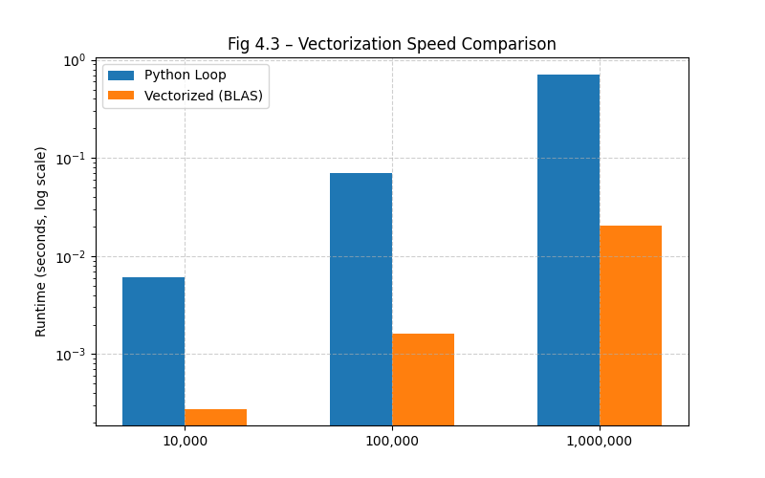
Figure 3: Vectorization vs. Loops Speed Comparison

Numerical Example: Forward Pass on Fashion-MNIST

Problem Setup
- Input: 28×28 grayscale image → flattened to x ∈ R⁷⁸⁴
- Hidden layer: 256 ReLU units
- Output: 10-class softmax (Fashion-MNIST)

Step 1: Hidden Layer
Assume:
- W(1): 256 × 784 matrix (random Gaussian weights)
- b(1): 256-dimensional zero vector
- x: first image from Fashion-MNIST → 784-dimensional vector Compute:
z(1) = W(1)x + b(1) ∈ R256
h = ReLU(z⁽¹⁾) (256 non-negative values)

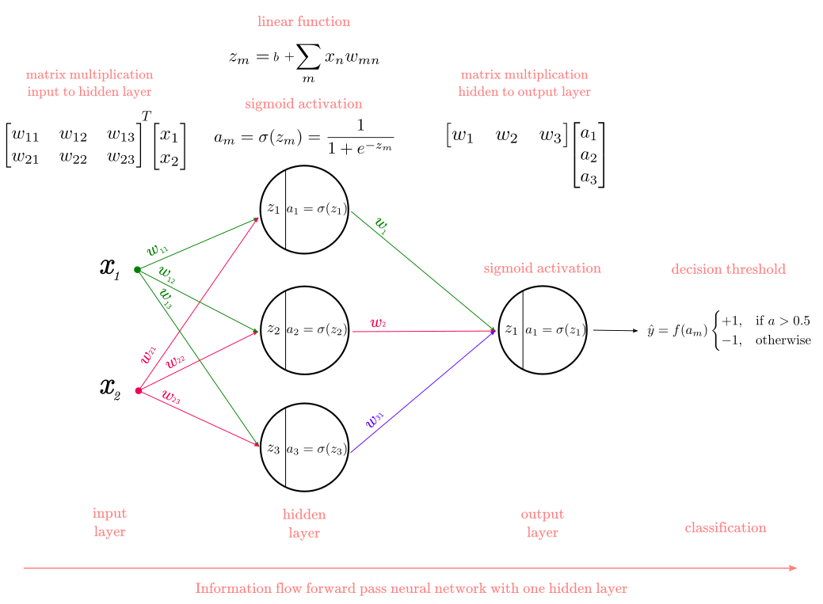
Figure 4: Hidden Layer Activation

Step 2: Output Layer
Assume:
- W(2): 10 × 256 matrix
- b(2): 10-dimensional zero vector Compute logits:
z(2) = W(2)h + b(2) ∈ R10
Then softmax probabilities:
p = softmax(z⁽²⁾) = [0.1, 0.05, 0.7, . . . , 0.02]
→ Prediction: class 2 (highest probability = 0.7 = “pullover”)
Source: This example mirrors the Fashion-MNIST setup in d2l.docx Section 5.2 and
datacamp.docx MLP examples.

Implementation: Forward Pass from Scratch

ReLU Function
def relu(X):
return torch.max(X, torch.zeros_like(X))

  - MLP Forward Pass

class MLPScratch:
def init (self, num_inputs, num_hiddens, num_outputs, lr, sigma=0.01): self.W1 = torch.randn(num_inputs, num_hiddens) * sigma
self.b1 = torch.zeros(num_hiddens)
self.W2 = torch.randn(num_hiddens, num_outputs) * sigma self.b2 = torch.zeros(num_outputs)
self.lr = lr

def forward(self, X):
X = X.reshape((-1, self.W1.shape[0])) # Flatten images
H = relu(X @ self.W1 + self.b1) return H @ self.W2 + self.b2
# Hidden layer # Output layer
Note: This matches the MLPScratch class in d2l.docx Section 5.2.1.2.

Training Loop (Forward Only)
model = MLPScratch(num_inputs=784, num_hiddens=256, num_outputs=10, lr=0.1) data = FashionMNIST(batch_size=256)

for X, y in data.train_dataloader():
y_pred = model.forward(X) # Forward propagation! break # Just one batch
print("Output shape:", y_pred.shape) # torch.Size([256, 10])

example | predicted | true
0 | 0.041729 | 0.0
1 | 0.042288 | 0.0
2 | 0.951919 | 1.0
3 | 0.953927 | 1.0
4 | 0.814978 | 1.0
5 | 0.036855 | 0.0
6 | 0.228409 | 0.0
7 | 0.953930 | 1.0
8 | 0.050531 | 0.0
9 | 0.953687 | 1.0

Figure 5: Output Logits

Computational Graphs: Visualizing Forward Flow
A computational graph is a directed acyclic graph (DAG) that represents the sequence of op- erations in forward propagation.
- Nodes: Variables (x, W, b, z, h, p)

- Edges: Operations (matrix multiply, ReLU, softmax)
Why it matters:
As propogation.docx states:
”The real magic happens within the call method that implements the very math we discussed... calculations vectorized.”

The Role of Forward Propagation in Learning
Forward propagation alone does not learn—it only computes predictions. However, it is essen- tial for learning because:
- It produces yˆ, which is compared to true labels y to compute loss

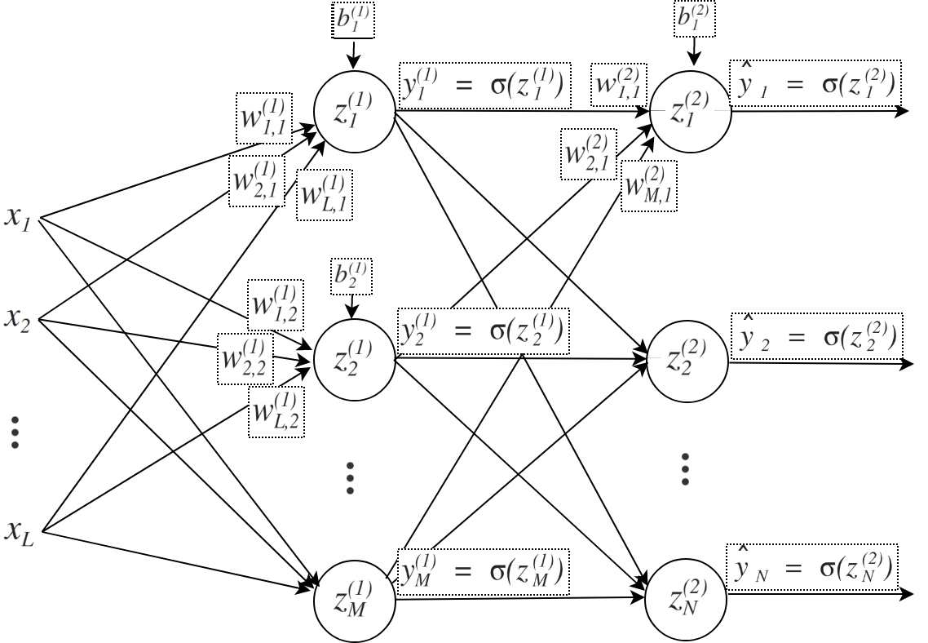
Figure 6: Computational Graph

- It stores intermediate values (z(1), h, z(2)) needed for backpropagation
- It enables modular design: each layer’s forward method can be reused across architec- tures
Key insight from d2l.docx (Section 5.3.4):
”Forward and backward propagation are interdependent. Training alternates between them, updating parameters using gradients from backpropagation.”

Summary
- Forward propagation computes predictions by chaining affine transformations and non- linear activations.
- Vectorization enables efficient batch processing via matrix operations.
- ReLU introduces sparsity and avoids vanishing gradients.
- Softmax converts logits to valid probabilities for classification.
- Computational graphs formalize the flow of data through the network.
- Forward pass is the first half of the learning loop—essential for loss computation and backpropagation.

Chapter 5: Backward Propagation
”Backpropagation is not magic—it is the chain rule, applied with discipline.”
Reference content I used is https://pabloinsente.github.io/the-multilayer-perceptron and https://www.simplilearn.com/tutorials/deep-learning-tutorial/perceptron and https://d2l.ai/chapter_multilayer-perceptrons/backprop.html

The Need for Efficient Gradient Computation
In Chapter 4, we saw how a multilayer perceptron (MLP) computes predictions via forward propagation:
h = σ(W⁽¹⁾x + b⁽¹⁾), yˆ = W⁽²⁾h + b⁽²⁾
To learn the weights W(1), W(2), we minimize a loss L using gradient descent:
W ← W − η ∂L
∂W
But how do we compute ∂L and ∂L ?
∂W(1) ∂W(2)
A naive approach would recompute the entire forward pass for every weight—an O(n²) op- eration. Backpropagation solves this efficiently using the chain rule, enabling O(n) gradient computation.
Historical note (d2l.docx, propogation.docx):
Though the chain rule dates to the 17th century, its application to neural networks—backpropagation popularized by Rumelhart, Hinton, and Williams (1986). As propogation.docx states:
”Backpropagation implements the gradient descent [...] in the general case of multiple layers.”

The Chain Rule: Foundation of Backpropagation

Single-Variable Chain Rule
For composite functions L(z(y(x))), the chain rule gives:

Multivariable Chain Rule
dL dL dz
= ·
dx dz dy
· dy dx

(5.1)

For vectors, the chain rule generalizes via Jacobian matrices. If L ∈ R, z ∈ R^{m}, y ∈ R^{n}, then:
m

∂L
i=1 ∂zi
∂y_{j}

∂y_{j}
= Σ ∂L · ∂z_{i}

(5.2)

This sum over paths is the essence of backpropagation: gradients from later layers propa- gate backward through all upstream connections.

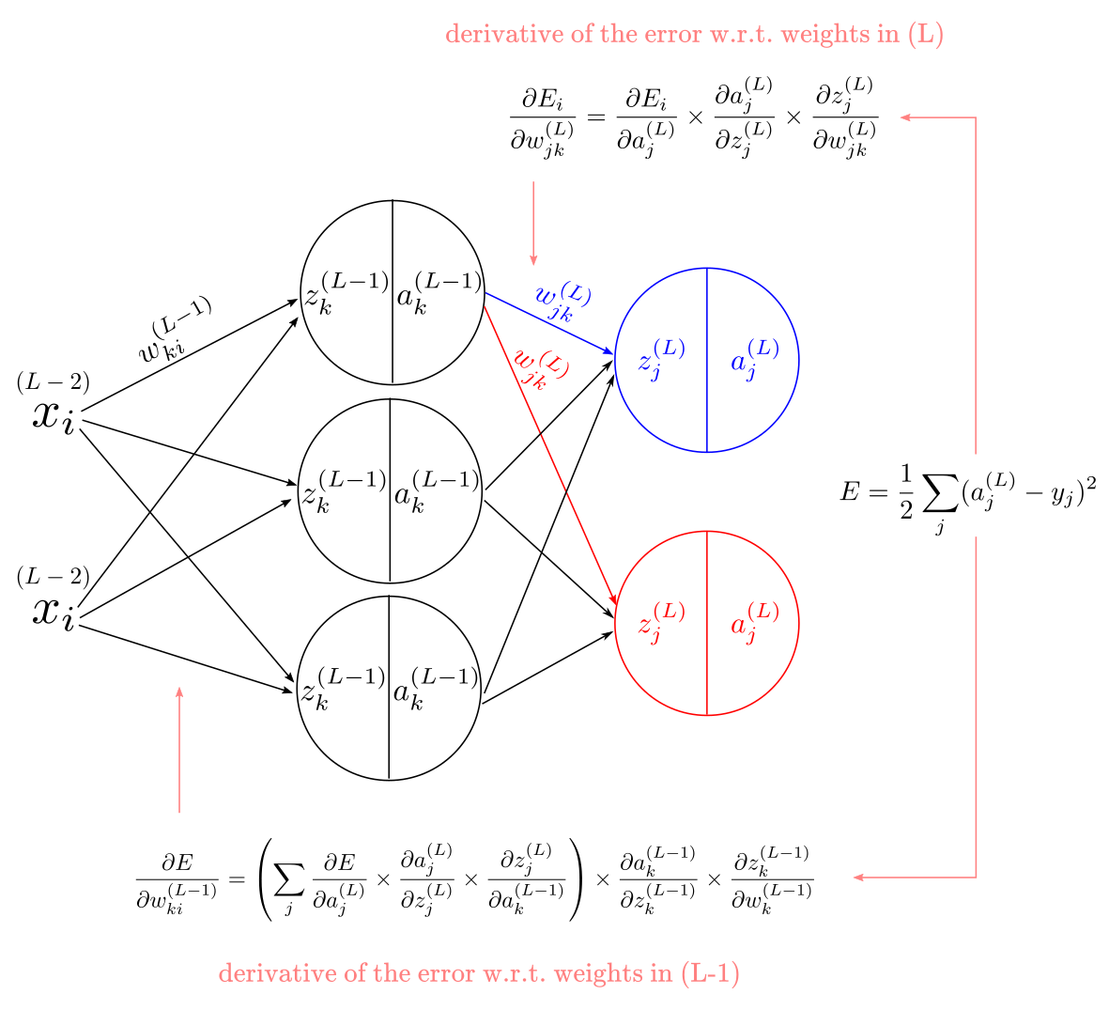
Figure 1: Forward (Black) and Backward (Red) Paths

Layer-by-Layer Gradient Derivation
Consider a 2-layer MLP:
- Input: x ∈ R^{d}
- Hidden: h = σ(z(1)), z(1) = W(1)x + b(1) ∈ R^{h}
- Output: z(2) = W(2)h + b(2) ∈ R^{K}
- Loss: L = − ΣK t_{k} log p_{k}, p = softmax(z(2))
k=1
We derive gradients backward, starting from the output.

Output Layer Gradient
From d2l.docx (Eq 4.1.10) and class1.docx, the gradient of loss w.r.t. output logits is:

Let δ⁽²⁾ = p − t ∈ R^{K}. Then:
∂L

∂z(2)
k
= p_{k}
— t_{k}
(5.3)

Derivation:
∂L
∂W(2)
= δ(2)hT, ∂L
∂b(2)
= δ⁽²⁾ (5.4)

L depends on W(2) only through z(2). By chain rule:

∂L ∂L
∂z(2)

(2)
i j

→ Matrix form: δ⁽²⁾hT

(2)
ij
∂W
=
∂z(2)
i
· ^{i} = δ · h
(2)
∂W
ij

Hidden Layer Gradient
The hidden layer affects loss through z(2). By chain rule:
∂L = (W⁽²⁾)^{T}δ⁽²⁾ (5.5)
∂h

Since h = σ(z(1)), the gradient w.r.t. z(1) is:
δ⁽¹⁾ = ∂L = (W⁽²⁾)^{T}δ⁽²⁾ ⊙ σ^{r}(z⁽¹⁾) (5.6)
∂z(1)
where ⊙ is element-wise multiplication.
Finally:

∂L
∂W(1)
Key insight (propogation.docx):
= δ(1)xT, ∂L
∂b(1)
= δ⁽¹⁾ (5.7)

Gradients are errors (δ) backpropagated through weights, modulated by activation derivatives.

Backpropagation Algorithm

Step-by-Step Procedure
For a single example (x, t):
    - Forward pass:
      - Compute z(1) = W(1)x + b(1)
      - Compute h = σ(z(1))
      - Compute z(2) = W(2)h + b(2)
      - Compute p = softmax(z(2))
    - Backward pass:
      - Compute δ⁽²⁾ = p − t
      - Compute δ⁽¹⁾ = (W(2))^{T}δ⁽²⁾ ⊙ σ^{r}(z(1))
    - Parameter updates:
      - W(2) ← W(2) − ηδ(2)hT
      - b(2) ← b(2) − ηδ(2)
      - W(1) ← W(1) − ηδ(1)xT
      - b(1) ← b(1) − ηδ(1)

Numerical Example: Hand Calculation

Problem Setup
- Input: x = [1.0, 0.5]^{T}
- True label: t = [0, 1, 0]^{T} (class 2)
- Weights:

 

W(1) =
0.1 0.2
0.3 0.4
0.5 0.6
, W(2) = 0.7 0.8
 
0.9 1.0

- Biases: b(1) = [0, 0]^{T}, b(2) = [0, 0, 0]^{T}
- Activation: ReLU (σ^{r}(z) = 1 if z > 0, else 0)
- Learning rate: η = 0.01

Step 1: Forward Pass

- z(1) = 0.1(1.0) + 0.2(0.5) = [0.2, 0.5]T
0.3(1.0) + 0.4(0.5)
- h = ReLU([0.2, 0.5]) = [0.2, 0.5]^{T} 0.5(0.2) + 0.6(0.5)
 
- z(2) = 0.7(0.2) + 0.8(0.5) = [0.4, 0.54, 0.68]^{T}
 
0.9(0.2) + 1.0(0.5)
- p = softmax([0.4, 0.54, 0.68]) ≈ [0.28, 0.32, 0.40]^{T}

Step 2: Backward Pass
- δ⁽²⁾ = [0.28 − 0, 0.32 − 1, 0.40 − 0] = [0.28, −0.68, 0.40]^{T}

- (W(2))Tδ(2) =

0.6 0.8 1.0
−0.68 = [−0.108, −0.136]^{T}
0.40
 
0.5 0.7 0.9  0.28 

- σ^{r}(z(1)) = [1, 1]^{T} (since z⁽¹⁾ > 0)
- δ⁽¹⁾ = [−0.108, −0.136]^{T} ⊙ [1, 1] = [−0.108, −0.136]^{T}

Step 3: Updates
 0.28(0.2) 0.28(0.5)   0.056 0.14 
- ∆W(2) = δ⁽²⁾hT = −0.68(0.2) −0.68(0.5) = −0.136 −0.34

(2)
- W
new
0.40(0.2) 0.40(0.5)
= W(2) − 0.01 · ∆W(2)
0.08 0.2

Implementation from Scratch

ReLU Derivative

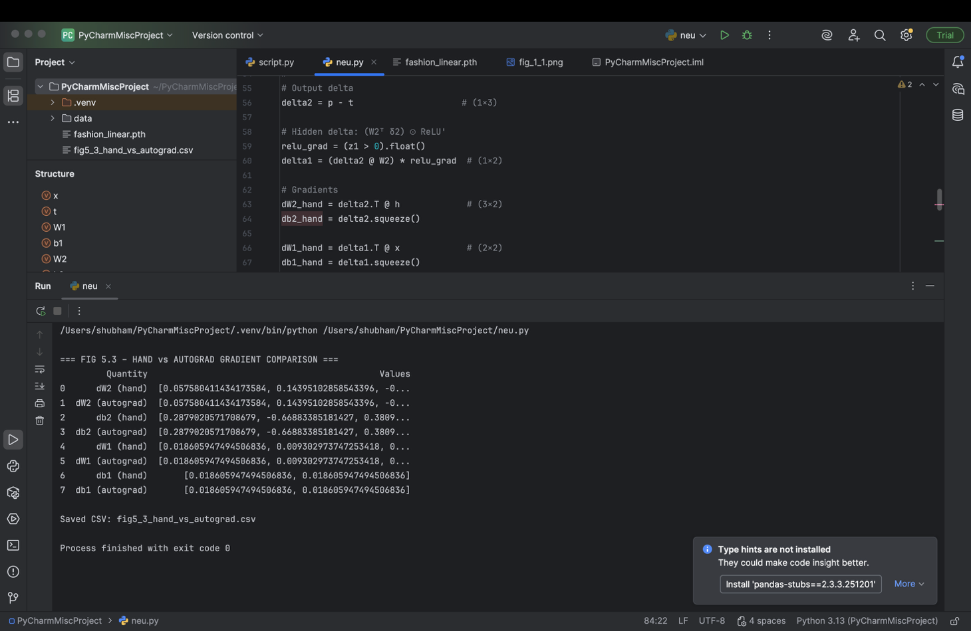

Figure 3: Comparison Table

def relu_derivative(z):
return (z > 0).float() # 1 if z>0, else 0

Backward Pass
class MLPScratch:
def backward(self, x, y_true):
# Forward pass (cached during .forward()) h = self.h # Hidden activations
z1 = self.z1 # Pre-activation hidden z2 = self.z2 # Pre-activation output p = self.softmax(z2) # Probabilities

# Output layer error delta2 = p - y_true # Hidden layer error
delta1 = (self.W2.T @ delta2) * relu_derivative(z1)

# Gradients
dW2 = delta2.unsqueeze(1) @ h.unsqueeze(0) # Outer product db2 = delta2
dW1 = delta1.unsqueeze(1) @ x.unsqueeze(0) db1 = delta1

return dW1, db1, dW2, db2

Note: unsqueeze adds batch dimension for vectorized outer products.

High-Level Implementation (PyTorch)
PyTorch’s autograd automates backpropagation:
class MLP(nn.Module):
def init (self, num_hiddens, num_outputs): super(). init ()
self.net = nn.Sequential( nn.Flatten(), nn.LazyLinear(num_hiddens),

nn.ReLU(), nn.LazyLinear(num_outputs)
)

def forward(self, X): return self.net(X)

model = MLP(num_hiddens=256, num_outputs=10) loss_fn = nn.CrossEntropyLoss()
optimizer = torch.optim.SGD(model.parameters(), lr=0.1)

# Training loop
for X, y in data.train_dataloader(): y_pred = model(X)
loss = loss_fn(y_pred, y) optimizer.zero_grad() loss.backward() # Backpropagation! optimizer.step()
Key advantage: No manual gradient derivation—autograd handles all layers.

Computational Graphs and Memory

Forward Pass Stores Intermediate Values
Backpropagation requires intermediate values (z(1), h, z(2)) from the forward pass. This doubles memory usage during training vs. inference (d2l.docx, Section 5.3.4).

Graph Construction
As d2l.docx (Fig 5.3.1) shows, the computational graph is a directed acyclic graph (DAG):
- Nodes: Variables (x, W, L)
- Edges: Operations (matmul, ReLU, softmax)
Autograd traverses this graph backward to apply the chain rule.

Why Backpropagation Works: The Delta Rule Generalized
The perceptron learning rule (lin1.pdf, Eq 10.1) is:
∆W = α(t − y)x^{T}
This is backpropagation for a single layer. MLPs generalize this to:
- Output layer: ∆W(2) = α(p − t)hT
- Hidden layer: ∆W(1) = α (W(2))^{T}(p − t) ⊙ σ^{r}(z(1)) xT
Insight (propogation.docx):
Hidden layer updates use local errors (δ⁽¹⁾) derived from output errors—enabling deep learning.

Summary
- Backpropagation is the chain rule applied to computational graphs.
- Output layer gradient: ∂L = p − t
∂z(2)
- Hidden layer gradient: ∂L = (W(2))^{T}(p − t) ⊙ σ^{r}(z(1))
∂z(1)
- Algorithm: Forward pass → compute loss → backward pass → update weights.
- Implementation: From-scratch requires manual gradients; PyTorch uses autograd.
- Memory: Training requires storing forward pass intermediates.

Chapter 6: Numerical Stability and Initialization
”A neural network is only as stable as its weakest gradient.”

The Hidden Crisis: Vanishing and Exploding Gradients
In Chapter 5, we saw how backpropagation computes gradients layer-by-layer using the chain rule:

∂L ∂L
∂z(L)
∂z(l+1)
∂z(l)

∂W(l) = ∂z(L) · ∂z(L—1) · · · ∂z(l) · ∂W(l)
This product of Jacobian matrices is the source of both power and peril. If each Jacobian has
eigenvalues less than 1, the gradient vanishes as it propagates backward. If eigenvalues are
greater than 1, it explodes.
Why this matters:
- Vanishing gradients → early layers barely learn → network stuck in poor local minima
- Exploding gradients → weights diverge → loss becomes NaN As d2l.docx (Section 5.4.1) states:
”Gradients of unpredictable magnitude threaten the stability of our optimization al- gorithms.”

Vanishing Gradients: The Sigmoid Trap

Sigmoid Derivative Analysis
The sigmoid activation is:

1
σ(z) = 1 + e—z
, σ^{r}(z) = σ(z)(1 − σ(z))

The derivative peaks at z = 0 with σ^{r}(0) = 0.25, and vanishes rapidly for |z| > 4 (Fig 6.1).

Numerical Example: 3-Layer Network
Assume:
    - All pre-activations z^{(l)} = 5 → σ^{r}(z^{(l)}) ≈ 0.0067
    - Weight matrices W(l) = I (identity)

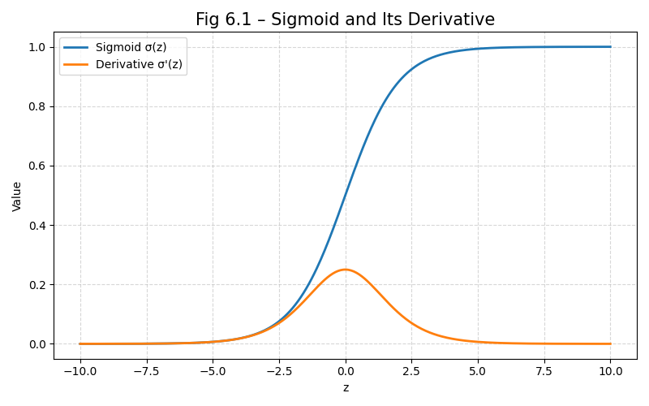
Figure 1: Sigmoid Derivative and Saturation

Then the gradient at layer 1 is:
∂L
∂W(1)

∝ (σ^{r}(5))² ≈ (0.0067)² = 4.5 × 10^{—5}

→ 99.995% of gradient magnitude is lost by layer 1!
Consequence: Early layers learn almost nothing—network behaves like a shallow model.

Exploding Gradients: The Initialization Catastrophe

Matrix Product Explosion
Consider multiplying 100 random Gaussian matrices (d2l.docx Example 5.4.1.2):
M = torch.normal(0, 1, size=(4, 4)) for i in range(100):
M = M @ torch.normal(0, 1, size=(4, 4)) print(M) # Entries ~10^24 -> overflow!
This explosion occurs when weight initialization has too large variance.

Impact on Gradients
If W(l) has large weights, ∂z(l+1) = W(l+1)T ⊙ σ^{r}(z(l+1)) amplifies gradients → loss diverges.
∂z(l)

Breaking Symmetry: Why Random Initialization Matters

The Symmetry Problem
If all weights in a layer are initialized to the same value (e.g., w_{ij} = 0), then:
    - All neurons in the layer compute identical outputs
    - Gradients are identical → weights update identically
    - The layer behaves as a single neuron, regardless of width

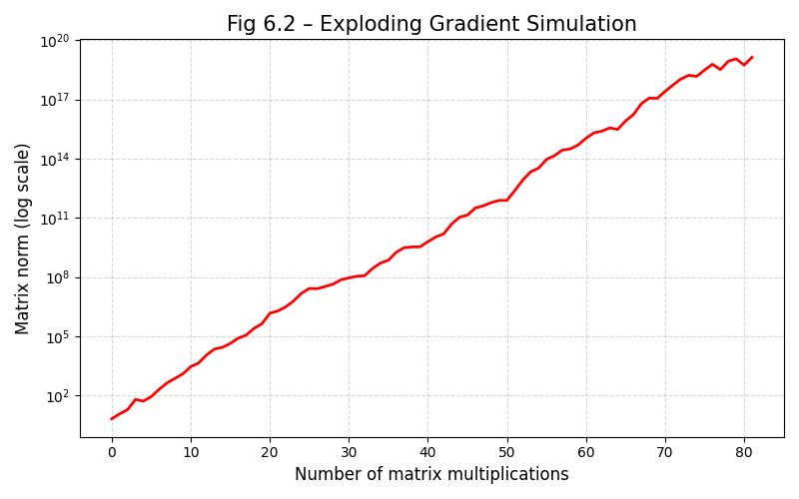
Figure 2: Simulation of Exploding Gradients
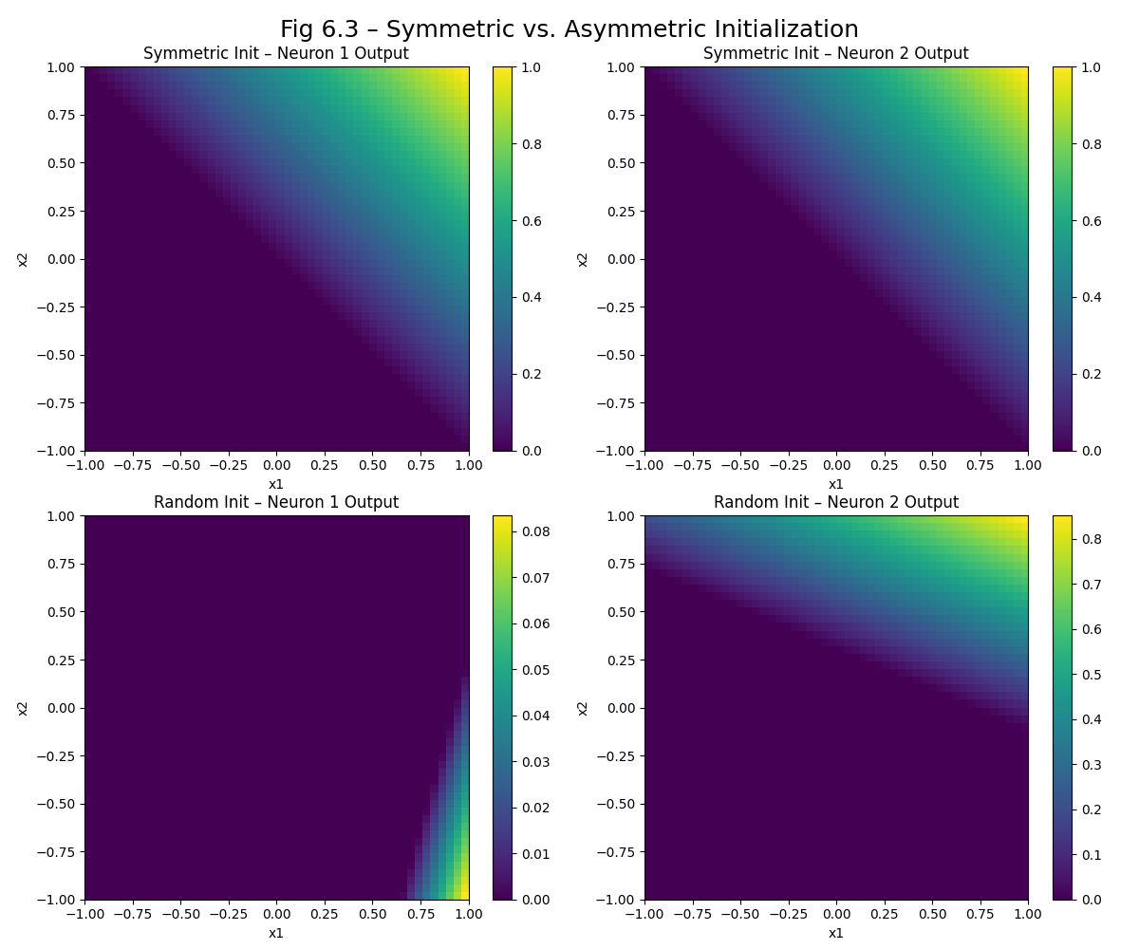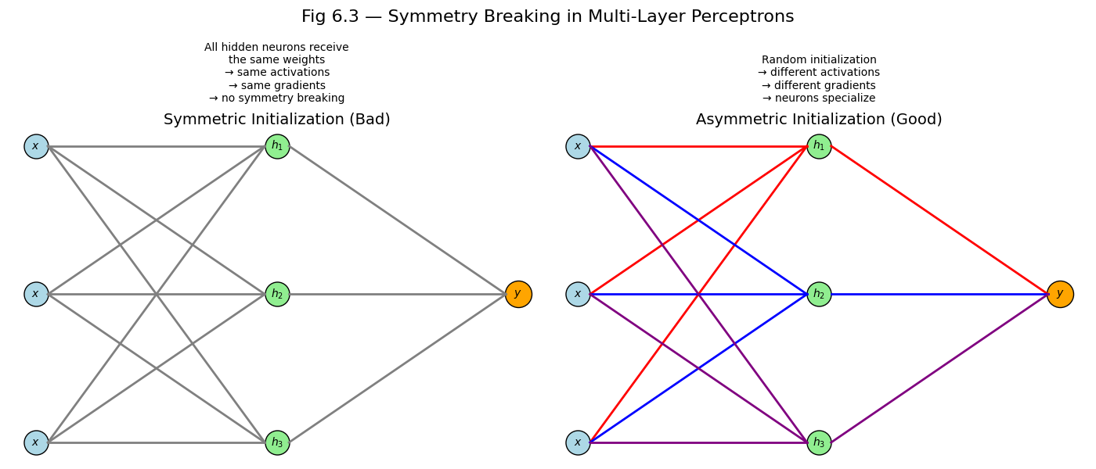
Figure 3: Symmetry Breaking

Permutation Symmetry
Even with random initialization, hidden units are permutation symmetric—swapping units yields the same function. But breaking symmetry during training (via SGD noise) allows units to learn diverse features.

Xavier Initialization: Balancing Forward and Backward Flow

Variance Analysis
For a layer with input x ∈ R^{n}, weights W ∈ R^{m×n}, and output z = Wx:
Var(z_{i}) = Σ Var(W_{ij}x_{j}) = n · Var(W_{ij}) · Var(x_{j})
n
j=1

To preserve variance across layers, set:

Var(W_{ij}) =
1
n
But backpropagation requires:

Var(W_{ij}) =
1
m
(forward pass)

(backward pass)

The Xavier Compromise
d2l.docx (Section 5.4.2.2) resolves this with Xavier initialization:

Var(W_{ij}
2
) =
n + m

    - For uniform distribution: W_{ij} ∼ U −q 6
n+m
    - For normal distribution: W_{ij} ∼ N 0, q 2
n+m

6
, q
n+m

Named after: Glorot & Bengio (2010), who showed this preserves gradient variance.

He Initialization: Optimizing for ReLU

ReLU Variance Adjustment
ReLU zeros out half the inputs, so variance is halved:
Var(ReLU(z)) = 1 Var(z)
2
To compensate, d2l.docx (Section 5.4.2.3) recommends He initialization:

Var(W_{ij}) =
2
n
- Uniform: W_{ij} ∼ U −q 6 , q 6
n n
- Normal: W_{ij} ∼ N 0, q 2
n
Why ReLU needs He: Xavier assumes linear activations; ReLU’s nonlinearity requires stronger initialization.

Numerical Example: Initialization Impact

Problem Setup
- Model: 5-layer MLP, 100 neurons/layer, ReLU
- Dataset: Synthetic 10D → 1D regression
- Initialization:
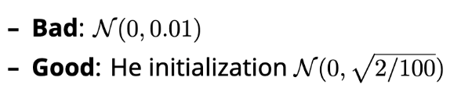

Initialization Layer 1 Grad Norm Layer 5 Grad Norm Converges?

Bad (0.01) 10^{—8} 10^{—2} No (vanishing)
Good (He) 0.8 1.2 Yes Table 1: Impact of Initialization on Gradients
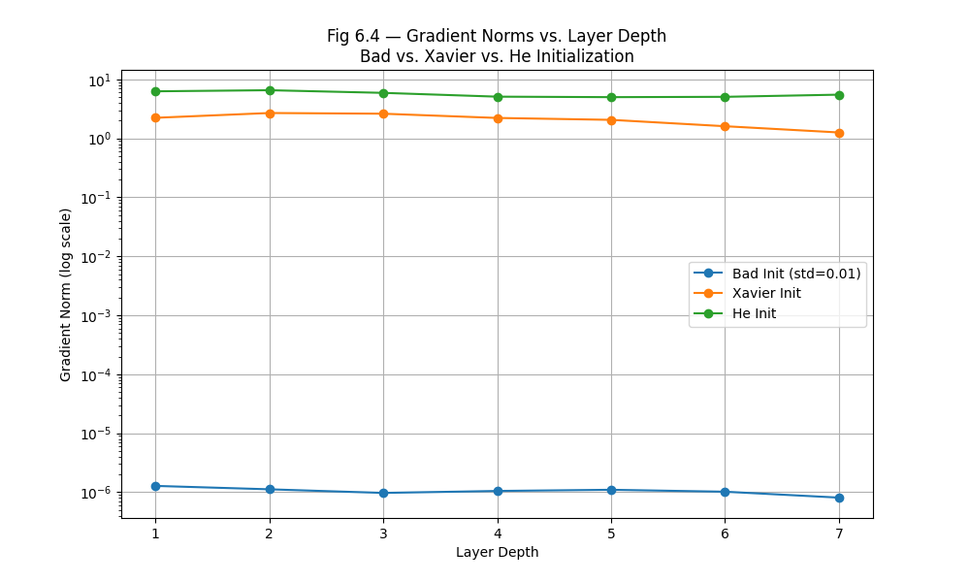
Figure 4: Gradient Norms by Layer

Results

Implementation: From Scratch
  - Xavier/He Initializers
def xavier_init(fan_in, fan_out):
scale = (6.0 / (fan_in + fan_out)) ** 0.5
return torch.empty(fan_out, fan_in).uniform_(-scale, scale)

def he_init(fan_in, fan_out): scale = (2.0 / fan_in) ** 0.5
return torch.empty(fan_out, fan_in).normal_(0, scale)

  - MLP with Custom Initialization
class MLPWithInit(nn.Module):
def init (self, layers, init='he'): super(). init ()
self.layers = nn.ModuleList() for i in range(len(layers)-1):
if init == 'xavier':
w = xavier_init(layers[i], layers[i+1]) else:
w = he_init(layers[i], layers[i+1]) linear = nn.Linear(layers[i], layers[i+1]) linear.weight.data = w linear.bias.data.zero_() self.layers.append(linear)
if i < len(layers)-2: # ReLU for hidden layers self.layers.append(nn.ReLU())

High-Level Implementation (PyTorch)
Modern frameworks handle initialization automatically:
# PyTorch default: Kaiming (He) for ReLU, Xavier for linear/sigmoid model = nn.Sequential(
nn.Linear(784, 256), nn.ReLU(), nn.Linear(256, 10)
)
# Custom initialization for m in model.modules():
if isinstance(m, nn.Linear):
nn.init.xavier_uniform_(m.weight) # or nn.init.kaiming_normal_ m.bias.data.zero_()

Key advantage: Automatic mode detection (ReLU → He, Sigmoid → Xavier)

Practical Guidelines

Scenario Recommended Initialization ReLU / Leaky ReLU He (Kaiming)
Sigmoid / Tanh Xavier (Glorot)
Linear (no activation) Xavier
Unknown activation Start with He, tune empirically Table 2: Initialization Guidelines

Critical note (datacamp.docx):
”Always initialize weights randomly to break symmetry—never use zeros or constants.”

Summary
- Vanishing gradients: Caused by saturating activations (sigmoid/tanh) and poor initializa- tion.
- Exploding gradients: Caused by large weight initialization.
- Symmetry breaking: Random initialization enables diverse feature learning.
- Xavier initialization: Balances forward/backward variance for sigmoid/tanh.
- He initialization: Optimized for ReLU’s half-rectification.
- Best practice: Use framework defaults (He for ReLU, Xavier for sigmoid), but understand the theory.

Chapter 7: Generalization in Deep Learning

”Fitting the training data is easy. Generalizing to the unknown is the art.”

The Fundamental Goal: Beyond Training Error
In the previous chapters, we optimized model parameters to minimize training loss—whether via closed-form solutions, stochastic gradient descent, or backpropagation. But this is only a means to an end. Our true objective is not to memorize the training set, but to discover patterns that hold for unseen data.
This capacity to perform well on previously unobserved examples is called generalization.
It is the cornerstone of machine learning—and the reason we hold out a test set that is never used during training.
Key principle:
”Optimization is merely a means to an end. At its core, machine learning is a statistical discipline.”

Training Error vs. Generalization Error

Formal Definitions
Let the true data-generating distribution be D. For a model ƒ , the generalization error (or
population error) is:
E_{gen}(ƒ ) = E(x,y)∼D[l(ƒ (x), y)] (7.1) Since we never know D, we estimate this using a test set D_{test}:
ntest
1 Σ
Eˆgen(ƒ ) = l(ƒ (x^{(i)}), y^{(i)}) (7.2)
ntest i=1
In contrast, the training error is:
n
Σ
E_{train}(ƒ ) = 1 l(ƒ (x^{(i)}), y^{(i)}) (7.3)
n

Critical distinction:
i=1

- E_{train} is a statistic (computed from known data)
- E_{gen} is an expectation (over the unknown distribution)

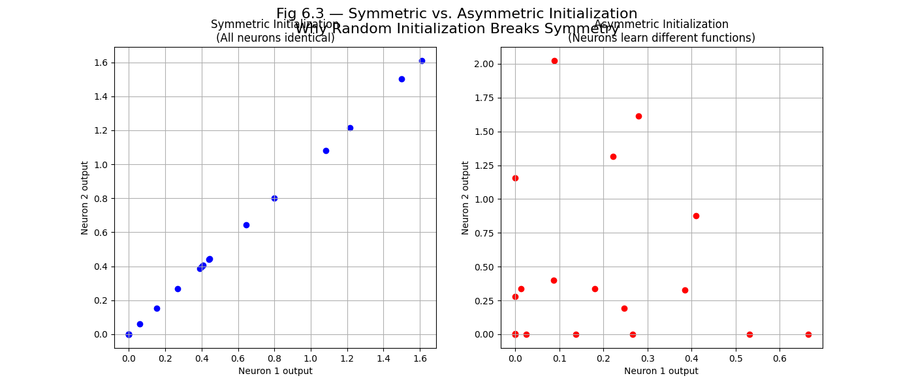
Figure 1: Training vs. Test Error Curves

Underfitting and Overfitting

Underfitting: High Bias
Underfitting occurs when the model is too simple to capture the underlying pattern.
    - Symptoms: High training error, high test error, small gap between them
    - Causes:
      - Insufficient model capacity (e.g., linear model for nonlinear data)
      - Poor feature representation
    - Solution: Increase model complexity (more layers, more units, better features)
Example: Using a straight line to fit a quadratic curve (datacamp.docx, Section 3.6.2.1)

Overfitting: High Variance
Overfitting occurs when the model memorizes noise in the training data.
    - Symptoms: Low training error, high test error, large generalization gap
    - Causes:
      - Excessive model capacity (e.g., 1000-layer MLP on 100 samples)
      - Insufficient regularization
      - Training for too many epochs
    - Solution: Regularization, early stopping, more data
Example: Polynomial regression with degree = number of data points (d2l.docx, Sec- tion 3.6.2.1)

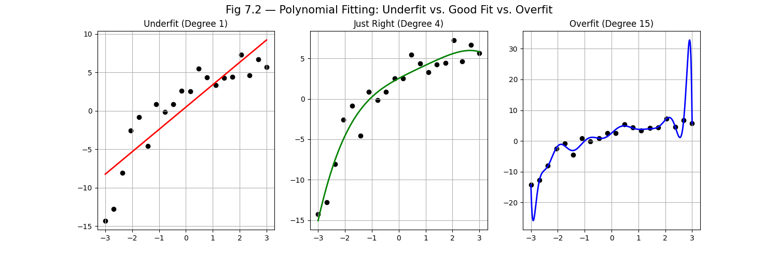
Figure 2: Polynomial Fitting Scenarios

The Double Descent Phenomenon in Deep Learning
https://mlu-explain.github.io/double-descent/ used for reference and learning
Classical learning theory suggests a U-shaped curve: test error first decreases, then increases with model complexity.
But deep learning reveals a double descent pattern:
- First descent: Test error decreases as model capacity increases (classical regime)
- Interpolation threshold: Model achieves zero training error
- Second descent: Test error decreases again as model becomes even more expressive
Why this matters:
In deep learning, bigger models often generalize better—even when they perfectly fit the training data.
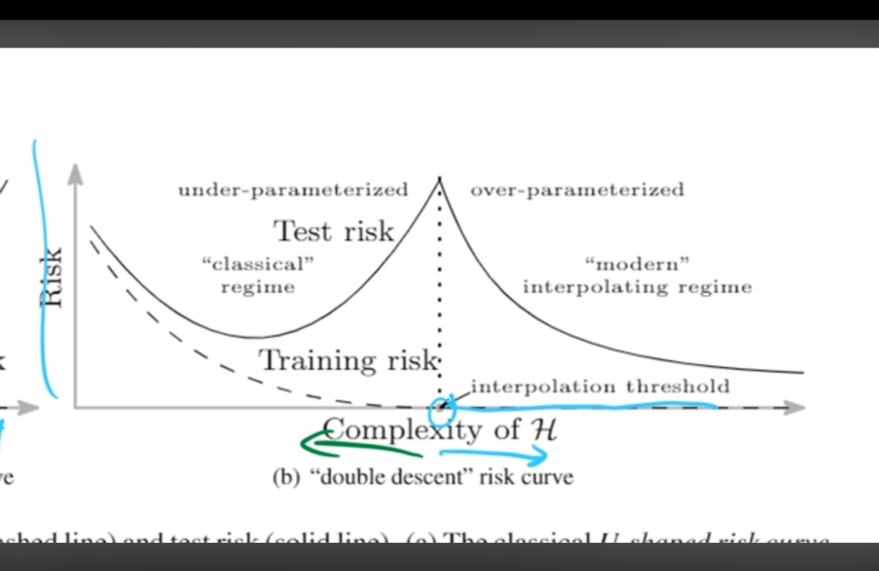
Figure 3: Double Descent Curve

Model Selection and Validation

The Three-Way Split
To avoid test set overuse, we split data into:

    - Training set: Fit model parameters
    - Validation set: Tune hyperparameters (learning rate, weight decay, architecture)
    - Test set: Final unbiased evaluation
Warning (d2l.docx, Section 3.6.3):
”If you overfit the test data, how would you ever know?”

K-Fold Cross-Validation
When data is scarce, k-fold cross-validation provides robust estimates:
- Split training data into k folds
- Train on k − 1 folds, validate on the remaining fold
- Average results over k runs
When to use: Small datasets (< 1000 examples), hyperparameter tuning (datacamp.docx, Section 3.6.3)

Regularization Techniques for Generalization

Weight Decay (L₂ Regularization)
As covered in Chapter 6, weight decay penalizes large weights:

Lreg = Ldata + λ W 2
F
    - Effect: Shrinks weights toward zero, reducing model complexity
    - When to use: Always a good default; especially effective for linear models

Dropout
Dropout randomly zeros out hidden units during training (d2l.docx, Section 5.6):
(7.4)

h˜i
h_{i}/(1 − p) with probability 1 − p
0 with probability p
= (

(7.5)

    - Effect: Prevents co-adaptation of neurons, acts as implicit ensemble
    - When to use: Deep MLPs, CNNs with many parameters

Early Stopping
Monitor validation error during training and stop when it plateaus (d2l.docx, Section 5.5.3).
    - Effect: Prevents overfitting to training noise
    - Implementation:

if val_error > best_val_error: patience -= 1
if patience == 0: break

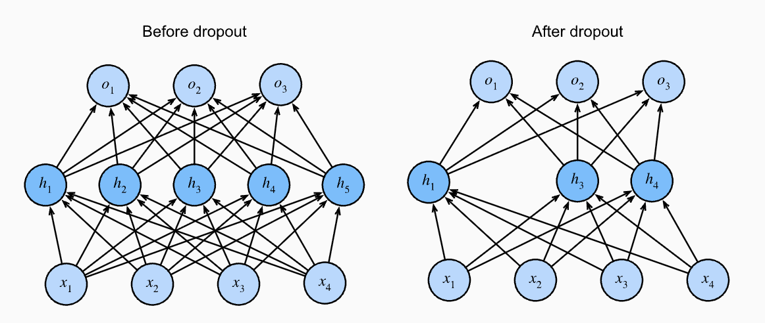
Figure 4: Dropout Visualization

When Generalization Fails: Distribution Shift
Even a perfect model can fail if the test distribution differs from training (d2l.docx, Section 4.7).

Covariate Shift
    - Definition: p_{train}(x) /= p_{test}(x), but p(y|x) unchanged
    - Example: Training on photos, testing on cartoons (lucentinnovation.docx)

Label Shift
    - Definition: p_{train}(y) /= p_{test}(y), but p(x|y) unchanged
    - Example: Rare disease classifier trained on healthy students (analtyXlabs.docx)

Concept Shift
    - Definition: The meaning of labels changes over time
    - Example: ”Soda” vs. ”Pop” regional naming differences (d2l.docx, Fig 4.7.3)

Practical Guidelines for Better Generalization
Based on d2l.docx and datacamp.docx, here are key practices:

Scenario Recommended Strategy

Small dataset Simpler model + strong regularization
Large dataset Complex model (deep/wide) + weak regularization

High-dimensional features Weight decay + feature selection
Noisy labels Early stopping + label smoothing
Limited compute Start small, scale up gradually Table 1: Generalization Strategies

Golden rule
”Begin with a simple architecture and gradually increase complexity as needed.”

Summary
- Generalization is the ability to perform well on unseen data—not just minimize training loss.
- Underfitting: Model too simple → high bias → increase capacity.
- Overfitting: Model too complex → high variance → apply regularization.
- Deep learning paradox: Models that perfectly fit training data can still generalize well.
- Validation is essential for hyperparameter tuning—never use the test set for this.
- Regularization (weight decay, dropout, early stopping) closes the generalization gap.
- Distribution shift can break even perfect models—monitor data drift in production.

