Linear Algebra
Linear Algebra
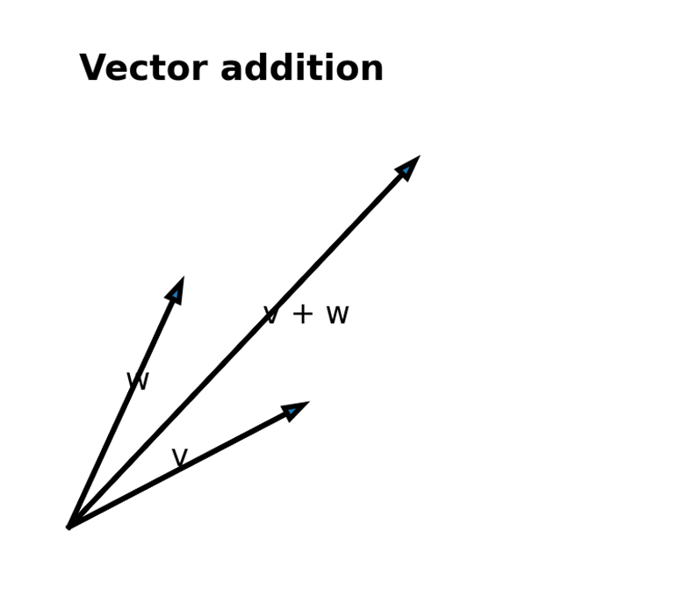

Contents
· Module Goal
· What a vector is and how to think about it
· Vectors as Python lists
· Vector addition and subtraction
· Vector sum, scalar multiplication, and vector mean
· Dot product and projection
· Magnitude, sum of squares, and distance
· What a matrix is
· Shape, rows, columns, and matrix construction
· Identity matrices and diagonal patterns
· Matrices for datasets
· Matrices for relationships and networks
· Why linear algebra matters in data science
· Quick revision sheet
· Practice questions

1. Understanding Linear Algebra in Data Science

Module Goal
The goal of this section is to show why linear algebra is one of the first math tools a data scientist should understand. It gives us a clean way to represent many related numbers together and to work with them as one object.
By the end of this section, you should feel comfortable with the idea that data can be stored as vectors and matrices, and that these objects are not abstract decorations. They are practical tools for organizing, comparing, and transforming information.

Main Content
Linear algebra is the branch of mathematics that studies vectors, matrices, and the rules for combining them. the chapter begins with the simple idea that we can think of a list of numbers as a vector. Once that idea clicks, a lot of later data science ideas become easier to understand.
A data scientist uses linear algebra whenever data has more than one feature. If one row stores a person's height, weight, and age, then that row is already a vector. If a whole table stores many people, then the table is a matrix. In other words, linear algebra helps us move from a single number to a structured collection of numbers.
The most important mental shift is this: you do not need to see vectors and matrices as purely symbolic math objects. You can see them as containers for real data. Once you start doing that, operations like adding, averaging, and comparing become much more natural.
uses very small examples on purpose. Small examples are easier to inspect, easier to code from scratch, and easier to understand. That is why the chapter begins with basic vector operations before moving to matrices.

Real World Examples
A person can be described by a vector such as [height, weight, age]. A student can be described by [exam1, exam2, exam3, exam4]. A movie can be described by [budget, rating, runtime, votes]. The numbers are different, but the idea is the same: each vector stores related information in one place.
In machine learning, the same style of representation appears again and again. Recommendation systems store preferences, text models store counts, and image models store pixel values. The structure changes, but the algebra stays useful.
This is why linear algebra is not only for mathematicians. It is a language for data.

Code Implementation
# A tiny example of data as vectors
person_1 = [70, 170, 40] # height, weight, age
person_2 = [65, 120, 26]

# You can treat each row as one observation
dataset = [person_1, person_2]

print("Number of features:", len(person_1))
print("Number of people:", len(dataset))

Conclusion
The big takeaway is simple: linear algebra gives us a language for multivariate data.
When you understand vectors and matrices, you are better prepared for statistics, machine learning, and data analysis.

2. What Is a Vector?

Goal
The goal here is to build an easy and practical understanding of a vector. A vector is not just a list of numbers; it is a way to describe one object using several related measurements.
After this section, you should know how to interpret a vector in plain language and why the same idea works for many different kinds of data.

Main Content
Abstractly, a vector is something you can add to another vector and multiply by a number. That is the algebra part. Concretely, in data science, a vector is usually a point in a finite-dimensional space. That means each coordinate tells us something about the object we are studying.
For example, if we take the vector [70, 170, 40], we might read it as height, weight, and age. If we take the vector [95, 80, 75, 62], we can read it as scores across four exams. The numbers are not random. They are coordinates that belong together.
One helpful idea is to think of a vector as a compact summary of a real-world thing. Instead of carrying three separate variables around, we carry one vector. That makes it easier to compare objects, compute averages, and measure distance.
In geometry, a vector can also be imagined as an arrow from the origin to a point. That picture is useful because it gives direction and size. In data science, we often care less about the picture and more about the coordinates, but both views are useful.

Real World Examples
A profile on a social app could be a vector of interests, age, activity level, and location code.
A customer could be represented by spending totals across different product categories.
A document could be represented by counts of important words or topics.

Code Implementation
# Vector as a simple list of numbers
height_weight_age = [70, 170, 40]
exam_scores = [95, 80, 75, 62]

print(height_weight_age)
print(exam_scores)
print("Vector length:", len(exam_scores))

Conclusion
A vector is a neat package of related numbers.
Once you start seeing data this way, many later ideas become much easier to understand.

3. Vectors as Python Lists

Goal
Python lists to represent vectors from scratch. The goal is not performance. The goal is understanding.
You should leave this section knowing how a vector becomes a list, and why that simple choice lets us write our own math functions.

Main Content
The simplest way to represent a vector in Python is to store its components in a list. If a vector has three coordinates, we put three numbers in a list. If it has four coordinates, we put four numbers in a list. That keeps the data structure easy to read and easy to manipulate.
The advantage of lists is that they are familiar and flexible. The disadvantage is that Python lists do not know anything about vector arithmetic. If we want to add vectors, subtract vectors, or find distances, we must write those functions ourselves.
By building the operations from scratch, we learn what the operations actually do. Later, when we use NumPy or another library, the concepts will already feel familiar.
Another important detail is that vectors must have the same length when we compare them or combine them componentwise. A three-dimensional vector and a four-dimensional vector are not directly compatible for addition.

Real World Examples
A list like [1, 2, 3] can represent a point in 3D space.
A list like [85, 90, 78, 92] can represent four exam marks.
A list like [0.2, 0.5, 0.3] can represent probabilities or proportions.

Code Implementation
# Two vectors stored as lists
v = [1, 2, 3]
w = [4, 5, 6]

print("v:", v)
print("w:", w)
print("Same length?", len(v) == len(w))

Conclusion
Lists are a simple starting point for vector math.
They make the logic visible, which is exactly what we want while learning.

4. Vector Addition and Subtraction

Module Goal
The goal of this section is to understand componentwise addition and subtraction. These are the most basic vector operations and the foundation for many later calculations.
You should be able to explain why vectors can only be added when they have the same size and why each coordinate is handled separately.

Main Content
Vector addition works component by component. If v = [1, 2] and w = [3, 4], then v + w becomes [4, 6]. Each coordinate in the result comes from adding the matching coordinates in the two vectors.
Subtraction works the same way. If v = [5, 7] and w = [2, 3], then v - w becomes [3, 4]. This is useful when we want to compare two objects or measure how far one is from another along each feature.
vector addition is not just a programming trick. It matches our idea of combining related measurements. If one vector is a baseline and another is a change, then adding them gives a new state.
A useful mental model is to think of each vector as a list of separate dials. Addition turns each dial forward using the matching dial in the other vector. Subtraction turns it backward.

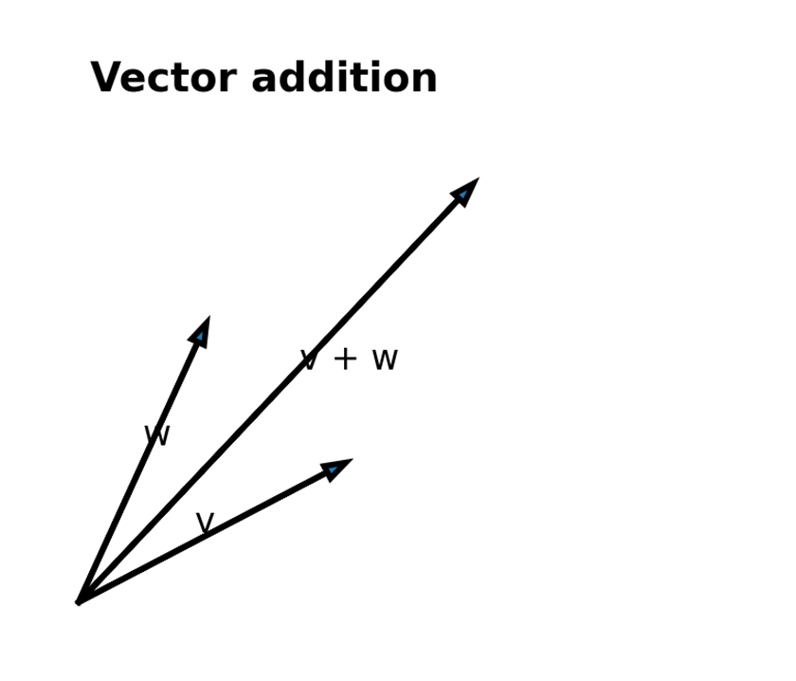

Real World Examples
If one customer spends [100, 200, 50] and then spends [20, 30, 10] more, the new spending vector is [120, 230, 60].
If two students have score vectors, subtracting one from the other shows where the differences are strongest.
In image processing, two pixel vectors can be added or compared coordinate by coordinate.

Code Implementation
def vector_add(v, w):
return [v_i + w_i for v_i, w_i in zip(v, w)]

def vector_subtract(v, w):
return [v_i - w_i for v_i, w_i in zip(v, w)]

print(vector_add([1, 2], [3, 4]))
print(vector_subtract([5, 7], [2, 3]))

Conclusion
Vector addition and subtraction let us move smoothly between related points in the same space.
These operations are simple, but they appear everywhere in data work.

5. Vector Sum, Scalar Multiplication, and Vector Mean

Module Goal
The goal here is to understand how to combine many vectors and how to scale a vector by a number.
By the end of this section, you should know why vector sum and vector mean are so useful when analyzing groups of observations.

Main Content
Sometimes we do not want to add only two vectors. We want to add many vectors at once. For that, we use vector sum. The result is a vector whose coordinates are the sums of the matching coordinates from each input vector.
Scalar multiplication means multiplying every coordinate of a vector by the same number. If the scalar is 2, every component doubles. If the scalar is 0.5, every component is cut in half. This is a powerful way to scale data.
From scalar multiplication and vector sum, we get vector mean. The mean of a list of vectors is just the sum divided by the number of vectors. That is one of the most common operations in data analysis because it gives a central representative of a collection.
These operations are especially important when we work with data matrices, averages across rows, and centroid-style calculations in clustering. The idea is simple, but the applications are broad.

Real World Examples
If three people have vectors [2, 4], [6, 8], and [10, 12], then their vector sum is [18, 24] and their mean is [6, 8].
If a feature vector is multiplied by 10, it means the measurement scale has been changed. This is common in finance, image processing, and unit conversion.
A team average can be computed by averaging each member's feature vector coordinate by coordinate.

Code Implementation
from functools import reduce

def scalar_multiply(c, v):
return [c * v_i for v_i in v]

def vector_sum(vectors):
return reduce(vector_add, vectors)

def vector_mean(vectors):
n = len(vectors)
return scalar_multiply(1 / n, vector_sum(vectors))

print(vector_sum([[1, 2], [3, 4], [5, 6]]))
print(vector_mean([[1, 2], [3, 4], [5, 6]]))

Conclusion
If addition combines objects, scalar multiplication changes their scale.
If vector sum combines many objects, vector mean gives us a central one.

6. Dot Product and Projection

Module Goal
This section explains one of the most important operations in linear algebra: the dot product.
You should understand both the formula and the intuition. The formula is easy. The intuition is that the dot product measures alignment.

Main Content
The dot product multiplies matching coordinates and adds the results. For vectors v and w, the dot product is v_1w_1 + v_2w_2 + ... + v_nw_n. It may look small, but it is extremely important.
Why is it important? Because the dot product tells us how much one vector points in the direction of another. If two vectors point in similar directions, the dot product is large and positive. If they point in opposite directions, the dot product is negative.
It connects the dot product to projection. If we imagine dropping one vector onto another, the dot product helps tell us how much of the first vector lies in the second vector's direction. That geometric picture is very helpful.
In data science, the dot product appears in similarity measures, linear models, scoring functions, and neural networks. So even though the definition is short, the role it plays is huge.
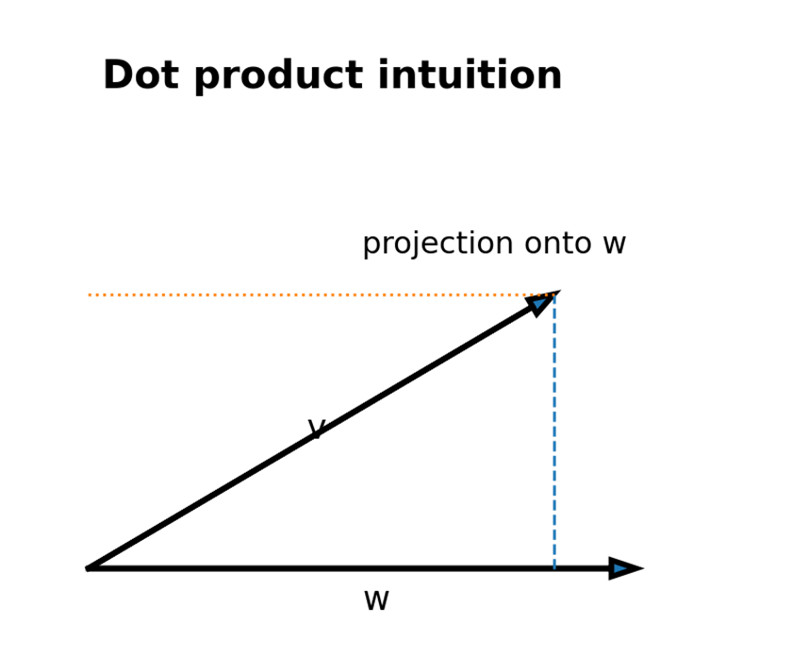
Dot product intuition: one vector can be viewed through the direction of another.

Real World Examples
A recommendation system may compare a user vector and an item vector using a dot product to estimate interest.
A search engine may use dot products to score how close a document vector is to a query vector.
A machine learning model may compute weighted sums, which are dot products in disguise.

Code Implementation
def dot(v, w):
return sum(v_i * w_i for v_i, w_i in zip(v, w))

print(dot([1, 2, 3], [4, 5, 6])) # 32
print(dot([1, 0], [7, 9])) # 7

Conclusion
The dot product is a compact way to measure alignment between vectors.
Once you understand it, many formulas in data science become easier to read.

7. Sum of Squares, Magnitude, and Distance

Module Goal
The goal of this section is to explain how a vector's size is measured and how we measure the distance between two vectors.
These ideas are basic geometry, but they are also central to clustering, nearest neighbors, and data comparison.

Main Content
The sum of squares of a vector is simply the dot product of the vector with itself. If v is [v1, v2, ..., vn], then the sum of squares is v1² + v2² + ... + vn². This quantity appears in many formulas.
The magnitude, or length, of a vector is the square root of the sum of squares. In ordinary geometry, that is the length of the arrow from the origin to the point. In data science, it is a way to measure how large a vector is.
Distance between two vectors is the magnitude of their difference. That is one of the clearest and most useful formulas in the chapter. It says: subtract componentwise first, then take the length of the result.
Distance is one of the most common ideas in machine learning. If two vectors are close, they may describe similar objects. If they are far apart, they may describe different objects.

Real World Examples
In a recommendation system, distance can help compare users or products.
In clustering, nearby points may belong to the same group.
In anomaly detection, points far from the others may be suspicious or unusual.

Code Implementation
import math

def sum_of_squares(v):
return dot(v, v)

def magnitude(v):
return math.sqrt(sum_of_squares(v))

def squared_distance(v, w):
return sum_of_squares(vector_subtract(v, w))

def distance(v, w):
return math.sqrt(squared_distance(v, w))

print(magnitude([3, 4])) # 5.0
print(distance([1, 2], [4, 6])) # 5.0

Conclusion
Magnitude tells us how long a vector is.
Distance tells us how far apart two vectors are, which is one of the most useful ideas in applied data work.

8. What Is a Matrix?

Module Goal
The goal of this section is to understand matrices as two-dimensional collections of numbers.
You should see how matrices extend the idea of vectors and why they are a natural way to store multiple observations.

Main Content
A matrix is a rectangular grid of numbers arranged in rows and columns. matrices are represented as lists of lists, where each inner list is a row. That choice is simple, readable, and easy to code from scratch.
A matrix lets us store a whole dataset in one object. If each row is a vector, then the matrix is a collection of vectors. That is a very common pattern in data science because most real datasets are not one-dimensional.
The shape of a matrix tells us how many rows and columns it has. A 2 × 3 matrix has two rows and three columns. Knowing the shape is crucial because many operations only work when shapes are compatible.
The chapter also points out that matrices can represent more than datasets. They can represent linear transformations and relationships between entities. That makes them very powerful.
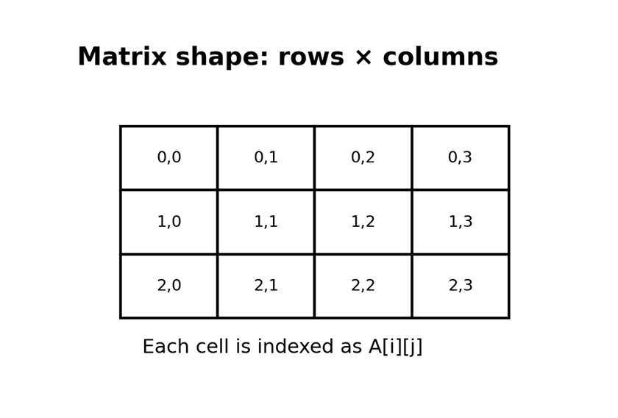
A transparent matrix diagram showing rows, columns, and cell positions

Real World Examples
A table of student marks is naturally a matrix.
A table of customer behavior features is naturally a matrix.
A network of friendships can also be represented by a matrix.

Code Implementation
A = [
[1, 2, 3],
[4, 5, 6]
]

print("Rows:", len(A))
print("Columns:", len(A[0]))
print("A[1][2] =", A[1][2])

Conclusion
Matrices are the two-dimensional cousins of vectors.
They are one of the main tools that let us organize large amounts of data cleanly.

9. Shape, Rows, Columns, and Matrix Construction

Module Goal
The goal here is to become comfortable with matrix shape and with the idea of reading rows and columns correctly.
You should also understand how to create a matrix programmatically instead of writing every entry by hand.

Main Content
If a matrix has n rows and k columns, its shape is written as n × k. In Python, the number of rows is len(A), and the number of columns is len(A[0]) if the matrix is not empty. That is enough to begin working with matrix dimensions.
Rows are usually easy because each row is already a list. Columns need a small helper function because we need to pick one item from each row. This is a common pattern in code: rows are stored directly, columns are derived when needed.
it shows how to create matrices using a function that generates entries one by one. That is a very flexible idea because you can create identity matrices, pattern matrices, or any structure you want without typing every value manually.
The important lesson is that matrix construction is not only about storage. It is also about building structured patterns from a rule.

Real World Examples
If a dataset has 1,000 rows and 3 features, its matrix shape is 1000 × 3.
If you want the first column, you collect the first element from every row.
If you want a checkerboard pattern or identity matrix, generating entries with a rule is much easier than typing them out.

Code Implementation
def shape(A):
return len(A), len(A[0]) if A else 0

def get_row(A, i):
return A[i]

def get_column(A, j):
return [A_i[j] for A_i in A]

def make_matrix(num_rows, num_cols, entry_fn):
return [[entry_fn(i, j) for j in range(num_cols)]
for i in range(num_rows)]

print(shape([[1, 2, 3], [4, 5, 6]]))
print(get_column([[1, 2, 3], [4, 5, 6]], 1))
print(make_matrix(3, 3, lambda i, j: 1 if i == j else 0))

Conclusion
Understanding shape, rows, and columns is essential before doing any serious matrix work.
Once these basics are clear, matrix manipulation becomes much easier.

10. Identity Matrices and Diagonal Patterns

Module Goal
The goal of this section is to understand the special structure of identity and diagonal matrices.
These matrices look simple, but they are surprisingly useful in algebra and computation.

Main Content
An identity matrix has 1s on the main diagonal and 0s everywhere else. It is the matrix version of the number 1, because multiplying by it leaves things unchanged in many algebraic settings.
A diagonal matrix is more general. It has non-zero values on the diagonal and zero values elsewhere. Identity matrices are a special case of diagonal matrices where all diagonal values are 1.
This pattern is useful because it makes certain operations very clean and easy to reason about. It also gives us a good way to generate test matrices and to understand matrix multiplication later on.
the identity matrix is created with a small function that checks whether row index and column index are equal. That is a very neat example of using a rule to generate a matrix.

Real World Examples
Identity matrices appear in algebra whenever we want an operation to preserve a vector or matrix.
Diagonal matrices show up in scaling operations, where each dimension is scaled independently.
Many numerical algorithms use diagonal or nearly diagonal matrices because they are computationally convenient.

Code Implementation
def is_diagonal(i, j):
return 1 if i == j else 0

identity_matrix = make_matrix(5, 5, is_diagonal)
for row in identity_matrix:
print(row)

Conclusion
Identity matrices are small but powerful.
They are one of the clearest examples of structure in linear algebra.

11. Matrices for Datasets

Module Goal
The goal here is to connect matrices to the kind of data tables you see every day.
You should see how a dataset becomes a matrix when each observation is stored as a row.

Main Content
When we store many vectors together, we naturally get a matrix. For example, a list of people with height, weight, and age can be stored as a matrix where each row is one person and each column is one feature.
This is extremely convenient because it lets us apply the same operations to many records at once. Instead of handling each person separately, we can write code that works over the whole matrix.
In data science, this is the standard way to think. Rows are observations, columns are features, and the matrix is the dataset. Once you are comfortable with that picture, later topics like statistics and machine learning feel much less mysterious.
note that a matrix can be used to represent a collection of vectors in general. That means a matrix is not just a table; it is a mathematical object with many possible meanings.

Real World Examples
A class with ten students and four exam scores can be stored in a 10 × 4 matrix.
A survey with 500 respondents and 20 questions can be stored as a 500 × 20 matrix.
A text dataset with documents and word frequencies is often turned into a matrix.

Code Implementation
data = [
[70, 170, 40],
[65, 120, 26],
[77, 250, 19],
[69, 160, 35]
]

print("Dataset shape:", shape(data))
print("First row:", get_row(data, 0))
print("Second feature column:", get_column(data, 1))

Conclusion
A dataset matrix is one of the most common forms of data representation.
Linear algebra gives us the language to work with it cleanly.

12. Matrices for Relationships and Networks

Module Goal
The goal of this section is to show how matrices can store relationships, not just measurements.
You should understand adjacency matrices as a compact way to record who is connected to whom.

Main Content
A matrix can represent a graph or network by using 1s and 0s. If node i is connected to node j, then A[i][j] = 1. If there is no connection, then A[i][j] = 0. That is called an adjacency matrix.
This representation is useful when we need to answer connection questions quickly. Instead of scanning a list of edges, we can look up a matrix entry directly. That is one of the reasons matrices are so useful in graph problems.
The chapter uses the DataSciencester friendship network to make this idea concrete. A network of people can be stored as a matrix, and then many questions about friendships become simple lookups or row scans.
The key idea is that matrices are not only for numeric tables. They can also encode binary relationships and other structured patterns.
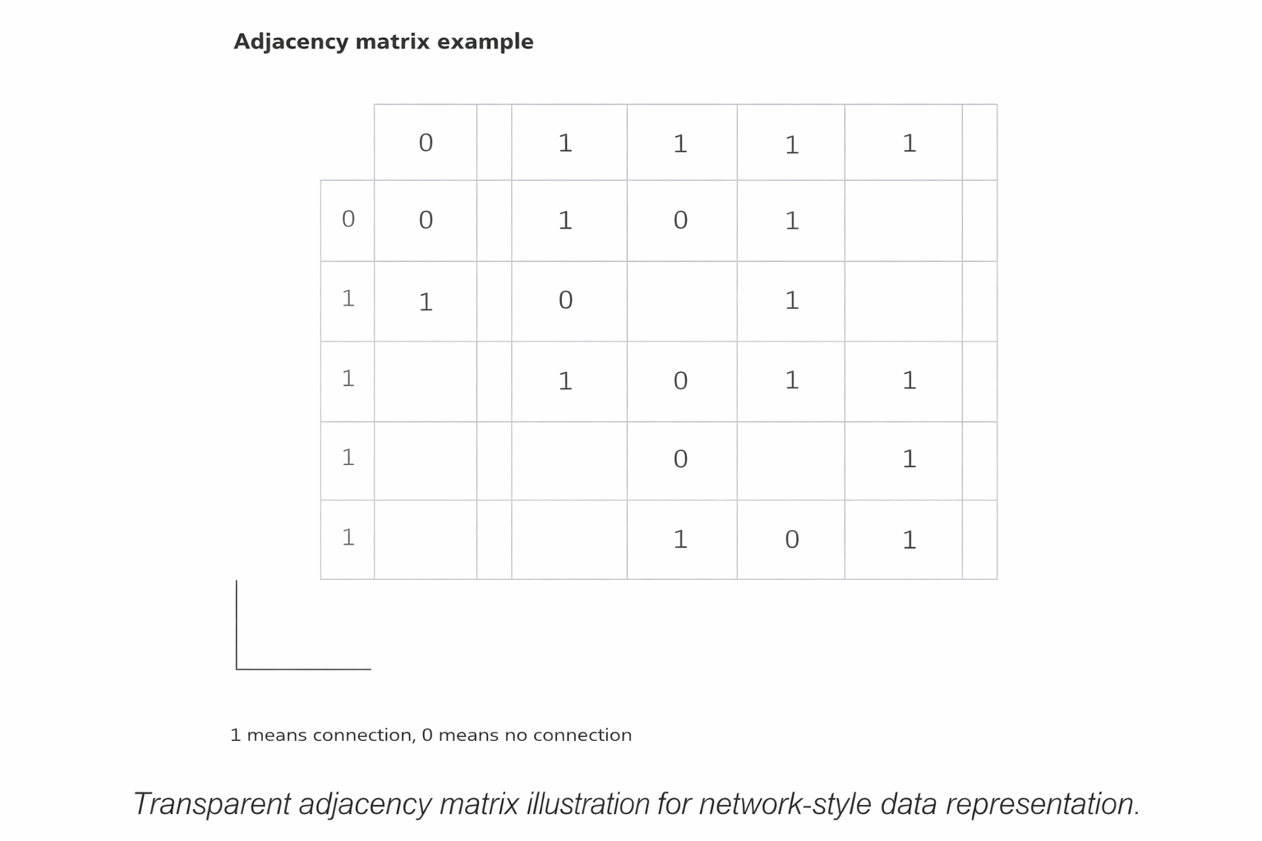

Real World Examples
Social media follows can be stored in an adjacency matrix.
A road map can be stored in a matrix where intersections are nodes and roads are connections.
A product co-purchase network can also be represented this way.

Code Implementation
friendships = [
[0, 1, 1, 0, 0],
[1, 0, 1, 1, 0],
[1, 1, 0, 1, 1],
[0, 1, 1, 0, 1],
[0, 0, 1, 1, 0]
]

print("Are 0 and 2 connected?", friendships[0][2] == 1)
print("Friends of node 2:", [i for i, is_friend in enumerate(friendships[2]) if is_friend])

Conclusion
Adjacency matrices are a great example of how algebra can model real relationships.
They show how one mathematical structure can stand in for a whole network.

13. Why Linear Algebra Matters in Data Science

Module Goal
The goal of this section is to connect everything back to data science practice.

Main Content
Linear algebra matters because data science almost always deals with many measurements at once. Vectors let us package related measurements, and matrices let us package many vectors together. That gives us a compact and powerful way to work.
A lot of common data science tasks are really linear algebra tasks in disguise. Computing similarity, finding distance, averaging samples, transforming features, and representing networks all rely on the ideas from this chapter.
Later we use these ideas repeatedly. Statistics uses them for comparisons and summaries. Machine learning uses them for features, weights, and predictions. Networks and clustering also depend on them heavily.
So even if the chapter feels small at first, it is actually building a foundation. Once that foundation is solid, the rest of the syllabus becomes easier to learn and easier to remember.

Real World Examples
A nearest-neighbor model uses distance between vectors.
A linear model uses weighted sums, which are dot products.
A network model uses matrices to describe relationships.

Code Implementation
# A tiny similarity-style calculation
user = [1, 0, 1, 1]
item = [0, 1, 1, 1]
score = dot(user, item)
print("Similarity score:", score)

Conclusion
Linear algebra is not isolated theory; it is the backbone of many later methods.
Learning it early makes the rest of data science much smoother.

14. Quick Revision Sheet

Main Content
This revision sheet collects the most important ideas from the chapter in one place. Use it before exams, presentations, or interviews. The goal is not to re-read everything. The goal is to recall the structure quickly.
Vectors are lists of numbers that represent points or observations. Matrices are lists of vectors arranged in rows. Addition, subtraction, and scalar multiplication work componentwise. The dot product multiplies matching components and adds the results.
Magnitude is the square root of the sum of squares. Distance is the magnitude of the difference between two vectors. Shape tells us how many rows and columns a matrix has. Identity matrices have 1s on the diagonal and 0s elsewhere.

Real World Examples
· A student's profile can be a vector.
· A classroom of students can be a matrix.
· A friendship graph can be an adjacency matrix.
· A recommender system can score vectors with the dot product.

Code Implementation
# Fast recall version
# vector_add, vector_subtract, scalar_multiply, dot, magnitude, distance
# shape, get_row, get_column, make_matrix, identity matrix
# These are the core building blocks from Chapter 4.

Conclusion
If you remember only one thing, remember this: linear algebra is the language of structured numerical data. It helps us organize data, compare data, and transform data.

15. Formula and Function Cheat Sheet
Use this page as a compact memory aid. It is designed for quick revision and can be read in a minute or two.
Concept | Meaning
Vector addition | v + w = [v1 + w1, v2 + w2, ...]
Vector subtraction | v - w = [v1 - w1, v2 - w2, ...]
Scalar multiplication | c * v = [c*v1, c*v2, ...]
Vector mean | sum(vectors) / number_of_vectors
Dot product | v·w = v1w1 + v2w2 + ... + vnw_n
Magnitude | ||v|| = sqrt(v·v)
Distance | dist(v, w) = ||v - w||
Matrix shape | rows × columns
Identity matrix | 1 on diagonal, 0 elsewhere

16. Practice Questions
1. 1. Explain a vector in your own words using a real-life example.
2. 2. Why must two vectors have the same length before you add them?
3. 3. Write the formula for vector mean and describe what it does.
4. 4. What does the dot product tell us about two vectors?
5. 5. How is distance between vectors related to subtraction and magnitude?
6. 6. What is the shape of a 7 × 4 matrix?
7. 7. How do you get a column from a matrix stored as a list of lists?
8. 8. What makes an identity matrix special?
9. 9. Why is a dataset often stored as a matrix?
10. 10. How can a matrix represent a friendship network?
11. 11. What is the difference between a vector and a matrix?
12. 12. Give one reason the chapter builds these tools from scratch.

Model Answer Hints
· Use the terms componentwise, rows, columns, and coordinates correctly.
· Give at least one data science example for every major concept.
· Mention that matrices can store both datasets and relationships.
· Link the dot product to similarity or projection.

Code Workbook
# Try writing these yourself:
# 1) vector_add
# 2) scalar_multiply
# 3) dot
# 4) magnitude
# 5) distance
# 6) shape
# 7) get_column
# 8) make_matrix
# 9) identity matrix

Conclusion
These questions are meant to help you speak about the chapter confidently. If you can answer them without looking, you are ready to move on.

Final Conclusion
it is one of the most important chapters in the whole text. It introduces the language that later chapters keep using again and again.
Vectors help us describe one observation. Matrices help us describe many observations or relationships together. The chapter also teaches us how to build the core functions ourselves so the ideas become clear, not hidden inside a library.
The main message is simple: if data science is about turning data into insight, then linear algebra is one of the main tools that makes that transformation possible.
When you review this chapter, focus on the meaning of each operation, not just the formula. If the meaning is clear, the formulas are easy to remember.

Important Formula Sheet
1. Vector addition:(a1, a2, ..., an) + (b1, b2, ..., bn) = (a1+b1, a2+b2, ..., an+bn)
2. Scalar multiplication:c(a1, a2, ..., an) = (ca1, ca2, ..., can)
3. Sum of squares:v dot v = v1^2 + v2^2 + ... + vn^2
4. Magnitude of a vector:||v|| = sqrt(v1^2 + v2^2 + ... + vn^2)
5. Distance between two vectors:dist(v, w) = ||v - w||
6. Dot product:v dot w = v1w1 + v2w2 + ... + vnwn
7. Angle between vectors:cos(theta) = (v dot w) / (||v|| ||w||)
8. Projection of v onto w:proj_w(v) = ((v dot w) / (w dot w)) w
9. Matrix entry notation:A_ij means the entry in row i and column j
10. Matrix multiplication:(AB)_ij = sum over k of A_ik B_kj
11. Transpose:(A^T)_ij = A_ji
12. Identity matrix:I_ij = 1 when i = j, otherwise 0
13. Solving linear equations:Ax = b
14. Covariance:cov(x, y) = 1/(n-1) * sum((xi - xbar)(yi - ybar))
15. Correlation:corr(x, y) = cov(x, y) / (sigma_x sigma_y)

Module 1: Introduction to Data Science

Module 1: Introduction to Data Science
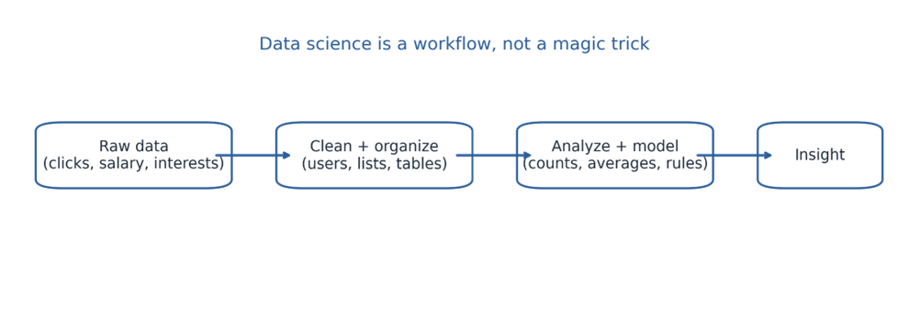

Module Goal
This module serves as the entry point to the entire syllabus, focusing on building a clear understanding of data science.
The main goal is to explain what data science is, why it is important, and how data scientists think when solving real-world problems.
Instead of starting with theory, the chapter uses a practical and engaging approach through a fictional company called DataSciencester.
The story helps illustrate real-world questions, such as:
- Who is connected to whom
- What people like or prefer
- Who might become a paying customer
- What topics are trending
- What insights can be extracted from existing data
The chapter emphasizes the data science mindset, showing that:
- Analysis starts with basic structures and simple functions
- Asking the right questions is more important than complex tools
It highlights that data science is not only about advanced models but also about:
- Organizing data effectively
- Identifying patterns
- Converting insights into actionable decisions
The importance of data science is growing because almost every field relies on data, including:
- Online shopping
- Healthcare
- Social media
- Banking
Overall, this chapter builds a strong foundation for thinking practically and analytically like a data scientist.
What you should understand by the end of this chapter
· Data science means extracting insight from messy data.
· A network, a table, and a list of interests can all become useful once they are organized correctly.
· Small examples are powerful because they teach the same logic used on bigger data.
. Exploration usually comes before prediction.

→ Data can be structured or unstructured. Structured data is neatly arranged in tables, while unstructured data may come from text, images, videos, or social media posts. A data scientist must know how to handle both kinds because real-world data is rarely perfect or clean

Main Content

Understanding the World of Data – Key Points
- The chapter begins by highlighting that we live in a data-rich world, where data is generated continuously from various sources.
- Examples of data generation include:
  - Websites tracking user clicks
  - Smartphones tracking location
  - Smart devices monitoring user habits
  - Businesses recording customer purchases
- This data is valuable because it often contains hidden insights that are not immediately visible.
- The key skill in data science is the ability to:
  - Ask the right questions
  - Identify where to find meaningful answers in the data
- The chapter provides a broad definition of a data scientist:
  - A data scientist is someone who extracts useful insights from messy, unstructured data
- The field of data science is interdisciplinary, combining multiple areas such as:
  - Statistics
  - Programming
  - Experimentation
  - Communication
  - Domain knowledge
- Different data scientists may specialize in different areas:
  - Some focus more on statistical analysis
  - Some focus on software engineering
  - Others work at the intersection of both
- The main idea is that all data scientists share a common goal:
  - Using data to better understand patterns, behaviors, and real-world problems

1.1 The world is already full of data
Think about everyday life. Every online visit leaves a trail, every purchase adds a record, every social action forms a link, and every device can produce a stream of measurements. The chapter uses these examples to show that data is not rare anymore; it is everywhere. The challenge is not collecting data alone. The challenge is converting it into something meaningful.
· Clicks show what users notice.
· Locations show movement and behavior.
· Purchases show preferences and buying habits.
· Connections show relationships.
· Interests show identity, curiosity, and possible expertise.
That is why data science begins with curiosity. If data is everywhere, then interesting questions are everywhere too.
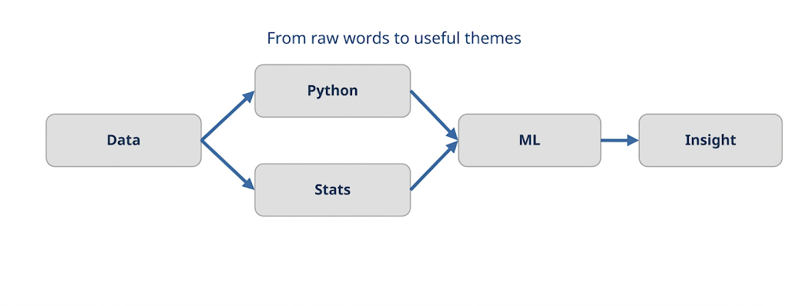

1.2 What is data science?
Data science is essentially about transforming messy raw data into meaningful insights.
These insights can be used in many real-world situations, such as:
- Helping a company grow its business
- Improving products or services
- Recommending connections (like friends or content)
- Analyzing salary or market trends
- Predicting whether a user is likely to pay for a service
The chapter emphasizes that data science is not just about machine learning.
Before applying any model, important foundational steps are required:
- Cleaning the data (removing errors or inconsistencies)
- Organizing the data properly
- Counting and summarizing information
- Comparing different groups
- Understanding the problem structure
These early steps are crucial because:
- They often reveal important insights even before modeling
- They help ensure better accuracy and understanding in later stages
Overall, the key idea is:
- Data science starts with basic analysis and understanding, and not just advanced algorithms.
A simple definition to remember
· Raw data is just the starting point.
· Insight comes after observation, organization, and analysis.
. A good model is useful only when it fits the problem and the data.

A complete data science workflow usually includes collecting data, cleaning data, exploring patterns, building models, testing results, and communicating findings. This process shows that data science is not just about coding; it is also about asking the right questions and interpreting the answers correctly.

1.3 Why the DataSciencester story matters

DataSciencester Example – Key Points
- DataSciencester is a fictional social network created to teach data science concepts in a practical and engaging way.
- Although it is playful, it provides a smart learning approach by connecting all examples within a single story.
- This storytelling method helps because:
  - It turns abstract concepts into real-world scenarios
  - You feel like you are solving actual business problems, not just reading code
- The approach makes analysis feel more natural and relatable, similar to real workplace situations.
- It reflects how real projects work, where problems are often unclear or loosely defined, such as:
  - Building a recommendation system
  - Creating a trend analysis
  - Making a yes-or-no prediction
- The example demonstrates that one dataset can answer multiple types of questions, depending on how it is analyzed.
- The main advantages of using DataSciencester are:
  - Makes learning interesting and interactive
  - Helps in better understanding and retention
  - Shows how data science works in a realistic environment
- Overall, it simplifies learning by:
  - Converting theory into a memorable story
  - Helping students apply concepts to real-world problems easily

1.4 Finding key connectors in a network
- The first task in the chapter is to identify the most connected people in a network.
- The data starts in a simple form:
  - A list of users
  - A list of friendship relationships
- This data is then transformed into a more useful structure:
  - A friend list for each user
- Once organized, it becomes easy to:
  - Count the number of connections each user has
  - Rank users based on their number of friends
- This introduces the concept of degree centrality:
  - It measures how many direct connections a person has
  - More connections → more central in the network
- Degree centrality is useful because it is:
  - Simple to calculate
  - Easy to understand
- However, the chapter also highlights an important limitation:
  - Just counting connections does not always reflect true importance
- A person with fewer connections might still be important because:
  - They are positioned strategically in the network
  - They may act as a bridge between groups
- Overall, the key idea is:
  - Basic metrics like degree centrality are helpful, but network position also matters for deeper understanding.

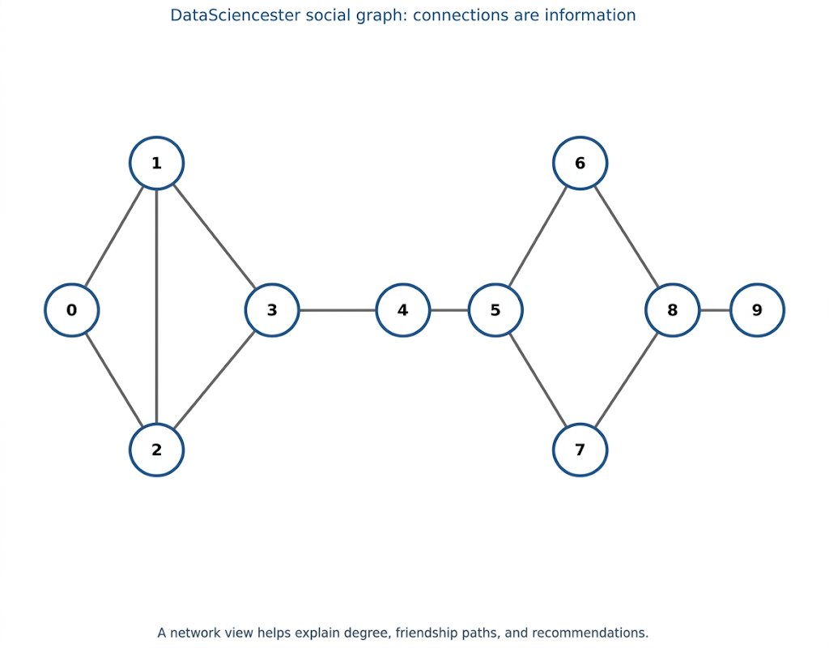

Importance of Basic Measures & Real-World Centrality
- An important lesson in data science is that a first answer does not need to be perfect to be useful.
- Simple methods often act like a rough sketch, giving an initial understanding of the problem.
- More advanced techniques can later be used to refine and improve the results.
- Basic measures are valuable because they:
  - Provide quick insights
  - Help guide further analysis
  - Make complex problems easier to approach
- The concept of network centrality is widely used in real-world applications, such as:
  - Social media platforms
  - Business organizations and teams
  - Communication networks
- In these contexts:
  - People with many connections can spread information quickly
  - They often appear more visible or active in the network
- However, centrality does not always equal importance:
  - A person with fewer connections may still have greater influence
  - Strong, meaningful connections can be more valuable than many weak ones
- Overall, the key idea is:
  - Start with simple analysis, then gradually move to deeper insights
  - Quality and position of connections can matter more than quantity in some cases.

1.5 Suggesting friends: friends of friends
After building the network, the next task is making recommendations (e.g., suggesting new friends).
A simple idea is to recommend “friends of friends”.
However, the naive approach has problems, such as:
- It may include duplicate users
- It may include the user themself
- It may suggest people who are already friends
To improve the recommendation system, the analysis is done in clear stages:
- Create a list of friend-of-friend IDs
- Remove the user’s own ID
- Remove users who are already friends
- Count mutual friends to prioritize better suggestions
The idea of counting mutual friends helps because:
- People appearing through multiple paths are more likely to be relevant
- It improves the quality of recommendations
This process reflects a key data science mindset:
- Start with a simple solution
- Identify problems or limitations
- Gradually refine and improve the logic

from collections import Counter

def not_the_same(user, other_user):
return user["id"] != other_user["id"]

def not_friends(user, other_user):
return all(not_the_same(friend, other_user)
for friend in user["friends"])

def friends_of_friend_ids(user):
return Counter(foaf["id"]
for friend in user["friends"]
for foaf in friend["friends"]
if not_the_same(user, foaf)
and not_friends(user, foaf))
The code is valuable not because it is fancy, but because it teaches a very useful habit:
→write helper functions so the logic stays readable.
→ Clean structure makes analysis easier to trust.
This idea is similar to the recommendation systems used by social media platforms.
When a platform suggests people you may know, it often uses mutual connections, shared groups, and past interactions.
This shows how a simple concept from a small example can become a powerful real-world feature.

1.6 Using shared interests
The chapter extends analysis from friendship networks to user interests, making the model richer and more meaningful.
Users with similar interests (technologies, languages, methods) can be good connection candidates, even if they are not already friends.
The key idea is to convert raw data into a structured format using indexing.
Two important types of indexes are created:
- Interest → Users Index: maps each interest to the list of users who like it
- User → Interests Index: maps each user to their list of interests
Once these indexes are built, it becomes easy to:
- Find users with similar interests
- Count shared interests between users
- Generate better recommendations based on similarity
This demonstrates a common data science pattern:
- Spend time organizing and structuring data first
- Make future analysis faster and more efficient
The main takeaway is:
- Proper data organization simplifies complex problems and allows quick, scalable insights.
Why indexing matters
· Without an index, every search scans the entire list.
· With an index, you jump directly to the relevant records.
. The same idea is used in search engines, databases, and recommender systems.

**This section quietly introduces a big idea:
→ data structures are part of the analysis.
→The way you store information changes what kind of questions you can ask efficiently.

1.7 Salaries and experience
The salary example demonstrates an important data analysis habit.
Initial observation shows that more experience (tenure) generally leads to higher salary.
The first approach is to group data by exact tenure values, but this is not effective because:
- Each tenure value is often unique
- It becomes hard to find meaningful patterns
To solve this, the data is grouped into ranges (buckets) instead of exact values.
This technique is called data bucketing, and it helps to:
- Simplify complex data
- Make patterns more visible and understandable
After bucketing:
- Average salaries within each group become clearer
- Overall trends are easier to interpret
This reflects a key concept in exploratory data analysis (EDA):
- If data is too detailed or noisy, group it into meaningful categories
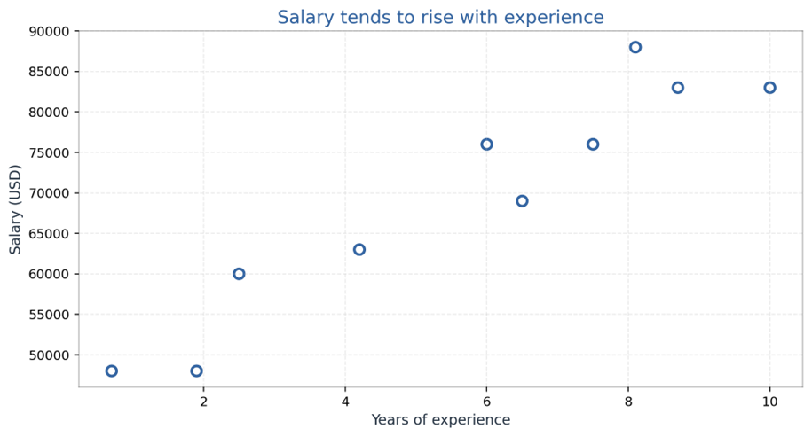

salary_by_tenure_bucket = defaultdict(list)
for salary, tenure in salaries_and_tenures:
bucket = tenure_bucket(tenure)
salary_by_tenure_bucket[bucket].append(salary)

average_salary_by_bucket = {
bucket: sum(salaries) / len(salaries)
for bucket, salaries in salary_by_tenure_bucket.items()
}

Understanding Bucketing & Its Purpose – Key Points
- The main takeaway is that buckets themselves are not perfect or fixed.
- The chapter clearly states that bucket ranges can be somewhat arbitrary.
- The real goal of bucketing is to:
  - Identify initial patterns in the data
  - Provide a starting point for deeper analysis
- Data analysis often follows a progression:
  - Start with a rough pattern (like bucketing)
  - Then move toward a more precise model (e.g., estimating impact of each year of experience)
- Bucketing is useful because it:
  - Reduces noise in scattered data
  - Makes patterns easier to detect and explain
- It is especially helpful when:
  - Exact values are too detailed or inconsistent
  - The data does not show clear trends in raw form
- In this example:
  - Bucketing helps make the salary vs experience trend clearer
  - It turns complex data into a more meaningful and interpretable form
- Overall, the key idea is:
  - Use simple techniques like bucketing to discover patterns first, then refine with more advanced analysis later.

1.8 Paid accounts: simple prediction rules
The chapter explores a practical question: Which users are likely to pay for accounts?
It analyzes the relationship between user experience (tenure) and payment behavior.
From the small dataset, a rough pattern is observed:
- Users with very little experience are more likely to pay
- Users with very high experience are also more likely to pay
- Users in the middle range are less likely to pay
The pattern is not perfectly smooth or reliable, but it still provides a useful insight.
This introduces the concept of classification in data science:
- Instead of predicting a number, you predict a category
- Example: Paid vs Unpaid users
The chapter highlights an important limitation:
- The dataset is too small for a strong or reliable model
- The rule is just a rough estimate, not a final conclusion
Despite limitations, the example is valuable because it shows:
- How analysts move from observing patterns
- To making basic predictions
def predict_paid_or_unpaid(years_experience):
if years_experience < 3.0:
return "paid"
elif years_experience < 8.5:
return "unpaid"
else:
return "paid"

Data Science Workflow & Prediction Mindset – Key Points
- The most important takeaway is the workflow, not perfection.
- A typical data science process follows these steps:
  - Inspect the data
  - Identify patterns
  - Convert patterns into simple rules
  - Improve or replace them with better models over time
- Early prediction rules are useful because they:
  - Provide a starting point for analysis
  - Help in understanding the problem quickly
- However, simple rules should not be treated as final answers.
- Real-world prediction models require:
  - Careful testing and validation
  - Sufficient and reliable data samples
- Small datasets can be misleading because:
  - They may show false patterns
  - Results may not generalize to real situations

1.9 Topics of interest
The final mini-project focuses on understanding what users are interested in using text data.
Although it looks simple, it is actually an introduction to text analysis (NLP basics).
The process begins with basic steps:
- Convert text to lowercase
- Split text into words (tokenization)
- Count word frequency
This simple approach quickly reveals popular topics, such as:
- Python
- Java
- Data
- Machine Learning
Word counting is useful because it:
- Highlights trending topics
- Gives quick insight into user interests
However, the chapter also points out limitations:
- It does not handle multi-word phrases (e.g., “machine learning”) properly
- It ignores synonyms
- It lacks understanding of context
This leads to more advanced text analysis ideas, such as:
- Phrase detection
- Semantic meaning
- Context-aware models
Despite its simplicity, this method is powerful because:
- It provides quick and useful insights
- It is easy to implement and scale
In real-world systems, similar techniques are used for:
- Topic detection
- Content classification
- Understanding user behavior

A practical way to think about this section
· Raw text needs cleanup before it can be counted meaningfully.
· Counts can reveal popularity, but not always nuance.
. Even simple statistics can guide content planning and product decisions.

1.10 The big lessons hidden in the story
· A good data scientist does not wait for a perfect model before being useful.
· Small helper functions make analysis easier to read and modify.
· Indexes and counts often matter as much as advanced algorithms.
· A rough answer is often the first step toward a better answer.
· The best question is not always the fanciest one.
This chapter is really a tour of thinking habits: organize first, compare carefully, and improve the analysis step by step.

Real World Examples
The chapter’s ideas are fictional, but the logic shows up everywhere in real systems.
1. Social platforms use network structure to suggest friends, followers, or professional contacts.
2. Streaming services and shopping apps use user behavior and shared interests to recommend new content.
3. Companies use salary and experience patterns to estimate compensation and career growth.
4. Subscription businesses often build simple prediction rules before moving to more advanced machine learning.
5. Content teams count topics and keywords to decide what to write about next.
In each case, the same core steps appear again and again: collect the records, organize them, notice the pattern, and turn the pattern into action.

Real-world translation of the chapter
· Friends of friends becomes recommendation systems.
· Shared interests becomes similarity scoring.
· Salary and tenure becomes trend analysis and forecasting.
. Word counts becomes content strategy and text mining.

Code Implementation
The chapter’s code is deliberately small because the goal is understanding, not industrial-scale performance. Here is the chapter’s logic, rewritten in a cleaner modern Python style and explained in plain English.

Step 1: store users and friendships
users = [
{"id": 0, "name": "Hero"},
{"id": 1, "name": "Dunn"},
{"id": 2, "name": "Sue"},
{"id": 3, "name": "Chi"},
]

friendships = [(0, 1), (0, 2), (1, 2), (1, 3)]

The user list gives each person an ID and a name. The friendship list stores pairs of IDs. This is a compact way to represent a network before converting it into a more convenient structure.

Step 2: attach friend lists
for user in users:
user["friends"] = []

for i, j in friendships:
users[i]["friends"].append(users[j])
users[j]["friends"].append(users[i])

Now each user knows who their friends are. That makes later analysis easier because you no longer need to search the entire friendship list every time.

Step 3: count connections
def number_of_friends(user):
return len(user["friends"])

total_connections = sum(number_of_friends(user) for user in users)
avg_connections = total_connections / len(users)

This is the simplest useful network metric in the chapter. Count, sum, divide. Even this basic arithmetic already gives a useful snapshot of how connected the network is.

Step 4: remove noise from friend suggestions
from collections import Counter

def friends_of_friend_ids(user):
return Counter(
foaf["id"]
for friend in user["friends"]
for foaf in friend["friends"]
if foaf["id"] != user["id"]
and foaf not in user["friends"]
)

This version uses counting to rank candidates by how many mutual friends they share with the user. That makes the recommendation more informative than a raw list.

Step 5: index interests
from collections import defaultdict

user_ids_by_interest = defaultdict(list)
interests_by_user_id = defaultdict(list)

for user_id, interest in interests:
user_ids_by_interest[interest].append(user_id)
interests_by_user_id[user_id].append(interest)

Once the index exists, matching users by common interest is fast and readable. This is a small example of how data structures shape analysis.

Step 6: bucket experience and average salary
def tenure_bucket(tenure):
if tenure < 2:
return "less than two"
elif tenure < 5:
return "between two and five"
else:
return "more than five"

Bucketing is a bridge between raw numbers and useful interpretation. It reduces noise and makes the pattern easier to explain.

Why this code matters
The code teaches more than syntax.
It teaches a way of working:
- keep data in a format that supports the next question,
- write helper functions when logic gets messy, and use the smallest useful model first.

summary
Overall, this chapter teaches that data science starts with observation, organization, and curiosity. The examples may be small, but the thinking is the same as in real projects. Once data is structured properly, it becomes much easier to discover patterns and make useful decisions.

Conclusion
Module 1 focuses on building intuition, not showcasing technical complexity.
It emphasizes that data science begins with:
- A clear question
- A messy dataset
- A willingness to organize and explore data step by step
The chapter teaches that simple tools can solve real problems, such as:
- Counting connections (friends)
- Grouping salaries into ranges
- Indexing user interests
- Counting words in text
These basic actions may seem simple, but they are core data science practices when used with purpose.
A major takeaway is that data science is an iterative process:
- Start with a rough solution
- Check if the result makes sense
- Improve the data structure and approach
- Refine the model or method
This cycle of improvement continues throughout real-world projects and the rest of the syllabus.

Quick revision line
. Data science = messy data + useful questions + careful organization + insight.

module 1 revision checklist
· Can you explain what data science means in one sentence?
· Can you describe why a network representation is useful?
· Can you explain why friend-of-friend suggestions need filtering?
· Can you tell why interest indexing is faster than scanning every record?
· Can you describe why bucketing salary data helps interpretation?
· Can you explain the difference between observation and prediction?

Practice Questions
1. What kinds of data appear in everyday life that a data scientist could study?
2. Why is a simple count sometimes enough to produce a useful insight?
3. How does the DataSciencester example help explain real-world analytics?
4. Why is indexing important when searching interests or friendships?
5. What is the weakness of using exact tenure values to study salary?
6. Why does the chapter use a rough paid/unpaid rule even though it is not a final model?
7. How does counting topic words help a content strategy team?
8. Which part of the chapter feels most like data cleaning, and why?

