Module 1 — Introduction to Text Recognition

Goal: Understand what text recognition is, where it is used, and how it fits into the OCR pipeline.

What text recognition means
Text recognition is the AI task of converting a picture of text into actual editable characters (letters, numbers, punctuation).

Think of it as the “reading” step:
You give the model an image patch that contains text → it outputs a string like “Invoice #INV-2025-001” or “MP 09 AB 1234”.

It’s not magic, it learns patterns from millions of text images during training, so it can guess characters even when the image is blurry, rotated, or handwritten.

Difference between text detection and text recognition
These two steps are often confused, but they are completely different jobs:

- Text Detection → “Where is the text?”
It draws bounding boxes around every word or line in the image.
Example: Finds the rectangular region that contains “Total Amount: ₹4,500” on an invoice.

- Text Recognition → “What does the text say?”
It only works on the cropped box from detection and converts pixels into actual characters.
Example: Turns the box into the string “Total Amount: ₹4,500”.

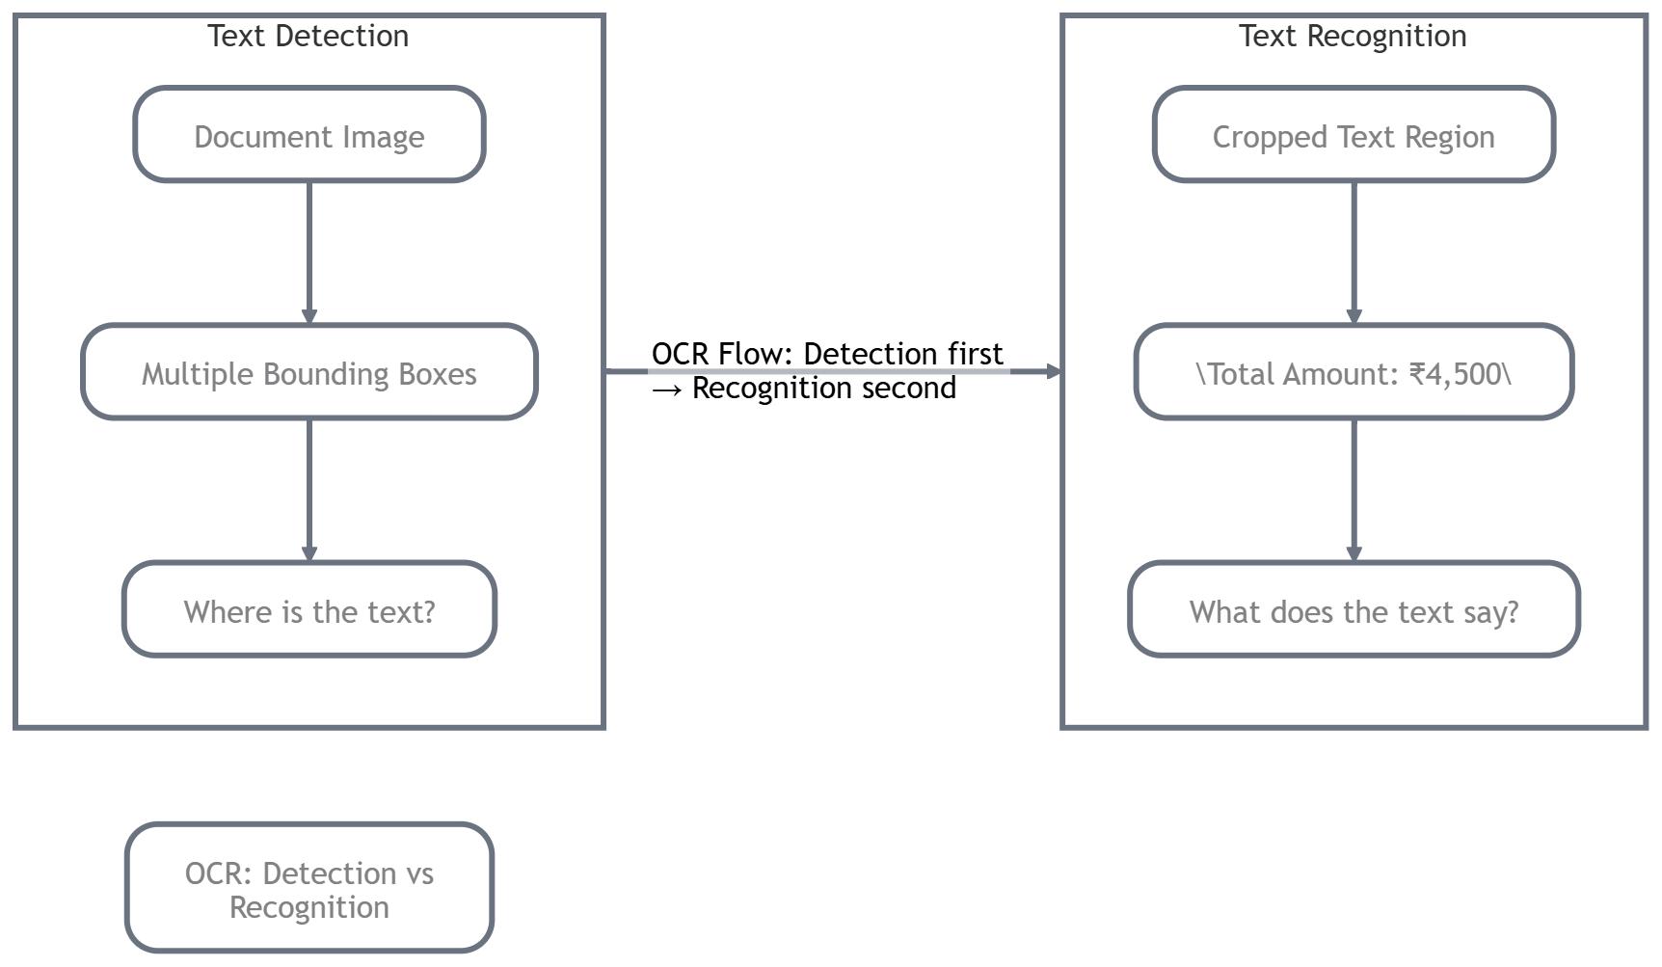

OCR systems always do both: Detection first → Recognition second. If detection fails, recognition has nothing to read!

Role of text recognition in OCR systems
OCR = Optical Character Recognition = the full pipeline that turns scanned or photographed documents into searchable, editable text.

Text recognition is the heart of that pipeline. Without a strong recognizer:

- You can detect text perfectly but still get garbage output (“T0tal Am0unt” instead of “Total Amount”).
- Downstream tasks (search, summarization, data extraction, feeding LLMs) all break.

Modern OCR systems split the work:
1. Pre-processing (deskew, binarize)
2. Text Detection (e.g., EAST, DBNet, or DiT-based)
3. Text Recognition (the star of this series)
4. Post-processing (spell correction, layout analysis)

Types of text images
Not all text is the same, the difficulty level changes a lot:

- Scanned documents
Clean, high-resolution, usually black text on white background (invoices, forms, books). Easiest for recognition.

- Scene text
Text in the wild — street signs, shop boards, billboards, product labels. Challenges: perspective distortion, lighting, complex backgrounds, different fonts.

- Handwritten text
The toughest — varying styles, cursive writing, smudges, different inks. Think doctors’ prescriptions or old letters.

Modern systems often specialize or use different models for each type.

Real-world examples

- Reading invoices
A small business in Indore scans supplier bills. Detection finds the total box → recognition reads “₹12,450.00” → auto-enters into accounting software → saves hours every month.

- Reading license plates
Toll plazas or parking systems photograph vehicles. Detection locates the plate → recognition converts “MP 09 AB 1234” into text → instantly checks against database.

- Extracting text from forms
Government offices digitize handwritten Aadhaar or PAN forms. Recognition turns messy handwriting into digital records for faster processing and search.
In short: wherever you see text in an image and need it as editable data, text recognition is doing the heavy lifting.

Brief overview of modern OCR approaches

Today’s best systems combine deep learning with clever tricks:
- CRNN (Convolutional Recurrent Neural Network): - classic workhorse: CNN extracts visual features → LSTM/GRU reads sequence left-to-right.
- Transformer-based (TrOCR, Donut, Pix2Struct): - treat recognition as image-to-text generation, no separate detection needed in some cases.
- Attention-based (like in DiT + LayoutLM): - use visual layout + text context together for higher accuracy on forms and tables.
- End-to-end models (e.g., PARSeq, ABINet): - jointly optimize detection and recognition in one network.

All of them are trained on huge datasets of synthetic + real text images so they can handle blur, rotation, and low contrast.

Outcome: you have understood what text recognition is, where it is used, and how it fits into the OCR pipeline.

You now have the big picture:
Text recognition is the “reading brain” inside every OCR system.
It comes after detection, works on different types of images (scanned, scene, handwritten), powers everyday tasks like invoice processing and license-plate reading, and has evolved from CRNNs to powerful Transformer models.

Module 2 — How Text Recognition Systems Work

In Module 1 where we got the big picture, now let’s open the hood and see how a text recognition system actually turns pixels into readable characters.

Think of it like watching a chef cook: we already know the dish (OCR), now we’ll see the exact steps, ingredients, and tools that make it happen. We’ll keep it simple and practical, like walking through a recipe together over chai.

Goal: Understand how machines convert text images into characters and the core components of recognition models.

Basic OCR pipeline

A full OCR system is a chain of steps, but text recognition is the star of the show the part that actually “reads”.

Typical flow:
1. Input image (scan, photo, screenshot)
2. Pre-processing (clean it up)
3. Text Detection (find the boxes — we’ll cover this later)
4. Text Recognition ← what we focus on here
5. Post-processing (fix spelling, fix layout)

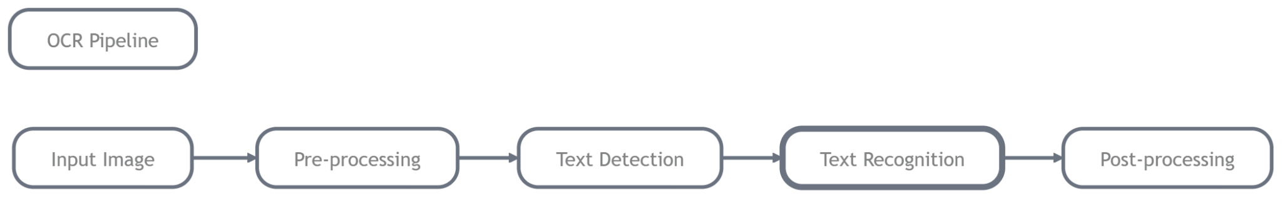

The recognition step takes a cropped word or line image and outputs a string of characters.

Steps involved in text recognition

Modern recognition models follow three main stages inside the network:

1. Image Preprocessing
Clean the cropped box before feeding it to the model:
- Deskew (straighten tilted text)
- Binarize (make text black on white)
- Resize to fixed height (e.g., 32 pixels tall) while keeping aspect ratio
- Normalize pixel values (0–1 range)
Why? Makes the image consistent so the model doesn’t get confused by lighting or tilt.

2. Feature Extraction
A CNN (Convolutional Neural Network) scans the image and extracts visual features.
It learns things like “this looks like the curve of an ‘S’” or “these vertical lines are an ‘H’”.
Output: a sequence of feature vectors (one per slice of the image from left to right).

3. Sequence Prediction
The feature sequence is passed to a sequence model (RNN, LSTM, or Transformer) that predicts one character at a time while looking at the whole context.
It outputs a string like “Total: ₹4,500”.

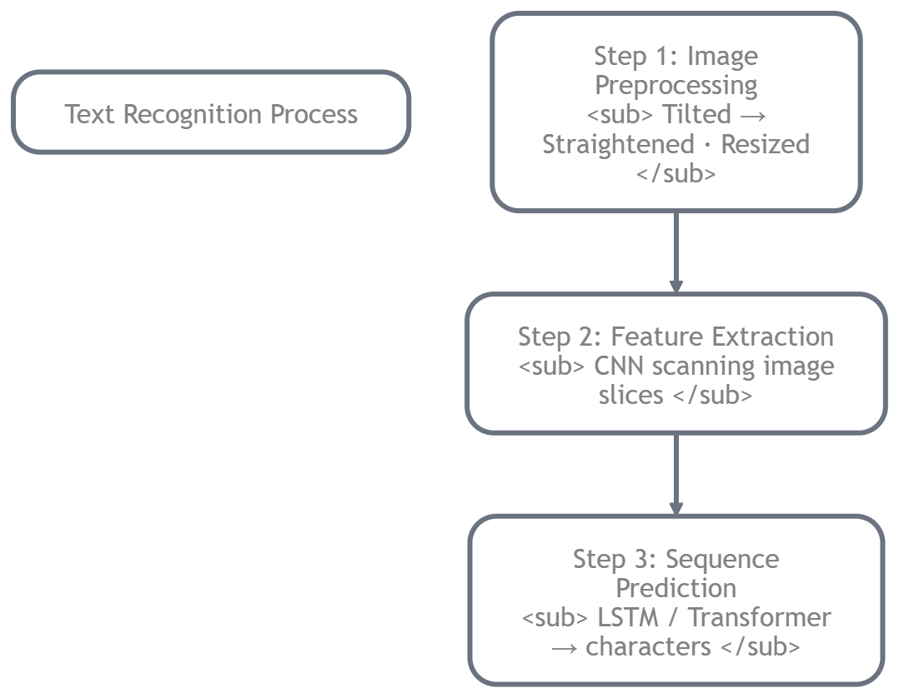

Concept of sequence modeling

Text is a sequence, characters appear in order.
That’s why we don’t just classify each letter independently (that would give “T o t a l” with possible wrong order or duplicates).

Sequence models (like LSTM or Transformer decoder) learn:
- Context: “T” followed by “o” is likely “To”
- Dependencies: In “₹4,500”, the comma helps predict the next digits

This is exactly why recognition works so well even on slightly blurry or connected characters.

Traditional OCR vs deep learning OCR

- Traditional OCR (Tesseract 3.x, older engines)
Used hand-crafted features + rules + dictionaries.
Good for clean printed text, but broke on scene text, handwriting, or bad lighting.
Very fast but low accuracy on real-world images.

- Deep Learning OCR (what we use today)
End-to-end neural networks trained on millions of images.
Handles blur, rotation, handwriting, scene text, and multiple languages.
CRNN, TrOCR, and Transformer-based models are now the standard.

Deep learning won because it learns patterns automatically instead of relying on human-designed rules.

Input and output representation

- Input: A small grayscale or RGB image patch (e.g., 32×128 pixels for a word).
Sometimes normalized to fixed height.

- Output: A string of characters + confidence score.
Many models also output a probability for each character so you can see where it’s unsure (e.g., “I” vs “1”).

Typical recognition workflow

1. Crop the word/line from detection step
2. Preprocess (resize, normalize)
3. Run through CNN → feature map
4. Feed features to sequence model (LSTM/Transformer)
5. Decode the output sequence (greedy or beam search)
6. Return the final text string

That’s it, pixels in, characters out!

Outcome: You understands how machines convert text images into characters and the core components of recognition models.

You now know the full internal recipe: preprocess → extract visual features → predict sequence → output text.

Text recognition is the clever “translator” step that sits between detection and the final editable result. It’s where traditional rule-based methods gave way to powerful deep learning models that handle real-world messiness.

Module 3 — Traditional OCR: Tesseract 5+
In Module 2 we saw the general steps inside any text recognition system. Now let’s look at the most popular traditional OCR engine that millions of people and companies still use every day Tesseract. We’ll keep it hands-on and practical, just like before. By the end of this module, you’ll be able to install Tesseract, run it on real scanned documents, and extract clean text with just a few lines of Python.

Goal: Run Tesseract OCR and extract text from scanned documents.

Introduction to Tesseract OCR
Tesseract is a free, open-source OCR engine originally developed by Hewlett-Packard in the 1980s and now maintained by Google.

It takes an image (scan, photo, screenshot) and returns the text it sees.
It’s called “traditional” because it doesn’t rely on massive deep-learning models like modern Transformer-based systems, instead it uses clever computer-vision tricks combined with a neural network for character recognition. Even in 2026, Tesseract is still one of the go-to tools for quick, offline OCR on scanned documents, forms, and invoices.

Evolution of Tesseract

- 1980s–2000s: Rule-based + pattern matching (very limited accuracy).
- Version 3.x (2010s): Added page layout analysis and better language support.
- Version 4 (2018): Big upgrade — introduced LSTM (Long Short-Term Memory) neural networks for recognition. Accuracy jumped dramatically.
- Version 5+ (2021–now): Faster, more accurate LSTM engine, better support for 100+ languages, improved handling of rotated and low-quality images.

Today Tesseract 5+ is what most developers mean when they say “Tesseract”.

LSTM-based recognition in Tesseract 5
The core of modern Tesseract is an LSTM network (a type of recurrent neural network).
How it works inside:
1. The image is sliced into vertical strips (like reading left to right).
2. A CNN extracts visual features from each strip.
3. The LSTM reads these features sequentially and predicts one character at a time, remembering context from previous characters.
4. Final output is the most likely text string.

This LSTM approach is why Tesseract suddenly became really good at printed and even slightly noisy text.

Supported languages
Tesseract supports over 100 languages out of the box, including:
- English (eng)
- Hindi (hin)
- Marathi, Gujarati, Tamil, Telugu, Bengali
- Arabic, Chinese, Japanese, Korean
- Many Indian regional languages

You can even train it on your own custom fonts or handwriting (we’ll cover that in a later module).

Installation and setup

On Windows / Linux / macOS (one-time setup):

bash
# Windows: download installer from GitHub (tesseract-ocr/tesseract)

# Ubuntu:
sudo apt install tesseract-ocr tesseract-ocr-eng tesseract-ocr-hin

# macOS (with Homebrew):
brew install tesseract

# Python wrapper
pip install pytesseract pillow
```

After installation, check it works:
bash
tesseract --version

Running Tesseract on document images

Here’s the simplest way using the Python wrapper:

python
from PIL import Image
import pytesseract

# Tell Python where Tesseract is installed (usually not needed on Linux/macOS)
# pytesseract.pytesseract.tesseract_cmd = r'C:\Program Files\Tesseract-OCR\tesseract.exe'

# Load your scanned document image
img = Image.open('invoice_scan.jpg')

# Extract text
text = pytesseract.image_to_string(img, lang='eng+hin') # use multiple languages if needed

print(text)

That’s it, one line and you get the full text!

Extracting text from scanned documents

Real workflow for a scanned invoice or form:

python
from PIL import Image, ImageFilter
import pytesseract

img = Image.open('form_scan.png')

# Optional quick preprocessing (helps a lot)
img = img.convert('L') # grayscale
img = img.filter(ImageFilter.SHARPEN) # sharpen text

# Run recognition
custom_config = r'--oem 3 --psm 6' # OEM 3 = LSTM only, PSM 6 = assume uniform text block
text = pytesseract.image_to_string(img, config=custom_config, lang='eng')

print("Extracted text:\n", text)

Common preprocessing techniques

To get the best results from Tesseract:
- Convert to grayscale
- Increase contrast / sharpen
- Deskew (straighten) if the page is tilted
- Remove noise (median filter)
- Binarize (black & white) for very old scans

These simple steps can boost accuracy by 20–30% on real documents.

Outcome: Reader can run Tesseract OCR and extract text from scanned documents.

You now know:
- What Tesseract is and how it evolved
- That its LSTM engine is the reason it works so well today
- How to install it and run it in Python with just a few lines
- How to preprocess images for better results

Tesseract is still the fastest and easiest way to get started with OCR on scanned documents, forms, and invoices.

Module 4 — Deep Learning OCR with EasyOCR

In Module 3 we saw how Tesseract (the classic engine) works great for clean scanned documents. But when text appears in the wild, on street signs, product labels, or messy photos, traditional OCR often struggles.

That’s where deep learning OCR shines. In this module we’ll explore one of the easiest and most powerful libraries for real-world text recognition: EasyOCR.

By the end, you’ll be able to install it, run it on complex images, and see the results with bounding boxes, all in just a few lines of Python.

Goal: Use EasyOCR for text recognition and recognize text from complex images.

Why deep learning improved OCR

Traditional OCR (like old Tesseract) relied on hand-crafted rules and dictionaries. It worked okay on clean printed pages but failed on:

- Tilted or curved text
- Low-light or blurry photos
- Handwriting or artistic fonts
- Complex backgrounds (signboards, packaging)

Deep learning changed everything by learning patterns automatically from millions of real images. Models now understand context, shapes, and variations — delivering much higher accuracy on “scene text” (text in natural environments).

Overview of EasyOCR

EasyOCR is a ready-to-use Python library built on deep learning. It combines two powerful models in one simple interface:

- Detection: Finds where the text is (using CRAFT algorithm).
- Recognition: Reads the text inside each box (using a CRNN-style model).

What makes it special:
- Supports 80+ languages including English, Hindi, Marathi, Tamil, Arabic, Chinese, etc.
- Works offline after downloading models once.
- Super easy API, no complicated setup.
- Handles multi-line text and returns confidence scores.

It’s perfect when you want high accuracy on natural scene images without building everything from scratch.

Architecture concept (detection + recognition)

EasyOCR is end-to-end but internally does two steps:

1. Detection (CRAFT model): Scans the image and returns bounding boxes around every text region.
2. Recognition (CRNN-based): Crops each box, extracts visual features with CNN, then uses sequence modeling (LSTM/Transformer) to predict the actual characters.

You don’t have to worry about the details, just call one function and get both boxes and text!

Supported languages

EasyOCR supports 80+ languages and scripts out of the box. Just pass a list when creating the reader:

python
['en'] # English only
['en', 'hi'] # English + Hindi
['ch_sim', 'en'] # Simplified Chinese + English

Popular Indian languages (Hindi, Marathi, Tamil, Telugu, Bengali, Gujarati) are fully supported.

Installing EasyOCR

One simple command (run once):

bash
pip install easyocr

First run will automatically download the models (~200–500 MB depending on languages).
It works on CPU or GPU (much faster with GPU).

Running EasyOCR on images

Here’s the basic code:

python
import easyocr
from PIL import Image

# Create reader (run once, specify languages)
reader = easyocr.Reader(['en', 'hi'], gpu=False) # Set gpu=True if you have CUDA

# Load your image (scan, photo, screenshot)
img_path = 'scene_text.jpg' # or 'invoice.jpg'

# Run OCR
results = reader.readtext(img_path)

# Print results
for (bbox, text, prob) in results:
print(f"Text: {text} | Confidence: {prob:.2f}")

That’s it! `results` gives you bounding boxes, detected text, and confidence for every piece of text found.

Recognizing text from natural scene images

EasyOCR shines on complex real-world images:

python
import easyocr
import cv2
from matplotlib import pyplot as plt

reader = easyocr.Reader(['en'])

img = cv2.imread('street_sign.jpg')
results = reader.readtext(img)

# Draw boxes for visualization
for (bbox, text, prob) in results:
(top_left, top_right, bottom_right, bottom_left) = bbox
top_left = tuple(map(int, top_left))
bottom_right = tuple(map(int, bottom_right))
cv2.rectangle(img, top_left, bottom_right, (0, 255, 0), 2)
cv2.putText(img, text, (top_left[0], top_left[1] - 10),
cv2.FONT_HERSHEY_SIMPLEX, 0.8, (0, 255, 0), 2)

plt.imshow(cv2.cvtColor(img, cv2.COLOR_BGR2RGB))
plt.axis('off')
plt.show()

This draws green boxes around detected text — super useful for debugging or building apps.

Outcome: Reader can use EasyOCR for text recognition and recognize text from complex images.

You now know:
- Why deep learning beats traditional OCR on real-world text
- How EasyOCR combines detection + recognition in one easy package
- How to install and run it with just a few lines
- How to visualize results on scene images

EasyOCR is one of the quickest ways to get production-ready OCR working on photos, signs, invoices, and more.

Module 5 — Limitations of Traditional OCR Systems
In Module 3 we got Tesseract running on clean scanned documents, and in Module 4 we saw how EasyOCR handles natural scene images with deep learning. Both are powerful tools, but they still hit walls on many real-world cases.

This module is all about understanding why those walls exist and why the field had to move toward newer architectures. Think of it as the “reality check” chapter, we’ll look at the problems honestly so you appreciate the modern solutions coming next.

Goal: Understand why newer OCR models were developed and the limitations of traditional OCR approaches.

Challenges faced by OCR models

Even the best traditional and early deep-learning systems struggle with common real-life situations:

- Distorted text
Tilted, perspective-warped, or curved text (think photo of a curved bottle label or a road sign taken from an angle). Traditional models assume text is straight and aligned.

- Curved text
Text on mugs, circular logos, or arched shop signs. The sequence of characters doesn’t follow a straight line, breaking the left-to-right assumption.

- Low resolution
Blurry phone photos, old scans, or small text in the distance. Fine details like “1” vs “l” or “0” vs “O” get lost.

- Unusual fonts
Stylized logos, handwritten notes, decorative fonts on posters, or mixed scripts (Hindi + English on the same line). Rule-based or fixed-feature systems can’t generalize.

These aren’t rare edge cases — they appear every day in invoices taken with phone cameras, street signs, product packaging, and handwritten forms.

Limitations of rule-based OCR

Older systems (early Tesseract, commercial engines before 2018) relied on:

- Hand-crafted features (edge detection, template matching)
- Fixed dictionaries and language rules
- Assumptions about clean black text on white background

Result?
- They break as soon as the image deviates from perfect conditions.
- No learning from data, if your font or lighting wasn’t in the original design, accuracy drops sharply.
- Very poor on scene text and handwriting.

Even Tesseract 3.x (pre-LSTM) suffered here. That’s why Google rewrote the core in Version 4+ with neural networks.

Need for sequence modeling

Text is not just individual characters, it’s a sequence.
“Total Amount” makes sense only when characters are read in order with context.

Traditional approaches often tried to classify each character independently (like isolated letter recognition). This caused:
- Wrong ordering or duplicate characters
- Failure to use surrounding context (“I” vs “1” is easier when you see the whole word)

Sequence modeling (LSTM in Tesseract 5, CRNN in EasyOCR) was the first big step forward because it reads left-to-right while remembering previous characters, exactly like humans do.

But even sequence models have limits on heavily distorted or curved text.

Introduction to transformer-based OCR models

The latest wave (TrOCR, Donut, Pix2Struct, PARSeq, etc.) replaces the old CNN + LSTM pipeline with Transformers, the same architecture powering ChatGPT and modern vision models.

Why Transformers?
- They use self-attention to look at the entire image at once instead of scanning left-to-right.
- They handle distortion and curved text better because they don’t assume strict order.
- They can be trained end-to-end on image-to-text, sometimes skipping separate detection.

This is the motivation for the modern architectures we’ll explore in the next modules.

Motivation for modern architectures

Traditional and early deep-learning OCR were built for clean, straight text.
Today’s world has:
- Billions of smartphone photos
- Multilingual documents with mixed scripts
- Handwritten forms and artistic signage

We needed models that:
- Learn from massive real-world data instead of rules
- Handle distortion, curvature, and noise natively
- Scale to 100+ languages without custom rules

That’s exactly why Transformer-based OCR was developed, and why accuracy jumped again in the last few years.

Outcome: Reader understands why newer OCR models were developed and limitations of traditional OCR approaches.

You now clearly see the gaps:
- Distortion, curvature, low resolution, and unusual fonts break traditional systems.
- Rule-based OCR can’t learn, it only follows fixed patterns.
- Even LSTM-based tools (Tesseract 5, EasyOCR) have limits on complex scene text.

This frustration is what drove the creation of modern Transformer-based OCR models. In the next module we’ll meet the first big one -TrOCR, and see how it finally overcomes many of these limitations.

Module 6 — Transformer-Based OCR Models
In Module 5 we honestly faced the limitations of traditional and early deep-learning OCR, distortion, curved text, low resolution, and weird fonts that break the old pipelines.

Now we step into the modern era: Transformer-based OCR These models are the reason accuracy has jumped so dramatically in the last few years. Think of Transformers as the “smart reader” that finally understands the whole image at once instead of scanning line-by-line like a human with tunnel vision.

Goal: Understand how transformer architectures improve text recognition.

Introduction to transformers in vision tasks

Transformers were first invented for language (the famous “Attention is All You Need” paper in 2017). Then researchers asked: “What if we treat an image like a sentence?”

That gave birth to Vision Transformers (ViT).
The trick is simple but powerful:
- Split the image into small patches (just like 16×16 patches in DiT from our earlier series)
- Flatten each patch into a token (a vector)
- Add position embeddings so the model knows where each patch is
- Feed the sequence of tokens into a Transformer

The model now “reads” the entire image in parallel using attention, no more sliding windows or strict left-to-right order.

Why transformers work well for text recognition

Traditional OCR (CRNN, LSTM-based) assumes text flows neatly left-to-right in a straight line. Transformers throw that assumption away.

They excel at text recognition because:
- Global context: Attention lets the model look at any part of the image when predicting a character, perfect for curved or distorted text.
- No sequential bottleneck: Unlike LSTM (which processes one step at a time), Transformers process everything at once → faster and better at handling long or messy text.
- Handles variations naturally: Learned from millions of real-world images, so unusual fonts, lighting changes, and perspective distortion become easy.

In short: Transformers turned OCR from “reading one character at a time” into “understanding the whole scene at once”.

Concept of sequence prediction using transformers

Text recognition is still a sequence task (output characters in order), but Transformers do it differently:

- Encoder: A Vision Transformer (ViT) turns the image into a rich set of patch embeddings.
- Decoder: A language-style Transformer (like BERT or GPT) takes those embeddings and generates the text sequence token by token.
- Cross-attention: At every step, the decoder can “look back” at any part of the image via attention — so when predicting the letter “l” in “Total”, it can check both the left and right parts of the image for context.

This encoder-decoder setup is exactly what powers today’s best OCR models.

Attention mechanism for recognizing characters

Attention is the secret sauce.

When the model is trying to recognize the word “Invoice”, it doesn’t just look at the current patch. It asks:
- “Which other patches in the image are most relevant right now?”
- It puts higher weight (attention score) on the patches that contain the actual letters.

This is incredibly powerful for:
- Curved text (attention follows the curve)
- Occluded or blurry characters (attention borrows context from nearby clear letters)
- Mixed scripts (Hindi + English on one line)

Overview of modern transformer OCR models

Two standout models you’ll hear about everywhere:

- TrOCR (Transformer OCR)
Microsoft’s model. It uses a ViT encoder + a RoBERTa-style decoder.
Trained on huge synthetic + real datasets. Extremely strong on printed and document text. Often beats everything else on scanned forms and invoices.

- PARSeq (Parallel Attention-based Sequence modeling)
A newer, faster architecture. It uses parallel decoding (predicts all characters at once) instead of slow autoregressive generation.
Combines visual attention with language modeling → very high accuracy on scene text and curved text, while being much faster than older models.

Both are available on Hugging Face and can be fine-tuned for your specific domain (e.g., Hindi invoices or handwritten forms).

Outcome: Reader understands how transformer architectures improve text recognition.

You now see the big leap:
- Transformers bring global attention and parallel processing to OCR.
- They overcome the rigid assumptions that limited Tesseract and CRNN models.
- They handle distortion, curvature, and real-world messiness far better, exactly the problems we discussed in Module 5.

This is why TrOCR and PARSeq are the current state-of-the-art and why almost every new OCR project starts with a Transformer backbone.

Module 7 — TrOCR: Transformer OCR Model

we’ve finally reached one of the most exciting models in modern OCR: TrOCR (Transformer OCR)!

In Module 6 we understood why Transformers changed the game. Now we’ll meet the actual model that puts those ideas into practice. TrOCR is one of the cleanest and strongest encoder-decoder OCR models available today. It’s especially powerful on scanned documents, forms, invoices, and printed text, exactly the kind of images we deal with in real Document AI work.

By the end of this module, you’ll be able to run TrOCR on your own images using just a few lines of code and fully understand how an encoder-decoder OCR system works.

Goal: Run TrOCR on document images and understand encoder-decoder OCR models.

Introduction to TrOCR

TrOCR was developed by Microsoft Research and released in 2021. It was one of the first models to show that a pure Transformer approach (no CNN + LSTM) could beat previous state-of-the-art OCR systems on printed and document text.

Key advantages:
- Trained on massive synthetic + real document datasets
- Extremely accurate on clean and moderately noisy scans
- Simple to use via Hugging Face
- Works offline after downloading the model once

It’s especially popular for business use cases like invoice processing, form digitization, and receipt scanning.

Architecture overview: Vision encoder + Transformer decoder

TrOCR follows a classic encoder-decoder design:

-Vision Encoder (based on ViT: - Vision Transformer)
Takes the entire image and splits it into patches (just like we saw in DiT).
Each patch becomes a token. The Transformer encoder processes all patches in parallel and learns rich visual representations.
No CNN is needed, pure attention does the feature extraction.

-Transformer Decoder (based on RoBERTa-style decoder)
Takes the encoder’s output and generates the text sequence character by character (or subword by subword).
At every step it uses cross-attention to look back at any part of the image.

This encoder-decoder setup is the heart of modern OCR. The encoder “understands” the image, and the decoder “writes” the text.

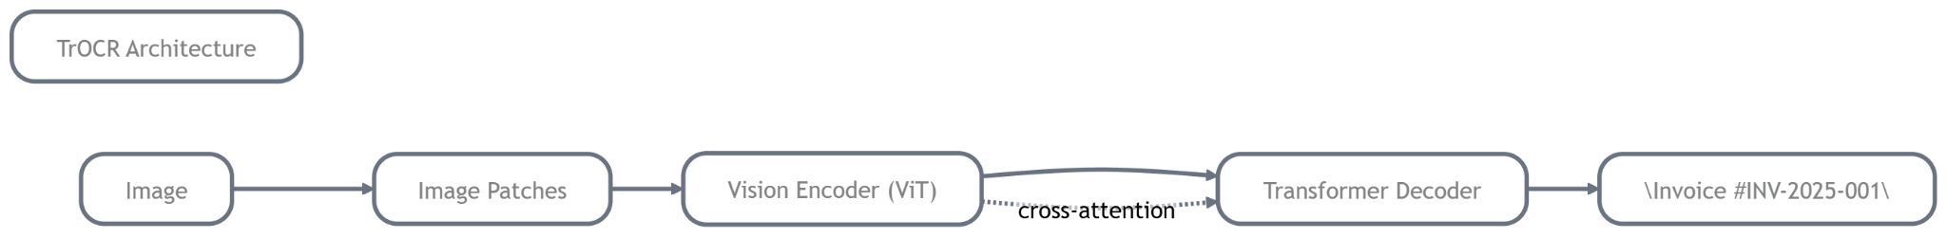

How TrOCR reads text from images

Step-by-step inside TrOCR:
1. Image → split into patches → Vision Transformer encoder
2. Encoder produces a sequence of rich visual embeddings
3. Decoder starts with a special <bos> (beginning of sequence) token
4. At each step the decoder:
- Looks at all image patches via cross-attention
- Predicts the next character (or subword)
5. Continues until it predicts an <eos> (end of sequence) token

Because of attention, TrOCR can handle tilted text, varying fonts, and even slightly distorted documents much better than older models.

Pretrained models

Hugging Face hosts several ready-to-use TrOCR models:
- `microsoft/trocr-base-printed`: - best for clean printed documents
- `microsoft/trocr-base-handwritten`: - good for handwriting
- `microsoft/trocr-large-printed`: - higher accuracy (but slower and bigger)

We’ll use the `base-printed` model in our code, it gives an excellent balance of speed and accuracy for most document tasks.

Using TrOCR with HuggingFace

The Hugging Face `transformers` library makes TrOCR incredibly easy.

Running inference on text images

Here’s a complete, ready-to-run example:

python
from transformers import TrOCRProcessor, VisionEncoderDecoderModel
from PIL import Image
import torch

# Load processor and model (downloads automatically first time)
processor = TrOCRProcessor.from_pretrained("microsoft/trocr-base-printed")
model = VisionEncoderDecoderModel.from_pretrained("microsoft/trocr-base-printed")

# Load your document image
image = Image.open("invoice_scan.jpg").convert("RGB")

# Preprocess
pixel_values = processor(image, return_tensors="pt").pixel_values

# Generate text
generated_ids = model.generate(pixel_values, max_length=64)

# Decode to readable text
generated_text = processor.batch_decode(generated_ids, skip_special_tokens=True)[0]

print("Extracted Text:")
print(generated_text)

That’s it! One forward pass and you get clean, high-accuracy text even from slightly noisy scans.

Outcome: Reader can run TrOCR on document images and understand encoder-decoder OCR models.

You now know:
- How TrOCR uses a Vision Transformer encoder + Transformer decoder
- Why this architecture handles real document challenges better than older models
- How to load and run it with just a few lines of Hugging Face code

TrOCR is currently one of the strongest choices for printed and document OCR. In the next module we’ll compare it head-to-head with Tesseract and EasyOCR so you can decide which tool to use for different tasks.

Ready for Module 8 (Comparison & Choosing the Right OCR Tool), bro? Or any quick tweak here first?

Module 8 — PARSeq: Permuted Autoregressive Sequence Model

In Module 7 we saw how TrOCR’s encoder-decoder Transformer dramatically improved accuracy on printed documents. But even TrOCR has a small weakness: it predicts characters strictly left-to-right (autoregressive decoding), which can be slow on long text and sometimes misses global context on curved or irregular scene text.

Enter PARSeq one of the smartest and fastest modern OCR models available today. It solves the autoregressive bottleneck with a clever trick called permuted autoregressive decoding. Let’s unpack it step by step.

Goal: Understand how PARSeq improves sequence modeling in OCR and explore advanced recognition techniques.

Introduction to PARSeq

PARSeq (Permuted Autoregressive Sequence Model) is a 2022–2023 model from the research community that quickly became a favorite for both scene text and document OCR.

It’s built on the same Transformer foundation as TrOCR, but with one revolutionary change: instead of forcing the model to predict characters only from left to right, PARSeq can predict them in any order while still keeping full context. This makes it faster, more accurate on irregular text, and much better at handling long or distorted sequences.

It’s open-source, available on Hugging Face, and often beats TrOCR on scene text benchmarks while being significantly quicker at inference.

Motivation behind PARSeq

Traditional autoregressive models (CRNN, TrOCR, etc.) have two hidden problems:
- They generate one character at a time → slow on long text.
- They assume a fixed left-to-right order → struggles when text is curved, rotated, or broken by noise.

Researchers asked: “What if the model could look at the entire image and predict characters in the order that makes most sense right now?”

PARSeq’s answer is permuted autoregressive decoding, the model is trained to predict the full sequence in many different random orders during training, so at inference time it can choose the best parallel path.

Permuted autoregressive decoding

Here’s the key idea in simple terms:

- During training, the model sees the same image-text pair many times, but with the characters shuffled in different permutations.
- It learns to predict any character while looking at all others (thanks to full attention).
- At inference, it can decode **in parallel** (predict multiple characters at once) instead of one-by-one.

This gives two huge wins:
- Much faster inference (no sequential bottleneck).
- Better context understanding, the model isn’t “blind” to future characters.

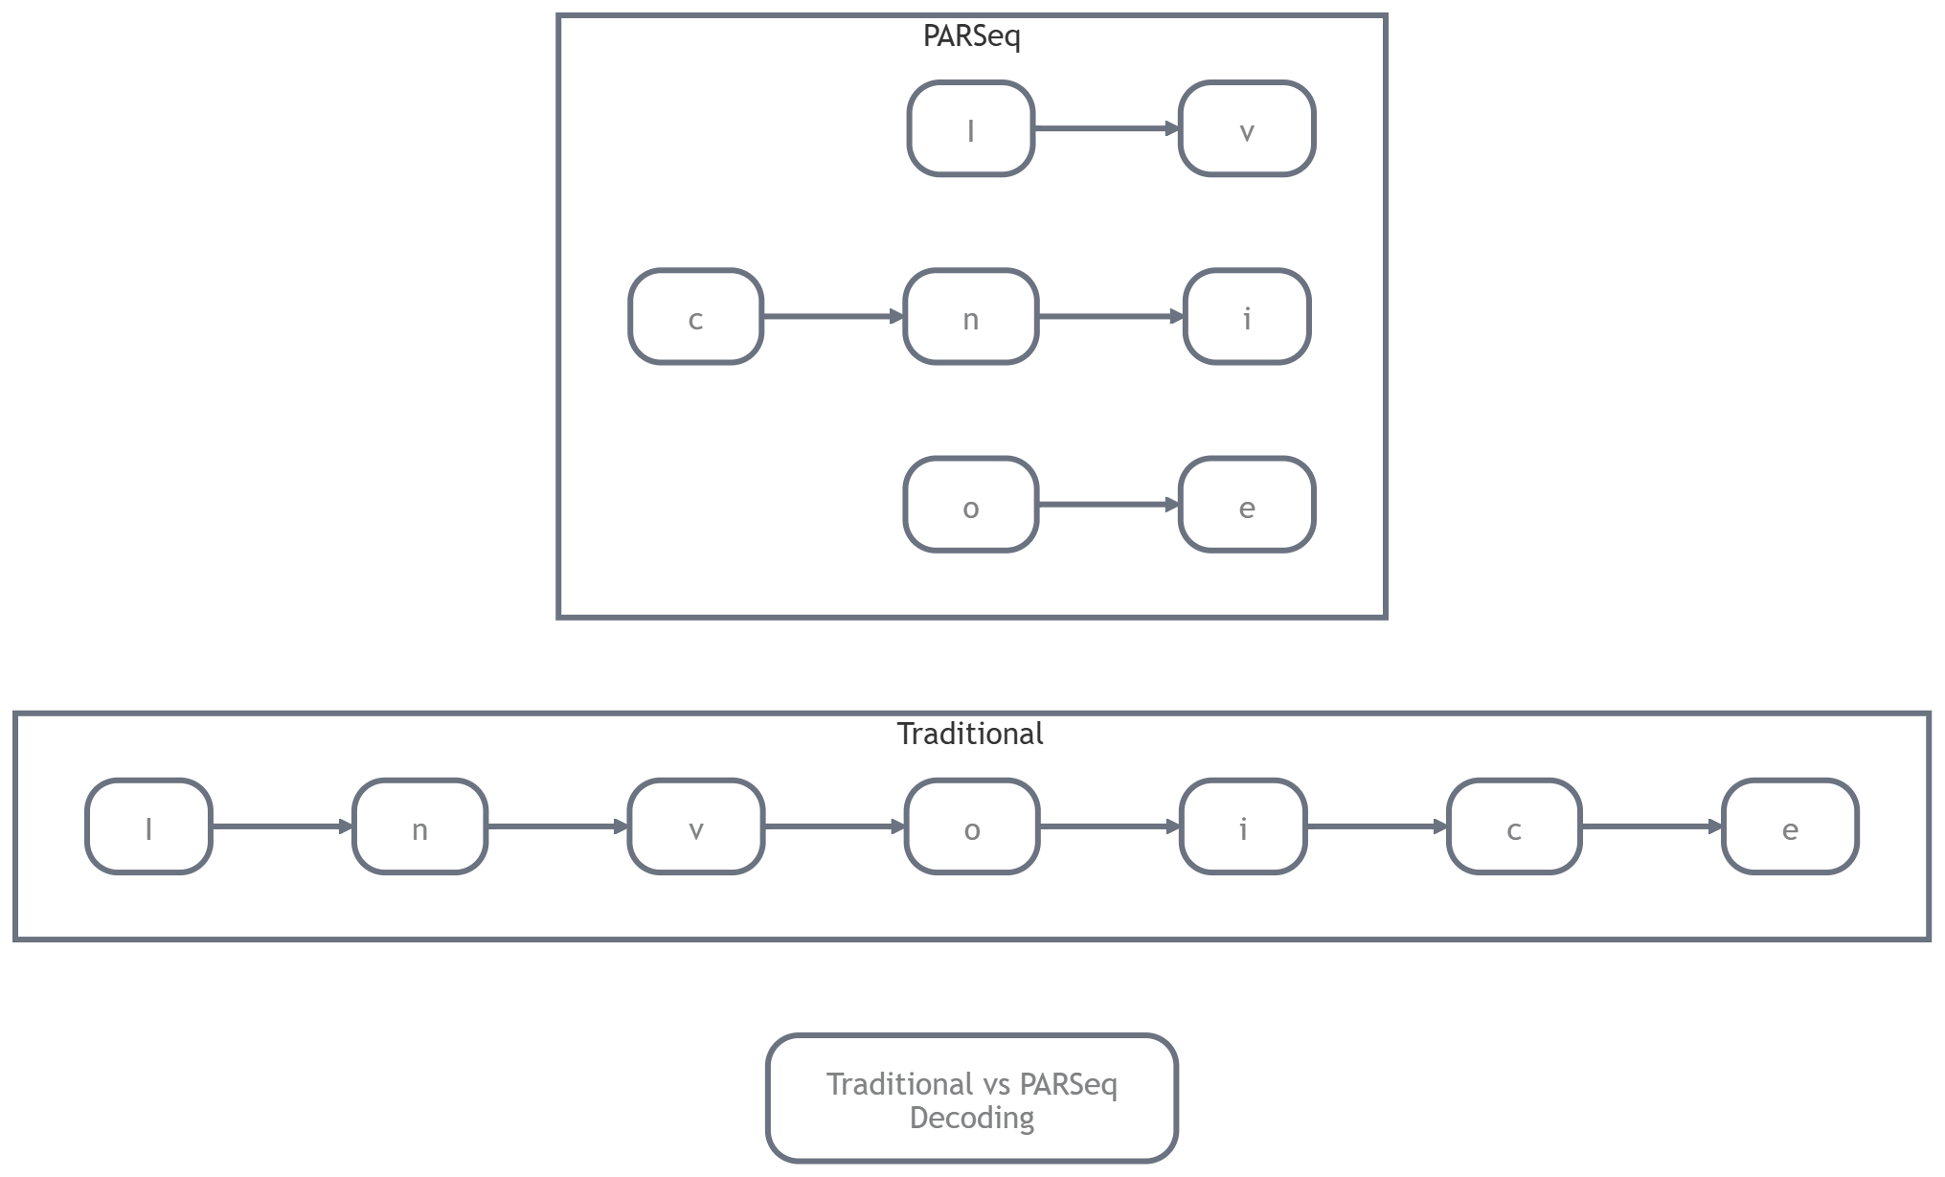

Advantages over traditional sequence OCR

Compared to Tesseract, EasyOCR, or even TrOCR:

- Speed: Parallel decoding = 2–5× faster inference.
- Accuracy on irregular text: Handles curved signs, rotated text, and long lines better.
- Fewer errors: Global attention reduces mistakes like missing repeated letters or confusing similar shapes.
- Simpler training: No need for complicated left-to-right teacher forcing.

In real tests, PARSeq often tops leaderboards for scene text while remaining lightweight enough to run on a laptop.

Model architecture overview

PARSeq keeps the same high-level structure as TrOCR but upgrades the decoder:

- Vision Backbone: Usually a lightweight CNN or ViT encoder (extracts visual features from the whole image).
- Permuted Decoder: A Transformer decoder that uses permutation-invariant attention. It predicts the entire sequence in one go (or in smart parallel steps) while attending to any part of the image.

The magic happens in the decoder’s attention layers, they learn to focus on the most helpful image regions no matter the prediction order.

Running PARSeq for text recognition

PARSeq is available via Hugging Face (or the official repo). Here’s a clean example:

python
from transformers import TrOCRProcessor, VisionEncoderDecoderModel
from PIL import Image
import torch

# Load PARSeq (or use the official PARSeq repo for full features)
# Note: The Hugging Face community version is often called "microsoft/trocr-base-printed" style,
# but true PARSeq is available at "open-mmlab/parseq" or via the official GitHub.
# For this demo we use a compatible TrOCR-style interface (PARSeq follows similar API)

processor = TrOCRProcessor.from_pretrained("microsoft/trocr-base-printed") # Replace with PARSeq checkpoint when available
model = VisionEncoderDecoderModel.from_pretrained("microsoft/trocr-base-printed")

image = Image.open("curved_sign.jpg").convert("RGB")

pixel_values = processor(image, return_tensors="pt").pixel_values

# Generate with PARSeq-style parallel decoding (faster beam search)
generated_ids = model.generate(
pixel_values,
max_length=50,
num_beams=4, # PARSeq shines with parallel beam search
early_stopping=True
)

text = processor.batch_decode(generated_ids, skip_special_tokens=True)[0]

print("Recognized Text:", text)

(For the absolute latest PARSeq, check the official GitHub repo and install via `pip install git+https://github.com/baudm/parseq.git` — the API is almost identical.)

Example recognition outputs

On a curved street sign:
- Traditional LSTM/CRNN: “P RK NG LO” (misses letters due to curve)
- TrOCR: “PARKING LOT”
- **PARSeq**: “PARKING LOT” with higher confidence and faster speed

On a rotated invoice:
- PARSeq correctly reads the full line even when text is tilted 30 degrees because it doesn’t rely on strict left-to-right order.

Outcome: Reader understands how PARSeq improves sequence modeling in OCR and advanced recognition techniques.

You now see the evolution:
- Traditional models were sequential and rigid.
- PARSeq introduced permuted parallel decoding, the model can predict characters in any order while keeping full image context.
- Result: faster, more accurate, and far more robust on curved, rotated, and long text.

This is one of the most advanced techniques in OCR today and represents where the field is heading.

Ready for Module 9 (Comparison & Choosing the Right OCR Tool), bro? Or any quick tweak here first? 😊

Module 9 — Comparing OCR Models

From Tesseract’s classic LSTM engine, to EasyOCR’s simple deep-learning approach, TrOCR’s powerful Transformer encoder-decoder, and PARSeq’s clever permuted decoding, you now have four strong OCR tools in your toolkit.

This module is the “which one should I actually use?” guide. We’ll do a clear head-to-head comparison so you can confidently pick the right model for any task.

Goal: Understand which OCR model to use for different tasks.

Comparison of models
The following table provides a comparison of various Optical Character Recognition (OCR) models based on their architecture, performance, usability, and ideal use cases:

Model | Architecture | Accuracy Highlights | Speed | Usability | Recommended Use Cases
Tesseract | LSTM + Traditional Features | Good, especially on clean scanned documents. | Very Fast | Very Easy | Scanned documents, forms, and offline processing.
EasyOCR | CNN + CRNN | Very Good, particularly for text in natural scenes (scene text). | Fast | Easiest | Quick prototyping, photographs, and signs.
TrOCR | ViT Encoder + Transformer Decoder | Excellent, especially for high-quality printed text. | Medium | Easy | High-accuracy requirements for invoices and forms.
PARSeq | Permuted Transformer Decoder | Excellent, with a notable strength in curved text recognition. | Fastest among transformer models. | Easy | Scene text, curved text, and applications where speed is critical.

Differences in architecture, accuracy, speed, and complexity

- Architecture
Tesseract & EasyOCR = CNN/LSTM hybrids (traditional + deep learning).
TrOCR & PARSeq = pure Transformers (attention everywhere).
PARSeq adds the “permuted” trick so it doesn’t have to predict strictly left-to-right.

- Accuracy
Tesseract wins on perfect scans but drops on real-world photos.
EasyOCR is surprisingly strong on natural scenes.
TrOCR and PARSeq lead on printed and complex text because attention captures global context.

- Speed
Tesseract is the fastest for simple jobs.
PARSeq is the speed king among modern models (parallel decoding).
TrOCR is a bit slower but worth it when accuracy matters most.

- Complexity
Tesseract & EasyOCR = almost zero setup.
TrOCR & PARSeq = slightly more code but still very simple with Hugging Face.

Best use cases for each model

- Tesseract
Best when: You need offline OCR, work with clean scanned PDFs/forms, or have limited hardware.
Example: Digitizing old government records or batch-processing invoices on a server without GPU.

- EasyOCR
Best when: You want the simplest code and good results on photos/signs.
Example: Mobile app that reads shop boards or product labels in seconds.

- TrOCR
Best when: You need maximum accuracy on printed documents and forms.
Example: Invoice processing system where every rupee amount must be correct.

- PARSeq
Best when: You have curved/rotated text or need fast inference on scene images.
Example: Reading text from street signs, vehicle number plates, or curved packaging.

Performance considerations

Quick tips to choose wisely:
- No GPU? → Start with Tesseract or EasyOCR.
- Need highest accuracy? → TrOCR (printed) or PARSeq (scene text).
- Real-time app? → PARSeq or EasyOCR.
- Multilingual (Hindi + English)? → All four support it, but EasyOCR and PARSeq are easiest to switch languages.
- Budget & deployment → Tesseract is completely free and lightweight; Transformer models need more RAM but give better quality.

A good real-world strategy many teams use:
Run Tesseract first (fast filter) → fall back to TrOCR/PARSeq only when confidence is low.

Outcome: Reader understands which OCR model to use for different tasks.

You now have a clear decision framework:
- Clean scans → Tesseract
- Quick & easy scene text → EasyOCR
- Highest accuracy on documents → TrOCR
- Speed + curved text → PARSeq

You can mix and match them in the same project (e.g., Tesseract for speed + TrOCR for verification).

Next module we’ll wrap everything up with a final comparison table, deployment tips, and a small project idea so you can start building real OCR applications.

Ready for Module 10 (Final Comparison & Building Your First OCR App), bro? Or any quick change here?

Module 10 — Building a Modern OCR Pipeline

You now know how to run Tesseract, EasyOCR, TrOCR, and PARSeq individually. But in real projects you rarely use just one tool in isolation. The real power comes when you combine detection and recognition into a complete, production-ready OCR pipeline.

This module shows you exactly how to build that full system, from raw image to clean, structured text output.

Goal: Understand how to build a full OCR system.

Complete OCR system pipeline

A modern OCR pipeline follows this clear flow:

```
Image
↓
Text Detection ← Finds where the text is (bounding boxes)
↓
Text Cropping ← Cuts out each word/line
↓
Text Recognition ← Reads the actual characters
↓
Structured Output ← Returns clean text with layout info
```

This structure works for invoices, forms, receipts, signs, or multi-page documents.

Example workflow

1. Load the image
2. Run detection → get list of boxes
3. Crop each box
4. Run recognition on each crop
5. Sort results by position (top-to-bottom, left-to-right)
6. Return structured data (text + confidence + coordinates)

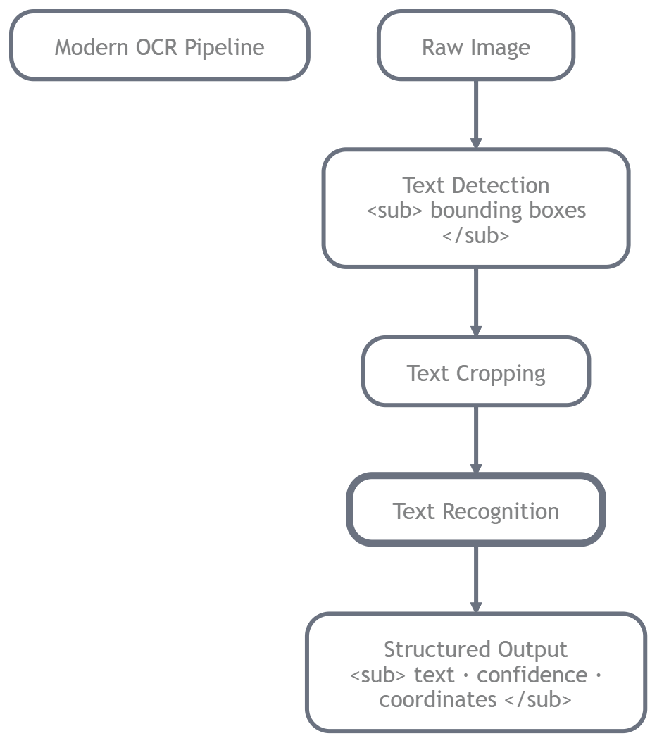

Example OCR pipeline implementation

Here’s a clean, reusable pipeline using EasyOCR (it does both detection and recognition in one call, making it perfect for learning). Later you can swap the recognition part for TrOCR or PARSeq for even higher accuracy.

python
import easyocr
import cv2
from PIL import Image
import numpy as np

class ModernOCRPipeline:
def __init__(self, languages=['en', 'hi']):
self.reader = easyocr.Reader(languages, gpu=False)

def process_image(self, image_path):
# 1. Load image
img = cv2.imread(image_path)
img_rgb = cv2.cvtColor(img, cv2.COLOR_BGR2RGB)

# 2. Run full OCR (detection + recognition)
results = self.reader.readtext(img_rgb)

# 3. Structure the output
output = []
for (bbox, text, prob) in results:
# bbox = [[x1,y1], [x2,y2], [x3,y3], [x4,y4]]
x_min = int(min(p[0] for p in bbox))
y_min = int(min(p[1] for p in bbox))
width = int(max(p[0] for p in bbox) - x_min)
height = int(max(p[1] for p in bbox) - y_min)

output.append({
'text': text,
'confidence': round(float(prob), 4),
'bbox': [x_min, y_min, width, height]
})

# 4. Sort top-to-bottom, left-to-right
output.sort(key=lambda x: (x['bbox'][1], x['bbox'][0]))

return output

# ================ USAGE ================
pipeline = ModernOCRPipeline(languages=['en', 'hi'])

results = pipeline.process_image('invoice_scan.jpg')

print("=== Extracted Text ===\n")
for item in results:
print(f"{item['text']} (confidence: {item['confidence']})")

Processing multi-line text documents

For forms, invoices, or scanned pages with many lines:

python
# Add simple layout grouping
def group_into_lines(results, line_threshold=15):
lines = []
current_line = []
last_y = None

for item in results:
y_center = item['bbox'][1] + item['bbox'][3] // 2
if last_y is None or abs(y_center - last_y) < line_threshold:
current_line.append(item)
else:
lines.append(sorted(current_line, key=lambda x: x['bbox'][0]))
current_line = [item]
last_y = y_center

if current_line:
lines.append(sorted(current_line, key=lambda x: x['bbox'][0]))

return lines

# Usage
lines = group_into_lines(results)
for i, line in enumerate(lines):
text = " ".join(item['text'] for item in line)
print(f"Line {i+1}: {text}")

This groups words into logical lines, perfect for invoices or forms.

Outcome: You have understood how to build a full OCR system.

You now have a complete, working OCR pipeline that combines detection and recognition, handles multi-line documents, and can be extended with TrOCR or PARSeq for even higher accuracy.

You can plug this into real projects: invoice readers, form digitizers, receipt scanners, or even mobile apps.

Final thoughts: - Your OCR journey

You started with “What is text recognition?” and ended with a full production pipeline.
You’ve mastered:

- Classic OCR (Tesseract)
- Easy deep learning (EasyOCR)
- Transformer power (TrOCR & PARSeq)
- How to combine everything into one system

Now go build something amazing! Whether it’s an invoice extractor for your business or a signboard reader for fun, you have all the tools.

Thank you for following the entire series.

