MCP

MODULE 1: MCP Fundamentals
A Model needs context to work — this comes from the Context Window, which holds the prompt, conversation history, and all relevant data. Once the model processes all this context, it generates the desired output.
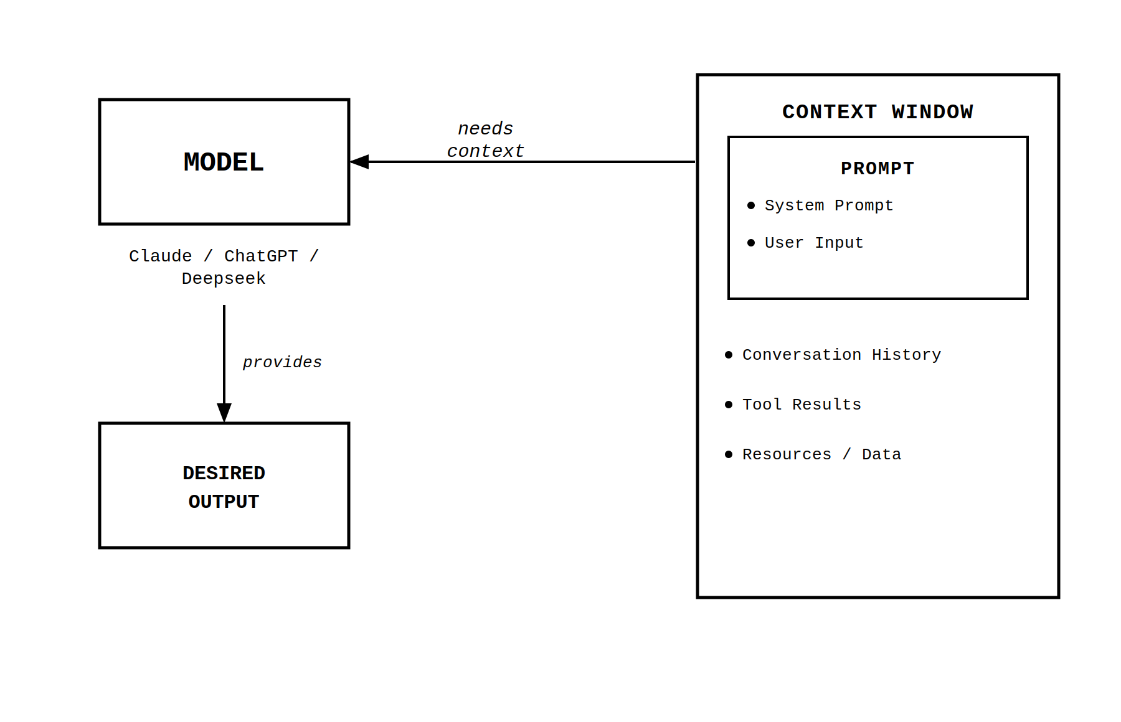The model can not consider what it does not know. So, we want to make sure that the model has everything it requires to give the output.
1.1 MCP - Model Context Protocol
Models can access publicly available information on the web, but they cannot reach content that requires authentication or lives on your local system — like your emails, calendar, or company files. To give a model access to this personal or private data, you have two options.
- You could manually copy and paste the relevant information into the chat, but that is a tedious task.
- The smarter approach is to build tools that let the model connect directly to the desired applications and fetch the data it needs on its own.
MCP is a pretty new concept. It was introduced by Anthropic in Nov 2024. Before MCP, the standard approach was tool calling — writing custom functions for each model-tool pair. If you had m models and n tools, you needed m × n custom functions — a maintenance nightmare as the numbers grow. MCP solves this by introducing a universal standard: each model becomes a host and each tool becomes a server, and they all communicate using the same protocol. Now you only need m + n setups instead of m × n.
Think of it like there are 10 people from 10 countries. Each country speaks their native language that is not known by any other country. 5 people in ‘Team A’ and 5 people in ‘Team B’. If each member of Team B has to talk to each member of Team A, then each member of Team B (B1, B2, B3, B4, B5) has to know 5 languages (A1, A2, A3, A4, A5). So, in total ‘5*5’ languages learnt by Team B. But, if all the 10 people know a common language, then they can easily communicate with each other. Since, everyone is learning 1 language, then ‘5+5’ languages are learnt in total.
Similarly in the computer world, protocol is introduced when two systems have to communicate with each other. It is the common language that both sides agree to speak. MCP defines the protocol, and it uses JSON-RPC 2.0 for communication.
Let’s break down what MCP means:
Model: It refers to any AI model that receives ‘context’ and utilizes it to provide the output.
Context: Here, context refers to everything inside the ‘context window’ that goes to the ‘model’
Protocol: A set of defined rules used as the language to autonomously fetch the ‘context’ for the ‘model’.
1.2 Why use MCP?
MCP is an open-source standard originally introduced by Anthropic (the company behind Claude) and now widely adopted across the AI ecosystem. It is a standardized way for AI models / assistants to connect to external data sources, tools, APIs, files, databases, and workflows.

Advantages
- Standardized: One MCP server works with Claude, ChatGPT, Gemini (via adapters), Cursor, VS Code Copilot, etc., making it more scalable than traditional tool calling.
- Much richer context: dramatically reduces hallucinations and improves answer quality
- Open & community-driven: fast-growing ecosystem (hundreds of community servers already).

Disadvantages
- Security risks: If poorly implemented, MCP servers can expose sensitive data or become attack vectors (token theft, over-privileged actions, prompt injection into tools).
- Performance & latency: Can feel slower than pure in-model function calling.

Some Use Cases
- Personal productivity: Connect local files, Notion, Obsidian, email (Gmail/Outlook), calendars, browser history
- Software development: Give AI access to your codebase (GitHub, local repo), run tests, search docs (e.g. Microsoft Learn MCP server), edit in VS Code / Cursor
- Enterprise & business tools: Connect to Slack, Salesforce, SharePoint, Jira, Confluence, internal databases
- Agentic workflows: Build semi-autonomous agents that can read docs, search web, update CRM or send emails
- Custom tools: Expose calculators, financial APIs, home automation, or proprietary company systems
- Coding assistants: Real-time context from your project without copy-pasting huge codebases
1.3 Core Concepts

Host:
- Prepares ‘context window’ for the ‘model’
- Maintains and manages the ‘clients’

Clients:
- Sends the host's requests to the server and brings responses back
- Speak the MCP protocol, handling all the technical communication details so the host doesn't have to worry about them

Each client has a 1:1 relationship with one MCP server. It keeps connections isolated and organized, so the host doesn't have to manage low-level transport details directly.

Servers:
- Expose three primitives — tools, resources, and prompts — which the host collects and uses to build richer context for the model.
- Receive requests from the client, executes the actual task, and sends results back to the client.

MODULE 2: Architecture & Protocol Design

2.1 MCP Architecture — How It All Connects
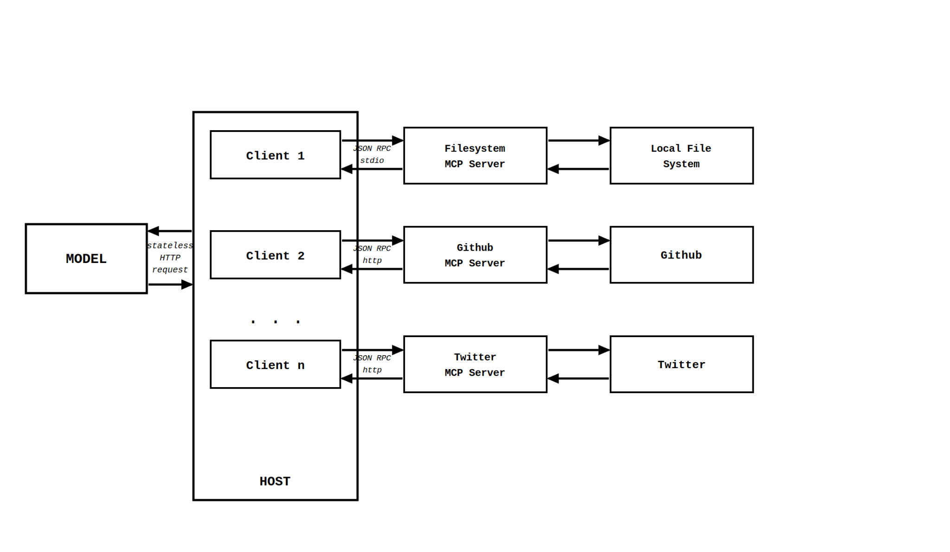
MCP setup has three layers: the Model, the Host, and the Servers.
At the center of MCP sits the Host, which acts as the orchestrator and controller of the entire system. The host is the application the user interacts with. It is responsible for managing the model, spinning up clients, and coordinating everything that happens.
The Model is a stateless reasoning engine. It does not remember anything on its own — it simply receives whatever is inside the context window and uses it to reason and produce an output. Every time it is called, it starts fresh. The host communicates with the model via HTTP requests, sending it the context it needs and receiving a response back.
Inside the host, there are one or more Clients. Each client is a dedicated communication bridge that maintains a one-to-one connection with a single MCP server. When the model needs external data or needs to trigger an action, the host instructs the client to go fetch it.
The MCP Servers sit outside the host. Each one wraps a specific tool or data source — such as a filesystem, GitHub, or Twitter. The client and server talk to each other using JSON-RPC, a lightweight messaging format.

Example:
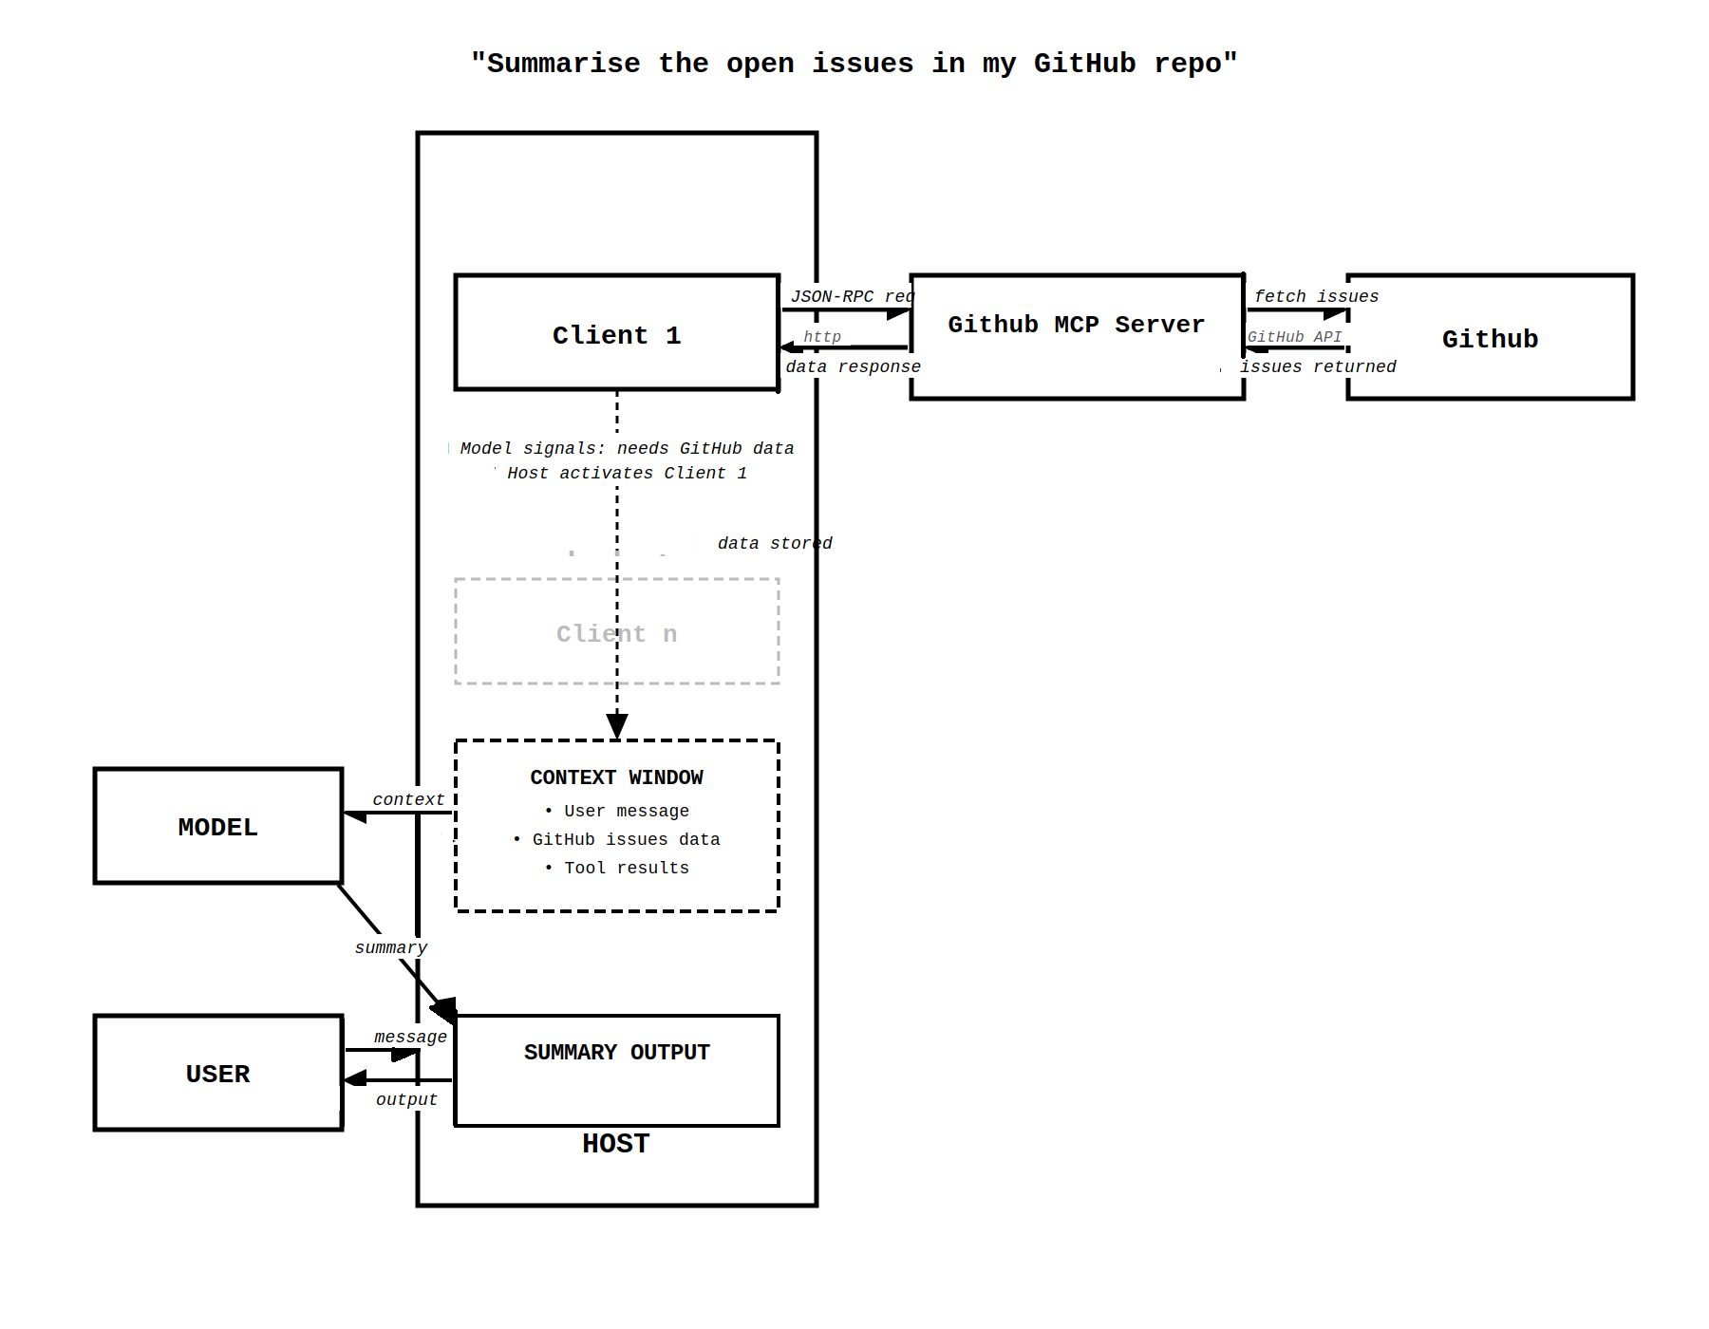

Model - Host Relationship
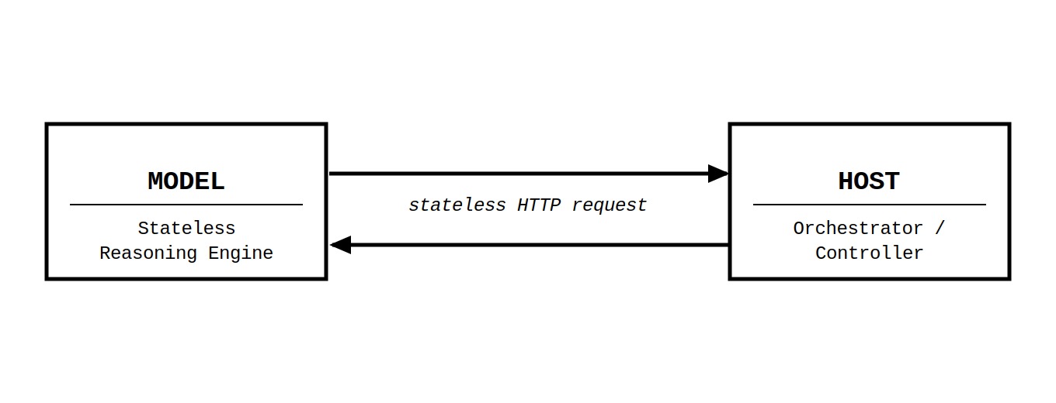
A stateless HTTP request is a request where the server does not retain information about previous requests; each request must contain all necessary context.

How the Host Directs Model Behavior

- Deciding When the Model Should Run: Model only works when the host sends a request to it. When a user asks a question or performs an action, the host processes that input and then decides whether it needs help from the model. If needed, the host sends the request to the model and waits for a response.
- Preparing the Information Sent to the Model: The host is responsible for assembling the content window - gathering the system prompt, conversation history, tool results, resources and packaging them before sending them to the model.
- Selecting which Model to Use: The model itself cannot change to another model or select one on its own. The choice is always made by the host. For example, the host might choose a model like GPT or another AI depending on the task.

Key Responsibilities of the Server:
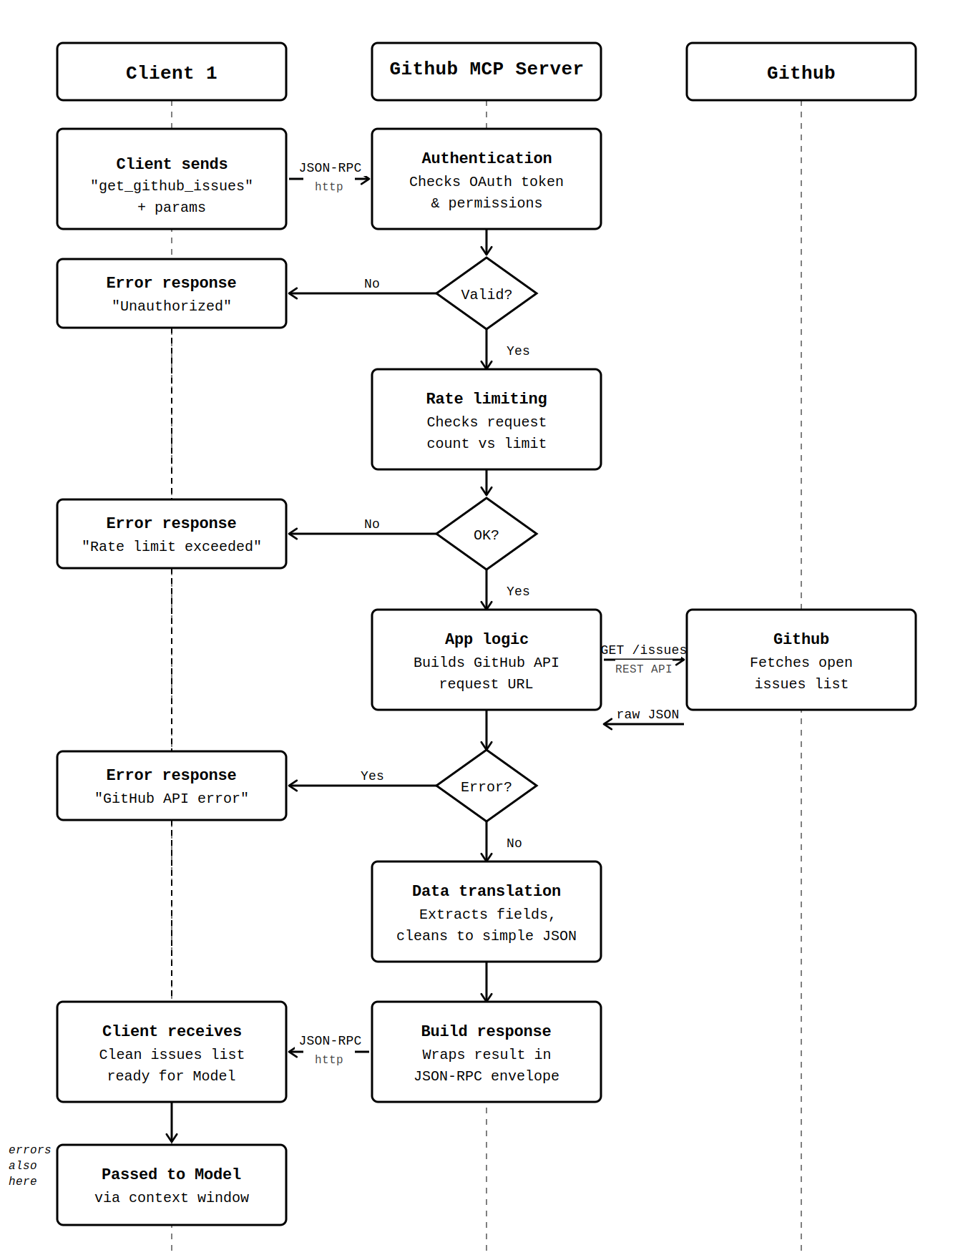
- Authentication: The server manages the login and permission checks with GitHub. Instead of the client handling tokens, OAuth, or security rules, the server securely verifies the user.
- Rate Limiting: GitHub APIs allow only a certain number of requests within a time period. The server monitors and controls requests so the system does not exceed GitHub’s limits.
- Translating Data Format: Different systems use different data formats. The server receives complex API responses from GitHub, extracts only the required fields, and restructures the data into a simple JSON format that the client can easily understand.
- Error Handling: If something goes wrong (network failure, invalid request, GitHub API error), the server detects the problem and sends a clear, understandable error message instead of crashing.
- Tool-Specific Application Logic: Some tasks require GitHub-specific rules, such as fetching repository data, listing issues and creating pull requests.

2.2 Transport Layer — How messages travel
For communication between the clients and servers, transport mechanism vary depending on where the server is present:
- Stdio (Standard Input/Output) — Used for local servers running on the same machine. The client writes messages to the server's stdin and reads responses from its stdout. It is fast and simple, no network required. Example: a Filesystem MCP Server accessing files on your laptop.
- HTTP — Used when the server is hosted remotely. Messages are sent as standard web requests over the internet. Example: a GitHub MCP Server or a Twitter MCP Server hosted in the cloud.
- SSE (Server-Sent Events) — Used for real-time streaming over HTTP, where the server continuously pushes updates back to the client as they become available. Useful for long-running tasks or live data feeds.
- WebSockets — Used for persistent, two-way communication between the client and server. After an initial HTTP handshake, the connection stays open, allowing both sides to send messages at any time. This is useful for highly interactive systems that require frequent back-and-forth communication.
Transport type | Use case | Process
stdio | Local communication | Direct process-to-process communication
HTTP | Remote communication | Request–response over network
SSE (Server-Sent Events) | Remote streaming / server push updates | Server continuously streams events to the client over an HTTP connection
WebSockets | Remote real-time / interactive communication | Persistent bidirectional connection

2.3 Data Layer — What messages contain
Regardless of transport type, every message follows the JSON-RPC structure — keeping the data format consistent. Every message is a simple JSON object containing a method name, parameters, and an ID to match responses back to requests. Currently, its second version is in use and it is called JSON RPC 2.0.
Example:
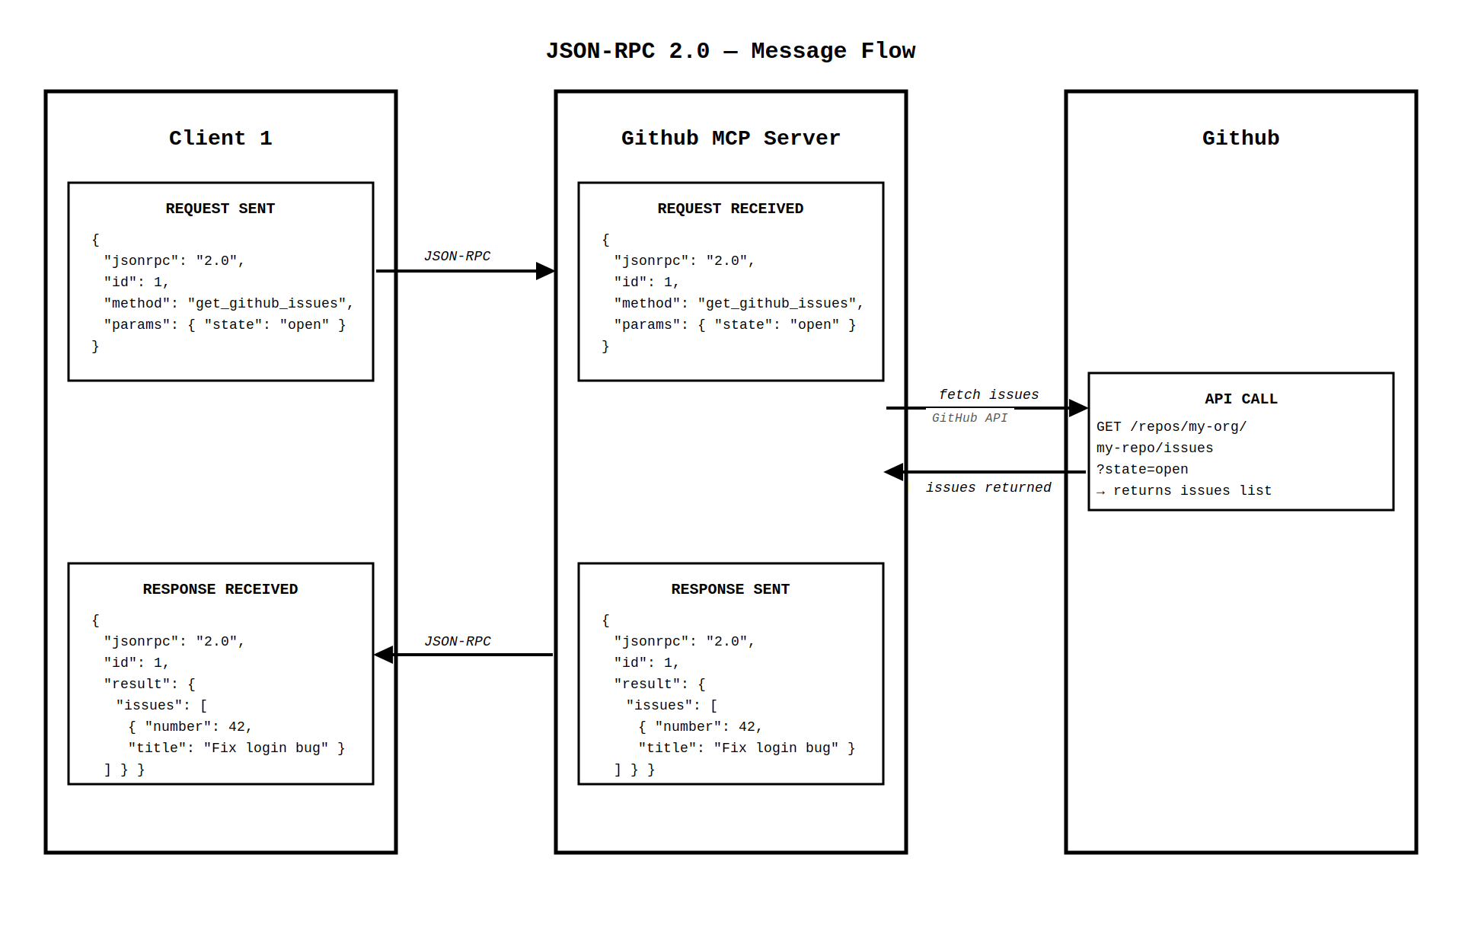
Every request has an id and a method, and every response carries back the same id with either a result or an error.

Client 1 sends Request Message when it wants to fetch open GitHub issues:
{
"jsonrpc": "2.0",
"id": 1,
"method": "get_github_issues",
"params": {
"repo": "my-org/my-repo",
"state": "open"
}
}
jsonrpc — always "2.0", tells the server which version of the protocol is being used
id — a unique number to track this request, so the response can be matched back to it
method — the action being requested, like calling a function by name
params — the inputs needed to carry out the method

The GitHub MCP Server sends back the Response Message after fetching the issues.
{
"jsonrpc": "2.0",
"id": 1,
"result": {
"issues": [
{ "number": 42, "title": "Fix login bug", "state": "open" }
]
}
}

jsonrpc — same version tag, always present
id — matches the id from the request, so the client knows which request this answers
result — the actual data returned by the server

If Something Goes Wrong, Error Response comes back to the client from the server.
{
"jsonrpc": "2.0",
"id": 1,
"error": {
"code": -32601,
"message": "Method not found"
}
}
Instead of result, the server sends an error object with a code and a human-readable message. The id still matches so the client knows exactly which request failed.

Features of JSON-RPC
- Lightweight: As the messages are small, there is no big overhead making it fast and cheap.
- Easy to parse: Computers can easily read and understand the messages because every message is just plain JSON text. There is no weird binary data or complicated compression.
- Language-agnostic: It relies on JSON which is supported by almost every programming language, so the systems written in different languages can communicate with each other using this message format.
- Built-in request tracking & error handling: Every request gets an "id" which makes it easy to match answers. Also, the errors come in standard format (code + message), so the problems are clear.
- Matches how LLMs already think about tools: Modern AI models such as Claude and GPT already follow a similar pattern of calling functions with structured JSON parameters, so adopting JSON-RPC feels natural and requires few additional step to integrate with existing model capabilities.

2.3 Methods
In MCP, communication between the client and server happens using JSON-RPC methods which define what kind of request is being made and what action the server should perform. Some of the functional groups of these methods are:
- Initialization methods: start and configure the connection
- Tool methods: discover and execute tools
- Resource methods: access external data
- Prompt methods: retrieve reusable prompt templates
2.3.1 Initialization Methods
These methods are used when the client first connects to an MCP server.
Key methods:
- initialize
  - Sent by the client when starting a connection.
  - It tells the server the client's capabilities and protocol version.
- initialized
  - Sent after initialization is complete to confirm that the connection is ready.

2.3.2 Tool Methods
These methods allow the client to discover and execute tools provided by the server.
Key methods:
- tools/list
  - Returns all available tools on the server.
- tools/call
  - Executes a specific tool with provided arguments.

2.3.3 Resources Methods
Resources are data sources that the model can read.
Key methods:
- resources/list
  - Lists available resources.
- resources/read
  - Reads the contents of a resource.

2.3.4 Prompt Methods
Prompts are predefined prompt templates stored on the server.
Key methods:
- prompts/list
  - Lists available prompt templates.
- prompts/get
  - Retrieves a specific prompt template.

2.4 Lifecycle
MCP connection is like starting a phone call with a friend who speaks a different language. You don't just jump into chatting — you first check if you can understand each other, agree on what you can talk about, then chat normally, and finally say goodbye nicely so nothing gets messed up.
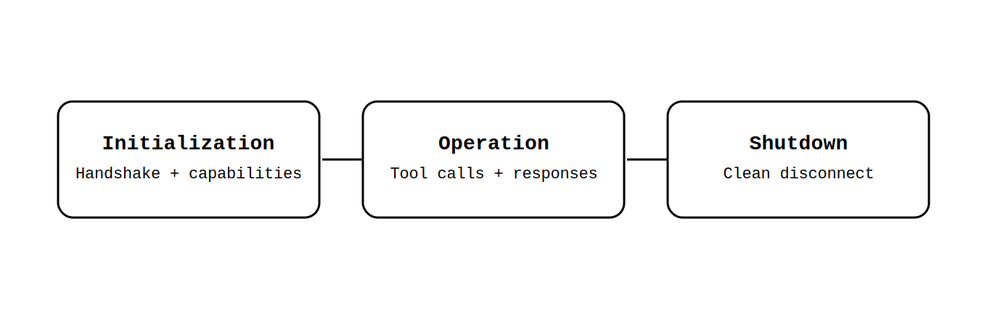
MCP has a strict three-phase lifecycle to make sure everything is safe, compatible, and clean:
- Initialization (the handshake)
- Operation (the actual work)
- Shutdown (the polite goodbye)

Phase 1: Initialization — The Handshake & Agreement
Initialization is the starting phase of the protocol where the system sets up the environment, establishes connections, and ensures that all required components are ready to work together.
This is how it happens:
Client sends initialize message to the server.
Example Message:
{
"jsonrpc": "2.0",
"id": 1,
"method": "initialize",
"params": {
"protocolVersion": "2025-03-26",
"clientInfo": {
"name": "my-mcp-client",
"version": "1.4.2"
},
"capabilities": {
"roots": { "listChanged": true },
"sampling": {},
"elicitation": {}
}
}
}
protocolVersion tells the server which version of the MCP spec the client understands. It's a date string in YYYY-MM-DD format (eg., 2025-03-26). If the server can't speak that version, it rejects the handshake.
clientInfo is just identification — name and version of the client software. Useful for debugging and server-side logging.
capabilities is the heart of the handshake — it's a negotiation of optional features:
- roots — the client can expose filesystem root URIs (e.g. /home/user/project) to the server, so tools can reason about the user's workspace. Setting listChanged: true means the client will proactively notify the server if those roots change.
- sampling — the client is willing to accept sampling/createMessage requests from the server. This lets the server ask the client's LLM to generate text on its behalf — a powerful inversion where the server drives LLM calls through the client.
- elicitation — the client supports elicitation/create requests. It means the server can pause mid-tool-execution and ask the user a structured question (e.g. a confirmation dialog or a form) and receive the answer back.

Both sampling and elicitation are declared by presence alone — an empty {} means "I support this". Omitting the key entirely means "I don't support this, don't send me those requests."

The server replies with its own initialize response declaring its capabilities (tools, resources, prompts, etc.).
Example Message:
{
"jsonrpc": "2.0",
"id": 1, // mirrors the client's request id
"result": {

"protocolVersion": "2025-03-26", // version server will speak

"serverInfo": {
"name": "my-mcp-server",
"version": "2.1.0"
},

"capabilities": {

// TOOLS
// Server exposes callable tools to the client/LLM
"tools": {
"listChanged": true // will notify when tool list changes
},

// RESOURCES
// Server can serve readable resources (files, DB rows, URLs…)
"resources": {
"subscribe": true, // client may subscribe for live updates
"listChanged": true // will notify when resource list changes
},

// PROMPTS
// Server exposes reusable prompt templates
"prompts": {
"listChanged": true
},

// LOGGING
// Server can emit structured log messages to the client
"logging": {}

}
}
}
The server's message have:
"id": 1 — the server echoes back the exact same id the client sent. This is how JSON-RPC correlates responses to requests. The client sees id: 1 and knows this is the answer to its initialize call.
"result" not "error" — a successful response uses result. If the server rejects the handshake (e.g. incompatible protocol version), it would send "error": { "code": -32600, "message": "..." } instead and the session never opens.
Server capabilities are the mirror of client capabilities — but they declare what the server offers, not what the client can do:
- tools — the server has callable tools. listChanged: true means it will proactively send notifications/tools/listChanged if new tools come online.
- resources — the server can serve readable content. subscribe: true means the client can call resources/subscribe to get live update notifications when a resource changes.
- prompts — the server has reusable prompt templates the client can fetch.
- logging — the server will emit structured log messages via notifications/message.

After the client receives this reply, it must send one final notification to complete the initialization step:
{"jsonrpc":"2.0","method":"notifications/initialized"}
That's a one-way fire-and-forget (no id, no params) to tell the server "I've processed your capabilities, we're good to go." Only after this notification can either side start making real requests.

If the server rejects the initialize request — say the protocol version is incompatible — it replies with a JSON-RPC error object instead of a result:
{
"jsonrpc": "2.0",
"id": 1,
"error": {
"code": -32600,
"message": "Unsupported protocol version: 2024-01-01",
"data": {
"supported": ["2025-03-26"]
}
}
}
The client receives this, sees "error" instead of "result", and knows the session was rejected. It does not send notifications/initialized and the session never opens.

Transport fails: If the connection itself can't be made (process won't start, port refused, socket error), there is no MCP channel to send anything over. The client simply gets an OS-level error — a failed spawn(), a TCP ECONNREFUSED, a timeout. There's no MCP error message because MCP never got a chance to speak. The client handles this in its own code, outside the protocol.

Important rules during initialization:
- Client MUST NOT send any real requests (like tools/list or resources/read) before the server replies to initialize.
- The server SHOULD NOT send requests (except ping or logging) before the client sends the initialized notification.
- Both sides can send simple ping messages at any time (even during init) to check if the other is alive. If there is no response in a timeout (usually 30–60 seconds), close the connection.
Progress Notification — During a long init, the server can send progress updates. Example: "Loading auth... 50%".
Example:
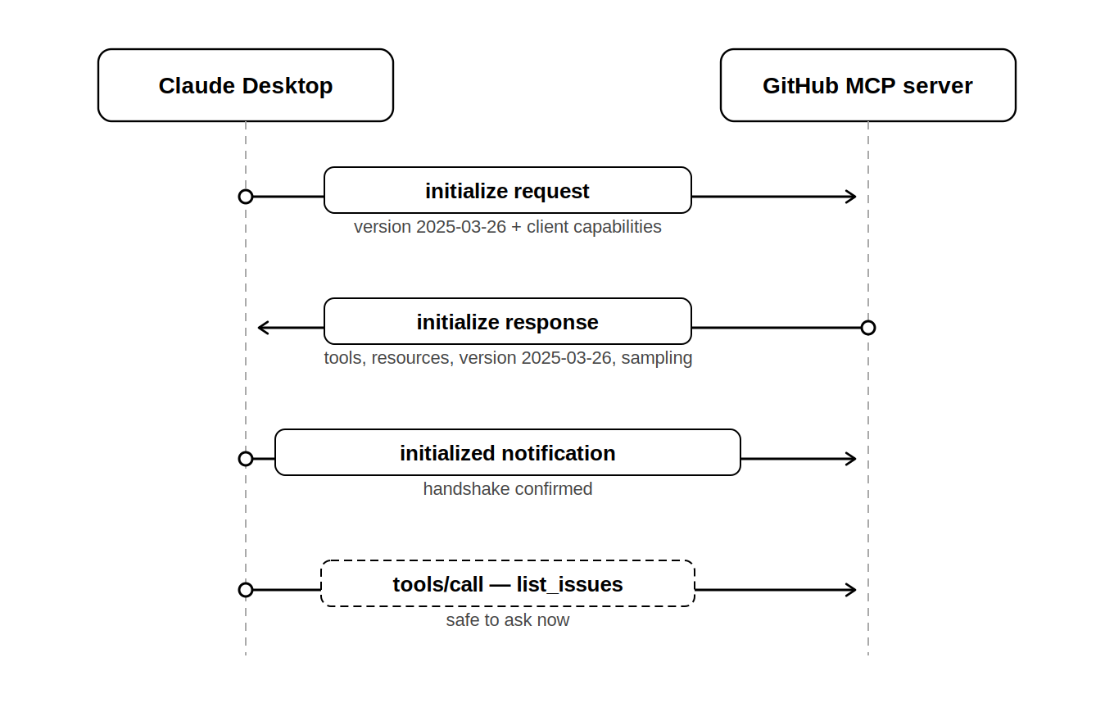

Phase 2: Operation — The Main Work
The operation phase is the actual working life of the session. Once the client sends notifications/initialized, both sides are free to exchange any messages they negotiated support for. The client drives most of it: it calls tools, reads resources, fetches prompt templates, and manages filesystem roots. The server mostly responds — but it's not purely passive. It can proactively notify the client when things change (tool list updated, resource modified, new log entry), and it can reach back into the client to request an LLM generation via sampling or pause a tool to ask the user a question via elicitation.
The key things that happen in this phase:
- Tool calls — the LLM invokes server-side functions and gets results back
- Resource reads — the model reads files, DB rows, or live data feeds the server exposes
- Prompt fetching — the client pulls server-managed prompt templates and injects them into the LLM context
- Sampling — the server asks the client's LLM to generate text mid-execution
- Elicitation — the server pauses and asks the human user a structured question before continuing
- Roots — the server stays aware of which filesystem paths the client has in scope
- Logging — the server streams structured log entries the client can display or store
- Ping — either side checks the other is still alive at any point

Tool Calls
Tool calls are the most frequent activity in the operation phase.
"method": "tools/list"
The client uses this method to discover what tools the server offers. Each tool comes back with a name, description, and an input schema describing what arguments it accepts.
Example response:
{
"jsonrpc": "2.0",
"id": "req-001",
"tools": [
{ "name": "read_file",
"inputSchema": { "path": "string" } },
{ "name": "run_query",
"inputSchema": { "sql": "string" } }
]
}

"method": "tools/call"
The client uses this method with the tool name and arguments. The server executes it to return a result as text, image, or an error block.
Example response:
{
"jsonrpc": "2.0",
"id": "req-002",
"result": {
"content": [
{
"type": "text",
"text": "id,amount\n1,250\n2,99"
}
],
"isError": false
}
}

Method | Purpose
tools/list | get all available tools and their schemas
tools/call | invoke a tool with arguments, get result back
notifications/progress | streamed updates during slow tool execution
notifications/tools/listChanged | tool list has changed, client must refresh

Resources
Resources are passive data sources the model can read — files, database rows, API snapshots, configuration blobs.
Method | Purpose
resources/list | browse available resources with URL with names and MIME types
resources/read | fetch content from a specific URL
resources/subscribe | watch a resource for live changes
notifications/resources/updated | resource has changed, time to re-read
resources/unsubscribe | Stop the feeds of a resource
Subscriptions are a powerful feature. If a client calls resources/subscribe on a URI, the server will fire notifications/resources/updated every time that resource changes. The client then re-reads it to get the latest version. This is what makes live logs, metrics feeds, or file watchers possible. When the client is done watching, it calls resources/unsubscribe to stop the stream.

Prompts
Prompts let the server own and manage reusable prompt templates rather than having them hardcoded in the client. The client calls prompts/list to see available templates, each with a name, description, and the list of arguments it accepts. It then calls prompts/get with a name and filled-in arguments, and the server returns a fully rendered messages array ready to be injected directly into the LLM context.
A prompt template can also embed resource references — pointers to URIs the client should resolve and attach as content. The client reads those resources and includes them inline. If the server updates its template library at any point, it fires notifications/prompts/listChanged and the client refreshes.
Method | Purpose
prompts/list | get all templates with their argument definitions
prompts/get | render a named template with arguments into LLM-ready messages
resources/read | Prompts can contain resource refs — client resolves them using this method
notifications/prompts/listChanged | prompt library updated, refresh needed

Example: User asks "Summarize my repo issues"
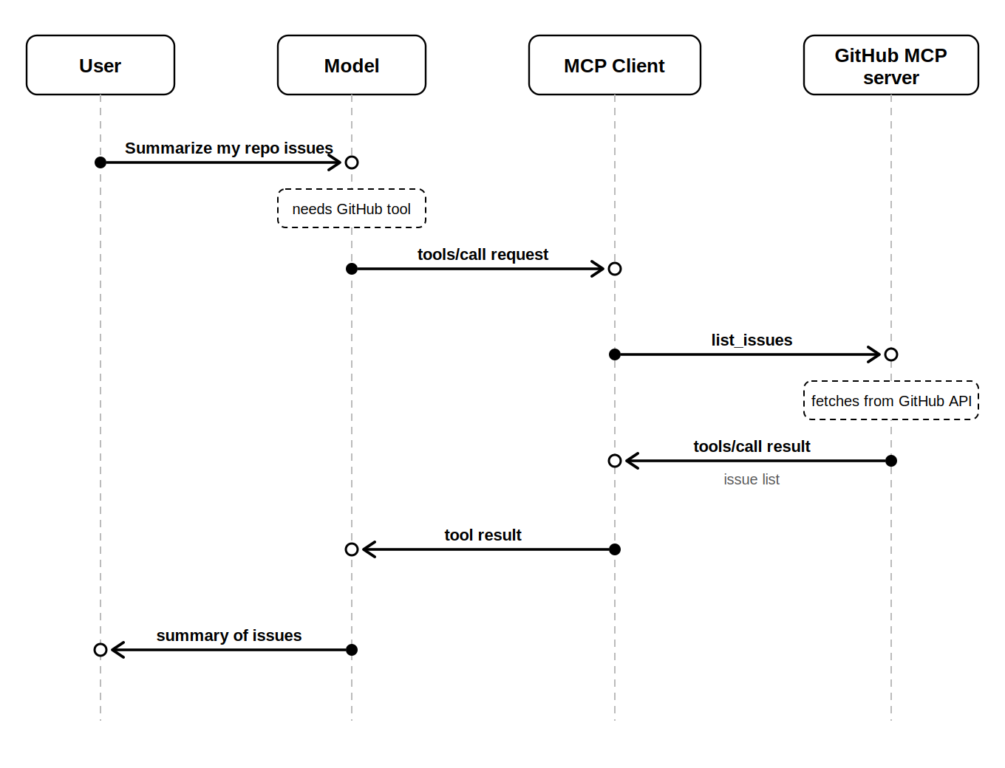

Phase 3: Shutdown — Clean Goodbye
Shutdown is the final stage of the lifecycle, where the system gracefully stops its operations and releases resources. Instead of abruptly terminating processes, a proper shutdown ensures that all components finish their tasks and close connections safely.
There is no shutdown method or notifications/closing in the protocol. Shutdown is entirely handled by the transport layer — meaning the way messages travel is also the way the session ends.
- Stdio shutdown (for local servers)
  - Client usually closes stdin → server sees end-of-input and exits.
  - If server hangs, client can send SIGTERM (polite stop) → then SIGKILL (force stop) after timeout.
  - Rarely, server closes stdout first.
- HTTP / SSE / WebSocket shutdown (for remote servers)
  - Client closes the HTTP connection or stops sending POSTs.
  - Server detects disconnect (no more requests, timeout on keep-alive).
  - Reconnects are possible — client can re-initialize on a new connection.
Best practice: Always let the client initiate shutdown gracefully when closing the app or removing the server.
That’s the full lifecycle — handshake → work → clean exit. Understanding this makes debugging MCP connections way easier. In the next modules, when we build servers and clients, you'll see this flow in action!

MODULE 3: Creating Servers
We've got the fundamentals and the architecture down from the first two modules, so now it's time to roll up our sleeves and actually build something. In this module, we're going to create an MCP server from scratch. We'll use real-world examples, like building a basic server that lets your model access local files on your computer. And I'll put some code you can copy-paste and run yourself.
3.1 Getting Started with Tools for Building Servers
First off, to build an MCP server, we need a toolkit. The main one is called FastMCP, which is like a quick-start kit for making servers. It's built on top of FastAPI (a popular way to make web apps in Python), so if you've used that before, this will feel familiar. FastMCP handles all the JSON-RPC stuff we talked about in Module 2, so you don't have to worry about the low-level details.
FastMCP or MCP SDK
There are a couple of versions:
- If you want the older version (1.0), use pip install mcp[cli].
- For the latest (version 2.0), go with pip install fastmcp.
But here's a tip: Skip pip if you can. FastMCP folks recommend using 'uv' instead—it's a super-fast package manager for Python that's way quicker than pip. It saves time on installs, especially for bigger projects.
To install package manager uv open your terminal and run:
pip install uv
3.2 Basic Setup: Preparing Your Project
Let's set up a new project. We'll use VS Code as our editor because it's free and great for Python, but any editor works.
- Open VS Code and create a new folder for your project. Call it something like "my-mcp-server".
- Open the terminal inside VS Code (go to Terminal > New Terminal).
- Initialize the project with uv. This creates a virtual environment and a pyproject.toml file for your dependencies. Run:
uv init
- Add FastMCP to your project:
uv add fastmcp
This will download FastMCP and set it up. If you run into any errors (like Python version mismatches), just check the uv docs—they're straightforward.
Now your project is ready. You'll have a main.py file created automatically by uv init, but we'll edit it next.

3.3 Creating Your MCP Server
We'll make a simple one that exposes a "tool" for reading local files. This means your AI model can ask for file contents, and the server will fetch them.
Open main.py in VS Code and replace what's there with this code:
from fastmcp import MCPServer
import os

server = MCPServer(name="Local File Server", description="Access local files on your machine")

@server.tool(
name="read_file",
description="Read the contents of a local file",
parameters={
"path": {"type": "string", "description": "The file path to read"}
}
)
def read_file(path: str) -> str:
if not os.path.exists(path):
raise ValueError("File not found")
with open(path, 'r') as f:
return f.read()

if __name__ == "__main__":
server.run()

What's happening here?
- We import MCPServer from fastmcp.
- Create a server instance with a name and description (this shows up when your AI discovers it).
- Define a @server.tool decorator for our function. It takes a name, description, and parameters (like the file path).
- The read_file function checks if the file exists, reads it, and returns the text. Simple!
Now, the model can directly fetch information from your local files for the tasks that require them without you needing to do any extra work. For example, if you're working on a coding project, the model can now "read" your code files directly without you pasting them.

3.4 Testing and Running Your Server
In your terminal, run:
uv run fastmcp dev main.py
This starts the server in development mode—it watches for code changes and reloads automatically. You'll see output like "Server running on http://localhost:8000".
To test, you can use a tool like curl or just open that URL in your browser. But for a real test, we'll connect it to a host.
When you're ready to run it for real:
uv run fastmcp run main.py
This starts it in production mode—faster and no auto-reload.
3.5 Adding Your Server to a Host
Once it's running, you need to "install" it so your AI can find it. For Claude Desktop, run:
uv run fastmcp install claude-desktop main.py
This registers the server with Claude. Now, in Claude, you can chat and say something like "Read the file at /path/to/myfile.txt", and it'll use your server!
Example: Let's say you're a writer with notes in a local folder. With this server, you can ask, "Summarize my notes in ideas.txt," and it pulls the file automatically. No more copy-paste hassle.
Here's a simple flow of how we created the server:
Start -> Install uv -> Create project folder -> Run uv init -> uv add fastmcp -> Write code in main.py -> Test with uv run fastmcp dev -> Run production with uv run fastmcp run -> Install to the host

Tips and Next Steps:
- Security: Always be careful with what your server exposes. For files, maybe add checks to only allow certain folders.
- Expand it: Add more tools, like one for writing files or listing directories.
- Troubleshooting: If something breaks, check the terminal logs—they're usually clear.

3.6 Building & Deploying Remote MCP Server
So far we've run the MCP server only on your own laptop. Now, let's build a remote MCP server that lives on the internet. Multiple people can connect to this at the same time, that means one server serves many clients.
Example: A small team builds one remote "Company Files MCP Server". Every developer’s Cursor/Claude connects to it → no one copies company docs anymore. One update to the server helps everyone instantly.
(Imagine a simple diagram here:
Laptop (Client 1) → Internet → Cloud Server (handles 10 clients)
Phone (Client 2) → ↑
Desktop (Client 3) → ↑
Arrows show many clients talking to one powerful remote server.)

Let’s make our file-reader server remote-ready. We'll use streamable HTTP transport (best for remote — supports real-time streaming).

Step 1: Basic Setup (same as before)
In a fresh folder:
uv init
uv add fastmcp

Step 2: Make the Server Remote-Friendly (main.py)
Update your main.py to use HTTP explicitly and add a bit more info:
from fastmcp import MCPServer
import os

server = MCPServer(
name="Remote File Reader",
description="Safely read files from our shared project folder",
# This makes it HTTP-ready for remote use
transport="http" # or "streamable-http" for better real-time feel
)

@server.tool(
name="read_file",
description="Read contents of a file (only in allowed folder for safety)",
parameters={
"path": {"type": "string", "description": "Relative path, e.g. notes.txt"}
}
)
def read_file(path: str) -> str:
# Safety: only allow files inside a project folder
base_dir = os.path.abspath("./allowed_files")
full_path = os.path.abspath(os.path.join(base_dir, path))

if not full_path.startswith(base_dir):
raise ValueError("Access denied - path outside allowed folder!")

if not os.path.exists(full_path):
raise ValueError("File not found")

with open(full_path, 'r', encoding='utf-8') as f:
return f.read()

if __name__ == "__main__":
server.run(host="0.0.0.0", port=8000) # Important: 0.0.0.0 lets internet reach it

Create a subfolder called allowed_files and put a test file there (e.g. test.txt with "Hello from remote!").

Step 3: Run & Test Locally First
uv run fastmcp dev main.py
# or uv run main.py
Open browser → http://localhost:8000 (or whatever port) → you should see MCP info.
Better test: Use MCP Inspector (a free browser tool for testing MCP servers — search "MCP Inspector" or find it at gofastmcp.com/tools or similar community sites).
- Paste your local URL (e.g. http://localhost:8000)
- Click "List Tools" → see read_file
- Try calling it with path: test.txt
Step 4: Push to GitHub (makes deployment easy)
git init
git add .
git commit -m "Initial remote MCP file server"
git branch -M main
# Create empty repo on GitHub first, then:
git remote add origin https://github.com/yourusername/your-mcp-repo.git
git push -u origin main

(screenshot here: GitHub repo page after push, showing main.py and allowed_files folder.)

Step 5: Deploy to the Cloud
FastMCP works great on many platforms. Here are the few options:
Option A: Prefect Horizon (FastMCP officially recommends – often free tier)
- Go to prefect.io/horizon (or search "Prefect Horizon MCP")
- Sign up (GitHub login works)
- Click "New Deployment" and connect your GitHub repo
- Select your main.py file
- Choose "HTTP" transport
- Deploy: get a URL like https://your-server.horizon.prefect.cloud/mcp
Option B: Render.com (super simple, free hobby tier)
- Sign up at render.com
- Click New > Web Service > Connect GitHub repo
- Runtime: Python
- Build command: uv sync
- Start command: uv run main.py
- Add env vars if needed later
- Deploy: get https://your-app.onrender.com
Option C: Google Cloud Run (free credits for new users, very powerful)
- Go to console.cloud.google.com > Cloud Run
- Create service and source from GitHub
- Or build Dockerfile
- Set port 8000, allow unauthenticated for testing
Many people deploy to Render/Cloud Run/Northflank/Railway — all support Python + HTTP in minutes.
(Imagine flowchart here:
Local code → Git push → Cloud platform (Render/Prefect/Cloud Run) → Public URL → Multiple clients connect → AI uses tools remotely)

Step 6: Connect from Your Model
In Claude Desktop or Cursor:
- Add new MCP server and paste your cloud URL (e.g. https://your-app.onrender.com)
- It auto-discovers tools
- Ask: "Read test.txt from your file server"
- Boom — works from anywhere

Problem | Why it happens | Fix
Slow responses | Network latency + big data | Use streamable-http, keep results small, cache where possible
Connection refused / timeout | Firewall, wrong host (127.0.0.1 instead of 0.0.0.0) | Use host="0.0.0.0", open port 8000 in cloud
Unauthorized access | No auth yet | Add API key check (next sections/modules)
Rate limits / crashes | Too many users at once | Add rate limiting, scale up cloud resources
File paths break remotely | Different OS/server folders | Use relative paths + base_dir lock (like we did)

3.7 FastMCP Server and FastAPI: How They Work Together
If you already know FastAPI (or even if you're just starting to learn it), you're going to love this part. FastMCP and FastAPI feel like brothers — they share almost the same way of thinking and writing code.
- Both use decorators heavily (@app.get(), @server.tool())
- Both are super fast (built on async Python + Starlette under the hood)
- Both love type hints (they make your code safer and give automatic docs)
- Both give you beautiful automatic documentation
Because of this close family relationship, FastMCP makes it very easy to turn an existing FastAPI backend into an MCP server — or even run both on the same application.

Imagine you already built a small FastAPI app for your team:
- /weather?city=Mumbai: returns current weather
- /calculate?expr=2*3+5: simple calculator
Now your boss says: "Hey, can Claude read our weather API directly without us copy-pasting JSON every time?"
You have two smart choices — both easy because of the FastAPI ↔ FastMCP connection:
- Quick way: Generate MCP tools automatically from your existing FastAPI routes (FastMCP reads your OpenAPI spec)
- Clean way: Mount the MCP server inside the same FastAPI app (one server, one port, zero duplication)

Option 1: Convert FastAPI → MCP Server (Automatic from OpenAPI)
Suppose you already have this FastAPI app (saved as app.py):
from fastapi import FastAPI

app = FastAPI(title="My Awesome API")

@app.get("/weather")
def get_weather(city: str):
"""Get fake weather for a city"""
return {"city": city, "temp": 28, "condition": "Sunny"}

@app.get("/calculate")
def calculate(expr: str):
"""Very simple (and unsafe!) calculator"""
try:
result = eval(expr) # WARNING: never do this in real production!
return {"result": result}
except:
return {"error": "Invalid expression"}

Now add FastMCP and expose those endpoints as MCP tools with just a few lines:
# Add these imports at the top
from fastmcp import FastMCP
from fastmcp.providers.openapi import OpenAPIProvider

# Create MCP server that reads your FastAPI OpenAPI spec
mcp = FastMCP(
name="My Company Tools",
description="Weather and calculator for our team AI"
)

# Tell FastMCP: "Hey, use my FastAPI app's OpenAPI as the source of tools"
provider = OpenAPIProvider(app) # magic line
mcp.add_provider(provider)

# Optional: run both on same app if you want
# app.mount("/mcp", mcp.asgi_app())

if __name__ == "__main__":
import uvicorn
uvicorn.run(app, host="0.0.0.0", port=8000)

Run it normally with:
uv run uvicorn app:app --reload

Or use the FastMCP dev command:
uv run fastmcp dev app.py

Now Claude (or any MCP host) can discover and call /weather and /calculate as native tools — no extra work!
(A small diagram here:
FastAPI app → OpenAPI JSON spec → FastMCP OpenAPIProvider → MCP Tools/Resources → Claude/Cursor/Gemini)

Option 2: Run MCP inside the same FastAPI app (Recommended for production)
You can even keep your normal REST API for humans + add MCP for AI — same codebase, same server.
from fastapi import FastAPI
from fastmcp import MCPServer

app = FastAPI(title="My Awesome API")

# ... your normal routes here (weather, calculate, etc.)

# Create MCP server
mcp_server = MCPServer(name="Team AI Tools")

# Reuse the same functions as tools
@mcp_server.tool()
def get_weather(city: str):
return {"city": city, "temp": 28, "condition": "Sunny"}

# Or expose existing FastAPI logic directly
# (you can call internal service functions here)

# Mount MCP at /mcp (or any path you like)
app.mount("/mcp", mcp_server.asgi_app())

Now:
- Users hit http://localhost:8000/weather?city=Mumbai
- MCP server hits at http://localhost:8000/mcp
One server means zero code duplication and is easy to maintain.

Feature | Pure FastAPI | Pure FastMCP | FastAPI + FastMCP (mixed)
Normal REST API | Yes | No | Yes
MCP Tools for AI | No | Yes | Yes
Automatic docs (Swagger) | Yes | Yes (MCP style) | Both
If your backend is already in FastAPI, you get MCP with very little extra code.

MODULE 4: Creating and Deploying Clients
By now you know how to make MCP servers. Now let's build a client that uses those servers. Think of the client as the "brain" that talks to servers, grabs tools/resources, and feeds them to the model so it can do useful stuff.
We'll use LangChain + langchain-mcp-adapters — it's the easiest way to connect MCP to powerful agents/chatbots. LangChain turns MCP tools into normal LangChain tools automatically, so you can plug them into any agent or chain.
Example: Imagine you're a freelancer. Your local MCP server gives file access on your laptop. Your remote MCP server (deployed on Render/Prefect) gives team-shared GitHub issues. One chatbot connects to both → you ask "Summarize open issues and compare with my local notes.txt".

4.1 Why LangChain MCP Adapters?
- Turns MCP tools → LangChain tools (works with OpenAI, Anthropic, Gemini, etc.)
- Supports multiple servers at once (MultiServerMCPClient)
- Stateless by default (easy to scale)
- Works with local (stdio) + remote (HTTP/SSE/streamable-http)
- Huge community + examples
From the docs/GitHub: Install once, connect many servers, get tools ready for agents.
(Imagine a small diagram here:
Your Chatbot (LangChain) → MCP Client Adapter → Local Server (stdio) + Remote Server (HTTP) → Tools fetched → AI reasons & answers)

4.2 Project Setup
Open VS Code and make a new folder for this client project (e.g. "mcp-chatbot").
In the terminal inside VS Code:
uv init .
uv add langchain langchain-openai langchain-mcp-adapters python-dotenv streamlit

What's here?
- langchain & langchain-openai: Core + OpenAI model (you can swap to others)
- langchain-mcp-adapters: The MCP magic
- python-dotenv: For secrets like API keys
- streamlit: Makes a beautiful web chat UI in minutes

Create a .env file in the root:
OPENAI_API_KEY=sk-........................
LOCAL_MCP_URL=http://localhost:8000
“““ or stdio://path/to/local/server.py if you prefer REMOTE_MCP_URL = https://your-remote-app.onrender.com ”””

4.3 Building the Chatbot: Connect to 2 MCP Servers
Create app.py (this will be our Streamlit app):
import os
from dotenv import load_dotenv
import streamlit as st
from langchain_openai import ChatOpenAI
from langchain.agents import create_tool_calling_agent, AgentExecutor
from langchain_core.prompts import ChatPromptTemplate
from langchain_mcp_adapters import MultiServerMCPClient

load_dotenv()

# 1. Load MCP clients for both servers
local_url = os.getenv("LOCAL_MCP_URL", "http://localhost:8000")
remote_url = os.getenv("REMOTE_MCP_URL")

mcp_client = MultiServerMCPClient(
servers={
"local_files": local_url, # your local file reader
"remote_tools": remote_url # your deployed remote server
},
# Optional: add auth headers if your remote needs API key
# headers={"Authorization": "Bearer xyz"}
)

# Get all tools from both servers combined
tools = mcp_client.get_tools()

# 2. Set up the LLM (OpenAI here - swap to Anthropic/Gemini if you want)
llm = ChatOpenAI(model="gpt-4o-mini", temperature=0.7)

# Simple prompt that tells the agent what tools it has
system_prompt = """
You are a helpful assistant that can use tools from local files and remote services.
Use the tools when needed to answer accurately.
Always be friendly and clear.
"""

prompt = ChatPromptTemplate.from_messages([
("system", system_prompt),
("placeholder", "{messages}"),
("placeholder", "{agent_scratchpad}"),
])

# 3. Create the agent
agent = create_tool_calling_agent(llm, tools, prompt)
agent_executor = AgentExecutor(agent=agent, tools=tools, verbose=True)

# 4. Streamlit UI
st.title("MCP-Powered Chatbot")
st.caption("Talk to local files + remote server at the same time!")

# Chat history
if "messages" not in st.session_state:
st.session_state.messages = []

for message in st.session_state.messages:
with st.chat_message(message["role"]):
st.markdown(message["content"])

# User input
if prompt := st.chat_input("Ask me anything..."):
st.session_state.messages.append({"role": "user", "content": prompt})
with st.chat_message("user"):
st.markdown(prompt)

with st.chat_message("assistant"):
with st.spinner("Thinking..."):
# Run the agent!
response = agent_executor.invoke({"messages": st.session_state.messages})
answer = response["output"]
st.markdown(answer)

st.session_state.messages.append({"role": "assistant", "content": answer})

What's here?
- MultiServerMCPClient connects to both servers automatically.
- get_tools() pulls read_file from local + whatever tools your remote has.
- The agent decides when to call which tool.
- Streamlit gives a nice chat UI — run it and open it in browser.

4.4 Run & Test the Chatbot
Make sure both servers are running:
- Local: uv run fastmcp run path/to/your/local/main.py (or dev mode)
- Remote: Already deployed and live
Then start the chatbot:
uv run streamlit run app.py

Open http://localhost:8501 in your browser.
Try questions like:
- "What is in test.txt on my local files?"
- "Read the open issues or whatever your remote tool does"
- "Compare the content of notes.txt locally with data from remote"
Watch the terminal — you'll see tool calls to local + remote!
(Screenshot here: Streamlit chat window with user asking a question, assistant responding after calling tools from both servers.)

4.5 Deployment for Your Chatbot
- Streamlit Community Cloud (free & easy): Push to GitHub → connect at share.streamlit.io → auto-deploys.
- Railway.app or Render: Same as Module 3 — set start command to streamlit run --server.port $PORT app.py
- Add auth later (Streamlit has built-in secrets + you can add login).
Flowchart idea:
User → Streamlit UI → LangChain Agent → MultiServerMCPClient → Local MCP (stdio/HTTP) + Remote MCP (HTTP) → Tools execute → Answer back

Tips:
- Swap LLM: Use ChatAnthropic if you prefer Claude.
- Add memory: Wrap in RunnableWithMessageHistory for real conversations.
- Error handling: MCP calls can timeout — add try/except in agent.
- Security: Never expose sensitive servers publicly without auth.
You've now built a full client that uses multiple MCP servers + nice UI

MODULE 5: Advanced Concepts
Modules 1–4 gave you the foundation: understanding MCP, building servers (local/remote), and connecting them in a chatbot. Now let's level up with the features that turn simple tools into production-grade and secure systems.

5.1 Security & Authentication
Security is huge in MCP because servers can access real data (files, databases, emails). A bad setup = prompt injection, token theft, or unauthorized actions.
Key risks (real 2025–2026 examples):
- Prompt injection: User tricks the AI → AI tricks your server into deleting files.
- Over-privileged servers: Server has full DB access → one bad call leaks everything.
- No auth: Public remote server → anyone calls your tools.
Best fixes with FastMCP (2026 style):
- Simple API Key Auth (quick start)
In your server main.py:
from fastmcp import MCPServer
from fastmcp.auth import APIKeyAuth

server = MCPServer(
name="Secure File Server",
auth=APIKeyAuth(
api_keys=["sk-your-secret-key-123", "another-key-for-team"] # or load from env
)
)

# Your tools here...
@server.tool(name="read_file", ...)
def read_file(path: str):
# Only runs if key is valid

- JWT / OAuth for production (enterprise level)
FastMCP supports JWT out-of-the-box:
from fastmcp.auth import JWTAuth

server = MCPServer(
auth=JWTAuth(
secret="super-secret-signing-key", # use env var!
algorithm="HS256",
# Optional: validate roles/claims
validate=lambda claims: "admin" in claims.get("roles", [])
)
)
Clients get a JWT token from your auth server (or Auth0/Google) and send it.
- Granular Permissions (advanced)
Use FastMCP's authorization hooks:
@server.authorize
def check_access(context, method, params):
user = context.user # from JWT/headers
if method == "read_file" and "secret" in params["path"]:
if user.role != "admin":
raise PermissionError("Access denied to secret files!")
return True

Example: A company MCP server for Jira. Normal users can "list_issues", but only managers can "create_issue" or "delete".
(Imagine a table here comparing auth levels: None → API Key → JWT → Role-Based → Full Zero-Trust)

5.2 Resources & Prompts: The Other Superpowers
Tools execute actions. But MCP has two more primitives:
Resources — Read-only data sources (like files, DB views, docs). Model can read them directly into context without calling a tool every time.
Prompts — Reusable templates the server provides (e.g., "You are a expert code reviewer...").
Code example (add to your server):
# Resource: a static JSON config
@server.resource(
name="company_config",
description="Company-wide settings (JSON)"
)
def company_config():
return {
"office_hours": "9-6",
"currency": "INR",
"team_size": 45
}

# Prompt template
@server.prompt(
name="code_review",
description="Expert code review prompt"
)
def code_review_prompt():
return """
You are a senior Python engineer with 15+ years experience.
Review the following code for bugs, performance, style, and security.
Be detailed but kind.
Code:
{code}
"""
In your LangChain client (Module 4 style), resources auto-load into context if relevant; prompts can be fetched via prompts/get.
Real example: A Notion-like MCP server exposes "project_docs" as resources → AI reads them once per session. Saves tokens & speed!

5.3 Advanced Features: Sampling, Notifications, Elicitation
Advanced features include:
From 2025–2026 spec updates:
- Sampling — Server can ask the client LLM for help (e.g., "Summarize this long log before I send it").
Enable in FastMCP:
server.enable_sampling() # Client must support it (Claude does)
- Notifications — Server pushes updates (e.g., "New email arrived").
Use SSE/WebSockets transport + server.notify(...)
- Elicitation — Server asks user questions mid-flow (e.g., "Which repo?").
FastMCP handles it nicely with server.elicit(...)

5.4 Building Agentic Workflows
Combine everything:
- Multi-server client (like Module 4)
- Memory (add RunnableWithMessageHistory)
- Loop tools → reason → more tools
- Use prompts/resources for better context
Example upgrade to your chatbot:
Add memory + agent loop in app.py:
from langchain.memory import ConversationBufferMemory
memory = ConversationBufferMemory(return_messages=True)

# In agent_executor: add memory
agent_executor = AgentExecutor(
agent=agent,
tools=tools,
memory=memory,
verbose=True
)

Now it remembers previous tool results across messages!
Real example: "Check my local notes, then search remote GitHub issues, then draft email summary" — agent does it step-by-step.

5.5 Production Best Practices & Gotchas (2026 Edition)
- Use streamable-http for remote → better latency/streaming.
- Pin FastMCP version: uv add fastmcp==3.* (FastMCP 3.0+ has versioning/auth goodies).
- Dockerize: Multi-stage, non-root user (see guides).
- Monitor: Add logging, rate limits (fastmcp.ratelimit).
- Test: MCP Inspector + unit tests for tools.
- Scale: Stateless servers → Kubernetes replicas.
- Security: Always validate inputs, least privilege, audit logs.
Common gotchas:
- Path traversal in file tools → always use os.path.abspath + base_dir check.
- Token limits → chunk big resources.
- Latency → prefer local for speed, remote for sharing.
(Flowchart: User Query → Host → Multi MCP Client → Auth Check → Fetch Resources/Prompts → Tool Calls → Sampling if needed → LLM Response → Notifications back)
Next steps:
- Explore community servers (GitHub: modelcontextprotocol/servers)
- Build your own: e.g., Gmail MCP, custom DB, or home automation.

