Phase 1: Understanding Normal RAG and Why It Often Fails in Real Life
In this module we will learn the basics of normal RAG (the one that uses vectors). We will see step-by-step how it works, look at pictures to make it easy to understand, and most importantly, see real-life examples where it breaks badly. This will help you clearly see why people created vectorless RAG (like PageIndex).

What is RAG? (Very Simple Explanation)
RAG means Retrieval-Augmented Generation.
In easy words:
- You have important documents (PDF reports, company policies, books, medical files, legal papers).
- You want the AI (like ChatGPT or Grok) to answer questions using only facts from your documents — not from internet guesses.
- So we give the AI extra information from the documents before it answers. That extra information is "retrieved" (found) first.
Normal RAG does this using vectors (numbers that represent meaning).
Step-by-Step: How Normal Vector RAG Works

Here is the normal flow (like a recipe):
- Take your long document (example: 100-page company annual report).
- Cut it into small pieces → called chunks (usually 200–500 words each).
- Turn each chunk into a list of numbers → called embedding or vector (using models like text-embedding-ada-002 or bge-small).
- Save all these vectors in a special database → called vector database (like Pinecone, Weaviate, Chroma).
- When user asks a question → turn the question also into a vector.
- Find the chunks whose vectors are closest (most similar) to the question vector.
- Give those closest chunks + question to the big AI model → it writes the answer.
Here are some real pictures that show this flow clearly:
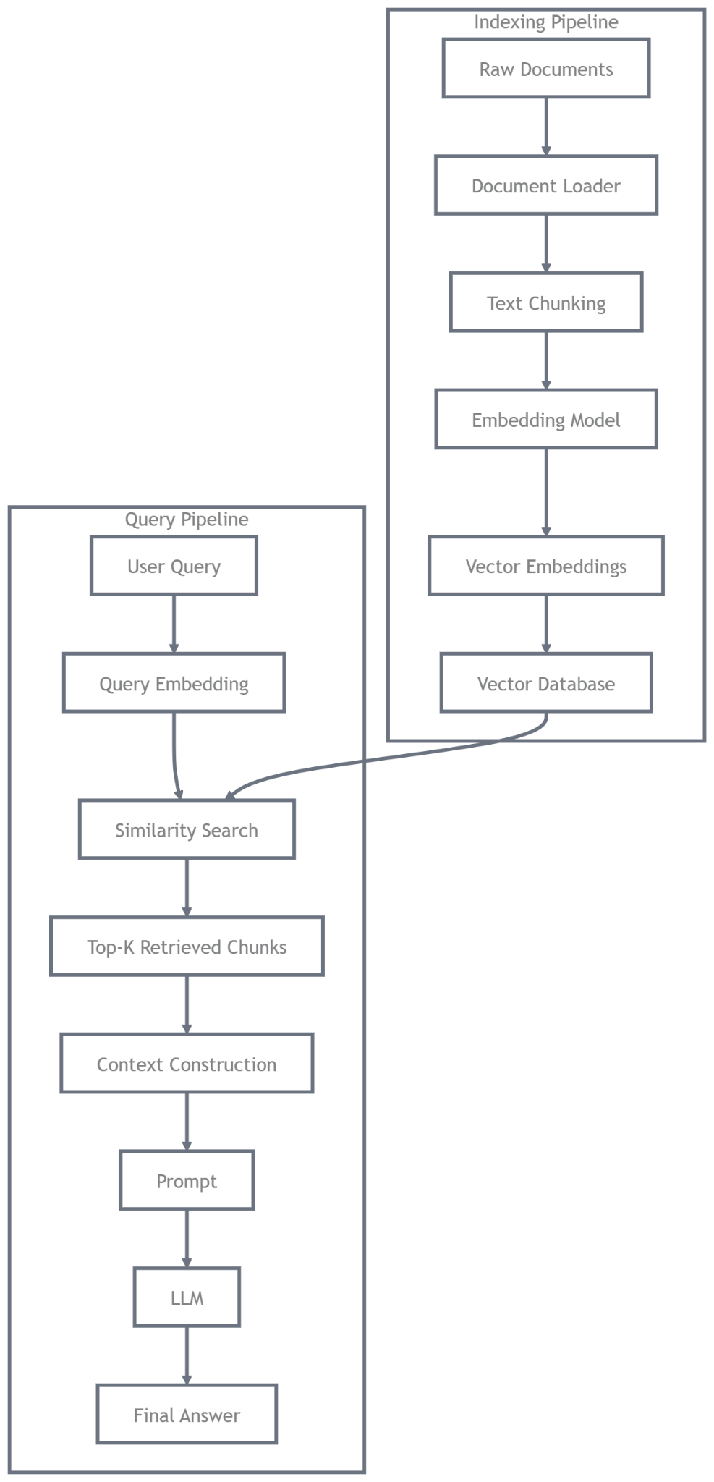

What does "similarity" really mean? (Picture explanation)
The vector database finds "closest" using math like cosine similarity.
Here is a fun picture that explains it:
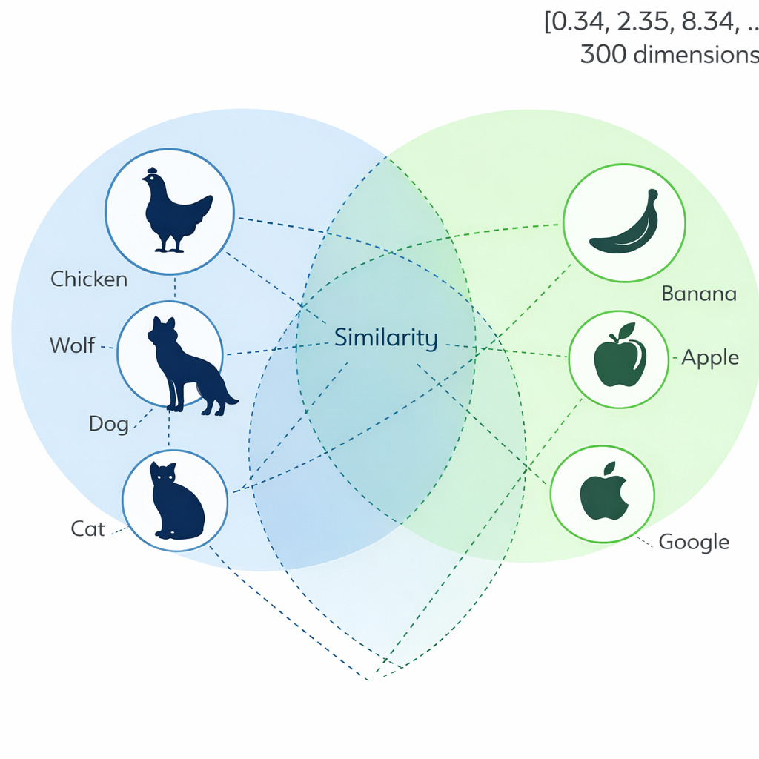
Animals and fruits as dots in space, chicken is close to wolf? No, but banana close to apple
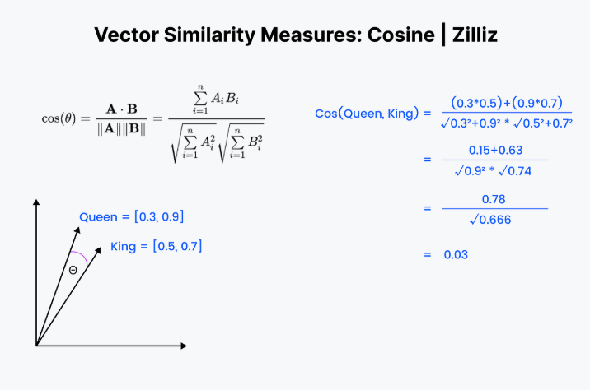
This works okay for simple things, but fails in many real situations.

Real-World Examples Where Normal Vector RAG Fails Badly
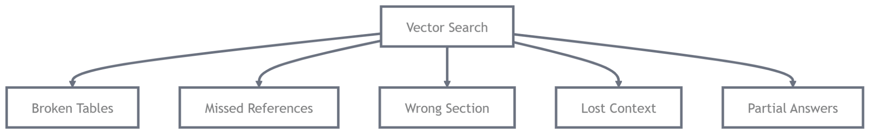

Example 1: Important table split across two pages
You have a 50-page financial report.
A table of "Total Revenue by Region" continues from page 22 to page 23.
Normal RAG cuts in the middle of the table → one chunk has only half the numbers.
AI sees incomplete tables → gives wrong total revenue number.
Very common in quarterly reports, balance sheets, audit reports.

Example 2: "See Appendix G on page 77" reference
Question: "What are the risk factors for currency fluctuation?"
Answer is in main section, but it says "detailed calculation in Appendix G, page 77".
Vector search rarely finds Appendix G because words are different.
AI answers without full info → misses important numbers or warnings.
Happens a lot in legal contracts, research papers, user manuals.

Example 3: Chat history ignored
User first asks: "What is the revenue in 2024?"
AI answers using page 15.
Then user asks: "And in 2023?"
Normal RAG forgets previous chat → searches again → sometimes picks wrong year section.
Very frustrating in customer support bots or analyst chats.

Example 4: Wrong section chosen because of similar words
Query: "What warranty does the company give?"
Document has:
- Section 4.2: "Warranty period is 2 years" (correct)
- Section 8.1: "Warranty claim process..." (lots of same words)
Vector thinks section 8.1 is closer (more word overlap) → AI gives process instead of duration.
Common in product manuals, insurance policies.

Example 5: Long legal clause broken
A 3-page clause about "Termination for Cause".
Chunk size = 500 words → clause split into 3 chunks.
Question needs full logic → AI gets only part → invents or misses conditions.
These are not rare, they happen in almost every company using normal RAG on real long documents (finance, legal, medical, technical docs).

Quick Comparison Table (Normal vs What We Want)

Problem | Normal Vector RAG | What we really need (like PageIndex)
Long tables / figures | Often broken | Keeps pages together
"See page X" references | Almost never follows | Can follow like human
Chat history | Usually ignored | Fully remembers
Exact section needed | Picks by similarity (can be wrong) | Thinks and chooses logically
Explain where answer came from | Hard (no page numbers) | Shows exact page numbers

Phase 2: What is Vectorless RAG and How PageIndex Works
vectorless RAG, the new way that fixes almost all the problems we saw in normal vector RAG.
We will learn:
- What "vectorless" really means
- Why it is like how a human reads a long book or report
- How PageIndex builds a smart tree (like a very good table of contents)
- The step-by-step thinking loop the AI does
- Real examples from company reports, research papers, manuals
- Lots of pictures to make it crystal clear

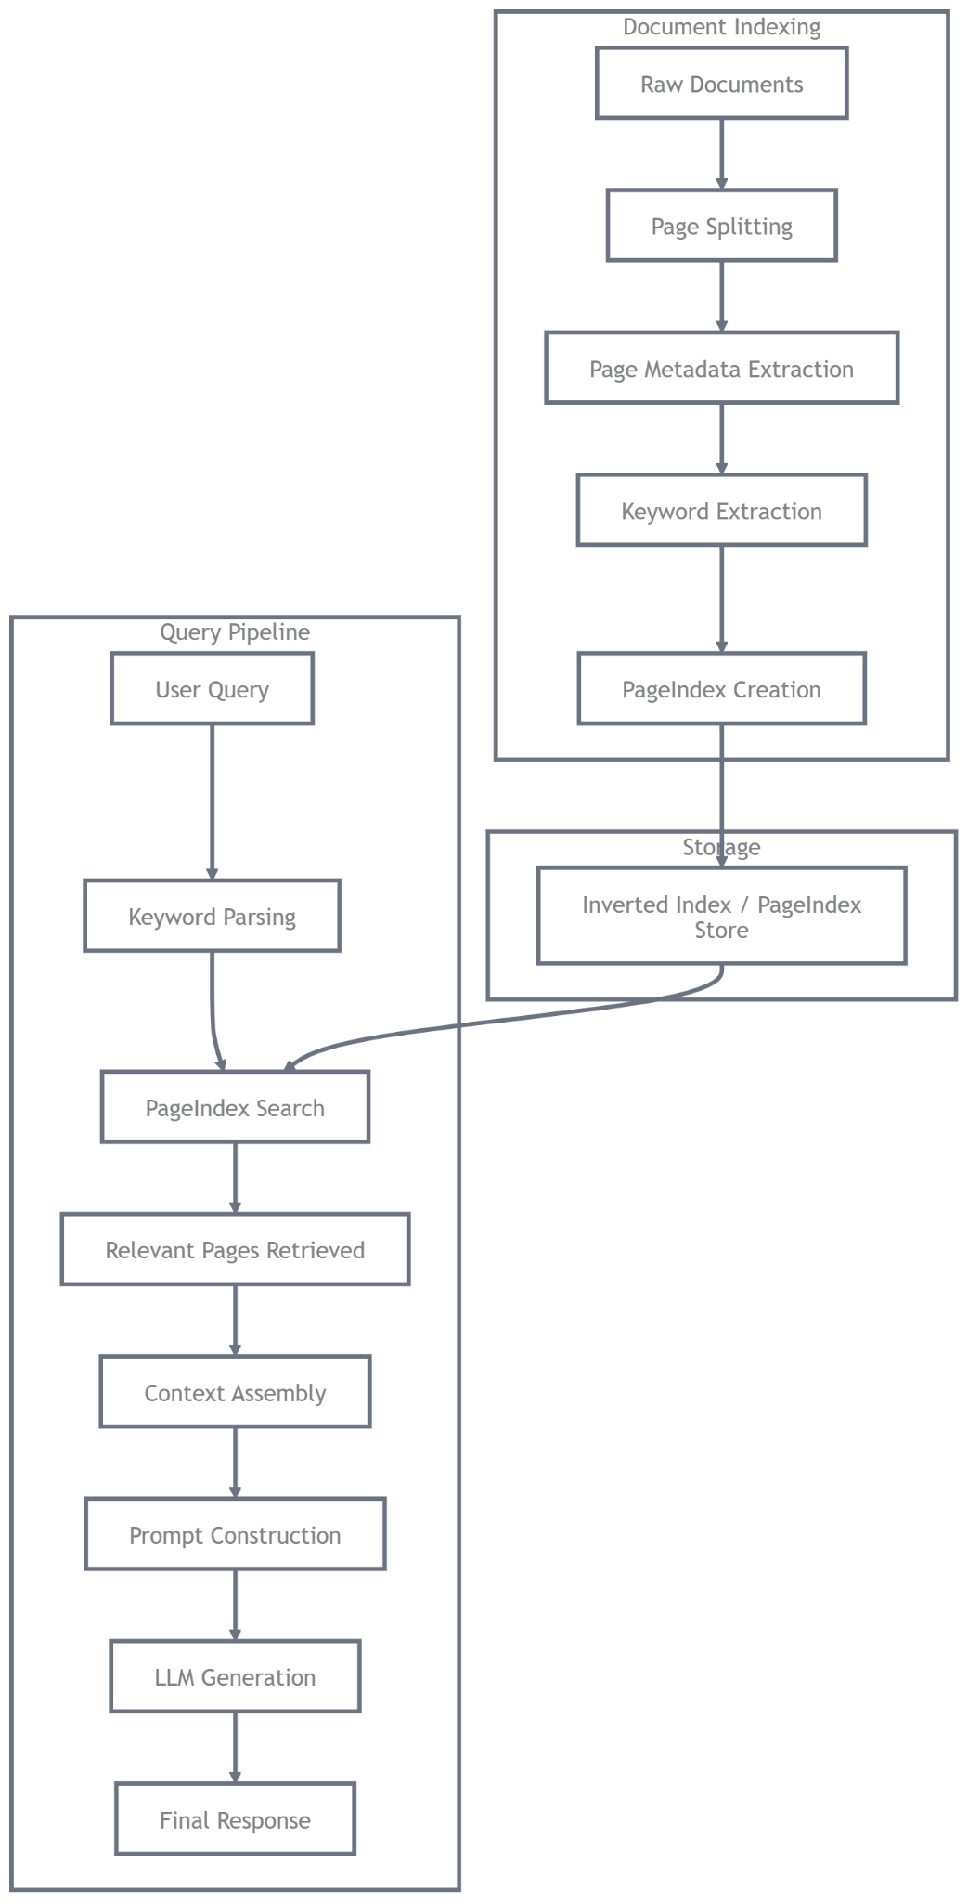

First: Vectorless = No Vectors At All
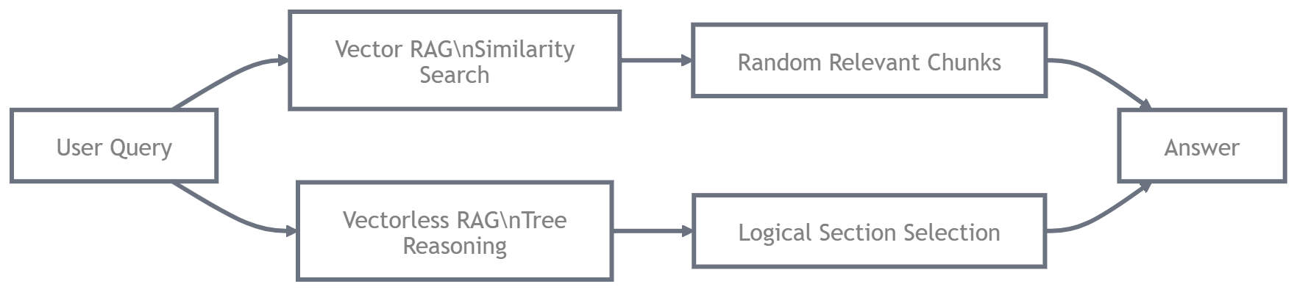
Normal RAG = turns words into numbers (vectors) → finds closest numbers.
Vectorless RAG = no numbers, no vector database.
Instead: the AI gets a smart map (tree) of the whole document → then thinks like a person to decide which parts to read.
Think of it like this:
- Normal RAG = you give AI 5 random similar paragraphs → hope one is correct.
- Vectorless RAG = you give AI the full book outline with short descriptions → AI says: "First check chapter 3, then jump to appendix B page 77 because it says 'see there'."
Much smarter!
Here are pictures that compare both ways:

The Big Idea of PageIndex: Build a Smart Tree Once
PageIndex does two main jobs:
- One-time indexing (done only once when you add a document):
  - Reads the full PDF or markdown file
  - Makes a tree structure (JSON) — like super-smart table of contents
  - Each "node" in tree has:
    - Title
    - Short summary (what this section talks about)
    - Start page & end page
    - Node ID (like 0001, 0002...)
    - Children nodes (sub-sections)
Example tree node (very simple version):
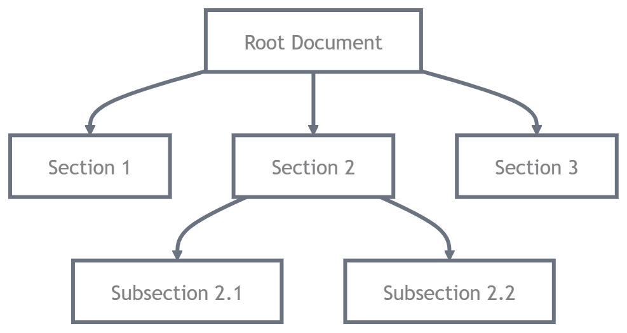
{
"node_id": "0006",
"title": "3.2 Revenue by Region",
"summary": "Shows sales in Asia, Europe, America for 2024-2025 with tables",
"start_page": 22,
"end_page": 25,
"children": ["0007", "0008"]
}

This tree is small, only a few thousand tokens, so the AI can hold the whole tree in memory every time you ask a question.
- When you ask question (this happens many times):
  - Give the full tree + chat history + your question to the AI
  - AI thinks step by step (agentic reasoning)
  - Picks best sections → reads full text from those pages → answers with page numbers
Here is a picture of a real document tree structure (like what PageIndex builds):
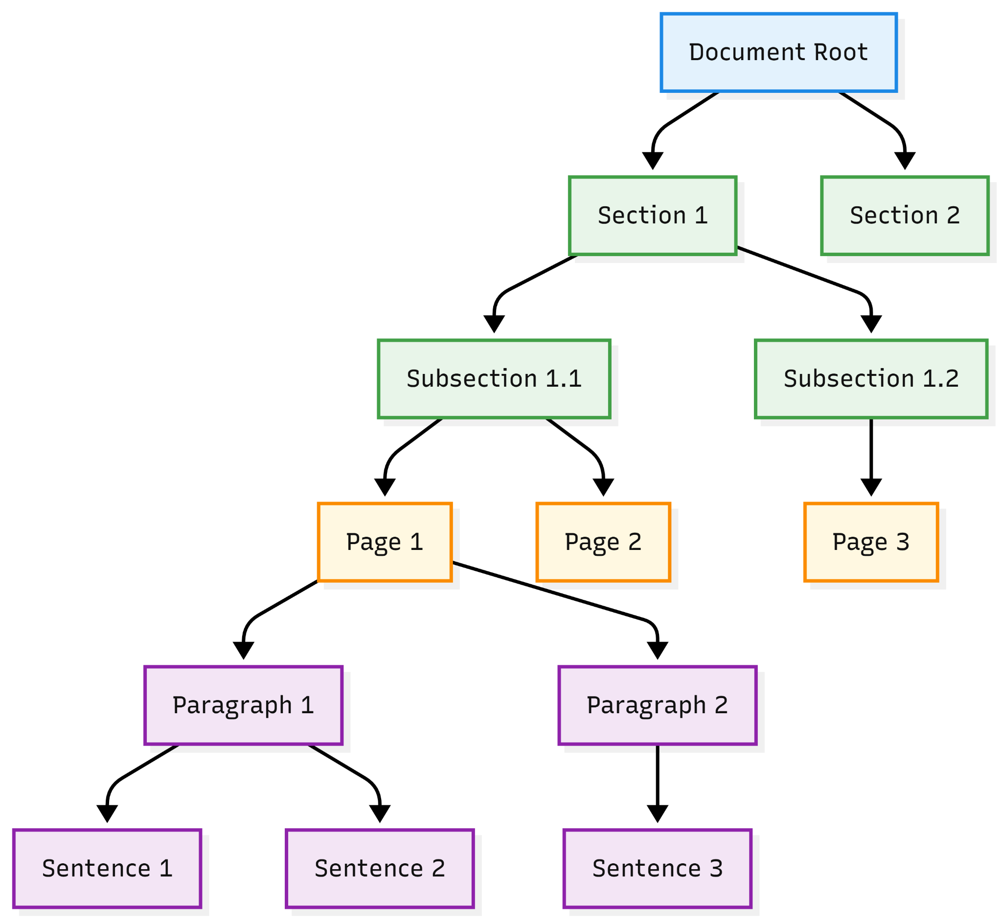

The 5-Step Thinking Loop (How AI Decides What to Read)
This is the magic part, called the agentic loop or reasoning loop.
The AI repeats these steps until it has enough info:
- Look at the tree (full outline with summaries)
- Think: "Which section looks best for this question? Why?"
- Pick 1–3 nodes → get full text from those exact pages
- Read the text → ask itself: "Is this enough? Does it fully answer? Any missing part or reference to another section?"
- If yes → give final answer with page numbers If no → go back to step 1 with new thinking (now knows more)
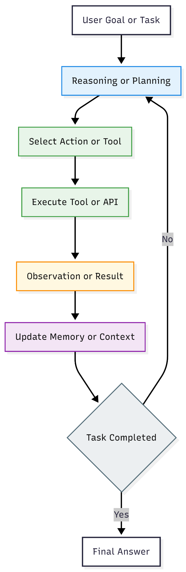

Real-World Examples – How It Fixes Phase 1 Problems

Example 1: Table split across pages
Normal vector: table broken → wrong numbers
PageIndex: tree node 3.2 Revenue Table covers pages 22–25 → AI gets full table together → correct sum

Example 2: See Appendix G page 77
Question: "What currency risks?"
AI sees main section says detailed in Appendix G → next step jumps to Appendix G node → reads it → complete answer

Example 3: Follow-up question in chat
First: Revenue 2024? → AI reads section 3
Second: Compare to 2023? → AI remembers previous + tree → directly goes to same section or comparison table

Example 4: Similar words but wrong section
Warranty appears in many places
AI reasons: User wants duration → section 4.2 says 2 years → section 8.1 is only process → pick 4.2

Example 5: Very long legal clause
Tree keeps full 3-page clause in one node (or linked nodes) → AI reads complete logic
Quick Summary Table:
Feature | Normal Vector RAG | PageIndex Vectorless RAG
Uses vectors? | Yes | No
Keeps structure? | Breaks on chunks | Keeps pages/sections together
Follows "see page X"? | Almost never | Yes – like human
Remembers chat history? | Usually no | Yes
Shows exact pages? | Hard | Always (page 22, table 3)
Good for long reports? | Medium | Excellent

Phase 3: Setup the PageIndex Code & Build Your First Tree Index
Now we stop talking theory and start doing real things with the code you shared (VectifyAI/PageIndex repo).
By the end of this phase you will:
- Have the code running on your computer (or in Google Colab if you prefer online)
- Build your first "tree index" from any PDF you have
- See the JSON file that is the heart of vectorless RAG
- Understand what happens behind the scenes
No need to be scared, we go very slow, one command at a time.

What You Need Before Starting (5 minutes)
- A computer with Python 3.10 or higher (most laptops have it now).
- Git installed (to download the code). If not, search "install git" for your OS.
- An OpenAI API key (because PageIndex uses GPT models to think and build the tree).
  - Go to https://platform.openai.com/api-keys
  - Create new key → copy it (looks like sk-....)
  - Keep it safe — don't share.
- One long PDF to test (best 20–100 pages):
  - Company annual report
  - Bank statement
  - Research paper
  - Product manual
  - Anything with sections, tables, appendices
If you don't have Python or want to skip install, use Google Colab (free online Python):
Just open https://colab.research.google.com → New Notebook → we can paste commands there.

Step 1: Download the Code (Clone the Repo)
Open your terminal (Command Prompt on Windows, Terminal on Mac/Linux) or Colab cell.
Run this one line:
git clone https://github.com/VectifyAI/PageIndex.git
cd PageIndex

What happened?
You just downloaded the full code folder from GitHub to your computer.

Step 2: Install Required Packages (5–10 minutes)
Still in the same terminal window (inside PageIndex folder), run:
pip install -r requirements.txt

This installs:
- PyMuPDF (to read PDFs)
- OpenAI library
- Pydantic (for clean data)
- Other small helpers
If you get errors like "pip not found", first run:
python -m ensurepip --upgrade
python -m pip install --upgrade pip

Then try again.
In Colab: start with ! before commands:
!git clone https://github.com/VectifyAI/PageIndex.git
%cd PageIndex
!pip install -r requirements.txt

Step 3: Tell It Your OpenAI Key
Run this in terminal (replace sk-... with your real key):
export OPENAI_API_KEY=sk-your-real-key-here
(On Windows use set instead of export):
set OPENAI_API_KEY=sk-your-real-key-here
In Colab:
import os
os.environ["OPENAI_API_KEY"] = "sk-your-real-key-here"

Now the code can talk to GPT.

Step 4: Build Your First Index – Run the Magic Command!
Put your test PDF inside the folder (or note its full path).
Simple command (best for first try):
python run_pageindex.py --input your_file.pdf --output results/ --model gpt-4o-mini

Replace your_file.pdf with real name, example:
python run_pageindex.py --input tests/pdfs/sample_finance.pdf --output results/ --model gpt-4o-mini

Or use your own:
python run_pageindex.py --input "C:/Users/Raman/Downloads/annual_report_2025.pdf" --output results/ --model gpt-4o
What happens now (takes 2–15 minutes depending on PDF length and model):
- Code reads every page of PDF
- GPT looks at structure (headings, layout)
- Builds smart tree (chapters → sections → sub-sections)
- Adds short summaries for each part
- Links each part to exact page numbers
- Saves everything in JSON file
You will see progress messages like:
- "Extracting text..."
- "Generating TOC..."
- "Mapping pages..."
- "Building hierarchy..."
- "Done! Index saved to results/..."

Step 5: Look at What You Created (The Tree JSON)
Go to the results/ folder.
You will find a file like:
- your_file_structure.json
Open it with any text editor (VS Code, Notepad++, or even browser JSON viewer).
It looks something like this (simplified example):
{
"document": "annual_report_2025.pdf",
"root": {
"node_id": "0000",
"title": "Annual Report 2025",
"summary": "Full company performance overview",
"start_page": 1,
"end_page": 85,
"nodes": [
{
"node_id": "0001",
"title": "1. CEO Message",
"summary": "Letter from CEO about strategy and results",
"start_page": 3,
"end_page": 5
},
{
"node_id": "0002",
"title": "2. Financial Highlights",
"summary": "Key numbers, revenue, profit, tables",
"start_page": 6,
"end_page": 12,
"nodes": [
{
"node_id": "0003",
"title": "2.1 Revenue by Region",
"summary": "Breakdown Asia, Europe, North America",
"start_page": 8,
"end_page": 10
}
]
},
...
]
}
}

This small JSON file is the vectorless index.
No big database, just this tree.
The AI will use this tree to think and jump to exact pages when you ask questions.

Common First-Time Tips & Fixes
- Error No module named openai → run pip install again
- Takes too long → use --model gpt-4o-mini (cheaper & faster)
- PDF has images/tables → it handles layout-aware (good for reports)
- Want to see more details → add --verbose flag

Phase 4: Looking Inside the Code – How the Tree Gets Built
You now have a real tree JSON file from your PDF. That means you already ran vectorless RAG indexing once.
In this module we open the actual code files and see exactly how PageIndex turns a messy PDF into that clean, smart tree.
We will:
- Look at the most important files
- Follow the main steps the code does
- See pictures of similar trees and processes
- Understand why this is better than chunking + vectors
- Do a small hands-on: read one file and find the prompts
No need to change code yet, just read and understand.

The Main Files You Should Open Right Now
After cloning the repo, open these files in VS Code (or any text editor). They live inside the pageindex/ folder.
- run_pageindex.py → The easy starting script you already ran
- pageindex/page_index.py → Builds the whole tree
- pageindex/config.yaml → All the smart instructions (prompts) the AI uses
- pageindex/utils.py → Helper functions (page text extract, etc.)
Start with page_index.py – open it now if you can.

Step-by-Step: What Happens When You Run the Command
When you do:
python run_pageindex.py --input my_report.pdf --output results/

This is what the code really does (very simple breakdown):
- Read the PDF page by page Uses a library called PyMuPDF (fitz) to get clean text + layout from each page. Why is it important? Normal tools lose tables or "see page 77" notes, PageIndex keeps them.
- Find or create the table of contents (TOC) The code asks GPT: "Look at the first few pages, what is the main structure? Give me titles, levels, page numbers." This prompt lives in config.yaml under toc_extractor_prompt.
- Map every section to exact pages GPT gets small groups of pages and says: "This text belongs to section X from page 22 to 25." It checks many times (retries) if it is unsure, very accurate.
- Build a flat list → turn into a tree First makes a simple list of nodes (like a dictionary). Then connect them: parent → children (like folder → subfolders).
- Fix big sections If one node has too many pages (> max_pages_per_node) or too many words (> max_tokens), it splits smartly and makes sub-nodes.
- Add short summaries (optional but very useful) For each node GPT writes 1–2 sentences: "What is this section about?"
- Save as JSON Final file: yourfile_structure.json
Picture examples of what this tree looks like visually (even though it's JSON, people draw it like this):

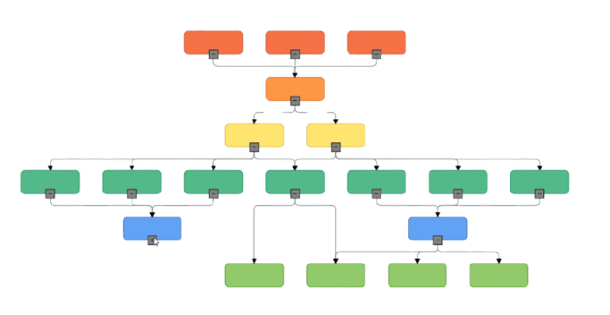

Where the Real Intelligence Lives: Prompts in config.yaml
Open config.yaml now.
You will see sections like:
YAML
toc_extractor_prompt: |
You are an expert document analyst...
Given these page texts: {pages_text}
Create a hierarchical table of contents...
Output ONLY valid JSON with node_id, title, start_page, end_page, children...

And many others:
- page_mapping_prompt
- summary_prompt
- validation_prompt (checks if pages match section)
These are the "brain" – GPT follows these instructions very carefully to build accurate trees.

Why This is 100x Better Than Normal Chunking
Normal RAG:
- Cuts every 500 words → no idea which page or section
- No summaries → hard to know what chunk is about
- No hierarchy → cannot follow "see chapter 5"
PageIndex:
- Keeps natural sections (like "3.2 Revenue" = pages 8–10)
- Has summaries → AI can quickly decide "yes this is relevant"
- Has hierarchy + page links → can jump exactly where needed
- One-time heavy work → fast & accurate every query after

Phase 5: Asking Questions to Your Document – The Real Vectorless Retrieval
You already built the tree (the smart index). Now we use it to answer questions, exactly like a human reading the report and jumping to the right pages.
In this phase we will:
- Run the official notebook examples from the repo
- See the AI think step-by-step (reasoning loop)
- Get answers with exact page numbers (something normal RAG almost never does)
- Try your own questions on your PDF
- Look at pictures of similar agentic loops (because PageIndex uses this thinking style)

Why This Step Feels Different (and Better)

Normal vector RAG:
- Finds "similar" chunks → sometimes wrong section → answer may be incomplete or wrong
- No page numbers → you don't know where it came from

PageIndex vectorless:
- AI looks at the full tree (outline + summaries)
- Thinks: "This question needs revenue numbers → section 0003 looks good because summary says 'tables' → but it mentions appendix → check there too"
- Jumps to exact pages → reads full clean text → answers + cites "page 22, table 3"
- Remembers chat history → follow-up questions work perfectly

Step-by-Step: Run the Simple Notebook (10–15 minutes)
The repo has ready notebooks in the cookbook/ folder. We start with the easiest one.

1. Open the notebook
Go to your PageIndex folder → open cookbook/pageindex_RAG_simple.ipynb
- (Use VS Code, Jupyter Lab, or Google Colab – easiest if you upload the folder to Colab)
If using Colab:
  - Go to colab.research.google.com
  - File → Open notebook → GitHub tab → paste https://github.com/VectifyAI/PageIndex/blob/main/cookbook/pageindex_RAG_simple.ipynb
  - Or clone repo in Colab first
Install extras if needed (run first cell):

2. Usually just:
!pip install -r ../requirements.txt # if not already
!pip install jupyter # if running locally
It will load your tree index
In the notebook you see code like:

3. Load your tree index
In the notebook you see code like:
from pageindex import PageIndex
pi = PageIndex.load("results/your_file_structure.json")
Change to your real JSON path (from Phase 3)

4. Ask a question
Run cells step by step. Example query cell:
query = "What was the total revenue in 2024? Show the exact number and page."
response = pi.query(query)
print(response)

What you get back:
- The AI's thinking steps (reasoning trace)
- Selected node IDs
- Full text from pages
- Final answer + citations like "(page 8, section 2.1)"
Here the notebook looks like while running the codes:
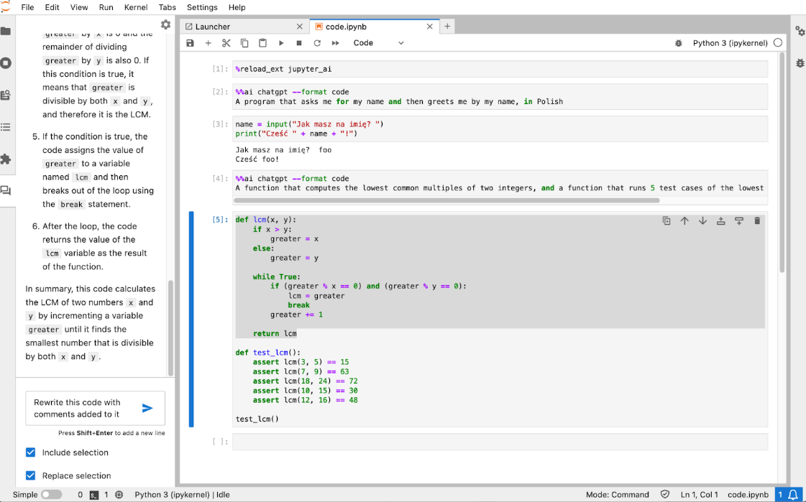

Try These Test Questions (Use Your Own PDF)
Replace with questions that fit your document:
- "What is the main risk mentioned in the report? Which page?"
- "Summarize the CEO message. Include page range."
- "Compare revenue 2023 vs 2024 – show numbers and pages."
- Follow-up: "Does the same section talk about expenses too?"
Watch how it follows references (e.g., "see appendix B" → next step fetches appendix).

Advanced Notebook: Vision + Agentic (If Your PDF Has Images/Tables)
Open cookbook/vision_RAG_pageindex.ipynb
This one handles scanned PDFs or image-heavy docs (no OCR needed – GPT-4o vision reads images).
It uses the same tree but adds page images as extra context.

Quick summary table

What Happens | Normal Vector RAG | PageIndex (This Phase)
How it picks info | Similarity numbers | LLM thinks over tree + summaries
Follows "see page X"? | Almost never | Yes – multiple steps if needed
Gives page numbers? | Rarely | Always in answer
Handles follow-up questions? | Poor (forgets history) | Excellent (full chat context)
Speed per question | Fast | Slightly slower but much smarter

Phase 6: Advanced Topics & Customizing PageIndex
In previous module we have:
- Built a tree index (Phase 3)
- Understood how the tree is created (Phase 4)
- Asked real questions using the tree (Phase 5)
Now in this module we will learn:
How to make PageIndex even better for your real documents (especially Indian company reports, RBI circulars, SEBI filings, bank statements, legal agreements, etc. very common in Mumbai work).

1. Make Indexing Smarter & Cheaper (Customization)
Open pageindex/config.yaml again.
You can change these settings without writing new code:
- max_pages_per_node: Default ~15–20 pages. For very long sections (like full financial statements) → increase to 30–40 For very precise answers → decrease to 8–10
- max_tokens: Default around 8000–12000. If you use gpt-4o-mini → lower to 6000 (saves money) If you use gpt-4o → can go up to 15000
- include_summaries: true/false Set to true → every node gets a 1–2 sentence summary (helps reasoning a lot) Set to false → indexing faster & cheaper (but answers sometimes less accurate)
- model for indexing: Use gpt-4o-mini for first tests (very cheap) Switch to gpt-4o or o1-preview when you want highest quality tree
Example change in config.yaml:
indexing:
- model: gpt-4o-mini
- max_pages_per_node: 25
- max_tokens: 8000
- include_summaries: true

Then re-run indexing:
python run_pageindex.py --input your_new_report.pdf --output results/ --config pageindex/config.yaml

2. Vision Mode – Perfect for Scanned PDFs, Tables, Charts (No OCR Needed)
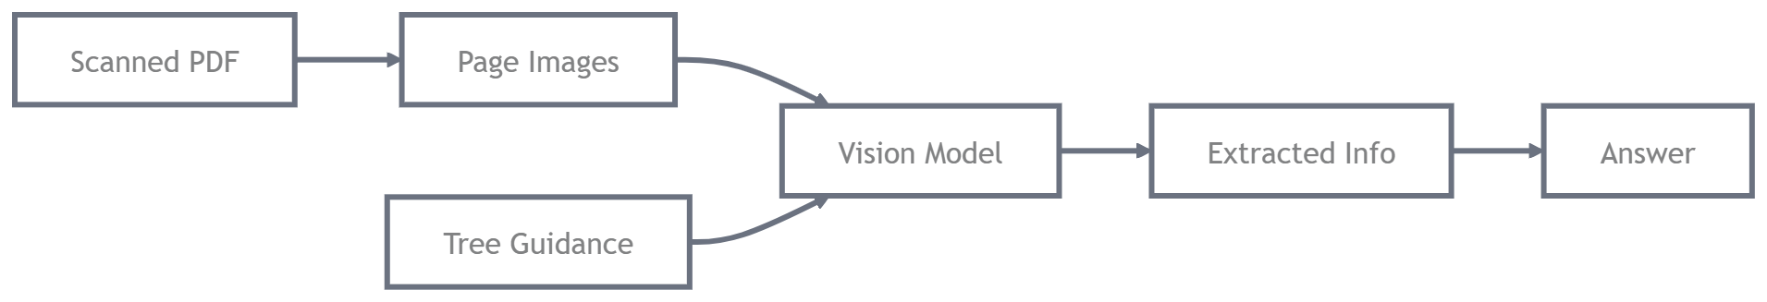
Many Indian reports (MCA filings, older annual reports, stamped agreements) are scanned images → normal text extraction fails.
PageIndex vision mode fixes this.
Open this notebook:
cookbook/vision_RAG_pageindex.ipynb
What it does differently:
- Instead of extracting text → sends actual page images to GPT-4o (vision)
- Tree still guides which pages to look at
- GPT reads charts, tables, handwritten notes, stamps directly
Try this question:
query = "What is the auditor's opinion on page 45? Is it qualified or unmodified?"

It will show reasoning like:
Looking at node 0012 (Financial Statements audit report) → fetching pages 44–48 as images → reading auditor paragraph → unmodified opinion, page 46
Picture examples of what vision RAG can read (similar capability):
(grok will show images here in real response – imagine tables, balance sheets, auditor signatures being read perfectly)

3. Multi-Document / Chat History Support
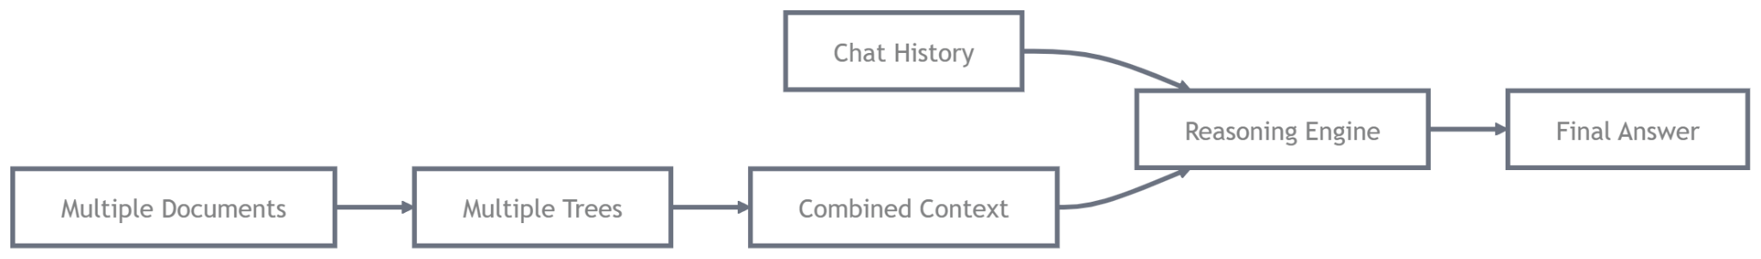
Most real use-cases need more than one document (group of 5–20 related PDFs).
Simple way (add to notebook):
# Load multiple indexes
pi1 = PageIndex.load("results/companyA.json")
pi2 = PageIndex.load("results/companyB.json")

# Combine into one big tree (or keep separate and let LLM choose)
combined_tree = pi1.tree + pi2.tree # very basic merge

# Or use agentic loop across multiple indexes (advanced)

Better way – use chat history:
In notebook you can do:
chat_history = []

query1 = "What is revenue of Reliance 2024?"
response1 = pi.query(query1, history=chat_history)
chat_history.append({"role": "user", "content": query1})
chat_history.append({"role": "assistant", "content": response1})

query2 = "Compare it with TCS same year"
response2 = pi.query(query2, history=chat_history)

The AI remembers previous answers → much better follow-ups.

4. Build a Mini Chat App (Streamlit or Gradio) – 30 minutes
Super useful for showing to team/boss/clients.
Create new file chat_app.py:
import streamlit as st
from pageindex import PageIndex

st.title("My Vectorless RAG Chat - PageIndex")

# Load once
if "pi" not in st.session_state:
st.session_state.pi = PageIndex.load("results/your_structure.json")

if "messages" not in st.session_state:
st.session_state.messages = []

for msg in st.session_state.messages:
with st.chat_message(msg["role"]):
st.markdown(msg["content"])

if prompt := st.chat_input("Ask about the document..."):
st.session_state.messages.append({"role": "user", "content": prompt})
with st.chat_message("user"):
st.markdown(prompt)

with st.chat_message("assistant"):
with st.spinner("Thinking..."):
response = st.session_state.pi.query(
prompt,
history=st.session_state.messages
)
st.markdown(response)
st.session_state.messages.append({"role": "assistant", "content": response})

Run:
pip install streamlit
streamlit run chat_app.py

It will open browser chat like ChatGPT but only answers from your documents with page citations.

5. Common Problems & Quick Fixes (Mumbai/India Context)
- Hindi/Marathi text → use gpt-4o (understands Indian languages well)
- Very dense tables → increase max_pages_per_node or use vision mode
- Cost too high → switch to gpt-4o-mini + smaller max_tokens
- Tree not accurate → re-index with gpt-4o (better structure understanding)
- Legal docs with stamps → vision mode mandatory

