Module 1: Foundations Prompt Engineering!
If you’re totally new to prompt engineering, no stress at all. Think of me as your friendly guide sitting right next to you. We’re going to go slow with real-life examples so everything clicks instantly. By the end, you’ll actually understand what prompt engineering is and exactly how it works.
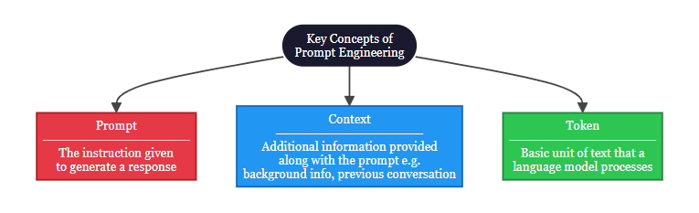

1.1 Introduction to Prompt Engineering

1.1.1 What is Prompt Engineering
Prompt Engineering is the science of articulating your vision in a way that the large language models (LLMs) and vision-language models (VLMs) can understand and generate the desired output. It involves strategically designing task-specific instructions to guide the model output.
Think of it as a super-smart friend who can write stories, answer questions, or even design things, but he takes every single word you say literally. Say something vague like “make me something nice” and you might get a random weird answer. But explain it step-by-step with all the details? Boom, perfect result every time!

1.1.2 Role of prompts in LLMs
Prompts are the primary way to control and improve LLM outputs. Without good ones, you just get boring, generic replies.
Do you know? Even big companies use prompt engineering instead of expensive model retraining. It’s like teaching the AI new tricks without touching its brain!
Here’s a quick tip: the clearer your prompt, the better the answer. But don’t go crazy long, too many details can confuse the AI and make it “hallucinate” (make stuff up). Balance is the secret sauce.

1.1.3 Prompt structure
Let’s see the magic with a real example. I’ll show you a bad prompt first, then the good one, and I even turned it into a simple flowchart so you can see why it works.
Vague prompt:
“Customer is angry about late delivery. Respond.”

Structured prompt:
“You are a senior customer support executive of an e-commerce brand. A customer is angry because their order is 3 days late. Tone: apologetic and solution-focused. Include: apology + reason + compensation offer + reassurance. Limit: 3 lines.”
See the difference? The good one has three clear parts:
- Instruction
- Context
- Input
Here’s a flowchart that shows exactly how this works:
Your Vision
Well Structured Prompt
Instruction
(Who you are + Task + Tone + Rules)
Context
(Background + Details + Examples)
Input
(The actual question or data)
High Quality Desired Output

1.1.4 Tokenization and context windows
LLMs don't read words like we do. They break text into pieces called tokens (about 3/4 of a word). They also have a memory limit called a context window.
Example:
- Token: "Hello!" = 2 tokens (["Hello", "!"]). "I'm learning." = 4 tokens (["I", "'", "m", " learning", "."]).
- Context Window: If a model has a 128K token window, it's like a notebook with 128,000 lines. Every prompt you give and reply it writes fills lines in this notebook. When it's full, it can't remember anything from the first page.
"A 'token' is ~4 characters of text; models have hard limits (e.g., 128K tokens) on how much context they can process at once."
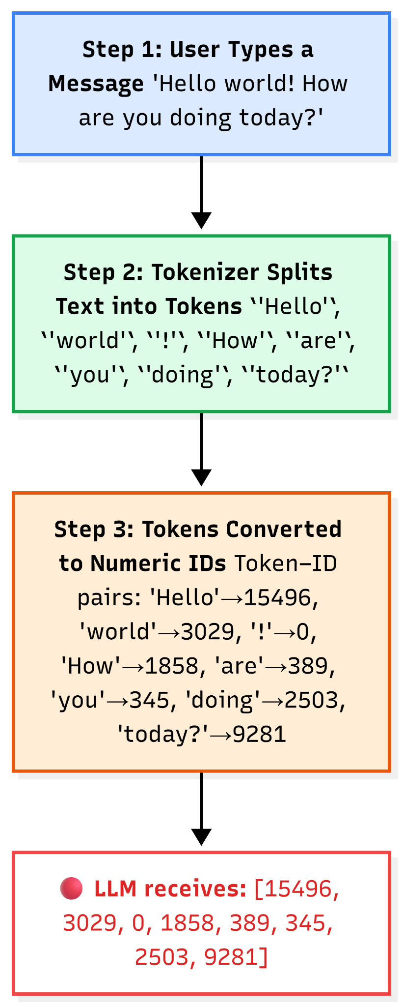
Here’s a visual of how tokenization actually happens:

1.2 Context Engineering
Now let’s level up! While prompt engineering is about writing good instructions, context engineering is about carefully designing and managing all the information the LLM sees in its "working memory" (the context window) so it can give better, more accurate, and consistent answers. It includes not just the prompt, but also extra details like past chats, important facts from documents, rules, tools, or user info.

1.2.1 Prompt vs Context
Think of it like this:
- Prompt: The direct message you send to LLM
- Context: Everything else you tell them (who the person is, past chats, rules, facts, etc.)
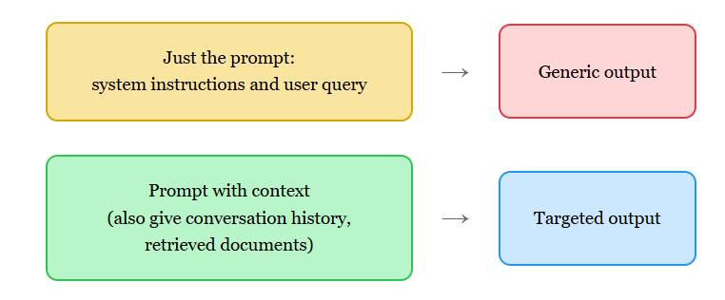

1.2.2 Structuring LLM inputs
LLM inputs (what goes into the context window) work best when organized clearly, like sections in a book. Good structure helps the model find and use information easily, reduces confusion, and gives better results.
Common way to structure:
- System instructions: Role and rules (e.g., "You are a helpful chef. Always be safe and list ingredients first.")
- Examples: Show what good answers look like.
- Retrieved or extra knowledge: Facts or documents needed for this task.
- Conversation history: Past messages so it remembers the chat.
- User question/input: What the user asks now.
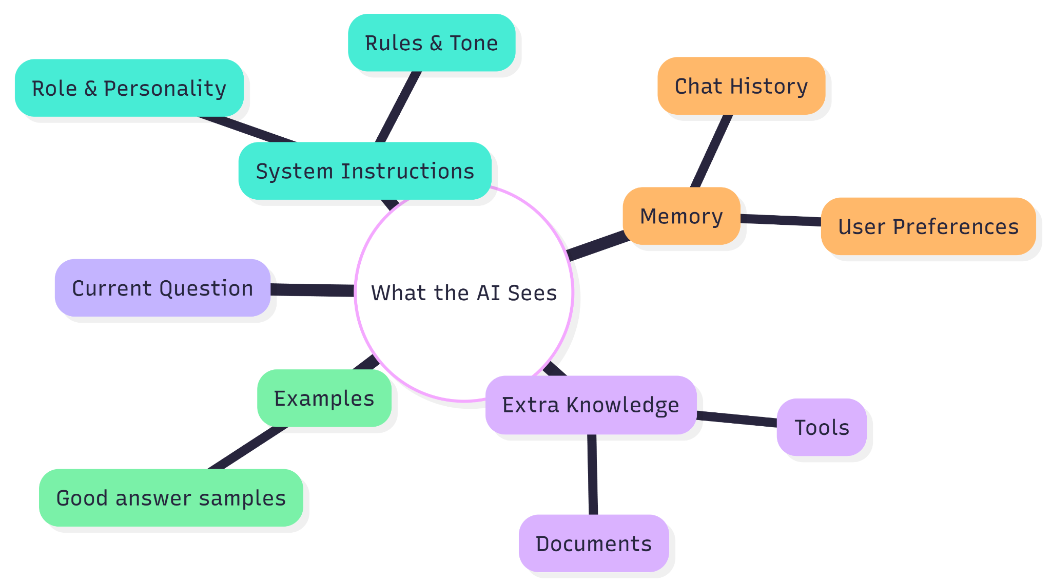

1.2.3 Memory, instructions, and external knowledge
These are the three magic ingredients that fill the context window:
- Instructions → Your job description for the AI
- Memory → Short-term (this chat) + Long-term (user likes spicy food, hates onions)
- External knowledge → Latest prices, documents, etc.
A meal-kit chatbot uses all three to never suggest onion recipes again, cute, right?

1.3 Entity & Characterization
This part is super fun! It’s about giving the AI a clear “identity” so it behaves consistently and feels like a real person.

1.3.1 Attribute-based prompting
Instead of saying “find me a laptop,” you list exact must-haves:
“Recommend laptops with: Price under ₹60,000, 16GB RAM, 15-inch screen…”
The AI matches perfectly every time.

1.3.2 Persona prompting
Now we give the AI a full character!
Example:
“You are Priya, a 28-year-old super-friendly fashion assistant in Mumbai. Tone: excited best-friend vibes…”
Suddenly the AI feels warm and helpful instead of robotic.

Here’s a nice visual of how persona prompting works: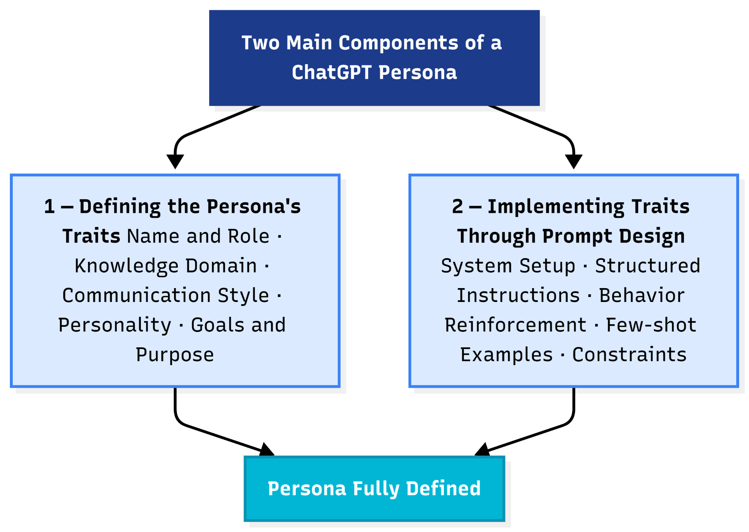

1.3.3 Structured role definition
The pro way: write it like a proper job description with bullets. Here’s an example turned into a quick diagram: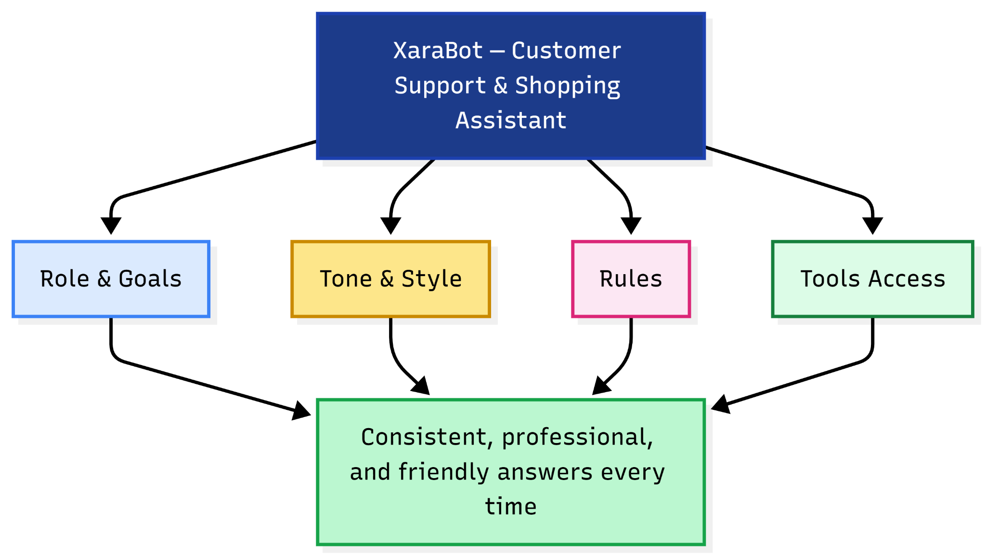

MODULE 2:

Basic prompt technique
If you just finished Module 1, you’re already ahead of most people. Now we’re going to make things even easier. Think of this module as learning the “everyday tricks” to talk to AI so it actually does what you want.
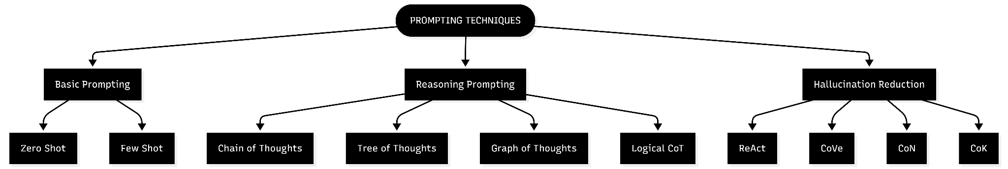

2.1 Zero-Shot Prompting
Do you know? Zero-shot is like asking your friend to do something without showing any examples, you just tell them clearly what you want. The AI uses everything it already learned during training. Super quick!
Here’s the magic: You just give a clear task, some context, rules, and the exact format you want. No examples needed.

Real example (extracting info from text):
“Extract the following information from the text:
Name:
Email:
Phone:
Skills:
Text: [paste the person’s bio here]”

Another fun one (e-commerce product description):
“You are a professional e-commerce copywriter… [full prompt with audience, features, tone, length, and exact output format]”
When to use it: Simple everyday tasks where the AI already knows the topic.
Pros: Lightning fast, no extra work.
Cons: Sometimes it guesses wrong on tricky or new stuff.

Here’s exactly how zero-shot works:

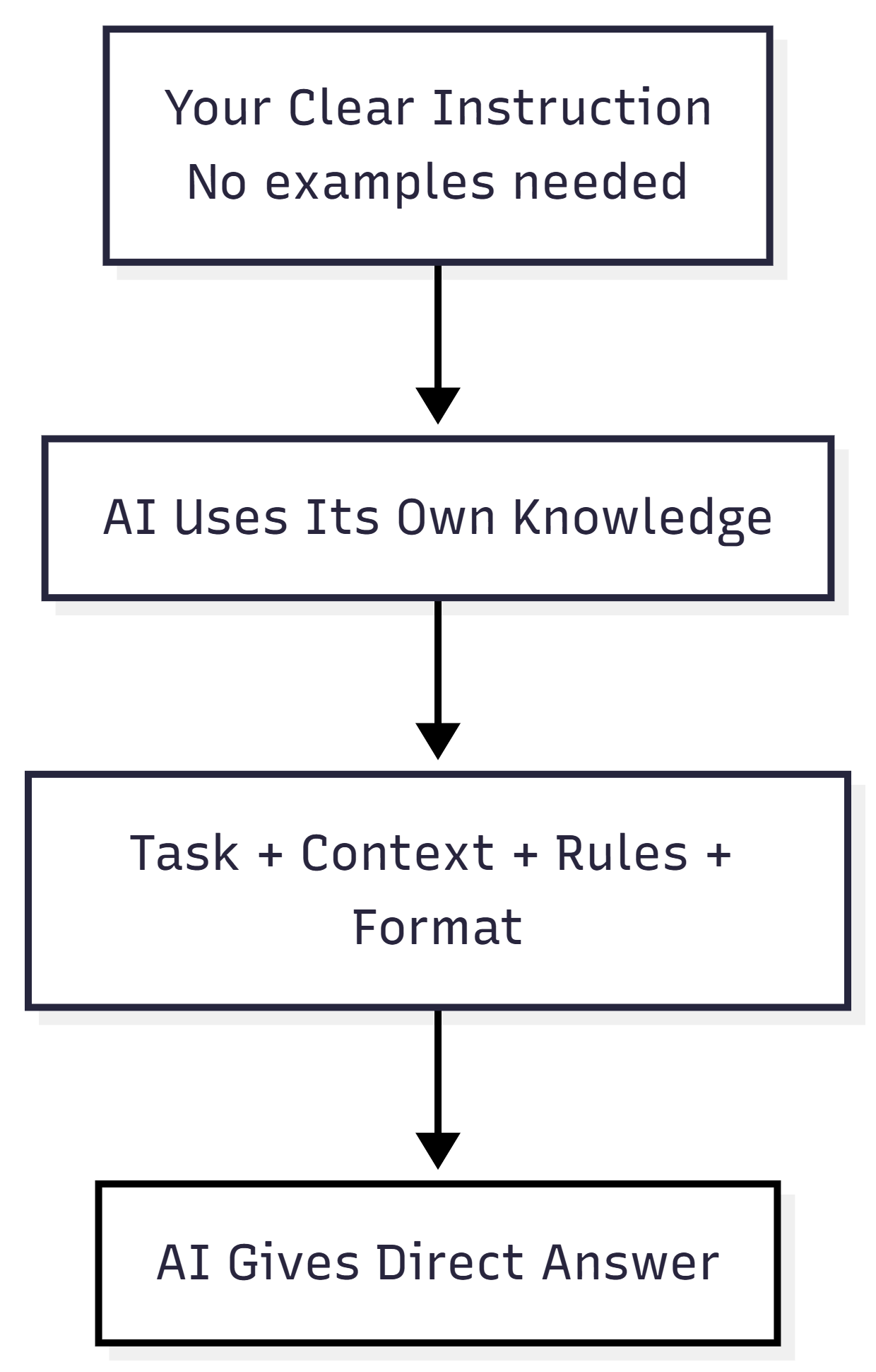
2.2 Few-Shot Prompting
Do you know? Few-shot is like showing your friend 2-3 examples first, then saying “now do the same for this new one.” The AI spots the pattern and copies the style perfectly!
How it works: Give a few “Input → Output” examples, then the real question.
Super useful example (writing product descriptions in brand voice):
“You are a copywriter for young people… Always start with a fun hook…
Few-Shot Examples:
Product: Blue Denim Jacket → [full description]
Product: Wireless Sport Earbuds → [full description]
Now write for: Black Smartwatch…”
Another one (explaining acronyms):
“Explain e-commerce acronyms like this:
Example 1: ‘AOV’ means…
Example 2: ‘CAC’ means…
Now explain: ‘CLV’.”
When to use it: When you want the AI to follow a specific style, format, or tone (classification, creative writing, etc.).
Pros: Way more accurate and consistent.
Cons: You have to create good examples (but once you have them, reuse forever!).

Here’s a visual flowchart of how few-shot beats zero-shot:
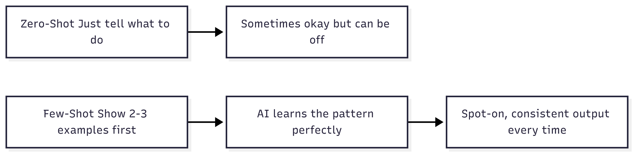

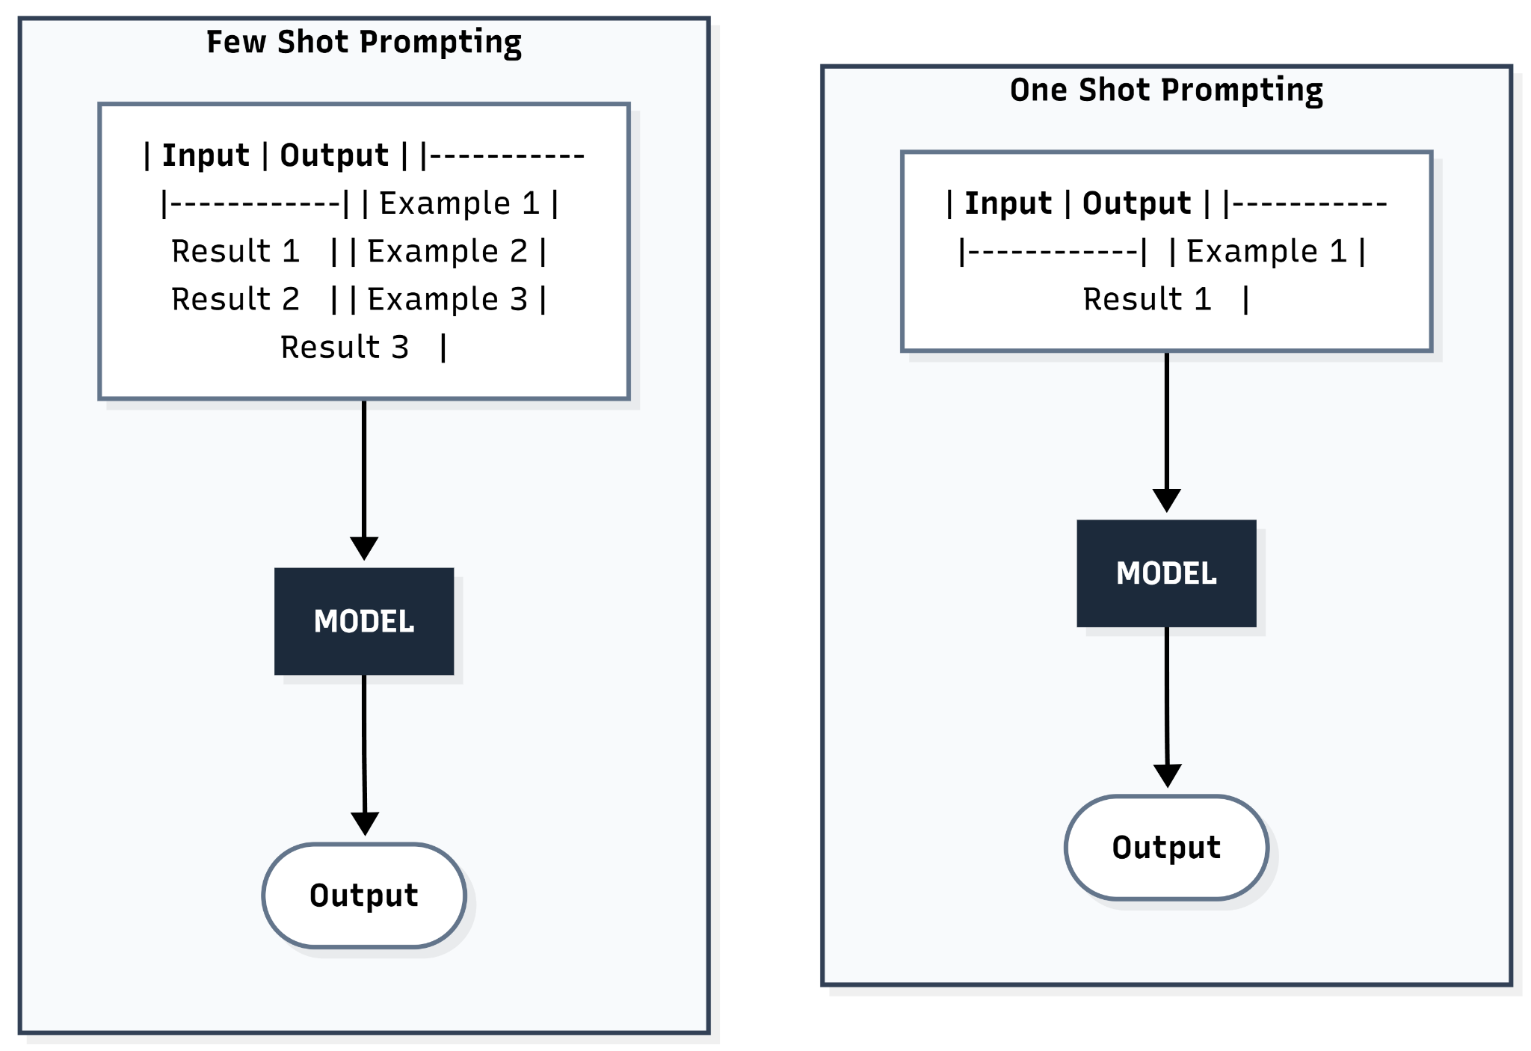

2.3 Prompt Templates
Do you know? Templates are like fill-in-the-blank forms you reuse every day. Save time and keep everything consistent!

2.3.1 Static templates (fixed format)
Simple blanks you fill every time.
Example:
“Write a short, exciting product description for [product_name]. Highlight: [key_feature1] and [key_feature2]. Keep under 100 words…”

2.3.2 Dynamic templates (smart if-then)
The template changes based on the situation.
Example:
“If the query is about order status → be apologetic…
If recommendation → suggest 2-3 items…”

2.3.3 Parameterized prompts (for pros)
Used in code to generate hundreds automatically.
Example in simple code:
prompt = f"""Create SEO title for {product_name} at ₹{price}…"""

Here’s a clear comparison diagram I made for you: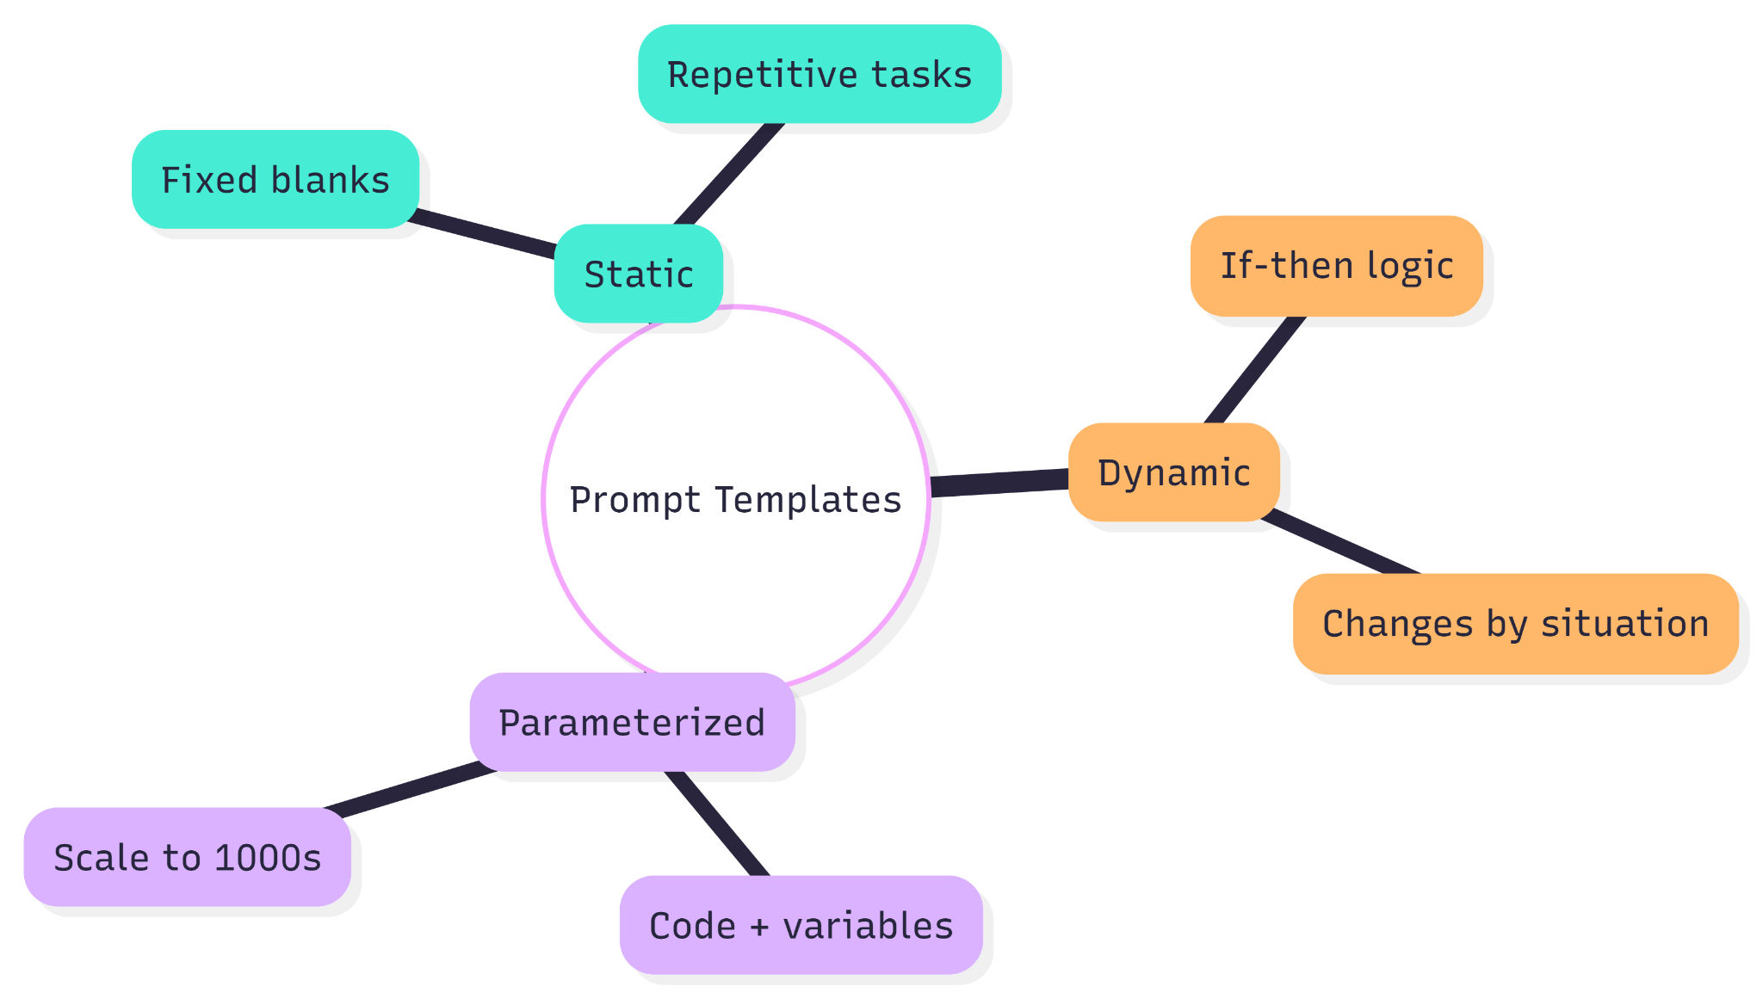

2.4 Prompt Evaluation
Do you know? Writing prompts is easy… but checking if they’re actually good? That’s the pro move! We test three things: Accuracy, Bias, and Robustness.

2.4.1 Accuracy
How often the answer is correct and useful.
Test 100 times → count good ones.
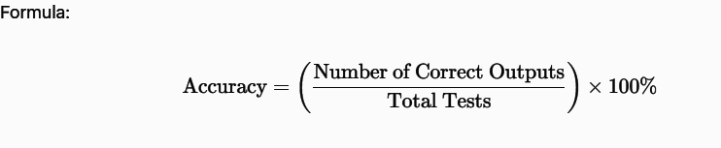

2.4.2 Bias
Does the AI unfairly prefer one group?
Example: Always suggesting “slim-fit” only for young people? That’s bias!
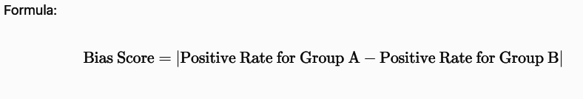
(0= perfectly fair)

2.4.3 Robustness
How well it handles typos, vague questions, or weird inputs.
Test with “best phone under 20k plz” or “cheap good phone” — good prompt still gives perfect answers.

Here’s a quick evaluation flowchart so you can test your own prompts: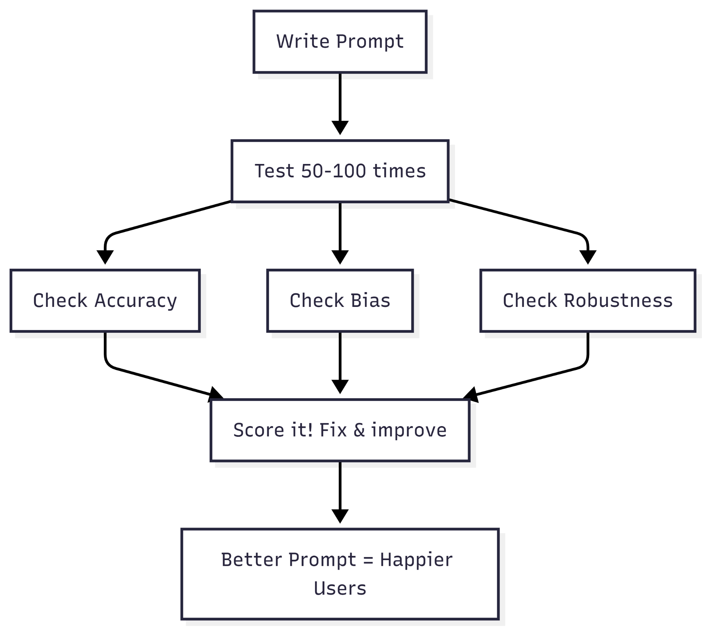
You now know the four basic techniques that 90% of people use every day. Zero-shot for speed, Few-shot for style, Templates for consistency, and Evaluation so you know it actually works.

MODULE 3

Reasoning-Based Prompting Techniques

3.1 Chain-of-Thought (CoT) Prompting
This method improves an LLM’s ability to solve complex reasoning problems by explicitly instructing it to think step by step before giving the final answer.

How it works: The prompt encourages the model to think step-by-step, either by showing reasoning examples or explicitly asking for reasoning before the final answer.

Example 1: Choosing Which Feature to Highlight in a Product Description
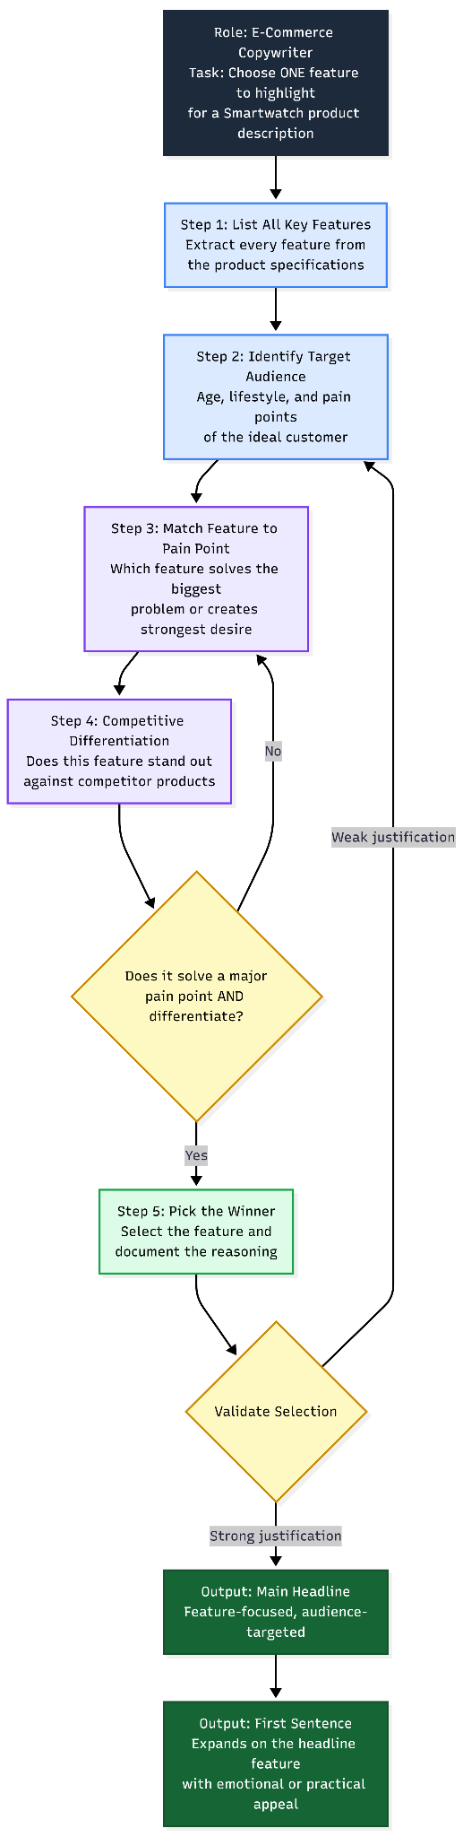
Reasoning steps: Features: Heart rate monitor, 1.8" AMOLED display, 7-day battery, IP68 waterproof, built-in GPS, call function. Target audience: Busy 25–35 year olds who jog and work long hours. Competitors mostly highlight battery and display
Output: Designed for busy professionals who juggle work and workouts, this smartwatch tracks your runs accurately with built-in GPS, giving you complete freedom on the move. ”

Example 2: Customer Complaint about "Wrong Color"

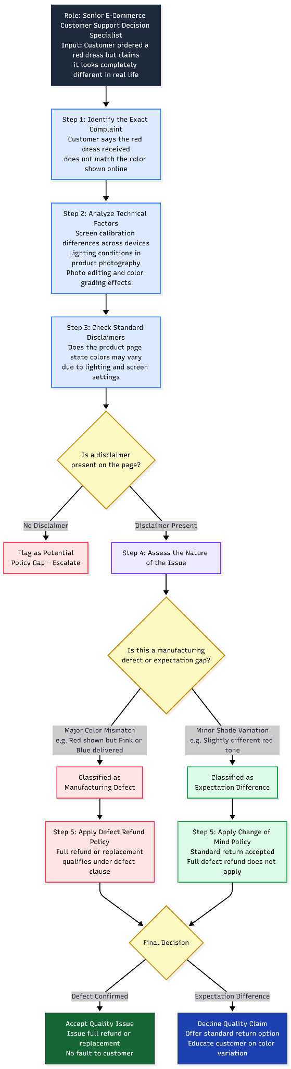
Reasoning steps:
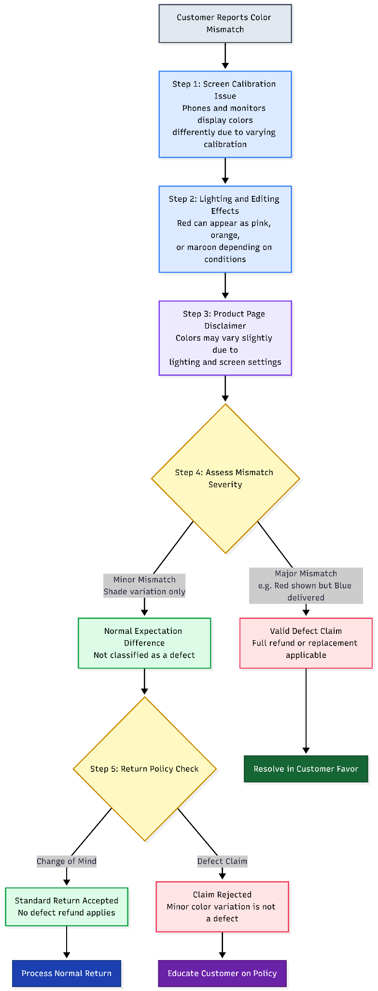
Output: Will offer easy return + prepaid label (change of mind), but not automatic full refund as a defect. ”

Example 3: Free Shipping Threshold
“You are a senior e-commerce revenue and customer experience strategist. Your job is to balance customer satisfaction with long-term profitability and fairness. Analyze the situation carefully before making the final decision.
Follow these reasoning steps:
- Identify the exact free shipping threshold policy and whether it is clearly communicated.
- Evaluate fairness implications of making small exceptions for near-threshold orders.
- Assess long-term behavioral impact if customers learn they can request exceptions.
- Consider the profit margin impact of repeated small exceptions.
- Determine whether there is a smarter alternative that increases order value while keeping the customer happy.
After completing the reasoning steps, provide a final decision and a short structured explanation.
Input: A customer has ₹498 in cart and asks: "Why no free shipping? It's almost ₹500!" Should we give free shipping anyway to keep them happy?
Reasoning steps:
Step 1: Free shipping starts at exactly ₹500 — it's a clear rule shown everywhere on the site.
Step 2: Giving exceptions for ₹2 creates unfairness (other customers who added one more item to reach ₹500 will feel cheated).
Step 3: Small exceptions hurt profit margins and train customers to always ask/bargain instead of adding items.
Step 4: Better to gently encourage: "Add just ₹2 more and get free shipping + surprise gift!"
Step 5: Most customers add a cheap item (candy, sticker, socks) when reminded — average order value actually increases.
Output: You're just ₹2 away from free shipping. Add any small item and enjoy free delivery plus you can get a little surprise! ”
When to use it: When the task involves multi-step logical reasoning, arithmetic, commonsense inference, or symbolic manipulation.

Pros and Cons:
- Pros: Reduces mistakes in complex problems.
- Cons: Can make responses longer and slower, does not help much for simple factual questions.

3.2 Automatic Chain-of-Thought (Auto-CoT) Prompting
This is an automated version of regular Chain-of-Thought where the model itself creates step-by-step examples.
How it works: You select a set of questions from a dataset, prompt the LLM with "Let’s think step-by-step" to generate multiple reasoning chains per question, then cluster and pick diverse chains to form high-quality few-shot demonstrations that are used in the final prompt for better execution on new problems.

Example 1: Multi-step Pricing & Margin Calculation
“First, automatically generate 3 similar pricing problems and solve them step-by-step. Requirements:
- Each example must involve cost price, target margin, and discount impact.
- Use different reasoning styles:
  - Chain A: Calculate minimum margin price first.
  - Chain B: Estimate revenue impact first.
  - Chain C: Compare competitor or psychological pricing angle first.
- Ensure each chain arrives at a logically correct final answer.
Keep examples concise but structured. Now solve the following problem using structured reasoning.
Provide:
- Clear numbered steps
- Final pricing recommendation
Problem: [Put the question here]”
Question: Cost ₹1500. Normal price ₹2499. Target min 25% margin. If discounted to ₹1999, expect +80% sales volume. What should be the sale price?
Model Output:
Step 1: Target min margin price = 1500 / (1-0.25) = 1500 / 0.75 = ₹2000.
Step 2: ₹1999 is very close to ₹2000 → margin ≈ 24.95% (almost meets).
Step 3: +80% volume increase makes total revenue much higher despite tiny margin drop.
Final answer: Set sale price at ₹1999.

Example 2: Inventory Restock Decision
“You are an expert e-commerce inventory and supply chain strategist. Your task is to solve restocking decisions using Auto Chain-of-Thought reasoning. First, automatically generate 5-10 similar inventory restock problems and solve them step-by-step.
- Auto-generate chains for past stock questions.
- Vary: sales trend first vs profit margin first vs supplier delay.
- Keep diverse valid paths.
- Keep solutions concise but structured and logically correct.
Follow structured reasoning:
- Calculate average daily sales.
- Estimate demand during lead time.
- Compare demand vs current stock coverage.
- Consider margin level and stockout risk.
- Decide optimal restock quantity with reasonable safety buffer.
Provide:
- Clear numbered reasoning steps
- Final restock recommendation (specific quantity range)
Problem: [Put the question here]”
Question: Wireless mouse: last 30 days sales 200 units (steady), stock left 40, lead time 7 days, high margin. How many to restock?
Model Output:
Step 1: Daily sales ≈ 6–7 units.
Step 2: In 7 days, sales needed ≈ 45–50 units.
Step 3: Current stock covers only ~6 days → risk out-of-stock.
Step 4: High margin → safe to buffer.
Final answer: Restock 100–120 units.
When to use it: When strong reasoning is needed without spending time crafting perfect chain-of-thought examples. Great for scaling up to many tasks.
Pros and Cons:
- Pros: Saves effort, avoids bad manual examples, often matches or beats hand-crafted CoT.
- Cons: Requires access to a question dataset and computational resources for generating chains, not ideal when manual control over examples is preferred for domain-specific precision.

3.3 Self-Consistency
Self-Consistency is a decoding strategy that improves reasoning accuracy by generating multiple diverse step-by-step reasoning paths from a language model and selecting the most consistent final answer across them, rather than relying on a single greedy reasoning path.
How it works: Instead of producing one chain-of-thought, the model samples several different reasoning chains and then chooses the final answer that appears most frequently or consistently across those sampled solutions.

Example 1: Deciding Refund Policy for "Item Looks Different" Complaint
“You are a senior customer support lead at an e-commerce store. Your goal is to make a fair, policy-aligned refund decision. Generate 8 independent reasoning paths. For each reasoning path:
- Analyze the customer complaint
- Interpret the refund policy carefully
- Consider screen color variation (10–20%)
- Consider product page color disclaimer
- Decide one of: Full refund, Partial refund, Return label only or Deny refund
After generating all 8 reasoning paths:
- Count how many times each decision appears.
- Select the decision with the highest frequency.
Provide output in this structure:
Reasoning Path Results:
Path 1: Decision
Path 2: Decision
...
Path 8: Decision
Provide justification for each decision.
Final Decision (Majority Vote): [ -- ]
Customer Ouery + Policy + Notes
Prompt Template
Multiple Reasoning Generator
(8 Independent Paths)
Decisions Output
Vote Counter
Majority Selection (Final Decision)
Customer says: [Bought red sneakers but they look maroon in daylight. Want full refund.]
Policy: [Full refund for defects within 7 days. Color variation due to screen/lighting comes under change of mind (₹100 return fee)]
Note: [Most screens show colors 10–20% differently. Sneakers photos include a color disclaimer.]
Think independently for each path before voting. ”

Example 2: Estimating Sales Lift from a Discount
“You are a senior e-commerce pricing analyst specializing in demand forecasting and profit optimization. Your task is to estimate sales lift and profit impact. Generate 8 Independent Estimation Paths. For each path:
- Start with baseline data:
  - Current volume
  - Selling price
  - Cost
  - Planned discount
  - Typical accessory lift range
- Independently estimate:
  - Expected % volume increase (choose a reasonable value within 60–100%)
  - New daily sales volume
  - Old daily profit
  - New daily profit after discount
- Conclude whether profit increases, profit decreases or profit stays the same.
Each path must:
- Use a slightly different % lift assumption
- Show short structured calculation
- Produce a final answer in required format
After generating all 8 paths:
- Count how many times each outcome appears
- Identify the most frequent:
  - Estimated new volume (range acceptable)
  - Profit direction (increase/decrease/same)
Output Format:
Path 1 → New volume: X units/day. Profit: ___
Path 2 → New volume: X units/day. Profit: ___
...
Path 8 → New volume: X units/day. Profit: ___
Final Majority Decision: "New volume: X units/day. Profit: increases / decreases / same."
Pricing Input (volume, price, cost, discount)
Prompt Template
Estimation Path Generator
(8 Independent Calculations)
Path Outputs (volume, profit)
Aggregation Layer (count outcomes & ranges)
Majority Selection (Final Decision)
Put the Question here: A wireless charger normally sells 50 units/day at ₹999 (cost ₹599). We plan a 20% discount. In e-commerce, 20% discount often increases volume by 60–100% for accessories. Estimate new daily sales volume and whether total profit increases or decreases. ”
When to use it: For arithmetic or any question where multiple ways of thinking exist, but only one right answer exists.
Pros and Cons:
- Pros: Significantly boosts accuracy in diverse-path problems.
- Cons: Increases computational cost and time due to multiple sampling, less effective for straightforward tasks with one clear path where greedy decoding suffices.

3.4 Logical Chain-of-Thought (LogiCoT) Prompting
Logical Chain-of-Thought (LogiCoT) Prompting improves multi-step reasoning by verifying each intermediate step using logical contradiction checks and iteratively correcting errors before producing the final answer.

How it looks: The model generates reasoning steps, then symbolically verifies each step by testing if assuming it false leads to contradiction; incorrect steps are revised and re-generated in an iterative think-verify-revise loop.

Example 1: Discount Approval for Bulk Order (If-Then + Margin Logic)
You are a **pricing logic expert** responsible for evaluating bulk discount requests using **formal logical reasoning**. Your task is to apply **LogiCoT (Logical Chain-of-Thought)** reasoning. Follow a structured deduction process and ensure every conclusion logically follows from the given premises and rules.

## Step 1: State the Premises
List all given facts clearly, like cost per unit, minimum required margin, normal selling price, customer request, and total order value.

## Step 2: Derive Minimum Price for Required Margin
Use the formula: Minimum Price = Cost / (1 − Margin)

## Step 3: Apply Logical Rules
**Rule A** If proposed price ≥ required minimum price → Approve full discount
**Rule B** Else if expected volume lift > 200% AND margin ≥ 15% → Partially approve discount

## Step 4: Calculate the actual margin at the proposed price
Use the formula: Margin = (Price − Cost) / Price

## Step 5: Check for contradictions:
- Ensure margin is **positive**
- Ensure the decision follows the defined rules
If a contradiction exists, reject the request.

## Step 6: Provide the final answer in this format:
**Decision:** Approve Full Discount / Partial Approval / Reject.
**Logical Justification:** Explain the reasoning using derived margin, rule evaluation, and contradiction check.
Input: Cost ₹1200/unit. Min margin 25%. Normal price ₹1999. Customer wants 50 units at ₹1500 each (total ₹75,000).
Logi-CoT Steps:
- If proposed price ≥ cost / (1 - 0.25) → approve.
- Else if volume lift > 200% expected → partial approve if margin ≥ 15%.
- Verify no contradiction (e.g., loss-making). Reason step by step logically: state premise → derive → check validity → conclude. Final: Approve full discount? Yes/No + logical justification.
Output: Margin calc shows ~16.7% → partial approval if lift high, verified no loss contradiction.

Example 2: Return Policy Contradiction Check
You are a **return policy logician**. Your task is to analyze return policy statements using **LogiCoT (Logical Chain-of-Thought)** reasoning and determine whether a logical conclusion follows from the given premises. Use **formal deductive reasoning**.
Clearly structure the reasoning as: **Premises → Derivations → Consistency Check → Contradiction Test → Conclusion**.

## Step 1: State the Premises
List the policy statements exactly as given.
- Premise 1: All returns within **7 days** are accepted **if unopened**.
- Premise 2: **Some unopened returns are denied** because of hygiene rules (e.g., underwear).

## Step 2: Convert Premises into Logical Form
Represent the statements using set relationships. Example format:
- Returns within 7 days ∩ Unopened ⊆ Accepted
- Some Unopened ⊆ Denied

## Step 3: Evaluate whether both premises can hold simultaneously.
Check whether:
- An unopened return could fall into both **Accepted** and **Denied** categories.
- Policy exceptions may override general rules.

## Step 4: Test the assumption:
**Assumption:** All returns within 7 days that are unopened are accepted.
Now compare with Premise 2: Some unopened returns are denied.
Determine whether this creates a contradiction with the assumption.

## Step 5: If a contradiction occurs:
- Conclude that the general rule must have **exceptions**.
Determine whether it logically follows that some returns within 7 days are denied.

## Final Output Format
**Logical Conclusion:** Yes / No
**Justification:** Provide a short explanation referencing the premises, contradiction test, and logical deduction.
Input: Can we conclude that some returns within 7 days are denied?
LogiCoT Reasoning Steps:
Step 1: Returns within 7 days ∩ Unopened ⊆ Accepted.
Step 2: Some Unopened returns are Denied.
Step 3: Check consistency: If some unopened are denied, does this contradict premise 1?
Step 4 (contradiction test): Assume all within-7-days unopened are accepted → contradicts “some unopened denied.”
Step 5: Therefore, the general rule has exceptions → some within-7-days unopened returns are denied.
Output: Yes, we can conclude that some returns within 7 days are denied because the product can be a hygiene related product.
When to use it: Use LogiCoT for tasks requiring rigorous logical deduction, such as mathematical proofs, complex puzzles, scientific hypothesis testing, or legal reasoning, where standard CoT might introduce unchecked errors.
Pros/Cons:
- Pros: Highly suitable for reducing logical inconsistencies in intricate, verification-heavy scenarios, leading to measurable performance gains over CoT.
- Cons: Not suitable for simple, non-reasoning tasks like factual recall or creative writing, as the iterative loop can increase computation time unnecessarily.

3.5 Chain-of-Symbol (CoS) Prompting
This method improves an LLM’s ability to reason about spatial, structural, or relational problems by replacing ambiguous natural language with compact symbolic representations that encode objects, positions, and relations explicitly.

How it looks: The prompt converts entities and relationships into structured symbols (grids, coordinates, tokens), enabling the model to manipulate symbolic states step-by-step instead of interpreting vague language descriptions.

Example 1: Product Page Layout Optimization (UI Spatial Reasoning)

You are a **UX strategist and interface planner**. Solve the given UX/UI problem using **Chain-of-Symbol (CoS) reasoning**, where layouts and relationships are represented using **symbols instead of long textual reasoning**. Your goal is to **optimize usability, clarity, and conversion** by rearranging interface elements logically.
# Symbol System
Represent the interface as a **symbolic grid**:
Vertical structure (top → bottom): **V1, V2, V3, V4 ...**
Horizontal structure (left → right): **L, M, N**
Use these codes:
- **^** = above
- **v** = below
- **R>** = to the right of
- **<L** = to the left of
- **P1** = high-priority element
- **P2** = supporting element
- **NO** = avoid overlap / clutter
- **SWP** = swap positions

# General Optimization Goals
- Critical actions must appear **early and visible**
- Important information should appear **before secondary content**
- Trust signals should appear **before decisions**
- Avoid clutter and overlapping elements
- Maintain a **logical reading flow**
# Step 1: Represent the current interface layout using the symbolic grid.
Example format: V1L: Element, V2L: Element, V3L: Element
# Step 2: Identify Priority Elements
Mark elements that directly affect the main user goal using **P1**.
Example: Conversion, form completion, checkout, navigation, information discovery
# Step 3: Chain-of-Symbol Adjustments
Modify layout using symbolic transformations.
Examples: Hero ^ Price, Price P1 R> CTA P1, CTA P1 ^ Reviews, NO overlap between Hero and CTA, Description v Reviews
Show **step-by-step symbolic changes**.
# Step 4: Provide the optimized layout using the symbolic grid.
Example format: H1A:V1L: Hero, V2L: Price P1 R> CTA P1, V3L: Reviews P2, V4L: Description, V5L: Related
# Step 5: Explain briefly why the new layout is better (add about usability, clarity, conversions, etc).

Example 2: Delivery Route Planning for Multiple Orders (Spatial Navigation)
You are a **last-mile delivery optimization planner**. Solve delivery routing problems using **Chain-of-Symbol (CoS) reasoning**, where maps, distances, and routes are represented with **symbols instead of long explanations**. Your goal is to determine the **shortest valid delivery route** while respecting **delivery constraints** (fragile items, perishable items, weight constraints, time priority, etc.).
# Use symbolic notation for spatial reasoning

**Location symbols**:
- **SRC** = Warehouse / Starting location
- **CL1, CL2, CL3 …** = Customers
- **MID** = Hub / intermediate location (if given)
**Distance representation**: A --3km--> B = road from A to B of **3 km**
**Direction symbols**:
- **FWD** = forward
- **BWD** = backward
- **RT** = right
- **LT** = left
**Constraint symbols**:
- **PRI** = priority delivery
- **FRG** = fragile item
- **CLD** = perishable / cold chain
- **HVY** = heavy item

# Optimization Goals
1. **Minimize total distance**
2. **Respect delivery constraints**
3. Avoid rule violations (e.g., fragile stacked under heavy)
4. Deliver time-sensitive items appropriately
5. Ensure the route remains logically consistent

# Step 1: Convert the problem description into a **symbolic map**.
Example format: SRC --2km--> CL1, SRC --3km--> CL2, CL1 FWD(1km) CL3

# Step 2: Mark delivery constraints on each location.
Example: CL1 FRG = fragile item, CL2 HVY = heavy item, CL3 CLD = perishable item

# Step 3: Interpret rules using symbols.
Examples:
- **FRG** fragile → deliver **first or last**
- **CLD** perishable → deliver **last**
- **HVY** heavy → avoid placing after fragile delivery

# Step 4: Create possible symbolic paths.
Examples:
SRC → CL1 → CL3 → CL2
SRC → CL2 → CL1 → CL3
Reject routes that violate constraints.

# Step 5: Calculate Route Distance
Add the distances of each step.
Example: SRC --2km--> CL1, CL1 --1km--> CL3, CL3 --6km--> CL2

# Step 6: Final Output
Provide:
**Shortest Valid Route**: [ example: SRC → CL1 → CL3 → CL2 ]
**Total Distance:** X km
**Constraint Check:**Confirm the route satisfies all delivery rules.

Example 3: Warehouse Shelf Reorganization (Spatial Planning)
You are a **warehouse layout optimizer**. Solve shelf organization problems using **Chain-of-Symbol (CoS) reasoning**. Instead of immediately describing the solution in natural language, first **convert the layout into symbolic form**, perform **symbolic transformations**, and then give the final plan. Your goal is to **optimize picking efficiency, safety, and travel distance**.
# Symbol System
Represent shelves as a **grid**.

Rows represent shelves (top → bottom): **R1 = top shelf, R2 = middle shelf, R3 = bottom shelf, R4… = additional shelves if given**
Columns represent positions from **left (near exit) → right (far)**: **C1, C2, C3, C4, ...**
Example slot: **R1C1** = top shelf, closest to exit ; **R3C4** = bottom shelf, farthest position

# Symbolic Movement Notation: Use these symbols during reasoning
- **MOVE(A,B)** = move item to new slot
- **SWAP(A,B)** = swap positions
- **UP(item)** = move item to a higher shelf
- **DOWN(item)** = move item to a lower shelf

# Item Attribute Symbols
- **FRG** = fragile
- **HVY** = heavy
- **HIT** = fast-moving / high-demand
- **EMP** = empty slot

# Optimization Rules
1. **Fragile items (FRG)** → higher shelves and closer to exit
2. **Heavy items (HVY)** → bottom shelves
3. **High-demand items (HIT)** → near exit
4. Minimize total picker travel distance
5. Avoid unsafe stacking (heavy above fragile)

# Step 1: Translate the shelf description into a grid
Convert the shelf layout into the symbolic grid format using **row-column coordinates**.

# Step 2: Mark Item Attributes
Attach the attribute codes to each item where applicable.

# Step 3: Chain-of-Symbol Adjustments
Perform symbolic moves step by step. Each move should improve safety or picking efficiency.
Example:
MOVE(R3C1 → R1C1)
SWAP(R2C2, R1C3)
UP(Vase)
DOWN(Dumbbell)

# Step 4: Final Output
Show the new symbolic grid after all adjustments. Briefly explain why the new layout improves.
Example:
R1: Vase(FRG) Screen(FRG) Perfume Charger
R2: Shirt Shoes Cable Laptop
R3: Dumbbell(HVY) Books Speaker EMP
When to use it: Apply CoS in scenarios involving intricate spatial configurations, such as puzzle solving, pathfinding in games or robotics, architectural layouts, or molecular structure modeling in chemistry, where it outperforms traditional CoT by minimizing linguistic ambiguities and enabling more precise, token-efficient reasoning compared to verbose natural language methods.
Pros/Cons:
- Pros: Highly suitable for visual or geometric problems requiring clarity, like 3D modeling or board games, offering superior accuracy and reduced prompt size.
- Cons: Not suitable for non-spatial tasks like sentiment analysis or creative writing, where symbols may lack expressiveness.

3.6 Tree-of-Thoughts (ToT) Prompting
This method improves an LLM’s ability to solve complex, multi-path reasoning problems by exploring multiple possible reasoning directions simultaneously in a structured tree and selecting the most promising path.

How it looks: The model generates multiple intermediate reasoning “thoughts,” evaluates them, and explores them using search strategies like breadth-first or depth-first to reach the best solution.

Example 1: Choosing the Best Flash Sale Strategy
You are a **marketing strategist and revenue optimization expert**. Solve the problem using **Tree-of-Thought (ToT) reasoning**. Instead of generating one answer, you must **explore multiple strategy branches**, evaluate them, and choose the best one. Your goal is to **maximize revenue and profit while managing risk**.
# Reasoning Method: Tree-of-Thought
Follow this structured process:

1. **Decompose the problem**
2. **Generate multiple strategic branches**
3. **Estimate outcomes for each branch**
4. **Evaluate branches with scoring**
5. **Select the best strategy or hybrid**

# Step 1: Understand the Business Context
Extract key inputs: product price, product cost, promotion budget, campaign duration, target objective (revenue / profit / customer acquisition)
# Step 2: Generate Strategy Branches
Create **3–4 different promotion paths**. Each path should include combinations of discount level, marketing channels, bundling offers, campaign tactics. Each path should represent a **distinct marketing approach**.
# Step 3: Predict Outcomes for Each Branch
For each branch estimate expected sales volume, total revenue, total profit, risks. Risks may include margin erosion, brand dilution, etc.
# Step 4: Evaluate Each Branch
Score each branch from **1–10** on revenue potential, profitability, risk level and feasibility. Present the evaluation clearly.
# Step 5: Tree-of-Thought Selection
Choose the **best-performing branch** or **combine strong elements** from multiple branches. Explain why the selected branch wins and the other branches were rejected.
# Output Format
Provide the answer in this structure:
### Branch 1
Strategy:
Predicted sales:
Revenue:
Profit:
Risks:
Scores:

### Branch 2
---
### Best strategy:
Justification: Explain why this branch (or hybrid) is superior.

Example 2: Optimal Inventory Allocation Across Cities
You are an **operations and logistics optimization planner**. Solve the problem using **Tree-of-Thought (ToT) reasoning**. Instead of producing a single solution immediately, you must **explore multiple strategy branches**, evaluate them, prune weak ones, and refine the best branch. Your objective is to **optimize delivery or inventory allocation while balancing demand, risk, logistics cost, and capacity constraints**. Follow this structured reasoning tree:
1. **Understand the inputs and constraints**
2. **Generate multiple allocation strategies (branches)**
3. **Simulate outcomes for each branch**
4. **Evaluate and score each branch**
5. **Prune weak branches**
6. **Refine and finalize the best allocation plan**

# Step 1: Extract Key Inputs
From the problem identify total inventory or delivery units available, demand distribution across locations, warehouse or delivery capacity limits, logistics costs or operational constraints, any profit or margin differences across locations.
# Step 2: Generate Strategy Branches
Create **3-4 different promotion paths**. Each path should focus on combinations of forecast demand percentages, higher-margin or higher-performing locations, stock buffers to cities with demand volatility or stockout risk, etc. Each branch should represent a **distinct operational approach**.
# Step 3: Simulate Outcomes

For each branch calculate units allocated to each city/location, expected sell-through, risk of stockouts, risk of overstock, logistics or redistribution cost
# Step 4: Evaluate Branches
Score each branch (1–10) on revenue potential, lost sales avoided, logistics efficiency, risk management, etc. Summarize scores clearly.
# Step 5: Prune Weak Branches
Identify branches with high overstock risk, excess logistics cost or poor revenue potential. Remove or deprioritize these branches.
# Step 6: Refine Best Strategy
If needed, combine the strongest elements from the best-performing branches.
# Output Format
### Branch 1 – Strategy Name
Allocation:
Expected sell-through:
Stockout risk:
Overstock cost:
Scores:

### Branch 2 – Strategy Name
---
### Pruned Branches: Explain which strategies were removed and why.
### Final Allocation Plan: Provide the final recommended allocation numbers. Explain briefly.

Example 3: Designing a Personalized Recommendation Bundle
You are a product bundling expert. Use Tree-of-Thoughts. The customer just added a ₹15,000 smartphone to the cart. Suggest a 3-item bundle to increase AOV.
Explore tree:
- Generate 3 bundle ideas (different themes: protection, performance, lifestyle).
- For each: list items, total price, perceived value, uplift probability (based on e-commerce patterns).
- Evaluate: score on conversion likelihood, margin, customer satisfaction.
- Backtrack if any branch has low margin or poor fit.
- Select top bundle + explain why it beats others.
(Expected: Branch 1: Case + screen protector → safe, low uplift.
Branch 2: Charger + earbuds → high synergy.
Branch 3: Smartwatch → premium but risky.
Best: Branch 2 for balance.)
When to use it: For challenges involving strategic exploration of numerous possibilities, such as combinatorial puzzles (e.g., Game of 24), optimization tasks in planning or scheduling, and game strategies, to achieve higher success rates in non-deterministic or high-complexity scenarios.
Pros/Cons:
- Pros: Highly suitable for exploratory and look-ahead intensive use cases like puzzles, games, or decision trees, offering superior performance through branching and backtracking.
- Cons: For straightforward linear tasks like basic arithmetic or factual queries, it increases computational cost and complexity without benefits.

3.7 Graph-of-Thoughts (GoT) Prompting
This method models reasoning as a flexible graph of interconnected ideas rather than a single linear chain, enabling branching, merging, revisiting, and combining multiple reasoning paths to solve complex problems more effectively.

How it looks: The prompt encourages generating multiple reasoning nodes and connections, allowing the model to explore, evaluate, merge, or backtrack across different thought paths before selecting the best solution.

Example 1: Optimal Product Bundle Creation (Merging Thoughts)
You are a **product bundling strategist and revenue optimization expert**. Solve the problem using **Graph-of-Thought (GoT) reasoning**. Instead of following a single reasoning path, represent ideas as **nodes in a graph** and relationships as **edges**. You may **expand, connect, merge, and refine nodes** to arrive at the best bundle strategy. Your goal is to **increase Average Order Value (AOV) while maintaining strong perceived value and margins**.
# Graph-of-Thought Reasoning Framework

Follow this structured process:
1. **Generate idea nodes**
2. **Connect dependencies between nodes**
3. **Merge promising nodes into stronger bundle concepts**
4. **Refine merged nodes using constraints**
5. **Distill the final bundle recommendation**

# Step 1: Generate Thought Nodes
Create **4–5 bundle concept nodes** representing different customer needs. Each node should represent a **distinct bundling strategy**.
# Step 2: Connect Dependencies (Edges)
Identify logical relationships between nodes. Represent relationships as: Node A → Node B, Node B → Node D. Explain briefly why these nodes connect.
# Step 3: Merge Promising Nodes
Combine **2–3 high-synergy nodes** to create stronger bundle concepts. Create **merged nodes** representing improved bundle strategies.
# Step 4: Refine Merged Nodes
Evaluate merged bundles against key criteria like perceived customer value, relevance to main product, price psychology, etc. Discard weak bundles and refine strong ones.
# Step 5: Distill Final Bundle
Select the **highest-performing bundle node**. Provide bundle items, bundle price, expected AOV increase

# Output Format
Bundle contents:
Bundle price:
Explain why this bundle maximizes conversion and value.
# Problem statement: [Put the question here]

Example 2: Multi-Channel Marketing Campaign Plan (Feedback Loops + Aggregation)
Input: You are a campaign planner. Use Graph-of-Thoughts. Represent reasoning as graph: nodes = campaign ideas/elements, edges = influences/dependencies, allow loops for refinement. Plan a ₹1 lakh budget campaign to boost Diwali sales of wireless earbuds (target 25–35 age group).
Reasoning:
Step 1: Generate nodes (Instagram reels, email blast, Google ads, influencer collab, site flash sale).
Step 2: Draw edges (e.g., reels → drive traffic to flash sale).
Step 3: Add feedback loops (e.g., low CTR on ads → refine targeting).
Step 4: Aggregate best paths (merge influencer + reels for viral boost).
Step 5: Output final optimized campaign graph summary + budget split + expected ROI reasoning.
Output: Graph merges social + influencer → high reach at low cost; loops refine targeting → better ROI.

Example 3: Inventory Reallocation Across Warehouses (Synergistic Combination)
Input: You are a supply chain optimizer. Use Graph-of-Thoughts. Think in graph: nodes = allocation ideas or constraints, edges = impacts (cost, speed, risk), merge nodes for better plans. Reallocate 800 units of trending hoodies from 3 warehouses (Mumbai high demand, Delhi medium, Bangalore low). Avoid stockouts + minimize shipping cost.
Reasoning:
Step 1: Generate nodes (proportional to forecast, push to high-margin regions, safety buffer per city).
Step 2: Connect dependencies (e.g., high demand node → needs buffer).
Step 3: Merge conflicting nodes (e.g., combine proportional + buffer for hybrid).
Step 4: Refine with loops (simulate cost if shortage occurs).
Step 5: Distill final allocation from graph. Give final units per warehouse + total expected cost savings.
Output: Graph merges demand forecast + buffer → smart split: Mumbai 450, Delhi 250, Bangalore 100.
When to use it: Utilize GoT for intricate problems involving non-linear dependencies, such as multimodal integration (e.g., text+image analysis in ScienceQA), optimization with multiple constraints (e.g., resource allocation), or creative synthesis requiring idea merging (e.g., brainstorming innovations), where it outperforms linear CoT or tree-based ToT by allowing dynamic aggregation and refinement across branches for more accurate and holistic solutions.
Pros/Cons:
- Pros: Highly suitable for complex, interconnected scenarios like scientific reasoning or strategic planning, providing flexibility and performance gains through graph operations.
- Cons: Not suitable for simple sequential tasks like basic calculations or direct factual retrieval, as the graph complexity can lead to unnecessary overhead and slower processing.

3.8 System 2 Attention (S2A) Prompting
It is a prompting strategy that improves accuracy by forcing the model to deliberately identify and regenerate only the most relevant parts of the context before answering, reducing distraction from irrelevant information.

How it looks: The model first rewrites or filters the input to keep only relevant information, then generates the final answer using this refined context.

Example 1: Cleaning Noisy Customer Reviews for Product Analysis
Prompt: You are a helpful assistant that filters context. Rewrite the following customer review text to include ONLY the factual description of the product experience and opinion about quality/performance. Remove: personal stories unrelated to product, typos, greetings, unrelated complaints (delivery, packaging unless product-related), opinions about brand/company, any spam or off-topic text. Keep it concise and neutral.
Now use ONLY the cleaned review. Classify product review as Positive / Negative / Neutral. Give a one-sentence reason.
Review text: [Put the input here]
Input: "Hi team, I ordered these earbuds last week and they arrived super fast thank you! But honestly the sound is amazing deep bass like wow, but one earbud keeps disconnecting randomly which is annoying. My dog chewed the old ones so these are better but still not perfect. Love your brand though! Also the box was damaged but product ok."
Output: Cleaned → "Earbuds have amazing deep bass sound but one disconnects randomly." → Negative, due to connectivity issues despite good sound.

Example 2: Summarizing Long Product Description + Specs for Title Generation
Prompt: Rewrite this product page text to include ONLY the key features, specifications, and main selling points. Remove: marketing fluff ("best ever", "revolutionary"), customer testimonials, unrelated brand history, repeated info, warranty boilerplate, or any opinionated language. Output only factual bullet points or short paragraphs.
Using ONLY this cleaned product info. Generate 3 short, SEO-friendly product titles (under 60 chars each).
Product text: [put the input here]
Input: "Introducing our revolutionary Wireless Neckband Earphones – the ultimate audio companion you've been waiting for! With 30-hour insane battery life, IPX5 sweat-proof design perfect for gym warriors, deep thumping bass that makes your music come alive, fast charging in just 10 mins for 10 hours playtime. Customers say: 'Best purchase ever!' Trusted by millions. 1-year warranty, etc."
Output: Cleaned → factual specs → titles like "Wireless Neckband Earphones 30H Battery IPX5", etc.

Example 3: Filtering Support Ticket for Root Cause Classification
Prompt: You are a neutral filter. Rewrite this customer support ticket to keep ONLY the technical details about the issue, steps tried, device info, and exact problem description. Remove: emotional language ("very frustrated", "worst service"), threats, unrelated questions, compliments, typos, greetings/sign-offs, personal info.
Use ONLY this cleaned ticket description. Classify the main issue category: Charging Problem / Software Bug / Hardware Defect / User Error / Other. Give short reasoning.
Ticket: [put the input here]
Input: "OMG I'm so angry! I bought your smartwatch last month and now it won't charge at all. I tried different cables, restarted, still nothing. This is ridiculous after paying so much. Please refund immediately or I'll post bad reviews everywhere. Model XYZ-123, Android phone."
Output: Cleaned → "Smartwatch won't charge. Tried different cables and restart." → Charging Problem or Hardware Defect.)
When to use it: Apply S2A in scenarios with noisy or biased contexts, like factual question answering from lengthy documents, objective long-form content creation (e.g., reports or summaries), or math problems embedded in verbose narratives, where it outperforms standard CoT or direct prompting by filtering irrelevancies to achieve higher factuality and neutrality.
Pros/Cons:
- Pros: Highly suitable for tasks prone to context dilution, such as QA in noisy data or unbiased generation, leading to improved accuracy and objectivity.
- Cons: Not suitable for simple, clean-context queries like basic facts or creative brainstorming, where the extra regeneration step adds unnecessary computation and time.

3.9 Logic-of-Thought (LoT) Prompting
Logic-of-Thought (LoT) Prompting improves reasoning consistency by embedding explicit logical structure (propositions and relations) into prompts so model conclusions remain aligned with intermediate reasoning.

How it looks: The method extracts logical statements from text, expands them using formal logic rules, and reinserts them into the prompt so the model reasons over logically complete information.

Example 1: New-User Coupon Eligibility (Propositional Expansion)
Prompt: You are a policy logic engine. Use Logic-of-Thought (LoT) strictly.
- Extract atomic propositions from policy and customer query (label P1, P2, etc.).
- Expand logically: apply modus ponens, contraposition, conjunction rules.
- Rewrite expanded logical form in clear natural language.
- Append this logical augmentation to the original query and decide the outcome.
Policy:
- If first-time buyer AND cart ≥ ₹2000 AND no sale items → 15% new-user coupon applies.
- If any sale item present → coupon blocked (even if other conditions met).
Customer query: [put the input here]
Input: "First-time buyer here. My cart is ₹2200 including a 20% off T-shirt. Can I apply the new-user 15% coupon?"
Output: Propositions → P1: First-time buyer (true), P2: Cart ≥ ₹2000 (true), P3: Sale item present (true). Expansion → (P1 ∧ P2 ∧ ¬P3) → eligible; but P3 true → ¬eligible. Final: Coupon blocked.

Example 2: Fraud Flag on High-Value COD Order
Prompt: You are a fraud logic module. Apply Logic-of-Thought.
- List core propositions from order facts.
- Expand using logical rules (implication, negation, reductio if needed).
- Translate expanded logic to plain sentences.
- Augment original context with this logic → conclude fraud risk (Low/Medium/High) + action.
Order facts: [put the input here]
Input:
- Order value ₹38,000 (smartphone).
- New customer account (created 2 days ago).
- Payment: Cash on Delivery.
- Shipping to a different state from the billing address.
- No previous orders.
Output: Propositions → P1: High value, P2: New account, P3: COD, P4: Address mismatch. Expansion → High value + COD + mismatch → strong fraud indicator (common pattern). Final: High risk → hold order for verification.

Example 3: Return Request on Personalized Item
Prompt: You are a return logic processor for TrendyMart. Use LoT prompting.
- Extract propositions from policy and request.
- Logically expand (if-then chains, contradictions).
- Rewrite in natural language augmentation.
- Combine with query → decide approve/deny + reason.
Policy:
- Personalized/custom items are non-returnable except for manufacturing defects.
- If item used/worn → ineligible even for defect claims.
Customer request: [put the input here]
Input: "I ordered a custom name-printed hoodie 4 days ago. The print is slightly off-center. I tried it on once but didn't wear it outside. Can I return for refund?"
Output: Propositions → P1: Personalized item (true), P2: No manufacturing defect (off-center is design expectation), P3: Tried on (used). Expansion → Personalized → non-returnable unless defect; no defect → ineligible. Final: Deny return.
When to use it: Use LoT for tasks involving formal logical deduction, such as reading comprehension with inferences (e.g., ReClor), question answering with consistency checks (e.g., LogiQA), or proof-based reasoning (e.g., ProofWriter), where it better handles unfaithful chains than plain CoT or ToT by injecting verified logical extensions, leading to higher accuracy in logic-heavy domains.
Pros/Cons:
- Pros: Suitable for logic-intensive use cases like theorem proving or contradiction detection, reducing errors through neurosymbolic verification.
- Cons: Not suitable for creative or ambiguous tasks like storytelling or opinion generation, where rigid logic may stifle flexibility and increase processing overhead.
Difference from Logical Chain-of-Thought (LogiCoT):
LogiCoT focuses on step-by-step narrative reasoning with explicit logical checks embedded in a chain (numbered steps, verify each step, look for contradictions in sequence). It's more like enhanced CoT with logic flavor — still linear and descriptive.
LoT is symbolic-first: It creates formal propositions → logically expands them (deduction, contraposition) → translates back to text. The emphasis is on information-preserving logical augmentation rather than just step-by-step storytelling. LoT often handles complex rule sets better with less information loss.

MODULE 4

Reducing Hallucination in LLMs
Hallucinations happen when the model makes up facts or details that aren't true, like inventing a historical event. It's a common issue because models predict based on patterns, not perfect knowledge. Some strategies to combat hallucinations include:

4.1 ReAct (Reason + Act) Prompting
ReAct is a prompting framework where an LLM combines reasoning steps and external actions (like searching or tool use), allowing it to gather information, update plans, etc.
How it works: The model generates a cycle of Thought (reason about what to do) → Action (use a tool, search, calculate) → Observation (see the result) → repeat until solved, using reasoning to decide actions and new observations to refine subsequent reasoning.
ReAct Prompt Template:
Use ReAct format strictly.
Thought: [reason step by step]
Action: [specific action, e.g., search catalog, calculate discount]
Observation: [result — note what you observe]
... loop until output is ready

Example 1: Finding the Best Matching Product for a Customer Query
Prompt: You are a smart shopping assistant. Use ReAct format strictly. Thought: [reason step by step], Action: [specific action, e.g., search catalog, calculate discount], Observation: [result — pretend or note what you observe] ... loop until output is ready
Customer query: [put the input here]
Input: "I need wireless earbuds under ₹2000 with good noise cancellation and at least 20 hours battery."
Expected loop:
Thought: Need to find products matching price, noise cancel, battery.
Action: Search catalog for "wireless earbuds noise cancelling under 2000 20h battery".
Observation: Found 3 models — Model X: ₹1799, ANC, 22h; Model Y: ₹1999, ANC, 18h (fail); Model Z: ₹1499, no ANC.
Thought: X matches best.
Output: Recommend Model X at ₹1799.

Example 2: Personalized Bundle Recommendation with Price Check
Prompt: You are a bundling expert. Use ReAct loop: Thought → Action → Observation. Actions: search_related_products(item), calculate_bundle_price(items), check_stock.
Input: Customer just added smartphone (₹24999) to cart. Suggest a value bundle.
Expected loop:
Thought: Smartphone buyer often needs protection + accessories.
Action: search_related_products("smartphone accessories")
Observation: Top: case ₹799, screen protector ₹499, charger ₹999.
Thought: Bundle case + protector = good protection, total add ₹1298.
Action: calculate_bundle_price([smartphone, case, protector])
Observation: Bundle price ₹26298 (5% discount).
Output: Recommend "Protection Bundle": case + screen protector for ₹26298 total.
When to use it: For tasks needing real-world info, tools, or interaction (search, calculators, APIs)—very powerful in agents or tool-using AIs.
Pros and Cons:
- Pros: Enhances interpretability and accuracy in interactive or knowledge-intensive tasks, handles exceptions well.
- Cons: Needs tool access (not plain chat); more complex to set up.

4.2 Chain-of-Verification (CoVe)
A structured prompting method where the model first produces an answer, then deliberately verifies its own claims through targeted questions and revises the final response to reduce hallucinations and logical errors.
How it works: The model generates an initial response, creates verification questions about its claims, answers them independently, and then revises the final answer using the verified facts.

Example 1: Aggregating Customer Review Highlights
Task: Summarize common pros/cons from reviews without fabricating points.
CoVe Flow:
- Draft Prompt: "Summarize pros and cons from these reviews of the smartphone: [paste 5–10 review snippets]."
(Draft: "Pros: amazing camera, super fast. Cons: poor battery, gets very hot.")
- Plan Verification Questions Prompt: "Generate 6 verification questions to confirm the summary matches the actual reviews (no added points)."
(Questions: 1. Do at least 3 reviews mention camera positively? 2. Is "super fast" mentioned? 3. How many mention battery as poor? etc.)
- Independent Answer Questions Prompt: "Count/verify from original reviews only: [question]"
(Answers: 1. Yes, 4 reviews. 2. No — "fast charging" but not "super fast". 3. 3 reviews mention battery drain.)
- Revise Prompt: "Draft summary: [draft]. Verified facts: [Q&A]. Revise to accurate, evidence-based summary."
(Final: "Pros: good camera (mentioned positively by 4/10). Cons: battery drains quickly (3 reviews), occasional heating.")

Example 2: Verifying a Product Feature Summary
Task: Summarize key features of a wireless earbud model accurately (no exaggeration).
CoVe Flow (multi-prompt):
- Draft Prompt: "Summarize the main features of XYZ wireless earbuds from the product specs: noise cancelling, 30-hour battery, IPX5 waterproof, deep bass."
(Draft: "XYZ earbuds offer top noise cancelling, incredible 40-hour battery, fully waterproof, and booming bass — best in class!")
- Plan Verification Questions Prompt: "Given the draft summary above and original specs, generate 4 verification questions to check accuracy, completeness, and no exaggeration."
(Questions: 1. What is the actual battery life claimed? 2. Is "top noise cancelling" supported by specs? 3. What is the exact waterproof rating? 4. Does it say "best in class"?)
- Independent Answer Questions Prompt (one per question or batch): "Answer this verification question based only on original product specs: [question]"
(Answers: 1. 30 hours. 2. No — specs say "active noise cancellation" but no "top". 3. IPX5. 4. No such claim.)
- Revise Prompt: "Original draft: [draft]. Verification Q&A: [paste answers]. Revise the summary to be 100% factual and accurate."
(Final: "XYZ wireless earbuds feature active noise cancellation, 30-hour battery life, IPX5 water resistance, and deep bass sound.")
When to use it: Best for hallucination-prone tasks such as multi-hop question answering (e.g., HotpotQA), fact extraction, list-based queries, or long-form content generation where deliberate self-verification identifies inconsistencies better than single-pass methods like CoT, ensuring higher factual accuracy.
Pros/Cons:
- Pros: Effectively reduces hallucinations and errors in complex, knowledge-intensive tasks by promoting self-correction; suitable for QA, verification, and generation needing coherence.
- Cons: Requires multiple steps, increasing latency and compute; not ideal for simple, factual queries or real-time applications where speed is prioritized over verification.

4.3 Chain-of-Note (CoN)
Chain-of-Note prompting improves retrieval-augmented language models by forcing them to explicitly evaluate, filter, and summarize retrieved documents into structured “notes,” helping the model ignore noisy or irrelevant information and correctly admit when knowledge is insufficient.

How it works: The model first converts retrieved documents into concise relevance-checked notes, then reasons only over those validated notes to produce an answer or decide “unknown.”

Example 1: Answering Policy Question from Mixed Docs
Prompt: You are a policy Q&A agent. Use Chain-of-Note. For each retrieved policy/document chunk:
- Note: Relevant to "return window for custom items"? Key rule? Contradiction/noise? Chain notes → answer only from reliable notes.
Query: [put the input here]
Input: "Can I return a custom-printed T-shirt?"
Retrieved:
Chunk 1: "Standard returns 15 days..."
Chunk 2: "Custom/personalized items non-returnable except defect."
Chunk 3: "Sale items final sale."
Chunk 4: "Free shipping over ₹999."
Note utilized: Reliable note from Chunk 2
Output: "No, custom-printed T-shirts are non-returnable except for manufacturing defects."

Example 2: Product Recommendation with Catalog + Reviews
Prompt: You are a recommender. Use Chain-of-Note. Query: [put the input here]
Input: Recommend budget noise-cancelling earbuds under ₹2500.
Retrieved chunks (mixed catalog + reviews):
Chunk 1: "Model A: ₹1999, ANC, 20h battery."
Chunk 2: "Model B review: Best ANC under 3k!"
Chunk 3: "Old blog post about wired headphones..."
Chunk 4: "Model C: ₹2999, no ANC."
Notes:
Note 1: Relevant, key specs.
Note 2: Relevant, positive sentiment for Model A/B range.
Note 3: Irrelevant (wired, old).
Note 4: Relevant but over budget + no ANC.
Output: "Model A at ₹1999 — solid ANC and battery, good reviews in budget range."
When to use it: Ideal for open-domain question-answering tasks where retrieved documents may contain noise, irrelevance, or gaps, outperforming standard RALMs in scenarios like handling unverified web sources, fact-checking in real-time searches, or queries requiring rejection of unknowns, as it systematically filters for precision over naive integration.

Pros and Cons:
- Pros: Enhances robustness in noisy environments by improving exact match accuracy and rejection rates for out-of-scope questions.
- Cons: Increases response latency and token usage due to sequential note-taking, less efficient for clean or high-quality retrievals.

4.4 Chain-of-Knowledge (CoK)

This prompting method improves factual accuracy and complex reasoning by guiding the model to iteratively gather, verify, and integrate knowledge from multiple sources before producing an answer, reducing hallucinations compared to single-step reasoning.

How it works: The prompt forces the model to first frame the problem, then progressively retrieve and validate relevant knowledge from internal or external sources, and finally synthesize a grounded answer.

Example 1: Deciding Dynamic Pricing for a Flash Sale
Prompt: You are a pricing strategist. Use Chain-of-Knowledge prompting. Build the knowledge chain step by step, then answer. Question: [put the input here]
Input: Should we run a 25% flash sale on wireless earbuds (normal ₹2499, cost ₹1499) for the next 24 hours?
Chain steps:
- Current stock level and trend.
- Average daily sales without discount.
- Expected sales lift from 25% discount (use typical e-commerce accessory benchmarks).
- Profit margin at full price vs discounted price.
- Competitor pricing for similar earbuds.
- Customer segment most likely to buy (age, behavior).
- Risk of devaluing the brand or training customers to wait for sales.
Now connect the chain and give final recommendation: Yes/No + percentage + reasoning.
Output: High stock + strong lift expected + competitors already discounting → Yes, but only 20% to protect margin.

Example 2: Should we approve an instant refund for a "not received" claim on a ₹12,999 order paid via UPI?
Reasoning Preparation: Produce initial rationales -
- Rationale 1: "If tracking shows delivered, probably not a genuine non-delivery."
- Rationale 2: "But UPI payments sometimes have fraud patterns." Spot inconsistencies/gaps → identify needed domains: tracking data, payment method risk, delivery partner SLA, common fraud signals, customer history, policy rules.
Dynamic Knowledge Building: Generate and insert facts progressively from multiple domains.
- Domain 1 (Tracking & Logistics): Order ID #ORD98765 — tracking status = "Delivered" 2 days ago, proof-of-delivery photo shows package at gate, signed as received.
- Domain 2 (Payment Risk): Paid via UPI (instant, low chargeback protection compared to cards), new customer account created 3 days before order.
- Domain 3 (Customer History): First order, no previous returns or disputes.
- Domain 4 (Fraud Patterns): Common scam = claim "not received" after COD/UPI delivery with photo proof → ~18% of such claims in last quarter were fraudulent per internal data.
- Domain 5 (Policy & SLA): Policy = investigate "not received" claims with proof required; refund only if confirmed lost/missing after 72-hour re-verification window with delivery partner.
- Domain 6 (Business Impact): Instant refund without check → high fraud exposure (₹12,999 risk); delay + investigation → possible negative review but protects revenue.
Answer Consolidation: Synthesize refined rationales -
"Strong delivery proof + new account + UPI + known fraud pattern outweighs lack of prior history → high fraud likelihood. Policy requires investigation before refund."
Output: Do not approve instant refund. Send polite messages asking customers to check with family/neighbor/guard (reference delivery photo), allow 72 hours for re-verification with delivery partner. If no update, escalate to full investigation/refund only if confirmed missing.
When to use it: Best for knowledge-intensive question-answering that span multiple domains and require high factual accuracy, outperforming traditional CoT by dynamically grounding responses in external heterogeneous sources to correct errors and reduce hallucinations.

Pros and Cons:
- Pros: Significantly improves factual reliability and reduces hallucinations in complex, knowledge-heavy tasks by integrating diverse sources, to minimise error.
- Cons: Adds computational overhead due to query generation and retrieval, unsuitable for simple factual questions.

Table 1: Overview of Popular Prompt Engineering Techniques
Technique | Simple explanation | How it works | Main goal | Things you might add to prompt
Zero-shot | Just ask — no examples | Give question only | Quick & simple tasks | (nothing extra)
Few-shot | Give 1–5 good examples before asking | Show → Answer format repeated a few times | When you want the model to copy a style | "Example 1: … → … Example 2: … → … Now do:"
Chain of Thought (CoT) | Tell the model: "think step by step" | Forces step-by-step reasoning before final answer | Math • Logic • Multi-step problems | "Let's think step by step."
Zero-shot CoT | Same as CoT but without any examples | Just add the magic sentence | When you don't want to write examples | "Let's think step by step."
Auto-CoT / Auto-generated CoT | Let the model create its own examples automatically | LLM generates reasoning examples for itself | Save time writing few-shot examples | (done behind the scenes)
Self-Consistency | Ask the same question several times → pick most common answer | Run CoT many times + majority vote | Makes answers more reliable | (run prompt 5–10× and vote)
Tree of Thoughts (ToT) | Like CoT, but tries several different paths (like branches) | Explore → evaluate → pick best path | Hard planning / puzzle / strategy problems | "Explore 3 possible next steps, evaluate each…"
Graph of Thoughts (GoT) | Even more flexible than tree — thoughts can connect in any way | Thoughts can merge / loop / have multiple parents | Very complex reasoning | (usually needs special framework)
ReAct | Think + Act + Observe loop (like an agent) | Reason → take action (search/tool) → see result → repeat | Tasks that need internet / tools / real world | "Think → Action → Observation → repeat until done"
Chain-of-Verification (CoVe) | First answer → make checklist of facts → check & fix | Generate → verify → correct | Reduce hallucinations / wrong facts | "Generate answer → create verification questions → check"

MODULE 5

Context Optimization Techniques
Large Language Models (LLMs) now support very large context windows (often 128k to 1M+ tokens in modern models from 2025–2026). However, real-world applications can still easily exceed these limits. Prompts may contain instructions, conversation history, examples, documents, and user inputs. When all of this information is included together, the total number of tokens can become too large.
Exceeding the token limit increases latency (response time), cost, and sometimes reduces model performance. Because of this, developers must manage how much information is included in the prompt.
Context optimization techniques help reduce the number of tokens while keeping the most important information for the task. The following sections explain common methods used to manage prompt context effectively in prompt engineering systems.

5.1 Naive Truncation
Naive truncation is the simplest and most commonly used method to ensure that a prompt fits within the model's context window.
5.1.1 Removing extra tokens
In this approach, tokens are simply removed from the prompt when the total token count exceeds the allowed limit. Most LLM APIs use left truncation, which removes the oldest tokens first, such as earlier conversation messages or introductory content. This keeps the most recent user query and system instructions intact.
Some systems may use right truncation, which removes tokens from the end of the prompt. However, this is less common because recent information is usually more important.
Pros/Cons:
- Pros: Zero additional compute, trivial to implement, predictable token usage.
- Cons: Completely non-semantic—critical information can be discarded arbitrarily. This often causes hallucinations, factual errors, or loss of user intent.
5.1.2 Sliding window approach
A slightly better approach is the sliding window method, which keeps the most recent context while summarizing or preserving key information from earlier parts.
For long documents or multi-turn conversations, the system can:
- Extract relevant sections based on keywords or simple similarity checks
- Maintain a fixed-size buffer of the most recent conversation turns
- Optionally include a short summary of earlier interactions
Example pseudocode logic:
if total_tokens > max_context:
# Keep system prompt + last k user/assistant turns
keep_recent = messages[-recent_turns:]
# Optionally prepend compressed summary of history
summary = generate_short_summary(older_messages)
truncated = [system] + [summary] + keep_recent

5.2 Retrieval-Based Selection
When working with external knowledge sources such as documents or databases, it is inefficient to include all available information in the prompt. Instead, retrieval-based methods select only the most relevant pieces of information.
In modern systems, retrieval, ranking, and optional compression are often combined before inserting information into the prompt.
A typical workflow might be:
Retrieve 20–50 document chunks → rerank to top 5–10 → optionally compress → insert into prompt.
Note: Retrieval methods are a key part of Retrieval-Augmented Generation (RAG). In this module, we only introduce the basic concept. RAG will be covered in detail in a separate module.
Advanced retrieval systems use techniques such as:
- Maximal Marginal Relevance (MMR): Retrieve documents that are both relevant and diverse, avoiding redundant information.
- Contextual Compression Retrieval: Retrieve documents and compress them before sending them to the LLM.
- Hierarchical Retrieval: Retrieve information in multiple levels instead of directly loading many chunks.
These approaches can reduce prompt size while improving answer accuracy by removing irrelevant information.

5.3 Natural Language Compression
More advanced techniques reduce prompt size by rewriting or summarizing content while keeping its meaning intact. These approaches can often compress text 5–20× while maintaining useful information.
5.3.1 Prompt compression
Prompt compression techniques shorten prompts while attempting to maintain task performance.
Examples include methods such as LLMLingua and LongLLMLingua, which use smaller language models to identify and remove low-information tokens such as:
- Stopwords
- Redundant phrases
- Repeated formatting or boilerplate text
Another category, called soft prompts, replaces long text instructions with learned token embeddings.
5.3.2 Token optimization
Token optimization focuses on reducing unnecessary tokens in the prompt.
Common strategies include:
- Removing excessive formatting
- Merging repeated instructions
- Shortening descriptions without losing meaning
Some research methods estimate token importance using entropy or perplexity scores from smaller language models. This helps remove tokens that contribute little to the final output.
5.3.3 Semantic summarization
Semantic summarization uses an LLM to rewrite long content into a shorter, meaning-preserving summary that is relevant to the user’s query.
One recent method is ACON (Agent Context Optimization) introduced in 2025. It is designed for long-running AI systems that accumulate large amounts of context.
ACON works through an iterative improvement process:
- Start with a simple summarization instruction (for example, "Summarize key facts, decisions, and unresolved tasks").
- Identify cases where the compressed context causes errors.
- Use a stronger LLM to analyze why compression failed.
- Improve the summarization guideline.
- Repeat the process until performance stabilizes.
Using this method, systems can compress context by 30–50% or more while maintaining about 95% of the original performance.

5.4 Dynamic Context Prompt Optimization (DCPO)
Dynamic Context Prompt Optimization adjusts the prompt during runtime as conversations or tasks progress.
5.4.1 Context rewriting
When a conversation becomes long (for example every 5–10 turns or when the token usage approaches 80% of the limit), the system can ask the model to rewrite the context.
The rewritten context may:
- Summarize previous conversation history
- Extract important entities and decisions
- Remove repeated or conflicting information
- Rewrite instructions more concisely
This keeps the prompt manageable while preserving important details.
5.4.2 Prompt refinement loops
Use reflection or self-critique: After generating an output, the model evaluates whether the response meets the determined criteria. If improvements are needed, the system adjusts the prompt or context before generating the next output. Some frameworks also compress reasoning traces over time so that the prompt remains small while the task continues.
5.4.3 Adaptive prompts
Adaptive prompting dynamically changes how prompts are constructed depending on the situation.
Examples include:
- Increasing or decreasing compression depending on the remaining token budget
- Injecting stored memory when needed
- Switching instruction style (detailed → concise) as the task becomes clearer
Some advanced agent frameworks also monitor token usage and automatically switch to summarized context or external storage when limits are approaching.

