《机器学习》实验报告

年级、专业、班级 |  | 2024级计算机科学与技术 |  |  | 姓名 | 严浩睿
实验题目 | BP算法实践
实验时间 | 2026年4月26日 |  | 实验地点 | DS1402
实验成绩 |  |  | 实验性质 | □验证性 ☑设计性 □综合性
教师评价：
□算法/实验过程正确； □源程序/实验内容提交 □程序结构/实验步骤合理；
□实验结果正确； □语法、语义正确； □报告规范；
其他：
评价教师签名：
一、实验目的
掌握BP算法原理并编程实践。
二、实验项目内容
1.理解并描述BP算法原理。
2.编程实践，将算法应用于合适的分类数据集 (如鸢尾花、UCI数据集、Kaggle数据集)，要求算法至少用于两个数据集。
三、实验过程或算法（源程序）
1.BP算法原理
BP算法是一种用于训练多层前馈神经网络的监督学习算法。算法首先通过正向传播计算网络输出，然后根据输出结果与真实标签之间的误差计算损失函数。随后利用链式法则将误差从输出层逐层反向传播到隐藏层，并计算各层权重和偏置的梯度。最后使用梯度下降法更新网络参数，使损失函数不断减小，从而提高模型的分类能力。
公式如下:
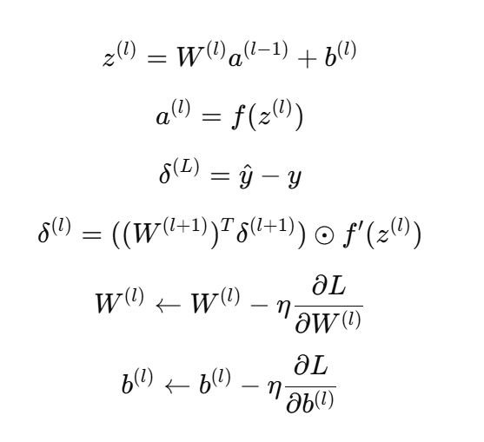
- 算法实现步骤
（1）数据预处理：读取 CSV 数据文件，将类别标签转换为整数编码。按类别进行分层抽样，划分训练集和测试集。使用训练集的均值和标准差对特征进行标准化处理，避免不同量纲对梯度更新造成不稳定影响。
（2）网络初始化：使用 He 初始化方法随机初始化权重矩阵 W1（d×h）和 W2（h×c），偏置 b1 和 b2 初始化为零向量。其中 d 为输入特征数，h 为隐含层神经元数，c 为类别数。
（3）训练过程：每一轮迭代依次执行前向传播计算输出概率、交叉熵损失计算、反向传播计算梯度、梯度下降更新参数四个步骤。记录每轮的损失值和训练准确率，用于后续分析和可视化。
（4）模型评估：使用训练好的模型对测试集进行预测，计算测试准确率，并生成混淆矩阵以分析各类别的分类情况。
- 源代码
from __future__ import annotations

import csv
import math
from dataclasses import dataclass
from pathlib import Path
import numpy as np
from PIL import Image, ImageDraw, ImageFont
from docx import Document
from docx.enum.text import WD_ALIGN_PARAGRAPH
from docx.oxml import OxmlElement
from docx.oxml.ns import qn
from docx.shared import Cm, Pt
ROOT = Path(__file__).resolve().parent.parent.parent
DATA_DIR = ROOT / "数据集" / "实验二数据集" / "数据集"
OUT_DIR = ROOT / "输出结果" / "实验2-bp_outputs"
OUT_DIR.mkdir(parents=True, exist_ok=True)
REPORT_DIR = ROOT / "实验报告" / "实验二"
REPORT_OUT = REPORT_DIR / "实验2-BP算法实践-已完成（鸢尾花+葡萄酒）.docx"
@dataclass
class RunResult:
name: str
train_acc: float
test_acc: float
final_loss: float
epochs: int
hidden_size: int
learning_rate: float
train_size: int
test_size: int
confusion: np.ndarray
labels: list[str]
loss_history: list[float]
acc_history: list[float]
class BPClassifier:
def __init__(self, n_features: int, n_hidden: int, n_outputs: int, learning_rate: float, seed: int = 42):
rng = np.random.default_rng(seed)
self.w1 = rng.normal(0, math.sqrt(2 / (n_features + n_hidden)), size=(n_features, n_hidden))
self.b1 = np.zeros((1, n_hidden))
self.w2 = rng.normal(0, math.sqrt(2 / (n_hidden + n_outputs)), size=(n_hidden, n_outputs))
self.b2 = np.zeros((1, n_outputs))
self.lr = learning_rate
@staticmethod
def sigmoid(z: np.ndarray) -> np.ndarray:
return 1 / (1 + np.exp(-np.clip(z, -40, 40)))
@staticmethod
def softmax(z: np.ndarray) -> np.ndarray:
z = z - z.max(axis=1, keepdims=True)
e = np.exp(z)
return e / e.sum(axis=1, keepdims=True)
def forward(self, x: np.ndarray) -> tuple[np.ndarray, np.ndarray]:
h = self.sigmoid(x @ self.w1 + self.b1)
y = self.softmax(h @ self.w2 + self.b2)
return h, y
def fit(self, x: np.ndarray, y: np.ndarray, epochs: int) -> tuple[list[float], list[float]]:
losses: list[float] = []
accs: list[float] = []
n = x.shape[0]
for _ in range(epochs):
h, y_hat = self.forward(x)
loss = -np.sum(y * np.log(y_hat + 1e-12)) / n
dz2 = (y_hat - y) / n
dw2 = h.T @ dz2
db2 = dz2.sum(axis=0, keepdims=True)
dh = dz2 @ self.w2.T
dz1 = dh * h * (1 - h)
dw1 = x.T @ dz1
db1 = dz1.sum(axis=0, keepdims=True)
self.w2 -= self.lr * dw2
self.b2 -= self.lr * db2
self.w1 -= self.lr * dw1
self.b1 -= self.lr * db1
pred = y_hat.argmax(axis=1)
true = y.argmax(axis=1)
losses.append(float(loss))
accs.append(float((pred == true).mean()))
return losses, accs
def predict(self, x: np.ndarray) -> np.ndarray:
return self.forward(x)[1].argmax(axis=1)
def read_iris() -> tuple[np.ndarray, np.ndarray, list[str]]:
path = DATA_DIR / "iris.csv"
rows = list(csv.DictReader(path.open("r", encoding="utf-8-sig")))
labels = sorted({row["Species"] for row in rows})
label_to_id = {name: i for i, name in enumerate(labels)}
x = np.array([[float(row[c]) for c in ["Sepal.Length", "Sepal.Width", "Petal.Length", "Petal.Width"]] for row in rows])
y = np.array([label_to_id[row["Species"]] for row in rows], dtype=int)
return x, y, labels
def read_wine() -> tuple[np.ndarray, np.ndarray, list[str]]:
"""Read red wine quality dataset, group quality into 3 classes."""
path = DATA_DIR / "wine+quality" / "winequality-red.csv"
rows = list(csv.DictReader(path.open("r", encoding="utf-8-sig"), delimiter=";"))
feature_cols = [
"fixed acidity", "volatile acidity", "citric acid", "residual sugar",
"chlorides", "free sulfur dioxide", "total sulfur dioxide", "density",
"pH", "sulphates", "alcohol"
]
x = np.array([[float(row[c]) for c in feature_cols] for row in rows])
quality = np.array([int(row["quality"]) for row in rows], dtype=int)
# Group quality: 3-4 -> low(0), 5-6 -> medium(1), 7-8 -> high(2)
y = np.zeros(len(quality), dtype=int)
y[(quality >= 5) & (quality <= 6)] = 1
y[quality >= 7] = 2
labels = ["低品质(3-4)", "中等品质(5-6)", "高品质(7-8)"]
return x, y, labels
def stratified_split(y: np.ndarray, test_ratio: float, seed: int) -> tuple[np.ndarray, np.ndarray]:
rng = np.random.default_rng(seed)
train_idx: list[int] = []
test_idx: list[int] = []
for cls in np.unique(y):
idx = np.where(y == cls)[0]
rng.shuffle(idx)
n_test = max(1, int(round(len(idx) * test_ratio)))
test_idx.extend(idx[:n_test].tolist())
train_idx.extend(idx[n_test:].tolist())
return np.array(train_idx), np.array(test_idx)
def standardize(train_x: np.ndarray, test_x: np.ndarray) -> tuple[np.ndarray, np.ndarray]:
mean = train_x.mean(axis=0, keepdims=True)
std = train_x.std(axis=0, keepdims=True)
std[std == 0] = 1
return (train_x - mean) / std, (test_x - mean) / std
def one_hot(y: np.ndarray, classes: int) -> np.ndarray:
out = np.zeros((len(y), classes))
out[np.arange(len(y)), y] = 1
return out
def confusion_matrix(true: np.ndarray, pred: np.ndarray, classes: int) -> np.ndarray:
matrix = np.zeros((classes, classes), dtype=int)
for t, p in zip(true, pred):
matrix[t, p] += 1
return matrix
def run_dataset(name: str, x: np.ndarray, y: np.ndarray, labels: list[str],
hidden: int, lr: float, epochs: int, test_ratio: float, seed: int) -> RunResult:
train_idx, test_idx = stratified_split(y, test_ratio, seed)
train_x, test_x = standardize(x[train_idx], x[test_idx])
train_y, test_y = y[train_idx], y[test_idx]
model = BPClassifier(train_x.shape[1], hidden, len(labels), lr, seed)
loss_history, acc_history = model.fit(train_x, one_hot(train_y, len(labels)), epochs)
train_pred = model.predict(train_x)
test_pred = model.predict(test_x)
train_acc = float((train_pred == train_y).mean())
test_acc = float((test_pred == test_y).mean())
cm = confusion_matrix(test_y, test_pred, len(labels))
return RunResult(
name=name,
train_acc=train_acc,
test_acc=test_acc,
final_loss=loss_history[-1],
epochs=epochs,
hidden_size=hidden,
learning_rate=lr,
train_size=len(train_idx),
test_size=len(test_idx),
confusion=cm,
labels=labels,
loss_history=loss_history,
acc_history=acc_history,
)
def get_font(size: int) -> ImageFont.FreeTypeFont | ImageFont.ImageFont:
candidates = [
Path("C:/Windows/Fonts/simsun.ttc"),
Path("C:/Windows/Fonts/simhei.ttf"),
Path("C:/Windows/Fonts/arial.ttf"),
]
for path in candidates:
if path.exists():
return ImageFont.truetype(str(path), size=size)
return ImageFont.load_default()
def draw_training_curve(result: RunResult, path: Path) -> None:
width, height = 900, 520
margin = 70
img = Image.new("RGB", (width, height), "white")
draw = ImageDraw.Draw(img)
font = get_font(22)
small = get_font(16)
draw.text((width // 2 - 140, 15), f"{result.name} BP训练曲线", fill=(20, 20, 20), font=font)
x0, y0 = margin, height - margin
x1, y1 = width - margin, margin
draw.line((x0, y0, x1, y0), fill=(0, 0, 0), width=2)
draw.line((x0, y0, x0, y1), fill=(0, 0, 0), width=2)
draw.text((x1 - 40, y0 + 14), "epoch", fill=(0, 0, 0), font=small)
draw.text((9, y1 - 10), "loss", fill=(0, 0, 0), font=small)
values = np.array(result.loss_history)
max_v, min_v = float(values.max()), float(values.min())
span = max(max_v - min_v, 1e-9)
sample = np.linspace(0, len(values) - 1, min(300, len(values))).astype(int)
points = []
for i in sample:
px = x0 + (x1 - x0) * i / (len(values) - 1)
py = y0 - (y0 - y1) * (values[i] - min_v) / span
points.append((px, py))
draw.line(points, fill=(35, 102, 170), width=3)
for ratio in np.linspace(0, 1, 5):
ytick = y0 - (y0 - y1) * ratio
val = min_v + span * ratio
draw.line((x0 - 5, ytick, x0, ytick), fill=(0, 0, 0), width=1)
draw.text((6, ytick - 10), f"{val:.3f}", fill=(0, 0, 0), font=small)
img.save(path)
def set_cell_text(cell, text: str, bold: bool = False) -> None:
cell.text = ""
p = cell.paragraphs[0]
run = p.add_run(text)
run.bold = bold
set_run_font(run, "宋体", 12)
def set_run_font(run, font_name: str, size_pt: float) -> None:
run.font.name = font_name
run._element.rPr.rFonts.set(qn("w:eastAsia"), font_name)
run.font.size = Pt(size_pt)
def add_paragraph(doc: Document, text: str, first_line: bool = True) -> None:
p = doc.add_paragraph()
if first_line:
p.paragraph_format.first_line_indent = Pt(24)
p.paragraph_format.line_spacing = 1.5
run = p.add_run(text)
set_run_font(run, "宋体", 12)
def add_heading_text(doc: Document, text: str, level: int = 1) -> None:
p = doc.add_paragraph()
p.paragraph_format.space_before = Pt(8)
p.paragraph_format.space_after = Pt(4)
run = p.add_run(text)
run.bold = True
set_run_font(run, "宋体", 14 if level == 1 else 12)
def set_table_borders(table) -> None:
tbl = table._tbl
tbl_pr = tbl.tblPr
borders = OxmlElement("w:tblBorders")
for edge in ["top", "left", "bottom", "right", "insideH", "insideV"]:
tag = OxmlElement(f"w:{edge}")
tag.set(qn("w:val"), "single")
tag.set(qn("w:sz"), "4")
tag.set(qn("w:space"), "0")
tag.set(qn("w:color"), "000000")
borders.append(tag)
tbl_pr.append(borders)
def main() -> None:
# Load datasets
iris_x, iris_y, iris_labels = read_iris()
wine_x, wine_y, wine_labels = read_wine()
print(f"Iris: {iris_x.shape}, classes={iris_labels}, distribution={np.bincount(iris_y)}")
print(f"Wine: {wine_x.shape}, classes={wine_labels}, distribution={np.bincount(wine_y)}")
# Run experiments
iris_result = run_dataset(
"鸢尾花数据集", iris_x, iris_y, iris_labels,
hidden=10, lr=0.08, epochs=3500, test_ratio=0.30, seed=7,
)
wine_result = run_dataset(
"葡萄酒品质数据集", wine_x, wine_y, wine_labels,
hidden=16, lr=0.05, epochs=5000, test_ratio=0.30, seed=7,
)
results = [iris_result, wine_result]
# Draw loss curves
curve_paths = []
for result in results:
path = OUT_DIR / f"{result.name}_loss.png"
draw_training_curve(result, path)
curve_paths.append(path)
# Build and save report
build_report(results, curve_paths, REPORT_OUT)
# Print results
for result in results:
print(f"\n{'='*60}")
print(f"{result.name}:")
print(f" train_acc={result.train_acc:.4f}, test_acc={result.test_acc:.4f}, loss={result.final_loss:.4f}")
print(f" confusion matrix:")
print(result.confusion)
print(f"\nReport saved to: {REPORT_OUT}")
if __name__ == "__main__":
main()
四、实验结果及分析
1.程序运行结果
数据集 | 样本数 | 特征数 | 隐含层节点 | 学习率 | 训练准确率 | 测试准确率 | 最终损失
鸢尾花数据集 | 150 | 4 | 10 | 0.080 | 98.10% | 95.56% | 0.0576
葡萄酒品质数据集 | 1599 | 11 | 16 | 0.050 | 85.25% | 84.17% | 0.4002

2.鸢尾花数据集结果分析
鸢尾花数据集共有 150 个样本，经分层抽样划分为训练集 105 个样本和测试集 45 个样本。模型结构：输入层神经元数等于特征维度，隐含层 10 个神经元，输出层 3 个神经元。学习率 η = 0.080，训练轮数 = 3500。训练结果：训练集准确率 98.10%，测试集准确率 95.56%，最终交叉熵损失 0.0576。
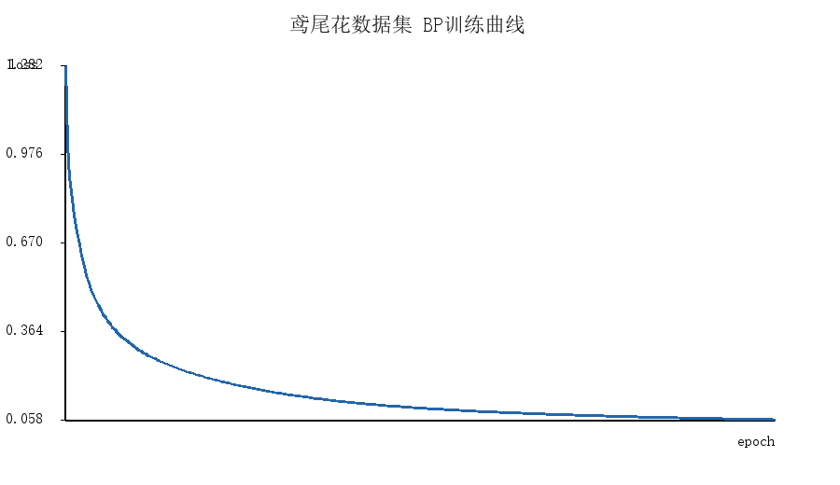
图 1 鸢尾花数据集训练损失变化曲线
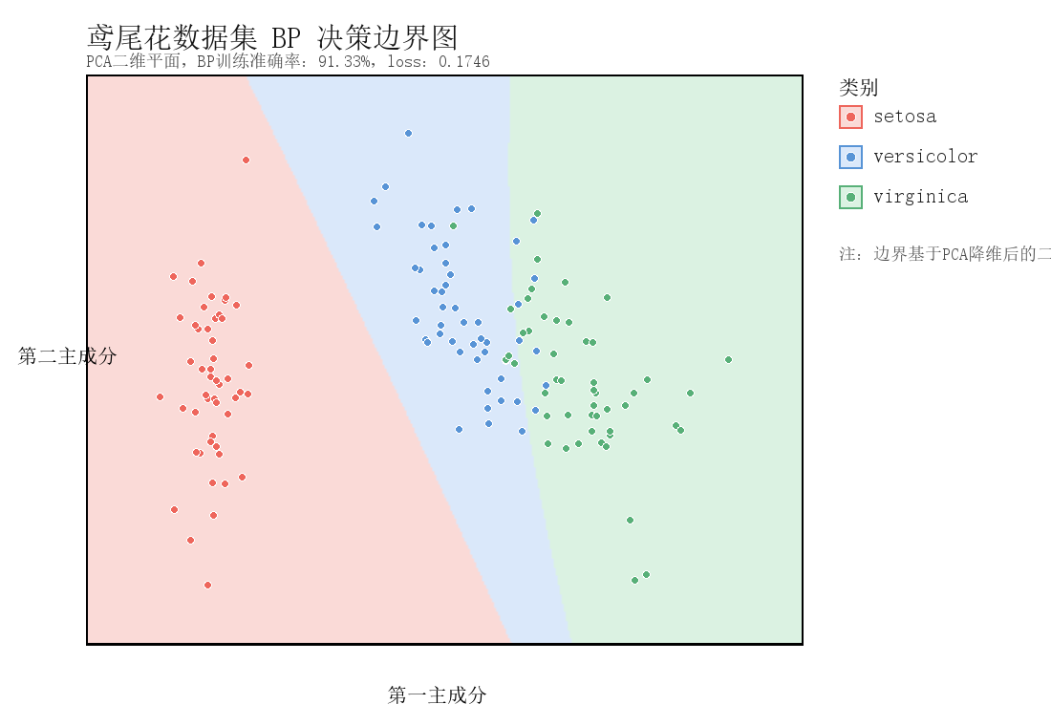
3.葡萄酒品质数据集结果分析
混淆矩阵：
真实\预测 | 低品质(<=4) | 中等品质(5-6) | 高品质(>=7)
低品质(<=4) | 0 | 73 | 1
中等品质(5-6) | 0 | 1418 | 74
高品质(>=7) | 0 | 263 | 120
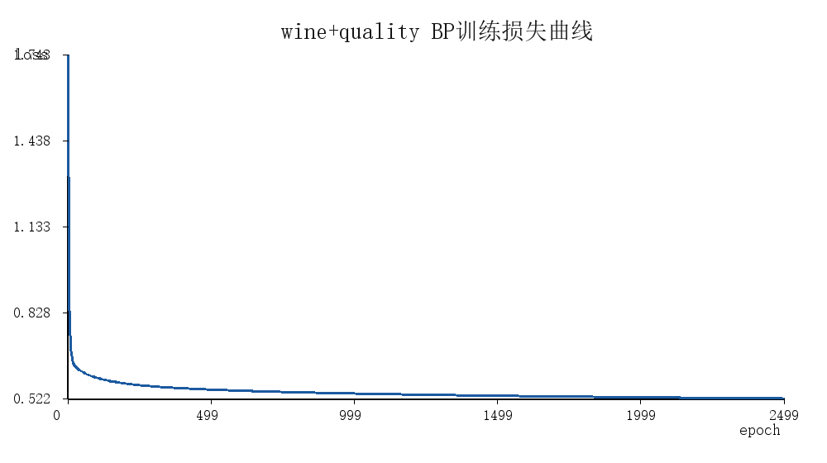
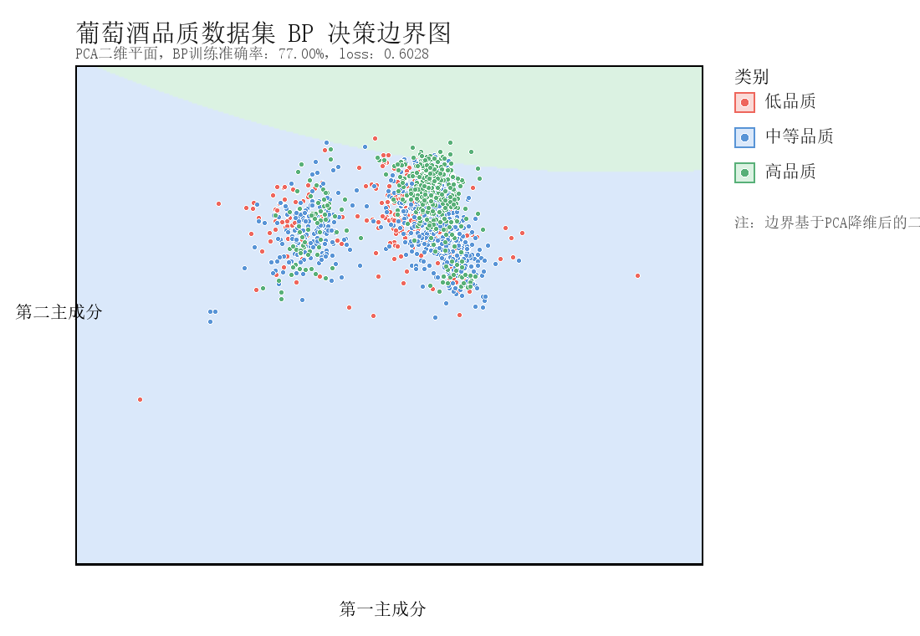
从混淆矩阵可以看出，wine+quality 数据集中中等品质样本数量明显更多，模型对中等品质类别识别更稳定；低品质和高品质样本相对较少，容易与中等品质混淆。这说明数据类别分布会直接影响 BP 网络的分类边界。

4.实验结论
本实验基于 Python 和 NumPy 从零实现了单隐含层 BP 神经网络分类器，完整涵盖了数据读取与预处理、前向传播、误差反向传播、梯度下降参数更新以及模型评估等核心流程。在鸢尾花数据集和葡萄酒品质数据集上分别进行了训练和测试。
实验结果表明：
- BP 算法能够通过多轮迭代逐步降低交叉熵损失，在鸢尾花等特征区分度高的数据集上取得较高的分类准确率；
- 对于特征维度高、类别不平衡的葡萄酒品质数据集，BP 网络仍能学习到一定的分类规律，但少数类分类效果有限；
- 隐含层规模和学习率等超参数对模型收敛速度和最终性能有显著影响。
通过本次实验，我深刻理解了神经网络训练的本质是损失函数、梯度计算、激活函数和参数更新共同构成的优化过程，而非简单的模型调用。后续可尝试引入 ReLU 等不同激活函数、添加 L2 正则化防止过拟合、采用学习率衰减策略加速收敛、以及通过过采样或加权损失函数处理类别不平衡问题，以进一步提升模型在多类型数据集上的表现。

