以 房 养 老 策 略 问 题



课程名称 数学实验
上课班级：108222-001

姓名 | 学院 | 年级 | 专业 | 学号 | 点名册序号
严浩睿 | 计算机学院 | 大二 | 计算机科  学与技术 | 20240395 | 24
吴扬 | 机械与运载  工程学院 | 大二 | 机械电子  工程 | 20242009 | 非本班
陈俊明 | 自动化学院 | 大二 | 自动化 | 20240380 | 非本班

开 课 时 间 2025 至 2026 学年第 二 学期

Problem Chosen
F
2026
MCM/ICM
Summary Sheet
Team Control Number
2614765

AI-Driven Occupational Evolution: To Augment or To Replace?
Summary
With the continuous advancement of technology, Gen-AI capabilities have become increasingly powerful, making it indispensable in both daily life and professional work for a growing number of people. In this paper, to explore how various higher education institutions can better prepare future graduates to navigate this new technology, we selected three representative professions—software engineer, chef, and graphic designer—and divided the overall project into five interconnected tasks.
For Task 1, we integrated AI development impacts to forecast future trends across the three pro-fessions. Through multidimensional analysis, we established a Future Development Forecasting Model(FDFM) as an equation curve simulation. Furthermore, to enhance analytical precision, we re-fined multiple components of the main model into four sub-models: AIM, EIM, PRM, and ODIM. Each sub-model incorporates multiple parameters, which were solved independently, thereby clarifying the overall model structure. Most parameters for the aforementioned models were set through literature review and analysis of academic papers.
For Task 2, we incorporated multiple parameters from Task 1 into a newly developed Enrollment Adjustment Model(EAM). Based on AI’s assessment of both gains and risks for the industry, we created a foundational model to generate predictive analysis and recommendations for educational in-stitutions’ enrollment policies.Through calculations, we determined that the enrollment expansion rates should be 11.58%, 2.53% and 7.64%, respectively.
For Task 3, we focused on setting the proportion of AI coursework to enhance graduates’ competi-tiveness. Accordingly, we established a corresponding Competitiveness Scoring System, categorizing courses into three distinct groups. For each category, we developed a separate sub-model evaluating three different dimensions: Market Fit, Personal AI Eﬀiciency, and Risk Resilience. This approach yielded overall competitiveness levels of 1.192, 0.567, and 1.252 respectively.
For Task 4, when educational institutions undertake policy reforms, they must consider not only graduate competitiveness but also the impact of multiple dimensions. Building upon the competitive-ness framework established in Task 3, we have introduced three additional evaluation dimensions encompassing diverse educational needs. This aims to objectively determine the weighting of various educational dimensions to better assess and refine teaching policies. To account for the inevitable in-terdependencies between dimensions, we have incorporated correlation analysis to ensure the relative scientific validity of the weightings. validity of the weightings.
For Task 5, when confronted with multiple models, I selected one representative model for Sensi-tivity Analysis to assess the reasonableness of parameter settings. Furthermore, regarding the various recommendations previously proposed based on the model, I also discussed the generalizability of these conclusions to determine their applicability and reliability.
Finally, we summarize the model results and provide a memo. We hope that the model constructed in this paper will offer new approaches for various higher education institutions to better assist future graduates in adapting to this new technology.
Keywords: Gen-AI, FDFM, EAM, multidimensional analysis, three additional evaluation dimensions

Contents

- Introduction 3
  - Problem Background 3
  - Restatement of the Problem 3
  - Our Work 4
- Assumptions 4
- Notations 5
- Future Development Forecasting Model (FDFM) 6
  - Automation Index Model 7
    - Model Establishment 7
    - Standardization of AI Technology Capability 7
    - Solving for Other Variables and Factors 9
  - Enhanced Index Model 9
    - Model Establishment 9
    - Human Expert Competency Benchmark and Diminishing Returns Index 10
    - Solving the Enhanced Potential Coefficient 10
  - Penetration Rate Model 10
    - Model Parameter Assumptions 11
  - Occupational Demand Index Model 12
    - Variable Descriptions and Standardization 12
    - Model Principles and Construction 12
  - Predictions 13
- Enrollment Adjustment Model (EAM) 13
  - Background 13
  - Analysis and Development 14
  - Model Calculation Results and Comparison 14
  - Recommendation 14
- Employment Competitiveness Analysis Model (ECAM) 15
  - Analysis and Establishment of the Model Principle 15
  - Interpretation of Variables in the Model 15
  - Data Processing and Model Computation 17
- Adjustment of the ECAM Based on Multidimensional Analysis 17
  - Construct a decision matrix 18
  - Correlation Analysis 19
  - Model Improvement Calculation 19
- Sensitivity Analysis 19
- Strengths and Weaknesses 20
  - Strengths 20
  - Weaknesses 21
- Conclusion 21
Memo 22
References 23
Report on Use of AI 24

Introduction

Problem Background
With the continuous advancement and maturation of AI technology, productivity has seen signif-icant gains across an increasing number of fields through AI applications. Gen-AI, in particular, has seen widespread adoption—evolving from low-capacity tools exclusive to early adopters into a power-ful, ubiquitous resource embedded in daily life. According to estimates from data analytics firms, the overall usage rate of Gen-AI in the U.S. workplace has surged from 8% to 28% today[1].
However, research indicates that Gen-AI may profoundly reshape future work patterns over the long term: in certain sectors, it could replace human labor or substantially reduce workforce demands, while other fields may experience minimal disruption or even achieve scaled expansion. Therefore, we have constructed analytical and decision models based on data, aiming to provide precise fitting calcula-tions to assist various higher education institutions in preparing future graduates to better navigate this emerging technology.
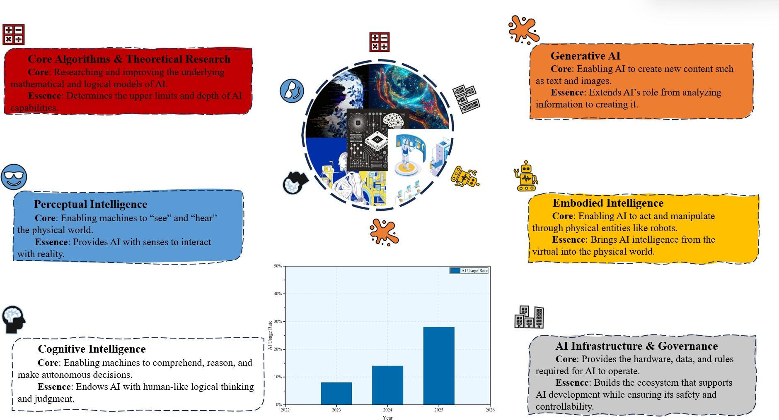

Figure 1: Background

Restatement of the Problem
Considering the background, we need to solve the following problems:
- Problem 1: Select three representative occupations from STEM careers, trade careers, and arts careers as research subjects.
- Problem 2: Based on current AI development data, how should a data-driven model be con-structed to explore the future development trends of the selected occupations?
- Problem 3: Based on the model analysis, should educational institutions expand or reduce the scale of relevant training programs?

- Problem 4: Based on inferences from the mathematical model results, what recommendations should be provided to enable educational institutions to maximize graduates’ employability com-petitiveness?
- Problem 5: How would our model and recommendations adjust under multidimensional analy-sis?

Our Work
In order to avoid complicated descriptions, intuitively reflect our work process, the flowchart is shown in Figure 2.
First, we selected three representative professions: software engineer, chef, and graphic designer. Next, we constructed three models, FDFM, incorporates four sub-models to measure the rate of change in industry scale under the development of Gen-AI technology, serving to explore future trends for three occupations.
The second model, EAM, is grounded in FDFM and incorporates a decision coefficient to determine whether to expand enrollment.
The third model, ECAM, analyzes the sum of weights across various dimensions to estimate stu-dents’ employment competitiveness. Finally, we conduct multidimensional analysis and refine the third model along with our recommendations.
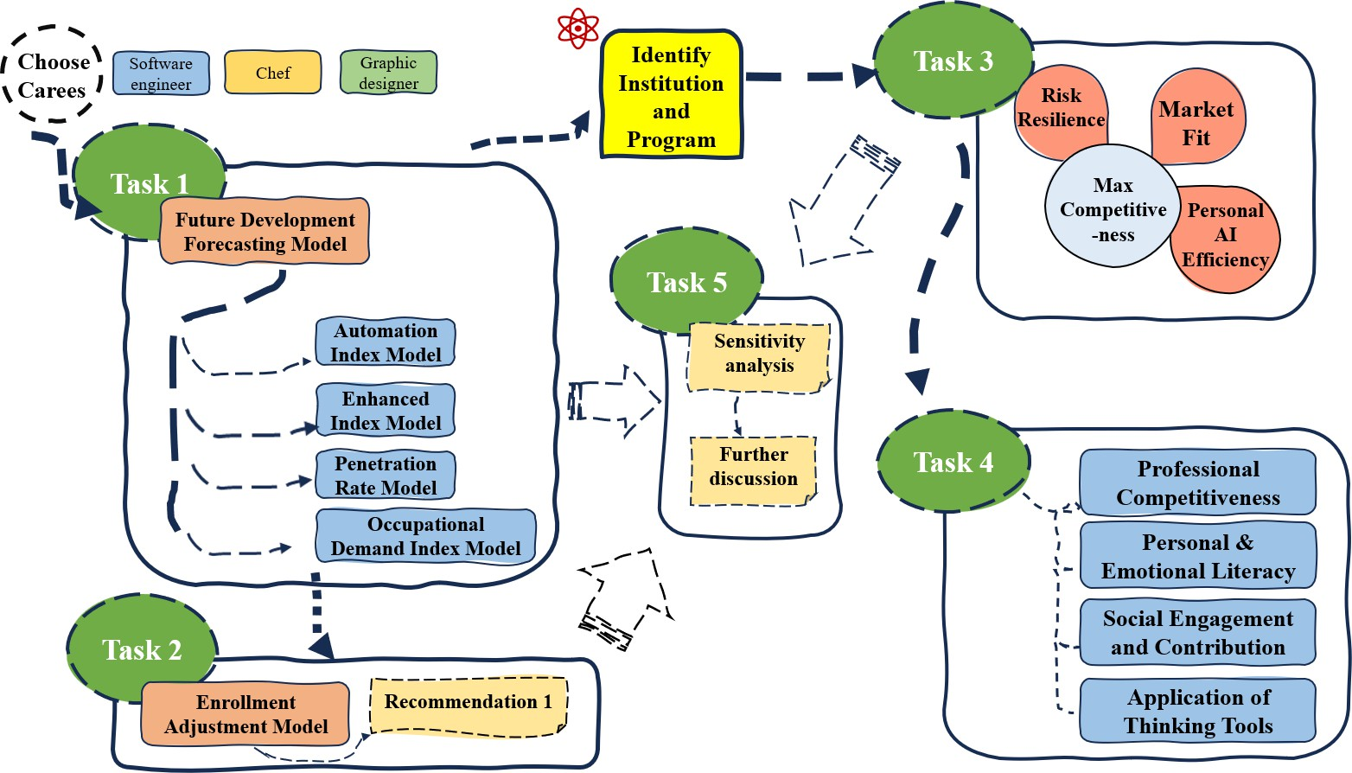

Assumptions
Figure 2: Flowchart of our work

To simplify the given problems, we make the following basic assumptions:
- The occupations we selected and the data we collected are accurate and representative.
- The relevant parameters partially estimated subjectively by us align with objective facts.

- Data from related industries can be approximated as data from the selected representative occu-pations, facilitating calculation and analysis.
- AI development will not experience major disruptive events, such as low-probability scenarios like a technological explosion.

Notations

Table 1: Notations used in this paper

Symbol Description
FDFM Future Development Forecasting Model EAM Enrollment Adjustment Model
ECAM Employment Competitiveness Analysis Model AIM Automation Index Model
EIM Enhanced Index Model
PRM Penetration Rate Model
ODIM Occupational Demand Index Model MCDA Multi-Criteria Decision Analysis
𝐿 _{𝑗} (𝑡) Parameters describing the employment scale of corresponding occupations
𝐴_{𝑗} (𝑡) The proportion of tasks that can be automated by AI
𝐸_{𝑗} (𝑡) The Multiple by Which AI Enhances Work Efficiency
𝑃_{𝑗} (𝑡) The proportion of AI tools used in the workplace
𝐷_{𝑗} (𝑡) Industry Talent Shortage Index
𝑇 (𝑡) AI Technology Capability Index
𝜔_{𝑗} Technology sensitivity
𝜈_{𝑗} Automation Threshold
𝜎(𝑥) Sigmoid function
𝛼_{𝑗} Occupation-specific elasticity coefficient
𝛽_{𝑗} Occupation-specific elasticity coefficient
𝛾_{𝑗} Occupation-specific elasticity coefficient
𝑚 AI Energy Efficiency Conversion Threshold
𝜆 MMUL Benchmark Accuracy
𝑊 Wage level
𝑉 Job vacancies or employment growth
𝐻 (𝑡) Enrollment Adjustment Index
𝑀 (𝑡) Market Fit
𝑁 (𝑡) Personal AI Efficiency
𝑍 (𝑡) Risk Resistance
Ω The risk resistance factor
𝐶𝑅 Consistency Ratio
𝐶𝐼 Consistency Index
𝑅𝐼 Random Consistency Index

Future Development Forecasting Model (FDFM)
Based on global AI developments in recent years, we have selected several representative indices to measure the relationship between AI and the future of professions. We begin by analyzing the selected indices based on the fundamental principles of the supply-demand equilibrium and substitution-creation framework.
As 𝑇 (𝑡) increases with development, it will drive the quantitative levels of 𝐴_{𝑗} (𝑡) and 𝐸_{𝑗} (𝑡) corre-sponding to specific occupations upward. The rise in 𝐴_{𝑗} (𝑡) and 𝐸_{𝑗} (𝑡) will then promote an increase in 𝑃_{𝑗} (𝑡) within that occupation through the driving mechanism of technology adoption. Ultimately, changes in 𝑃_{𝑗} (𝑡) will further influence 𝐿 _{𝑗} (𝑡), forming a chain reaction effect.
The fundamental relationship of chain reactions is shown in Figure 3:
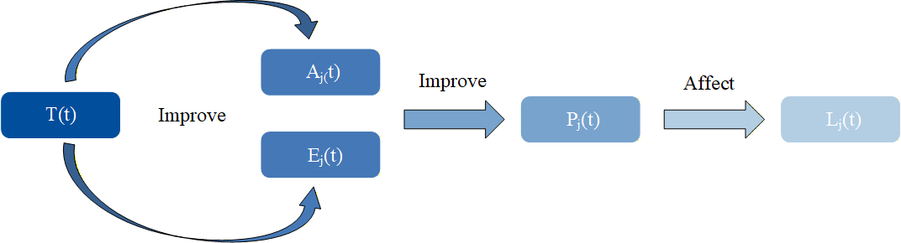
Figure 3: Chain reaction effect Therefore, we make the following differential equation:

𝑑𝐿_{𝑗} (𝑡)
𝑑𝑡
- t: time
= 𝛼_{𝑗}
· [1 − 𝐴_{𝑗}
(𝑡) · 𝑑𝐷𝑗 (𝑡) − 𝛽
𝑑𝑡 ^{𝑗}
]
· 𝐴_{𝑗}
(𝑡) · 𝑃_{𝑗}
(𝑡) · 𝐿 _{𝑗}
(𝑡) + 𝛾_{𝑗}
· 𝐸_{𝑗}
(𝑡) · 𝑃_{𝑗}
(𝑡) · 𝐿 _{𝑗}
(𝑡) (1)

- 𝛼_{𝑗} , 𝛽_{𝑗} , 𝛾_{𝑗} : occupation-specific elasticity coefficients
To better compute various indices in differential equations, we have divided FDFM into four sub-models.

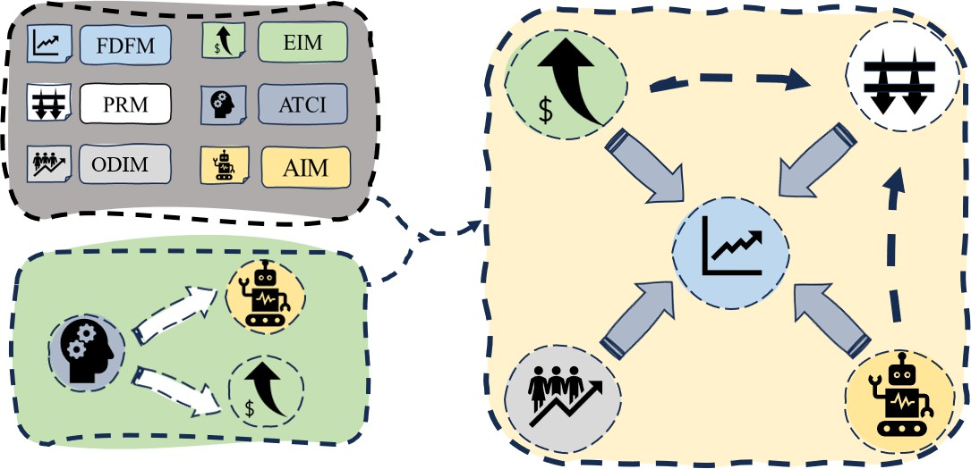

Figure 4: Relationship between the model and sub-models

Automation Index Model

Model Establishment
We define the automation index as the proportion of tasks within an industry that can be automated by AI. Since this index is influenced by technological capability 𝑇 (𝑡) and occupational characteristics, we constructed the AIM framework, which incorporates two variables and three factors:
Table 2: Variable names of SPW model

Variable name | Interpretations
𝐴𝑗,max | Maximum possible automation level for occupation 𝑗
𝑇 (𝑡) | AI Technology Capability Index

Table 3: Factor names of AIM model

Variable name | Interpretations
𝜔_{𝑗} | Maximum possible automation level for occupation 𝑗
𝜈_{𝑗} | Automation Threshold
𝜎(𝑥) | Sigmoid function
Therefore, we present the following formula:
𝐴_{𝑗} (𝑡) = 𝐴_{𝑗,max} · 𝜎 (𝜔_{𝑗} · ln 𝑇 (𝑡) − 𝜈_{𝑗} ) (2)

Standardization of AI Technology Capability
𝑇 (𝑡) represents the level of AI development and its capabilities. Here, we use the benchmark score on MMLU to assess the advancement of AI technology.Taking ChatGPT as an example, we selected

its MMLU benchmark accuracy from 2022 to 2025[2].
Then we fitted a logistic function:

𝜆 =
1

1 + 𝑒−𝑘 (𝑇 (𝑡)−𝑚)

(3)

After determining k, m, and other data, the value of 𝑇 (𝑡) can be calculated. So how should the values of k and m in the function be set? We have reasonably adopted a MCDA approach.
- m: In real-world workflows, professional ”augmentation” does not follow linear growth but in-stead reaches a tipping point where it transitions from ”occasionally usable” to ”fully embeddable in processes.” Setting the threshold between 0.44 and 0.86—and closer to 0.86—accurately re-flects the reality that ”GPT-4 level capabilities become scalable for enhancement.” Therefore, m=0.77 is the most reasonable choice as the ”stable starting point for practical usability.”
- k: The enhancement from GPT-3 to GPT-4 delivers ”rapid but not instantaneous” gains, with diminishing marginal returns evident in the GPT-4.1/GPT-5 phase. Therefore, setting k to 9 is the most reasonable choice.

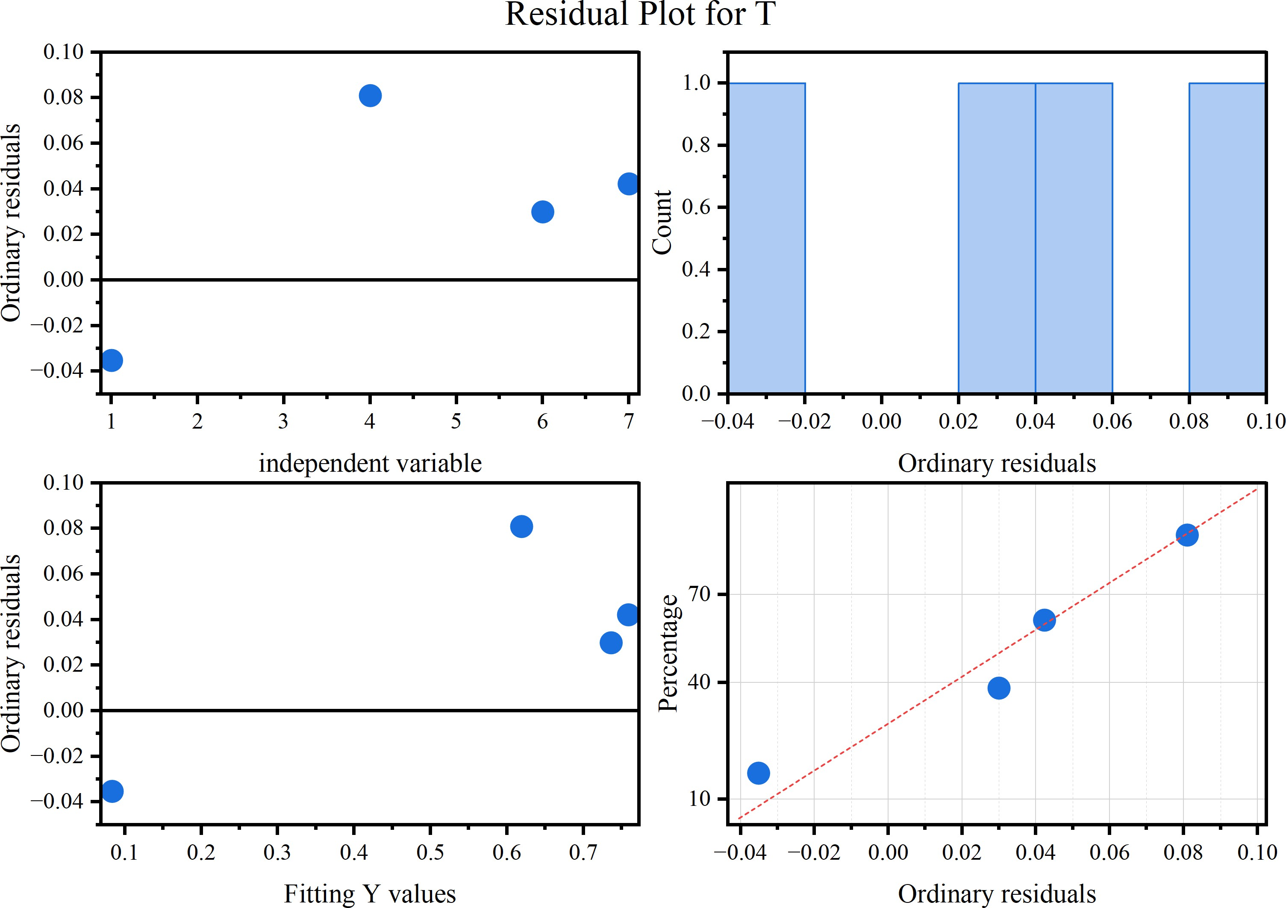
Figure 5: 𝑇 (𝑡) Residual Plot

The reference results for 𝑇 (𝑡) of the ChatGPT model are shown in Table 4:

Table 4: Comparison of 𝑇 (𝑡) values

Model | MMLU | 𝑇 (𝑡)
GPT-3 | 0.439 | 0.048
GPT-4 | 0.864 | 0.700
GPT-4.1 | 0.902 | 0.766
GPT-5 | 0.925 | 0.801

Solving for Other Variables and Factors
For 𝐴_{𝑗,max}, we define this variable as follows: the maximum proportion of tasks that can be auto-mated for this occupation when the technology is sufficiently advanced. The specific definition of 𝜔_{𝑗} is: the rate at which the occupation’s automation index increases under the influence of 𝑇 (𝑡). The spe-cific definition of 𝜈_{𝑗} is: when 𝑇 (𝑡) approaches this value, occupational automation reaches the sigmoid midpoint.
Based on the retrieved data[3], we automatically scored the work content of each occupation ac-cording to specific criteria[4], calculated these three metrics for each occupation, and compiled them into the following Table 5:
Table 5: Variables and Factors in AIM

Occupation | 𝐴𝑗,max | 𝜔_{𝑗} | 𝜈_{𝑗}
Software Engineer | 0.70 | 0.85 | 0.55
Chef | 0.25 | 0.35 | 0.78
Graphic Designer | 0.60 | 0.70 | 0.48

Enhanced Index Model

Model Establishment
As is widely recognized, the advancement of AI has boosted productivity across various industries to varying degrees. Therefore, we established the EIM to measure the impact of AI on productivity enhancement. The EIM incorporates the following three factors as shown in the Table 6:
Table 6: Factor names of EIM model

Variable name | Interpretations
𝜂_{𝑗} | Occupational Enhancement Potential Coefficient
𝑇human | Human Expert Competency Benchmark
𝜌_{𝑗} | Diminishing Returns Index

We then established the following formula:

𝐸_{𝑗} (𝑡) = 1 + 𝜂_{𝑗} · 𝑃_{𝑗} (𝑡) ·

𝑇 (𝑡) ^{𝜌}𝑗
𝑇human
[ ]

(4)

Human Expert Competency Benchmark and Diminishing Returns Index
In this part, we continue to employ the Multi-Criteria Decision Analysis (MCDA) methodology.
      - 𝑇_{human}: We assume that current state-of-the-art AI represents the strongest human level. As
the baseline, we define 𝑇_{human} = 1.0, making 𝑇 (𝑡) relative to the current top-tier capability—

intuitive and readily obtainable.
𝑇human

      - 𝜌_{𝑗} : We categorize work types into creative and decision-making tasks, as well as support and execution tasks. The former involves complex pathways for translating capabilities into tangible outcomes, exhibits rapid diminishing returns, and carries a lower 𝜌_{𝑗} value. The approximate range is:

0.3 < 𝜌_{𝑗} < 0.5 (5)
The latter conversion pathway is direct, exhibits slower diminishing returns, and has a higher
𝜌_{𝑗} value. The approximate range is:

0.6 < 𝜌_{𝑗} < 0.8 (6)

    - Solving the Enhanced Potential Coeﬀicient
The paper evaluates AI’s impact across multiple dimensions for various tasks, yielding the following impact metrics. We directly adopted the score reflecting AI’s speed in completing tasks as our 𝜂_{𝑗} . The corresponding time savings for each score are shown in the Table 7:

score Percentage of time saved

1 0%
2 1-10%
3 11-25%
4 26-50%
5 more than 50%

Table 7: Correlation Between Scores and Time Savings Percentage

The paper assigns an AI task completion speed score of 3.24, corresponding to approximately a 20% improvement in this chart, with a coefficient of 0.2.
Correspondingly, we only need to assign quantitative scores to the tasks of the relevant profession, then convert the resulting scores to derive the actual 𝜂_{𝑗} values.

Penetration Rate Model
The penetration rate refers to the proportion of AI usage within a profession. We provide the fol-lowing formula:

𝑑𝑃_{𝑗} (𝑡)
𝑑𝑡
= [ 𝑝 _{𝑗}
+ 𝑞 _{𝑗}
· 𝑃_{𝑗}
(𝑡)] · [1 − 𝑃_{𝑗}
(𝑡)] · 𝐹_{𝑗} ( 𝐴_{𝑗}
(𝑡), 𝐸_{𝑗}
(𝑡)) (7)

- 𝑝 _{𝑗} : Innovation Coefficient
- 𝑞 _{𝑗} : Imitation Coefficient
This formula employs an improved Bass diffusion model[5], where 𝐹_{𝑗} ( 𝐴, 𝐸) represents the adoption driving force function:

𝐹_{𝑗} ( 𝐴, 𝐸) =
𝜇_{𝑗} · 𝐴 + 𝜈_{𝑗} · (𝐸 − 1)

𝜇_{𝑗} + 𝜈_{𝑗}

(8)

𝜇_{𝑗} represents the weight of automation impact across all occupations, while 𝜈_{𝑗} represents the weight of augmentation impact across all occupations. Here, we set 𝜇_{𝑗} = 𝜈_{𝑗} = 1, meaning automation and augmentation effects exert equal influence on adoption decisions.

Model Parameter Assumptions
Given the difficulty in accurately estimating the innovation coefficient 𝑝 _{𝑗} and imitation coefficient
𝑞 _{𝑗} in this diffusion model from existing data, this paper draws upon existing theories and relevant research[6] to make the following reasonable assumptions:
      - 𝑝 _{𝑗} : Drawing on Rogers’ diffusion of innovations theory[7] and Bass’s model for studying new technologies, the p-values for the three occupational categories were set between 0.02 and 0.05 to reflect the proportion of innovators.
      - 𝑞 _{𝑗} : Based on the intensity of social network contagion effects, the range is set between 0.35 and 0.45, with software engineers having the highest rate and graphic designers the lowest.
The comparison is shown in Figure 6:
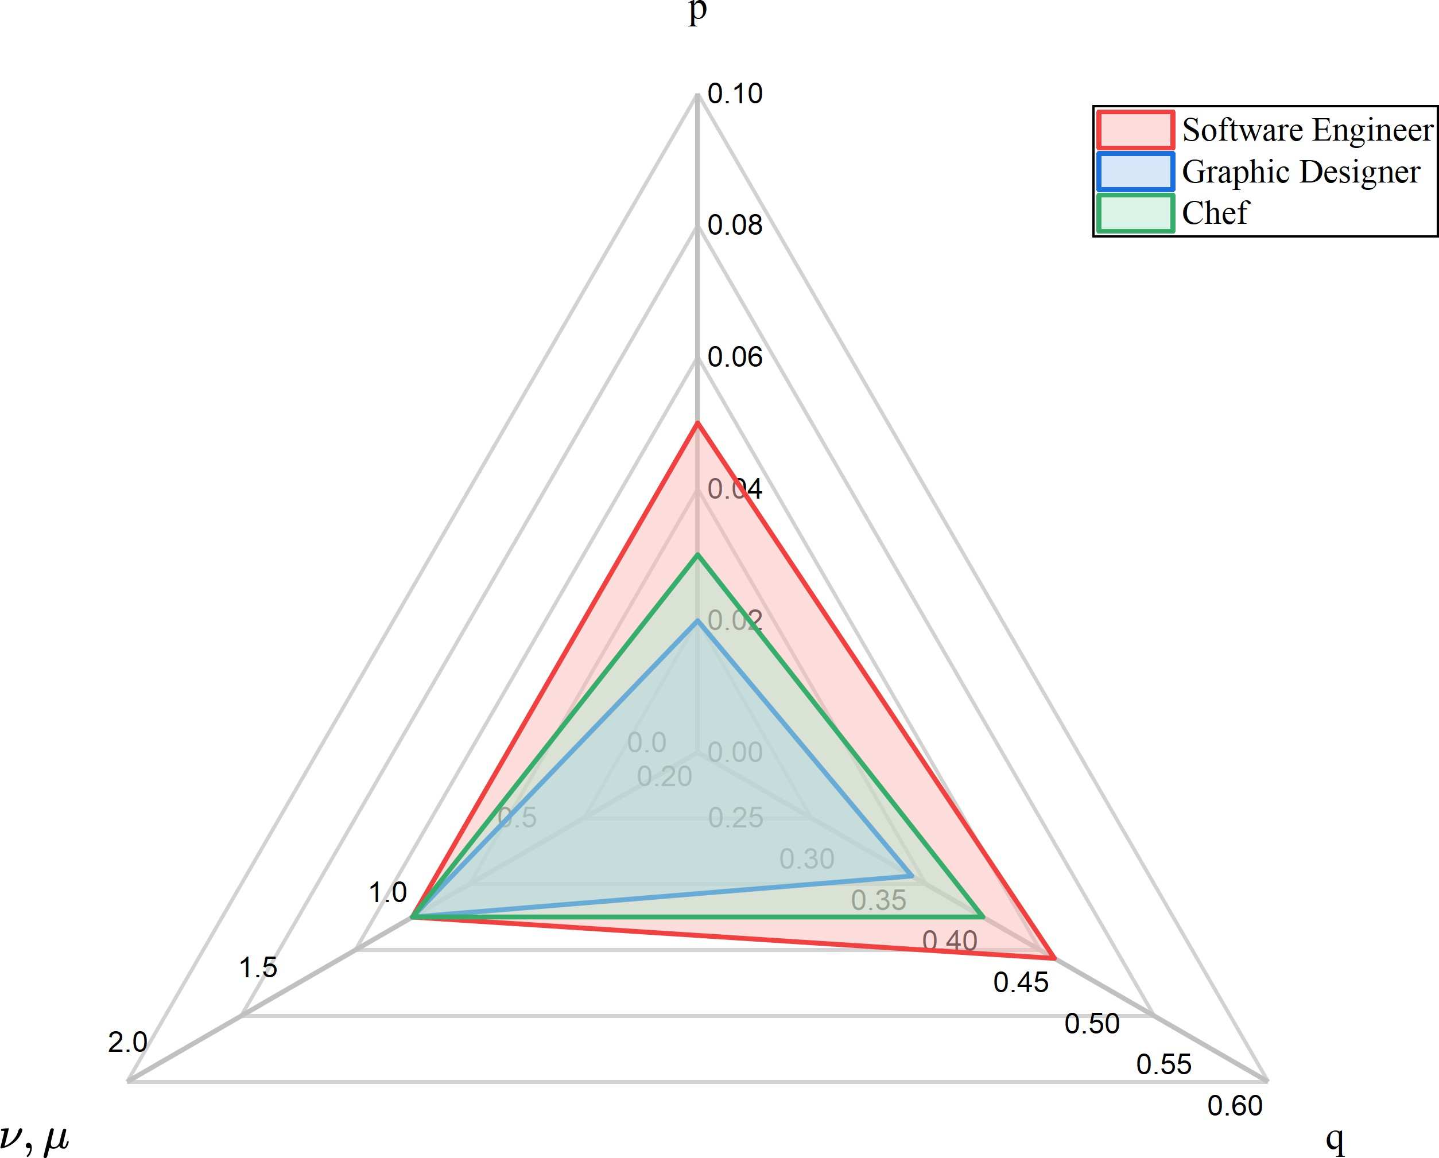
Figure 6: PRM Parameter Comparison Chart

Occupational Demand Index Model

Variable Descriptions and Standardization
In labor economics and occupational demand research, occupational demand is typically regarded as a latent variable that requires approximation through multiple observable indicators.
The two most commonly used categories of indicators are:
- 𝑊: Reflects the labor market’s willingness to pay and the scarcity of that occupation
- 𝑉: Reflects the scale of quantitative demand for that occupation
Next, we need to normalize these variables to eliminate differences in units of measurement. Standardized wage indicators

𝑊˜ 𝑗
𝑊_{𝑗} − min(𝑊)
= max(𝑊) − min(𝑊)

(9)

Standardized Job Vacancy Indicator:

𝑉˜𝑗

𝑉_{𝑗} − min(𝑉)
= max(𝑉) − min(𝑉)

(10)

The visualized standardized data is presented in Figure 7:

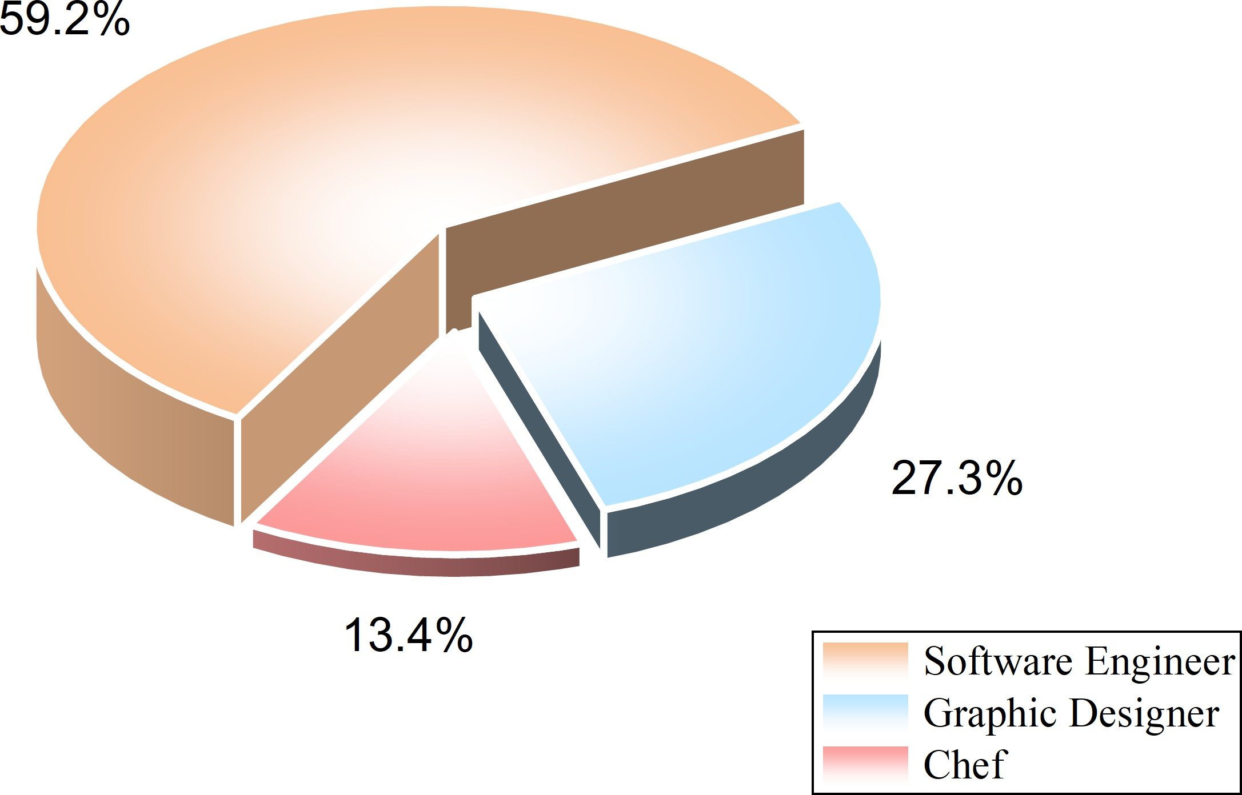
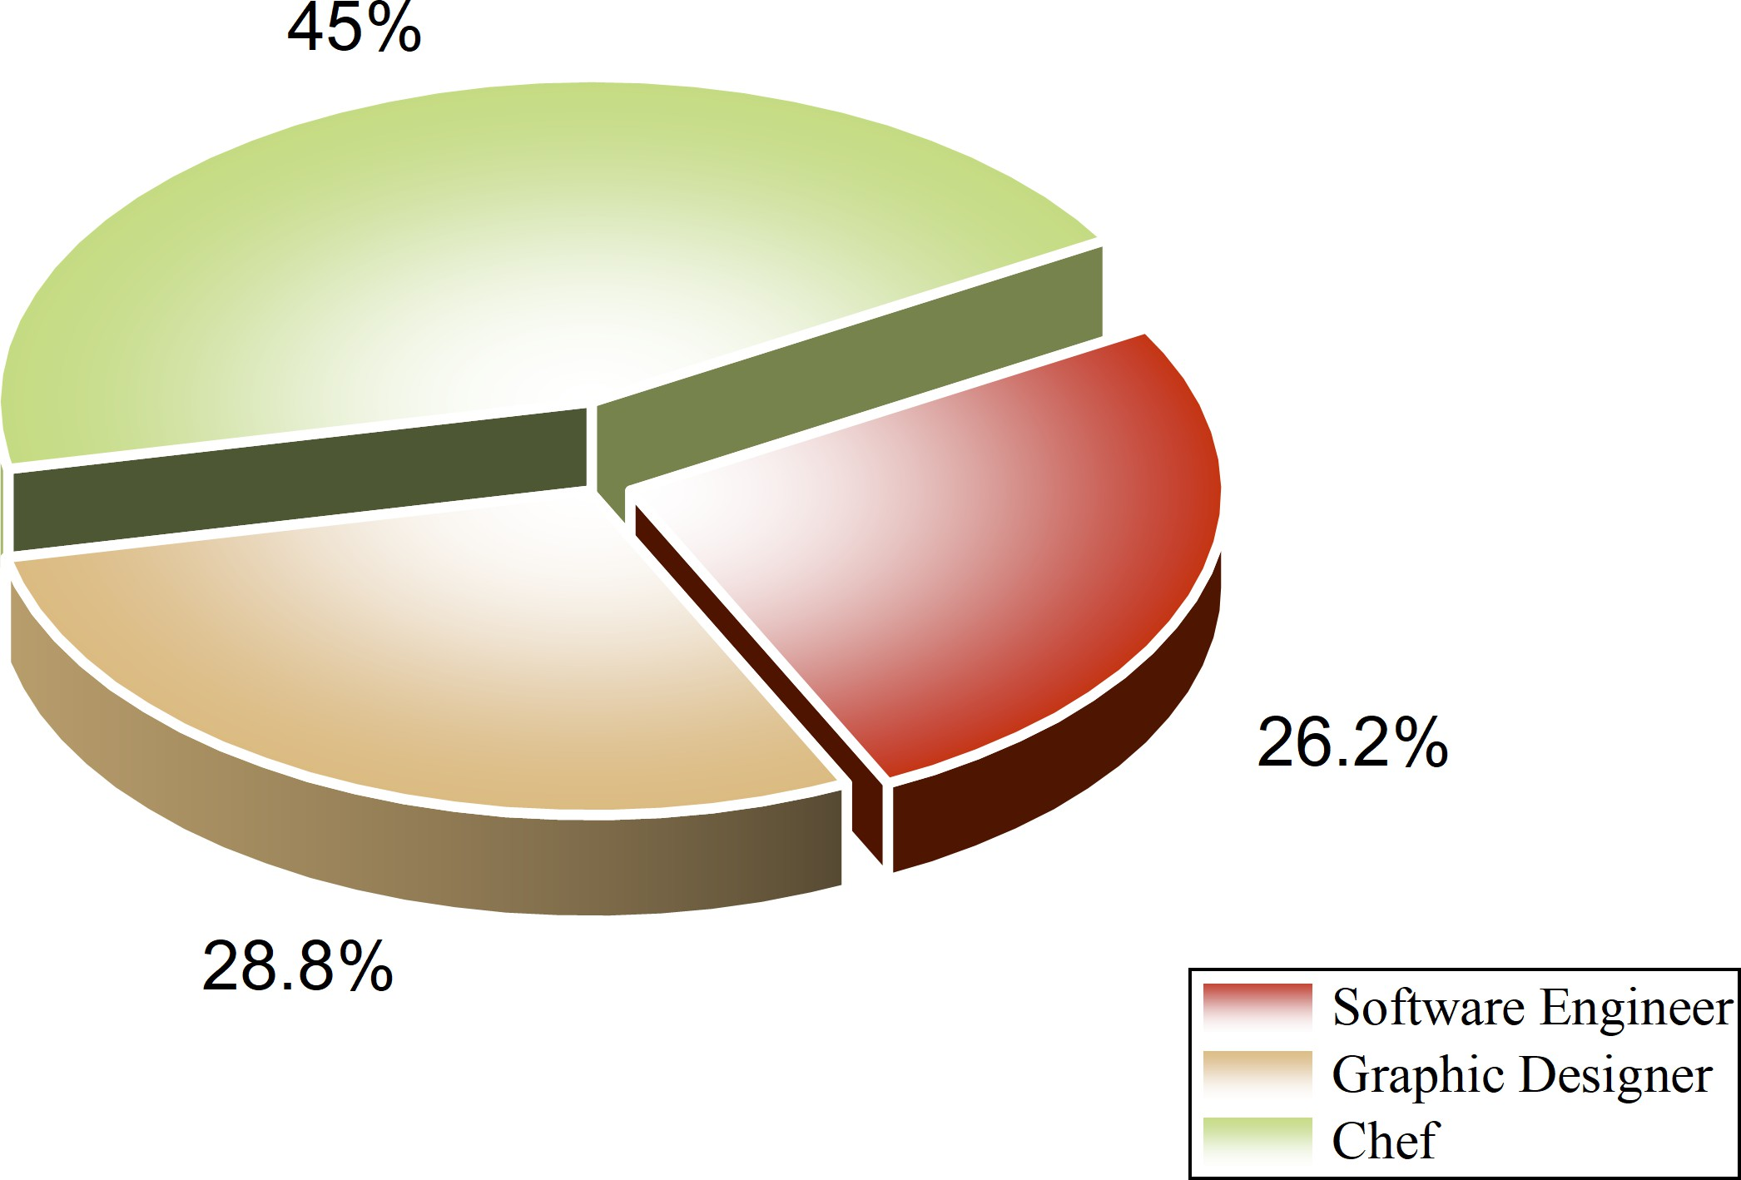

(a) Wage Data Comparison (b) Job Vacancy Data Comparison
Figure 7: Standardized Comparison Chart

Model Principles and Construction
After completing the standardization steps, we can begin constructing the model. The general form for building the occupational demand index is a weighted linear model. We present the following formula:
𝐷_{𝑗} = 𝜃₁ · 𝑊˜ 𝑗 + 𝜃₂ · 𝑉˜𝑗 (11)
- 𝜃₁: The weight of wage indicators

- 𝜃₂: The weight of job vacancy indicators
- 𝜃₁ + 𝜃₂ = 1

Predictions
Based on the established FDFM and its submodel system, once the solution process for all submod-els is completed, the computed exponential terms will be substituted into equation (1), thereby solving this differential equation.
Data fitting results are shown in Figure 8:
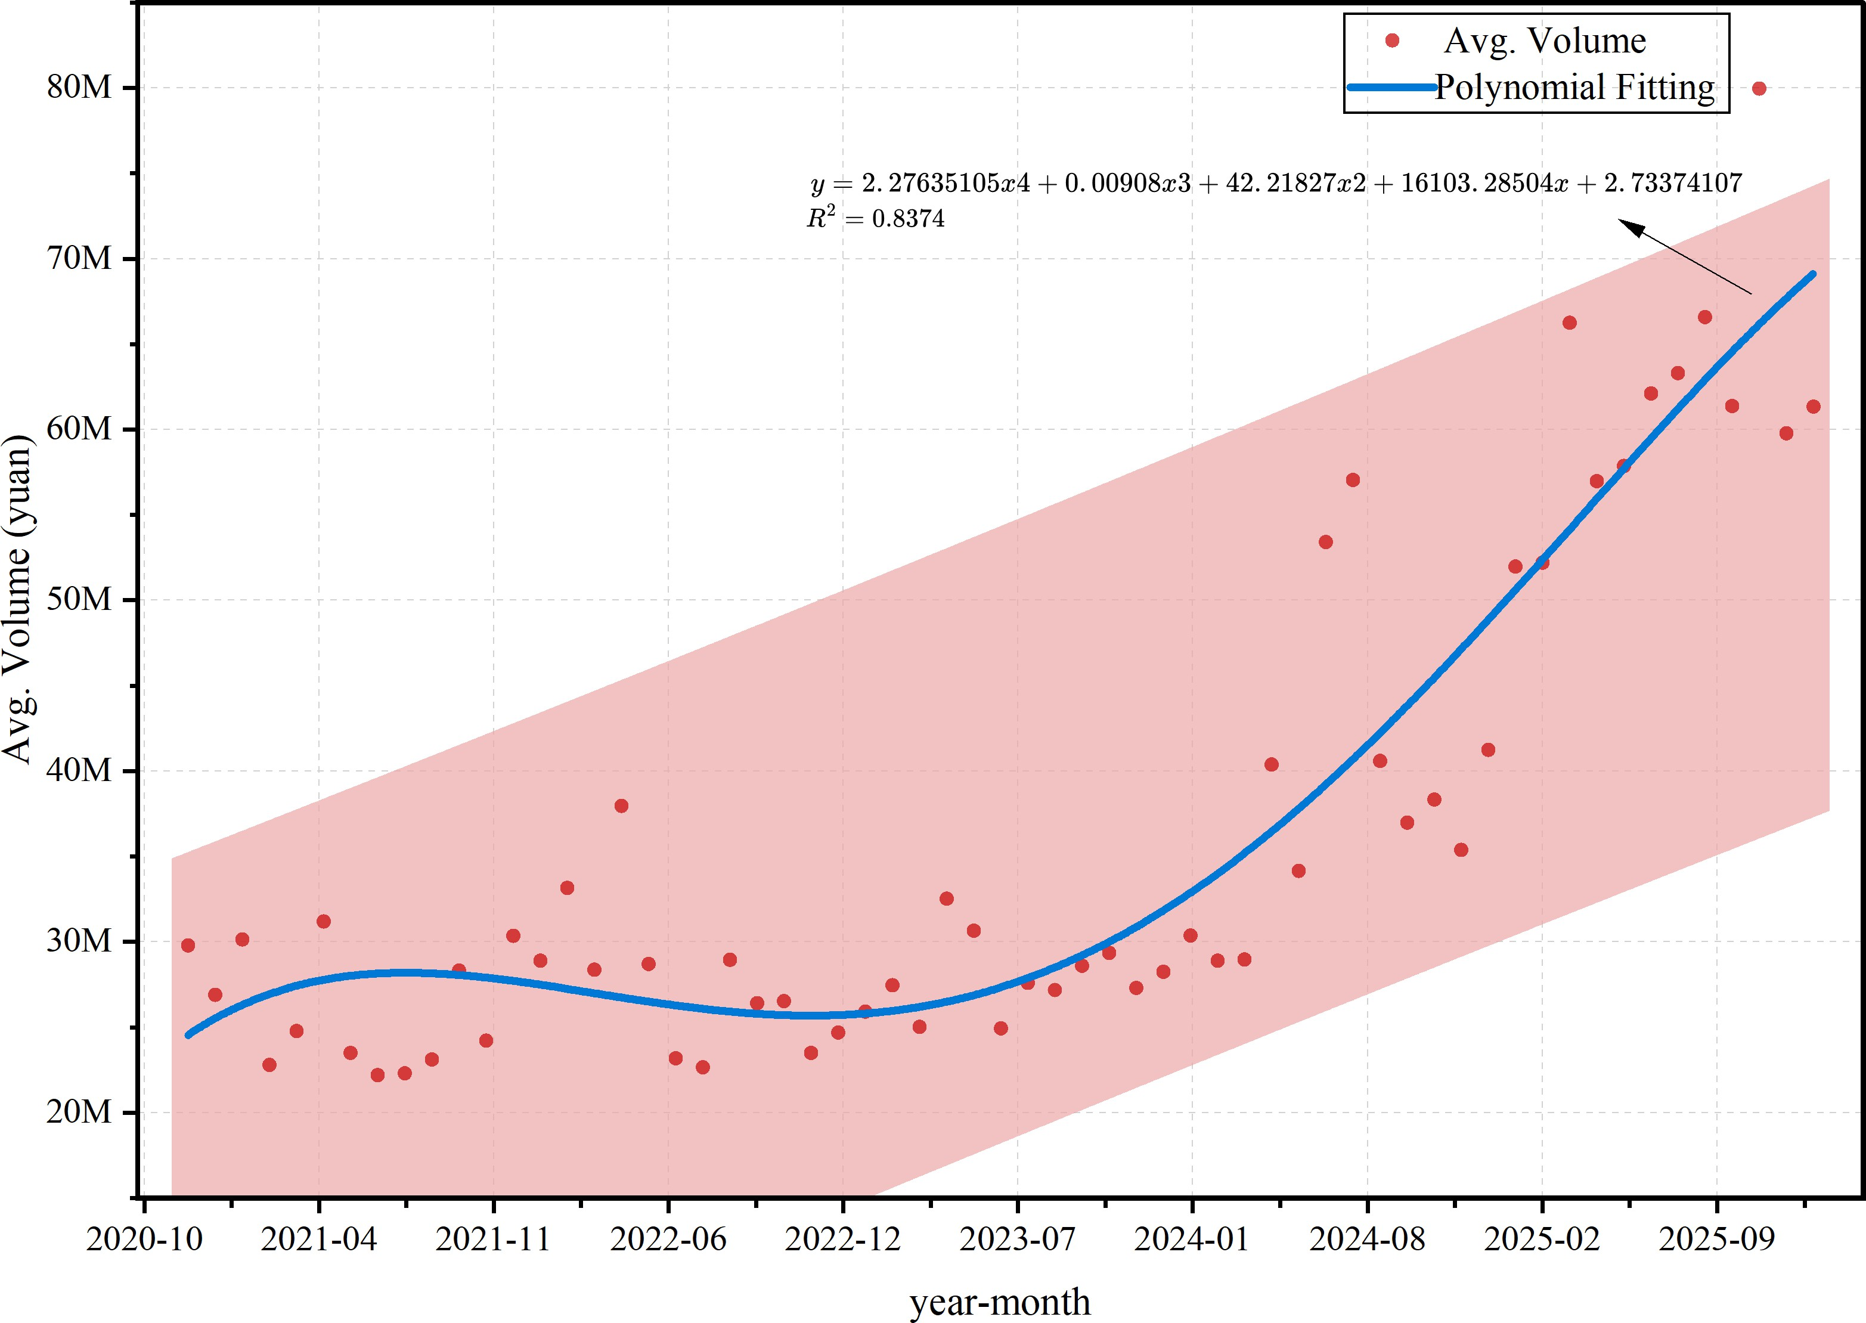
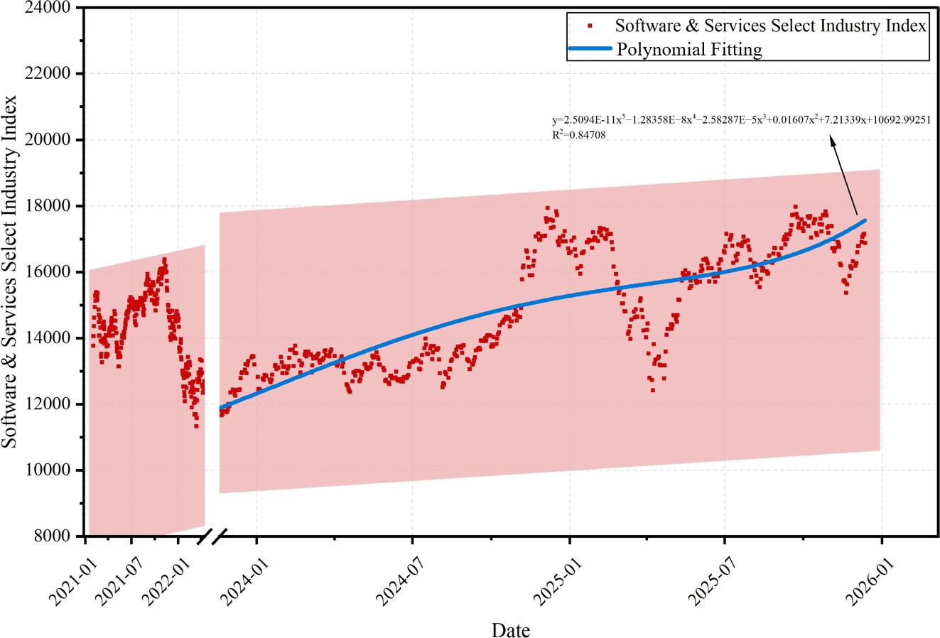
(a) Market average economic scale (b) Industry Index
Figure 8: Scatter Plot and Fitting Curve

Based on the fitting curve, we can conclude that with the continuous advancement of Gen-AI, all three selected professions exhibit an upward development trend.

Enrollment Adjustment Model (EAM)

Background
For the three professions we selected, after discussion and research, we have matched them with specific higher education institutions and study programs:
- Massachusetts Institute of Technology: Bachelor of Science in Computer Science and Engi-neering
- Cordon Bleu International: Diploma in Culinary Management
- Rhode Island School of Design: Bachelor of Fine Arts in Graphic Design
The three professions mentioned above exhibit significant differences in their knowledge structures, skill development pathways, and the ways in which they are impacted by Gen-AI, making them suitable subjects for comparative analysis.

Analysis and Development
Through analysis and fundamental consensus, we understand that project scale and enrollment are nearly inextricably linked. Therefore, when determining expansion or contraction, we can establish a comprehensive model—the enrollment scale adjustment model—based on the inherent growth trends of the current industry and the impact of AI technology.
First, we present the formula for the employment growth rate:

𝑔_{𝐿} (𝑡) =
1
𝐿 _{𝑗} (𝑡)
𝑑𝐿_{𝑗} (𝑡)
𝑑𝑡

(12)

Next, we present the formula for the risk substitution index:

𝑅_{sub}(𝑡) = 𝛽_{𝑗} · 𝐴_{𝑗} (𝑡) · 𝑃_{𝑗} (𝑡) (13)
Then, we present the formula for the enhanced opportunity index:
𝑂_{aug}(𝑡) = 𝛾_{𝑗} · 𝐸_{𝑗} (𝑡) · 𝑃_{𝑗} (𝑡) (14)
Finally, through formulas (12), (13), and (14), we derive the formula for the enrollment adjustment index:
𝐻 (𝑡) = (1 + 𝑔_{𝐿} (𝑡))(1 + 𝐴_{𝑗} (𝑂_{aug}(𝑡) − 𝑅_{sub}(𝑡))) − 1 (15)

Model Calculation Results and Comparison
Based on the above modeling, we can derive the required 𝐻 (𝑡) value. If 𝐻 (𝑡) is greater than 0, enrollment should be expanded; if less than 0, enrollment should be reduced The larger the absolute value of Enrollment Index. The greater the proportion of expansion or reduction required.
The calculated 𝐻 (𝑡) values for each occupation and the comparison results are shown in the Table
8:
Table 8: EAM Calculation Results

Occupation | 𝐻 (𝑡) | Enrollment  Index | Adjustment Strategy
Software Engineer | > 0 | 11.58% | Expand enrollment
Chef | > 0 | 2.53% | Expand enrollment
Graphic Designer | > 0 | 7.64% | Expand enrollment

Recommendation
Against the backdrop of generative AI reshaping the structure of vocational skill demands, rele-vant learning programs should resolutely scale up. The core rationale lies in the fact that while AI technology automates certain occupational tasks, it simultaneously spurs demand for composite skills combining ”AI collaboration capabilities + professional core competencies.” Moreover, significant tal-ent gaps persist in target occupations.

To ensure the effectiveness of this expansion, it is recommended to reconstruct a modular curricu-lum system centered on ”AI tool application + deep professional expertise,” guided by the iterative trends in vocational skills.

Employment Competitiveness Analysis Model (ECAM)

Analysis and Establishment of the Model Principle
Given that different occupations and learning programs necessarily involve significantly different coursework, we broadly categorize AI-related learning programs into three major types:
- Innovation and Development Courses
- AI and Tool Application Courses
- Ethics and Morality Courses
We must assign weights to these three major course categories to maximize graduates’ competi-tiveness.
Therefore, we first need to establish a graduate competitiveness model, with the formula as follows:

𝐾 (𝑡) = 𝑀 (𝑡) + 𝑁 (𝑡) + 𝑍 (𝑡) (16)
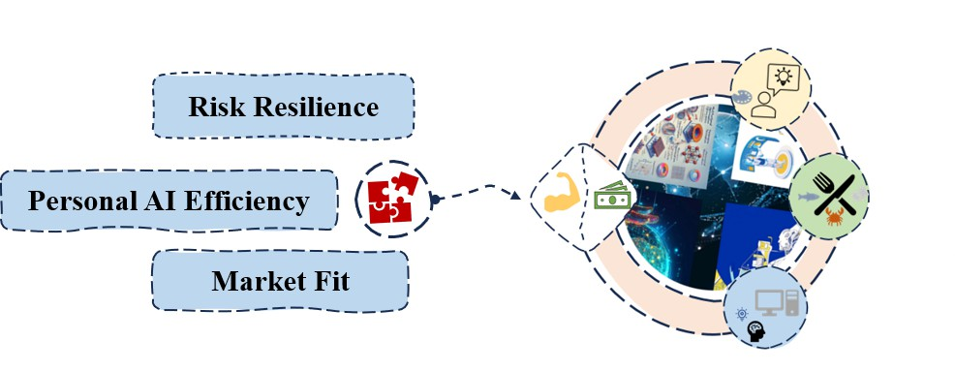
Figure 9: Model Structure Diagram

Interpretation of Variables in the Model
To calculate 𝐾 (𝑡), we need to solve for the three variables in formula (16). For these variables, we employ the following fundamental processing methods:
- 𝑀 (𝑡): This refers to the degree of alignment between course offerings and market demands. When curricula closely match market needs, graduates naturally possess stronger competitive-ness. Here, we conducted a sample survey using the BOSS Zhipin platform[8], collecting 500 job postings per occupation.

We recorded the frequency of keywords related to the three course categories mentioned above within each job description. The resulting keyword frequencies were calculated, and the sum of each keyword’s frequency multiplied by its weight represents the market fit score for graduates in that occupation.
The keyword frequency collection results are shown in Figure 10:
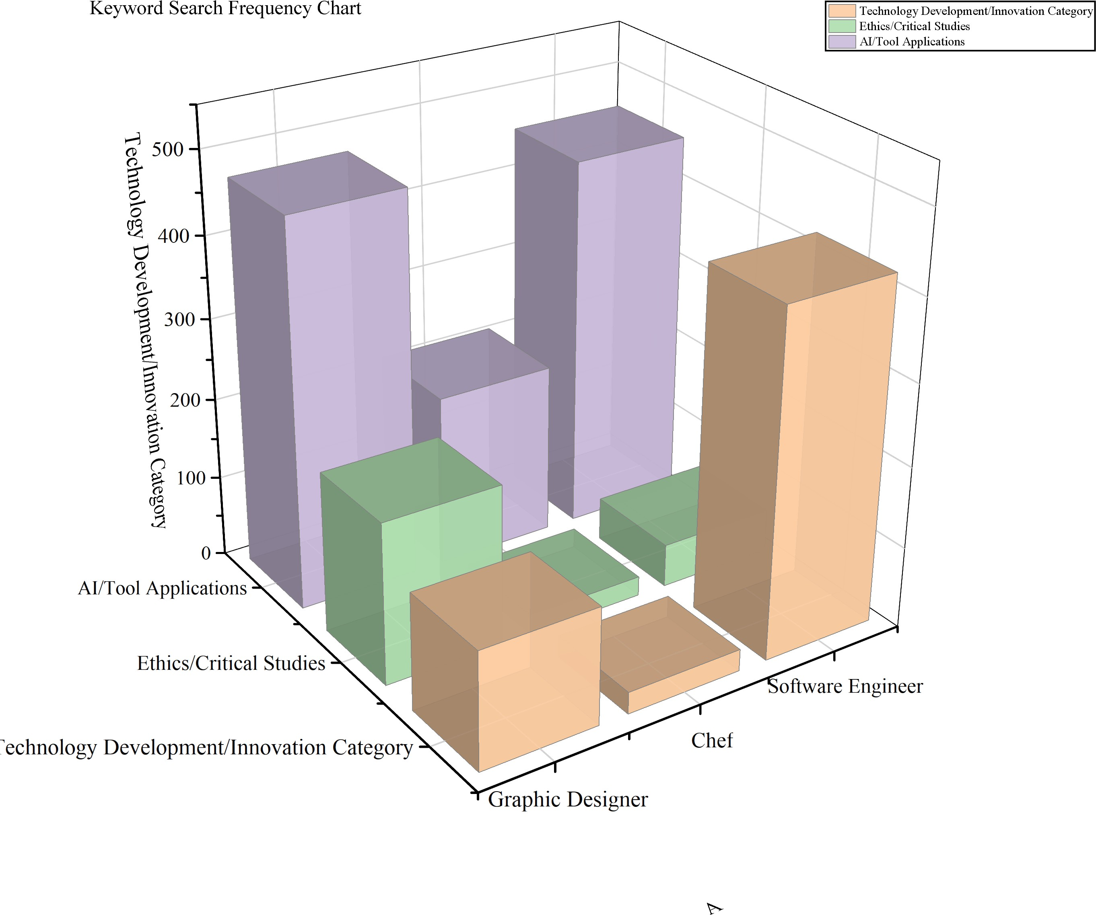
Figure 10: Values of various ECAM variables

- 𝑁 (𝑡): This refers to the efficiency improvement ratio achieved through effective AI education. We will estimate the efficiency enhancement ratio for each course based on the task list, then multiply it by respective weights and the corresponding enhancement potential coefficient to obtain the work efficiency improvement value for graduates of that profession after AI educa-tion.
- 𝑍 (𝑡): This refers to the likelihood of remaining irreplaceable in the job market after AI ed-ucation. The risk resistance factor Ω for each course corresponding to a profession will be estimated based on the task list. Finally, multiplying this by the course’s weighting will yield the course’s total Ω value. Thus:

𝑍 (𝑡) = ln(1 + Ω) (17)

Data Processing and Model Computation
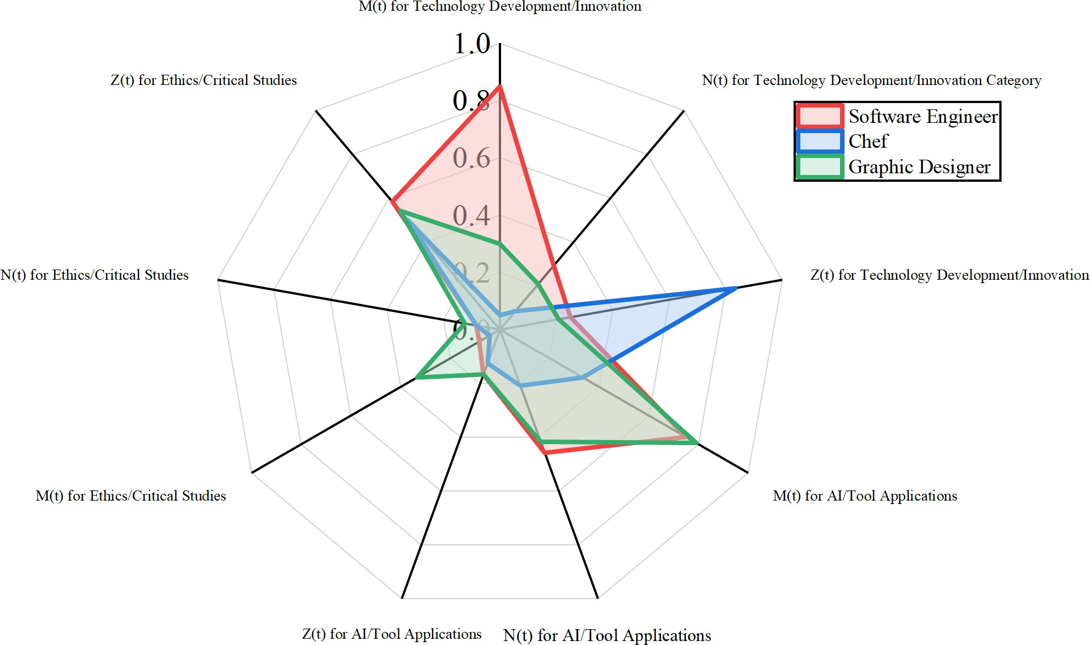
We collected data on 𝑀 (𝑡) and estimated the specific scores for 𝑁 (𝑡) and 𝑍 (𝑡). At the same time, we integrated the values of these variables into a chart, as shown in Figure 11:

Figure 11: Model Calculation Results The model calculations yielded the following results:

Table 9: ECAM Calculation Results

Occupation | Technology Devel-  opment Category | Tool Application  Category | Ethical Judgment  Category | K(t)
Software Engineer | 0 | 1.00 | 0 | 1.192
Chef | 0 | 0.816 | 0.184 | 0.567
Graphic Designer | 0 | 1.00 | 0 | 1.252

Adjustment of the ECAM Based on Multidimensional Analysis
The essence of education lies in enabling students to learn and enhance their learning capabili-ties. Treating employment competitiveness as the sole criterion for evaluating educational outcomes is clearly inadequate. Therefore, three additional evaluation dimensions will be introduced to conduct a multidimensional assessment of education. The reference dimension is shown in Figure 12[9]:

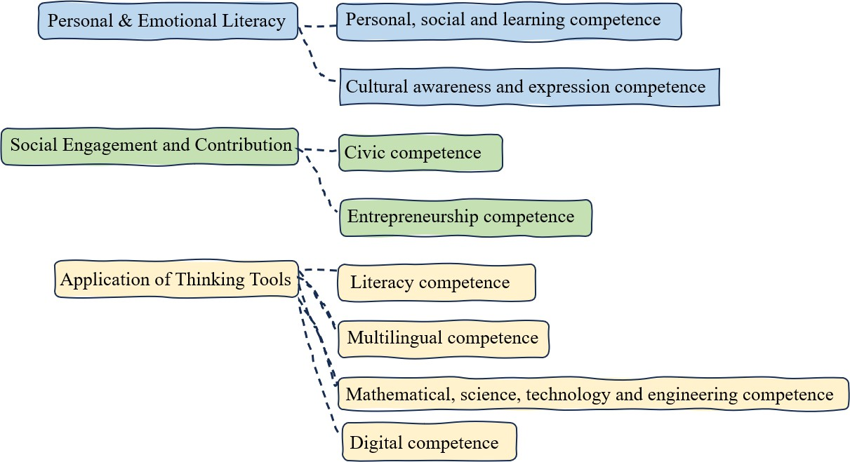
Figure 12: Eight Core Competency Categories and Multi-Dimensional Evaluation Mapping We introduce the following evaluation dimensions:
- PC: Professional Competitiveness
- PEL: Personal and Emotional Literacy
- SEC: Social Engagement and Contribution
- AT: Application of Thinking Tools

Construct a decision matrix
Use pairwise analysis with a judgment matrix to determine the weight of each dimension. We construct the following judgment matrix:
A | PC | PEL | SEC | AT
PC | 1 | 3 | 2 | 1/2
PEL | 1/3 | 1 | 1/2 | 1/3
SEC | 1/2 | 2 | 1 | 1/2
AT | 2 | 3 | 2 | 1

Table 10: Dimension Judgment Matrix Then we calculate the consistency ratio:

𝐶𝑅 =
𝐶𝐼 

𝑅𝐼
0 The judgment matrix is a perfectly consistent matrix
< 0.1 The judgment matrix passes the consistency test
≥ 0.1 The judgment matrix fails the consistency test

(18)

𝐶𝐼 =

𝑛 − 1
𝑅𝐼 = max
𝑛 − 1
𝜆_{max} − 𝑛
𝜆′
– 𝑛
(19)

Correlation Analysis
We need to consider the influence each dimension exerts on the others, leading us to propose the following correlation measurement formula:
∑
𝑊_{𝑖} = 𝑤_{𝑖} + 𝜆 · 𝛽_{𝑗𝑖} · 𝑤_{𝑗} (20)
𝑗 ≠𝑖

- Elitist Eﬀiciency Principle (𝜆 ≈ 0.2): Weakens synergy and emphasizes core goals (e.g., em-ployment) themselves.
- Balanced Development Principle (𝜆 ≈ 0.5): Moderately recognizes synergy effects and seeks balance.
- Systemic Ecology Principle (𝜆 ≈ 0.8): Strongly regards education as an ecosystem and highly values mutual nourishment between dimensions.

Model Improvement Calculation
We adopt the Balanced Development Principle (𝜆 ≈ 0.5).
Now I present the 𝑈_{𝑖} _{𝑗} matrix:

𝑈𝑖 𝑗 | PC | PEL | SEC | AT
PC | – | 0.3 | 0.1 | 0.4
PEL | 0.3 | – | 0.2 | 0.5
SEC | 0.2 | 0.5 | – | 0.3
AT | 0.3 | 0.2 | 0.1 | –
Table 11: SOI Dimension Interaction Matrix (𝑈_{𝑖} _{𝑗} )

Finally, the resulting 𝑊 will also be normalized to obtain the weight of each major dimension.

Result = [29.26%, 10.68%, 18.50%, 41.56%] (21)

Sensitivity Analysis
Among all models, the AIM is the most critical. Therefore, we decided to conduct a sensitivity analysis on this model to observe how changes in individual parameters affect it, thereby reflecting the stability of other models.
Taking software engineers as an example, benchmark 𝐴_{𝑗} (𝑡) = 0.417.
We set the change rates for 𝜔_{𝑗} , 𝜈_{𝑗} , 𝐴_{𝑗,max}, and 𝑇 (𝑡) to ±20%. After calculation, the following results were obtained, as shown in Figure 13:

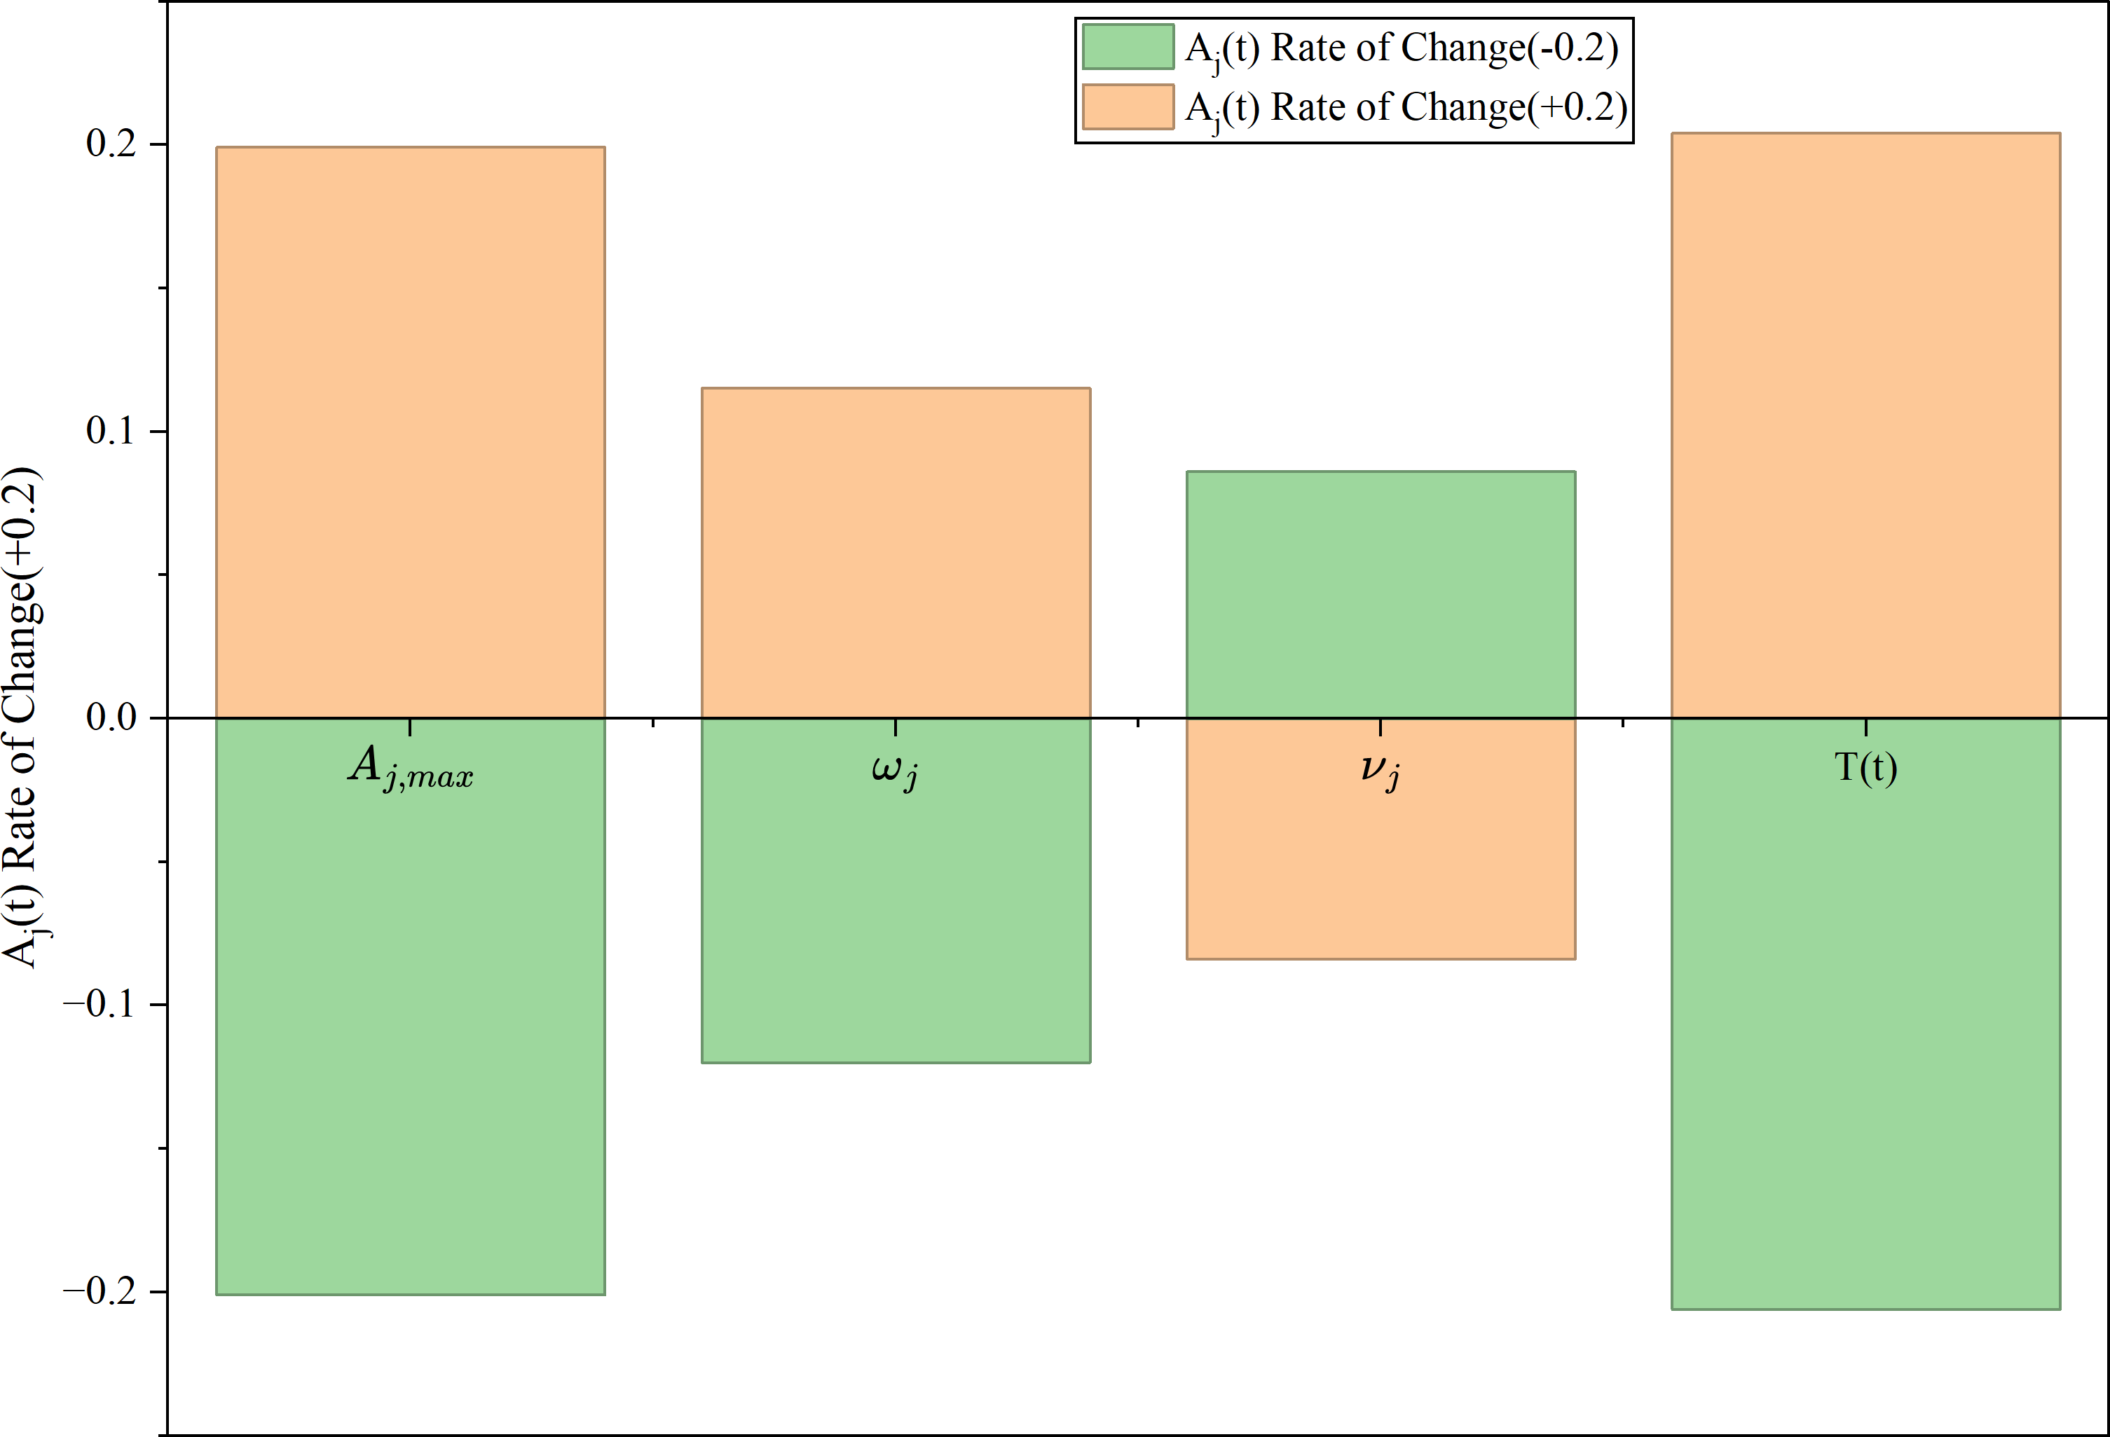
Figure 13: Results under ±20% change rates of key parameters Based on the chart, the following conclusions can be drawn:
- 𝐴_{𝑗,max} and 𝑇 (𝑡) exert the greatest influence on the automation index, nearly linear.
- Graphic designers are most sensitive to technological developments, while chefs are the least sensitive.
- The effects of 𝜔_{𝑗} and 𝜈_{𝑗} are relatively minor but exhibit nonlinearity.

Strengths and Weaknesses

Strengths
- The model possesses strong dynamic forecasting capabilities, meeting the requirements for ”future career trajectories.” It employs differential equations to describe changes in employment scale, capturing the dynamic process of ”short-term displacement and long-term creation.” This structure aligns more closely with the nonlinear characteristics of Gen-AI disruption than static trend forecasting.
- A logical closed-loop establishes causal chains between 𝑇 (𝑡) and its exogenous variables 𝐸_{𝑗} (𝑡),
𝐴_{𝑗} (𝑡), 𝑃_{𝑗} (𝑡), 𝐿 _{𝑗} (𝑡), forming a complete endogenous variable system.
- The introduction of a technology diffusion model—Bass diffusion model, reflects that Gen-AI does not replace jobs instantaneously but permeates gradually.

- Multi-criteria decision analysis simultaneously considers multiple dimensions, quantitatively expressing these conflicts and seamlessly integrating with the prediction model.
- Multiple sub-models quantify various factors.

Weaknesses
- Excessive parameters make data calibration difficult, requiring significant time to locate re-search papers supporting our arguments and data.
- The ”creative value” of arts professions is hard to quantify. Models primarily using employment scale as the core metric may fail to adequately reflect the unique characteristics of the arts sector.
- Lack of exogenous shocks such as economic crises or policy regulations.

Conclusion
Against the backdrop of Gen-AI reshaping occupational development paradigms and prompting ad-justments to higher education training programs, this study focuses on three representative occupations—software engineer, chef, and graphic designer—carefully selected to cover diverse career categories and capture the heterogeneous impacts of AI across sectors.
At the same time, guided by the principles of supply-demand equilibrium and the substitution-creation framework, we developed a integrated three-tier model system: the FDFM, EAM, and ECAM. This research contributes a data-driven analytical framework to unpack the complex interplay be-tween Gen-AI and occupational change, offering actionable guidance for higher education institutions to adjust training scales and optimize curriculum systems—particularly through modular designs cen-tered on ”AI tool proficiency + professional core competence”. Yet limitations persist: the quantifica-tion of art occupations’ creative value remains challenging, and exogenous shocks such as economic crises or policy shifts are not incorporated into the current model. Future work should address these gaps by integrating more micro-level occupational task data and introducing multi-scenario simula-tions to enhance the model’s adaptability. Ultimately, bridging the gap between higher education and Gen-AI-driven occupational transformation requires collaborative efforts from educational institutions, industry enterprises, and research bodies. By aligning talent cultivation with evolving market demands, we can not only support graduates’ high-quality employment but also foster the sustainable develop-
ment of industries navigating the AI era.

Memo
Dear MMF,
We are pleased to present our proposed analytical framework addressing Problem F of the 2026 ICM, which explores how post-secondary educational institutions should respond to the rapid devel-opment and widespread adoption of Generative Artificial Intelligence (Gen-AI).
This study focuses on three representative career paths—software engineer, chef, and graphic designer—and investigates how generative artificial intelligence is reshaping employment demand, skill requirements, and the long-term sustainability of these professions. To support this analysis, we developed a multivariate dynamic career forecasting model that integrates automation intensity, productivity gains, technological diffusion, and emerging skill demands into a unified analytical system.
These variables dynamically interact over time, capturing both the substitution effect caused by automation and the creation effect driven by productivity enhancement and the emergence of new oc-cupations. The AI technology index employs an S-logistic function to model occupational automation barriers, while AI adoption follows an improved diffusion process. Numerical solutions of the system generate medium- to long-term projections under various technological growth scenarios.
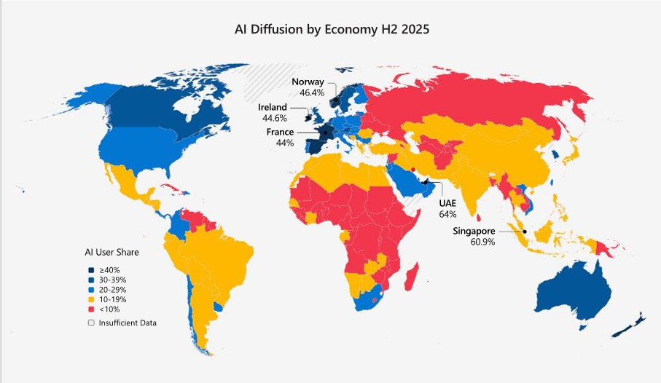

Simulation results indicate that while generative AI may initially reduce labor demand in highly automatable tasks, long-term employment levels can recover or even grow when augmentation ef-fects and skill adaptation effects become dominant. STEM occupations exhibit robust productivity-driven growth, trade occupations maintain relative resilience due to physical task constraints, and arts occupations—although highly susceptible to automation—stand to gain significantly from human–machine collaboration.
Undeniably, overall, the emergence of AI is driving a broad trend of advancement across the three industries examined. The world is entering an era in which artificial intelligence will play a central role in shaping future career structures and educational strategies.
Thank you for your time and consideration.

Yours sincerely, Team #2614765

References
- Austin, D. (2025, September 24). September 24, 2025 - eDiscovery Today by Doug Austin. eDis-covery Today by Doug Austin. https://ediscoverytoday.com/2025/09/24/
- Stats, L. (2026, February 1). MMLU leaderboard. LLM Stats. https://llm-stats.com/ benchmarks/mmlu?utm_source=chatgpt.com
- Manyika,J.,Lund,S.,Chui,M.,Bughin,J.,Woetzel,L.,Batra,P.,Ko,R.,& Sanghvi,S.(2017, Novem-ber 28).Jobs lost,jobs gained: What the future of work will mean for jobs, skills, and wages. McK-insey & Company.https://www.mckinsey.com/featured-insights/future-of-work/
jobs-lost-jobs-gained-what-the-future-of-work-will-mean-for-jobs-skills-and-wages
- 15-1252.00 - Software Developers. (n.d.). https://www.onetonline.org/link/summary/ 15-1252.00
- Bass, F. M. (1969). A new product growth for model Consumer Durables. Management Science, 15(5), 215–227. https://doi.org/10.1287/mnsc.15.5.215
- Zhao, N., Li, H., & Yang, N. (2024). TAM-TOE Integrated perspective research on adoption of ar-tificial intelligence technology in construction projects. JOURNAL OF ENGINEERING STUD-
IES, 16(2), 137–146. https://doi.org/10.3724/j.issn.1674-4969.23011030
- Rogers, E. M., Simon, & Schuster. (2003). Diffusion of Innovations, 5th Edition. https://www. amazon.com/Diffusion-Innovations-5th-Everett-Rogers/dp/0743258231
- Boss Zhipin. (n.d.). Find jobs on Boss Zhipin – Talk directly! Recruitment, job search & career opportunities. https://www.zhipin.com/chongqing/?seoRefer=index
- European Union. (2018). [Title of the document]. https://eur-lex.europa.eu/ legal-content/EN/TXT/PDF/?uri=CELEX:32018H0604(01)

Report on Use of AI

DeepL (Feb 2, 2025 version)
Explanation: In our work, we handle a large volume of foreign academic papers and technical materials involving mathematical modeling and data analysis, translating numerous specialized terms. Comparing human translations with AI-generated results reveals that AI tools perform exceptionally well in handling technical terminology and complex sentence structures. However, in certain cases, human proofreading remains necessary to ensure translation accuracy. Overall, team members unani-mously agree that AI translation tools significantly save time and enhance efficiency. Nevertheless, it is recommended that critical content undergo manual review.

- OpenAI ChatGPT (Nov 5, 2023 version, ChatGPT-4)
Query: Regarding the diminishing returns index in the enhanced index function, please provide me with a set of reference data based on relevant academic papers.

Output: Based on occupational characteristics: Creative/decision-making roles (e.g., design, strat-egy): The pathway for translating skills into tangible outcomes is complex, with rapid diminishing re-turns. The 𝜌_{𝑗} -value should be lower (0.3–0.5). Support/execution roles (e.g., code completion, data organization): The conversion pathway is direct, with slower diminishing returns. The 𝜌_{𝑗} -value can be higher (0.6–0.8).

Explanation: For parameters influenced by multiple factors, AI can help us derive reasonable reference values by interpreting multiple sets of literature. This significantly reduces manual effort.

- OpenAI ChatGPT (Nov 5, 2023 version, ChatGPT-4)
Query: Regarding the diminishing returns index in the enhanced index function, please provide me with a set of reference data based on relevant academic papers.

Output: Accuracy is converted into the “proportion of tasks the model can reliably solve.” As-suming an accuracy >90% signifies fundamental mastery in the domain, any improvement beyond this threshold can be regarded as an increase in “proficiency” and amplified nonlinearly. This is mapped using an S-shaped function (such as the Logistic function).

Explanation: Our team references the idea from AI.

- Adobe Color (Feb 2, 2025 version)
Explanation: We aim to make the color scheme of the drawings more aesthetically pleasing.

