LocalChat
Protocol Standard

Andrew Jones, Ryan Ferreira (Editors)
Department of Computer Science and Engineering
University of South Florida
Tampa, FL 33620

atjones3@mail.usf.edu, rrferrei@mail.usf.edu

Version 3.02 – November 19, 2010

This document is for the class project for Computer Networks (CNT 4004) for Fall 2010, University of South Florida, taught by Dr. Christensen.

Document history

Version 1.0 (October 13, 2010) – Initial version
Version 2.0 (October 17, 2010) – Added semantics. Dropped message acknowledge from the standard. Added encryption/decryption algorithm.
Version 3.0 (October 26, 2010) – Added message acknowledge into the standard. Updated FSMs and Timing Diagrams to reflect the newest standard.
Version 3.01 (October 28, 2010) – Altered wording to be more easily read. Added new formats to message syntax.
Version 3.02 (November 19, 2010) – Added notes to FSMs to remove ambiguity. Added notes to the Notes section to remove ambiguity.
Contributors

Standards Editors:
- Ryan Ferreira
- Andrew Jones

Conformance Test Editor:
- Mehrgan Mostowfi

Presenters:
- Franklin Berens
- Devin Clark
- Zachary Griswold
- Richard Meana
- Matt Olson

Contributors:
- Paul Balda  - Karin Barrios  - Travis Behr  - Franklin Berens  - Christine Bringes  - Jeffrey Cama  - David Dimter  - Tian Dominguez  - Thomas Estep  - Marc Falquez  - Ryan Ferreira  - Val Geyvandov  - Christopher Gillis  - Gabriela Gonzales  - Zachary Griswold  - Alana Johnson  - Andrew Jones  - Jordan Katz  - David Kimani  - Joseph Kuziel | - Theodore Larkins  - Jino Mathew  - Riachard Meana  - Evan Nadav  - Matthew Olson  - William Oropallo  - Micca Osmar  - Richard Persaud  - Amy Rawlins  - Michael Ring  - Daniel Risner  - Carol Simkanich  - Sheree Smythe  - Brian Stallo  - Cory Stephenson  - Mark Suarin  - Yeisy Valdes  - Jennifer White  - Lucas Wright

Table of Contents

1. Overview 5 2

2. Definitions 5

3. Protocol Syntax 5
3.1 List of Messages
3.2 Message format

4. Protocol Semantics 7
4.1 Finite State Machines
4.2 Timing Diagrams

5. Notes 11

List of References 11

Appendix – Encryption/Decryption Algorithm 12

1. Overview

This is the standard for an application layer protocol for LocalChat that is outlined in the LocalChat requirements document version 1.02. The goal of this standard is to allow for different independent implementations of LocalChat to communicate with each other. That is, if two different programs are written following the specifications outlined in this document, they will be able to transmit messages to each other’s machines. This document covers the both the syntax and semantics of the LocalChat standard.

LocalChat is a messaging service that allows for the transmission of messages over a Local Area Network (LAN) without requiring a server. This is a more lightweight alternative to SMS messaging or server-based instant messaging. To add security, encryption and decryption of messages must be an option in the transmission of messages over the LAN.

2. Definitions

In addition to the definitions stated in the LocalChat requirements document 1.02, the key definitions for LocalChat are the following:
- Encryption Flag – An ASCII ‘0’ or ‘1’ that indicates whether or not a message is encrypted. A ‘1’ is used for encrypted messages while a ‘0’ is used for unencrypted messages.
- Message – A string that contains information to be transmitted to a user. This information includes message type, username, sequence number, encryption flag, and message body.
- Message Body – A string with a maximum of 140 characters (ASCII codes 32-126).
- Message Type – A four-letter command that specifies what the purpose of a message is.
- Sequence Number – A number, converted to ASCII characters, that ensures that the receiver of a message only prints a message once.
- User name – A string of lower case characters (ASCII codes 97-122) up to 32 characters in length for a user associated with a given peer.

3. Protocol Syntax

3.1 List of Messages

This standard has four different message types. The four messages are broadcast, broadcast acknowledge, message, and message acknowledge. The four-letter commands that will be used for each message type are the following:

BCST – Message to determine localChat users in current subnet (e.g., hotspot) (broadcast)
BACK – Message to announce “I am here” for a user sending a BCST (broadcast acknowledgement)
MESG – A text message sent to a specific user (message)
MACK – An acknowledgment for a received MESG (message acknowledgement)

3.2 Message Formats

BCST:

Message_Type | User_Name

The Message_Type field is four bytes in length while the User_Name field is 32 bytes in length.
Message_Type = “BCST” (ASCII)
User_Name = source user name (padded on the right with null characters to fill all 32 bytes)
Note: The BCST message is sent MAC broadcast.

BACK:

Message_Type | User_Name

The Message_Type field is four bytes in length while the User_Name field is 32 bytes in length.
Message_Type = “BACK” (ASCII)
User_Name = source user name (padded on the right with null characters to fill all 32 bytes)
Note: The BACK message is sent MAC unicast.

MESG:

Message_Type | User_Name | Seq_Num | Encrypt | Message_Body

The Message_Type field is four bytes in length, the User_Name field is 32 bytes in length, the Seq_Num field is five bytes in length, the Encrypt field is 1 byte in length, and the Message_Body field is 140 bytes in length.
Message_Type = “MESG” (ASCII)
User_Name = source user name (padded on the right with null characters to fill all 32 bytes)
Seq_Num = ASCII encoded sequence number
Encrypt = “1” for encryption enabled, “0” for encryption disabled
Message_Body = text message (padded on the right with null characters to fill all 140 bytes)
Notes:
- The MESG message is sent MAC unicast.
- For an encrypted message, the padding is also encrypted.
- The sequence number is an integer value represented in ASCII. It is to be padded on the left with zeros if the number is less than five characters in length.

MACK:

Message_Type | User_Name | Seq_Num

The Message_Type field is four bytes in length, the User_Name field is 32 bytes in length, and the Seq_Num field is five bytes in length.
Message_Type = “MACK” (ASCII)
User_Name = source user name (padded on the right with null characters to fill all 32 bytes)
Seq_Num = ASCII encoded sequence number
Notes:
- The MACK message is sent MAC unicast.
- The sequence number is an integer value represented in ASCII. It is to be padded on the left with zeros if the number is less than five characters in length.

4. Protocol Semantics

4.1 Finite State Machines

The LocalChat protocol is described with four finite state machines (FSMs). The FSMs are broadcast sender, broadcast receiver, text message sender, and text message receiver. Key variables are:

RDTimer: Timer for responding to a BCST message
TOTimer: Timer for triggering a retry or timeout of an unacknowledged MESG message
Count: Integer counter for retry

Broadcast Sender:
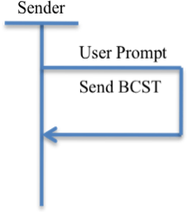
Figure 1: FSM of Broadcast Sender

Notes:
- BCST User_Name is filled-in with the sender’s user name
- “User Prompt” refers to a user event that is defined during implementation

Broadcast Receiver:
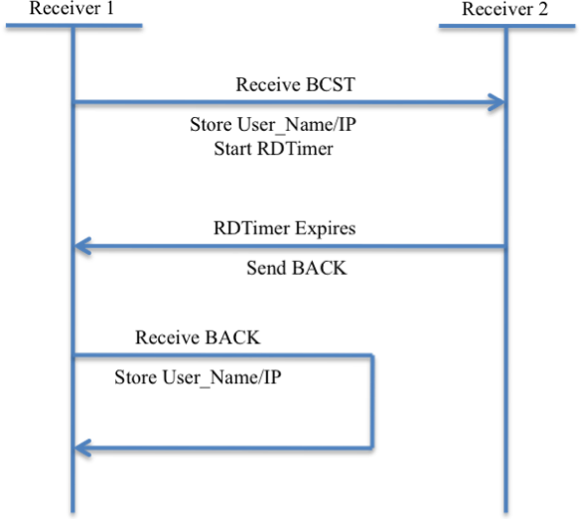
Figure 2: FSM of Broadcast Receiver

Notes:
- BACK User_Name is filled-in with the receiver’s user name
- RDTimer is set to uniform(0, 1000) in units of milliseconds on Start RDTimer action
- Store User_Name/IP stores the received user name into memory
- IP refers to the source IP address of the sent packet

Text Message Sender:
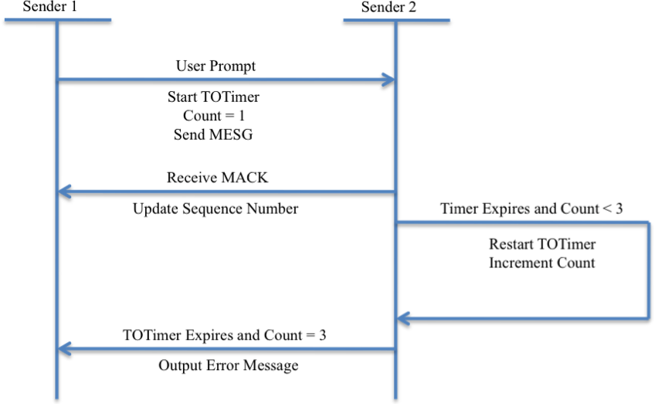
Figure 3: FSM of Text Message Sender

Notes:
- MESG User_Name is filled with the sender’s user name
- TOTimer is set to 10 milliseconds on Start TOTimer and Restart TOTimer actions
- MESG Seq_Num is set to an arbitrary and unique value for each unique message
- “Update Sequence Number” refers to changing Seq_Num to a different, arbitrary value
- “Output Error Message” refers to printing an error message when a message can’t be sent

Text Message Receiver:
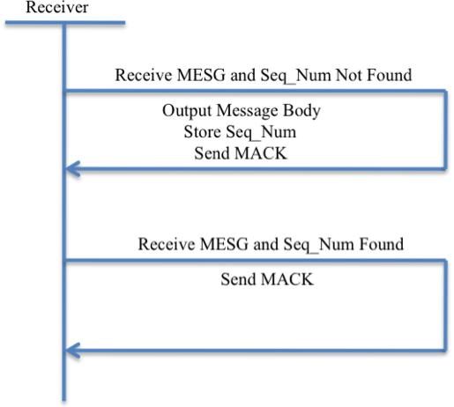
Figure 4: FSM of Text Message Receiver
Notes:
- MACK User_Name is filled-in with the receiver’s user name
- MACK Seq_Num is set to the Seq_Num that is received in the MESG message
- It is only necessary to store the most recent Seq_Num. That is, when the Store Seq_Num action occurs, the most recent Seq_Num overwrites the previous Seq_Num

4.2 Timing Diagrams

Assuming there are no lost packets, broadcast and broadcast acknowledgement will follow the timing diagram in Figure 5.
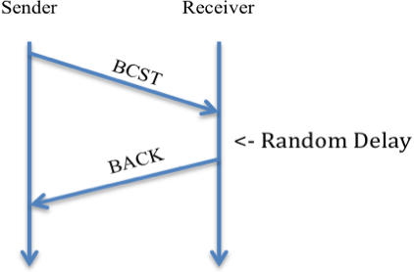
Figure 5: Broadcast Timing Diagram

Note: Nothing is done to ensure delivery in the cases that a BCST or BACK packet is lost.

Assuming there are no lost packets, message and message acknowledgement will follow the timing diagram in Figure 6. There are cases in which packets can be lost. The timing diagrams in Figure 7 and Figure 8 show these cases.
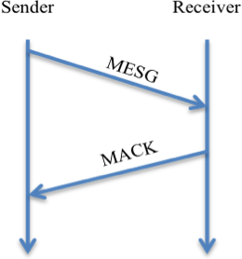
Figure 6: Flawless Message Passing

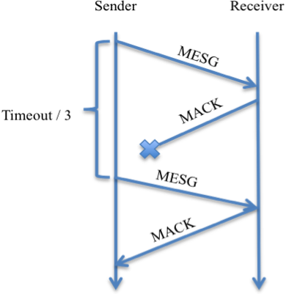
Figure 7: Message Passing with Lost MACK

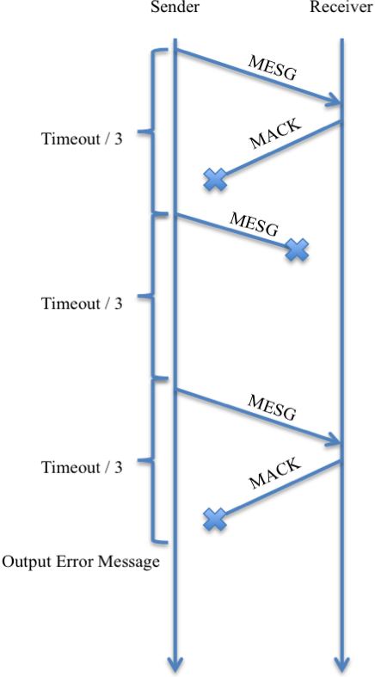
Figure 8: Message Passing with a Timeout

Note: Timeout refers to the 30 milliseconds that are waited before outputting an error message. Timeout/3 is equivalent to TOTimer that is used in Figure 3.

5. Notes

- Port 8888 will be used for broadcast messages (BCST and BACK).
- Port 9999 will be used for message sending (MESG and MACK).
- UDP will be used for all types of messages.
- The characters used for an encryption key are ASCII 32-126.
- If a message is received from an unknown peer, the unknown peer is to be added to the username/IP list.
- If a timeout occurs, it can be assumed that the user is no longer logged on and can be removed from the username/IP list.
- The sequence number is an arbitrary number.

List of References

- LocalChat Requirements Document Version 1.02
http://www.csee.usf.edu/~christen/class2/hidden/localChat_req102.doc

Appendix – Encryption/Decryption Algorithm

If the encryption flag is set to ‘1’, then all characters will be bitwise XOR’d with a 140-character key that is determined by an offline mechanism. Each character in the key will be XOR’d with the character that is in the same location in the message body (e.g., key[5] is XOR’d with messageBody[5]). The 141st character does not need to be encrypted/decrypted. It should be noted that the process to encrypt and decrypt is the same. The algorithm for this process is outlined on the following page.
Encrypt (string key, string messageBody) {
for i = 0 to 139
newMessage[i] = key[i] XOR messageBody[i]
return newMessage

