

**Mawlana Bhashani Science and Technology University**

**Lab-Report**

Report No: 06

Course code: ICT-4202

Course title: Wireless and Mobile Communication Lab

Date of Performance: 25.09.2020

Date of Submission: 30.09.2020

**Submitted by Submitted To**

Nazrul Islam

Assistant Professor

Dept. of ICT

MBSTU.

Name: Md. Afzalur Rahman Tanzin

ID:IT-16026

4th year 2ndsemester

Session: 2015-2016

Dept. of ICT

MBSTU.

**Experiment No: 06**

**Experiment Name: Switching an interface to move a host around a network using mininet.**

**Objective:**

* Downloading and running mininet on virtual machine(VM)
* Switching an interface to move a host around the network
* Using mobility.py

**Code:**

|  |
| --- |
|  |
|  | from mininet.node import OVSSwitch  from mininet.net import Mininet |
|  | from mininet.topo import LinearTopo |
|  | from mininet.log import info, output, warn, setLogLevel |
|  |  |
|  | from random import randint |
|  |  |
|  |  |
|  | class MobilitySwitch( OVSSwitch ): |
|  | "Switch that can reattach and rename interfaces" |
|  |  |
|  | def delIntf( self, intf ): |
|  | "Remove (and detach) an interface" |
|  | port = self.ports[ intf ] |
|  | del self.ports[ intf ] |
|  | del self.intfs[ port ] |
|  | del self.nameToIntf[ intf.name ] |
|  |  |
|  | def addIntf( self, intf, rename=False, **kwargs ): |
|  | "Add (and reparent) an interface" |
|  | OVSSwitch.addIntf( self, intf, **kwargs ) |
|  | intf.node = self |
|  | if rename: |
|  | self.renameIntf( intf ) |
|  |  |
|  | def attach( self, intf ): |
|  | "Attach an interface and set its port" |
|  | port = self.ports[ intf ] |
|  | if port: |
|  | if self.isOldOVS(): |
|  | self.cmd( 'ovs-vsctl add-port', self, intf ) |
|  | else: |
|  | self.cmd( 'ovs-vsctl add-port', self, intf, |
|  | '-- set Interface', intf, |
|  | 'ofport_request=%s' % port ) |
|  | self.validatePort( intf ) |
|  |  |
|  | def validatePort( self, intf ): |
|  | "Validate intf's OF port number" |
|  | ofport = int( self.cmd( 'ovs-vsctl get Interface', intf, |
|  | 'ofport' ) ) |
|  | if ofport != self.ports[ intf ]: |
|  | warn( 'WARNING: ofport for', intf, 'is actually', ofport, |
|  | '\n' ) |
|  |  |
|  | def renameIntf( self, intf, newname='' ): |
|  | "Rename an interface (to its canonical name)" |
|  | intf.ifconfig( 'down' ) |
|  | if not newname: |
|  | newname = '%s-eth%d' % ( self.name, self.ports[ intf ] ) |
|  | intf.cmd( 'ip link set', intf, 'name', newname ) |
|  | del self.nameToIntf[ intf.name ] |
|  | intf.name = newname |
|  | self.nameToIntf[ intf.name ] = intf |
|  | intf.ifconfig( 'up' ) |
|  |  |
|  | def moveIntf( self, intf, switch, port=None, rename=True ): |
|  | "Move one of our interfaces to another switch" |
|  | self.detach( intf ) |
|  | self.delIntf( intf ) |
|  | switch.addIntf( intf, port=port, rename=rename ) |
|  | switch.attach( intf ) |
|  |  |
|  |  |
|  | def printConnections( switches ): |
|  | "Compactly print connected nodes to each switch" |
|  | for sw in switches: |
|  | output( '%s: ' % sw ) |
|  | for intf in sw.intfList(): |
|  | link = intf.link |
|  | if link: |
|  | intf1, intf2 = link.intf1, link.intf2 |
|  | remote = intf1 if intf1.node != sw else intf2 |
|  | output( '%s(%s) ' % ( remote.node, sw.ports[ intf ] ) ) |
|  | output( '\n' ) |
|  |  |
|  |  |
|  | def moveHost( host, oldSwitch, newSwitch, newPort=None ): |
|  | "Move a host from old switch to new switch" |
|  | hintf, sintf = host.connectionsTo( oldSwitch )[ 0 ] |
|  | oldSwitch.moveIntf( sintf, newSwitch, port=newPort ) |
|  | return hintf, sintf |
|  |  |
|  |  |
|  | def mobilityTest(): |
|  | "A simple test of mobility" |
|  | info( '* Simple mobility test\n' ) |
|  | net = Mininet( topo=LinearTopo( 3 ), switch=MobilitySwitch ) |
|  | info( '* Starting network:\n' ) |
|  | net.start() |
|  | printConnections( net.switches ) |
|  | info( '* Testing network\n' ) |
|  | net.pingAll() |
|  | info( '* Identifying switch interface for h1\n' ) |
|  | h1, old = net.get( 'h1', 's1' ) |
|  | for s in 2, 3, 1: |
|  | new = net[ 's%d' % s ] |
|  | port = randint( 10, 20 ) |
|  | info( '* Moving', h1, 'from', old, 'to', new, 'port', port, '\n' ) |
|  | hintf, sintf = moveHost( h1, old, new, newPort=port ) |
|  | info( '*', hintf, 'is now connected to', sintf, '\n' ) |
|  | info( '* Clearing out old flows\n' ) |
|  | for sw in net.switches: |
|  | sw.dpctl( 'del-flows' ) |
|  | info( '* New network:\n' ) |
|  | printConnections( net.switches ) |
|  | info( '* Testing connectivity:\n' ) |
|  | net.pingAll() |
|  | old = new |
|  | net.stop() |
|  |  |
|  | if __name__ == '__main__': |
|  | setLogLevel( 'info' ) |
|  | mobilityTest() |

**Output:**

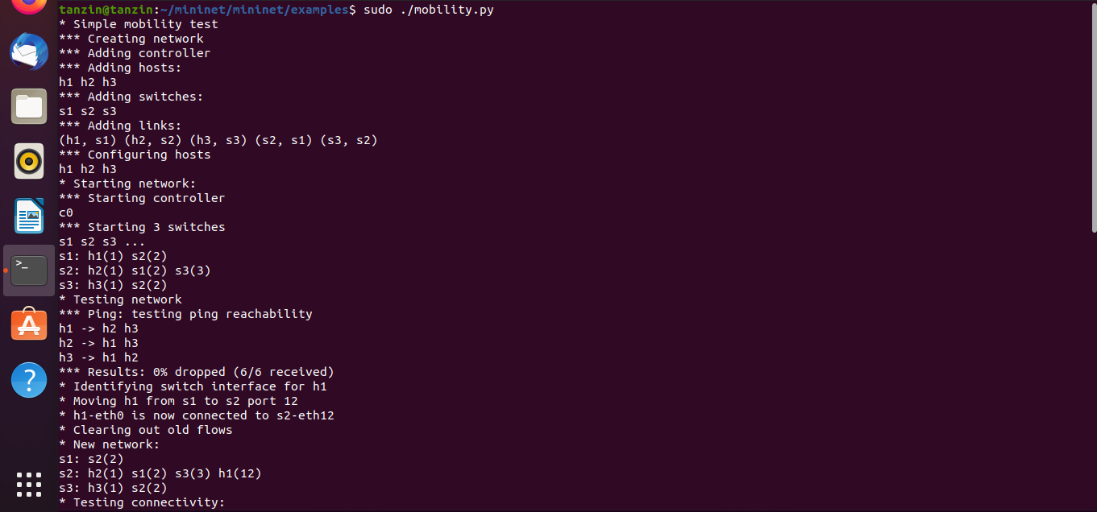

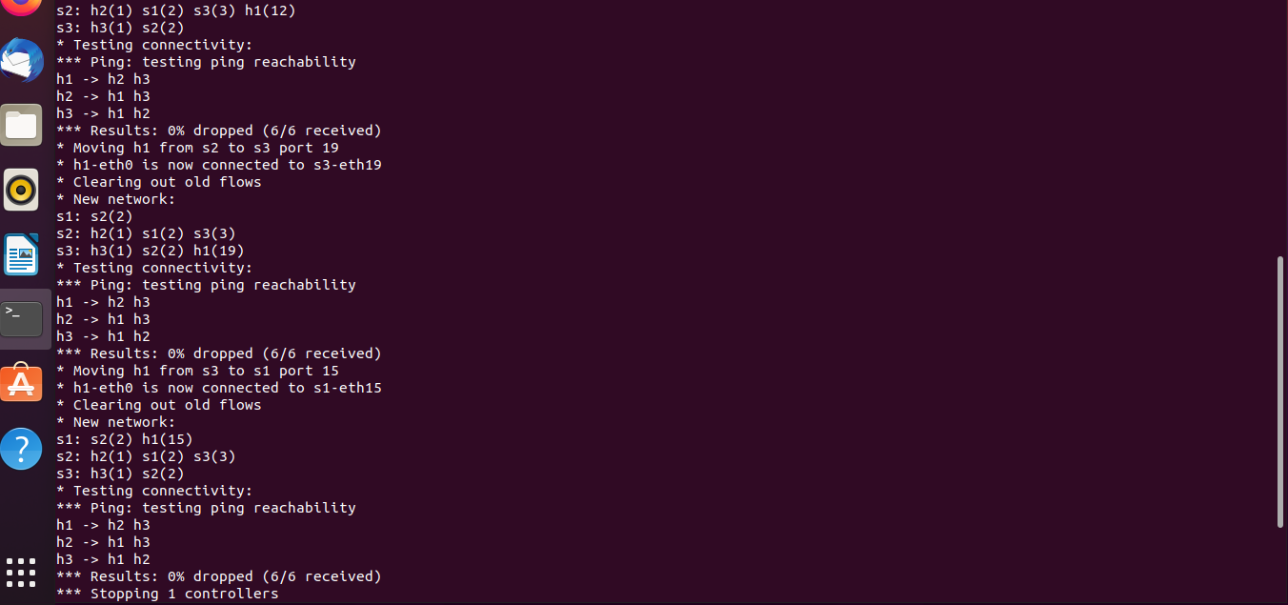

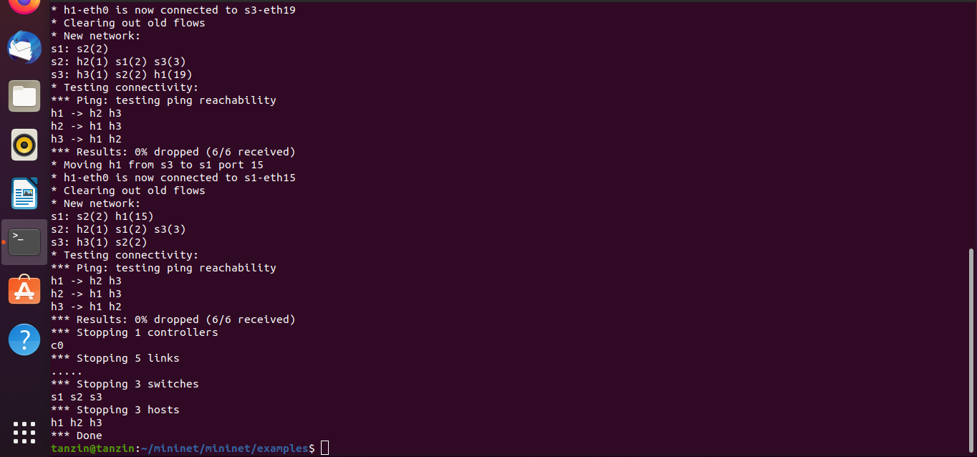

**Conclusion:**

In this experiment we switches an interface to move a host around a network using mininet. Mininet is a very convenient tool for this task. It clearly shows the wifi mobility test using mobility.py.