**ASSIGNMENT 1**

**Submitted by:**

**Aashish Singh**

**Student ID: 23003143**

**Submitted to:**

**Professor: Nawaz Chowdhury**

**Subject: Web Development 2**

**Course code: CSD213**

**Due date: 22 May 2024**

**Table of Content**

**Assignment Steps** 3

**Assignment Steps-1** 3

**Assignments Step-3** 6

**Output:** 7

# 

# **Assignment Steps**

## **Assignment Steps-1**

Question 2.

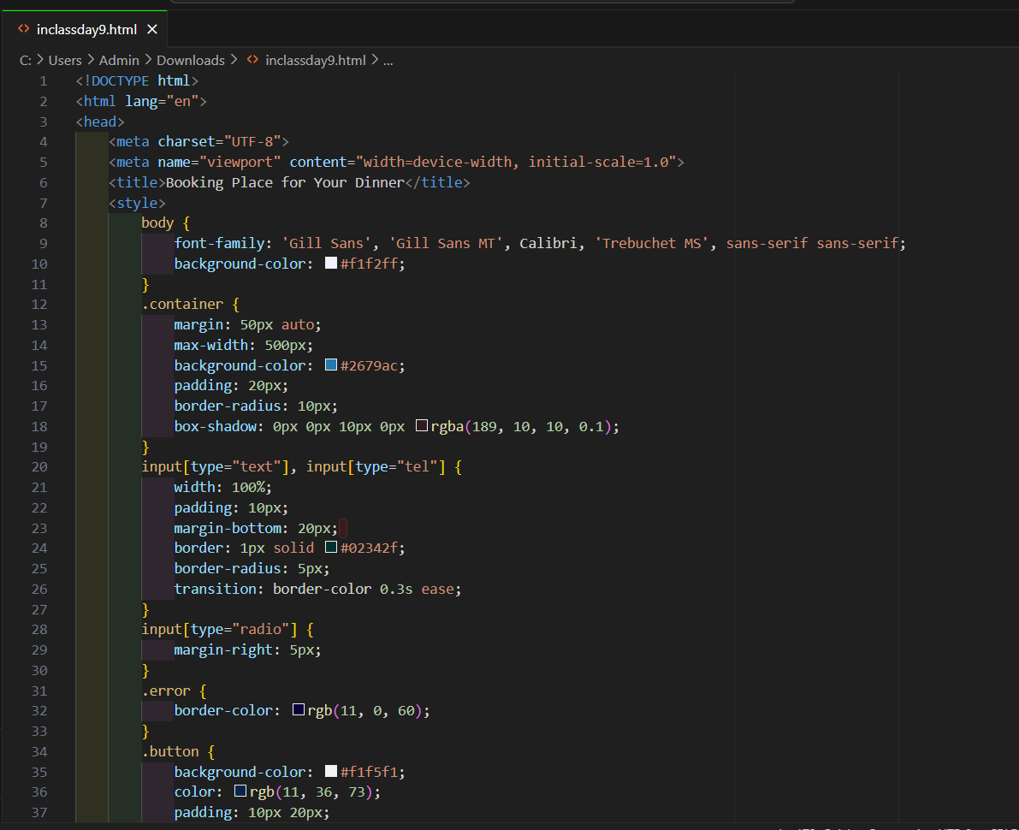

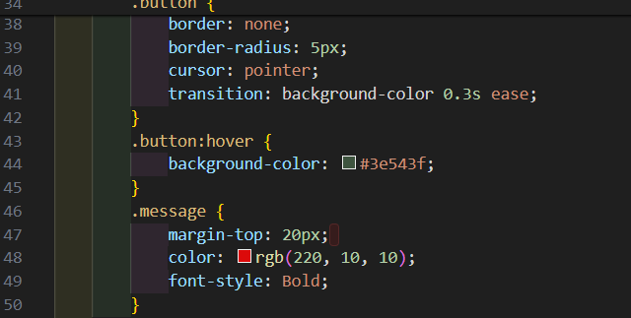

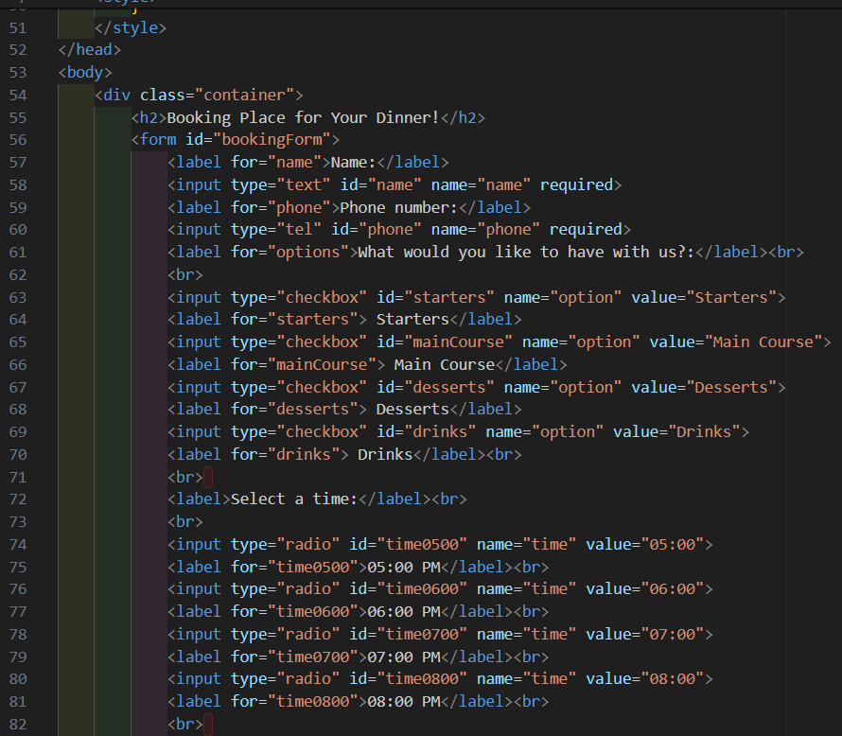

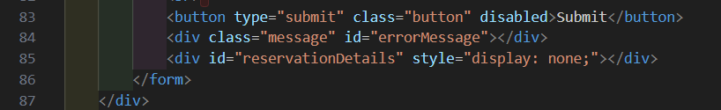

**Assignment Step-2**

For question no 3.

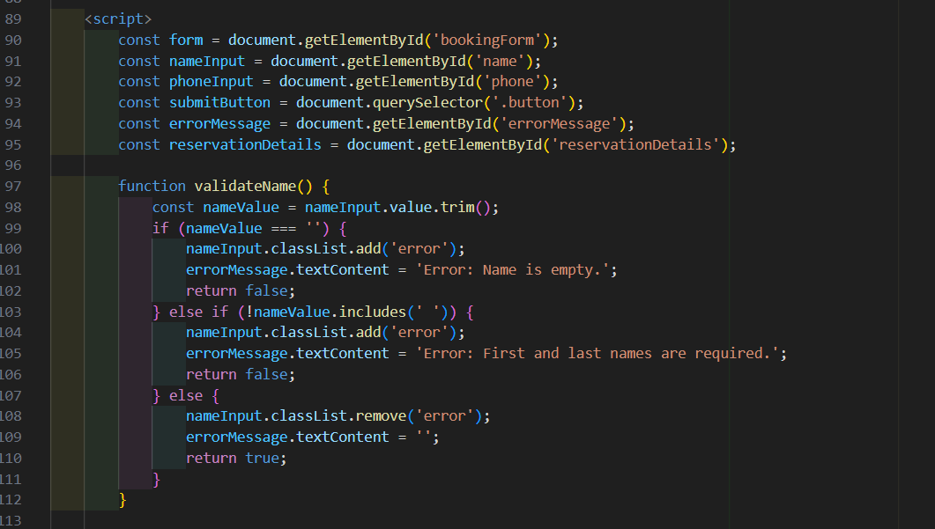

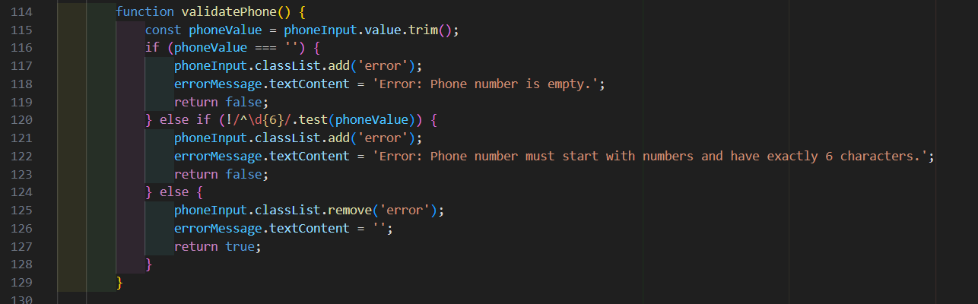

# **Assignments Step-3**

For question No 4.

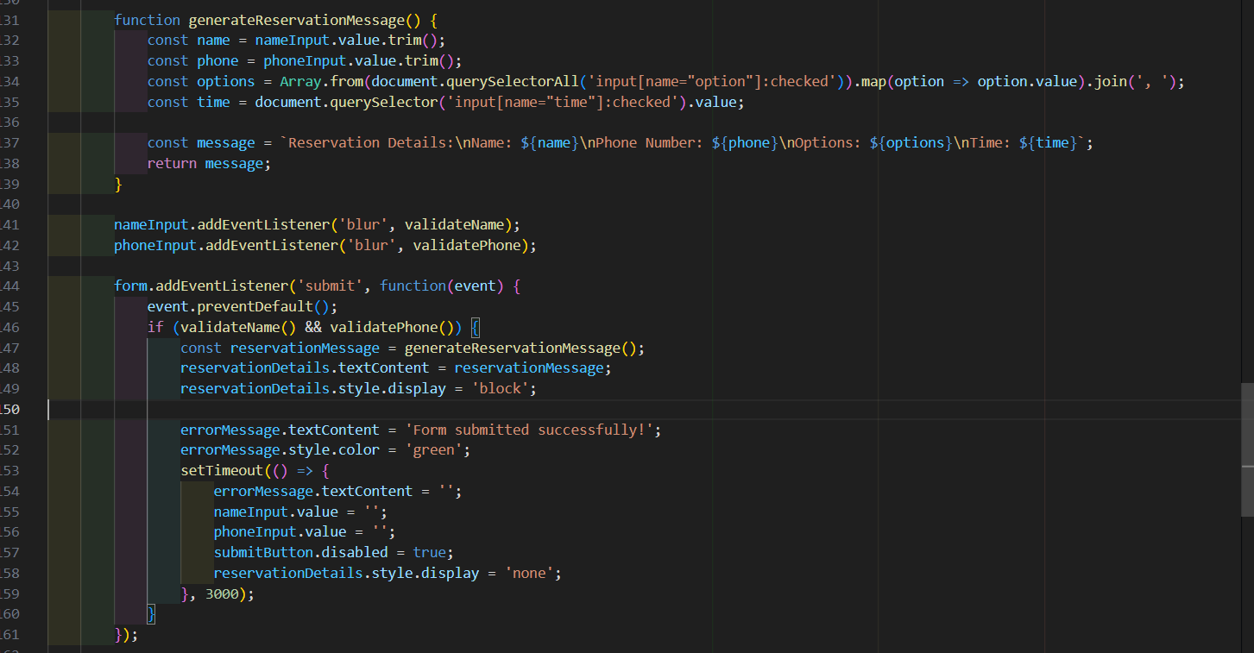

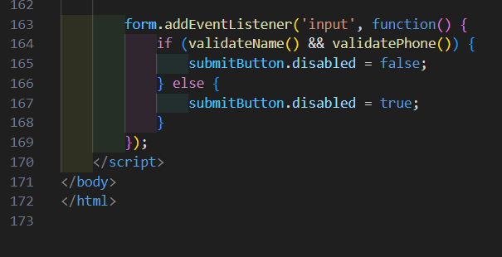

# **Output:**

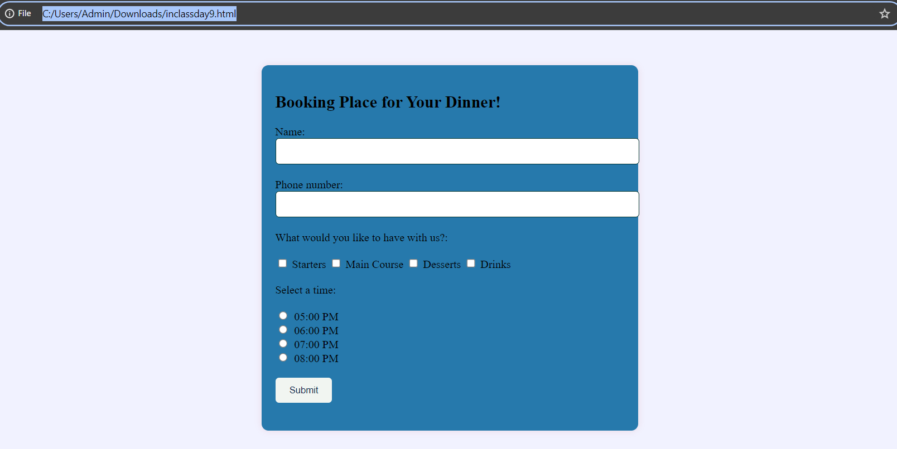

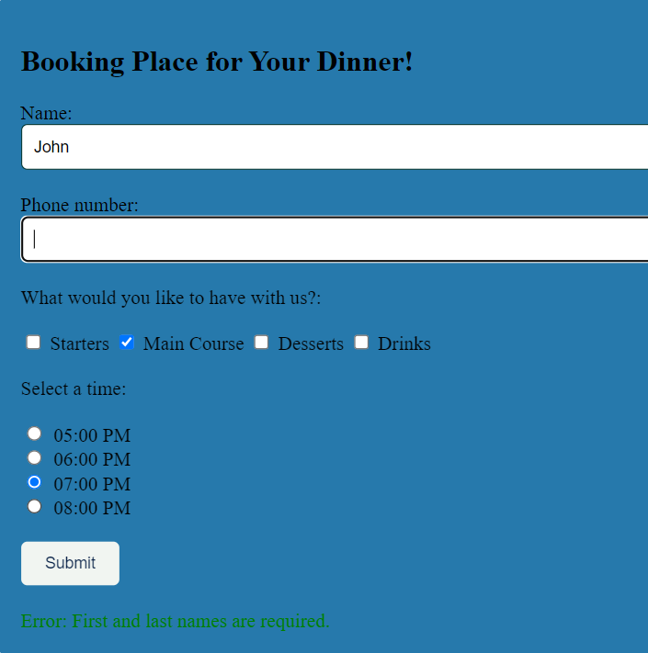

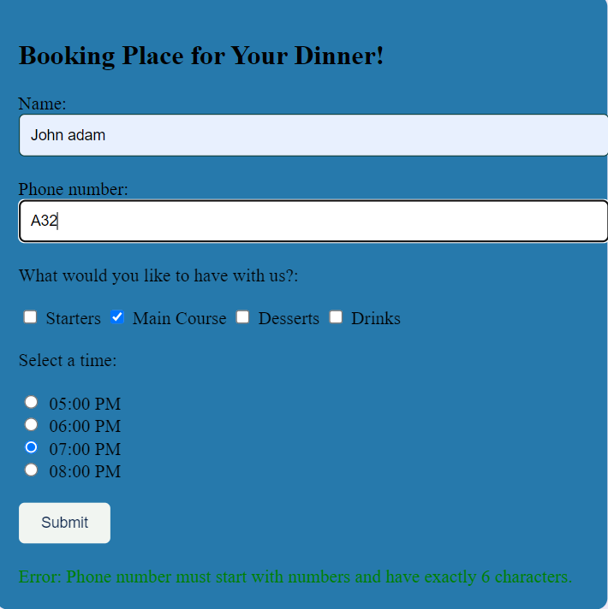

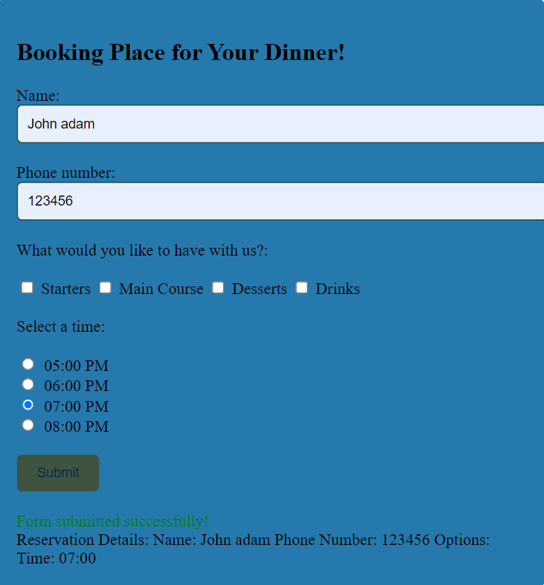

**This Output is like if we add everything not choosing meal option it will save details without meal options.**

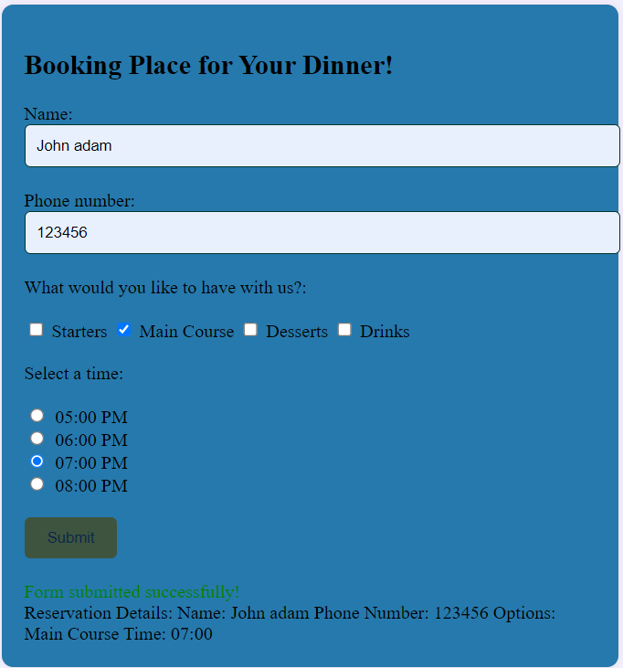

**This is complete out for this code.**

**Reference**

**……………………………………………………………………**