**Test 3B**

**Submitted by:**

**Aashish Singh**

**Student ID: 23003143**

**Submitted to:**

**Professor: Nawaz Chowdhury**

**Subject: Programming Paradiams**

**Course code: CSD216**

**Due date: 24 July 2024**

**Table of Content**

**Assignment :1** 3

**Assignment Steps-2** 5

# 

# **Assignment :1**

Mapping, Filtering through Lists

Create a list that displays the salaries of a company's employees.

For this list, let salaries = [$75,000; $48,000; $120,000; $190,000; $300,113; $92,000; $36,000].

# Filter through the list to find high-income salaries. For this list, salaries above $100,000 are considered high.

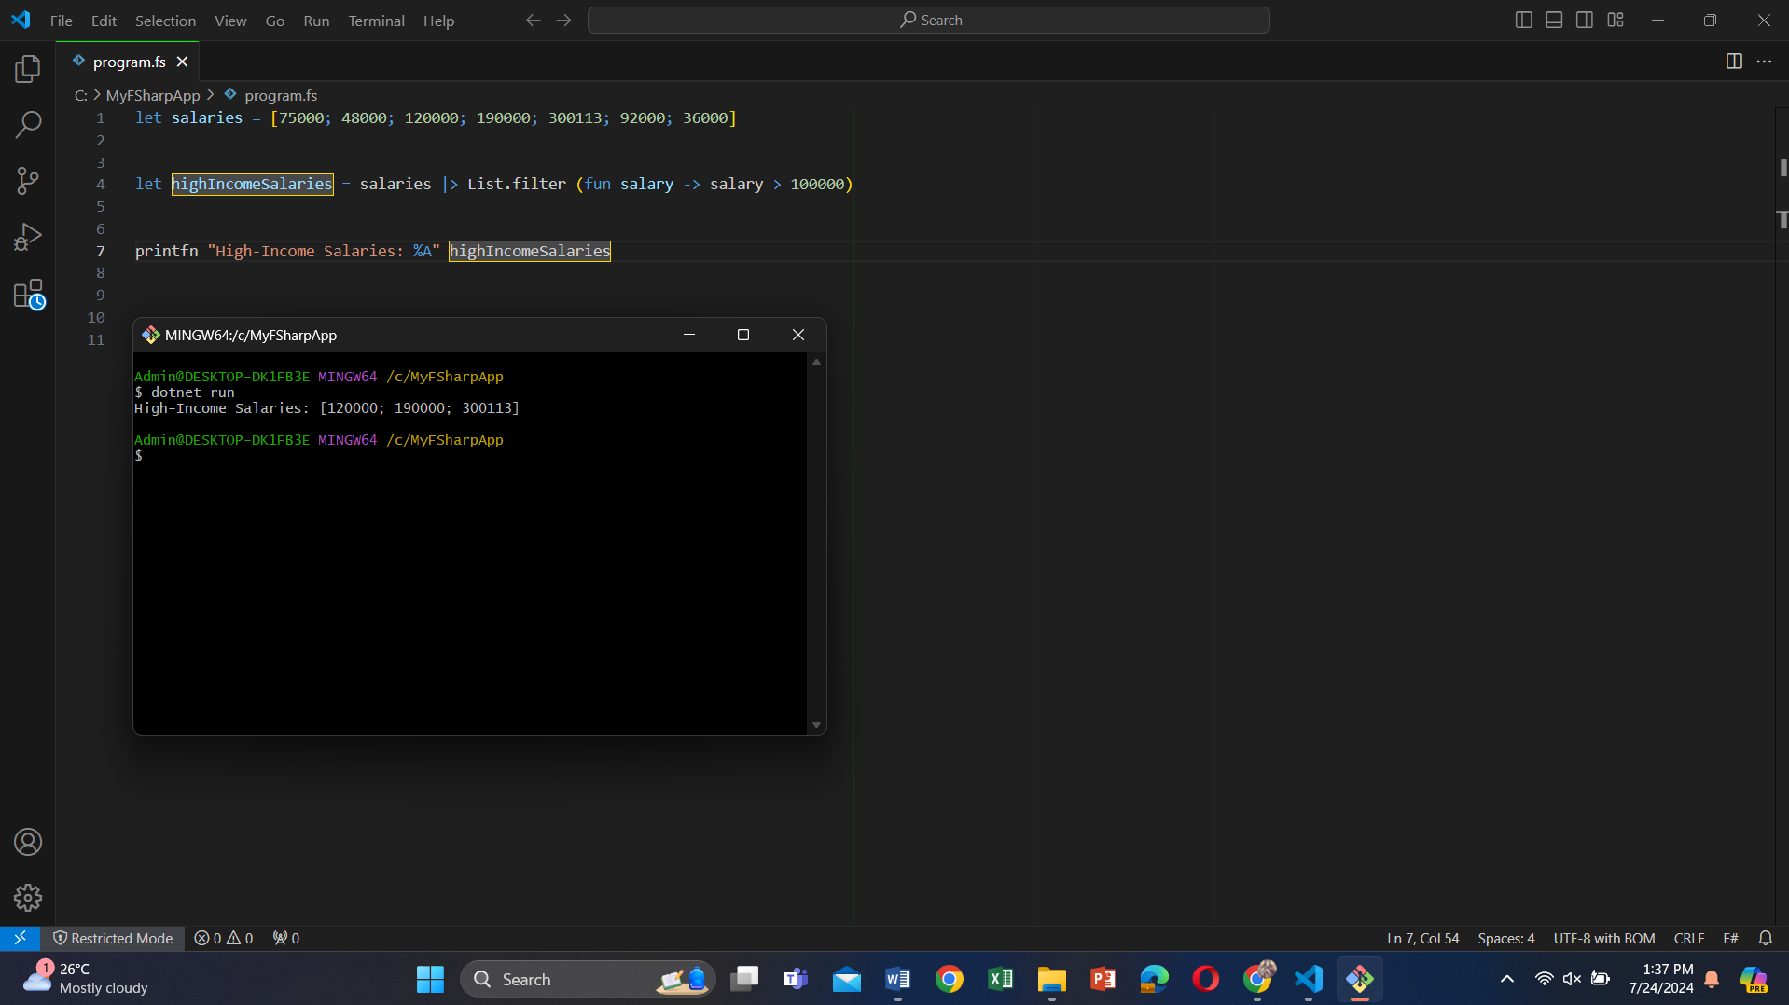

Use the map function to calculate tax for all salaries based on the table provided.

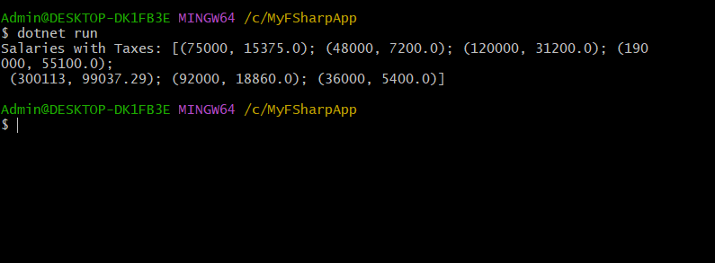

Filter salaries less than $49,020 and add $20,000 to these salaries using the map function.

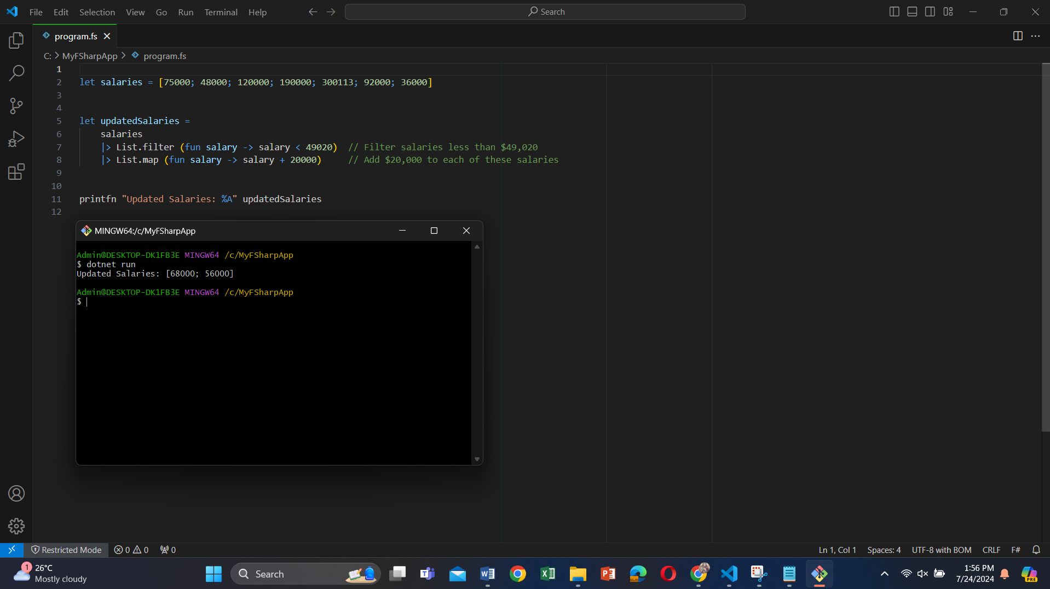

Filter salaries between $50,000 and $100,000 and sum them all using the reduce/fold function.

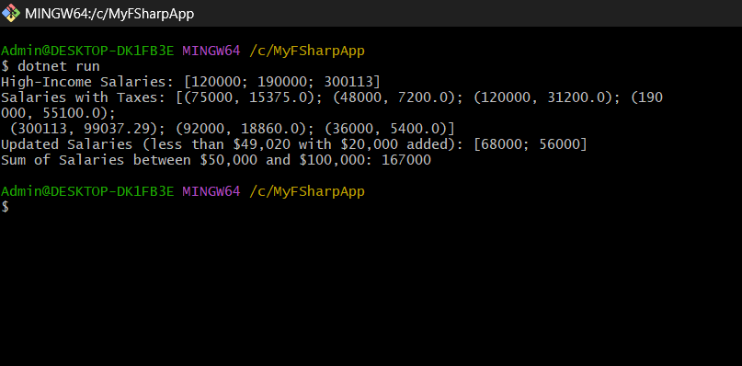

## **Assignment Steps-2**

Tail Recursion

Use tail recursion to write a program that will calculate the sum of all multiples of 3 up to a given number. Assume that we pass only a multiple of 3 as a parameter to this function. No validation is needed.

Example: If the parameter is 27, then the result of the function should be: 3+6+9+12+15+18+21+24+27 = 135

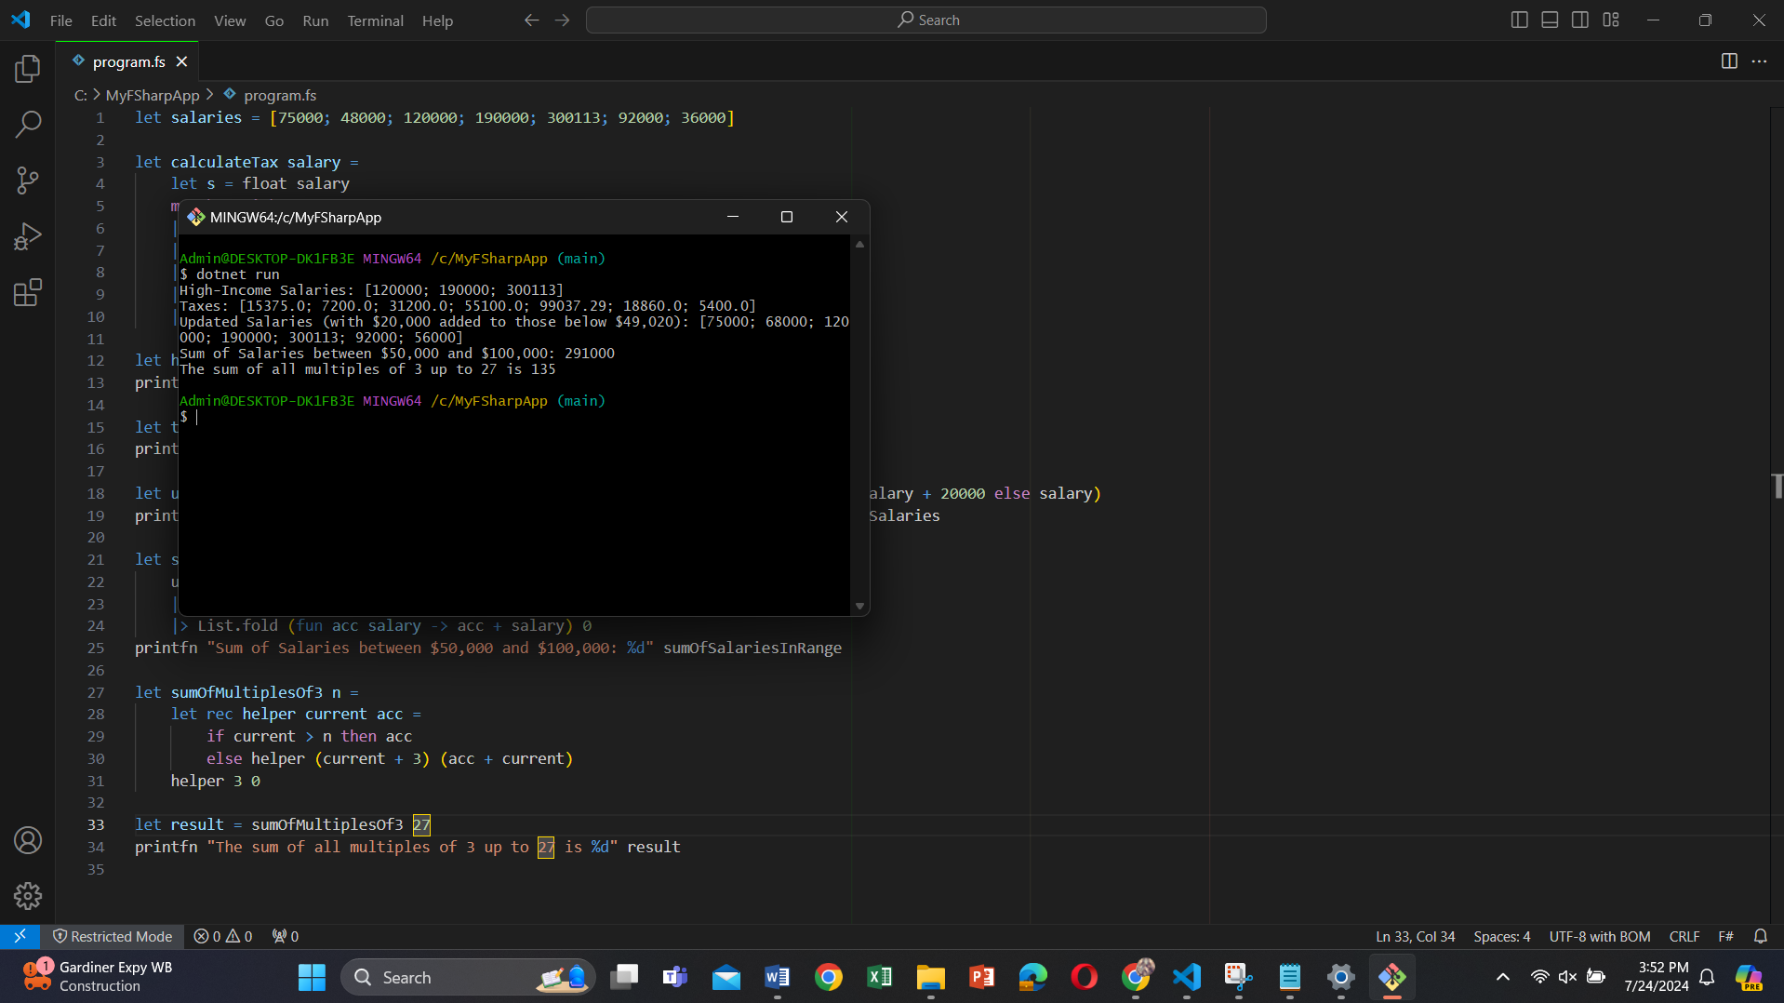

**Reference**

**……………………………………………………………………**