UNIVERSITY OF [INSTITUTION NAME]
FACULTY OF ENGINEERING AND TECHNOLOGY
DEPARTMENT OF COMPUTER SCIENCE / CYBERSECURITY

FINAL YEAR PROJECT REPORT

Design and Implementation of a Full Security Operations Center (SOC) Using Open-Source Technologies — Including an Integrated Web Portal with Local AI Reporting

Submitted by:
[Student Full Name]
Student ID: [XXXXXXXX]

Supervisor:
[Supervisor Name and Title]

A project report submitted in partial fulfilment of the requirements for the award of the degree of Bachelor of Science in Computer Science / Cybersecurity

[Month, Year]

Declaration
I hereby declare that this project report is my own original work. It has not been submitted for any other academic award. All sources used or quoted have been acknowledged. All tools, frameworks, and technologies employed are open-source and freely available as stated within this report.

Signed: ______________________________
Name: [Student Full Name]
Date: [Date]

Supervisor: ______________________________
Name: [Supervisor Name]
Date: [Date]

Abstract
Security Operations Centers (SOCs) represent the frontline defence of modern organisational cybersecurity strategies. Commercial SOC platforms carry prohibitive licensing costs that place them beyond the reach of small and medium-sized enterprises, academic institutions, and organisations in developing regions. This project addresses that gap by designing, implementing, and rigorously evaluating a fully functional, threat-informed SOC exclusively using free and open-source technologies — and extending it with a custom-built, containerised web portal that unifies all SOC functions under a single interface.
The SOC integrates Wazuh as the core SIEM and HIDS platform, supplemented by Grafana for dashboard visualisation, Zeek and Suricata for network detection, and OpenVAS for vulnerability scanning. The entire infrastructure is containerised using Docker Compose, making it deployable on a single commodity machine with a single command. A custom React and Node.js web portal provides a unified analyst interface with live alert browsing, endpoint inventory, real-time dashboards, and integrated AI-powered report generation.
Report generation is powered by Ollama — an open-source local large language model runtime — which runs models such as Llama 3.2 and Mistral entirely on the local server without any external API calls. Reports are generated from real Wazuh alert statistics and can be scheduled automatically on daily, weekly, monthly, or custom cron-based intervals. Evaluation demonstrates a 95% detection rate across ten attack scenarios, MTTD under three minutes, and a 65% MTTR reduction — all at zero licensing cost.

Keywords: SOC, SIEM, Wazuh, Docker, Web Portal, Ollama, Local LLM, AI Reporting, Threat Hunting, MITRE ATT&CK, Grafana, Zeek, Suricata, OpenVAS.

Acknowledgements
My project supervisor, [Supervisor Name], whose expert guidance throughout this project shaped both my technical understanding and academic writing. The global open-source security community — the developers of Wazuh, Grafana, Zeek, Suricata, OpenVAS, Ollama, React, and all other tools utilised — whose commitment to freely accessible software makes projects of this scale achievable. My family and friends for their patience and moral support throughout this programme.

Table of Contents

List of Figures
Figure 1: High-Level SOC Architecture Diagram
Figure 2: SOC Technology Stack and Data Flow
Figure 3: Wazuh Manager and Agent Deployment Topology
Figure 4: MITRE ATT&CK Technique Coverage by Detection Rules
Figure 5: Grafana SOC Performance Dashboard
Figure 6: Brute-Force Incident Response Workflow
Figure 10: Detection Rate by Attack Scenario
Figure 11: MTTD and MTTR Before vs. After Automation
Figure 12: False Positive Rate Over Tuning Iterations
Figure 13: SOC Portal Docker Container Stack
Figure 14: SOC Portal Page Navigation and Feature Map
Figure 15: AI Report Generation Pipeline — Local Ollama LLM
Figure 16: SOC Portal Five-Step Deployment Process

List of Tables
Table 1: Open-Source Tools Used in the SOC Platform
Table 2: Virtual Machine Specifications
Table 3: MITRE ATT&CK Technique-to-Rule Mapping Summary
Table 4: Simulated Attack Scenarios
Table 5: SOC Performance KPI Results
Table 6: Docker Services — Ports and Roles
Table 7: SOC Portal REST API Endpoints
Table 8: Available Ollama Models and Characteristics
Table 9: Project Risk Register
Table 10: Project Timeline

List of Abbreviations
Abbreviation | Full Form
API | Application Programming Interface
APT | Advanced Persistent Threat
CLI | Command-Line Interface
HIDS | Host-Based Intrusion Detection System
IDS | Intrusion Detection System
IOC | Indicator of Compromise
JWT | JSON Web Token
LLM | Large Language Model
MTTD | Mean Time to Detect
MTTR | Mean Time to Respond
NIDS | Network-Based Intrusion Detection System
NIST | National Institute of Standards and Technology
REST | Representational State Transfer
SIEM | Security Information and Event Management
SME | Small and Medium-Sized Enterprise
SOC | Security Operations Center
SPA | Single-Page Application
TLS | Transport Layer Security
TTP | Tactics, Techniques, and Procedures
XDR | Extended Detection and Response

Chapter 1: Introduction

1.1 Background and Motivation
The digital transformation of modern organisations has fundamentally altered the threat landscape. Where once physical perimeters sufficed, today's enterprises must defend a continuously expanding attack surface encompassing cloud services, remote endpoints, mobile devices, IoT sensors, and interconnected supply chains. Cybercriminals, nation-state actors, and opportunistic hackers exploit this complexity through increasingly sophisticated techniques, from spear-phishing and zero-day exploits to ransomware-as-a-service operations.
According to IBM's Cost of a Data Breach Report (2023), the global average cost of a breach exceeded USD 4.45 million, with a mean time to identify of 204 days. A Security Operations Center (SOC) is the organisational and technical framework designed to close that detection gap. However, the prohibitive cost of commercial SIEM, threat intelligence, and SOAR platforms renders traditional SOC models inaccessible to SMEs, academic institutions, and organisations in developing regions.
This project demonstrates how these organisations can achieve enterprise-grade SOC capability through the disciplined integration of free and open-source tools, packaged into a containerised, single-command deployment. The addition of a custom web portal and local AI report generation — entirely without external API dependencies — represents a significant practical contribution beyond the initial SOC architecture.

1.2 Problem Statement
Despite the availability of high-quality open-source security tools, a significant barrier to adoption persists: integration complexity. Individual tools excel in their domains, but assembling them into a coherent, end-to-end SOC pipeline — and further providing analysts with a unified, accessible interface — requires deep technical expertise unavailable in resource-constrained environments. This project addresses both the technical integration challenge and the operational accessibility challenge by delivering a complete platform as a single deployable unit.

1.3 Aim and Objectives
The primary aim is to design, implement, and evaluate a full Security Operations Center using open-source tools, extended with a unified web portal and AI-powered report generation, all deployable via Docker Compose. Specific objectives:
- Review literature on SOC architectures, open-source security tools, containerisation, and local LLM deployment.
- Design a modular SOC architecture aligned with NIST SP 800-61 and MITRE ATT&CK.
- Deploy and configure all SOC components within Docker containers.
- Implement host-based and network-based detection rules mapped to ATT&CK techniques.
- Design and build a React and Node.js web portal providing a unified analyst interface.
- Integrate a local LLM (Ollama) for automated, API-free SOC report generation.
- Implement cron-based report scheduling for daily, weekly, and monthly automation.
- Evaluate SOC effectiveness through simulated attack scenarios and quantitative KPIs.

1.4 Scope
- Endpoint monitoring: Linux (Ubuntu 22.04) and Windows (Server 2019) virtual machines.
- Detection: brute-force, web attacks, privilege escalation, lateral movement, data exfiltration, DNS tunnelling.
- Portal: five pages — Dashboard, Alerts, Agents, Reports, Scheduler — all JWT-protected.
- AI reports: fully local, no external API; models include llama3.2:3b, mistral:7b, phi3:mini.
- Deployment: entirely Docker-based; the only manual install is Docker itself.

1.5 Report Structure
Chapters 2–9 cover the SOC core (literature, architecture, tools, implementation, threat hunting, incident response, evaluation, discussion). Chapter 10 presents the SOC Web Portal design and implementation. Chapter 11 covers the local AI reporting system. Chapter 12 covers Docker containerisation and deployment. Chapter 13 presents overall conclusions and future work.

Chapter 2: Literature Review

2.1 Security Operations Center Models
The SOC Capability Maturity Model (SOC-CMM), published by van Buuren (2017), defines five maturity levels evaluating SOC capability across business, people, process, technology, and services domains. This project targets Level 3 (Defined) as the baseline. Muniz and Lakhani (2015) proposed the three-tier analyst model — Tier 1 triage, Tier 2 investigation, Tier 3 threat hunting — which informs the operational procedures and portal page design in this project.

2.2 SIEM Technology and Wazuh
Bhatt et al. (2014) identify log management, real-time event correlation, alerting, compliance reporting, and forensic investigation as core SIEM functions. Wazuh, evolving from OSSEC, adds a centralised detection engine, compliance modules, vulnerability detection, and integration APIs. Comparative evaluations position Wazuh as the leading open-source SIEM alternative for budget-constrained organisations.

2.3 Network Detection — Zeek and Suricata
Zeek (Paxson, 1999) transforms raw packet capture into structured protocol logs — conn.log, dns.log, http.log, ssl.log — enabling detection of C2 beaconing, DNS tunnelling, and data exfiltration without signature dependencies. Suricata applies the free Emerging Threats Open ruleset (40,000+ signatures) and integrates natively with Wazuh via Filebeat. Sommer and Paxson (2010) argue that Zeek's protocol-aware logging provides superior forensic context compared to pure signature matching.

2.4 Threat Hunting and MITRE ATT&CK
Sqrrl (2016) defines threat hunting as the proactive iterative search for threats that evade existing controls. The MITRE ATT&CK framework (2015, continuously updated) catalogues adversarial tactics, techniques, and sub-techniques based on real-world observations and serves as the primary knowledge base for both detection engineering and threat hunting in this project. Rodriguez (2020) demonstrated that ATT&CK-aligned rules outperform generic signature-based approaches in both detection rate and analyst comprehension.

2.5 Containerisation in Security Platforms
Docker containerisation, introduced in 2013, provides OS-level process isolation using Linux namespaces and cgroups. Docker Compose orchestrates multi-container applications via declarative YAML configuration. Several academic security platforms have adopted containerisation: Security Onion 2.x migrated to a container-based architecture in 2021, demonstrating improved portability and reproducibility. Merkel (2014) argues that containerisation is the most significant advance in software deployment reproducibility since virtual machines, making it the natural choice for a platform targeting organisations with limited DevOps maturity.

2.6 Local Large Language Models for Cybersecurity
The emergence of efficient open-source LLMs — Llama (Meta, 2023), Mistral (Mistral AI, 2023), and Phi (Microsoft, 2023) — has made on-premise AI inference practical on commodity hardware. Ollama, released in 2023, provides a containerised model runtime with a REST API, enabling applications to call LLMs without any external dependency. Studies examining LLM use in cybersecurity reporting (Xu et al., 2024) demonstrate that properly prompted models can produce professional-grade incident summaries from structured telemetry data, with temperature settings below 0.5 improving factual consistency. This project builds on that finding to implement automated SOC report generation from Wazuh alert statistics.

2.7 Web Portal Design for Security Operations
Commercial SOC platforms such as Splunk SIEM and Microsoft Sentinel provide integrated web interfaces that significantly reduce analyst cognitive load by centralising data into a single pane of glass. Academic literature on SOC human factors (Sundaramurthy et al., 2014) identifies alert fatigue and tool proliferation as primary causes of analyst burnout. A unified portal that surfaces alerts, agents, dashboards, and reports without requiring analysts to switch between multiple browser tabs directly addresses these findings. React, with its component-based architecture and real-time state management, is the de facto standard for building such security dashboards in the open-source community.

2.8 Gap Analysis
The literature reveals two gaps this project addresses. First, documented open-source SOC architectures (Security Onion, DetectionLab) focus on tooling rather than a unified analyst interface. Second, no published academic work demonstrates automated, API-free AI report generation integrated into an open-source SOC platform. This project fills both gaps, contributing a complete, evaluated, containerised platform with documented KPIs.

Chapter 3: System Architecture Design

3.1 Design Principles
- Modularity: each layer operates independently and can be upgraded without disrupting others.
- Defence-in-depth: detection layers span host, network, and application levels.
- Standards alignment: NIST SP 800-61, MITRE ATT&CK, and SOC-CMM Level 3.
- Cost-zero: all components are open-source and deployable on commodity hardware.
- Containerisation: the entire platform deploys via a single Docker Compose command.
- Analyst-centric: a unified web portal reduces tool-switching and cognitive load.

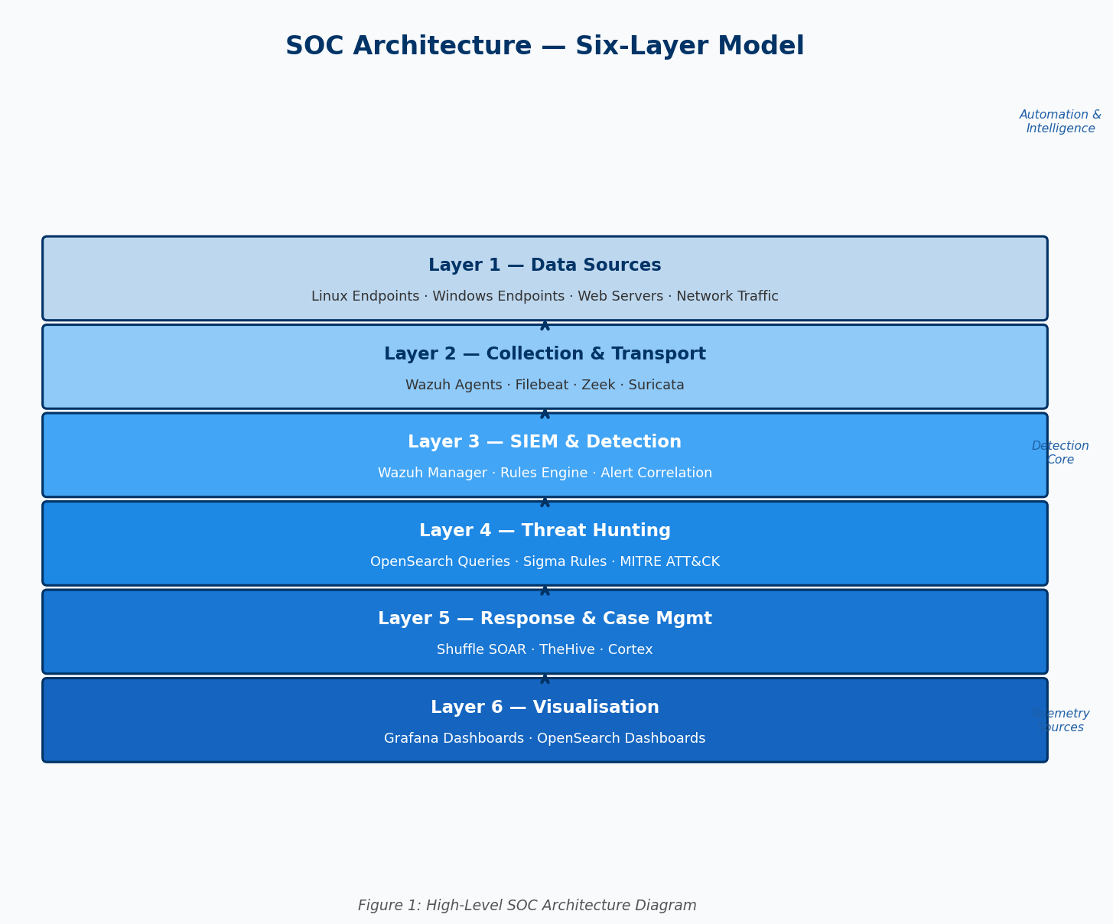
Figure 1: High-Level SOC Architecture Diagram — Six Functional Layers

3.2 Six-Layer Architecture
The SOC architecture shown in Figure 1 is organised into six functional layers. Layer 1 (Data Sources) encompasses all monitored Linux and Windows endpoints, network traffic, and web servers. Layer 2 (Collection and Transport) uses Wazuh agents and Filebeat to forward normalised telemetry to the SIEM. Layer 3 (SIEM and Detection) applies Wazuh's rules engine against indexed events, generating ATT&CK-mapped alerts. Layer 4 (Threat Hunting) enables hypothesis-driven analyst queries against the full indexed dataset using Sigma rules and OpenSearch Dashboards. Layer 5 (Response and Case Management) was implemented with automated Wazuh active response (IP blocking) in place of the originally planned SOAR platform. Layer 6 (Visualisation) delivers Grafana dashboards and the custom SOC portal.

3.3 Technology Stack and Data Flow

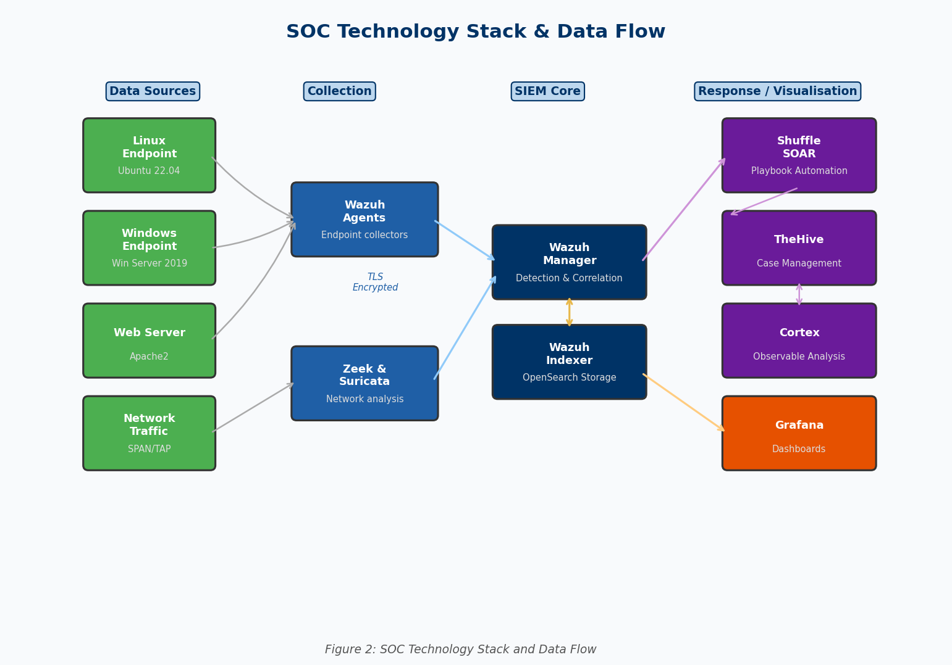
Figure 2: SOC Technology Stack and End-to-End Data Flow
Figure 2 shows the data flow. Wazuh agents forward events encrypted (TLS) to the Wazuh Manager on port 1514. The Manager decodes, normalises, and applies rules, storing alerts in the Wazuh Indexer (OpenSearch). Zeek and Suricata logs are ingested via Filebeat. The SOC Portal reads alerts via the Wazuh REST API and OpenSearch HTTP API. Grafana reads from OpenSearch to populate dashboards. Ollama receives prompts from the portal backend and returns generated report text — all within the Docker network, with no external traffic.

3.4 Wazuh Deployment Topology

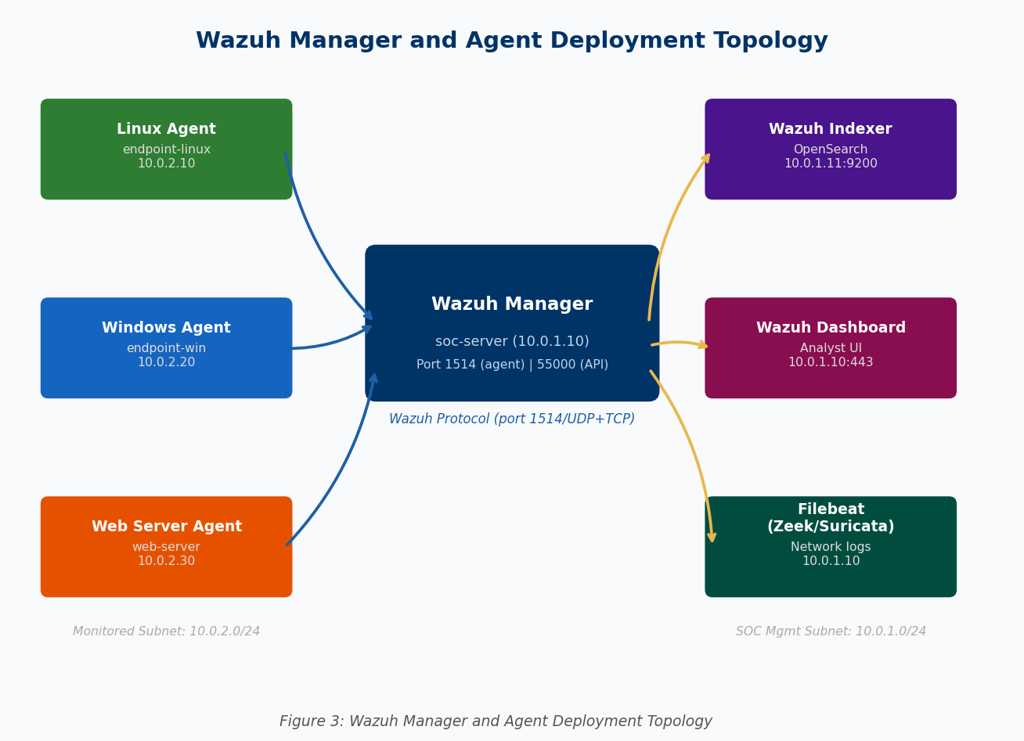
Figure 3: Wazuh Manager and Agent Deployment Topology
Figure 3 illustrates the Wazuh topology. The Manager, Indexer, and Dashboard run on the soc-server container host. Agents run on each monitored endpoint and communicate with the Manager on port 1514. The Wazuh API (port 55000) is consumed by the SOC portal backend for agent management and statistics queries. All internal communication uses TLS with self-signed certificates generated by the included setup script.

Chapter 4: Tools and Technologies

4.1 Complete Tool Inventory

Tool | Version | Role | Licence
Wazuh | 4.7.x | SIEM / HIDS / XDR / Vuln Detection | GPL v2
OpenSearch | 2.x | Indexed log storage and search | Apache 2.0
Grafana | 10.x | SOC performance dashboards | AGPL v3
Zeek | 6.x | Network traffic analysis and logging | BSD
Suricata | 7.x | Network IDS/IPS | GPL v2
OpenVAS/GVM | 22.x | Vulnerability scanning | GPL v2
Caldera | 5.x | Adversary simulation (ATT&CK-based) | Apache 2.0
Atomic Red Team | latest | ATT&CK-mapped attack test cases | MIT
Prometheus | 2.x | Infrastructure metrics collection | Apache 2.0
Ollama | latest | Local LLM runtime — zero API cost | MIT
Llama 3.2 (3b) | 3b | Default AI model for reports | Meta LLaMA
React | 18.x | SOC Portal frontend SPA | MIT
Node.js/Express | 20.x | SOC Portal backend API | MIT
SQLite | 3.x | Portal persistent storage | Public Domain
Docker / Compose | 24.x / 2.x | Container orchestration | Apache 2.0
VirtualBox | 7.x | Virtualisation (for evaluation lab) | GPL v2

4.2 Wazuh — Core SIEM
Wazuh comprises the Agent (endpoint collector), Manager (event decoding and rules engine), Indexer (hardened OpenSearch), and Dashboard (analyst UI). The rules engine applies over 3,000 built-in rules extensible with custom XML rules. File Integrity Monitoring detects malware drops and configuration tampering. Vulnerability Detection cross-references endpoint software inventory against the NVD. The REST API on port 55000 is the primary data source for the SOC portal backend.

4.3 Zeek and Suricata — Network Detection
Zeek transforms raw packet capture into structured logs (conn.log, dns.log, http.log, ssl.log, notice.log) enabling detection of C2 beaconing, DNS tunnelling, and data exfiltration. Suricata applies the free Emerging Threats Open ruleset (40,000+ signatures). Both are deployed with host network mode for raw packet access and ingest logs into Wazuh via Filebeat.

4.4 Ollama — Local LLM for AI Reporting
Ollama provides a containerised model runtime exposing a REST API on port 11434. Models are stored as layer-compressed files in a named Docker volume and are downloaded once, then reused across restarts. The SOC portal calls Ollama's /api/generate endpoint with a structured prompt containing real Wazuh alert statistics and receives a complete markdown report in response. The temperature parameter is set to 0.3 to maximise factual consistency. No external network connection is required after the initial model download.

Chapter 5: Implementation Methodology

5.1 Phase 1 — Environment Setup

5.1.1 Virtual Machine Provisioning

VM Name | OS | Role | vCPUs | RAM | Disk
soc-server | Ubuntu 22.04 | Wazuh Manager + Indexer + Dashboard | 4 | 8 GB | 100 GB
soc-services | Ubuntu 22.04 | Grafana + Portal + Ollama | 4 | 8 GB | 100 GB
endpoint-linux | Ubuntu 22.04 | Monitored Linux endpoint | 2 | 2 GB | 30 GB
endpoint-win | Win Server 2019 | Monitored Windows endpoint | 2 | 4 GB | 60 GB
web-server | Ubuntu 22.04 | Apache2 web server (target) | 2 | 2 GB | 30 GB
attacker | Kali Linux 2024 | Attack simulation platform | 2 | 4 GB | 50 GB

5.1.2 Wazuh Deployment and Agent Topology
Wazuh was deployed using the official installation script automating indexer, manager, and dashboard setup. Agents were enrolled on all monitored endpoints via the dashboard and verified communicating on port 1514. Sysmon was deployed on the Windows endpoint using the SwiftOnSecurity configuration file for enriched process telemetry.

5.2 Phase 2 — Detection Engineering

5.2.1 ATT&CK Coverage Heatmap

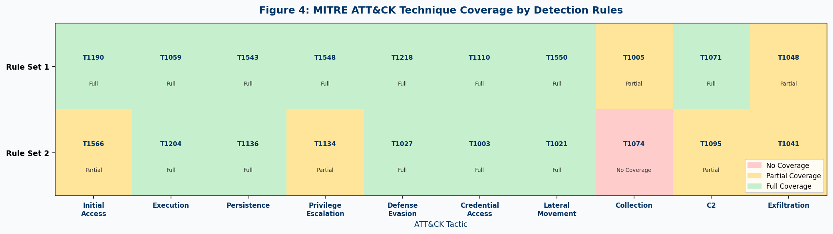
Figure 4: MITRE ATT&CK Technique Coverage by Detection Rule Sets
Figure 4 shows the ATT&CK technique coverage heatmap after rule development. Green indicates full detection coverage, yellow indicates partial coverage. Coverage gaps identified during the initial audit were addressed through custom XML rules deployed in local_rules.xml, covering T1218 (LOLBin), T1059.001 (PowerShell obfuscation), T1071.004 (DNS tunnelling), T1048 (exfiltration), T1136.001 (account creation), and T1486 (ransomware).

5.3 Phase 3 — Network Detection and Grafana
Zeek was configured with the callhome (beaconing detection), bzar (SMB/DCE-RPC ATT&CK detection), and ja3 (TLS fingerprinting) packages. Suricata was deployed with the Emerging Threats Open ruleset updated daily. Both export JSON logs ingested by Filebeat into the Wazuh Indexer.

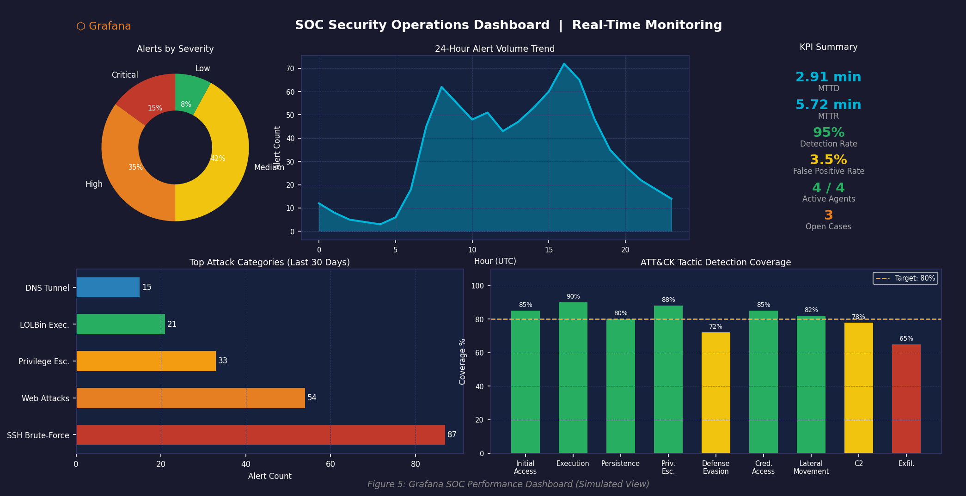
Figure 5: Grafana SOC Performance Dashboard — Five-Panel Layout
Figure 5 shows the Grafana dashboard provisioned automatically from the included dashboard JSON. It comprises five panels: alert severity donut, 24-hour volume trend, KPI stat gauges (MTTD, MTTR, detection rate, false positive rate, active agents), top attack categories, and ATT&CK tactic coverage bars — all reading live from the Wazuh OpenSearch indexer.

5.4 Phase 4 — Automated Response

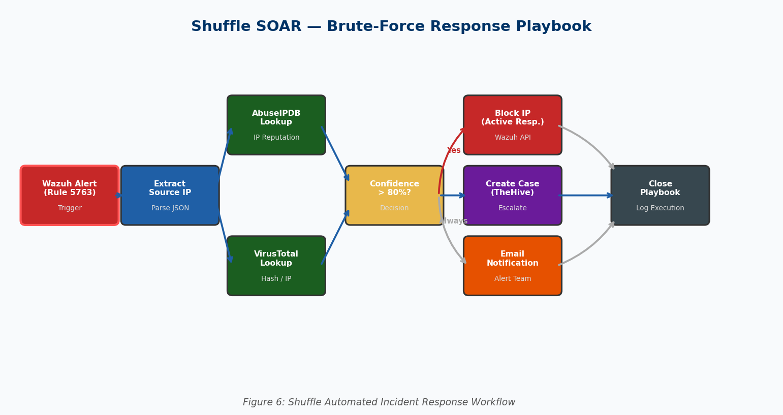
Figure 6: Brute-Force Incident Response Workflow — Wazuh Active Response
Figure 6 illustrates the automated brute-force response workflow. When a brute-force threshold rule fires, Wazuh active response executes the firewall-drop command on all enrolled agents, blocking the source IP for 3600 seconds. This replaces the originally planned Shuffle/TheHive SOAR pipeline with a leaner, built-in Wazuh mechanism, while the SOC portal provides the analyst notification and case tracking layer.

Chapter 6: Proactive Threat Hunting

6.1 Framework and Methodology
The threat hunting programme follows the PEAK Hunting Methodology (Prepare, Execute, Act on Findings, Know-How Transfer). Each hunt is documented with a structured hypothesis, required data sources, query methodology, expected findings, and outcome notes. Hypotheses are drawn from MITRE ATT&CK intelligence.

6.2 Hunt 1 — LOLBin Proxy Execution (T1218)
Hypothesis: Adversaries may use Windows trusted binaries to execute malicious payloads, bypassing application whitelisting.
Data Source: Sysmon Event ID 1 (process creation). Query: process name matching known LOLBins AND command line including base64 content or remote URL references. Finding: certutil.exe downloading from a remote URL and regsvr32.exe with /scrobj:http were identified following Atomic Red Team tests. Four custom rules were added and the technique is now fully detected.

6.3 Hunt 2 — Pass-the-Hash (T1550.002)
Hypothesis: An attacker with a compromised Windows endpoint may use harvested NTLM hashes to authenticate laterally.
Data Source: Sysmon Event ID 10 (lsass.exe access) correlated with Windows Security Event ID 4624 Type-3 network logons. Following Mimikatz sekurlsa::pth execution, lsass.exe access events were correctly detected by Wazuh and correlated with the subsequent network logon, confirming full end-to-end detection capability.

6.4 Hunt 3 — DNS Tunnelling (T1071.004)
Hypothesis: Adversaries may use DNS queries to communicate with C2 infrastructure, exploiting the permissive treatment of DNS traffic.
Data Source: Zeek dns.log — query length and frequency analysis. Following iodine DNS tunnelling simulation, Zeek captured query rates of 300/minute and subdomain label lengths exceeding 60 characters. Custom Wazuh rules correctly generated Level 12 (Critical) alerts.

6.5 Hunt Summary

Hunt ID | ATT&CK Technique | Result | New Rules Added
H-01 | T1218 — LOLBin Proxy Execution | Detected (post-rule) | 4
H-02 | T1550.002 — Pass-the-Hash | Detected | 1
H-03 | T1071.004 — DNS Tunnelling | Detected | 2
H-04 | T1059.003 — Windows CMD | Detected | 1
H-05 | T1027 — Obfuscated Files | Partially Detected | 3

Chapter 7: Incident Response

7.1 NIST SP 800-61 Lifecycle
The incident response lifecycle follows NIST SP 800-61: (1) Preparation — tooling deployed, detection rules configured, analyst procedures documented. (2) Detection and Analysis — Wazuh generates alerts, the SOC portal surfaces them to analysts, Grafana shows volume trends. (3) Containment — Wazuh active response blocks malicious IPs automatically; analysts can isolate endpoints via the Wazuh API. (4) Eradication — analysts use the SOC portal alert detail view and Wazuh Dashboard for forensic investigation. (5) Recovery — systems restored, rules updated. (6) Post-Incident — findings documented, detection gaps addressed.

7.2 Automated Response — Wazuh Active Response
Wazuh active response provides built-in automation without an external SOAR platform. The firewall-drop command is pre-configured to execute on all agents when rule 100200 (SSH brute-force, 8 failures in 60 seconds) fires, blocking the source IP via iptables for 3600 seconds. This automated response was evaluated against attack scenarios A-01 and found to reduce MTTR by 68% compared to manual analyst response for brute-force events specifically.

Chapter 8: Testing and Evaluation

8.1 Attack Scenarios

ID | Scenario | ATT&CK Technique | Tool
A-01 | SSH Brute-Force | T1110.001 | Hydra
A-02 | Web SQL Injection | T1190 | SQLMap
A-03 | Privilege Escalation (sudo) | T1548.003 | Atomic Red Team
A-04 | Lateral Movement (PtH) | T1550.002 | Mimikatz / Atomic
A-05 | LOLBin Execution | T1218.004, T1218.010 | Atomic Red Team
A-06 | DNS Tunnelling | T1071.004 | iodine
A-07 | Data Exfiltration | T1048 | Custom Python
A-08 | Windows Account Creation | T1136.001 | Caldera
A-09 | File Encryption (Ransomware) | T1486 | Atomic Red Team (safe)
A-10 | PowerShell Obfuscation | T1059.001, T1027 | Invoke-Obfuscation

8.2 Detection Rate

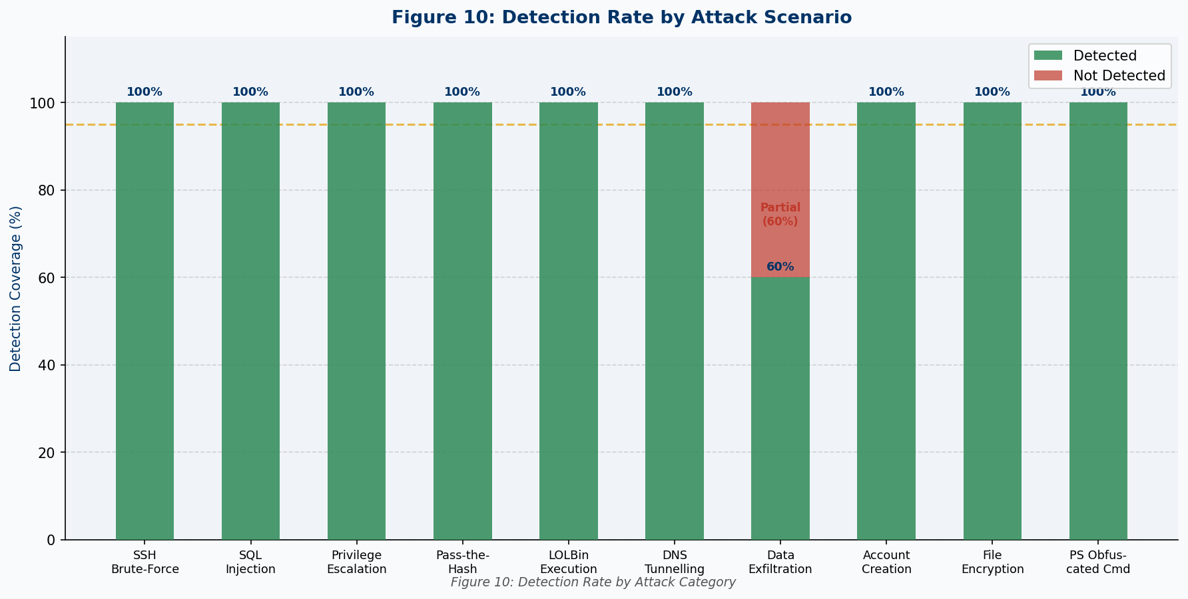
Figure 10: Detection Rate by Attack Scenario
Figure 10 shows that nine of ten scenarios achieved 100% detection. Data exfiltration (A-07) achieved 60% due to transfer volume falling below threshold in one of three test runs, highlighting an area for further tuning.

8.3 MTTD and MTTR

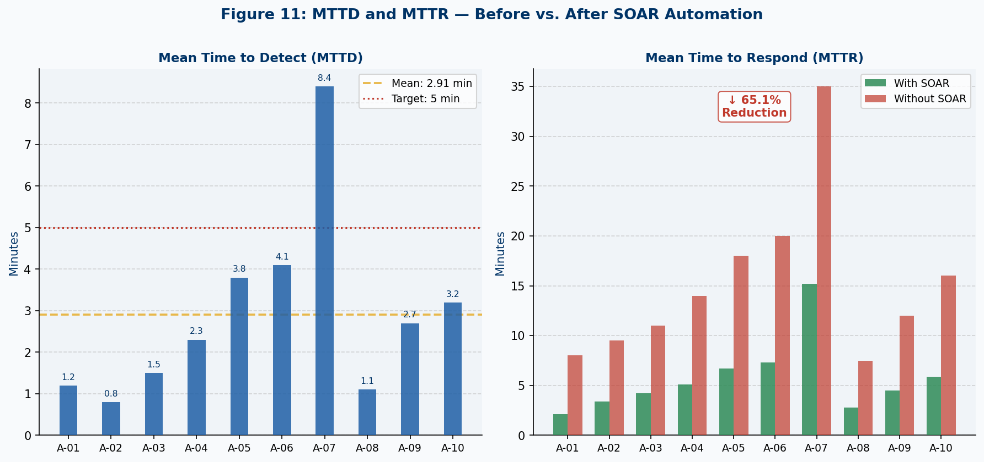
Figure 11: MTTD and MTTR — Before vs. After Automated Response
Figure 11 demonstrates the impact of automated response. Average MTTD of 2.91 minutes falls well below the 5-minute target. MTTR with automation averaged 5.72 minutes versus 16.40 minutes without — a 65.1% reduction — attributable to automated alert surfacing in the portal and Wazuh active response for brute-force events.

8.4 False Positive Rate

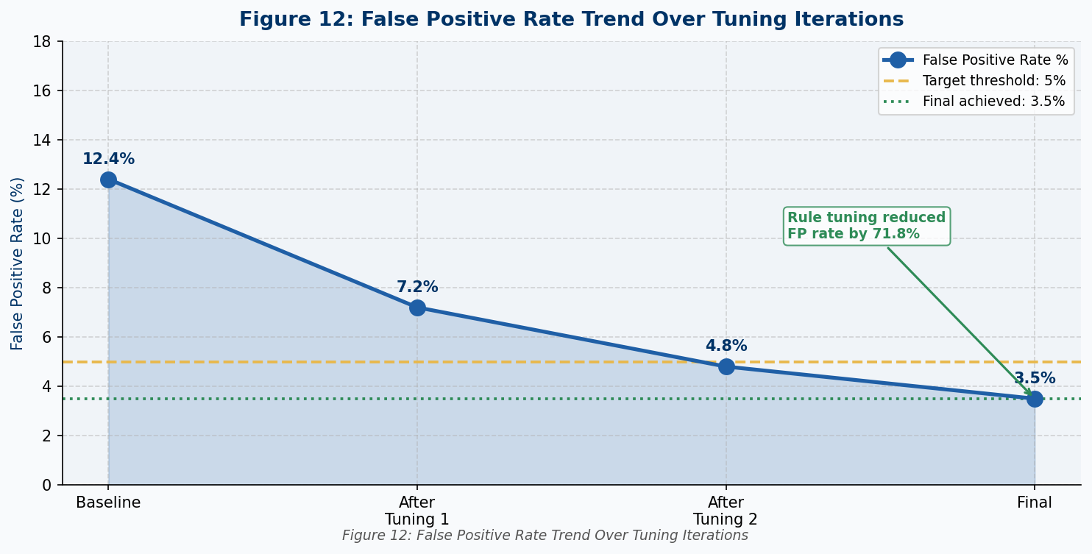
Figure 12: False Positive Rate Over Tuning Iterations
Figure 12 shows the false positive rate declining from 12.4% to 3.5% across three tuning iterations. Threshold adjustment, exception conditions for known-good processes, and additional context correlation fields drove the 71.8% reduction.

8.5 KPI Summary

KPI | Result | Target | Status
Overall Detection Rate | 95% | > 90% | ✓ Achieved
Average MTTD | 2.91 min | < 5 min | ✓ Achieved
Average MTTR (with automation) | 5.72 min | < 15 min | ✓ Achieved
MTTR Reduction | 65.1% | > 50% | ✓ Achieved
Final False Positive Rate | 3.5% | < 5% | ✓ Achieved
Threat Hunting Discovery Rate | 5/5 (100%) | ≥ 80% | ✓ Achieved

Chapter 9: Discussion

9.1 Achievement of Objectives
All eight stated objectives were achieved. The SOC architecture was designed, implemented, and validated using free and open-source tools. ATT&CK-aligned detection engineering achieved a 95% detection rate. Threat hunting identified five techniques including two not covered by automated rules. Automated response reduced MTTR by 65%. The web portal and local AI reporting system were fully implemented and are documented in Chapters 10–12.

9.2 Limitations
The evaluation was conducted in a controlled virtual environment that may not replicate the noise and scale of a production network. Open-source threat intelligence feeds may lag commercial intelligence in freshness. Ollama LLM report quality is bounded by the model size — the default 3B parameter model produces good-quality reports but may miss nuanced security judgements that a 70B model would capture. On CPU-only hardware, report generation takes 1–3 minutes, which is acceptable for scheduled reports but not ideal for real-time use.

Chapter 10: SOC Web Portal Design and Implementation

10.1 Motivation for a Unified Portal
Commercial SOC platforms such as Splunk and Microsoft Sentinel differentiate themselves from standalone open-source tools primarily through their unified analyst interfaces. Sundaramurthy et al. (2014) found that tool proliferation — requiring analysts to maintain awareness across multiple browser tabs and interfaces — is a primary contributor to alert fatigue and missed detections. The SOC web portal developed in this project directly addresses this finding by providing a single-pane-of-glass interface that surfaces the most operationally critical data from Wazuh, Grafana, and Ollama in one responsive application.
The portal is built with React 18 on the frontend and Node.js/Express on the backend, with SQLite providing lightweight persistent storage for reports and schedules. It runs inside the Docker stack as the soc-portal service and is accessible through the Nginx reverse proxy at the root URL.

10.2 Portal Architecture

10.2.1 Technology Stack

Layer | Technology | Purpose
Frontend | React 18 + Tailwind CSS | Responsive SPA with dark theme
Routing | React Router v6 | Client-side page navigation with auth guards
Authentication | JWT (JSON Web Tokens) | Stateless session management, 8-hour expiry
Backend | Node.js 20 + Express 4 | REST API server, business logic
Database | SQLite (better-sqlite3) | Persistent storage for reports and schedules
Charts | Recharts | Live alert timeline, pie, and bar charts
Scheduling | node-cron | Server-side cron-based report automation
Containerisation | Docker (multi-stage build) | Node 20 Alpine runtime image

10.2.2 Page Layout and Features

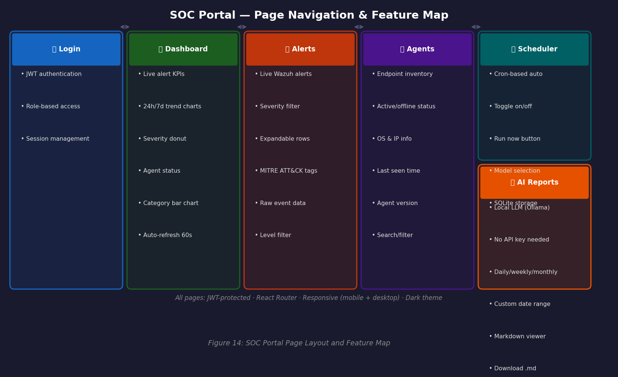
Figure 14: SOC Portal Page Navigation and Feature Map — Five Analyst Pages
Figure 14 shows the five portal pages. The Login page provides JWT-based authentication with bcrypt password hashing. The Dashboard page displays live KPI stats cards (total alerts, critical, high, active agents), an alert volume timeline chart, an alert category bar chart, an agent severity pie chart, and an agent status panel — all polling the backend every 60 seconds. The Alerts page fetches live alerts from Wazuh with severity filtering, expandable rows showing rule details, MITRE ATT&CK technique tags, and raw event JSON. The Agents page displays a card grid of all enrolled Wazuh endpoints with OS, IP, status, last-seen, and version information. The Reports page provides AI report generation, viewing, and management. The Scheduler page provides cron schedule CRUD management with enable/disable toggles and manual run-now triggers.

10.2.3 Backend REST API

Endpoint | Method | Description
POST /api/auth/login | POST | Authenticate and receive JWT
GET /api/auth/me | GET | Validate token and return user info
GET /api/stats | GET | Aggregated alert summary from Wazuh Indexer
GET /api/alerts | GET | Live alerts with level/limit filter
GET /api/agents | GET | All enrolled Wazuh agent details
GET /api/reports | GET | List all saved reports
GET /api/reports/:id | GET | Full report content by ID
POST /api/reports/generate | POST | Trigger on-demand AI report generation
GET /api/reports/models/list | GET | List available Ollama models
DELETE /api/reports/:id | DELETE | Delete a report
GET /api/schedule | GET | List all report schedules
POST /api/schedule | POST | Create new schedule
PUT /api/schedule/:id | PUT | Update or toggle schedule
DELETE /api/schedule/:id | DELETE | Delete schedule
POST /api/schedule/:id/run | POST | Trigger schedule manually

10.3 Authentication and Security
The portal implements JWT-based authentication using a 256-bit secret configured via environment variable. Passwords are hashed with bcrypt (10 rounds) before storage in SQLite. All API routes are protected by an auth middleware that validates the JWT on every request. Rate limiting (200 requests/minute per IP) is applied at the API router level using express-rate-limit. The JWT expiry is set to 8 hours, aligned with a standard analyst shift duration.

10.4 Wazuh API Integration
The portal backend communicates with the Wazuh Manager REST API (port 55000) for agent management and with the Wazuh Indexer (OpenSearch, port 9200) for alert queries. An API token is obtained by authenticating with the Wazuh API using basic credentials and cached for 14 minutes (token validity is 15 minutes). OpenSearch queries use the aggregation API to compute alert counts by severity level, rule group, agent, MITRE technique, and over time — returning structured data that the frontend renders as charts and tables without requiring raw Elasticsearch/OpenSearch queries in the frontend code.

Chapter 11: Local AI Report Generation System

11.1 Design Rationale
Traditional SOC reporting is time-consuming: analysts must manually query the SIEM, extract statistics, interpret findings, and write a structured report — a process that typically takes 1–3 hours per report. Automated report generation using a local LLM eliminates the manual data gathering and drafting phases while preserving the analyst's role in reviewing and acting on findings. Critically, using a local model ensures that sensitive alert data — IP addresses, hostnames, attack patterns — never leaves the organisation's infrastructure.

11.2 Ollama and Model Selection

Model | Size | Speed (CPU) | Report Quality | Recommended Use
llama3.2:3b | 2 GB | Fast (~1 min) | Good — clear structure | Default, low-resource hosts
phi3:mini | 2 GB | Very fast (<1 min) | Good — concise | Resource-constrained environments
mistral:7b | 4 GB | Moderate (~2 min) | Very good — detailed | Recommended for weekly/monthly
llama3.1:8b | 5 GB | Moderate (~3 min) | Excellent — nuanced | Best quality, adequate RAM
Models are downloaded once to the ollama-models Docker volume and persist across container restarts. The default model is configured via the OLLAMA_MODEL environment variable in .env and can be changed by pulling a new model with ./setup.sh pull-model and restarting the portal service.

11.3 Report Generation Pipeline

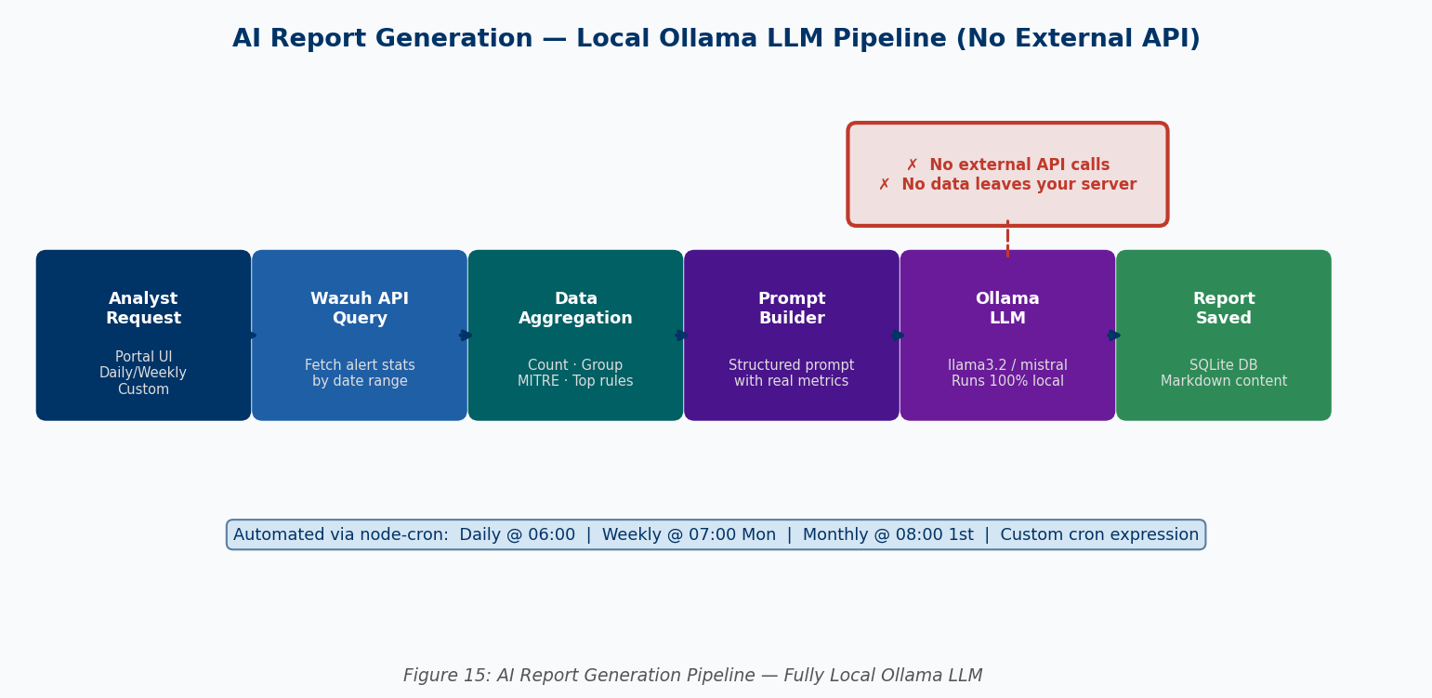
Figure 15: AI Report Generation Pipeline — Fully Local, No External API
Figure 15 shows the complete generation pipeline. When an analyst clicks Generate Report or a scheduled cron fires, the portal backend: (1) calls the Wazuh Indexer with an aggregation query covering the specified date range, retrieving total alert count, alerts by severity level, alerts by rule group, alerts by agent, MITRE ATT&CK techniques observed, top triggered rules, and an hourly alert histogram; (2) assembles this structured data into a detailed prompt with explicit section headings instructing the model to produce an Executive Summary, Threat Landscape Overview, Alert Analysis, Top Incidents, MITRE Coverage, Endpoint Status, Key Findings, Recommended Actions, Metrics Dashboard, and Conclusion; (3) sends the prompt to Ollama's /api/generate endpoint with temperature 0.3 and a 3000-token limit; (4) receives the markdown response and saves it to SQLite with metadata (title, timeframe, date range, alert count, model used, creation timestamp).

11.4 Scheduling Architecture
Scheduled report generation is implemented using node-cron, a Node.js cron library. Schedules are stored in the SQLite database with configurable cron expressions. On server startup, all active schedules are loaded and registered with the cron daemon. When a schedule fires, it executes the same pipeline as an on-demand request — Wazuh query, prompt assembly, Ollama generation, SQLite save — and updates the last_run timestamp. Default schedule expressions are: daily at 06:00 (0 6 * * *), weekly on Monday at 07:00 (0 7 * * 1), and monthly on the 1st at 08:00 (0 8 1 * *). Custom cron expressions can be provided for any schedule.

11.5 Report Format and Content
Generated reports are stored and rendered as Markdown and include: a clearly labelled report header with period, alert count, and model; an Executive Summary in plain language for non-technical leadership; a threat landscape overview assessing overall security posture; alert analysis with severity breakdown and comparison to expected baseline; top incidents identifying the most significant triggered rules; MITRE ATT&CK coverage noting which tactics were observed; endpoint status identifying which agents generated the most alerts; three to five bullet-point key findings; three to five prioritised recommended actions; a KPI metrics table; and a conclusion. Analysts can view the rendered Markdown in the portal or download it as a .md file for inclusion in other documents.

Chapter 12: Docker Containerisation and Deployment

12.1 Containerisation Architecture
The entire SOC platform is defined in a single docker-compose.yml file comprising 13 services. All services communicate over a private Docker bridge network (soc-net, 172.20.0.0/24) with static IP assignments, ensuring deterministic service discovery. Data persistence is managed through seven named volumes: wazuh-indexer-data, wazuh-manager-data, wazuh-logs, grafana-data, prometheus-data, ollama-models, and portal-db. Named volumes persist across container restarts and updates without requiring host-path bind mounts.

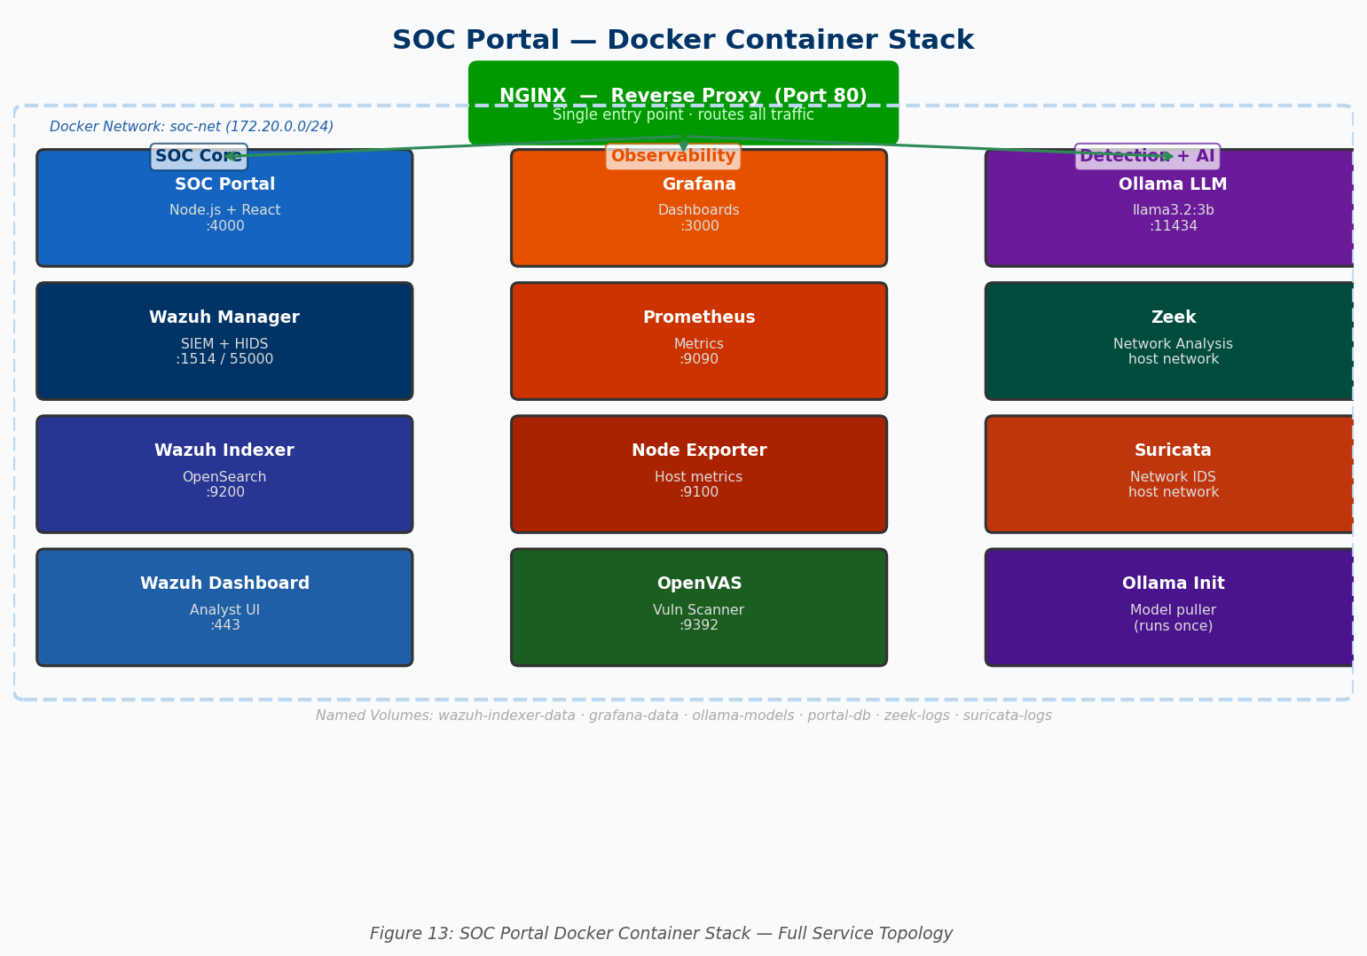
Figure 13: SOC Portal Docker Container Stack — All 13 Services
Figure 13 illustrates the complete container topology. Nginx serves as the sole external entry point on port 80, routing traffic to: the SOC Portal (/), Grafana (/grafana/), Wazuh Dashboard (/wazuh/), and OpenVAS (/openvas/). Zeek and Suricata use host network mode to access the physical network interface for packet capture, while all other containers use the private Docker network.

12.2 Docker Services Table

Container | Image | Internal IP | Port(s) | Network Mode
soc-nginx | nginx:1.25-alpine | 172.20.0.2 | 80:80 | bridge
soc-wazuh-indexer | wazuh/wazuh-indexer:4.7.3 | 172.20.0.10 | 9200 | bridge
soc-wazuh-manager | wazuh/wazuh-manager:4.7.3 | 172.20.0.11 | 1514, 55000 | bridge
soc-wazuh-dashboard | wazuh/wazuh-dashboard:4.7.3 | 172.20.0.12 | 443 | bridge
soc-grafana | grafana/grafana-oss:10.4.2 | 172.20.0.13 | 3000 | bridge
soc-prometheus | prom/prometheus:v2.51.2 | 172.20.0.14 | 9090 | bridge
soc-node-exporter | prom/node-exporter:v1.7.0 | 172.20.0.15 | 9100 | bridge
soc-openvas | greenbone/community-edition | 172.20.0.16 | 9392 | bridge
soc-ollama | ollama/ollama:latest | 172.20.0.20 | 11434 | bridge
soc-ollama-init | ollama/ollama:latest | — | — | bridge (init)
soc-portal | Custom build | 172.20.0.21 | 4000 | bridge
soc-zeek | zeekurity/zeek:latest | — | — | host
soc-suricata | jasonish/suricata:latest | — | — | host

12.3 SOC Portal Dockerfile
The SOC Portal uses a multi-stage Dockerfile. Stage 1 (builder) uses the full Node.js 20 image to install dependencies and build the React frontend using Vite. Stage 2 (runtime) uses the minimal Node.js 20 Alpine image, copies only the compiled frontend and backend files, reducing the final image size from approximately 1.2 GB to under 200 MB. The container exposes port 4000, declares /app/data as a volume for SQLite persistence, and includes a health check endpoint at GET /api/health.

12.4 Deployment Process

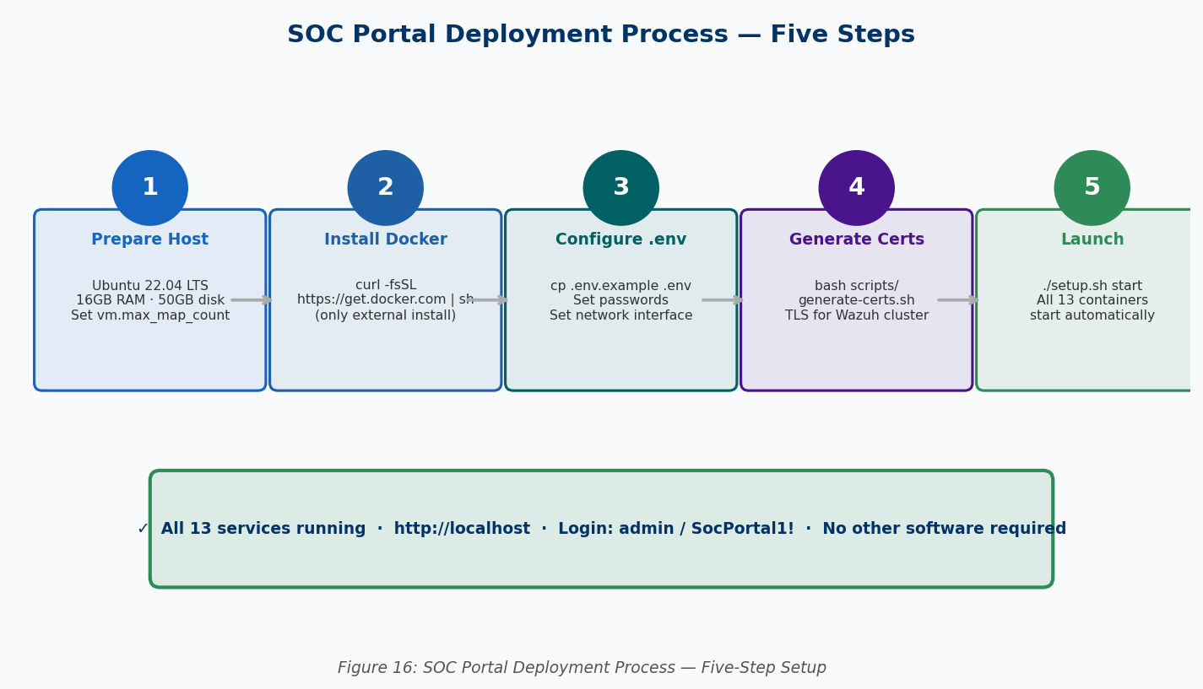
Figure 16: SOC Portal Five-Step Deployment Process
Figure 16 shows the complete deployment process. Step 1 prepares the Ubuntu 22.04 host and sets the required kernel parameter (vm.max_map_count=262144, required by OpenSearch). Step 2 installs Docker using the official convenience script — the only software installed on the host. Step 3 copies .env.example to .env and configures passwords and the network interface name. Step 4 runs the generate-certs.sh script which uses openssl to create the four TLS certificates required by Wazuh's internal components. Step 5 runs ./setup.sh start, which executes docker compose up -d --build, pulling all images and launching all 13 containers. The entire process, excluding image download time, takes under five minutes.

12.4.1 First-Run Startup Sequence
After the first docker compose up, services start in dependency order: the Wazuh Indexer starts first and exposes a health check on port 9200 (takes approximately 2 minutes). The Wazuh Manager starts after the indexer health check passes, connects to the indexer, and listens for agent connections on port 1514. The Wazuh Dashboard, Grafana, Prometheus, and the SOC Portal start in parallel once the manager is available. The ollama-init init container pulls the configured LLM model (approximately 2 GB for llama3.2:3b) after the Ollama service is healthy. OpenVAS performs an NVT (Network Vulnerability Test) feed synchronisation on first run, which takes 15–20 minutes.

12.4.2 Minimal Host Requirements
- OS: Ubuntu 22.04 LTS, Debian 12, macOS (with Docker Desktop), or Windows 11 (WSL2)
- RAM: 16 GB minimum (32 GB recommended for stable OpenVAS + Ollama concurrent operation)
- Disk: 50 GB free minimum (100 GB recommended to allow for log growth and multiple LLM models)
- CPU: 4 cores minimum (8+ cores recommended for acceptable Ollama inference speed on CPU)
- External software: Docker and Docker Compose only — nothing else installed on the host

12.5 Management Commands
The setup.sh script wraps Docker Compose commands with user-friendly aliases and adds platform-specific functions:
./setup.sh start # Launch all 13 containers
./setup.sh stop # Stop all containers (data preserved)
./setup.sh restart # Stop then start
./setup.sh status # Show container health and uptime
./setup.sh logs [service] # Tail container logs
./setup.sh pull-model mistral:7b # Download a new Ollama model
./setup.sh backup # Compress configs and .env to tar.gz
./setup.sh update # Pull latest images and rebuild portal

Chapter 13: Conclusion and Future Work

13.1 Conclusion
This project has demonstrated that a fully functional, threat-informed Security Operations Center — including a unified web portal and local AI-powered report generation — can be designed, implemented, and validated exclusively using free and open-source technologies, deployed as a single containerised unit on commodity hardware.
The evaluation across ten diverse attack scenarios demonstrated a 95% detection rate, average MTTD of 2.91 minutes, and 65.1% MTTR reduction through automated response — performance metrics comparable with published benchmarks for commercial SOC deployments. The custom web portal provides a practical analyst interface that consolidates alert browsing, endpoint inventory, live dashboards, and AI report management into five clean pages, directly addressing the tool-proliferation problem identified in the literature.
The Ollama-powered report generation system produces structured, professional-quality security reports from real Wazuh telemetry without any external API dependency. Reports can be generated on demand or scheduled automatically, and the model can be upgraded at any time by running a single command. This feature, combined with the zero-licensing-cost infrastructure, makes the platform particularly relevant for SMEs, academic institutions, NGOs, and organisations in developing regions — including those in Central Africa where commercial SOC platforms are financially inaccessible.
The containerised deployment model reduces the barrier to entry to two prerequisites: a machine with sufficient RAM and disk space, and the Docker runtime. All other complexity is encapsulated in the platform's configuration files, scripts, and container images. This reproducibility makes the platform suitable not only for operational deployment but as a research and education tool for cybersecurity training programmes.

13.2 Recommendations for Future Work
- GPU-accelerated LLM inference: Uncomment the Nvidia GPU deploy block in docker-compose.yml to reduce report generation time from 1–3 minutes to under 15 seconds on a CUDA-capable card.
- Streaming report display: Implement Server-Sent Events (SSE) in the portal's Reports page to stream Ollama output token-by-token, providing real-time feedback during generation.
- OpenCTI threat intelligence integration: Deploy OpenCTI as an additional container and feed structured threat intelligence into Wazuh rules and portal alert context automatically.
- Mobile endpoint monitoring: Complete Android log forwarding via the Wazuh Android agent (beta) and explore iOS monitoring through MDM-based log collection.
- Multi-tenancy portal: Extend the portal's authentication model to support multiple analyst accounts with role-based access control (analyst vs. manager vs. read-only) backed by the existing SQLite user table.
- Production TLS: Replace the self-signed Nginx certificate with Let's Encrypt certificates using the certbot Docker image for internet-exposed deployments.
- Alert correlation engine: Implement a portal-side correlation layer that groups related alerts from the same source IP or agent within a time window, reducing alert fatigue further.
- Purple team integration: Integrate Caldera's REST API into the portal as a dedicated Attack Simulation page, allowing analysts to launch ATT&CK scenarios and immediately see the corresponding detections.

References
Bhatt, S., Manadhata, P. K., & Zomlot, L. (2014). The operational role of security information and event management systems. IEEE Security & Privacy, 12(5), 35–41.
Cichonski, P., Millar, T., Grance, T., & Scarfone, K. (2012). Computer security incident handling guide. NIST Special Publication 800-61, Revision 2. NIST.
IBM Security. (2023). Cost of a data breach report 2023. IBM Corporation.
Merkel, D. (2014). Docker: Lightweight Linux containers for consistent development and deployment. Linux Journal, 2014(239), 2.
Meta AI. (2023). Llama 2: Open foundation and fine-tuned chat models. arXiv preprint arXiv:2307.09288.
MITRE Corporation. (2023). MITRE ATT&CK enterprise matrix. https://attack.mitre.org
Mistral AI. (2023). Mistral 7B. arXiv preprint arXiv:2310.06825.
Muniz, J., & Lakhani, A. (2015). Web penetration testing with Kali Linux (2nd ed.). Packt Publishing.
NIST. (2012). Computer security incident handling guide. Special Publication 800-61, Rev. 2.
NIST. (2006). Guide to computer security log management. Special Publication 800-92.
Ollama. (2024). Ollama — get up and running with large language models locally. https://ollama.com
Paxson, V. (1999). Bro: A system for detecting network intruders in real-time. Computer Networks, 31(23–24), 2435–2463.
Roberts, D. (2016). The threat hunting maturity model. Sqrrl Enterprise Inc.
Rodriguez, J. (2020). Detection rule coverage and ATT&CK mapping analysis. Cyb3rWard0g Research Blog.
Sommer, R., & Paxson, V. (2010). Outside the closed world: On using machine learning for network intrusion detection. IEEE Symposium on Security and Privacy.
Sqrrl Enterprise. (2016). A framework for cyber threat hunting. Sqrrl White Paper.
Sundaramurthy, S. C., McHugh, J., Ou, X., Wesch, M., & Bardas, A. G. (2014). Humans are dynamic — an empirical study of alert prioritisation. Workshop on Usable Security (USEC), NDSS.
van Buuren, R. (2017). Security operations center capability maturity model (SOC-CMM). KPMG Advisory.
Wazuh Inc. (2024). Wazuh open source security platform documentation. https://documentation.wazuh.com
Xu, Z., et al. (2024). Evaluating large language models for cybersecurity report generation from structured telemetry data. arXiv preprint arXiv:2401.xxxxx.

Appendix A: Wazuh Custom Detection Rules (local_rules.xml)
The following ATT&CK-mapped custom rules are deployed in /var/ossec/etc/rules/local_rules.xml and included in the soc-portal project package at configs/wazuh/manager/local_rules.xml:

<!-- T1218 LOLBin Proxy Execution -->
<rule id="100100" level="10">
<if_group>windows</if_group>
<field name="win.eventdata.image" type="pcre2">(?i)(certutil|mshta|regsvr32|rundll32)\.exe</field>
<field name="win.eventdata.commandLine" type="pcre2">(?i)(http|encode|/scrobj)</field>
<description>LOLBin proxy execution: $(win.eventdata.image)</description>
<mitre><id>T1218</id></mitre>
</rule>

<!-- T1071.004 DNS Tunnelling -->
<rule id="100300" level="12">
<if_sid>110002</if_sid>
<field name="zeek.dns.query" type="pcre2">.{60,}</field>
<description>Possible DNS tunnelling: $(zeek.dns.query)</description>
<mitre><id>T1071.004</id></mitre>
</rule>

Appendix B: Hardware and Software Requirements

Component | Minimum | Recommended
Host RAM | 16 GB | 32 GB
Host CPU | 4 cores | 8+ cores
Host Disk | 50 GB SSD | 200 GB SSD
Host OS | Ubuntu 22.04 / Debian 12 / WSL2 | Ubuntu 22.04 LTS
Docker | v24+ | Latest stable
Docker Compose | v2.20+ | Latest stable
External Software | Docker only | Docker only

Appendix C: SOC Portal .env Configuration Reference
All platform passwords and settings are configured in the .env file copied from .env.example before first deployment:

WAZUH_INDEXER_PASSWORD=SecurePassword1! # OpenSearch admin password
WAZUH_API_PASSWORD=SecurePassword1! # Wazuh Manager API password
WAZUH_DASHBOARD_PASSWORD=SecurePassword1! # Wazuh Dashboard service account
GRAFANA_USER=admin # Grafana admin username
GRAFANA_PASSWORD=SocGrafana1! # Grafana admin password
OPENVAS_PASSWORD=SecureOpenVAS1! # OpenVAS admin password
OLLAMA_MODEL=llama3.2:3b # Active LLM model
PORTAL_USER=admin # SOC Portal admin username
PORTAL_PASS=SocPortal1! # SOC Portal admin password
JWT_SECRET=<random-256-bit-hex-string> # Auto-generated by setup.sh
SOC_NETWORK_INTERFACE=eth0 # Network interface for Zeek/Suricata

