Afaf Banu Syed

[Email address]

Abstract

The Document has Design of a Mobile Application called “DoorSteps”

INFO8250- Mobile Application Design

LAB01 – RAPID MOBILE APP UI DESIGN

Contents

1.0 INTRODUCTION 2

2.0 WIREFRAMES 2

# **INTRODUCTION**

The Mobile Application is for services that can be provided at doorsteps to the users. The Application is targeted to residents of a town, such as Kitchener. The App provides household services to users who don’t have the time to do a few hectic or usual chores. The name of the Application is DoorSteps.

# **WIREFRAMES**

The below are the Wireframes created for the “DoorStep” Mobile Application. These provide a detail explanation of how the user can use the Mobile Application with ease for all the services. The main screen lists the services and when one of the screen is selected, the user gets connected to the Vendors. The user has the option of selecting from the Vendors based on the star ratings provided to them by the other users.

The User has to login via the below screen. The registered user has to provide username and password to log into the account.

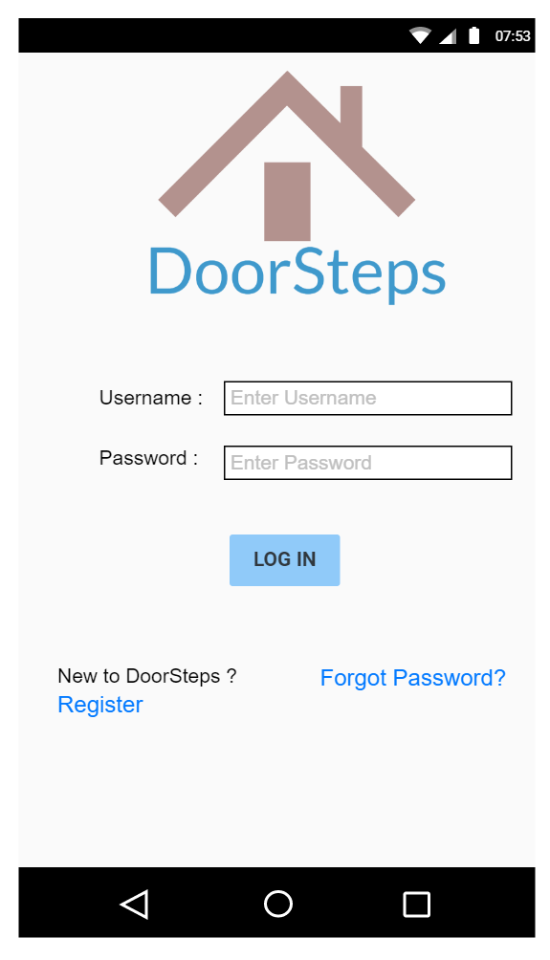

The user can see the services provided, such as Shoe Cleaning, Gardening, Grocery Shopping, Window Cleaning and so on. The user can scroll through the services, as shown in the below screen. The selected option will be highlighted with bigger font, while the rest of the services are faded with smaller fonts. For example, here the user has selected “Window Cleaning” services.

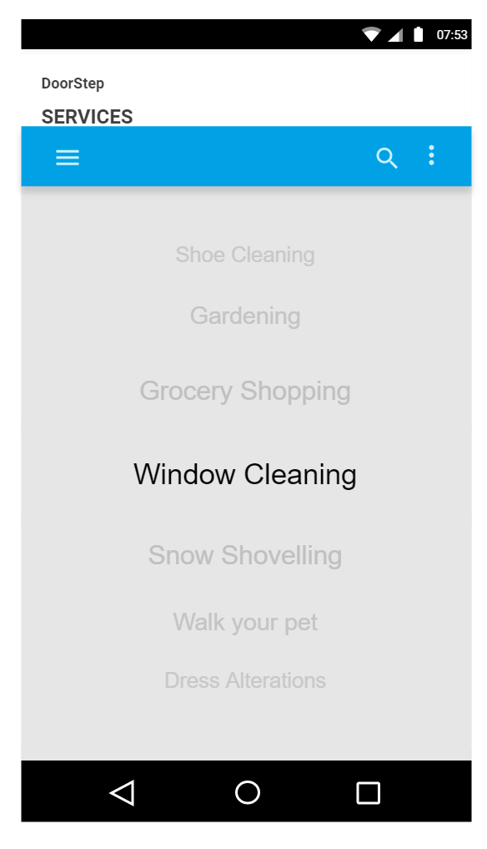

Most of the services when selected provides a list of vendors who does the services, along with their ratings. The user can select the vendor based on the ratings of preference. For instance, when the user selected the Window cleaning service, it listed the below vendors. The user has to choose one Vendor, and here he has chosen the vendor with the highest ratings.

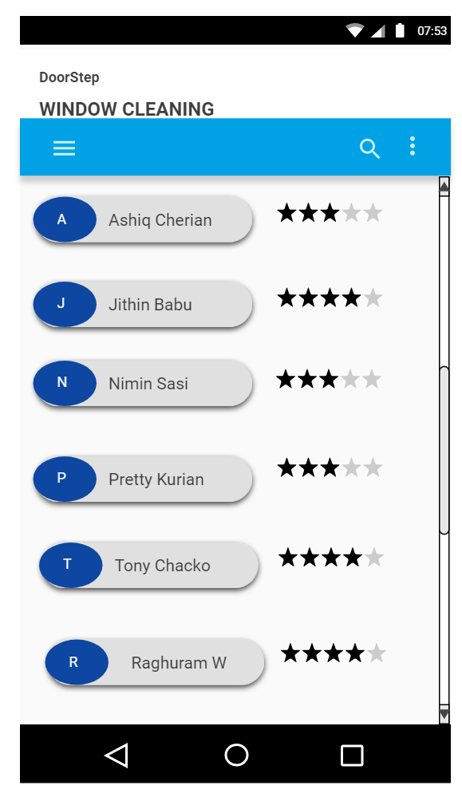

Vendor Name

Star Ratings

The user has the option of calling the Vendor, or mailing the Vendor for contacting. The user can also “Send Location”, so that it is easy for the Vendor to visit the user for the services. The user can provide feedback about the Vendor, also set the star ratings.

