Data Quality, Afagh Johari/A01347469, 1.

Contents
Data Quality, Afagh Johari/A01347469, 1. 1
Contents 1
Overview of Project 2
Initial Assessment 4
BusinessName: Nulls 4
LicenceRSN: Duplicates 5
PostalCode : Invalid format 6
City : Mis-spellings 6
Province : 2-Capitalized Letter Standard Not Followed 7
FeePaid: Null Values 8
SME Review of Initial Assessment 8
BusinessName : Null (Medium) 8
LicenceRSN: Duplicates (High) 9
PostalCode : Invalid format (Medium) 9
City : Mis-spellings (Medium) 9
Province : 2-Capitalized Letter Standard Not Followed (Medium) 9
FeePaid: Null Values (High) 9
Further Research for the SME 9
LicenceRSN: Duplicates (High) 9
SME Review of Further Research 10
SME Suggests Some DQ Rules 10
BusinessName : Null (Medium) 10
LicenceRSN: Duplicates (High) 10
PostalCode : Invalid format (Medium) 10
City : Mis-spellings (Medium) 10
Province : 2-Capitalized Letter Standard Not Followed (Medium) 11
FeePaid: Null Values (High) 11

Overview of Project
The data set that is going to be analyzed is the data of business companies which has been recorded in 2014. Under Licence By-Law No.4450, a valid business licence is required in order to operate a business in the City of Vancouver. A business licence can be obtained from the City's Licence Office and is valid for the remainder of the calendar year unless stated otherwise.
This data which is retrieved from https://opendata.vancouver.ca/explore/dataset/business-licences/ talks about business company license and other details such as date of issue, are they issued or not, their status, type of business, business name, expiration date of license, address, location, and how many employee they have.
Because of some reasons some of them has problem and their data is not correct.
In this project we are analyzing company data to find out the issue. If the data was entered wrong, we will have problem in renewing company’s license. Table1-1 has short description of each column:
 | Column name | Description
1 | UnitType | Type of a unit that has licence
2 | Unit | Unit number. It is part of address
3 | Street | Street name. It is part of address
4 | Status | Status of licence since applied
5 | Province | Province name. It is part of address
6 | PostalCode | PostalCode. It is part of address
7 | NumberofEmployees | How many people are working there
8 | LocalArea | Where the company is located in the province
9 | LicenceRSN | Makes licence number unique
10 | LicenceRevisionNumber | It is used for each revision
11 | LicenceNumber | Licence serial number
12 | IssuedDate | Date of licence is issued
13 | House | House number
14 | Geom | Geometric location first point
15 | geo_point_2d | Geometric location second point
16 | FOLDERYEAR | Dataset year
17 | FeePaid | The fee is payed for licence
18 | ExtractDate | Date of licence which is extracted
19 | ExpiredDate | Licence date expiration
20 | Country | Country of the company
21 | City | City of the company
22 | BusinessType | Business Type of company
23 | BusinessTradeName | It shows name of the business which is registered for a license in the system.
24 | BusinessSubType | Field of the Business that company is working
25 | BusinessName | Name of company
Table 1-1

I have worked as a data analyst with experience of more than 10 years by database designing of variety systems such as tracker system, HR system, storage system, dashboard and analyzing accounting system, commercial system, I am appreciated to work with Mr. John Smith who works as an SME in the City has good knowledge of registering and renewing the company licence and the way that the data is going to be saved in database, is helping me to improve the data and resolve the problems thru bellow stages:
- Initial Assessment: In this section all the columns will be analyzed and the issues will be talked.
- SME Review of Initial Assessment: Mr. Smith the SME in City will review the initial section and will put his comment on the analyze in initial Assessment and they should be corrected.
- Further research for the SME: After all the corrections was done according to SME comments, he will review them again and lead me to do more analyze.
- SME review of further research: All the changes has been done according to the researches of SME will be review.
- SME suggests some DQ rules: SME can suggest what kind of analysis should be done. i.e., statistical analysis

Initial Assessment

BusinessName: Nulls
According to the context of column analysis (0.16%) companies do not have name. What is the role of business name?
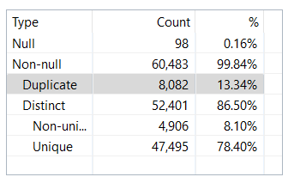

Excel pivot table is used count Business Name in different situations:
- Count by Status where BusinessName is Null:
There are no BN=Null records with Status=Issued.
 | Status | Count of BusinessName
 | Cancelled | 90
 | Gone Out of Business | 6
 | Inactive | 1
 | Pending | 1
 | Grand Total | 98
- How many records has Issued Status and Null BusinessName? Zero because BusinessName is null.
Status | Issued
BusinessName=Null
Count of BusinessName

LicenceRSN: Duplicates
Further detailed analysis reveals 0.03% of the companies have duplicate LicenceRSN. For example, Jessica Jiyoung Jo (Jessica Jo) company has four license numbers which are issued and two of them are duplicated. Complete information is shown below:
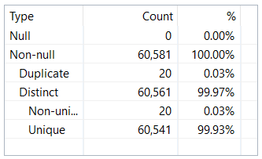

Jessica Jiyoung Jo (Jessica Jo) Company

This is Complete list of company with duplicate LicenceRSN and Status=Issued:
By considering LicenceRSN, BusinessName, Status=Issued, IssuedDate, BusinessType, and address there are some duplicate records such as “Jessica Jiyoung Jo (Jessica Jo) Company” as described above.

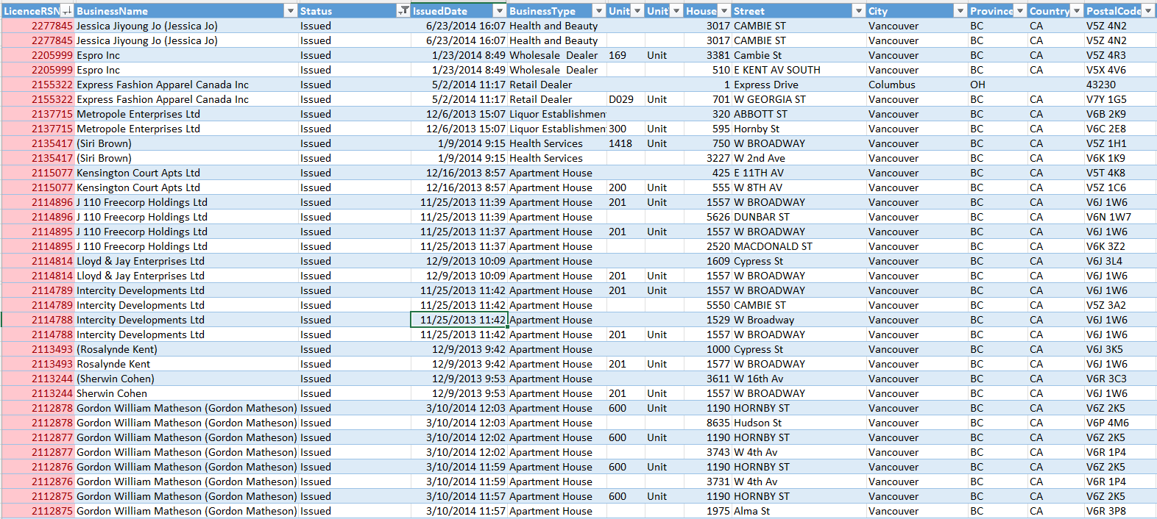

PostalCode : Invalid format
According to the reports in DQ analyzer length and format of entered postal codes are different. Canadian standard format is: (LDL DLD) and 54.66% of data are in Canadian format, but there are other formats witch they are just letter or combination of letter, number and space but not in a standard format. Even there are single occurrences by these formats: L, LD DLD, LD: DLD, DLLDLD. There are 0.01% PostalCodes with just number that it seems they are US format, but US standard format is (99999, 999999999).

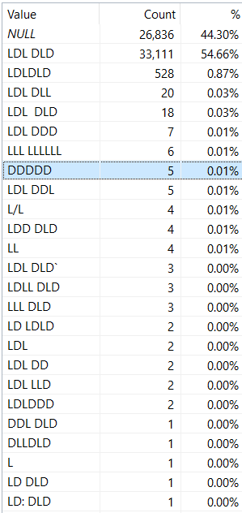

Sample of US records for PostalCode:
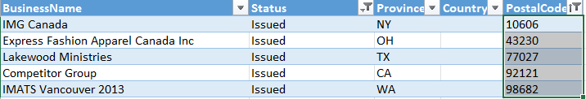

City : Mis-spellings
There are some cities that they might be similar. The Unique and Duplicate counts in the DQA/Basic represents possibility of the misspellings.
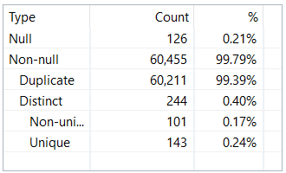

As shown in the picture there are two city that have mis-spelling: New Westminster and Mill Bay.
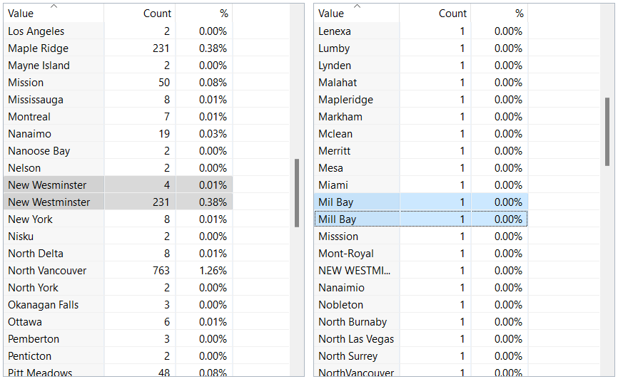

Province : 2-Capitalized Letter Standard Not Followed
In the province column there is complete name of province, also noncapitalized letter like (VA, Vancouver), (WA, Wa), (bc).If these are okay, but there are so many of them that the out-of-province addresses might be billing addresses or some other innocuous reason.
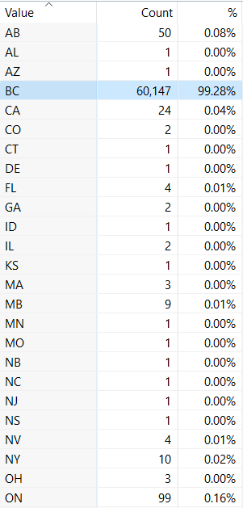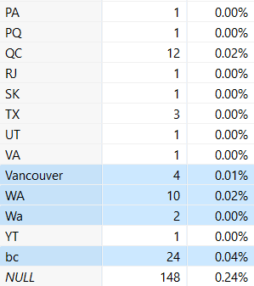

FeePaid: Null Values
There are 9300 company witch they did not pay the fee.
There are 204 companies with issued status and null values FeePaid column.
There is a list that includes the count of BusinessType with Status=Issued
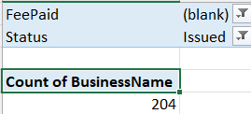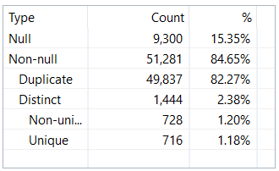

In the bellow table count of business type that did not pay fee which they are issued is presented.

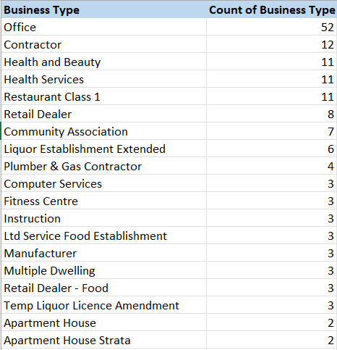

SME Review of Initial Assessment

BusinessName : Null (Medium)
How many of those are Issued?” and if there are any with Issued Status, do they have a value in the BusinessTradeNames column?

LicenceRSN: Duplicates (High)
There is a small chance that a licence number has been used twice. Licence RSN is a unique identifier. Please consider whether the volume of records issued by month might be a partial cause of the duplication problem.

PostalCode : Invalid format (Medium)
In Canada postal code has a specific format: letter, digit, letter space digit, letter, digit. There is some wrong info for this field in City database.
- The length of Canadian postal code is 7 and check the correct format: letter+number+letter+one space+number+letter+number.
- If the PostalCode is for US it’s length is 10:
number+number+ number+number+’-’+ number+number+ number+number+number
- Prepare list of wrong data in the column and fix them and redo the analysis.
- Consider Status=Issued.

City : Mis-spellings (Medium)
Name of the city is not recorded correctly.
- The address is not compatible with the postal code. Please correct them.
- You can use Drop downlist to prevent mis-spelling.

Province : 2-Capitalized Letter Standard Not Followed (Medium)
In province column the acronym should be capitalized.

FeePaid: Null Values (High)
To obtain licence, each company must pay its fee to be registered. If it is not paid it means they would not receive it till paying completely.

Further Research for the SME

LicenceRSN: Duplicates (High)
Further detailed analysis reveals 0.03% of the companies have duplicate LicenceRSN.
To show statistical data for LicenceRSN duplication, SPC is used. In this analysis on the LicenceRSN the duplicated data is
- retrieved from City database for 2014
- and the duplicate LicenceRSN are specified by filtering them in excel according to the issued status
- and counted by month of Issuedate.
Based on the diagram in 201312, SPC is out-of-control.

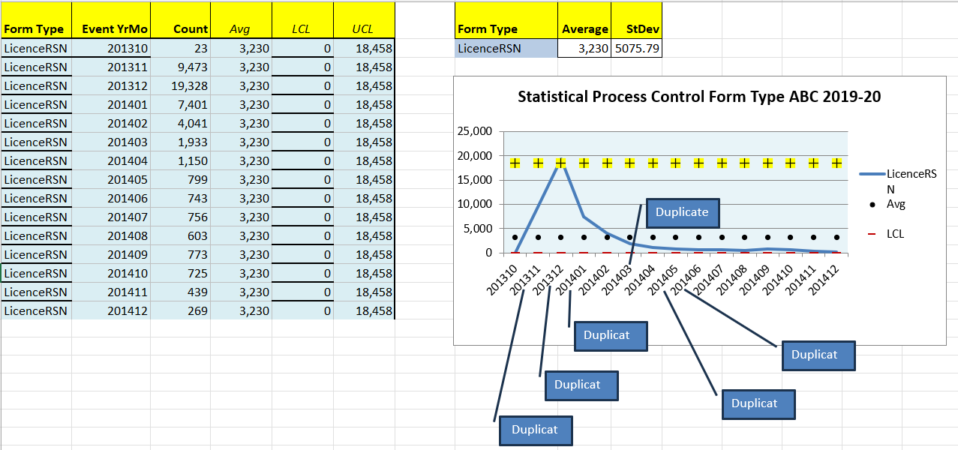

SME Review of Further Research
Here SME suggests for DQ analyzer diagram.
The SPC diagram shows the process is not under statistical control. The reason might be because of wrong data entry or there may be some difference in record details. Sometimes instead of editing a record, it is going to be added as a new record. Please send me the duplicate list with all the details. It will be sent to the department which was created, and it should be enhanced and corrected by the source.

SME Suggests Some DQ Rules

BusinessName : Null (Medium)
BusinessName must not be null if the record’s Status=Issued and BusinessType<>Short-Term Rental. Prepare list of null BusinessName with Status=Issued and enter their name and re do the analyzing.

LicenceRSN: Duplicates (High)
LicenceRSN is a primary key so generate an alert if it is not unique.

PostalCode : Invalid format (Medium)
- PostalCode must match the format of the Country for the record if the Status=Issued.

City : Mis-spellings (Medium)
- City must exist in the CityLookupTable if Status=Issued.

Province : 2-Capitalized Letter Standard Not Followed (Medium)
Same as City. Province must be two capitalized letters OR must exist in the ProvinceState table if Status=Issued.

FeePaid: Null Values (High)
FeePaid must be greater than zero if Status=Issued.

