[2024-11-28-10:05:07] Current time: 2024-11-28-10:05:07

[2024-11-28-10:05:07] Exp name: Exp_0

[2024-11-28-10:05:07] Env name: random complex pollution envs

[2024-11-28-10:05:07] Optimize y flag: False

[2024-11-28-10:05:07] Learning rate alpha: 31.622776601683793

[2024-11-28-10:05:07] LR_GAMMA: 0.02

[2024-11-28-10:05:07] REGULAR_COEFF: 0.01

[2024-11-28-10:05:07] Inner loop initial learning rate eta_0: 1.0

[2024-11-28-10:05:07] Radius of the ball W: 32000

[2024-11-28-10:05:07] Sample y size M: 100

[2024-11-28-10:05:07] Iter upper bound T: 10000

[2024-11-28-10:05:07] Trajectory number K_eval: 100000

[2024-11-28-10:05:07] Trajectory length H: 100

[2024-11-28-10:05:07] Train trajectory number K_sgd: 1000

[2024-11-28-10:05:07] Train trajectory length H_sgd: 100

[2024-11-28-10:05:07] Return policy mode: 100

[2024-11-28-10:05:07] Ground-truth evaluate flag: False

[2024-11-28-10:05:07] Ground-truth advantage flag: False

[2024-11-28-10:05:07] Log evaluate flag: True

[2024-11-28-10:05:07] Check fineness: 1000

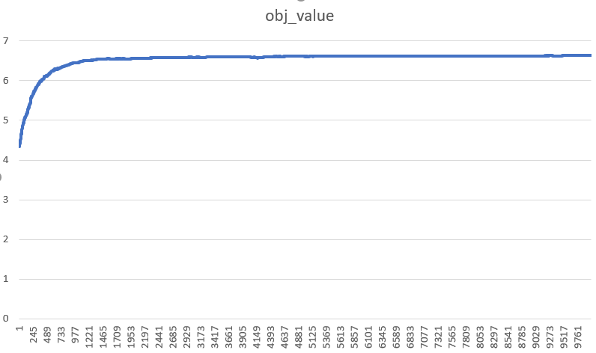

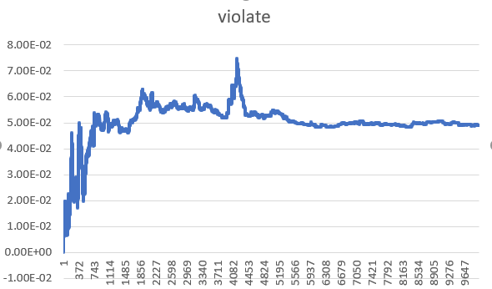

[2024-11-29-03:20:10] Current time: 2024-11-29-03:20:10

[2024-11-29-03:20:10] Exp name: Exp_0

[2024-11-29-03:20:10] Env name: random complex pollution envs

[2024-11-29-03:20:10] Optimize y flag: False

[2024-11-29-03:20:10] Learning rate alpha: 31.622776601683793

[2024-11-29-03:20:10] LR_GAMMA: 0.1

[2024-11-29-03:20:10] REGULAR_COEFF: 0.01

[2024-11-29-03:20:10] Inner loop initial learning rate eta_0: 1.0

[2024-11-29-03:20:10] Radius of the ball W: 32000

[2024-11-29-03:20:10] Sample y size M: 100

[2024-11-29-03:20:10] Iter upper bound T: 1000

[2024-11-29-03:20:10] Trajectory number K_eval: 100000

[2024-11-29-03:20:10] Trajectory length H: 100

[2024-11-29-03:20:10] Train trajectory number K_sgd: 1000

[2024-11-29-03:20:10] Train trajectory length H_sgd: 100

[2024-11-29-03:20:10] Return policy mode: 100

[2024-11-29-03:20:10] Ground-truth evaluate flag: False

[2024-11-29-03:20:10] Ground-truth advantage flag: False

[2024-11-29-03:20:10] Log evaluate flag: True

[2024-11-29-03:20:10] Check fineness: 1000

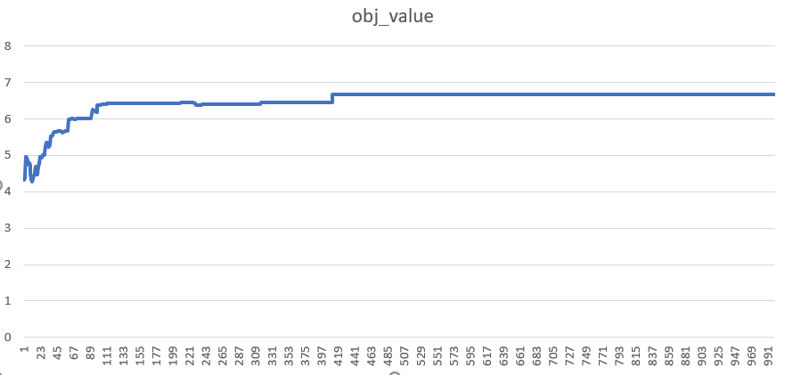

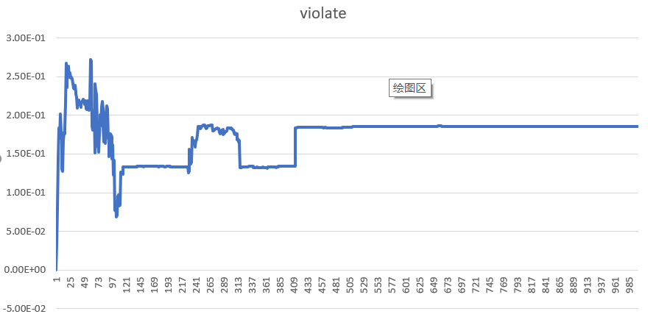

[2024-11-29-06:36:49] Current time: 2024-11-29-06:36:49

[2024-11-29-06:36:49] Exp name: Exp_0

[2024-11-29-06:36:49] Env name: random complex pollution envs

[2024-11-29-06:36:49] Optimize y flag: False

[2024-11-29-06:36:49] Learning rate alpha: 31.622776601683793

[2024-11-29-06:36:49] LR_GAMMA: 0.02

[2024-11-29-06:36:49] LR_GAMMA_COEFF: 20

[2024-11-29-06:36:49] REGULAR_COEFF: 0.01

[2024-11-29-06:36:49] Inner loop initial learning rate eta_0: 1.0

[2024-11-29-06:36:49] Radius of the ball W: 32000

[2024-11-29-06:36:49] Sample y size M: 100

[2024-11-29-06:36:49] Iter upper bound T: 1000

[2024-11-29-06:36:49] Trajectory number K_eval: 100000

[2024-11-29-06:36:49] Trajectory length H: 100

[2024-11-29-06:36:49] Train trajectory number K_sgd: 1000

[2024-11-29-06:36:49] Train trajectory length H_sgd: 100

[2024-11-29-06:36:49] Return policy mode: 100

[2024-11-29-06:36:49] Ground-truth evaluate flag: False

[2024-11-29-06:36:49] Ground-truth advantage flag: False

[2024-11-29-06:36:49] Log evaluate flag: True

[2024-11-29-06:36:49] Check fineness: 1000

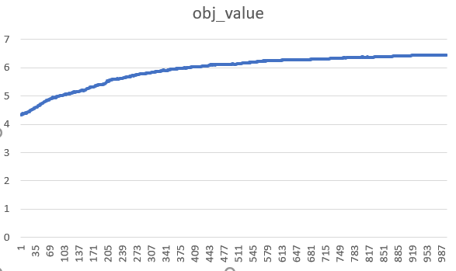

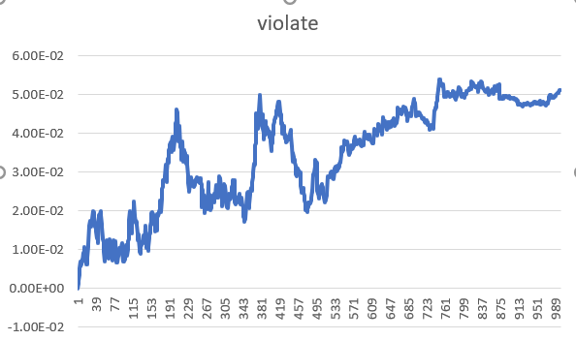

[2024-12-03-02:07:36] Current time: 2024-12-03-02:07:36

[2024-12-03-02:07:36] Exp name: Exp_0

[2024-12-03-02:07:36] Env name: random complex pollution envs

[2024-12-03-02:07:36] Optimize y flag: False

[2024-12-03-02:07:36] Learning rate alpha: 31.622776601683793

[2024-12-03-02:07:36] LR_GAMMA: 0.02

[2024-12-03-02:07:36] LR_GAMMA_COEFF: 100

[2024-12-03-02:07:36] REGULAR_COEFF: 0.01

[2024-12-03-02:07:36] Inner loop initial learning rate eta_0: 1.0

[2024-12-03-02:07:36] Radius of the ball W: 32000

[2024-12-03-02:07:36] Sample y size M: 100

[2024-12-03-02:07:36] Iter upper bound T: 1000

[2024-12-03-02:07:36] Trajectory number K_eval: 100000

[2024-12-03-02:07:36] Trajectory length H: 100

[2024-12-03-02:07:36] Train trajectory number K_sgd: 1000

[2024-12-03-02:07:36] Train trajectory length H_sgd: 100

[2024-12-03-02:07:36] Return policy mode: 100

[2024-12-03-02:07:36] Ground-truth evaluate flag: False

[2024-12-03-02:07:36] Ground-truth advantage flag: False

[2024-12-03-02:07:36] Log evaluate flag: True

[2024-12-03-02:07:36] Check fineness: 1000

