PROJECT PHASE-1 DOCUMENTATION
Dairy Farm Management System (GreenPasture MIS)
A JSF + Hibernate web application for cattle and milk-production management

Field | Detail
Course / Module | Enterprise Application Development
Deliverable | Phase 1 — Project Proposal & Practical Implementation
Entities implemented (CRUD) | Cattle, MilkProduction
Frameworks | Jakarta Server Faces 4.0 (Mojarra), Hibernate ORM 6.4, Hibernate Validator 8.0
Database | PostgreSQL
Author | ________________________
Date | ________________________
GitHub repository | https://github.com/<your-username>/DairyFarmManagementSystem
Proposal & demo video (Google Vid) | https://<paste-google-vid-share-link-here>

1. Abstract
The Dairy Farm Management System (GreenPasture MIS) is a web-based management information system that digitises the two most data-intensive activities on a small dairy farm: keeping an accurate registry of cattle and logging the milk produced by each animal every day. The system is built on the Jakarta EE 10 web profile. The user interface is implemented with Jakarta Server Faces 4.0 (Facelets), business/controller logic is placed in CDI managed beans, and all data is stored in a PostgreSQL relational database through the Hibernate ORM 6 framework using a Data Access Object (DAO) layer. Two domain entities — Cattle and MilkProduction — support full Create, Read, Update and Delete (CRUD) operations. Data integrity is protected by three independent layers of validation (built-in JSF validators/converters, Jakarta Bean Validation annotations on the model, and custom JSF validators), and the presentation is styled using external, internal and inline CSS. The result is a portable, maintainable application that runs on any Servlet 6 container (Apache Tomcat 10.1+).

2. Problem Statement
Small and medium dairy farms still record cattle information and daily milk yields on paper registers or ad-hoc spreadsheets. This manual approach creates a number of recurring problems:
- Records are easily lost, damaged or duplicated, and there is no single authoritative copy of the data.
- There is no automatic checking of what is entered, so impossible values (a birth date in the future, a 900-litre milking, a blank breed, a duplicated ear-tag number) routinely enter the records.
- Producing simple facts — how much milk was produced today, which cows are under treatment, the yield history of one animal — requires slow manual searching and totalling.
- Only one person can use the register at a time, and the data cannot be accessed away from the office.
- Historical data is rarely usable for decision-making because it is unstructured.
The farm needs a centralised, validated, multi-user system that stores cattle and milk-production data reliably and makes it immediately available through a web browser.

3. Scope of the Project

3.1 In scope (Phase 1)
- Cattle registry: create, list, update and delete cattle records (tag number, breed, date of birth, health status).
- Milk production log: create, list, update and delete daily production records (animal, date, shift, litres).
- One-to-many relationship between a cow and its milk-production records.
- Three-layer server-side validation of every input field.
- Relational persistence in PostgreSQL through Hibernate ORM, with an abstract DAO layer.
- Responsive JSF user interface with a consistent navigation shell, styled with external, internal and inline CSS.
- Single-database deployment on Apache Tomcat 10.1 / 11.

3.2 Out of scope (deferred to later phases)
- User authentication, authorisation and role management.
- Reporting dashboards, charts and export to PDF/Excel.
- Multi-farm / multi-tenant support.
- REST / web-service API and mobile application.
- Additional farm modules (feeding, veterinary treatment history, breeding, payroll, sales/invoicing).
- Internationalisation and offline operation.

4. AS-IS Model (current situation)
Today the process is entirely manual:
- A farm hand writes new animals into a paper cattle register (or a spreadsheet), assigning an ear-tag number by hand.
- After each milking session the litres produced by each cow are written on a daily tally sheet.
- At the end of the day someone adds up the tally sheet with a calculator to get the total yield.
- To answer a question about one animal, the register and every past tally sheet must be searched by hand.
- Sheets are filed in a folder; if a sheet is lost or unreadable, that data is gone.
Characteristics of the AS-IS process: paper-based, single-user, no data validation, no relational link between an animal and its production history, error-prone manual aggregation, no remote access, and poor durability of records.

5. TO-BE Model (proposed situation)
The proposed system replaces the paper process with a centralised web application:
- Cattle are registered through a web form. The system rejects duplicate or malformed tag numbers and impossible dates before the record is ever saved.
- Milk production is logged through a second web form that links each entry to an existing cow chosen from a drop-down list, to a date, and to a shift (Morning / Evening).
- All data is written to a single PostgreSQL database that is the one authoritative source of truth.
- Every record can be listed, edited or deleted from the browser, with immediate on-screen confirmation or error messages.
- Because the relationship between a cow and its production records is modelled explicitly, per-animal history and daily totals can be produced directly from the data (foundation for Phase 2 reporting).
- The application is reached with a browser from any machine on the network; several users can work at once.
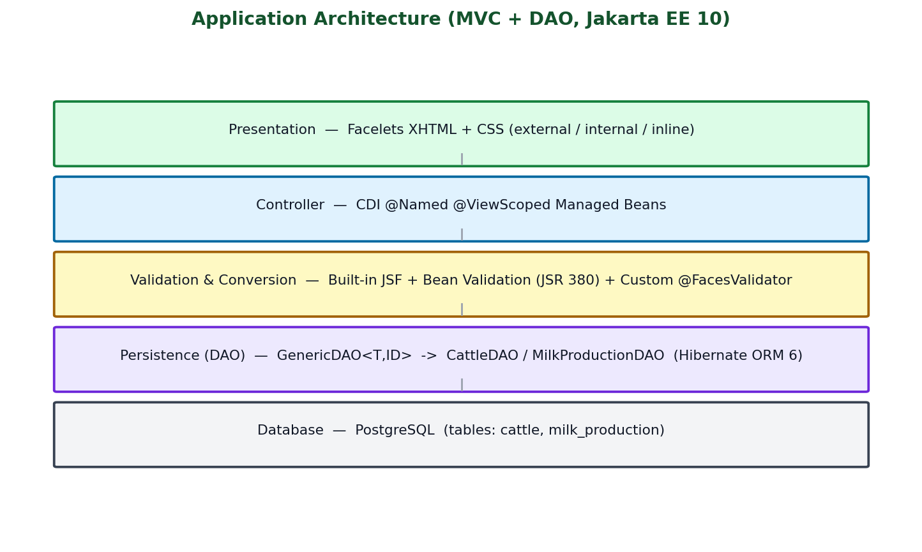
Figure 1 — TO-BE application architecture (MVC + DAO).

6. Business Requirements

6.1 Functional requirements
ID | Requirement
BR-01 | Register a new cow with tag number, breed, date of birth and health status.
BR-02 | Reject a tag number that is blank, shorter than 3 or longer than 20 characters, contains characters other than letters/digits/hyphen, or is already used.
BR-03 | List all registered cattle in a table and allow editing or deleting any record.
BR-04 | Reject a date of birth that is in the future.
BR-05 | Record daily milk production: the cow, the record date, the shift (Morning/Evening) and litres.
BR-06 | Only allow a production record to reference an existing cow.
BR-07 | Constrain milk quantity to a realistic range of 0 to 100 litres per shift.
BR-08 | Reject a production date that is in the future; shift must be exactly 'Morning' or 'Evening'.
BR-09 | List all production records with the cow's tag number, and allow editing or deleting.
BR-10 | Show a clear success or error message after every create, update or delete.

6.2 Non-functional requirements
ID | Requirement
NFR-01 | The system is a web application usable from a standard browser; no client installation.
NFR-02 | All validation is enforced on the server, not only in the browser.
NFR-03 | Data is stored in an RDBMS and survives application restarts; writes are transactional.
NFR-04 | The UI layout is responsive and consistent across the three pages.
NFR-05 | The application runs on any Jakarta EE 10 Servlet container (Apache Tomcat 10.1+).
NFR-06 | The code is organised in clear layers (view, controller, DAO, model) to ease maintenance.
NFR-07 | Persistence uses parameter binding (no string-built SQL), preventing SQL injection.

7. Software Qualities Applied in the System
The qualities below follow the ISO/IEC 25010 product-quality model and are each tied to a concrete design decision in this project.
Quality | How it is achieved in this system
Functional suitability / correctness | Complete CRUD for both entities; three validation layers guarantee only valid data is persisted; entity identity is compared by primary key (equals/hashCode) so selection lists behave correctly.
Reliability | Every DAO write runs inside a Hibernate transaction and rolls back on any exception; the SessionFactory is rebuilt if it is found closed; managed beans catch runtime failures and report them instead of crashing the page.
Usability | Single consistent navigation shell on every page; form and data table shown side by side; inline per-field error text plus a summary message area; drop-downs for constrained values (health status, shift, cow); responsive two-column layout that collapses on small screens.
Maintainability / modularity | Strict MVC + DAO layering; a generic GenericDAO<T,ID> interface removes duplicated CRUD code; a single external stylesheet centralises all shared styling; each validator/converter is a small, independent, annotated class.
Portability | Pure Jakarta EE 10 APIs; deployable as a WAR to any Servlet 6 container; the database is selected only through hibernate.cfg.xml (URL + dialect), so switching RDBMS needs no code change.
Security | All input is validated server-side; Hibernate uses bound parameters (no SQL injection surface); JSF escapes output by default (protection against XSS); business rules (ranges, patterns) are enforced on the model, not only the UI.
Performance efficiency | @ViewScoped beans cache the record lists and the cattle drop-down for the life of the view; the cow reference on a production record is fetched eagerly so the list renders without extra queries.
Compatibility / interoperability | Standard JDBC + Hibernate dialect abstraction; runs on Tomcat 10.1 (Cargo) or the IDE's bundled Tomcat 11 without change.
Testability | The DAO layer is defined by an interface and can be mocked; JUnit 5 (Jupiter) and an H2 test dependency are already on the build path for unit testing.

8. Initial Class Diagram (all entities)
The domain model has two persistent entities. A Cattle has many MilkProduction records; each MilkProduction belongs to exactly one Cattle (a bidirectional one-to-many association mapped with @OneToMany(mappedBy="cattle") / @ManyToOne). The supporting classes for each architectural layer are listed beneath the entities.
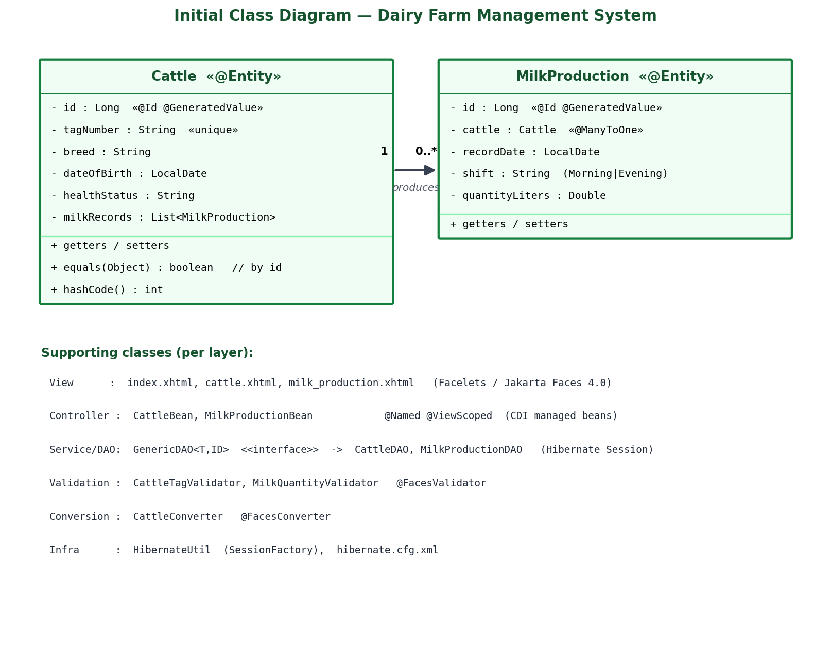
Figure 2 — Initial class diagram.

8.1 Entity attribute specification
Cattle (table: cattle)
Attribute | Type | Column | Constraints
id | Long | cattle_id | PK, identity-generated
tagNumber | String | tag_number | NOT NULL, UNIQUE, 3–20 chars, [A-Za-z0-9-]
breed | String | breed | NOT NULL / not blank
dateOfBirth | LocalDate | date_of_birth | NOT NULL, past or present
healthStatus | String | health_status | NOT NULL (Healthy / Under observation / Under treatment)
milkRecords | List<MilkProduction> | — | @OneToMany(mappedBy="cattle"), cascade ALL
MilkProduction (table: milk_production)
Attribute | Type | Column | Constraints
id | Long | production_id | PK, identity-generated
cattle | Cattle | cattle_id (FK) | @ManyToOne, NOT NULL
recordDate | LocalDate | record_date | NOT NULL, past or present
shift | String | shift | NOT NULL, matches ^(Morning|Evening)$
quantityLiters | Double | quantity_liters | NOT NULL, 0 ≤ x ≤ 100

9. Practical Implementation — CRUD with JSF and Hibernate
The two entities Cattle and MilkProduction each expose complete CRUD through a Facelets page backed by a CDI managed bean and a Hibernate DAO.

9.1 Layers and key classes
Layer | Artefact(s) | Responsibility
View | index.xhtml, cattle.xhtml, milk_production.xhtml | Facelets pages: navigation shell, input form, data table, messages.
Controller | CattleBean, MilkProductionBean (@Named @ViewScoped) | Hold the form model and the list model; expose save() / edit() / delete() / cancel() actions; add FacesMessages.
Persistence | GenericDAO<T,ID> → CattleDAO, MilkProductionDAO | Open a Hibernate Session, run persist/merge/get/remove/HQL inside a transaction, roll back on error.
Model | Cattle, MilkProduction (@Entity) | JPA-mapped domain objects that also carry Bean-Validation constraints.
Infrastructure | HibernateUtil, hibernate.cfg.xml | Build and cache the SessionFactory; hold DB connection settings and mappings.

9.2 CRUD flow (example: create a cow)
- The user fills the form in cattle.xhtml; each field is bound with EL to #{cattleBean.cattle.*}.
- On Save, JSF runs Apply-Request-Values → Process-Validations (all three validation layers) → Update-Model → Invoke-Application.
- cattleBean.save() calls cattleDAO.save(cattle); CattleDAO opens a Session, begins a transaction, calls session.persist(cattle) and commits (rollback on exception).
- The bean adds a success FacesMessage, resets the form and reloads the list via cattleDAO.findAll() (HQL).
- The data table re-renders with the new row.

10. The Three Types of Validation
Every input field is validated on the server by up to three independent mechanisms.

10.1 Type 1 — Built-in JSF validators and converters
Standard component attributes and <f:...> tags in the Facelets pages:
- required="true" with a requiredMessage on every input (tag, breed, date, health, cattle, shift, quantity).
- <f:convertDateTime type="localDate" pattern="yyyy-MM-dd"/> on the two date fields — rejects unparseable dates.
- <f:convertNumber type="number" minFractionDigits="1"/> on the milk-quantity field — rejects non-numeric input.
- type="date" on the HTML5 date inputs, and constrained <f:selectItem> lists for health status and shift.
<h:inputText id="birth" type="date" value="#{cattleBean.cattle.dateOfBirth}"
required="true" requiredMessage="Date of birth is required">
<f:convertDateTime type="localDate" pattern="yyyy-MM-dd"/>
</h:inputText>

10.2 Type 2 — Jakarta Bean Validation (JSR 380) on the model
Constraint annotations on the entity fields, enforced automatically by Hibernate Validator during the JSF Process-Validations phase and again by Hibernate before an INSERT/UPDATE:
- Cattle: @NotNull @Size(min=3,max=20) on tagNumber; @NotBlank on breed and healthStatus; @NotNull @PastOrPresent on dateOfBirth.
- MilkProduction: @NotNull on cattle; @NotNull @PastOrPresent on recordDate; @NotBlank @Pattern(regexp="^(Morning|Evening)$") on shift; @NotNull @Min(0) @Max(100) on quantityLiters.
@NotNull @Min(value = 0, message = "Milk quantity must be >= 0")
@Max(value = 100, message = "Milk quantity exceeds 100L per shift")
@Column(name = "quantity_liters", nullable = false)
private Double quantityLiters;

10.3 Type 3 — Custom JSF validators (and a custom converter)
Small classes annotated with @FacesValidator, attached with <f:validator validatorId="...">:
- CattleTagValidator — enforces the exact tag pattern [A-Za-z0-9-]{3,20} on the tag-number field.
- MilkQuantityValidator — re-checks the 0–100 range on the quantity field, accepting any Number (Long or Double) returned by the converter.
- CattleConverter (@FacesConverter) — converts the selected cow between its database id (String in the HTML option) and the Cattle object bound to the model.
@FacesValidator("cattleTagValidator")
public class CattleTagValidator implements Validator<String> {
public void validate(FacesContext c, UIComponent comp, String value) {
if (value == null || !value.trim().matches("[A-Za-z0-9-]{3,20}"))
throw new ValidatorException(new FacesMessage(
FacesMessage.SEVERITY_ERROR, "Use 3-20 letters, numbers, or hyphens", null));
}
}
Note: on the milk-quantity field <f:validateBean disabled="true"/> is set so that the range check is reported once by the custom validator rather than twice; Bean Validation remains active on all other fields and on the entity when Hibernate persists it.

11. Styling — External, Internal and Inline CSS
CSS type | Where | Purpose
External | resources/css/style.css, linked on every page with <h:outputStylesheet library="css" name="style.css"/> | All shared styling: sidebar, top bar, cards, forms, data tables, badges, responsive layout, design tokens (CSS custom properties).
Internal | <style> block in the <h:head> of index.xhtml, cattle.xhtml and milk_production.xhtml | Page-level refinements: tabular-figure alignment for numeric table columns and a print stylesheet that hides the sidebar and top bar when the page is printed.
Inline | style="..." attributes in the pages, e.g. style="padding:0" on the table card body and style="letter-spacing:.03em" on the status badge | One-off tweaks that apply to a single element only.

12. Technology Stack
Concern | Technology
Language / platform | Java 17, Jakarta EE 10 (web profile), packaged as a WAR
View | Jakarta Server Faces 4.0 (Mojarra 4.0.5), Facelets XHTML
Dependency injection | CDI 4.0 via Weld (weld-servlet-core 5.1)
Persistence | Hibernate ORM 6.4.4 (JPA provider) + JDBC
Validation | Hibernate Validator 8.0 (Jakarta Bean Validation / JSR 380)
Database | PostgreSQL (driver 42.7.2); schema via hbm2ddl.auto=update
Build | Apache Maven (maven-war-plugin)
Run / deploy | Cargo plugin → Apache Tomcat 10.1, or the IDE's bundled Tomcat 11
Testing (available) | JUnit 5 (Jupiter), H2 in-memory database

13. Project Structure
src/main/
|-- java/com/dairyfarm/
| |-- model/ Cattle.java, MilkProduction.java (@Entity)
| |-- dao/ GenericDAO.java, CattleDAO.java, MilkProductionDAO.java
| |-- bean/ CattleBean.java, MilkProductionBean.java (@Named @ViewScoped)
| |-- util/ HibernateUtil.java (SessionFactory)
| `-- validator/ CattleTagValidator.java, MilkQuantityValidator.java,
| CattleConverter.java
|-- resources/
| |-- hibernate.cfg.xml (DB config + mappings)
| `-- META-INF/ (beans.xml is under webapp/WEB-INF)
`-- webapp/
|-- WEB-INF/ web.xml, faces-config.xml, beans.xml
|-- resources/css/style.css (external CSS)
|-- index.xhtml (dashboard / navigation)
|-- cattle.xhtml (Cattle CRUD)
`-- milk_production.xhtml (MilkProduction CRUD)

14. How to Build and Run
- Start PostgreSQL and create the database referenced in src/main/resources/hibernate.cfg.xml (default: jdbc:postgresql://localhost:5432/dairy_farm_db). Hibernate creates the tables on first start.
- Build: mvnw package (produces target/DairyFarmManagementSystem-1.0-SNAPSHOT.war)
- Run: mvnw cargo:run — downloads Apache Tomcat 10.1 and deploys at http://localhost:8080/ .
- Or deploy the WAR to the IDE's bundled Apache Tomcat 11.
- Open http://localhost:8080/ and use the Cattle and Milk Production pages.

15. Source Code and Video Links
GitHub repository (public):
https://github.com/<your-username>/DairyFarmManagementSystem
Proposal & practical walkthrough video (5–10 min, recorded with Google Vid — screen + camera):
https://<paste-google-vid-share-link-here>
The video covers: the project proposal (sections 1–8 of this document), a live demo of CRUD on both entities, a demonstration of each of the three validation types rejecting bad input, and a walk-through of the external / internal / inline CSS.

Appendix A — Key Code Listings
A.1 CattleDAO — Hibernate CRUD (create/update/delete/read)
public void save(Cattle cattle) {
Transaction tx = null;
try (Session session = HibernateUtil.getSessionFactory().openSession()) {
tx = session.beginTransaction();
session.persist(cattle);
tx.commit();
} catch (Exception e) {
if (tx != null) tx.rollback();
throw new IllegalStateException("Unable to save cattle", e);
}
}
public List<Cattle> findAll() {
try (Session session = HibernateUtil.getSessionFactory().openSession()) {
return session.createQuery("FROM Cattle", Cattle.class).list();
}
}
A.2 CattleBean — managed bean action
@Named("cattleBean")
@ViewScoped
public class CattleBean implements Serializable {
private final CattleDAO dao = new CattleDAO();
private List<Cattle> cattleList;
private Cattle cattle;
@PostConstruct public void init() { cattle = new Cattle(); load(); }
public void load() { cattleList = new ArrayList<>(dao.findAll()); }
public void save() {
try {
if (cattle.getId() == null) dao.save(cattle); else dao.update(cattle);
addMessage(FacesMessage.SEVERITY_INFO, "Cattle saved successfully");
cattle = new Cattle(); load();
} catch (RuntimeException ex) {
addMessage(FacesMessage.SEVERITY_ERROR, "Cattle could not be saved");
}
}
public void edit(Cattle c) { cattle = c; }
public void delete(Cattle c) { dao.delete(c.getId()); load(); }
}
A.3 MilkProduction entity — Bean Validation constraints
@Entity @Table(name = "milk_production")
public class MilkProduction implements Serializable {
@Id @GeneratedValue(strategy = GenerationType.IDENTITY)
@Column(name = "production_id") private Long id;
@ManyToOne(fetch = FetchType.EAGER) @JoinColumn(name = "cattle_id", nullable = false)
@NotNull(message = "Cattle selection is required") private Cattle cattle;
@NotNull @PastOrPresent(message = "Record date cannot be in the future")
@Column(name = "record_date", nullable = false) private LocalDate recordDate;
@NotBlank @Pattern(regexp = "^(Morning|Evening)$", message = "Shift must be 'Morning' or 'Evening'")
@Column(name = "shift", nullable = false) private String shift;
@NotNull @Min(0) @Max(100)
@Column(name = "quantity_liters", nullable = false) private Double quantityLiters;
}
A.4 CattleConverter — entity <-> id converter for the drop-down
@FacesConverter("cattleConverter")
public class CattleConverter implements Converter<Cattle> {
private final CattleDAO dao = new CattleDAO();
public Cattle getAsObject(FacesContext c, UIComponent comp, String value) {
if (value == null || value.isBlank()) return null;
return dao.findById(Long.valueOf(value));
}
public String getAsString(FacesContext c, UIComponent comp, Cattle v) {
return (v == null || v.getId() == null) ? "" : v.getId().toString();
}
}

