**QUESTION 1 - Functional Decomposition Approach**

Functional decomposition is an approach to system design where a complex problem is broken down into smaller, more manageable functions or modules. Each module performs a specific task, and they work together to achieve the overall goal. Here's a functional decomposition design for the payroll system:

**Assumptions**

1. The system has access to a database containing employee information, including names, employee IDs, job roles, hourly rates, and hours worked.
2. Employees can have different payment methods, such as direct deposit, checks, or cash.
3. Payroll calculations are done monthly.

**Design**

1. **Employee Information Module**
   * Responsible for retrieving and managing employee information from the database.
   * Functions:
     + Retrieve employee details (name, employee ID, job role, hourly rate).
     + Update employee information (e.g., for changes in hourly rate or job role).
2. **Timekeeping Module**
   * Handles the tracking of employee hours worked.
   * Functions:
     + Record hours worked by employees.
     + Calculate overtime if applicable.
3. **Payroll Calculation Module**
   * Computes monthly salaries for each employee.
   * Functions:
     + Calculate regular wages based on hours worked and hourly rates.
     + Apply overtime pay if applicable.
4. **Payment Method Module**
   * Manages the different payment methods for employees.
   * Functions:
     + Determine the payment method for each employee.
     + Generate paychecks, initiate direct deposits, or prepare cash payments.
5. **Reporting Module**
   * Generates payroll reports for management and accounting purposes.
   * Functions:
     + Create monthly payroll reports.
     + Summarize payment details.
     + Provide records for tax withholding and reporting.
6. **User Interface Module**
   * Provides an interface for users to interact with the payroll system.
   * Functions:
     + Input and update employee information.
     + Record hours worked.
     + Initiate payroll calculations.
     + Access payroll reports.

The functional decomposition approach divides the payroll system into smaller, well-defined modules, each responsible for a specific aspect of the system's functionality. These modules can work together to create an integrated payroll system.

**Component diagram:**

*Diagram to visualize the system's structure.*

**Task 2:**

Complete solution in the ***task2.java*** file.  
  
  
**OUTPUT:**

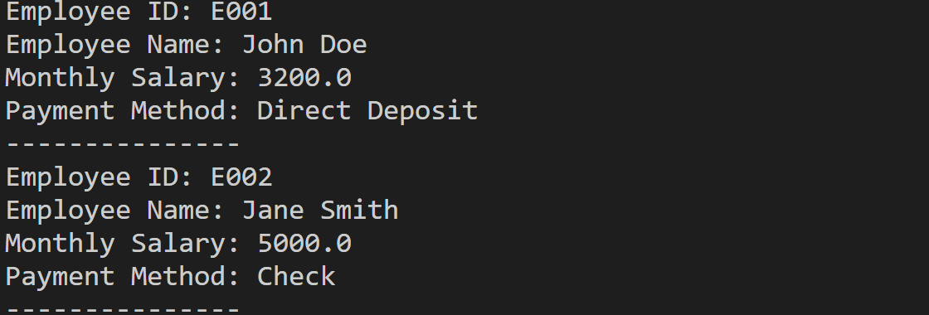

**Task 3:**

Complete solution in the ***task3.java*** file.  
  
  
**OUTPUT:**