ACS WIL DATA ANALYTICS PROJECT
Customer Churn Analysis
Clustering Analysis Documentation

Prepared by | Afaq Ahmad
Role | Data Analyst - Clustering Analysis
Project | Customer Churn Analysis
Program | ACS WIL Data Analytics Program
Method | K-Means Clustering

Prepared as part of the ACS Work Integrated Learning (WIL) Data Analytics project.

Table of Contents
1. Introduction
2. My Role in the Team
3. Tools and Technologies Used
3.1 Google Colab
3.2 Python
3.3 Pandas
3.4 Scikit-learn
3.5 Matplotlib
4. Clustering Dataset Overview
5. Clustering Analysis Process
6. Step-by-Step Code and Evidence
6.1 Loading and Initial Inspection
6.2 Feature Selection and Data Preparation
6.3 Train/Test Split and Scaling Check
6.4 Elbow Method
6.5 K-Means Model Training
6.6 Cluster Visualisation
6.7 Cluster Summary and Churn Interpretation
6.8 Saving the Outputs
7. Key Findings
8. Key Learning
9. Conclusion
10. Short Presentation Guide

1. Introduction
This document outlines the clustering analysis I completed as part of our ACS WIL Data Analytics project. Our team is working on a Customer Churn Analysis project. My part of the project focuses on grouping customers with similar characteristics so the team can better understand customer patterns.
For the clustering analysis, I used tenure and MonthlyCharges as the two clustering features. I used the Elbow Method to compare possible numbers of clusters and then trained a K-Means model using four clusters as the working solution.

2. My Role in the Team
My role is Data Analyst - Clustering Analysis. My main responsibilities were to use the prepared clustering dataset, check the required variables, split the data, review scaling, apply the Elbow Method, train the K-Means model, create cluster visualisations, interpret the customer groups and communicate the findings to the team.

3. Tools and Technologies Used

3.1 Google Colab
I used Google Colab to run the analysis in a browser. It allowed me to upload the prepared dataset, run each step separately and review the outputs.

3.2 Python
Python was used as the main programming language for the clustering workflow.

3.3 Pandas
Pandas was used to load the CSV files, select the clustering variables, inspect the data and create summary tables.

3.4 Scikit-learn
Scikit-learn was used for train_test_split, StandardScaler checks and the KMeans clustering algorithm.

3.5 Matplotlib
Matplotlib was used to create the Elbow Method graph and the final cluster visualisation.

4. Clustering Dataset Overview
The clustering-ready dataset contains 7,043 customer records. The two variables used to create the clusters are tenure and MonthlyCharges. These variables were already standardised in the prepared clustering dataset, so the clustering analysis uses relative values rather than interpreting the plotted numbers directly as months or dollars.
Item | Value
Customer records | 7,043
Clustering features | tenure, MonthlyCharges
Training records | 5,634
Testing records | 1,409
K values tested | 1 to 10
Selected K | 4

5. Clustering Analysis Process
- Load the prepared clustering-ready dataset.
- Select tenure and MonthlyCharges.
- Check for missing values and confirm the data is suitable for clustering.
- Split the data into 80% training and 20% testing.
- Check whether the selected variables are already standardised.
- Use the Elbow Method for K values from 1 to 10.
- Select K = 4 as a reasonable working solution based on the observed elbow.
- Train the K-Means model.
- Assign customers to four clusters.
- Visualise and interpret the customer groups.
- Compare churn after clustering for interpretation only.
- Save the model, summaries, datasets and graphs.

6. Step-by-Step Code and Evidence

6.1 Loading and Initial Inspection
I first loaded the prepared CSV file and checked that the required clustering columns were available.
import pandas as pd
df = pd.read_csv("churn_clustering_ready (2).csv")
FEATURES = ["tenure", "MonthlyCharges"]
print("Dataset shape:", df.shape)
print(df[FEATURES].head())
print(df[FEATURES].isnull().sum())

6.2 Feature Selection and Data Preparation
Only tenure and MonthlyCharges were used as inputs to the clustering model.
df = df.dropna(subset=FEATURES).copy()
X = df[FEATURES].astype(float)

6.3 Train/Test Split and Scaling Check
The data was split into 80% training and 20% testing. The code checks whether the selected features already appear standardised. If they are not standardised, StandardScaler is fitted on the training data and then applied to the testing data.
from sklearn.model_selection import train_test_split
from sklearn.preprocessing import StandardScaler
X_train, X_test = train_test_split(
X, test_size=0.20, random_state=42
)
already_standardised = all(
abs(X[column].mean()) < 0.10 and 0.80 < X[column].std() < 1.20
for column in FEATURES
)
Result: 5,634 training records and 1,409 testing records.

6.4 Elbow Method
I tested K values from 1 to 10. The inertia decreased as the number of clusters increased. The graph was reviewed to identify a reasonable elbow point for the final model.
from sklearn.cluster import KMeans
k_values = range(1, 11)
inertias = []
for k in k_values:
model = KMeans(n_clusters=k, random_state=42, n_init=10)
model.fit(X_train_scaled)
inertias.append(model.inertia_)
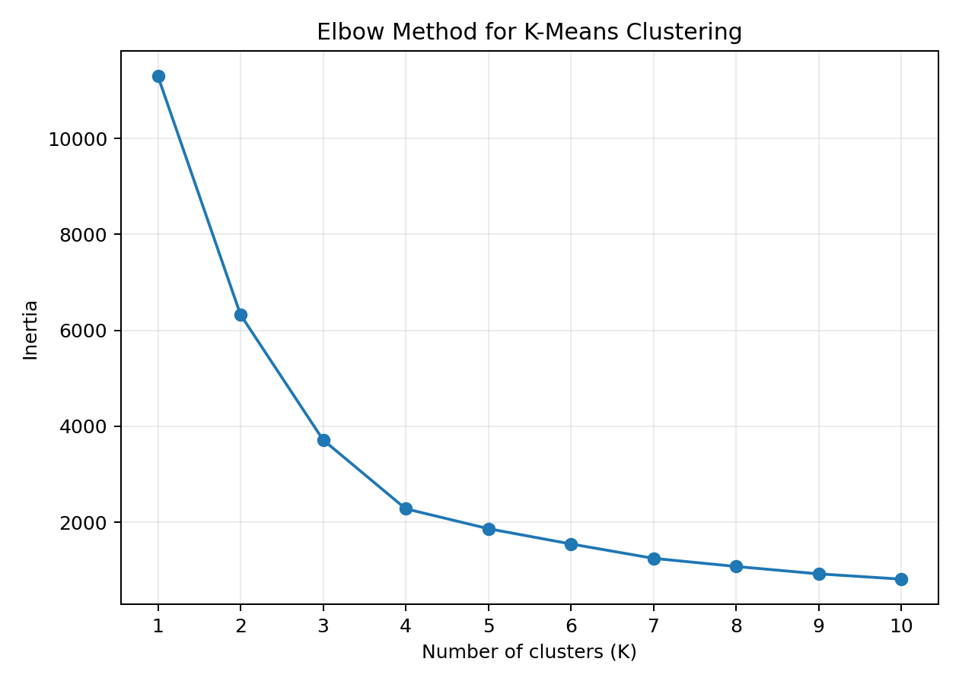
Figure 1. Elbow Method used to compare K values from 1 to 10.
Based on the observed shape of the curve, I selected K = 4 as the working solution for this project. This is a practical modelling decision rather than a claim that four is the only possible number of clusters.

6.5 K-Means Model Training
After selecting K = 4, I trained the final K-Means model on the training data.
SELECTED_K = 4
kmeans = KMeans(
n_clusters=SELECTED_K,
random_state=42,
n_init=10
)
kmeans.fit(X_train_scaled)
df["Cluster"] = kmeans.predict(X_all_scaled)

6.6 Cluster Visualisation
The scatter plot below shows the four customer clusters using tenure and MonthlyCharges. Each cluster contains customers with similar positions across these two variables.
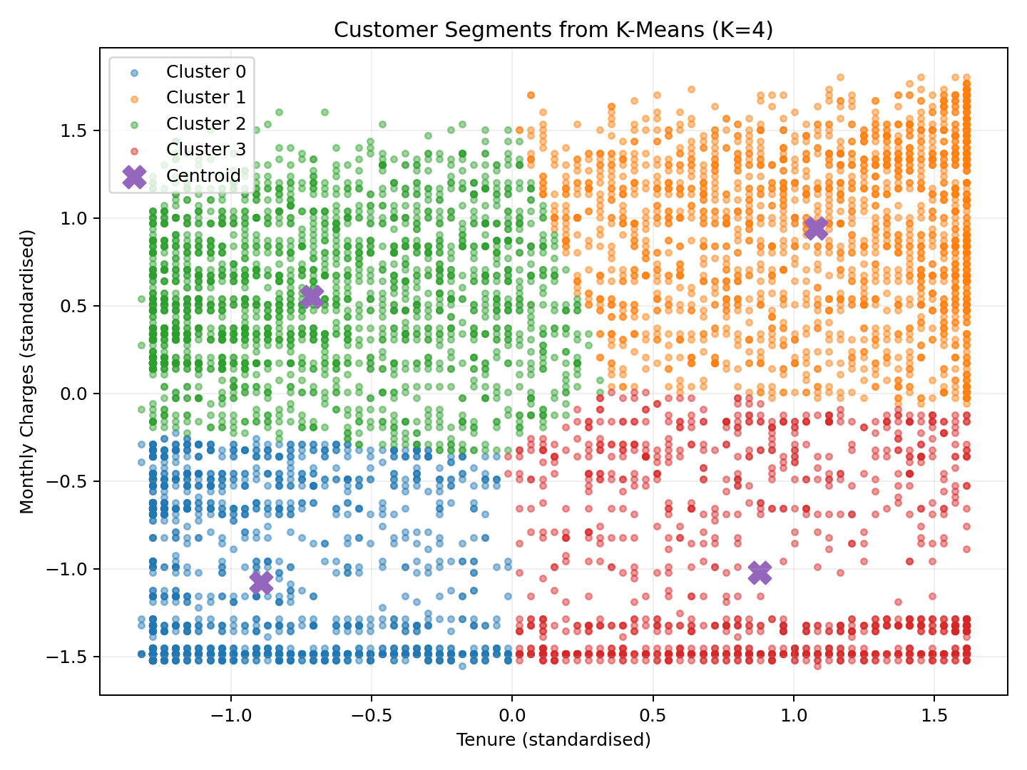
Figure 2. K-Means customer cluster visualisation (K = 4).

6.7 Cluster Summary and Churn Interpretation
After the clusters were created, I calculated the number of customers and the average standardised tenure and monthly-charge values for each group. Churn was not used to create the clusters. It was compared afterwards only to help interpret the groups.
Cluster | Customers | Avg tenure | Avg monthly charges | Churn rate
0 | 1,728 | -0.89 | -1.07 | 24.54%
1 | 1,944 | 1.08 | 0.94 | 15.64%
2 | 2,211 | -0.71 | 0.55 | 49.07%
3 | 1,160 | 0.88 | -1.02 | 4.83%
Interpretation of the four groups: Cluster 0 has relatively low tenure and low monthly charges; Cluster 1 has relatively high tenure and high monthly charges; Cluster 2 has relatively low tenure and high monthly charges; and Cluster 3 has relatively high tenure and low monthly charges.
In this run, Cluster 2 had the highest observed churn rate (49.07%), while Cluster 3 had the lowest observed churn rate (4.83%). These figures describe this dataset and can be used by the team as a starting point for further churn analysis.

6.8 Saving the Outputs
summary.to_csv("cluster_summary.csv", index=False)
df.to_csv("clustered_dataset.csv", index=False)
joblib.dump(
{"model": kmeans, "scaler": scaler, "features": FEATURES},
"kmeans_model.pkl"
)
The final project outputs include the Python analysis file, Elbow Method graph, cluster visualisation, cluster summary, clustered dataset, training/testing files and saved K-Means model.

7. Key Findings
- The analysis produced four customer segments using tenure and MonthlyCharges.
- Cluster 0 represents relatively low-tenure, low-charge customers.
- Cluster 1 represents relatively high-tenure, high-charge customers.
- Cluster 2 represents relatively low-tenure, high-charge customers.
- Cluster 3 represents relatively high-tenure, low-charge customers.
- Cluster 2 showed the highest observed churn rate in this analysis, while Cluster 3 showed the lowest.
- Churn was used only after clustering for interpretation and was not an input to the K-Means model.

8. Key Learning
Through this work, I learned how clustering can be used to group customers based on similar numerical characteristics. I also learned how the Elbow Method supports the selection of a working K value and how K-Means assigns observations to clusters.
This task gave me practical experience using Python, Pandas, Scikit-learn, Matplotlib and Google Colab. It also helped me understand that the technical model is only one part of the task; the results must also be visualised and explained clearly to the team.

9. Conclusion
Overall, I completed the clustering stage by using the prepared dataset, selecting tenure and MonthlyCharges, splitting and checking the data, using the Elbow Method, training a four-cluster K-Means model, creating visualisations and interpreting the resulting customer groups.
The results provide a simple segmentation of the customer base that the team can use for further analysis. The cluster and churn comparisons are descriptive findings from this dataset and can support later investigation into customer retention.

10. Short Presentation Guide
Opening: Hi everyone. My role in this project is Data Analyst, focusing on clustering analysis. My main task was to group customers with similar characteristics using tenure and monthly charges.
Data preparation: I used the prepared clustering dataset, selected tenure and MonthlyCharges, checked the data and used an 80/20 training and testing split.
Elbow Method: I tested K values from 1 to 10 using the Elbow Method. Based on the observed elbow, I selected K equals 4 as the working number of clusters.
K-Means: I then trained the K-Means model. It grouped customers with similar tenure and monthly-charge characteristics into four customer groups.
Visualisation: This graph shows the four clusters. I interpret them using relatively high or low tenure and relatively high or low monthly charges.
Churn: After clustering, I compared churn to help interpret the groups. Churn was not used to create the clusters.
Finish: In summary, I prepared the data, used the Elbow Method, trained K-Means with four clusters, visualised the groups and interpreted the results for the team. Thank you.

Quick Questions
What is clustering? Grouping similar customers together.
What is K? The number of clusters. I used K = 4.
Why the Elbow Method? To compare different K values and help choose a reasonable number of clusters.
Which variables did you use? tenure and MonthlyCharges.
Did churn create the clusters? No. Churn was only used afterwards for interpretation.
Process to remember: Data -> tenure & MonthlyCharges -> Elbow Method -> K=4 -> K-Means -> 4 customer groups -> interpretation

