Summary of Key Findings
Customer Segmentation and Churn Prediction
Stage 3, Final Report 3-2(a) | Data Analyst, Predictive Modeling | October 2026

1. Executive Summary
This report summarises what was learned from segmenting 7,043 telecommunications customers and from predicting customer churn with an Artificial Neural Network (ANN). The main findings are:
- Churn is common. 1,869 of the 7,043 customers (26.5%) left the company.
- Churn is concentrated in new customers. Customers in the two "New" segments make up 56% of the customer base but 81% of all churners.
- New customers on higher monthly charges are the highest risk. The "New Premium" segment (about 15 months of tenure, $81 per month) churns at 49.2% and accounts for 58% of all churners. The "Loyal Budget" segment churns at only 4.8%.
- The ANN predicts churn reliably. On 1,409 unseen customers it reached an AUC-ROC of 80.5% and an accuracy of 78.2%. With a tuned decision threshold it identifies 64% of the customers who actually left.
- The model is strongest where the risk is highest. It identifies 83% of the churners in the New Premium segment, but it rarely flags loyal customers who leave.
- Tenure and monthly charges drive the predictions. Contract type, internet service and gender showed no relationship with churn in this dataset.
- The data, not the model, limits accuracy. A simple logistic regression performs just as well as the ANN, so better results would need richer customer data.

2. Data and Approach
The analysis used Dataset_ATS_v2.csv, which holds 7,043 customers with 10 attributes and no missing values. Customers were first grouped with K-means clustering on tenure and monthly charges. The prediction model was then trained on 5,634 customers (80%) and tested on 1,409 unseen customers (20%), with 26.5% churn in both parts. The ANN has two hidden layers of 16 and 8 neurons and is described in the architecture document.

3. Customer Segmentation Findings

3.1 Choosing the number of segments
K-means clustering was run on standardised tenure and monthly charges for 2 to 10 clusters. The elbow curve bends at four clusters, and the silhouette score, which measures how well separated the groups are, peaks at four (0.476). Both methods therefore support four segments.
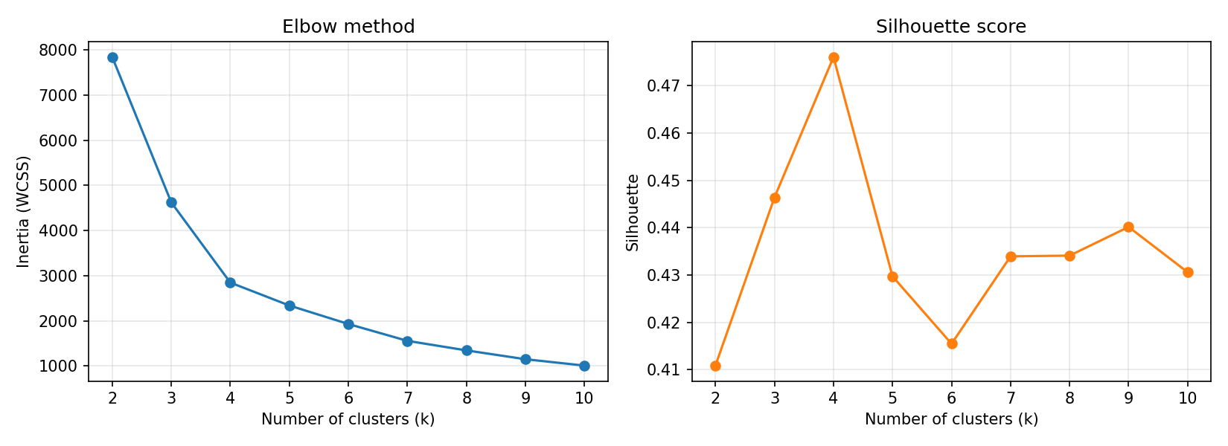
Figure 1. Elbow method (left) and silhouette score (right) for 2 to 10 clusters.

3.2 The four segments
Each segment was converted back to real units (months and dollars) and given a plain-language name.
Segment | Customers | % of base | Avg tenure (months) | Avg monthly charge | Churn rate | Churners (share of all)
New Premium (high risk) | 2,202 | 31.3% | 14.8 | $81.23 | 49.2% | 1,083 (57.9%)
New Budget | 1,733 | 24.6% | 10.5 | $32.49 | 24.5% | 424 (22.7%)
Loyal Premium | 1,948 | 27.7% | 58.8 | $93.08 | 15.7% | 306 (16.4%)
Loyal Budget | 1,160 | 16.5% | 54.1 | $34.15 | 4.8% | 56 (3.0%)

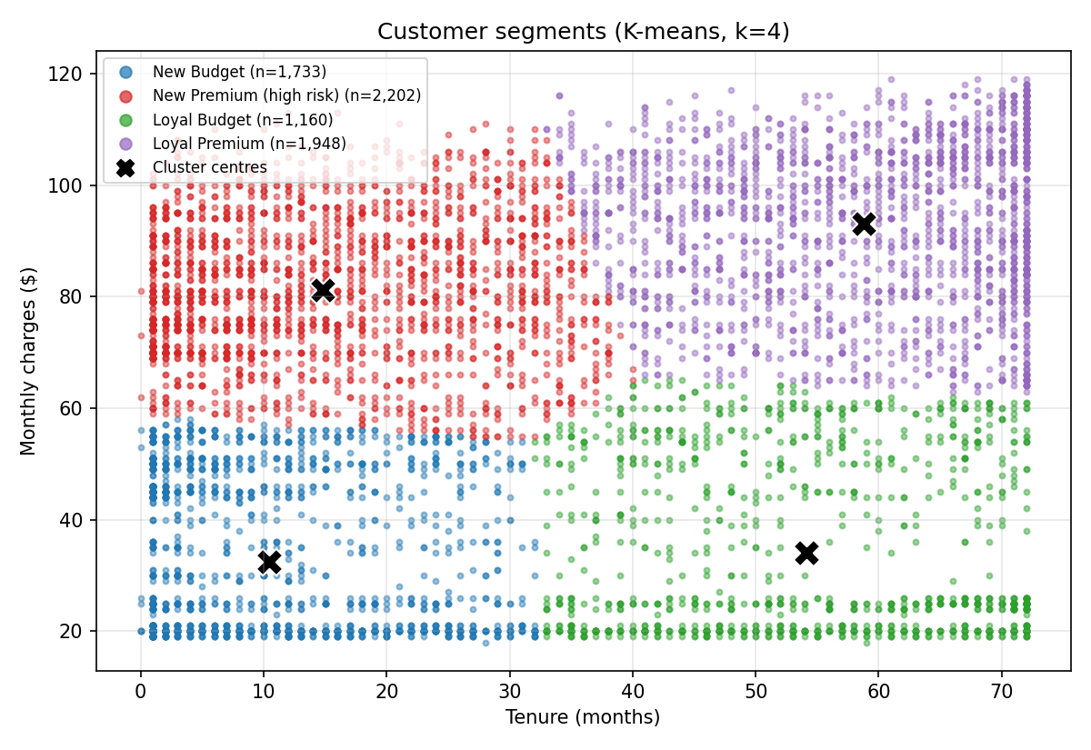
Figure 2. Customer segments by tenure and monthly charges. Black crosses mark the cluster centres.
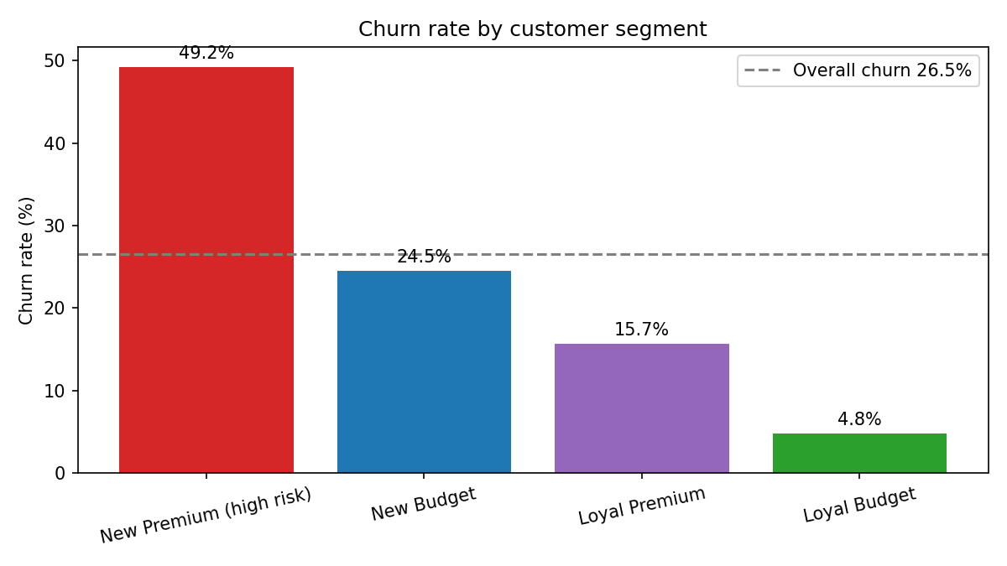
Figure 3. Churn rate by segment. The dashed line is the overall churn rate of 26.5%.

3.3 What the segments show
- New Premium (high risk): nearly one in two customers leaves. This single segment produces more than half of all churn.
- New Budget: churn is close to the overall average (24.5%). These customers are new but pay little, and a quarter of them still leave.
- Loyal Premium: high-paying, long-standing customers churn at 15.7%, well below average, but they are valuable, so each loss costs more.
- Loyal Budget: the most stable group, at 4.8% churn. They need little retention effort.
Tenure separates the segments most strongly, and monthly charges sort the risk within each tenure group. New customers who pay more churn at twice the rate of new customers who pay less (49.2% against 24.5%).

4. Churn Prediction Findings

4.1 Model performance
The ANN (12 inputs, hidden layers of 16 and 8 neurons, one sigmoid output) was used to predict churn for the 1,409 customers it had never seen. The default decision threshold is 0.50. A second threshold of 0.39 was chosen using validation data only, to catch more of the customers who leave.
Metric | Threshold 0.50 (default) | Threshold 0.39 (tuned)
Accuracy | 78.2% | 76.7%
Precision | 60.7% | 55.2%
Recall (churners caught) | 50.8% | 63.9%
F1 score | 55.3% | 59.2%
AUC-ROC | 80.5% | 80.5%

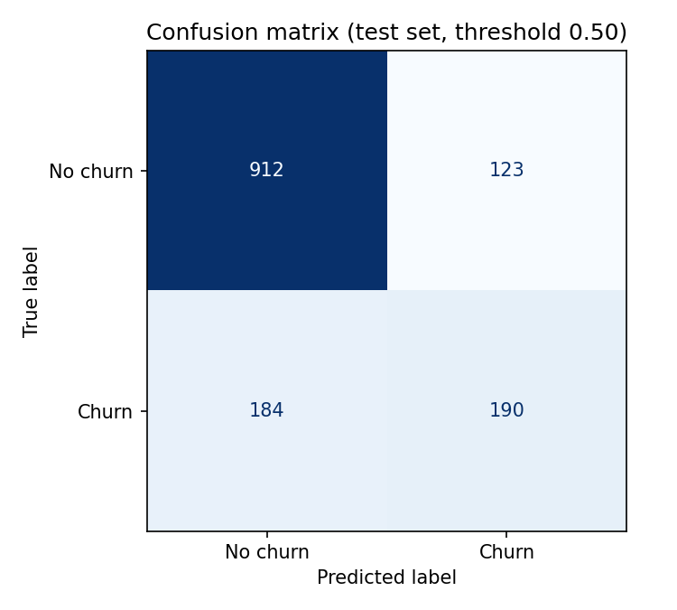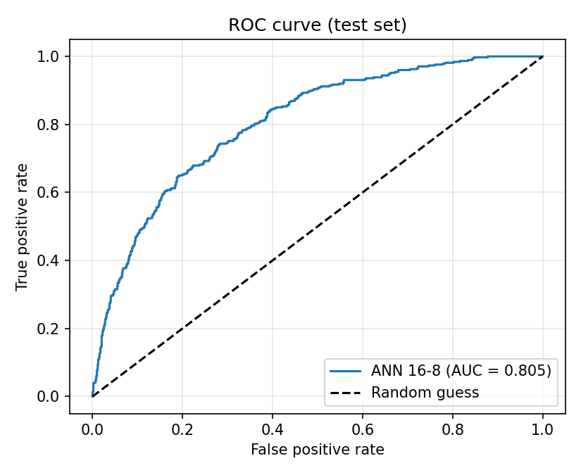
Figure 4. Confusion matrix at threshold 0.50 (left) and ROC curve (right) on the test set.
- Reliable and stable. Retraining with five different random seeds gave an AUC of 80.6% with a spread of only 0.1 percentage points.
- No overfitting. Training and validation loss stayed almost identical while the model trained.
- Trade-off at the tuned threshold. The model catches 64% of churners instead of 51%, but it also contacts more customers who would have stayed (precision falls from 61% to 55%). The tuned threshold is recommended when missing a leaver costs more than an unnecessary offer.
- No gain from complexity. A larger 64-32 network with dropout (AUC 80.7%) and a logistic regression baseline (AUC 80.7%) perform the same as the selected model (AUC 80.5%).

4.2 How well the model predicts within each segment
Combining the two analyses shows where the predictions are most useful. The table uses the test customers only and the tuned threshold of 0.39.
Segment | Test customers | Actual churn | Flagged by model | Churners caught | Flagged who left
New Premium (high risk) | 446 | 49.8% | 69.1% | 82.9% | 59.7%
New Budget | 345 | 23.5% | 32.2% | 59.3% | 43.2%
Loyal Premium | 410 | 14.6% | 3.4% | 11.7% | 50.0%
Loyal Budget | 208 | 5.3% | 0.0% | 0.0% | none flagged

- Accurate where it matters most. In the New Premium segment the average predicted churn probability (50.6%) closely matches the actual churn rate (49.8%), and the model catches 83% of the leavers.
- Blind to loyal churners. The model flags almost no loyal customers, so most loyal customers who leave are missed (it catches only 12% of them in Loyal Premium). The available data contains little that explains why a long-standing customer would leave.

5. Factors Behind Churn: Overview
The full analysis is in the separate document on churn and retention factors. In summary:
Factor | Finding
Tenure | The strongest driver. Churn is 47.4% in the first year and 9.5% after four years.
Monthly charges | The second driver. Churn is 11.9% under $40 per month and 37.0% between $70 and $95.
Senior citizens | Churn is 41.7%, against 23.6% for other customers.
Dependents | Customers without dependents churn at 31.3%, against 15.4% with dependents.
Contract, internet service, gender, phone service | No meaningful relationship with churn in this dataset.

6. Conclusions
- Retention effort should focus on customers in their first year, especially those on higher monthly charges. This is where most churn occurs and where the model is most accurate.
- The ANN is a dependable targeting tool. Customers can be ranked by predicted churn probability so that retention offers go to those most likely to leave.
- Loyal customers who leave cannot be predicted with the current data. Additional information, such as support calls, billing disputes, usage and payment method, would be needed to protect this group.
- Contract type did not distinguish churners from non-churners in this dataset, which is unusual for telecommunications data. This is documented as a data limitation and should be checked with the data provider.

