Factors Contributing to Churn and Retention
Analysis Based on the ANN Model and Customer Data
Stage 3, Final Report 3-2(b) | Data Analyst, Predictive Modeling | October 2026

1. Purpose and Method
This document identifies which customer characteristics are linked to churn and which are linked to staying. Three methods were combined so that the conclusions do not depend on a single technique:
- ANN permutation importance. Each factor is shuffled in the test data and the drop in the trained model's AUC is measured. A large drop means the model depends heavily on that factor. Each factor was shuffled 30 times.
- Logistic regression odds ratios. These show the direction and size of each factor's effect while the other factors are held constant. A value above 1 raises churn risk and a value below 1 lowers it.
- Churn rates and chi-square tests. Churn rates are compared across groups in all 7,043 customers, and a chi-square test checks whether each difference is larger than chance would produce.

2. Summary of Factors
Factor | Churn rate comparison | ANN importance (AUC drop) | Chi-square p-value | Verdict
Tenure | 47.4% in year 1 to 9.5% after 4 years | 0.212 | < 0.001 | Strongest driver
Monthly charges | 11.9% under $40 to 37.0% at $70-95 | 0.110 | < 0.001 | Second driver
Senior citizen | 41.7% against 23.6% | 0.007 | < 0.001 | Driver
Dependents | 31.3% without, 15.4% with | 0.002 | < 0.001 | Linked to churn, adds little predictive power
Contract type | 27.3%, 25.8%, 25.4% | 0.002 | 0.24 | No relationship
Internet service | 27.4% DSL, 25.4% fibre | 0.001 | 0.064 | No relationship
Phone service | 24.9% without, 26.7% with | 0.006 | 0.34 | No relationship on its own
Multiple lines | 26.5% with and without | 0.001 | 1.00 | No relationship
Gender | 26.9% female, 26.2% male | -0.001 | 0.49 | No relationship

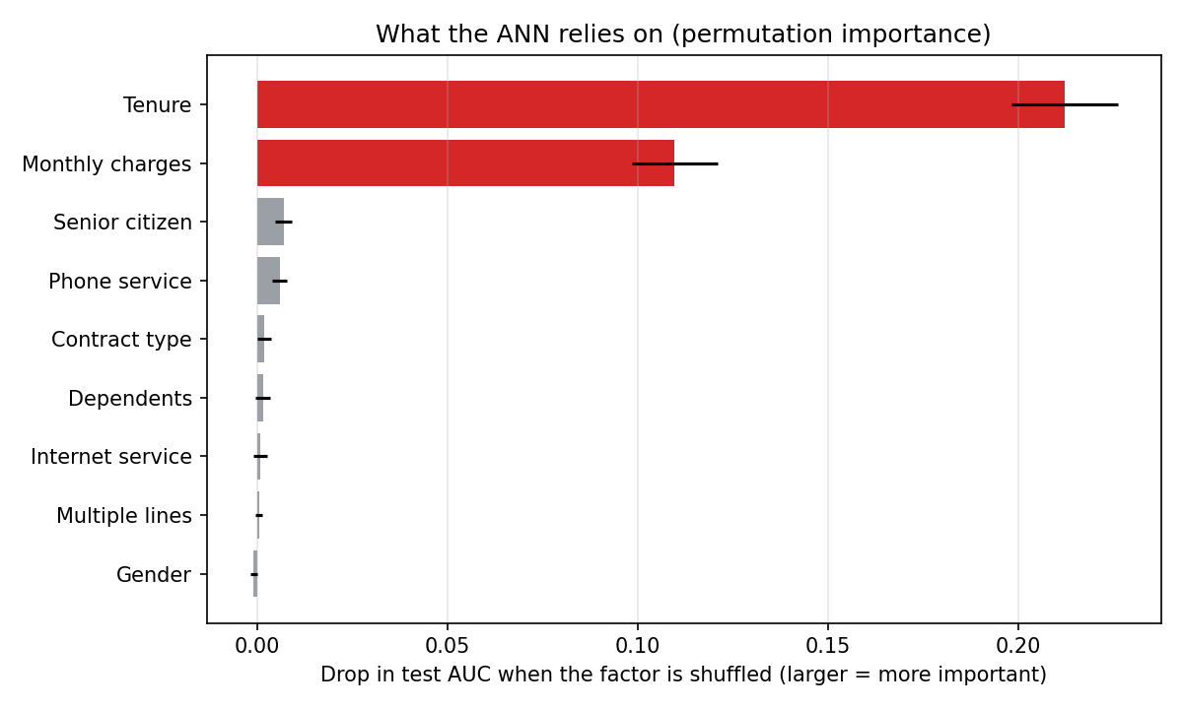
Figure 1. Permutation importance in the ANN. Tenure and monthly charges dominate; every other factor is close to zero.
Tenure and monthly charges together account for almost all of the model's predictive power. A logistic regression using only four factors (tenure, monthly charges, senior citizen and dependents) reaches an AUC of 0.802, compared with 0.807 for the same model using all 12 inputs.

3. Factors That Increase Churn

3.1 Short tenure
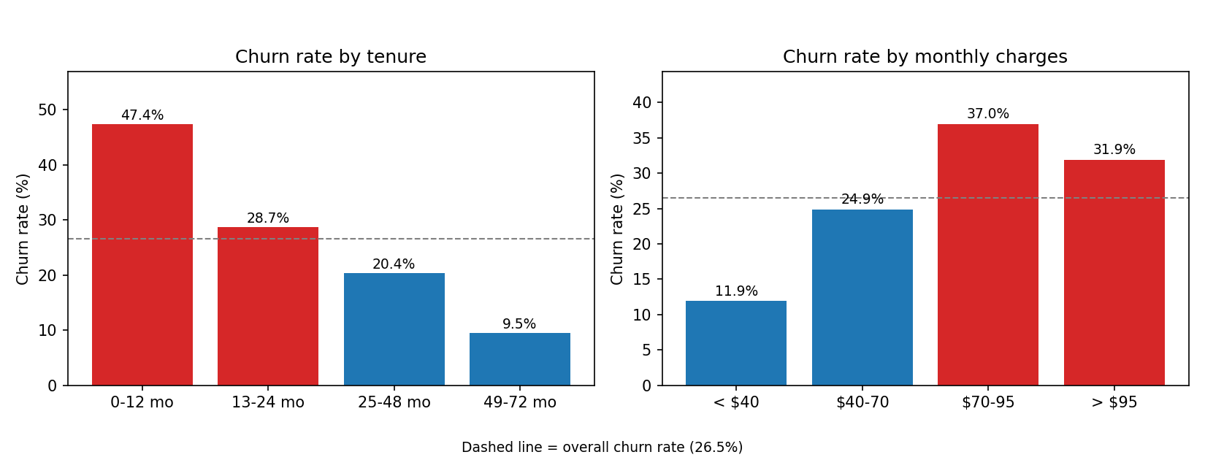
Figure 2. Churn rate by tenure (left) and by monthly charges (right). The dashed line is the overall rate of 26.5%.
- Churn falls steadily as customers stay longer: 47.4% in the first 12 months, 28.7% in months 13 to 24, 20.4% in months 25 to 48 and 9.5% after that.
- In the logistic regression, every additional 24.6 months of tenure (one standard deviation) cuts a customer's odds of churning to about a quarter, with other factors held constant.
- The first year is therefore the critical period: almost half of the customers with a year or less of tenure had left.

3.2 High monthly charges
Overall, churn peaks at $70 to $95 (37.0%) and eases slightly above $95 (31.9%). That dip is misleading: customers paying the most are mostly long-standing customers, whose low churn masks the effect of price. Once tenure is held fixed, higher charges always mean higher churn, as the heatmap shows.
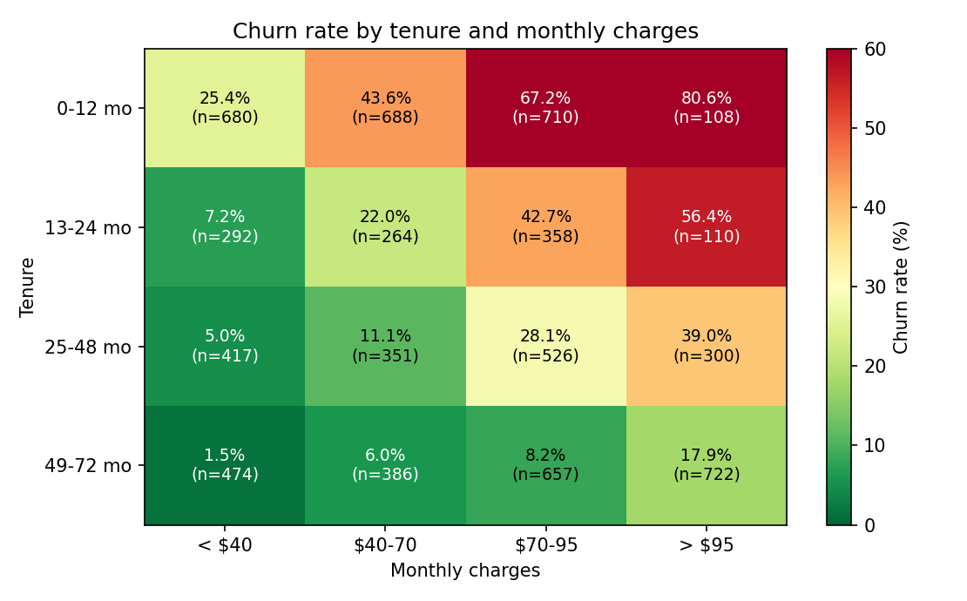
Figure 3. Churn rate by tenure band and monthly charges band, with the number of customers in each cell.
- Highest risk: customers in their first year paying $70 to $95 churn at 67.2% (710 customers), and those paying over $95 churn at 80.6% (108 customers, so a smaller sample).
- Lowest risk: customers with more than four years of tenure paying under $40 churn at only 1.5% (474 customers).
- In the logistic regression, a $30 higher monthly charge (one standard deviation) raises the odds of churning by a factor of about 2.8, with other factors held constant.
Tenure and charges therefore work together. New customers on expensive plans are the group most likely to leave, and this is the same group that the clustering analysis identified as the New Premium segment.

3.3 Senior citizens
- Senior citizens make up 16% of customers (1,142) and churn at 41.7%, against 23.6% for other customers.
- The effect remains after accounting for the other factors: the odds ratio is about 1.7.
- Seniors without dependents churn at 43.2% (1,051 customers). Only 91 seniors have dependents, which is too few to draw firm conclusions about that group.

3.4 No dependents
Customers without dependents churn at 31.3%, against 15.4% for customers with dependents. The gap appears at every stage of the customer lifecycle, as the table shows.
Tenure band | Without dependents | With dependents
0-12 months | 51.0% | 33.3%
13-24 months | 32.9% | 18.8%
25-48 months | 23.6% | 13.6%
49-72 months | 11.6% | 6.1%

Although dependents are clearly linked to churn, they add almost nothing to the model once tenure and monthly charges are known (retraining without this factor left the AUC unchanged). Dependents are therefore most useful as an easy way to describe and target at-risk customers, not as an extra predictive signal.

4. Factors That Support Retention
The groups with the lowest churn show what keeps customers:
Group | Churn rate | Customers
More than 4 years' tenure and under $40 per month | 1.5% | 474
25 to 48 months' tenure and under $40 per month | 5.0% | 417
More than 4 years' tenure and $40 to $70 per month | 6.0% | 386
More than 4 years' tenure with dependents | 6.1% | 853
More than 4 years' tenure (all customers) | 9.5% | 2,239
Monthly charges under $40 (all customers) | 11.9% | 1,863

- Time with the company is the strongest protector. Customers who survive the first two years become progressively more stable.
- Lower, stable bills go with low churn at every stage of tenure.
- Household ties (having dependents) go with roughly half the churn of customers without them.

5. Factors With No Relationship to Churn
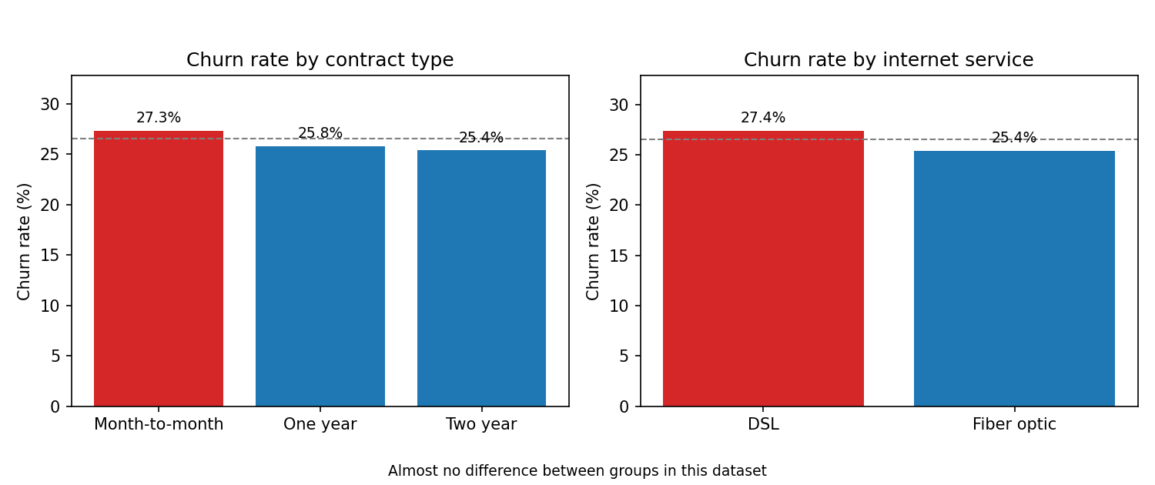
Figure 4. Churn rate by contract type (left) and internet service (right) shows almost no difference between groups.
- Contract type, internet service, multiple lines and gender show differences of only one or two percentage points, and none is statistically significant.
- Phone service has a small effect in the model but only in combination with monthly charges. On its own, churn is almost the same with and without it (24.9% against 26.7%, p = 0.34), so it is not treated as a driver.
- Contract type is unusual here. In most telecommunications data, customers on month-to-month contracts churn far more than customers on long contracts, and customers on long contracts have longer tenure. In this dataset, average tenure is the same for all three contract types (about 32 months) and churn is almost identical. This suggests the field may not carry its usual information, and it should be checked with the data provider before any contract-based strategy is adopted.

6. Implications
- Retention work should target the first year of the customer relationship, because tenure is the strongest factor.
- Among new customers, the highest-priced plans carry the greatest risk, so these customers need the earliest and strongest intervention.
- Seniors and customers without dependents are higher-risk groups that can be identified easily and contacted proactively.
- Contract type cannot be used to target retention in this dataset, even though it is a common lever in the industry.
These implications are turned into specific retention strategies in the recommendations document.

