Final Report
Customer Churn Prediction Using an Artificial Neural Network
Stage 3 Deliverable 3-2 | Data Analyst, Predictive Modeling | October 2026

Contents
Part | Title | Brief reference
Part 1 | Summary of Key Findings | 3-2(a)
Part 2 | Factors Contributing to Churn and Retention | 3-2(b)
Part 3 | Recommendations for Targeted Retention Strategies | 3-2(c)
Part 4 | Limitations and Proposed Solutions | 3-2(d)

This report brings together the four required parts of the Stage 3 Final Report. Each part is also provided as a separate document in the Final_Report folder.
The model, code, data and results behind this report are in the Predictive_Modeling folder of the project repository. The architecture of the ANN is described in the document ANN_Architecture.docx in that folder, and the video demonstration is submitted separately.

Summary of Key Findings
Customer Segmentation and Churn Prediction
Stage 3, Final Report 3-2(a) | Data Analyst, Predictive Modeling | October 2026

1. Executive Summary
This report summarises what was learned from segmenting 7,043 telecommunications customers and from predicting customer churn with an Artificial Neural Network (ANN). The main findings are:
- Churn is common. 1,869 of the 7,043 customers (26.5%) left the company.
- Churn is concentrated in new customers. Customers in the two "New" segments make up 56% of the customer base but 81% of all churners.
- New customers on higher monthly charges are the highest risk. The "New Premium" segment (about 15 months of tenure, $81 per month) churns at 49.2% and accounts for 58% of all churners. The "Loyal Budget" segment churns at only 4.8%.
- The ANN predicts churn reliably. On 1,409 unseen customers it reached an AUC-ROC of 80.5% and an accuracy of 78.2%. With a tuned decision threshold it identifies 64% of the customers who actually left.
- The model is strongest where the risk is highest. It identifies 83% of the churners in the New Premium segment, but it rarely flags loyal customers who leave.
- Tenure and monthly charges drive the predictions. Contract type, internet service and gender showed no relationship with churn in this dataset.
- The data, not the model, limits accuracy. A simple logistic regression performs just as well as the ANN, so better results would need richer customer data.

2. Data and Approach
The analysis used Dataset_ATS_v2.csv, which holds 7,043 customers with 10 attributes and no missing values. Customers were first grouped with K-means clustering on tenure and monthly charges. The prediction model was then trained on 5,634 customers (80%) and tested on 1,409 unseen customers (20%), with 26.5% churn in both parts. The ANN has two hidden layers of 16 and 8 neurons and is described in the architecture document.

3. Customer Segmentation Findings

3.1 Choosing the number of segments
K-means clustering was run on standardised tenure and monthly charges for 2 to 10 clusters. The elbow curve bends at four clusters, and the silhouette score, which measures how well separated the groups are, peaks at four (0.476). Both methods therefore support four segments.
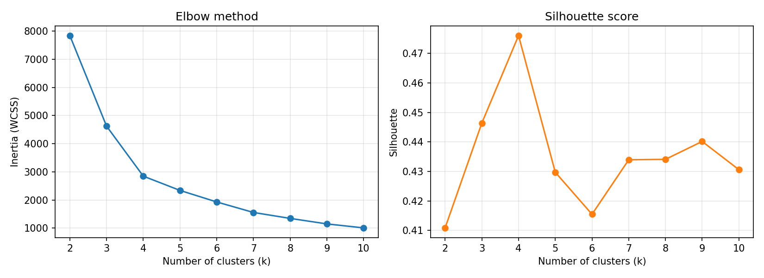
Figure 1. Elbow method (left) and silhouette score (right) for 2 to 10 clusters.

3.2 The four segments
Each segment was converted back to real units (months and dollars) and given a plain-language name.
Segment | Customers | % of base | Avg tenure (months) | Avg monthly charge | Churn rate | Churners (share of all)
New Premium (high risk) | 2,202 | 31.3% | 14.8 | $81.23 | 49.2% | 1,083 (57.9%)
New Budget | 1,733 | 24.6% | 10.5 | $32.49 | 24.5% | 424 (22.7%)
Loyal Premium | 1,948 | 27.7% | 58.8 | $93.08 | 15.7% | 306 (16.4%)
Loyal Budget | 1,160 | 16.5% | 54.1 | $34.15 | 4.8% | 56 (3.0%)

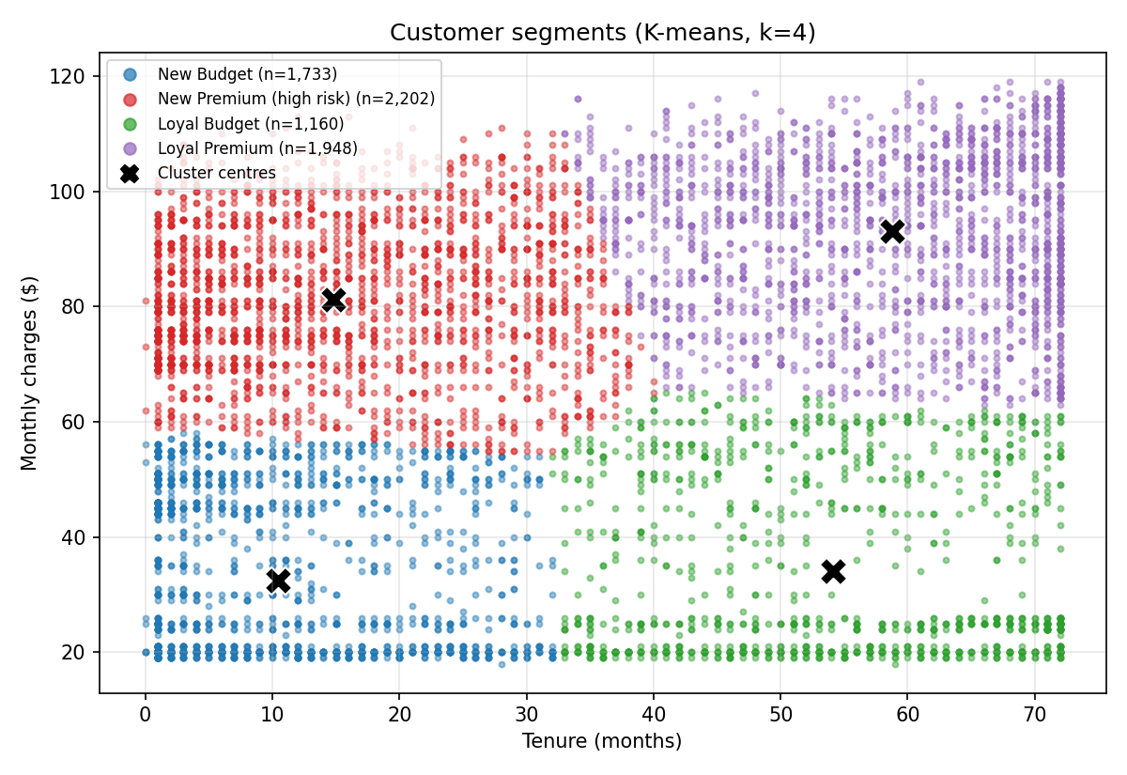
Figure 2. Customer segments by tenure and monthly charges. Black crosses mark the cluster centres.
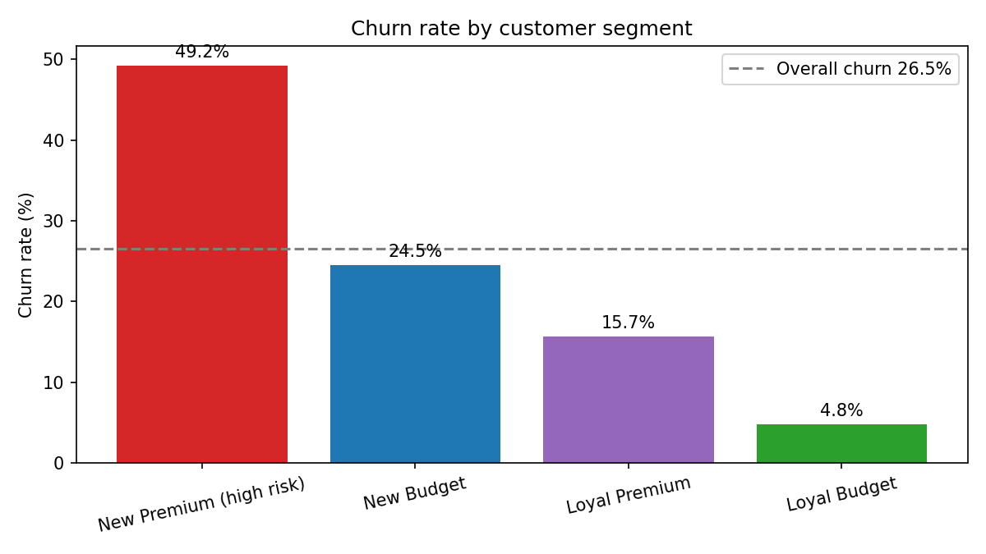
Figure 3. Churn rate by segment. The dashed line is the overall churn rate of 26.5%.

3.3 What the segments show
- New Premium (high risk): nearly one in two customers leaves. This single segment produces more than half of all churn.
- New Budget: churn is close to the overall average (24.5%). These customers are new but pay little, and a quarter of them still leave.
- Loyal Premium: high-paying, long-standing customers churn at 15.7%, well below average, but they are valuable, so each loss costs more.
- Loyal Budget: the most stable group, at 4.8% churn. They need little retention effort.
Tenure separates the segments most strongly, and monthly charges sort the risk within each tenure group. New customers who pay more churn at twice the rate of new customers who pay less (49.2% against 24.5%).

4. Churn Prediction Findings

4.1 Model performance
The ANN (12 inputs, hidden layers of 16 and 8 neurons, one sigmoid output) was used to predict churn for the 1,409 customers it had never seen. The default decision threshold is 0.50. A second threshold of 0.39 was chosen using validation data only, to catch more of the customers who leave.
Metric | Threshold 0.50 (default) | Threshold 0.39 (tuned)
Accuracy | 78.2% | 76.7%
Precision | 60.7% | 55.2%
Recall (churners caught) | 50.8% | 63.9%
F1 score | 55.3% | 59.2%
AUC-ROC | 80.5% | 80.5%

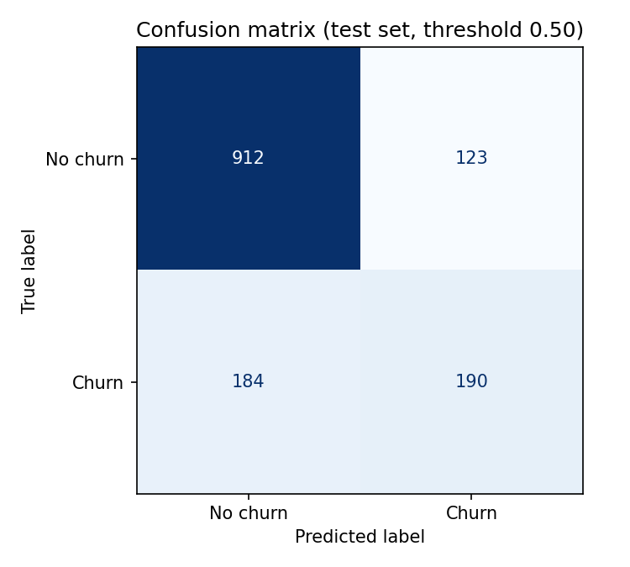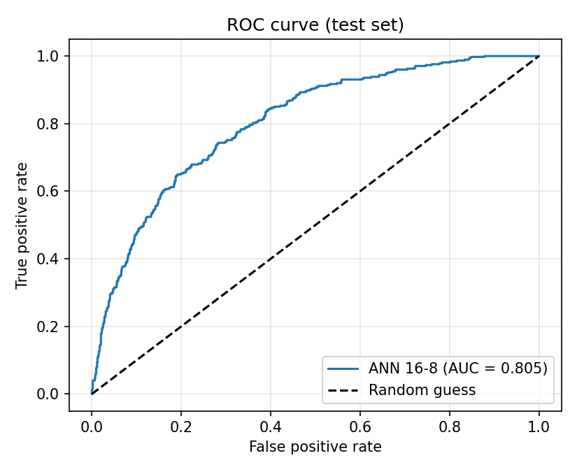
Figure 4. Confusion matrix at threshold 0.50 (left) and ROC curve (right) on the test set.
- Reliable and stable. Retraining with five different random seeds gave an AUC of 80.6% with a spread of only 0.1 percentage points.
- No overfitting. Training and validation loss stayed almost identical while the model trained.
- Trade-off at the tuned threshold. The model catches 64% of churners instead of 51%, but it also contacts more customers who would have stayed (precision falls from 61% to 55%). The tuned threshold is recommended when missing a leaver costs more than an unnecessary offer.
- No gain from complexity. A larger 64-32 network with dropout (AUC 80.7%) and a logistic regression baseline (AUC 80.7%) perform the same as the selected model (AUC 80.5%).

4.2 How well the model predicts within each segment
Combining the two analyses shows where the predictions are most useful. The table uses the test customers only and the tuned threshold of 0.39.
Segment | Test customers | Actual churn | Flagged by model | Churners caught | Flagged who left
New Premium (high risk) | 446 | 49.8% | 69.1% | 82.9% | 59.7%
New Budget | 345 | 23.5% | 32.2% | 59.3% | 43.2%
Loyal Premium | 410 | 14.6% | 3.4% | 11.7% | 50.0%
Loyal Budget | 208 | 5.3% | 0.0% | 0.0% | none flagged

- Accurate where it matters most. In the New Premium segment the average predicted churn probability (50.6%) closely matches the actual churn rate (49.8%), and the model catches 83% of the leavers.
- Blind to loyal churners. The model flags almost no loyal customers, so most loyal customers who leave are missed (it catches only 12% of them in Loyal Premium). The available data contains little that explains why a long-standing customer would leave.

5. Factors Behind Churn: Overview
The full analysis is in Part 2 of this report. In summary:
Factor | Finding
Tenure | The strongest driver. Churn is 47.4% in the first year and 9.5% after four years.
Monthly charges | The second driver. Churn is 11.9% under $40 per month and 37.0% between $70 and $95.
Senior citizens | Churn is 41.7%, against 23.6% for other customers.
Dependents | Customers without dependents churn at 31.3%, against 15.4% with dependents.
Contract, internet service, gender, phone service | No meaningful relationship with churn in this dataset.

6. Conclusions
- Retention effort should focus on customers in their first year, especially those on higher monthly charges. This is where most churn occurs and where the model is most accurate.
- The ANN is a dependable targeting tool. Customers can be ranked by predicted churn probability so that retention offers go to those most likely to leave.
- Loyal customers who leave cannot be predicted with the current data. Additional information, such as support calls, billing disputes, usage and payment method, would be needed to protect this group.
- Contract type did not distinguish churners from non-churners in this dataset, which is unusual for telecommunications data. This is documented as a data limitation and should be checked with the data provider.

Factors Contributing to Churn and Retention
Analysis Based on the ANN Model and Customer Data
Stage 3, Final Report 3-2(b) | Data Analyst, Predictive Modeling | October 2026

1. Purpose and Method
This document identifies which customer characteristics are linked to churn and which are linked to staying. Three methods were combined so that the conclusions do not depend on a single technique:
- ANN permutation importance. Each factor is shuffled in the test data and the drop in the trained model's AUC is measured. A large drop means the model depends heavily on that factor. Each factor was shuffled 30 times.
- Logistic regression odds ratios. These show the direction and size of each factor's effect while the other factors are held constant. A value above 1 raises churn risk and a value below 1 lowers it.
- Churn rates and chi-square tests. Churn rates are compared across groups in all 7,043 customers, and a chi-square test checks whether each difference is larger than chance would produce.

2. Summary of Factors
Factor | Churn rate comparison | ANN importance (AUC drop) | Chi-square p-value | Verdict
Tenure | 47.4% in year 1 to 9.5% after 4 years | 0.212 | < 0.001 | Strongest driver
Monthly charges | 11.9% under $40 to 37.0% at $70-95 | 0.110 | < 0.001 | Second driver
Senior citizen | 41.7% against 23.6% | 0.007 | < 0.001 | Driver
Dependents | 31.3% without, 15.4% with | 0.002 | < 0.001 | Linked to churn, adds little predictive power
Contract type | 27.3%, 25.8%, 25.4% | 0.002 | 0.24 | No relationship
Internet service | 27.4% DSL, 25.4% fibre | 0.001 | 0.064 | No relationship
Phone service | 24.9% without, 26.7% with | 0.006 | 0.34 | No relationship on its own
Multiple lines | 26.5% with and without | 0.001 | 1.00 | No relationship
Gender | 26.9% female, 26.2% male | -0.001 | 0.49 | No relationship

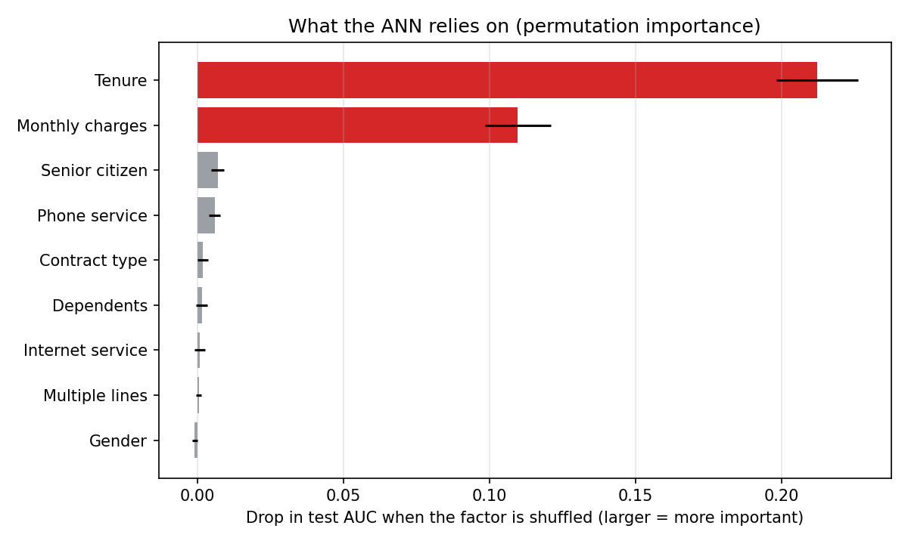
Figure 1. Permutation importance in the ANN. Tenure and monthly charges dominate; every other factor is close to zero.
Tenure and monthly charges together account for almost all of the model's predictive power. A logistic regression using only four factors (tenure, monthly charges, senior citizen and dependents) reaches an AUC of 0.802, compared with 0.807 for the same model using all 12 inputs.

3. Factors That Increase Churn

3.1 Short tenure
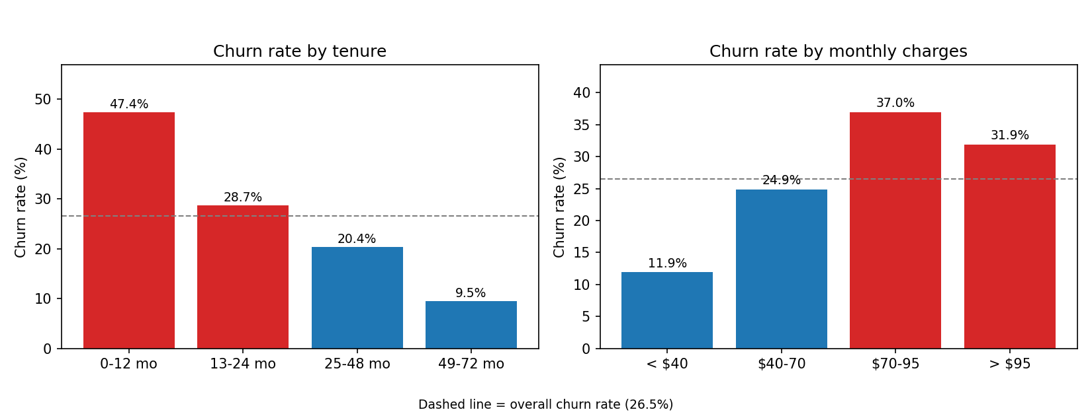
Figure 2. Churn rate by tenure (left) and by monthly charges (right). The dashed line is the overall rate of 26.5%.
- Churn falls steadily as customers stay longer: 47.4% in the first 12 months, 28.7% in months 13 to 24, 20.4% in months 25 to 48 and 9.5% after that.
- In the logistic regression, every additional 24.6 months of tenure (one standard deviation) cuts a customer's odds of churning to about a quarter, with other factors held constant.
- The first year is therefore the critical period: almost half of the customers with a year or less of tenure had left.

3.2 High monthly charges
Overall, churn peaks at $70 to $95 (37.0%) and eases slightly above $95 (31.9%). That dip is misleading: customers paying the most are mostly long-standing customers, whose low churn masks the effect of price. Once tenure is held fixed, higher charges always mean higher churn, as the heatmap shows.
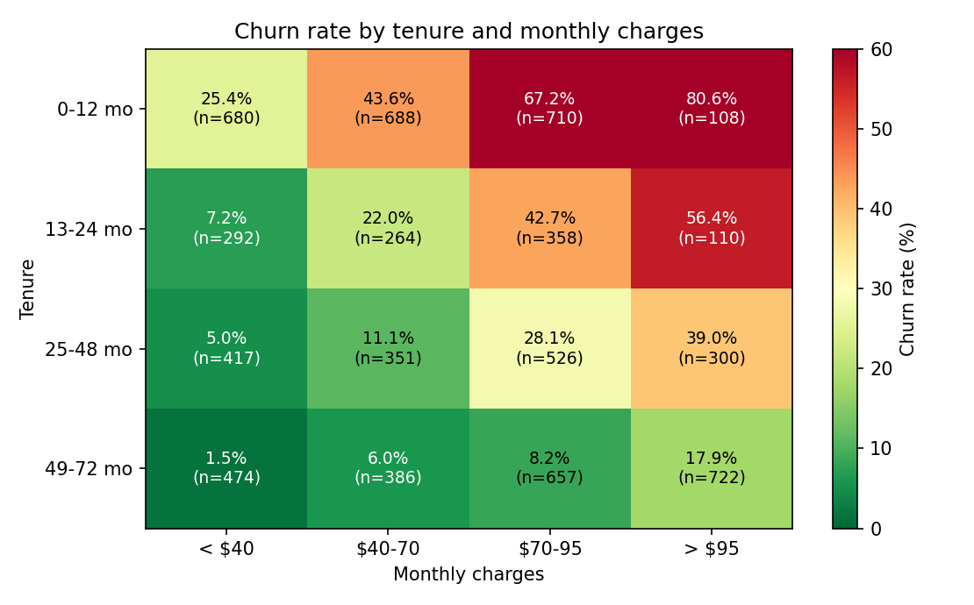
Figure 3. Churn rate by tenure band and monthly charges band, with the number of customers in each cell.
- Highest risk: customers in their first year paying $70 to $95 churn at 67.2% (710 customers), and those paying over $95 churn at 80.6% (108 customers, so a smaller sample).
- Lowest risk: customers with more than four years of tenure paying under $40 churn at only 1.5% (474 customers).
- In the logistic regression, a $30 higher monthly charge (one standard deviation) raises the odds of churning by a factor of about 2.8, with other factors held constant.
Tenure and charges therefore work together. New customers on expensive plans are the group most likely to leave, and this is the same group that the clustering analysis identified as the New Premium segment.

3.3 Senior citizens
- Senior citizens make up 16% of customers (1,142) and churn at 41.7%, against 23.6% for other customers.
- The effect remains after accounting for the other factors: the odds ratio is about 1.7.
- Seniors without dependents churn at 43.2% (1,051 customers). Only 91 seniors have dependents, which is too few to draw firm conclusions about that group.

3.4 No dependents
Customers without dependents churn at 31.3%, against 15.4% for customers with dependents. The gap appears at every stage of the customer lifecycle, as the table shows.
Tenure band | Without dependents | With dependents
0-12 months | 51.0% | 33.3%
13-24 months | 32.9% | 18.8%
25-48 months | 23.6% | 13.6%
49-72 months | 11.6% | 6.1%

Although dependents are clearly linked to churn, they add almost nothing to the model once tenure and monthly charges are known (retraining without this factor left the AUC unchanged). Dependents are therefore most useful as an easy way to describe and target at-risk customers, not as an extra predictive signal.

4. Factors That Support Retention
The groups with the lowest churn show what keeps customers:
Group | Churn rate | Customers
More than 4 years' tenure and under $40 per month | 1.5% | 474
25 to 48 months' tenure and under $40 per month | 5.0% | 417
More than 4 years' tenure and $40 to $70 per month | 6.0% | 386
More than 4 years' tenure with dependents | 6.1% | 853
More than 4 years' tenure (all customers) | 9.5% | 2,239
Monthly charges under $40 (all customers) | 11.9% | 1,863

- Time with the company is the strongest protector. Customers who survive the first two years become progressively more stable.
- Lower, stable bills go with low churn at every stage of tenure.
- Household ties (having dependents) go with roughly half the churn of customers without them.

5. Factors With No Relationship to Churn
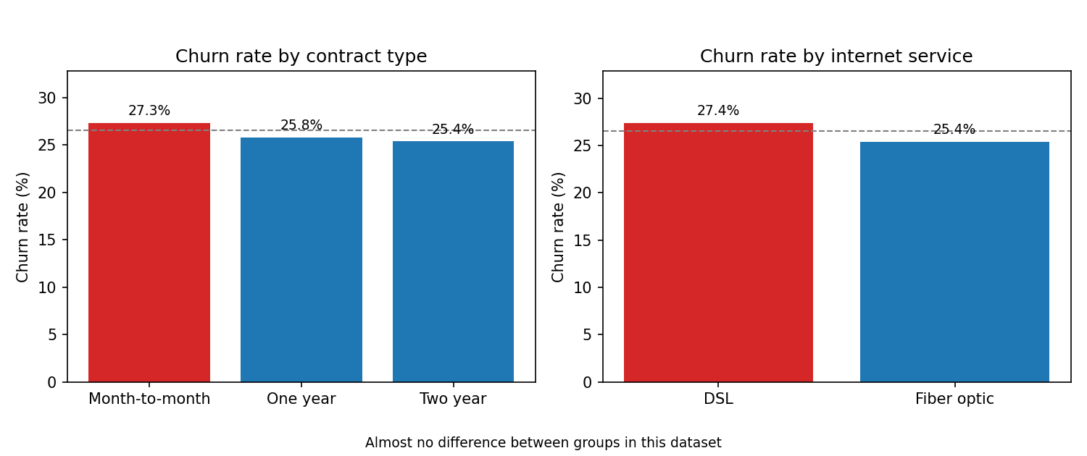
Figure 4. Churn rate by contract type (left) and internet service (right) shows almost no difference between groups.
- Contract type, internet service, multiple lines and gender show differences of only one or two percentage points, and none is statistically significant.
- Phone service has a small effect in the model but only in combination with monthly charges. On its own, churn is almost the same with and without it (24.9% against 26.7%, p = 0.34), so it is not treated as a driver.
- Contract type is unusual here. In most telecommunications data, customers on month-to-month contracts churn far more than customers on long contracts, and customers on long contracts have longer tenure. In this dataset, average tenure is the same for all three contract types (about 32 months) and churn is almost identical. This suggests the field may not carry its usual information, and it should be checked with the data provider before any contract-based strategy is adopted.

6. Implications
- Retention work should target the first year of the customer relationship, because tenure is the strongest factor.
- Among new customers, the highest-priced plans carry the greatest risk, so these customers need the earliest and strongest intervention.
- Seniors and customers without dependents are higher-risk groups that can be identified easily and contacted proactively.
- Contract type cannot be used to target retention in this dataset, even though it is a common lever in the industry.
These implications are turned into specific retention strategies in Part 3 of this report.

Recommendations for Targeted Retention Strategies
Turning the Segmentation and Churn Prediction Results Into Action
Stage 3, Final Report 3-2(c) | Data Analyst, Predictive Modeling | October 2026

1. Purpose and Basis
This document recommends how the company can reduce churn by directing retention effort to the customers most likely to leave. Every recommendation is tied to a finding from the earlier analysis:
- Customers were grouped into four segments by tenure and monthly charges, and the segments differ sharply in churn.
- Tenure and monthly charges are the two factors that matter most, and senior citizens and customers without dependents also churn more.
- The ANN gives each customer a churn probability, which can be used to decide who to contact.
Important: the findings show associations, not proven causes. The strategies below are well-founded starting points and should be tested with a pilot before being rolled out to every customer (see Section 7).

2. Where to Focus
Segment | Churn rate | Share of all churners | Priority | Retention goal
New Premium (high risk) | 49.2% | 57.9% | 1 | Stop early exits among customers paying higher bills
New Budget | 24.5% | 22.7% | 2 | Keep new low-spend customers engaged through their first year
Loyal Premium | 15.7% | 16.4% | 3 | Protect high-value customers with regular relationship care
Loyal Budget | 4.8% | 3.0% | 4 | Maintain with minimal cost

More than half of all churn comes from one segment, and four out of five churners come from the two New segments. Effort spent on customers in their first year has the largest potential return.

3. Strategies by Segment

3.1 New Premium (high risk): Priority 1
Why: 49% of these customers leave. They have about 15 months of tenure and pay about $81 per month. First-year customers paying $70 to $95 churn at 67%.
- Structured first-year programme. Contact each new customer on a fixed schedule, for example at months 1, 3, 6 and 9, to check satisfaction and fix problems early.
- Early bill review. Check each new customer's first bills against what they expected, and offer a plan review to anyone paying well above the average. High charges are the strongest risk factor after tenure.
- Value-matching offers. For customers paying $70 or more in their first year, offer a plan optimisation, a time-limited loyalty credit or an added benefit that makes the price feel worthwhile.
- Model-triggered outreach. Use the ANN's churn probability to start the contact earlier for customers who look most at risk (see Section 5).
Measure: churn rate in this segment (currently 49.2%) and first-year churn (currently 47.4% for customers with 12 months or less).

3.2 New Budget: Priority 2
Why: 24.5% churn is close to the overall average, and this group makes up one quarter of all customers. They pay little, so costly offers are not justified.
- Low-cost engagement. Use automated messages, welcome guides and usage tips rather than personal calls.
- Milestone recognition. Mark the 6-month and 12-month anniversaries with a small reward, because churn keeps falling as customers stay longer.
- Careful pricing. Avoid price increases or upsell pressure in the first year, since higher charges raise churn risk at every tenure.
Measure: churn rate in this segment (currently 24.5%) and the share of customers who pass 12 months.

3.3 Loyal Premium: Priority 3
Why: churn is 15.7%, well below average, but these customers pay about $93 per month, so each loss is costly. The model can identify only a small share of the loyal customers who leave, so general care matters more than prediction here.
- Regular relationship care. Provide an annual account review and a named contact or priority service line.
- Recognition of loyalty. Offer loyalty pricing reviews or rewards for long-standing high-spend customers.
- Listen for early signals. Run satisfaction surveys and record support complaints, so that better data is available to predict churn in this group (see Part 4 of this report).
Measure: churn rate in this segment (currently 15.7%) and satisfaction scores.

3.4 Loyal Budget: Priority 4
Why: churn is only 4.8%, and this segment produces 3% of all churners.
- Keep service reliable and avoid disruptive changes, but do not spend retention budget here.
- These stable customers are a natural group to invite to referral programmes.
Measure: churn rate staying at or below 5%.

4. Targeting by Customer Characteristics
Some characteristics cut across the segments and can be used to focus support and offers:
Group | Churn rate | Suggested action
Senior citizens | 41.7% | Offer assisted onboarding, simpler plans and the contact channel they prefer (for example a phone call rather than an app message).
Customers without dependents | 31.3% | Include them in early outreach, since this group churns at twice the rate of customers with dependents.
Customers with dependents | 15.4% | Test household or family-style offers, as customers with family ties stay longer. This is an association and needs testing.

Contract type is not recommended as a lever. In this dataset, contract type showed no relationship with churn, so offers built around contract length are not supported by the data. This should be revisited if the contract field is confirmed to be accurate.

5. Using the ANN to Choose Who to Contact
The trained ANN gives every customer a churn probability. A customer is added to the outreach list when the probability is above a chosen threshold. The threshold controls the trade-off between reaching more future leavers and contacting more customers who would have stayed. Results on the 1,409 unseen test customers (374 of whom actually churned):
Threshold | Customers contacted | Leavers reached | Share of leavers | Contacted who would leave
0.50 (default) | 313 | 190 | 50.8% | 60.7%
0.39 (tuned) | 433 | 239 | 63.9% | 55.2%

- Recommended default: 0.39. It reaches 49 more leavers (a 26% increase) for 120 more contacts. This suits retention offers that are cheap relative to the value of a customer.
- Segment-specific thresholds. In New Premium, the 0.39 threshold reaches 83% of leavers and 60% of contacted customers would have left. In New Budget, the default 0.50 contacts fewer customers (22% against 32%) and still reaches 42% of leavers, which may suit a lower-cost approach.
- Re-score regularly. Scoring customers every month keeps the list current as tenure and charges change.
- Know the limit. The model rarely flags loyal customers, so it should complement, not replace, the care described for Loyal Premium.

6. Implementation Plan
Phase | Timing | Activities
1. Set up | Weeks 1 to 4 | Score all customers with the ANN, build the outreach list for New Premium, and agree offers and budget.
2. Pilot | Months 2 to 4 | Run the first-year programme and offers on part of the New Premium and New Budget customers, keeping a comparison group untouched.
3. Evaluate | Months 4 to 6 | Compare churn between treated and untreated customers, and measure the cost of each retained customer.
4. Scale and improve | Month 6 onwards | Extend the successful actions to all customers, add new data sources and retrain the model.

7. Measuring Success
- Baselines from this analysis: overall churn 26.5%, New Premium 49.2%, New Budget 24.5%, Loyal Premium 15.7%, Loyal Budget 4.8%, first-year churn 47.4%.
- Use a control group. Leave a random share of at-risk customers without an offer, so the true effect of the programme can be separated from normal variation.
- Track cost as well as churn. Compare the cost of each offer with the revenue kept from customers who stay.
- Monitor the model. Check each month that the share of leavers it reaches stays close to the 64% measured here, and retrain if it falls.
For scale only, the table below shows how many customers would be kept if churn in each segment fell by one tenth. This is an illustration, not a forecast, and the real effect must come from the pilot.
Segment | Customers who churned | Kept if churn fell by 10% (illustration)
New Premium (high risk) | 1,083 | about 108
New Budget | 424 | about 42
Loyal Premium | 306 | about 31
Loyal Budget | 56 | about 6

The table shows why effort is best spent on the two New segments, where most of the churners are.

Limitations and Proposed Solutions
Challenges Encountered and How to Address Them
Stage 3, Final Report 3-2(d) | Data Analyst, Predictive Modeling | October 2026

1. Purpose and Overview
This document records the limitations and challenges found during the project and proposes a solution for each. Where possible, a limitation was tested with a specific check instead of only being described. The checks are in the script limitations_checks.py, and their results are in limitations_check_results.csv.
In short: the model and the segmentation are sound and stable, but the data is the main constraint. The dataset has few customer attributes, two of its fields appear to carry no information, and some records are duplicated. As a result, the model works well for first-year customers and poorly for loyal customers who leave.
Limitation | Severity | Evidence | Proposed solution
Contract and internet fields show no relationship with churn | High | Churn 27.3%, 25.8%, 25.4% across contracts; same average tenure (about 32 months) | Confirm the fields with the data provider and rebuild with verified data
Few customer attributes | High | 9 attributes, only 4 related to churn; ANN no better than logistic regression | Add usage, billing, support and payment data
Loyal customers who leave are missed | High | Only 11.7% of Loyal Premium leavers caught; none flagged in Loyal Budget | Collect behavioural data; build a model for long-tenure customers
Duplicate and overlapping records | Medium | 302 duplicate rows; 93 of 1,409 test rows match a training row; AUC 80.5% falls to 79.1% on a clean test set | Add a customer ID; remove duplicates before splitting
Moderate recall at the default threshold | Medium | 50.8% of leavers caught at 0.50, 63.9% at 0.39 | Use the tuned threshold; test class weights and cost-based thresholds
Findings are associations, not causes | Medium | Recommendations not yet tested | Run a pilot with a control group
Fairness of age and gender inputs | Medium | Senior status is used; gender has no predictive value | Remove gender; review age use before deployment
Single snapshot with no dates or churn definition | Medium | No timing of departures; churn period not stated | Obtain dated records and a written churn definition
Single train/test split | Low | Cross-validation AUC 81.6% with a spread of 1.3 points | Report cross-validation as standard
Segmentation uses two variables | Low | Silhouette 0.476; segments very stable across random starts | Add variables and test other methods

2. Data Limitations

2.1 Contract and internet service carry no signal (high severity)
- In most telecommunications data, customers on month-to-month contracts churn far more than customers on long contracts, and long-contract customers have longer tenure. Here, churn is 27.3%, 25.8% and 25.4% for month-to-month, one-year and two-year contracts (p = 0.24), and average tenure is the same for all three (32.4, 32.2 and 32.5 months).
- Every customer has either DSL or fibre internet. There is no group without internet service, which would normally be present.
- The same pattern appears in the raw file and in the processed files, so it comes from the dataset and not from the preparation steps.
Proposed solution: confirm with the data provider how these fields were produced and whether the file has been altered from the original. If a corrected version exists, rebuild the model with it. Until then, no retention strategy should rely on contract type.

2.2 Few customer attributes (high severity)
- The dataset has nine customer attributes. Only four (tenure, monthly charges, senior citizen and dependents) are related to churn.
- A logistic regression using just those four reaches a test AUC of 0.802, against 0.807 with all inputs, so the other fields add almost nothing.
- Common drivers of churn are missing: usage, billing disputes, support contacts, payment method, plan changes, satisfaction and competitor offers.
Proposed solution: enrich the data with these sources and retrain. This is the single most effective way to improve prediction.

2.3 Duplicate and overlapping records (medium severity)
- The raw file contains 302 duplicate rows (6,741 unique rows out of 7,043). The training set has 203 duplicates and the test set has 11.
- 93 of the 1,409 test rows (6.6%) are identical to a row in the training set, so the model has effectively seen them before.
- There is no customer ID, so it is impossible to tell whether these are the same customer repeated or different customers with identical attributes. With so few attributes, identical rows can occur by chance.
Effect on results: on a clean test set of 1,310 customers with no duplicates and no training-set twins, the model's AUC is 79.1% (accuracy 77.1%, recall 48.3% at threshold 0.50), against 80.5% on the full test set. A model retrained on de-duplicated data scores 79.3% on the same clean set. The headline AUC of 80.5% is therefore slightly optimistic, and about 79% is a more cautious estimate for new, unique customers.
Proposed solution: add a customer ID to the data, remove confirmed duplicates before splitting, and split by customer so the same customer cannot appear in both sets.

2.4 Scaling and data leakage (checked: no problem found)
A common mistake is to standardise the data using all customers before splitting it, which lets information from the test set reach the model. This was checked. In the processed training file, tenure and monthly charges have a mean of exactly 0 and a standard deviation of exactly 1, while the test file does not (tenure mean 0.002, standard deviation 0.999). This shows the scaler was fitted on the training data only and then applied to the test data, which is the correct method.
The script data_preprocessing.py reproduces the encoding, the 80/20 split (stratified, random_state 42) and the scaling from the raw dataset, and its output is identical to the processed files used in this project. Only the clustering file is scaled on all 7,043 customers, which is appropriate because clustering has no train/test split and does not use the churn label.

2.5 Single snapshot of the data (medium severity)
The dataset is a single snapshot with no dates. It does not show when customers left, how their bills changed over time or whether seasonality exists, and the definition of churn is not documented.
Proposed solution: obtain time-stamped records and a written churn definition, so that the model can predict churn within a stated period, such as the next 90 days.

3. Modelling Limitations

3.1 A performance ceiling set by the data (high severity)
The 16-8 ANN, the 64-32 ANN with dropout and a logistic regression all reach an AUC of about 0.805 to 0.807. A gradient-boosted tree model reached about 0.82 in a further check, a small gain. Five-fold cross-validation on all 7,043 customers gave a mean AUC of 81.6% (folds ranged from 79.5% to 82.7%), which agrees with the test result. Cross-validation also contains the duplicate rows, so a realistic range for new customers is an AUC of about 0.79 to 0.82.
Proposed solution: improving the data matters more than changing the model. Once richer data is available, compare tree-based models and neural networks again.

3.2 Loyal customers who leave are not detected (high severity)
Within the Loyal Premium segment the model catches only 11.7% of leavers, and it flags none in Loyal Budget. Tenure and charges, the factors the model relies on, say little about why a long-standing customer would leave.
Proposed solution: collect behavioural signals such as falling usage, support complaints and billing problems, and build a separate model for customers with long tenure. Survival analysis, which models how long each customer stays, is another option once dated records exist.

3.3 Moderate recall at the default threshold (medium severity)
About 26.5% of customers churn, so the classes are imbalanced. At the default threshold of 0.50 the model catches 50.8% of leavers, and its recall varied between about 44% and 51% across five random seeds. Lowering the threshold to 0.39 raises recall to 63.9% at the cost of precision (55.2%). The threshold was chosen on one validation split.
Proposed solution: keep the tuned threshold, test class weights during training, and set the final threshold from the real costs of an offer and of losing a customer.

4. Segmentation Limitations
- The segmentation uses only tenure and monthly charges. The silhouette score of 0.476 shows moderate separation, and the segment boundaries cut through a continuous spread of customers, so they are practical divisions and not sharply separate groups.
- The segments are very stable. Re-running K-means from ten different starting points gave almost identical groups (adjusted Rand index of at least 0.997).
Proposed solution: add variables such as senior status and dependents, test alternative methods, and review the segments each quarter.

5. Business and Ethical Limitations
- Association is not causation. The analysis shows which customers tend to leave, not that a given action will keep them. The recommendations should be tested in a pilot with a control group before being rolled out.
- Fairness. Senior citizen status is both a driver and a possible targeting criterion. Gender has no predictive value (importance close to zero), so it should be removed from the model. Using age to target customers should be reviewed for fairness and for any legal restrictions.
- Cost and benefit are not modelled. The data holds no information on the cost of offers or the lifetime value of customers, so the recommendations rank segments by churn volume, not by profit.

6. Roadmap of Improvements
Action | Addresses | Effort | Timing
Confirm contract and internet fields with the data provider and rebuild if needed | 2.1 | Low | Immediately
Add a customer ID, remove duplicates, split by customer | 2.3 | Low | Next data refresh
Collect usage, billing, support, payment and satisfaction data | 2.2, 3.2 | High | 3 to 6 months
Report cross-validation as a standard result | 3.1 | Low | Next model version
Test tree-based models, class weights and cost-based thresholds | 3.1, 3.3 | Medium | Next model version
Build a separate model for long-tenure customers | 3.2 | Medium | After new data
Pilot the retention strategies with a control group | 5 | Medium | Months 2 to 6
Review fairness and remove gender from the inputs | 5 | Low | Before deployment

7. How to Use the Results Given These Limitations
- Use the model to rank first-year customers by churn risk, where it is most accurate, and quote its performance cautiously: an AUC of about 0.79 to 0.82 and recall of about 50% to 64%, depending on the threshold.
- Treat loyal-customer churn as an open problem, and do not base any strategy on contract type until the data has been verified.

