Contents

Introduction 2

Players and Cards 2

Deal 2

Bidding 2

Play 3

Scoring 4

Preference 4

Examples 5

Terms of agreement 5

# Introduction

This is Cards game called “to be decided later”.

# Players and Cards

The usual game is for four players. This is generally agreed to be the best version of the game and will be described first. It is possible for 3,5 or 6 players to play.

For 1 to 4 players, a standard TWO 52-card pack (104 card plus 2 jokers), the cards of each suit ranking from high to low A-K-Q-J-10-9-8-7-6-5-4-3-2. Deal and play are clockwise.

For 5 or six player another deck of 52 card pack is required. Plus 3 jokers. (156 cards plus 3 jokers)

# Deal

The first dealer is chosen by drawing a card. The one drawing the highest card, will deal.

Each round after the first one is dealt by the person having the highest total of cards for the particular round.

The game starts by dealing 13 cards to each player. The 13 cards can be dealt one card at a time, 2 at a time or 3 at a time. The dealer decides how to deal. But no more than 3 cards can be given at one time.

# Bidding

This game has no bidding. It consists of 9 pre defined rounds as follows:

1. Four of a kind(4 Aces, or 4 kings..etc. the four has to be different Meaning spades, hearts..etc) as well as a set of 4 cards of the same type (i.e 10, j, q k of spades or 5,6,7,8 Hearts…etc)
2. 2 sets of 4 cards
3. 2 sets of 4 of a kind
4. A set of 5 cards (i.e. 4,5,6,7,8 of the same type)
5. A set of 5 and a 4 of a kind (i.e. 9,10,J,,Q,K hearts as well as 4 of spade, 4 of diamond, 4 of heart or 4 of Clubs)
6. A set of 6.
7. A set of 6 and 4 of a kind
8. A set of 7
9. Rummy (finish all the cards in one show using whatever combination you have but with a minimum of 3 cards for each set

Note: the examples given for each round are examples. The set can be combination of numbers)

The round ends when one of the players has no more cards in hand.

# Play

As mentioned earlier the first player to deal is the one that picks up the highest card. This player shuffles the card and request the player to his/her left to cut the cards. The player on the left cuts the card and can look at the last three cards and if one of them is a joker, (s)he keeps it for this round. Each player should end up with 13 cards (even if the player who cuts the deck picked a joker) as well as an open card on the table. The rest of the cards are placed faced down on the table.

Each player tries to collect the number and type of cards for the particular Card. For the first round , as seen from the previous section, each player has to gather a 4 of a kind and a series of 4 cards. The first player either picks the card on the table or draws one from the rest of the deck. If the player selects not to take the card on the table, any player can take that card (priority to player on the right of the each player) as well as a card from the deck (as a penalty). If the player has collected the requirement of the round, (s)he places them on the table and throws a card. Otherwise just throws a card. The next player can pick the card thrown by the first player or pick a card from the deck, the other players has the option to pick the last card on the table and take another card from the deck (as a penalty). The penalty is only taken after the player has picked a card. The game is played anti clockwise,

The player who has the required sets for the round, places them on the table (on their turn). The player can not place any other set (any type of set) till his/her next turn.

Example in Round One: the player has 4 Aces (clubs, spades, hearts and diamond), and a series of 3,4,5,6 of diamonds as well as other random cards (the random cards can be a good set (i.e. 3 kings). The player can only place the 1 round requirement and leave the rest on hand till the next turn.

The players who have not placed any cards on the table (because they have not collected the requirement for the round yet) can not throw a card that may go into the other players set. Let us say a player has 4 Aces, a series of 3,4,5, 6)

**Although each player started with 13 cards, while playing any player may end up with a more than the 13 cards due to the penalty cards taken when picking a card from the table when it is not their turn**.

Why are players picking cards and penalties? To gather the required sets for the round or to enhance the players in the hope to finish first.

# Scoring

The person who has all the cards on his/her side of table wins the round and would have a score of zero. Each other player counts the cards left at hand as follows:

* Joker counts as 50 points
* Ace counts as 20
* 10, J, Q, K, count as 10
* All other cards are counted as their number ( 9 for 9 8 for 8…etc

These should be recorded per round. The score of the round for each player is recorded, the second round will have the total of 1st and 2nd round and so on. The player having the highest count/score for the round, will deal the next round

A cumulative score is kept for each player and the game ends after the 8th round. The player with the least score wins the game.

Any or all players can see the score at any time.

After the end of the game, they players may decide to play another game or quit.

# Preference

* Each player can pick an avatar (a few predefined avatars) or upload/capture a phot of him/herself.
* Players can comment while playing the game. The comment, like a chat Cn include text or emoji only (no attachments).
* Game history should be stored for display later
* Games should be multi lingual, all resources u(labels, menus, messages…) should be in a JSON file where it can be translated. And used when the first player selects a language from the login page or settings page.
* Plugins for Ad management and Payments should be available in the game. The payment is subscription as well as money from Ad Management.

Examples of Rounds

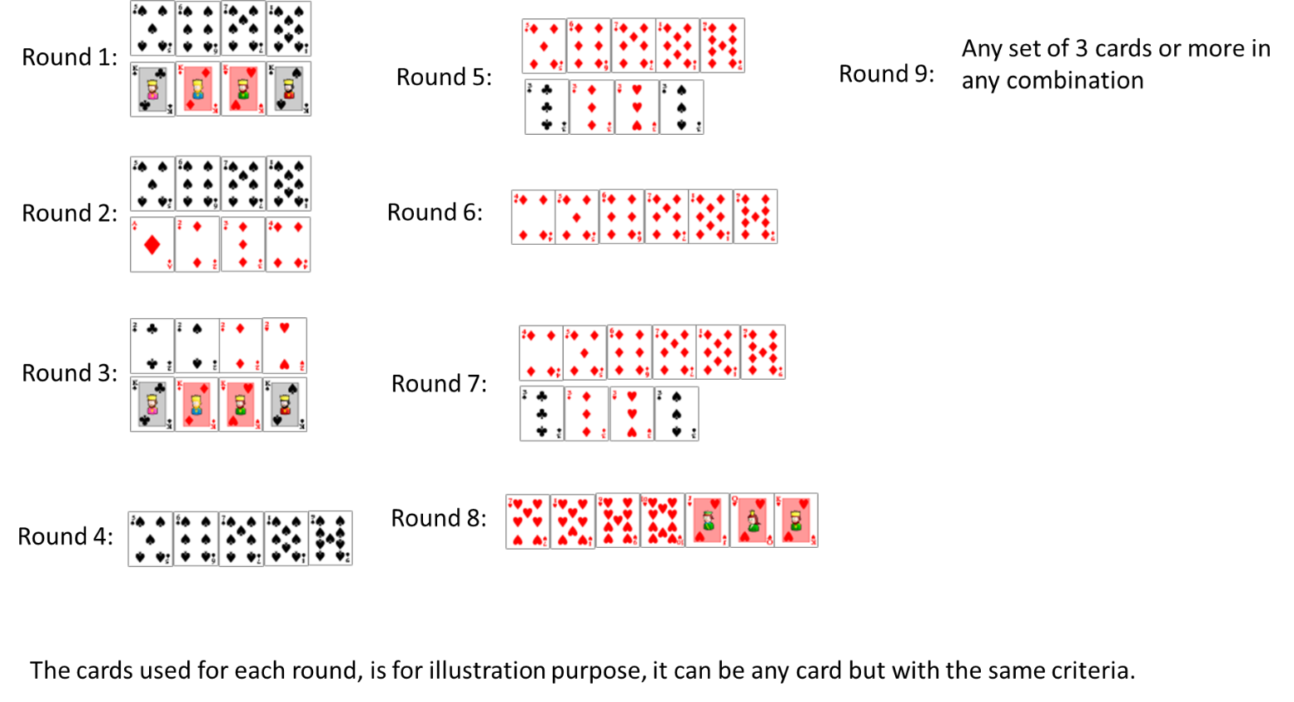

# Terms of agreement

All assets relating to the game including but not limited to idea, design, architecture, database, source code, binaries, images…etc, will be the property of the buyer. The buyer has full ownership and royalties of the developed game.

The seller and any entity relating to or cooperating with the seller will not use any of the assets relating to the game developed to the seller. The seller and any entity relating to or cooperating with the seller guarantees no legal actions will be taken against the buyer for ownership of the full assets of the game.

The Seller will also be responsible to upload the game to the Apple and google play stores on behalf of the buyer. All other deliverable as mentioned in the premium section of the seller’s Fiverr advertisement are included as part of the deliverables.