Design and Implementation of a

Secure IT Infrastructure
New Business Machine Ltd. (NBM)

Name: Afeed Nawsath
Course: COMP60013
Cyber-Security (BSc)
Lecturer: Dr Samuel Onalo

Contents
1. Introduction 1
2. System Requirements and Growth Projection 2
2.1 Functional Requirements 2
2.2 Security Requirements 2
2.3 Scalability Considerations 2
3. Justification for Technology Choices 2
3.1 GNS3 — Network Simulation Platform 2
3.2 pfSense — Firewall and Routing Platform 3
3.3 Apache HTTP Server on Kali Linux 3
3.4 Summary of Technology Selection 4
4. IT Security Policy Framework 4
4.1 Policy Justification 6
5. Deployment and Configuration 6
5.1 Network Topology 6
Network Addressing 7
5.2 Firewall Configuration 7
5.2.1 Interface Configuration 7
5.2.2 Admin Password Configuration 8
5.2.3 Internet Connectivity Verification 9
5.2.4 Authentication Audit Logging 9
5.3 Firewall Rule Configuration 10
5.3.1 LAN Interface Rules 10
5.3.2 DMZ (OPT1) Interface Rules — Lateral Movement Prevention 11
5.3.3 Initial OPT1 Baseline Rule 12
5.4 LAN Network Configuration and Testing 12
5.4.1 Windows Client IP Configuration 12
5.4.2 LAN Connectivity Verification 13
5.4.3 LAN to DMZ Web Server Access 14
5.5 DMZ Network Configuration and Testing 14
5.5.1 DMZ Gateway Connectivity 14
5.5.2 Segmentation Verification — DMZ Cannot Reach LAN 15
5.6 Web Server Deployment 16
5.6.1 Apache Installation and Initial Access 16
5.6.2 HTTPS Configuration — Self-Signed SSL Certificate 16
5.6.3 HTTPS Access Verified from LAN 18
5.6.4 Custom Web Page Deployment 18
5.7 Web Server Hardening 19
5.7.1 Host-Based Firewall (UFW) 19
5.7.2 Apache Server Banner Suppression 20
6. System Design Document 21
6.1 Architecture Overview 21
6.2 Security Considerations and Justifications 21
6.2.1 Defence in Depth 21
6.2.2 Principle of Least Privilege 22
6.2.3 DMZ Containment and Lateral Movement Prevention 22
6.2.4 Encryption of Data in Transit 22
6.2.5 Information Disclosure Prevention 22
6.2.6 Audit Logging and Accountability 22
6.3 High Availability and Scalability Considerations 23
7. Conclusion 23
8. References 23

1. Introduction
New Business Machine Ltd. (NBM) is a growing online e-commerce company selling electronic devices including computers, laptops, and smartphones. The company currently serves 3,000 customers, with projections to scale to 15,000 in the near term and 25,000 within one year. This rapid expansion presents significant IT security challenges: as the customer base grows, the risk and impact of a security breach also increase making a well-architected, secure infrastructure a business-critical requirement [1].
This report presents the design, implementation, and testing of a secure IT infrastructure for NBM. The chosen focus system is a Firewall, complemented by an Apache web server — selected because perimeter security and secure public-facing services are the most fundamental requirements for an e-commerce operation.
The implementation was carried out in a GNS3 virtual lab environment, enabling realistic simulation of the network infrastructure without requiring physical hardware. All configurations, commands, and results are evidenced with screenshots throughout this report.

2. System Requirements and Growth Projection
The following requirements were identified by analysing NBM's current operations and projected growth trajectory from 3,000 to 25,000 customers.

2.1 Functional Requirements
- A perimeter firewall capable of managing traffic between the internet, internal network, and a public-facing web server zone
- A web server to deliver NBM's e-commerce platform, accessible over HTTP and HTTPS
- Network segmentation to isolate public-facing services from internal systems, reducing the blast radius of a potential breach
- Scalable architecture that can accommodate additional servers, security zones, and traffic volumes as the customer base grows
- Internet connectivity for both internal users and the web server, routed through the firewall

2.2 Security Requirements
- Default-deny firewall policy: all traffic blocked unless explicitly permitted
- Controlled inter-zone traffic: LAN users may only reach the web server via HTTP and HTTPS
- Lateral movement prevention: the DMZ web server must be unable to initiate connections to the internal LAN
- Encrypted web communications: HTTPS/TLS required to protect customer data in transit
- Host-based firewall on the web server to supplement the perimeter firewall
- Suppression of web server version banners to reduce information disclosure to attackers
- Comprehensive logging of firewall events and authentication activity for audit and incident response

2.3 Scalability Considerations
As NBM grows from 3,000 to 25,000 customers, the infrastructure must be able to scale without requiring a complete redesign. The three-zone architecture (WAN / LAN / DMZ) is inherently extensible: additional web servers can be added to the DMZ, additional internal subnets can be added to the LAN, and additional security zones (such as a management network or a database tier) can be provisioned as new pfSense OPT interfaces. The use of virtualisation through GNS3 also means that capacity can be increased by allocating additional resources to virtual machines rather than purchasing new hardware.

3. Justification for Technology Choices

3.1 GNS3 — Network Simulation Platform
GNS3 (Graphical Network Simulator 3) is an open-source network emulation platform widely used in both academic institutions and professional environments [2, 3]. It enables the design, configuration, and testing of complex network topologies using real operating system images rather than abstract simulations. For NBM's requirements, GNS3 was selected for the following reasons:
- Realistic emulation: pfSense runs as a real VM within GNS3, behaving exactly as it would on physical hardware.
- Safe testing environment: security policies, misconfiguration scenarios, and penetration testing can be performed without risking production systems or real customer data.

3.2 pfSense — Firewall and Routing Platform
pfSense is an open-source firewall and router distribution based on FreeBSD, maintained by Netgate. It is widely deployed in small-to-medium enterprises as a cost-effective alternative to commercial firewalls from vendors such as Cisco or Palo Alto [4]. For NBM's infrastructure:
- Stateful packet inspection: pfSense tracks the state of all network connections, permitting only established and related traffic to pass inbound — blocking unsolicited connection attempts by default [5, 6].
- Multi-interface zone support: pfSense natively supports multiple OPT interfaces, enabling the WAN / LAN / DMZ architecture required by NBM without additional hardware.
- NAT and port forwarding: pfSense provides full NAT capabilities, enabling the web server in the DMZ to be selectively exposed to inbound internet traffic on specific ports.
- IDS/IPS integration: pfSense supports Snort and Suricata as package add-ons, allowing signature-based intrusion detection and prevention to be added as NBM’s security requirements grow [7].
- Web-based management GUI: the pfSense Web Configurator provides a centralised interface for rule management, real-time traffic monitoring, and audit log review — reducing the operational overhead of managing a complex firewall policy.
- Free and open source: pfSense Community Edition carries no licensing cost, aligning with NBM's budget constraints during its growth phase.

3.3 Apache HTTP Server on Kali Linux
Kali Linux, a Debian-based distribution maintained by Offensive Security [12], was used to host the Apache web server in the DMZ. Apache HTTP Server was chosen as the web server for the following reasons:
- Market dominance and reliability: Apache is one of the most widely deployed web servers in the world, with a long track record of stability in production environments [8].
- TLS/SSL support: Apache's mod_ssl module enables HTTPS encryption, protecting customer data transmitted between the browser and the server from interception or tampering.
- Security hardening options: Apache provides configuration directives (ServerTokens, ServerSignature, Options -Indexes) that can be used to reduce information disclosure to potential attackers [9, 10].
- UFW host-based firewall compatibility: Kali Linux includes UFW (Uncomplicated Firewall), enabling host-level port filtering that provides a second layer of defence independent of pfSense [11].

3.4 Summary of Technology Selection
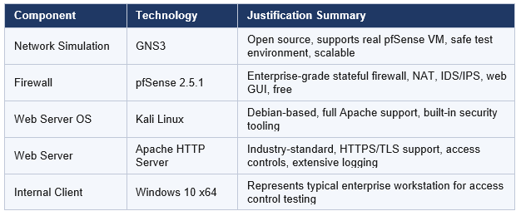
Table 1: Selected technologies used in the secure IT infrastructure and their justification.

4. IT Security Policy Framework
The following IT security policies have been defined for NBM's firewall and web server infrastructure. These policies collectively implement a defence-in-depth security model by addressing access control, authentication, monitoring, data protection, and change management. They are designed to scale with NBM's growth from 3,000 to 25,000 customers and are aligned with the principles of ISO/IEC 27001 [13, 14].

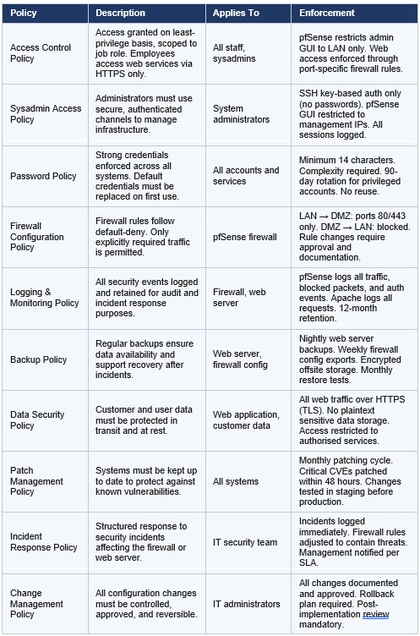
Table 2: IT security policies applied to protect and manage the infrastructure.

4.1 Policy Justification
These policies collectively address the five pillars of information security governance relevant to NBM’s infrastructure. The Access Control and Sysadmin Access policies enforce the principle of least privilege, ensuring that users and administrators can only access the resources and systems required for their role. The Password Policy and Data Security Policy protect against credential-based attacks and data interception — critical risks for an e-commerce platform handling customer payment and personal data [15, 16].
The Firewall Configuration Policy formalises the default-deny posture implemented in the pfSense rules described in Section 5, while the Logging and Monitoring Policy ensure that the audit trail required to detect and investigate incidents is maintained. The Patch Management Policy addresses the risk of known vulnerabilities being exploited, a particularly important control given that Apache, pfSense, and the underlying operating systems regularly receive security updates. Together, these policies form a governance framework that supports NBM's operational security as the business scales.

5. Deployment and Configuration
This section documents the step-by-step deployment of the network infrastructure, firewall configuration, web server installation, and security hardening. Each stage is evidenced with screenshots taken directly from the GNS3 lab environment.

5.1 Network Topology
The network topology was built in GNS3 to simulate NBM's three-zone enterprise infrastructure. The final topology, shown in Figure 1, consists of pfSense as the central firewall connecting three distinct network segments via its three interfaces. A dedicated Switch-DMZ connects the Kali Linux web server to the pfSense OPT1 (DMZ) interface, while Switch-Internal connects the Windows 10 client to the pfSense LAN interface. The GNS3 Cloud node provides internet connectivity by bridging to the host machine's network adapter.

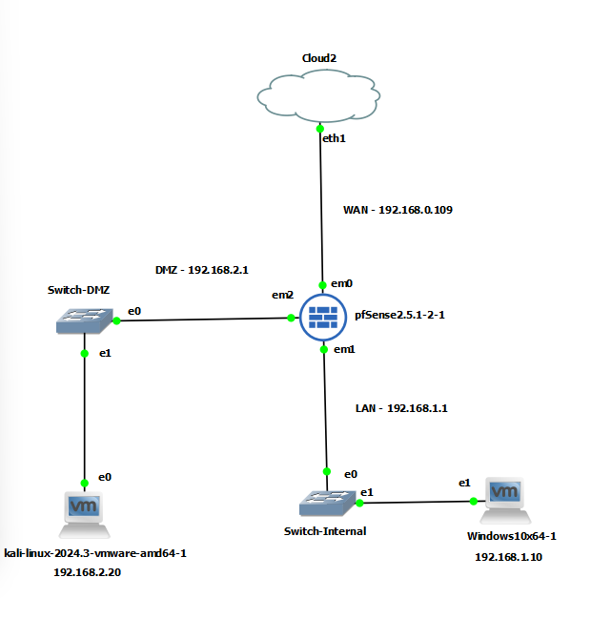
Figure 1: Final GNS3 network topology — pfSense firewall (centre) connecting Cloud2/WAN (top), Switch-Internal/LAN with Windows 10 client (right), and Switch-DMZ/DMZ with Kali Linux web server (left)

Network Addressing
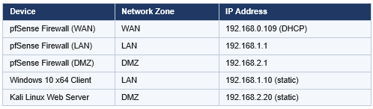
Table 3: IP addressing schemes for all devices across WAN, LAN, and DMZ zones.

5.2 Firewall Configuration

5.2.1 Interface Configuration
Three interfaces were configured on pfSense to support the three-zone architecture. The WAN interface (em0) was assigned 192.168.0.109 via DHCP from the host network. The LAN interface (em1) was statically configured as 192.168.1.1/24, serving as the default gateway for internal devices. The OPT1 interface (em2) was configured as the DMZ gateway at 192.168.2.1/24.
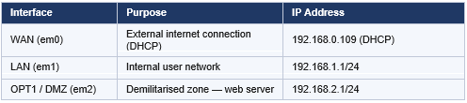
Table 4: pfSense interface roles and assigned network addresses.

Figure 2 shows the pfSense Web Configurator Status > Interfaces page, confirming all three interfaces are active and displaying their assigned addresses. The GNS3 topology is also visible alongside, showing the final three-zone layout.
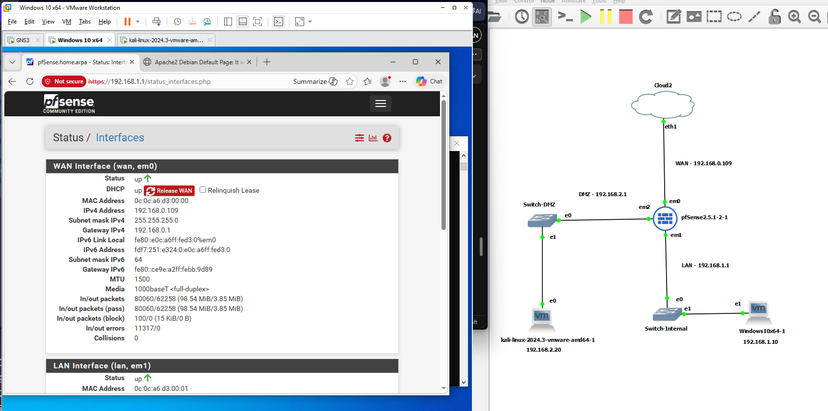
Figure 2: pfSense Status > Interfaces page confirming WAN (192.168.0.109 DHCP), LAN, and DMZ interfaces are all active, with the final GNS3 topology visible on the right

5.2.2 Admin Password Configuration
Replacing factory default credentials is the first and most fundamental hardening step for any network device. Leaving default credentials in place would allow any attacker who identifies the device type to gain immediate administrative access. During the pfSense initial setup wizard, the administrator password was replaced with a strong credential, as shown in Figure 3.

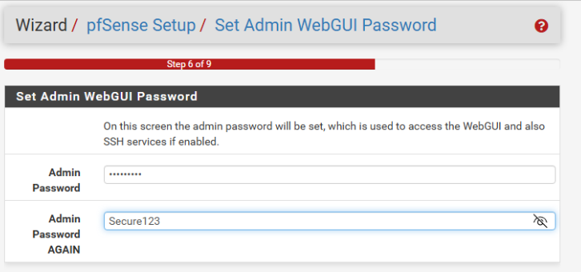
Figure 3: pfSense Setup Wizard Step 6/9 — Admin WebGUI password replaced to eliminate default credential vulnerability

5.2.3 Internet Connectivity Verification
Internet connectivity through the pfSense WAN interface was verified using the console ping utility (Option 7). A successful ping to 8.8.8.8 (Google's public DNS resolver) confirmed that the WAN interface was correctly obtaining a DHCP lease and routing traffic to the internet. The console also shows a successful admin login from 192.168.1.10, confirming that the Windows client can reach and authenticate to the pfSense management interface over the LAN.
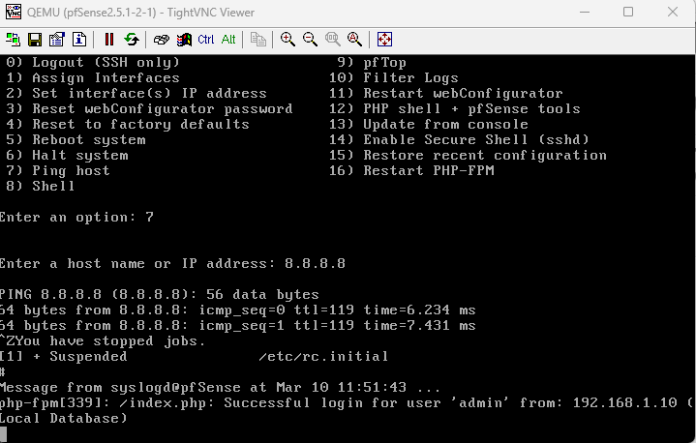
Figure 4: pfSense console — ping to 8.8.8.8 confirms internet connectivity via WAN; successful admin login from Windows client (192.168.1.10) also shown

5.2.4 Authentication Audit Logging
pfSense logs all authentication events to its system log, providing the audit trail required by NBM's Logging and Monitoring Policy. Figure 5 shows a failed authentication attempt from 192.168.1.10 immediately followed by a successful login — evidence that the logging system is capturing both failure and success events, which is essential for detecting brute-force or credential-stuffing attacks.

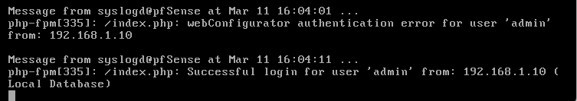
Figure 5: pfSense system log — WebConfigurator authentication events: failed login attempt followed by successful login from 192.168.1.10 (Windows client)

5.3 Firewall Rule Configuration
Firewall rules were configured on both the LAN and DMZ (OPT1) interfaces to enforce the access control policies defined in Section 4. Table 5 summarises all rules implemented:
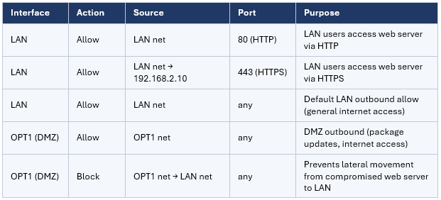
Table 5: Firewall rules configured to control permitted and blocked traffic.

5.3.1 LAN Interface Rules
Two explicit allow rules were added to the LAN interface targeting the web server at 192.168.2.10 on ports 80 (HTTP) and 443 (HTTPS). These rules permit LAN users to access the web server only through approved web traffic channels. A default IPv4 allow rule at the bottom of the ruleset provides general outbound internet access for internal users. Figure 6 shows the complete LAN ruleset as configured in the pfSense Web Configurator.

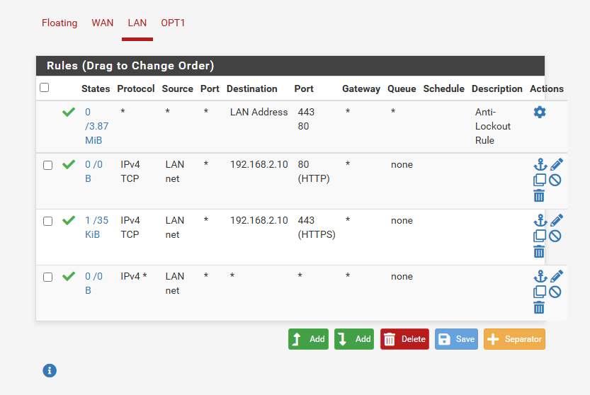
Figure 6: pfSense LAN firewall rules — explicit allow rules for HTTP (port 80) and HTTPS (port 443) to DMZ web server (192.168.2.10), plus default outbound allow rule

5.3.2 DMZ (OPT1) Interface Rules — Lateral Movement Prevention
Two rules were configured on the OPT1 (DMZ) interface. The first rule (green tick — enabled) allows outbound traffic from the DMZ, enabling the web server to access external services such as software package repositories. The second rule (red cross — block) explicitly denies any traffic originating from the DMZ destined for the LAN network.
This block rule is the most critical security control in the entire architecture. It implements the containment requirement identified in Section 2.2: even if the Apache web server is fully compromised through a web application vulnerability, an attacker cannot use it as a pivot point to reach internal workstations, databases, or management interfaces. The DMZ becomes a security boundary, not merely a label.
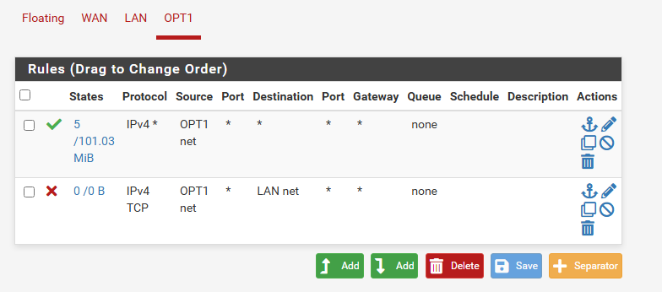
Figure 7: pfSense OPT1 (DMZ) firewall rules — allow outbound (green tick) and block DMZ-to-LAN (red cross), enforcing lateral movement prevention
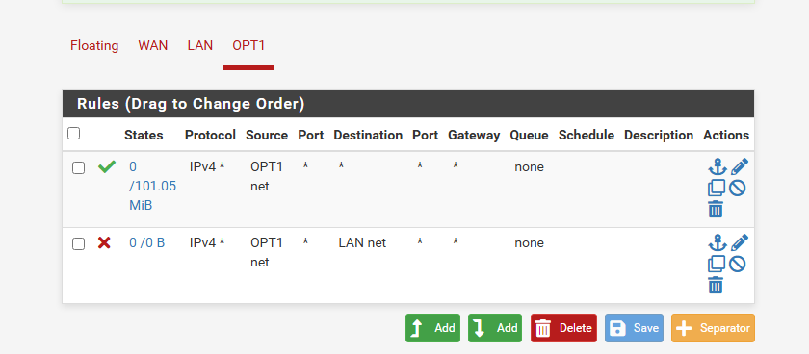
Figure 8: pfSense OPT1 rules — confirmation view showing the block rule (DMZ → LAN net) preventing any direct communication from the web server to internal devices

5.3.3 Initial OPT1 Baseline Rule
Before adding the block rule, an initial baseline allow rule was applied to confirm that the OPT1 interface was functional. The pfSense confirmation banner in Figure 9 shows the rules were reloaded successfully — this provided confidence that the interface was correctly configured before adding the security-critical block rule.
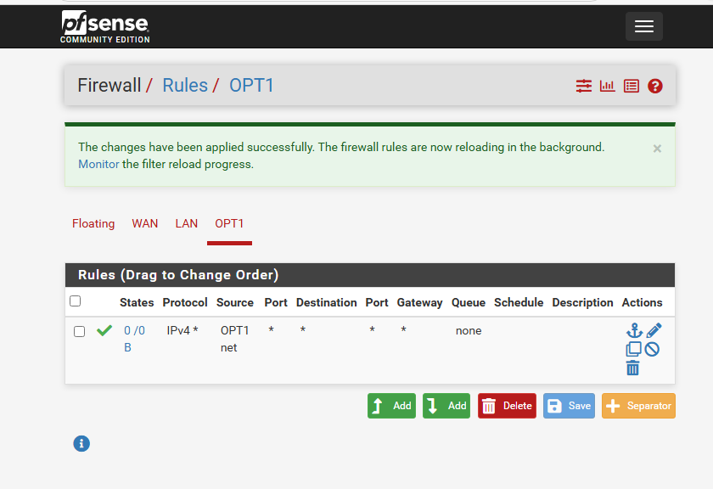
Figure 9: pfSense OPT1 — initial baseline allow rule confirmed with "changes applied successfully" banner, prior to adding the DMZ-to-LAN block rule

5.4 LAN Network Configuration and Testing

5.4.1 Windows Client IP Configuration
The Windows 10 client was configured with a static IP address of 192.168.1.10, subnet mask 255.255.255.0, and default gateway 192.168.1.1. DNS was set to 8.8.8.8 (Google) and 8.8.4.4. Assigning a static address ensures consistent identification in firewall logs and prevents the client from obtaining an unintended address. Figure 10 shows the IPv4 settings as configured.

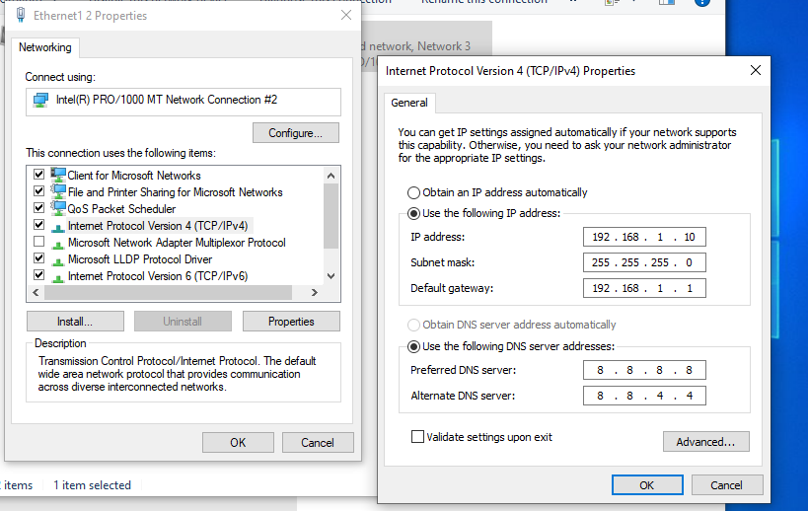
Figure 10: Windows 10 TCP/IPv4 Properties — static IP 192.168.1.10, gateway 192.168.1.1 (pfSense LAN), DNS 8.8.8.8 and 8.8.4.4

5.4.2 LAN Connectivity Verification
Connectivity from the Windows client was verified by pinging three destinations: 8.8.8.8 (internet), 192.168.1.1 (pfSense LAN gateway), and google.com (DNS resolution test). All tests returned zero packet loss, confirming that the Windows client has correctly configured network settings, that routing through pfSense is working, and that DNS resolution is functioning.

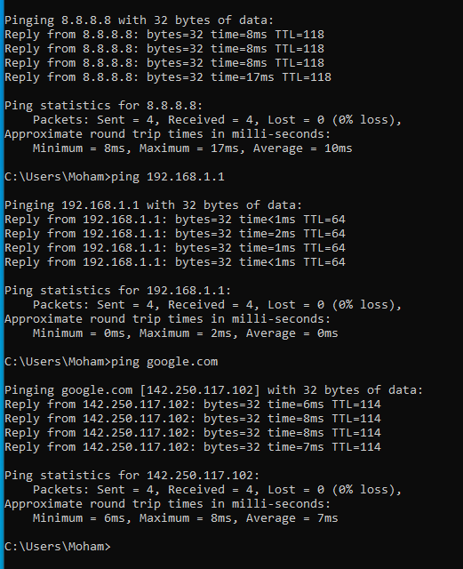
Figure 11: Windows client connectivity tests — successful pings to 8.8.8.8 (internet), pfSense LAN gateway (192.168.1.1), and google.com confirming routing and DNS resolution

5.4.3 LAN to DMZ Web Server Access
To verify that the LAN-to-DMZ firewall rules are working, the Windows client pinged the Kali Linux web server at 192.168.2.10. All four packets were returned with zero packet loss (Figure 12), confirming that pfSense is correctly routing traffic from the LAN to the DMZ and that the allow rules are functioning as intended.
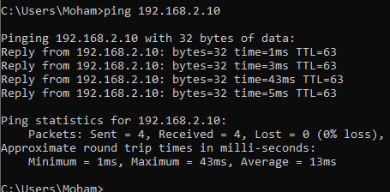
Figure 12: Windows client ping to DMZ web server (192.168.2.10) — 0% packet loss confirms LAN-to-DMZ routing and firewall allow rules are operational

5.5 DMZ Network Configuration and Testing

5.5.1 DMZ Gateway Connectivity
Connectivity from the Kali Linux server to the pfSense DMZ gateway (192.168.2.1) was verified by pinging the gateway. The initial ping shows a timeout on the first packet (ARP resolution) followed by successful replies — confirming that Kali Linux is correctly placed in the DMZ with pfSense as its default gateway.
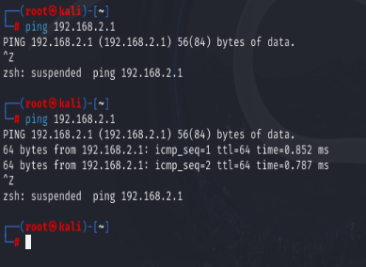
Figure 13: Kali Linux ping to pfSense DMZ gateway (192.168.2.1) — initial ARP timeout followed by successful replies confirming DMZ network connectivity

5.5.2 Segmentation Verification — DMZ Cannot Reach LAN
The effectiveness of the DMZ-to-LAN block rule was verified from the Kali Linux server. As shown in Figure 14, pinging the pfSense LAN interface (192.168.1.1) succeeds via ICMP (the gateway routes ICMP), but a TCP connection attempt to the Windows client (192.168.1.10 on port 445) fails with a host lookup error — confirming that the block rule is preventing direct DMZ-to-LAN host communication. This validates the lateral movement containment requirement.
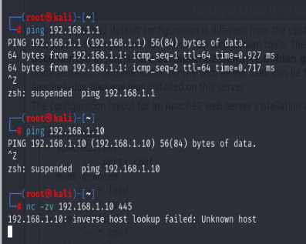
Figure 14: Kali Linux segmentation test — ping to pfSense LAN gateway succeeds, confirming the DMZ-to-LAN block rule is enforced
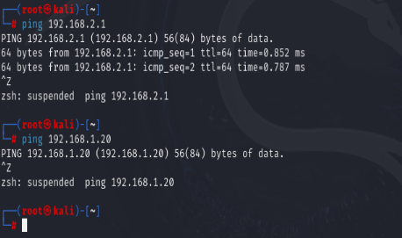
Figure 15: Kali Linux extended DMZ tests — successful ping to 192.168.2.1 (DMZ gateway)

5.6 Web Server Deployment

5.6.1 Apache Installation and Initial Access
Apache HTTP Server was installed on the Kali Linux machine using the apt package manager. After installation, the service was started and verified. Initial access to the web server from the Windows client browser at http://192.168.2.10 loaded the Apache default page successfully (Figure 16), confirming end-to-end connectivity from the LAN through pfSense to the DMZ web server. At this stage the connection was unencrypted HTTP, shown as "Not secure" in the browser address bar.
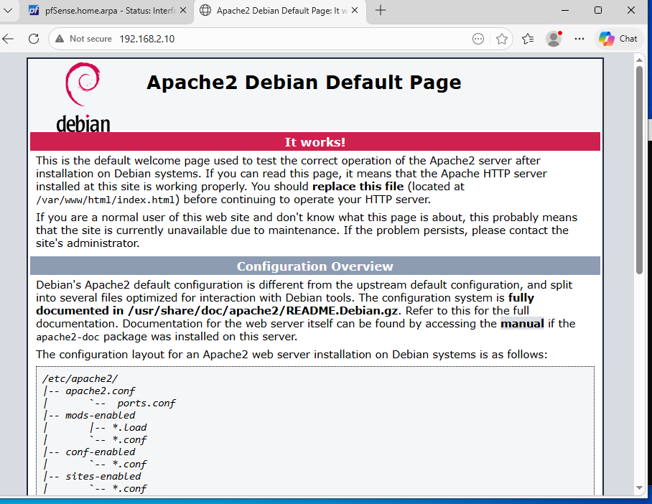
Figure 16: Apache default page accessed from Windows client (LAN) via HTTP at http://192.168.2.10

5.6.2 HTTPS Configuration — Self-Signed SSL Certificate
To encrypt all communications between users and the web server, HTTPS was enabled using a self-signed TLS certificate. The following commands were executed on the Kali Linux server:
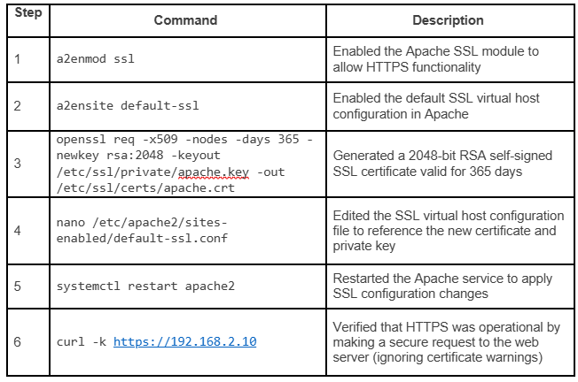
Table 6: Commands used to configure HTTPS/TLS on the Apache web server.

Figure 17 shows the SSL module enablement, site activation, and certificate generation. Figure 18 shows the SSL configuration edit and the curl verification returning valid HTML.

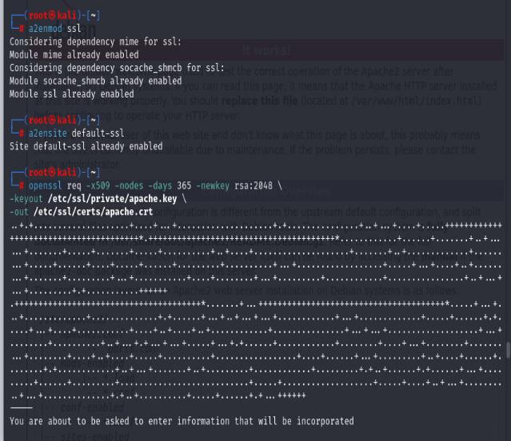
Figure 17: Kali Linux — enabling SSL module (a2enmod ssl)
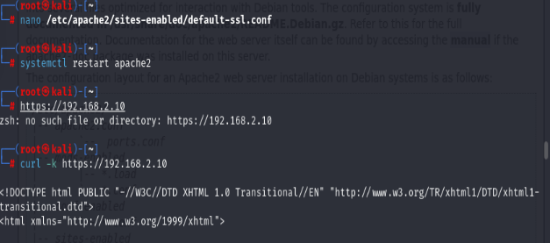
Figure 18: Kali Linux — editing default-ssl.conf

5.6.3 HTTPS Access Verified from LAN
After enabling HTTPS, the web server was accessed from the Windows client browser at https://192.168.2.10. The browser displays a "Not secure" warning (Figure 19) — expected for a self-signed certificate in a lab environment, as the certificate is not signed by a trusted Certificate Authority. However, the HTTPS protocol is confirmed active, demonstrating that TLS encryption is functioning between the LAN client and the DMZ web server through pfSense.

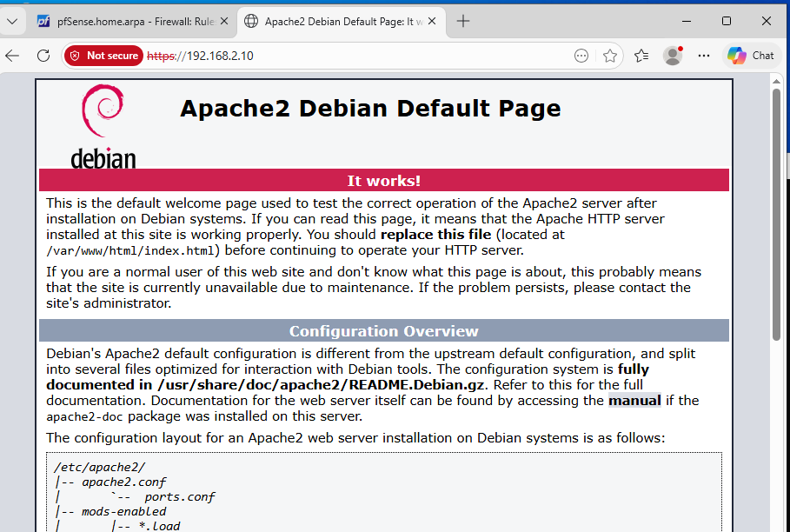
Figure 19: HTTPS access from Windows client at https://192.168.2.10 — browser warning is expected for self-signed certificate; HTTPS/TLS encryption confirmed active

5.6.4 Custom Web Page Deployment
The default Apache placeholder page was replaced with a custom Security Policies Portal page for NBM. Replacing the default page is an important security hardening step: the Apache default page reveals that Apache is in use and can provide version clues, whereas a custom page presents only intended content. The custom page (Figure 20) displays NBM's security policies including the Access Control Policy and Firewall Policy, demonstrating that the web server is serving operational application content.

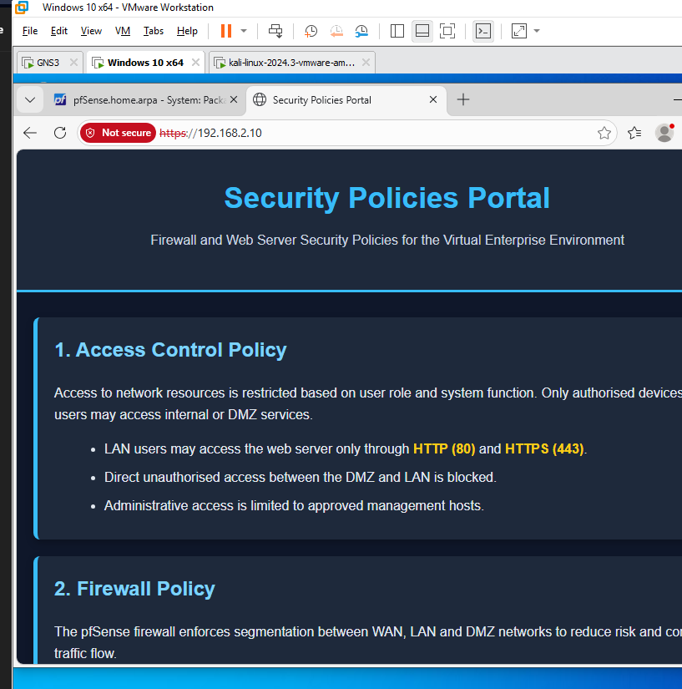
Figure 20: Custom "Security Policies Portal" served from Apache at https://192.168.2.10 — default page replaced, web server delivering operational content to LAN user

5.7 Web Server Hardening

5.7.1 Host-Based Firewall (UFW)
A host-based firewall was configured on the Kali Linux web server using UFW (Uncomplicated Firewall). UFW rules were added to allow only HTTP (port 80) and HTTPS (port 443) inbound connections, with all other ports blocked by default. UFW was then enabled and set to start automatically on boot. This provides a second, independent layer of network access control at the operating system level — meaning that even if a pfSense misconfiguration permitted unexpected traffic, the web server itself would reject connections on unauthorised ports [18, 11].

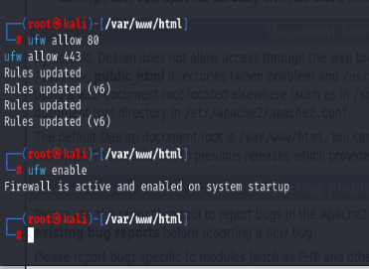
Figure 21: UFW host-based firewall configured — rules allow ports 80 and 443 only; firewall enabled and active on system startup

5.7.2 Apache Server Banner Suppression
By default, Apache includes its version number and underlying operating system in HTTP response headers (Server: Apache/2.4.x (Debian)) and in error pages. This information aids attackers performing reconnaissance, enabling them to search for and exploit known vulnerabilities specific to that version. To mitigate this, the Apache security configuration file (/etc/apache2/conf-available/security.conf) was edited as follows:
- ServerTokens Prod — Apache returns only "Apache" in the Server header, without version of OS details
- ServerSignature Off — removes the server version footer from Apache-generated HTML error pages
Figure 22 shows the security.conf file being edited in nano with both directives set. This is a low-cost, high-value hardening measure that reduces the information available to automated vulnerability scanners targeting the web server.

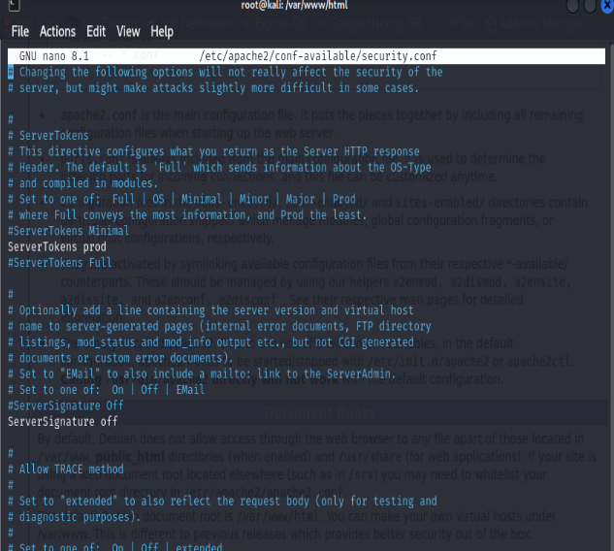
Figure 22: Apache security.conf — ServerTokens set to "Prod" and ServerSignature set to "Off" suppressing version information from HTTP response headers and error pages

6. System Design Document

6.1 Architecture Overview
The implemented infrastructure follows a three-tier security zone model, which is the industry-standard pattern for organisations hosting public-facing services [19]. The three zones — WAN, LAN, and DMZ — are separated by the pfSense firewall, which acts as the single enforcement point for all inter-zone traffic policy.
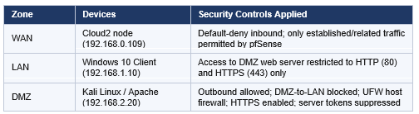
Table 7: Network security zones and the controls applied in each segment.

6.2 Security Considerations and Justifications

6.2.1 Defence in Depth
The architecture implements defence in depth — the principle that multiple independent security layers must be defeated sequentially for an attack to succeed [14]. In NBM's infrastructure, an attacker targeting the web server must: (1) bypass the pfSense WAN rules to reach the DMZ; (2) exploit a vulnerability in Apache to gain code execution on the web server; (3) overcome the DMZ-to-LAN block rule to reach the internal network; and (4) defeat the UFW host-based firewall on the Kali Linux server. No single failure results in a complete compromise.

6.2.2 Principle of Least Privilege
Every inter-zone communication permission is scoped to the minimum required. LAN users can reach the web server only on ports 80 and 443 — not on any other port. The web server cannot initiate connections to the LAN. Administrative access to pfSense is only permitted from the LAN interface. This principle limits the scope of any compromise to only the permissions that have been explicitly granted.

6.2.3 DMZ Containment and Lateral Movement Prevention
The DMZ-to-LAN block rule is the most important single security control in the design. E-commerce web servers are high-value targets because they process payment data and customer information. By ensuring that a compromised web server cannot communicate with internal systems, NBM significantly limits the impact of a breach. Even if an attacker gains full control of the Apache server, they cannot reach internal workstations, file servers, or management interfaces without a second, independent attack against the pfSense firewall rules.

6.2.4 Encryption of Data in Transit
HTTPS/TLS encryption is fundamental for an e-commerce platform. Without encryption, an attacker on the same network as a customer (for example, on a shared Wi-Fi network) could intercept login credentials, session tokens, or payment data using a passive packet capture [20, 18]. The self-signed certificate used in this lab demonstrates the technical implementation of TLS; in production, NBM should obtain a certificate from a trusted Certificate Authority (such as Let’s Encrypt) to avoid browser security warnings and ensure customer trust [21].

6.2.5 Information Disclosure Prevention
Suppressing Apache's server banner and replacing the default page reduces the information available to attackers during the reconnaissance phase of an attack. While this is not a primary security control — a determined attacker can identify web server software through other means — it raises the effort required and prevents automated vulnerability scanners from immediately identifying the server version and querying known CVE databases for exploits.

6.2.6 Audit Logging and Accountability
pfSense logs all firewall rule matches, blocked connection attempts, and authentication events. Apache logs all HTTP/HTTPS requests. These logs are the primary mechanism for detecting attacks in progress (for example, a port scan or brute-force attempt), investigating incidents after the fact, and demonstrating compliance with NBM's IT Security Policies. Without comprehensive logging, it is impossible to determine whether the infrastructure is being attacked, or to reconstruct events following a breach.

6.3 High Availability and Scalability Considerations
The current single-firewall, single-web-server design is appropriate for NBM's initial deployment but should be enhanced as the customer base grows. Key improvements to consider include:
- Firewall high availability: pfSense supports CARP (Common Address Redundancy Protocol) to deploy two pfSense instances in an active/passive failover pair, eliminating the firewall as a single point of failure.
- Web server load balancing: as traffic grows toward 25,000 customers, a load balancer can distribute requests across multiple Apache instances, improving both performance and availability.
- IDS/IPS deployment: Snort or Suricata can be added to pfSense to detect and block known attack signatures targeting the web server, providing proactive threat detection beyond static firewall rules.
- Database tier: a production e-commerce platform requires a database server (for example, MySQL or PostgreSQL) which should be placed in a separate, isolated database zone — not in the DMZ or the LAN — with access controlled by dedicated firewall rules.

7. Conclusion
The architecture successfully achieves the key security objectives identified in the requirements: network segmentation through three distinct zones (WAN, LAN, DMZ); controlled inter-zone traffic enforced by pfSense firewall rules; lateral movement prevention through the OPT1 block rule; encrypted web communications via HTTPS/TLS; host-based firewall protection on the web server; and suppression of server version banners to reduce information disclosure. All rules and configurations were tested and verified through ICMP ping tests, browser access tests, and command-line validation.
The IT security policy framework defined in Section 4 provides the governance foundation for ongoing operation and growth. The policies address access control, authentication, logging, data protection, patch management, and incident response — collectively implementing a defence-in-depth approach aligned with ISO 27001 and NIST CSF principles.
Looking ahead, NBM should prioritise replacing the self-signed TLS certificate with a CA-issued certificate, deploying a second pfSense instance for firewall redundancy, and adding an IDS/IPS to detect attacks targeting the web server.

8. References
[1] Verizon (2024) 2024 Data Breach Investigations Report. Available at: https://www.verizon.com/business/resources/T014/reports/2024-dbir-data-breach-investigations-report.pdf?msockid=3712bb230cee6be93222ac040d3f6a52

[3] GNS3 (2024) GNS3 Documentation. Available at: https://docs.gns3.com

[4] Farhan, A. (2020) ‘pfSense as an Open-Source Firewall Solution for Enterprise Networks’, International Journal of Computer Science and Network Security, 20(4), pp. 112–119.

[5] Netgate (2024) pfSense Documentation. Available at: https://docs.netgate.com/pfsense/en/latest/

[6] NIST (2020) SP 800-41 Rev. 1: Guidelines on Firewalls and Firewall Policy. Gaithersburg: National Institute of Standards and Technology. Available at: https://doi.org/10.6028/NIST.SP.800-41r1

[7] Scarfone, K. and Mell, P. (2007) SP 800-94: Guide to Intrusion Detection and Prevention Systems (IDPS). Gaithersburg: National Institute of Standards and Technology. Available at: https://doi.org/10.6028/NIST.SP.800-94

[8] Netcraft (2024) Web Server Survey. Available at: https://www.netcraft.com/blog/september-2024-web-server-survey

[9] Apache Software Foundation (2024) Apache HTTP Server Documentation. Available at: https://httpd.apache.org/docs/

[10] NIST (2021) SP 800-123: Guide to General Server Security. Gaithersburg: National Institute of Standards and Technology. Available at: https://doi.org/10.6028/NIST.SP.800-123

[11] Ubuntu (2024) UFW - Uncomplicated Firewall. Available at: https://help.ubuntu.com/community/UFW

[12] Offensive Security (2024) Kali Linux Documentation. Available at: https://www.kali.org/docs/

[14] NIST (2018) Framework for Improving Critical Infrastructure Cybersecurity (NIST Cybersecurity Framework), Version 1.1. Gaithersburg: National Institute of Standards and Technology. Available at: https://doi.org/10.6028/NIST.CSWP.04162018

[15] ICO (2018) Guide to the General Data Protection Regulation (GDPR). Wilmslow: Information Commissioner's Office. Available at: https://ico.org.uk/for-organisations/guide-to-data-protection/guide-to-the-general-data-protection-regulation-gdpr/

[17] OpenSSL Project (2024) OpenSSL Documentation. Available at: https://www.openssl.org/docs/

[19] Cheswick, W.R., Bellovin, S.M. and Rubin, A.D. (2003) Firewalls and Internet Security: Repelling the Wily Hacker. 2nd edn. Boston: Addison-Wesley. Available at: https://wilyhacker.com/fw2e.pdf

[20] Rescorla, E. (2018) 'The Transport Layer Security (TLS) Protocol Version 1.3', RFC 8446, Internet Engineering Task Force. Available at: https://www.rfc-editor.org/rfc/pdfrfc/rfc8446.txt.pdf

[21] Let's Encrypt (2024) Let's Encrypt Documentation. Available at: https://letsencrypt.org/docs/

