Course Name | Big Data Systems Design
Course Code | MBAI 5110 G
Term & Year | Winter 2026
Assignment Number | 1
Submission Due Date | 2026/02/15
Submitted Date | 2026/02/14
Student Name | Afeena Gafoor
Student ID | 101018679

PART A- Spark DataFrames

Task A
- Load the CSV/Parquet data into Spark DataFrame
#Read parquet file
df = spark.read.parquet("/home/vboxuser/Big Data Systems Design/Assignment1/yellow_tripdata_2025-01.parquet")
df.show(5)
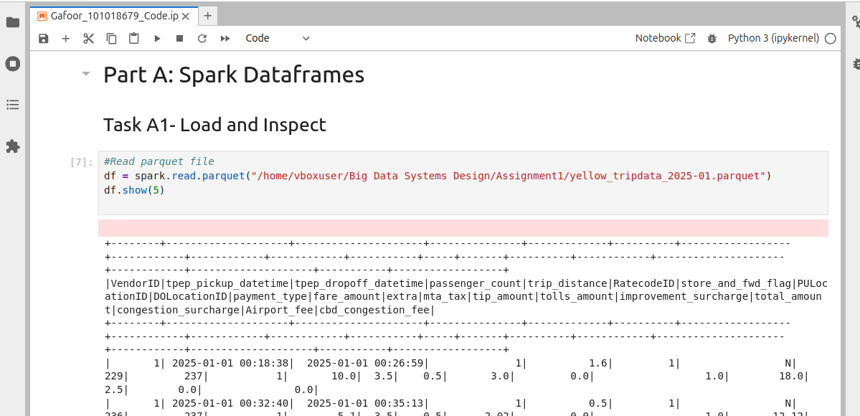
- Print schema and show sample 5 rows
df.printSchema()

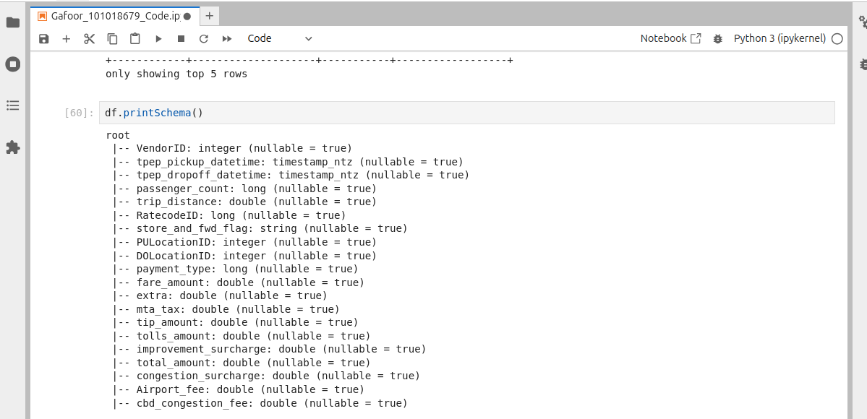
df.show(5)

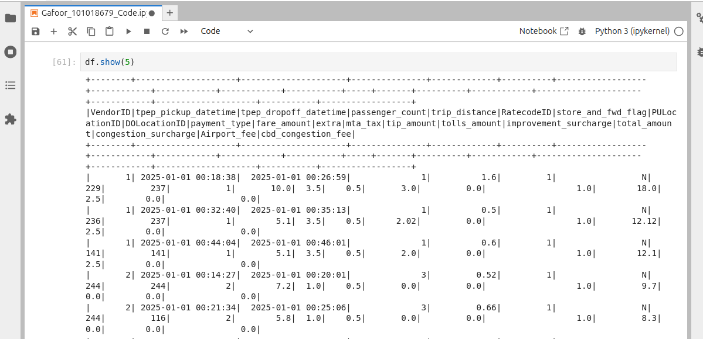
- Handle missing/null or invalid values and check missing/null values
# Show counts for: rows and columns
print("Rows:", df.count())
print("Columns:", len(df.columns))
print(df.columns)
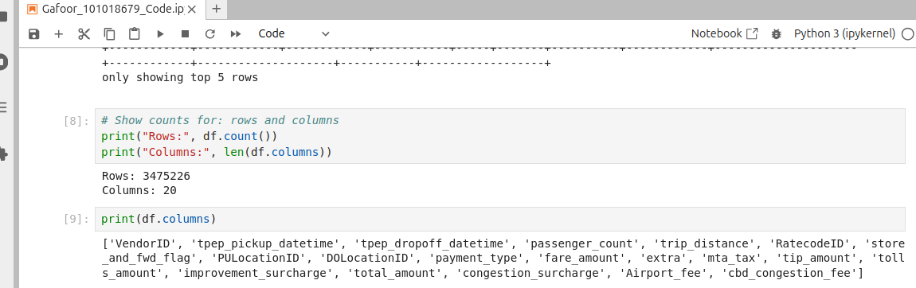

# import all functions
from pyspark.sql.functions import *

#Identify Columns of Interest
df_basic = df.select(
"tpep_pickup_datetime",
"tpep_dropoff_datetime",
"PULocationID",
"DOLocationID",
"passenger_count",
"fare_amount",
"trip_distance"
)

df_basic.show(5)

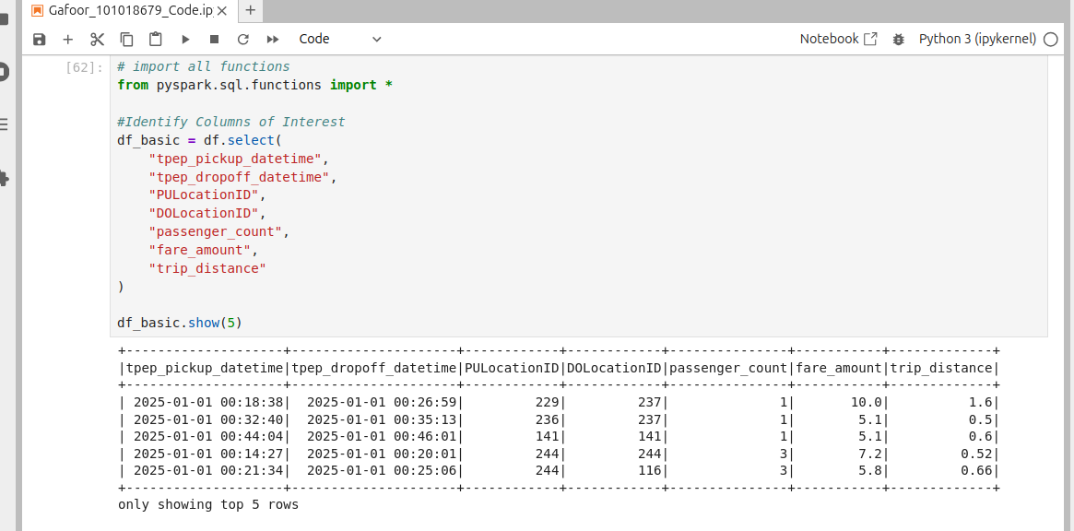

df_clean = df_basic
df_clean.printSchema()
# Create a single row data frame showing the number of null values in each column of interest
null_counts = df_clean.select([sum(col(c).isNull().cast("int")).alias(c) for c in df_basic.columns])

#print full results with column names
null_counts.show(truncate=False)

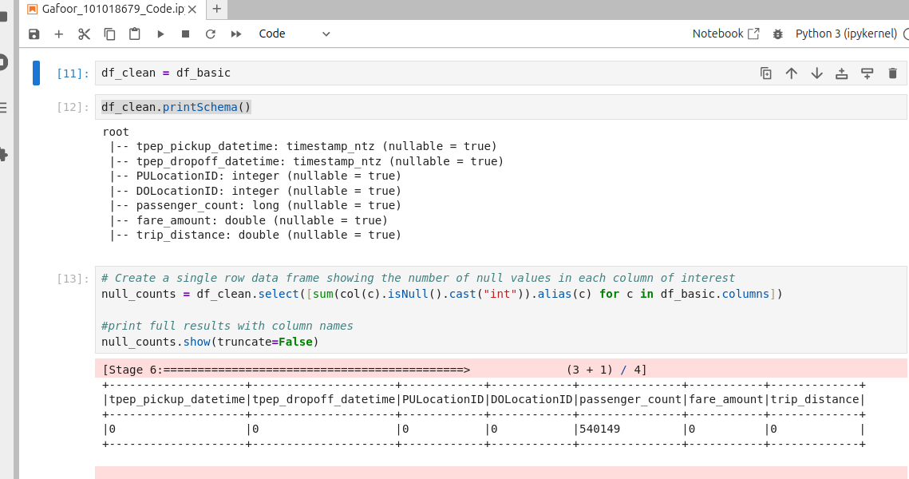

# drop records where passenger_count has nulls
df_clean = df_basic.dropna(subset=["passenger_count"])
print("Rows:", df_clean.count())
print("Columns:", len(df_clean.columns))
# find the PuLocationID that are not a value in the data dictionary
df_clean.filter((df_clean.PULocationID < 1) & (df_clean.PULocationID > 265 )).show()
# find the DOLocationID that are not a value in the data dictionary
df_clean.filter((df_clean.DOLocationID < 1) & (df_clean.DOLocationID > 265 )).show()
#distinct values in trip_distance
df_clean.select("passenger_count").distinct().orderBy("passenger_count").show()

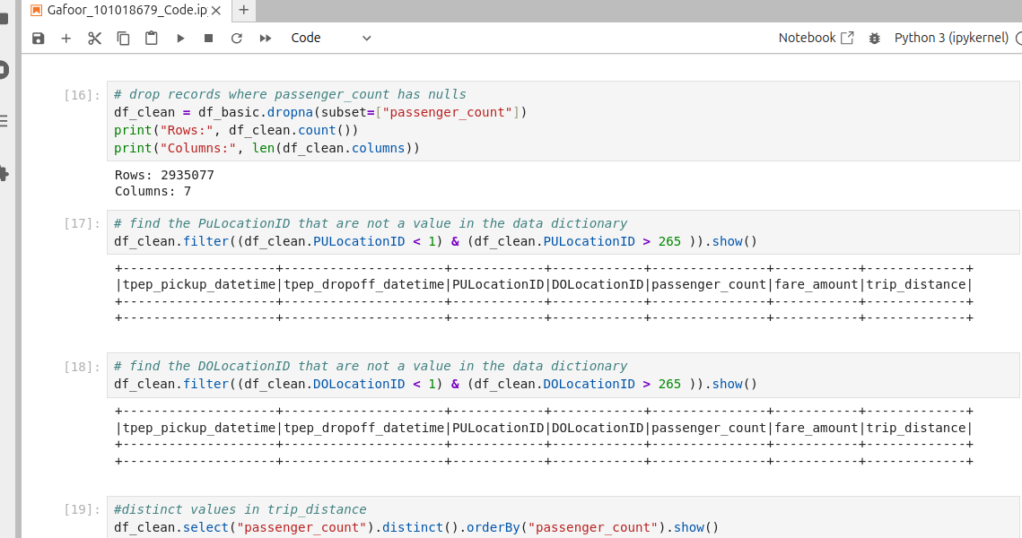

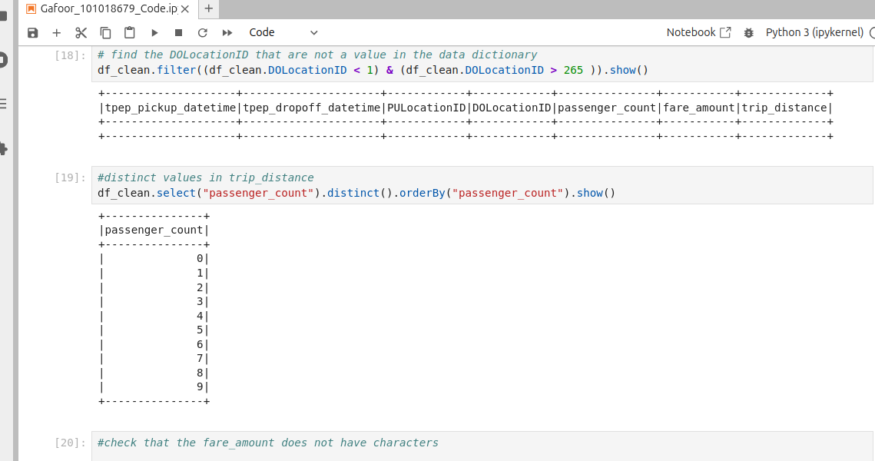

#check that the fare_amount does not have characters

bad_fares = df_clean.filter(
(col("fare_amount").cast("double").isNull())
)

bad_fares.select("fare_amount").distinct().show(50, truncate=False)
#check if trip distance does not have characters

bad_trip_distance = df_clean.filter(
(col("trip_distance").cast("double").isNull())
)

bad_trip_distance.select("trip_distance").distinct().show(50, truncate=False)

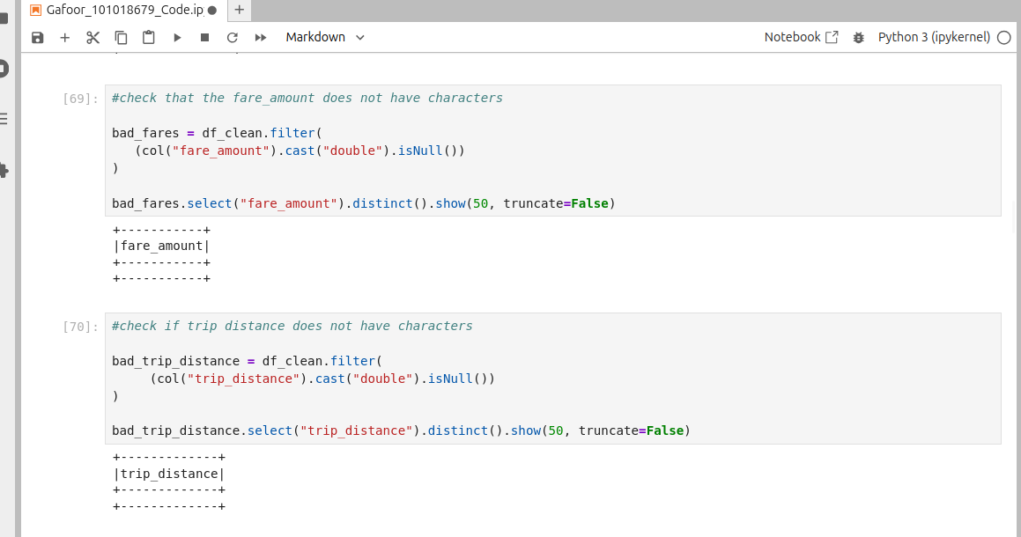

Task A2
- Print the average trip distance per day – I answered this as day of week and day of month
#A2.1: Average Trip Distance per day of month

AvgDayOfMonth=(df_clean
.withColumn("DayOfMonth", dayofmonth("tpep_pickup_datetime"))
.groupBy("DayOfMonth")
.agg(round(avg("trip_distance"),2).alias("AvTripDistByDayOfMonth"))
.orderBy("DayOfMonth")
)

AvgDayOfMonth.show(truncate=False)
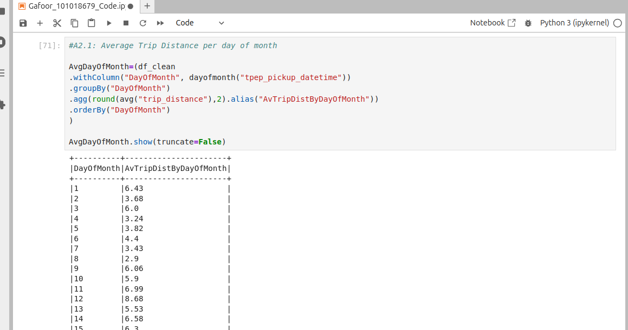

#A2.1: Average Trip Distance per day of week

AvgDistDayOfWeek = (df_clean
.withColumn("DayOfWeek", dayofweek("tpep_pickup_datetime"))
.groupBy("DayOfWeek")
.agg(round(avg("trip_distance"),2).alias("AvgTripDistByDayOfWeek"))
.orderBy("DayOfWeek")
)

AvgDistDayOfWeek.show(truncate=False)

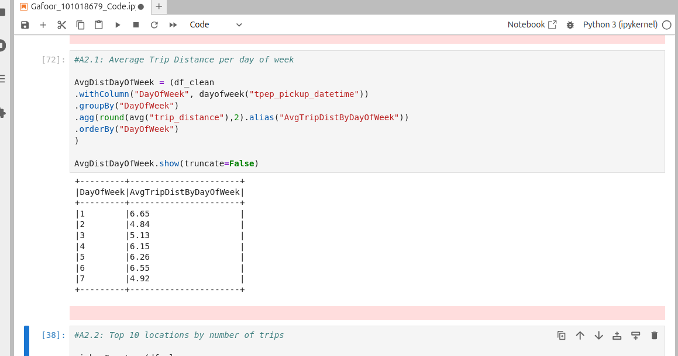

- Print the top 10 pickup locations by number of trips
#A2.2: Top 10 locations by number of trips

pickupCounts= (df_clean
.groupBy(col("PULocationID").alias("PickupLocation"))
.count().alias("CountByPULocation")
.orderBy("count",ascending=False)
)
pickupCounts.show(10, truncate=False)
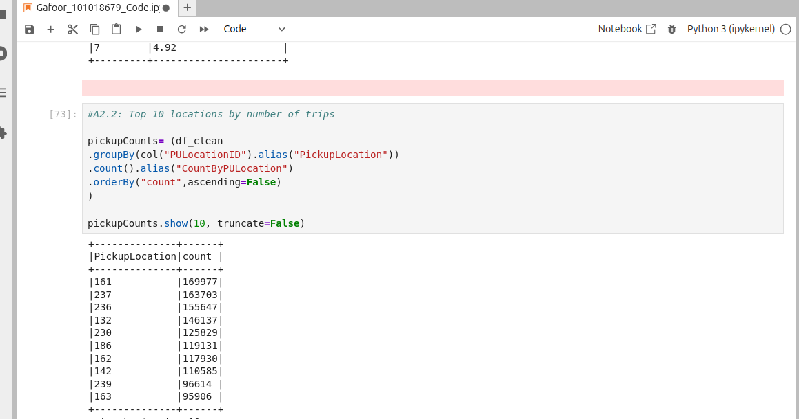

- Find the average fare per passenger count
#A2-3: Average Fare per passenger count
farePerPassCount=(df_clean
.groupBy(col("passenger_count").alias("PassengerCount"))
.agg(round(avg("fare_amount"),2).alias("AverageFareAmount"))
.orderBy("passenger_count",ascending=True)
)
farePerPassCount.show(truncate=False)
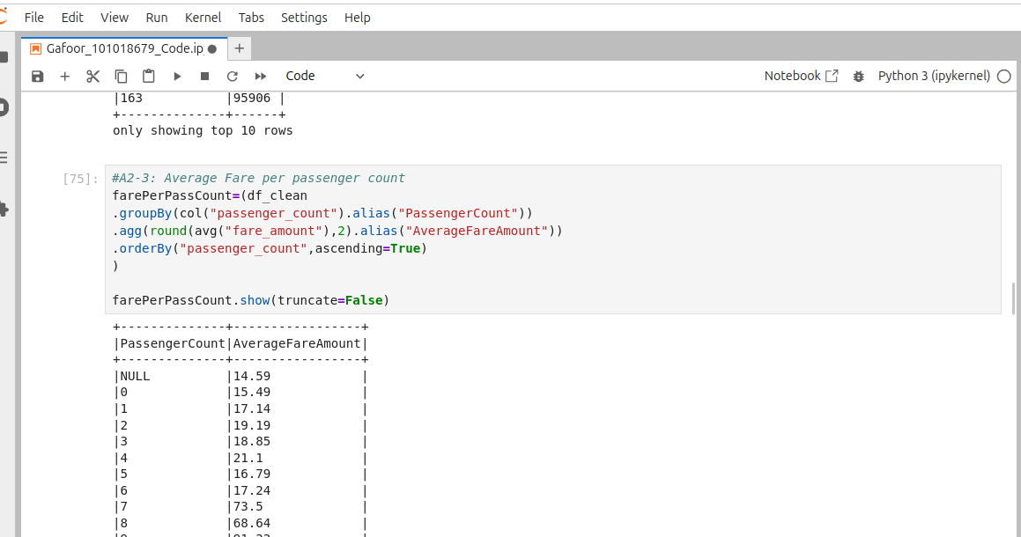

- Filter trips longer than 10 miles and analyze fare distribution
#A2-4: Filter trips longer than 10 miles and analyse the fare distribution
longTrips= df_clean.filter(col("trip_distance") > 10)

print("trips over 10:", longTrips.count(),"\n")

#Fare Analysis
longTrips.select(
min("fare_amount").alias("MinFare"),
round(avg("fare_amount"),2).alias("AvgFare"),
max("fare_amount").alias("MaxFare")
).show()
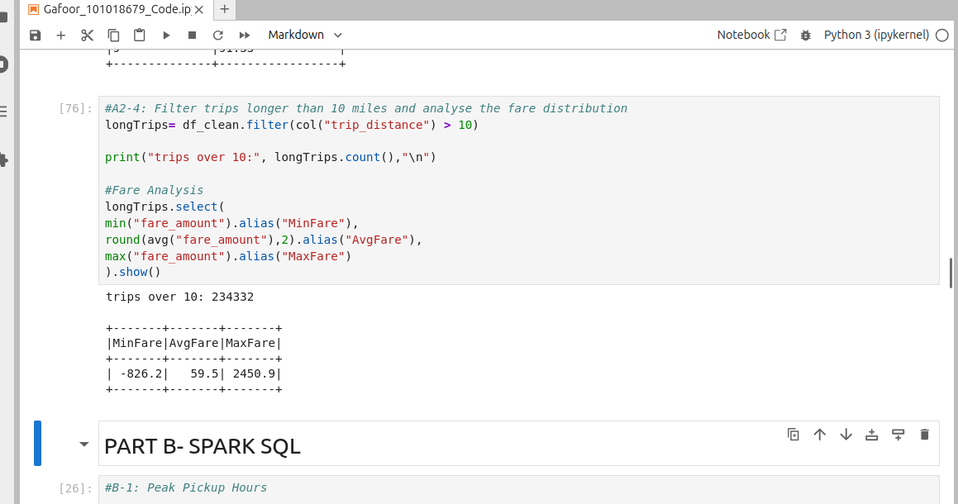

PART B- Spark SQL
- Find peak pickup hours
#B-1: Peak Pickup Hours

# Create or Replace view
df_clean.createOrReplaceTempView("taxi_trips")

spark.sql("""
select
hour(tpep_pickup_datetime),
count(*) as TotalTrips
from taxi_trips
group by hour(tpep_pickup_datetime)
order by TotalTrips desc""").show()
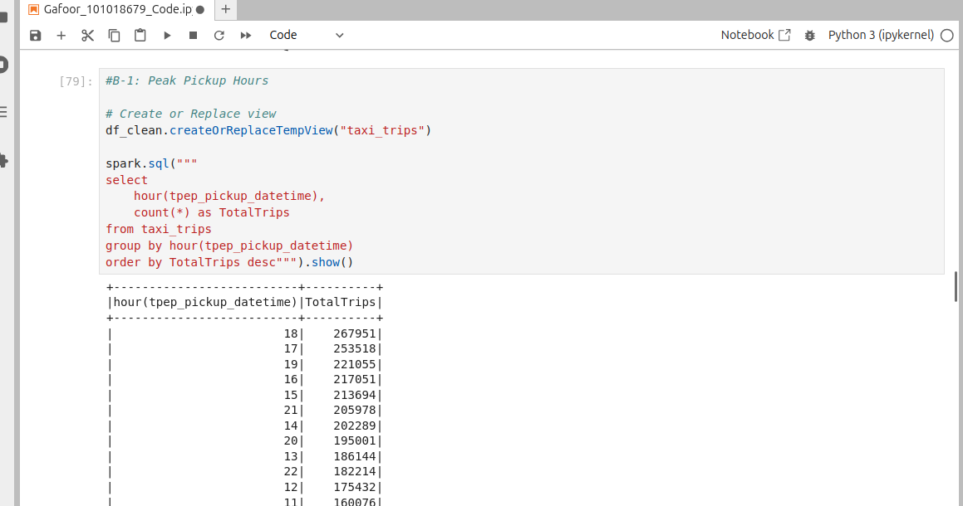
- Calculate total revenue per day
#B-2: Total Revenue Per Day
spark.sql("""
select
date_format(to_date(tpep_pickup_datetime),'yyyy-MM-dd') as tripDate,
round(sum(fare_amount),2) as FareAmount
from taxi_trips
group by date(tpep_pickup_datetime)
order by tripDate desc""").show()

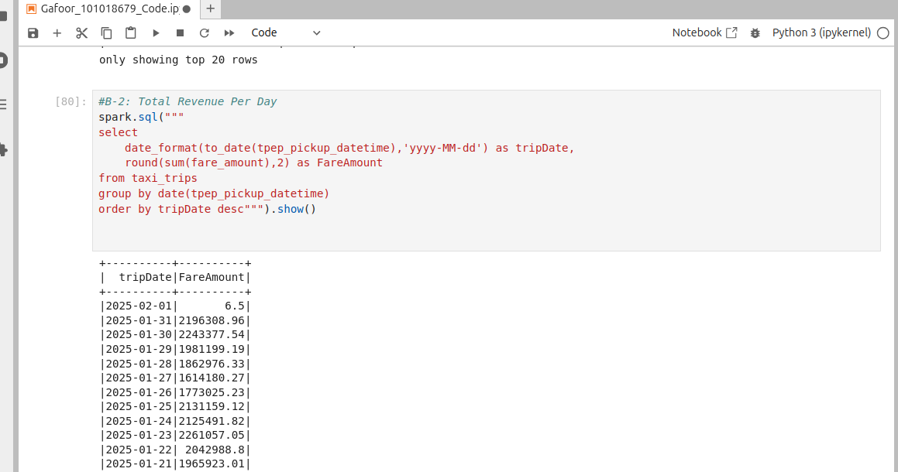

- Identify the top 5 busiest pickup–drop-off pairs
#B-3: Top 5 busiest pickup/dropoff pairs
spark.sql("""
select
concat( PULocationID, '-', DOLocationID) as Pairs,
count(PULocationID || DOLocationID) as PairCount
from taxi_trips
group by concat( PULocationID, '-', DOLocationID)
order by PairCount desc""").show(5)
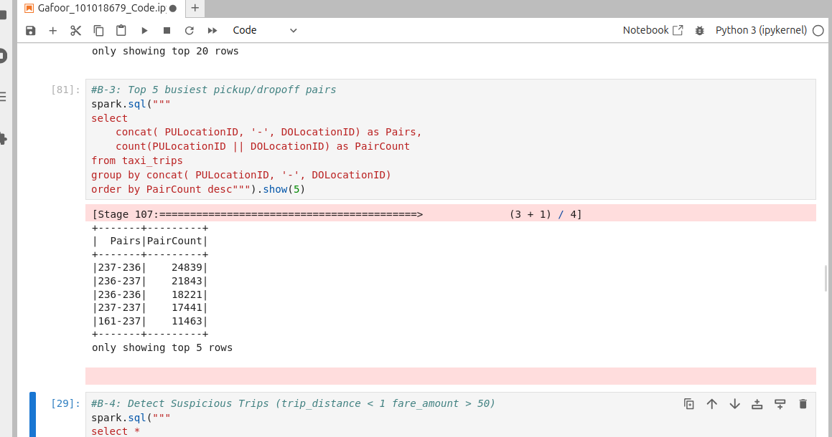

- Detect suspicious trips (distance < 1 mile but fare > $50)
#B-4: Detect Suspicious Trips (trip_distance < 1 fare_amount > 50)
spark.sql("""
select *
from taxi_trips
where trip_distance < 1
and fare_amount > 50""").show()
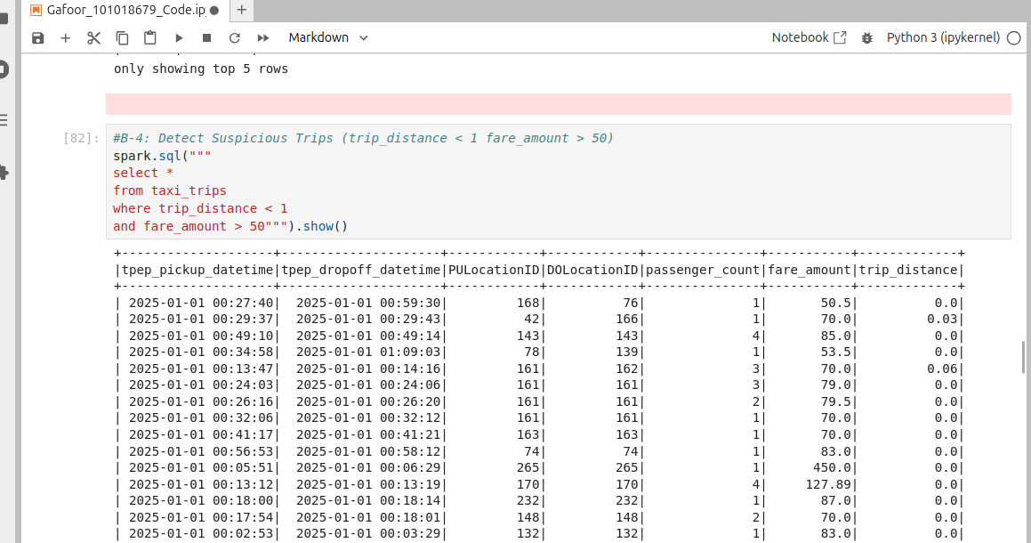

PART C- Spark Structured Streaming
- Create streaming Taxi Trip Dataset: Use the rate source to simulate streaming taxi trip data

from pyspark.sql.types import *

# C1- Create a streaming source to simulate taxi data

df_streamrate = (
spark.readStream
.format("rate")
.option("rowspersecond",5)
.load()
)

#Simulate streaming independently and name it like the columns
taxiStream = df_streamrate.select(
col("timestamp").alias("tpep_pickup_datetime"),
(col("timestamp") + expr("INTERVAL 10 MINUTES")).alias("tpep_dropoff_datetime"),
((col("value") % 265) + 1).cast("int").alias("PULocationID"),
(((col("value") + 17) % 265) + 1).cast("int").alias("DOLocationID"),
(col("value") % 10).cast("int").alias("passenger_count"),
((col("value") % 50) + 5).cast("double").alias("fare_amount"),
((col("value") % 20) + 1).cast("double").alias("trip_distance")
)

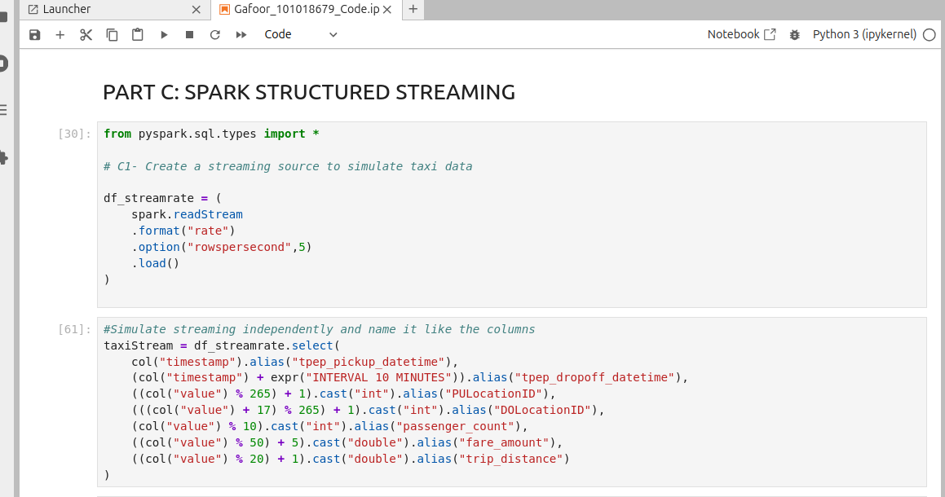
- Compute the rolling average fare every 5 minutes
#C2- Rolling average fare every 5 minutes

avgFare5min = taxiStream \
.withWatermark("tpep_pickup_datetime", "10 minutes") \
.groupBy(
window(col("tpep_pickup_datetime"), "5 minutes")
)\
.agg(
avg("fare_amount").alias("avgFare")
)

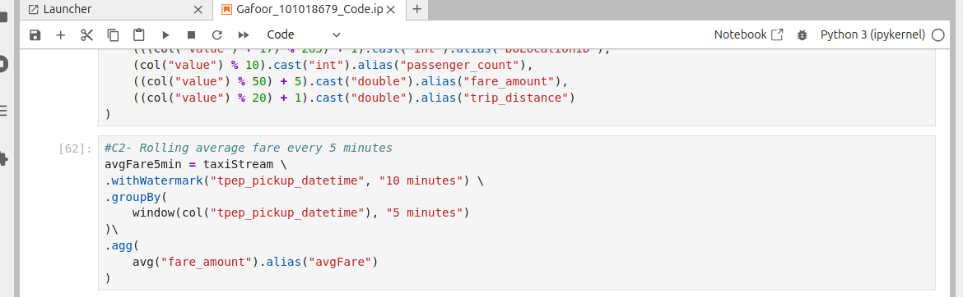
3. Count trips per pickup location using window operations
#C3- Count Trips per location using windows operation

tripsPerLocation = taxiStream \
.withWatermark("tpep_pickup_datetime", "10 minutes") \
.groupBy(
window(col("tpep_pickup_datetime"), "5 minutes"),
col("PULocationID")
) \
.agg(
count("*").alias("tripCount")
)
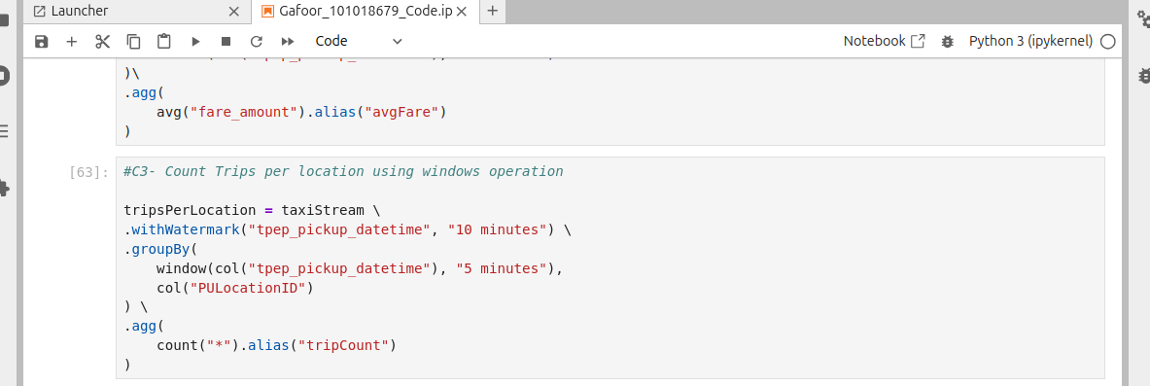
- Write Results to:
  - Console
  - Memory Table
  - Parquet
#C4- Write Stream
# Console
consoleQuery = avgFare5min.writeStream \
.outputMode("update") \
.format("console") \
.option("truncate", False) \
.start()

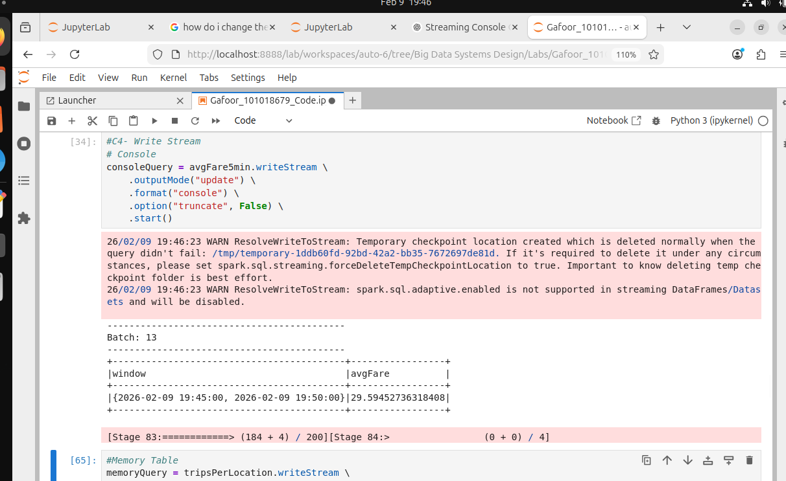

#Memory Table
memoryQuery = tripsPerLocation.writeStream \
.outputMode("complete") \
.format("memory") \
.queryName("tripsPerLocationtable") \
.start()
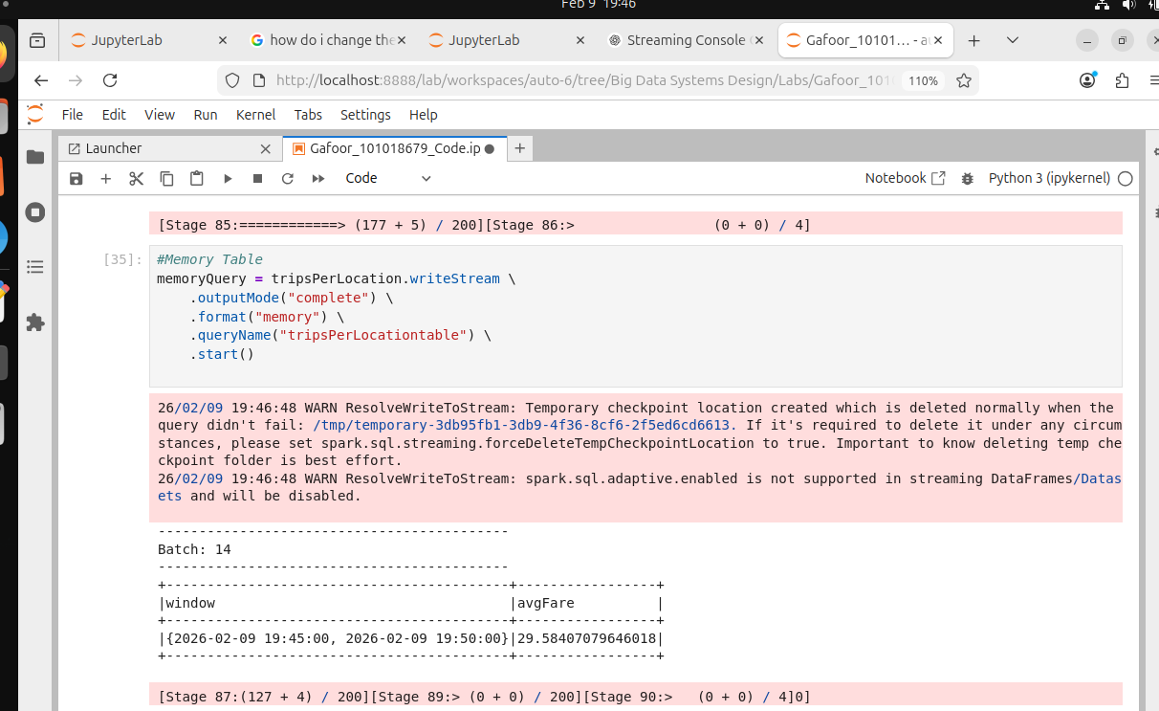

# To Parquet- Rolling Average
fileQuery = avgFare5min.writeStream \
.outputMode("append") \
.format("parquet") \
.option("path", "/home/vboxuser/Big Data Systems Design/Assignment1/tmp/avgFareParquet") \
.option("checkpointLocation", "/home/vboxuser/Big Data Systems Design/Assignment1/tmp/avgFareParquetCheckpoint") \
.start()
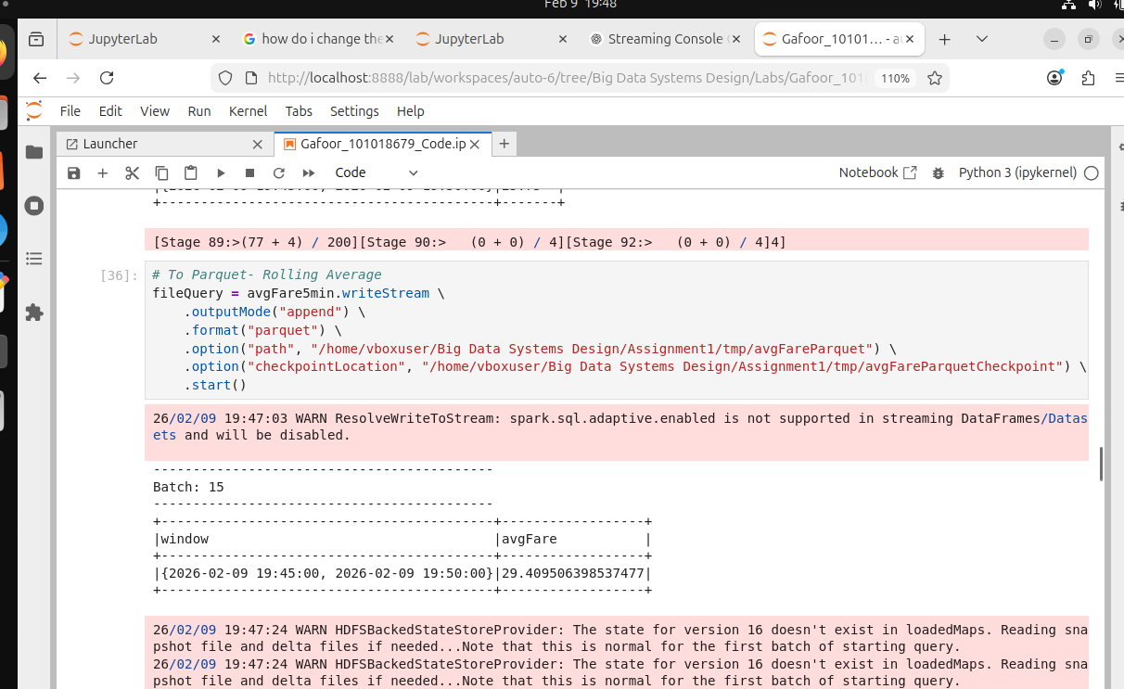
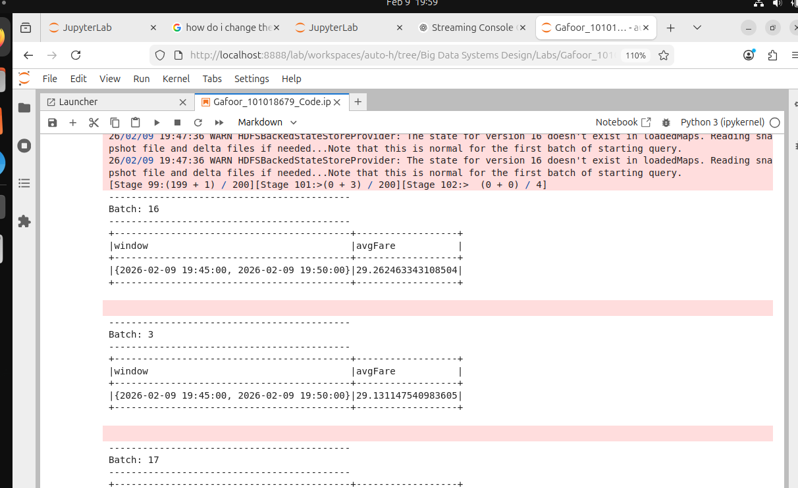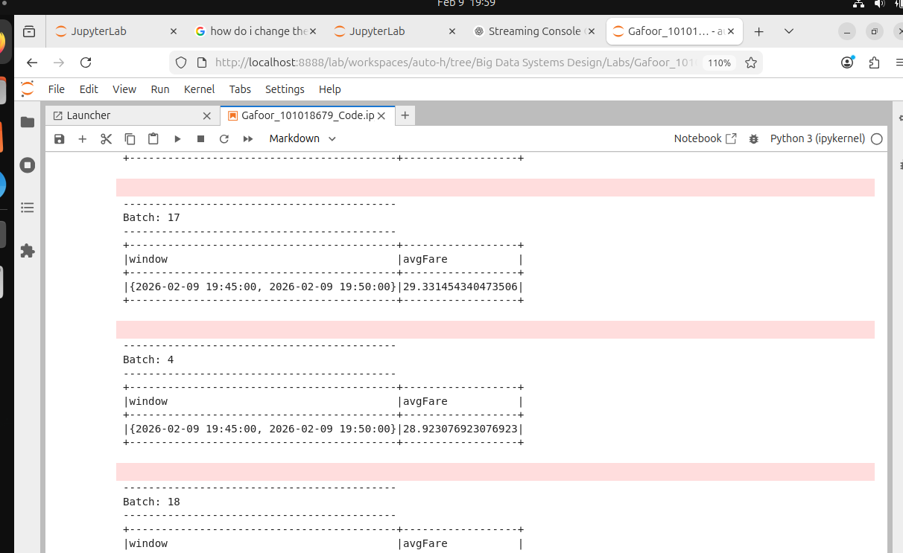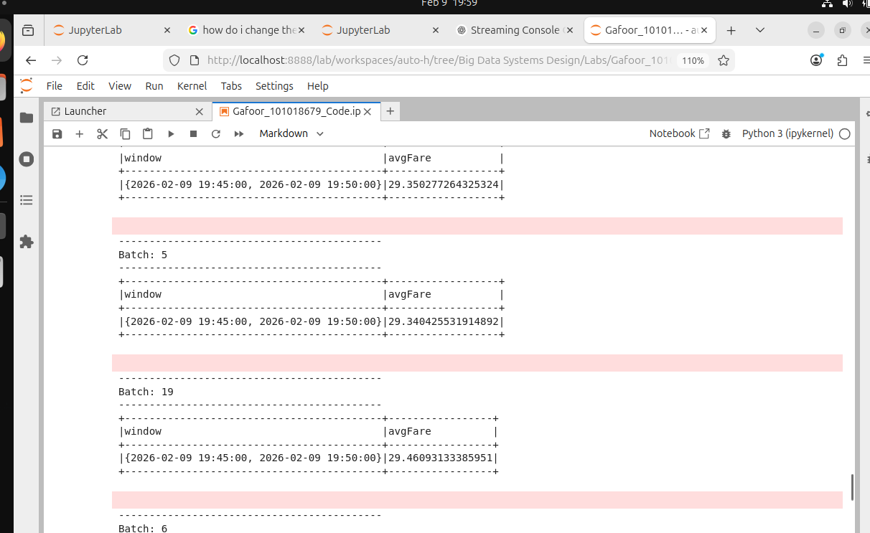
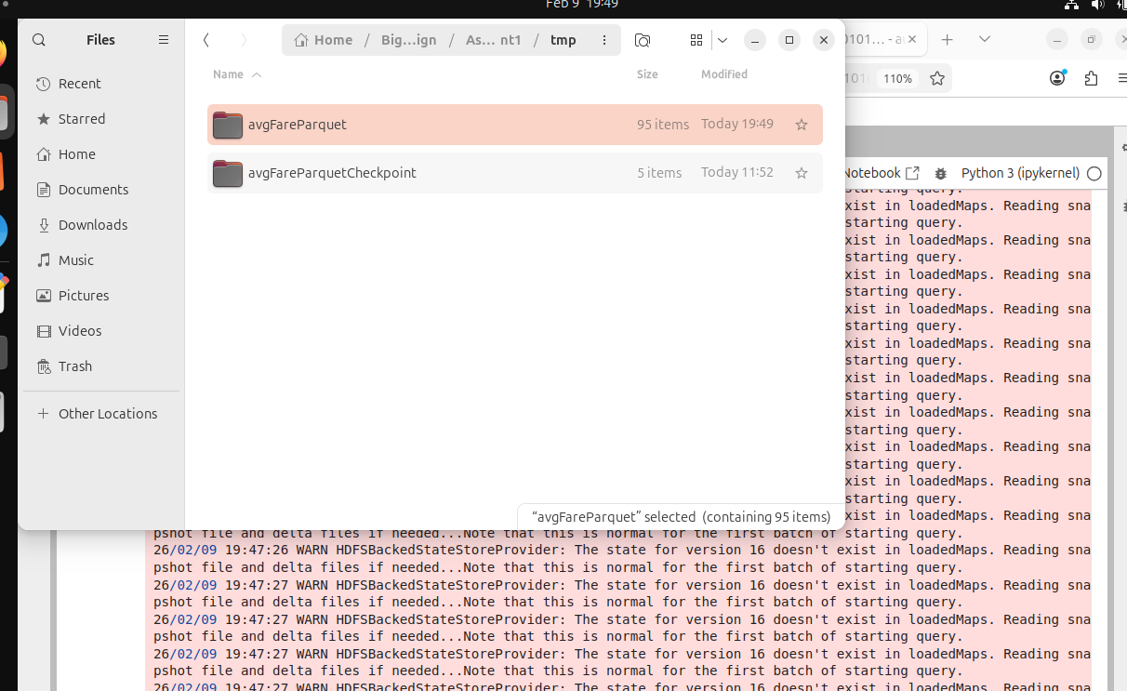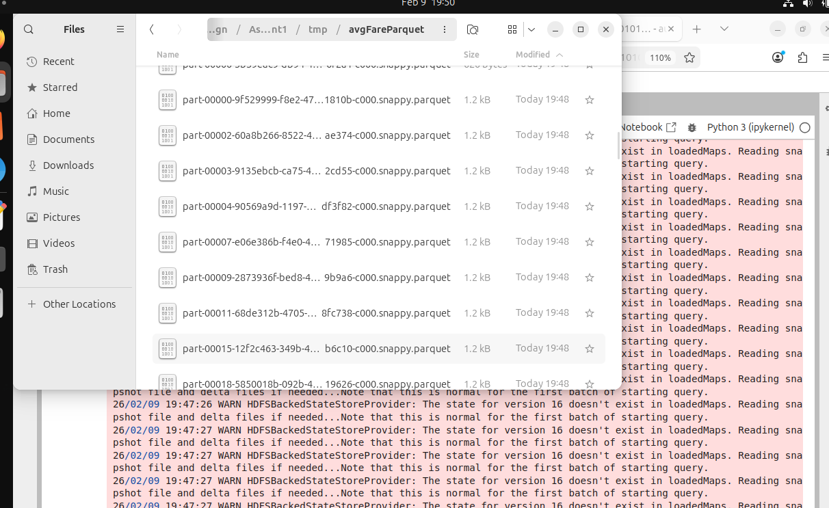

PART D- RDD Operations
- Filter: Select trips with passenger_count > 5
- Map: Extract (pickup_location, fare)
- ReduceByKey: Compute the total fare per pickup location
#D-1: Map Reduce
PickupFareDF = spark.sql(
"""
select
PULocationID,
fare_amount,
passenger_count
from taxi_trips
"""
)

PickupFareRDD = PickupFareDF.rdd

#filter out all rides that had > 4 passengers
Pcount = PickupFareRDD.filter(lambda r: r.passenger_count > 4)

# For every pickup location show the fare amount
PFare = Pcount.map(lambda r: (r.PULocationID, r.fare_amount))

# sum the fare amount by location
TotalFarePerLocation = PFare.reduceByKey(lambda a, b: a + b)

# display
TotalFarePerLocation.take(10)

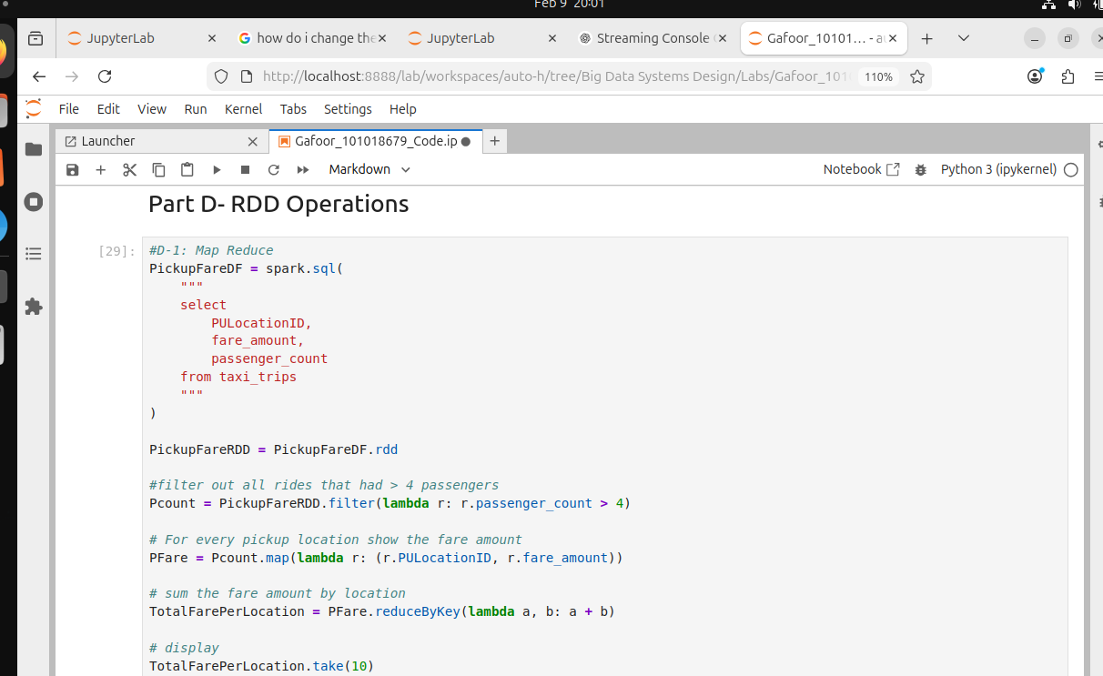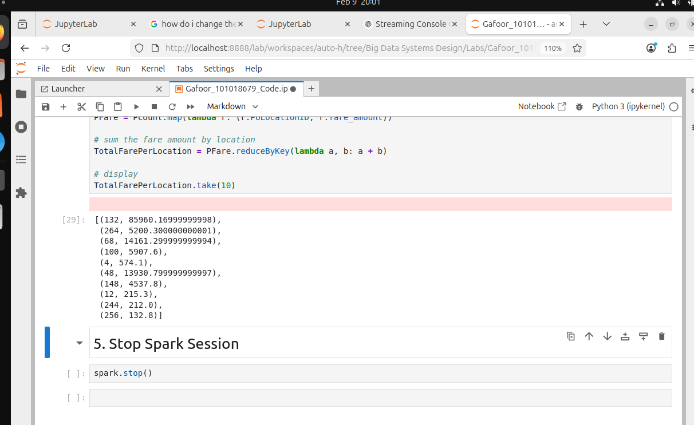

PART E- REFLECTIONS
- Under what circumstances should RDDs be preferred over DataFrames? Justify with examples.
RDDs are preferred over DataFrames when dealing with unstructured data and when fine-grained, low-level control over execution logic is required. DataFrames require a predefined schema, and when data is highly unstructured or irregular, forcing it into a schema can be difficult and/or inefficient.
For example, when counting the number of times a word is repeated in a book, an RDD can be used to process the raw text directly without defining a schema. The text file is split across partitions, and the spark equivalent of Transformation and Actions are applied to perform the word count efficiently (in Hadoop it is Map Reduce).

- Compare the performance characteristics of RDDs, DataFrames, and Spark SQL. Briefly explain how Spark’s optimization mechanisms affect performance.

Feature | RDD | DataFrames | Spark SQL
Query Optimization | None | Catalyst | Catalyst
Memory Efficiency | None | Tungsten | Tungsten
Execution Speed | Slow | Fast | Fastest

Explanation:
- RDDs
  - Lack automatic optimization and use higher memory and CPU overhead.

- DataFrames
  - Represent structured data with schemas.
  - Optimized using Catalyst for logical and physical query planning
  - Use Tungsten for efficient memory management and execution

- Spark SQL
  - Built on top of DataFrames.
  - SQL allows Spark to apply optimizations (immediately), often resulting in the best performance i.e,it will process the “where clause” of first

There are two mechanisms to Spark’s Optimization:

- Catalyst Optimizer: optimizes query plans (filter pushdown, join reordering). This mechanism answers the question: What is the best plan?

- Tungsten Engine: improves CPU efficiency, memory usage, and reduces garbage collection. This mechanism answers the question: How do we make it faster?

Spark SQL and Data frames are similar in performance, and their performance is better than RDD.

- Discuss the key challenges associated with real-time streaming data processing in Spark, such as state management, late data, and fault tolerance.

The following challenges can arise from real time streaming data:

  - State Management: Many streaming applications require maintaining state across events (counts, user session info).
    - Challenge: State can grow unbounded which can affect memory usage.
    - Spark solution: Stateful operations, checkpointing, and state timeouts in Structured Streaming.

  - Late Data: Events may arrive late due to network latency or system delays.
    - Challenge: Incorrect aggregations if late data is ignored.
    - Spark solution: Event-time processing with watermarks to handle late data.

  - Fault Tolerance: Failures can cause data loss or duplicate processing during the process of recovering
    - Challenge: To ensure the recovery of the data is done correctly (keeping state consistent, not losing data, not processing the same data twice)
    - Spark solution: Checkpointing and write-ahead logs ensure fault tolerance

- Describe at least three real-world applications where Structured Streaming is suitable, explaining why it is preferred over batch processing in these cases

- Fraud detection (Banking/ Payments): To prevent financial loss, transactions can be continuously monitored to detect any anomaly as they occur
Why streaming over batch: Batch processing would be too slow for real -time fraud prevention. Whereas Structured Streaming allows rolling aggregations and window- based analysis allowing for real time fraud detection.

- Real-time incident and collision detection: In traffic systems, collisions or sudden speed drops must be detected immediately. Using Structured Streaming, Spark can continuously analyze incoming traffic events to identify abnormal patterns, such as abrupt deceleration or stopped vehicles.

Why streaming over batch: Batch processing may detect incidents minutes or hours later, whereas Structured Streaming enables immediate alerts, reducing emergency response time, improving road safety and can dispatch help to emergency situations

- Real-time monitoring and alerting systems: Structured Streaming is widely used for monitoring application logs, system metrics, and IoT data. Spark can trigger alerts when thresholds are exceeded (e.g., system overloads or sensor failures).

Why streaming over batch: Alerts must be generated immediately. Batch jobs introduce delays that make monitoring ineffective for operational use.

Source: NYC Taxi & Limousine Commission (TLC) URL: https://www.nyc.gov/site/tlc/about/tlc-trip-record-data.page
Selected Month = January (Yellow Taxi Trip Records) yellow_tripdata_2025-01.parquet

