Executive Summary
This analysis examined over 10,000 collision records from Toronto’s open data portal to identify the factors that most strongly predict severe injury outcomes. Logistic regression models revealed that vulnerable road users—particularly pedestrians, cyclists, moped drivers, and motorcyclists—face 13 to 34 times higher odds of severe injury compared to drivers. Older adults (55+) also show a significantly increased risk, with the predicted probability of severe injury rising from 74% among 25-year-olds to 83% among 75-year-olds. Additionally, the 20–24 age group is identified as a high-risk group.

Environmental and temporal patterns indicate that dusk (artificial) lighting and morning and noon rush hours are the periods of highest risk. The months of January, October, November, and December also show elevated risk.

These insights support targeted interventions, including improved lighting and protected infrastructure, senior-friendly crossing designs, rush-hour enforcement, winter safety campaigns, school sensitization programs, and social media awareness campaigns. Collectively, these measures align with Toronto’s Vision Zero objective to eliminate severe injuries and fatalities.

All results are based on odds ratios and predicted probabilities from logistic regression models built in Python (JupyterLab). Detailed statistical outputs are summarized in the appendices.

Definition of Business Problem

Traffic collisions resulting in severe injuries or fatalities continue to pose a significant challenge to public safety in Toronto. Annually, the city records thousands of these incidents. This disproportionately affects vulnerable road users such as pedestrians, cyclists, and older adults, all of which are at elevated risk experiencing a serious injury.

This study aims to examine the user, environmental conditions, and temporal variables to determine which factors most strongly correlate with the severity of injuries sustained in traffic collisions. By identifying these predictors, the research seeks to inform targeted interventions that enhance roadway safety.

Findings from this analysis will provide empirical support for municipal decision makers (including transportation planners and public safety officials) enabling them to prioritize infrastructure upgrades, enforcement strategies and policy initiative. Ultimately, the goal is to utilize a data-driven approach to eliminating severe traffic injuries and fatalities across the city.

Description of Data
The analysis uses the Toronto Motor Vehicle Collisions Involving Killed or Seriously Injured Persons dataset from the City of Toronto Open Data Portal (2006–2023).
- Data Source: Toronto Open Data Portal
- Dataset Size: (10044, 169)
- Columns Used: UserInvType_*, UserAgeRange_*, EnvLightingCondition_*, EnvRoadSurfaceCondition_*, TimePeakOffPeak_*, TimeSeason_*, TimeMonth_*,TimeRange_*

Data Cleaning and Preparation:
A series of steps were performed to prepare the data for the Logistical Regression:
- Renamed columns to more meaningful names
- Identified and removed records with missing critical data
- Converted date and time into useable numeric features
- Created dummy variables for all categories: Driver (Involvement Type), Age 20–24 (Age Group), Daylight (Lighting Condition), Dry (Road Surface), 2006 (Year), January (Month), 12 (Hour), 12:00–14:59 (Time Range), Peak (Peakoff - Peak), Non - Winter (Season)
- Cleaned and standardized categorical predictor variables

Proposed Analysis
A Logistic Regression Model was used to estimate the likelihood that a collision results in a severe injury (Fatal or Major), given different user, environmental, and temporal conditions.
Logistic regression is appropriate for this analysis because the outcome variable (Severity of Injury) is binary (severe vs. non-severe). Each variable was assessed using:
- p-values for statistical significance,
- Confidence Intervals (CI) for reliability
- Odds Ratios / Percentage Change to interpret the direction and magnitude of impact.
- Predicted Probabilities which communicated risk
Multiple models were generated in Python (JupyterLab) using the statsmodels library for each slice.

Interpreting the Results
Four statistical measures are presented throughout this report:
- P-values: P-values indicate whether the effect of a variable is statistically meaningful or likely due to random chance.
- Confidence Interval: Confidence intervals show the range within which the true effect is likely to fall, providing a measure of reliability and precision.
- Odds Ratios (OR): show how much more or less likely a collision outcome is compared with a baseline group. For example, an OR = 2 means the odds are twice as high as the baseline.
- Predicted Probabilities: express those relationships as actual chances (percentages) of a severe injury occurring.
Odds Ratios are used to describe relative risk across categories (e.g., involvement type, lighting) while Predicted Probabilities are used to communicate the absolute likelihood of a severe injury for each group.

User Questions and Answers
- How much higher are the odds of severe injury for older adults compared to younger drivers?
Older adults are substantially more vulnerable to severe injuries in collisions compared to younger drivers. Drivers aged 55- 69 have 40- 80% higher odds of experiencing a severe injury than those aged 20- 24. This risk increases sharply with age. Individuals aged 70- 79 are about twice as likely at 100% - 120%, and those aged 85- 89 are over three times as likely to sustain severe injuries. These results are derived from the odds ratios in Model B (Appendix A), where all p-values indicate strong statistical significance. This confirms that age is a reliable and meaningful predictor of injury severity.

This trend highlights the need for senior-focused safety interventions, such as improved lighting, longer pedestrian crossing times, and speed management in areas with a high concentration of older adults.

- Which involvement types significantly increase the odds of a severe injury?
Unprotected Road Users face the highest likelihood of severe injury. The analysis shows that cyclists, motorcyclists, moped drivers, and pedestrians are between 13 and 34 times more likely to suffer a severe injury than drivers. In contrast, truck drivers and passengers experience notably lower odds which is likely due to vehicle protection. According to the odds ratios reported in Model A (Appendix A), these involvement types show highly significant results, with confidence intervals entirely above 1.0, a clear indication of a strong positive impact on injury severity.
These findings suggest that investments in protected cycling lanes, dedicated motorcycle infrastructure, and pedestrian-priority zones can significantly reduce injury severity across Toronto’s streets.

- Is the effect of age statistically significant in predicting severe injuries?
Yes. Age is a statistically significant factor in predicting the likelihood of severe injuries. Individuals aged 50- 94 consistently show higher odds of severe injury compared to younger drivers. For these age groups, the odds increase by approximately 1.3x to 11.7x, confirming that injury severity rises sharply as people age. The pattern is confirmed by Model B (Appendix A), where all associated p-values demonstrate strong statistical significance, reinforcing age as a key predictor of severe injury outcomes.
This demonstrates the importance of age-sensitive transportation planning, including driver assessment programs, mobility alternatives for seniors, and public education on safe driving among older populations.
- Does being a pedestrian increase or decrease the odds of severe injury relative to drivers?
Being a pedestrian greatly increases the risk of severe injury compared to being a driver.
Pedestrians are approximately 13 times more likely to suffer a severe injury when involved in a collision. This is both statistically and practically significant. Model A (Appendix A) reports a pedestrian odds ratio of 13.76 with a 95 % confidence interval (11.6 – 16.3) and a highly significant p-value, confirming that pedestrians face a statistically strong and substantially higher risk of severe injury compared with drivers.
This reinforces the importance of pedestrian safety infrastructure such as, raised crosswalks, refuge islands, better intersection lighting, and reduced vehicle speeds in pedestrian-heavy zones.

- What is the predicted probability that a collision involving a 75- 79 years old results in severe injury?
The model predicts that a collision involving a person aged 75–79 has an 83% probability of resulting in a severe injury. This probability is based on the predictive outputs from Model A (Appendix A), which translate the statistical model into an estimated real-world likelihood of severe injury.
This underscores the vulnerability of older adults in traffic collisions and highlights the need for policies and design improvements that minimize collision impact, including lower urban speed limits and better access to emergency medical response services.

- By how many percentage points is the probability of a severe injury increase from age 25-29 to age 75-79
The probability of a severe injury rises from 74% for those aged 25- 29 to 83% for those aged 75- 79, an 8.5 percentage-point increase. While this may appear modest, it represents a meaningful escalation in real-world risk. This comparison is drawn from the predicted-probability results in Model A (Appendix A), which express the difference in absolute risk between the two age groups.
This finding emphasizes the importance of early safety interventions for aging drivers, such as defensive-driving refreshers and community mobility programs to reduce collision exposure.

Charts
Severity risk increases steadily with age. Individuals aged 75+ face an 80- 99% probability of severe injury, emphasizing the need for senior-focused safety measures:

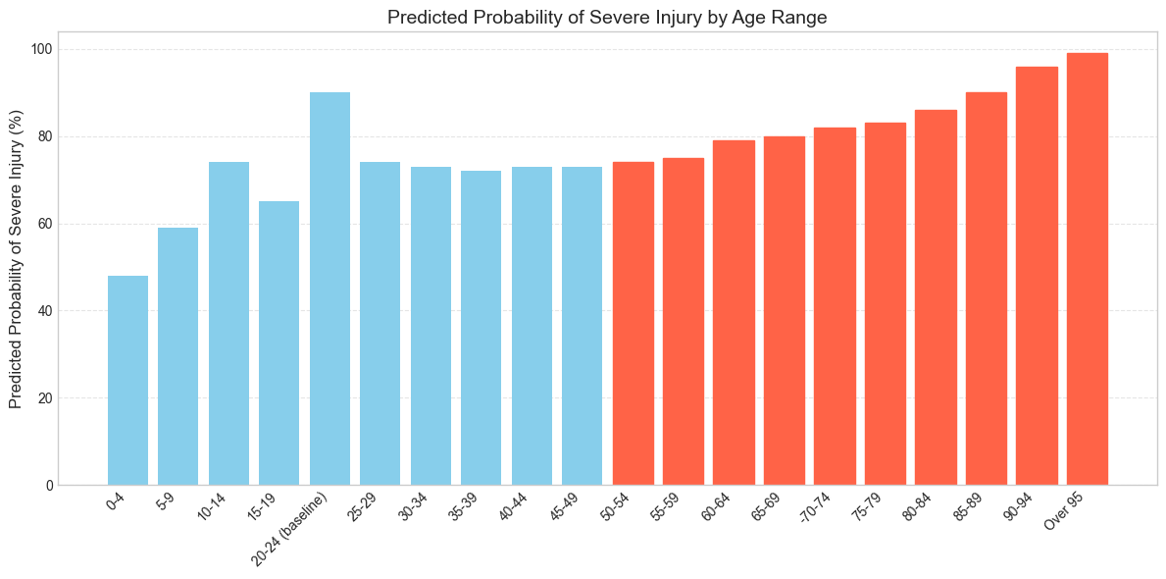
Figure 1- Predicted Probability of Severe Injury by Age Range
Vulnerable users- cyclists, motorcyclists, moped drivers, and pedestrians are 13- 34x more likely to be severely injured than drivers. Passengers and truck drivers face lower risks: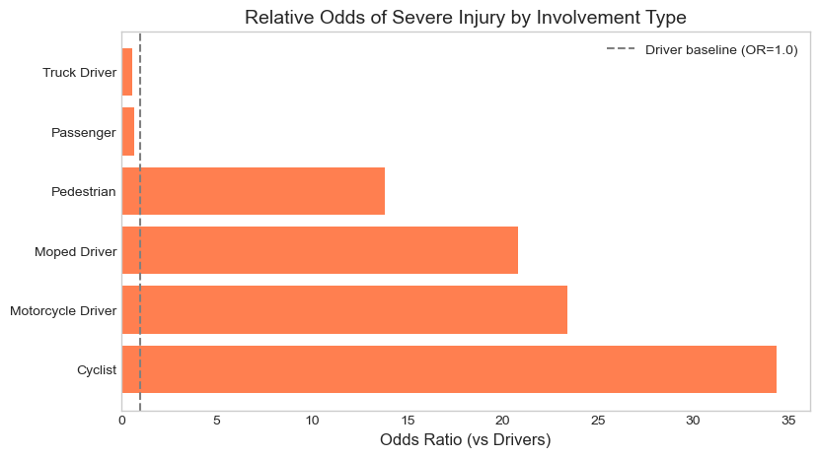
Figure 2- Relative Odds of Severe Injury by Involvement Type
Managerial Insights (User Factors)
The results make it clear that age and involvement type are critical determinants of injury severity. Older adults, pedestrians, cyclists, moped, and motorcyclists face the greatest danger, while enclosed-vehicle occupants are far better protected.
To address these risks, decision-makers should focus on safer infrastructure, targeted education campaigns, and enhanced medical readiness to protect Toronto’s most vulnerable road users.

Environment Questions and Answers
- How much higher are the odds of a severe collision under Dusk lighting compared to Daylight conditions?
Collisions that occur under dusk artificial lighting are almost twice as likely to result in a severe injury compared to those occurring in daylight. This suggests that visibility challenges at dusk contribute significantly to crash severity. As shown in Model A (Appendix B), dusk with artificial lighting has an odds ratio of 1.9 (95 % CI 1.1 - 3.1), indicating a statistically significant increase in severity compared to daylight. In contrast, dusk under natural light is not statistically significant (CI 0.7- 1.7).
The city can mitigate this risk through better street lighting, enhanced visibility measures, and driver-awareness programs during early evening hours.

- Which specific road surface conditions are statistically significant predictors of severe outcomes when compared to Dry roads?
Two surface conditions stand out:
- “Other” road surfaces are associated with roughly twice the odds of severe injury compared to dry conditions.
- “Ice” surfaces show a 58% lower likelihood of severe injury, likely due to reduced vehicle speeds.
Model B (Appendix B) shows that “Other” road surfaces are associated with roughly twice the odds of severe injury (95 % CI 1.1 – 3.9), while “Ice” surfaces are linked to significantly lower odds (95 % CI 0.2 – 0.7), reflecting slower driving speeds and reduced impact forces.
These findings indicate that while icy conditions slow traffic and reduce impact severity. It is still difficult to identify and address road surface conditions that are classified as others since this seems to be a generic classification.

- Are there differences in severity between Dark and Daylight conditions statistically significant or can they be due to random variation?
Yes, the differences in severity between Dark and Daylight conditions statistically significant. Collisions in natural darkness (without artificial lighting) are significantly more likely to be severe, while those under dark (with artificial lighting) lighting show no statistically meaningful difference from daylight conditions and can be explained by a random variation. Model A (Appendix B) indicates that natural darkness reduces the odds of severe injury by approximately 11 % (95 % CI 0.79- 0.99), a statistically significant effect. Collisions under artificial lighting show a smaller, non-significant difference (95 % CI 0.8 – 1.1).
Improving illumination and reflective road markings in dark areas can reduce these severity outcomes.

- Does the change in reduced visibility (dark to dusk to daylight) show a decrease or increase in odds of a severe collision?
The analysis shows that visibility does influence injury severity, but not uniformly.
Collisions in natural darkness have 11% lower odds of being severe, while natural dusk has a slight, not statistically significant 12% increase. As detailed in Model A (Appendix B), collisions in natural darkness have about 11 % lower odds of being severe (95 % CI 0.79 - 0.999), while natural dusk shows a small, non-significant 12 % increase (95 % CI 0.74 - 1.70).
Although not all visibility effects are statistically significant, they point to the importance of visibility management in safety planning- better lighting, reflective infrastructure, and driver awareness.

- How do the predicted probabilities of severe conditions differ between packed snow and ice surfaces?
Collisions on packed snow are significantly more likely to result in severe injury (78% probability) than those on ice (54% probability). This suggests that even though drivers slow down on ice, packed snow may create a deceptive sense of safer driving conditions for road users. Based on predicted probabilities from Model B (Appendix B), collisions on packed snow have an estimated 78 % chance of severe injury versus 54 % on ice, underscoring the risk of deceptive traction on snow-covered surfaces.
Snow-removal operations and winter tire awareness campaigns should focus on mitigating risks from snow-covered surfaces.
- What overall pattern emerges between lighting condition and severity risk? Do probabilities rise as lighting decreases?
The results show that injury severity does not increase steadily as lighting decreases (dawn -> dusk -> dark). Instead, artificially lit dusk conditions are the most dangerous, while natural-light conditions are generally safer. These results are confirmed by the predicted probabilities in Model B (Appendix B), showing that artificial dusk conditions produce the highest severity likelihood among all lighting scenarios.
This indicates that transition periods between light and dark are particularly risky and should be prioritized for visibility enhancements and speed enforcement.
- What is the most dangerous combination of lighting conditions and road surface conditions?
The analysis did not include interaction effects between lighting and road-surface conditions, so this combination could not be evaluated within scope. Future research using more advanced modeling tools (i.e. other libraries) could help identify these high-risk intersections.

CHARTS
Dusk with artificial lighting nearly doubles the odds of a severe injury, suggesting visibility challenges during transition hours:
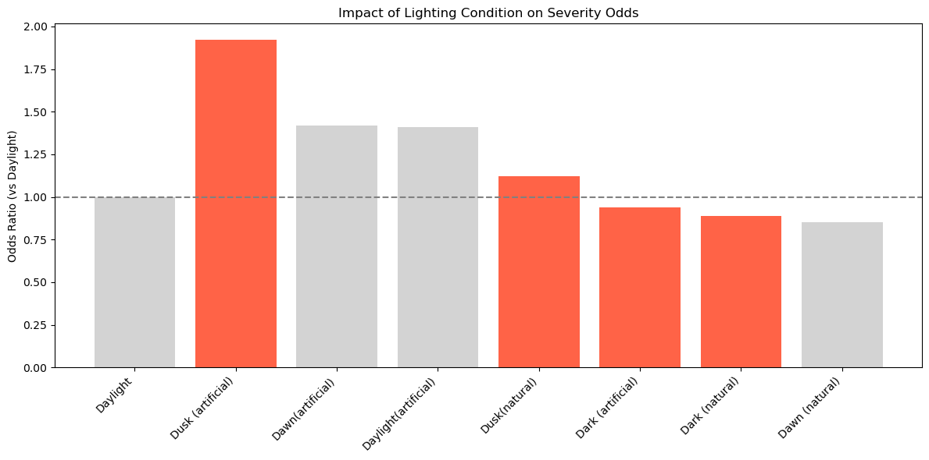
Figure 3- Impact of Lighting Condition on Severity Odds (grey bars indicate not statistically important)
Collisions on packed snow and “other” surfaces show higher severity risks. Ice conditions show fewer severe outcomes, likely due to slower driving speeds:
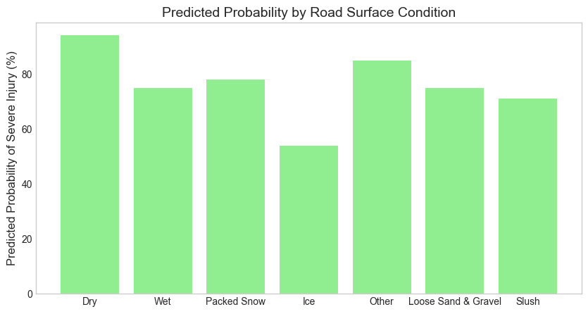
Figure 4- Predicted Probability by Road Surface Condition

Managerial Insights (Environmental Factors)
Environmental conditions have a measurable influence on injury severity, particularly lighting at dusk and non-standard road surfaces.
The findings suggest targeted actions:
- Invest in street lighting upgrades in high-traffic dusk corridors.
- Maintain consistent winter road-surface treatment.
- Implement seasonal safety campaigns during fall and winter to promote safe driving behavior under variable conditions.

Time Questions and Answers
- What is the predicted probability of a severe collision during winter compared to not-winter
Collisions during winter have a 73.2% probability of being severe, compared to 73.9% in non-winter months. This small difference (0.7%) suggests that season alone does not significantly affect injury severity. This comparison is drawn from predicted probabilities in Model B (Appendix C) and the baseline intercept values in Appendix D, confirming that winter conditions have no statistically meaningful effect on severity.
Drivers appear to adapt their behavior to winter conditions, indicating that driver education and preparedness campaigns should continue to reinforce safe winter habits rather than focus solely on the season itself.

- What months have a higher severity probability?
The months of October, November, and December show the highest probabilities of severe collisions, with November being the peak month (78% predicted probability). The safest month is April, at roughly 69%. This pattern suggests that shorter daylight hours and poorer driving conditions late in the year contribute to higher risk. Predicted probabilities from Model C (Appendix C) highlight the October–December months as periods of elevated severity risk, consistent with shorter daylight and adverse weather conditions.
The city should therefore plan fall and early-winter safety campaigns emphasizing reduced speed, increased alertness, and tire preparedness.

- How do predicted probabilities vary across the time-of-day ranges?
Severity risk peaks during morning rush hours (6:00 AM- 8:59 AM), with a predicted probability of 78% for severe injury. The lowest-risk period is early morning (3:00 AM-5:59 AM) at 69%. This pattern reflects greater traffic volume and speed variation during commute hours. Model E (Appendix C) shows a clear morning-peak effect, with the 6 – 8:59 AM time range exhibiting the highest predicted probability of severe injury.
Targeted enforcement and driver-awareness initiatives during peak periods can help reduce collision severity.

- How do the odds of severe traffic injuries during off-peak hours compare to those of peak hours
The odds of severe injury are 17% lower during off-peak hours compared to peak hours. According to Model A (Appendix C) and baseline values from Appendix D, off-peak hours show approximately 17 % lower odds of severe injury, a statistically significant difference.
This statistically significant difference highlights the importance of managing traffic congestion and speed behavior during rush-hour windows.

- Is season a significant risk factor influencing the likelihood of severe collisions?
No. The analysis shows that season alone is not a significant risk factor. The odds of severe injury are slightly lower (- 3.6%) in winter, which is not statistically significant. Model B (Appendix C) reports an odds ratio of 0.96 (95 % CI 0.86 - 1.07) with a non-significant p-value, providing little evidence that winter increases the odds of severe injury.
Winter safety efforts should therefore complement, rather than replace, broader initiatives focused on road design and driver behavior.

- Does time of day (peak vs. off peak) have a statistically significant impact on severity?
Yes. Collisions during off-peak hours have 17% lower odds of getting a severe injury. As shown in Model A (Appendix C), off-peak collisions have an odds ratio below 1 (95 % CI 0.75 – 0.90), with strong statistical evidence that time of day significantly affects injury severity.
This confirms that peak-hour congestion and higher interaction rates drive increased severity levels.

- In which direction does off-peak affect accident severity (increase or decrease the likelihood of severe injuries)
The effect is negative. Off-peak conditions reduce the likelihood of severe injuries by approximately 17%. Model A (Appendix C) confirms a statistically significant negative relationship (95 % CI 0.75 – 0.90), meaning that off-peak periods are associated with fewer severe outcomes compared to peak hours.
This emphasizes that traffic management and enforcement during peak hours can directly reduce severe outcomes.

CHARTS
Collision severity increases toward year-end (October–December) into the early part of the year, likely due to reduced daylight and changing weather:
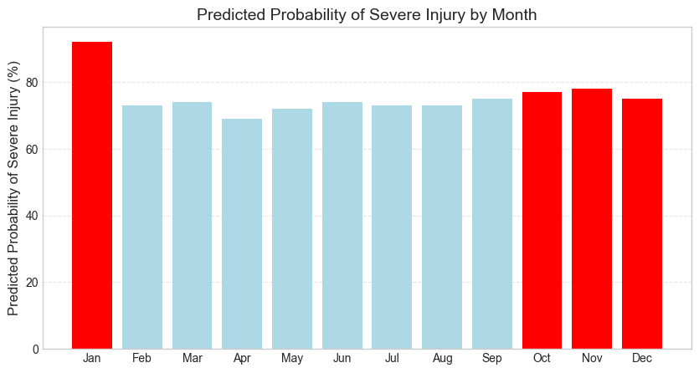
Figure 5- Predicted Probability of Severe Injury by Month
Morning rush hours (6–8:59 AM) along with (12:00-2:59PM) have the highest predicted probability of severe injuries. Enforcement and awareness should focus on peak commuting times:
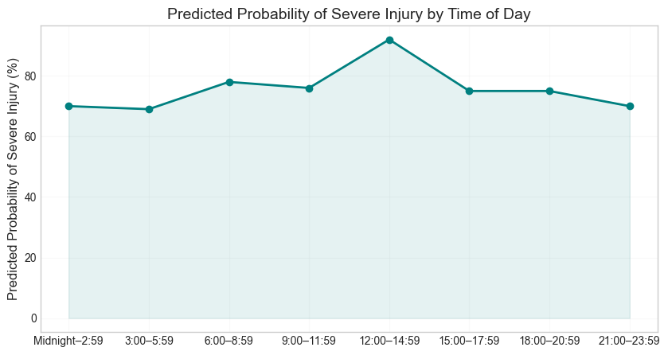
Figure 6- Predicted Probability of Severe Injury by Time of Day

Managerial Insights (Time Factors)
Timing plays a clear role in collision severity. Rush hours, particularly morning commutes (6 AM-8:59AM), show the greatest risk, while seasonal differences are minimal. Municipal leaders should prioritize speed management and enforcement during peak hours, seasonal awareness campaigns in late fall and improved signal timing in commuter corridors to reduce high-severity incidents.

CONCLUSION
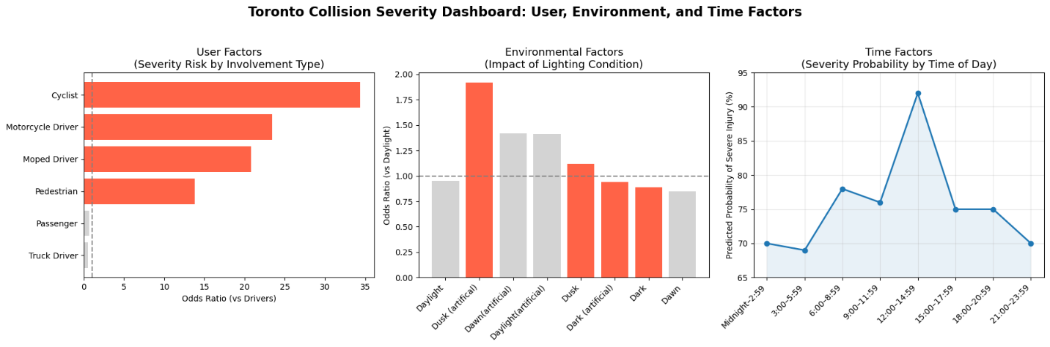

Data and Code Availability
All code and relevant files are stored here: https://drive.google.com/drive/folders/1t6MoUdou-3VU8HN0dL1emab5bXMtExD1?usp=drive_link
The folder structure reflects the phases of the project. Please review the “ReadMe” in the location for a further breakdown. A high-level breakdown is as follows:
- Cleaned dataset (TorontoCity_traffic_collisions_KPI_Modified.csv)
- Python (JupyterLab) code notebooks used for data wrangling, making slices and logistic regression modeling
- .csv files are provided
- .xlsx files contain the manual analysis out the output files

APPENDIX A
All questions under User were answered using Appendix A. Baseline: Driver (Involvement Type), Age 20–24 (Age Group)
Model A [User Involvement] (Odds Ratio, Confidence Interval, P-values)
 | Odds Ratio | 2.50% | 97.50% | pval_new | Consideration | Odds Inc/Dec
UserInvType_Wheelchair | 1268277000.00000 | 0 | inf | 0.99833070000000000 | Little Evidence | 1.26828E+11
UserInvType_In_Line_Skater | 1234460000.00000 | 0 | inf | 0.99918030000000000 | Little Evidence | 1.23446E+11
UserInvType_Moped_Passenger | 206225600.00000 | 0 | inf | 0.99908300000000000 | Little Evidence | 20622559900
UserInvType_Cyclist | 34.40779 | 21.173987 | 55.912758 | 0.00000000000000000 | Very Strong | 3340.779
UserInvType_Motorcycle_Driver | 23.44595 | 15.249722 | 36.047371 | 0.00000000000000000 | Very Strong | 2244.595
UserInvType_Moped_Driver | 20.81081 | 2.828074 | 153.139514 | 0.00287445900000000 | Very Strong | 1981.081
UserInvType_Pedestrian | 13.75895 | 11.595644 | 16.325858 | 0.00000000000000000 | Very Strong | 1275.895
UserInvType_Motorcycle_Passenger | 1.73423 | 0.87873 | 3.42263 | 0.11245330000000000 | Little Evidence | 73.4234
UserInvType_Cyclist_Passenger | 1.48649 | 0.134653 | 16.409909 | 0.74629010000000000 | Little Evidence | 48.6486
Intercept | 1.34546 | 1.25476 | 1.442704 | 0.00000000000000008 | Very Strong | 34.5455
UserInvType_Passenger | 0.66595 | 0.594188 | 0.74637 | 0.00000000000277243 | Very Strong | -33.40541
UserInvType_Truck_Driver | 0.53679 | 0.322583 | 0.893228 | 0.01664093000000000 | Strong | -46.32132
UserInvType_Other | 0.29730 | 0.057594 | 1.534624 | 0.14746940000000000 | Little Evidence | -70.27027

Model A [User Involvement] (Predictive Probability):
Involvement | PredProb_Severe
UserInvType_Wheelchair | 1.00E+00
UserInvType_In_Line_Skater | 1.00E+00
UserInvType_Moped_Passenger | 1.00E+00
UserInvType_Cyclist | 9.79E-01
UserInvType_Motorcycle_Driver | 9.69E-01
UserInvType_Moped_Driver | 9.66E-01
UserInvType_Pedestrian | 9.49E-01
UserInvType_Motorcycle_Passenger | 7.00E-01
UserInvType_Cyclist_Passenger | 6.67E-01
UserInvType_Passenger | 4.73E-01
UserInvType_Truck_Driver | 4.19E-01
UserInvType_Other | 2.86E-01
UserInvType_Driver___Not_Hit | 3.60E-09

Model B [User Age Range] (Odds Ratio, Confidence Interval, P-values)
 | Odds Ratio | 2.50% | 97.50% | pval_new | Considerations | Odds Inc/Dec
UserAgeRange_Over_95 | 196.777112 | 0.000227 | 170620260.2 | 0.4489491000 | Little Evidence | 19577.7112
UserAgeRange_90_to_94 | 11.73566 | 2.843073 | 48.44255363 | 0.0006629349 | Very Strong | 1073.566
UserAgeRange_85_to_89 | 4.0861 | 2.503719 | 6.668567211 | 0.0000000178 | Very Strong | 308.61
UserAgeRange_80_to_84 | 2.757026 | 1.906119 | 3.987784766 | 0.0000000722 | Very Strong | 175.7026
Intercept | 2.21547 | 1.956899 | 2.508205796 | 0.0000000000 | Very Strong | 121.547
UserAgeRange_75_to_79 | 2.186817 | 1.605978 | 2.977729875 | 0.0000006779 | Very Strong | 118.6817
UserAgeRange_70_to_74 | 2.015279 | 1.514457 | 2.681719151 | 0.0000015295 | Very Strong | 101.5279
UserAgeRange_65_to_69 | 1.780955 | 1.372841 | 2.310392088 | 0.0000138471 | Very Strong | 78.0955
UserAgeRange_60_to_64 | 1.678282 | 1.314427 | 2.142855991 | 0.0000328461 | Very Strong | 67.8282
UserAgeRange_55_to_59 | 1.384763 | 1.115269 | 1.71937889 | 0.0031993940 | Very Strong | 38.4763
UserAgeRange_50_to_54 | 1.318292 | 1.072219 | 1.620836537 | 0.0087552880 | Very Strong | 31.8292
UserAgeRange_25_to_29 | 1.310161 | 1.087354 | 1.578621889 | 0.0045036520 | Very Strong | 31.0161
UserAgeRange_10_to_14 | 1.272868 | 0.900883 | 1.798448351 | 0.1712816000 | Little Evidence | 27.2868
UserAgeRange_40_to_44 | 1.222763 | 0.993219 | 1.505357732 | 0.0579834500 | Moderate | 22.2763
UserAgeRange_30_to_34 | 1.20236 | 0.988962 | 1.461805576 | 0.0645117800 | Moderate | 20.236
UserAgeRange_45_to_49 | 1.193575 | 0.970771 | 1.467516726 | 0.0932372800 | Moderate | 19.3575
UserAgeRange_35_to_39 | 1.165698 | 0.95476 | 1.423238925 | 0.1322195000 | Little Evidence | 16.5698
UserAgeRange_15_to_19 | 0.853051 | 0.694391 | 1.047962191 | 0.1300842000 | Little Evidence | -14.6949
UserAgeRange_5_to_9 | 0.64725 | 0.446158 | 0.938976738 | 0.0219255800 | Strong | -35.275
UserAgeRange_unknown | 0.53056 | 0.364888 | 0.771450668 | 0.0009048383 | Very Strong | -46.944

Model B [User Age Range] (Predictive Probability):
AgeRange | PredProb_Severe
UserAgeRange_Over_95 | 0.9977110
UserAgeRange_90_to_94 | 0.9629630
UserAgeRange_85_to_89 | 0.9005240
UserAgeRange_80_to_84 | 0.8593160
UserAgeRange_75_to_79 | 0.8289090
UserAgeRange_70_to_74 | 0.8170100
UserAgeRange_65_to_69 | 0.7978020
UserAgeRange_60_to_64 | 0.7880540
UserAgeRange_55_to_59 | 0.7541730
UserAgeRange_50_to_54 | 0.7449390
UserAgeRange_25_to_29 | 0.7437620
UserAgeRange_10_to_14 | 0.7382200
UserAgeRange_40_to_44 | 0.7303850
UserAgeRange_30_to_34 | 0.7270590
UserAgeRange_45_to_49 | 0.7256010
UserAgeRange_35_to_39 | 0.7208710
UserAgeRange_15_to_19 | 0.6539680
UserAgeRange_5_to_9 | 0.5891470
UserAgeRange_unknown | 0.5403230
UserAgeRange_0_to_4 | 0.4766360

APPENDIX B
All questions under Environment were answered using Appendix B. Baseline Daylight (lighting condition) and Dry (Road surface).

Model A [Light Conditions] (Odds Ratio, Confidence Interval, P-values)
 | Odds Ratio | 2.50% | 97.50% | pval_new | Consideration | Odds Inc/Dec
EnvLightingCondition_Other | 41592.67003 | 0.0000000000 | 7.436975E+212 | 0.9653254000 | Little Evidence | 4159167.003
Intercept | 2.878201 | 2.7109920000 | 3.0557220000 | 0.0000000000 | Very Strong | 187.8201
EnvLightingCondition_Dusk__artificial | 1.920059 | 1.1735880000 | 3.1413290000 | 0.0093976790 | Very Strong | 92.0059
EnvLightingCondition_Dawn__artificial | 1.421343 | 0.7331952000 | 2.7553570000 | 0.2978460000 | Little Evidence | 42.1343
EnvLightingCondition_Daylight__artificial | 1.411472 | 0.8141468000 | 2.4470450000 | 0.2196078000 | Little Evidence | 41.1472
EnvLightingCondition_Dusk | 1.123387 | 0.7427058000 | 1.6991900000 | 0.5815796000 | Little Evidence | 12.3387
EnvLightingCondition_Dark__artificial | 0.941325 | 0.8391680000 | 1.0559190000 | 0.3022444000 | Little Evidence | -5.8675
EnvLightingCondition_Dark | 0.890076 | 0.7931498000 | 0.9988476000 | 0.0477523300 | Strong | -10.9924
EnvLightingCondition_Dawn | 0.849296 | 0.4892002000 | 1.4744550000 | 0.5616625000 | Little Evidence | -15.0704

Model A [Light Conditions] (Predictive Probabilities):
EnvironmentLighting | PredProb_Severe
EnvLightingCondition_Other | 0.999992
EnvLightingCondition_Dusk__artificial | 0.846774
EnvLightingCondition_Dawn__artificial | 0.803571
EnvLightingCondition_Daylight__artificial | 0.802469
EnvLightingCondition_Dusk | 0.76378
EnvLightingCondition_Dark__artificial | 0.730409
EnvLightingCondition_Dark | 0.719245
EnvLightingCondition_Dawn | 0.709677

Model B [Road Surface] (Odds Ratio, Confidence Interval, P-values)
Road Surface | Odds Ratio | 2.50% | 97.50% | pval_new | Consideration | Odds Inc./Dec.
EnvRoadSurfaceCondition_Spilled_liquid | 99965490.000000000000000 | 0 | inf | 0.999118 | Little Evidence | 9996548900.000000
Intercept | 2.775234000000000 | 2.64143 | 2.91582 | 0 | Very Strong | 177.523400
EnvRoadSurfaceCondition_Other | 2.030951000000000 | 1.06755 | 3.86376 | 0.030837 | Strong | 103.095100
EnvRoadSurfaceCondition_Packed_Snow | 1.297188000000000 | 0.48102 | 3.49818 | 0.607202 | Little Evidence | 29.718800
EnvRoadSurfaceCondition_Wet | 1.109321000000000 | 0.98166 | 1.25358 | 0.096259 | Moderate | 10.932100
EnvRoadSurfaceCondition_Loose_Sand_or_Gravel | 1.080990000000000 | 0.21802 | 5.35989 | 0.924049 | Little Evidence | 8.099000
EnvRoadSurfaceCondition_Slush | 0.888814100000000 | 0.48683 | 1.62271 | 0.70115 | Little Evidence | -11.118590
EnvRoadSurfaceCondition_Loose_Snow | 0.732283600000000 | 0.47501 | 1.12889 | 0.158253 | Little Evidence | -26.771640
EnvRoadSurfaceCondition_Ice | 0.417982800000000 | 0.24427 | 0.71524 | 0.001459 | Very Strong | -58.201720

Model B [Road Surface] (Predictive Probabilities):
RoadSurface | PredProb_Severe
EnvRoadSurfaceCondition_Spilled_liquid | 1
EnvRoadSurfaceCondition_Other | 0.849315
EnvRoadSurfaceCondition_Packed_Snow | 0.782609
EnvRoadSurfaceCondition_Wet | 0.754819
EnvRoadSurfaceCondition_Loose_Sand_or_Gravel | 0.75
EnvRoadSurfaceCondition_Slush | 0.711538
EnvRoadSurfaceCondition_Loose_Snow | 0.670213
EnvRoadSurfaceCondition_Ice | 0.537037

APPENDIX C
All questions under Time were answered using Appendix C. Baseline: 2006 (Year), January (Month), 12 (Hour), 12:00–14:59 (Time Range), Peak (Peakoff - Peak), Non - Winter (Season)

Model A [Peak] (Odds Ratio, Confidence Interval, P-values):
 | Odds Ratio | 2.50% | 97.50% | pval_new | Consideration | Odds Inc./Dec.
Intercept | 3.117012 | 2.913327 | 3.334937 | 0.0000000000 | Very Strong | 212
TimePeakOffPeak_OFF_PEAK | 0.829925 | 0.758664 | 0.907879 | 0.0000470367 | Very Strong | -17.0075

Model A [Peak] (Predictive Probabilities):
PeakOffPeak | PredProb_Severe
TimePeakOffPeak_OFF_PEAK | 0.721207

Model B [Season] (Odds Ratio, Confidence Interval, P-values):
 | Odds Ratio | 2.50% | 97.50% | pval_new | Consideration | Odds Inc./Dec.
Intercept | 2.832131 | 2.694002 | 2.977342 | 0 | Very Strong | 183.2131
TimeSeason_WINTER | 0.963552 | 0.863875 | 1.074729 | 0.505143 | Little Evidence | -3.6448

Model B [Season] (Predictive Probabilities):
Season | PredProb_Severe
TimeSeason_WINTER | 0.731825

Model C [Season] (Odds Ratio, Confidence Interval, P-values):
 | Odds Ratio | 2.50% | 97.50% | pval_new | Confidence | Odds Inc./Dec.
Intercept | 2.470588 | 2.09974 | 2.906934 | 0.0000000000 | Very Strong | 147.0588
TimeMonth_November | 1.472693 | 1.167021 | 1.858429 | 0.0011093100 | Very Strong | 47.2693
TimeMonth_October | 1.36113 | 1.089294 | 1.700802 | 0.0066793880 | Very Strong | 36.113
TimeMonth_December | 1.220643 | 0.969139 | 1.537416 | 0.0903271300 | Moderate | 22.0643
TimeMonth_September | 1.206286 | 0.971779 | 1.497385 | 0.0890531100 | Moderate | 20.6286
TimeMonth_March | 1.142173 | 0.900814 | 1.448201 | 0.2724078000 | Little Evidence | 14.2173
TimeMonth_June | 1.123828 | 0.906373 | 1.393454 | 0.2873308000 | Little Evidence | 12.3828
TimeMonth_February | 1.099353 | 0.862463 | 1.401309 | 0.4442763000 | Little Evidence | 9.9353
TimeMonth_July | 1.088187 | 0.876654 | 1.350761 | 0.4434915000 | Little Evidence | 8.8187
TimeMonth_August | 1.078885 | 0.872147 | 1.334629 | 0.4841960000 | Little Evidence | 7.8885
TimeMonth_May | 1.054103 | 0.844643 | 1.315507 | 0.6410932000 | Little Evidence | 5.4103
TimeMonth_April | 0.888636 | 0.707646 | 1.115917 | 0.3095877000 | Little Evidence | -11.1364

Model C [Season] (Predictive Probabilities):
Month | PredProb_Severe
TimeMonth_November | 0.784409
TimeMonth_October | 0.770789
TimeMonth_December | 0.750978
TimeMonth_September | 0.748759
TimeMonth_March | 0.738346
TimeMonth_June | 0.735206
TimeMonth_February | 0.730897
TimeMonth_July | 0.728884
TimeMonth_August | 0.727184
TimeMonth_May | 0.72255
TimeMonth_April | 0.687055

Model D [Hour] (Odds Ratio, Confidence Interval, P-values):
 | Odds Ratio | 2.50% | 97.50% | pval_new | Consideration | Odds Inc./Dec.
Intercept | 2.69919 | 2.19474 | 3.31958 | 0.0000000000 | Very Strong | 169.9187
TimeHour_7 | 1.43941 | 1.01508 | 2.04112 | 0.0409555700 | Strong | 43.9413
TimeHour_8 | 1.36177 | 0.9791 | 1.894 | 0.0665792400 | Moderate | 36.1771
TimeHour_18 | 1.328 | 1.00547 | 1.75397 | 0.0456710400 | Strong | 32.7995
TimeHour_9 | 1.25714 | 0.91824 | 1.72113 | 0.1533607000 | Little Evidence | 25.7141
TimeHour_15 | 1.2493 | 0.93918 | 1.66182 | 0.1262739000 | Little Evidence | 24.93
TimeHour_6 | 1.23832 | 0.88722 | 1.72837 | 0.2089163000 | Little Evidence | 23.8323
TimeHour_19 | 1.23207 | 0.92603 | 1.63925 | 0.1520097000 | Little Evidence | 23.2068
TimeHour_11 | 1.17683 | 0.86847 | 1.59466 | 0.2935853000 | Little Evidence | 17.6825
TimeHour_17 | 1.1473 | 0.87151 | 1.51035 | 0.3272942000 | Little Evidence | 14.7299
TimeHour_10 | 1.07999 | 0.79812 | 1.46141 | 0.6180093000 | Little Evidence | 7.999
TimeHour_22 | 1.05762 | 0.78728 | 1.42078 | 0.7099433000 | Little Evidence | 5.7615
TimeHour_21 | 1.05688 | 0.7923 | 1.4098 | 0.7066905000 | Little Evidence | 5.6879
TimeHour_4 | 0.98369 | 0.61205 | 1.58101 | 0.9458570000 | Little Evidence | -1.6307
TimeHour_14 | 0.94679 | 0.71642 | 1.25123 | 0.7006855000 | Little Evidence | -5.3213
TimeHour_1 | 0.91158 | 0.65048 | 1.2775 | 0.5908181000 | Little Evidence | -8.8419
TimeHour_16 | 0.91058 | 0.69199 | 1.19823 | 0.5036315000 | Little Evidence | -8.9418
TimeHour_20 | 0.90263 | 0.68559 | 1.18837 | 0.4653516000 | Little Evidence | -9.7371
TimeHour_5 | 0.87569 | 0.60059 | 1.27678 | 0.4902071000 | Little Evidence | -12.4315
TimeHour_2 | 0.85884 | 0.62086 | 1.18805 | 0.3580184000 | Little Evidence | -14.1156
TimeHour_13 | 0.84291 | 0.63534 | 1.11829 | 0.2360730000 | Little Evidence | -15.7091
TimeHour_0 | 0.81439 | 0.60018 | 1.10506 | 0.1873525000 | Little Evidence | -18.5607
TimeHour_23 | 0.81267 | 0.60416 | 1.09314 | 0.1702994000 | Little Evidence | -18.733
TimeHour_3 | 0.72875 | 0.52585 | 1.00993 | 0.0573542700 | Moderate | -27.125

Model D [Hour] (Predictive Probabilities):
Hour | PredProb_Severe
TimeHour_7 | 0.795302
TimeHour_8 | 0.786127
TimeHour_18 | 0.781874
TimeHour_9 | 0.772379
TimeHour_15 | 0.771277
TimeHour_6 | 0.769716
TimeHour_19 | 0.768817
TimeHour_11 | 0.760563
TimeHour_17 | 0.755906
TimeHour_10 | 0.744578
TimeHour_22 | 0.740576
TimeHour_21 | 0.740443
TimeHour_4 | 0.726415
TimeHour_14 | 0.71875
TimeHour_1 | 0.711027
TimeHour_16 | 0.710801
TimeHour_20 | 0.708995
TimeHour_5 | 0.702703
TimeHour_2 | 0.69863
TimeHour_13 | 0.694672
TimeHour_0 | 0.687324
TimeHour_23 | 0.686869
TimeHour_3 | 0.662963
Model E [Time Range] (Odds Ratio, Confidence Interval, P-values):

 | Odds Ratio | 2.50% | 97.50% | pval_new | Consideration | Odds Inc./Dec.
Intercept | 2.49882 | 2.23295 | 2.79636 | 0.0000000000 | Little Evidence | 149.8824
TimeRange_6_00_to_8_59 | 1.44876 | 1.19767 | 1.75249 | 0.0001348602 | Very Strong | 44.8759
TimeRange_9_00_to_11_59 | 1.25985 | 1.06042 | 1.4968 | 0.0086108970 | Very Strong | 25.9852
TimeRange_18_00_to_20_59 | 1.22994 | 1.05229 | 1.43757 | 0.0093117180 | Very Strong | 22.9937
TimeRange_15_00_to_17_59 | 1.17655 | 1.00739 | 1.37413 | 0.0400824500 | Very Strong | 17.6554
TimeRange_21_00_to_23_59 | 1.05347 | 0.89389 | 1.24154 | 0.5342633000 | Strong | 5.3469
TimeRange_Midnight_to_2_59 | 0.92407 | 0.77126 | 1.10716 | 0.3918764000 | Little Evidence | -7.5929
TimeRange_3_00_to_5_59 | 0.8827 | 0.71472 | 1.09016 | 0.2466716000 | Little Evidence | -11.7299

Model E [Time Range] (Predictive Probabilities):
TimeRange | PredProb_Severe
TimeRange_6_00_to_8_59 | 0.783559
TimeRange_9_00_to_11_59 | 0.758929
TimeRange_18_00_to_20_59 | 0.754505
TimeRange_15_00_to_17_59 | 0.746193
TimeRange_21_00_to_23_59 | 0.724702
TimeRange_Midnight_to_2_59 | 0.697802
TimeRange_3_00_to_5_59 | 0.688057

APPENDIX D
All questions were answered using Appendix D
- P-values (Answer the question: Is the effect of the variable real or is it a random chance?)
  - Interpretation
<0.01 <0.05 <0.1 >0.1
Very Strong | Strong | Moderate | Little Evidence
We will be disregarding the: Moderate, Little Evidence, and considering: Very Strong, Strong

- Confidence Interval (Answer the question: Is the effect statistically significant?)
  - Interpretation
    - [CI _{Lower} > 1, CI _{Upper} > 1]: Significant Positive Impact
    - [CI _{Lower} < 1, CI _{Upper} < 1]: Significant Negative Impact
    - [CI _{Lower} < 1, CI _{Upper} > 1]: Not Statistically Significant

- Odds Ratio (OR) (exp(coefficient))
  - Context Interpretation
    - <X> has <y times> higher odds of <outcome> than <baseline>, Example: cyclist have 34 x higher odds of a severe injury than drivers
- Odds Increase/Decrease
  - Context Interpretation
    - X has Y% higher/lower odds of <outcome>than <baseline>
  - Formula: (Odds Ratio -1) * 100 %

- Predictive Probability
  - Context Interpretation
    - In this context, the % chance of a severe injury

- Percentage Points
  - Interpretation
    - The difference between two percentage points
- Predictive Probability of Intercept
  - Context Interpretation: On some occasions we compare Winter to non- winter (or peak to Off-peak) and the predictive probability for the baseline is not computed.
    - Formula
      - Predictive Probability _{Baseline} = Odds Ratio / (1 + Odds Ratio)
- Intercept vs. Baseline
  - Intercept: Outcome when all predictors = 0 (used for computing baseline predictive probabilities)
  - Baseline: For group comparison (baseline = 1 for plotting categorical odds ratio)

Citations

- Hosmer, D. W., Lemeshow, S., & Sturdivant, R. X. (2013). Applied Logistic Regression (3rd ed.). Wiley.

- Kleinbaum, D. G., & Klein, M. (2010). Logistic Regression: A Self-Learning Text (3rd ed.). Springer.
- UCLA IDRE. (n.d.). FAQ: How do I interpret odds ratios in logistic regression?

