Assignment 2
Redesigning Florence Nightingale’s Chart
Afeena Gafoor
Ontario Tech University
Visualization & Storytelling
Gabby Resch

Introduction
There were a few options for consideration: Minard’s Russian Campaign Map, John Snow’s Cholera Map and Florence Nightingale’s War Mortality Diagram. Each served a unique purpose and had varying objectives.
Snow’s map sought to prove that cholera was transmitted through contaminated water (Snow, 1855), while Minard’s illustrated the staggering human losses of Napoleon’s march through Russia (Minard, 1869). On the other hand, Nightingale’s diagram transcended mere data presentation. It was a compelling instrument of advocacy aimed at influencing public health policy (Small, 1998). Inspired by her mission to use visual storytelling as a force for reform I will reimagine Nightingale’s chart using the current day tools and technologies

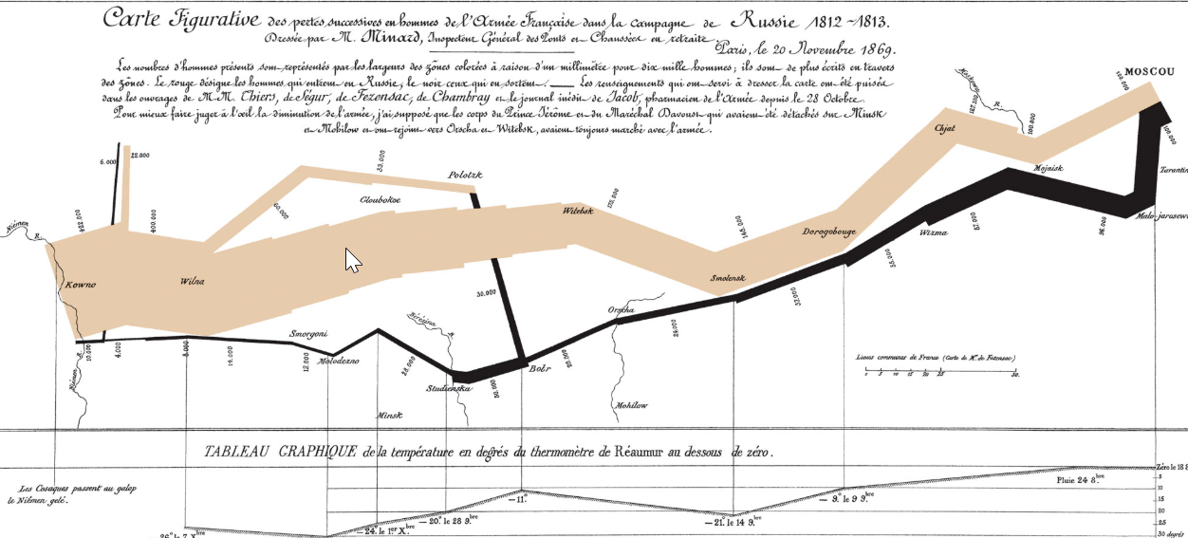 | 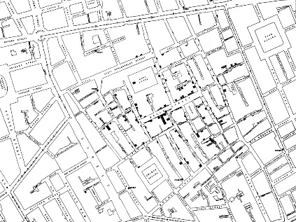 | 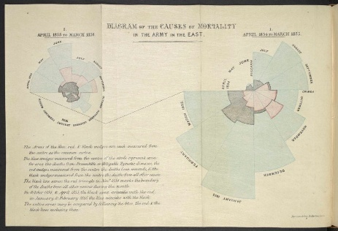

Data Source
This visualization was created using data from Professor Gabby’s deaths.csv dataset, available on GitHub (see citation).

Chart Redesign- Iterations
Below are the iterations for this project and how it evolved

Chart | Iteration
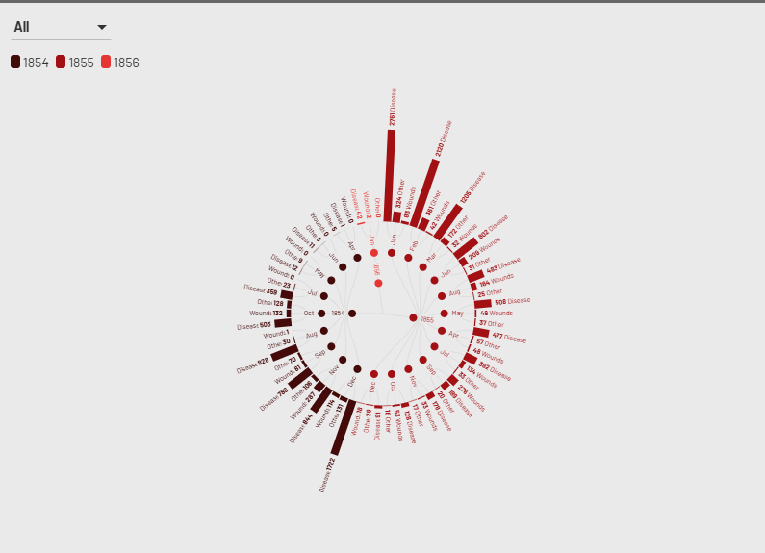 | This was the initial redesign of Florence’s chart. It was done in Flourish  https://app.flourish.studio/visualisation/25422650/edit
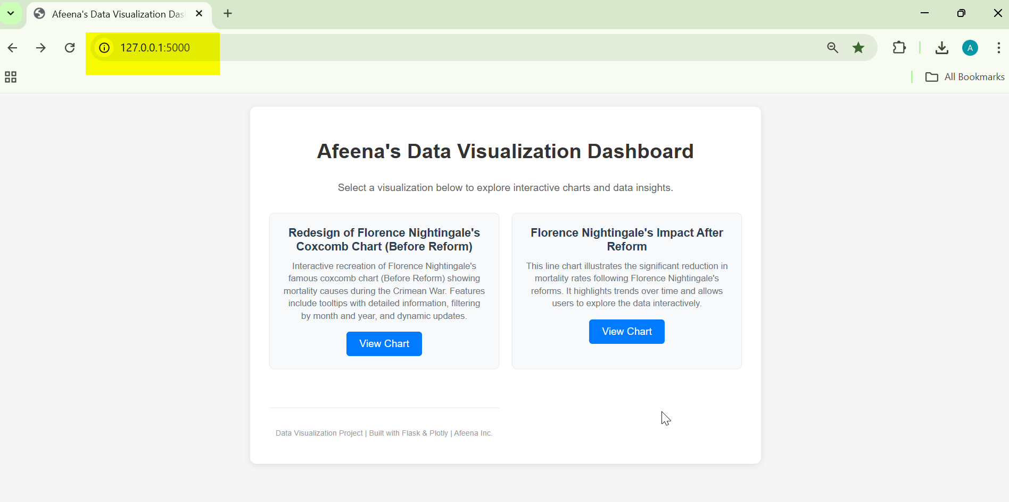  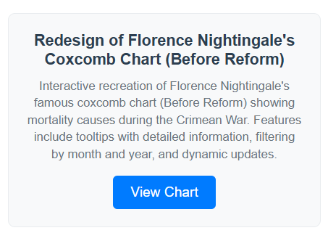  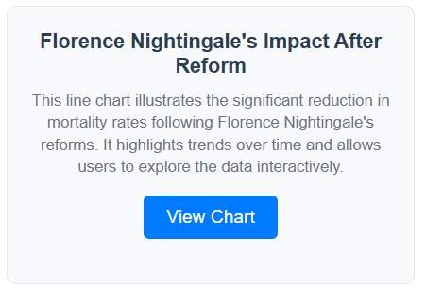 | This dashboard is powered by a Flask server and showcases two primary visualizations:  - A modern reinterpretation of Florence Nightingale’s iconic coxcomb chart (before the reform)  - A time-series analysis illustrating the impact of reform efforts on mortality rates over time (before vs. after reform)
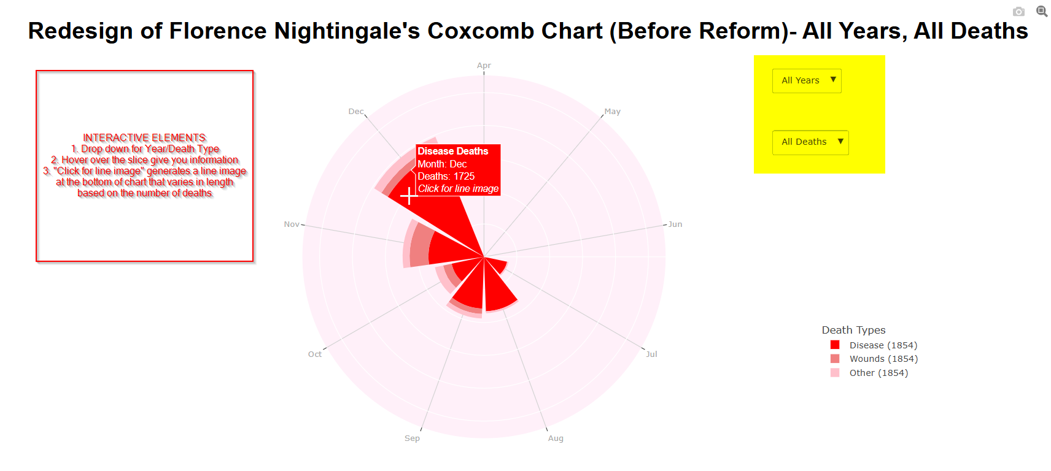 | This visualization is hosted on a Flask server and includes several interactive components:  - A dropdown menu that allows users to filter the data by year and cause of death.  - Hover functionality that displays detailed information for each chart segment.  - A clickable feature that generates a corresponding line graphic below the chart, with the line’s length proportional to the number of deaths.
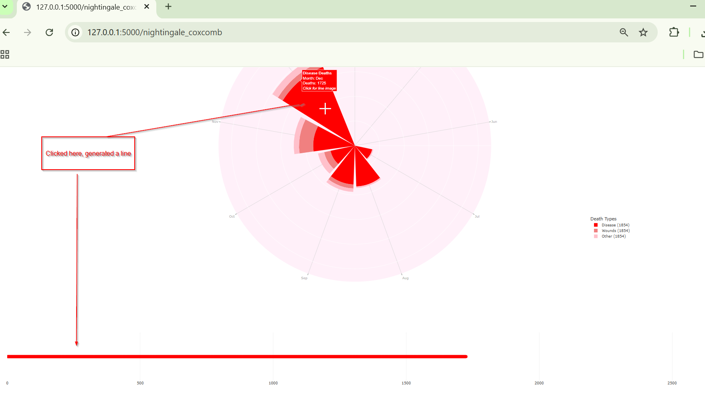  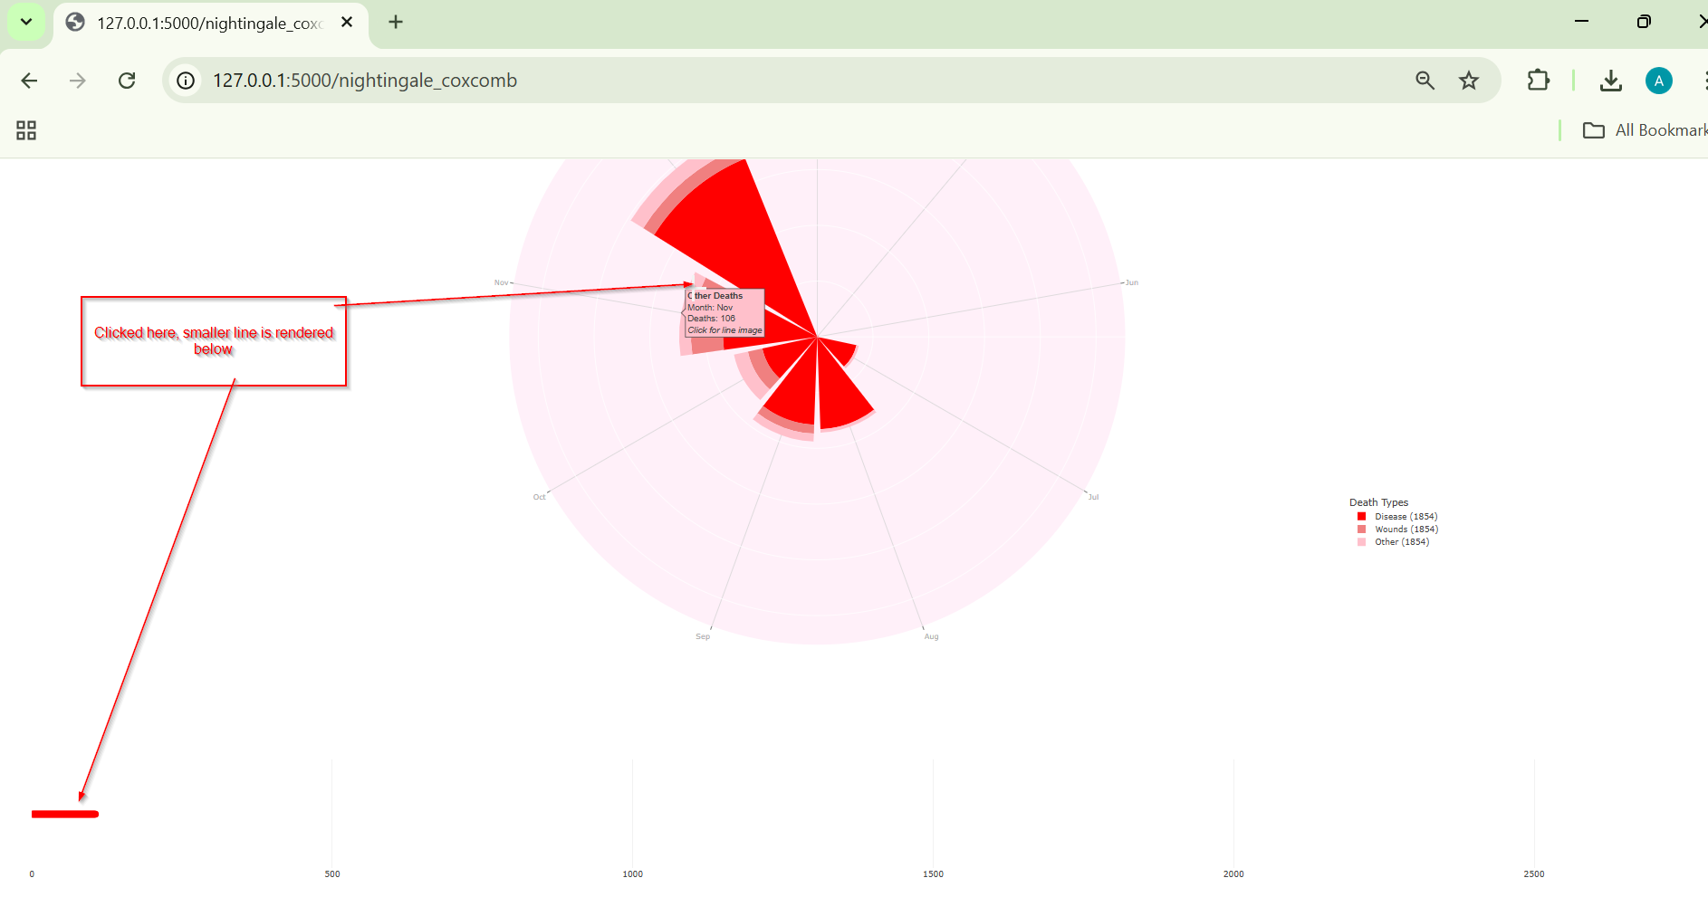 | Clicking on a specific slice triggers a JavaScript driven interaction that renders a line beneath the chart with its length scaled proportionally to the number of deaths represented by that slice.
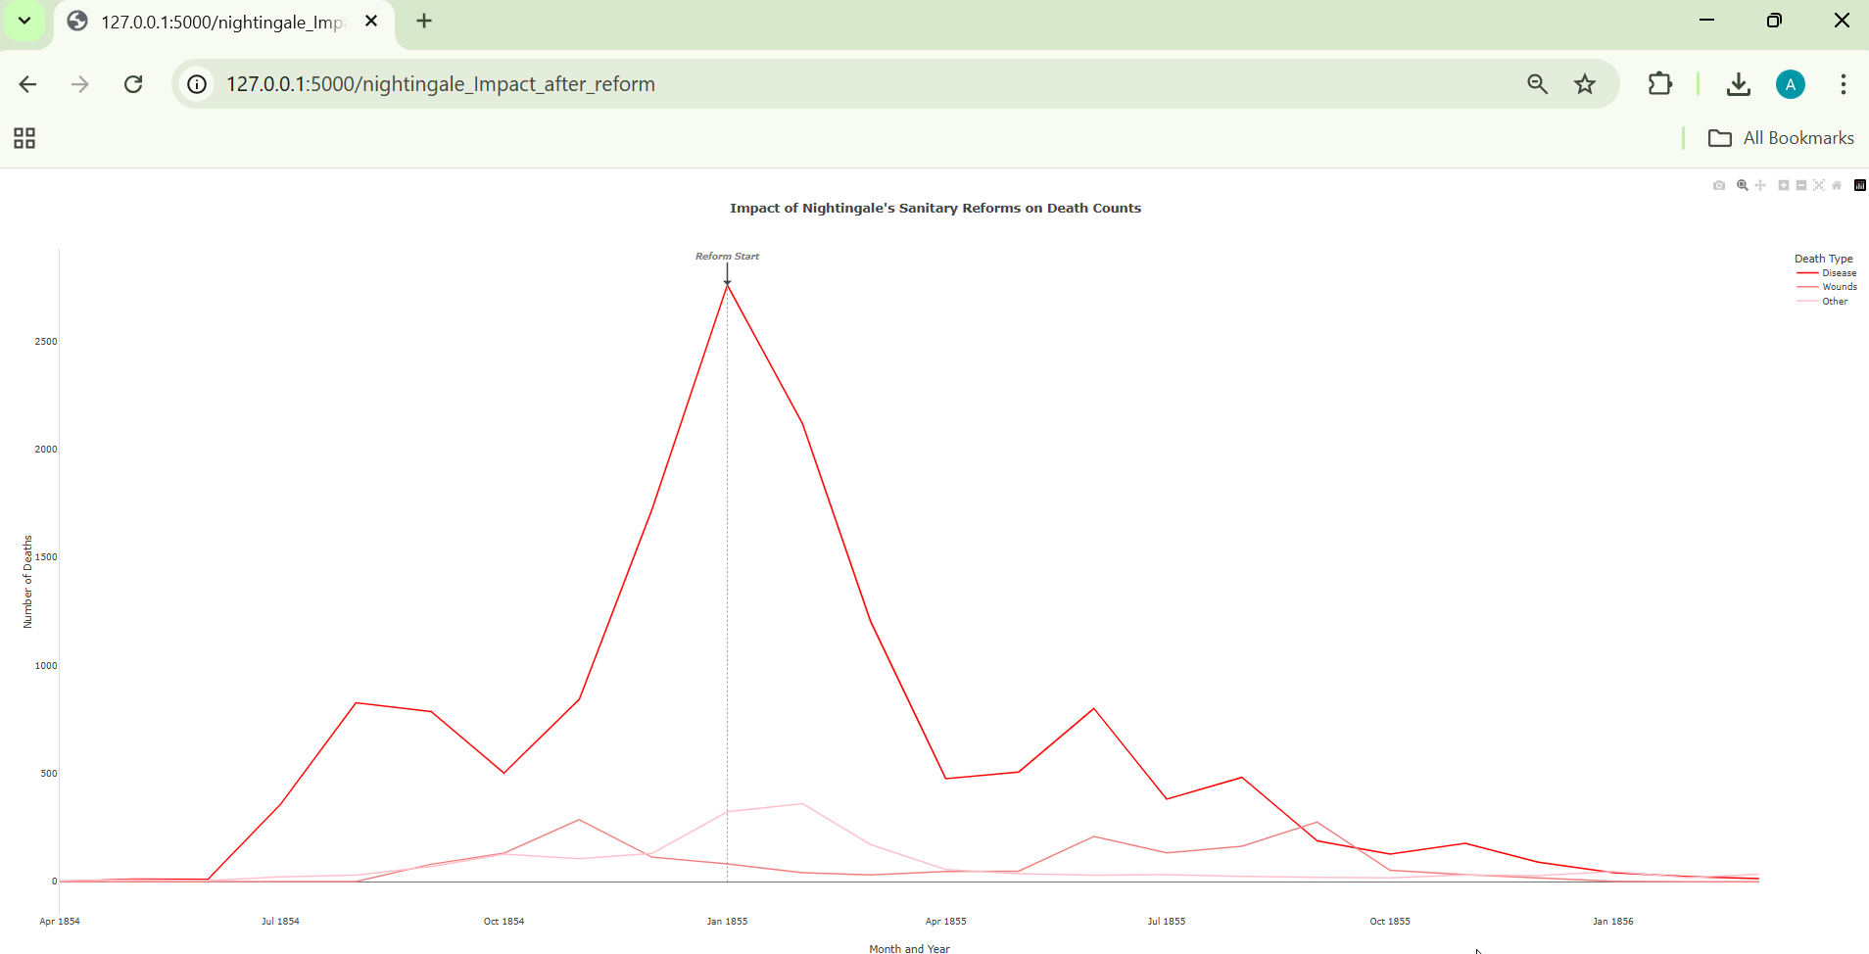 | The second graph provides a comprehensive view of the dataset, illustrating a significant decline in deaths starting in January 1855.

Running the Dashboard on your Flask Server
See Appendix 1 for further details. A demonstration file, demo_dashboard.mp4, is also included to illustrate the interaction with the dashboard.

Appendix 1
- IMPORTANT FILES
  - The following files/folders are needed to run Assignment2
  - Files: app.py, Nightingale_Interactive.ipynb
  - Folders: data, Templates
- FOLDER STRUCTURE FOR FLASK PROJECTS
  - C:...\FlaskProjects\
    - app.py
    - Nightingale_Interactive.ipynb
  - templates\
    - index.html
    - nightingale_chart.html
    - nightingale_impact_after_reform.html
- RUNNING THE IPBYN TO RENDER CHARTS
  - It is recommended you run this first to generate your html files: nightingale_chart.html, nightingale_impact_after_reform.html
- RUNNING THE FLASK SERVER TO RENDER THE DASHBOARD
  - from the python command prompt run: python.app
  - Navigate to the localhost: http://127.0.0.1:5000/

Citations
- Small, H. (1998, March 18). Florence Nightingale’s statistical diagrams. Stats & Lamps Research Conference, Florence Nightingale Museum. University of York. https://www.york.ac.uk/depts/maths/histstat/small.htm

- Snow, J. (1855). On the mode of communication of cholera (2nd ed.). C. F. Cheffins.

- Minard, C. J. (1869). Carte figurative des pertes successives en hommes de l’armée française dans la campagne de Russie 1812–1813 [Figurative map of the successive losses in men of the French army in the Russian campaign 1812–1813]. École Nationale des Ponts et Chaussées.

- Gabby. (n.d.). deaths.csv [Data set]. GitHub. https://github.com/gbby/MBAI-Notebooks/tree/main/data

- Nightingale, F. (1858). Notes on matters affecting the health, efficiency, and hospital administration of the British Army (Vol. 1). London: Harrison and Sons. Available at Internet Archive: https://archive.org/details/b20387118

