

FACULTY OF INFORMATION AND COMMUNICATION TECHNOLOGY

STUDENT NO ST10448454

STUDENT FULL NAME AFEZIWE THANDANI

PROJECT TITLE CONTRACT MONTHLY CLAIM SYSTEM

PORTFOLIO OF EVIDENCE PART 1

MODULE NAME PROGRAMMING 2B

MODULE CODE PROG6212

LECTURE A. PHEWA

DATE 28 AUGUST 2025

Table of Contents

INTRODUCTION 3

What is CMCS 3

Project objective 3

Design explanations 3

Database Structure 3

GUI Layout 3

Assumptions and Constraints 4

Assumptions 4

Constraints 4

UML Diagram 5

Project Plan 6

GUI Screenshot 7

# INTRODUCTION

The purpose of this project is to design and develop a .NET WPF application called the Contract Monthly Claim System (CMCS).

## What is CMCS

The contract Monthly system is designed to streamline the process of claim submission, verification, and approval. It is tailored for lectures, program coordinators, academic managers

### Project objective

My goal is to create an efficient, reliable, and user-friendly system that simplifies the claim process while ensuring transparency and accuracy for all stakeholders.

# Design explanations

The design of the Contract Monthly Claim System (CMCS) was guided by the need to make the process of submitting and approving claims clear, user-friendly, and role based. The system is built in WPF because it allows for modern and attractive user interfaces with support for custom styles and branding.

## Database Structure

The database was designed around three main groups of users: lecturers, coordinators, and managers.

One lecture can submit many claims.

One Coordinator can review many Claims

One manager can verify many claims

One claim can have multiple Supporting Documents

Each claim must reference a valid module.

The Claims table links all these roles by recording details of hours worked, rates, total amounts, and approval status. Supporting documents are stored in a separate table so that each claim can have multiple attachments. This structure ensures data integrity, separation of roles, and easy tracking of claim progress.

## GUI Layout

The graphical user interface (GUI) of the Contract Monthly Claim System (CMCS) was designed with usability, accessibility, and role-specific functionality in mind. Each role (Lecturer, Coordinator, Manager) has a separate dashboard and navigation flow to ensure clarity and prevent unauthorized access to other functions. The colour palette chosen (#26676E, #95C0BD, #E6B4AA, #D4DCDC) provides a professional yet welcoming appearance, with consistent design across all screens.

Lecturer GUI

The lecturer dashboard is simple and user-friendly, focusing on essential actions.

Submit Claim Page: Allows lecturers to enter module, hours worked, hourly rate, and attach supporting documents.

View Claims Page: Displays all previously submitted claims with their status (Pending, Approved, or Rejected).

Logout Button: Provides a clear exit option to ensure security.

Icons are used next to buttons (e.g., *Submit Claim*, *View Claims*) to improve recognition and accessibility.

Coordinator GUI

The coordinator dashboard focuses on reviewing lecturer claims.

Review Claims Page: Shows pending claims in a table format with details such as claim ID, module, hours worked, and total amount. Coordinators can choose to Approve or Reject each claim using action buttons.

Processed Claims Page: Displays claims already reviewed, with coloured status labels (green for Approved, red for Rejected).

The layout is designed to simplify decision-making and ensure accountability for each action taken.

Manager GUI

The manager dashboard provides a high-level overview and reporting functions.

Verify Reports Page: Displays a summary of total claims, approved claims, and rejected claims. A detailed table below the summary shows claim details by lecturer and module.

Status values are color-coded for quick visual interpretation.

This layout allows managers to verify the accuracy of reviews without altering data.

Design Considerations

Consistency: All dashboards share the same header bar with the system title and consistent spacing/margins.

Accessibility: Buttons use clear labels and icons, ensuring that actions are easy to understand.

Role Separation: Each role only sees functionality relevant to them — lecturers cannot access coordinator or manager features, and vice versa.

User-Cantered Design: The system prioritizes simplicity, ensuring that lecturers, who may not be technically advanced, can easily submit claims.

# Assumptions and Constraints

## Assumptions

Lectures will register/login to use the system before submitting claims. (They must have unique accounts so claims can be tracked per lecture.)

Coordinators and Managers have separate accounts with different permissions. (They cannot access lecture functions, and lectures cannot access coordinator/manager functions.)

Claims include supporting documents (for example timesheets, proof of work) uploaded as attachments

Each claim is tied to a module (module name, module code, hours worked, hourly rate).

The system workflow is linear: Lecture 🡪 Coordinator 🡪 manager. (A claim cannot jump directly to the manager without Coordinator review.)

## Constraints

Technology Constraint: The system must be built in C# using WPF.

Time Constraint: Development is limited to the POE timeline, so some advanced features (like automatic payroll integration) will not be included.

Data Constraint: Only data relevant to claims (lecture info, modules, hours, supporting Document and etc) will be stored. No unrelated personal or financial data.

# UML Diagram

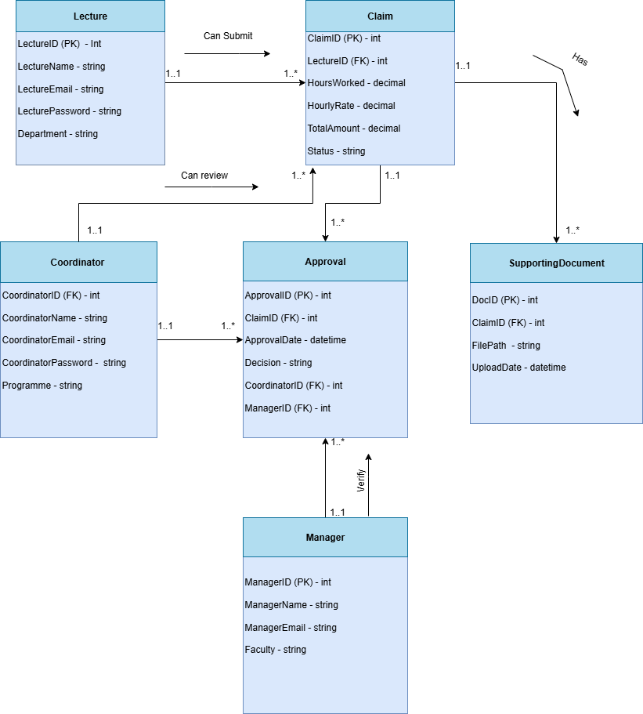

# Project Plan

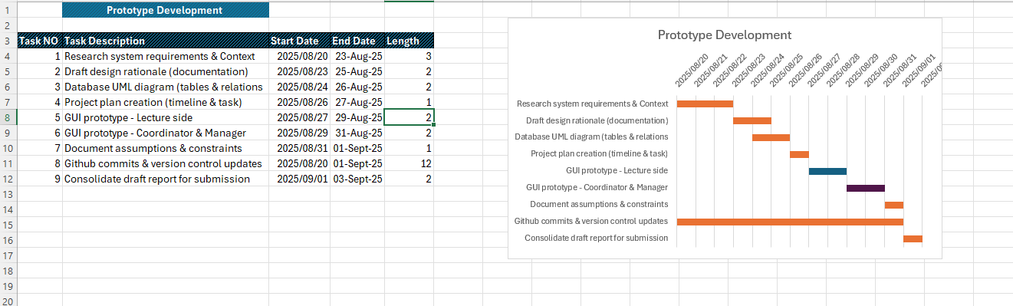

# GUI Screenshot

**Landing Page Lecture Dashboard**

**Coordinator Dashboard Manager Dashboard**

**Submit Claim Page**

**Lecture - My Claims Page**

**Coordinator – Review Claim Page**  **Coordinator – Processed Claims page**

**Manager – Verify Report Page**