Etl task flow :
Step 1 : bucket created and uploaded csv
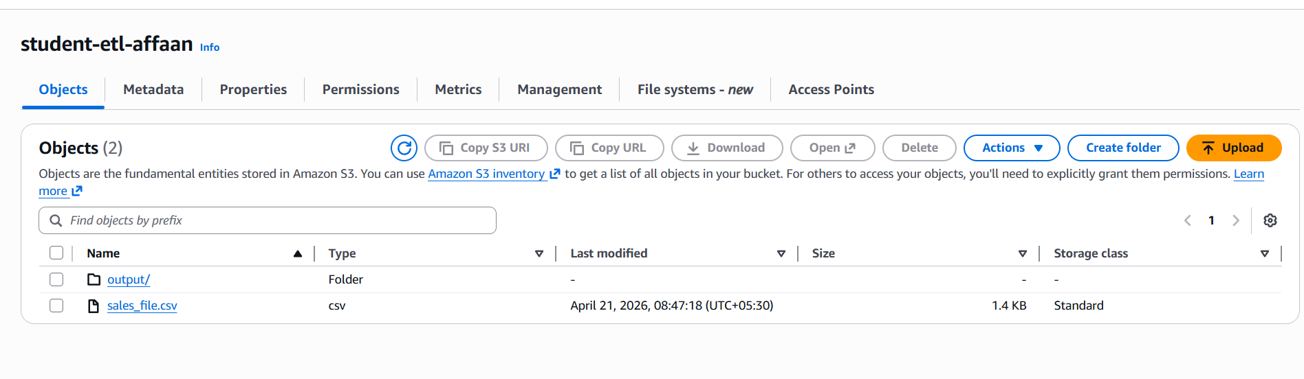

Step 2 : instance created
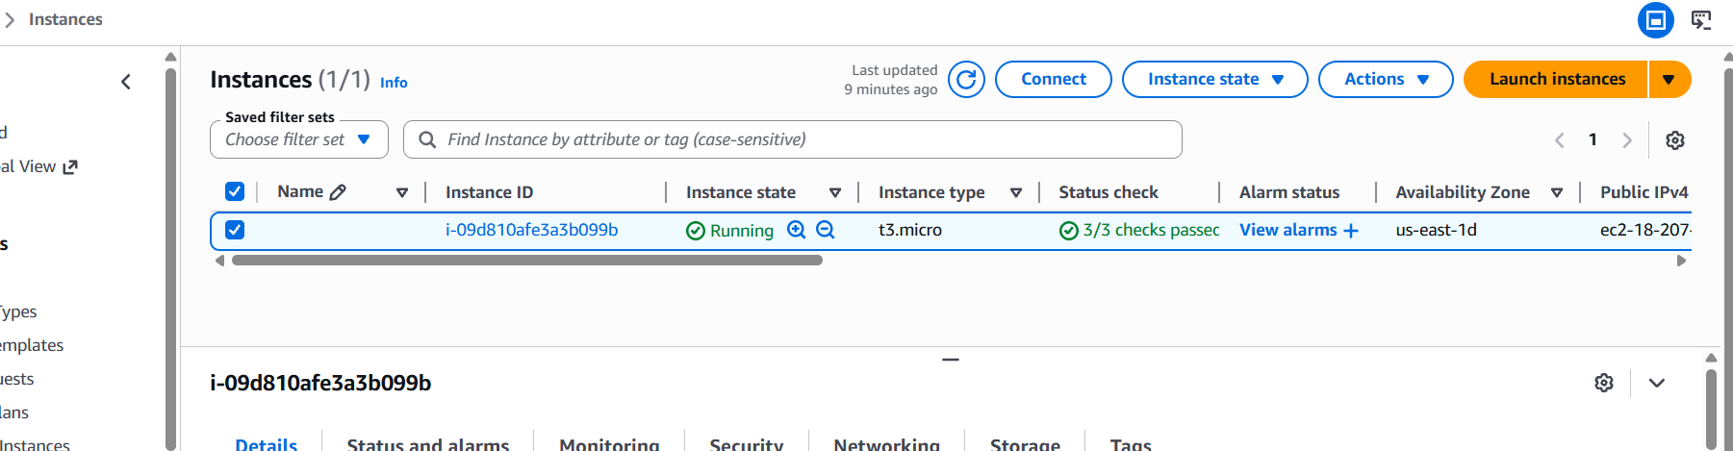

Step 3 : connected to mobaxterm using public ipv4 address

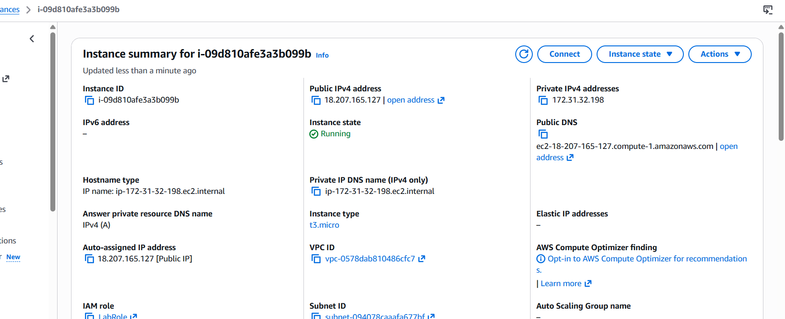

Step 4: installed libraries
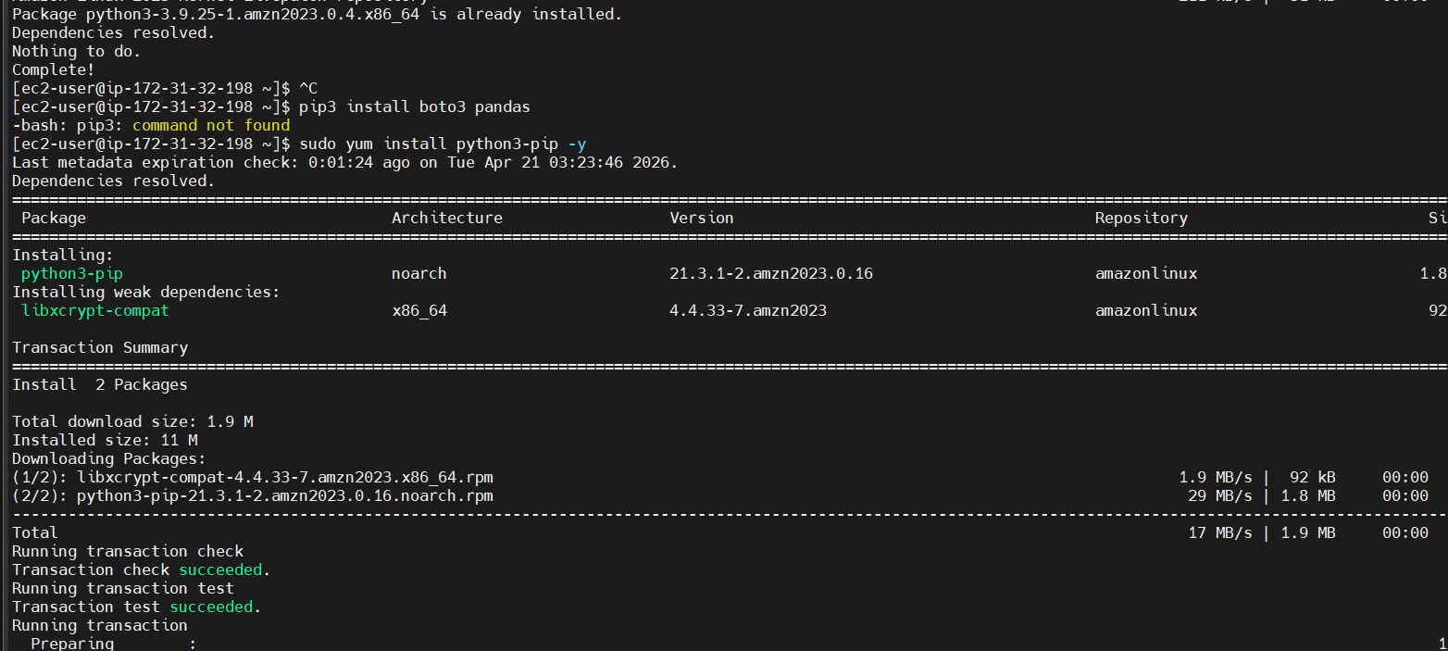
step 5: wrote python script to filter data where amount > 1000

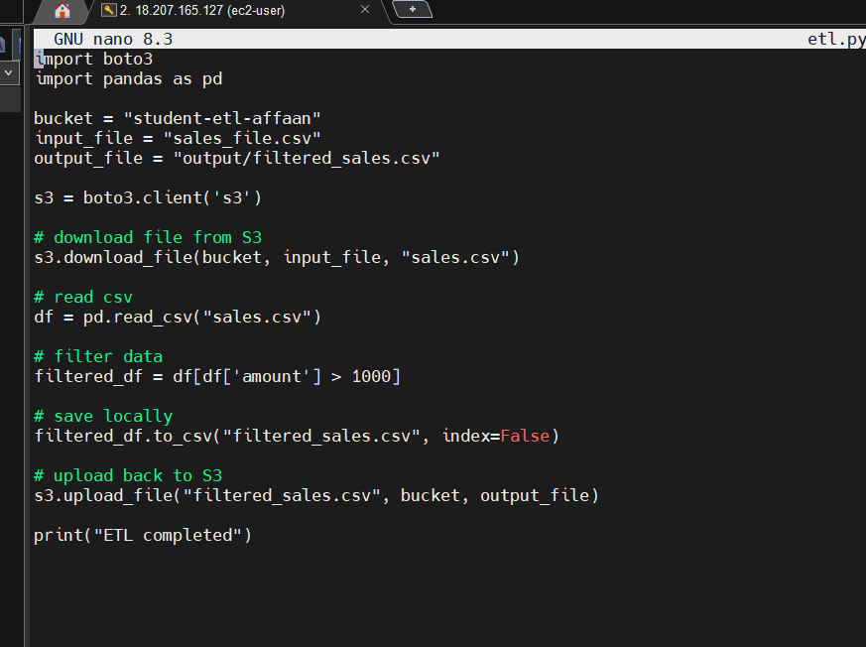

Step 6: script ran successfully
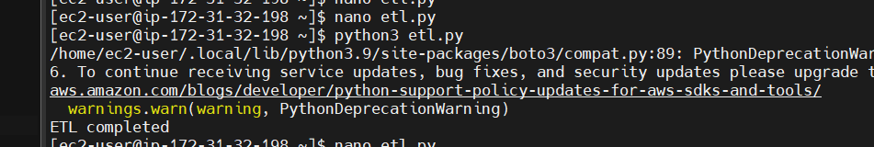
step 7 : output generated
