

# NATIONAL UNIVERSITY OF SCIENCES AND TECHNOLOGY

# School of Electrical Engineering and Computer Sciences

## WEB ENGINEERING PROJECT

## STUDYMATE

## Title of the assignment: Right to Education

### SUBMITTED BY:

### Affan Rehman-374064

### Hasan Fakhar-365849

## GITHUB REPO: [STUDYMATE](https://github.com/Affan-Rehman/StudyMate)

CLASS + SECTION: BESE-12A

# Description Document

## **Problem statement :**

In underprivileged areas, a critical challenge persists in the form of limited access to quality education, perpetuating educational disparities and hindering the socio-economic development of these communities. The lack of resources, infrastructure, and qualified educators contributes to a stark educational divide, impeding the growth and opportunities available to individuals in these regions. This disparity not only limits the potential of individuals but also perpetuates a cycle of poverty and inequality. Recognizing the urgency of addressing this issue, there is a need for innovative solutions that leverage technology to bridge the educational gap and empower individuals in underserved areas to access high-quality learning resources.

Solution? StudyMate.

## **Targeted Audience:**

* Students in underserved areas with limited access to quality education.
* Teachers and educators who want to offer their courses online.

## **Gathering Requirements:**

* Conduct google forms in to understand the specific educational needs and preferences: from friends and social circle.

## **Framework chosen: Laravel**

The decision to adopt Laravel for our project was driven by its advantageous MVC (Model-View-Controller) architecture. This framework's commitment to the separation of concerns facilitates a structured and modular approach to development, enhancing the maintainability and scalability of our applications. The clear division of code into Models, Views, and Controllers promotes organization and modularity, allowing for independent development and easier maintenance. With this architecture, our team benefits from streamlined code organization, improved maintainability, and the ability to scale specific components of our applications as needed.

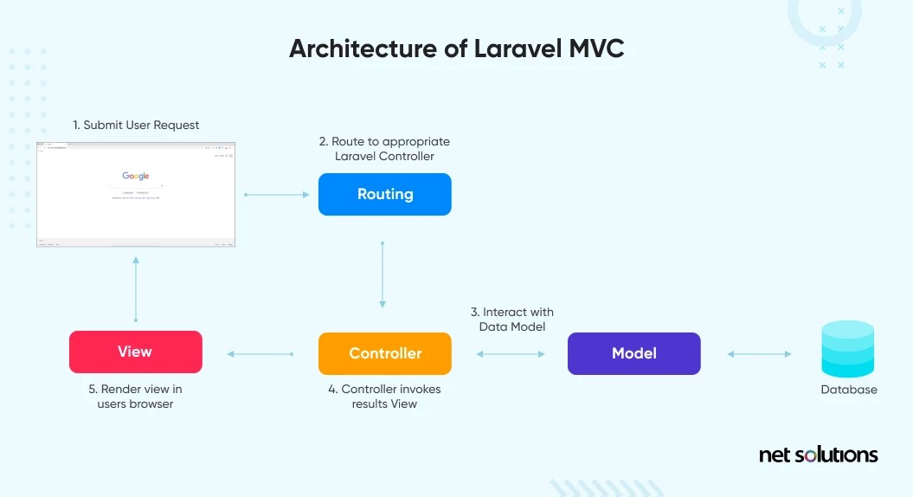

## **How To Setup?**

* Clone the github repository from <https://github.com/Affan-Rehman/StudyMate>
* Delete vendor folder
* Install Dependencies by running “composer install”
* Generate Application by “php artisan key:generate”
* Change database configuration in .env file
* Create database and all tables by using command “php artisan migrate”
* Create admin entry by running seeder file command “php artisan db:seed --class=AdminSeeder”

Start the Laravel Development Server by “php artisan serve”

## **Route Structure**

The application's routes are defined in the **web.php** file within the Laravel framework. Key points regarding the route structure:

* The root URL redirects users to the login page.
* Routes are grouped based on middleware, allowing access control and authentication.
* A screenshot of a computer

  Description automatically generatedThe middleware 'auth' ensures that certain routes are accessible only to authenticated users.
* Different routes are available for various functionalities, such as:
  + Viewing the home page (**/index**), FAQ (**/faq**), courses (**/courses**), team information (**/team**), and about section (**/about**) for authenticated users.
  + Displaying all blog posts (**/blogs**) available for authenticated users.
  + Admin-specific routes, accessible only with both 'auth' and 'admin' middleware:
    - Admin dashboard (**/admin**) showing all blog posts.
    - Adding a new blog post (**/admin/addblog**) via a form submission.
    - Deleting a blog post (**/admin/deleteBlog/{id}**) based on its ID.

## **Backend and Database Setup**

* The application is backed by a MySQL database.
* The database schema includes one table for storing blog posts (**blogs** table), containing columns for **name** and **content**.
* One table for users where one user is admin, and one is student.
* One table for FAQ with id, question, and the answer.
* One table for teams with id, name, and the course.
* One table for id, course, description, link and linkd where linkd is the desc for the link to be shown to users and link is the link it redirects to.

All have timestamps as well.

## **Frontend and Responsiveness**

* The application's frontend is designed using the Laravel Blade templating engine.
* The frontend utilizes Bootstrap for responsive design, ensuring compatibility across various devices and screen sizes.

## **Functional Requirements**

## Courses:

Display categorized courses with information about subjects and respective teachers.

## Course Materials**:**

Enable access to study materials by clicking material in a course (dropdown menu).

## Admin Dashboard**:**

A secure login for admins to access and manage database.

## Route Structure**:**

Implement secure redirection to the login page for authentication and proper access control through middleware.

## Database Setup:

Use a MySQL database with a schema that includes a table for storing blog posts (columns for name and content).

## **non-Functional Requirements**

### Security:

Ensure user authentication, authorization, and sensitive data handling with robust encryption measures.

### Scalability:

Design the application to accommodate future features and enhancements, leveraging Laravel's modular architecture.

### Maintainability:

Follow Laravel's MVC architecture for a structured and maintainable codebase.

### Usability:

Create a user-friendly interface with responsive design for compatibility across devices and screen sizes.

### Performance:

Optimize database queries and backend operations for efficient application performance.

### Documentation:

Provide clear installation/setup instructions for easy deployment and future reference.

### Backup and Recovery:

Set up regular backups and a recovery plan to prevent data loss and ensure system availability in case of failures through sql database.

## **conflicts**

### assignment selection:

**Issue**: Deciding between assignments for the project.

**Resolution**: Chose the more scalable and socially relevant assignment which was Affan’s due to his project’s ability to scale and be properly mapped onto a societal issue. The issue with Hasan’s project was the inability to scale and it was not mapping onto a societal issue, rather just an awareness platform about an issue.

**Outcome**: Aligned the project with addressing societal needs effectively.

### database implementation:

**Issue**: Disagreement on adding a database implementation for FAQ, courses, teachers due to time constraints.

**Resolution**: Agreed to consider if within project timeline.

**Outcome**: The database functionality for FAQ, teachers and courses was then added.

## **Conclusion**

This Laravel-based application offers a user-friendly interface for students to explore various sections of the website and access blog posts. Meanwhile, the admin has the capability to manage blog posts by adding new content or deleting existing posts. The application's use of Laravel's routing system and middleware ensures proper access control and authentication.

The combination of Laravel's robust backend capabilities, MySQL database integration, and frontend design using Bootstrap results in a cohesive and functional web application.

# Authentication Pages:

## **Login page**

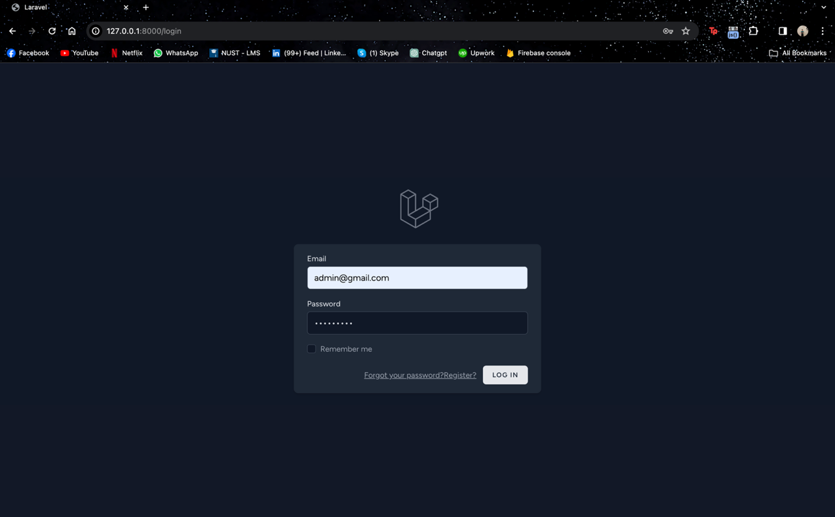

## **Register page**

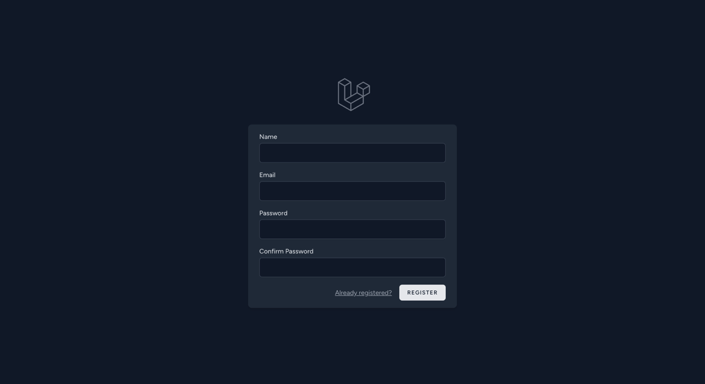

## **Student Pages:**

* Homepage: On my homepage, I've created an elegant and user-friendly platform that invites learners from all around the world to connect with knowledge. This is the place where I introduce the core sections of the website.

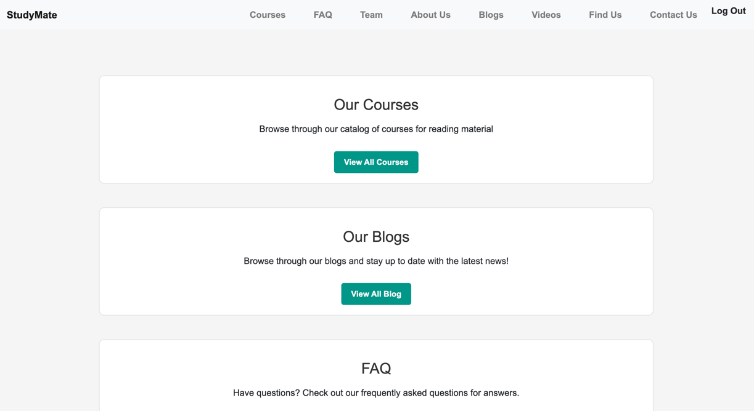

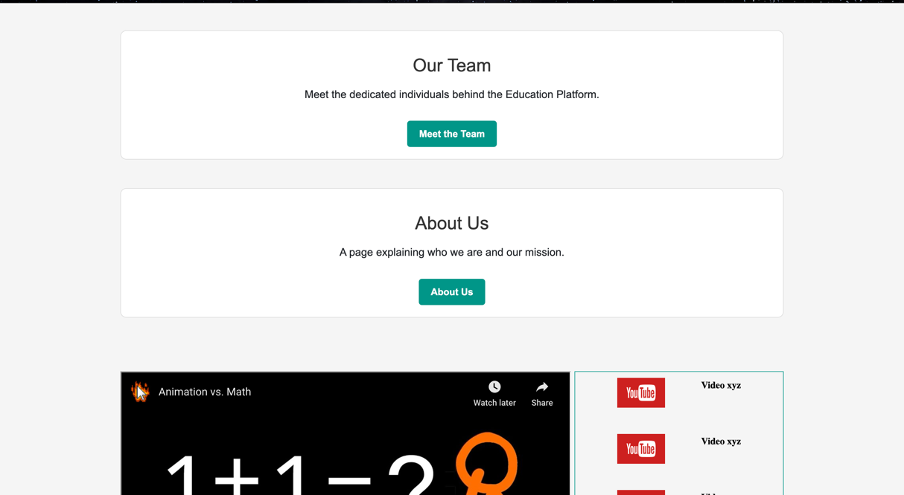

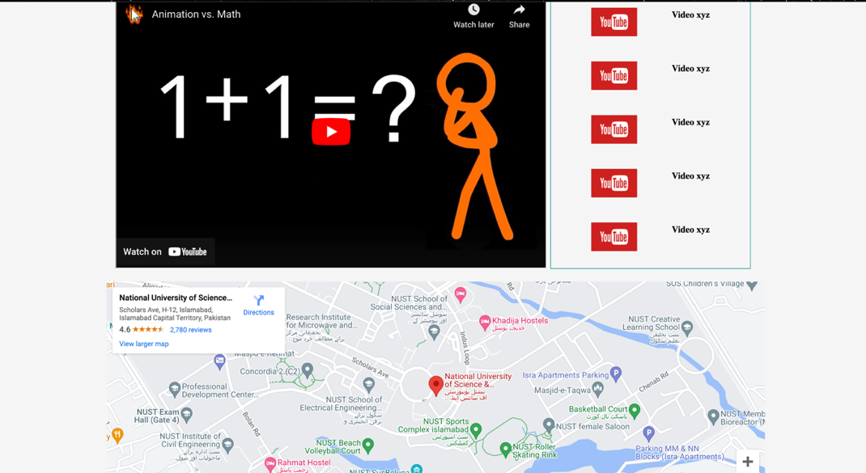

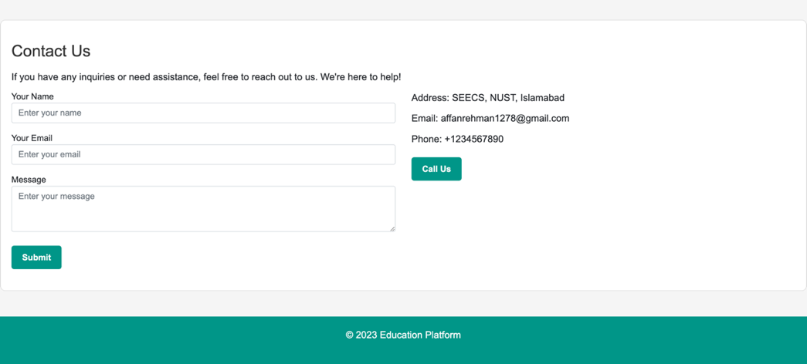

Courses: In the "Courses" section, I present a variety of subjects alongside their respective teachers. When you hover over any subject, I've designed a dropdown menu to appear, providing quick access to real-time study materials. This feature enhances the learning experience, making it more accessible and engaging.

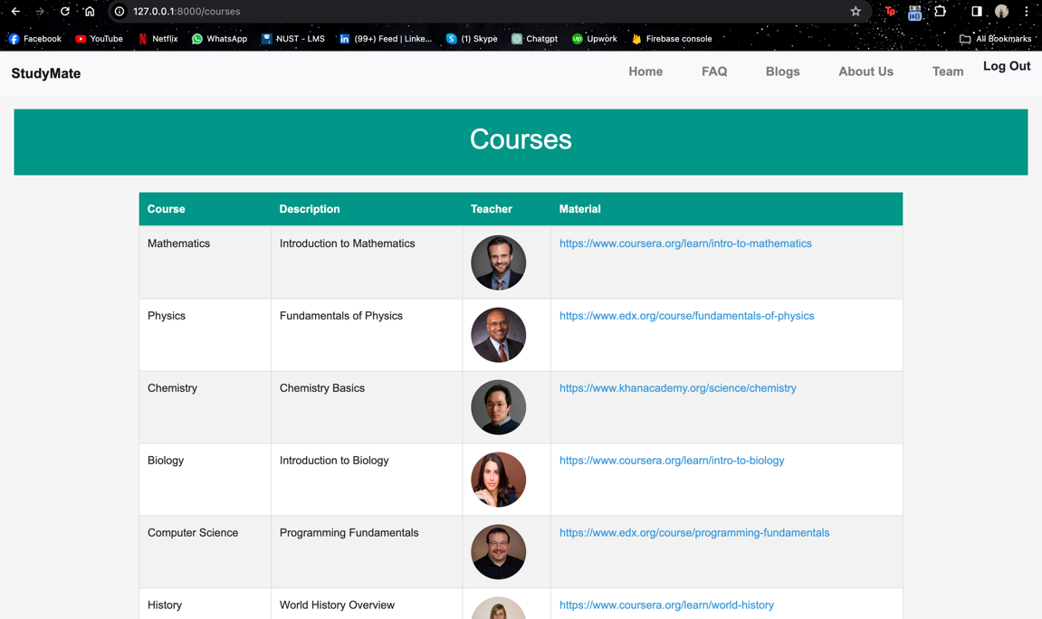

* FAQ (Frequently Asked Questions): I've included a "FAQ" section to address the questions you might have as a student. It's here to provide clear and concise answers to help you navigate your educational journey.

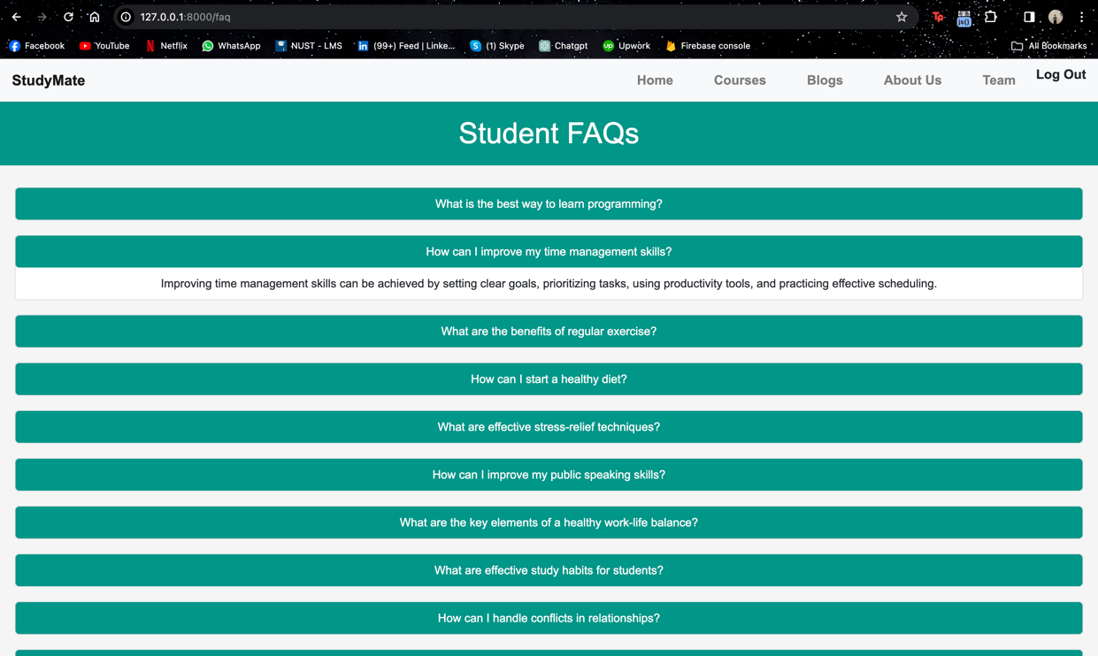

* Meet the Team: In my "Meet the Team" section, I introduce the dedicated educators who make this platform come to life. Each teacher is paired with their subject, making it easy for you to find the right mentor for your learning adventure.

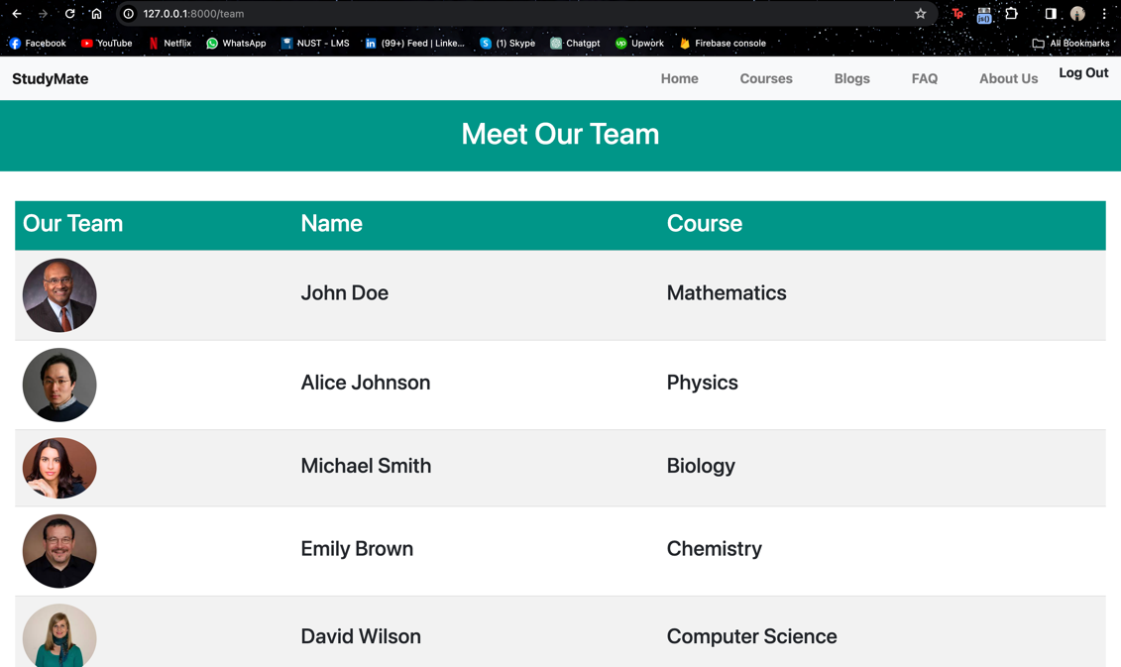

* About Us: An about us page that tells you about who we are and what we do.   
  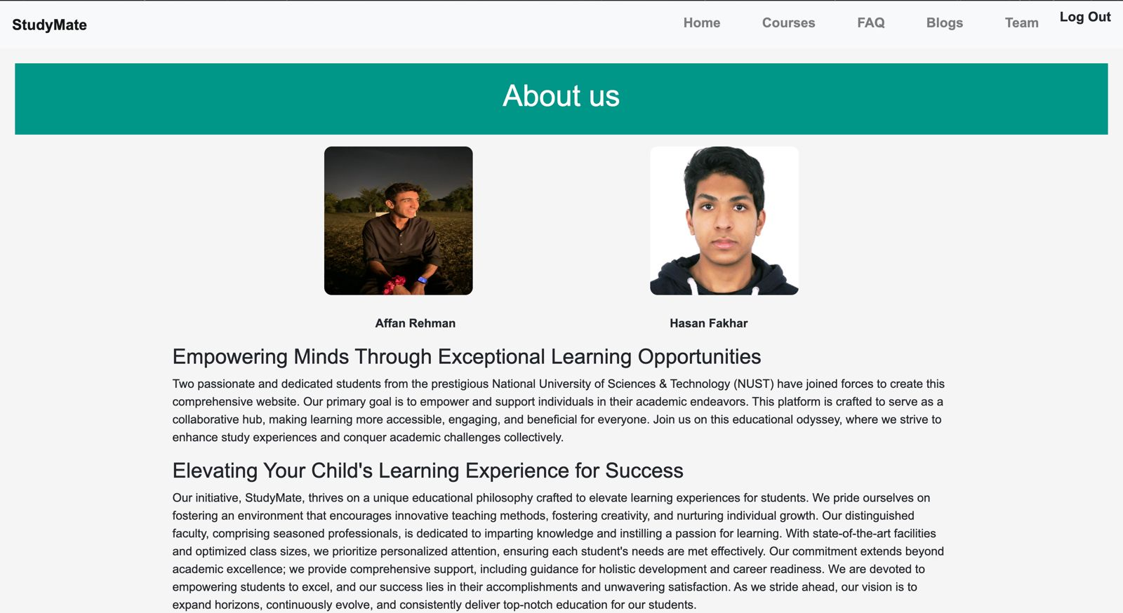
* Blogs**:** A page that shows all blogs made by the admin that are

broadcasted to every user, this may include news, warnings, promotions etc.

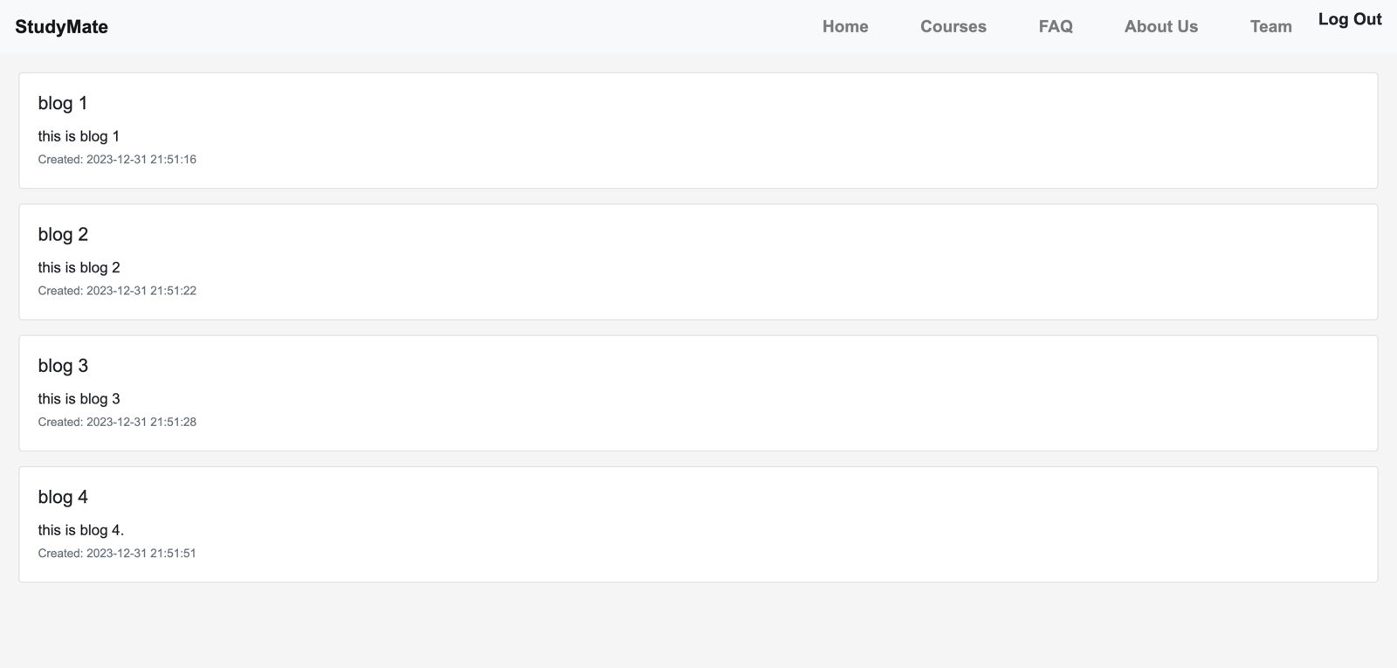

## **ADMIN WEBPAGES**

### Blogs:

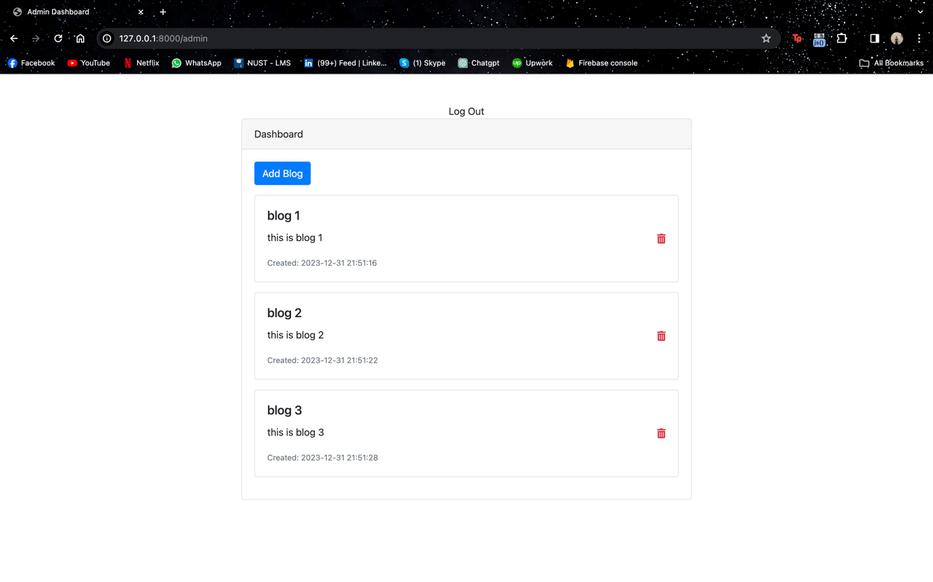

### Add Blog Page:

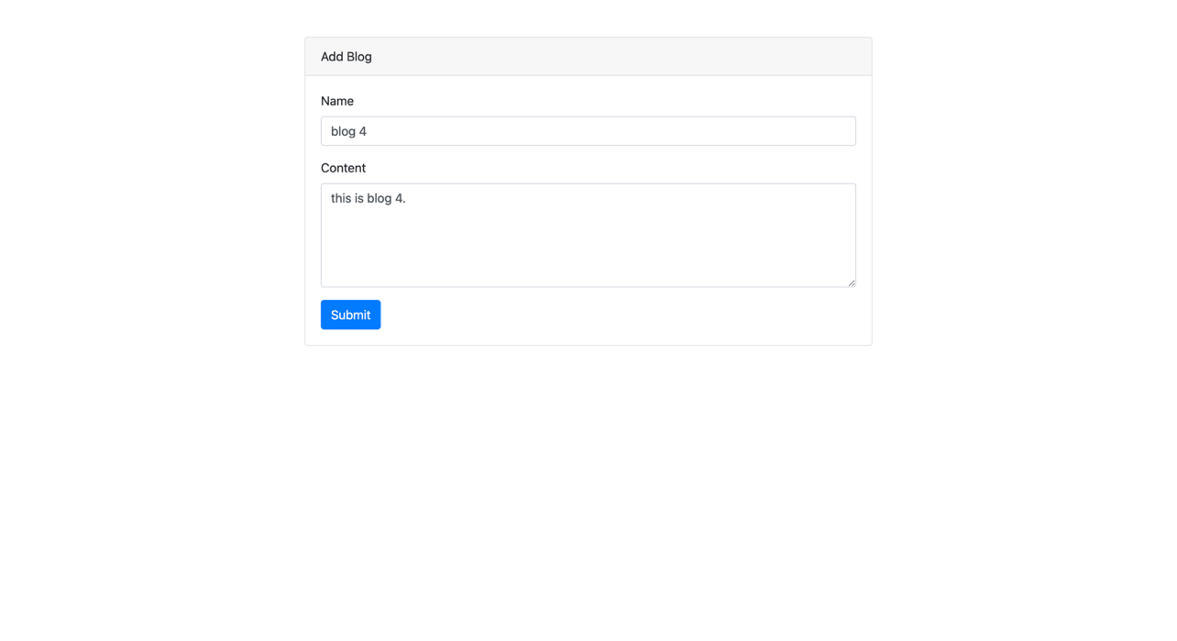

# SURVEY

## survey link

[StudyMate form](https://forms.gle/UwQVaWAcHAbWufi16)

## Main Result

It is clear from survey that people prefer a web education approach that is StudyMate.

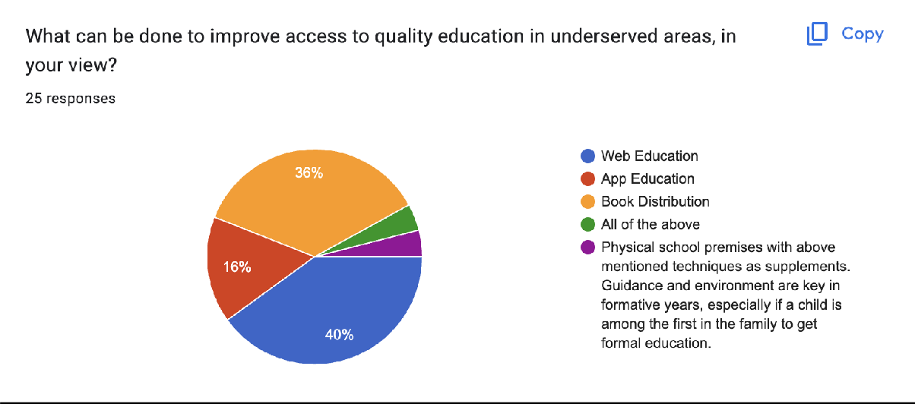

## Survey response

