

**NATIONAL UNIVERSITY OF SCIENCES AND TECHNOLOGY**

School of Electrical Engineering and Computer Sciences

**WEB ENGINEERING**

**ASSIGNMENT# 1**

**Title of the assignment: Right to Education**

**SUBMITTED BY: Affan Rehman-374064**

**CLASS + SECTION: BESE-12A**

**Problem:** Lack of Access to Quality Education in Underserved Areas

**Targeted Audience:**

* Students in underserved areas with limited access to quality education.
* Teachers and educators who want to offer their courses online.
* Education policymakers and administrators.

**Gathering Requirements:**

* Conduct surveys and interviews in under-served areas to understand the specific educational needs and preferences: from friends.
* Collaborate with teachers and educators to identify the courses they want to offer and their requirements: from college.
* Consult with education policymakers and administrators to ensure compliance with education standards.

**Web-Based Solution Features:**

* **Homepage**: On my homepage, I've created an elegant and user-friendly platform that invites learners from all around the world to connect with knowledge. This is the place where I introduce the core sections of the website.
* **Courses**: In the "Courses" section, I present a variety of subjects alongside their respective teachers. When you hover over any subject, I've designed a dropdown menu to appear, providing quick access to real-time study materials. This feature enhances the learning experience, making it more accessible and engaging.
* **FAQ (Frequently Asked Questions)**: I've included a "FAQ" section to address the questions you might have as a student. It's here to provide clear and concise answers to help you navigate your educational journey.
* **Meet the Team**: In my "Meet the Team" section, I introduce the dedicated educators who make this platform come to life. Each teacher is paired with their subject, making it easy for you to find the right mentor for your learning adventure.
* **Navigation**: To simplify navigation, I've implemented a user-friendly navigation bar. Simply click on a section's header to be directed to the content you're looking for on the same page.

**SURVEY RESULT:**

It is clear from survey that people prefer a web education approach.

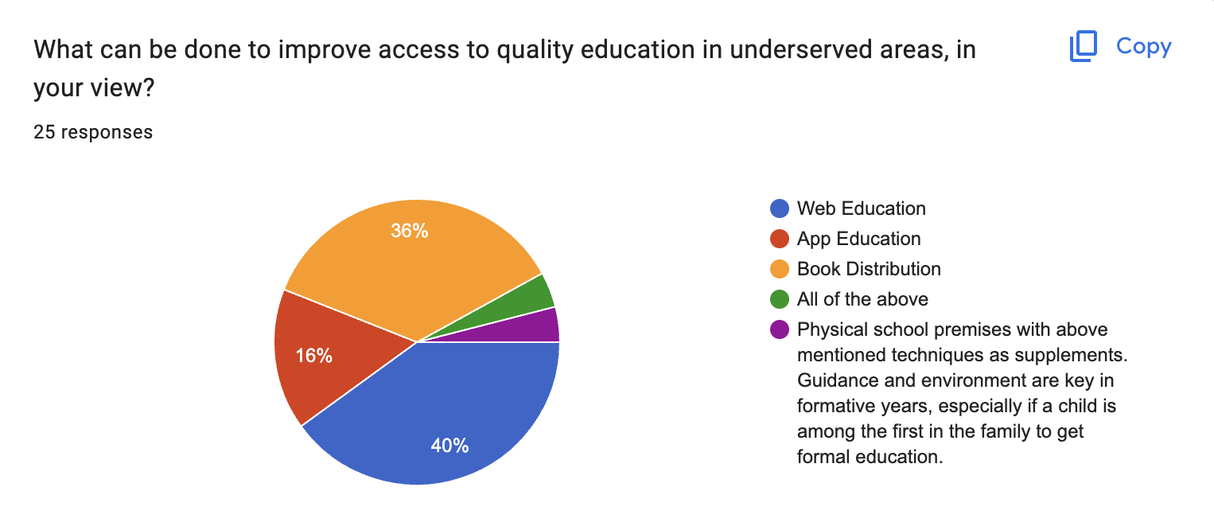

**SURVEY:**

