Software Requirements and Design Document
for
Foreign And Digital Currency Exchange
Affan Ahmad, Adil Nadeem, Tehreem Shakeel
BLU.
26th November 2024
Table of Contents
Table of Contents ii
1. Introduction 1
1.1 Purpose 1
1.2 Product Scope 1
1.3 Title 1
1.4 Objectives 1
1.5 Problem Statement 1
2. Overall Description 1
2.1 Product Perspective 1
2.2 Product Functions 2
2.3 List of Use Cases 2
2.4 Extended Use Cases 2
2.5 Use Case Diagram 2
3. Other Nonfunctional Requirements 2
3.1 Performance Requirements 2
3.2 Safety Requirements 2
3.3 Security Requirements 2
3.4 Software Quality Attributes 2
3.5 Business Rules 3
3.6 Operating Environment 3
3.7 User Interfaces 3
4. Domain Model 3
5. System Sequence Diagram 3
6. Sequence Diagram 3
7. Class Diagram 4
8. Package Diagram 4
9. Deployment Diagram 4

Introduction

Purpose
The Foreign and Digital Currency Exchange (FDCX) project aims to provide a robust platform for trading, exchanging, and managing digital and fiat currencies, along with stock transactions. The system is developed in Java using JavaFX for the front end and MySQL for the backend, integrated through JDBC. This Software Requirements and Design Document (SRS) covers the functional and non-functional aspects of the system.

Product Scope
FDCX is designed to facilitate users and administrators in managing accounts, trading assets, and monitoring system operations efficiently. The system offers features such as cryptocurrency trading, fiat currency exchange, stock management, and account verification through external services like NADRA.

Title
Foreign and Digital Currency Exchange (FDCX)

Objectives
- Automate the management of fiat and digital currency transactions.
- Provide secure user verification via NADRA for account creation.
- Offer trading and management functionalities for stocks and currencies.
- Enable seamless administration to manage currencies, stocks, and user accounts.

Problem Statement
The financial market currently lacks a unified system that integrates fiat and cryptocurrency management with stock trading, making it difficult for users to efficiently manage diverse financial assets. Traditionally, currency exchanges require users to visit physical locations, leading to long queues, time-consuming processes, and inconvenience. Manual account verification, trade tracking, and are prone to inefficiencies and errors, further exacerbating user frustration.
The Foreign and Digital Currency Exchange (FDCX) project addresses these challenges by automating key operations, streamlining user verification through NADRA integration, and providing a secure and convenient platform for trading and exchanging fiat and digital currencies alongside stocks. It eliminates the need for physical visits, significantly reducing the hassle and ensuring an efficient, seamless financial management experience.

Overall Description

Product Perspective
FDCX is a new, self-contained system designed to manage various financial operations in a unified platform. The system integrates external services like NADRA for user verification and FBR for tax compliance.

Product Functions
- User Management: Account creation, login, and verification via NADRA.
- Admin Operations: Adding/removing currencies and stocks in the system.
- Trading Features: Buying, selling, trading, and exchanging currencies and stocks.
- System State Management: Loading and saving system data through the ‘FDCXFactory’.

List of Use Cases
- Register User: Facilitate user account creation through NADRA verification.
- View Exchange Rates: Display current exchange rates for fiat and digital currencies.
- View Wallet / Transaction History: Allow users to access their wallet details and view their transaction logs.
- Withdraw Currency: Enable users to withdraw funds from their wallet.
- Deposit Currency: Allow users to deposit fiat or digital currencies into their wallet.
- Trade Currency: Provide options for users to buy or sell digital or fiat currencies.
- Exchange Currency: Facilitate seamless currency exchange between fiat and digital currencies or between different cryptocurrencies.
- View/Claim Loyalty Points: Display loyalty points earned and enable users to claim them.
- Stock Predictions: Offer insights and predictions on stock performance to aid user decisions.
- Stock Buy: Allow users to purchase stocks using available wallet funds.
- Stock Sell: Enable users to sell their owned stocks.
- Add New Stock: Allow admins to add a new stock to the system.
- Remove Existing Stock: Allow admins to remove a stock from the system.
- Add New Currency: Allow admins to add a new fiat or cryptocurrency to the system.
- Remove Existing Currency: Allow admins to remove a fiat or cryptocurrency from the system.
- Tax Calculation and Reports: Calculate taxes based on transactions and generate user-specific reports.
- Premium Subscription Management: Manage user subscriptions, including upgrades, renewals, or cancellations of premium plans.

Extended Use Cases

Use Case Diagram

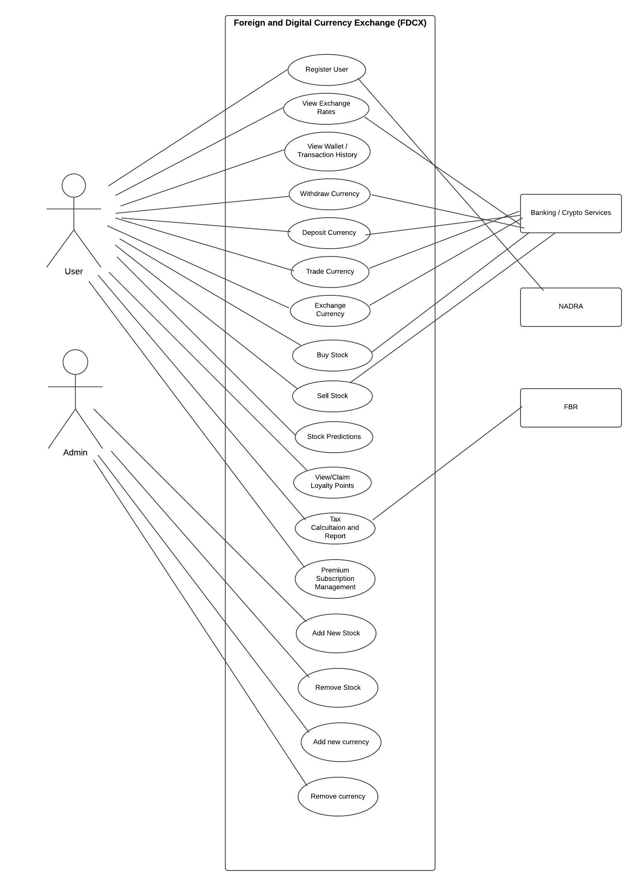

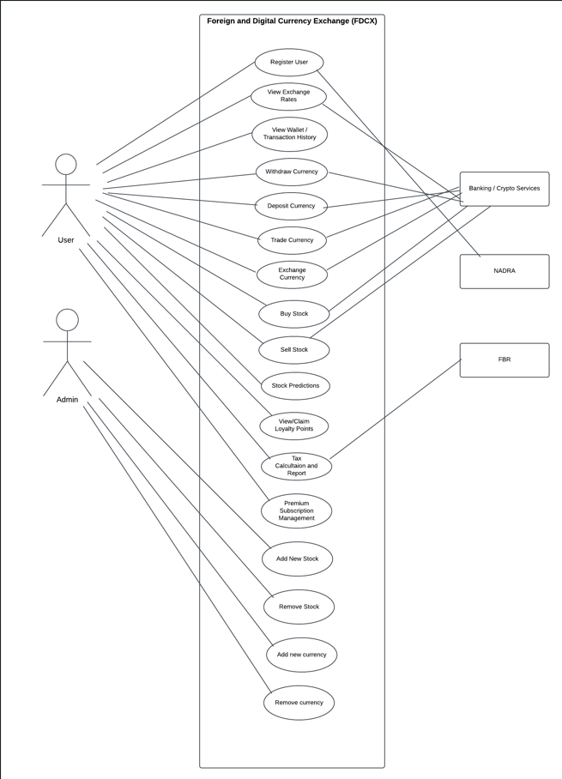

Other Nonfunctional Requirements

Performance Requirements
Database transactions must be completed within 2 seconds under peak load.

Safety Requirements
- Data backups must occur daily to prevent data loss.
- System downtime for maintenance should not exceed 2 hours per week.

Security Requirements
User authentication via secure credentials using NADRA.
Admin operations restricted to authorized personnel.

Software Quality Attributes
• Reliability: Uptime guarantee.
• Scalability: Support for additional currencies and stocks.
• Usability: Intuitive JavaFX interface for seamless navigation.

Business Rules
• Only verified users (via NADRA)can create accounts and trade assets.
• Admins have exclusive rights to modify the system state
(adding/removing system currencies and stocks)

Operating Environment
• OS: Windows or Linux.
• Backend: MySQL with JDBC.
• Frontend: JavaFX with Eclipse IDE.

User Interfaces

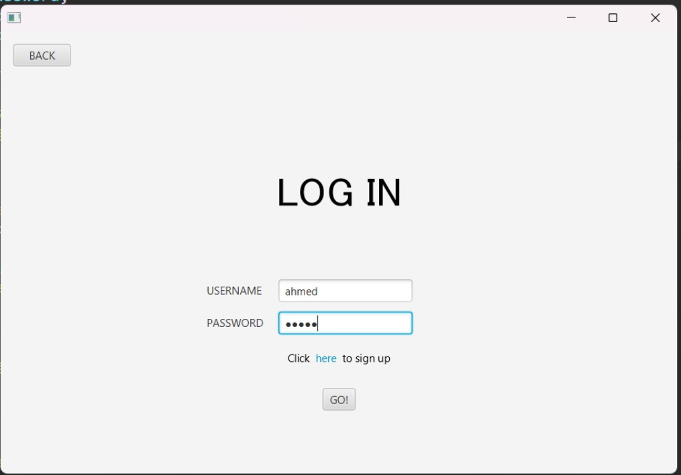

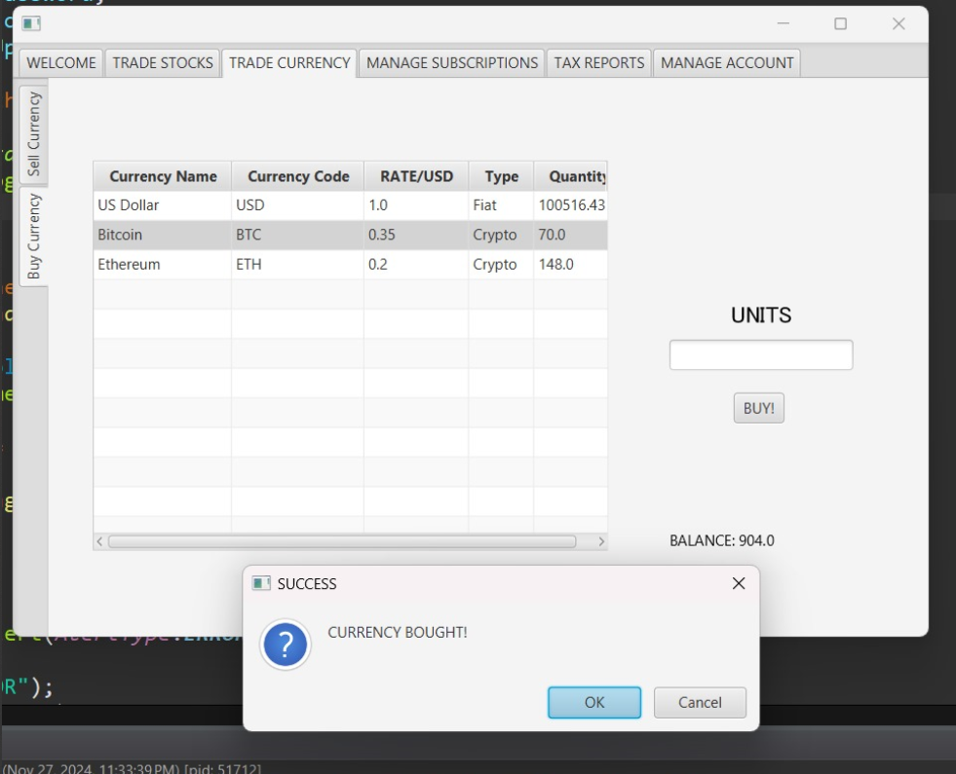

Domain Model

System Sequence Diagram

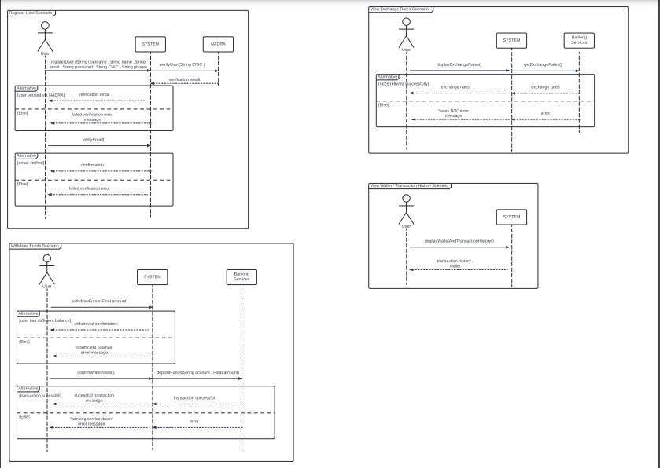

Sequence Diagram

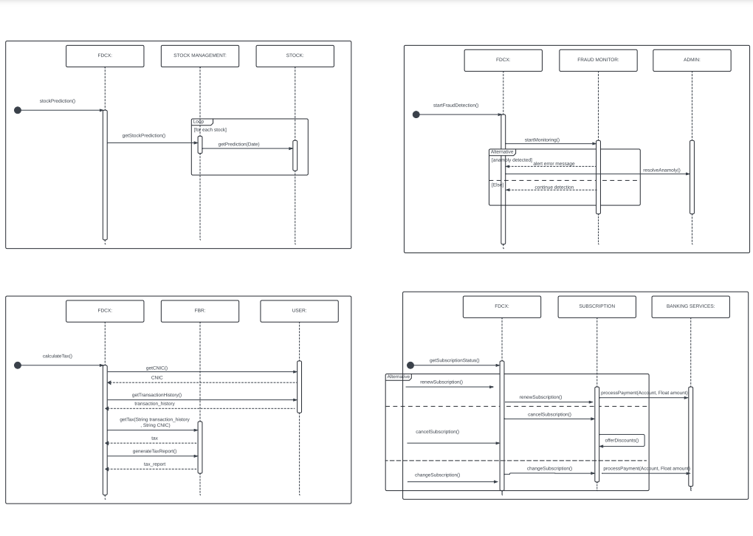

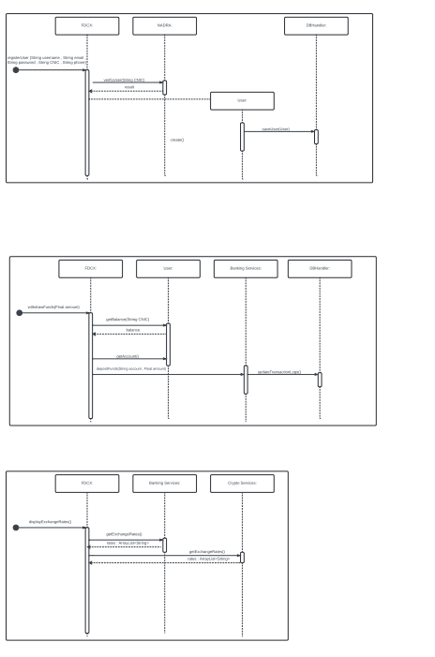

Class Diagram

Component Diagram

Package Diagram

Deployment Diagram

